Cyber-Physical Systems and Digital Twins for “Cognitive Building” in the Construction Industry
Frank Ato Ghansah^{a*} and Weisheng Lu^{b}
ª PhD Candidate, Real Estate and Construction Department, Faculty of Architecture, The University of Hong Kong, Hong Kong
^{b} Professor, Real Estate and Construction Department, Faculty of Architecture, The University of Hong Kong, Hong Kong

Abstract
Purpose: Despite the growing attention on the relevance of improved building management systems with cognition in recent years in the architecture, engineering, construction, and operation (AECO) community, no review has been conducted to understand the human-environment interaction features of cyber-physical systems (CPS) and digital twins (DTs) in developing the concept of a cognitive building (CB). Thus, this paper aims to review existing studies on CPS and DTs for CB to propose a comprehensive system architecture that considers human-environment interactions.
Methodology: Scientometric analysis and content analysis was adopted for this study.
Findings: The scientometric analysis of 1,042 journal articles showed the major themes of CPS/DTs for CB, and these can be categorized into three key technologies to realise CB in the AECO community: CPS, DTs, and cognitive computing (CC). Content analysis of 44 relevant publications in the built environment assisted in understanding and evidently confirming the claim of this study on the integration of CPS and DTs for CB in construction by also involving the CC. It is found and confirmed that CB can be realised with CPS and DTs along with the CC. A CB system architecture (CBSA) is proposed from the three key technologies considering the human-environment interactions in the loop. The study discovered the potential applications of the CBSA across the building lifecycle phases, including the design, construction, and operations and maintenance, with the potential promise of endowing resilience, intelligence, greater efficiency, and self-adaptiveness. Based on the findings of the review, four research directions are proposed: human-environment interactions, CB for sustainable building performance, CB concept for modular buildings, and moving beyond CB.
Originality: This study stands out for comprehensively surveying the intellectual core and the landscape of the general body of knowledge on CPS/DTs for CB in the built environment. It makes a distinctive contribution to knowledge as it does not only propose CBSA by integrating CPS and DTs along with CC, but also suggests some potential practical applications. These may require expert judgments and real case examples to enhance reproducibility and validation.

Keywords: Cognitive building, Content analysis, Cyber-Physical Systems, Digital twins, Intelligent buildings, Scientometric analysis, Smart buildings

1. Introduction
The architecture, engineering, construction, and operation (AECO) industry uptakes digital technologies in resolving many of its problems such as stagnant productivity, poor safety, poor thermal performance, poor energy performance, and others (Alencastro et al., 2018). To tackle these problems, stakeholders are increasingly requiring, designing, and operating buildings, particularly to meet the needs of users, increase productivity, maximize the performance of technological systems, and ensure energy and cost savings (Eini et al., 2021). Buildings now have the self-learning capability to anticipate occupants’ energy-related behaviors and act smartly upon them. This proceeds to the concept of cognitive facility management where a facility can sense, learn, and act in a cognitive manner for a higher level of intelligence (Xu et al., 2019).

The idea of “Cyber-Physical Systems” (CPS) seems to provide an unexploited opportunity to develop the buildings’ cognitive capability. CPS is the combination of physical components and computer/cyber components. The application of CPS includes the Internet of Things (IoT), cognitive computing (CC), DTs, and robotization (Yitmen and Alizadehsalehi, 2021). The key to CPS’s effective implementation is the seamless and secure integration of spatially distributed systems and networked sensors, actuators, computer devices, and feedback control systems that make it up. This transformation may affect buildings to metamorphosize from passive to cognitive assets, thereby interacting with human activities contained by them across a significant scope of innovation.

Digital twin (DT) is another concept closely related to cyber-physical integration (Tao et al., 2019). It digitally mirrors a real-life object, process, or system (Panetta, 2018), and creates a high-fidelity model object in virtual space and simulate to affect the real world and provide feedback (Tao et al., 2019). CPS operates in line with DTs, though there may be variations. Thus, DT is described as a critical component of CPS and a key enabler for decision making based on data (Flores-Garcia et al., 2020). In this study, CPS and DTs would be regarded as keywords in the method section to attain a reliable research trend analysis.

In the AECO industry, the emerging concept of CPS and DT points to the needs of buildings shifting from passive building management to buildings that are equipped with human-like intelligence capabilities and self-adaptiveness. Hence, leading to the idea of ‘cognitive building (CB).’ Primarily, CBs go further than automation and provide actionable insight with a more complex and integrated approach using machine learning algorithms (Yitmen et al., 2021; Motamedi and Shahinmoghadam, 2021). CBs may have the capability to learn new rules through interactions with the environment and autonomously updating its knowledge base throughout the building’s lifecycle. Despite the academic studies on the relevance of improved building automation/management systems with cognition in recent years (Park et al. 2019; Yitmen et al., 2021; Kor, 2021), no review has been conducted to understand the human-environment interaction features of CPS/DT in forming the concept of a CB. Meanwhile, this study, if conducted will help in developing a comprehensive system architecture that clearly helps one to understand the human-environment interactions in CB in the AECO community.

The purpose of this study is to provide an up-to-date comprehensive literature review on the application of CPS/DTs in realizing CB. The specific research objectives of this paper are: (1) to understand the status of CPS/DTs for CB in literature, (2) to identify the key technologies for CB and propose a system architecture for CB in AECO, (3) to identify the prospects, and (4) finally to identify the limitations of existing studies and propose future research directions. This study stands out for comprehensively surveying the intellectual core and the landscape of the general body of knowledge on CPS/DTs for CB in the AECO community. Contributions to the body of knowledge include identifying the trend and key concepts of the existing literature, spotting the omissions and gaps, proposing CB system architecture (CBSA), and determining where future research efforts should be focused. Practically, this study serves as a useful and up-to-date reference point for policymakers and practitioners to improve their understanding and aid them in planning and funding initiatives to implement the CB concept. The paper is structured into seven sections. Subsequent to the introduction is Section 2, which highlights the overview of CPS/DTs for CB. Section 3 demonstrates the research method for this study. Section 4 discusses the results of the analysis, whilst section 5 deliberates on the limitations of the existing studies and proposes future research directions. Section 6 discusses the theoretical and practical contributions. Finally, section 7 draws a conclusion on the study.

2. Overview of CPS/DT for CB
CPS provides an unexploited opportunity to developing building’s cognitive capability. This consists of the combination of physical and cyber components (Yitmen and Alizadehsalehi, 2021). The cyber system comprises systems and entities involved in processing, communicating, and controlling information through computational means, whilst the physical component consists of systems that exist in nature, such as biological entities as well as those developed by humans such as transportation and energy-producing systems (Sanfelice, 2016). The notion of CPS is to utilize computing (i.e., sensing, analyzing, predicting, and understanding), communication (interaction and interface management), and control (interoperate, evolve, evidence-based certification) to make systems intelligent and autonomous (Rawat et al., 2015).
On the other hand, DT refers to the digital representation that mirrors a real-life object, process, or system by creating high-fidelity virtual model objects in virtual space and simulate their behaviors to affect the real world and provide feedback (Panetta, 2018). DTs integration with the CPS enables the prediction and detection of physical issues sooner and more accurately, optimizes processes, and produces better quality. Flores-Garcia et al. (2020) described DTs as a critical component of CPS and a key enabler for data-driven decision-making. Akanmu et al. (2021) attested by regarding DTs as a necessary ingredient for realizing CPS.
The concept of CB was put forth not long after CPS/DTs emerged and were applied to structures. CBs use machine learning algorithms to take a more sophisticated and integrated approach than automation to give actionable insight. Yitmen et al. (2021) defined CB as having intelligent and self-evolving DTs which can effectively manage its operations and maintenance. Technically, CBs’ lifecycle management is assisted by computerized systems, having cognitive power to enable features, such as situational/context-awareness, human-centered computing, self-evolution through continuous learning from experience, and fully/semi-automated decision-making and actuation (Motamedi and Shahinmoghadam, 2021). CBs stand to vary from smart buildings with the ability to update their knowledge according to the changing needs of the occupants. This is due to its nature of being equipped with CPSs/DTs, and the capability to learn new rules through interactions with the environment and autonomously updating its knowledge base throughout the building’s lifecycle (Motamedi and Shahinmoghadam, 2021). The above analogy points to the need to shift from passive building management to buildings that are equipped with human-like intelligence capabilities and self-adaptiveness.
Recent studies have proposed related cognitive systems in the AECO community (Park et al. 2019; Yitmen et al., 2021; Kor, 2021) by describing the data gathering and the decision-making process from different perspectives, including facility management, smart city, and the construction phase of buildings. The CS in the built environment expresses an evolution of the concept of CPS and DTs with the notion of cognitive capabilities in a sense that CS is highly facilitated by the CPS and DTs. Despite the growing attention, the comprehensive system architecture for understanding human-environment interactions in developing CB in the AECO industry is still unclear.

3. Research Methods
A systematic review of existing literature was adopted for this study as it seeks to address knowledge and relationship gaps with analysis, provide recommendations for practice, and highlight what remains unknown and uncertain around findings and recommendations. This study was conducted as shown in Figure 1.

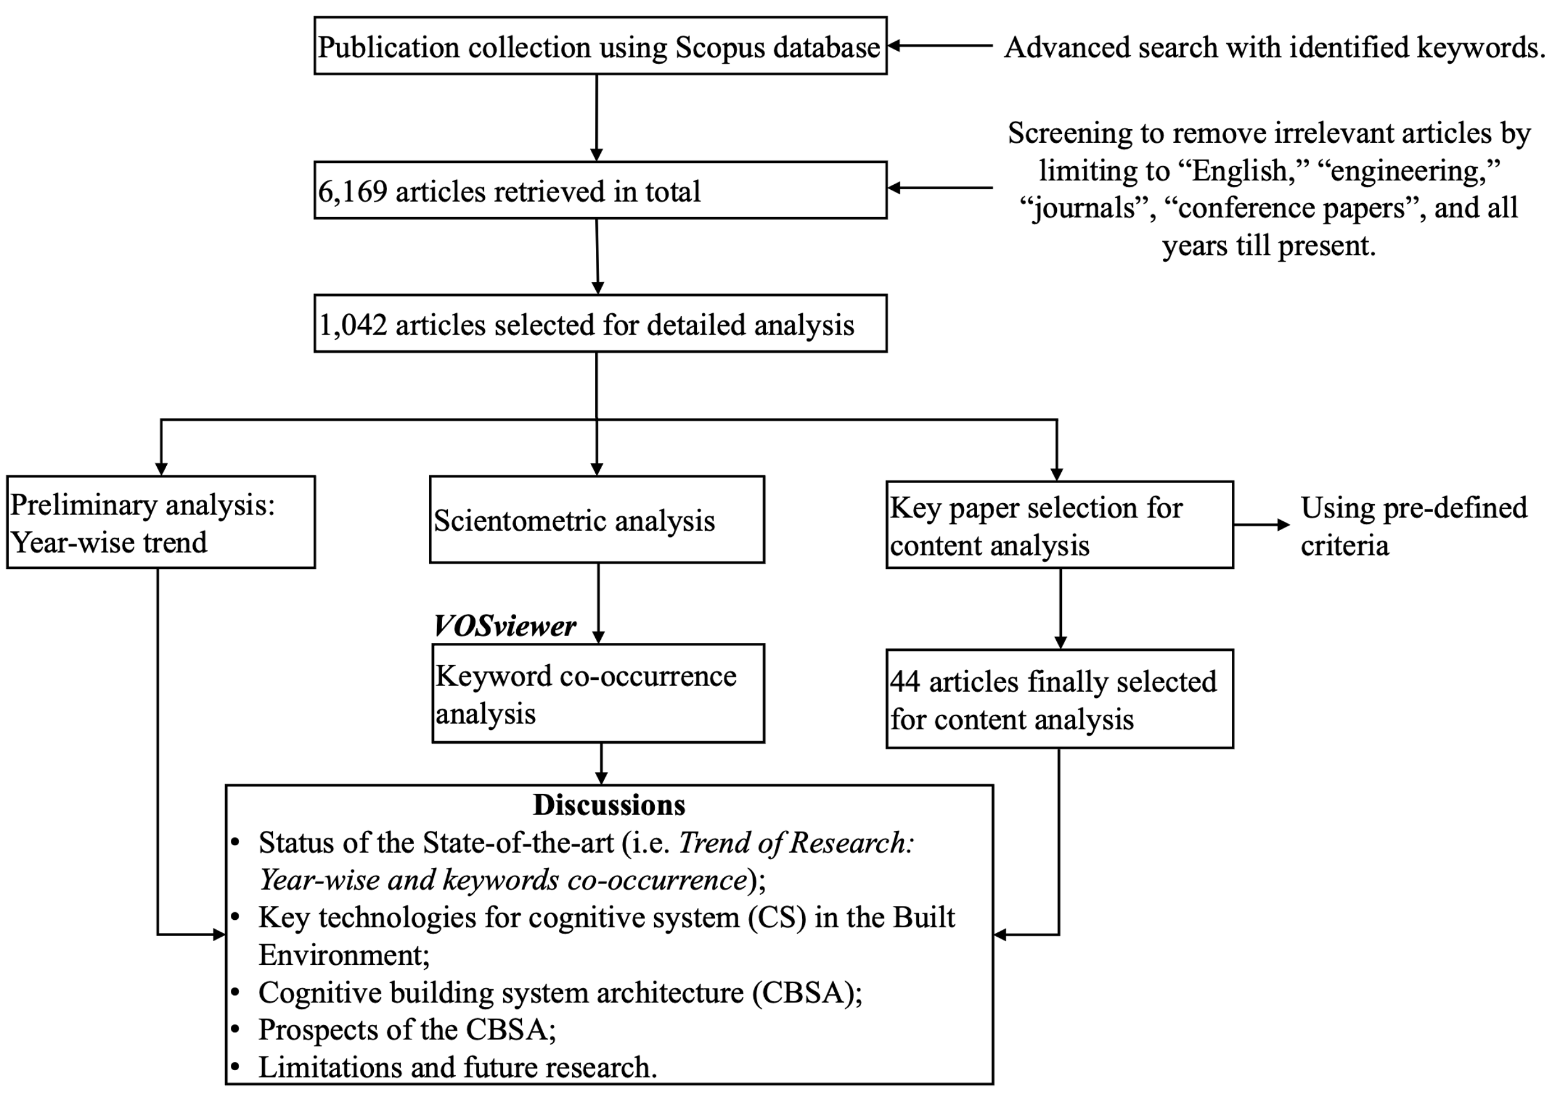
Figure 1: Research Flow Chart (Source: Authors’ own creation)

3.1 Publication Collection
First, publication collection was conducted on 20 October 2022 using the Scopus database, which is believed to have earned a reputation as a comprehensive bibliographic data source and is proven to be reliable compared to the other databases (IFERP, 2022). In the Scopus search, the search keywords included, “cyber physical systems”, “cyber-physical system”, “digital twin”, “virtual twin”, “digital representative”, “cognitive buildings”, “intelligent buildings”, and “smart buildings”. This was facilitated by the Booleans: “AND” and “OR”. The search was set to “all years till present.” The keywords were not limited to only the AECO industry but all industries to assess CPS/DTs across many disciplines, as well as the extent to which it has been adopted in the construction sector. 6,169 publications were retrieved from Scopus.

The publications were further screened to remove unwanted publications by limiting them to “English,” “engineering,” “journals”, and “conference papers”. During the screening, relevancy of publications to the subject matter was also considered based on the keyword choice. Finally, 1,042 publications were regarded as relevant in creating a database for this study. Preliminary analysis was first performed on the 1,042 publications by checking the year-wise trend before conducting further analysis.

3.2 Scientometric Analysis
VOSviewer software (version 1.6.11) was adopted for the scientometric analysis due to its capacity to execute science mapping and answer the key question concerning the domain knowledge. This approach was selected due to its ability to objectively map the scientific knowledge area to help identify research themes, trends, and key concepts.

In performing the scientometric analysis, a “network of keywords” offers an understanding of the existing research interest and the interconnection between them. To achieve this, a keyword co-occurrence was adapted in this study. The number of times keywords appear together in a document is referred to as co-occurrence, whereas the strength of the co-occurrence link is measured by the number of publications in which two terms appear together (van Eck and Waltman, 2019). A typical co-occurrence network of keywords consists of nodes and edges (Van Eck and Waltman, 2019). The nodes represent the keywords whilst the edges represent the relations among sets of keywords. The edges also have the potential of representing the strength or the weight of the relations.

To attain a readable picture of the keywords, the study selected “author keywords” as a unit of analysis rather than “all keywords” (Hosseini et al., 2018). Therefore, the limitation of this approach is the extensive reliance on the “author’s experience and knowledge in choosing research keywords.” The minimal number of occurrences was set at five, and 415 keywords out of 8857 met this criterion. Repeated keywords were removed.

3.3 Content Analysis
To select key papers for the content analysis section of this study, the approach adopted by Kirchherr and Van Santen (2019), Antwi-Afar (2021), and Ababio and Lu (2022) was adopted. Hence, the first 30 highly cited articles of the document analysis were selected. Next, 25 articles were randomly selected based on their prominence in the literature using the snowball method. After removing any duplicates and assessing the obtained articles according to the pre-defined criteria, a total of 44 articles were finally considered efficient for content analysis and discussion (see Supplementary material: Appendix A). The pre-defined criteria include study highlights, study scope, gaps/challenges, contribution, and prominence to the study’s subject matter. This assisted the study to understand, examine and analyze the themes/key concepts, know the existing studies, spot the omissions/gaps, identify the key technologies for CB, and propose a conceptual system architecture.

4. Results and Discussion

4.1 Status of the State-of-the-art
To respond to the first objective, it is essential to review and discuss the trend of research on CPS and DTs for CB in literature by adopting the year-wise approach.

4.1.1 Trend of Research: Year-wise (the 21st century)
CPS/DTs revolution for CB has risen from multiple foundations to result in a family of systems that have the potential to provide a remarkable solution for traditional, contemporary, and emerging areas of societal needs. Figure 2 shows the trend in research publications on CPS/DTs for CB from 1973 to 2022. It reveals a steady and gradual increase in research interest from 1973 to 2022. The trend is expected to sustain after 2022 due to the promotion of advanced digital technologies in the industries. The finding also revealed that the concept of the DTs and CPS could be traced back to 1973.

The applications of CPS and DTs are on the rise across many industries and disciplines such as construction, healthcare, manufacturing, transportation, aviation, education, and agriculture (Garcia and Roofigari-Esfahan, 2020). There is an increasing need for the industries to process a huge amount of heterogeneous data to extract valuable insight for better decisions and state-of-the-art improvement of products. CPS and DTs in the twenty-first century are predicted to push for economic construction productivity and growth and endow akin levels of innovation to the late-twentieth-century internet revolution (Jahromi and Kundur, 2020).

The increasing publication trend is promising, and this shows researchers, practitioners, and clients are getting interested in the application of the CPS/DTs. This has the propensity to provide an explanation for the increasing interest in CPS and its application in the building industry. The construction industry has envisioned that CPS and DTs will augment the AECO industry through connected and autonomous systems to efficiently improve communication, operation, safety, and performance. Hence, their applications are massively encouraged in AECO.

Figure 2: Trend in research publication (1973 to 2022) (Source: Authors’ own creation)

4.1.2 Keywords Co-occurrence
Figure 3 depicted the major themes and key concepts in physical and cyber interactions toward CB, after the scientometric analysis The occurrence of a theme is directly proportional to the size of the circle which is determined by the weight of the theme. The higher the weight of a theme, the larger the label and the circle of the theme. Hence, ‘Cyber-Physical Systems’ appeared to have the highest occurrence; followed by ‘Digital twin,’ ‘industry 4.0,’ ‘security’, ‘Internet of Things (IoT), ‘Machine Learning’, ‘smart manufacture’, ‘cloud computing ‘Smart Grid’, and ‘Artificial Intelligence (AI)’. Also, the color of the theme is determined by the cluster to which it belongs. Therefore, the themes/keywords were classified into 15 clusters depending on the knowledge domain (see Supplementary material: Appendix B). From the results, CPS is regarded as the core and foundation of industry 4.0 in Germany (Wang et al., 2016).

Another insight revealed is that the AECO industry has received less applicability of CPS/DTs for CB, as ‘smart cities’ was the only construction-based keyword discovered within the first 100 keywords (See Supplementary material: Appendix C). This is because, the AECO industry has recently started promoting CPS/DT, and it is embryonic. Finally, the results of the scientometric denoted the cognitive capabilities through ‘machine learning,’ ‘AI,’ and ‘deep learning’. This aligns with the studies by Jordan and Mitchell (2015) and Capuano and Toti (2019) when claimed ‘machine learning’, ‘AI’, and ‘deep learning’ as significant parts of CC. Thus, the findings of the scientometric analysis evidently show that CPS and DTs have been significantly adopted along with CC in the quest of attaining a cognitive system.
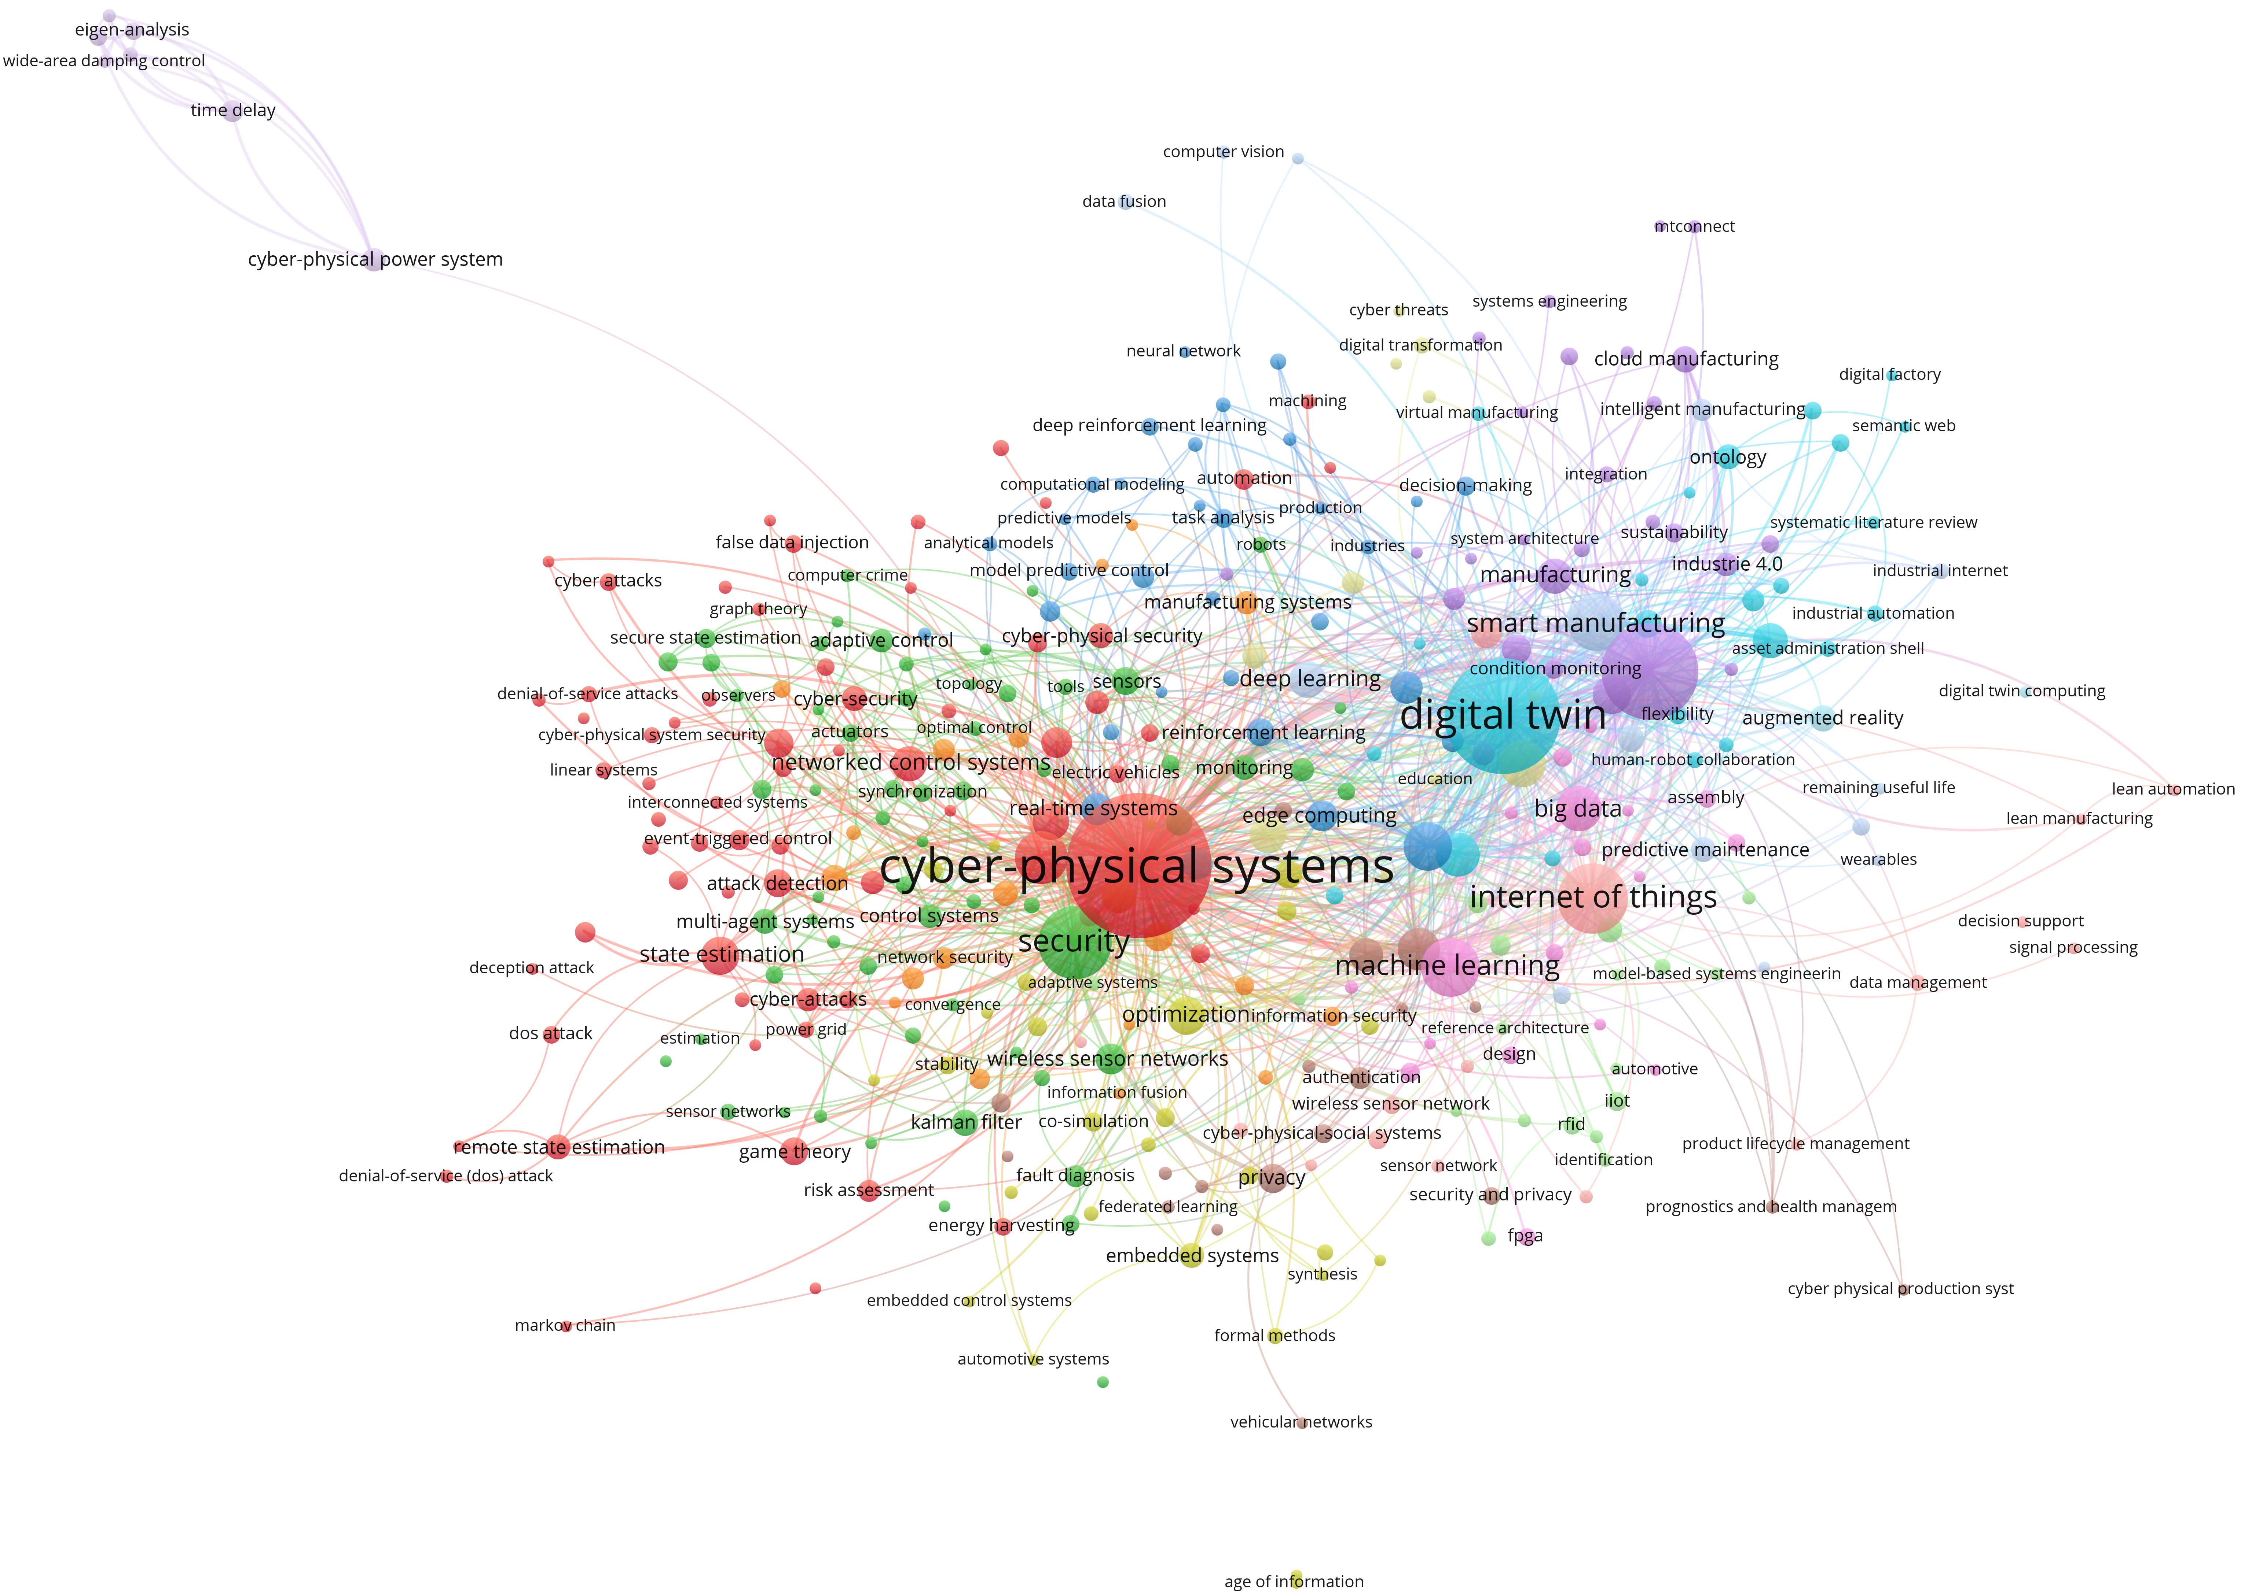

Figure 3: Keywords Co-occurrence Analysis (Source: Authors’ own creation)

4.2. Key Technologies for Cognitive System (CS) in the Built Environment
This section discusses the key technologies for cognitive system in buildings; hence, responding to the second objective.

The difficulty in observing and measuring enough structured and unstructured data throughout the building lifecycle phases (Sinha, 2021) calls for a cognitive system (CS). The adoption of advanced technologies, such as CPS, DTs, IoT, AI, ML, etc. shown by the scientometric analysis has been on a rise in the AECO community due to evidence of the benefits from other industries (i.e., manufacturing, transport, etc.). Bringing data together via the IoT enables a holistic approach using AI to track patterns of activities related to construction, operations, and building usage (Parikh, 2018). Thereby, construction activities and buildings can further be optimized to mimic human intelligence via CS.

CS is inspired by human intelligence, for instance, the capacity to sense, think, and make the optimal decision in each situation (Lytras and Visvizi, 2021). This has gained possibility in the AECO community because of the advanced technologies being promoted, including CPS, DT, BD, AI, and IoT, all connected to self-learning hybrid models with proactive cognitive capabilities for different phases of the building lifecycle. The manufacturing and the health industry have started adopting cognitive systems, and its evidence of benefits shows there are prospects in the AECO community if implemented appropriately. CB application in the AECO community needs to be geared towards augmenting the building and construction processes and conditions by mimicking human intelligence. This is achieved through CC, which is noted by Lytras and Visvizi (2021) as machines’ ability to mimic the human capacity to sense, think and make optimal decisions in given situations.

The review of the existing studies synthesized with the result of the scientometric analysis revealed and confirmed that three key technologies can be integrated to realise the CB concept in building, and these include, CPS, DTs, and CC. thus, CB can be realised with CPS and DTs along with the CC. These are further discussed to understand the feasibility of realizing CB in the AECO community. Hence, confirming the claims made by this study.
- Cyber-Physical Systems (CPS): CPSs are integrated monitoring, sensing, and actuating systems that build a 2-way connection between the physical space and cyber components to autonomously manage processes, information, and resources (Lee et al., 2015; Yitmen, 2021). It is realized by the seamless and secured integration of partially distributed and networked sensors, actuators, computing devices, and feedback control systems that are interacting with each other to engage the physical entity, environment, and human over a communication network in real-time (Jahromi and Kundur, 2020). These can exist in a small and local system such as building management or a highly connected, complex, and large system integrated over several domains. The sensing, actuating, and human-environment-interactive features of CPS in combination with highly distributed and networked intelligence and computational power have the potential to significantly increase efficiency, flexibility, and autonomy while improving situational awareness, robustness, and resiliency of the physical buildings (NASEM, 2016). Sensors and actuators, which are the core elements of CPS (Tao et al., 2019), sense the environment to improve performance and health conditions. Thereby, CPS becoming a vital feature of a CB. To achieve an efficient CB in the AECO, the existing CPS architecture must be augmented to efficiently utilize its sensors and actuators for understanding the human-environment interaction. Also, with CPS, more attention needs to be paid to how the system is designed, produced, and operated without considering the data and models for designing, production, and operation.

- Digital Twins (DTs): On the other hand, DTs represent the digital replica of potential and actual physical assets (physical twin), devices, systems, processes, places, and people that can be used for different aims (El Saddik, 2018). This creates a physical asset model for various reasons, and its data can continuously adjust to changes in the environment or operations, using real-time sensory data. DT predicts the future of corresponding physical assets, monitor, and recognize any potential issues with its real physical, which forms a vital feature of a cognitive system. With the emerging technologies, an adaptive DT model can be developed for building lifecycle management. Also, integrating DT with deep learning has the cognitive potential of facilitating smart planning and construction amid increasing sophistications and capabilities over time (Kor, 2021; Yitmen et al., 2021; Ghansah and Lu et al., 2023). Thus, the DT provides models and data for designing, production, control, and operation throughout the building lifecycle, with less consideration on how the system is designed, produced, and operated.

- Cognitive computing (CC): Also, CC plays an important role in realizing cognition through CPS/DTs integration into systems such as buildings. It covers emerging technologies such as BD, ML, cognitive algorithms, and A.I. CC has the potential to simulate human thought processes into computational models using CPS/DTs. Haykin (2012) attested that human cognition has three accepted main components, and can be integrated into building systems: perception, action, and learning. This aligns with the four categories of cognitive system by Bedeley et al. (2018): observation, decision, interpretation, and evaluation. CC, therefore, serves as a necessary ingredient for empowering the cognitive system to mimic human intelligence. CC infuses and evolves into scopes such as machine learning (ML), deep learning (DL), natural language processing (NLP), computer vision (CV), and AI (Capuano and Toti, 2019). AI falls into a significant part of CC, whilst ML is a subset of AI. DL is a subset of ML. NLP and CV, as stated by (Jordan and Mitchell, 2015) are a subset of AI with the application of some ML and DL techniques. This shows a robust relationship in the application components of CC, and these can be integrated into the CPS/DT to achieve actionable insight from building and construction data, achieving the CB concept.

CS in buildings expresses the evolution of the human-environment interactions in the CPS loop (H-E-CPS/DTs), and can be crafted to fit the requirements of monitoring complex processes. This is embedded into the building to create the concept of CB with cognitive capabilities including detecting anomalies, behavioral learning, and the power to determine physical actions to improve measures defining its state or function. CB uses optimization approaches to aid decision-making using analytics and CC, and there is the capacity to enhance user wellbeing and productivity in the facility management or operations and maintenance phase of buildings (Akanmu et al., 2021). This can also be extended to the design and construction phase where the cognitive capacity embedded into CPS/DT can help in effective monitoring and assessment of workers’ safety indoors and on-sites.

4.3 Cognitive building system architecture (CBSA)
Integrating CS into building holds promises for ensuring reliability, resilience, self-adaptiveness, and intelligence, especially at the operation stage and this holds the capability of CPS, DTs, and CC technologies. The knowledge core of CB has semantic-driven recognition, learning, inference, estimation, and decision qualification consisting of a series of predictions and ML models developed using the data from multiple sources such as physical equivalents and sensors from all aspects of operational conditions of a building system. With this, CB covers cognitive skills for efficient management and operations in buildings, lowering energy and production costs, and efficiency improvement.

The CB consists of three main dimensions which include the physical world, the digital world, and the linkage between the physical and the digital world inspired by smart platform, IoT layer, and data layer linked with cognitive capabilities. These are highly dependent on the three key technologies discussed in Section 4.2. CB ensures self-learning based on the captured domain knowledge, historic data, simulations, and predictive models when implementing the process. Figure 4 shows the proposed system architecture for CB in the construction industry involving the three main dimensions: the physical world, digital world, and the real-time linkage between the physical and the digital world. These are discussed further.

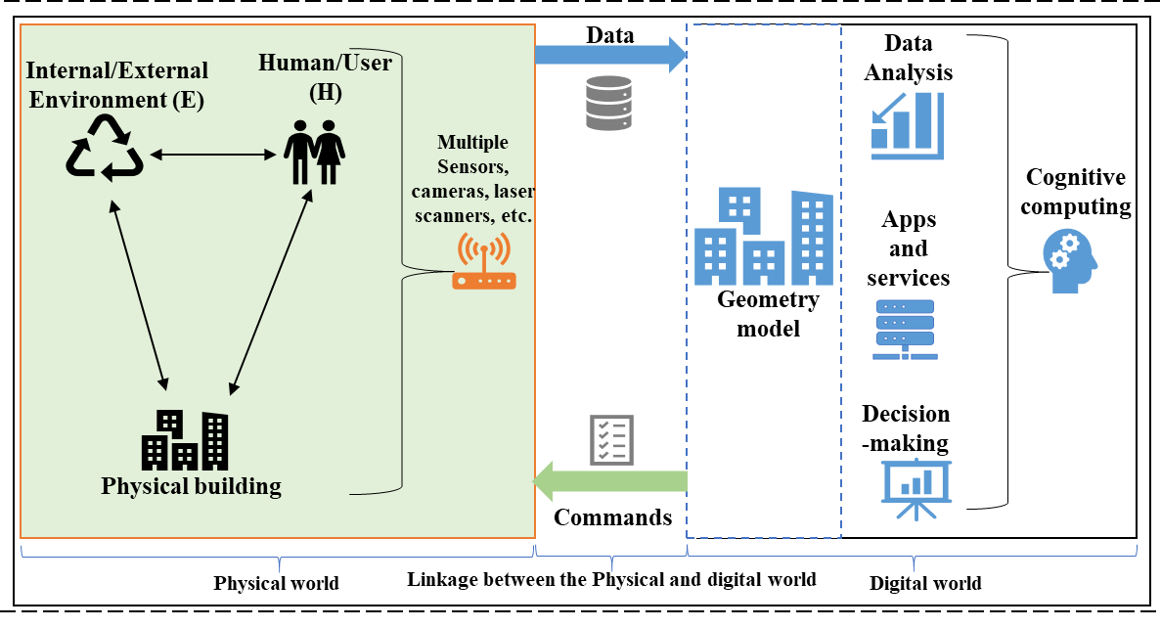
Figure 4: CB System Architecture (CBSA) (Source: Authors’ own creation)

- Physical World: This includes the physical building, the internal/external environment, and the users of the facility; hence, forming the three main sources where data is generated in building. The Sensors and actuators are necessary to interact with the physical world for data exchange, which is a vital feature of CB (Jazdi, 2014; Tao et al., 2019). IoT systems are responsible for sensing the conditions of the physical entity and environment and executing control commands. Multiple sensors distributed in the physical world (i.e., physical building) help achieve large, distributed data, including user’s behavior data, real-time performance, and environmental conditions (high humidity, low temperature, etc.). Multiple sensors may perform state identification to enable the interaction between the cyber/digital and physical worlds (Wang and Haghighi, 2016) in achieving cognition in buildings. Therefore, the state of the physical world in CB significantly affects the digital world via sensor integration or IoT system.

- Digital World: This constitutes the digital copy (i.e., virtual model) for the physical building to simulate and reflect the state and behavior through modeling and analysis. This predicts and controls the future state of buildings, environment, and user behaviours through feedback (Hochhalter et al., 2014). All kinds of data collected by the sensors are transmitted to the digital world where processing is done with the aid of CC application. These include status, behavior, and properties of the physical world, as well as dynamic changes in the environment. Through effective data management, processing, and analysis in the digital world, control commands are generated based on predefined rules and control semantic specifications (Tao et al., 2019). The results are then fed back to the physical world to execute operations according to the control commands to adopt changes. The digital world serves as a communication and recording mechanism to help interpret the behaviors of buildings or users and to predict the future state of a building based on real-time data, historical data, experience, and knowledge, as well as data on the model. This is facilitated by the CC technologies.

- Linkage between Physical and Digital world: This is an important dimension of CB which reflects a real-time change of the physical world to the digital world for data processing. This makes an effective deployment of the sensors and actuators in both the physical world and the digital world, respectively. The data and control bus in the cognitive system provides support for real-time communication and data exchange Tao et al., 2019). With sensors and actuators, any change changes in physical processes (behavior, conditions, or performance) cause changes in the digital world and vice versa. This is due to the effective linkage between the physical and digital world, because of the sensors and actuators. It also assures effective communication that would help interpret and predict the behavior of buildings based on real-time data, towards user wellbeing and productivity. To achieve an effective linkage in buildings, sensors must connect the physical world with the digital world by converting the real-time phenomena into signals that can be processed, stored, visualised, and acted upon in the digital world.

To realize cognitive and actionable capabilities in buildings, different systems are required, which interact with each other as shown in Figure 4. Multiple sensors ingest data from the physical world (human, environment, and physical buildings) into the digital world, loading it to the database. The database provides the required data to create a geometry model, which is a digital surrogate to the physical building. To provide insight into the future state of the digital surrogate, CC using simulations and AI models can offer forecasts, which enrich the digital surrogate, thereby informing a knowledge base. Decision-making is made based on knowledge-based information, and the commands are sent back to the digital world to manage the physical entity and the user. Feedback from commands is also stored in the knowledge base. Cognitive computing is tasked with providing forecasts whenever inference is required to execute specific queries. To realize this, it learns from past data, providing an inductive estimate of the future behavior of buildings and users. External processes could trigger cognitive computing (simulation, AI, etc.), providing additional actionable capabilities.

4.4 Prospects of the CBSA
The application of the CBSA in the AECO community will significantly revolutionize the way buildings are planned, built, managed, and connected to other autonomous systems. The industry utilizes innovative CPS connecting smart buildings through IoT/enabled smart city networks in real-time. This implies that the CB, a potential product of the CBSA, could augment the AECO via connected and autonomous systems to efficiently improve communication, operation, safety, and performance. The application can be tailored toward the significant area in the AECO community among other innovative approaches throughout the building lifecycle. Based on the content analysis of selected relevant articles, prospective applications of the CBSA in the AECO community are detailed in Table 1; hence, responding to the third objective.

Table 1: Prospects in the AECO community (Source: Authors’ own creation)
Application Area | Building Lifecycle Phase |  |  | Source
 | Design | Construction | O&M
Construction component tracking and operations |  |  |  | Anumba et al. (2010); Akanmu et al. (2020); Akanmu et al. (2021)
Construction progress monitoring |  |  |  | Yang et al. (2015); Lin and Golparvar-Fard (2020)
Planning and task clarification |  |  |  | Jiang et al. (2021)
Conceptual design |  |  |  | Jiang et al. (2021)
Preliminary design |  |  |  | Jiang et al. (2021)
Detailed design |  |  |  | Jiang et al. (2021)
Virtual verification |  |  |  | Jiang et al. (2021)
Asset monitoring |  |  |  | Arslan, et al. (2019)
Retrofitting and demolishing |  |  |  | Jiang et al. (2021)
Automatic control |  |  |  | Akanmu et al. (2014); Jiang et al. (2021)
Comprehensive asset management |  |  |  | Welch et al. (2014); Jiang et al. (2021)
Management of heavy construction projects |  |  |  | Roofigari-Esfahan and Razavi (2020)
Construction quality monitoring and management |  |  |  | Jiang et al. (2021)
Construction safety monitoring and management |  |  |  | Jiang et al. (2021)
Workers monitoring and management |  |  |  | Arslan et al. (2019), Jiang et al. (2021)
Machinery monitoring and management |  |  |  | Liu et al. (2018); Yuan et al. (2016)
Material monitoring and management |  |  |  | Jiang et al. (2021)
Temporal structure monitoring |  |  |  | Yuan and Anumba (2020), Akanmu et al. (2021)
Intelligent crane operation |  |  |  | Fang et al. (2020)
Enhanced Mobile Crane safety |  |  |  | Kan et al. (2020)
Structural-infrastructure health monitoring |  |  |  | Jeong et al. (2020); Jiang et al. (2021)
Traffic management with connected and autonomous vehicles |  |  |  | Fayazi et al. (2019); Elefteriadou (2020)
Smart cities |  |  |  | Wu and Fang (2020)
Facilities management |  |  |  | Xu et al. (2020); Torreno et al. (2020); Akanmu et al. (2021)
Real-time Energy demand response (Energy management) |  |  |  | Srinivasan et al. (2020); Akanmu et al. (2021)
BIM |  |  |  | Tang et al. (2019); Motamedi and Shahinmoghadam (2021)
Blockchain |  |  |  | Samaniego and Deters (2016); Yoon et al. (2021)

4.4.1 Design phase
From the perspective of the design phase, CBSA can be implemented in many areas as shown in Table 1. The potential of a project can be planned based on the concept of CB to make decisions, determine some constraints, and provide a project’s overall framework and draft (Jiang et al., 2021). Clear task clarification can be obtained in assisting future design because of CB implementation. CB, due to its DTs component, can facilitate designers to efficiently design, iterate schemes, and collaborate by continuous upgrade and evaluation of the design documents and obtained data in the physical world. The model in CB can be estimated and evaluated to reduce defects and inconsistencies using simulation and analysis embedded in CB. These imply that CB can be implemented at the design phase to effectively revise, improve, and verify designs. Design using CB is more efficient than traditional DTs, as CB involves advanced algorithms and tools to improve the efficiency of design in the future.

4.4.2 Construction phase
The rapid development of the smart construction site due to the implementation of many digitals has made CB possible in prospective areas of the construction phase, as shown in Table 1. For instance, the use of BIM has paved an opportunity for CPS integration to produce DTs. This can further be integrated with CC to achieve CB in the AECO community. The connection and real-time communication needed during project execution on site encourage the adoption of CPS, which is a required component for achieving CB per this study. During construction, CB can facilitate construction monitoring and management including the workers, material and machinery monitoring and management, quality, safety, and construction progress. Thereby, placing an important research gap to consider the implementation of CB in such areas.

4.4.2 Operations and maintenance (O&M) phase
The application of CB is very substantial in the O&M phase, as it possesses the component (i.e., DT) which can ensure asset management (Love et al., 2019). CB has several prospective areas, as shown in Table 1. Leveraging IoT devices such as sensors, CB can monitor existing buildings to extract data through the physical-cyber connection. The data concerning the status of buildings can be analyzed with CC using AI, ML, etc. to assist in making an effective decision on facility management.

5 Limitations and Future Research
This section discusses the research limitations of the existing studies and makes recommendations for future research directions. This is achieved by synthesising the findings from the first three objectives of the study. Thus, the fourth objective is responded.

5.1 Limitations of the Existing Studies
Among the selected studies, limitations were found to first exist in the individual application of technologies, especially CPS and DT. Another limitation also lies in the method adopted by existing studies in achieving cognition in the AECO community.

With the studies on the CPS, limitations were discovered to exist in the loop of application depending on the focus of the study, including the human and environment. Among the previous studies that have conducted research on CPS in the AECO industry, little or no attention has been given to the human-environment interaction in the loop. Meanwhile, this is very vital to user goals in CBs. Table 2 shows the studies and the loop considerations. The service discovery mechanism for IoT which is a core for CPS (Tao et al., 2019) considers the dynamic environment (Nambi et al., 2014), thereby extracting data from the surrounding external environmental conditions and activities, which has a significant influence on the building systems, including high humidity, high temperature, etc. It is thus essential to also consider the environment in the Human-CPS as it can significantly affect the building and construction conditions.

Table 2: Studies and the loops considered in the AECO community (Source: Authors’ own creation)
Authors | Year | Title | Loop
 |  |  | CPS | Human | Environment
Correa | 2018 | Cyber-physical systems for the construction industry |  | * | *
Gracia and Roofigari-Esfahan | 2020 | Technology Requirements for CPS Implementation in Construction |  | * | *
Akanmu et al. | 2020 | Cyber-Physical Systems-Based Component Tracking and Operation |  | * | *
Roofigari- Esfahan and Razavi | 2020 | CPS-Based Approach to Improve Management of Heavy Construction Projects |  | * | *
Lin and Golparvar-Fard | 2020 | Cyber-Physical Systems-Based Component Tracking and Operation |  | * | *
Yuan and Anumba | 2020 | Cyber-Physical Systems for Temporary Structures Monitoring |  | * | *
Eskandar et al. | 2020 | Human-in-the-Loop Cyber-Physical Systems for Construction Safety |  |  | *
Fang et al. | 2018 | A knowledge-based cyber-physical system (CPS) architecture for informed decision making in construction |  | * | *
Fang et al. | 2020 | Cyber-Physical Systems (CPS) in Intelligent Crane Operations |  | * | *
Kan et al. | 2020 | CPS-Based System for Enhanced Mobile Crane Safety |  | * | *
Jeong et al. | 2020 | Structural-Infrastructure Health Monitoring |  | * | *
Wu and Fang | 2020 | Role of CPS in Smart Cities |  | * | *
Torreno et al. | 2020 | Cyber-Physical Social Systems for Facility Management |  | * | *
- considered, *-not considered

Another limitation lies with the existing studies concerning DTs in the built environment. Prior studies (Jiang et al., 2021; Alizadehsalehi and Yitmen, 2021; Akanmu et al., 2021; Yitmen and Alizadehsalehi, 2021) have considered DTs application, yet still the approach to integrating the DTS with CPS and CC seem not to be clear enough to consider human-environment interaction. Meanwhile, the virtual models can be a supplementary boost to the capability and composition of H-E-CPS, making DTs a necessary ingredient for developing Human-Environment-CPS (Akanmu et al., 2021), which can help produce efficient cognitive system in buildings.

Lastly, another limitation lies in the methods adopted by existing studies in achieving cognition in buildings (Table 3). The methods adopted are devoid of the human-environment interactions as there is much focus on taking data on the physical building and its environment. Some methods are reported to have been “too blue-sky to be quickly implemented” as well as having less concentration on the meaningful interpretation of data and models produced to achieve the target goal (data processing). The IoT devices are reported to have been integrated into the building system to understand more of the building performance with regards to its environment. However, human-environment interactions have been left out of the loop, and not been given much attention with regards to the cognitive system in building. As humans are the actual users of buildings, a cognitive system involving human, and its environment is paramount for the emerging concept of CB in the AECO community.

Table 3: Limitations of Relevant Existing Studies (Source: Authors’ own creation)
Authors | Year | Method/Technique | Application | Limitations
Xu et al. | 2019 | Literature review; content analysis. | Advanced the stagnant FM discourses defined and subsequently confined by the smart/intelligent building languages 3 decades ago. | Too blue-sky to be quickly implemented.
Du et al. | 2020 | Literature review; content analysis; simulation. | Established methods and tools for the intelligent information systems of smart cities. | More focus on data and models.  No consideration for environmental factors such as temperature, ventilation, etc.
Yitmen and Alizadehsalehi | 2021 | Literature review, content analysis. | Decision-making in the built environment. | Focus on literature review.
Kor | 2021 | An Exploratory Analysis; focus group. | Decision making for smart planning and construction. | More focus on data and models.
Yitmen et al. | 2021 | Literature review; content analysis; questionnaire survey. | Incorporated cognitive activities to detect complex and unpredictable actions and reason about dynamic process optimization strategies to support decision-making in building lifecycle management. | More focus on data and models.
Park et al. | 2019 | Literature review; content analysis. | Described how data gathered from smart city applications can be analyzed using cognitive computing. | Most attention is on making IoT cognitive systems. Less concentration on the meaningful interpretation of data and models produced to achieve the target goal (data processing).

5.2 Future Research Direction
Based on the findings of the review, several future research directions are proposed and discussed in this section. The suggested areas are based on examining the future works proposed by previous studies, their omissions, and the untapped potentials for CBs based on the lessons from other industries that have advanced ahead of construction (Figure 5).

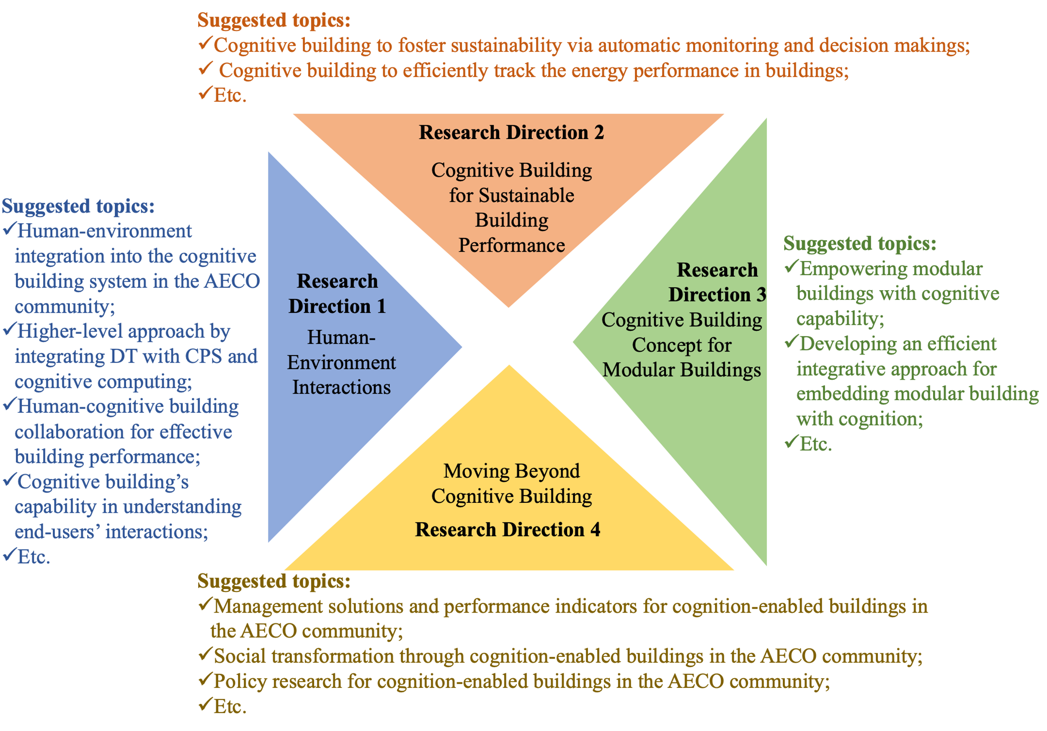
Figure 5: Future Research Directions of CB in Construction and Suggested Topics (Source: Authors’ own creation)

5.2.1 Human-Environment Interactions
Human-environment interactions are paramount in CB in the AECO community. Most previous studies related the cognitive system in buildings to the physical building’s performance and the environment. However, few have focused on the human-environment interaction related to the cognitive system in buildings (Correa, 2018; Eskandar et al., 2020). More efforts are required to consider the human-environment interactions in the cognitive system in buildings, as humans are regarded to be the users of such innovative buildings. Counting the human and its environment in the loop of the cognitive system in the built environment has the potential to promote the development of CB that serve humans. Hence, an important future research direction related to incorporating human-environment interactions in the CB concept in the AECO community.

5.2.2 Cognitive Building (CB) for Sustainable Building Performance
Sustainability in buildings is critical in this modern era, where buildings are now noted to consume many resources such as water, energy, etc. Meanwhile, the consumption rate of these resources can be monitored to ensure effective use. Digital technologies have been integrated to ensure the sustainable consumption of resources. CB can be integrated with BIM and blockchain to endow building facilities with security, greater efficiency, resilience, and intelligence. In addition, CPS and DTs, principal components of CB, share the unique essential concepts of an intensive cyber-physical connection, real-time interaction, organization integration, and in-depth collaboration, even though may have differences. However, getting a cognitive system to automatically understand the consumption rate and make recommendations through efficient simulations is missing. As the CB concept emerges in the built environment, more efforts are encouraged to develop cognitive-enabled systems that can understand and automate the consumption rate in buildings by factoring the activities of humans toward sustainability. Therefore, by combining the CPS and DT for CB as shown in this study, a promising future direction could be to apply this concept of CB for sustainable building performances.

5.2.3 Cognitive Building (CB) Concept for Modular Buildings (Cognitive Modular Building)
The promotion of advanced technologies in the construction industry has then led to the adoption of a modular building; a disruptive innovative approach where buildings are manufactured in manufacturing companies and transported to construction sites for installation (Pan and Hon, 202). This approach has undergone rethinking in optimizing the approach to minimize building issues. Prior studies discovered issues such as poor energy performance, poor thermal performance, poor indoor air quality, and safety in modular building units (Boafo et al., 2016; Woo et al., 2017). The concept has, therefore, failed to resolute building issues. Singapore optimized this approach by pre-finishing the module units with internal finishes at the manufacturing company to produce Prefabricated Prefinished Volumetric Construction (PPVC) through Design for Manufacturing and Assembly (Gbadamosi et al., 2020). Modular building design can undergo further optimization to harness its full potential to resolute buildings to the user’s satisfaction and the environment (Ghansah et al., 2022ab). Therefore, the design for modular building units has the potential to be optimized by integrating cognitive capabilities via the CPSs/DTs. This serves as the next line of study that has the potential of producing a cognitive modular building from the manufacturing company and being transported to the site for installation. Integrating cognitive systems to achieve cognition in modular building units holds promises for ensuring reliability, resilience, self-adaptiveness, and intelligence at the O&M phase. This is assumed to have a high assumption rate in minimizing the operational issues in Modular buildings. Hence, an important future research direction is related to incorporating CB concepts into the concept of modular building in the built environment.

5.2.4 Moving Beyond Cognitive Building (CB)
Social concerns, management, and regulations for CB need to be considered along with technical concerns. Despite the emerging discussions on developing CBs in the AECO community (Xu et al., 2019; Du et al., 2020), there is a lack of research on how the CBs should be managed, assessed, deployed, and regulated from a viewpoint of sociotechnical system. Incorporating cognitive system has the propensity to disrupt most activities and systems including security, business models, and stakeholder relations. Therefore, more efforts are encouraged to holistically consider the potential concerns of CBs by considering the surrounding technological issues, social implications, management, and regulatory concerns.

6 Theoretical and Practical Implication
Theoretically, the study makes a significant contribution to the knowledge of CB concept in the built environment by synthesizing previous studies and offering insight into future discoveries in this promising field. A substantial contribution is also made through the proposal of CBSA to realize CB in the built environment considering the human-environment interactions in the loop.

For practical implication, for instance, at the O&M phase, some key aspects of the CBSA proposed by this study were adopted in the construction of IBM’s typical CB called Watson. The concept of Watson was aligned with the key performance indicators (KPIs) of IBM’s building, namely improved efficiency, and better tenant experience (see supplementary material: Appendix D). To achieve this, Watson was integrated with advanced technologies including IoT systems, cognitive computing, and others capable of helping facility managers transform their businesses and better utilize assets. Watson was noted to provide useful insight using CC and comprehensive facility management capabilities. A limitation of Watson was its high level of technology-centered, instead of on humans and the environment. Despite the approach adopted by IBM in the successful construction of Watson, there is a need to consider the human-environment interaction. As a practical contribution, the study identifies the applicability of the human-environment-centered CB concept across various areas in the construction industry. The CBSA, which is human-environment-centered, can serve as a useful and reference system for policymakers and practitioners to understand the applications of the CB concepts in the AECO community, including the enabling key technologies. The CBSA has significant practical application throughout the building lifecycle phases. The findings of the study can therefore assist building professionals and policymakers in up-taking and improving the CB concept to satisfy users and building/facility managers toward smart living.

7 Conclusion
Despite the growing attention on the relevance of improved building management systems with cognition in recent years, no review has been conducted to understand the human-environment interaction features of CPS/DT in developing the concept of the CB. Meanwhile, if considered could help in developing a comprehensive system architecture that understands the user-environment interactions in CB in the AECO community. The study approach involves a scientometric analysis of literature and content analysis of relevant publications. The key findings are provided subsequently.

The first objective is responded by the in-depth analysis of year-wise trend of the subject matter and the associated keyword co-occurrence. The findings reveal a steady and gradual increase in research interest from 1973 to 2022. The trend is noted across many industries and disciplines, including construction, healthcare, manufacturing, transportation, aviation, education, and agriculture. The scientometric analysis revealed the significant keywords and themes in literature relating to the key technologies adopted for CB. With further analysis using the content analysis, three keywords are noted for CB in the AECO community, and these include the CPS, DTs, and CC. These are evidently discussed further to confirm the claims by this study toward the proposal of CBSA. It is found that CB can be realised with CPS and DTs along with the CC; hence, responding to the second objective. The third objective is responded by identifying the prospects of the proposed CBSA across the building lifecycle phases, including the design, construction, and the O&M, with the potential promise of endowing resilience, intelligence, greater efficiency, and self-adaptiveness in buildings. The study concluded that the CBSA has the capability to include the human-environment interactions in the loop of CB concept; hence, tackling an ongoing issue with the CB concept by exiting studies in the AECO community. Other limitations of the existing studies are highlighted.

The fourth objective is responded completely by extracting the insights from and synthesizing the prior studies and recommending four research directions: (1) human-environment interactions, (2) CB for sustainable building performance, (3) CB concept for modular buildings, and (4) moving beyond CB. These four directions, in unison, provide a promising future for CB concept in the AECO community.

The findings of the study have shown to hold significant contributions to the academia and practitioners in the AECO community. However, some limitations must be taken into considerations when applying the findings of this study. The scope of the review was limited to publications from the Scopus databased published in English. Therefore, one could argue for a more thorough review by extending the selection of publications from other database, including the Web of Science, PubMed, JSTOR, ScienceDirect, IEEE Xplore, Academic Search Complete, etc. Nevertheless, the pattern of the findings should remain the same.

References
Ababio, B.K. and Lu, W., 2023. Barriers and enablers of circular economy in construction: a multi-system perspective towards the development of a practical framework. Construction Management and Economics, 41(1), pp.3-21.
Akanmu, A., Nguyen, D., Rasheed, S.H. and Olatunji, O., 2014, March. An automated approach to construction site layout generation. In 50th ASC Annual International Conference, Washington, DC (pp. 26-28).
Akanmu, A.A., Anumba, C.J. and Ogunseiju, O.O., 2021. Towards next generation cyber-physical systems and digital twins for construction. Journal of Information Technology in Construction, 26(27), pp.505-525.
Akanmu, A.A., Olayiwola, J., Ogunseiju, O. and McFeeters, D., 2020. Cyber-physical postural training system for construction workers. Automation in construction, 117, p.103272.
Alencastro, J., Fuertes, A. and de Wilde, P., 2018. The relationship between quality defects and the thermal performance of buildings. Renewable and sustainable energy reviews, 81, pp.883-894.
Alizadehsalehi, S. and Yitmen, I. 2021, Digital twin-based progress monitoring management model through reality capture to extended reality technologies (DRX), Smart and Sustainable Built Environment, https://doi.org/10.1108/SASBE-01-2021-0016.
Anumba, C. J., Akanmu, A., and Messner, J., 2010. Towards a cyber-physical systems approach to construction. In Construction research congress 2010: Innovation for reshaping construction practice (pp. 528–537).
Antwi-Afari, P., Ng, S.T., and Hossain, M.U., 2021. A review of the circularity gap in the construction industry through scientometric analysis. Journal of cleaner production, 298, p.126870.
Arslan, M., Cruz, C. and Ginhac, D., 2019. Understanding occupant behaviors in dynamic environments using OBiDE framework. Building and environment, 166, p.106412.
Boafo, F.E., Kim, J.H. and Kim, J.T., 2016. Performance of modular prefabricated architecture: case study-based review and future pathways. Sustainability, 8(6), p.558.
Bongomin, O., Gilibrays Ocen, G., Oyondi Nganyi, E., Musinguzi, A. and Omara, T., 2020. Exponential disruptive technologies and the required skills of industry 4.0. Journal of Engineering, 2020.
Capuano, N. and Toti, D., 2019. Experimentation of a smart learning system for law based on knowledge discovery and cognitive computing. Computers in Human Behavior, 92, pp.459-467.
Correa, F.R., 2018, May. Cyber-physical systems for construction industry. In 2018 IEEE Industrial Cyber-Physical Systems (ICPS) (pp. 392-397). IEEE.
Du, J., Zhu, Q., Shi, Y., Wang, Q., Lin, Y. and Zhao, D., 2020. Cognition digital twins for personalized information systems of smart cities: Proof of concept. Journal of Management in Engineering, 36(2), p.04019052.
Eini, R., Linkous, L., Zohrabi, N. and Abdelwahed, S., 2021. Smart building management system: Performance specifications and design requirements. Journal of Building Engineering, 39, p.102222.
El Saddik, A., 2018. Digital twins: The convergence of multimedia technologies. IEEE multimedia, 25(2), pp.87-92.
Elefteriadou, L., 2020. Cyber Physical Systems in Transportation: Traffic Management with Connected and Autonomous Vehicles. In Cyber-Physical Systems in the Built Environment (pp. 237-254). Springer, Cham.
Fang, Y., Cho, Y.K., Kan, C. and Anumba, C.J., 2020. Cyber-Physical Systems (CPS) in Intelligent Crane Operations. In Cyber-Physical Systems in the Built Environment (pp. 175-192). Springer, Cham.
Fang, Y., Roofigari-Esfahan, N. and Anumba, C., 2018, January. A knowledge-based cyber-physical system (CPS) architecture for informed decision making in construction. In Construction Research Congress 2018 (pp. 662-672). American Society of Civil Engineers.
Fayazi, S.A., Vahidi, A. and Luckow, A., 2019. A Vehicle-in-the-Loop (VIL) verification of an all-autonomous intersection control scheme. Transportation Research Part C: Emerging Technologies, 107, pp.193-210.
Flores-García, E., Kim, G.Y., Yang, J., Wiktorsson, M. and Do Noh, S., 2020, August. Analyzing the Characteristics of Digital Twin and Discrete Event Simulation in Cyber Physical Systems. In IFIP International Conference on Advances in Production Management Systems (pp. 238-244). Springer, Cham.
Garcia, D.A.L. and Roofigari-Esfahan, N., 2020. Technology Requirements for CPS Implementation in Construction. In Cyber-Physical Systems in the Built Environment (pp. 15-30). Springer, Cham.
Gbadamosi, A.Q., Oyedele, L., Mahamadu, A.M., Kusimo, H., Bilal, M., Delgado, J.M.D. and Muhammed-Yakubu, N., 2020. Big data for Design Options Repository: Towards a DFMA approach for offsite construction. Automation in Construction, 120, p.103388.
Ghansah, F.A. and Lu, W. (2023), Major opportunities of digital twins for smart buildings: a scientometric and content analysis, Smart and Sustainable Built Environment, Vol. ahead-of-print No. ahead-of-print. https://doi.org/10.1108/SASBE-09-2022-0192.
Ghansah, F.A., Lu, W. and Jinying, X., 2022a. Cognitive Modular Building to Enhance User Wellbeing: An Insight from Literature Review on Potential Benefits, Design Considerations and Opportunities. In International Symposium on Advancement of Construction Management and Real Estate (pp. 448-460). Springer, Singapore.
Ghansah, F.A., Chen, J. and Lu, W., 2022b. Developing a user perception model for smart living: A partial least squares structural equation modelling approach. Building and Environment, p.109399.
Haykin, S., 2012. Cognitive dynamic systems: perception-action cycle, radar, and radio. Cambridge University Press.
Hochhalter, J.D., Leser, W.P., Newman, J.A., Glaessgen, E.H., Gupta, V.K., Yamakov, V., Cornell, S.R., Willard, S.A. and Heber, G., 2014. Coupling damage-sensing particles to the digital twin concept (p. 10). National Aeronautics and Space Administration, Langley Research Center.
Hosseini, M.R., Martek, I., Zavadskas, E.K., Aibinu, A.A., Arashpour, M. and Chileshe, N., 2018. Critical evaluation of off-site construction research: A Scientometric analysis. Automation in Construction, 87, pp.235-247.
IBM 2016, Cognitive-buildings-infographic, https://www.ibm.com/internet-of-things/common/pdf/cognitive-buildings-infographic.pdf, Accessed: 08/12/2021.
IFERP, 2022, Scopus vs Web of science journal; Which one is better, https://www.iferp.in/blog/2022/04/28/scopus-vs-web-of-science-journal-which-one-is-better/, Accessed: 30/10/2022.
Jahromi, A.A. and Kundur, D., 2020. Fundamentals of Cyber-Physical Systems. In Cyber-Physical Systems in the Built Environment (pp. 1-13). Springer, Cham.
Jazdi, N., 2014, May. Cyber physical systems in the context of Industry 4.0. In 2014 IEEE international conference on automation, quality and testing, robotics (pp. 1-4). IEEE.
Jeong, S., Hou, R., Lynch, J.P., and Law, K.H., 2020. Structural-Infrastructure Health Monitoring. In Cyber-Physical Systems in the Built Environment (pp. 215-235). Springer, Cham.
Jiang, F., Ma, L., Broyd, T. and Chen, K., 2021. Digital twin and its implementations in the civil engineering sector. Automation in Construction, 130, p.103838.
Jordan, M.I. and Mitchell, T.M., 2015. Machine learning: Trends, perspectives, and prospects. Science, 349(6245), pp.255-260.
Kan, C., Anumba, C.J., Fang, Y. and Messner, J.I., 2020. CPS–Based System for Enhanced Mobile Crane Safety. In Cyber-Physical Systems in the Built Environment (pp. 193-213). Springer, Cham.
Kirchherr, J.W. and van Santen, R., 2019. Research on the circular economy: A critique of the field. Resources, Conservation and Recycling, 151.
Kor, M., 2021. Integration of Digital Twin and Deep Learning for facilitating Smart Planning and Construction: An Exploratory Analysis. https://www.diva-portal.org/smash/record.jsf?pid=diva2:1569258, Accessed: 30/10/2022.
Lee, J., Bagheri, B. and Kao, H.A., 2015. A cyber-physical systems architecture for industry 4.0-based manufacturing systems. Manufacturing letters, 3, pp.18-23.
Lin, J.J. and Golparvar-Fard, M., 2020. Construction progress monitoring using cyber-physical systems. In Cyber-Physical Systems in the Built Environment (pp. 63-87). Springer, Cham.
Liu, D., Chen, J. and Li, S., 2019. Collaborative operation and real-time control of roller fleet for asphalt pavement compaction. Automation in Construction, 98, pp.16-29.
Love, P.E. and Matthews, J., 2019. The ‘how’ of benefits management for digital technology: From engineering to asset management. Automation in Construction, 107, p.102930.
Lytras, M.D. and Visvizi, A., 2021. Artificial intelligence and cognitive computing: Methods, technologies, systems, applications, and policy making. Sustainability, 13(7), p.3598.
Motamedi, A. and Shahinmoghadam, M., 2021. BIM-IoT-integrated Architectures as the Backbone of Cognitive Buildings: Current State and Future Directions. In BIM-enabled Cognitive Computing for Smart Built Environment (pp. 45-68). CRC Press.
Nambi, S.A.U., Sarkar, C., Prasad, R.V. and Rahim, A., 2014, March. A unified semantic knowledge base for IoT. In 2014 IEEE World Forum on Internet of Things (WF-IoT) (pp. 575-580). IEEE.
NASEM, 2016. A 21st century cyber-physical systems education. Washington, DC: The National Academies Press. https://doi.org/10.17226/23686.
Pan, W. and Hon, C.K., 2020, June. Briefing: Modular integrated construction for high-rise buildings. In Proceedings of the Institution of Civil Engineers-Municipal Engineer (Vol. 173, No. 2, pp. 64-68). Thomas Telford Ltd.
Panetta, K. (2018). Gartner top 10 strategic technology trends for 2019. Gartner. Retrieved from https://gtnr.it/2UFB33a, Accessed; 21/07/2021.
Parikh, S. 2018, Cognitive systems and their role in enabling value creation within an enterprise, accessed: 25/08/2021, https://www.livemint.com/AI/Xltz2QBIKR3vuZlhaHBcCM/Cognitive-systems-and-their-role-in-enabling-value-creation.html.
Park, J.H., Salim, M.M., Jo, J.H., Sicato, J.C.S., Rathore, S. and Park, J.H., 2019. CIoT-Net: a scalable cognitive IoT based smart city network architecture. Human-centric Computing and Information Sciences, 9(1), pp.1-20.
Roofigari-Esfahan, N. and Razavi, S., 2020. CPS-Based Approach to Improve Management of Heavy Construction Projects. In Cyber-Physical Systems in the Built Environment (pp. 89-105). Springer, Cham.
Samaniego, M., Jamsrandorj, U. and Deters, R., 2016, December. Blockchain as a Service for IoT. In 2016 IEEE international conference on internet of things (iThings) and IEEE green computing and communications (GreenCom) and IEEE cyber physical and social computing (CPSCom) and IEEE smart data (SmartData) (pp. 433-436). IEEE.
Sanfelice, R.G., 2016. Analysis and design of cyber-physical systems. A hybrid control systems approach. Cyber-physical systems: From theory to practice, pp.3-32.
Sinha, V. 2021, Structured and unstructured data: 7 critical difference, accessed: 25/08/2021, https://hevodata.com/learn/structured-vs-unstructured-data-key-differences/#intro1.
Tang, S., Shelden, D.R., Eastman, C.M., Pishdad-Bozorgi, P. and Gao, X., 2019. A review of building information modeling (BIM) and the internet of things (IoT) devices integration: Present status and future trends. Automation in Construction, 101, pp.127-139.
Tao, F., Qi, Q., Wang, L. and Nee, A.Y.C., 2019. Digital twins and cyber–physical systems toward smart manufacturing and industry 4.0: Correlation and comparison. Engineering, 5(4), pp.653-661.
van Eck, N.J., Waltman, L., 2019. VOSviewer Manual: Manual for VOSviewer Version 1.6.11. https://www.vosviewer.com/documentation/Manual_VOSviewer_1.6.11. pdf. Accessed 15/07/2021.
Wang, Z.L., Shen, H.C. and Zuo, J., 2019. Risks in prefabricated buildings in China: importance-performance analysis approach. Sustainability, 11(12), p.3450.
Woo, J., 2017. A post-occupancy evaluation of a modular multi-residential development in Melbourne, Australia. Procedia Engineering, 180, pp.365-372.
Wu, J. and Fang, D., 2020. Role of CPS in Smart Cities. Cyber-Physical Systems in the Built Environment, pp.255-272.
Xu, J., Lu, W., Anumba, C.J. and Niu, Y., 2020. From smart construction objects to cognitive facility Management. In Cyber-Physical Systems in the Built Environment (pp. 273-296). Springer, Cham.
Xu, J., Lu, W., Xue, F. and Chen, K., 2019. ‘Cognitive facility management’: Definition, system architecture, and example scenario. Automation in Construction, 107, p.102922.
Yang, J., Park, M.W., Vela, P.A. and Golparvar-Fard, M., 2015. Construction performance monitoring via still images, time-lapse photos, and video streams: Now, tomorrow, and the future. Advanced Engineering Informatics, 29(2), pp.211-224.
Yitmen, I. and Alizadehsalehi, S., 2021. Overview of Cyber-Physical Systems and Enabling Technologies in Cognitive Computing for Smart Built Environment. In BIM-enabled Cognitive Computing for Smart Built Environment (pp. 1-20). CRC Press.
Yitmen, I., 2021. BIM-enabled cognitive computing for smart built environment: Potential, requirements, and implementation. CRC Press.
Yitmen, I., Alizadehsalehi, S., Akıner, İ. and Akıner, M.E., 2021. An Adapted Model of Cognitive Digital Twins for Building Lifecycle Management. Applied Sciences, 11(9), p.4276.
Yoon, J.H., Gao, X. and Pishdad-Bozorgi, P., 2021. Blockchain: Technologies for Facilitating Cyber-Physical Security in Smart Built Environment. In BIM-enabled Cognitive Computing for Smart Built Environment (pp. 164-189). CRC Press.
Yuan, X. and Anumba, C.J., 2020. Cyber-Physical Systems for Temporary Structures Monitoring. In Cyber-Physical Systems in the Built Environment (pp. 107-138). Springer, Cham.

