**On the Elastoplastic Buckling Analysis of Cylinders under Non-proportional Loading by the Differential Quadrature Method**

Rabee Shamass1,*, Giulio Alfano1 and Federico Guarracino2

1 - College of Engineering, Design and Physical Sciences, Brunel University, UB8 3PH Uxbridge, UK

2 – University of Naples ‘Federico II’, Via Claudio 21, 80125 Napoli, Italy

*Corresponding author. E-mail address: [Rabee.Shamass@brunel.ac.uk](mailto:Rabee.Shamass@brunel.ac.uk) ; rabeeshammas@yahoo.com

**Abstract**

*The paper investigates the elastoplastic buckling of thin circular shells subjected to non-proportional loading consisting of axial tensile stress and external pressure. The governing equations of buckling for cylindrical shells derived by Flugge serve as the basis of analysis. To capture the elastic/plastic behaviour, two plasticity theories are considered; the flow theory and the deformation theory of plasticity. Plastic buckling pressures for cylinders with various combinations of boundary conditions are presented for which no analytical solutions are available. The results obtained from the flow and deformation theories confirm that, under over-constrained kinematic assumptions, the deformation theory tends to provide lower values of buckling pressure and the discrepancies in the results from the two plasticity theories increase with increasing thickness-to-radius ratios, tensile stresses, boundary clamping and $E/σ_{y}$ ratios. The plastic buckling results obtained by means of the differential quadrature method are compared with carefully conducted FEA results for both the flow and the deformation theory of plasticity. The reasons underlying the apparent plastic buckling paradox are thus investigated for a vast class of boundary conditions and loads.*

**Keywords:** differential quadrature method; flow and deformation plasticity; non-linear finite element analysis; non-proportional loading; plastic buckling; shell instability

**1. Introduction**

Plastic buckling of circular cylindrical shells typically occurs in the case of moderately thick cylinders subjected to axial compression, external pressure, torsion or combinations of such load cases and has been the subject of active research for many decades due to its relevance to the design of aerospace, submarine, offshore and civil engineering structures.

There are many practical cases of buckling of shells involving various combinations of boundary conditions. Obtaining closed form solutions for different boundary conditions requires complex mathematics and is generally difficult or even impossible to obtain analytically. Therefore, many approximate numerical methods have been employed over the years for buckling problems, such as the finite difference (FD), the finite element (FE), the Rayleigh-Ritz and the Galerkin methods, etc. The differential quadrature (DQ) method may offer some advantages over some of these methods and at the same time a clearer insight into the mechanics of the problem under analysis. For example, Wang [1] employed the DQ method to study transient analysis of isothermal chemical reactors. He showed that the DQ method can provide accurate results using only nine grid points while the FD method required 480 grid points to provide the same accuracy.

The Rayleigh-Ritz and Galerkin methods require less computational effort in comparison with the FE and FD methods but at the same time they require the selection of trial functions satisfying boundary conditions. This does not apply to the DQ method, which leaves a certain freedom in dealing with the boundary conditions of the problem. Therefore, the method has become quite popular in the numerical solution of some problems in engineering and physical science. For instance, the DQ method is routinely employed to provide solutions to partial differential equations arising in various simplified models of fluid flow, diffusion of neutrons through homogeneous media and one-dimensional nonlinear transient heat diffusion and conduction problems [2]. This technique has also been applied in the simulation of fluid mechanics [3], heat transfer [2] , transport processes [4], dynamic structural mechanics [5], chemical engineering [6], lubrication mechanics [7], static aero-elasticity [2] and to analyse deflection, vibration and buckling of linear and nonlinear structural components [8],[9],[10],[11]. More recently, Niu et al. [12] successfully employed the DQ method to solve complex problem which is nonlinear thermal flutter problem of supersonic composite panels. He investigated the efficiency of the DQ method by considering the effect of the number of sampling points on the convergence and the accuracy of the results. Moreover, Wu et al. [13] investigated free vibration and elastic buckling of sandwich beams with a stiff core and functionally graded carbon nanotube reinforced composite face sheets based on the Timoshenko beam theory. The governing equations and boundary conditions are discretized and solved using the differential quadrature method to obtain the natural frequency and elastic buckling load of the sandwich beam. Yang et al. [14] successfully employed the differential quadrature method and the second-order backward difference scheme to obtain the linear and nonlinear vibration frequencies of Monomorph and bimorph actuators made of piezoelectric materials.

The DQ method, first used by Bert et al. [15] to solve structural problems of shell analysis, was successively used to analyse other linear and nonlinear structural problems. More recently, geometrically nonlinear transient analysis of moderately thick laminated composite shallow shells were studied using the DQ method [16]. At the date of writing, the DQ method has been applied to analyse elastic buckling of plates of different shapes such as rectangle, square, skew, circle and trapezoid with different boundary conditions [16], elastic buckling of circular cylindrical shells [18], elastic buckling of one-dimensional composite laminated beam-plates [19], elastoplastic buckling of thick rectangular plates under biaxial loading [20], [21], [22] and elastoplastic buckling of skew thin plates [23].

It can be noticed that, so far, the DQ method has only been successfully used to obtain elastic buckling loads of plates and cylinders and plastic buckling loads of plates. The available analytical solutions of plastic buckling of cylindrical shells subjected to combined loads are only for cylinders with one type of simply-supported boundary conditions [24], [25]. Thus, the DQ method is used in this paper for the first time for the elastoplastic buckling analysis of cylinders subjected to combined tensile stress and external pressure with different boundary conditions.

This study assumes that the cylindrical shells are thin, homogeneous and isotropic. The Flugge [26] stability equations, based on the assumption of infinitesimal deformations and moderate rotations, are used and a buckling mode varying harmonically in the circumferential direction of the cylinder is assumed, thus allowing us to use the one-dimensional version of the DQ method. Both the flow theory and deformation theory of plasticity are considered. The validated elastic and plastic buckling results obtained with the help of the DQ method are analysed to achieve the following objectives in the framework of the study of the so-called “plastic buckling paradox”:

* investigate the effect of different boundary conditions on the plastic buckling results and the discrepancies between predictions of the flow and deformation theories;
* investigate the effect of cylinder’s geometries (thickness-to-radius *h/R* and length-to-diameter *L/D* ratios), material properties (Young’s modulus-to-yield strength $E/σ_{y}$) and values of the applied tensile stress on the plastic buckling pressure and the discrepancy between the results of the flow and deformation theories;
* compare the results of the DQ method, which uses a bifurcation analysis approach, with those of non-linear incremental FE analyses based on both the flow and the deformation theories of plasticity;
* point out once more the possible reasons of some large discrepancies in the predictions of buckling loads between the flow theory and the deformation theory of plasticity when the kinematics is not free, following earlier work by the same authors [25],[27],[28].

The outline of the paper is as follows. The main governing equations and related boundary conditions of the problems are derived in Section 2. In Section 3 a solution procedure for these equations, based on the DQ method, is described and results are presented and discussed together with a sensitivity analysis with respect to the boundary conditions and to some of the key input parameters. The results of nonlinear FE simulations are then presented in Section 4 and their comparison with those given by the DQ method is discussed in Section 5, also within the framework of the plastic buckling paradox. Conclusions are then drawn in Section 6.

**2. Flugge’s differential equations for cylinders under combined loading**

Consider a circular cylindrical shell of length *L* radius *R* and uniform thickness *h* and subjected to two different loads: a uniform normal pressure on its lateral surface, $q,$ and an axial tensile stress, $σ_{t}$.

Let us denote by $x$ the axis of the shell and by $r$ an axis orthogonal to $x$ on a reference cross section, defining a radial direction. Introducing an angle $θ∈[0,2π]$, $\left(x,θ,r\right)$ a set of cylindrical coordinates is set for the cylindrical shell, see Fig. 1. At any point within the shell, let us denote by $z$ the distance of the point from the middle surface of the shell, taken positive if the point is on the outer side of the middle surface. Writing the governing equations in rate form, the components of the velocity vector may be written as follows [26]:

|  |  |
| --- | --- |
|  | (1) |

where $u$ and $v$ are the velocity components at the middle surface of the shell in the *x* and *θ* directions, respectively and *w* is the transverse velocity in the $r$ direction.

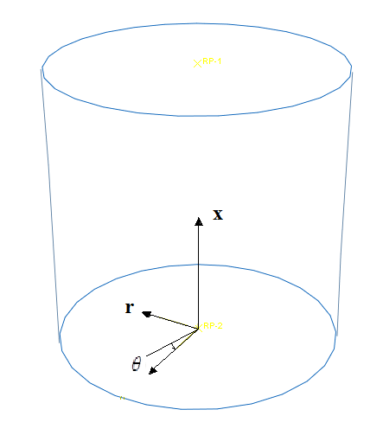

Fig. 1: The cylindrical reference system

**2.1. Strain-displacement relations**

Within the framework of the thin-shell theory, the through-thickness shear strain rates $\dot{ε_{rx}}$ and $\dot{ε_{rθ}}$ are zero. The non-zero components of the strain rate associated with the velocity field in equation (1) at an arbitrary point of the shell are related to the middle-surface strain-rate components $\dot{λ_{x}},\dot{λ_{θ}}$ and $\dot{λ_{xθ}}$ and to the changes in the curvature and twist of the middle surface, $\dot{{ K}_{x}},\dot{K_{θ}}$ and $\dot{K_{xθ}}$*,* by the following three relations

|  |  |
| --- | --- |
| $$\dot{ε_{xx}}=\dot{λ_{x}}-z \dot{K_{x}} \dot{ε_{θθ}}=\dot{λ_{θ}}-z \dot{K_{θ}} \dot{ε_{xθ}}=\dot{λ_{xθ}}-z \dot{K_{xθ}}$$ | (2) |

The expressions of the strain rates of the middle surface, assuming a small displacement theory, may be written as

|  |  |
| --- | --- |
| $$\dot{λ_{x}}=\frac{∂u}{∂x} \dot{λ_{θ}}=\frac{1}{R}\left(\frac{∂v}{∂θ}+w\right) \dot{λ_{xθ}}=\frac{1}{2}\left(\frac{∂v}{∂x}+\frac{1}{R}\frac{∂u}{∂θ}\right)$$ | (3) |

while those for the changes in the curvature and twist of the middle surface are as follows

|  |  |
| --- | --- |
| $$\dot{K_{x}=}\frac{∂^{2}w}{∂x^{2}} \dot{K_{θ}=}\frac{1}{R^{2}}\frac{∂^{2}w}{∂θ^{2}} \dot{K_{xθ}=}\frac{1}{R}\frac{∂^{2}w}{∂θ∂x}$$ | (4) |

**2.2. Stress-strain relations in plastic range**

While strains are linearly related to stresses by Hooke’s law in the elastic range, the relations between stresses and strains are nonlinear in the plastic range.

In this study, two plasticity theories, namely the flow and the deformation theories, are considered.

Since the stress rate through the thickness ($\dot{σ_{rr}}$) is identically zero in the thin-shell theory, the constitutive relations for a linearized elastic-plastic solid that behaves identically under loading and unloading are as follows

|  |  |
| --- | --- |
| $$\dot{σ_{xx}}=\frac{E}{1+ν}\left(α \dot{ε_{xx}}+β \dot{ε_{θθ}}\right)$$ | (5) |
| $$\dot{σ_{θθ}}=\frac{E}{1+ν}\left(β \dot{ε_{xx}}+γ \dot{ε_{θθ}}\right)$$ |
| $$\dot{τ_{xθ}}=\frac{E}{1+ν}\left(\frac{2+2ν}{E} G \dot{ε_{xθ}}\right)$$ |

where $E$ is the elastic modulus, $G$ is the effective shear modulus and $ν$ is the Poisson’s ratio for the material.

The expressions of $α , β$, $γ$ and *G* are given by [25]

* For the case of deformation theory based on Hencky equations

|  |  |
| --- | --- |
| $$α=\frac{1+ν}{ρ}\left[4-3\left(1-\frac{E_{t}}{E_{s}}\right)\frac{{σ_{xx}}^{2}}{{\overline{σ}}^{2}}\right]$$ | (6) |
| $$β=\frac{1+ν}{ρ}\left[2-2\left(1-2ν\right)\frac{E_{t}}{E}-3\left(1-\frac{E_{t}}{E_{s}}\right)\frac{σ_{xx}σ_{θθ}}{{\overline{σ}}^{2}}\right]$$ |
| $$γ=\frac{1+ν}{ρ}\left[4-3\left(1-\frac{E_{t}}{E_{s}}\right)\frac{{σ_{θθ}}^{2}}{{\overline{σ}}^{2}}\right]$$ |
| $$ρ=3\frac{E}{E_{s}}+\left(1-2ν\right)\left[2-\left(1-2ν\right)\frac{E_{t}}{E}-3\left(1-\frac{E_{t}}{E_{s}}\right)\frac{σ_{xx}σ_{θθ}}{{\overline{σ}}^{2}}\right]$$ |
| $$G=\frac{E}{2\left(1+ν\right)+3\left(\frac{E}{E_{s}}-1\right)}$$ |

* For the case of flow theory based on Prandtl-Reuss equations

|  |  |
| --- | --- |
| $$α=\frac{1+ν}{ρ}\left[4-3\left(1-\frac{E_{t}}{E}\right)\frac{{σ_{xx}}^{2}}{{\overline{σ}}^{2}}\right]$$ | (7) |
| $$β=\frac{1+ν}{ρ}\left[2-2\left(1-2ν\right)\frac{E_{t}}{E}-3\left(1-\frac{E_{t}}{E}\right)\frac{σ_{xx}σ_{θθ}}{{\overline{σ}}^{2}}\right]$$ |
| $$γ=\frac{1+ν}{ρ}\left[4-3\left(1-\frac{E_{t}}{E}\right)\frac{{σ_{θθ}}^{2}}{{\overline{σ}}^{2}}\right]$$ |
| $$ρ=\left(5-4ν\right)-{\left(1-2ν\right)}^{2}\frac{E_{t}}{E}-3\left(1-2ν\right)\left(1-\frac{E_{t}}{E}\right)\frac{σ_{xx}σ_{θθ}}{{\overline{σ}}^{2}}$$ |
| $$G=\frac{E}{2\left(1+ν\right)}$$ |

For the case of elastic buckling, the tangent modulus and the secant modulus at the point of bifurcation are the same as the elastic moduli, i.e. ${ E}_{t}=E_{s}=E$*,* then

|  |  |
| --- | --- |
| $α=γ=\frac{1}{1-ν}$*, $β=\frac{ν}{1-ν}$* | (8) |

Since the material obeys the von Mises yield criterion, the effective stress $\overline{σ}$ is written with the assumption of plane stress as follows

$${\overline{σ}}^{2}={σ_{xx}}^{2}-σ_{xx} σ_{θθ}+{σ_{θθ}}^{2}$$

Setting $σ_{xx}=σ_{t}$, that is the applied axial tensile stress, and $σ_{θθ}=\frac{-q R}{h}$ at the point of bifurcation, we obtain

|  |  |
| --- | --- |
| $${\overline{σ}}^{2}={σ_{t}}^{2}+σ_{t} \frac{q R}{h} +{\left(\frac{q R}{h}\right)}^{2}$$ | (9) |

The Ramberg-Osgood relationship between the effective stress $\overline{σ}$ and the effective strain $\overline{ε}$ is used:

|  |  |
| --- | --- |
| $$\overline{ε}=\frac{\overline{σ}}{E}\left[1+α{\left(\frac{\overline{σ}}{σ_{y}}\right)}^{n_{p}-1}\right]$$ | (10) |

where $σ_{y}$ is the nominal yield strength, sometimes called ‘proof stress’ $, α$ is the ‘yield offset’ and $n_{p}$ is the hardening parameter.

The material used in this study is aluminium alloy 6061-T4 that used in the tests carried out by Giezen et al [29]. The material constants were found by Shamass et al. [28] by fitting the Ramberg-Osgood relation to the available data set $.$ They are reported in Table 1:

|  |  |  |  |  |
| --- | --- | --- | --- | --- |
| $E$ [MPa] | $σ_{y}$ [MPa] | $$ν$$ | $$n_{p}$$ | $$α$$ |
| 65129.73 | 177.8 | 0.31 | 16 | 0.733 |

Table 1: Ramberg-Osgood constants

The ratios of the elastic modulus *E* to the tangent modulus, *Et*, and to the secant modulus, *Es*, are expressed by the Ramberg and Osgood relationship as

|  |  |
| --- | --- |
| $$\frac{E}{E_{t}}=1+\frac{α n_{p}{ \overline{σ}}^{n_{p}-1}}{{ σ_{y}}^{n_{p}-1}}$$ | (11) |
| $$\frac{E}{E_{s}}=1+{\frac{ α}{ {σ_{y}}^{n_{p}-1}} \overline{σ}}^{n_{p}-1}$$ | (12) |

**2. 3. Governing differential equations**

Let assume that $u, v$ and $w$ are the incremental velocity components at the middle surface of the shell when it buckles. The rate of change of the additional membrane forces and bending moments (stress resultants) per unit length of the middle surface, associated to a variation of the original state, are denoted by ${\dot{N}}_{x}, {\dot{N}}_{θ}, {\dot{N}}_{θx}$ and ${\dot{M}}_{x},{\dot{M}}_{θ},{\dot{M}}_{θx}$, respectively.

We also assume that no unloading occurs at the instant of the plastic buckling, an assumption normally made in the analytical or semi-analytical formulation of plastic buckling problems [30]. Then, based on Flugge’s theory [26], the rate form of the governing differential equations considering a membrane pre-buckling state for the case of cylinders subjected to external pressure and axial tension can be formulated as[26]

|  |  |
| --- | --- |
|  | (13) |
| $R \frac{∂\dot{N_{θ}}}{∂θ}+R^{2} \frac{∂\dot{N_{xθ}}}{∂x}-\frac{∂\dot{M_{θ}}}{∂θ}-R \frac{∂\dot{M_{xθ}}}{∂x}-q R \left(\frac{∂^{2}v}{∂θ^{2}}+ \frac{∂w}{∂θ}\right)+h σ_{t} R^{2} \frac{∂^{2}v}{∂x^{2}}=0$ |
| $\frac{∂^{2}\dot{M_{θ}}}{∂θ^{2}}+R \frac{∂^{2}\dot{M_{xθ}}}{∂x∂θ}+R \frac{∂^{2}\dot{M_{θx}}}{∂x∂θ}+R^{2} \frac{∂^{2}\dot{M_{x}}}{∂x^{2}}+R \dot{N_{θ}}+q R \left(R \frac{∂u}{∂x}-\frac{∂v}{∂θ}+\frac{∂^{2}w}{∂θ^{2}}\right)-h σ_{t} R^{2} \frac{∂^{2}w}{∂x^{2}}=0$ |

The stress rate resultants are related to the stress rate by

|  |  |
| --- | --- |
| $\dot{N_{x}}=\int_{-h/2}^{h/2}{\dot{σ_{x}}}dz \dot{N_{θ}}=\int_{-h/2}^{h/2}{\dot{σ_{θ}}}dz \dot{N_{xθ}}=\dot{N_{θx}}=\int_{-h/2}^{h/2}{\dot{τ_{xθ}}}dz$ | (14) |
| $\dot{M_{x}}=-\int_{-\frac{h}{2}}^{\frac{h}{2}}{\dot{{z σ}_{x}}}dz \dot{M_{θ}}=-\int_{-h/2}^{h/2}{\dot{{z σ}_{θ}}}dz \dot{M_{xθ}}=\dot{M_{θx}}=-\int_{-h/2}^{h/2}{\dot{{z τ}_{xθ}}}dz$ |

Equations (13) are supplemented by the conditions along the boundaries $x=0$ and $x=L$. For simply-supported boundary conditions we have the following four possibilities [31]

|  |  |
| --- | --- |
|  | (15) |
| $S3:w=u=\dot{M_{x}}=\dot{N_{xθ}}=0 S4:w=v=u=\dot{M_{x}}=0$ |

while for clamped boundary conditions we have the following four possibilities [31]

|  |  |
| --- | --- |
|  | (16) |
| $$C3:w=u=w^{´}=\dot{N_{xθ}}=0 C4: w=v=u=w^{´}=0$$ |

In the numerical analyses described later for BOSOR5 and ABAQUS, the above boundary conditions are defined in Table 2, where *δu, δv, δw* and *δβ* are incremental displacements at the boundary.

|  |  |  |  |  |  |  |  |  |  |
| --- | --- | --- | --- | --- | --- | --- | --- | --- | --- |
| Name | *δu* | *δv* | *δw* | *δβ* | Name | *δu* | *δv* | *δw* | *δβ* |
| S1 | f | r | r | f | C1 | f | r | r | r |
| S2 | f | f | r | f | C2 | f | f | r | r |
| S3 | r | f | r | f | C3 | r | f | r | r |
| S4 | r | r | r | f | C4 | r | r | r | r |

Table 2: Different boundary conditions terminology for cylindrical shells (f: free to displace during buckling; r: restrained displacement during buckling)[32]

**2.4. The rate of displacement function**

At the onset of bifurcation, the variables $u, v$ and $w$ shown in the resulting governing equations (13) are function of both coordinates $x$ and $θ$. To solve the set of partial differential equations (13), the separation method is used in which the dependent variables $u, v$ and $w$ can be expressed as a multiplication of two functions of independent variables $x$ and $θ$. The key assumption here is that the buckling mode $u, v$ and $w$ is assumed to vary harmonically in the circumferential direction of the cylinder. Thus an analytically two-dimensional problem is reduced to a numerically one-dimensional model. This simplifying assumption with regards to assumed buckling modes is used in many analytical and numerical treatments such as BOSOR5 [33] and NAPAS [34]. Thus, displacements are therefore assumed to be expressed as follows:

|  |  |
| --- | --- |
| $$u\left(x,θ\right)=u\left(x\right) Sin (nθ)$$ | (17) |
| $$v\left(x,θ\right)=v\left(x\right) Cos (nθ)$$ |
| $$w\left(x,θ\right)=w\left(x\right) Sin (nθ)$$ |

where *n* is the number of waves in the circumferential direction of the cylinder.

Substituting these expressions into equations (3) and (4), then the resulting strain rate components from equations (2) are substituted into constitutive equations (5). Integrating equations (14) and substituting the stress rate resultants into the governing equations of the eigenvalue problem (13) give:

|  |  |
| --- | --- |
| $u^{´´}\left(R^{2} h σ_{t}+\frac{R^{2} E h α}{1+ν}\right)+u\left(x\right)\left(-G h n^{2}\right)+v^{´}\left(-R G h n-\frac{R E h n β}{1+ν}\right)+w^{´}\left(\frac{R E h β}{1+ν}\right)=q \left(-R n^{2} u\left(x\right)- R^{2}w^{´}\right)+ the resultants are related to the stress rate by accompany this disturbance of the original state are given by$ | (18) |
| $u^{´}\left(\frac{R E h n β}{1+ν}+R G h n\right)+v^{´´}\left(R^{2} h σ_{t}+R^{2}G h\right)+v(x) \left(\frac{-E h n^{2} γ}{1+ν}\right)+w^{´´}\left(-\frac{1}{6} G h^{3} n-\frac{E h^{3} n β}{12\left(1+ν\right)}\right)+w(x) \left(\frac{E h n γ}{1+ν}+\frac{E h^{3} n^{3} γ}{12 R^{2} \left(1+ν\right)}\right)=q \left(R n w\left(x\right)-R n^{2} v(x)\right)$ |
| $u^{´} \left(\frac{R E h β}{1+ν}\right)+v\left(x\right)\left(\frac{-E h n γ}{1+ν}\right)+w^{´´´´}\left(\frac{R^{2} E h^{3} α}{12 \left(1+ν\right)}\right)+w^{´´}\left(-\frac{1}{3} G h^{3} n^{2}-R^{2} h σ_{t}-\frac{E h^{3} n^{2} β}{6\left(1+ν\right)}\right)+w\left(x\right)\left( \frac{E h γ}{1+ν}+\frac{E h^{3} n^{4} γ}{12 R^{2} \left(1+ν\right)}\right)=q \left(R n^{2} w(x)-R n v\left(x\right)- R^{2} u^{´}\right)$ |

or

|  |  |
| --- | --- |
| ${A_{1} u}^{´´}+A_{2} u\left(x\right)+A_{3}v^{´}+{A_{4} w}^{´}=q \left( A_{5} u\left(x\right)+A_{6} w^{´}\right)+ theresultants are related to the stress rate by accompany this disturbance of the original state are given by$ | (19) |
| ${C_{1} u}^{´}+C_{2} v^{´´}+C_{3} v\left(x\right)+C_{4} w^{´´}+C_{5}w(x) =q \left(C_{6} w\left(x\right)+C_{7} v(x)\right)$ |
| $D_{1} u^{´} +D_{2} v\left(x\right)+D_{3} w^{´´´´}+D_{4} w^{´´}+D_{5} w\left(x\right) =q \left(D_{6} w\left(x\right)+D_{7} v\left(x\right)+D_{8} u^{´}\right)$ |

The expressions of $\dot{{ M}_{x}}$*, $\dot{N_{x}}$*  and $\dot{N_{xθ}}$ used for the boundary conditions become

|  |  |
| --- | --- |
| $\dot{M_{x}}=w^{´´}+\left(\frac{-n^{2} β}{R^{2} α}\right) w\left(x\right)=0$ | (20) |
| $\dot{N_{x}}=u^{´}+\left(\frac{-n β}{R α}\right) v\left(x\right)+\left(\frac{β}{R α}\right)w\left(x\right)=0$ |
| $\dot{N_{xθ}}=\left(\frac{n}{R}\right)u\left(x\right)+v^{´}=0$ |

or

|  |  |
| --- | --- |
| $\dot{M_{x}}=w^{´´}+B_{1} w\left(x\right)=0$ | (21) |
| $\dot{N_{x}}=u^{´}+B_{2} v\left(x\right)+B_{3} w\left(x\right)=0$ |
| $\dot{N_{xθ}}=B_{4} u\left(x\right)+v^{´}=0$ |

where the primes indicate the derivatives with respect to the coordinate $x$.

**3. Solution via the differential quadrature method**

The differential quadrature (DQ) is an approximation method to calculate the th-order derivative of the solution function $f(x)$ at a grid point $i$. Consider firstly a one dimensional problem. The th-order derivative of a function $f(x)$ is given by a linear weighting of the function values at *N* points of the domain

|  |  |
| --- | --- |
|  | (22) |

Here $E_{ij}^{k}$ are called the weighting coefficients of the $k$ th-order derivative at the th point in the domain, $N$ and $f\left(x_{j}\right)$ are the total number of grid points and the solution values at the grid point $j$, respectively. Denote ${ A}_{ij}$, $B_{ij}$, $C_{ij}$ and $D_{ij}$ the weighting coefficients of the first-, second-, third- and fourth-order derivatives for the ordinary DQ method. The weighting coefficient $A_{ij}$ can be computed explicitly by [35]

|  |  |
| --- | --- |
|  | (23) |
| $A_{ii}=\sum_{j=1,i≠j}^{N}{\frac{1}{\left(x_{i}-x_{j}\right)}}$ |

where

|  |  |
| --- | --- |
| $ω_{N}\left(x\right)=\left(x-x_{1}\right)\left(x-x_{2}\right)…….\left(x-x_{i-1}\right)\left(x-x_{i}\right)\left(x-x_{i+1}\right)…..(x-x_{N})$ | (24) |
| $ω_{N}^{´}\left(x\right)=\left(x-x_{1}\right)\left(x-x_{2}\right)…….\left(x-x_{i-1}\right)\left(x-x_{i+1}\right)…..(x-x_{N})$ |

The weighting coefficients for higher order derivatives ${ B}_{ij}$, $C_{ij}$ and $D_{ij}$ can be calculated through the following [35]

|  |  |
| --- | --- |
|  | (25) |

It is worth pointing out that also the finite difference method (FD) discretizes the continuous domain into $N$ discrete points. In the FD method, the approximation of the derivatives at one grid point is based on a low-order (linear or quadratic) interpolation of the function values over a small number of adjacent points. Instead, in the DQ method the derivatives at each point are based on the interpolation of the function over all the grid points, using Lagrange polynomials. This normally increases the accuracy of the solution for a given number of grid points, although the method leads to a full matrix instead of the banded matrix obtained with the FD method. In other words, the DQ method can be considered as a higher-order finite difference method [3].

There are two main issues related to sampling points in the DQ method. The first one is the location of the sampling points, which can affect the accuracy of the solution of the differential equations. The simplest choice is to take them evenly spaced. However, in most cases, one can obtain better convergence and a more accurate solution by choosing unequally spaced sampling points [2],[19]. The second issue is how to enforce the boundary conditions. Jang and his co-workers [36] propose the so-called $δ$-technique, in which additional points are located at a small distance ($δ={10}^{-5}$) from the boundary points. Then the boundary conditions are applied at both the actual boundary points and the $δ$-points.

In this study, as already discussed, the buckling mode is assumed to follow a trigonometric curve in the circumferential direction. In this way, the problem is reduced to a one-dimensional one and the sampling points are only taken in the axial direction of the cylinder. The following relation for the grid spacing has been used:

|  |  |
| --- | --- |
| $x\left(1\right)=0 , x\left(2\right)=δ L , x\left(N-1\right)=L (1-δ) , x\left(N\right)=L$ | (26) |
| $x\left(i\right)=L\left(\frac{1-Cos\left(\frac{π\left(i-2\right)}{N-3}\right)}{2}\right) 3< i<N-2$ |

Fig. 2 shows the position of the grid points along the axial direction of the cylinder for N=14.

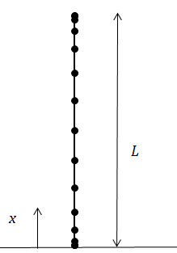

Fig. 2: Sketch of the axial direction of a cylinder with grid points

**3.1. DQ approximation of the differential equations and solution procedure**

Using the DQ method, the governing equations (19) are expressed as

|  |  |
| --- | --- |
| $A_{1} \sum_{j=1}^{N}{B_{ij} u_{j}}+A_{2} u_{i} +A_{3}\sum_{j=1}^{N}{A_{ij} v_{j}}+A_{4}\sum_{j=1}^{N}{A_{ij} w_{j}} =q \left( A_{5} u_{i}+A_{6} \sum_{j=1}^{N}{A_{ij} w_{j}}\right) + nesultants are related to the stress rate by accompany this disturbance of the original state are donated by$ | (27a) |
| $C_{1} \sum_{j=1}^{N}{A_{ij} u_{j}}+C_{2} \sum_{j=1}^{N}{B_{ij} v_{j}}+C_{3} v_{i}+C_{4} \sum_{j=1}^{N}{B_{ij} w_{j}}+C_{5} w_{i} =q \left(C_{6} w_{i} +C_{7} v_{i} \right)$ | (27b) |
| $D_{1} \sum_{j=1}^{N}{A_{ij} u_{j}} +D_{2} v_{i}+D_{3} \sum_{j=1}^{N}{D_{ij} w_{j}}+D_{4} \sum_{j=1}^{N}{B_{ij} w_{j}}+D_{5} w_{i} =q \left(D_{6} w_{i}+D_{7} v_{i}+D_{8} \sum_{j=1}^{N}{A_{ij} u_{j}}\right)$ | (27c) |

The boundary conditions (15) become

|  |  |  |  |  |
| --- | --- | --- | --- | --- |
| S1: | $w_{1}=w_{N}=v_{1}=v_{N}=0$ $\sum_{j=1}^{N}{A_{1j} u_{j}}+B_{2} v_{1}+B_{3} w_{1}=0$ $\sum_{j=1}^{N}{A_{Nj} u_{j}}+B_{2} v_{N}+B_{3} w_{N}=0$ $\sum_{j=1}^{N}{B_{1j} w_{j}}+B_{1} w_{1}=0$ $\sum_{j=1}^{N}{B_{Nj} w_{j}}+B_{1} w_{N}=0$ | S3: | $w_{1}=w_{N}=u_{1}=u_{N}=0$ $B_{4} u_{1}+\sum_{j=1}^{N}{A_{1j} v_{j}}=0$ $B_{4} u_{N}+\sum_{j=1}^{N}{A_{Nj} v_{j}}=0$ $\sum_{j=1}^{N}{B_{1j} w_{j}}+B_{1} w_{1}=0$ $$\sum_{j=1}^{N}{B_{Nj} w_{j}}+B_{1} w_{N}=0$$ | (28) |
| S2: | $w_{1}=w_{N}=0$ $\sum_{j=1}^{N}{A_{1j} u_{j}}+B_{2} v_{1}+B_{3} w_{1}=0$ $\sum_{j=1}^{N}{A_{Nj} u_{j}}+B_{2} v_{N}+B_{3} w_{N}=0$ $\sum_{j=1}^{N}{B_{1j} w_{j}}+B_{1} w_{1}=0$ $\sum_{j=1}^{N}{B_{Nj} w_{j}}+B_{1} w_{N}=0$ $B_{4} u_{1}+\sum_{j=1}^{N}{A_{1j} v_{j}}=0$ $B_{4} u_{N}+\sum_{j=1}^{N}{A_{Nj} v_{j}}=0$ | S4: | $w_{1}=w_{N}=v_{1}=v_{N}=u_{1}=u_{N}=0$ $\sum_{j=1}^{N}{B_{1j} w_{j}}+B_{1} w_{1}=0$ $$\sum_{j=1}^{N}{B_{Nj} w_{j}}+B_{1} w_{N}=0$$ |

Similar expressions hold for the clamped boundaries except that $\dot{M_{x}}=0$ is replaced by ${ w}^{´}=0$. Thus they become

|  |  |
| --- | --- |
| $\sum_{j=1}^{N}{A_{1j} w_{j}}=0 \sum_{j=1}^{N}{A_{Nj} w_{j}}=0$ | (29) |

Imposing these boundary conditions makes some of the equations in (27) redundant. In order to eliminate such a redundancy, the numberings of the inner point are chosen as: $i=2, 3,….,N-1$ for the equation (27a), $i=2, 3,….,N-1$ for the equation (27b) and $i=3, 4,….,N-2$ for the equation (27c).

The combination of the governing equations written in differential quadrature form equation (27) and of the boundary conditions yields a set of linear equations which can be written in the following partitioned matrix form

|  |  |
| --- | --- |
| $\left[\begin{matrix}\left[ABB\right] & \left[ABI\right] \\ \left[AIB\right] & \left[AII\right]\end{matrix}\right].\left\{\begin{matrix}\begin{matrix}\left\{u_{b}\right\} \\ \left\{v_{b}\right\} \\ \left\{w_{b}\right\}\end{matrix} \\ \begin{matrix}\left\{u_{i}\right\} \\ \left\{v_{i}\right\} \\ \left\{w_{i}\right\}\end{matrix}\end{matrix}\right\}=q.\left[\begin{matrix}\left[0\right] & \left[0\right] \\ \left[BIB\right] & \left[BII\right]\end{matrix}\right].\left\{\begin{matrix}\begin{matrix}\left\{u_{b}\right\} \\ \left\{v_{b}\right\} \\ \left\{w_{b}\right\}\end{matrix} \\ \begin{matrix}\left\{u_{i}\right\} \\ \left\{v_{i}\right\} \\ \left\{w_{i}\right\}\end{matrix}\end{matrix}\right\}$ | (30) |

Sub-matrices ${\left[ABB\right]}_{8×8}$, ${\left[ABI\right]}_{8×\left(3N-8\right) }$ stem from the boundary conditions while ${\left[AIB\right]}_{\left(3N-8\right)×8}$, ${\left[AII\right]}_{\left(3N-8\right)×\left(3N-8\right)}$, ${\left[BIB\right]}_{\left(3N-8\right)×8}$, ${\left[BII\right]}_{\left(3N-8\right)×\left(3N-8\right)}$ stem from the governing equations. $b$ and $i$ refer to the location of boundary and interior points, respectively. $\left\{u_{b}\right\}={\left\{u_{1},u_{N}\right\}}^{T}$, $\left\{v_{b}\right\}={\left\{v_{1},v_{N}\right\}}^{T}$ and $\left\{w_{b}\right\}={\left\{w_{1},w_{2},w_{N-1},w_{N}\right\}}^{T}$

The above equation can be transformed into a general eigenvalue form

|  |  |
| --- | --- |
| $\left[A^{*}\right].\left\{W_{i}\right\}=q \left[B^{*}\right].\left\{W_{i}\right\} ⟺ \left[{\left[B^{*}\right]}^{-1}.\left[A^{*}\right]-q \left[I\right]\right].\left\{W_{i}\right\}=0$ | (31) |

Where

|  |  |
| --- | --- |
| $\left[A^{*}\right]=\left[\left[AII\right]-\left[AIB\right].{\left[ABB\right]}^{-1}.\left[ABI\right]\right]$ $\left[B^{*}\right]=\left[\left[BII\right]-\left[BIB\right].{\left[ABB\right]}^{-1}.\left[ABI\right]\right]$ | (32) |
| $\left\{W_{i}\right\}=\left\{\begin{matrix}\left\{u_{i}\right\} \\ \left\{v_{i}\right\} \\ \left\{w_{i}\right\}\end{matrix}\right\}$ |

By solving the eigenvalue problem represented by equation (31) with the help of a standard eigensolver, one can obtain the lowest eigenvalue (i.e., buckling pressure *q*) and corresponding eigenvector (i.e., the buckling mode $\left\{W_{i}\right\}$).

Since $α, β, γ$ and $G$ depend on the unknown load *q*, equation (31) defines a nonlinear problem. Thus an iterative method is needed for obtaining the solution of equation (31).

A computer program has been written in Matlab language for determining the plastic buckling pressure and buckling mode using both the flow and deformation theories of plasticity for the examined cylinders. The flow chart of the algorithm is shown in Fig. 3.

Set initial value of $q_{0}$ ( $q_{0}$ is small value, $q_{0}=0.01 Mpa$ in this study)

Calculate $E_{t}$ or $E_{s}$ from equation (11) or (12)

Calculate $α. β, γ$ and $G$ from equation (7) or (6) for the flow or deformation theories

Calculate the coefficients $A_{1}...A_{5}, C_{1}...C_{7}, D_{1}...D_{8}, B_{1}...B_{4}$ of the equations (19) and (21)

Calculate the weighting coefficients from the equations (23) and (25)

Set governing equations (27) and boundary conditions (28) or (29) and identify the sub-matrices (30)

Calculate matrices $\left[A^{*}\right]$ and $\left[B^{*}\right]$ from equation (32) and find the lowest eigenvalue $q$ of system (31)

$q_{0}$ is the plastic buckling pressure

Check if $\frac{\left|q-q_{0}\right|}{q}≤err$, where *err* is the prescribed error bound (*err*= ${10}^{-5}$ in this study)

Yes

No

, where $ξ$ taken in this study equal to 0.1

Fig. 3: Flow chart of the solution procedure

**3.2. Verification with known solutions**

In order to verify the solution procedure based on the DQ method has been correctly implemented in the written code, the obtained results, in terms of the buckling pressure of cylinders subjected to combined loading, are compared with those provided by the BOSOR5 code and with existing analytical solutions in Shamass et al. [25], as shown in Tables 3 and 4.

For brevity, letter S is used for the case of simply-supported edge and letter C for that of a clamped edge. Two letters and numbers are used to represent the boundary conditions of the cylinder. For example, a S1-S1 cylinder will have a simply-supported edge of the type 1 at $x=0$ and $x=L$.

Fig. 4 shows the buckling pressures computed for a C4-C4 cylinder under constant tensile stress $σ_{t}=82.7 MPa$ by the DQ method with different numbers of grid points. The geometry of the cylinder is given by $L=2R=38.1mm$ and $h=0.76mm$. It can be seen that the DQ method with *N*=9 can already yield accurate results for both the flow and deformation theory of plasticity. *N* is set to 15 for all DQ results presented in this paper.

Tables 3a-3b show the plastic buckling pressures and corresponding buckling modes calculated by DQ method for C3-C3 and C4-C4 cylinders with *L/D*=1, *D*=38.1mm and *h*=0.76mm and subjected to increasing value of axial tensile stress, while Tables 3c shows the plastic buckling pressures for S4-S4 cylinders for increasing $h/R$ ratios . The results are shown together with results calculated using BOSOR5. Here it should be noted that the flow theory employed in BOSOR5 uses the modified shear modulus which is the shear modulus predicted by the deformation theory [33]. Therefore, for comparison purpose, the flow theory with the same modified shear modulus was used in the DQ method. The DQ plastic bucking pressures and corresponding buckling modes are in very good agreement with those obtained using BOSOR5 for all types of boundary conditions, loads and cylinders’ geometry.

The results for S1-S1 cylinders subjected to combined axial tensile stress and external pressure and bifurcated in plastic phase are shown in Table 4 for both the flow and deformation theory of plasticity. The results are shown together with plastic buckling pressures obtained using analytical solution in Shamass et al. [25], which assumes the S1-S1 type (simply-supported) of boundary condition. The geometry of the cylinder is defined by $L=2R=38.1mm$ and $h=0.76mm$. For all the cases of applied axial tension, the current buckling pressure results agree with those obtained analytically with errors varying in the range 0.7%-9% using the flow theory and 3.1%-3.7% using the deformation theory. It should be noted that in some cases the buckling modes obtained here are different from those obtained analytically when the flow theory is used. These examples serve as a check that both the formulation and the computer program are correct.

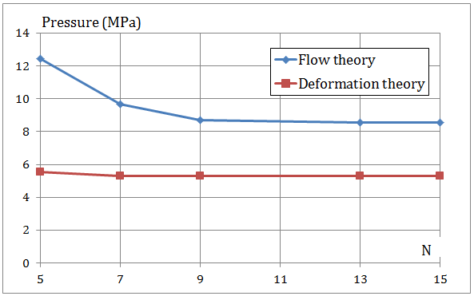

Fig. 4: Convergence study

|  |  |  |  |  |  |  |  |  |  |  |
| --- | --- | --- | --- | --- | --- | --- | --- | --- | --- | --- |
| Buckling pressure *qcr* (MPa) and corresponding buckling mode *n,m* calculated from BOSOR5 | | | | | Buckling pressure *qcr* (MPa) and corresponding buckling mode *n,m* calculated from present study | | | | Error - flow theory (%) | Error -deformation theory (%) |
| Tensile stress (MPa) | Flow theory | | Deformation theory | | Flow theory | | Deformation theory | |
| *n,m* | *qcr* | *n,m* | *qcr* | *n,m* | *qcr* | *n,m* | *qcr* |
| 0.00 | 5,1 | 7.24 | 5,1 | 7.07 | 5,1 | 7.149 | 5,1 | 6.91 | -1.3 | -2.2 |
| 13.79 | 5,1 | 7.16 | 5,1 | 6.9 | 5,1 | 7.06 | 5,1 | 6.72 | -1.4 | -2.5 |
| 27.58 | 5,1 | 7.07 | 5,1 | 6.64 | 5,1 | 6.96 | 5,1 | 6.50 | -1.6 | -2.1 |
| 55.16 | 4,1 | 6.9 | 5,1 | 6.12 | 4,1 | 6.87 | 5,1 | 5.96 | -0.4 | -2.6 |
| 82.74 | 4,1 | 6.55 | 5,1 | 5.52 | 4,1 | 6.62 | 5,1 | 5.30 | 1.1 | -4.0 |
| 110.32 | 3,1 | 6.64 | 5,1 | 4.74 | 3,1 | 6.24 | 5,1 | 4.52 | -6.0 | -4.7 |
| 137.90 | NB | NB | 5,1 | 3.88 | NB | 5.73 | 5,1 | 3.63 | NB | -6.5 |
| 165.47 | NB | NB | 5,1 | 3.02 | 8,2 | 5.07 | 5,1 | 2.68 | NB | -11.4 |

(a)

|  |  |  |  |  |  |  |  |  |  |  |
| --- | --- | --- | --- | --- | --- | --- | --- | --- | --- | --- |
| Buckling pressure *qcr* (MPa) and corresponding buckling mode *n,m* calculated from BOSOR5 | | | | | Buckling pressure *qcr* (MPa) and corresponding buckling mode *n,m* calculated from present study | | | | error-flow theory (%) | error-deformation theory (%) |
| Tensile stress (MPa) | The flow theory | | The deformation theory | | The flow theory | | The deformation theory | |
| *n,m* | *qcr* | *n,m* | *qcr* | *n,m* | *qcr* | *n,m* | *qcr* |
| 0 | 5,1 | 7.24 | 5,1 | 7.07 | 5,1 | 7.15 | 5,1 | 6.92 | -1.3 | -2.1 |
| 13.79 | 5,1 | 7.16 | 5,1 | 6.90 | 5,1 | 7.05 | 5,1 | 6.73 | -1.5 | -2.5 |
| 27.58 | 5,1 | 7.07 | 5,1 | 6.72 | 5,1 | 6.97 | 5,1 | 6.5 | -1.4 | -3.3 |
| 55.16 | 5,1 | 6.98 | 5,1 | 6.13 | 4,1 | 6.88 | 5,1 | 6.0 | -1.5 | -2.1 |
| 82.74 | NB | NB | 5,1 | 5.52 | 4,1 | 6.64 | 5,1 | 5.3 | NB | -4.0 |
| 110.32 | NB | NB | 5,1 | 4.75 | NB | NB | 5,1 | 4.52 | NB | -4.8 |
| 137.9 | NB | NB | 5,1 | 3.96 | NB | NB | 5,1 | 3.63 | NB | -8.4 |
| 165.48 | NB | NB | 5,1 | 3.02 | NB | NB | 5,1 | 2.67 | NB | -12 |

(b)

|  |  |  |  |  |  |  |  |  |  |  |
| --- | --- | --- | --- | --- | --- | --- | --- | --- | --- | --- |
| Buckling pressure *qcr* (MPa) and corresponding buckling mode *n,m* calculated from BOSOR5 | | | | | Buckling pressure *qcr* (MPa) and corresponding buckling mode *n,m* calculated from present study | | | | error-flow theory (%) | error-deformation theory (%) |
| *h/R* | The flow theory | | The deformation theory | | The flow theory | | The deformation theory | |
| *n,m* | *qcr* | *n,m* | *qcr* | *n,m* | *qcr* | *n,m* | *qcr* |
| 0.0107 | 7,1 | 0.52 | 7,1 | 0.52 | 7,1 | 0.53 | 7,1 | 0.53 | 1.9 | 1.0 |
| 0.0160 | 6,1 | 1.24 | 6,1 | 1.22 | 6,1 | 1.18 | 6,1 | 1.14 | -5.1 | -6.7 |
| 0.0214 | 5,1 | 2.06 | 6,1 | 1.94 | 5,1 | 1.96 | 5,1 | 1.84 | -4.9 | -5.4 |
| 0.0321 | 4,1 | 4.05 | 5,1 | 3.4 | 4,1 | 3.9 | 5,1 | 3.24 | -3.7 | -4.7 |
| 0.0408 | 3,1 | 6.64 | 5,1 | 4.66 | 3,1 | 6.11 | 5,1 | 4.46 | -8.0 | -4.3 |
| 0.0428 | 3,1 | 7.15 | 5,1 | 5 | 3,1 | 6.59 | 5,1 | 4.75 | -7.9 | -5.0 |
| 0.0535 | NB | NB | 5,1 | 6.68 | NB | NB | 4,1 | 6.26 | NB | -6.2 |
| 0.0749 | NB | NB | 4,1 | 10 | NB | NB | 4,1 | 9.46 | NB | -5.4 |
| 0.0856 | NB | NB | 4,1 | 11.89 | NB | NB | 4,1 | 11.14 | NB | -6.3 |

(C)

Table 3: Comparison between plastic buckling pressures and corresponding buckling mode obtained using DQ method and BOSOR5 for: (a) C3-C3 cylinders, (b) C4-C4 cylinders, (c) S4-S4 cylinders with $σ_{t}=110.3 MPa$ (NB: No buckling) (*m*: number of half waves in the longitudinal direction of the cylinder, *n*: number of half waves in the circumferential direction)

|  |  |  |  |  |  |  |  |  |  |  |
| --- | --- | --- | --- | --- | --- | --- | --- | --- | --- | --- |
| Tensile stress (MPa) | Buckling pressure *qcr* (MPa) and corresponding buckling mode *n,m* calculated from present study | | | | Buckling pressure *qcr* (MPa) and corresponding buckling mode *n,m* calculated from Shamass et al. [25] | | | | error % -flow theory | error %-deformation theory |
| The flow theory | | The deformation theory | | The flow theory | | The deformation theory | |
| *n,m* | *qcr* | *n,m* | *qcr* | *n,m* | *qcr* | *n,m* | *qcr* |
| 0.0 | 5,1 | 6.75 | 5,1 | 6.60 | 5,1 | 6.51 | 5,1 | 6.39 | 3.7 | 3.3 |
| 13.8 | 4,1 | 6.68 | 5,1 | 6.42 | 5,1 | 6.42 | 5,1 | 6.21 | 4.0 | 3.4 |
| 27.6 | 4,1 | 6.52 | 4,1 | 6.19 | 4,1 | 6.27 | 4,1 | 6.00 | 4.0 | 3.2 |
| 41.4 | 4,1 | 6.40 | 4,1 | 5.93 | 4,1 | 6.11 | 4,1 | 5.75 | 4.7 | 3.1 |
| 55.2 | 4,1 | 6.36 | 4,1 | 5.66 | 4,1 | 5.99 | 4,1 | 5.47 | 6.2 | 3.5 |
| 68.9 | 4,1 | 6.44 | 4,1 | 5.35 | 4,1 | 5.98 | 4,1 | 5.18 | 7.7 | 3.3 |
| 82.7 | 3,1 | 6.43 | 4,1 | 5.02 | 3,1 | 6.03 | 4,1 | 4.85 | 6.6 | 3.5 |
| 96.5 | 3,1 | 6.47 | 4,1 | 4.67 | 3,1 | 5.93 | 4,1 | 4.51 | 9.1 | 3.5 |
| 110.3 | 5,3 | 6.45 | 4,1 | 4.29 | 3,1 | 5.97 | 4,1 | 4.14 | 8.0 | 3.6 |
| 124.1 | 8,5 | 6.26 | 4,1 | 3.88 | 3,1 | 6.14 | 4,1 | 3.74 | 2.0 | 3.7 |
| 137.9 | 8,5 | 6.3 | 4,1 | 3.45 | 3,1 | 6.36 | 4,1 | 3.33 | -0.9 | 3.6 |
| 151.7 | 3,2 | 6.52 | 4,1 | 3.02 | 3,1 | 6.60 | 4,1 | 2.91 | -1.2 | 3.8 |
| 165.5 | 3,2 | 6.89 | 4,1 | 2.59 | 3,1 | 6.84 | 4,1 | 2.50 | 0.7 | 3.6 |

Table 4: Comparison of Shamass et al. [25] with present study for both the flow and deformation theories.

**3.3. Effect of thickness ratio on the buckling pressure**

The influence of the thickness-radius ratio $h/R$ on the buckling pressure (*q*) for different values of applied tensile stresses, using both the flow and deformation theories, is presented in Fig. 5. The elastic and plastic buckling results are also presented in the same figures. The length-diameter ratio is taken as $L/D=1$. The results are calculated for three different values of the axial tensile stress and three cases of boundary conditions.

Figs. 5a-5d show that, below a certain value of thickness-radius ratio $h/R$*,* i.e. 0.008, 0.008, 0.0214 and 0.0428, respectively, for the four considered cases, the plastic buckling results predicted using the flow and deformation theories are identical. When the thickness ratio is increased beyond these values, the differences in results between the two theories tend to increase and become extremely high for high thickness ratios. It is also observed that the deformation theory generally gives consistently lower buckling pressures than the flow theory. This confirms what is generally reported as the plastic buckling paradox.

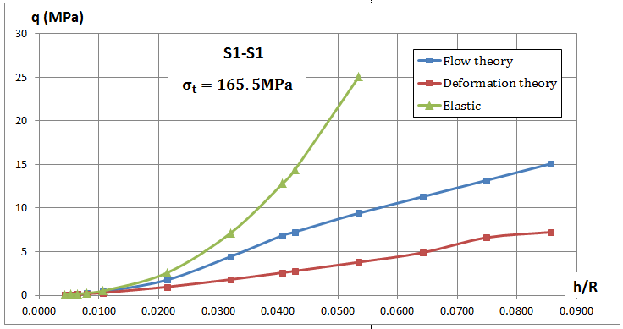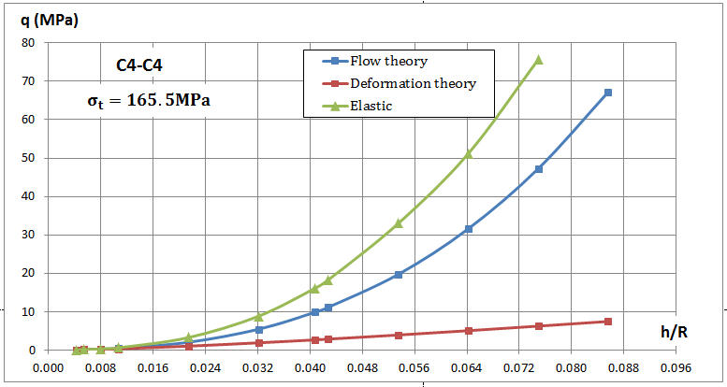

(a) (b)

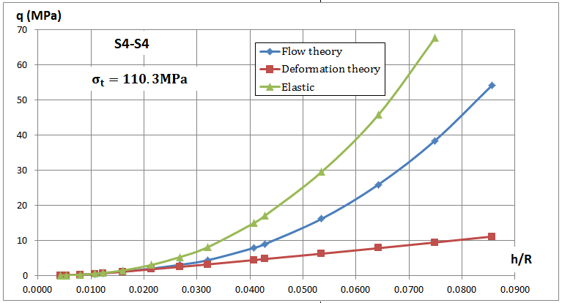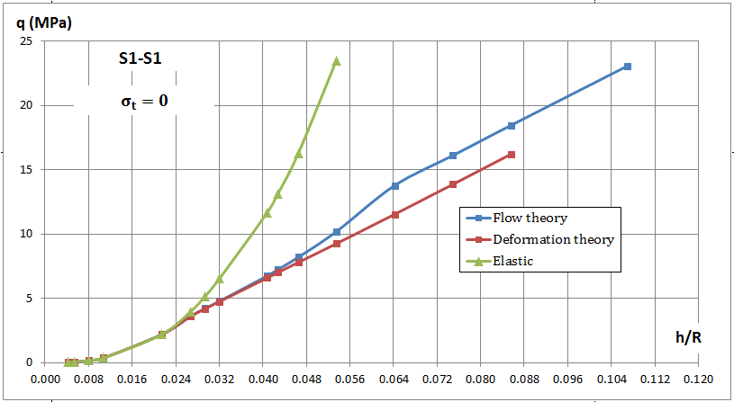

(c) (d)

Fig. 5: Influence of thickness ratio $h/R$ on the discrepancies between the buckling pressures q obtained using the flow and deformation theories

Fig. 6 shows the influence of the thickness-radius ratio *h/R* on the ratio $\overline{σ}/σ_{y}$ calculated using the flow, the deformation and the elastic theory, where $\overline{σ}$ is the effective stress calculated from equation (9). When it is $\frac{\overline{σ}}{σ_{y}}>1$, noticeable differences between buckling pressure obtained by the flow theory and the deformation theory are observed. Moreover, increasing the ratio $\frac{\overline{σ}}{σ_{y}}$, the discrepancies between the two plasticity theories also increase. Although both theories of plasticity could be expected to give approximately the same results for proportional loading (tensile stress equal to zero), Fig. 5d shows that, also in this case, there are some differences in plastic buckling pressures predicted by the flow and deformation theories when the ratio *h/R* is high and Fig. 6d shows the discrepancy in the calculated buckling pressure occurs when $\frac{\overline{σ}}{σ_{y}}>1$.

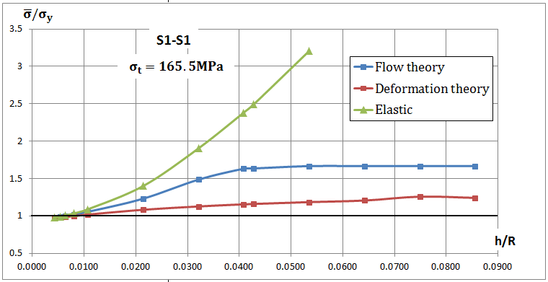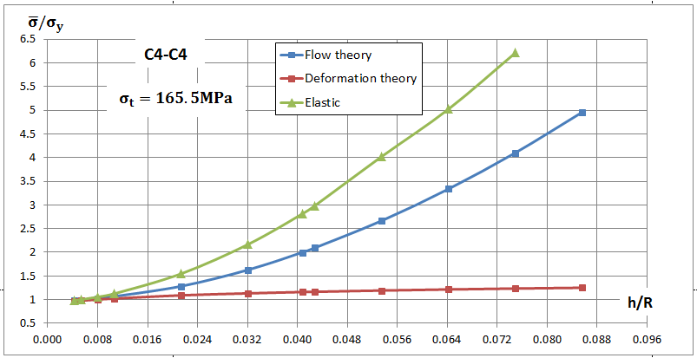

(a) (b)

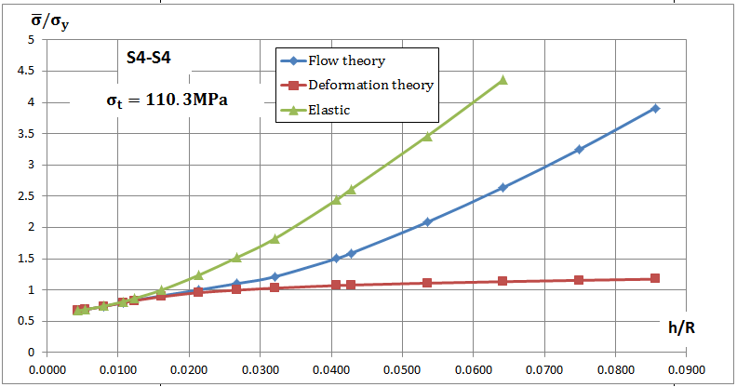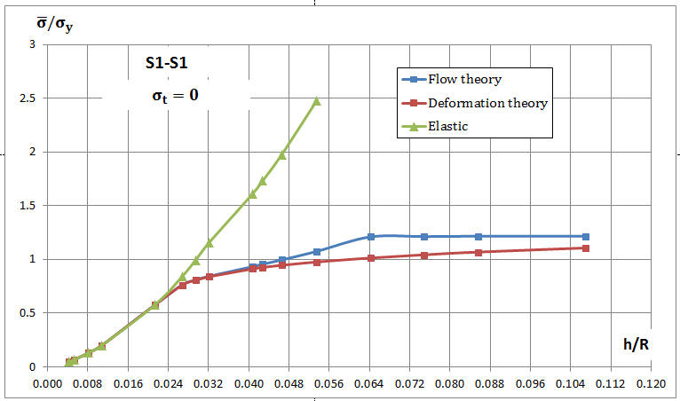

(c) (d)

Fig. 6: Influence of thickness ratio $h/R$ on the ratio $\overline{σ}/σ_{y}$

**3.4. Effect of tensile stress and $E/σ_{y}$ ratio on the buckling pressure**

Fig. 7 shows the plastic buckling pressures under various axial tensile stresses according to the flow and deformation theory for S3-S3 cylinders. Two thickness-radius ratios are considered. The length-diameter ratio is taken as $\frac{L}{D}=1$. It is observed that the differences between the flow theory and deformation theory results are quite large when *h/R* = 0.041. In a certain loading range ($0≤σ_{t}≤70MPa$) and when *h/R* = 0.0214, both plasticity results are identical while they are quite different when *h/R*=0.041.

Fig. 8 shows the influence of the ratio $E/σ_{y}$ on the buckling pressures using both the flow and deformation theories of plasticity for C4-C4 cylinders. Again, the length-diameter ratio is taken as $\frac{L}{D}=1$. It seems that a large discrepancy in predictions between two theories exists for increasing $E/σ_{y}$ ratio.

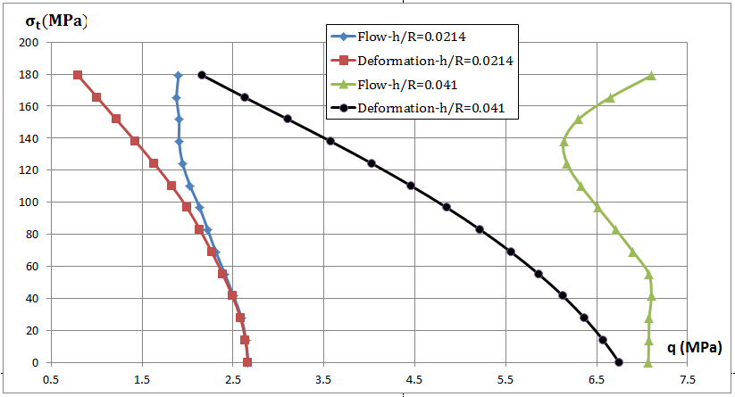

Fig. 7: Influence of tensile stress $σ_{t}$ on the discrepancies between the buckling pressures *q* obtained using the flow and deformation theories for two thickness ratios

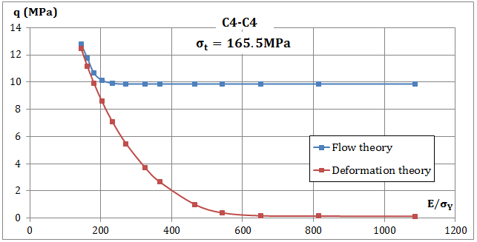

Fig. 8: Influence of $E/σ_{y}$ ratio on the discrepancies between the buckling pressures *q* obtained using the flow and deformation theories

**3.5. Effect of boundary conditions on the buckling pressure**

Tables 5-8 show the buckling pressures and buckling modes of cylinders for eight sets of boundary conditions and for different values of axial tensile stress with *L/D*=1, *D*=38.1mm and *h*=0.762mm. The plastic buckling results for clamped and simply-supported cylinders represented by the boundary conditions C4-C4 and S4-S4 indicate that clamping increases the plastic buckling pressures predicted using the flow theory by 10%-15% when $σ_{t}≥82.7MPa$ while it has no influence on the plastic buckling pressures predicted by the deformation theory.

In the following a comparison between the plastic buckling pressures for additional sets of cylinders is presented. In the first set, the boundary condition is S1-S1 (or C1-C1), for which the edges are free to move axially. In the second set, the boundary condition is S4-S4 (or C4-C4), for which the incremental axial displacement $u$ vanishes. It can be observed that the presence of the axial restraint at the boundaries increases the plastic buckling pressures calculated using the flow theory by 17%-22% when $σ_{t}≥96.5MPa$ and by 25%-32% when C1-C1 and C4-C4 cylinders are compared, while it has no significant influence on the plastic buckling pressures calculated using the deformation theory (the intensification is about 4%).

The influence of the circumferential displacement $v$ on the plastic buckling pressures can be investigated in two sets of boundary conditions, namely S3-S3 and S4-S4 (or C3-C3 and C4-C4). The incremental circumferential displacement $v$ vanishes in the S4-S4 and C4-C4 cylinders. It seems that the circumferential restraint at the boundaries increases the plastic buckling pressures predicted using the flow theory by 20%-25% when $σ_{t}≥96.5MPa$ and by 25%-35% when C3-C3 and C4-C4 cylinders are compared, while it has no influence on the results calculated using the deformation theory for all values of tensile stresses.

It can be concluded that the presence of axial, circumferential and rotational restrains at the edges of the cylinders with increasing axial tensile stresses can significantly increase the discrepancies between the results of the flow and deformation theories in the range 8%-260%, as it is shown in Table 8 for cylinders C4-C4.

|  |  |  |  |  |  |  |  |  |
| --- | --- | --- | --- | --- | --- | --- | --- | --- |
| **Constant axial tensile stress (MPa)** | **S1-S1** | | | | **S2-S2** | | | |
| **Buckling mode *n,m*** | **Buckling pressure-Flow** | **Buckling mode *n,m*** | **Buckling pressure-Deformation** | **Buckling mode *n,m*** | **Buckling pressure-Flow** | **Buckling mode *n,m*** | **Buckling pressure-Deformation** |
| 0.0 | 5,1 | 6.75 | 5,1 | 6.60 | 4,1 | 6.69 | 4,1 | 6.53 |
| 13.8 | 4,1 | 6.68 | 5,1 | 6.42 | 4,1 | 6.56 | 4,1 | 6.34 |
| 27.6 | 4,1 | 6.52 | 4,1 | 6.19 | 4,1 | 6.43 | 4,1 | 6.13 |
| 41.4 | 4,1 | 6.40 | 4,1 | 5.93 | 4,1 | 6.34 | 4,1 | 5.88 |
| 55.2 | 4,1 | 6.36 | 4,1 | 5.66 | 4,1 | 6.34 | 4,1 | 5.62 |
| 68.9 | 4,1 | 6.44 | 4,1 | 5.35 | 3,1 | 6.37 | 4,1 | 5.33 |
| 82.7 | 3,1 | 6.43 | 4,1 | 5.02 | 3,1 | 6.35 | 4,1 | 5.01 |
| 96.5 | 3,1 | 6.47 | 4,1 | 4.67 | 3,1 | 6.5 | 4,1 | 4.66 |
| 110.3 | 5,3 | 6.45 | 4,1 | 4.29 | 4,2 | 6.4 | 4,1 | 4.28 |
| 124.1 | 8,5 | 6.26 | 4,1 | 3.88 | 9,5 | 6.2 | 4,1 | 3.87 |
| 137.9 | 8,5 | 6.3 | 4,1 | 3.45 | NB | NB | 4,1 | 3.45 |
| 151.7 | 3,2 | 6.52 | 4,1 | 3.02 | NB | NB | 4,1 | 3.02 |
| 165.5 | 3,2 | 6.89 | 4,1 | 2.59 | NB | NB | 4,1 | 2.59 |

Table 5: Plastic buckling pressures and corresponding buckling modes calculated using the DQ method and obtained by the flow theory and the deformation theory under different values of tensile stresses for S1-S1 and S2-S2 cylinders.

|  |  |  |  |  |  |  |  |  |
| --- | --- | --- | --- | --- | --- | --- | --- | --- |
| **Constant axial tensile stress (MPa)** | **S3-S3** | | | | **S4-S4** | | | |
| **Buckling mode n,m** | **Buckling pressure-Flow** | **Buckling mode n,m** | **Buckling pressure-Deformation** | **Buckling mode n,m** | **Buckling pressure-Flow** | **Buckling mode n,m** | **Buckling pressure-Deformation** |
| 0.0 | 5,1 | 7.07 | 5,1 | 6.75 | 5,1 | 7.14 | 5,1 | 6.79 |
| 13.8 | 5,1 | 7.07 | 5,1 | 6.57 | 5,1 | 7.09 | 5,1 | 6.60 |
| 27.6 | 5,1 | 7.08 | 5,1 | 6.37 | 5,1 | 7.08 | 5,1 | 6.39 |
| 41.4 | 5,1 | 7.1 | 5,1 | 6.13 | 5,1 | 7.12 | 5,1 | 6.14 |
| 55.2 | 3,1 | 7.07 | 5,1 | 5.86 | 5,1 | 7.26 | 5,1 | 5.86 |
| 68.9 | 3,1 | 6.9 | 5,1 | 5.56 | 4,1 | 7.50 | 5,1 | 5.56 |
| 82.7 | 3,1 | 6.71 | 5,1 | 5.22 | 4,1 | 7.76 | 5,1 | 5.23 |
| 96.5 | 3,1 | 6.52 | 5,1 | 4.86 | 4,1 | 7.82 | 5,1 | 4.86 |
| 110.3 | 3,1 | 6.32 | 5,1 | 4.46 | 4,1 | 7.91 | 5,1 | 4.46 |
| 124.1 | 3,1 | 6.17 | 5,1 | 4.03 | 4,1 | 8.02 | 5,1 | 4.03 |
| 137.9 | 3,1 | 6.14 | 5,1 | 3.58 | 4,1 | 8.14 | 5,1 | 3.58 |
| 151.7 | 3,1 | 6.30 | 5,1 | 3.11 | 4,1 | 8.27 | 5,1 | 3.11 |
| 165.5 | 3,1 | 6.65 | 5,1 | 2.63 | 4,1 | 8.40 | 5,1 | 2.63 |

Table 6: Plastic buckling pressures and corresponding buckling modes calculated using the DQ method and obtained by the flow theory and the deformation theory under different values of tensile stresses for S3-S3 and S4-S4 cylinders.

|  |  |  |  |  |  |  |  |  |
| --- | --- | --- | --- | --- | --- | --- | --- | --- |
| **Constant axial tensile stress (MPa)** | **C1-C1** | | | | **C2-C2** | | | |
| **Buckling mode *n,m*** | **Buckling pressure-Flow** | **Buckling mode *n,m*** | **Buckling pressure-Deformation** | **Buckling mode *n,m*** | **Buckling pressure-Flow** | **Buckling mode *n,m*** | **Buckling pressure-Deformation** |
| 0.0 | 5,1 | 7.0 | 5,1 | 6.73 | 5,1 | 7.0 | 5,1 | 6.73 |
| 13.8 | 5,1 | 7.0 | 5,1 | 6.55 | 5,1 | 7.0 | 5,1 | 6.55 |
| 27.6 | 4,1 | 6.94 | 5,1 | 6.35 | 4,1 | 6.94 | 5,1 | 6.35 |
| 41.4 | 4,1 | 6.92 | 4,1 | 6.10 | 4,1 | 6.92 | 4,1 | 6.10 |
| 55.2 | 4,1 | 7.02 | 4,1 | 5.81 | 4,1 | 7.01 | 4,1 | 5.81 |
| 68.9 | 4,1 | 7.21 | 4,1 | 5.50 | 2,1 | 7.20 | 4,1 | 5.50 |
| 82.7 | 7,4 | 6.97 | 4,1 | 5.16 | 2,1 | 6.89 | 4,1 | 5.16 |
| 96.5 | 5,3 | 6.71 | 4,1 | 4.79 | 2,1 | 6.6 | 4,1 | 4.79 |
| 110.3 | 5,3 | 6.45 | 4,1 | 4.40 | 2,1 | 6.39 | 4,1 | 4.40 |
| 124.1 | 5,3 | 6.26 | 4,1 | 3.98 | 7,4 | 6.23 | 4,1 | 3.98 |
| 137.9 | 3,2 | 6.3 | 4,1 | 3.55 | NB | NB | 4,1 | 3.55 |
| 151.7 | 3,2 | 6.64 | 4,1 | 3.11 | NB | NB | 4,1 | 3.11 |
| 165.5 | 3,2 | 6.98 | 5,1 | 2.65 | NB | NB | 5,1 | 2.65 |

Table 7: Plastic buckling pressures and corresponding buckling modes calculated using the DQ method and obtained by the flow theory and the deformation theory under different values of tensile stresses for C1-C1 and C2-C2 cylinders.

|  |  |  |  |  |  |  |  |  |
| --- | --- | --- | --- | --- | --- | --- | --- | --- |
| **Constant axial tensile stress (MPa)** | **C3-C3** | | | | **C4-C4** | | | |
| **Buckling mode *n,m*** | **Buckling pressure-Flow** | **Buckling mode *n,m*** | **Buckling pressure-Deformation** | **Buckling mode *n,m*** | **Buckling pressure-Flow** | **Buckling mode *n,m*** | **Buckling pressure-Deformation** |
| 0.0 | 6,1 | 7.47 | 5,1 | 6.91 | 6,1 | 7.48 | 5,1 | 6.92 |
| 13.8 | 5,1 | 7.54 | 5,1 | 6.72 | 5,1 | 7.63 | 5,1 | 6.73 |
| 27.6 | 5,1 | 7.48 | 5,1 | 6.50 | 5,1 | 7.71 | 5,1 | 6.50 |
| 41.4 | 5,1 | 7.50 | 5,1 | 6.25 | 5,1 | 7.85 | 5,1 | 6.25 |
| 55.2 | 3,1 | 7.45 | 5,1 | 5.96 | 5,1 | 8.05 | 5,1 | 6.0 |
| 68.9 | 3,1 | 7.24 | 5,1 | 5.64 | 5,1 | 8.30 | 5,1 | 5.65 |
| 82.7 | 3,1 | 6.98 | 5,1 | 5.30 | 5,1 | 8.54 | 5,1 | 5.30 |
| 96.5 | 3,1 | 6.7 | 5,1 | 4.92 | 5,1 | 8.79 | 5,1 | 4.92 |
| 110.3 | 3,1 | 6.5 | 5,1 | 4.52 | 5,1 | 9.02 | 5,1 | 4.52 |
| 124.1 | 3,1 | 6.3 | 5,1 | 4.10 | 5,1 | 9.24 | 5,1 | 4.10 |
| 137.9 | 3,1 | 6.26 | 5,1 | 3.63 | 5,1 | 9.51 | 5,1 | 3.63 |
| 151.7 | 3,1 | 6.40 | 5,1 | 3.16 | 5,1 | 9.68 | 5,1 | 3.16 |
| 165.5 | 3,1 | 6.76 | 5,1 | 2.67 | 5,1 | 9.85 | 5,1 | 2.67 |

Table 8: Plastic buckling pressures and corresponding buckling modes calculated using the DQ method and obtained by the flow theory and the deformation theory under different values of tensile stresses for C3-C3 and C4-C4 cylinders.

Tables 9 show the computed buckling mode of cylinders subjected to constant axial tensile stress equals to 110.3 MPa and under different boundary conditions using both the flow and deformation theories. In these tables, the buckling shape in the circumferential direction of the cylinders is reported at the section in which the maximum radial displacement is observed. The buckling shape in the axial direction of the cylinders is reported for $θ=0$. It is interesting to observe from Tables 5 to 9 that for high values of applied axial tensile stress and for all types of boundary conditions except for C4-C4, the buckling modes observed using the flow theory differ from those obtained using the deformation theory of plasticity.

|  |  |  |  |
| --- | --- | --- | --- |
| Buckling shape in the circumferential direction using the flow theory | Buckling shape in the axial direction using the flow theory | Buckling shape in the circumferential direction using the deformation theory | Buckling shape in the axial direction using the deformation theory |
| S1-S1 | | | |
|  |  |  |  |
| S2-S2 | | | |
|  |  |  |  |
| C1-C1 | | | |
|  |  |  |  |
| C2-C2 | | | |
|  |  |  |  |

Table 9: Buckling mode shapes of cylindrical shells under non-proportional loading and various boundary conditions (the constant axial tensile stress is 110.3MPa)

**3.6. Effects of *L/D* ratio on the buckling pressure**

The effects of length-diameter ratio *L/D* on the plastic buckling pressures of cylinders subjected to various values of axial tension using both the flow and deformation theories are presented in Fig. 9. The results are relative to C4-C4 cylinders. It can be seen that, by decreasing the ratio *L/D* and increasing the tensile stress, the differences between the results obtained using the flow and the deformation theory increase significantly. It is clear that increasing *L/D* causes a significant reduction in plastic buckling pressures predicted using the flow theory and a slight reduction in critical pressures obtained using the deformation theory.

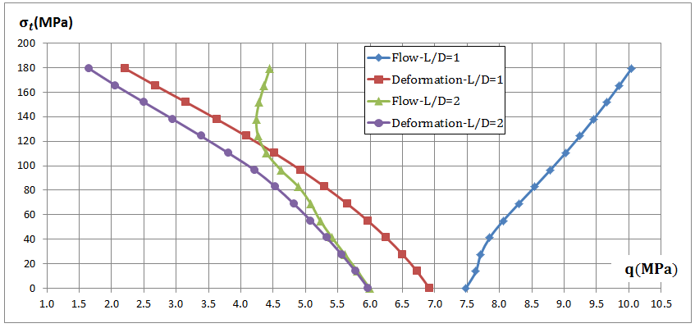

Fig. 9: Influence of *L/D* ratio on the discrepancies between the buckling pressures obtained using the flow and deformation theories

**4. Finite-element modelling**

The plastic buckling of imperfect cylinders subjected to constant axial tensile stress and increasing external pressure has been numerically simulated by means of the non-linear FE commercial package ABAQUS, version 6.11-1 [37], using both the flow and deformation theories of plasticity. The results of the analysis are compared with the current DQ results.

The FE simulations were conducted for cylinders of aluminum alloy 6061-T4. The plastic buckling pressures and the corresponding deformation shapes predicted by the flow theory and deformation theory were obtained for: a) C1-C1 cylinders subjected to various axial tensile stresses with *h/R*=0.0408; b) S1-S1 cylinders with different values of thickness-radius ratios, *h/R*, and subjected to constant axial tensile stress; c) S2-S2 cylinders subjected to three different values of axial tensile stress with *h/R*=0.0408. The chosen length-diameter ratio *L/D* was equal to one. For this value most of the buckling modes are symmetric with respect to the middle cross section. Therefore, half of the cylinder was modelled and symmetry boundary conditions were assigned to the symmetry plane of the cylinder, as shown in Fig. 10. In the case of C1-C1 boundary conditions, nodes on the top edge of the shell were fixed except for the axial displacement. In the case of S1-S1 boundary conditions, the rotations normal to the cylinder wall were allowed. For cylinders S2-S2, the circumferential displacements were allowed. Two types of loading were considered: axial tensile load applied at the top edge as a shell edge load in the longitudinal direction and external pressure applied normally to the surface of the shell elements (Fig. 10). First the tensile load was applied and held constant. Successively, an increasing lateral pressure was applied.

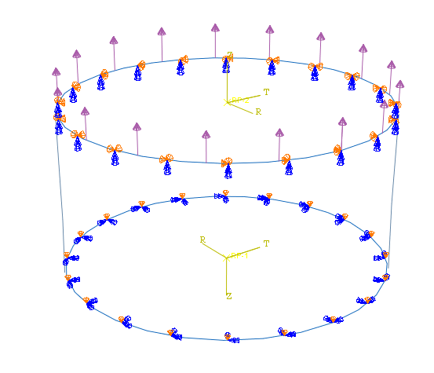

Symmetry boundary condition

Shell edge load at the tope edge

Fig. 10: Boundary conditions

The cylinders were modelled using a general-purpose 4-noded fully integrated shell element, “S4” [37]. This element accounts for finite membrane strains and large rotations; therefore, it is suitable for large-strain analyses [37]. A structured mesh was used, made from a division of 150 and 50 elements along the circumference and the length, respectively. The Ramberg–Osgood input parameters used in the numerical simulations were reported in Section 3.2. Both the flow and deformation theories of plasticity have been employed. A detailed description of the implementation of the flow and deformation theories in the numerical analysis was given in Shamass et al. [27]. Initially, a linear buckling analysis was conducted assuming linear elastic material behavior and small displacements. The first 16 eigenmodes were used to seed the imperfection with maximum amplitude equal to 3% of the thickness. This strategy removes the presence of bifurcation point associated with primary and secondary paths [38]. The smallest buckling pressure predicted for all imperfection shapes, each one being proportional to one of the eigenmodes, was assumed to be the buckling pressure and its deformation shape was taken as the corresponding buckling mode. The Newton-Raphson scheme implemented in ABAQUS was used.

**5. Comparison between the DQ and the FEA results**

The plastic buckling pressures, based on the flow theory and deformation theory, were calculated numerically using ABAQUS and compared with the results by the DQ method. The results are presented in Figs 11 - 13. It can be observed that the flow theory employed in the DQ method gives consistently higher values of the buckling pressures than those calculated using deformation theory, as illustrated in Figs 11a-12a. However, Figs 13a-13b show that when conducting geometrically nonlinear finite-element calculations using the flow theory and the deformation theory of plasticity, the flow theory results become realistic and much closer to the results from the deformation theory. The differences in the results is in the range 0.7% - 15% for C1-C1 cylinders and -6% - 9.4% for S1-S1 cylinders. It is important to note that the plastic buckling pressures calculated analytically using the deformation theory are in very good agreement with those obtained numerically, as shown in Figs 11b-12b. The discrepancy between the analytical and numerical results using the deformation theory ranges from -4.3% to 9.4% for S1-S1 cylinders, and from -1.7% to 8.2 % for C1-C1 cylinders. It is thus confirmed that, using the DQ method with a harmonic variation of the buckling mode assumed along the circumferential direction, the use of the flow theory of plasticity in the elastic-plastic bifurcation analysis may lead to unacceptable results and to over-estimate the buckling pressures when bucking occurs at an advanced plastic phase, while the deformation theory provides physically acceptable results within the same framework. However, the flow theory provides acceptable and reliable results in a non-linear incremental analysis, which therefore does not give origin to any plastic buckling paradox

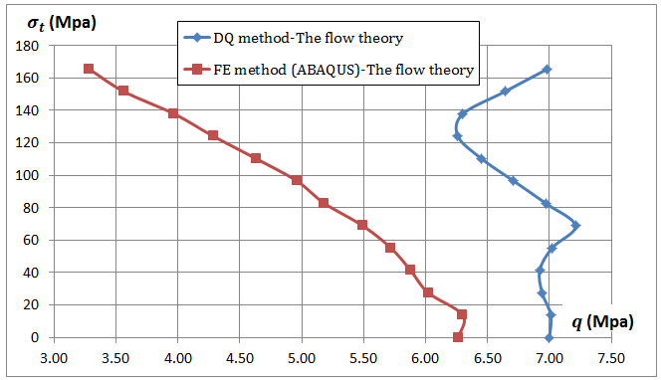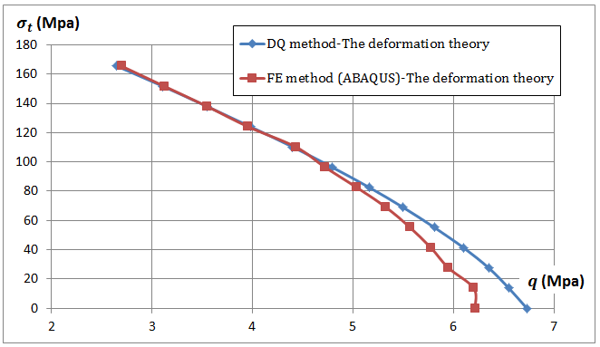

1. (b)

Fig. 11: Comparison between DQ method and numerical buckling pressure for C1-C1 cylinders with *h/R*=0.0408, calculated using both the: (a) flow theory and (b) deformation theory

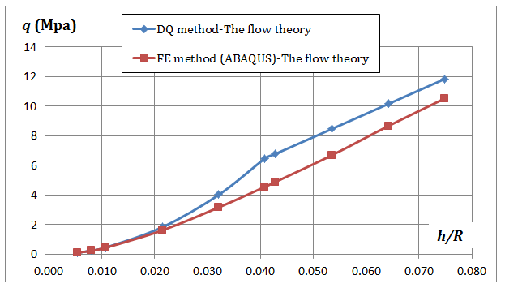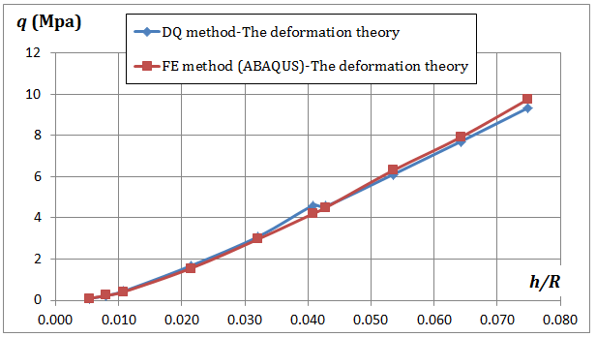

(a) (b)

Fig. 12: Comparison between DQ method and numerical buckling pressure for S1-S1 cylinders with $σ_{t}=110.5 MPa,$ calculated using both the: (a) flow theory and (b) deformation theory

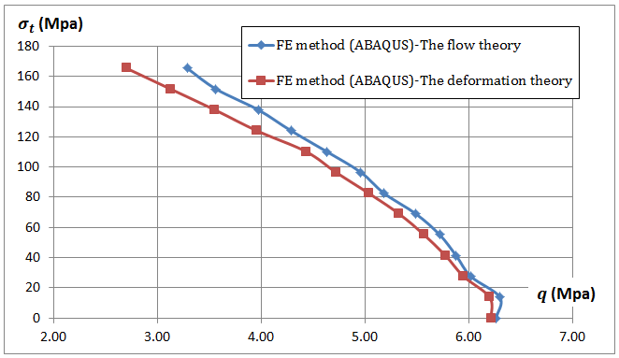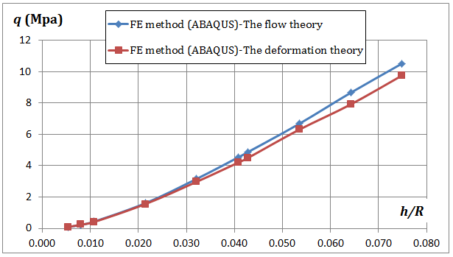

(a) (b)

Fig. 13: Comparison between the flow and deformation theory buckling pressures calculated using ABAQUS for: (a) C1-C1 cylinders and (b) S1-S1 cylinders.

**5.1. Interpretation results in the context of the plastic buckling paradox**

The main findings from the present study are the following:

1. when an accurate FE model is set up accounting for material and geometrical non-linearity, the flow theory does not over-estimate plastic buckling pressures and the results obtained by the flow and deformation theories are similar and may occasionally differ by no more than 14%, a fact which has already been discussed by Shamass et al. [28];
2. the discrepancy between the flow and deformation theories results arises when they are calculated in the framework of a buckling analysis, either analytically or by using the DQ method. The discrepancy increases significantly when the buckling occurs well within the plastic domain of the material. The deformation theory generally provides consistently lower buckling pressures than the flow theory;
3. the discrepancy in the results between the flow theory and the deformation theory significantly increases, according to the presented procedure, with the stiffening of the cylinder, that is with the increase of the thickness ratio, the clamping of the boundaries and the ratio $E/σ_{y}$.

Shamass et al. [27] have already shown that a certain buckling shape determined by the simplified assumptions of the analytical treatments, which result in kinematic constraints, leads to an excessive stiffness of the cylinder and, consequently, an overestimation of the buckling stress for both the flow and deformation theories. However, the deformation theory compensates the over-stiffening of the shell, thus providing buckling stress results that are lower than those obtained by the flow theory. This fact is confirmed also by the DQ treatment presented here, in which the kinematics of the problem is approximated by assuming that the buckling mode varies harmonically in the circumferential directions, as shown in equation 17. Therefore, the implicit kinematic constraint, which derives from assuming a harmonic buckling shape, seems to be once again the main reason for the discrepancy between the flow theory and deformation theory results obtained analytically. This does not happen in the case of carefully constructed and validated nonlinear FE analyses in which the kinematics is far less constrained.

Table 10 shows the plastic buckling pressures and corresponding buckling modes obtained using the DQ method and geometrically non-linear finite element method. It can be seen for all cases, as mentioned above, that the flow and the deformation theory results obtained by the FE method are similar, and the corresponding buckling modes predicted by both plasticity theories are identical. However, by using the DQ method, when large differences in the buckling pressures between the flow and deformation theories are observed, it is seen that the buckling modes are different. These buckling modes predicted by the flow theory are also different from those obtained by the FE method, see Tables 11-13.

|  |  |  |  |  |  |  |  |  |
| --- | --- | --- | --- | --- | --- | --- | --- | --- |
| Tensile stress (MPa) | Buckling pressure *qcr* (MPa) and corresponding buckling mode *n,m* calculated from present study | | | | Buckling pressure *qcr* (MPa) and corresponding buckling mode *n,m* obtained from ABAQUS | | | |
| Flow theory | | Deformation theory | | Flow theory | | Deformation theory | |
| *n,m* | *qcr* | *n,m* | *qcr* | *n,m* | *qcr* | *n,m* | *qcr* |
| 0 | 5,1 | 7.00 | 5,1 | 6.73 | 5,1 | 6.26 | 5,1 | 6.22 |
| 13.8 | 5,1 | 7.01 | 5,1 | 6.55 | 5,1 | 6.30 | 5,1 | 6.20 |
| 27.6 | 4,1 | 6.94 | 5,1 | 6.35 | 5,1 | 6.02 | 5,1 | 5.95 |
| 41.4 | 4,1 | 6.92 | 4,1 | 6.1 | 5,1 | 5.88 | 5,1 | 5.78 |
| 55.2 | 4,1 | 7.02 | 4,1 | 5.81 | 5,1 | 5.72 | 5,1 | 5.57 |
| 68.9 | 4,1 | 7.21 | 4,1 | 5.5 | 5,1 | 5.49 | 5,1 | 5.33 |
| 82.7 | 7,4 | 6.97 | 4,1 | 5.16 | 4,1 | 5.18 | 4,1 | 5.04 |
| 96.5 | 5,3 | 6.71 | 4,1 | 4.79 | 4,1 | 4.96 | 5,1 | 4.72 |
| 110.3 | 5,3 | 6.45 | 4,1 | 4.4 | 4,1 | 4.63 | 4,1 | 4.43 |
| 124.1 | 5,3 | 6.26 | 4,1 | 3.98 | 4,1 | 4.29 | 4,1 | 3.96 |
| 137.9 | 3,2 | 6.3 | 4,1 | 3.55 | 4,1 | 3.97 | 4,1 | 3.55 |
| 151.7 | 3,2 | 6.64 | 4,1 | 3.11 | 4,1 | 3.56 | 5,1 | 3.13 |
| 165.5 | 3,2 | 6.98 | 5,1 | 2.65 | 5,1 | 3.28 | 5,1 | 2.70 |

(a)

|  |  |  |  |  |  |  |  |  |
| --- | --- | --- | --- | --- | --- | --- | --- | --- |
| *h/R* | Buckling pressure *qcr* (MPa) and corresponding buckling mode *n,m* calculated from present study | | | | Buckling pressure *qcr* (MPa) and corresponding buckling mode *n,m* obtained from ABAQUS | | | |
| Flow theory | | Deformation theory | | Flow theory | | Deformation theory | |
| *n,m* | *qcr* | *n,m* | *qcr* | *n,m* | *qcr* | *n,m* | *qcr* |
| 0.0053 | 8,1 | 0.092 | 8,1 | 0.092 | 7,1 | 0.092 | 7,1 | 0.092 |
| 0.0080 | 7,1 | 0.23 | 7,1 | 0.23 | 6,1 | 0.226 | 6,1 | 0.241 |
| 0.0107 | 6,1 | 0.44 | 6,1 | 0.44 | 7,1 | 0.43 | 7,1 | 0.41 |
| 0.0214 | 5,1 | 1.82 | 5,1 | 1.67 | 5,1 | 1.61 | 5,1 | 1.56 |
| 0.0321 | 4,1 | 4.01 | 4,1 | 3.09 | 4,1 | 3.16 | 4,1 | 2.98 |
| 0.0408 | 5,3 | 6.45 | 4,1 | 4.55 | 4,1 | 4.54 | 4,1 | 4.20 |
| 0.0428 | 5,3 | 6.77 | 4,1 | 4.57 | 4,1 | 4.88 | 4,1 | 4.51 |
| 0.0535 | 5,3 | 8.46 | 4,1 | 6.11 | 4,1 | 6.69 | 5,1 | 6.31 |
| 0.0642 | 5,3 | 10.16 | 4,1 | 7.71 | 4,1 | 8.66 | 4,1 | 7.92 |
| 0.0749 | 5,3 | 11.85 | 4,1 | 9.35 | 4,1 | 10.53 | 4,1 | 9.77 |

(b)

|  |  |  |  |  |  |  |  |  |
| --- | --- | --- | --- | --- | --- | --- | --- | --- |
| Tensile stress (MPa) | Buckling pressure *qcr* (MPa) and corresponding buckling mode *n,m* calculated from present study | | | | Buckling pressure *qcr* (MPa) and corresponding buckling mode *n,m* obtained from ABAQUS | | | |
| Flow theory | | Deformation theory | | Flow theory | | Deformation theory | |
| *n,m* | *qcr* | *n,m* | *qcr* | *n,m* | *qcr* | *n,m* | *qcr* |
| 27.6 | 4,1 | 6.43 | 4,1 | 6.13 | 4,1 | 5.82 | 4,1 | 5.72 |
| 68.9 | 3,1 | 6.36 | 4,1 | 5.33 | 4,1 | 5.23 | 4,1 | 5.11 |
| 110.3 | 4,2 | 6.38 | 4,1 | 4.28 | 4,1 | 4.57 | 4,1 | 4.21 |

(c)

Table 10: plastic buckling pressure and corresponding buckling mode obtained using the DQ and FE method: (a) C1-C1 cylinder; (b) S1-S1 cylinder and (c) S2-S2 cylinder.

|  |  |  |  |  |  |  |
| --- | --- | --- | --- | --- | --- | --- |
| *h/R* | DQ results | | | | FE results (ABAQUS) | |
| Buckling shape in the circumferential direction using the flow theory (*n*) | Buckling shape in the axial direction using the flow theory (*m*) | Buckling shape in the circumferential direction using the deformation theory (*n*) | Buckling shape in the axial direction using the deformation theory (*m*) | Buckling shape in the circumferential direction using either the flow theory or deformation theory | Buckling shape in the axial direction using either the flow theory or deformation theory |
| 0.0321 |  |  |  |  |  |  |
| 0.0408 |  |  |  |  |  |  |
| 0.0642 |  |  |  |  |  |  |
| 0.0749 |  |  |  |  |  |  |

Table 11: Comparison between buckling shapes from different methods for S1-S1 cylinders ($σ_{t}=110.5MPa$,)

|  |  |  |  |  |  |  |
| --- | --- | --- | --- | --- | --- | --- |
| $$σ_{t} (MPa)$$ | DQ results | | | | FE results (ABAQUS) | |
| Buckling shape in the circumferential direction using the flow theory (*n*) | Buckling shape in the axial direction using the flow theory (*m*) | Buckling shape in the circumferential direction using the deformation theory (*n*) | Buckling shape in the axial direction using the deformation theory (*m*) | Buckling shape in the circumferential direction using either the flow theory or deformation theory | Buckling shape in the axial direction using either the flow theory or deformation theory |
| 27.6 |  |  |  |  |  |  |
| 68.9 |  |  |  |  |  |  |
| 110.3 |  |  |  |  |  |  |

Table 12: Comparison between buckling shapes from different methods for S2-S2 cylinders ( $\frac{h}{R}=0.0408$)

|  |  |  |  |  |  |  |
| --- | --- | --- | --- | --- | --- | --- |
| $$σ_{t} (MPa)$$ | DQ results | | | | FE results (ABAQUS) | |
| Buckling shape in the circumferential direction using the flow theory (*n*) | Buckling shape in the axial direction using the flow theory (*m*) | Buckling shape in the circumferential direction using the deformation theory (*n*) | Buckling shape in the axial direction using the deformation theory (*m*) | Buckling shape in the circumferential direction using either the flow theory or deformation theory | Buckling shape in the axial direction using either the flow theory or deformation theory |
| 13.8 |  |  |  |  |  |  |
| 110.3 |  |  |  |  |  |  |
| 165.5 |  |  |  |  |  |  |

Table 13: Comparison between buckling shapes from different methods for C1-C1 cylinders ( $\frac{h}{R}=0.0408$)

**6. Conclusions**

In this paper, the DQ method has been used to obtain the elastic-plastic buckling pressures of cylinders under non-proportional loading and various boundary conditions. The analysis has been based on Flugge stability equations. In the problem considered, the buckling mode was assumed to vary harmonically in the circumferential direction. The problem has thus been reduced to a one-dimensional one, and the sampling points had to be taken only in the axial direction of the shell. Buckling pressures were obtained using direct iterations with a standard eigenvalue solver.

Comparisons were made with some results given in the literature and results obtained using BOSOR5. The DQ results show good agreement with some of the known solutions. A parametric study was then performed to characterise the effect of the thickness-radius, $h/R$*,* length-diameter, $L/D$*,* material stiffness-strength, $E/σ_{y}$ ratios, tensile stress and various boundary conditions on the discrepancies between the flow theory and deformation theory predictions.

Non-linear finite-element (FE) analyses of cylindrical shells have also been carefully conducted using both the flow theory and the deformation theory of plasticity. Plastic buckling results were compared with the present DQ results for three types of boundary conditions and various values of thickness-radius *h/R* ratio and tensile stress.

The findings are:

* using the DQ method, the discrepancy between the buckling pressures predicted by the flow theory and the deformation theory increases with the increase in *h/R, $E/σ_{y}$*  ratios and tensile stress and with the decrease in the *L/D* ratio;
* using the DQ method, both theories provide the same results when the buckling occurs in the elastic phase. When buckling occurs in plastic phase, the flow theory results deviate from those obtained using the deformation theory;
* preventing the edge rotation along of the generator and the presence of axial and circumferential restraint at the boundaries increase the plastic buckling pressures obtained using the flow theory while it has no or very little influence on the plastic buckling pressures calculated using the deformation theory for all values of the applied tensile stresses;
* by conducting geometrically nonlinear finite-element analyses, the flow theory provides physically reliable results, which are in accordance with the deformation theory ones. The large discrepancies between flow and deformation theories results observed with analytical solutions or using the DQ method vanish when using the flow theory in non-linear incremental analysis;
* The root of the discrepancy can once again (see Shamass et al. [25],[27],[28]) be attributed to the over-constrained assumed kinematics, i.e. harmonic buckling shapes in the circumferential direction. This fact leads to overestimate the buckling pressures when the flow theory of plasticity is used, while the deformation theory counterbalances the excessive kinematic stiffness and provides results which are much lower that the flow theory findings.
* In order to further verify that the assumption on the harmonic kinematics in Equation (17) is the only origin of the unacceptable results for the DQ method, additional analytical investigations could be carried out by taking into consideration buckling modes different from the harmonic one and evaluate if this can deliver any improvement in the predictions based on the flow theory of plasticity. However, since the harmonic assumption is the standard approach in the DQ method, this would imply a modification of the whole procedure, which could become more complex and therefore offset many of its advantages.
* it is recommended that a geometrically nonlinear finite-element formulation for imperfect shells is used, with carefully determined and validated constitutive laws, to avoid the discrepancies between the two plasticity theories, and that accurate post-buckling curves are tracked using the physically more sound flow theory of plasticity.

**Acknowledgement**

The first author would like to gratefully acknowledge the financial support from the Damascus University.

References

[1] K. M. Wang, Solving the model of isothermal reactors with axial mixing by the differential ouadrature method. *Int J Numer Meth Eng*, 18(1) (1982) 111-118.

[2] C. W. Bert and M. Malik, Differential quadrature method in computational mechanics: a review. *Applied Mech Rev*, 49(1) (1996) 1-28.

[3] C. Shu and B. E. Richards, Application of generalized differential quadrature to solve two‐dimensional incompressible Navier‐Stokes equations. *Int J Numer Meth Fl*, 15(7) (1992) 791-798.

[4] F. Civan and C. M. Sliepcevich, Application of differential quadrature to transport processes. *J Math Anal Appl*, 93(1) (1983) 206-221.

[5] O. Sepahi, M. R. Forouzan and P. Malekzadeh, Free Vibration analysis of triply coupled pre-twisted rotor blades by the differential quadrature method. *Int J Struct Stab Dy*, 11(01) (2011) 127-147.

[6] F. Civan, Rapid and accurate solution of reactor models by the quadrature method. *Comput Cham Eng*, 18(10) (1994) 1005-1009.

[7] M. Malik and C. W. Bert, Differential quadrature solutions for steady-state incompressible and compressible lubrication problems. *J Tribol*, 116(2) (1994) 296-302.

[8] M. Nassar, M. S. Matbuly and O. Ragb, Vibration analysis of structural elements using differential quadrature method. *J adv res*, 4(1) (2013), 93-102.

[9] X. Wang and H. Gu, Static analysis of frame structures by the differential quadrature element method. *Int J Numer Meth Eng,* 40(4) (1997), 759-772.

[10] C. W. Bert and M. Malik, Free vibration analysis of thin cylindrical shells by the differential quadrature method. *J Press Vess Tech*, 118(1) (1996) 1-12.

[11] C. W. Bert, S. K. Jang A. G. and Striz, Nonlinear bending analysis of orthotropic rectangular plates by the method of differential quadrature. *Comput Mech*, 5(2-3) (1989) 217-226.

[12] Y. Niu, Z. Wang and W. Zhang, Nonlinear Thermal Flutter Analysis of Supersonic Composite Laminated Panels Using Differential Quadrature Method. *Int J Struct Stab Dy*, 14(07) (2014) 1450030.

[13] H. Wu, S. Kitipornchai, and J. Yang, Free vibration and buckling analysis of sandwich beams with functionally graded carbon nanotube-reinforced composite face sheets. *Int J Struct Stab Dy*, 15(07) (2014) 1450011.

[14] J. Yang, S. Kitipornchai and C. Feng (2015). Nonlinear Vibration of PZT4/PZT-5H Monomorph and Bimorph Beams with Graded Microstructures. *Int J Struct Stab Dy*, 15(07) (2015) 1540015.

[15] C. W. Bert, S. K. Jang and A. G. Striz , Two new approximate methods for analyzing free vibration of structural components. *AIAA journal*, 26(5), (1988) 612-618.

[16] H. Kurtaran, Geometrically nonlinear transient analysis of moderately thick laminated composite shallow shells with generalized differential quadrature method. *Compos Struct*, 125 (2015) 605-614.

[17] Ö. Civalek, Application of differential quadrature (DQ) and harmonic differential quadrature (HDQ) for buckling analysis of thin isotropic plates and elastic columns. *Eng Struct,* 26(2) (2004) 171-186.

[18] P. Mirfakhraei and D. Redekop, Buckling of circular cylindrical shells by the differential quadrature method. *Int J Pres Ves Pip,* 75(4) (1998) 347-353.

[19] S. Moradi and F. Taheri, Delamination buckling analysis of general laminated composite beams by differential quadrature method. *Compos Part B: Eng*, 30(5) (1999) 503-511.

[20] X. Wang, and J. Huang, Elastoplastic buckling analyses of rectangular plates under biaxial loadings by the differential qudrature method. *Thin Wall Struct*, 47(1) (2009) 14-20.

[21] W. Zhang, and X. Wang, Elastoplastic buckling analysis of thick rectangular plates by using the differential quadrature method. *Comput Math Appl*, 61(1) (2011) 44-61.

[22] M. Maarefdoust and M. Kadkhodayan, Elastoplastic buckling analysis of rectangular thick plates by incremental and deformation theories of plasticity. *Proc Instit of Mech Eng, Part G: J Aero Eng*, (2014) 0954410014550047.

[23] M. Maarefdoust and M. Kadkhodayan, Elastic/plastic buckling analysis of skew thin plates based on incremental and deformation theories of plasticity using generalized differential quadrature method. *Intl J Eng-Transport B: Appl*, 27(8) (2014) 1277-1286.

[24] J. Chakrabarty, *Applied Plasticity*, 2nd edition, (Springer, New York, USA, 2010).

[25] R. Shamass, G. Alfano and F. Guarracino, An analytical insight into the buckling paradox for circular cylindrical shells under axial and lateral loading. *Math Probl Eng,* ID 514267 (2015) 1-11.

[26] W. Flugge, *Stresses in Shells*, (Springer-Verlag, Berlin, 1960).

[27] R. Shamass, G. Alfano and F. Guarracino, A numerical investigation into the plastic buckling paradox for circular cylindrical shells under axial compression. *Eng Struct,* 75 (2014) 429-447.

[28] R. Shamass, G. Alfano and F. Guarracino, An investigation into the plastic buckling paradox for circular cylindrical shells under non-proportional loading. *Thin Wall Struct*, 95 (2015) 347-362.

[29] J.J [Giezen](http://link.springer.com/search?facet-author=%22J.+J.+Giezen%22), C. D. Babcock and J. Singer, Plastic buckling of cylindrical shells under biaxial loading. [*Exp Mech*](http://link.springer.com/journal/11340), 31 (1991) 337-343

[30] J. W. Hutchinson, Plastic buckling. *Advances in Applied Mechanics*, 14(67) (1974).

[31] E. Ore and D. Durban, Elastoplastic buckling of axially compressed circular cylindrical shells. *Int J Mech Sci,* 34(9) (1992) 727-742.

[32] J. G. Teng and J. M. Rotter, *Buckling of thin metal shells*. (Spon press, London, 2004).

[33] D. Bushnell, B0S0R5—program for buckling of elastic-plastic complex shells of revolution including large deflections and creep. *Comput and Struct,* 6(3) (1976) 221-239.

[34] J. G. Teng and J. M. Rotter, Non-symmetric bifurcation of geometrically nonlinear elastic-plastic axisymmetric shells under combined loads including torsion. *Comput and* Struct, 32(2) (1989) 453-475.

[35] X. Wang, F. Liu, X. Wang and L. Gan, New approaches in application of differential quadrature method to fourth‐order differential equations. *Commun Numer Meth En*, 21(2) (2005) 61-71.

[36] S. K. Jang, C. W. Bert and A. G. Striz, Application of differential quadrature to static analysis of structural components*. Int J Numer Mech Eng*, 28(3) (1989) 561-577.

[37] Simulia, ABAQUS Theory Manual. Version 6.11-1. Dassault Systems (2011).

[38] B.G. Falzon, *An Introduction to modelling buckling and collapse*. (*NAFEMS Ltd*, Glasgow, 2006).