Design as redesign in the case of architectural competitions: the role of design visualisations and juries
Organisational research positions design as complex and open-ended. We contribute to research on design and the organisation of competition by conceptualising design as redesign and as a collective ‘thing’ consisting of an interconnected and dynamically evolving set of new design issues and matters of concern that blur actors’ professional roles. Our approach builds on actornetwork theory using an ethnographic study to follow architects’ design work in a commercial case of a dialogue-based architectural competition. Building scales and design concepts were translated and inscribed into different forms of design visualisations and circulated amongst the client, the architect office, and the workshop during the encounter between the team of architects and the jury. As circulating references, design visualisations retain and transform the design and give rise to new contradictory design issues during the actors’ verbal dialogue.
Keywords: dialogue-based architectural competition; design visualisation; actor-network theory; ethnography; design work

Introduction
It will generally be agreed that the work of an architect - in designing a house, say - presents tasks that lie well towards the ill structured end of the problem continuum. Of course this is only true if the architect is trying to be ‘creative’ – if he does not begin the task by taking off his shelf one of a set of standard house designs that he keeps there (Herbert Simon 1973, 187)
Architecture constitutes the physical environment that we work and live in and we need to better understand how it is accomplished and by whom. The architectural profession is said to play a significant role in designing buildings to meet the client’s needs (e.g. Caven and Diop 2012). Yet, the role and identity of the architect as an autonomous master designer is under pressure, especially in large-scale urban projects which involve new divisions of labour and new forms of collaboration with clients and actors from other professions such as engineering and construction (Ahuja, Nikolova, and Clegg, 2017). Cohen et al. (2005) call for more empirically situated research to better understand the changing context of architectural work. While Ahuja, Nikolova, and Clegg (2017) contribute to our understanding of how architects become alienated during the construction process when their design work is challenged by other actors and concerns, there is little research on how such tensions play out during architectural competitions. Commercial architectural competitions are relatively common, and the focus of this paper. More specifically, our purpose is to better understand how the organisation of competitions shapes both architectural design work and the roles played by the actors involved.
Architectural competitions are used in the early design phases to visualise alternative designs for the future building. How the future building is visualised in physical materials and how the selection process is organised differs from project to project. In this paper, we present and analyse a case of a new form of architectural competition that the Danish Association of Architects and the client organisation label as ‘process competition’. We use the term ‘dialogue-based’ because this form of competition allows for dialogue among competing architect teams and a jury before a winning design is selected. The case in question concerns the design for a new landmark building in Copenhagen on the centrally located and culturally important site of the
Carlsberg brewery in the Carlsberg City District.
Research on design juries has focused on the evaluation and selection of a winning design. For example, Chupin (2011), Kazemian and Rönn (2009), Kreiner (2012), Silberberger (2012), and Van Wezemael, Silberberger, and Paisiou (2011) examined the inner workings of the jury’s judgement processes. Kreiner, Jacobsen, and Jensen (2011) and Kreiner (2012) reveal how the process also played out in interactions among competing design teams and the jury. The latter contributions suggest that the jury, in addition to evaluating and deciding on a winning design, can also be implicated in the process of developing the design prior to making its decision.
A second and complementary strand of research has focused on the strategies of architectural firms when they compete for work. For example, Kreiner (2009) and Manzoni and Volker (2017) revealed different strategies that architectural firms use to handle paradoxes and challenges whilst competing for a winning design. Kreiner (2009) also drew attention to the particular challenge of reading the competition brief as instruction, indication, and inspiration, each having different implications for the way in which the design brief and task is approached; ranging from exploitation (when read as instruction) to exploration (when read as inspiration). Competitions are also used for other purposes. For example, Styhre (2011) showed how events like in-house competitions are used by architectural firms to develop, reproduce, and maintain visual skills and a professional identity within the firm. However, these contributions do not consider the interactions among the firms’ design teams and the jury during the competition.
Finally, there is a third related strand of research with an ethnographic approach that reveals the interactions among designers and visual materials as design proposals are developed. For example, Yaneva (2005) followed the use of physical scale models in architectural design at the office of Rem Koolhaas and revealed how the building emerged from a non-linear, complex, and even surprising design process. Ewenstein and Whyte (2007) followed the use of an array of visual materials such as sketches on paper, architectural drawings, and CAD images, as a team of architects at Edward Cullinan Architects developed a competition entry for a master plan including a university college and how its design concept emerged. Våland (2009) considered, for an office building, how future end-users participated in developing the competition brief in interacting with material devices such as printed card board and physical representations. The interests of future users can also be represented by artefacts in competitions. Georg’s (2015) ethnographic research revealed how people used a sustainability tool as a means to assess sustainability before, during, and after the competition. She found that the tool functioned like a competition brief, inscribing
‘programmes of action’ that constrain the design task (p. 332).
The above three research strands reveal the work of juries and design teams, and consider future end-users as designers in developing the competition brief. The contributions have pointed to the paradoxes, tensions, and surprises in architectural competitions and how designs emerge in the course of interactions among people (both professional architects and lay people) and design visualisations. Yet, there still appears to be a lack of research on the simultaneous interactions among juries, design teams, and end-users/other stakeholders and the importance of design visualisations. Drawing upon Latour’s (2009) notion of design as redesign, we build upon and extend the above contributions by considering the role of design visualisations as circulating references (Latour 1999; Strebel and Silberberger 2017) and by asking the following question: how do design visualisations circulate and connect different organisational sites and actors such as the architects’ office, the jury, and the client’s workshop? More specifically, we ask whether circulating design visualisations in addition to representing an emerging design solution also acts as a conduit for new design issues and further redesign. This question, we believe, is also relevant for management and organisational research, as it aims to shed new light on the contradictory processes that shape the building and construction design of physical spaces and, crucially, how management and organisation are embedded in these processes. Our research also aims to contribute to contemporary debate on the organisation of competition (e.g. Arora-Johnsson, Brunsson, and Hasse 2020).
In the next section we position our contribution alongside the extant literature on architectural competitions, followed by a section about our theoretical framework based on actor-network theory (ANT). Next, we present our methodological considerations on case research and data collection using ethnographic techniques to capture the micro processes of the dialogue-based architect competition. The section that follows presents our case analysis. The final section concludes our paper and arguments by considering the implications for theory, method, and future research.

The role of juries in architectural competitions
Many elements of the ‘modern’ version of the architectural competition were introduced in northern Italy in the Renaissance (Lipstadt 2003). Clients used open competitions to find novel design solutions outside their own networks and independent of and prior to the building process; side-by-side comparisons and the assessments of models and near-identical representations were conducted by external advisers (Lipstadt 2003, 403). The modern version was institutionalised in Scandinavia at the end of the
19th century and has since been governed by rules set by the National Associations of
Architects in each country (Kazemian and Rönn 2009; Rönn 2013). For example, in France and many other European countries, the open competition has to be anonymous and governed by a professional panel of judges (Kazemian and Rönn 2009; Lipstadt 2003). Diverse interests meet at architectural competitions, and therefore competitions can be understood as ‘laboratories’ or ‘experimental settings’ (Van Wezemael 2011).
More recently, several new forms of competition have emerged that allow for face-to-face interactions during the competition process in both public and private tenders. One example is the EU Competitive Dialogue Procedure. This form was designed for the procurement of complex projects where economic and technical aspects cannot be described in advance by the client organisation (Hoezen et al. 2010). In the Danish construction sector, where our case study is situated, different forms of competitions that introduce dialogues between clients and competing teams have been used in urban design projects (Georg 2015) and construction projects (Kreiner 2012; Kreiner, Jacobsen, and Jensen 2011). New web-based architectural competitions that allow for interactions among juries and designers to foster open innovation have also been conducted (Kamstrup 2017). The use of dialogue in competitions also points to the significance of the relationship between the client and the design team. Empirical studies from the Netherlands have investigated the tensions between economic and architectural values that form part of the negotiations between client organisations and architects (Bos-de Vos, Wamelink, and Volker 2016). Volker (2012) showed how new EU competition procedures that promoted upfront specifications of success criteria created tension between artistic freedom in architectural design and bureaucratic EU procedures.
The dialogues among the jury, future users, and architect teams can facilitate mutual learning and new knowledge (Kreiner, Jacobsen, and Jensen 2011), since the architect teams can integrate inputs from future users and other stakeholders before their final design solution is submitted. But dialogue in a competition may also generate unintended consequences, because the feedback that the architect teams receive can be ambiguous (Kreiner, Jacobsen, and Jensen 2011). The criteria for selecting a winner are not given a priori, instead they emerge as part of the competition, based on the jury members’ judgements of the designs (Kreiner 2012; Silberberger 2012; Stark 2011; Van Wezemael, Silberberger, and Paisiou 2011). In sum, an architectural competition can be organised in different ways, ranging from the traditional anonymous ‘masquerade’, with interactions with design visualisations but without face-to-face engagement (Kreiner 2007), to the recent and more complex competition forms that also include face-to-face verbal dialogue and interactions with key stakeholders such as clients, users, design teams, and a panel of judges.
The literature on architectural competitions also points at the many dilemmas (Kreiner 2009; Rönn 2009) and paradoxes (Manzoni and Volker 2017) that architects experience when they compete for work. One such dilemma is related to style. Kornberger, Kreiner, and Clegg (2011, 150) noticed that whilst there are objective forces in a competition programme, such as the design brief, other competing design teams and the jury, every architect also has his or her own subjective style and identity, which makes competing a balancing act, because identity and style may result in not giving the clients what they ask for (150). In our case, the jury has a new role, because its members interact with the design teams during the process of developing architectural designs for the future building. How these interactions, consisting simultaneously of verbal dialogue and visualisations, shape the emerging design solution is the focus of our analysis. Therefore, our case contributes to the literature on architectural competitions by providing ethnographic insights into how the design process unfolds in the novel setting of a dialogue-based competition.

The role of design visualisations
Ewenstein and Whyte’s (2007, 2009) ethnographic work provides an important contribution to our understanding of the link between architectural competition and the architects’ use of design visualisations such as sketches and CAD drawings. They used actor-network theory to position visual representations as an inherent part of the development of design, as non-human actants where: ‘the drawing is an active participant in a process of exploratory, projective reflection.’ Following ANTs principle of symmetry they argue that visual representations do more than just represent. Visual representations raise new questions and issues vis-à-vis different stakeholders. They play active and even unruly roles in generating new problems and issues across stakeholders and organisational contexts. The building design is an epistemic object – abstract and in flux, and is never complete. It points to unknown and incomplete knowledge. The knowledge boundary of the epistemic object is open and dynamic.
Yaneva’s (2005) ethnographic study drew attention to the unexpected surprises that emerge when architects use physical scale models (mock-ups) to develop building designs. Like Ewenstein and Whyte (2009), Yaneva took inspiration from ANT by emphasizing the active role of visualisations and in particular, scale models, in accomplishing architectural designs. Yaneva analysed how architects shifted between the use of small- and large-scale models. The study revealed the design process as nonlinear and reversible where the different scale models co-exist and play different yet mutually reinforcing roles. Together, they submit the building to scaling trials, involving different scenarios, possibilities, and issues, which eventually result in a physical building. Neither large nor small models can accomplish the existing building, since each only renders a partial vision of the developing building. Not all models are used all the time and they may return to use later or fall into disuse. The resulting design is not finite, but is instead conceptualised by Yaneva (2005, 892) as a ‘pause’, that is, the design is a temporary and provisional stabilisation in an ongoing design process.
Whilst Ewenstein and Whyte, Yaneva and contributions such as Styhre (2011) focus on architects’ design work in their office, we follow how architectural design practices unfold outside the designers’ office/inside the temporary organisational spaces created for a dialogue-based architectural competition, such as the client’s kick off meeting and the subsequent design workshop. It is a commercial yet novel context, in which a winning design team is eventually going to be appointed and afforded a contract and in which design visualisations can circulate and transgress from the organisational site and practices at the professional architect office. We also examine how professional identities are impacted through the circulation of design artefacts, following Våland and Georg’s (2018) ethnographic study of design interventions to facilitate organisational change, which showed that visual and material artefacts used in architectural design work challenge how employees’ identities are enacted.

Theoretical framework

Design as redesign – according to the actor-network theory (ANT)
We adopt for this paper three concepts from ANT to help us trace and analyze architectural design competitions as dynamically evolving problematic situations. The first is Latour’s notion of design as redesign. The second is translation, drawing on Callon, to show how problems are translated and transformed through the design competition. The third is circulating references also from Latour, to establish how representations inscribe and carry specific interests, conflicts or concerns through the process.
ANT is processual and relational. The concept of an actor is extended to things - composite material-relational entities, consisting of both humans and non-humans.
Latour (1996, 369) explained it thus: ‘[ANT] does not limit itself to human individual actors but extend the word actor -or actant- to non-human, non-individual entities’. This methodological symmetry allows the tracing of heterogeneous actor networks and of processes of inscription – the production of representations which carry the concerns and (potentially contradictory) interests of the human and non-human actants within the network.
Hence, Latour’s (2009) conception of design as redesign is grounded in moving away from a modernist view of seeing finalized, fixed, matter of fact objects towards seeing ‘things’ – non-linear, unsettled, fluid matters of concern which are open to challenge and transformation (see Latour 2004; Tryggestad, Harty, and Jacobsen 2019). Integral to this conception is an understanding of design as a complex heterogeneous collective gathering consisting of humans such as professional designers and end-users, and non-humans such as organisations, artefacts and visual inscriptions.
Design as redesign then leaves an open empirical question as to what roles humans and non-humans such as a design visualisation (an inscription) can play during the architectural competition. Latour’s (2009) notion of design as a ‘thing’ can thus be qualified with a focus on the actants and their material-semiotic relations and roles. We should look for processes that are riddled with trials and negotiations since design ‘is never a process that begins from scratch: to design is always to redesign. There is always something that exists first as a given, as an issue, as a problem.’ (p. 4). The notion of design as redesign suggests that existing issues and problems can somehow transform during the gathering, as when an artefact becomes an actant in a ‘complex assemblies of contradictory issues’ (p. 4). Kreiner (2010) used ANT and Latour’s (2004) notion of matters of concern to argue for a complex understanding of the relationship between architectural design and organisational spaces and practices.
Two further concepts from ANT are utilized below. The first is the socio-logic of translation from Callon’s (1980) work to understand scientific research and knowledge production. It describes the ‘particular logic by which problems are directly associated with groups’. Translation stresses the interdependencies of problems and their formation into a problematic situation being the outcome of struggles and negotiations to define what is problematic and what is not. Callon explains the distinction between problem and a problematic situation in this way: ‘Problems are identified and rendered autonomous; established fact stated; links postulated; whole sections of reality pushed back into the shadows.’ (p.209). Problems are therefore outcomes of backgrounding and foregrounding, accepting particular assumptions as fact (or ‘not problems’) and aligning with particular interests. A problematic situation is one where problems are combined, challenged or translated, thus it ‘de-contextualises concepts, proposals and categories, and then re-contextualises them using its own logic’.’ (p. 219). Callon points to ‘translation mechanisms’ such as money, written proposals, estimations, tables, and other inscriptions that render something (in)visible, (un)problematic and worth more (or less) attention, investments, and interest. Defining something as problematic (or not) is thus a ‘highly strategic activity, aiming as it does to interest varied groups in an enterprise whose development as a whole they will not be able to control’ (p. 210).
The notion of a socio-logic of translation was used by Tryggestad and Georg (2011) to trace the emerging tensions between design visualisations and economic calculations in large-scale urban high-rise constructions and to examine whether there is a particular dominating economic logic attached to these design processes. The sociologic of translation appears relevant to our case because it concerns how architectural design problems such as contradictory scales emerge and are negotiated during the encounters between architectural professionals, users/clients, and members of a jury.
The last concept is that of circulating references (Latour 1999). Here, Latour departs from conventional language philosophy and the correspondence theory of truth in which a word (a sign and inscription) is assumed to represent and correspond to a thing that is given in an ‘outside’ world. Truth is better understood as an outcome of a complex dynamic process involving cascades of linked signs and inscriptions that bridge the gap between the word and the world of things. Latour thus propose an empirical philosophy grounded in in situ ethnographies that account for the movements from signs to the thing (and back). Earth scientists’ use of diagrams to map the qualities of the soil in the Amazon forest is an example of this. According to Latour, the diagram does much more than merely representing a reality, it also transforms and translates it since the diagram ‘redistributes the temporal flux and inverts the hierarchal order of space, it reveals to us features that previously were invisible.’ (p. 65). Yet, as a circulating reference, the diagram also helps in ‘keeping something constant through a series of transformations’ (p. 58). Earthly matter such as soil and building designs can be preserved because of such circulating inscriptions that connects sites that were previously disconnected such as the architects office and the clients workshop.
In our case, the notion of circulating references helps us consider how design drawings and other inscriptions link up with each other during the architectural competition and to explore their roles in both representing design and in generating new design problems and concerns. We show how design drawings, scale models, and other design visualisations such as the master plan, design brief, and building programme circulate across sites and link up with each other to constitute problematic situations at the workshop, which is the ‘thing’ and empirical site that we focus on.

Research methods
ANT is as much a methodological-empirical approach inspired by anthropology and ethnography as a theory. Going with Latour’s (1987, 2009) and Callon’s (1980) exhortation to ‘follow the actors’, that is, the actants and unfolding associations, we trace how the design process unfolds across organisational sites as participants in the architectural competition engage in dialogue and develop new emerging concerns in interaction with design visualisations. This ethnographic technique resembles what Czarniawska (2007) termed as ‘shadowing’ of objects (and not just people) as they circulate across organisational sites. Our ANT-inspired case ethnography is based on a comprehensive dataset spanning the entire competition process during spring and early summer 2011.

Data collection and limitations
The empirical study encompasses different types of materials; notably planning documents, in situ direct observations, and interviews. The document study focuses on the master plan, the Carlsberg City building programme, the municipality district plan, the user building programme, and the competition brief. The written materials consist of more than a thousand pages. Direct observation was conducted at different organisational sites and contexts during the competition, such as meetings in the clients’ offices before the competition began, during all 12 workshops (each architect team had three workshops with the jury) and the three final meetings of the jury. A total of 12 semi-structured interviews were also conducted. Before and during the competition, five semi-structured interviews were conducted with members of the client organisation and user representatives and, after the competition, seven semi-structured interviews were conducted with representatives from the client organisation, user representatives,
leaders from two architect teams, and two judges. Over 200 digital photographs were taken to document the interactions during the workshops, and the data drawn were supplemented further by audio recordings at all 12 workshops. The PowerPoint presentations used by the teams at the workshops were also collected and their further use in our research was approved by the members of the management of the design team and the client organisation. Figure 1 illustrates the interactions between the involved participants during the competition, all of which were documented.
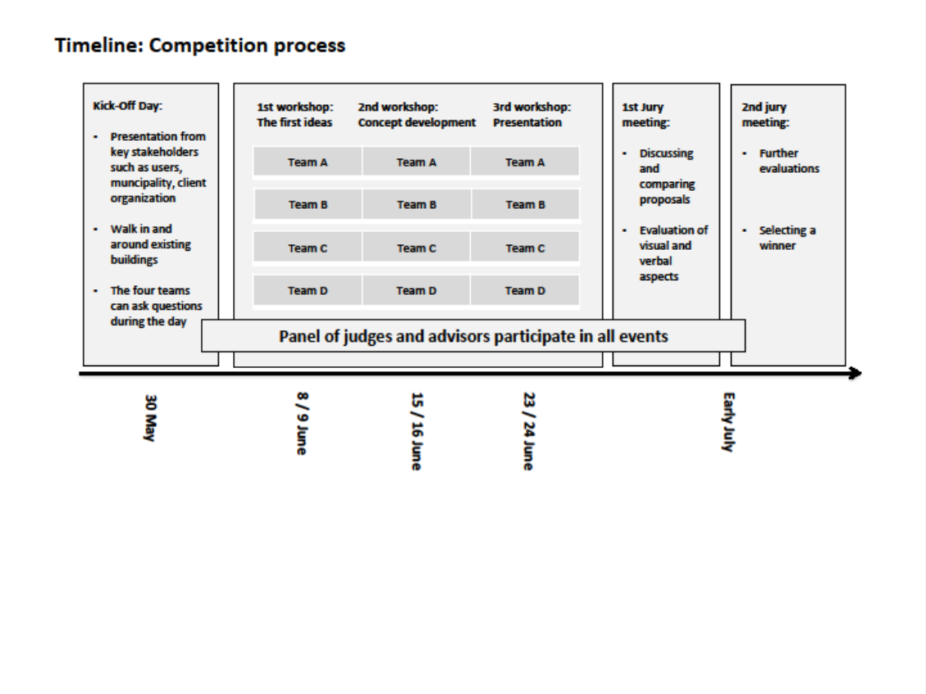

Figure 1. Timeline of the competition and research involvement. The figure is produced by the authors.

The client organisation granted us access to conduct the study, not because we were trained architects (none of us are), but because we were experienced STS and ethnographic scholars interested in the practices of architecture and architectural competition. The CEO of the client organisation informed the participants that the workshops were to be observed by organisational scholars at the ‘kick off’ day that all the architects attended. The CEO indicated that it was a good thing to have an outside view of the process because the client organisation had decided to organise the competition in a novel way. Data collection started a month before the competition began, with observations of meetings where members from the client organisation together with consultants from the Danish Association of Architects wrote the competition brief and planned the workshops. In these observations, the focus was on the work of preparing for and organising the competition process. Before the meetings, the client organisation granted access to a shared digital folder on Dropbox where documents and pictures were uploaded.
This access provided further insights and an opportunity to study how the client organisation worked on the written documents in spring 2011, how pictures were used in the competition brief, and how the design task was documented and then communicated to the architect teams. This provided more detailed knowledge and insights on how different actors were presented in the competition brief – in text, pictures, and visualisations. These key actors (user groups, the municipality, and members of client organisations) were also represented at the workshops. It was possible to actively ask questions whilst observing the planning meetings before the workshops, wherein the workshops themselves were more passively observed (Spradley 1979). However, it was accepted by all people that the researcher could walk around and take pictures of the interactions amongst themselves and the objects present at the workshops. Our data collection pertaining to the workshops gave us the possibility to research and understand the role of design visualisations in the commercial context of architectural competitions, that is, the processes and practices through which professional design practices meet stakeholders or users before a winning design and design team is appointed.
One limitation in our data collection method is that we did not observe how the four teams worked on their designs and presentations in between the three workshops. Direct observations of the office work ‘backstage’ could have provided interesting perspectives on how the verbal feedback that the teams received from the jury during the workshops was used in developing and improving their proposals. However, as we argue above, the role of design visualisations at the architect office has been researched in the ethnographies of professional design work (e.g. Ewenstein and Whyte 2009; Yaneva 2005). So given our interest in the interaction between the jury board and the design teams, we limit our study to how one of the design teams used design visualisations at the workshop and how the jury responded to the team’s presentation. However, we do not consider this to be a limitation in pursuing our research question and purpose. Instead, it allows us to go into greater depth regarding this complex dynamic interplay at the workshop. Being in a position of privileged empirical access, university ethical procedures were strictly followed and we have taken care to negotiate the use of data with the actors involved, including their acceptance of our use of visual materials.
The analysis is structured into three vignettes. The first vignette focuses on the design work that predated and prepared for the workshop, notably the work of developing the master plan and the competition brief including the evaluation criteria. Here we show how an original design intention for small scale, connected spaces is problematized by the interests of an influential actor requiring a single, much larger building. The second vignette accounts for the design team’s presentation at the workshop and how they developed their strategic approach to defining and addressing this problematic situation (Callon 1980) of contradiction between the small-scale master plan and large-scale building programme. The third vignette shows how the formal roles of the design team and the jury became blurred and hybridised as various design inscriptions were used to frame and negotiate problematic situations.

Design as redesign in a dialogue-based architectural competition

First vignette: Design work in preparation for the workshop
When the Carlsberg Group decided to move their brewery to Jutland, they left a large area of 33 hectares unoccupied in Copenhagen. The area was very attractive for development and was used for housing, commercial needs, educational institutions, and recreational areas. In 2006, Carlsberg organised an international open architectural competition to select a master plan for the Carlsberg City District area. The winning proposal included an idea and design concept for the master plan: to reintroduce the density of the small-scale classical city. An important source of inspiration for this small-scale design concept was Giambattista Nolli’s plan of Rome from the 18th century: the Nolli Map.

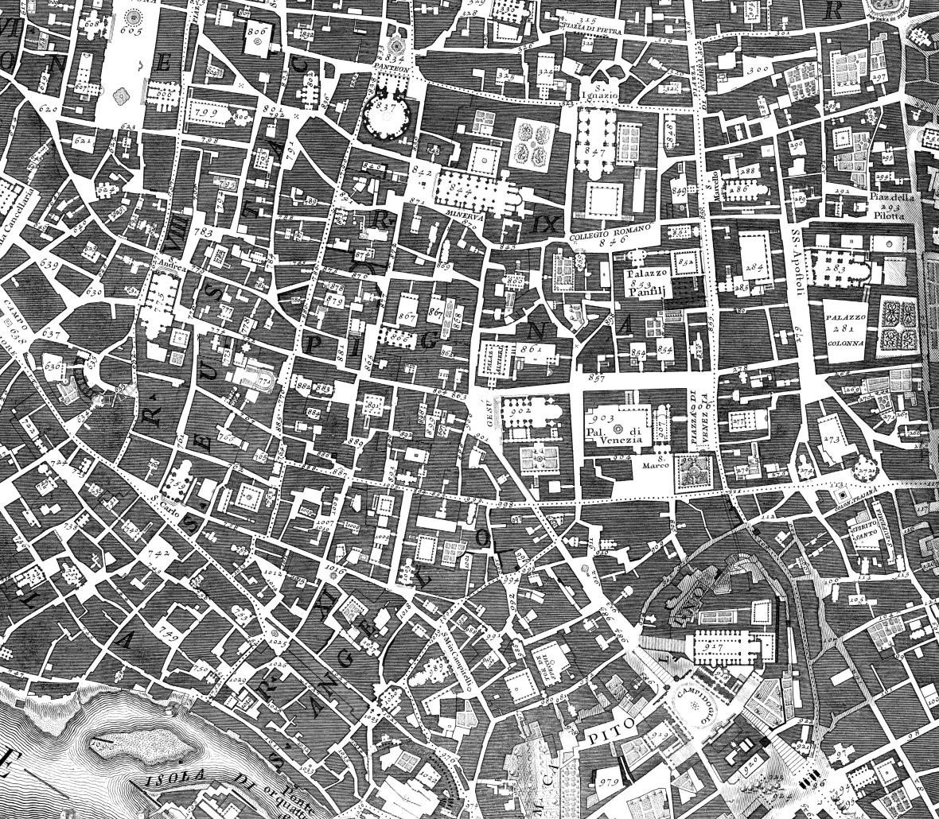
Figure 2. Extract from Giambattista Nolli’s plan of Rome. University of Oregon Nolli
Map Copyright 2006. Reprinted by permission of the University of Oregon Nolli Map Project http://nolli.uoregon.edu

The master plan used the Nolli Map to reintroduce complexity and density into the new city. In the master plan, the common spaces and the ‘life’ between the houses were considered more important than the buildings themselves for the development of a coherent city. The master plan inscribed a social world and urban life for the future citizens on the lines of the small-scale city districts in 18th century Rome. It connected past spaces and modes of urban life, whilst projecting it into the future Carlsberg City District.
The next step in developing the Carlsberg City District involved organising a competition for the design of the first building complex next to the existing railway station. During the formulation of the competition brief for the dialogue-based competition, the client organisation negotiated with potential future users. As it turned out, one of these prospective users did not fit well with the ‘small town’ design concept and the user identity inscribed into the master plan because the client was a non-human, that is, a very large university consisting of 10,000 students and faculty who needed more space and associated functions for teaching and still more if they were to be housed in one building complex. The client’s interest could only be accommodated by a very large building. This new user – University City College (UCC) – and new problematisation of the site emerged after the master plan was finalised. UCC wanted to establish a new spatially integrated campus site for the entire university. As the largest tenant and user of the prospective building, UCC was granted representation in the jury and therefore at the workshops. Therefore, the dialogue-based architectural competition became not only a way to visualise how UCC could be part of the future building, but also how this very large organisational user and tenant could fit in with the ‘small-scale’ social ethos and design concept of the master plan. UCC’s interests were brought into the negotiation as potentially the biggest user of the new site, but also brought a problem of large-scale requirement into the situation previously dominated by interests of small scale density, circulated through and represented by the Nolli map.
The competition brief defined the constraints and premises for the design task by stipulating the following requirements: the building had to be large enough, a minimum of 80,000 metres2, and had to remain within a maximum budget of 1.3 billion Danish kroner, or approximately 170 million euros. The building also had to be completed within a strict timeframe because the main user was the UCC and its 10,000 students.
These students were scheduled to move from several different locations in Copenhagen to their new spatially integrated campus site. The campus was scheduled to open in autumn 2016. When finished, the building complex was to consist of many stores, cafés, a new railway station, and a tall multipurpose tower with offices and teaching facilities closer to the ground and housing accommodation higher up.
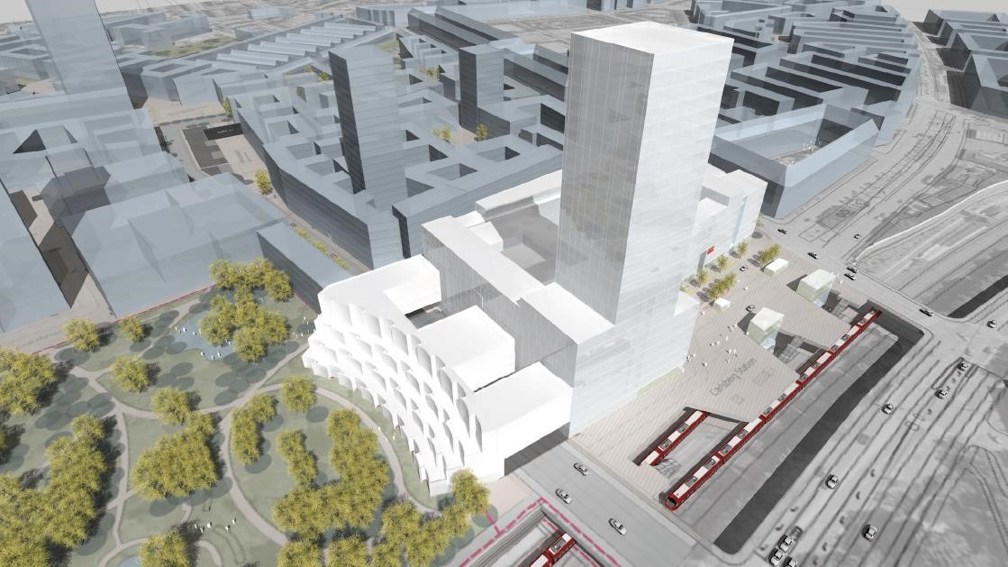
Figure 3. Building programme visualising the large scale building in the context of Carlsberg City District (source: competition brief). Image is courtesy of Carlsberg City District. Reproduced with permission.

As seen in Figure 3, the competition brief and building programme contextualised the new large building complex in a new future cityscape in which it did not stand alone. There were a handful of other large and tall buildings there too, which would make it less exceptional, once these other buildings were completed. This first building complex was not only large in terms of volume, but also unusually high. As it turned out, it would become the third tallest building in Denmark, 100 metres high, the tallest residential building in the country and a new landmark for the city of Copenhagen upon completion. The building programme in the competition brief circumscribed and delimited the design context for the new building complex and task by foregrounding and focusing on this first upcoming building complex (highlighted in white in Figure 3), whilst backgrounding the other large upcoming buildings (signified by the use of grey). These other large building complexes were scheduled for a series of later-to-be-realised projects when users had signed up and the funding had been secured. Of equal significance, the competition brief also backgrounded the master plan and the ‘smallscale’ design concept by inscribing a very large organisational user, UCC, into its building design
This new emphasis on the interests and requirements of its large prospective user were influential on the evaluation criteria. The competition brief for the building design stated four evaluation criteria: (1) overall architectural idea, (2) organisation and process, (3) whether the design could be realised within the given economic frame and time schedule, and (4) the team’s fee. The competition brief translated and delimited the design context and task by inscribing UCC’s urgent and specific interest in a very large and spatially integrated campus solution, by reinforcing the UCC design requirement and by focusing on its timely delivery on budget by inscribing a supporting set of evaluation criteria.
Our analysis of the competition brief reveals the translation mechanism at work when defining what is problematic and what is not (Callon 1980). The brief backgrounds, or leaves in the ‘shadows’ (Callon 1980), the masterplan’s small-scale design concept. Conversely and simultaneously the brief delimits and foregrounds the task and challenge of designing a large-scale building. Together this two-way process of backgrounding/foregrounding helps to define and delimit the problematic situation the client addresses in the brief; to solve the design for the large building so that it can also house the new organisational user, UCC. The competition brief is inscribed with this design task and the associated interests of having a large-scale design concept.
In the following two vignettes, we primarily focus on the first workshop and how one design team presented and visualised their design ideas and their further encounters and dialogues with the panel of judges. As we will further show, the competition brief’s backgrounding of the small-scale design concept inscribed into the city’s masterplan did not resolve the tension vis-à-vis the large-scale design concept inscribed into the building but returns back in the form of new problematic situations.

Second vignette: Workshop presentations - negotiating contradictory design scales
The competition started with a ‘kick off’ day. Following this, each team had only about a week to prepare before the first of three subsequent workshops with the jury (see Figure 1) took place. Each of the three thematic workshops lasted approximately two hours. The jury consisted of six judges and nine client advisers representing different organisations who participated in all 12 workshops. Of the six judges, two were architects appointed by the Danish Association of Architects. A third architect represented the master plan and a fourth represented Copenhagen Municipality. The last two judges represented Carlsberg City District and UCC. These two representatives were not professional architects. The nine client advisers were associated with the five organisations mentioned above. They also engaged in discussions during the competition.
The competition was designed in such a way that it gave the 15 members of the jury insights into all the four teams’ work. The four teams did not know anything about the other teams’ presentations and the jury was not allowed to talk about the work of the other teams. The workshops progressed in the following manner. First, the teams began by making their presentations for approximately 45 minutes each. After the presentations, the teams left the room and the jury discussed the presentation for approximately 10 minutes. The workshops ended with the teams and the jury reconvening and discussing different issues related to the presentation. The teams and the jury walked around the room and talked about the sketches and models of the building that were placed in the room. In the following, we return to one team’s presentation.
Although the design team worked within a tight deadline, they managed to prepare a presentation of their overall design idea. Bringing a physical scale model and mock-up of the building complex to the workshop was perhaps the first and most visible sign of these preparations. The design team demonstrated that they were also aware of the overall design task and challenge as these were stipulated in the competition brief. Some functions and spaces in the building were very large. The overall building programme, which was part of the competition brief, stipulated that the functional space for UCC alone would take up 54,000 metres2. This area represented the better part of the estimated minimum of 80,000 metres2 for the entire building complex. It was a design specification that became a challenge in the context of the master plan and its design concept of a ‘Carlsberg city’ as a town with small-scale houses. The master plan and UCC represented two concerns or alternate problematisations that contradicted each other in relation to scale. The document representing UCC’s building programme addressed scale as an important matter of concern, but one that was tensioned against the master plan. The UCC building programme was developed from a user involvement process that started in 2009 (UCC/Juul Frost Arkitekter 2011b) and included the analyses and visualisations of the flow of students and faculty within the built campus spaces (UCC/Juul Frost Arkitekter 2011a). It described and visualised large connected spaces and rooms inside the building in contradiction to the master plan vision of an outside region consisting of a vibrant social life between city houses of a considerably smaller scale.
This contradiction in and problematisation of scale and related tensions between the social life inside a singular large building and outside between smaller-scale buildings was revealed when the team used different design visualisations to show different aspects of the same district: one small-scale and one large-scale design. There did not appear to be a simple answer that could reconcile both design concepts and their respective concerns, or a single inscription or representation that could resolve this problematic situation. Therefore the ‘scale conflict’ - a contradictory design issue - was also inscribed into the building programme and represented by UCC’s interest in a very large building. The building programme also revealed (see Figure 3) a background with a client and owner of the site, Carlsberg, who also appeared to have an interest in building several large-scale high-rise building complexes on its city district site. In the following section, we will show how the team tried to solve this conflict of scales and the tensions created at the workshop.
Translating contradictory scales by using the Nolli Map and 2D visualisations to focus on in-between spaces
The team’s strategic approach to the scale conflict focused on integrating both contradictory visions inscribed in to the large-scale UCC building programme and the small-scale master plan. The team used the Nolli Map to develop their strategic narrative and approach. The team explained to the jury that they used the Nolli Map differently from how it was used in the master plan. Assisted by a series of related visual devices, such as PowerPoint presentations and a screen, the architects showed their use of the Nolli Map. As the team explained in detail, they would use the Nolli Map strategically to solve the contradictory design task and challenge:
Architect: We have been thinking of using the Nolli Map as a strategic tool to approach the task, and think – not only as a plan where it [the Nolli Map] consists of distances and scales, but also to think of it in a spatial fashion…
Whilst the Nolli Map was used horizontally in the master plan as a way of mapping and creating coherent spaces in the entire Carlsberg City District, the team used the map in a new vertical way. This way, the (literally) translated Nolli Map became a circulating reference (Latour 1999) connecting the master plan with the building programme. The team presented their translation of the Nolli Map as a kind of 3D visualisation and design of the in-between spaces where the building met the squares and spaces around the building above and close to the ground. The team verbally explained how they translated the Nolli Map by (1) tipping it up vertically from the complex map of spatial contours of squares and buildings (as used in the master plan), and (2) using it for designing spatial contours where the large-scale building met the city spaces. The team’s translation of the Nolli Map provided a new and focused view and understanding of the design problem and its boundaries – it was used to background the large scale of building and foreground the interface between the exterior of the building and adjacent outside spaces. From a wide perspective on the overall design of all the buildings and squares in the entire Carlsberg City District (as used in the master plan) to a design problem that was much more focused, it zoomed into the building’s exterior and the immediate area outside this one specific building.
As noted in vignette 1, the competition brief delimited the design task to focusing on the single building complex. With the team’s new vertical use and translation of the Nolli Map, they did not challenge the larger scale of the building programme. Instead, the team followed the inscription by using the Nolli Map to address the challenges that a large-scale building complex posed for smaller-scale social life (as inscribed in the master plan and its horizontal use of the Nolli Map). According to the team, their vertical use of the Nolli Map afforded a complementary focus on the flow and exchanges between the inside and the immediate outside of this large building complex. Compared to the small-scale design concept and the perspective of the master plan, the team’s novel use of the Nolli Map translated the issue of contradictory scales in a way that helped address and eventually resolve this contradiction without challenging the building programme’s strategic change in perspective and scale. It translated issues of scale into issues of spaces proximate to the ground around the building pushing back the related scale issues concerning the impact of the tall building on the city scape.
As a visual representation and circulating reference (Latour 1999), the Nolli Map translates the design problem formulated in the brief into a novel problematic situation (Callon 1980). What happens in the problematic situation is that the team decontextualize their design concept from the Nolli Map and re-contextualise it in their proposal. However, the design problem of contradictory scales, interests, and concerns is not resolved. As we will show below, whilst the new use of the Nolli Map provides a perspective that helps visualise and focus on the in-between spaces where the building meets the proximate city spaces, it also generates new design issues and challenges within the ‘zones’, that is, the lowest 3-4 metres of the façade and the area closest to where the building envelope meets public spaces outside.
The team worked on the challenge of establishing an inner flow in the large building and connecting this flow with the outside and rest of the Carlsberg City District. The space where the building met the squares around it was an important point of reference in their design work. These specific zones (kantzoner) were also described and referred to as important in the municipality’s district plan for the area because this stated that it was in the meeting point between buildings and city spaces that life unfolded (Copenhagen Municipality, 8) as consistent with the master plan. The municipality district plan described the importance of the lower parts of the façades that told ‘about what is inside the building’ and facilitated dialogues with people that passed by the building (p. 8). The team used 2D visualisations to approach this challenge of the ‘zones’ and to establish a flow between the inside and the outside of the building’s 880 metre-long façade.
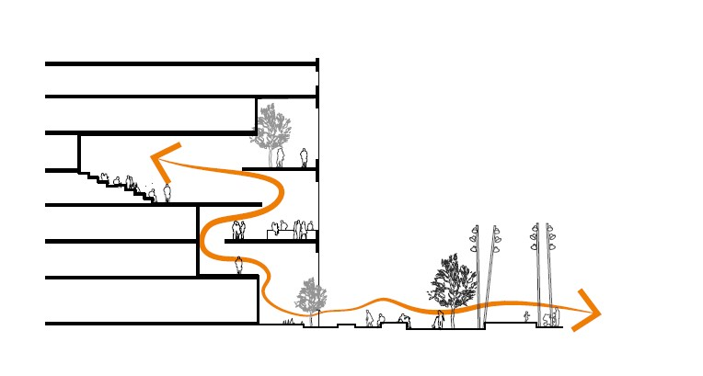
Figure 4. The team’s visualisations of zones (Source: team’s PowerPoint presentation). Image is courtesy of Vilhelm Lauritzen Architects, Christensen and Co Architects, COBE Architects, NORD Architects, and EFFEKT. Reproduced with permission.

The visualisation in Figure 4 was used by the team to show the horizontal and vertical flow of people in the zones where the building façade met public spaces. The zones were permeable from both inside and outside, illustrated by the arrow. This visualisation scales the large building down into a series of boundary zones inhabited by humans moving through the façade. Figure 3 is an example of the team’s many 2D digital translations of the design problem as defined in the 3D rendering of the building programme in Figure 3 – an obviously large and distinct building. The team also developed physical models to qualify their approach to contradictory scales, which will be addressed below.
Translating the contradictory scales through the mock-up
The specific in-between ‘zone problem’ that was defined and visualised by the team in different ways through the Nolli Map and the 2D visualisation in Figure 4 was translated further by the team’s development and use of a 3D physical mock-up scale model, shown below in Figure 5.
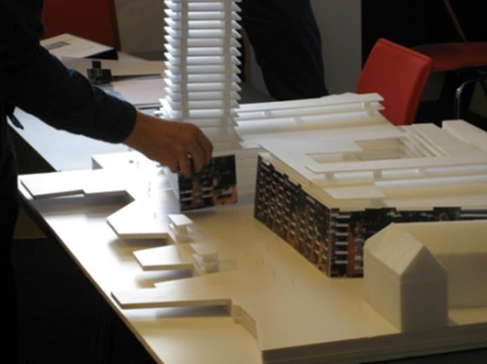
Figure 5. Picture from the workshop, showing the interaction between architects, the mock-up model and physical elements for the façade (in the hand).

Figure 5 is a picture of the physical scale model of the building programme. When the team presented this mock-up, they stood around it together with the members of the jury. The picture shows the team’s use of this physical scale model in visualising how the material aspects of the lowest part of the façades appeared. The model, which the team brought to the workshop, had yet to include inscriptions on users and functions such as stores, cafés, windows, and entrance to the UCC and the apartments. The model was almost ‘naked’ and stripped of such inscriptions. It was still mostly about size and form and not so much about users and functions until the design team also mobilised the façade elements with windows, balconies, and doors, and hence inscribed imagined users into the discussion. The design team then asked the jury questions as they developed and explored different design options:
Architect: Is this what the façade should look like? (asking whilst using his hand to add alternative façade elements to the mock-up model).
The scale conflict was enacted through the manipulation of the mock-up, as an aesthetic issue concerning how the façade should look. At this point, the jury were not only asked to reactively judge the design but also invited to assume a more proactive role in challenging the mock-up design and to confirm what was good, what was missing and what could or should have been otherwise. The process of exploring the design problem related to the façade continued as the members of the design team asked questions such as:
Architect: Do we want the same rhythm all around the building?
By rhythm, this architect implied the physical appearance of the façade design elements such as windows and balconies close to the ground. The design team attached mock-up façades taken from different districts and historical buildings around Copenhagen in front of the physical mock-up of the building complex. This visual set-up showed the heterogeneous rhythm of the ‘old’ existing city against the backdrop of the new building complex.
Together, the team’s visualisation of zones (figure 4) and the mock-up showed how the exploration of the scale conflict between small and large design concepts for the city district was translated into concerns related to the rhythm around the 880 metre building façade. Whilst mobilising the façade elements, the design team created a new association and circulating reference to the historical parts of the existing Copenhagen city. By juxtaposing and superimposing this reference to the small-scale aesthetics of the historical city on the mock-up of the new building complex, it visualised the conflicting scales between the existing city and the new large building. The design team’s visual and verbal presentation was not simply about presenting their design solution but more their way of defining the ‘rhythm’ as another aspect of the scale problem and to invite the jury to contribute with their inputs and views on how to design the façade elements closer to the ground. Their use of the physical model of the building facilitated this invitation and focused dialogue better with the jury. The interplay between the physical mock-up of the building complex and the façade elements constituted another translation of a problematic situation pertaining to scale. Following Callon (1980) problematic situations entails struggles and negotiations about defining what is problematic and what is not – here size is translated into issues of human scale interaction with the building and surrounding area, and of the aesthetics of historical and modern styles for the façade.
As circulating references, the Nolli Map and physical mock-up translated design concerns about contradictory scales and also transported the concern from the architects’ studio to the workshop. The presentation implied a specific translation of the building programme in affording a focus on the singular building complex. The presentation did not challenge the building programme and strategy of large-scale building complexes but rather helped translate the related issues of contradictory scales closer to the building ground as well as closer to the jury. The jury was invited into the dialogue and was allowed to have a say, perhaps most notably on the design issues related to the façade elements, the ‘rhythm’, and proximate in-between spaces. This is significant in addressing the scale problem, as it begins to bring in and align specific interests of the jury into the problematic situation.

Third vignette: After the presentation – in dialogue with the jury about new emerging design issues
The design team left the room after their presentation, leaving the mock-up model and the panel of judges to their deliberations. When they re-entered the room after 10 minutes, the first design issue that had emerged used the metaphor of a ‘shopping centre’ to address the problematic link between building size and the flows of people. Several members in the jury pointed out that ‘they’ – referring to both the team and the jury – had to be careful not to design a new Field’s (a large shopping centre at the outskirts of Copenhagen) that would leave the streets around the building empty. This new reference to Field’s was mobilised by the members of the jury and carried a negative connotation; i.e. the unwanted social problem of empty streets. The discussion results in a novel problematic situation at the workshop. As also noted by Callon (1980), problematic situations, in turn, create metaphors, in our case the negative metaphor of a ‘new Fields’. It was felt that such a shopping centre building design would not add value to the public and shared spaces of the new Carlsberg City District. Some members of the jury explicitly told the team that they were concerned that the students would arrive at the building in the morning and leave in the evening without having any contact with the city.
Jury member: Personally, I have a problem with the [inner] flow. How do you get the students out on to the streets?
If people were only moving inside the building, it would constitute a failure given the potential for a lively and vibrant city that 10,000 students represented. In effect, the jury actively challenged the team’s inscribed UCC users and the ways in which they flowed symmetrically between the inside and outside of the building.
During the team’s presentation, the design challenge had been formulated as one of the large spaces inside the building linking with the adjacent spaces just outside the building. However, the jury member representing UCC appreciated the design approach and told the team so. From UCC’s perspective, the future building was seen and understood from the inside out. Their most important concerns were the educational functions although they acknowledged that the public city space outside was also important. According to the UCC representative, it was not a bad thing to have the inner flow since it could facilitate the organisational development process of the university campus. Yet the UCC representative’s concern with a well-functioning inner flow of students did not address the design issue of linking the building to the outside flow and the adjacent city spaces in the rest of the new city.
Other members of the jury representing the municipality, the master plan and the professional architectural judges pointed at other matters of concern. They expressed their concern that the team’s current design of the building was too strongly oriented towards UCC’s intentions toward the flow of students and functions inside the building.
Although the team visualised how students could use the zones just outside the building, it was not clear to all the jury members as to how their design solution related to the intentions presented in the master plan. In the master plan, the idea was that the spaces between the buildings should create a coherent city. It appeared that the tension between the master plan and the UCC programme regarding scale remained unresolved. The team’s proposed design solution took its point of departure in designing a building for UCC, privileging the humans inside the building. However, many other humans would live in the future city.
As an example of the dynamic character of problematic situations, here, despite the seemingly successful translation of the original scale problem into problems of human-scale flow at interfaces between inside and outside, and around the aesthetics of the façade, a further translation re-emphasises the tensions between UCC’s interests in large scale and students, and the master plan’s interests in small scale and broader social interaction. The problem of flow of people that the team addressed through its design was questioned by the jury who linked the proposed design to the master plan and contrasted it with a large-scale shopping centre. By verbally invoking this negative reference and association with a ‘shopping centre’ design, members of the jury broadened the scope of the design problem and suggested that it was about designing for a coherent city and not simply for a large, coherent and well-integrated university campus. As a result of this dialogue, the design problem was translated into one of integrating other user groups in the building design. Therefore, the inscription of UCC users into the design now afforded new questions and perspectives on future users that the design team had yet to inscribe.
Visualisation played an important role as circulating references when the jury supplemented their formal role as judges with a more proactive role as designers by endorsing particular design elements (regarding the flow inside the building envelope) and by proposing further suggestions for improvements (regarding the connection to its outside). The predefined role set of the jury and the team of architects was blurred further when the design process became more spatially distributed – as the mock-up model circulated and linked the preparation work conducted in the architects’ office with the site of the workshop – as more stakeholders were enjoined to have a say about the design during the workshop. Ultimately, this led to a translation towards further problematisation, rather than consensus or reconciliation.

Discussion
We will now return to our research question: how do design visualisations circulate and connect different organisational sites and actors such as the architects’ office, the jury, and the client’s workshop? Below, we will address this question whilst discussing our findings with respect to the architectural profession, the role of the jury in architectural competitions, and more generally, the organisation of competition for architectural designs.
First, the literature on the architectural profession (e.g. Ahuja, Nikolova, and Clegg 2017) has noted that architect’s identities can come under pressure as projects move from design to construction. Our research complements these findings by showing how architects at work in the novel design setting (Cohen et al. 2005) of dialogue-based competition are challenged by other actors and concerns. We add a novel theoretical understanding of how and why this pressure unfolds as problematisation occurs, but also when and where this happens as we follow visualisations across sites, connecting organisational actors that were previously disconnected. ANT has been criticised for ignoring power structures and for its managerialists bias (Whittle and Spicer 2008) but our case analysis counters this by revealing how many different actors and interests are inscribed onto circulating visual materials, noting the power effects of what becomes problematic or not (Callon 1980). Like Skærbæk and Tryggestad (2010) we provide a non-managerialist ANT account of power as an effect that goes beyond predetermined power and resistance asymmetry to consider the emergence of significant organisational contest, negotiation and translation. In our case it concerns the city scape and social life in a new district in Copenhagen city. We posit that management and organisational scholars would be better equipped to understand such major strategic and organisational change by paying closer attention to the active role of visual materials in shaping our life, including our built environment.
The context for the architect’s design work is changing as design visualisations, such as scale models, circulate and connect with client interests during the competition. Yaneva (2005) showed how models in different scales are used in the design process at the architect’s office. Our case complements and extends this ANT understanding of the role of scale models as the physical mock-up circulated from the architect’s office to the workshop in a network that transgressed the office space and boundary of the design team. In our case, the translation between different scales and forms of visualisation (2D, 3D and physical models) are not only used by the architects to visualise the building (Yaneva 2005). The mock-up leaves the hands of the architects after their presentation and interacts with the jury when they use it to address user groups and interests that are left outside the model and presentation. During the workshop the design problem develops into novel problematic situations (Callon 1980) where the contradictory scales are addressed afresh, perhaps most notably in the form of critical associations and metaphors such as the ‘new Field’s’. The visualisations play an active role as circulating references in this process of retranslation and redesign (Latour 1999,
2009).
Second, our case contributes to understanding the role of professional juries in architectural competitions. Kazemian and Rönn (2009) argued that professional architects as members of the jury govern the objective requirements of the competition brief, rules, and professional norms. Our study suggests a different, more dynamic role building on previous empirical studies on architectural competitions which focus on professional juries’ final judgement and evaluations whilst selecting a winner (Chupin 2011; Kreiner 2012; Silberberger 2012; Van Wezemael, Silberberger, and Paisiou 2011). These contributions found that evaluation criteria are not purely given a priori but develop dynamically from the discussions amongst the jury members. Our findings supplement the extant literature’s focus on the internal work of the jury before its final and formal decision at the jury meeting by showing how the jury also plays another and more proactive role in shaping the design that they will subsequently formally evaluate.
Although the competition operates with a predefined set of professional roles (as architects and panel of judges respectively), our case vignettes reveal the formally assigned jury becoming actively enrolled in developing architectural designs. The architect team are initially bounded as professional designers whilst preparing design visualisations in their PowerPoint presentations and mock-up models within their studios. The mock-up then provides a conduit for a blurring of the professional roles between the architects and the jury when the architects interacting with it simultaneously ask the panel for design suggestions. The design process becomes more spatially distributed as these design visualisations circulate and links the work conducted at the architect’s office with the workshop site – as more stakeholders are enrolled to have a say about the design during the workshop.
Third, our study contributes to research on the organisation of competition.
Arora-Jonsson, Brunsson, and Hasse (2020) argue that the overlap between competition and organisation is under-studied (p. 4). The architectural competition can be seen as an archetype of an organised competition and our case analysis illuminates this institution as it has evolved from an organisation based on anonymity to the present-day dialoguebased competition with face-to-face interactions between the client and competing design teams.
As a supplement to Arora-Jonsson, Brunsson, and Hasse (2020) who argues that the competition is socially constructed, our ANT study shows the organised competition does not become less equipped with or reliant on visual- material devices as the interaction becomes more ‘social’ and dialogue-based. Instead, what our study shows is that the development and circulation of a whole array of inscriptions and visualisations becomes central to dialogue, to problematisation and to redesign. The dialogue-based architectural competition becomes an evolving gathering and ‘thing’ that mobilises professional architects to equip themselves for the series of workshops to come. The visualisations they develop circulate amongst sites, from office to workshops prepared by the client. The jury is also equipped with visualisations, and even more so than the teams, because they accumulate design from all the involved teams before they enter the formal role of selecting a winning design. Our case also adds nuances to the understanding of the organisation and function of competition by showing how judgements and evaluations become situated in a more heterogeneous and dynamic network of interests. This is an unfolding process in which previous well-defined organisational roles representing professional architects and clients are switched as clients and future users of design becomes equipped earlier in the design process, which turns their role into that of a proactive hybrid designer. In either case, it seems that circulating references (Latour 1999), play an important role.

Conclusion and future research
Like previous ethnographic studies of visualisations in design work (e.g. Ewenstein and Whyte 2009; Yaneva 2005) our study found that material devices actively contribute to knowledge production in generating new questions and concerns. Design visualisations do not stay inside the office and practice of professional architects, but rather circulate across organisational sites and create new connections and interactions between organisational sites. They enrol different groups of actors such as architects, clients, end-users, and members of the jury to the ‘thing’ and workshop dedicated to the building design. The design visualisations cannot stabilise questions and concerns about the building design, not only because they generate new issues and concerns, but also because they do so as they leave the hands of the architects and circulate across several organisational sites, creating new associations and translations of the design problem.
New problems and concerns emerge continuously at the workshop when the team engages in dialogue with the jury. The verbal inputs from the jury translate into multiple issues and perspectives such as the relative importance of an inside versus and outside view of the building and its role in the city. To conclude with Latour (2009) and Callon (1980), design implies redesign, that is – design as a complex interrelated set of emerging issues constituting a number of problematic situations – in which the design process appears to be similar to Heracles’ fight with the Hydra: every time Heracles cut off a head, two new heads grew back.
Notwithstanding our contribution, future research on architectural competitions can attempt to address some of the limitations in our work. One limitation concerns the use of a single case with its own unique history and characteristics. Future ethnographic studies on architectural competitions should aim at researching other cases and revealing other insights that can eventually challenge our findings and contributions regarding design as redesign. Future research can also develop more detailed ethnographic studies of design processes and scale conflicts in relation to the built urban environment, and more specifically, in relation to inscriptions such as the master plan and the building programme. At least our case analysis seems to suggest that the master plan eventually became backgrounded and subordinated to the building programme. More empirical and conceptual work is necessary to understand these dynamics of redesign better, including the relationship between form/scale and finance (Parker 2015; Tryggestad and Georg 2011) and the complex ramifications for the cities that we work and live in.

References
Ahuja, Sumati, Natalia Nikolova, and Stewart Clegg. 2015. Paradoxical identity: The changing nature of architectural work and its relation to architects’ identity. Journal of Professions and Organization 4, no. 1: 2-19.
Arora-Jonsson, Stefan, Nils Brunsson, Raimund Hasse. 2020. Where Does Competition Come From? The role of organization. Organization Theory 1, no.1.
Bos-de Vos, Marina, JWF Hans Wamelink, and Leentje Volker. 2016. Trade-offs in the value capture of architectural firms: The significance of professional value. Construction Management and Economics 34, no. 1: 21-34. Callon, Michel. 1980. Struggles and Negotiations to Define what is Problematic and what is not: The Socio-logic of Translation. In The Social Process of Scientific Investigation. Sociology of the Sciences A Yearbook, vol 4. ed. K.D. Knorr, R.
Krohn, and R. Whitley, 197-219. Dordrecht, Holland: Springer.
Caven, Valerie, and Marie Diop. 2012. Architecture: a ‘rewarding’career? An AngloFrench comparative study of intrinsic rewards in the architecture profession.
Construction Management and Economics 30, no. 7: 513-523.
Cohen, Laurie, Adrian Wilkinson, John Arnold, and Rachael Finn. (2005). ‘Remember I’m the bloody architect!’ Architects, organizations and discourses of profession. Work, employment and society 19, no. 4: 775-796.
Czarniawska, Barbara. 2007. Shadowing and Other Techniques for Doing Fieldwork in Modern Societies. Malmö: Copenhagen Business School Press.
Chupin, Jean-Pierre. 2011. Judgement by design: Towards a model for studying and improving the competition process in architecture and urban design.
Scandinavian Journal of Management 27, no. 1: 173-184.
Copenhagen Municipality. Carlsberg II, District Plan.
http://humleby.dk/wordpress/wp-content/uploads/2018/05/2016-1221_lokalplan_t6-1.pdf.
Ewenstein, Boris, and Jennifer Whyte. 2007. Beyond words: Aesthetic knowledge and knowing in organizations. Organization Studies 28, no. 5: 689-708.
Ewenstein, Boris, and Jennifer Whyte. 2009. Knowledge practices in design: the role of visual representations as epistemic objects. Organization studies 30, no. 1: 7-30.
Georg, Susse. 2015. Building sustainable cities: tools for developing new building practices? Global networks 15, no. 3: 325–342.
Hoezen, Mieke, John van Rutten, Hans Voordijk, and Geert Dewulf. 2010. Towards better customized service led contracts through the competitive dialogue procedure. Construction management and economics 28, no. 11: 1177–1186.
Kamstrup, Andreas. 2017. Crowdsourcing and the Architectural Competition as Organisational Technologies. Frederiksberg. PhD diss., Copenhagen Business School.
Kazemian, Reza, and Magnus Rönn. 2009. Finnish architectural competitions: structure, criteria and judgement process. Building research and information 37, no. 2:
176–186.
Kornberger, Martin, Kristian Kreiner, and Stewart Clegg. 2011. The value of style in architectural practice. Culture and Organization 17, no. 2: 139-153.
Kreiner, Kristian. 2007. Constructing the Client in Architectural Competitions. An Ethnographical Study of revealed strategies. Paper presented at The 23rd EGOS colloquium 2007, Crete, June 7-9.
Kreiner, Kristian. 2009. Architectural Competitions - Empirical Observations and Strategic Implications for Architectural Firms. Nordic Journal of Architectural Research 21, no. 2-3: 37-51.
Kreiner, Kristian. 2010. Organizational spaces: from ‘matters of fact’ to ‘matters of concern’. In Organisational Spaces. Rematerializing the Workaday World, ed
Alfons van Marrewijk and Dvora Yanow, 200-211. Northampton: Edward Elgar.
Kreiner, Kristian. 2012. Organizational decision mechanisms in an architectural competition. The Garbage Can Model of Organizational Choice: Looking Forward at Forty. Research in the sociology of organizations 36: 399–429.
Kreiner, Kristian, Peter Holm Jacobsen, and Daniel Toft Jensen. 2011. Dialogues and the problems of knowing: Reinventing the architectural competition.
Scandinavian journal of management 27, no. 1: 160–166.
Latour, Bruno. 1986. Visualization and cognition: thinking with eyes and hands.
Knowledge and society 6: 1–40.
Latour, Bruno. 1987. Science in action: how to follow scientists and engineers through society. Cambridge, MA: Harvard University Press.
Latour, Bruno. 1996. On actor-network theory: A few clarifications. Soziale Welt 47:
369–81.
Latour, Bruno. 1999. Pandora’s hope: essays on the reality of science studies.
Cambridge, MA: Harvard University Press.
Latour, Bruno. 2004. Why Has Critique Run out of Steam? From Matters of Fact to Matters of Concern. Critical Inquiry 30, no. 2: 225-248.
Latour, Bruno. 2008. A cautious Prometheus? A few steps toward a philosophy of design (with special attention to Peter Sloterdijk). In Networks of Design Proceedings of the 2008 annual international conference of the design history society, ed Jonathan Glynne, Fiona Hackney, and Viv Minton, 2-10. United Kingdom: Universal Publishers.
Lipstadt, Hélène. 2003. Can ‘art professions’ be Bourdieuean fields of cultural production? The case of the architecture competition. Cultural studies 17, no. 3– 4: 390–419.
Manzoni, Beatrice, and Leentje Volker. 2017. Paradoxes and management approaches of competing for work in creative professional service firms. Scandinavian Journal of Management 33, no. 1: 23-35.
Parker, Martin. 2015. Vertical capitalism: Skyscrapers and organization. Culture and Organization 21, no. 3: 217- 234.
Rönn, Magnus. 2009. Judgement in the architectural competition. Rules, policies and the dilemmas. Nordic Journal of Architectural Research 21, no. 2-3: 52–66.
Silberberger, Jan. 2012. Jury sessions as non-trivial machines: a procedural analysis.
Journal of design research 10, no. 4: 258–268.
Simon, Herbert, A. 1973. The structure of ill structured problems. Artificial intelligence 4, no. 3-4: 181-201.
Skærbæk, Peter, and Kjell Tryggestad. 2010. The role of accounting devices in performing corporate strategy. Accounting, Organizations and Society 35, no. 1:
108–124.
Spradley, J.P. 1979. Participant observation. Orlando: Hartcourt Brace Jovanovich College Publishers.
Stark, David. 2011. What’s Valuable? In The Worth of Goods: Valuation and Pricing in the Economy, ed. Jens Beckert and Patrik Aspers, 319-338. Oxford: Oxford University Press.
Strebel, Ignaz, and Jan Silberberger. 2017. Introduction: Unpacking architectural competitions – project design and the building process. In Architecture Competition: Project Design and the Building process, ed Ignaz Strebel and Jan Silberberger, 1-28. London: Routledge.
Styhre, Alexander. 2011. The architect's gaze: The maintenance of collective professional vision in the work of the architect. Culture and Organization 17, no. 4: 253-269.
Tryggestad, Kjell, and Susse Georg. 2011. How objects shape logics in construction.
Culture and Organization 17, no. 3: 181-197.
Tryggestad, Kjell, Chris Harty, and Peter Holm Jacobsen. 2019. Bringing the Hospital Back In: Implications for Studying Organizations. In Context in action and how to study it: Illustrations from health care, ed Ninna Meier and Sue Dopson, 104-
124. Oxford: Oxford University Press.
UCC/ Juul Frost Arkitekter, 2011a. Rumprogram.
https://ucc.dk/sites/default/files/programoplaeg_output.pdf.
UCC/ Juul Frost Arkitekter, 2011b. Program oplæg: programmatisk disponering. https://ucc.dk/sites/default/files/programoplaeg.pdf.
Våland, Marianne Stang. 2009. End User Participation as an Input to Shape the Brief in Architectural Competitions – A Threefold Translation Process. Nordic Journal of Architectural Research 21 no. 2-3: 108-122.
Våland, Marianne Stang, and Susse Georg. 2018. Spacing identity: Unfolding social and spatial-material entanglements of identity performance. Scandinavian
Journal of Management 34, no. 2: 193-204.
Van Wezemael, Joris. 2011. Research on architectural competitions: Towards a theory of jury-based decision-making. Scandinavian Journal of Management 27, no. 1:
157-159.
Van Wezemael, Joris E., Jan M. Silberberger, and Sofia Paisiou. 2011. Assessing ‘Quality’: The unfolding of the ‘Good’ – Collective decision making in juries of urban design competitions. Scandinavian journal of management 27, no. 1: 167– 172.
Volker, Leentje. 2012. Procuring architectural services: Sensemaking in a legal context.
Construction management and economics 30, no. 9: 749–759.
Whittle, Andrea, and André Spicer. 2008. Is actor network theory critique?
Organization studies 29, no. 4, 611-629.
Yaneva, Albena. 2005. Scaling Up and Down Extraction Trials in Architectural Design.
Social studies of science 35, no. 6: 867–894.

