A solar thermal driven ORC-VFR system employed in subtropical Mediterranean climatic building

Hooman Azad Gilani¹, Siamak Hoseinzadeh^{2*}, Farbod Esmaeilion³, Saim Memon^{4,5}, Davide Astiaso Garcia², Mamdouh El Haj Assad⁶

¹ Building Energy Research Group, School of Architecture, Building and Civil Engineering, Loughborough University, Loughborough, Leics., LE113TU, UK

² Department of Planning, Design, Technology of Architecture, Sapienza University of Rome, Via Flaminia 72, 00196 Rome, Italy.

³ Department of Mechanical Engineering, K.N. Toosi University of Technology, Tehran 19967-15433, Iran

⁴ Solar Thermal Vacuum Engineering Research Group, London Centre for Energy Engineering, School of Engineering, London South Bank University, London SE1 0AA, UK.

⁵ Department of Engineering and Technology, School of Computing and Engineering, University of Huddersfield, Huddersfield, West Yorkshire, HD1 3DR, UK.

⁶ Sustainable and Renewable Energy Engineering Department, University of Sharjah, Sharjah, United Arab Emirates.

*Corresponding Author: Siamak Hoseinzadeh

Address: Department of Planning, Design, Technology of Architecture, Sapienza University of Rome, Via Flaminia 72, 00196 Rome, Italy.

Google Scholar: https://scholar.google.com/citations?user=dxITgAEAAAAJ&hl=en
ORCID: https://orcid.org/0000-0002-4282-074X

Abstract
This paper investigates the configuration of solar thermal collector driven organic Rankine cycle (ORC) utilized to power air-conditioning system of the two-story office building in Paralimni, Cyprus, through a Variable-Refrigerant-Flow (VRF) system. The reason to choose this Mediterranean climate of Paralimni, Cyprus, is due to its higher dependency on fossil fuels compared to many other countries in the EU and with a high potential of harnessing solar irradiations and demand for air-conditioning (AC) loads. Based on the climatic data of the study area, this system can make an effective performance. Modeling the building and estimating the AC system power consumption is carried out in the Design-Builder. Designing the organic Rankine Cycle is done with EES. A solar hot water system is designed with TRNSYS to supply the required mass flow rate of water at the desired temperature of 95°C. In this climate, an annual surface irradiation rate of 1793 kWh/m² whilst the AC requirement of 7909 kWh for a two-story building. The employed ORC with an internal heat exchanger is designed with a constant output rate of 3.920 kW, which delivers a total of 8154 kWh yearly. The required heat input of the ORC is supplied by a solar hot water system, employing evacuated tube collectors. The solar system consumes a 454 kWh auxiliary heating rate per year to deliver the desired mass flow rate and outlet temperature for the ORC. As a result, the designed solar-driven ORC delivers 7700 kWh energy each year, meaning 7700 kWh energy saving per year, equal to 97% of VRF annual energy demand. This amount of yearly energy saving yields 2010 USD yearly capital saving as the reward of investment in this system, and defining a 20-year project, the implementation of this solar-driven power generation system at the end of the project’s lifetime would save 25,049 USD.

Keywords: Solar Energy; Variable Refrigerant Flow; Organic Rankine Cycle; Solar Hot Water System; Evacuated Tube Collector, financial savings.
1. Introduction

Humans have long faced myriad difficulties in supplying diverse forms of energy for residential and office zones in urban communities [1]. Over the last few decades, an understanding of environmental and ecological potentials in various regions has resulted in the implementation of novel configurations for generating diverse types of energy (e.g. cooling, heating, and power) [2]. Due to economic and environmental constraints, energy grids may benefit from innovative approaches that have low costs and environmental impacts [3]. Hereafter, proposing an effective energy conversion infrastructure could have several benefits, in which each unit should operate in a way to be productive for achieving the most possible energy. The linked performance effectiveness is supposed to attain its maximum value in this circumstance. Economic characteristics are powerful forces in all processes and have undeniable effects on how they operate. While each system's environmental implications can have a significant impact on policy, economics, and performance issues. As a result, urbanization and population expansion necessitate an increase in energy output for consumption in metropolises.

The complexities of power production that our planet faces seem overwhelming; however, the utilization of solar energy for power production has a high degree of contribution among various types of renewable energy systems [4-6]. The prospect of solar power in some locations with high capacity has a fair yield, for example, the Middle East, Mediterranean coasts, and North Africa are ideal locations for it [7, 8]. The advent of solar-based systems has probably had the most significant effect on the introduction of technical-economically feasible solar-assisted cycles‎. Tsai [9] modeled a refrigerant-based photovoltaic-thermal (PVT) which supported a heat pump water heater. In this regarded system, several considerations such as solar energy rate, water temperature, system yield, and PVT temperature were considered as design parameters for each subsystem model.

Zhu et al. [10] proposed a dual nozzle ejector enhanced vapor compression configuration for assisting heat pumps based on solar energy. The reported results from the technical analysis approved that the solar/air source heat pump systems are promising options for a cooling process with a high coefficient of performance (COPs) of up to 9.6. The simulation outcomes illustrated that for a range of specified operation settings, the COP could be improved by 30%. Another research by [11], for a particular environment of Kazakhstan was conducted where the application of solar collector and two-stage cascade heat pump system operating with different environmental-friendly refrigerants has shown that the solar energy accessibility throughout the winter climates is not satisfactory to meet the needs of space heating [12]. A large-scale collector integrated with heat storage in Canada could provide 65% of the yearly heating requirement [13]. An investigation in Kunming-China indicated that achieving maximum utilization of solar energy for heating yield in a greenhouse depended on solar radiation, water, and ambient temperatures, wind speed, and relative humidity [14].

According to the recent survey conducted by Hasan et al. [15], solar/thermal hybrid Variable-Refrigerant-Flow (VRF) reached 45-50% of energy saving in comparison with stand-alone VRF system. During the warm time intervals (e.g. April to June), around 47% of involved energy was saved, throughout the day, which led to being an inexpensive option. Moreover, the investigation of a novel configuration that combined the most developed and standard systems to produce electricity, heating, and cooling loads revealed that using parabolic trough collectors could exploit the available solar irradiations [16].

Raising the temperature of the generator, according to the findings [17], boosted energy and exergy efficiency. For which, special attention is devoted to the use of hybrid systems, whereas solar heat pumps are integrated systems and heat pumps are integrated with solar thermal or photovoltaic. In this case, heat pumps are connected to a solar thermal collector in series or parallel. Earlier one provides a thermal load for evaporator indirectly however later one has the potential to store the heat or deliver directly [18]. A technical comparison in [19] between these two types demonstrated that the parallel model has more efficiency than the other.

Numerous studies have shown the applications of low-temperature waste heat for driving heat pumps and the Organic Rankine Cycle (ORC) [20-22]. As a result, an increased coordination between working fluid and waste heat in the ORC has been investigated. Furthermore, regarding the probability to increase the output, the combinations of ORC with heat pumps have been investigated [23]. In these systems, ORC can efficiently recover low-grade waste thermal energy because of its special thermodynamic properties. Because of the thermodynamic properties of ORC, turbine inlet temperature/pressure, pinch temperature, temperature differences in heat recovery steam generator, net power, and energy efficiency were calculated commendably [24]. Scharrer et al. [25] introduced and analyzed a reversible heat pump–ORC–heat storage configuration by a geothermal heat source. The great asset of this system was its improved efficiency. In a typical system, waste heat would no longer be useful under normal conditions, but the exergy performance of the considered device would be increased. In addition, surplus power stored as heat could therefore be recovered more efficiently via an ORC. Yılmaz [26] used trans-critical organic Rankine vapor compression (T-ORVC) refrigeration system to air-condition the indoor air of transit buses by the waste heat energy of engine exhaust gases. Increasing the expanders’ efficiencies led to growth in coefficients of performances (COP).

A crucial advantage of the Variable-Refrigerant-Flow (VRF) system for conventional applications is its broad-spectrum capacity adjustment, separable control, and most importantly for heat retrieval. VRF system is capable of providing simultaneous cooling and heating that leads to enhanced energy efficiency and inside comfort. These systems are residential networks that are utilized for either cooling or heating solution. Small-scale VRF systems have a single compressor; however larger sizes normally consist of several compressors for adjustable flow rates. In such systems, since HVAC (Heating, ventilation, and air conditioning) systems often work at their highest capacity, the assigned yields for inverters are at high ranges (from 40% to 80%) [27, 28]. The inverter used in the VRF can keep the room temperature ranges usually between ±0.5°C [29, 30].

According to [31]. the combination of high-temperature heat and power storage system with an ORC cycle could grow the electrical productivity alongside economical outputs. It is approved that using ORC as a supplementary system can improve the cycle’s overall efficiency by using the surpass thermal energies. A diverse group of researchers has concentrated on solar energy and its uses in water heating and air conditioning. These works were associated with the use of solar-based cycles in absorption air conditioning, at relatively low capacities. On the other hand, some researchers worked on the vapor absorption/ adsorption cycles and small capacities direct expansion air conditioner [32-34]. Furthermore, low graded thermal energy is intended to be used in vast applications. Based on this attitude, heat pumps are applicable components to be in cooperation with other systems for air-conditioning, water heating, and water-saving in various scales [35].

The preceding research studies imply improvements in low-grade thermal energies for cooling, heating, and energy production purposes. There is no definite study to investigate variable refrigerant volume heat pump air conditioning systems integrated with solar-assisted ORC. Moreover, there is no particular work that has been conveyed on the operation of solar-driven ORC used to power the AC system for Cyprus climatic conditions. The reason to choose the location of Paralimni, Cyprus, is due to its higher dependency on fossil fuels compared to many other countries in the EU [36. 37]. Despite the fact, Cyprus has a higher potential of harnessing solar irradiations for up to 6 kWh.m⁻² [38]. To recognize how cooling and heating loads are needed for indoor thermal comfort in Cyprus, and how their energy demands are important in the overall energy consumption of cities, this paper is aimed to devise a solar-driven air conditioning system for an office building to provide a free or low-cost air conditioning throughout the year. In this way, the AC system is indirectly driven by the solar thermal collector. Modeling the building and estimating the AC system power consumption is carried out in the Design-Builder. Designing the organic Rankine Cycle is done with EES. A solar hot water system is designed with TRNSYS to supply the required mass flow rate of water at the desired temperature. The study demonstrates the technical feasibility of this design and reviews the potential of this system to save energy and cost. Financial savings achieved by the implementation of this system could be a basis for pricing commercial solar power generation packages that could be integrated with the solar hot water system and AC system.

2. Materials and methods
2.1. System configuration (Prototype)

Fig. 1 illustrates the system configuration of the present study employed in a two-story office building, located in Paralimni, Cyprus, This system is modeled having a heat pump VRF system selected as the building’s AC (air-conditioning) system. It is to avoid repetition; the complete details of the VRF system implemented are reported by authors’ previous work in Gilani et al. [39]. The yearly power consumption of the AC system is calculated and an organic Rankine cycle is designed so that it meets the AC yearly energy demand. A solar hot water system is designed to produce hot water at 95°C and this hot water is used as the heat source of the Rankine cycle. In this way, the AC system is indirectly driven by the solar thermal collector. Modeling the building and estimating the AC system power consumption is carried out in the Design-Builder. Designing the organic Rankine Cycle is done with EES. A solar hot water system is designed with TRNSYS to supply the required mass flow rate of water at the desired temperature of 95°C.
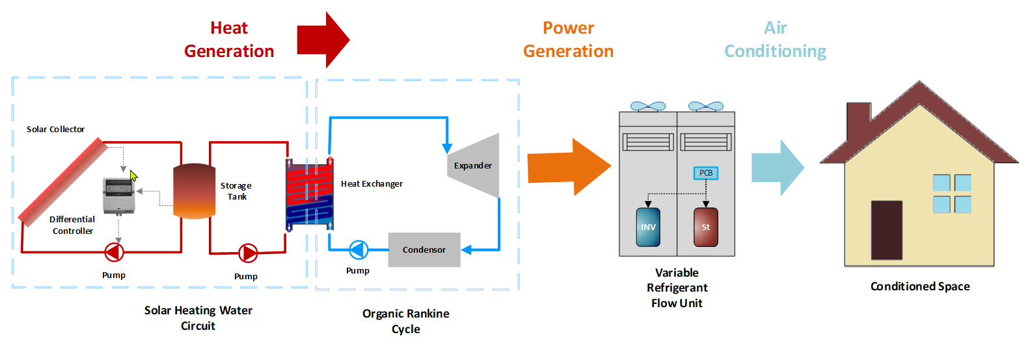
Fig. 1. A schematic diagram of the configuration of solar thermal collector driven organic Rankine cycle (ORC) utilized to power air-conditioning system of the two-story office building in Cyprus through VRF system.

Fig. 2 shows the interconnection of the above simulation tools. In the first phase, the building and its AC system are modeled, to obtain its yearly energy consumption. This energy is used to design the organic Rankine cycle with a constant work output so that it generates the same amount of work per year. By designing the organic Rankine cycle, its input heat is determined and is used to design the solar hot water system. In the last phase, the solar hot water system is designed such that it provides the heat required by the power generation cycle in phase two. The weather data for the chosen Mediterranean hot-arid climate location of Paralimni, Cyprus, employed on both Design-Builder and TRNSYS simulations, obtained from Meteonorm [40, 41], are listed in Table 1. It shows the summertime high air temperature and relative humidity values highlight the importance of an effective AC system in this area for maintaining indoor thermal comfort.
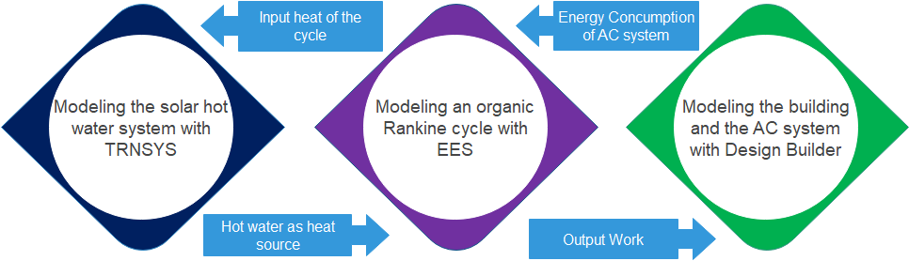

Fig. 2. Interconnected configuration of the simulation tools and the workflow of the present study.

Table 1: Mediterranean hot-arid climate location of Paralimni, Cyprus, data.
Location | Latitude  (ºN) | Yearly horizontal radiation intensity |  |  | Highest summer hourly ambient  temperature  (ºC) | Lowest winter hourly ambient temperature  (ºC) | Relative humidity in summer months (Highest average monthly)  (-)
 |  | Total  (kWh/m²) | Diffuse  (kWh/m²) | Diffuse/Total  (-)
Paralimni | 35 | 1,793 | 674 | 0.38 | 36.92 | 3.1 | 64%

2.2. Building design and constructional features
The building proposed as a two-story office building, surface dimensions of 456 m², is modeled in the software Design-Builder, as illustrated in Fig. 3. The building is north-south facing with 10.8 m² and 14.5 m² glazing in north and south facades, respectively. The constructional and front-facing windows features are detailed in Table 2 and Table 3, respectively. Each floor contains two small offices and one large common office area. It is presumed that the only place that is unoccupied is the ground floor. The corridors are unconditioned as the limiting parameter in the design to be focused on occupied spaces. In addition to the employed typical wall insulation, detailed in Table 2, the building construction is designed at low rates of infiltration, so the rate of fresh air exchange is taken as 0.5 ACH (Air changes per hour). The occupancy pattern of 8:00 AM to 4:00 PM is employed in the modeling, whilst the AC system is synchronized with the occupancy profile.

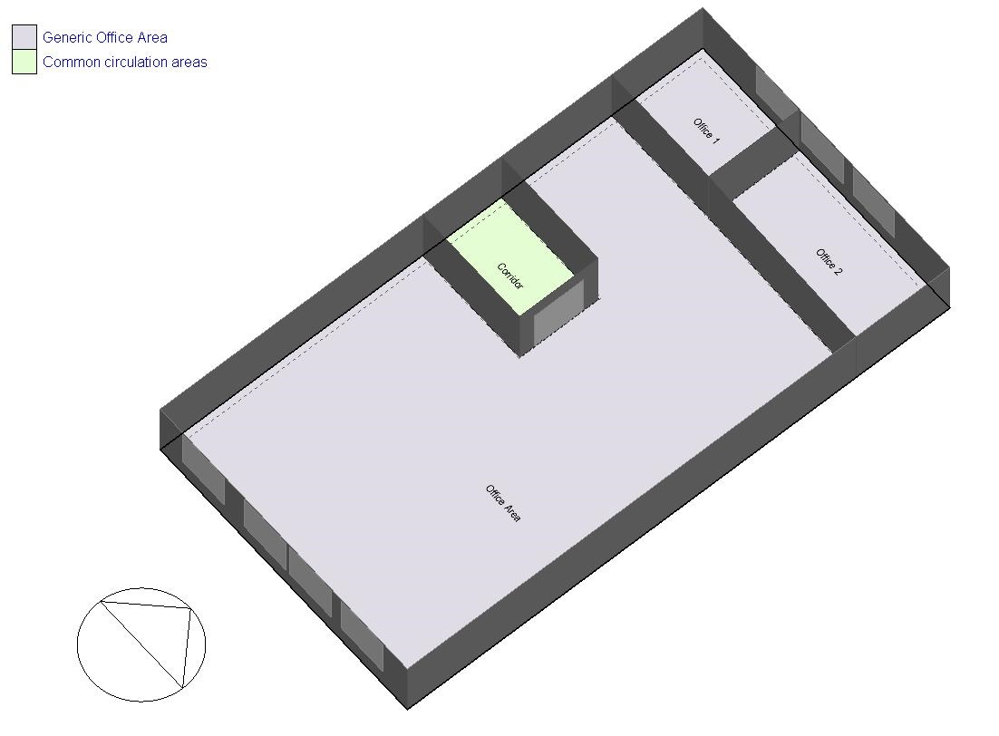
Fig. 3. An illustration of the office spacing of the two-story building, surface dimensions of 456 m², is modeled in the software Design-Builder.

Table 2: Building construction features
External Surface | Layer | Material | Thickness  (m) | Conductivity  (W/m.ºC) | Specific heat  (J/kg.ºC) | Density  (kg/m³)
Wall | 1 (Outermost layer) | Brickwork outer | 0.1 | 0.84 | 800 | 1700
 | 2 | XPS extruded polystyrene - CO₂ blowing | 0.079 | 0.034 | 1400 | 35
 | 3 | Concrete block (medium) | 0.1 | 0.51 | 1000 | 1400
 | 4 (Innermost layer) | Gypsum plastering | 0.013 | 0.4 | 1000 | 1000
Roof | 1 (Outermost layer) | Asphalt 1 | 0.01 | 0.7 | 1000 | 2100
 | 2 | MW glass wool (rolls) | 0.1445 | 0.04 | 840 | 12
 | 3  (not used in thermal calculations) | Air gap >=25mm | 0.3 | 0.18 | 1000 | 1000
 | 4 (Innermost layer) | Plaster board | 0.013 | 0.25 | 896 | 2800
Ground floor | 1 (Outermost layer) | Urea formaldehyde foam | 0.0869 | 0.04 | 1400 | 10
 | 2 | Cast concrete | 0.1 | 1.13 | 1000 | 2000
 | 3 | Floor/roof screed | 0.07 | 0.41 | 840 | 1200
 | 4 (Innermost layer) | Timber flooring | 0.03 | 0.14 | 1200 | 650

Table 3: Building front-facing windows features
Fenestration type | Glazing type | Total solar transmission (SHGC) (-) | Direct solar transmission  (-) | U-value  (W/m².ºC)
Double glazing, reflective, clear, internal blinds | Dbl Ref-A-L Clr 6mm/6mm Air | 0.154 | 0.05319 | 2.761

2.3. Simulation method of integrated energy setup
The Variable-Refrigerant-Flow (VRF) based heat pump system, fed by an outdoor unit, is proposed for both cooling and heating employed in six zones allocated to be air-conditioned, and its applied design out-door parameters are shown in Table 4. There are two compressors in the outdoor unit; one is on/off constant speed driven and another is variable speed driven regulated by the inverter. It should be noted that to accurately model a VRF system in Design-Builder, all system characteristic curves, such as cooling and heating power ratio curves, cooling and heating energy input ratio (EIR) curves, and so on, must be generated and used carefully and precisely based on the data and parameters given by the manufacturer. On the Design-Builder official website [42], a collection of spreadsheets is provided to assist the user in generating the necessary curves for any given VRF system.

Table 4: Applied designed VRF outdoor parameters.
Outdoor unit type | Gross rated cooling capacity  (kW) | Gross rated cooling  COP  (-) | Gross rated heating capacity  (kW) | Gross rated heating  COP  (-) | Number of compressors  (-) | The maximum outdoor temperature in cooling mode  (ºC) | The minimum outdoor temperature in heating mode  (ºC) | Condenser type
II | 42.2 | 4.38 | 47.5 | 4.4 | 2 | 50 | -25 | Air-cooled

Fig. 4 illustrates a schematic diagram of the organic Rankine cycle for which the working fluid is isobutene. The solar thermal system's water at 95°C provides the necessary input heat to the cycle. An internal heat exchanger is implemented after the turbine to recover part of the fluid thermal energy before it enters the condenser. The cycle generates constant work output for 8 hours a day and 260 days (all weekdays through the year). The total yearly net-work output of the organic Rankine cycle meets the total yearly energy consumption of the VRF system. Finally, a solar hot water system provides enough mass flow rate of water at the desired temperature of 95ºC to be used as the heat source in the organic Rankine cycle. To reach high temperatures of 95ºC, evacuated tabular collectors are used in the solar system. Considering the limited space available on the roof (265 m²), and maintaining enough space between collectors to avoid shading and allow maintenance, a maximum of 60 collectors could be installed on the roof practically.
Fig 4. Schematic diagram of the implemented organic Rankine cycle (ORC) with internal heat exchanger and hot water from the solar thermal system as the heat source.

Fig. 5 illustrates details of the solar thermal collector-based hot water system in TRNSYS and Table 5 lists the related information. The system is equipped with an electric heater to provide extra energy to the water outlet of the system when there is not enough solar energy available to raise the tank outlet temperature to 95ºC. This is the only external source of energy for the implemented solar-drive Organic Rankine Cycle. Minimizing this auxiliary energy is the ultimate goal of designing this solar power generation scheme. It is worth noting that the size of the storage tank influences system capacity, including the amount of auxiliary energy needed.

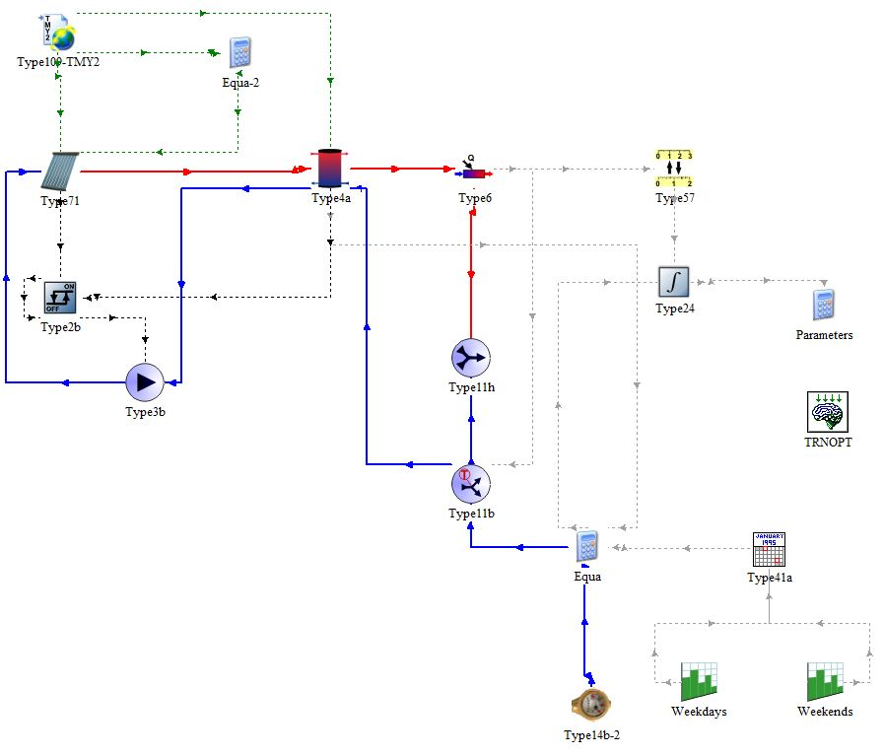
Fig. 5. The solar thermal collector-based hot water system in TRNSYS.

Table 5: Solar thermal collector based hot water system parameters
Parameter | Value
Collector type | Evacuated tube collector
Number of collectors | 60
Total aperture area (m²) | 47
Storage tank capacity (optimized) (m³) | 48
Total collector mass flow rate (kg/s) | 1.68
System output temperature (ºC) | 95

Thus, the simulation in TRNSYS uses the TRNOPT component (Figure 6) to connect to GenOpt Generic Optimization Program and minimizes the yearly auxiliary power requirement of the system by changing tank volume as the optimization variable. This value (47 m³) is inserted in Table 5. It is worthwhile to note that designing the solar hot water system is the last phase of designing the system and before this stage, mass flow rate and a temperature drop of the hot water leaving the solar system are determined, based on the design of the organic Rankine cycle.

2.4. Financial Saving
In the last section of this study, using the life cycle cost analysis (LCCA) method, the potential financial saving of the solar-driven organic Rankine cycle would be discussed. A review and description of the LCCA method can be found in [43-45]. The Net-Present Value (NPV) is calculated from Eq. (1) [46].
$$NPV=\sum_{t=1}^{n}{\frac{R_{t}}{(1+i)^{t}}}$$ | (1)
In which, $R_{t}$, $i$ and $t$ are net cash inflow-outflows during a single period, a discount rate of return that could be earned in alternative investment, and the number of periods, respectively. NPV was applied as of today’s value of the expected cash flows minus today’s value of invested cash.

3. Results and discussion

In this section, the energy consumption of the VRF air conditioning unit, power generation of the organic Rankine cycle, and performance of the solar hot water system are investigated.

3.1 Heating and cooling analysis of VRF AC System

Over the season, the VRF device was selected to keep the indoor temperature of all conditioned zones under a maximum 0.5°C variance from the cooling indoor setpoint temperature of 24°C.To achieve this, the region with the most heat gain must be used and the shared office area on the second floor is considered and its temperature variations in the day with the highest cooling sensible load (21st of August) is calculated and plotted in Fig. 6, along with outside dry-bulb and setpoint temperature profiles. The indoor temperature of the region with the greatest heat gain during the day is maintained at a set point temperature of 24°C, indicating that the VRF cooling system is capable of retaining the optimal indoor comfort temperature during the cooling season's peak hours. The direct normal and diffuse horizontal solar radiations on an hourly basis for the same day are shown in Fig. 7. During the day, high levels of solar irradiation are available, up to 0.65 kW/m², and the majority of the coming radiation is direct natural solar radiation. This observation suggests that devising any solar cooling system for this location is advantageous. Sensible cooling and cooling electricity of the building are shown in Fig. 8. The VRF system's sensible cooling load is not constant and changes during the day, which is the variable-capacity design of VRF systems explains this. The results show that the electrical power required for cooling is about 5 kW, while sensible cooling is approximately 23 kW, meaning that the average operating COP of the variable refrigerant flow system is almost as high as 4.6. The high efficiency and flexibility of this system are the reason for choosing it as the AC system of this low-energy building.
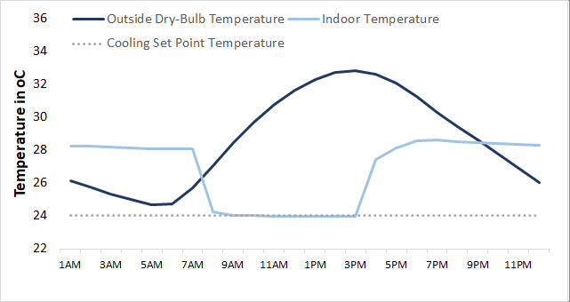
Fig. 6. Hourly indoor and outside temperature variations for the 21st of August (south-facing office area of 2nd floor)

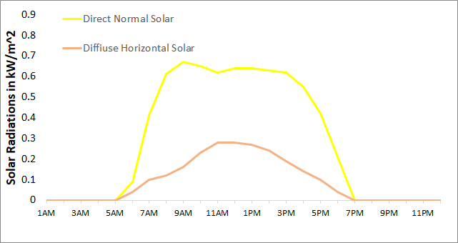
Fig. 7. Hourly solar radiation values for the 21st of August

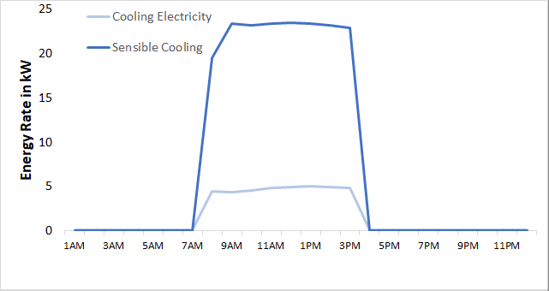
Fig. 8. Hourly sensible cooling and cooling electricity of the building for the 21st of August

Fig. 9 shows the constant high levels of solar radiation and the superiority of direct natural beam radiation. Hourly indoor and outdoor temperature variations for whole years are shown in Fig. 10. Relatively high ambient temperatures in wintertime accompanied with internal gains as lighting, people, and equipment for an office building, keep the indoor temperature much higher than the heating setpoint temperature of 18°C, and even on some occasions make the demand for cooling. As a result, in this application, providing a cooling effect is the main goal of the AC system. Comparing sensible cooling and heating loads in Fig.11 confirms this conclusion and it is all the year sensible cooling is present and dominant. Finally, the electricity consumption of the AC system throughout the year is shown in Fig. 12. It can be seen that while the maximum energy rate in summer nearly reaches up to 7 kW, the cooling effect of the system exceeds 30 kW, indicating a high operational COP of the system. Table 6 summarizes the annual information of the VRF system. The AC system consumes 7,909 kWh of electricity per year. This is the yearly work output expected from the organic Rankine cycle.
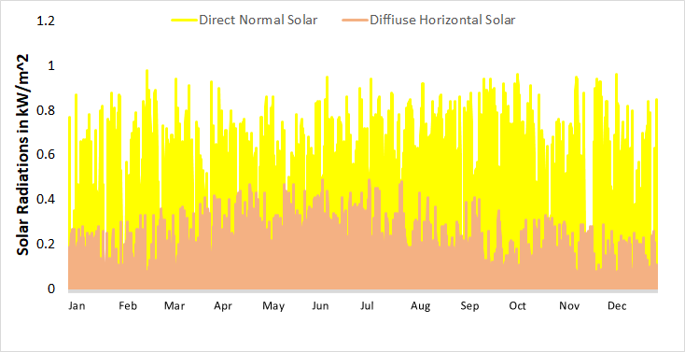
Fig. 9. Hourly solar radiation values for one year

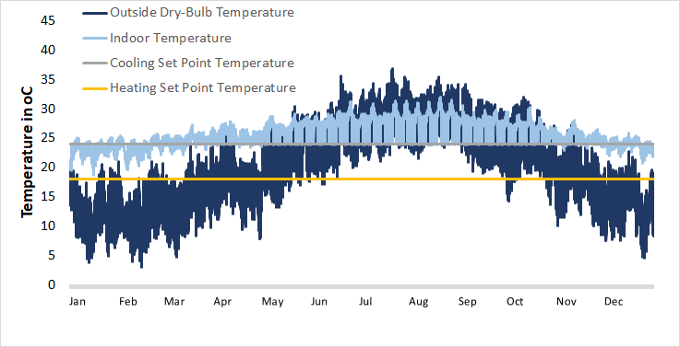
Fig. 10. Hourly Indoor and outside temperature variations for one year (south-facing office area of 2nd floor)

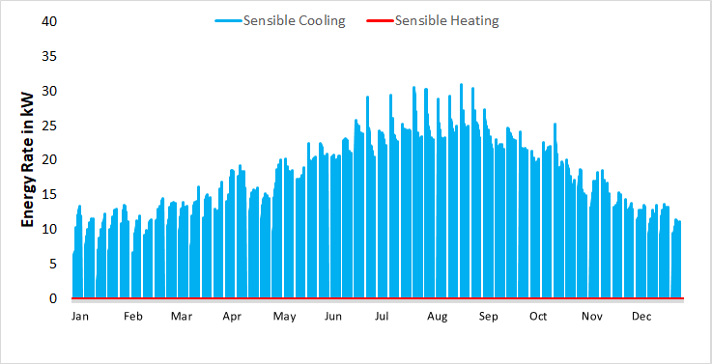
Fig. 11. Hourly sensible cooling and heating loads for one year

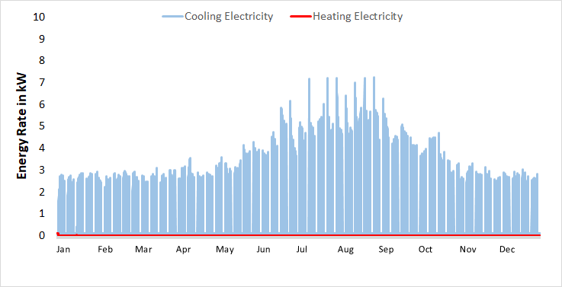
Fig. 12. Hourly cooling and heating electricity for one year
Table 6: Per Annum energy performance of the VRF
Maximum cooling rate  (kW) | Maximum heating rate  (kW) | Total cooling load  (kWh) | Total heating load  (kWh) | Total cooling and heating load  (kWh) | VRF electricity  (kWh)
30.96 | 0.03 | 34,685 | 0.12 | 24,390 | 7,909

3.2. Analysis with organic Rankine cycle
The yearly energy consumption of the AC system is 7,909 kW. The designed ORC with a constant rate of power generation should produce the same amount of energy per year. The AC and power generation systems operate 8 hours a day for 260 weekdays during the year. So the power generation rate of the cycle for 2,080 operation hours during the year should be nearly 3.8 kW. As it is shown in Fig. 4, an internal heat exchanger with an efficiency of 0.85 is implemented after the turbine so part of the thermal energy of the fluid exiting from the turbine is extracted before entering the compensator. This extracted heat is transferred to the fluid before its entrance to the evaporator and preheats it. This preheating results in lower energy requirements in the evaporator and lowers the load of the solar system. Table 7 determines the 6 thermodynamic states shown in Fig. 4 and Table 8 compares the performance of the simple organic Rankine cycle with the one equipped with an internal heat exchanger.

Table 7: Thermodynamic states of organic Rankine cycle with internal heat exchanger*
State | h (kJ/kg) | P (kPa) | T (K) | s (kJ/kg.K) | Description
1 | 115.1 | 500 | 315.5 | 0.3942 | Saturated
2 | 119.3 | 2500 | 316.5 | 0.3962 | Liquid
3 | 207.6 | 2500 | 350.8 | 0.6608 | Liquid
4 | 592.8 | 2500 | 412.1 | 1.66 | Superheated
5 | 532.6 | 500 | 356.8 | 1.702 | Superheated
6 | 444.3 | 500 | 315.5 | 1.438 | Saturated
* Refer to Fig. 4

Table 8: Organic Rankine cycle performance
Cycle | Mass flow rate (kg/s) | Input heat  (kW) | Efficiency  (-) | Net power output  (kW)
Simple | 0.07 | 33.14 | 0.12 | 3.92
Internal heat exchanger | 0.07 | 26.96 | 0.15 | 3.92

As demonstrated in Table 8, both cycles generate 3.92 kW, slightly more than the 3.8 kW is required to achieve the annual energy demand of the AC system. Adding the internal heat exchanger increase the efficiency slightly from 0.12 to 0.15. The cycle with the heat exchanger requires 26.96 kW heat input. This is the load that must be delivered by the solar system. Table 9 lists the yearly heat input and work output of the cycle. While the AC system consumes 7,909 kWh yearly, the power generation system provides 8,154 kWh per year, with 245 kWh extra energy available.

Table 9. Organic Rankine cycle yearly performance
Cycle | Input heat  (kWh) | Net power output  (kWh)
Internal heat exchanger | 56,077 | 8,154

3.3. Analysis with Solar Hot Water System

To generate 3.92 kW power output, the organic Rankine cycle needs 26.96 kW heating input power. This heating capacity is supplied by the solar thermal collector system. It is assumed that hot water leaves the solar system at 95ºC and returns at 40ºC, experiencing a 55ºC temperature drop. As a result, the mass flow rate of the hot water to the load is determined to be 0.117 kg/s. The power generation system should be able to provide an output at 8:00 AM when the AC system is turned on, so hot water at 95ºC must be available by then. To ensure this, the auxiliary heating system of the solar loop is set to start one hour earlier during weekdays, at 7:00 AM. AC system, power generation cycle, and solar loop all come to stop at 4:00 PM. As discussed earlier, the storage tank’s volume is varied to minimize the consumption of yearly auxiliary power.

Fig. 13 shows hourly heat transfer rates in the solar system. Part of solar useful energy gain is lost due to the tank thermal losses and some is used to change the internal energy of the tank’s content. The rest is delivered to the load. It is observed that almost always energy rate from the tank to the load is adequate and meets the calculated output heating rate of 26.96 kW demanded by the organic Rankine cycle, and very insignificant auxiliary power is required. In order to increase the visibility, auxiliary heating rates have been plotted on the right-hand side scale. Cumulative energy values in the solar system are shown in Fig. 14. Again, auxiliary heating has been plotted on the right-hand side scale to increase visibility. At the end of the year, the total energy delivered to the load by the tank reaches the value of 56,077 kWh of the total yearly input heat requirement of the power generation cycle. As a result, the solar system is providing the power generation cycle with its demanded input heat, with the insignificant auxiliary requirement.

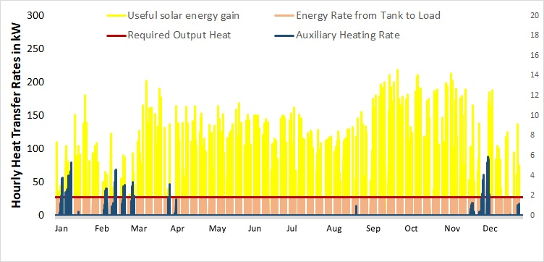
Fig. 13. Hourly heat transfer rates in the solar system for one year

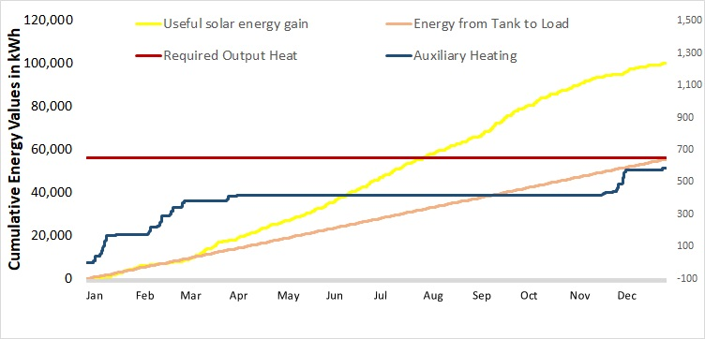
Fig. 14. Cumulative energy values in the solar system for one year

3.4. Solar-Driven Organic Rankine Cycle Air Conditioner
Table 10 summarizes the important results of previous sections and Fig. 15 shows the yearly energy flow in the designed solar-driven organic Rankine cycle air conditioner. The organic Rankine cycle needs 56,077 kWh to be operated. Which, 55,623 kWh of this heat is delivered by the solar system and the rest of 454 kWh is added to the system as the external source of energy input to the solar-driven organic Rankine cycle air conditioning system. The power generation cycle provides 8,154 kWh work output of which 7,909 kWh is consumed by the VRF system and 245 kWh is left as the system total work output. So, the system net energy input is equal to 454 kWh – 245 kWh = 209 kWh. This is the external energy that should be supplied to the system. Comparing this value with the original yearly energy consumption value of the VRF system, 7,909 kWh, indicates that the designed solar-driven organic Rankine cycle air conditioner satisfies 97% of the annual energy consumption of the VRF system and yields 7,700 kWh energy saving per year.

Fig. 15. Energy flow in the designed solar-driven organic Rankine cycle air conditioner

Table 10. Yearly energy values in the designed solar-driven organic Rankine cycle air conditioner
Solar system heat output  (kWh) | Auxiliary heating  (kWh) | Organic Rankine cycle input heat  (kWh) | Organic Rankine cycle work output  (kWh) | VRF energy consumption  (kWh) | Net work output  (kWh) | Net energy input  (kWh) | Energy saving  (kWh)
55,623 | 454 | 56,077 | 8,154 | 7,909 | 245 | 209 | 7,700

3.5. Financial cost-saving analysis

In this section, the potential financial saving of the solar-driven organic Rankine cycle is discussed. The system saves 7,700 kWh of energy per year. Taking Cyprus's electricity price for business applications 0.261 USD/kWh [46], utilizing this system would save 2,010 USD yearly. The total financial saving of this project could be estimated using the LCCA (Life-Cycle-Cost-Analysis) method. In this project, the aim is to invest money to purchase a commercial organic Rankine cycle package plus the solar system and save electricity costs in return. Considering 2,010 USD yearly capital saving as the reward of investment on this system, and defining a 20-year project and using the parameters listed in Table 11, the net present value of the capital saving due to implementation of solar-driven power generation system at the end of the project’s lifetime would be 25,049 USD. This figure could be a basis for pricing a commercial organic Rankine cycle that added with the costs of installing the solar system, making the scheme financially feasible. Yet, it should be emphasized that the prime goal of proposing this system is to provide low-cost or free air conditioning for all year for this country, with its high demands for thermal comfort at low costs.

Table 11: Parameters and information for economic analysis
Parameter | Value | Reference
Electricity tariff ($/kWh) | 0.261 | [46]
Annual discount rate (%) | 5 | [1]
System expected lifetime (years) | 20 | -

4. Conclusions
In this research, the configuration of solar thermal collector driven organic Rankine cycle (ORC) utilized to power air-conditioning system of the two-story office building in Paralimni, Cyprus, through VRF system is investigated. The reason to choose this Mediterranean climate of Paralimni, Cyprus, is due to its higher dependency on fossil fuels compared to many other countries in the EU and with a high potential of harnessing solar irradiations. In this climate, the annual surface irradiation rate is 1,793 kWh/m² whilst the air-conditioning (AC) requirement is equal to 7,909 kWh for a two-story building. The VRF method was chosen with caution, allowing for a maximum deviation of 0.5°C from the setpoint indoor climate. The employed organic Rankin cycle with an internal heat exchanger is designed with a constant output rate of 3.920 kW. The power generation cycle delivers a total of 8,154 kWh yearly. The required heat input of the ORC is supplied by a solar hot water system, employing evacuated tube collectors. Because of the small space on the roof, the maximum number of collectors possible, 60, was used in this analysis. The solar thermal system consumes a 454 kWh auxiliary heating rate per year to deliver the desired mass flow rate and outlet temperature for the ORC. As a result, the designed solar-driven organic Rankin cycle delivers a net of (8,154 – 454) kWh = 7,700 kWh output energy each year, meaning 7,700 kWh energy saving per year, equal to 97% of VRF annual energy demand. This amount of yearly energy saving yields 2,010 USD yearly capital saving as the reward of investment in this system, and defining a 20-year project, the implementation of this solar-driven power generation system at the end of the project’s lifetime would save 25,049 USD. This amount could be a bias for pricing the commercial ORC packages so the total saving of the project could offset the initial and operational costs of installing such packages in similar projects. The results implicate that this system configurated scheme is a technically practical approach for low cost or free air conditioning for all year for this country, with its high demands for thermal comfort at low costs. Less power demand of AC system not only reduces the energy cost for the end-user but also means less CO₂ emission and contribution in elevating the global warming challenge. As a result, combining a VRF air conditioner with solar power generation systems can not only provide people with a fair level of comfort and wellbeing, but it can also help to reduce Cyprus’s electricity import dependence.

References

- H. Kariman, S. Hoseinzadeh, A. Shirkhani, P. S. Heyns, and J. Wannenburg, "Energy and economic analysis of evaporative vacuum easy desalination system with brine tank," Journal of Thermal Analysis and Calorimetry, vol. 140, no. 4, pp. 1935-1944, 2020.
- S. Hoseinzadeh, M. Hadi Zakeri, A. Shirkhani, and A. J. Chamkha, "Analysis of energy consumption improvements of a zero-energy building in a humid mountainous area," Journal of Renewable and Sustainable Energy, vol. 11, no. 1, p. 015103, 2019.
- A. Ahmadi et al., "Energy, exergy, and economic analyses of integration of heliostat solar receiver to gas and air bottom cycles," Journal of Cleaner Production, vol. 280, p. 124322.
- S. Memon, M. Mihreteab, T. Katsura, A. Radwan, S. Zhang, A.A. Serageldin, E.M. Abo-Zahhad, Experimental and Theoretical Performance Evaluation of Parabolic trough Mirror as Solar Thermal Concentrator to Thermoelectric Generators, Int. J. Sol. Therm. Vac. Eng. 1 (2020) 22–38. https://doi.org/10.37934/stve.1.1.2238.
- A. Radwan, T. Katsura, S. Memon, E.M. Abo-Zahhad, O. Abdelrehim, A.A. Serageldin, M.R. Elmarghany, A. Khater, K. Nagano, Development of a new vacuum-based photovoltaic/thermal collector, and its thermal and exergy analyses, Sustain. Energy Fuels. 4 (2020) 6251–6273. https://doi.org/10.1039/d0se01102a.
- A. Radwan, T. Katsura, S. Memon, E.M. Abo-Zahhad, A.A. Serageldin, K. Nagano, Analysis of a vacuum-based photovoltaic thermal collector, Energy Reports. 6 (2020) 236–242. https://doi.org/10.1016/j.egyr.2020.11.255.
- S. A. Makkeh, A. Ahmadi, F. Esmaeilion, and M. Ehyaei, "Energy, exergy and exergoeconomic optimization of a cogeneration system integrated with parabolic trough collector-wind turbine with desalination," Journal of Cleaner Production, p. 123122, 2020.
- S. Hoseinzadeh and R. Azadi, "Simulation and optimization of a solar-assisted heating and cooling system for a house in Northern of Iran," Journal of Renewable and Sustainable Energy, vol. 9, no. 4, p. 045101, 2017.
- H.-L. Tsai, "Modeling and validation of refrigerant-based PVT-assisted heat pump water heating (PVTA–HPWH) system," Solar Energy, vol. 122, pp. 36-47, 2015.
- L. Zhu, J. Yu, M. Zhou, and X. Wang, "Performance analysis of a novel dual-nozzle ejector enhanced cycle for solar assisted air-source heat pump systems," Renewable energy, vol. 63, pp. 735-740, 2014.
- Y. Yerdesh, Z. Abdulina, A. Aliuly, Y. Belyayev, M. Mohanraj, and A. Kaltayev, "Numerical simulation on solar collector and cascade heat pump combi water heating systems in Kazakhstan climates," Renewable Energy, vol. 145, pp. 1222-1234, 2020.
- L. Semple, R. Carriveau, and D. S.-K. Ting, "A techno-economic analysis of seasonal thermal energy storage for greenhouse applications," Energy and Buildings, vol. 154, pp. 175-187, 2017.
- R. H. E. Hassanien, M. Li, and Y. Tang, "The evacuated tube solar collector assisted heat pump for heating greenhouses," Energy and Buildings, vol. 169, pp. 305-318, 2018.
- S. Hasan, M. E. Khan, and M. Parvez, "Experimental analysis of a solar thermal hybrid VRF system for maximum energy economy based on Delhi (India) climate," Energy Sources, Part A: Recovery, Utilization, and Environmental Effects, pp. 1-14, 2019.
- E. Bellos and C. Tzivanidis, "Parametric Investigation of a Trigeneration System with an Organic Rankine Cycle and Absorption Heat Pump Driven by Parabolic Trough Collectors for the Building Sector," Energies, vol. 13, no. 7, p. 1800, 2020.
- S. Poppi, N. Sommerfeldt, C. Bales, H. Madani, and P. Lundqvist, "Techno-economic review of solar heat pump systems for residential heating applications," Renewable and Sustainable Energy Reviews, vol. 81, pp. 22-32, 2018.
- A. Baral, R. N. Bhattarai, and A. K. Jha, "Life Cycle Cost Analysis of Hybrid Solar Thermal VRF System for Space Conditioning: A Case Study of Hall in Dhunche," in Proceedings of IOE Graduate Conference, 2019.
- D. Carbonell, M. Y. Haller, D. Philippen, and E. Frank, "Simulations of combined solar thermal and heat pump systems for domestic hot water and space heating," Energy Procedia, vol. 48, pp. 524-534, 2014.
- H. Yu, T. Gundersen, and X. Feng, "Process integration of organic Rankine cycle (ORC) and heat pump for low temperature waste heat recovery," Energy, vol. 160, pp. 330-340, 2018.
- Mateu-Royo, A. Mota-Babiloni, J. Navarro-Esbrí, B. Peris, F. Moles, and M. Amat-Albuixech, "Multi-objective optimization of a novel reversible High-Temperature Heat Pump-Organic Rankine Cycle (HTHP-ORC) for industrial low-grade waste heat recovery," Energy Conversion and Management, vol. 197, p. 111908, 2019.
- A. Yang, Y. Su, W. Shen, I.-L. Chien, and J. Ren, "Multi-objective optimization of organic Rankine cycle system for the waste heat recovery in the heat pump assisted reactive dividing wall column," Energy Conversion and Management, vol. 199, p. 112041, 2019.
- R. A. Raustad, "A variable refrigerant flow heat pump computer model in EnergyPlus," Univ. of Central Florida, Orlando, FL (United States), 2013.
- J. Wang, Z. Yan, M. Wang, S. Ma, and Y. Dai, "Thermodynamic analysis and optimization of an (organic Rankine cycle) ORC using low grade heat source," Energy, vol. 49, pp. 356-365, 2013.
- Scharrer et al., "Life Cycle Assessment of a Reversible Heat Pump–Organic Rankine Cycle–Heat Storage System with Geothermal Heat Supply," Energies, vol. 13, no. 12, p. 3253, 2020.
- A. Yılmaz, "Transcritical organic Rankine vapor compression refrigeration system for intercity bus air-conditioning using engine exhaust heat," Energy, vol. 82, pp. 1047-1056, 2015.
- K. Li, J. Yu, M. Liu, D. Xu, L. Su, and Y. Fang, "A Study of Optimal Refrigerant Charge Amount Determination for Air-Conditioning Heat Pump System in Electric Vehicles," Energies, vol. 13, no. 3, p. 657, 2020.
- Y. Jiang, T. Ge, and R. Wang, "Performance simulation of a joint solid desiccant heat pump and variable refrigerant flow air conditioning system in EnergyPlus," Energy and buildings, vol. 65, pp. 220-230, 2013.
- W. Goetzler, "Variable refrigerant flow systems," Ashrae Journal, vol. 49, no. 4, pp. 24-31, 2007.
- B. L. Guptaa, Performance Enhancement of Refrigeration System using Peltier Module. International Journal of Current Engineering and Technology, 2011 doi:10.14741/ijcet/22774106/spl.4.2016.5
- A. Arabkoohsar, "Combination of air-based high-temperature heat and power storage system with an Organic Rankine Cycle for an improved electricity efficiency," Applied Thermal Engineering, vol. 167, p. 114762, 2020.
- S. A. Mousavi Maleki, H. Hizam, and C. Gomes, "Estimation of hourly, daily and monthly global solar radiation on inclined surfaces: Models re-visited," Energies, vol. 10, no. 1, p. 134, 2017.
- G. d. N. P. Leite, F. Weschenfelder, A. M. Araújo, Á. A. V. Ochoa, N. d. F. P. Neto, and A. Kraj, "An economic analysis of the integration between air-conditioning and solar photovoltaic systems," Energy conversion and management, vol. 185, pp. 836-849, 2019.
- K. Engelbrecht, C. R. H. Bahl, and K. K. Nielsen, "Experimental results for a magnetic refrigerator using three different types of magnetocaloric material regenerators," International Journal of refrigeration, vol. 34, no. 4, pp. 1132-1140, 2011.
- M. S. Todorovic and J. T. Kim, "In search for sustainable globally cost-effective energy efficient building solar system–Heat recovery assisted building integrated PV powered heat pump for air-conditioning, water heating and water saving," Energy and buildings, vol. 85, pp. 346-355, 2014.
- M. Damianos. "Mondaq." https://www.mondaq.com/ (accessed May, 2020).
- REN21. "Renewable 2019 Global Status Report." https://www.ren21.net/ (accessed May, 2020).
- "Global Solar Atlas." https://globalsolaratlas.info/map (accessed May, 2020).
- H.A. Gilani, S. Hoseinzadeh, H. Karimi, A. Karimi, A. Hassanzadeh, D.A. Garcia, Performance analysis of integrated solar heat pump VRF system for the low energy building in Mediterranean island, Renew. Energy. 174 (2021) 1006–1019. https://doi.org/10.1016/j.renene.2021.04.081.
- J. Remund et al., "Meteonorm handbook part I: software," Version, vol. 7, pp. 1-55, 2014.
- TROLL and K. PAFFEN, "Jahreszeitenklimate der Erde. Maßstab 1: 80 000 000," ed: Berlin, 1969.
- Design Builder. "VRF Curve Generation Utilities."
https://designbuilder.co.uk/download/release-software (accessed May, 2020).
- C. O. Okoye, O. Taylan, and D. K. Baker, "Solar energy potentials in strategically located cities in Nigeria: Review, resource assessment and PV system design," Renewable and Sustainable Energy Reviews, vol. 55, pp. 550-566, 2016.
- C. O. Okoye and O. Solyalı, "Optimal sizing of stand-alone photovoltaic systems in residential buildings," Energy, vol. 126, pp. 573-584, 2017.
- C. O. Okoye and B. C. Oranekwu-Okoye, "Economic feasibility of solar PV system for rural electrification in Sub-Sahara Africa," Renewable and Sustainable Energy Reviews, vol. 82, pp. 2537-2547, 2018.
- "Investopedia." https://www.investopedia.com/ accessed October 2020.
- GlobalPetrolPrices."Electricity prices."
https://www.globalpetrolprices.com/electricity_prices/ (accessed June, 2020).
- Photius. "Central bank discount rate (%) 2019 Country Ranks, by Rank." https://photius.com/rankings/2019/economy/central_bank_discount_rate_2019_0.html (accessed June, 2020).

