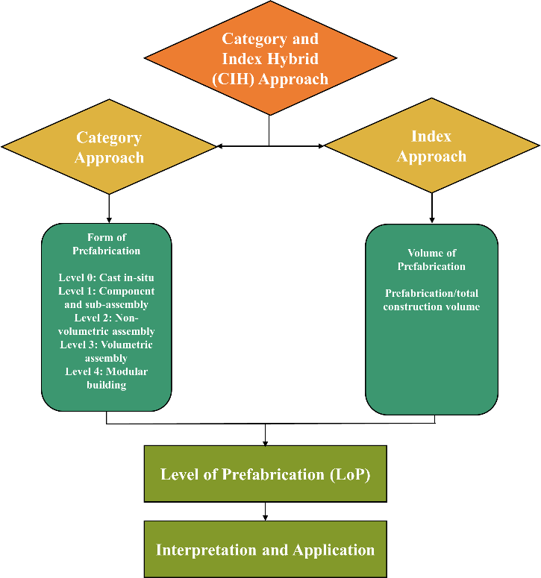

Figure 1: Proposed CIH Approach for Measuring LoP

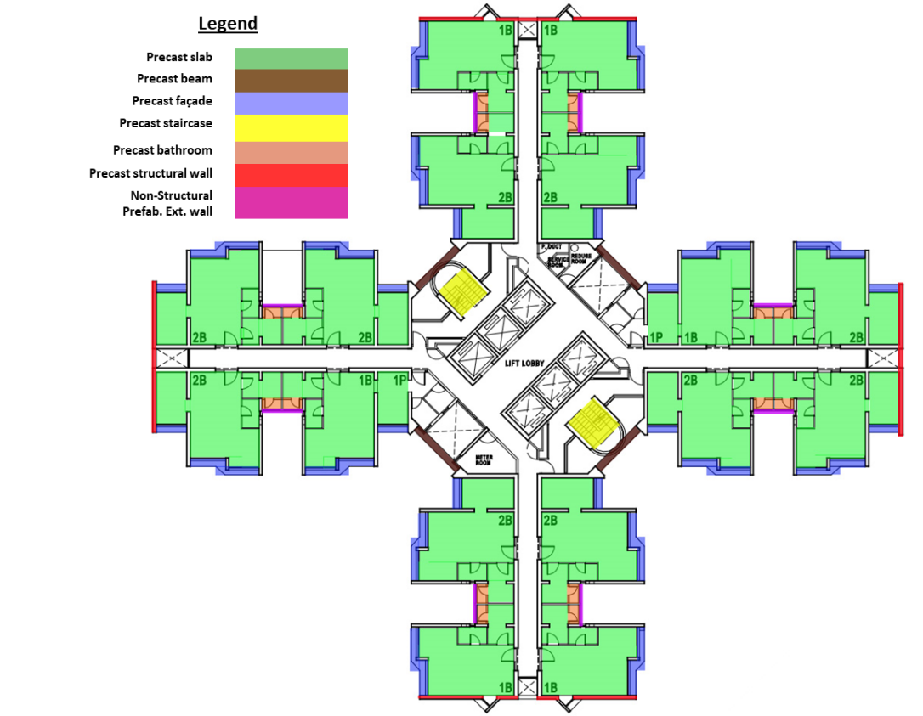
Figure 2: Construction floor plan of a selected high-rise building project and its precast components adopted

Figure 3: stacked Column Figure for Evaluating Data from CIH Approach.

