Biological Basis to Child Health: The Skin

Kate Davies RN (Child), Dip HE, BSc (Hons), MSc, PGCert, PGDip
Children’s Advanced Nurse Practitioner
Senior Lecturer in Non Medical Prescribing
London South Bank University
Honorary Research Fellow in Paediatric Endocrinology
Queen Mary University of London / Barts and The London NHS Trust

Catherine Hewitt (RN Child), MSc.
Senior Lecturer in Children’s Nursing
London South Bank University

Abstract
This CPD article focusing on the skin is the nth article in the Biological Basis to Child Health series. It will focus on how the skin develops, the function, and explore different dermatological conditions which affect infants, children and hereditary skin conditions, and rashes commonly seen in childhood. Treatment will be discussed alongside the role of the children’s nurse in educating children, young people and their families.

Keywords
Skin, Protection, Vitamin D, Newborn, Temperature, Rash, Steroids

Aims and Outcomes
After reading this article and completing the Time Out exercises, you will have a more in-depth understanding of the skin and commonly seen dermatological conditions, by:
- Explaining the functions of the skin
- Reviewing commonly seen skin conditions in the newborn infant and baby
- Summarising hereditary skin disease and the impact on the child and the family
- Identifying features of different rashes and the nursing implications
- Discussing the impact of topical steroid treatment

Introduction
The integumentary system is formed by skin and several skin appendages, such as glands, hair, nails, and teeth. The skin covers the whole outer surface of the body and is the largest organ in the body, providing protection from mechanical impacts and pressure, variations in temperature, micro-organisms, radiation and chemicals. The structure and functions of the skin are vital to an individual’s overall health and well-being.

Embryology of the Skin
Gastrulation around day 14 after conception (Webster & de Wreede, 2016) produces three germ layers – the ectoderm, mesoderm and endoderm. After this process, the embryonic surface emerges as a sole layer of neuroectoderm, which ultimately develops into the nervous system and skin epithelium. The skin develops through a process of proliferating cells that by the end of the 11th week affords the fetus three layers of covering. The third and middle layer of the skin includes basal kerationocytes, which regulate the future production of melanin and the resultant pigmentation of the skin. By month five additional skin layers have developed (see Figure 1) and this facilitates the development of downy hair and sebum, that necessary to lubricate the skin. Vernix is a thick, white, creamy biofilm that is produced by the vernix caseosa and which helps build the new born infant’s protective skin barrier. Vernix should remain on the baby’s skin at birth, with bathing being delayed by at least six hours (Visscher & Narendran, 2014).

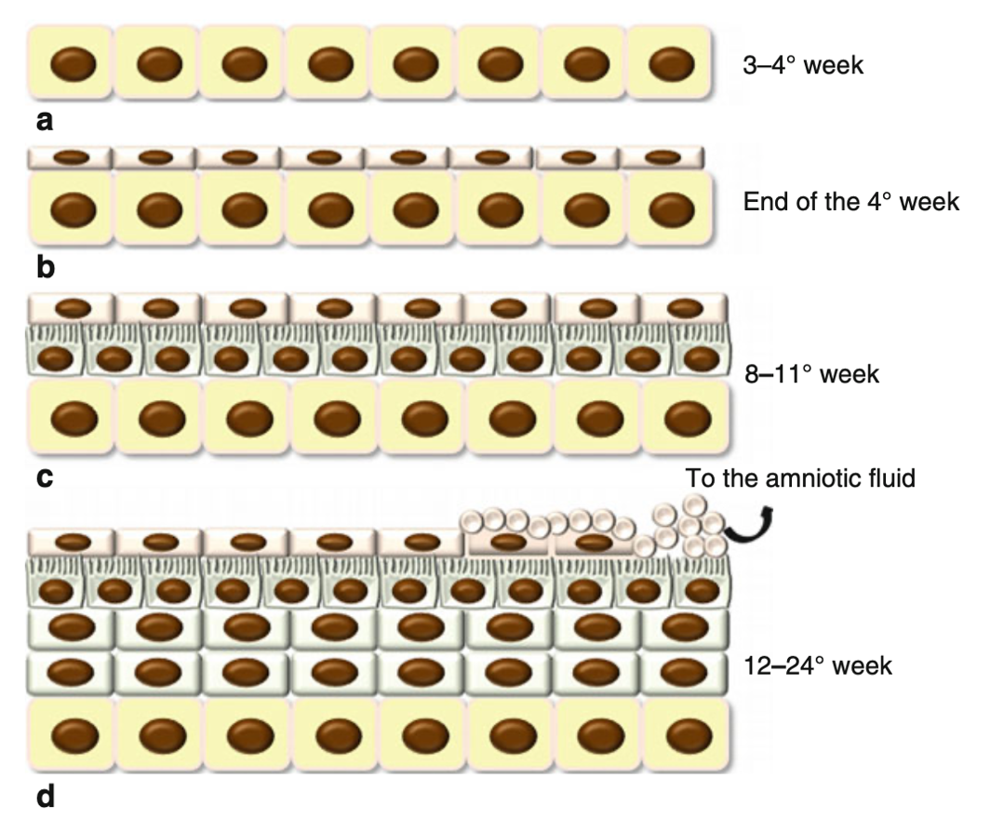

Figure 1: Development of the Epidermis (De Falco, Pisano, & De Luca, 2014)

Skin Structure
The skin is formed of 3 main layers, and each layer contains cells that represent progressive layers of skin cell differentiation and function as the skin grows (De Falco et al., 2014)

Epidermis:
This outermost, defensive layer of skin, provides a waterproof barrier and creates our skin tone. There are no blood vessels or nerve endings here, however there is interstitial fluid from the dermis which provides nutrients and oxygen and also drains away as lymph. The basal cells of the epidermis undergo proliferation cycles that provide for the renewal of the outer epidermis. The epidermis is divided into five layers:
- stratum germinativum (basal layer)
- stratum spinosum
- stratum granulosum
- stratum lucidum, and
- stratum corneum, which is most superficial.

Keratinocytes produce keratin, a protein that gives hair, nails, and skin their hardness and water-resistant properties, therefore protecting underlying structures. They are the main cells of the epidermis formed in the basal level and as they move they gradually die and become flattened. The epidermis has three additional cells that facilitate functional characteristics: melanocytes, Langerhans and Merkel cells. Melanocytes synthesize and secrete melanin that protects against UV radiation and gives skin its colour.
Langerhans cells protect by keeping dangerous antigens from entering the body.
Merkel cells are associated with touch receptors which function as slowly adapting mechanoreceptors that mediate the senses of touch and hair movement (Gormley-Fleming, 2015)

Dermis:
The dermis is 1-4mm thick and sits beneath the epidermis (McCance & Huether, 2018). It contains tough connective tissue, and the matrix contains collagen fibres, interlaced with elastic fibres. The disorganised arrangement of connective tissue allows the skin to be moveable and stretch when the body moves. Structures found in the dermis are blood and lymph vessels, nerves, hair follicles and sweat glands (Waugh & Grant, 2018). Some blood-borne cells, such as lymphocytes, plasma cells, and leukocytes, enter the dermis in response to stimuli (McCance & Huether, 2018). The cells within the dermis include mast cells, which release histamine and play a role in hypersensitivity reactions of the skin. The fibroblasts secrete the connective tissue matrix and collagen and are responsible for generating connective tissue and plays a critical role in wound healing.

Subcutaneous layer (hypodermis):
The deeper subcutaneous tissue (hypodermis) is made of fat and connective tissue and is situated below the dermis , and it connects the skin to the underlying fascia (fibrous tissue) of the bones and muscles. Like the dermis, the layer contains blood vessels and nerves, and also a layer of fat. This layer of fat works alongside the blood vessels to maintain an appropriate body temperature, and acts as insulation and cushioning for internal organs, muscles, and bones. (Som, Laitman, & Mak, 2017)

Functions of the Skin

Protection
The first line of defence, the skin protects the body from harmful ultraviolet (UV) rays, trauma, infection, dehydration and chemicals. In the epidermis, Langerhans cells protect against intruding antigens by phagocytosis, which triggers an immune response. Sensory nerve endings in the dermis permit responses to the external environment, including withdrawal to unpleasant or painful stimuli, enabling protection from additional injury. The pigment melanin protects the skin against the UV rays, (Waugh & Grant, 2018) although exposure to sunlight promotes melanin synthesis.

Regulation of body temperature
Temperature regulation is a major function of the skin and is controlled by the hypothalamus. Core body temperature is normally around 36.8 degrees centigrade, with usually a 0.5-0.75-degrees difference (Waugh & Grant, 2018).
Babies and young children have a higher body temperature than older children, due to their body surface area being larger in relation to their body weight and they have less subcutaneous tissue, alongside a more active metabolism. Newborns usually have an average body temperature of 37.5°C. To maintain this constant temperature, the body has a range of complex mechanisms to ensure thermoregulation is a priority. A negative loop system (Figure 2) regulates the balance of heat loss and gain to the environment to maintain a constant temperature. The regulation of body temperature does not always work perfectly in younger children, which is why they are more likely to react with a fever.

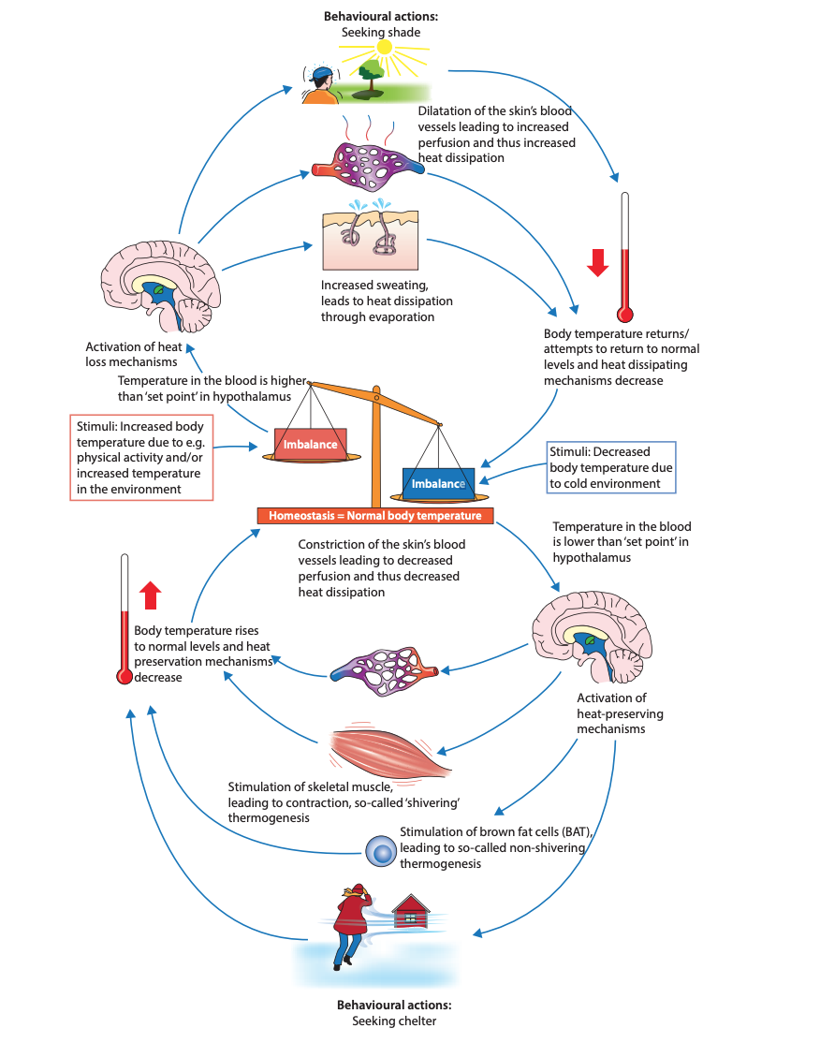

Figure 2: Thermoregulation (Grodzinsky & Sund Levander, 2020)

In order to maintain this temperature, ‘heat loss from the body must equal heat gained from the body’ (Glasper, Coad, & Richardson, 2015). Heat loss mechanisms include:
- Radiation – Transfer of heat to cooler solid objects not in direct contact with the body.
- Evaporation – When the body cools, as the body heat converts the water in sweat to a water vapour.
- Conduction - Transfer of heat from one solid object to another solid object in direct contact with it, for example sitting on a metal chair, the heat from the body would transfer to the cold metal chair.
- Convection - Transfer of heat from the body surface to the surrounding air via air current, for example the use of a fan to cool the body (Waugh & Grant, 2018).

Heat production involves an increase in metabolic rate, and the most active organs will produce the most heat, involving:
- Contraction of the muscles – the more strenuous the muscular exercise, the more heat is produced. Shivering – rapid muscle contractions and relaxation – increases heat production. Newborn’s shivering responses are immature: it is therefore imperative to dry and keep the newborn warm after birth (Peate & Gormley-Fleming, 2015). Lipolysis of ‘brown fat’ adipose tissue is the only source of heat directly after birth, which is located at the nape of the neck, interscapular region, axillae, groin and around the kidneys and adrenals (Figure 3).
- The liver is active metabolically and therefore generates considerable heat production.
- During peristalsis, the digestive organs also generate heat, alongside digestive chemical reactions.

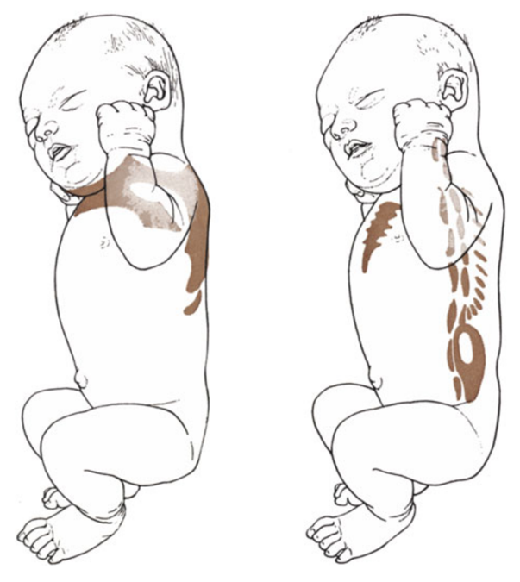

Figure 3: The main brown fat locations in a newborn (Lidell, 2019).

TIME OUT 1
Consider clinical situations with a high risk of temperature loss in newborns. What methods could you undertake to prevent hypothermia after birth? How would you explain this to parents?

Wound healing
Skin integrity needs to be restored quickly if an injury is sustained, in order to maintain its functions. Even though a full term infant’s skin is structurally similar to an adults, a baby has only a little more than half the dermal thickness of an adult’s, and children tend to have more vulnerable skin than adults (UK, 2014). The four main stages in the wound healing process are seen in Figure 4.

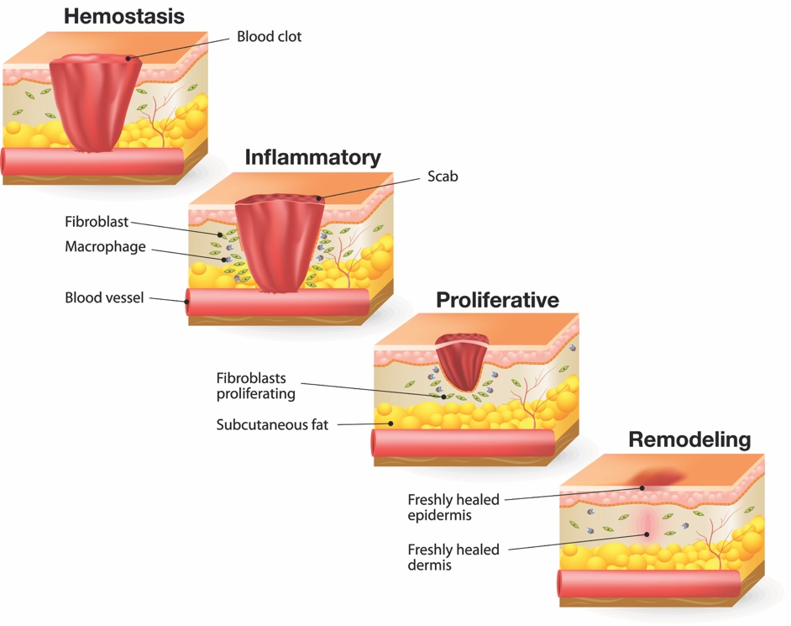

Figure 4: The wound healing process

Vitamin D Synthesis
The skin plays an active role in Vitamin D synthesis from ultraviolet radiation from sunlight. As well as sunlight, other sources of Vitamin D are from our diet, or Vitamin D supplementation. In the United Kingdom (UK), the Ultra Violet B (UVB) rays from the sun are only strong enough to promote Vitamin D synthesis between the hours of 1000 – 1500, between the months of April to October (Musson & Collin, 2015). 20% of the body should be exposed for 20 minutes three times a week during these months prior to sunscreen application: Vitamin D synthesized during this time can then subsequently be stored in the remaining winter months.

UVB rays do not penetrate well into people with a darker skin colour, so they tend to need 3 – 6 times more longer sun exposure (Chan, Milner, White, & Musson, 2019). UVB also does not penetrate through clothing, so individuals covering themselves due to cultural or religious values are also at a higher risk of Vitamin D deficiency. It has been identified that there is an increased incidence of Vitamin D deficiency in UK Asian families, resulting in Vitamin D deficient children, particularly if they are breast fed (Shaw & Pal, 2002).

Keratinocytes are a source of Vitamin D, and are the only cells in the body which can convert Vitamin D into a form (Cholecalciferol) that can be processed by the liver (Umar et al., 2018).

Cholecalciferol is then modified by an enzyme (25-Hydroxylase) which converts it into Calcidol, which is the measured form in the blood (Mostafa & Hegazy, 2015). It is then stored in the liver and fat cells: when it is needed, it is finally converted in the kidney by 1 alpha hydroxylase into its active form in the blood: 1,25 Vitamin D (1,25(OH)D), or Calcitriol.

TIME OUT 2
Visit now the following website to explore what you might need to explain to parents about the need for Vitamin D production within their children. What within the website could be shared directly with the parent and what do you think needs explaining?

https://www.nhs.uk/news/food-and-diet/the-new-guidelines-on-vitamin-d-what-you-need-to-know/
Newborn Skin Conditions
Haemangioma
Infantile haemangiomas are the most common benign tumours in infancy (Chowdhury, Katugampola, & Finlay, 2013), with a prevalence of around 5%, but they are more common in low birthweight babies, decreased gestational age, where the incidence can be as high as 23% in premature babies (Léauté-Labrèze, Harper, & Hoeger, 2017), in females, and in multiple births. At birth, they can present as a ‘precursor lesion’, with a vasoconstricted patch, a bruise like macule, or well demarcated bright red plaques, which usually affect the face, but other parts of the skin or organs can be affected (see Figure 8)(British Association of Dermatologists - (BAD, 2017). About 50% of haemangiomas regress by 5 years of age, and the remainder by age 10 years (Chowdhury et al., 2013). Because of this, the majority do not require treatment; however, more severe cases are at risk of ulceration, disfigurement, or some degree of functional impairment, depending on the site of the haemangioma and require specialist treatment (Luu & Frieden, 2013).

‘Mongolian Blue Spot’
This is now clinically known as ‘congenital dermal melanocytosis’, although the phrase Mongolian blue spot is still commonly used. The ‘spot’ is a blue/grey or blue/green patch over the sacrogluteal area, and is seen in newborns in Asian or Afro-Caribbean origin (Chowdhury et al., 2013). They result from the presence of melanocytes in the lower dermis, that failed to migrate from the neural crest to the epidermal layer in the embryological stages, although recent studies suggest they can be due to inborn errors of metabolism (Zhong, Huang, & Nambudiri, 2019). They usually fade in early childhood and need no treatment (Larralde & Abad, 2020).

Milia (‘milk spots’)
Milia (figure 10) are small yellow/white keratinous cysts, found in around half of healthy newborns, and are usually present at birth, although they can develop later in premature infants. They are smooth surfaced papules, commonly found on the cheeks, forehead and nose, but can also be found elsewhere, for example, the upper trunk, arms and legs, penis or mucous membranes (Patrizi, Neri, Virdi, & Gurioli, 2016). The cysts are the result of keratin being retained within the dermis, which then blocks the pores. They usually disappear within a few weeks, requiring no intervention, and leave no scarring.

Nappy Rash (‘diaper dermatitis’)
It takes around one year for an infant’s skin to develop full protective function (Lumbers, 2019). Due to the wetness of a nappy, the barrier function of the wet skin is destroyed, so irritants to the skin are easier to penetrate through. Irritants include urine and faeces (Lissauer & Carroll, 2017), with Candida Albicans (‘thrush’) potentially isolated in around 80% of affected babies (Kutlubay et al., 2017). Initial damage is seen as red, unbroken skin but if not treated, can become more red, cracked and bleed (Lissauer & Carroll, 2017). Protective emollients can be used, and sometimes topical steroid creams may be needed in more severe cases. Advice to parents is to change a nappy as soon as their baby has passed urine or defecated: younger babies need changing around twelve times a day, whereas older babies may only need changing up to eight times a day (NHS, 2018).

Hereditary Skin Conditions
There are many inherited skin conditions, such as Ichthyosis (“ick-thee-o-sis”) which presents as cutaneous scaling (Craiglow, 2013). There are varying types of inherited ichthyosis, encompassing a wide range of keratinizing disorders (Vahlquist, Ganemo, & Virtanen, 2008) but the most common is ichthyosis vulgaris (IVU), which has an identified FLG (filaggrin) gene defect with autosomal dominant inheritance. X-linked recessive ichthyosis (XRI) is the second most common, affecting 1 in every 2000 males. The barrier function is compromised, so there is a decreased ability for protection, and further dermatological management is required, such as supporting skin rehydration, removal of excess scales, and use of moisturizers, emollients, keratolytic agents (ie creams to soften and separate the cornified epithelium) and topical steroids (Mertz, Nguyen, & Spies, 2018).

Inherited Epidermolysis Bullosa (EB) encompasses a number of disorders (Fine et al., 2014), from mild (EBS – epidermolysis bullosa simplex) to severe (JEB – junctional epidermolysis bullosa, the most severe being a life limiting fragile skin conditions. Friction can cause blistering, open wounds and loss of skin layers and sores. In the mildest form, blisters tend to be confined to the soles of the feet and the palms, and are worse in warmer weather. Other types of EB can be more generalised, and the mouth can occasionally have blisters (BAD, 2019). EB is an inherited, autosomal recessive condition, where both parents carry the gene, but are unaffected.
TIME OUT 3
Visit www.debra.org.uk to find out more about the patient support group, and how DEBRA – Dystrophic EB Research Association - supported specialist nurses can have an impact on a child’s care.

Rashes
Any child presenting with a rash needs to have a detailed history and a full systemic assessment and examination taken, focusing on the distribution of the rash, and also the specific types of lesions that are on the skin, including factors such as the shape, size and colour, and can be described as Primary or Secondary (Gormley-Fleming & Peate, 2019). Table 1 describes the different primary lesions seen on the skin.

Name | Description | Example | Further information
Macule | A circumscribed, small flat area, size less than 1cm, with different perceptible colour to the surrounding tissue | Café au lait patch | Non-contagious. Can be associated with NF1 and McCune-Albright syndrome
Papule | Small, circumscribed solid bump that rises above surrounding skin. Less than 1cm across. | Molloscum contagiosum | Contagious. Common pox virus infection. Papules are skin coloured. Self limiting, but treatment can be cryotherapy or topical creams
Macular / Papular | Flat, red area on the skin with small raised bumps | Measles | Contagious. Starts on face, spreading to the trunk. Associated with spots in mouth, fever, cough and lymphadenopathy
Vesicle | Small, circumscribed fluid-filled sac, elevated from epidermis, containing serous fluid, usually less than 1cm in diameter | Coldsores – Herpes simplex virus | Contagious, usually around the mouth in children. Disappear without treatment in 7 – 10 days, but topical acyclovir cream can be used
Papular / Vesicular | Papular rash that turns into itchy vesicular blisters | Chicken pox – caused by varicella zoster virus | Contagious airborne disease. Symptoms are malaise, fever, and rash on head and trunk, healing over a week
Wheal | Raised, pruritic area of skin, can be paler or redder than surrounding skin, although typically reddish. Not all the same. Can vary in configuration. Some rounded. Some flat topped. | Urticaria / hives | Non-contagious. Temporary erythema and oedema with dermal swelling. Itchy. Usually treated with antihistamine if needed
Nodule | A raised, solid area under the skin filled with tissue or fluid. Usually at least 1cm in size | Strawberry naevus / infantile haemangioma | Non-contagious: 50% regress spontaneously before age 10 years
Petechiae | Small 1-2mm “pin point” flat round red/purple spots under the skin or mucous member surface caused by capillary haemorrhage. Non blanching. | Meningococcal septicaemia | Widespread macular erythematous rash which changes into non blanching petechiae. Associated with flu like symptoms, fever, headache and neck stiffness
Bulla | Large circumscribed blister with thin walls in epidermis containing serous fluid. Usually more than 5mm diameter. | Chicken pox / shingles (varicella zoster virus) | Shingles bullae are often appear as a single stripe of fluid-filled blisters that break easily. The blisters may emerge on the face, neck, or torso.
Plaque | Elevated, solid lesion on the skin, usually bigger than 1cm | Psoriasis | Most commonly starts in adolescence, or middle age. Multiple areas of red, slightly raised, with ‘scaly’ skin
Cyst | Lump filled with fluid or semi-solid material, just below the skin, encased in a sac. | Dermoid cyst | Present from birth / early childhood. Mostly on head or neck

Table 1: Different skin lesions and associated examples (Gormley-Fleming & Peate, 2019) (Ashton, Leppard, & Cooper, 2014; Chowdhury et al., 2013).

The acute rash, seen in meningococcal septicaemia, can be a petechial rash, which looks like tiny pin-prick sized red or purple spots on the skin, commonly occurring in clusters where there is pressure on the skin, such as underwear elastic or the nappy area; this can develop into a purpuric rash which looks more like bruising, showing up as reddish purple splotches and can turn necrotic if untreated (MRF, 2020): if it does not ‘blanch’ under a glass, it can be a sign of sepsis and a medical emergency (NHS, 2019)

Secondary lesions are brought about by modification of the first lesion, either through treatment or natural progression. These can include crusts, scales, lichenification (skin thickening), fissures and ulcers.
TIME OUT 4
Visit these sources on the nhs websites:

https://www.nhs.uk/conditions/rashes-babies-and-children/

https://www.nhs.uk/conditions/pregnancy-and-baby/nappy-rash/

In your experience to what extent does the information found there allay parents fears? What if anything do you need to explain drawing upon your own experience of parental needs?

Eczema
Eczema affects up to 20% of all children in the UK. (Cosh, 2016). It usually develops in childhood, and can be genetically predisposed (Gormley-Fleming & Peate, 2019). It is a chronic inflammatory skin condition, which causes the skin to become very itchy, red, dry and cracked, which can lead to bleeding and infection. Severe itching can cause sleep disturbances and can have a psychological impact on the child and family (Greener, 2019), so emotional and practical support from a multidisciplinary team is paramount. Trigger factors need to be considered, such as food allergens, contact allergens (eg dust mites, wool, animal dander), inhalant allergens (eg pollen), irritants (eg washing powder), and also skin infections (Gormley-Fleming & Peate, 2019), although allergy testing and food avoidance is controversial in eczema management (Le Roux, Powell, Banks, & Ridd, 2018)

Emollients are the essential ongoing treatment for eczema, giving a surface film of lipids to help restore barrier function and reduce the risk of entry of triggers. Topical corticosteroids (TCS) are first line treatment for eczema, and are creams, gels or ointments containing corticosteroids – hormones which help the body reduce skin inflammation and irritation (Myers & D’Souza, 2018). Although emollients are advised according to NICE guidelines as first line treatment (NICE, 2007) (currently under review), treatment does need to be tailored according to symptom severity. However, TCS should not be used in children under the age of one year; in the over ones, TCS can only be used under wraps / bandages, and under dermatological guidance for no longer than fourteen days (Van Onselen, 2012). Wet wrapping is a treatment for eczema flare ups, and involve moisturizing the skin, and then layering wet and dry bandages for a period of a few hours or overnight, allowing the skin to rehydrate (Gittler, Wang, & Orlow, 2017)

‘Steroid phobia’ amongst patients and carers has been identified due to the potential side effects (skin atrophy, stretchmarks and adrenal suppression), which can be attributed to the fear of drug application, despite adequate instructions and guidelines, awareness of absorption rates at different body sites (Walden, Hardaway, & Petrus, 2011), and advice on using finger tip units (Finlay, 2012) (Long & Finlay, 1991). CYP nurses can educate patients and caregivers on the correct methods to apply treatment and allay fears and anxieties: verbal information, supported with clear written guidance is key, as well as targeting individual requirements (Aubert-Wastiaux et al., 2011). Antibiotics may be necessary if staphylococcus aureus has been isolated, which is commonly seen in skin infections, and oral antihistamines may be useful if there is urticaria or severe itching (Van Onselen, 2012).

Acne
Acne Vulgaris is a common skin condition that affects most people in the UK at some time, most often seen in teenagers, with the peak age being between 16 – 20 years and affects the pilosebaceous unit in the skin (Chowdhury et al., 2013). It may begin before the onset of puberty, following androgen stimulation of the sebaceous gland near the hair follicle, alongside an increased sebum excretion rate (Lissauer & Carroll, 2017).

The acne forms in the hair follicle, in the pilosebaceous unit. Skin cells are shed on the skin’s surface, but they also shed within the follicle, which, alongside increased cohesiveness, and the increased sebum production, leads to a comedone forming. These are hair follicles that are filled with sebum, keratin, and natural flora (Benner & Sammons, 2013). The comedones are small lumps, usually on the face, scalp, back and chest. Open comedones are known as blackheads, which have larger openings and contain oily plugs of sebum and sloughed off cells, and are black in colour due to melanin, not dirt. Closed comedones are known as whiteheads, and are similiar, but have smaller openings (Myers & D’Souza, 2018). At this stage, this is non-inflammatory, but further papules and pustules can develop with the onset of inflammation, which can often lead to scarring. (See Figure 5)

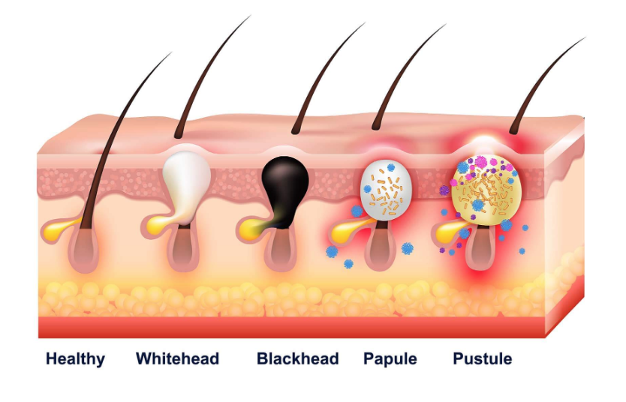

Figure 5: Types of Acne

Due to the raised androgens, some androgen receptor blockers such as Spironolactone have been successfully used, as well as adrenal androgen and ovarian androgen production blockers (Barros & Thiboutot, 2017), and oral contraceptives. Inflammatory acne may require oral antibiotics. Severe acne can have an emotional impact on a young person, so complementary and alternative therapies have also been suggested as useful, as does exploring diet, as high glycaemic index diets have been shown to be linked with acne (Zaenglein et al., 2016). Overall, the young person should be advised to wash their skin twice a day using an antiseptic wash or a mild cleanser, and to avoid cosmetics and irritants (Myers & D’Souza, 2018).

Conclusion
Many skin conditions in children can be distressing, having a considerable impact on the everyday life of a child and their family. Having an understanding of the anatomy and physiology of the skin can help the children’s nurse have an insight into the care and management of skin conditions, by identifying causes, triggers and treatment.
Specific care is needed in the newborn period due to immature thermoregulation, so children’s nurses working in neonatal care should be aware of the negative feedback loop on heat loss and heat gain. Management of some dermatological conditions can be lifelong, so it is important the children’s nurse liaises with members of the multidisciplinary team, with clinical nurse specialists often being the key liaisons and advocates for patients and families.

References

Ashton, R., Leppard, B., & Cooper, H. (2014). Differential diagnosis in dermatology (4th ed.). London: Radcliffe.
Aubert-Wastiaux, H., Moret, L., Le Rhun, A., Fontenoy, A. M., Nguyen, J. M., Leux, C., . . . Barbarot, S. (2011). Topical corticosteroid phobia in atopic dermatitis: a study of its nature, origins and frequency. British Journal of Dermatology, 165, 808 - 814. doi:10.1111/j.1365-2133.2011.10449.x
BAD. (2017). Haemangioma of Infancy In B. A. o. Dermatologists (Ed.).
BAD. (2019). Epidermolysis bullosa simplex In B. A. o. Dermatologists (Ed.).
Barros, B., & Thiboutot, D. (2017). Hormonal therapies for acne. Clinics in Dermatology, 35, 168 - 172. doi:10.1016/j.clindermatol.2016.10.009
Benner, N., & Sammons, D. (2013). Overview of the treatment of acne vulgaris. Osteopathic Family Physician, 5, 185 - 190. doi:10.1016/j.osfp.2013.03.003
Chan, Y. F., Milner, K.-L., White, C., & Musson, P. (2019). Vitamin D Deficiency and Treatment in Children and Adults. In S. Llahana, C. Follin, C. Yedinak, A. Grossman, K. Davies, & M. Keil (Eds.), Advanced Practice in Endocrinology Nursing (Vol. 2, pp. 1037 - 1062). Cham: Springer.
Chowdhury, M. M. U., Katugampola, R. P., & Finlay, A. Y. (2013). Dermatology at a Glance. Oxford: Wiley-Blackwell.
Cosh, J. (2016). Understanding the effects of eczema. Nursing children and young people, 28(2), 9.
Craiglow, B. G. (2013). Ichthyosis in the Newborn. Semin Perinatol, 37(1), 26 - 31. doi:10.1053/j.semperi.2012.11.001
De Falco, M., Pisano, M. M., & De Luca, A. (2014). Embryology and Anatomy of the Skin. In A. Baldi, P. Pasquali, & E. P. Spugnini (Eds.), Skin Cancer: A Practical Approach (pp. 1 - 15). New York: Springer.
Fine, J.-D., Bruckner-Tuderman, L., Eady, R. A. J., Bauer, E. A., Bauer, J. W., Has, C., . . . Zambruno, G. (2014). Inherited epidermolysis bullosa: Updated recommendations on diagnosis and classification. J Am Acad Dermatol, 70(6), 1103 - 1126. doi:10.1016/j.jaad.2014.01.903
Finlay, A. Y. (2012). Defining the fingertip unit. BMJ, 344, e3061. doi:10.1136/bmj.e3061
Gittler, J. K., Wang, J. F., & Orlow, S. J. (2017). Bathing and Associated Treatments in Atopic Dermatitis. Am J Clin Dermatol, 18(1), 45-57. doi:10.1007/s40257-016-0240-2
Glasper, A., Coad, J., & Richardson, J. (Eds.). (2015). Children and Young People’s Nursing - at a glance. Chichester: Wiley Blackwell.
Gormley-Fleming, E. (2015). The Skin. In I. Peate & E. Gormley-Fleming (Eds.), Fundamentals of Children’s Anatomy and Physiology: A Textbook for Nursing and Healthcare Students (pp. 444 - 465). Chichester: Wiley Blackwell.
Gormley-Fleming, E., & Peate, I. (Eds.). (2019). Fundamentals of Children’s Applied Pathophysiology: An Essential Guide for Nursing and Healthcare Students. Chichester: Wiley Blackwell.
Greener, M. (2019). Atopic eczema, what lies beneath? Practice Nursing, 30. doi:https://doi.org/10.12968/pnur.2019.30.Sup2.S3
Grodzinsky, E., & Sund Levander, M. (2020). Thermoregulation of the human body. In E. Grodzinsky & M. Sund Levander (Eds.), Understanding fever and body temperature (pp. 49 - 66). Cham: Palgrave Macmillan.
Kutlubay, Z., Tanakol, A., Engin, B., Simsek, E., Serdaroglu, S., Tuzun, Y., . . . Eren, B. (2017). Newborn Skin: Common Skin Problems. Maedica: A Journal of Clinical Medicine, 12, 42 - 47.
Larralde, M., & Abad, M. E. (2020). Transient Skin Disorders in the Neonate and Young Infant. In P. Hoeger, V. Kinsler, & A. Yan (Eds.), Harper’s Textbook of Pediatric Dermatology (4th ed., pp. 72 - 83). New Jersey: John Wiley & Sons.
Le Roux, E., Powell, K., Banks, J. P., & Ridd, M. J. (2018). GPs' experiences of diagnosing and managing childhood eczema: a qualitative study in primary care. Br J Gen Pract, 68(667), e73-e80. doi:10.3399/bjgp18X694529
Léauté-Labrèze, C., Harper, J. I., & Hoeger, P. H. (2017). Infantile Haemangioma. The Lancet, 1 - 10. doi:10.1016/S0140-6736(16)00645-0
Lidell, M. E. (2019). Brown Adipose Tissue in Human Infants. Handb Exp Pharmacol, 251, 107-123. doi:10.1007/164_2018_118
Lissauer, T., & Carroll, W. (Eds.). (2017). Illustrated Textbook of Paediatrics (5th ed.). Edinburgh: Elsevier.
Long, C. C., & Finlay, A. Y. (1991). The finger tip unit - a new practical measure. Clinical and Experimental Dermatology, 16, 444 - 447.
Lumbers, M. (2019). Understanding the vulnerability of a baby’s skin to help treat and prevent nappy rash. British Journal of Midwifery, 27(12), 752 - 757.
Luu, M., & Frieden, I. J. (2013). Haemangioma: clinical course, complications and management. British Journal of Dermatology, 169, 20 - 30. doi:10.1111/bjd.12436
McCance, K. L., & Huether, S. E. (2018). Pathophysiology: The biologic basis for disease in adults and children (8th ed.). Oxford: Elsevier Mosby.
Mertz, S. E., Nguyen, T. D., & Spies, L. A. (2018). Ichthyosis Vulgaris. Journal of the Dermatology Nurses’ Association. doi:10.1097/jdn.0000000000000423
Mostafa, W. Z., & Hegazy, R. A. (2015). Vitamin D and the skin: Focus on a complex relationship: A review. Journal of Advanced Research, 6, 793 - 804. doi:10.1016/j.jare.2014.01.011
MRF. (2020). What is the ‘meningitis rash?’. Retrieved from https://www.meningitis.org/blogs/what-is-the-meningitis-rash
Musson, P., & Collin, J. (2015). Management of Vitamin D deficiency in childhood and adolescence. Nursing children and young people, 27(9), 27 - 35.
Myers, J., & D’Souza, D. (2018). Care of the Child and Young Person with Dermatological Problems. In J. Price & O. McAlinden (Eds.), Essentials of Nursing Children and Young People (pp. 396 - 408). London: Sage.
NHS. (2018). Nappy Rash: Your pregnancy and baby guide. Retrieved from https://www.nhs.uk/conditions/pregnancy-and-baby/nappy-rash/
NHS. (2019). Meningitis. Retrieved from https://www.nhs.uk/conditions/meningitis/symptoms/
NICE. (2007). Atopic eczema in under 12s: Diagnosis and management Retrieved from https://www.nice.org.uk/guidance/cg57
Patrizi, A., Neri, I., Virdi, A., & Gurioli, C. (2016). Frequent newborn skin diseases. Clinical Dermatology, 4(3-4), 82 - 86. doi:10.11138/cderm/2016.4.3.082
Peate, I., & Gormley-Fleming, E. (Eds.). (2015). Fundamentals of Children’s Anatomy and Physiology: A Textbook for Nursing and Healthcare Students. Wiley Blackwell: West Sussex.
Shaw, N. J., & Pal, B. R. (2002). Vitamin D deficiency in UK Asian families: activating a new concern. Arch Dis Child, 86, 147 - 149.
Som, P. M., Laitman, J. T., & Mak, K. (2017). Embryology and anatomy of the skin, its appendages, and physiologic changes in the head and neck. Neurographics, 7(5), 390 - 415. doi:10.3174/ng.9170210
UK, W. (2014). Principles of Wound Management in Paediatric Patients. London: Wounds UK
Umar, M., Sastry, K. S., Ali, F. A., Al-Khulafi, M., Wang, E., & Chouchane, A. I. (2018). Vitamin D and the pathophysiology of inflammatory skin diseases. Skin Pharmacol Physiol, 31, 74 - 86. doi:10.1159/000485132
Vahlquist, A., Ganemo, A., & Virtanen, M. (2008). Congenital Ichthyosis: An overview of current emerging therapies. Acta Derm Venereol, 88, 4 - 14. doi:10.2340/00015555-0415
Van Onselen, J. (2012). Prescribing for mild to moderate childhood atopic eczema. Nurse Prescribing, 10(10), 481 - 487.
Visscher, M., & Narendran, V. (2014). Vernix Caseosa: Formation and Functions. Newborn and Infant Nursing Reviews, 14(4), 142-146. doi:10.1053/j.nainr.2014.10.005
Walden, P., Hardaway, A., & Petrus, B. (2011). Not just skin deep. Nursing Made Incredibly Easy!, 9(4), 49-50. doi:10.1097/01.NME.0000398512.10299.da
Waugh, A., & Grant, A. (2018). Ross & Wilson: Anatomy and Physiology in Health and Illness (13th ed.). Edinburgh: Elsevier.
Webster, S., & de Wreede, R. (2016). Embryology at a glance (2nd ed.). Oxford: Wiley Blackwell.
Zaenglein, A. L., Pathy, A. L., Schlosser, B. J., Alikhan, A., Baldwin, H. E., Berson, D. S., . . . Bhushan, R. (2016). Guidelines of care for the management of acne vulgaris. J Am Acad Dermatol, 74(5), 945 - 973. doi:10.1056/NEJMcp1702493
Zhong, C. S., Huang, J. T., & Nambudiri, V. E. (2019). Revisiting the history of the ‘Mongolian spot’: The background and implications of a medical term used today. Pediatric Dermatology, 36, 755 - 757. doi:10.1111/pde.13858

Add to BAD references (software keeps changing it)
BAD EB - https://www.bad.org.uk/shared/get-file.ashx?id=163&itemtype=document Accessed 4 February 2020

BAD Haemangioma - https://www.bad.org.uk/shared/get-file.ashx?id=86&itemtype=document Accessed 4 February 2020

