Biological Basis to Child Health: The Senses

Kate Davies RN (Child), Dip HE, BSc (Hons), MSc, PGCert, PGDip
Children’s Advanced Nurse Practitioner
Senior Lecturer in Non Medical Prescribing
London South Bank University
Honorary Research Fellow in Paediatric Endocrinology
Queen Mary University of London / Barts and The London NHS Trust

Abstract
This CPD article focusing on the five senses is the nth article in the Biological Basis to Child Health series. Human beings all should possess five basic senses: Hearing, Sight, Touch, Smell and Taste. However, some congenital and acquired conditions can impact these, and the effects have a marked effect on how a child develops and communicates with others. This article will explore all of these senses, by discussing the embryological bases, pertinent anatomy and physiology, and common conditions that are seen in children which can have an impact on their care. The principle aim is to provide children’s nurses with an insight into the importance of these senses, how they interact with each other, and how knowledge of these concepts can be linked to clinical practice.

Keywords
Ear, hearing, newborn, sight, taste, smell, touch, pain

Aims and Outcomes
After reading this article and completing the Time Out exercises, you will have a more in-depth understanding on the development of the five senses, and how they are important in child development and commonly seen childhood conditions. You will be able to:
- Discuss hearing development and reasons for hearing loss
- Explain how sight works, and how ophthalmological conditions affect eyesight
- Understand the sense of smell and why it may be altered
- Outline the importance of understanding taste in children
- Explain how the sense of touch works in relation to pain in children.

Introduction
The senses have specialised organs linked specifically to them: Hearing (the ear), Vision (the eye), Touch (the skin and also the internal organs), Smell (the nose) and Taste (the tongue). All of these relevant sense organs relay information back to the brain via the cranial nerves in the central nervous system. Many childhood conditions related to the senses are seen under specialists, such as Ophthalmologists, or Ear, Nose and Throat specialists. However, knowledge of the senses is needed whilst caring for sick children, such as considering the tastes of some medicines, or pain management. Addressing how children respond to environmental stimuli is key in understanding their relationship with their world, which is imperative in child-centred care (Boore, Cook, & Shepherd, 2016)

Hearing
Embryology of the ear
The ear begins to form as a thickening known as an ‘otic placode’ in the ectoderm in the third week of gestation, and subsequently forms in on itself to form a pouch called the otic pit in the fourth week (Webster & de Wreede, 2016). This then separates forming the otocyst, surrounded by mesoderm which develops into the otic capsule, and finally, from around the 10th week, (Jeffery & Spoor, 2004) eventually the bony labyrinth. (See Figure 1). This ossifies during weeks 16 – 24 and creates the protective space for the inner ear.

The upper part of the otic vesicle will develop into the cochlear duct, which is the part of the inner ear involved in balance. By the sixth week, it grows into nearby mesenchyme, spiralling 2.5 turns by the eighth week, and will be fully formed by the second trimester. The lower part of the otic vesicle develops into the cochlear duct also, and is part of the inner ear involved in hearing. Cells in the cochlear duct separate into sensory cells and the tectorial membrane (the Organ of Corti), which transmits sound to the vestibucochlear nerve – cranial nerve VIII (see article on neurology?).

In the middle ear, the three bones – malleus, incus and stapes develop from cartilage from the pharyngeal arches. They stay in place until as late as the eighth month of gestation, when the tissue regresses, and the bones become suspended within the cavity.

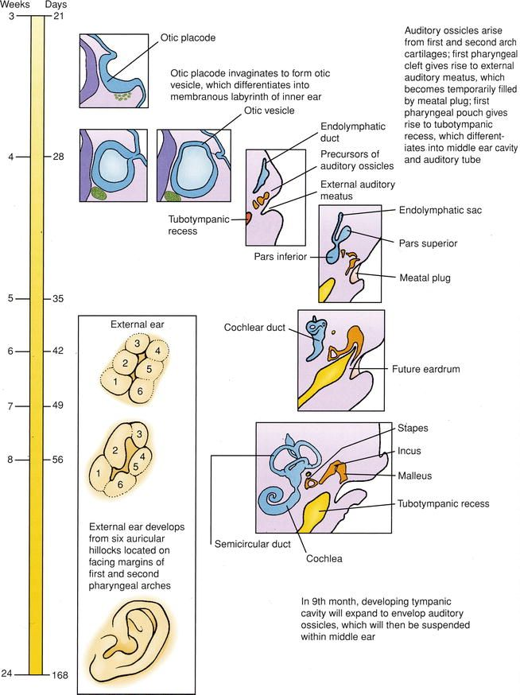

Figure 1: Ear embryology (Oliver & Kesser, 2013).

The outer ear consists of the eardrum (tympanic membrane), the external auditory meatus (ear canal) and the pinna. The pinna develops from six swellings, known as ‘hillocks’ from around week six, both from the pharyngeal arches. The pinna is developing inferior to the jaw, and it will finally ascend to the level of the eyes. This is completely developed by gestational week 20.

Anatomy and Physiology
The ear is divided into three sections: the outer ear, the middle ear and the inner ear (See Figure 2). The tympanic membrane in the outer ear is the boundary between the outer and middle ear. The external auditory meatus from the auricle to the tympanic membrane is about 2.5cm long and 0.7cm wide in adulthood. Most of the growth occurs in the first year of life. (BSA, 2013) It is lined with hair follicles, sebaceous glands and ceruminous glands which secrete cerumen – earwax. Earwax contains lysosome (a bactericidal enzyme) and immunoglobulins, and helps prevent materials like dust or small insects reaching the tympanic membrane, along with hairs and the natural curve of the canal (Waugh & Grant, 2018).

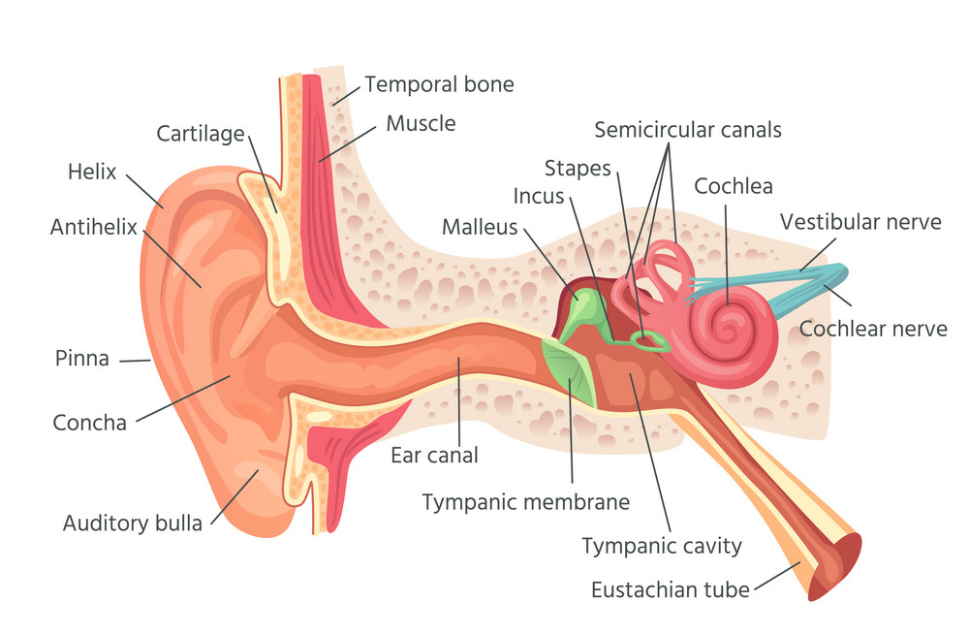
Figure 2: The ear (shutterstock image)

The middle ear is an air filled space behind the tympanic membrane where the ossicles lie (Munir & Clarke, 2013). Air reaches this area via the Eustachian tube, which is linked to the nasopharynx, and is 4cm long. Air at normal atmospheric pressure on both sides of the tympanic membrane is maintained by the Eustachian tube, and helps the membrane vibrate when sound waves hit it. The Eustachian tube is shorter and angled more horizontally than that of an adult (Takasaki et al., 2007). The Eustachian tube is usually closed, but if there is unequal pressure across the tympanic membrane (for example, in an airplane), it can be opened by swallowing, chewing or yawning, when the ears ‘pop’, normalising the pressure once more (Waugh & Grant, 2018).

The inner ear (Labyrinth) is the principle area for hearing and balance, and contains the vestibule, the three semi-circular canals, and the cochlea, which looks like a snail’s shell, and creates electrical impulses in the vestibulocochlear nerve, which are relayed to the brain as sound (Munir & Clarke, 2013)

How hearing works
The creation of sound can be broken down into a series of steps (See Figure 3)

1 2, 3 4 5 6
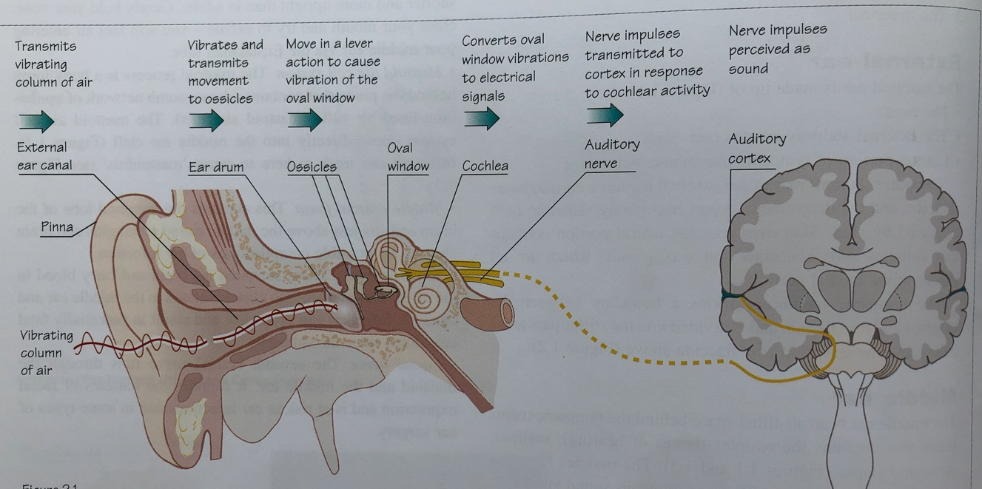

Figure 3: Physiology of hearing (Munir & Clarke, 2013) (to be redrawn with numbers for the columns)

1 - Sound is carried as sound waves in the air, at about 340 metres per second. These sound waves are collected and concentrated by the auricle down the ear canal, causing the tympanic membrane (ear drum) to vibrate.

2 - These vibrations cause the ossicles to move, causing pressure transmitting into the cochlear duct, causing the auditory receptors in the hair cells to be stimulated (Waugh & Grant, 2018). The malleus vibrates with the tympanic membrane, and then the vibrations are transmitted to the incus and the stapes

3 – As the stapes moves backwards and forwards, the footplate vibrates in the oval window.

4 – The vibration of the oval window sets up fluid pressure waves in the cochlea, which are transmitted to the round window

5 – The window vibrations are converted to electrical signals

6 – Nerve impulses are generated in the cochlear nerve fibres. These nerve impulses then pass to the brain in the cochlear area of the vestibulocochlear nerve (8th cranial nerve). The vestibulocochlear nerve has two main functions: the cochlear nerve transmits the auditory information from the cochlea to the brain; and the vestibular nerve transmits spatial orientation and balance from the semi-circular canals and the vestibule to the brain (Peckham & Wiggins, 2018). Auditory nuclei in the medulla of the brain then synapse, before being conducted to the auditory area in the cerebral lobe of the cerebrum. (Boore et al., 2016)

The foetus responds to sound in the latter stages of pregnancy. At birth, a baby will be startled by noise, but prefers voices. (Lissauer & Carroll, 2017)The newborn hearing screening test in the United Kingdom helps identify hearing loss in babies early, and is usually done before a baby is discharged home if they were born in hospital, or within the first few weeks of life by another health care professional (NHS, 2018). Normal hearing responses in infants and young children can be seen in Table 1.

Shortly after birth | Startles and blinks at a sudden noise, eg, door slam
By 1 month | Notices sudden prolonged sounds eg, vacuum cleaner, and pauses and listens when they begin
By 4 months | Quietens or smiles to the sound of a parent’s voice even when the baby can’t see them. Baby may also turn their head or eyes towards the parent if they come up from behind and speak to them from the side
By 7 months | Turns immediately to the sound of a parent’s voice across a room or to very quiet noises made on each side, as long as not occupied with other things
By 9 months | Listens attentively to familiar everyday sounds and searches for very quiet sounds made out of sight. Shows pleasure in babbling loudly
By 12 months | Shows some response to own name and other familiar words. May respond when parent says ‘no’ and ‘bye-bye’

Table 1: Hearing checklist (Lissauer & Carroll, 2017)

Hearing loss
Approximately 1 in every 1000 newborns are diagnosed with bilateral sensorineural hearing loss (SNHL) (Parker & Bitner-Glindzicz, 2015), and newborn screening can help with earlier diagnosis and treatments, such as cochlear implants being provided sooner (NICE, 2019) if acoustic hearing aids do not provide adequate benefit. There are over 600 identified medical conditions associated with SNHL, including Down syndrome, Treacher Collins syndrome, Pendred syndrome, and CHARGE syndrome (Coloboma, Heart defects, Atresia of Choanae, Retarded growth and development, Genital hypoplasia, Ear anomalies) (Parker & Bitner-Glindzicz, 2015). Perinatal risk factors should also be considered, including rubella, toxoplasmosis, herpes, and cytomegalovirus, and ototoxic drug history (Singh Bist, Kumar, Agarwal, & Sharma, 2016). Postnatal causes lie with infections including meningitis, measles and mumps, and, commonly, glue ear (NDCS, 2020), or otitis media with effusion (OME). OME is the most common cause of childhood hearing loss, and is characterised by the presence of fluid in the middle ear, (see Figure 4) and around 85% of children will experience an episode in childhood (Robb & Williamson, 2016). Recurrent infections and persistent conductive hearing loss (Miall, Rudolf, & Smith, 2016) may require the insertion of tiny ‘grommets’, or ventilation / tympanostomy tubes, which are inserted into the eardrum during a short operation (Venekamp, Mick, Schilder, & Nunez, 2018).

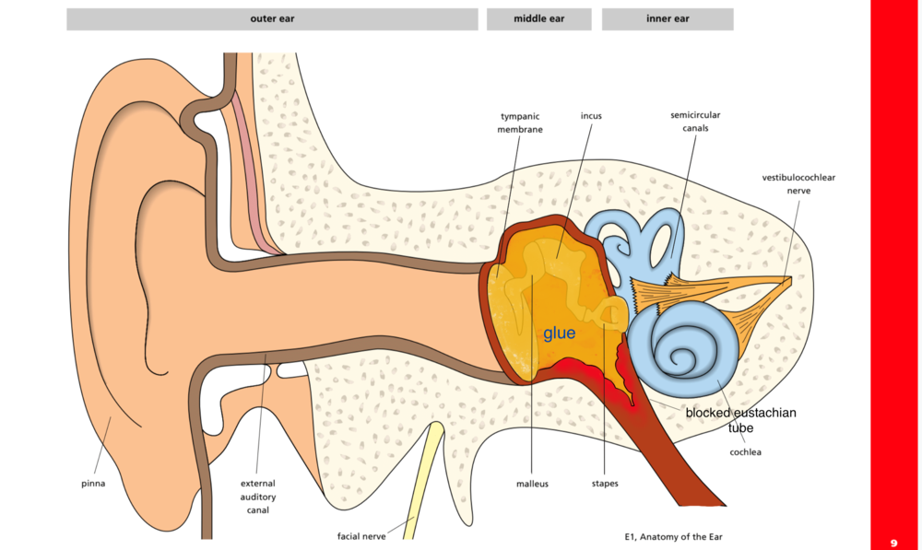

Figure 4: Glue ear

Sight
Embryology of the Eye
Development of the eye begins around day 22 of gestation, with bilateral invaginaton of neuroectoderm in the forebrain (Webster & de Wreede, 2016). As the neural tube closes, these pouches develop into the optic vesicles; subsequently, these optic vesicles come into contact with the surface ectoderm, resulting in the formation of the lens placodes, which form an epithelial structure – the lens pit. As the invagination continues, the optic cup is formed, and the lens pit deepens into the space created by the cup (Cook, 2016), which is completed by day 35 of gestation.

The optic stalk is joined to the forebrain, and develops into the optic nerve – Cranial nerve II - by week 9. The retina develops from the optic cup, which has two layers: the outer layer which is pigmented,, and the inner layer develops into the neural layer, which is closer to the lens. The posterior four fifths of the inner neural layer consists of the cells for rods and cones involved in vision: the anterior remaining one fifth is one cell thick, which becomes the iris and ciliary body (Webster & de Wreede, 2016). The outer vascular layer of the eye – the choroid – lies between the retina and sclera, and develop from the loose mesenchyme (mesodermal embryonic tissue) which is around the posterior part of the developing eye. Loose mesenchyme around the anterior part splits and becomes the cornea, and neural crest cells contribute to the development of the cornea and sclera. Development of the eye continues after birth, with myelination of the visual pathway not finishing until around two years of age (Carr & Foster, 2014).

Anatomy and Physiology
The eyes are situated in the orbital cavities in the skull, and are supplied by the optic nerve They are nearly spherical in shape: the majority of the growth of the eyeball (the ‘globe’) takes place antenatally, and ceases around the age of one year (Augusteyn et al., 2012), when it will be around around 2.5cm across in diameter (Waugh & Grant, 2018). Internally, the eye is split into two chambers – anterior and posterior (see Figure 5). The posterior chamber is the space in the eye behind the iris but in front of the lens. The anterior chamber is between the iris and cornea, and is filled with aqueous humour, which is a clear watery fluid, and the posterior is filled with the more jelly like substance, known as vitreous humour. In the walls of the eye, there are three layers of tissue:

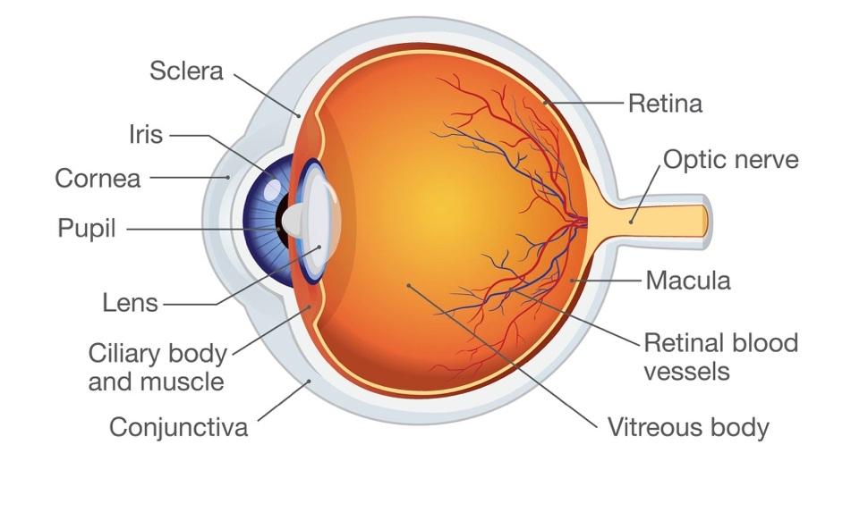

Figure 5: Anatomy of the Eye

Outer Fibrous layer – Sclera and Cornea.
The sclera is the white of the eye, covered by a layer of tissue which lines the inside of the eyelids, called the conjunctiva: at the anterior, this continues as the transparent cornea where light rays pass through to reach the retina.

Middle vascular layer (Uvea) – The Choroid, Ciliary body and Iris.
The choroid is the posterior part of the uvea, and joins to the iris by the ciliary body (Galloway, Amoaku, Galloway, & Browning, 2016). The ciliary body is triangular shaped and consists of muscle fibres: contraction and relaxation of the fibres attached to the suspensory ligaments influences the size and thickness of the lens (Waugh & Grant, 2018). The iris is at the most anterior part, and is a thin circular disc, with the pupil in the centre. Contraction of the iris sphincter muscles constrict the pupil, whereas contraction of the dilator pupillae muscle dilates the pupil. Behind the pupil is the lens which is transparent, and the thickness of the lens is controlled by suspending ligaments (Waugh & Grant, 2018)

Inner nervous tissue – The Retina.
This is the most innermost lining of the eye, and is where light is converted into electrical energy for transmission to the brain: rods and cones here are photoreceptors.

TIME OUT 1
Try and recall the physiology of image formation, and discuss with a colleague the function the lens plays, and its role in refraction. You can look up the website of Moorfields Eye Hospital in London, UK www.moorfields.nhs.uk which can give you some guidance, and also an insight into common childhood eye conditions.

There are two main layers of the retina: the posterior pigmented layer contains melanin which absorbs stray light, and also the anterior layer, which subsequently has three further layers:

1 – Photoreceptor layers – this is where light is absorbed and converted into electrical energy for transmission to the brain. Only two photoreceptor layers are functional, and these are the rods and cones. Cones are responsible for acute vision and colour, whereas rods are responsible for vision in dim light and for wider visual fields (Galloway et al., 2016)

2 – Bipolar cell layers – these are cells which receive information from the rods and cones, and are the first neurons of the visual pathway

3 – Ganglion cell layers – these are the second neurons in the visual pathway, and make up the optic nerve ( see figure 6 )

Figure 6: Anatomy of the optic nerve (Peate & Gormley-Fleming, 2015) (to be redrawn)

Vision

When the rods and cones are stimulated by light, they trigger electrical signals in bipolar cells which transmit signals from the photoreceptors to ganglion cells. These then generate nerve impulses, and the axons of these cells exit the eyeball at the optic nerve (cranial nerve II), continue across the optic chiasm where half the axons from each eye cross over, and the optic nerves divide their signals, so they can attempt to detect any differences in the image (Peate & Gormley-Fleming, 2015) continuing on to the thalamus. Of note, there are no rods and cones where the nerve fibres join to form the main optic nerve, so images therefore cannot be focused on this area of the retina: this area is known as the ‘blind spot’, or the optic disc. Finally, they synapse and project to the visual areas in the occipital lobes of the cerebral cortex (Tortora & Derrickson, 2017) (See Figure 7)

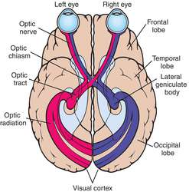

Figure 7: The Visual Pathway

Vision in Infants and Children
A newborn baby’s vision is limited – they can only see up to about 6 metres away (6/200: most adults can see up to 200 metres). Many infants can ‘fix and follow’ horizontally a face or a coloured ball (Lissauer & Carroll, 2017), and most babies ‘squint’. By age 6 weeks, both eyes should be moving together, and by 12 weeks the squinting will have stopped. Face perception begins to develop towards having a particular interest in human faces, particularly eyes and facial expressions, around the age of 3 months (Hyvarinen, Walthes, Jacob, Chaplin, & Leonhardt, 2014). Visual acuity – clarity of vision – will have reached adult levels by 4 years of age, but children in the UK will be tested at school entry around age 4/5 years. Infants are also tested within 72 hours of birth, between 6-8 weeks of age, and then again around the age of 1-2 years of age (NHS, 2019).

Several ocular teratogens are known (see Table 2), as well as other risk factors for childhood eye conditions, including low birth weight (<1500g), low gestational age (<32 weeks), or if there is a family history of eye disorders, such as congenital cataracts, glaucoma or retinoblastoma (Carr & Foster, 2014).

Teratogen | Newborn eye condition
Alcohol | Coloboma  Cataract  Nystagmus
Opioids | Nystagmus  Reduced vision
Cocaine | Prolonged eyelid oedema  Optic nerve abnormalities
Vitamin A | Microphthalmia  Hyperteleroism
Rubella | Cataract  Glaucoma  Microphthalmos
Cytomegalovirus / Herpes Simplex Virus | Cataract  Microphthalmos  Chorioretinitis
Syphilis | Cataract  Glaucoma
Anticonvulsants | Myopia  Long eyelashes
Type 1 Diabetes | Optic nerve hypoplasia

Table 2: Ocular teratogens (Carr & Foster, 2014)

Blindness
Blindness is described as visual acuity less than 20/200. It can be absolute, with no light perception at all (Moschos, 2014). In children, most causes of blindness are avoidable, being either preventable and treatable: 3% of the world’s blind population are children (Gogate & Gilbert, 2007), which equates to around 14 million of the world’s children are blind (Solebo, Teoh, & Rahi, 2017). The World Health Organisation (WHO) classifies vision impairment into two groups, distance and near presenting vision impairment (WHO, 2019). The most common causes of childhood blindness are seen in Table 3:

Most important causes of childhood blindness
The most common avoidable causes of childhood blindness globally | - Retinopathy of prematurity  - Cataract  - Corneal opacity
The most common causes of childhood blindness in high-income and middle-income countries | - Cerebral visual impairment  - Optic nerve hypoplasia  - Inherited retinal disorders

Table 3: Causes of childhood blindness (Solebo et al., 2017)

Strabismus (Squints)
A strabismus is the malalignment of the two eyes. It can be concomitant, where the deviations remain in the same positions, or incomitant, where the angles of the gaze changes (Olver, Cassidy, Jutley, & Crawley, 2014), and it affects approximately 2.1% of the population (RCO, 2012). Strabismus can potentially be the leading presenting symptom with a serious eye or brain condition, such as retinoblastoma, a brain tumour or hydrocephalus, so it is important that children’s nurses are able to recognise this and alert the multidisciplinary team if needed. If not severe, management usually commences with glasses, but may require surgery (RCO, 2012).

Eye Infections
There are several causes of conjunctivitis (‘pink eye’), which is inflammation of the conjunctiva, including allergies, bacteria or viruses (M. Nair & Peate, 2015). The inflammation can be infectious or non-infectious, and can also be acute or chronic. Newborns can also have a blocked tear duct, which results in tears not draining properly and eyes may become crusty. Ocular allergy can affect up to 25% of children throughout Europe, and eye itchiness is the leading symptom, along with redness and a watery discharge (Fauquert, 2019). Cold compresses can help, along with ocular, intranasal and oral antihistamines. Bacterial conjunctivitis is very common in children, and staphylococci and streptococci are typical bacterial causes (Smith, 2019), and is highly contagious. The eye will also exude a thick discharge, which can be white, yellow or green, which drains throughout the day, but ‘glues’ the eyelids together overnight, resulting in the eye becoming ‘stuck shut’ in the morning, which can be distressing and confusing for the younger child. Treatment includes bathing the affected eye with cotton wool soaked in cooled, boiled water: severe cases may need chloramphenicol eye drops or ointment (Gormley-Fleming & Peate, 2019; Smith, 2019)

Touch
Embryology
Touch sensation is controlled by mechanosensory neurons that are embedded in the skin, which then subsequently relay signals to the central nervous system (Jenkins & Lumpkin, 2017). Low Threshold Mechano Receptors (LMTRs) are neurons that respond to gentle touch stimuli, and they arise from neural crest cells – ectodermal cells, which form sensory ganglia, as well as melanocytes, bone, cartilage and smooth muscle. Cutaneous sensory perception appears around the mouth area around the seventh week of gestation, and gradually spreads to the remaining mucous and cutaneous areas by 20 weeks. Synapses develop from the sixth week, and myelination is complete by 37 weeks (Anand & Carr, 1989). However, the cortico-thalamic connections are believed to have developed by around 24 – 28 weeks gestation, leading to the belief that a foetus can feel pain at least in the last trimester (Mellor, Diesch, Gunn, & Bennet, 2005).

Touch sensation
Sensory receptors that detect touch, pressure, stretch and vibration are distributed widely over the skin, and they either have free nerve endings, or nerve endings that are enclosed within a capsule, and there are at least six types of tactile receptors found in the skin: (Richardson, 2008a) (See Figure 8)
Free Nerve Endings
These are the dendrites – branched extensions of the nerve cells – of sensory neurons, and are found almost everywhere, between the cells in the skin epidermis. It is an afferent nerve fibre, which are fibres carrying impulses to the central nervous system. They respond to pain and temperature, but also touch and pressure (Richardson, 2008a).
Root hair plexus
Root hair plexuses detect the movement of the hairs on the skin, serving as a very sensitive mechanoreceptor for touch sensation.
Merkel’s disc
These are found at the base of the epidermis (Marieb & Keller, 2017) around the epidermal-dermal junction and only cover a small area. Again, they mediate the senses of touch and hair movement.
Meissner’s corpuscle
Meissner’s corpuscles are mechanoreceptors sensing light touch beneath the epidermis (Vega et al., 2012), and are abundant in glabrous (hairless) skin, such as the eyelids, lips, nipples, fingertips, external genitalia and the soles of the feet (lots in the toes) (Richardson, 2008a), as well as the tongue and palate, all particularly known sensitive areas.

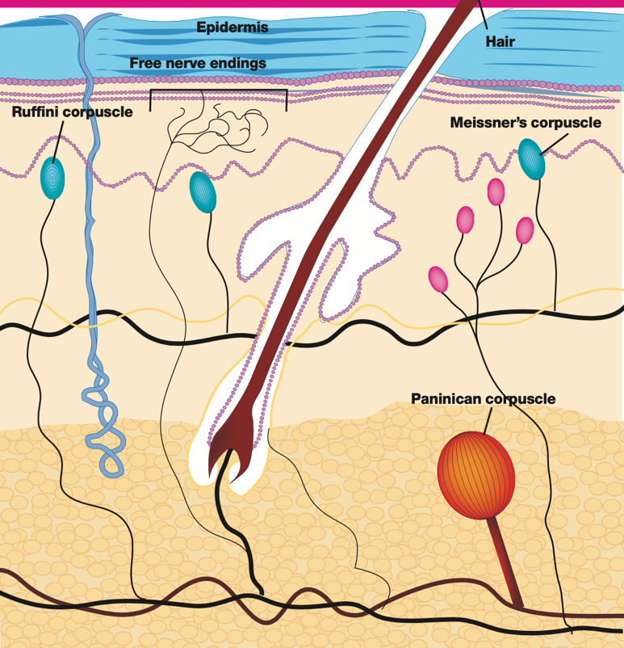

Figure 8: Touch receptors in the skin

Pacinian corpuscle
The Pacinian corpuscles are located deeper within the dermis of the skin, and are made up of lamellae – thin layers – giving it an onion shaped appearance. They detect high frequency vibrations (Quindlen, Lai, & Barocas, 2015), and are scattered throughout the dermis, especially at the fingers, mammary glands and external genitalia. They are the largest of the receptors, and are visible to the naked eye.
Ruffini corpuscle
Ruffini corpuscles are also sensitive to deep and continuous pressure, and are found in the deeper dermis, hypodermis and joint capsules (Richardson, 2008a)

Touch perception
Nerve fibres for touch, feeling pressure and proprioception – the sense of self movement and body perception – are myelinated (where the axon sheaths are covered with a myelin sheath, which helps faster transmission of nerve signals) (Boore et al., 2016). Tactile receptors are attached to different nerve types, but most receptors utilise the A beta fibres to transmit the signals (Richardson, 2008b), which carry information related to touch. A delta fibres carry information related to pain and temperature. Receptors for ‘crude’ touch and pressure tend to have a wider receptive field, so it can be difficult to locate the stimuli source. Sensations from these receptors are then carried via nerves to the spine, and then the brain, via the spinothalamic pathway: they reach the thalamus, and then relayed to the sensory cortex in the cerebral hemispheres (Richardson, 2008b). (See Figure 9).

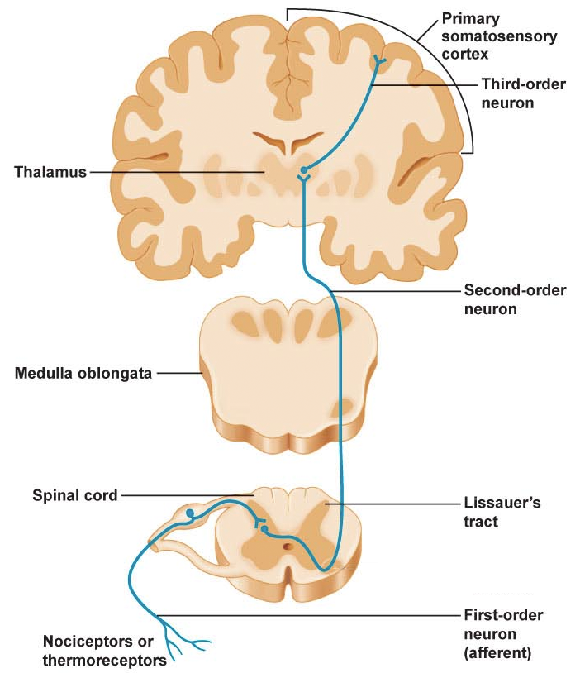

Figure 9: Spinothalamic pathway

Three main levels of neural integration function within the somatosensory system:
Receptor level
This is where a stimuli needs to excite a receptor, and the energy converts into a graded potential, known as Transduction (Marieb & Keller, 2017) where the stimulus is formed into a nerve impulse (Swift, 2018), and is the first step of the nociceptive pain process (see Figure 10)

Figure 10: 5 stages of Nociception (Boore et al., 2016)

Receptors – known as nociceptors – respond to different types of stimuli: thermal (temperatures above 40 degrees), mechanical (extreme pressure), or chemical (strong acid or alkali). This stimulus then causes the nerve to release chemical pain mediators such as prostaglandins, bradykinins, serotonin, substance P and histamine (Swift, 2018). The action potential needs to be then conducted along the nerve fibres, known as Conduction, and the three different types of fibres: A delta fibres, C fibres and A beta fibres, all have differing speeds of conduction (Boore et al., 2016).
Circuit level
Impulses are now delivered to the cerebral cortex for stimulus localization and also perception (Marieb, 2014). Transmission occurs here, where the neuron pain nerve fibres finally end in the dorsal horn of the spinal cord, and then are directed to the brain. During modulation, pain signals activate the brainstem, triggering descending nerve fibres to release endogenous opioids (endorphins and encephalin), as well as serotonin, noradrenaline, gamma-aminobutyric acid (GABA) and neurotensin (Swift, 2018).
Perceptual level
Sensory input interpretation occurs in the cerebral cortex in the final stage of nociception – Perception, which is the conscious experience of pain. Everyone’s perception and experiences of pain are hugely different, due to past experiences of pain, the individual’s emotional state, and also the intensity, location and method of the stimulus (Boore et al., 2016).

Pain and Pain Assessment in Children
All the neural pathways that are required for nociception are present from birth, but also function in preterm neonates as well (S. Nair & Neil, 2013). Peripheral sensory receptors develop early in foetal life, around 7-8 weeks gestation, and all over the body by 16 weeks: premature infants at 26 weeks have shown to have withdrawal reflexes after acute stress, and infants at 30 weeks gestation have demonstrated similar facial grimaces to those of adults in the response to painful stimuli (Noia et al., 2017). Newborn babies have nearly fully developed endocrine systems, releasing the stress hormone cortisol and catecholamines to stressors (Mathew & Mathew, 2003). With infants, young children, and children with neurological impairments, children’s nurses have to be able to identify behavioural and clinical indicators of pain, which can differ from child to child (see Table 4).

Neonate | Young Child
Cardiovascular  - Increased heart rate  - Increased blood pressure  - Increased respiratory rate  - Decreased oxygen saturations  Sweat  - Increased palmar sweating  Endocrine  - Increased cortisol  - Increased catecholamines  - Increased renin activity and aldosterone  - Increased growth hormone  - Increased glucagon  - Decreased insulin  Behaviour  - Changes in facial expression  - Onset and duration of crying (sometimes stopping)  Flexor  - Withdrawal of limbs  Pupil dilation  Flushing  Pallor | Changed behaviour  - Irritability  - Unusual posture  - Flat affect  - Screaming  - Crying / Dobbing  - Reluctant to move  - Aggressive  - Disturbed sleep  - Clingy  - Quiet  - Loss of appetite

Table 4: Clinical and behavioural indicators of pain (Loizzo, Loizzo, & Capasso, 2009; Twycross & Saul, 2018).

Pain tools for assessment of pain in neonates are useful, such as the PIPP (Premature Infant Pain Profile), and pre-verbal children can be assessed using the FLACC (Face, Legs, Activity, Cry, Consolability) scale (Twycross & Saul, 2018). Various scales are in place for older, verbal children, such as numerical rating scales, the Wong-Baker faces scale (See Figure 11) (Twycross, 2017), or visual analogue scales (Beltramini, Milojevic, & Pateron, 2017)

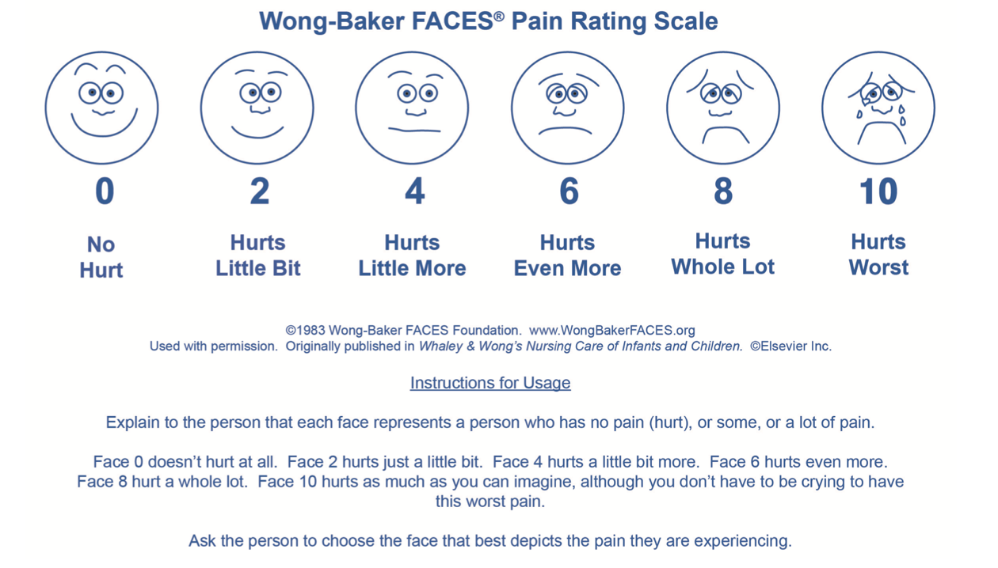

Figure 11: Wong-Baker Faces Scale (Saul et al., 2016).

Being able to assess a child’s pain is a vital nursing skill that a children’s nurse must possess, and they must be able to assess pain in a variety of settings and ages.

TIME OUT 2
Professional guidelines are in place from the Royal College of Nursing (RCN, 2009), stressing the importance on being able to anticipate a child’s pain (Saul, Peters, & Bruce, 2016). Have a look at this guidance: https://www.euroespa.com/wp-content/uploads/2014/10/003542.pdf - can you identify with it, with regards to your clinical practice? Find out what pain assessment tools are used in your clinical practice, and reflect on how these could be made more visible for children and their families.

Smell
Embryology
Early in the 4th week of gestation, the frontonasal process, along with the developing brain, contribute to an invagination from the ectoderm, called the stomodeum. Otic placodes – thickenings of ectoderm – arise during neural tube formation, which deepen. The ectoderm from the stomodeum borders the developing foregut to form the oropharyngeal membrane, which disintegrates in the 5th week. Mandibular processes begin to merge to the facial midline. The frontonasal processes now surround the stomodeum, with the paired maxillary processes on either side (Som & Naidich, 2013). Nasal placodes are now sinking below the surface as nasal grooves, and form nasal sacs. During this 5th week, the olfactory epithelium begins to develop and send out nerve processes, eventually forming the olfactory nerves: by the 7th week, olfactory epithelium reach their final ‘adult’ destination on the upper lateral nasal wall, and also the nasal septum.

At the 6th week, the lateral nose begins to form with lateral nostrils on either side, and the nasolacrimal duct forms. The nasal septum continues to develop in the 7th week, and then nasal plugs close the nostrils, which open again in week 16. The oronasal membranes rupture early in the 7th week: failure for this to occur results in choanal atresia, where the nasal passages are blocked by bone or tissue (Kwong, 2015). By the 10th week, the nasal septum begins to fuse with the palate, and by week 12 gestation, the ossification of all facial bones are in place (Som & Naidich, 2013). Between the gestational weeks of 4 to 7 is the most active in nose development.

Anatomy and Physiology

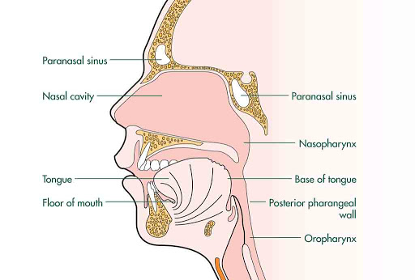

Figure 12: The nose (or something similar to be re-drawn)

Nasal cavities extend from the vestibule behind the nostrils towards the nasopharynx, and the septum separates the two nasal cavities. The paranasal sinuses are a network of spaces filled with air, and the mucosa is abundant with mucous-producing goblet cells (Munir & Clarke, 2013). The nose acts as a passageway for air entering the respiratory tract (see Respiratory article), but also acts to warm and moisten the air, and ciliated respiratory mucosa helps act as a filter. Olfactory mucosa are a specialised area of neuroepithelium involved in the sense of smell.

Smell

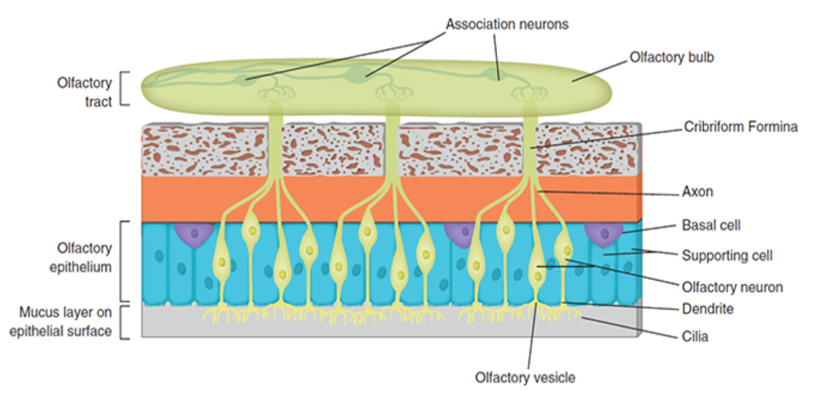

Figure 13: Olfaction (Boore et al., 2016)

Olfactory glands in the mucosa (see Figure 13) stimulate the olfactory receptors by ‘sniffing’, which concentrates the volatile molecules in the roof of the nose (Waugh & Grant, 2018)These cranial nerves – Cranial nerve 1, the Olfactory nerves, are the shortest of the cranial nerves, and pass from to the nasal mucosa to the brain, passing through the ethmoid bone to the skull. The sense of smell affects appetite and stimulates the digestive system, and smells can create long lasting memories. Once the olfactory receptors are stimulated, nerve stimuli pass to the olfactory bulb via the olfactory tract in the brain, including signals to the hypothalamus, the thalamus (where conscious smell perception occurs), the amygdala, where emotional responses take place, and the hippocampus, where smell is linked to memory (Boore et al., 2016). It is difficult to assess the olfactory nerves during a neurological examination in infants and children: disorders of smell are rare in children, and usually testing is unsuccessful (Carey & Curran, 2007). The ‘Paediatric Smell Wheel’, however, has been identified to be useful in children as young as 4 years of age, including pictures to better engage children (Cameron, 2018) (see Figure 14).

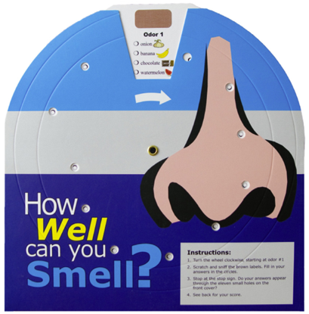
Figure 14: The Paediatric Smell Wheel (Cameron, 2018)

In older children, asking to identify a smell like mint or toast is useful.

Anosmia and nasal conditions
Anosmia is the absence of the sense of smell, and can be temporary or permanent. In children, the inability to smell is similar to that of adults, where rhinological disease, or post viral infection, is at the forefront (Hauser, Jensen, Mirsky, & Chan, 2018). Sinusitis can present in around 7% of children presenting in primary care with an upper respiratory tract infection (DeMuri & Wald, 2013). Sinuses do not actually complete development until late adolescence, and the paranasal sinuses often can become infected, with thick, coloured and purulent nasal drainage, and intense pain. Inflammation may also be as a result of allergy, cystic fibrosis, or reflux (AAP, 2001).

Around 10% of 6/7 year olds and up to 20% of 14 year olds in England experience allergic rhinitis, triggered by an exposure to allergens, and can be the most common form of nasal congestion in children (Barr, Al-Reefy, Fox, & Hopkins, 2014). Common allergies include house dust mites, animal danders, moulds, grain and tree pollens, and treatment is usually with second generation antihistamines such as cetirizine. Children’s nurses should be aware that first line anthistamines such as chlorphenamine should ideally be avoided in children due to their sedative properties, thus affecting school performance (Barr et al., 2014).

Specific paediatric cohorts have detailed pure anosmia, including in cystic fibrosis, CHARGE syndrome, and 22q11 deletion syndrome, although Kallmann syndrome is the most well known syndrome associated with congenital anosmia, with hypogonadotrophic hypogonadism – where the ovaries or testes produce no oestrogen / testosterone , due to the lack of GnRH (gonadotrophin releasing hormone) from the hypothalamus, and LH (luteinizing hormone) and FSH (follicle stimulating hormone) from the pituitary gland, resulting in infertility (Wei, Davis, Honour, & Crowne, 2017).

TIME OUT 3
How do you think it might affect a child if they could not smell? Is there anything that could be dangerous for them? What other clinical conditions can you think of which can affect the sense of smell?

Taste
Embryology of Taste Buds
Taste bud cells on the tongue are epithelial in origin from the oropharyngeal cavity (Northcutt, 2004), and presumptive buds develop from around 11 weeks gestation: taste pores form as soon as these buds appear (Bradley & Stern, 1967). ‘Taste pores’, which are recognised as a sign of taste bud maturity appear between the 10th and 14th week WITT, and
the cells elongate and pierce the surface epithelium as a small tuft of cells, with the recognizable adult formed taste bud developing by around 15 weeks.

Anatomy and Physiology
The sense of taste – gustation – is closely linked to the sense of smell, (for example, if you have a cold, this can affect the taste buds) and involves stimulation of chemoreceptors by chemicals which have dissolved (Waugh & Grant, 2018). These chemoreceptors are in the taste buds on the four types of papillae on the tongue (see Figure 15), which create a roughened surface to be able to rasp and lick food (Keshav & Bailey, 2013):

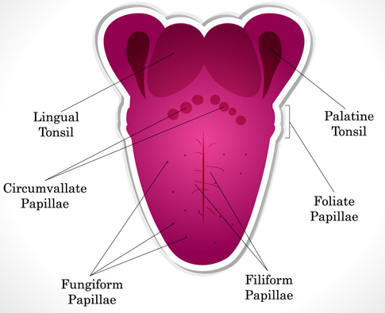
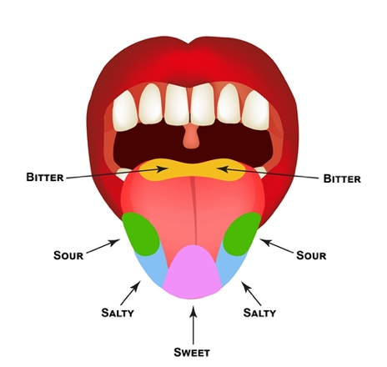
Figure 15: Tongue papillae Figure 16: Primary tastes

Filiform papillae
These are small spiky filaments which do not actually contain buds, but are involved with the experience of food texture.

Foliate papillae
These are on the sides of the tongue and towards the back, and tend to degenerate by the age of three years.

Fungiform papillae
These are mushroom shaped and contain around three to five taste buds, and are mostly at the tip of the tongue.

Circumvallate papillae
These are larger papillae, and here there are up to around 300 taste buds (Boore et al., 2016).

The taste buds can sense five different primary tastes: (See Figure 16)

- Sweet – Sugary carbohydrates
- Sour – Acids, such as fruit acids
- Bitter – Stimulated by alkaloids in plant leaves, or spoiled food
- Salty – Stimulated by metal ions like potassium and sodium
- Umami – This is no specific zone on the tongue, but is the meaty / savoury taste from meat or fish (Boore et al., 2016).

The taste buds consist of small nerve endings from the glossopharyngeal (VII), the facial (IX) and vagus (X) nerves, which are very sensitive. Nerve impulses are generated along these nerves , and then subsequently synapse in the medulla and the thalamus, ending in the taste centre in the parietal lobe of the cerebral cortex (Waugh & Grant, 2018).

Taste in Children
Children are born preferring sweet tastes, which attracts them to breast milk, and even acting as an analgesic (Mennella, Bobowski, & Reed, 2016). Tasting something sweet has been shown to blunt experiences of pain in infants, exerting a calming effect, and administering a sucrose solution – either squirted into the mouth or on a dummy – during painful procedures such as heel lance, venepuncture, intramuscular injections, or even eye examinations, has been proven to be beneficial: this is something that children’s nurses need to consider when caring for infants who need to undergo these procedures (Stevens, Yamada, Ohlsson, Haliburton, & Shorkey, 2016).

Children are more ‘bitter sensitive’ that adults, hence an aversion to green vegetables, or liquid formulations of some medicines. (Mennella, Roberts, Mathew, & Reed, 2015). The palatability of many children’s drug formulations need to be considered when caring for children. Formulations with unpleasant taste can affect adherence and administration. Antibiotics are well known to have varying tastes: Amoxicillin has a pleasant, banana sweet taste, whereas flucloxacillin is known to be highly unpalatable, for example, so children’s nurses should be aware of this, and potentially suggest that prescriptions can be changed to oral capsules if necessary. Evidence shows that some children as young as 6 years of age can potentially swallow tablets, by providing ‘pill school’: training in swallowing sweets in varying sizes with flavoured juice / squash, such as tictacs, then smarties, and then yoghurt covered raisins (Baguley, Lim, Bevan, Pallet, & Faust, 2012).

TIME OUT 4
Reflect on the oral medications that are routinely used in your clinical area. Are there particular medications that children typically have an aversion to? What methods are used to overcome the unpleasant taste? Discuss with a colleague the tastes of these medicines and build up a working guideline for your area.
Conclusion
From exploring how the senses develop, it can be seen how they work together in how children make sense of their worlds, and how they can enhance the quality of life. For example, the combination of taste and pain, and how babies are calmed by sweet tasting sucrose solution during painful procedures. Taste is also affected if the smell sense is altered, as can be seen in children with allergy or other rhinological conditions. Having an understanding on sensory order neurons and sensory pathways (see article on nervous system) is also imperative when considering the role of the cranial nerves with regards to sensory input. This article has provided an overview on the development, anatomy and physiology of the special senses, and it is hoped that it will provide the children’s nurse with an interest in exploring specific issues further which are relevant to their clinical practice.

References

AAP. (2001). Clinical Practice Guidelines: Management of Sinusitis. In Pediatrics (Vol. 108, pp. 798 - 808): American Academy of Pediatrics.
Anand, K. J. S., & Carr, D. B. (1989). The Neuroanatomy, Neurophysiology, and Neurochemistry of Pain, Stress, and Analgesia in Newborns and Children. Pediatric Clinics of North America, 36(4), 795-822. doi:10.1016/s0031-3955(16)36722-0
Augusteyn, R. C., Nankivil, D., Mohamed, A., Maceo, B., Pierre, F., & Parel, J. M. (2012). Human ocular biometry. Exp Eye Res, 102, 70-75. doi:10.1016/j.exer.2012.06.009
Baguley, D., Lim, E., Bevan, A., Pallet, A., & Faust, S. N. (2012). Prescribing for children - taste and palatability affect adherence to antibiotics: a review. Arch Dis Child, 97(3), 293-297. doi:10.1136/archdischild-2011-300909
Barr, J. G., Al-Reefy, H., Fox, A. T., & Hopkins, C. (2014). Allergic rhinitis in children. BMJ, 349, g4153. doi:10.1136/bmj.g4153
Beltramini, A., Milojevic, K., & Pateron, D. (2017). Pain Assessment in Newborns, Infants, and Children. Pediatr Ann, 46(10), e387-e395. doi:10.3928/19382359-20170921-03
Boore, J., Cook, N., & Shepherd, A. (2016). Essentials of anatomy and physiology for nursing practice. London: Sage.
Bradley, R. M., & Stern, I. B. (1967). The development of the human taste bud during the foetal period. J. Anat., 101(4), 743 - 752.
BSA. (2013). Taking an aural impression: children under 5 years of age. In: British Society of Audiology.
Cameron, E. L. (2018). Olfactory perception in children. World J Otorhinolaryngol Head Neck Surg, 4(1), 57-66. doi:10.1016/j.wjorl.2018.02.002
Carey, J., & Curran, A. (2007). Examination of the paediatric cranial nerves. Journal of Clinical Examination, 2, 44-48.
Carr, N., & Foster, P. (2014). Examination of the newborn: The key skills. Part 1: The Eye. The Practising Midwife.
Cook, J. (2016). The embryology of the eye Eye News, 22(4), 28 - 30.
DeMuri, G., & Wald, E. R. (2013). Acute bacterial sinusitis in children. Pediatrics in Review, 34(10), 429 - 437.
Fauquert, J.-L. (2019). Diagnosing and managing allergic conjunctivitis in childhood: the allergist's perspective. Pediatric Allergy and Immunology. doi:10.1111/pai.13035
Galloway, N. R., Amoaku, W. M. K., Galloway, P. H., & Browning, A. C. (2016). Basic Anatomy and Physiology of the Eye. In Common Eye Diseases and their Management (pp. 7-16).
Gogate, P., & Gilbert, C. (2007). Blindness in children: a worldwide perspective. Community Eye Health Journal, 20(62), 32 - 33.
Gormley-Fleming, E., & Peate, I. (Eds.). (2019). Fundamentals of Children’s Applied Pathophysiology: An Essential Guide for Nursing and Healthcare Students. Singapore: Wiley Blackwell.
Hauser, L. J., Jensen, E. L., Mirsky, D. M., & Chan, K. H. (2018). Pediatric anosmia: A case series. Int J Pediatr Otorhinolaryngol, 110, 135-139. doi:10.1016/j.ijporl.2018.05.011
Hyvarinen, L., Walthes, R., Jacob, N., Chaplin, K. N., & Leonhardt, M. (2014). Current Understanding of What Infants See. Curr Ophthalmol Rep, 2(4), 142-149. doi:10.1007/s40135-014-0056-2
Jeffery, N., & Spoor, F. (2004). Prenatal growth and development of the modern human labyrinth. J. Anat., 204, 71 - 92.
Jenkins, B. A., & Lumpkin, E. A. (2017). Developing a sense of touch. Development, 144(22), 4078-4090. doi:10.1242/dev.120402
Keshav, S., & Bailey, A. (2013). The Gastrointestinal system at glance (2nd ed.). Oxford: Wiley-Blackwell.
Kwong, K. M. (2015). Current Updates on Choanal Atresia. Front Pediatr, 3, 52. doi:10.3389/fped.2015.00052
Lissauer, T., & Carroll, W. (Eds.). (2017). Illustrated Textbook of Paediatrics (5th ed.). Edinburgh: Elsevier.
Loizzo, A., Loizzo, S., & Capasso, A. (2009). Neurobiology of Pain in Children: An Overview. The Open Biochemistry Journal, 3, 18 - 25.
Marieb, E. N. (2014). Human Anatomy and Physiology (10th ed.). Harlow: Pearson.
Marieb, E. N., & Keller, S. M. (2017). Essentials of Human Anatomy and Physiology (12th ed.). New York: Pearson.
Mathew, P. J., & Mathew, J. L. (2003). Assessment and management of pain in infants. Postgrad Med J, 79, 438 - 443.
Mellor, D. J., Diesch, T. J., Gunn, A. J., & Bennet, L. (2005). The importance of 'awareness' for understanding fetal pain. Brain Res Brain Res Rev, 49(3), 455-471. doi:10.1016/j.brainresrev.2005.01.006
Mennella, J. A., Bobowski, N. K., & Reed, D. R. (2016). The development of sweet taste: From biology to hedonics. Rev Endocr Metab Disord, 17(2), 171-178. doi:10.1007/s11154-016-9360-5
Mennella, J. A., Roberts, K. M., Mathew, P. S., & Reed, D. R. (2015). Children's perceptions about medicines: individual differences and taste. BMC Pediatr, 15, 130. doi:10.1186/s12887-015-0447-z
Miall, L., Rudolf, M., & Smith, D. (2016). Paediatrics at a Glance (4th ed.). Oxford: Wiley-Blackwell.
Moschos, M. M. (2014). Physiology and Psychology of Vision and its Disorders: A Review. Med Hypothesis Discov Innov Ophthalmol, 3(3), 83 - 90.
Munir, N., & Clarke, R. (2013). Ear, Nose and Throat at a Glance. Chichester: Wiley-Blackwell.
Nair, M., & Peate, I. (2015). Pathophysiology for Nurses. Oxford: Wiley Blackwell.
Nair, S., & Neil, M. J. E. (2013). Paediatric Pain: Physiology, Assessment and Pharmacology. Anaesthesia Tutorial of the Week, 2020, 1 - 10. Retrieved from www.totw.anesthesiologists.org
NDCS. (2020). National Deaf Children’s Society. Retrieved from https://www.ndcs.org.uk/
NHS. (2018). Newborn hearing screening. Retrieved from https://www.nhs.uk/conditions/pregnancy-and-baby/newborn-hearing-test/
NHS. (2019). Eye tests for children. Retrieved from https://www.nhs.uk/conditions/eye-tests-in-children/
NICE. (2019). Cochlear implants for children and adults with severe to profound deafness.
Noia, G., Cesari, E., Ligato, M. S., Visconti, D., Tintoni, M., Mappa, I., . . . Caruso, A. (2017). Foetal Pain. In Neonatal Pain (pp. 53-63).
Northcutt, R. G. (2004). Taste buds: development and evolution. Brain Behav Evol, 64(3), 198-206. doi:10.1159/000079747
Oliver, E. R., & Kesser, B. W. (2013). Embryology of Ear (General). In S. E. Kountakis (Ed.), Encyclopedia of Otolaryngology, Head and Neck Surgery (pp. 743-749). Berlin, Heidelberg: Springer Berlin Heidelberg.
Olver, J., Cassidy, L., Jutley, G., & Crawley, L. (Eds.). (2014). Ophthalmology at a Glance. Oxford: Wiley Blackwell.
Parker, M., & Bitner-Glindzicz, M. (2015). Genetic investigations in childhood deafness. Arch Dis Child, 100(3), 271-278. doi:10.1136/archdischild-2014-306099
Peate, I., & Gormley-Fleming, E. (Eds.). (2015). Fundamentals of Children’s Anatomy and Physiology: A Textbook for Nursing and Healthcare Students. Wiley Blackwell: West Sussex.
Peckham, M. E., & Wiggins, R. H. (2018). Cranial Nerve VIII: Vestibulocochlear. In Neuroimaging: Anatomy Meets Function (pp. 203-206).
Quindlen, J. C., Lai, V. K., & Barocas, V. H. (2015). Multiscale Mechanical Model of the Pacinian Corpuscle Shows Depth and Anisotropy Contribute to the Receptor's Characteristic Response to Indentation. PLoS Comput Biol, 11(9), e1004370. doi:10.1371/journal.pcbi.1004370
RCN. (2009). The recognition and assessment of acute pain in children. In. London: Royal College of Nursing
RCO. (2012). Guidelines for the Management of Strabismus in Childhood. In. London: Royal College of Ophthalmologists.
Richardson, M. (2008a). The Sense of Touch: Part 1: Touch Sensation. Nursing Times, 104(5), 28 - 29.
Richardson, M. (2008b). The Sense of Touch: Part 2: Perception of Touch. Nursing Times, 104(6), 26 - 27.
Robb, P. J., & Williamson, I. (2016). Otitis media with effusion in children: current management. Paediatrics and Child Health, 26(1), 9-14. doi:10.1016/j.paed.2015.09.002
Saul, R., Peters, J., & Bruce, E. (2016). Assessing acute and chronic pain in children and young people. Nurs Stand, 31(10), 51-63. doi:10.7748/ns.2016.e10549
Singh Bist, S., Kumar, L., Agarwal, V., & Sharma, M. (2016). Study of Aetiological Factors of Deafness in Children under Cochlear Implant Program. Journal of Evolution of Medical and Dental Sciences, 5(75), 5546-5549. doi:10.14260/jemds/2016/1253
Smith, H. (2019). Conjunctivitis - is it bacterial or allergic? SA Pharmacist’s Assistant, 23 - 26.
Solebo, A. L., Teoh, L., & Rahi, J. (2017). Epidemiology of blindness in children. Arch Dis Child, 102(9), 853-857. doi:10.1136/archdischild-2016-310532
Som, P. M., & Naidich, T. P. (2013). Illustrated review of the embryology and development of the facial region, part 1: Early face and lateral nasal cavities. AJNR Am J Neuroradiol, 34(12), 2233-2240. doi:10.3174/ajnr.A3415
Stevens, B., Yamada, J., Ohlsson, A., Haliburton, S., & Shorkey, A. (2016). Sucrose for analgesia in newborn infants undergoing painful procedures. Cochrane Database Syst Rev, 7, CD001069. doi:10.1002/14651858.CD001069.pub5
Swift, A. (2018). Understanding the effect of pain and how the human body responds. Nursing Times, 114(3), 22 - 26.
Takasaki, K., Takahashi, H., Miyamoto, I., Yoshida, H., Yamamoto-Fukuda, T., Enatsu, K., & Kumagami, H. (2007). Measurement of angle and length of the eustachian tube on computed tomography using the multiplanar reconstruction technique. Laryngoscope, 117(7), 1251-1254. doi:10.1097/MLG.0b013e318058a09f
Tortora, G. J., & Derrickson, B. H. (2017). Tortora’s Principles of Anatomy and Physiology (15th ed.). Chichester: John Wiley & Sons.
Twycross, A. (2017). Guidelines, strategies and tools for pain assessment in children Nursing Times, 113(5), 18 - 21.
Twycross, A., & Saul, R. (2018). Assessment and Management of Pain in Children and Young People. In J. Price & O. McAlinden (Eds.), Essentials of Nursing Children and Young People (pp. 36 - 54). London: Sage.
Vega, J. A., Lopez-Muniz, A., Calavia, M. G., Garcia-Suarez, O., Cobo, J., Otero, J., . . . Menendez-Gonzalez, M. (2012). Clinical implication of Meissner`s corpuscles. CNS Neurol Disord Drug Targets, 11(7), 856-868. doi:10.2174/1871527311201070856
Venekamp, R. P., Mick, P., Schilder, A. G., & Nunez, D. A. (2018). Grommets (ventilation tubes) for recurrent acute otitis media in children. Cochrane Database Syst Rev, 5, CD012017. doi:10.1002/14651858.CD012017.pub2
Waugh, A., & Grant, A. (2018). Ross & Wilson: Anatomy and Physiology in Health and Illness (13th ed.). Edinburgh: Elsevier.
Webster, S., & de Wreede, R. (2016). Embryology at a glance (2nd ed.). Oxford: Wiley Blackwell.
Wei, C., Davis, N., Honour, J., & Crowne, E. (2017). The investigation of children and adolescents with abnormalities of pubertal timing Annals of Clinical Biochemistty, 54(1), 20 - 32. doi:10.1177/0004563216668378
WHO. (2019). Blindness and vision impairment. Retrieved from https://www.who.int/news-room/fact-sheets/detail/blindness-and-visual-impairment

