IMAGING THE CONTINUOUS HYDROTHERMAL FLOW SYNTHESIS OF NANOPARTICULATE CEO2 AT DIFFERENT SUPERCRITICAL WATER TEMPERATURES USING IN SITU ANGLE-DISPERSIVE DIFFRACTION

Vesna Middelkoop a, b, Christopher J. Tighe a, Suela Kellici c, Robert I. Gruar a, James M. Perkins d, Simon D.M. Jacques a, b, Paul Barnes a, b, Jawwad A. Darr a
a Department of Chemistry, University College London, Christopher Ingold Laboratories, 20 Gordon Street, London WC1H 0AJ, UK
b Department of Crystallography, Birkbeck College, Malet Street, London WC1E7HX, UK
c Department of Applied Sciences, Faculty of Engineering, Science and Built Environment, London South Bank University, London SE1 0AA, UK
d Department of Materials, Imperial College London, South Kensington, London SW7 2AZ, UK
Corresponding authors at: Department of Chemistry, University College London, Christopher Ingold Laboratories, 20 Gordon Street, London WC1H 0AJ, UK. Tel.: +44 20 7679 4345.

Abstract
In situ high-energy synchrotron X-ray diffraction, a non-destructive synchrotron-based technique was employed to probe inside the steel tubing of a continuous hydrothermal flow synthesis (CHFS) mixer to spatially map, for the first time, the superheated water crystallisation of nanocrystalline ceria (CeO₂) at three different (superheated-water) temperatures representing three unique chemical environments within the reactor. Rapid hydrothermal co-precipitation at the three selected temperatures led to similarly sized ceria nanoparticles ranging from 3 to 7 nm. 2D maps of CeO₂ formation were constructed from the intensity and corresponding full width at half maximum (FWHM) values of the two most intense ceria reflections (111) and (002) for all three water inlet temperatures (350, 400 and 450 °C at 24 MPa) and subsequent changes in the particle size distribution were analysed. The accompanying high-resolution transmission electron microscopy (HRTEM) and tomographic particle size maps have confirmed that the mean ceria particle size slightly increases with temperature. This X-ray tomographic imaging study amounted to a formidable technical and engineering challenge, nevertheless one that has been met; this represents a significant achievement in imaging science, given the dynamic nature and hostile environment of a working CHFS reactor.
1. Introduction
Nanoceramics are of interest for a range of applications from biomaterials to fuel cell components, high surface area catalysts, photocatalysts and as materials with unique magnetic and optical properties [1]; [2]; [3]; [4] ; [5]. Nanoceramics can be made using a wide range of synthesis techniques, each with its pros and cons. The authors have developed continuous hydrothermal flow synthesis (CHFS) reactors for the rapid, relatively simple and controllable (and scalable) production of highly crystalline and phase-pure inorganic metal-oxide nanomaterials. Typically, the CHFS process uses a flow of superheated water at ca. 400 °C and 24 MPa as a reagent which is brought into contact (in a special mixer/reactor) with an aqueous flow of metal ions, resulting in the rapid conversion of the latter to metal oxide nanoceramics particles which are dispersed in flow. Water at or near supercritical conditions has specific properties that make it particularly useful for hydrothermal crystallisation of metal oxides; this has been summarised in reviews by Darr et al. and Byrappa et al. and others [6]; [7]; [8] ; [9].

The precise design of the mixer/reactor which allows long continuous running of CHFS is important and of great interest for the commercial development of such processes in the future. Credible designs for mixers include the vertical coaxial counter-current “nozzle” reactor design which has been investigated by LAI (Light Absorption Imaging) and CFD (Computational Fluid Dynamics) simulation [10]. Besides developing and testing other mixing designs, the authors recently measured temperature profiles and analysed the mixing behaviours inside a counter-current mixer using a geometry and conditions that were identical to those in the study herein, i.e. hot pressurised (24.1 MPa) water flowing at 20 mL min−1 (referred to 20 °C and 1 atm.) at temperatures of 350, 400 or 450 °C and precursors at room temperature flowing at 20 mL min−1[11]; [12]; [13] ; [14].

X-ray scattering/diffraction has the required attributes to be a direct probe of such a process. In a recent study, Bremholm et al. applied combined small- and wide-angle scattering measurements to follow the formation of Fe3O4 nanoparticles in supercritical water in a continuous flow reactor (of a continuous heated pipe design) [15]. In a previous pioneering study by the authors, in situ imaging of nanoparticle synthesis was carried out to produce spatial maps of nanoparticle crystallisation inside the mixing zone of a complex CHFS reactor (counter-current mixer) during the actual operation under supercritical conditions [16]. The modality of diffraction tomography was extended to both angle- and energy-dispersive diffraction imaging (TÆDDI) (i.e. requiring both a monochromatic and polychromatic synchrotron beam, respectively), thereby gaining two complementary tomographic data sets on the nano-ceria crystallisation processes at a common temperature of 450 °C.

Building on these landmark studies, the authors have further employed the in situ angle-dispersive mode of high energy X-ray diffraction (a non-destructive synchrotron-based technique [17]; [18]; [19]; [20]; [21] ; [22]) in order to penetrate the steel tubing of the CHFS mixing point and thereby probe and spatially map the crystallisation during growth of ceria nanoparticles in both near-critical (320–390 °C) and supercritical (400–500 °C) water regimes. This study aims to explore the effect of different temperatures of the superheated water feed on nano-CeO2 formation in the CHFS system. Due to, on the one hand, the vanishingly short timescales (a few milliseconds) of particle formation, their short residence time (a few seconds) and the comparatively low CeO2 content in the reactor and, on the other, the time-scale of the measurements (10 s per point with a total scan time of ca. 2 h), the system is assumed to operate in a steady state. As such, this continuous system provides maps of time average nanoparticle formation within the process rather than information on discrete particle formation reactions. With this in mind, these experiments point out the necessity of spatially resolved images that can be obtained simultaneously across a plane of the scanned region in one scanning motion.

2. Experimental
2.1. CHFS system

A few adjustments to the previous system [16] were made to improve performance and yield more stable flow rates with continuous operation. The new counter-current reactor configuration was built with a better and more concentric pipe arrangement. This was an important correction because the previously reported arrangement was unintentionally asymmetric (off-centred) which affected the flow. In addition, two Gilson HPLC solution-feed pumps were connected to the system and two inlets were fitted to the counter-current mixer by a 1/8″ Stainless Steel Swagelok T-piece to bring the cerium ammonium nitrate aqueous solution to the mixing point (see Fig. 1 and a photograph of the new CHFS assembly in Supplementary Figure S1). A second solution-feed was introduced to the CHFS system to direct the flow more uniformly and ensure a more stable inlet with symmetric flow to the almost symmetric pipe arrangement. Whereas a similar, preliminary (unpublished) experiment on ID15B (see Supplementary Material) had been a ‘slow’ flow regime experiment (10 and 10 mL min−1, total 20 mL min−1), and the previously published experiment on ID15A [16] a ‘fast’ flow regime experiment (25 and 25 mL min−1, total 50 mL min−1), the flow rate regime for these experiments on ID15A was set to ‘medium’. Briefly, hot (350, 400 or 450 °C) pressurised (24.1 MPa) water, flowing downwards through an inner pipe at a flow rate of 20 mL min−1 (referred to 20 °C and 1 atm.), was mixed with an opposing flow of precursor (0.25 M aqueous ammonium cerium nitrate) at room temperature, also having a flow rate of 20 mL min−1 (a combined flow rate of 10 mL min−1 for both inlets, total 40 mL min−1). The inlet temperature of the CeO2 precursor stream was fixed at 20 °C. Another change to the system was that two back-pressure regulators (BPRs, Tescom, UK) were connected to the system by a three-way valve (Swagelok, UK) to allow easy access and an instantaneous switch to the spare BPR in case of the failure of the other BPR. Fig. 1 is a sketch of the experimental set-up together with the counter-current mixer used in this study detailing the changes made from the previous publication. The geometry of the mixer is identical to that described in detail by Tighe et al. [12].
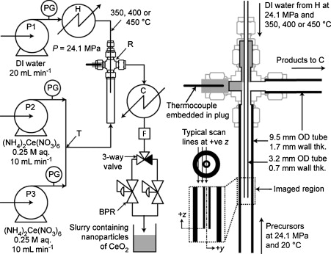
Fig. 1.
Flow diagram of the three-pump CHFS system and schematic diagram of the mixing point in symmetrical (centred) arrangement used in this set of experiments on ID15A. Two of three 305 Gilson HPLC pumps (P1, P2 and P3) were delivering cerium ammonium nitrate solution at a flow rate of 10 mL min−1 and one was delivering de-ionised water to the pre-heater at 20 mL min−1. The components contained within the CHFS system are: pre-heater (H), counter-current reactor (R), cooler (C), filter (F), pressure gauges (PG) and two back-pressure regulators (BPR). The insert shows the region imaged by the synchrotron radiation (z = 0 is the terminus of the inner pipe and y = 0 is the centreline of the inner/outer pipe).
2.2. Experimental set-up

These in situ tomographic angle-dispersive diffraction imaging (TADDI) experiments of continuous crystallisation of CeO2 nanoparticles under supercritical conditions were carried out at ESRF station ID15A. This station was chosen because of its particular suitability for diffraction imaging experiments, on account of its high energy, high flux, collimated X-ray beams and ‘fast’ detectors with good resolution. The choice of detector, a solid state large area Pixium 4700, was based on the detector's physical parameters (detector size and sample-detector distance) rather than solely on its imaging performance [23]. The monochromatic beam was tuned to a wavelength of 0.13 Å (equivalent to an energy of 89 keV). The sample-detector distance was set to 1280 mm and the beam size to 250 μm. More details for the experimental set-up in the angle-dispersive diffraction mode achieved at ID15A are provided in the Supplementary Material.

All the tomographic scans reported here were performed in the y and z directions, both perpendicular to the beam as shown in Fig. 1. Fig. 1 also indicates the region imaged by the synchrotron radiation. The tomographic scans map the content of nano-crystalline ceria in the mixing zone below and above the terminus of the inner pipe and along the outer walls of the inner pipe.

2.3. Data analysis method

Fig. 2 (top) shows an example of a typical two-dimensional diffraction pattern and its one-dimensional equivalent from a selected scan location inside the reactor. This two-dimensional diffraction pattern contains a series of concentric Debye-Scherrer rings from the steel pipe walls and the flowing nanoparticle ceria material. The continuous and smooth ceria nanoparticle diffraction rings can easily be separated from the bright and grainy diffraction rings. The well-defined ceria and steel rings were radially integrated to obtain a one-dimensional diffraction pattern (i.e. intensity versus 2θ-angle) using the data analysis software Datasqueeze.
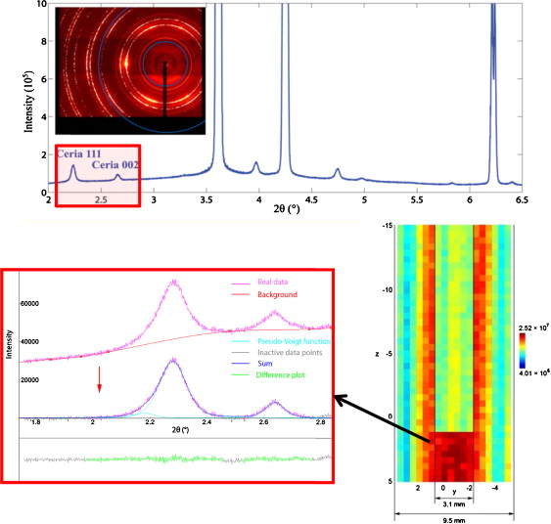
Fig. 2.
Typical two-dimensional pattern (insert in the top left corner) and the corresponding one-dimensional diffraction pattern collected on the Pixium 4700 detector (top). Incomplete rings (not full-circle) are outside of the range of the image due to the off-centered detector. The ceria (hkl) reflections of interest, (111) and (002) are observed between 2.0° and 2.8° 2θ (the enlarged area is shown at the bottom left); the peak fitting routine is applied on these two peaks to calculate peak parameters. Pixelated TADDI map (bottom right) is constructed from the total intensity of both unfitted ceria peaks (including the background intensity underneath them) in each pixel/scan point of total 20 × 41 points collected with 0.5 × 0.5 mm step size and 10 s per point count time. The integration limits are highlighted by blue circles. (For interpretation of the references to colour in this figure legend, the reader is referred to the web version of the article.)
Two selected, well-separated adjacent ceria peaks, the (111) peak and less strong (002) peak, in the 2.0° and 2.8° 2θ range in each of the one-dimensional patterns in the dataset were subjected to the peak fitting routine in the FITYK software package. An example of a pixelated (‘unsmoothed’) TADDI map constructed from the total intensity of both unfitted ceria peaks (including the background intensity underneath them) is shown at the bottom right of Fig. 2 as a quick scan preview. In order to determine the optimum values for the peak area and full width at half-maximum (FWHM) parameters the background intensity was subtracted and a pseudo-Voigt profile function was fitted to the observed peak shapes (an example of which is shown at the bottom left of Fig. 2). After these values were extracted from each diffraction pattern (scan point), all the two-dimensional yz TADDI maps of intensity (fitted peak area) or FWHM variations presented in this work are visualised by using the surf function, a built-in image processing function in MATLAB that includes colour intensity as a third dimension. In this way the data points in each of the ‘smoothed’ maps are displayed as a continuous ‘surface’ after the MATLAB nearest-neighbour pixel interpolation algorithm was applied, maintaining a faithful representation of the original pixelated maps. More detailed data analysis is available in the Supplementary Material section.

2.4. Particle size analysis of nano-CeO2

High-resolution transmission electron microscopy (HRTEM) images, on a 5 nm scale, of the CeO2 nanocrystallites synthesised at the three temperatures were obtained using a FEI Titan 80-300 (image) aberration corrected (S)TEM microscope operating at a maximum accelerating voltage of 300 kV. The ceria product collected from the CHFS system had to be washed, centrifuged, frozen and then freeze-dried prior to further analyses. The freeze-dried samples were prepared for HRTEM by first dispersing all three freeze-dried ceria specimens in ethanol. The obtained suspensions were ultra-sonicated for a short time before they were transferred onto a holey carbon-coated grid (400 mesh Cu(50), Agar Scientific). Detailed post-synthesis treatment and sample preparation procedures are outlined in the Supplementary Material.

Besides providing important details about morphology and particle size, HRTEM images were used to check the atomic structure (principal planes) of the specimen. Particles/crystallites sizes and atomic plane distances were measured on the HRTEM images in the image analysis software package, ImageJ, applying the straight line selection tool and FFT (Fast Fourier Transform) algorithm to regions of interest [24].

In the case of CHFS-synchrotron measurements it would not necessarily be simple and straightforward to obtain the instrumental broadening using standard powders [25]. In order to correct synchrotron instrumental broadening, additional analysis was required. This involved HRTEM to obtain realistic estimates for the crystallite size of the out-flowing ceria product. The previously reported approach by Middelkoop et al. [16] was taken in order to estimate the range of crystallite sizes in the TADDI images. The crystallite size of the outflow material was related to the peak widths in Fig. 3, Fig. 4 ; Fig. 5 by the following approximate equation: View the MathML source, where βinstrument is the instrument broadening contribution and the unknown component. In order to estimate the βinstrument component to the diffraction peak width broadening we used the mean of the HRTEM evaluations as a working measured particle size for the upper flow. This value can then be related to a peak width selected from the upper part of the ceria FWHM maps, by invoking the instrumental contribution to account for the difference between βmap-outflow and βHRTEM = Kλ/(LHRTEMcos θ ), and from which we effectively calibrate that instrumental component: View the MathML source (βinstrument = 0.038° at 350 °C, 0.037° at 400 °C and 0.046° at 450 °C). This instrumental component, βinstrument is then used to determine the material contribution to the hkl peak width, βhkl from any other region in the reactor vessel (assuming changes in instrumental contribution are negligible): View the MathML source, where βhkltotal is the uncorrected width. Thus using this corrected peak width, βhkl, in the Scherrer equation yields a particle size estimate, Lhkl, for the upper outflow path of the CHFS.
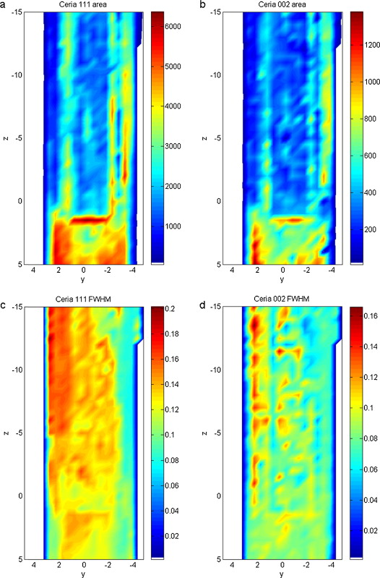
Fig. 3.
yz-TADDI maps obtained during nanocrystalline CeO2 formation taking place in the CHFS counter-current mixer at an inlet temperature of 350 °C and 24 MPa pressure. These maps are constructed from the intensity/area (ab) and FWHM (cd) of the ceria (111) and (002) peaks. The scan covers an area of 20 × 41 points, with step size 0.5 × 0.5 mm, collection time 10 s per point and total scan time 2 h and 27 min. Note that neither set of colour scale bars is normalised. The values in the colour scales are given in arbitrary units. Regions of lowest ‘intensities’ are depicted in blue and regions of no observed peaks are depicted in white. (For interpretation of the references to colour in this figure legend, the reader is referred to the web version of the article.)
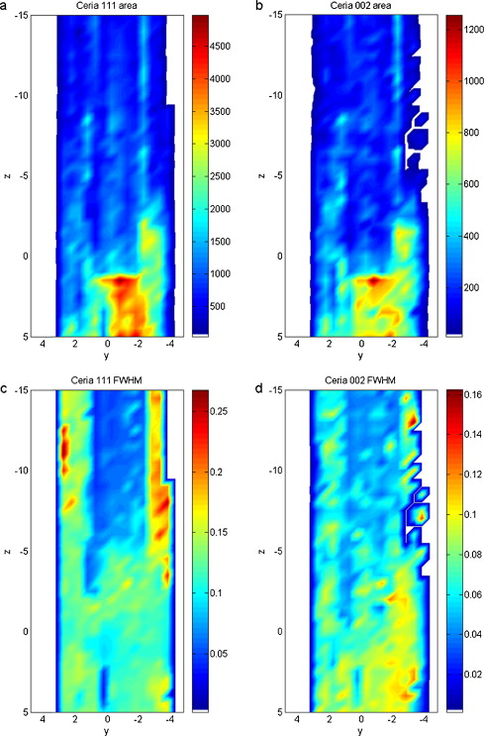
Fig. 4.
yz-TADDI maps obtained during nanocrystalline CeO2 formation in the CHFS counter-current mixer for a supercritical-water inlet temperature of 400 °C and pressure of 24 MPa. Maps are derived from the intensity/area (ab) and FWHM (cd) of the ceria (111) and (002) reflections. The scan covers an area of 20 × 41 points, with step size 0.5 × 0.5 mm, collection time 10 s per point and a total scan time of 2 h and 16 min. Neither set of colour scale bars is normalised. The values in the colour scales are given in arbitrary units. (For interpretation of the references to colour in this figure legend, the reader is referred to the web version of the article.)
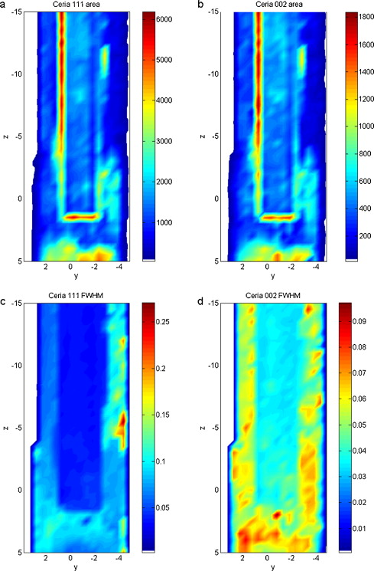Fig. 5.
yz-TADDI scans mapping the formation of nanocrystalline CeO2 in the CHFS counter-current mixer at a supercritical-water inlet temperature of 450 °C and 24 MPa pressure. Maps are derived from the inten sity/area (ab) and FWHM (cd) of the ceria (111) and (002) reflections. The scan covers an area of 18 × 41 points, with step size 0.5 × 0.5 mm, collection time 10 sec per point and total scan time 2 h and 3 min. Neither set of colour scale bars is normalised. The values in the colour scales are given in arbitrary units. (For interpretation of the references to colour in this figure legend, the reader is referred to the web version of the article.)
3. Results
3.1. TADDI results for CHFS at a subcritical water inlet temperature of 350 °C

The maps displayed in Fig. 3 are yz-TADDI scans performed during the continuous production of cerium oxide in near-critical water at an inlet temperature of 350 °C and 24 MPa pressure in the CHFS reactor.

Contrary to the expected result, the region of highest intensity is found to be where the stream of superheated water meets the counter-current flow of Ce-salt below the rim of the inner pipe (the bottom 20% of the map). Besides what appear to be deposits of ceria on the outside face of the pipe, there is also a discrete strip of intensity parallel to it, along the upstream passage on the right. The higher intensity of the ceria detected in the upstream flow clearly forms the contours of the inner pipe (images a and b in Fig. 3). The strip of large peak widths in the upper left flow passage area (red strip in Fig. 3c) appears to be an artefact of fitting errors associated with the low and very broad peaks, as is also another feature, the blue edges to the FWHM maps, associated with the very small peaks.

3.2. TADDI CHFS results at supercritical water inlet temperatures of 400 and 450 °C

The images in Fig. 4 ; Fig. 5 are yz-TADDI scans carried out during the continuous production of cerium oxide in the CHFS reactor at supercritical water inlet temperatures of 400 and 450 °C, respectively, and 24 MPa. These maps were different from the previous ID15A TADDI maps at supercritical water inlet temperatures of 450 °C (see [16] and Supplementary Material contained herein), in that they reveal a different location and distribution of crystalline CeO2 content and the FWHM maps give a much more even distribution of peak widths across the whole of the scanned area.

In all data sets (water inlet temperatures of 400, 450 °C and 350 °C), each ceria (002) map echoes the distribution pattern of its respective ceria (111) map, though at a three times lower intensity. There is, however, a considerable difference between the intensity maps for supercritical-water inlet temperatures of 400 and 450 °C. The maps representing results at 400 °C feature a very distinct intensity distribution (crystallisation zone) in the flow path immediately below the terminus of the inner pipe and an absence of deposits detected on the outer wall of the inner pipe (Fig. 4a and b). By contrast, the maps representing results at 450 °C also show a distinct crystallisation zone, although, interestingly, after a small but clear gap of ca 1–2 mm below the terminus. These maps also reveal a substantial amount of deposits of ceria localised on the inner pipe walls. Unfortunately, deposition within reactors of this type is inevitable as the temperature is sufficiently high to favour dehydration of the precursors. Formation of the oxide will allow crystallisation of the reaction product on any surface which could nucleate material growth.

In contrast to the scan at 350 °C, the scans at both supercritical temperatures appear to produce FWHM maps that are complimentary, to a degree, to the corresponding intensity maps in the sense of FWHM bearing an inverse relationship to intensity. One might expect high intensity regions (larger mass of crystallites) to correspond with smaller peak width regions on FWHM maps, and, through the Scherrer equation, to connect smaller FWHMs with larger crystallite size. However, the peak widths on these maps show a relatively uniform range of 0.02–0.2 (arbitrary units) whereas the previous ID15A-TADDI results [16] covered a wider span (up to 0.6). We have principally attributed this difference between the two experiments to the uniformity of mixing, where an offset in the inlet in the previous work led to poorer mixing and as such less homogenous nucleation and growth of nanoparticles. Otherwise the relative uniformity in peak widths and their distribution homogeneity make it hard to resolve separate regions of crystallite nucleation and growth. The intensity colour bars are not normalised to their maximum values in order to preserve small-scale features on the (002) reflection maps.

3.3. HRTEM measurements of CeO2 nanoparticles

HRTEM images were selected to provide a representation of individual CeO2 nanoparticles produced in each imaging experiment. This analysis revealed that highly crystalline CeO2 nanoparticles of sufficient quality were produced in each synthesis to obtain lattice fringes (atomic resolution). For each of the differently oriented nanoparticles, the Fourier transform of the selected areas was performed and profile plots of atomic plane equidistance were shown. The constant distance measured between lattice fringes (i.e. atomic planar spacing) of ∼0.3 nm is considered to be in agreement with the ceria (111) d-spacing values (as shown in Fig. 6, Fig. 7 ; Fig. 8a).

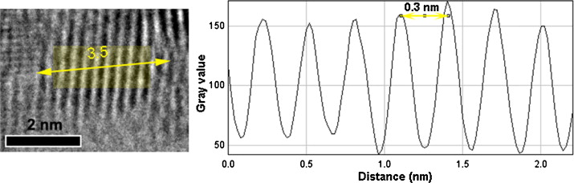Fig. 6.
Fourier-transformed region in the transparent (yellow) rectangular of a ∼3.5 nm diameter CeO2 nanocrystallite region synthesised at 350 °C (left). The resulting profile plot (right) shows the spacing between lattice fringes proportional to atomic planar distances of ∼0.3 nm for ceria (111). (For interpretation of the references to colour in this figure legend, the reader is referred to the web version of the article.)
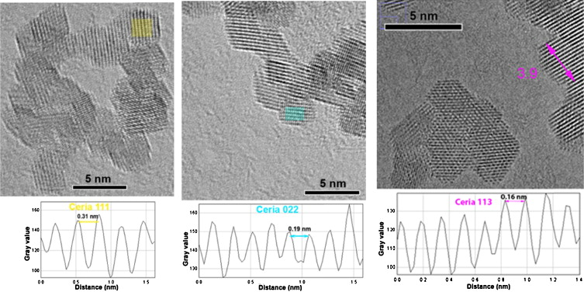Fig. 7.
Selected lattice-resolved HRTEM micrographs of individual nano-CeO2 (∼3.8 nm mean diameter) synthesised at 400 °C. Interplanar spacing measurements of lattice fringes inside the three rectangles correspond to the 0.31 nm, 0.19 nm and 0.16 nm spacings of the (111), (022) and (113) ceria reflections, respectively. (For interpretation of the references to colour in this figure legend, the reader is referred to the web version of the article.)
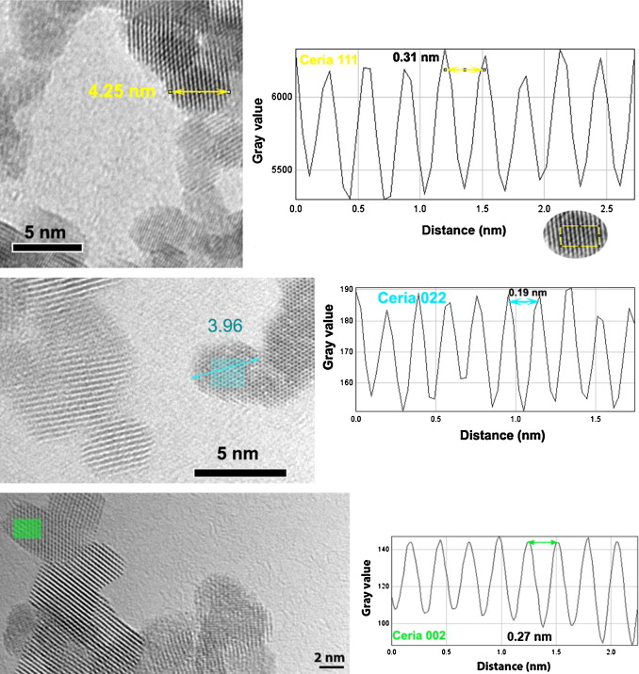Fig. 8.
HRTEM micrographs of typical aggregates of CeO2 nanoparticles (∼4 nm mean diameter) synthesised using a supercritical-water inlet temperature of 450 °C. Three well-oriented FFT’ed areas are indicated (in the transparent rectangle overlays) and the spacings calculated: 0.31 nm, 0.27 nm and 0.19 nm for ceria (111), (002) and (022) lattice fringes, respectively. (For interpretation of the references to colour in this figure legend, the reader is referred to the web version of the article.)
Fig. 7 ; Fig. 8 show parts of the HRTEM images with the areas of better oriented/dispersed nanoparticles, synthesised at 400 and 450 °C, respectively, compared to nanoparticles obtained at 350 °C. The appearance of lattice fringes is significant and in total, three other planes can be identified, ceria (022), (113) and (002). The ‘modulations’ of the reflections for ceria at 450 °C are clearly more distinct by comparison to the fringes profiles for ceria at 400 °C that are slightly noisy and irregular.

The results of the measurement of the particle size of nanocrystalline ceria at all three temperatures using HRTEM have shown that crystallites are mainly uniform in shape and size and are typically ca. 3–4 nm in diameter with an orthogonal morphology indicative of the crystal habit of CeO2. The histograms of the ceria particle size distribution (up to 242 particles counted) are given in the Supplementary Material section. The mean particle size and standard deviation values of all three specimens are presented in Table 1. As a whole, this set of values is in accord with those of the previous ID15A TADDI synthesis [16] and the generally perceived particle sizes of nano-ceria produced using CHFS technology [5]; [26] ; [27].

Table 1.
Particle size determined from TEM measurements for three different synthesis temperatures.
Water inlet temperature TEM
350 °C 3.6 ± 0.3 nm
400 °C 3.7 ± 0.3 nm
450 °C 4.1 ± 0.3 nm
Table options
Using the above HRTEM values as effective calibration enables a construction of particle size yz maps of nanocrystalline ceria based on the peak widths of the stronger ceria hkl reflection (111) for all three temperatures. The methodology is described in the earlier section “Particle Size Analysis of Nano-CeO2”.

4. Discussion
The previously published CFD simulations of Ma et al. [11] and the temperature profiling of Tighe et al. [12], undertaken at the same conditions, corroborate many of the observations presented in this work. As such, it was deemed appropriate to image the mixing point at a subcritical water inlet temperature of 350 °C, and supercritical water inlet temperatures of 400 and 450 °C (pressures of 24 MPa) so as to correlate any changes in particle size distribution against variation in process conditions. Two important effects were reported by Tighe et al. [12] relevant to the work herein. The first effect concerns the temperature of the preheated water which falls significantly as it travels down through the inner pipe, as a result of heat loss through the inner pipe to the cooler products flowing in the annulus around it. Typical comparison values for the same conditions (flow rates, pressure and mixer geometry) are 350 °C to 132 °C, 400 °C to 200 °C and 450 °C to 237 °C, respectively (nominal inlet to mixing temperatures). Thus, after the superheated water and precursors’ streams have mixed, and where the nanoparticles begin to form, the temperature was immediately substantially lower than the temperature of the region where the reacting mixture travels upwards through the annulus between the two pipes, determined from the overall heat balance. Secondly, by analysing the competing effects of momentum and buoyancy of the jet of supercritical water, Tighe et al. [12] concluded that the jet of supercritical water, issuing from the inner pipe, penetrated further into the oncoming precursors as the temperature increased, due to the increasing velocity/momentum. Furthermore, the above-mentioned results suggested recirculation issuing back into the jet of hot water (these flows should contain nanoparticles).

The imaging data shown in Fig. 3 are now found to be in agreement with the observations of Ma et al. [11] and Tighe et al. [12]. They show a region of lower intensity (i.e. lower concentration of CeO2) than elsewhere below the outlet of the inner pipe. This is obviously due to the X-ray beam, sampling the initial jet of hot water, issuing from the inner pipe that has not yet formed product nanoparticles. This contrasts with the region of higher concentration in the flow towards the edges of the pipe, where the precursors and hot water have mixed and have begun to form ceria nanoparticles. The thin layer of very high intensity signal coinciding with the walls of the pipe in Fig. 3a and b is the result of a build-up of ceria nanoparticles onto the walls of the pipes over the duration of lengthy experiments (ca. 2 h). However, these deposits were very thin and therefore would not significantly affect the flow dynamics over the course of an experiment.

There is further agreement between the imaging and temperature profiling data, obtained when the hot water enters the mixer at 400 °C. Here the region of higher intensity (as seen in Fig. 3a and b) appears to coincide with the expected location of the hot water jet (i.e. it has shifted downward from the position at 350 °C) as a result of the increased penetration of the preheated water flow into the precursor. Such a feature can be explained in terms of a high concentration of ceria nanoparticles being formed, upon mixing, very rapidly within a thin interface region between the preheated-water jet and the precursor flow, as predicted by Ma et al. [11].

Fig. 5a and b extends further the comparisons; first we note that both the imaging and the temperature profiling studies identify a region of high CeO2 concentration located at the bottom edge of the area being imaged where the momentum of the hot water jet significantly alters the overall balance of forces. The imaging results also bear this out with a region of high intensity at the bottom of Fig. 5a and b corresponding to the hot water jet encompassing most of the diameter of the outer pipe. It thus penetrates further into the oncoming precursors and causes the water-precursor interface (and the initial formation of CeO2 nanoparticles) to shift downwards.

The FWHM maps tend not to generally show sharp contrast and the regions of nucleation or particle growth are not clearly distinguished within the reactor. There are a number of factors that can contribute to this situation, such as the particle residence time, the evolution of order within the material as a function of time and the complex flow environment experienced by reagents within the reaction zone imaged. Over all imaged reactions, the particle residence time is short, being of the order of miliseconds in the mixing zone of CHFS reactors both at near- and supercritical temperatures and significantly shorter than the data accumulation time which lowers the resolution of the mapping [28] ; [29]. Another likely factor concerns the almost symmetric pipe arrangement in the CHFS experiments which can serve to direct the flow more uniformly. In this situation the formation of nanoparticles is thought to be very rapid and uniform when the precursors contact the preheated water. However, there are also contributions from other indirect influences such as small variations in the instrumental or strain broadening to the FWHM maps.

In Fig. 3c and d there appears to be a subtle contrast in FWHM between the region below the terminus of the inner pipe and the region in the annulus between the inner and outer pipes, where the products exit the mixer. These observations suggest that crystallisation within the reactor is very rapid and a nearly uniform flow of nanoparticles exits the reactor. Under the reaction conditions used it is not expected that dissolution of the nanoparticles occurs. However, in the annulus it is expected that the velocity and thus the turbulence of the flow increases due to heat transfer. In effect this heat transfer would cause the flow of nanoparticles to accelerate due to the change in density of the flow with increasing temperature.

A similar trend to that shown in Fig. 3c and d is also observed in Fig. 4 ; Fig. 5. This counter-intuitive result can be explained in terms of the prediction of Ma et al. [11] and Tighe et al. [12]. Both works suggest that internal recirculation (via entrainment) of some fraction of the nanoparticle-laden product is taking place, into the rear of the emerging preheated water jet (in this context leading to broadening of the residence time distribution). In this way, the smaller nanoparticles already formed would be exposed to fresh precursor, leading to further growth and an increase in total diffraction from this region. Using this reasoning, the region around the jet would contain a higher fraction of the larger nanoparticles, compared to the product flowing upwards through the annulus, which contain a mixture of these larger nanoparticles and smaller particles that were not recirculated.

In the light of the above considerations it is difficult to be certain about the true absolute particle size, determined from these maps. The lack of resolution in the incident beam effectively renders these tomographic images as yz maps of ceria content contained inside the tube along the beam path (as the schematic in Figure S2 provided in the Supplementary Material illustrates). In effect, the yz map combines the CeO2 crystallising in front of and behind the inner-tube and the deposited CeO2 material on the reactor walls but maintains meaningful resolution in yz. Fig. 9 suggests that over the period of measurement and as a function of increasing temperature, there is a distinct variation in the particle size only within a narrow range of values (these values can be read off against the scale bar). On the other hand, the size distributions estimated by HRTEM measurements slightly narrow with increasing temperature. Based on these observations it is reasonable to assume that particle nucleation and thus growth of the particles was more homogenous as a function of increasing temperature. Taking into account that two different techniques were employed, HRTEM and TADDI, and the errors associated with each of them (statistical uncertainties and the instrumental broadening, respectively), the effect of temperature on particle size appears to be marginal.

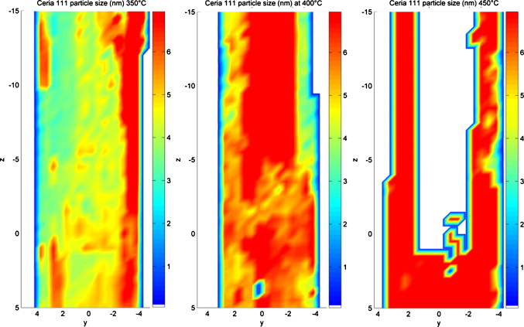Fig. 9.
CeO2 crystallite size yz maps constructed from the peak widths of the ceria (111) reflection showing spatial distribution of ceria particle sizes inside the counter-current mixer for three different CHFS temperatures (350 °C, 400 °C and 450 °C from left to right). Colour scale bars on the right side of every map correspond to a particle size range of 0–7 nm; the white area at the positions of the pipe walls in the map for ceria (111) at 450° blanks out the regions with peak widths < 0.05° for which a realistic particle size estimation cannot be made. (For interpretation of the references to colour in this figure legend, the reader is referred to the web version of the article.)
Figure options
5. Conclusions
The prime aim of this study has been to demonstrate in operando diffraction tomography of continuous hydrothermal synthesis around the region in which the superheated water jet exits the inner pipe and interacts with the incoming metal salt solution. As the results all relate to a set of specific conditions it is constructive to consider the obvious differences between them. The previous ID15A [16] and ID15B (Supplementary Material) results relate to a total flow rate of 50 mL min−1 and 20 mL min−1, respectively, both at a temperature of 450 °C and in an asymmetric inner tube arrangement. As already shown by the authors, the asymmetric arrangement was found to give an asymmetric product outflow with resolvable crystallite growth during outflow, from below the inner tube terminus to the higher outflow regions in the annulus formed between the inner and outer tubes. These observations compare against the three experiments described herein, with a symmetric inner tube arrangement used at supercritical-water inlet temperatures of 350, 400, 450 °C and a total flow rate of 40 mL min−1. The relevance of these three experiments (even though only carried out in the TADDI, rather than TÆDDI mode) is that they produced the first comparative images of nano-CeO2 synthesis in the CHFS system at three different temperatures which span both subcritical and supercritical water. However, a fully quantitative interpretation of these tomographic results is difficult as it involves a statistical balancing of two simultaneous crystallite growth scenarios after mixing with a further complication of product build-up within the reactor walls.

In the three sets of experiments reported here, TADDI has proven to be sufficiently sensitive so as to indicate both flow scenarios, recirculation and build up. This also rationalises the similarities seen in the previous TADDI results by the authors at ID15A [16] and ID15B (Supplementary Material). Although a more quantitative analysis of these effects remains a long-term goal we have already reached a stage, combining TADDI/TÆDDI imaging with temperature profiling and modelling techniques, where we can offer explanations to previously-observed anomalous effects. We are now able to reveal new insights regarding the internal processes occurring within a continuous hydrothermal flow synthesiser. Having to operate a continuous, supercritical water flow, synthesiser by remote control (necessarily so because of the prohibition of personnel within the instrument area during synchrotron operation) simultaneously with conducting TADDI/TÆDDI imaging is a difficult and complex task. Therefore, the results and interpretations reported here represent a significant and novel outcome to an exceptionally challenging problem. A drawback is that the detected intensity of the flow material is outweighed by the intensity of the material deposited on the inner pipe wall. On the upside, because of this the interal pipe configuration is confirmed more clearly. Overall these results have demonstrated that events predicted from previous experimental and modelling studies could be resolved physically using this technique. It offers a good demonstration of the consistency between the methods used to date to evaluate this process.

Supplementary Material
Supplementary Material available: material synthesis, experimental set-up, data analysis method, preliminary TADDI results at ID15B, sample preparation for TEM and CeO2 particle size distribution.

Acknowledgements
The authors would like to acknowledge funding from the EPSRC (“Synthesis, Design and Function in New Materials Chemistry”, ref. EP/D504872/1; “From Laboratory to Pilot Plant”, ref. EP/E040551/1) the ESRF for synchrotron beamtime, Mr. Paul Stukas for building the CHFS reactor frame, and Mr. Martin Vickers for the laboratory diffraction. The authors also wish to express their gratitude to Dr M. Peel for his help with the initial experimental set-up.

References
[1]
X. Weng, D. Brett, Y. Yufit, P. Shearing, N. Brandon, M. Reece, H. Yan, C. Tighe, J. Darr
Highly conductive low nickel content nano-composite dense cermets from nano-powders made via a continuous hydrothermal synthesis route
Solid State Ionics, 181 (2010), pp. 827–834
[2]
A.A. Chaudhry, S. Haque, S. Kellici, P. Boldrin, I. Rehman, F.A. Khalid, J.A. Darr
Instant nano-hydroxyapatite: a continuous and rapid hydrothermal synthesis
Chemical Communications, 21 (2006), pp. 2286–2288
[3]
X. Weng, P. Boldrin, I. Abrahams, S.J. Skinner, J.A. Darr
Direct syntheses of mixed ion and electronic conductors La4Ni3O10 and La3Ni2O7 from nanosized coprecipitates
Chemistry of Materials, 19 (2007), pp. 4382–4384
[4]
Z. Zhang, S. Brown, J.B.M. Goodall, X. Weng, K. Thompson, K. Gong, S. Kellici, R.J.H. Clark, J.R.G. Evans, J.A. Darr
Direct continuous hydrothermal synthesis of high surface area nanosized titania
J. of Alloys and Compounds, 476 (2009), pp. 451–456
[5]
S. Kellici, K.A. Gong, T.A. Lin, S. Brown, R.J.H. Clark, M. Vickers, J.K. Cockcroft, V. Middelkoop, P. Barnes, J.M. Perkins, C.J. Tighe, J.A. Darr
High-throughput continuous hydrothermal flow synthesis of Zn-Ce oxides: unprecedented solubility of Zn in the nanoparticle fluorite lattice
Philosophical Transactions of the Royal Society A-Mathematical Physical and Engineering Sciences, 368 (2010), pp. 4331–4349
[6]
J.A. Darr, M. Poliakoff
New directions in inorganic and metal-organic coordination chemistry in supercritical fluids
Chemical Reviews, 99 (1999), pp. 495–542
[7]
M. Yoshimura, K. Byrappa
Hydrothermal technology past, present and future
J. of Materials Science, 43 (2008), pp. 2085–2103
[8]
T. Adschiri, K. Byrappa, Supercritical hydrothermal synthesis of organic-inorganic hybrid nanoparticles, in: Atsushi Muramatsu (Eds.), Nanohybridization of Organic-Inorganic Materials, Springer-Verlag, Germany, 2009, pp. 217–250.
[9]
K. Byrappa, M. Yoshimura
Handbook of Hydrothermal Technology—A Technology for Crystal Growth and Materials Processing
(2nd ed.)Elsevier, London, UK (2013)
[10]
E. Lester, P. Blood, J. Denyer, D. Giddings, B. Azzopardi, M. Poliakoff
Reaction engineering: the supercritical water hydrothermal synthesis of nano-particles
J. of Supercritical Fluids, 37 (2006), pp. 209–214
[11]
C.Y. Ma, X.Z. Wang, C.J. Tighe, R. Gruar, J.A. Darr
Modelling and simulation of counter-current and confined jet reactors for continuous hydrothermal flow synthesis of nano-materials
V. Kariwala, L. Samavedham, R.D. Braatz (Eds.), Proceedings of the 8th IFAC International Symposium on Advanced Control of Chemical Processes, International Federation of Automatic Control, Oxford (2012), pp. 874–879
[12]
C.J. Tighe, R.I. Gruar, C.Y. Ma, T. Mahmud, X.Z. Wang, J.A. Darr
Investigation of counter-current mixing in a continuous hydrothermal flow reactor
J. of Supercritical Fluids, 62 (2012), p. 165
[13]
C.J. Tighe, R. Quesada Cabrera, R.I. Gruar, J.A. Darr
Scale up production of nanoparticles: continuous supercritical water synthesis of Ce–Zn oxides
Industrial & Engineering Chemistry Research, 52 (2013), pp. 5522–5528
[14]
R.I. Gruar, C.J. Tighe, J.A. Darr
Scaling-up a confined jet reactor for the continuous hydrothermal manufacture of nanomaterials
Industrial & Engineering Chemistry Research, 52 (2013), pp. 5270–5281
[15]
M. Bremholm, H. Jensen, S. Brummerstedt Iversen, B. Brummerstedt Iversen
Reactor design for in situ X-ray scattering studies of nanoparticle formation in supercritical water syntheses
J. of Supercritical Fluids, 44 (2008), pp. 385–390
[16]
V. Middelkoop, P. Boldrin, M. Peel, T. Buslaps, P. Barnes, J.A. Darr, S.D.M. Jacques
Imaging the inside of a continuous nanoceramic synthesizer under supercritical water conditions using high-energy synchrotron X-radiation
Chemistry of Materials, 21 (2009), pp. 2430–2435
[17]
P. Norby, A.N. Christensen, J.C. Hanson
Crystallization in nonaqueous media of Co- and Mn-substituted microporous aluminophosphates investigated by in situ synchrotron X-ray powder diffraction
Inorganic Chemistry, 38 (1999), pp. 1216–1221
[18]
V. Middelkoop, S.D.M. Jacques, M.G. O’Brien, A.M. Beale, P. Barnes
Hydrothermal/autoclave synthesis of AlPO-5: a prototype space/time study of crystallisation gradients
J. of Materials Science, 43 (2008), pp. 2222–2228
[19]
P. Bleuet, E. Welcomme, E. Dooryée, J. Susini, J.L. Hodeau, P. Walter
Probing the structure of heterogeneous diluted materials by diffraction tomography
Nature Materials, 7 (2008), pp. 468–472
[20]
S.D.M. Jacques, M. Di Michiel, A.M. Beale, T. Sochi, M.G. O’Brien, L. Espinosa-Alonso, B.M. Weckhuysen, P. Barnes
Dynamic X-ray diffraction computed tomography reveals real-time insight into catalyst active phase evolution
Angewandte Chemie International Edition, 43 (2011), pp. 10148–10152
[21]
S. Peng, J.S. Okasinski, J.D. Almer, Y. Ren, L. Wang, W. Yang, Y. Sun
Real-time probing of the synthesis of colloidal silver nanocubes with time-resolved high-energy synchrotron X-ray diffraction
J. of Physical Chemistry C, 116 (2012), pp. 11842–11847
[22]
O. Lazzari, C.K. Egan, S.D.M. Jacques, T. Sochi, M. Di Michiel, R.J. Cernik, P. Barnes
A new approach to synchrotron energy-dispersive X-ray diffraction computed tomography
J. of Synchrotron Radiation, 19 (2012), pp. 471–477
[23]
J.E. Daniels, M. Drakopoulos
High-energy X-ray diffraction using the Pixium 4700 flat-panel detector
J. of Synchrotron Radiation, 16 (2009), p. 463
[24]
W.S. Rasband, ImageJ, US National Institutes of Health, Bethesda, Maryland, USA, 2008, http://rsb.info.nih.gov/ij/.
[25]
B.E. Warren, X-ray Diffraction, Dover Publications, Inc., New York, USA, 1990, pp. 251–257.
[26]
A. Vella, R., Whitley, N., Armstrong, A, Dowd, J., Cline, Analysis of admixed CeO2 nanoparticles via TEM and X-ray diffraction techniques, in: M. Avdeev (Eds.), 30th Annual Condensed Matter and Materials Meeting, Australian Institute of Physics, 2006, pp. 1–4.
[27]
X.L. Weng, B. Perston, X.Z. Wang, I. Abrahams, T. Lin, S.F. Yang, J.R.G. Evans, D.J. Morgan, A.F. Carley, M. Bowker, J.C. Knowles, I. Rehman, J.A. Darr
Synthesis and characterization of doped nano-sized ceria-zirconia solid solutions
Applied Catalysis B: Environmental, 90 (2009), pp. 405–415
[28]
J.A. Darr, A. Cabanas, E. Lester, M. Poliakoff
A continuous and clean one-step synthesis of nano-particulate Ce1-xZrxO2 solid solutions in near-critical water
Chemical Communications, 11 (2000), pp. 901–902
[29]
A. Cabañas, J.A. Darr, E. Lester, M. Poliakoff
Continuous hydrothermal synthesis of inorganic materials in a near-critical water flow reactor; the one step synthesis of nano-particulate Ce1-xZrxO2 (x = 0–1) solid solutions
J. of Materials Chemistry, 11 (2001), pp. 561–568

