Manuscript ID: 124
DOI: 10.18462/iir.icr.2019.124

Reducing energy demand using cooling efficiently (REDUCE)

Jolyon P. AXELROD^{(a)}, Graeme G. MAIDMENT^{(b)}
^{(a)} FJB Systems LLP
Weybridge, KT13 9UH, UK, ja@fjb.co.uk
^{(b)} London South Bank University
London, SE1 0AA, UK, maidmegg@lsbu.ac.uk

Abstract
UK peak electrical demand and energy prices are rising. Concurrently, there is greater use of intermittent renewable energy and increased requirements for energy storage.
Refrigerated storage facilities (RSF) provide opportunities to store heat energy with potential to help balance energy demand with supply; reduce peak demand; facilitate more efficient operation; and reduce both costs and environmental impact.
REDUCE field studies investigated impact of load-shedding in RSF on food products; energy consumption and costs; and carbon emissions. Product temperatures met safety and legal limits. Peak tariff cost savings averaged >70% and carbon emission reductions were >10%.
REDUCE supports industry confidence in load-shedding which offers financial paybacks to users and reduces environmental impact. REDUCE highlights practical issues and areas for discussion and future research for successful implementation and monitoring of load-shedding.
Keywords: Refrigeration, Load-Shedding, Product Safety, Energy Efficiency, Environmental Impact.

1. Introduction
This paper describes our study into Reducing Energy Demand by Using Cooling Efficiently (REDUCE). Despite investigations into load shedding in RSF since the 1970s in the United States of America (USA) (Ashby et al., 1979), in the United Kingdom (UK) the take up of load shedding is limited, with concerns over product safety being a significant concern. There is potential for significant savings of energy, carbon emissions and financial costs, but the extent of such savings and issues involved in refrigeration load shedding in the UK require further investigation. Pressure on the electrical grid and constraints in demand, coupled with global environmental concerns have led to discussion about the potential of load shedding in RSF, but possible benefits are not fully known or understood.
Four linked field studies were conducted in chilled or frozen RSF to investigate issues around load shedding, yielding quantitative data collected from various monitors and probes and allowing product temperatures, energy use and costs to be analysed, estimated and compared. Observations of facilities were made throughout the studies provided further relevant evidence. This resulted in estimations of benefits of load shedding and highlighted some barriers to using it. Although industry experts believe that some RSF practice load shedding, there are no published UK details regarding this and neither the effects on product temperatures nor implications for costs and savings, nor any guidance for the industry have so far been published.
This paper describes the REDUCE study. Section 2 provides the general background to the subject, Section 3 describes the investigation and the results and discussion are covered in Section 4 and 5. Conclusions and areas of further work are described in Section 6.

2. Background

2.1 UK Energy and Refrigeration
Reviewing government data, increases of circa 2% can be seen in air-conditioning consumption over the past 6 years. Total electricity consumed by the Refrigeration, Air Conditioning and Heat Pump (RACHP) industry is 17.8% of total electricity supplied to the UK (DBEIS, 2016). For the UK to meet 2050 targets, 60% more energy from renewables will be required, with 50% increase in distributed generation and investment into energy, including energy storage balancing. Electrical vehicles could drive large increases in peak demand, along with decarbonising heat, with technology such as air source heat pumps. The National Grid made 4 predictions for future energy demand: Two Degrees; Slow Progression; Steady State; and Consumer Power (National Grid, 2017a). All show peak electricity increases and incentives are needed to optimally reduce this peak demand (Fig. 1). These initiatives have already begun with incentives to consumers to use energy more dynamically. Peak UK electrical demand makes up around 21% of total peak energy demand. Heat demand in buildings and industry (supplied by gas) currently makes up 75% of peak heat demand (Connolly, 2017).
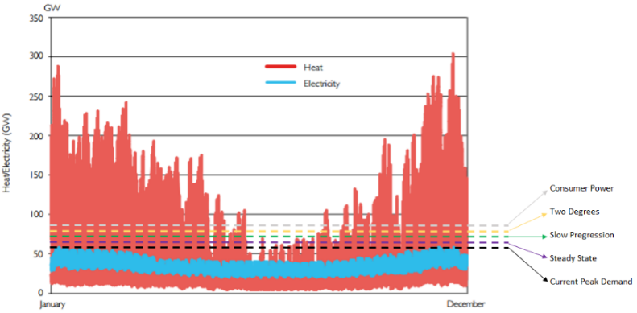
Figure 1. Indicative comparison of UK peak heat and electricity demand variability across a year – (National Grid, 2017a; Department of Energy and Climate Change, 2012).

2.2 UK Commercial and Industrial Electrical Energy Costs and Billing
Larger consumers of electricity pay certain additional charges on top of their actual electricity consumption, which are separated, and itemised on their bill. Two of these charges could be either partly, or fully avoided. Triad charges fall under Transmission of Network use of System (TNUoS) charges and the ‘Triad season’ runs from 1st November to the end of February. Charges comprise the total amount of electrical energy consumed within the three-half hourly (HH) periods multiplied by the tariff charge. The average current charge is £48.08 per kW used while in the HH Triad period, but is dependent on location. An average increase of circa 34% to 2022/23 is predicted (National Grid, 2017b). All previous Triad periods were in the zone ending between 17:30 and 18:30. Distribution Use of System (DUoS) charges are in place to recover the costs of installing and maintaining the local networks. For consumers on HH data meters, these DUoS charges vary with time of day, split into bands of red, amber and green. For example, UK Power Network (Eastern Power Network) are as follows (Table 1).
Table 1. DUoS time period and example costs
Time Period | Red Time Band | Amber Time Band | Green Time Band
Monday to Friday (including Bank Holidays) - All year | 16:00 – 19:00 | 07:00 – 16:00  19:00 – 23:00 | 00:00 – 07:00  23:00 – 24:00
Saturday and Sunday - All year | - | - | 00:00 – 24:00
LV HH Metered Tariff Unit Charge (p∙kWh⁻¹) | 10.911 | 0.078 | 0.014
HV HH Metered Tariff Unit Charge (p∙kWh⁻¹) | 6.384 | 0.020 | 0.004

2.3 Legal Control and Temperatures for Food Storage
UK food legislation at present is harmonised with European Union (EU) regulations. EU Regulations require that official controls are in place to check food operators, with the onus on food operators to conduct their own hazard analysis and critical control point (HACCP) assessments. Regulation EC 853/2004 sets standards for foods of animal origin defining minimum storage temperatures of some meat products. UK temperature control requirements do not apply to foodstuffs already covered by the EU. To all other chilled foodstuffs that are ‘likely to support the growth of pathogenic micro-organisms’, ‘a temperature above 8°C commits an offence’ (HM Government, 2013). Quick-frozen foodstuffs (QFF) are required to be maintained at -18°C throughout the product. The British Frozen Food Federation (BFFF) provides product temperature regulations (not air temperature) (BFFF, 2012), and suggest -18°C is selected for food quality issues rather than food safety issues, e.g. ice cream at -15°C becomes soft and its appearance may be affected by crystallisation (BFFF, 2009).
Evans reports that temperatures in many instances ‘(especially in frozen stores) are kept lower than necessary to provide a safety margin in case of plant failure’ (Evans, 2009). ‘At chilled temperatures the growth of micro-organisms occurs only slowly’, ensuring food quality can be maintained for extended periods. In the large majority of foods ‘microbial growth will be inhibited at temperatures below -12°C’. In the main, ‘food will spoil about four times as fast at 10°C and twice as fast at 5°C, as at 0°C’. ‘Spoilage micro-organisms do not grow below -10°C to -12°C and pathogens below -1°C’ (Motarjemi and Lelieveld, 2014). Two studies on fluctuations in frozen storage found fluctuations should be kept to a minimum or not more than ±3°C (Phimolsiripol, et al., 2007; Ashby et al., 1979).

2.4 Load Shifting and Shedding
Load shifting involves moving energy demand (load) to a different time period. The idea is that while net load remains constant, consumption and cost may be lower due to increased efficiency of plant, or more economical energy rates. An interesting study, conducted on shifting load in wet appliances, space heating cooling and electric vehicles, found load shifting proved invaluable for demand side management (DSM), and that peaks could be reduced, enabling more efficient use of renewable energy because of less constraints of the energy source (Wimmler et al., 2016). Many studies conducted since the late 1970s, reviewed by Ashby et al. (1979), showed how load shedding is controlled in buildings, leading to three distinct areas of research for refrigerated storage facilities using Building Thermal Mass (BTM), Thermal Energy Store (TES) or Phase Change Material (PCM) strategies. In the UK, it is widely accepted that load shedding takes place, but no UK research has emerged for RSF. Load shedding offers clear wins for consumers (more efficient plant; less maintenance and lower consumption costs); the environment; and the grid; (peaks are reduced, putting less demand on the already struggling electrical grid).

3. Investigation
The four linked REDUCE field studies were set in chilled or frozen RSF, yielding quantitative data from various monitors and probes, showing product temperatures, energy use and costs for analysis, estimation and comparison, resulting in estimations of benefits of load shedding. Observations of facilities, made throughout, provided additional evidence and highlighted some barriers to use.

3.1 Site Selection, Installation and Review
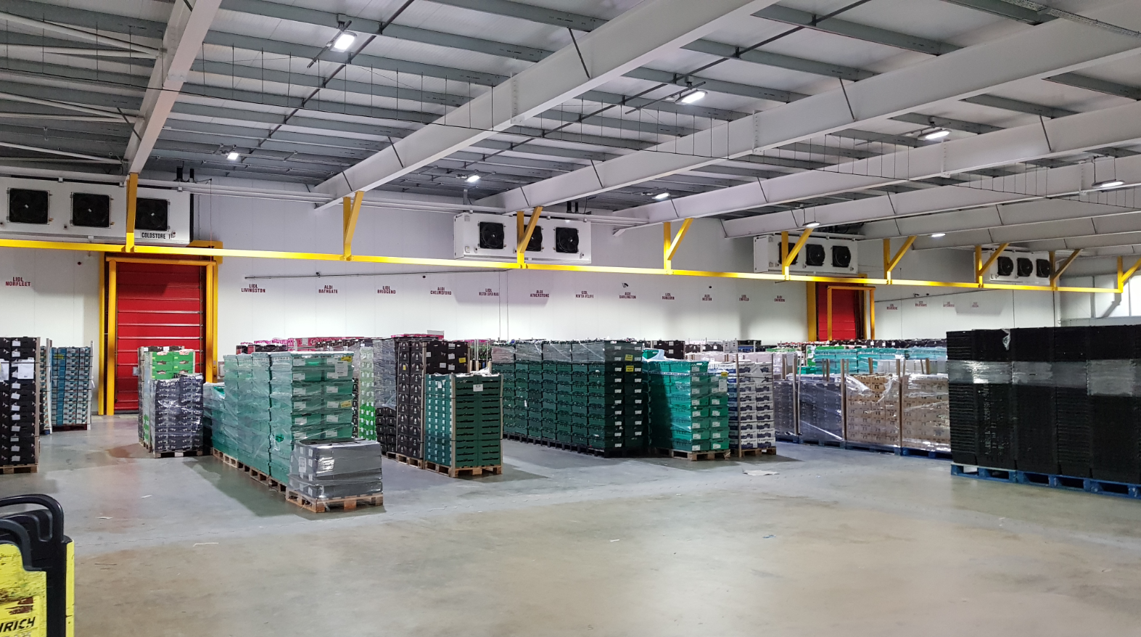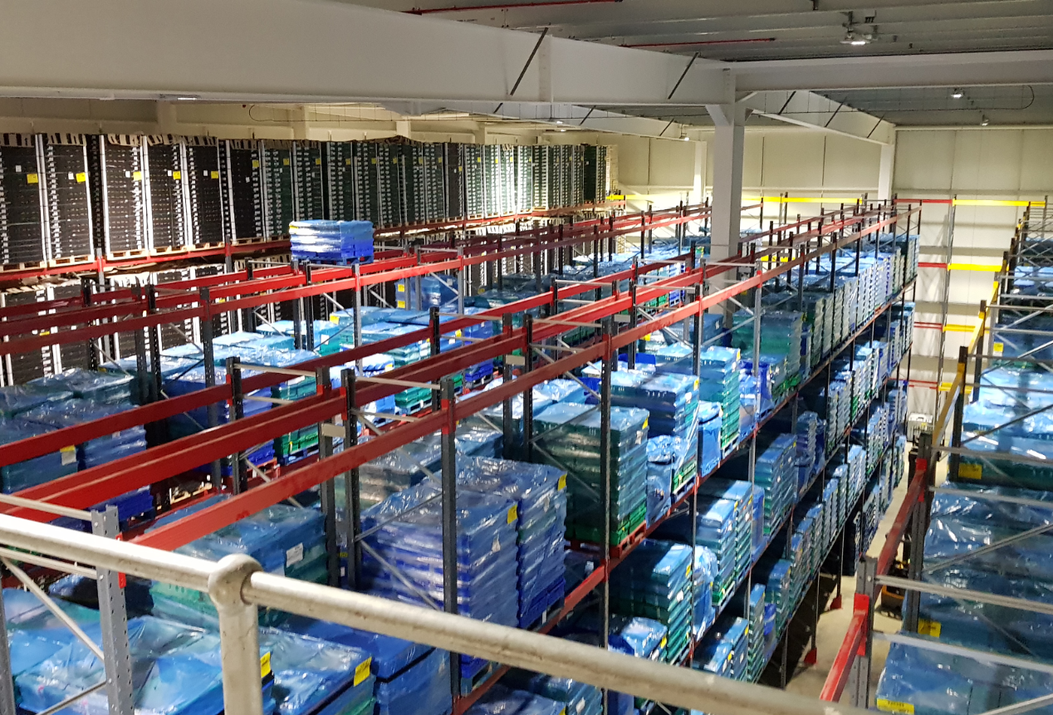
Figure 2. Facility 3 marshalling and storage area
Qualitative observational data was collected and considered in conjunction with quantitative results. All facilities’ refrigerated chambers were constructed using insulated composite panels. The three facilities physical area/volume of refrigerated space varied considerably. Plant was controlled via a supervisory control and data acquisition (SCADA) system. The refrigeration systems main components were individually metered with power sub meters (with displays). Defrosting was via hot gas or off cycle, which had to be disabled during the REDUCE field studies, in order to avoid higher temperatures while load shedding. RSF operated normally throughout all field studies (Fig. 2).
3.2 Field Studies
Evans found it was common for operators to switch off refrigeration during peak demand periods when energy is more expensive, stating the room temperature is allowed to rise slowly and only reduced once the cost of energy is lower, but with no data on the impact to space/product temperature (Evans, 2009). REDUCE field studies measured product temperature, chamber temperature and electrical energy consumption while load shedding. Refrigeration systems were shut down to match both the DUoS and TNUoS charge periods. Sequenced shut down began at 15:45 and was turned back on from 19:00. Sequencing is important, as fully loading the refrigeration plant can cause issues with electrical load.
Table 2. Product data logged for investigation
RSF | Chamber | Product 1 | Product 2 | Product 3
1 | 1 | 1 Yogurt (500g pack (125g/yogurt)) | 1 Salad Bag (100g Pack) | Salmon (225g 2 fillet package)
 | 2 | 1 Orange | 1 Cauliflower | -
2 | 1 | N/A | N/A | N/A
 | 2 | Ice Cream (8 pack, 500g each - Surface Temperature) | Pizza (350g Boxed - Surface Temperature) | Pizza (350g Boxed - Internal Box Temperature)
 | 3 | Ice Cream (8 pack, 500g each - Surface Temperature) | Pizza (350g Boxed - Surface Temperature) | Pizza (350g Boxed - Internal Box Temperature)
 | 4 | Ice Cream (8 pack, 500g each - Surface Temperature) | Pizza (350g Boxed - Surface Temperature) | Pizza (350g Boxed - Internal Box Temperature)
3 | 1 | Whole Chicken (1,250g) | Chicken Breast (600g) | 1 Sausage (from packaged 150g 4 pack)
 | 2 | 1 Orange | 1 Pomegranate | -
 | 3 | Vine Tomato's (250g pack) | 1 Butternut Squash | -
 | Marshalling | Whole Chicken (1,250g) | Chicken Breast (600g) | 1 Sausage (from packaged 150g 4 pack)

Some frozen product was pre-selected (RSF 2), for comparison to previous temperature fluctuation studies (Phimolsiripol et al., 2007; Schalbart et al., 2014): such as a dough-based product (pizza); and ice cream. All other product was selected to get a good range of stored product and was data logged and recorded for each facility (Table 2). All product was removed from pallets and stored independently, perceived to be ‘worst case’ as product within pallets offers much higher thermal mass. Chamber 1 (of 4) in Facility 2 remained operational throughout the study. It became apparent in Facility 1 that chill facilities were susceptible to health and safety issues due to condensation forming on the concrete slab while the refrigeration system was isolated (reported by maintenance team, close to the dock doors, during major refrigeration failure). In chilled facilities 1 and 3, Gemini’s Tinytag data loggers were used, using needle probes, inserted into the core of the product. Chamber air temperature was recorded on the air inlet to the evaporator. Floor slab temperature was recorded via a needle probe with the surface extended with tin foil, and insulation and a heavy weight placed over the probe, to ensure good slab contact. Facility 2 frozen product temperature was logged at the surface only, to avoid product damage. Product absorbs heat outside-in, so, core temperature would be lower. For pizza, both box and inner product were plastic wrapped, so probe was inserted into the wrap. Facilities 1 and 2 energy meters were logged every 10 minutes for power in kW used. Facility 3 had a calibrated energy system on site, recording site energy data at 10-minute intervals.

3.3 Data and Analysis
Temperature increase by product and electrical energy consumption (Table 3), showed Facility 1, Chamber 1, temperatures increased as expected during load shedding but fell to between 0.8°C and 2.8°C following it. Facility 2, Chamber 2 ice cream increased 2.45°C, to -17.56°C, the only ice cream to increase past -18°C for approximately 3 hours (manufacture recommends storage of at least -18°C). Ice cream core temperatures would be lower as product will absorb heat from the outside in. All chilled product remained below 4°C, the required minimum storage temperatures. Facility 3 is 16 m high, and stratification of air is believed to have been an issue. Altwies and Reindl, (2001), suggested evaporator fans operate for short periods of time during load shedding to avoid this.
Table 3. Load shedding temperatures
RSF | Chamber | Item | Temperature at 15:00  (°C) | Max Temperature During Load Shedding (°C) | Temperature Increase (°C)
Facility 1 | 1 | Chamber Air Temperature 1 (a) | 2.87 | 5.31 | 2.44
 |  | Chamber Air Temperature 1 (b) | 2.74 | 5.14 | 2.40
 |  | Salad Bag | 4.30 | 5.02 | 0.72
 |  | Yogurt | 3.24 | 3.88 | 0.64
 |  | Salmon | 2.31 | 3.79 | 1.48
 | 2 | Chamber Air Temperature 2 (a) | 6.11 | 8.44 | 2.33
 |  | Chamber Air Temperature 2 (b) | 6.78 | 8.60 | 1.82
 |  | Orange | 7.11 | 7.49 | 0.38
 |  | Cauliflower | 7.06 | 7.51 | 0.45
Facility 2 | 2 | Chamber 2 - Air | -19.31 | -15.17 | 4.14
 |  | Chamber 2 - Ice Cream | -20.01 | -17.56 | 2.45
 |  | Chamber 2 - Pizza (Surface) | -20.42 | -16.06 | 4.36
 |  | Chamber 2 - Pizza (Internal) | -20.47 | -16.86 | 3.61
 | 3 | Chamber 3 - Air | -19.96 | -16.71 | 3.25
 |  | Chamber 3 - Ice Cream | -20.03 | -18.34 | 1.69
 |  | Chamber 3 - Pizza (Surface) | -20.19 | -17.13 | 3.06
 |  | Chamber 3 - Pizza (Internal) | -20.28 | -17.68 | 2.60
 | 4 | Chamber 4 - Air | -19.98 | -17.05 | 2.93
 |  | Chamber 4 - Ice Cream | -20.37 | -19.04 | 1.33
 |  | Chamber 4 - Pizza (Surface) | -20.63 | -18.30 | 2.33
 |  | Chamber 4 - Pizza (Internal) | -20.63 | -18.45 | 2.18
Facility 3 | Marsha-lling | Marshalling Air Temperature | 4.37 | 6.97 | 2.60
 |  | Chicken Breast | 2.75 | 3.22 | 0.47
 |  | Whole Chicken | 2.84 | 3.14 | 0.30
 |  | Sausage | 2.78 | 3.39 | 0.61
 | 1 | Chamber 1 Air Temperature | 0.81 | 2.06 | 1.25
 |  | Chicken Breast | 1.03 | 1.26 | 0.23
 |  | Whole Chicken | 1.00 | 1.23 | 0.23
 |  | Sausage | 1.29 | 1.66 | 0.37
 | 2 | Chamber 2 Air Temperature | 4.34 | 4.80 | 0.46
 |  | Orange | 3.85 | 4.23 | 0.38
 |  | Pomegranate | 3.70 | 3.97 | 0.27
 | 3 | Chamber 3 Air Temperature | 9.95 | 10.44 | 0.49
 |  | Tomato | 8.85 | 8.80 | -0.05
 |  | Butternut Squash | 8.83 | 8.76 | -0.07
Condensation occurs when the surface temperature of a material is colder than the dew point temperature of the air. Fig. 3 shows floor condensation analysis carried out during the investigation. Dew point temperature does encroach upon the slab temperature at one point during the trial in Facility 3, so it is believed both external ambient conditions and floor slab construction would need to be considered. No condensation was noted during the study.
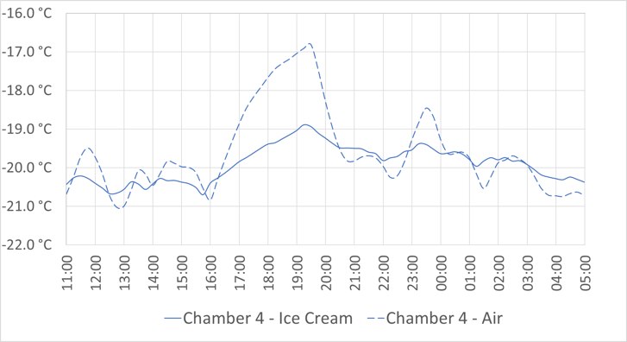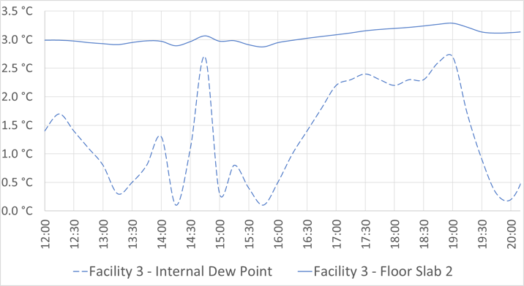
Figure 3. Example product temperature data and floor condensation assessment
Fig. 4 shows an example of refrigeration electrical energy, with kW readings from each power meter recorded over each 10-minute period. With data split into total compressor, condenser and individual chamber consumption. Data included the total consumption 3 hours before, energy during and energy 3 hours after load shedding. Initially it was expected that there would be no net gain or loss in energy due to load shedding as energy is being shifted from one period to another.
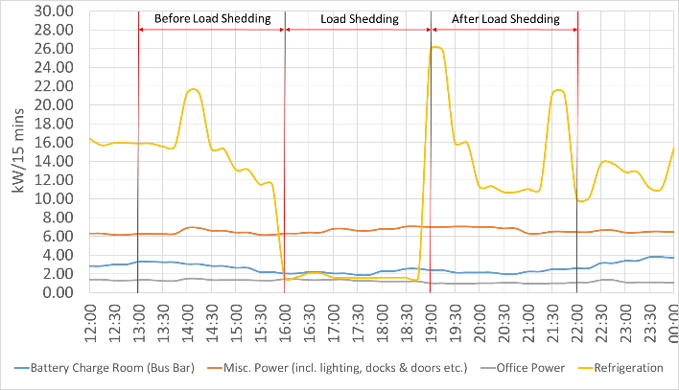
Figure 4. Facility 3 refrigeration electrical energy consumption
Table 4 shows the energy consumed before, during and after the load shedding period. While evaporators were isolated during load shedding, the plant continued to maintain the ammonia temperature in the surge vessel. Facility 1 (a) was the only result to show a net increase in energy. It was noted that isolating battery charging could be an easy win for consumers. Less energy consumption following load shedding can only occur due to a number of variables: efficiency of the refrigeration plant; lower ambient temperatures, higher operating efficiency; higher operating efficiency at full load and less heat load on the chamber; less product; less heat gains.
Table 4. Facility refrigeration load shedding energy analysis
RSF | Before Load Shedding (kWh) | During Load Shedding (kWh) | After Load Shedding (kWh)
Facility 1 a | 465.2 | 101.3 | 885.7
Facility 1 b | 335.6 | 9 | 547.5
Facility 2 | 3,706 | 2,341 | 3,854
Facility 3 | 185.4 | 20.1 | 192.2
Facility 1 raised questions over the control and operation, as both product and air temperatures were reduced to lower than their start point following load shedding. Following a second trial it was found that Facility 1, was controlled with a floating suction set-point, as the temperature of the chamber increased the suction temperature decreased. This was set to a maximum of 0°C, then decreasing (or increasing) 0.2°C every 5 minute. During trial B, compressor set point was manually set to 0°C. Over the 3-hour load shedding period the temperature decreased to -7.2°C, and effects of this are seen in both chamber temperatures and energy increases.

4.0 Results
Data analysis showed load shedding is possible without risk to product, peak tariffs can be reduced by up to 95% and carbon reductions can be up to 11%. Using average half hourly consumption, the Triad charge with no load shedding can be calculated. DUoS ‘red band’, cost savings can be calculated using the calculated amount of energy that was load shed during the period between 16:00 and 19:00. Carbon savings can be calculated using the data from Table 4. RSF 1 figures would improve if the system control was adapted, RSF 2 if all chambers were isolated during loading shedding. Shedding could be carried out during November to February (Triad season) or the entire year. Table 5 shows the results of each RSF load shed.

Table 5. Cost and carbon savings
 | RSF 1 a | RSF 1 b | RSF 2 | RSF 3
Triad Charge (£/kWh) | 51.87 | 51.87 | 51.87 | 49.2
Average HH (no load shed) (kWh) | 77.5 | 55.5 | 617.7 | 30.9
Average HH (with load shed) (kWh) | 16.88 | 3 | 390.2 | 6.7
Total Triad Saving with Load Shed (£) | 9,433 | 8,170 | 35,401 | 3,572
Total Energy Shed (kWh) | 363.9 | 326.6 | 1,365 | 165.3
*DUoS saving per day (£) | 23.23 | 20.85 | 87.14 | 10.55
*DUoS saving if in ‘Triad Season’ (£) | 2,788 | 2,502 | 10,457 | 1,266
*DUoS saving if conducted all year (£) | 8,456 | 7,610 | 31,719 | 3,851
Total tariff reduction during ‘Triad Season’ (%) | 78 | 95 | 37 | 78
Net Energy Change due to load shed (kWh) | +56.6 | -115 | -1,217 | -158.5
Carbon Emission Change per day (kgCO₂e) | +19.90 | -40 | -427.85 | -55.72
Carbon Emission Change per Triad Season (kgCO₂e) | +2,388 | -4,839 | -51,342 | -6,686
Carbon Emission Change per year (kgC0₂e) | +7,244 | -14,718 | -155,737 | -20,282
Total carbon change due to load shedding (%) | +4 | -11 | -11 | -26
* DUoS ‘Red Band’ Charge £0.06384. Carbon Factor for Electricity 0.35156 kgCO₂e

5. Discussion
REDUCE shows load shedding has promising financial and environmental paybacks, with potential to reduce peak period electrical load on the grid. Whilst REDUCE findings are restricted to three RSF of differing sizes and temperatures, it offers scalability. Load shedding offers a simple solution to financial and environmental challenges, making it of great interest. Little UK research exists on the effects of daily load shedding on very short-term product temperature fluctuations. Future research must consider potential of RSF for excess energy storage from the grid (such as renewables). Rather than shedding energy, and making constraint payments, using constrained electrical energy to over-cool during high generation periods, can reduce peak load requirements.
Observations from REDUCE show more investigation is needed on how PCMs and TES could improve storage of energy in large facilities. Clear guidelines and regulatory documentation for RSF operators, explaining acceptable fluctuations in temperature for specific products, duration and frequency are needed. Control adaptations to reduce temperatures prior to a load shed, or, as in Facility 3 addition of a maximum air temperature override, reduces risk to product in chambers. Better controlled sequencing of evaporator fans could avoid stratification of air. Implications include advanced sequencing to avoid defrosting during load shedding and the following hour (for example). Operators must consider timing of product deliveries during load shedding periods to ensure maintenance of correct temperature. Overall design of refrigeration plant and of entire operational management systems is extremely important for successful load shedding with consideration for liquid refrigerant storage, and availability of the necessary vessel size. Load shedding must take place at peak times and any resulting operating issues could be costly as these often occur on start-up of the refrigeration plant, which for many contractors is out of hours and charged at a higher rate.

6. Conclusions
REDUCE contributes to understanding the effects of load shedding on energy consumption, product temperature and carbon emissions in RSF and to industry confidence in load shedding. It is important, because there is no relevant, published UK data, despite various bodies acknowledging load shedding takes place. Scaled up savings show huge reductions in peak electrical tariffs, reductions in carbon emissions and reduced peak demand on the electrical grid. Incorporating load shedding can help balance the grid, but with little evidence on effectiveness, benefits, savings and pitfalls. REDUCE’ results show load shedding has great potential for RSF operators, reducing financial operating costs to consumers, as well as overall energy and carbon consumption. Product temperatures in all facilities remained within their defined tolerances. While the concept of load shedding is relatively simple there are many pitfalls. The REDUCE project has found many areas of discussion and practical issues associated with load shedding. Expert consideration of overall management of individual variations in facilities is needed. For example, in our field study we found that floor condensation is an issue to be considered in chill stores. Further work is urgently required to better understand the amount of current RSF in the UK; the total energy consumption of RSF; and to verify the DBEIS estimated consumption data. A load shedding regulatory document for operators would be extremely beneficial and could help enormously with UK uptake of load shedding. Expertise in load shedding in RSF can contribute to global energy solutions.

References
Altwies, J., Reindl, D., 2001. Passive Thermal Energy Storage in Refrigerated Warehouses. Int. Journal of Refrigeration 24, 149-157.
Ashby, B., Bennett, A., Bailey, W., Moleeratanond, W., Kramer, A., 1979. Energy Savings and Quality Deterioration from Holding Frozen Foods at Two Daily Temperature Levels. Transactions of the ASAE 22 (4), 938-943.
Connolly, D., 2017. Heat Roadmap Europe: Quantitative Comparison between the Electricity, Heating and Cooling Sectors for Different European Countries. Energy 139, 580-593.
Department for Business, Energy and Industrial Strategy (DBEIS), 2016. Energy Consumption in the UK 2016 - User Guide. (https://www.gov.uk/government/uploads/. Accessed online 16th November 2017)
Department of Energy and Climate Change (DECC), 2012. The Future of Heating: A Strategic Framework for Low Carbon Heat in the UK. (https://www.gov.uk/government/uploads/system/uploads/attachment_data/file/48574/4805-future-heating-strategic-framework.pdf. Accessed online 15th November 2017).
Evans, J., 2009. Food Chilling and Freezing Technologies: Potential for Energy Saving. Food Refrigeration and Process Engineering Research Centre (FRPERC). (http://www.design-technology.info/alphaindex/manufacturing-foodchillfreeze.pdf. Accessed online 11th November 2017).
HM Government, 2013. The Food Safety and Hygiene (England) Regulations. The Stationery Office Limited, UK.
Motarjemi, Y., Lelieveld, H., 2014. Food Safety Management - A Practical Guide for the Food Industry. Academic Press.
National Grid, 2017a. Future Energy Scenarios. (http://fes.nationalgrid.com/ media/1253/final-fes-2017-updated-interactive-pdf-44-amended.pdf. Accessed online 13th November 2017).
National Grid, 2017b. Forecast TNUoS Tariffs for 2018/19. (https://www.nationalgrid.com /sites/default/files/documents/October%20Forecast%20TNUoS% 20Tariffs%20for%20201819%20Report.pdf. Accessed online (25th November 2017).
Phimolsiripol, Y., Siripatrawan, U., Tulyathan, V., Cleland, D., 2007. Effects of Freezing and Temperature Fluctuations During Frozen Storage on Frozen Dough and Bread Quality. Journal of Food Engineering 84, 48-56.
Schalbart, P., Leducq, D., Alvarez, G., 2014. Ice-cream Storage Energy Efficiency with Model Predictive Control of a Refrigeration System Coupled to a PCM Tank. International Journal of Refrigeration 52 140-150.
The British Frozen Food Federation, 2009. Improving the Energy Efficiency of the Cold Chain. Accessed online (8th December 2017): http://bfff.co.uk/wp-content/uploads/2013/06/Energy-Efficiency-Report.pdf.
The British Frozen Food Federation, 2012. Guide to the Storage and Handling of Frozen Foods. UK: The British Frozen Food Federation.
Wimmler, C., Hejazi, G., Fernandes, E., Moreira, C., Conners, S., 2016. Impacts of Load Shifting on Renewable Energy Integration. Energy Procedia 107, 248-252.

