**MINIMISING PRODUCT MOISTURE LOSS IN PROFESSIONAL SERVICE CABINETS**

**Catarina MARQUES (*,**), Edward HAMMOND (*), Ian WOOD(**)**

(*) Department of Engineering, London South Bank University, 103 Borough Road,

London, SE1 0AA, United Kingdom

[marquesc@lsbu.ac.uk](mailto:marquesc@lsbu.ac.uk)

(**) Adande Refrigeration, 45 Pinbush Road, South Lowestoft Industrial Estate,

Lowestoft, Suffolk, NR33 7NL, United Kingdom

**ABSTRACT**

This paper investigates how refrigerated cabinet design can improve temperature stability and minimise product moisture loss, thus reducing food waste and enhancing raw and cooked product quality. The safe storage limit of perishable products was tested in three professional service cabinets with different evaporator designs (orientation and temperature), airflow distribution and velocity.

A representative small sample of meat, fish, dairy, fruit, vegetables, pasta and rice with a comparable freshness and shelf life was used for the test. The same frequency of door/drawer openings was performed in all refrigerated cabinets over an extended period to simulate typical restaurant operating conditions. At the end of the test period there was a visible difference in cabinet temperature and relative humidity which had a direct impact on product weight loss, final product value and overall organoleptic quality.

1. INTRODUCTION

Food waste has a considerable environmental and economic impact. According to a study commissioned by the Food and Agriculture Organization of the United Nations about one third of food produced worldwide is wasted, accounting for a total 1.3 billion tonnes (FAO, 2013). In the UK it is estimated that the hospitality and food service sector produces 0.92 million tonnes of food waste every year, which costs £2.5 billion (WRAP, 2013). A considerable proportion of the food waste produced by the foodservice sector comes from inadequate storage of refrigerated products such as meat, fish, dairy products, fruits and vegetables.

Refrigeration plays a vital role in reducing food losses and waste by significantly reducing the rate of growth of pathogens and spoilage organisms, and also slowing down various physiological (e.g., ripening and aging), biochemical (e.g., pigmentation reactions and lipid oxidations) and physical (moisture loss) processes within food products that can result in inferior product quality (Gwanpua *et al.*, 2014).

It is well established that temperature and relative humidity (rH) are the most important factors affecting the safety, organoleptic quality and shelf-life of perishable foodstuffs. There is limited information on the performance of refrigeration cabinets in busy commercial food service environments as most studies are focused in other stages of the cold chain, such as cold room storage, transport, retail and domestic refrigeration. However the same principles apply, the heat transfer phenomena involved during product cooling and storage are conduction within the product, convection (between cold air and product surface) and radiation (between product surface and cabinet walls) (Hu and Sun, 2000). Additionally, fresh produce is made of living tissues that undergo a respiration process where sugar is converted into heat energy, causing a loss in product quality and food value (ASHRAE, 2006). Low temperature inhibits the rate of product respiration and extends storage life. Protein products such as meat and fish are particularly sensitive to temperature abuse. An increase in mean product temperature by 0.5ºC may reduce the freshness period and storage life of processed fish by one day (Lauzon *et al.*, 2010).

Moisture evaporation from the product surface can also result in significant weight loss. The recommended storage rH for most horticultural crops is at or above 90% (Cantwell, 2002). Both temperature fluctuation and moisture loss can have a direct impact on the product final quality affecting the cooking time of the product. Heat and moisture transfers are influenced by flow characteristics (such as cooling air temperature and velocity), air properties (viscosity, density, conductivity and specific heat), product properties, shape, dimension and arrangement of the load within the cabinet (Duret *et al.*, 2014). CFD simulations and experimental temperature measurements in a static refrigerator compartment also indicate that the cold zone (evaporator) location influences the temperature distribution. A horizontal cold zone produces a better temperature distribution in the compartment and a 2.4ºC lower average temperature than a vertical cold zone with the same surface area (Marques *et al.*, 2013).

This paper investigates how refrigerated cabinet design can improve temperature stability and minimise product moisture loss, thus reducing food waste and enhancing product raw and cooked quality. The safe storage limit of perishable products was tested in three professional service cabinets with different evaporator designs (orientation and temperature), airflow distribution and velocity.

A representative small sample of meat, fish, dairy, fruit, vegetables, pasta and rice with a comparable freshness and shelf life was used for the test. The same frequency of door/drawer openings was performed in all refrigerated cabinets over an extended period to simulate typical restaurant operating conditions. The cabinet air temperature and humidity was recorded and all foodstuffs were weighed at the start and finish of the test to determine product weight loss due to dehydration/deterioration.

The sensory method (sight, smell, touch and taste) was employed to measure the freshness of the food at the end of the test and the financial risks of improper storage were assessed in terms of product loss and final product value.

1. MATERIALS AND METHODS

The performance of two types of professional refrigerated service cabinets was compared in separate tests carried out at Griffith Laboratories (cabinet A and C) and at Westminster Kingsway College (cabinet A and B). Table 1 illustrates the main differences in cabinet design.

Table 1. Characteristics of tested cabinets



All cabinets were loaded with exactly the same type of fresh products with approximately the same weight and remaining shelf-life. The products were purchased from a common source with high freshness standards. The food stored represents a small sample of the food normally stored in a restaurant foodservice cabinet and all appliances were under loaded during the test. The air temperature and relative humidity were recorded in all refrigerating appliances throughout the test period with data loggers. The accuracy of the temperature and relative humidity measurements was ± 0.5ºC and ± 3% respectively. The data loggers were placed in trays that held the food products. Photographs of stored products were taken at the beginning and end of the test to monitor any degradation in quality. Product weight loss due to dehydration/deterioration was estimated by weighing each product at the beginning and end of the trial. The ambient temperature in both test kitchens was maintained at approximately 20ºC during the test period.

2.1 Griffith Laboratories trial

The storage limits of fresh products were tested over an extended period of seven days, including a non-business period (Saturday/Sunday). The following products were stored in cabinets A and C:

* meat (whole duck, sausages, steaks, burgers, bacon and paté);
* dairy (quiche, Mozzarella, cheese sauce and Wensleydale cheese);
* fruits, vegetables and herbs (strawberries, pea shoots, mushrooms, mange tout, lentil and bean shoots, jelly, mint and coriander);
* fresh pasta and fried rice.

The storage temperature was set to 4°C in both cabinets; all products were left uncovered during the trial period to test cabinet and product shelf life under extreme conditions. The pre-packed products were stored in their original container. Figures 1 and 2 show the fresh products stored in cabinet C and A respectively.

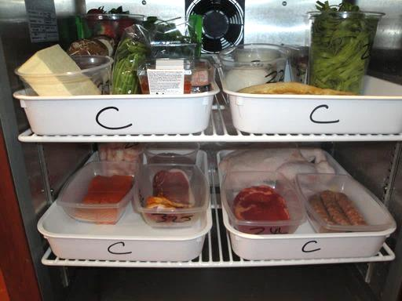 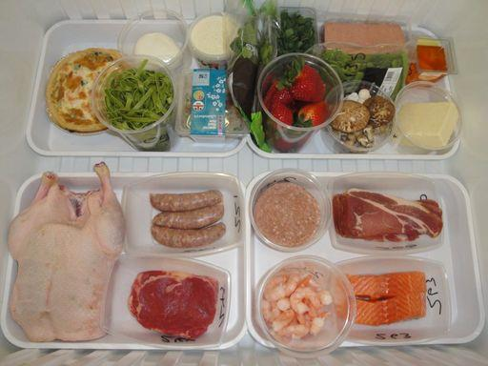

Figure 1. Day 1 - Fresh products in cabinet C Figure 2. Day 1 - Fresh products in cabinet A

Regular drawer and door openings were performed in both cabinets over five days of the seven day test period following the regime indicated in table 2.

Table 2. Cabinet door/drawer opening regime at Griffith Laboratories



2.2 Westminster Kingsway College trial

The Westminster Kingsway College is a centre for professional cookery and hospitality training. Cabinets A and B were tested in the training kitchen over an extended period of two and half days. Both units were set to 1ºC and fresh fish samples of salmon, tuna, cod, haddock and prawns were loaded into the cabinets as shown in Figures 3 and 4.

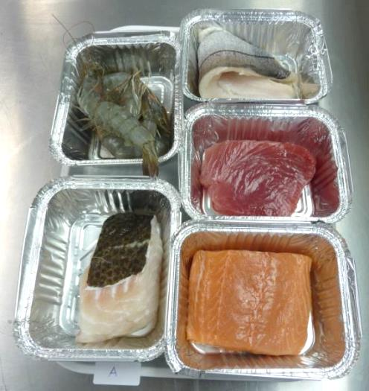 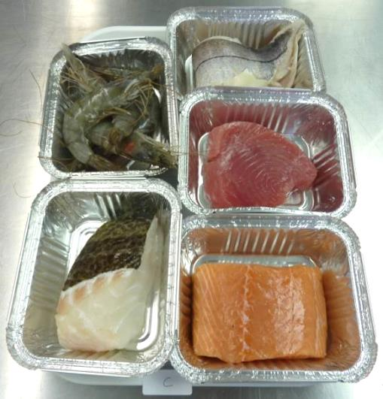

Figure 3. Day 1- Fresh fish in cabinet A Figure 4. Day 1- Fresh fish in cabinet B

The door/drawer opening frequency was the same for both tested appliances as described in table 3.

Table 3. Cabinet door/drawer opening regime at Westminster Kingsway College



A human sensory assessment remains the fastest and most accurate method of assessing fish freshness. At the end of the test the fish organoleptic quality was evaluated by two trained assessors with over 7 years’ experience evaluating raw and cooked fish quality.

1. RESULTS

3.1 Griffith Laboratories trial - Cabinet temperature and relative humidity

Figure 5 shows the cabinet air temperature and Figure 6 presents the relative humidity in the cabinets during the seven day test in the Griffith Laboratories test kitchen.

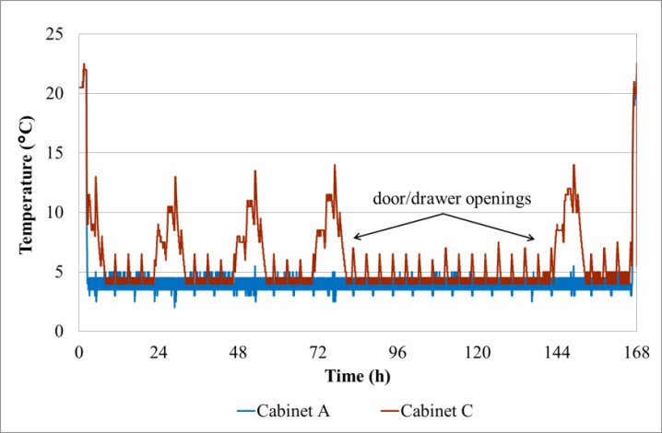 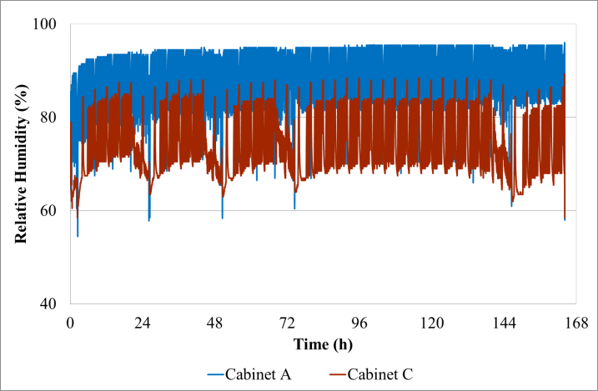

Figure 5. Cabinet temperature stability Figure 6. Cabinet relative humidity

As can be observed in Figure 5 the temperature in cabinet A remained below 5.5°C throughout the trial period including the intensive period of drawer openings. Cabinet C showed temperature swings and the air temperature remained above 10°C for 2 hours during the door opening periods. Table 4 shows a comparison of the average air temperature and relative humidity in the tested cabinets.

Table 4. Average air temperature and humidity in cabinet A and C over the seven day storage period



The temperature in cabinet A was on average 2 to 3°C cooler than on cabinet C and the humidity was 17% higher in cabinet A compared to cabinet C.

3.2 Griffith Laboratories trial – Product appearance

The product appearance at the end of the seven days storage period is illustrated in the photographs presented in Figure 7.

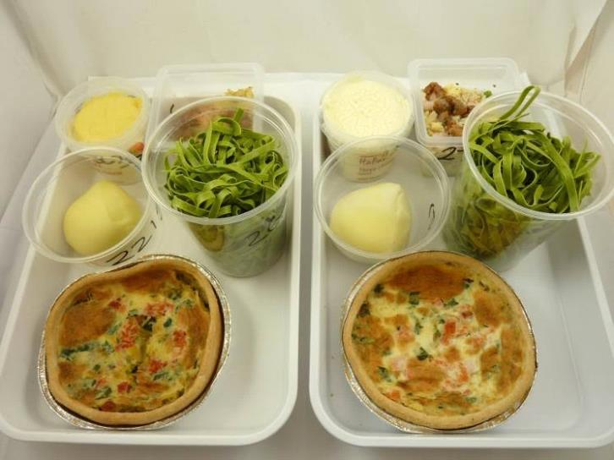 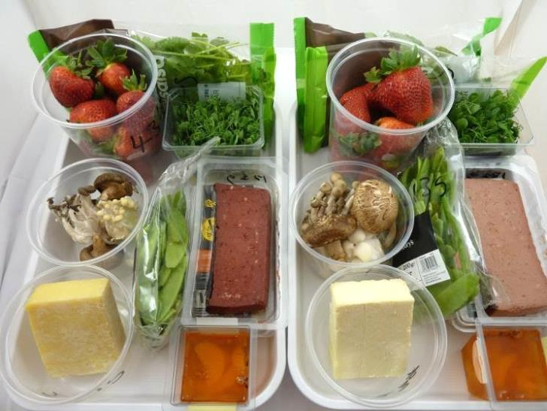

Cabinet A

Cabinet C

Cabinet A

Cabinet C

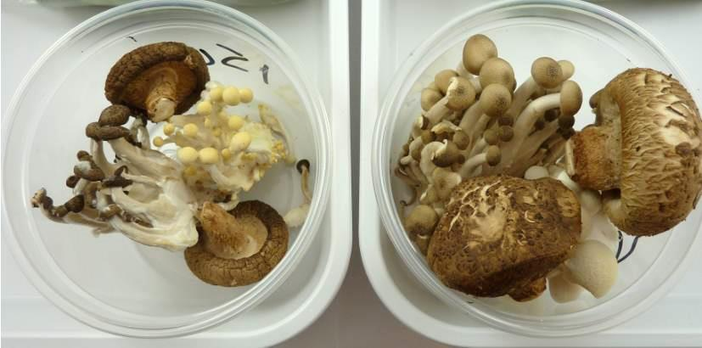 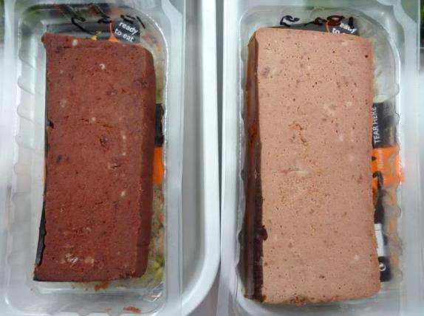

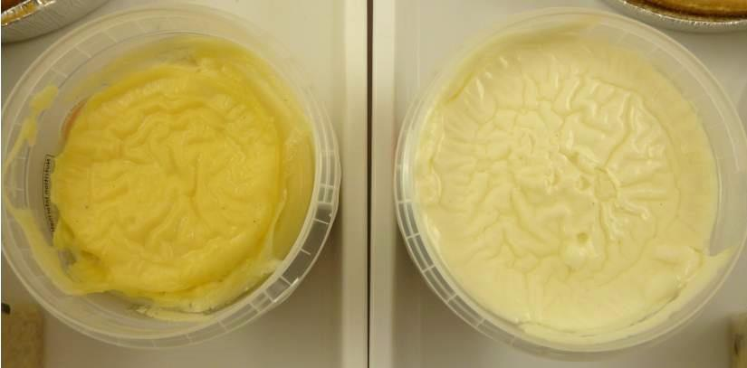 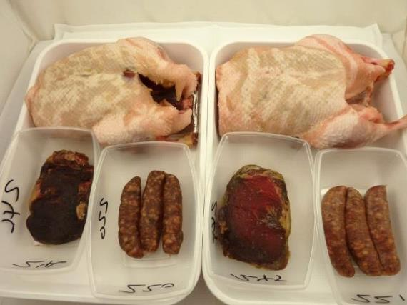

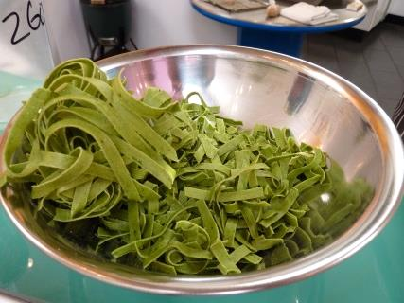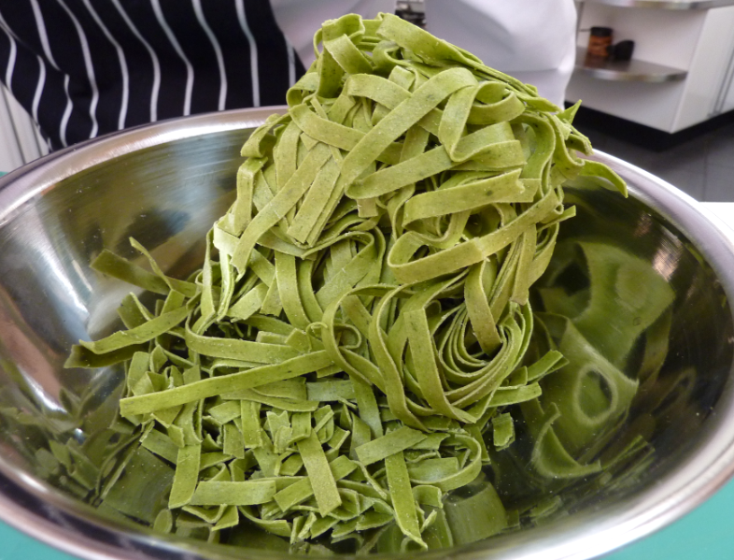 

Figure 7. Product appearance at the end of the Griffith Laboratories trial (left: cabinet C, right: cabinet A)

There was a visible difference in product quality at the end of the storage period between the products stored in the two cabinets. In cabinet C the mushrooms were shrunk and mouldy, the paté, cheese and meat products were severely dehydrated and the pasta was crumbling in small pieces. The products in cabinet A presented only mild signs of dehydration.

3.3 Griffith Laboratories trial – Product weight loss

Table 5 compares the products weight loss and value loss for the two cabinets.

Table 5. Product weight loss at the end of the seven days storage period

The results in table 5 show that at the conclusion of the test period, there was a 26% product weight loss in cabinet C and 10% weight loss on the products stored in cabinet A.

3.4 Westminster Kingsway College trial – Cabinet temperature and relative humidity

Figures 8 and 9 present the cabinet air temperature during the side by side test in the Westminster Kingsway College training kitchen.

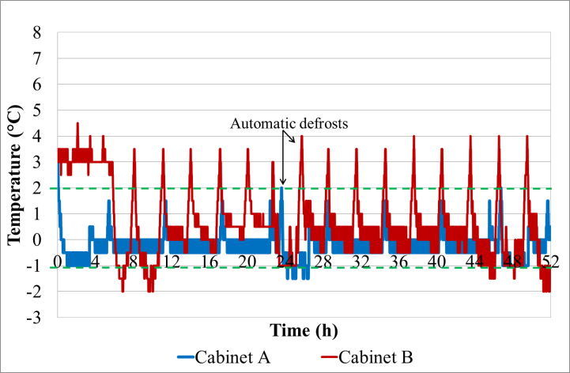 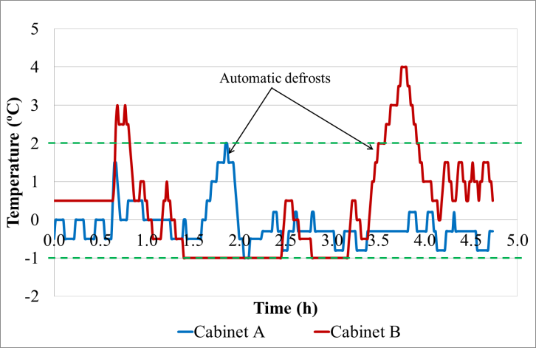

Figure 8. Cabinet temperature stability over 52 h Figure 9. Cabinet temperature stability over 5 h

The recommended storage temperature for fresh fish is between -1°C and 2°C and the maximum allowed temperature is 4°C. The average temperature and humidity (approximately 80%) achieved in both cabinets was similar, however the temperature span was considerably higher in cabinet B, e.g. 6°C as opposed to 3.5°C in cabinet A. Temperature fluctuation is the main factor affecting the quality of the fish.

3.5 Westminster Kingsway College trial – Product appearance

The raw fish appearance at the end of the two and half day storage period is shown in Figure 10.

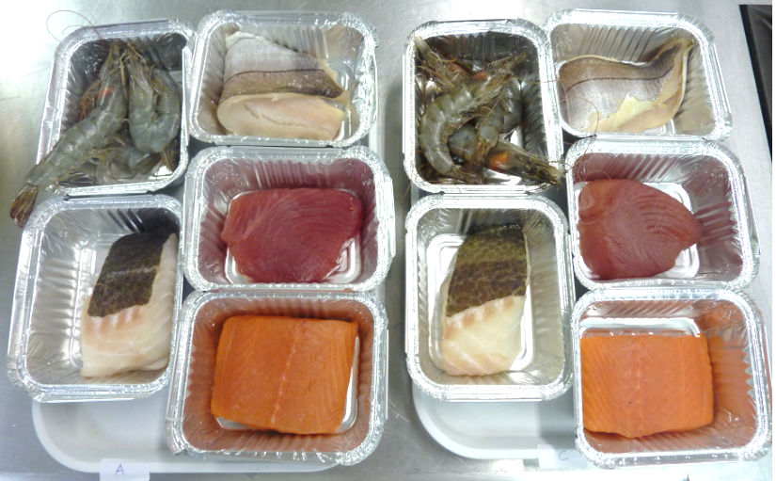

Figure 10.Fish appearance at the end of the trial (left: cabinet A, right: cabinet B)

As can be seen in Figure 10 the levels of dehydration, discoloration and shrinkage were more pronounced in the fish stored in cabinet B. The prawns were darker, the haddock and tuna were extremely dry and the cod skin lost its colour. The salmon and cod were cooked at the end of test and their flavour and odour was evaluated. Figures 11 and 12 show the salmon and cod cooked samples respectively.

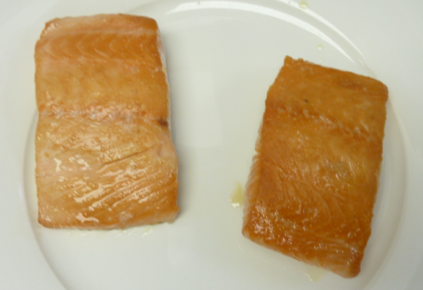 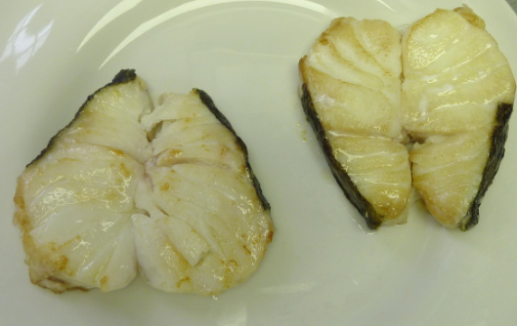

Figure 11. Salmon (left: cabinet A, right: cabinet B) Figure 12. Cod (left: cabinet A, right: cabinet B)

Both samples were cooked for the same time. The dehydration on the salmon stored in cabinet B was clearly visible as its surface was considerably darker than the salmon stored in cabinet A (see Figure 11). The salmon stored in cabinet B had a tangy metallic flavour, tasting “older”, whilst the salmon in cabinet A had a meaty, sweet flavour. The flavour intensity was slightly reduced on both cod samples. The main difference was on texture, the cod stored in cabinet A was succulent whist the cod from cabinet B had tough fibres (see Figure 12). Initially, both cod samples had the same weight, but after the 2.5 days storage period the weight loss of the cod stored on cabinet B was 4% (see table 6). This explains reduced thickeness of the cod portion stored in cabinet B and the texture difference perceived between both cod samples stored in the different appliances.

3.6 Westminster Kingsway College trial – Product weight loss

Table 6 compares the product weight loss between cabinets at the end of the two and half day storage period.

Table 6. Fish weight loss at the end of the storage period



The total weight loss of the fish stored in cabinet B was 3.5 times higher than that measured in the fish stored in cabinet A.

1. DISCUSSION

The results presented illustrate the differences in cabinet temperature and relative humidity and their impact on product weight loss and overall raw and cooked quality. All cabinets use the same type of insulation with the same thickness, however cabinet A has an insulated container rather than foamed walls. This results in better temperature control during frequent openings as the cold dense air stays in the bottom of the container. In door cabinets part of the cold air is replaced by warm moist air every time the door is opened. Other design features such as run time of the appliance, evaporator location, design temperature and airflow velocity and distribution play a major role on cabinet performance. Cabinet A can operate either in chilling mode or freezer mode and has a lower evaporating temperature than cabinets B and C. All cabinets use force convection but the air velocity inside the cabinet was lower on cabinet A. Further work is required to quantify differences in air flow velocity and run time between cabinets. It is likely that a combination of reduced ingress of ambient moist air into the refrigerated compartment, low air volume over the evaporator surface and a short compressor run time are in part responsible for the higher relative humidity measured in cabinet A.

1. CONCLUSIONS

The performance of refrigerated storage cabinets in busy professional kitchens has been compared. The results show the effect of temperature stability and relative humidity on product raw and cooked organoleptic quality and the impact on final product value. At the end of the extended storage period the product weight loss in cabinet A was three times lower than on cabinets B and C. Temperature and humidity control was also tighter in cabinet A resulting in 18% less food waste and 25% less product value loss. The experiments presented open scope on preventing de-humidification in refrigerated spaces. Further research will be carried out to investigate the effect of evaporator design, run time and air velocity on cabinet humidity control. The foodstuffs safety will also be evaluated at the beginning and end of the storage period by measuring microorganisms total viable count and yeast and moulds.

1. AKNOWLEDGEMENTS

The authors would like to thank the Griffith Laboratories and the Westminster Kingsway College for their technical expertise, assistance and test facilities, which were fundamental to carry out this research.

1. REFERENCES

Waste and Resources Action Programme (WRAP), 2013. The True Cost of food Waste within the Hospitality and Food Service. Available online at <http://www.wrap.org.uk/sites/files/wrap/The%20True%20Cost%20of%20Food%20Waste%20within%20Hospitality%20and%20Food%20Service%20Sector%20FINAL.pdf>

Food and Agriculture Organisation of the United Nations (FAO), International Fund for Agricultural Development (IFAD), United Nations World Food Programme (WFP), 2013, The State of Food Insecurity in the World 2013. The multiple dimensions of food security. Available online at http://www.fao.org/docrep/018/i3434e/i3434e00.htm

Gwanpua S.G., Verboven P., Leducq D., Brown T., Verlinden B.E., Bekele E., Aregawi W., Evans J., Foster A., Duret S., Hoang H.M., Van der Sluis S., Wissink E., Hendriksen L.J.A.M., Taoukis P., Gogou E., Stahl V., El Jabri M., Le Page J.F., Claussen I., Indergård E., Nicolai B.M., Alvarez G., A.H. Geeraerd. 2014, The FRISBEE tool, a software for optimising the trade-off between food quality, energy use, and global warming impact of cold chains, *Journal of Food Engineering* 148 (2015) 2–12.

Hu, Z., Sun, D.W., 2000. CFD simulation of heat and moisture transfer for predicting cooling rate and weight loss of cooked ham during air-blast chilling process. *Journal of Food Engineering* 46 (2000) 189 - 197.

ASHRAE, 2006.Vegetables. *In:* ASHRAE (ed.) *Refrigeration Handbook.*

Cantwell, M., 2002. Optimal handling conditions for fresh produce. In: Kader, A.A. (Ed.), *Postharvest Technology of Horticultural Crops*, 3311. University of California, Division of Agricultural and Natural Resources (Special publication), 511–518.

Duret S., Hoang H.-M., Flick D., Laguerre O., 2014. Experimental characterization of airflow, heat and mass transfer in a cold room filled with food products. *International Journal of Refrigeration* 46 (2014) 17 – 25.

Lauzon, H.L., Margeirsson, B., Sveinsdóttir, K., Guðjónsdóttir, M., Karlsdóttir, M.G., Martinsdóttir, E., 2010. Overview on Fish Quality Research e Impact of Fish Handling, Processing, Storage and Logistics on Fish Quality Deterioration. Technical report 39-10. Matís, Reykjavík, Iceland. Available online at

http://[www.matis.is/media/matis/utgafa/39-10-Overview-fishquality.pdf](http://www.matis.is/media/matis/utgafa/39-10-Overview-fishquality.pdf)

Marques, A. C., Davies, G. F., Evans, J. A., Maidment G. G., Wood, I., 2013. Theoretical modelling and experimental investigation of a thermal energy storage refrigerator, *Energy* 55 (2013) 457 – 465.