Determining the Level of Prefabricated Module Requirements in Offsite Construction

Rafiu Dimeji Seidu, Ruoyu Jin, Bert Ediale Young and Obas John Ebohon.
School of the Built Environment and Architecture, London South Bank University,
103 Borough Road, London, SE1 0AA, UK.
seidur@lsbu.ac.uk, jinr@lsbu.ac.uk, youngb6@lsbu.ac.uk, ebohono@lsbu.ac.uk

Yizhe Lu,
The Bartlett School of Construction and Project Management,
University College London, Faculty of the Built Environment, 1-19 Torrington Place London, WC1E 7H, UK.

Abstract

Offsite construction technique presents substantially speedier construction processes whilst lowering construction wastes. The level of prefabricated for offsite construction projects depend largely on the amount of complexity and the level of prefabricated components, which can be classified into two levels such as 2D penalized and 3D volumetric construction. However, there is often no specific method adoptable for determining the level of prefabrication construction. This research aims to determine the level of prefabrication requirement for offsite construction and their significance. An online database collected for offsite construction projects was analysed with decision making models. The results revealed that the building volume, i.e., the building footprint and height were the most influential factors. Furthermore, three other factors related to timber material, low-income target user, and residential function of prefabricated projects were also identified crucial in deciding the prefabrication level. The research concluded with certain guidance recommended for choosing the appropriate prefabrication level for building construction. For example, penalized construction generally had higher level of implementation than volumetric construction in prefabrication.

Keywords Building performance, Offsite construction, prefabrication level, Determining factor, Penalized construction, Volumetric construction.

Introduction

Prefabricated construction， also known as off-site construction or modern method of construction (MMC), is a modern construction approach consisting of two working sites, i.e., the off-site manufacturing site and construction site (Wuni and Shen, 2020). The prefabricated components are built in an offsite once the design is completed, then delivered to a construction site for assembly (Jiang et al., 2018). Offsite construction is an important trend in building industrialization, as it helps enhance the characteristic of the construction industry which has been largely dependent on traditional on-site construction (Young et al., 2020). The prefabricated construction method provides substantial advantages, such as reducing environmental effects, shortening project duration and improving productivity (Mostafa et al., 2020). Bertram et al. (2019) claimed that offsite construction can reduce project duration by 20% to 50 % and construction costs by 20 %. However, the term ‘prefabrication element’ covers a range of different approaches, systems, and forms (Bertram et al.,2019). It can be any component/s, sub-assemblies, volumetric pre-assembly, or modular building (Apaydın, 2011). The levels of prefabrication can be different according to the degree of complexity and the scale of the prefabricated component. Mostafa et al. (2020) stated that not every design is suitable for the highest level of prefabrication and assembly technique (i.e., 3D volumetric modules) as certain situations could make it less competitive. Therefore, in order to maximize the benefits of prefabrication, finding the suitable prefabrication level to fit different situations is crucial. This study examines the benefits and challenges of different levels of prefabrication in construction. The study also adopts a wide-ranging qualitative approach by analysing project samples collected from the industry. Utilizing a decision-making model for investors to decide prefabrication level, the study defines inputting features of projects in terms of key factors that could influence the prefabrication level of a given construction project. Suggestions are presented to provide guidance when deciding the most suitable prefabrication level for offsite construction projects.

Background

The significant features of prefabricated buildings include reducing construction cost and material waste. Hence, most prefabricated projects are perceived as more economical compared to tradition site construction using cementitious materials. However, the problems associated with long-term return on the initial prefabrication factory investment increase the investment risk to project sponsors. Moreover, building performance and maintenance is an important determining factor on the prefabrication level of projects, which is strongly related to all stakeholders’ interests, especially the building users. The review compares the two different prefabrication levels, i.e., volumetric and penalized construction, in terms of building performance during the operation and maintenance stage.

Building Performance

Thermal performance: Volumetric buildings usually adopt light materials such as Phase change material (PCM) boards as insulation, which are easy to transport and suitable for use. However, these materials with low density have less capability to store heat which can be absorbed and released easily causing overheating in some building areas (Rodrigues et al., 2016). Yoo et al. (2012) interviewed over 20 residents of shipping container houses, and detected that 14 out of 23 residents were dissatisfied with the insulation of their houses. In the penalized buildings, they can use rigid insulation (e.g., concrete) with better thermal performance. The panel connection design can also offer a high thermal resistance and an airtight envelope to prevent heat losses (Lopeza and Froesea, 2018). Hence, penalized buildings can perform better than the volumetric modules in terms of thermal performance.

Ease of maintenance and replacement: According to Lee et al. (2018), the volumetric module is manufactured as one room and each part of it can still be replaced separately during the maintenance phase, and the module is comprised of bundles of individual components. The construction materials in volumetric projects can be repaired as units. For instance, roof can be replaced as a whole module which includes the coating, waterproofing and roofing (Lee et al., 2018). The advantage of 3D volumetric construction lies in that the module or its components can easily be changed or repaired. In contrast, as penalized buildings are not fully constructed by the standard modular elements, the maintenance and replacement is more difficult compared to volumetric buildings which are based on standardized modular system. Penalized buildings use large mass of materials and are able to utilize rigid materials as insulation which can be more resistant to mould growth and insect infestation (Lopeza & Froesea, 2018). Their components have longer duration, and can prevent future maintenance issues whilst the volumetric components usually need to be repaired as a whole unit causing significant increase in the cost (Seidu et al., 2021). Due to the differences in their replacement approach and material duration between volumetric and penalized methods, the cost of maintenance and replacement for penalized components is less than for volumetric elements. Table 1 summarizes the comparison between the two different prefabrication levels in the operation stage.

Table 1. Comparison of two levels of prefabricated construction.

Criteria |  |  | Level of prefabrication
Aspects | Project stage | Project events | Penalized | Volumetric
Building Performance | Operation | Thermal performance | √
 |  | Ease of maintenance and replacement |  | √
 |  | Cost of maintenance and replacement | √

Overall, the penalized construction appears to be more cost-saving and better-performing than volumetric construction. However, the above result does not necessarily mean that it is better to implement penalized construction in all prefabrication projects. Since the project condition varies from one to another, there are lots of critical factors that can contribute to the selection of an appropriate prefabrication level for an offsite construction project. The majority of existing studies focuses on comparing conventional and offsite construction approaches, but with limited comparisons between different levels of prefabrication within offsite construction. Thus, it is still unclear, how to decide the most suitable prefabrication level for offsite construction projects. In fact, suitable level of prefabrication and assembly technique varies, depending on multiple factors such as the life span of the building (e.g., temporary or permanent), the desired space layout and the technical (e.g., heating, electricity, etc.) equipment to install (Rakotonjanahary et al., 2020). By deciding the proper prefabrication level for offsite construction projects, the overall benefits of the prefabrication projects can be improved. Therefore, choosing the appropriate level of prefabrication becomes critical for the effective implementation of offsite construction technologies.

Research Methods

The study aims to offer a direct decision-making tool for investors to effectively derive the suitable prefabrication level for construction projects. A Random Forest Classification Model is used as an enabler to predicate the prefabrication level of a project based on the identified critical input factors of the project (Breiman, 2001). The nature of the Random Forest Model is a form of decision tree, i.e., a predicative model. According to Biau and Scornet (2016), the decision tree starts from observations about an item (e.g., the critical factors) to output conclusions about the item's target value, e.g., prefabrication level of construction projects in this study.

The dataset used to construct the decision-making model is a sample of 80 projects’ information collected from ArchiDaily (2021), which is a project dataset with recent and recognised construction project information worldwide. The critical factors (e.g., building height, function, target user, number of floor, and structural material) in this case is used as the input features or attributes, and the prefabrication level (i.e., volumetric and penalized construction) in this case is used as the target value or output conclusion. In order to develop a more efficient decision-making model, the dataset used in model development was required to be optimized.

The forest model is developed by using Python script which is one of the commonly adopted programming languages. Following the model construction, it was evaluated for its accuracy of prediction for decision making, i.e., deciding the proper prefabrication level in this study. The most efficient way to verify the usefulness of the decision-making model is to apply real-world cases to evaluate its prediction performance (Pezhman et al., 2018). In this study, eight hypothetical construction projects were designed to investigate the applicability of the model.

Research Findings and Analysis

Input dataset was created from the database, and the value of output set (i.e., prefabrication levels of projects) was either volumetric or penalized. Initially based on the database, four major input factors were identified as attributes that could influence the decision of the level of prefabrication in offsite construction projects. They were: building footprint & height, building function & target user, construction material, and project location. The aforementioned four major input factors may not be equally important for deciding the prefabrication level of projects. The random forest model was used to compute the significance of these factors. The model was operated by constructing a multitude of decision trees at training time. The model was considered a powerful tool to rank the importance of variables in a classification scenario (Mistikoglu et al., 2015).

The ranking presented in Figure 1 indicated that building footprint is the dominant factor for deciding prefabrication level. This result supported the findings that the structural nature of modular building made building footprint a focal factor for deciding the prefabrication level. The second most important factor was the number of floor. Based on the analysis of building height, it was discovered that the number of floors was essential in deciding the prefabrication level, especially for super-low or super-high prefabricated buildings. The building footprint and height were the horizontal and vertical measurements of a building volume, respectively. As a result, the building volume played the most essential role in deciding prefabrication level for construction projects.

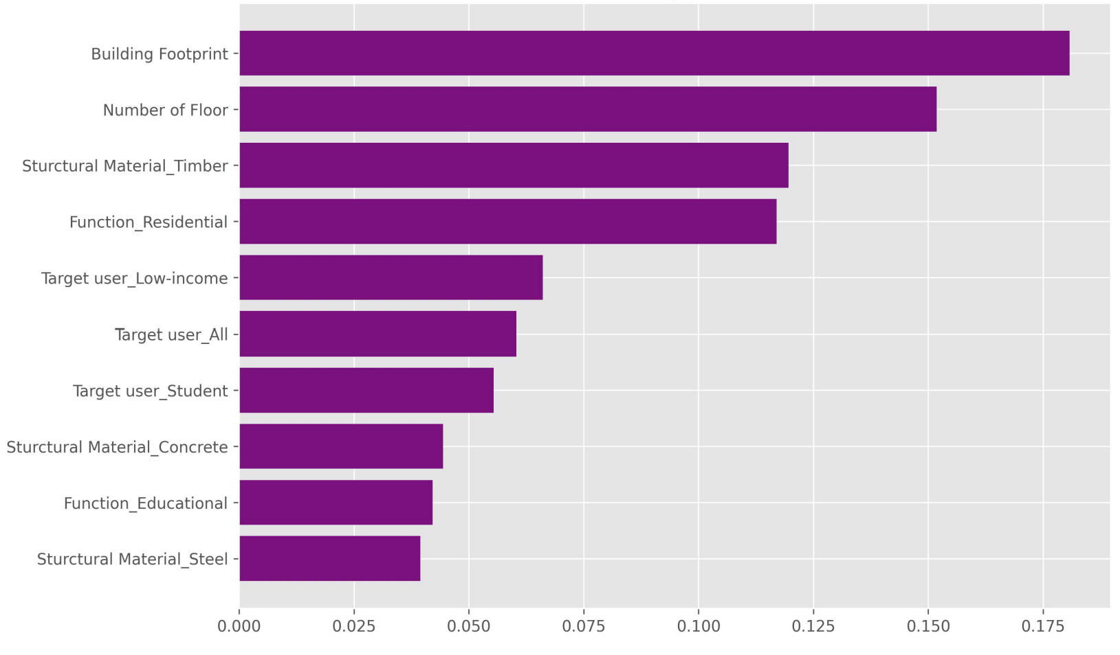
Figure 1: Importance ranking of top ten most critical factors

For the input dataset, the optimization was further performed by trimming the attributes (i.e., input factors) down into the most critical features. Building footprint and height were identified as the most critical factors engaging the three attributes related to timber material, low-income target user, and residential function of prefabrication projects. The other factors that may affect the prefabricated level are considered not important and will be ignored. The categories of structural material, building function, and target users were all reduced to binary values, i.e., timber or non-timber, residential or non-residential, and low-income or others, respectively. Table 2 shows the project attributes (i.e., the critical factors) and the target value (volumetric or penalized level) for the model.

Table 2: Features and target value of data used in model.
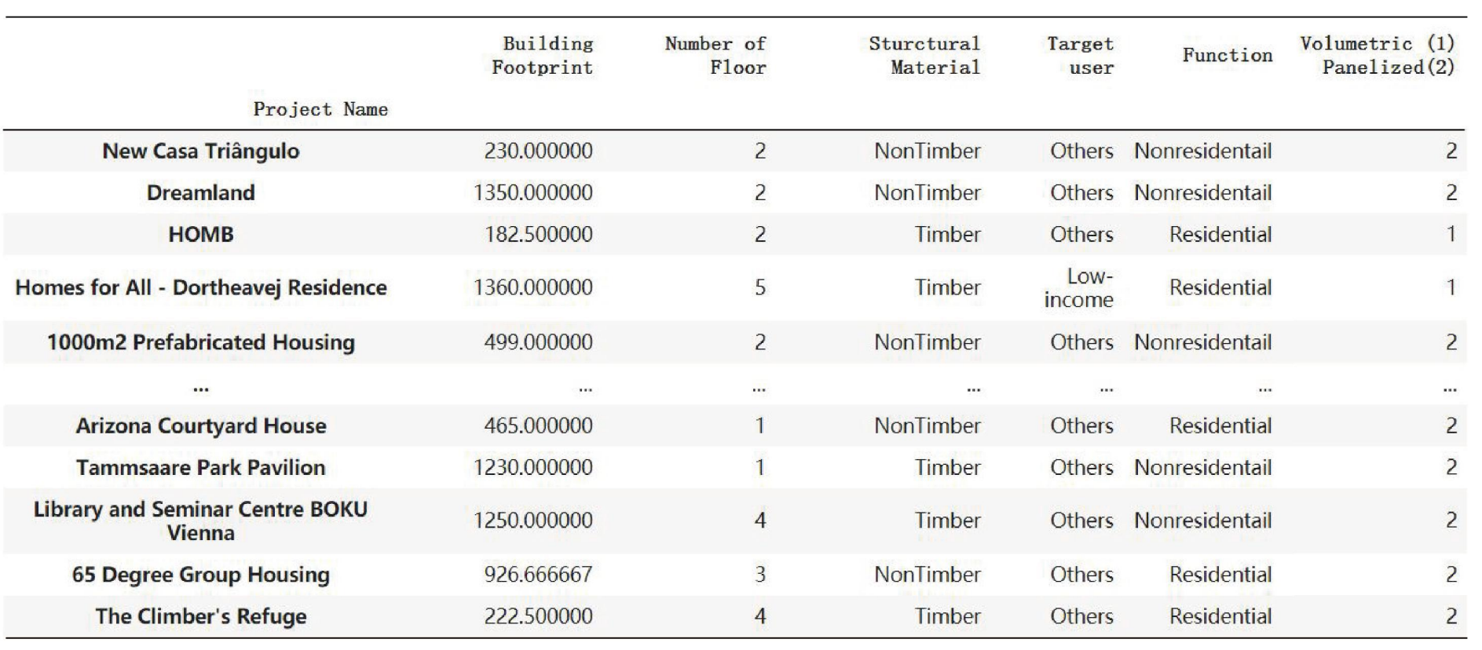

The most efficient way to verify the usefulness of the decision-making model is to apply real cases to validate its predicated results. Thus, eight hypothetical construction projects were adopted to investigate the applicability of the model. In order to ensure the quality of the virtual project data, the attributes of each hypothetical project were designed to the standard of real prefabrication projects as presented in Table 3.

Table 3: Features of hypothetical projects.
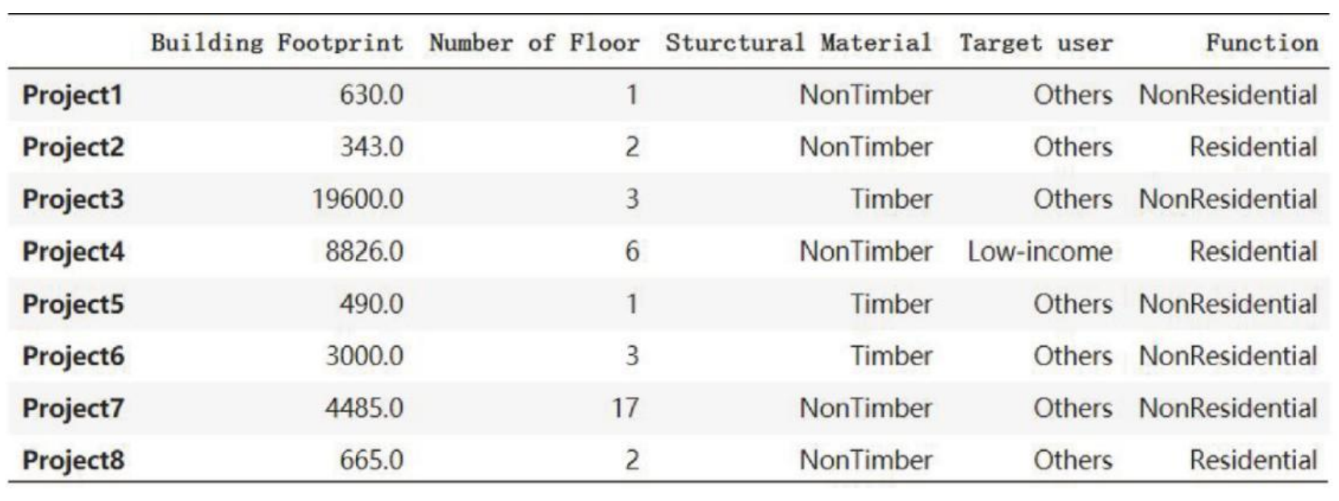
By inputting the input factors as attributes of eight hypothetical projects, the model generates the predicated prefabrication level for each project. Table 3 shows the comparison between predicated and real prefabrication level of the eight virtual projects. Since every hypothetical project is based on a real prefabrication project, the true prefabrication level of the eight projects can be obtained and compared with the predicated values. The results show that the predication levels of Projects No.2 and No.3 contradict real prefabrication level. It means that two out of eight projects are misclassified by the decision- making model. The model accuracy achieves 65%. The accuracy is not close to 100%, because a project may contain various attributes. In this decision-making model, only the most critical ones are considered, so that the accuracy may be affected. Overall, the results still verifies the usefulness of the model as a reference for investors and other stakeholders in deciding the proper prefabrication level of an offsite construction project.

Table 4: Comparison of predicated and true prefabricated level.
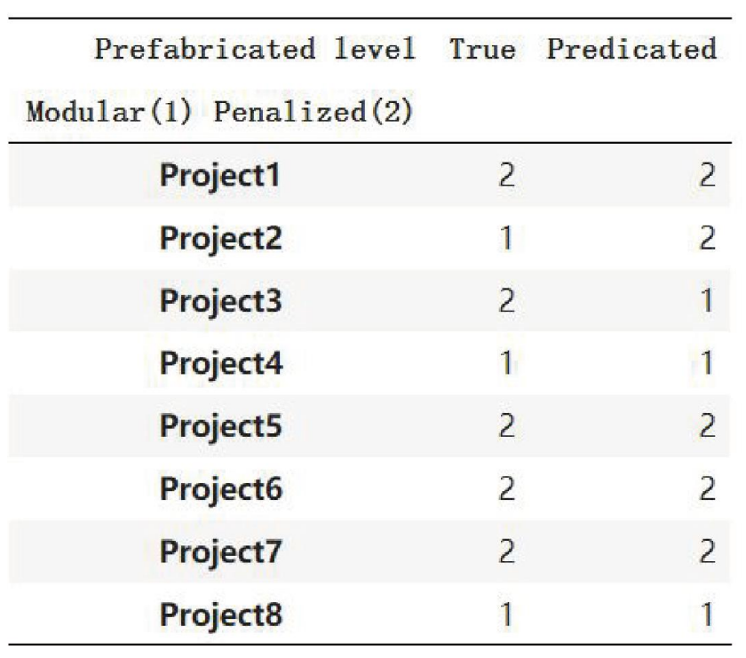

5. Results and Discussion

When it comes to offsite construction projects, it requires investors and designers to take decisions including selection of an appropriate level of prefabrication in the early stages of a project. According to Wuni et al. (2019), implementing offsite construction technique is associated with a host of investment risks compared to that in conventional construction. In order to reduce the risks caused by inappropriate prefabrication technique, it is necessary to provide reference for decision makers to decide the appropriate prefabrication level. The study offers a decision-making tool for people to predicate prefabrication level of construction projects based on their attributes by applying the model, stakeholders including investors and designers can have the recommended prefabrication level of an offsite project.

These attributes or critical input factors were initially identified from the 80 real off-site projects found. Each factor for deciding prefabrication level was analyzed in terms of the importance ranking. Five recommendations for deciding suitable prefabrication level were provided: 1) For the ‘building footprint and height’ factor, it was suggested to choose volumetric construction for the projects that had a less than 2500 ㎡ footprint with 3-8 stories. Meanwhile, for the projects that were more than 2500 ㎡ in footprint and more than eight-floor in height or the super-low projects with no more than 2 stories, the penalized construction might be more suitable for economic benefits; 2) regarding factor of building function and target user, it was not that essential to impact the decision of prefabrication level. However, when it came to residential projects or projects for low-income people, such as affordable housing and temporary shelter for the homeless, it was suggested to adopt 3D modular construction; 3) as for the attribute of construction material, the utilization of timber structure in volumetric construction should be carefully considered, because it could lead to poor building thermal condition. However, the new material and technology had been emerging rapidly. Via working with new material, the building constructed by timber modules could significantly reduce the occurrence of poor thermal condition. The wide utilization of CLT (i.e., cross-laminated timber) guarantees the insulating qualities of massive wood. The construction material was no longer a constraint in deciding prefabrication level of construction projects. However, the timber structure could still be considered an essential factor that could decide the prefabrication level; 4) in terms of project location, since the development of the offsite construction differ among countries; for these countries with insufficient technologies and immature market for higher level of prefabrication, it was suggested to utilize penalized construction instead of volumetric block system; 5) the importance ranking of all the factors indicated that the building volume (i.e. building footprint and height) was the most influential factor deciding the prefabrication level of construction projects. Besides the building footprint & height, the construction material, function and target user of a building could also impact the prefabrication level of an offsite project. Overall, the timber material, residential function and low-income target user were the three most influential elements next to building footprint & height. The project location was the least important factor among all.

By using the given suggestions and the decision-making model, it would be possible to reduce the problems and risks caused by unsuitable prefabrication levels. Nevertheless, the decision-making tool is relatively a simple model which was constructed by inputting only the most critical factors in this study. Future research can focus on conducting a more comprehensive analysis of critical input factors affecting the prefabrication level. These factors would contain more attributes such as the life span of the building (e.g., temporary or permanent) and the technical equipment to install so that a more accurate decision-making model can be delivered in more effectively deciding the prefabrication level.

Conclusion

The purpose of this paper is to help stakeholders including investors and designers decide the most suitable prefabrication level for construction projects. The volumetric construction and penalized construction were compared based on building performance in the operation stage. The results reveal that the penalized construction seems a better choice for offsite construction projects. Whereas, without considering the differences of projects, the suggestion cannot be conclusive. Since various factors can affect the prefabrication level of a modular building, the study adopts the decision tree model for analysing the identified critical input factors, and their significance.

The analysis suggests that building height & footprint should be emphasized as top priority for deciding prefabricated level. Additionally, the construction material, target user and building functions are also relatively important factors. Specifically, the three attributes related to timber material, low income target user, and residential function of prefabricated projects should be highlighted as more critical factors. Moreover, the specific suggestion is that the volumetric construction should be utilized more in projects with these attributes: having less than 2500 ㎡ footprint with 3-8 stories, low-income user, timber material, and residential function. Instead, penalized construction can be applied to projects with these attributes: more than 2500 ㎡ footprint, over 8 stories or low rise projects, no more than 2 stories, non-low-income user, non-timber material, and non-residential function.

For construction projects utilizing offsite technique, the decision for its prefabricated level is vital. This study provides useful suggestions and a simple decision-making tool to facilitating investors, designers and other stakeholders in deciding the prefabrication level for an offsite construction project.

References

Apaydın, F. (2011) “Effectiveness of Prefabricated House Industry’s Marketing Activities and Turkish Consumers’ Buying Intentions towards Prefabricated Houses”, Asian Social Science, 7(10), pp. 267-276. doi: 10.5539/ass.v7n10p267
ArchiDaily (2021). “The world's most visited architecture website.” Accessible via < https://www.archdaily.com/> , accessed on 23 March 2021.
Bertram, N. et al. (2019) Capital Projects & Infrastructure Modular construction: From projects to products, McKinsey & Company. Available at: www.mckinsey.com/industries/captital-projects-andinfrastructure
Biau, G., & Scornet, E. (2016). A random forest guided tour. Test, 25(2), 197-227.
Breiman, L. (2001) ‘Random Forests’, Machine Learning, 14(2001), pp. 5-32. Available at: https://link.springer.com/content/pdf/10.1023/A:1010933404324.pdf
Jiang, L. et al. (2018) ‘Constraints on the Promotion of Prefabricated Construction in China’, Sustainability, 10(7). doi: 10.3390/su10072516
Lee D.Y., Lee J.B. & Han C.H. (2018) ‘A study of the influence factors on modular residential asset’, 35th International Symposium on Automation and Robotics in Construction (ISARC 2018), Waterloo. Available at: https://www.iaarc.org/publications/fulltext/ISARC2018-Paper049.pd
Lopeza, D. & Froesea, T. M. (2018) ‘Analysis of costs and benefits of panelized and modular prefabricated homes’, Procedia Engineering, 145 (2016), pp. 1291 -1297. Available at: https://www.sciencedirect.com/science/article/pii/S1877705816301734
Mistikoglu, G., Gerek, I. H., Erdis, E., Usmen, P. M., Cakan, H., & Kazan, E. E. (2015). Decision tree analysis of construction fall accidents involving roofers. Expert Systems with Applications, 42(4), 2256-2263.
Mostafa, S., et al. (2020) ‘Leagile Strategies for Optimizing the Delivery of Prefabricated House Building Projects’, International Journal of Construction Management, 20:8, 867-881, doi:10.1080/15623599.2018.1494674
Pezhman, S. et al. (2018) ‘Identification of Factors and Decision Analysis of the Level of Modularization in Building Construction’, American Society of Civil Engineers, 24(2), pp. 04018010. doi: 10.1061/(ASCE)AE.1943-5568.0000313
Rakotonjanahary, M., Scholzen, F. & Waldmann, D (2020) ‘Summertime Overheating Risk Assessment of a Flexible Plug-In Modular Unit in Luxembourg’, Sustainability, 12(2071-1050), pp. 8474. doi: 10.3390/su12208474
Rodrigues, L., Sougkakis, V. & Gillott, M. (2016) ‘Investigating the potential of adding thermal mass to mitigate overheating in a super-insulated low-energy timber house’, International Journal of Low-Carbon Technologies, 11(3), pp. 305-316. doi:10.1093/ijlct/ctv003
Seidu, R.D, Ayinla. K, Esan-Ojuri. O, Young , B.E, Momoh. J. (2021). Cost Effectiveness of Implementing External Facades System. Proceedings of Centre for the Integrated Delivery of the Built Environment (IDoBE) on Uncertainties in the Built Environment: How can we build a resilient future in the new normal?. 22nd – 23rd November 2021, LSBU. London, UK.
Wuni, I. Y. & Shen, G. Q. (2020) ‘Critical success factors for modular integrated construction projects: a review’, Building Research & Information, 48(7), pp.763-784. doi:10.1080/09613218.2019.1669009
Wuni, I. Y., Shen, G. Q. & Hwang, B. (2019) ‘Risks of modular integrated construction: A review and future research directions’, Frontiers of Engineering Management. doi: 10.1007/s42524-019- 0059-7
Young, B, Seidu, R.D., Thayaparan, M., and Appiah-Kubi, J. (2020). “Modular Construction Innovation in the UK: The Case of Residential Buildings.” Proceedings of the International Conference on Industrial Engineering and Operations Management Dubai, UAE, March 10-12, 2020.
Yoo, H. Y., Park, Y. J.& Yoon, J. Y. (2012) ‘A Study on the Improving Direction of Container Housing through Field Survey—Based on the Analysis of 12 cases in the Urban Area’, Journal of the Korean housing association., 23(6), pp. 21–30. doi: 10.6107/JKHA.2012.23.6.021

Biography

Rafiu Dimeji Seidu – Course Director and Lecturer in Quantity Surveying.
Rafiu Dimeji Seidu is a Course Director for the BSc (Hons) Commercial Management Quantity Surveying (QS) in the division of Construction Property and Surveying Division, school of the Built Environment and Architecture, London South Bank University. Rafiu has worked as a Quantity Surveyor rising to the position of Commercial Manager in a QS, Real Estate and Construction Management firm both in the UK and abroad. Rafiu is a Fellow member of the Higher Education Academy (FHEA), Chartered Member of Association of Cost Engineers (MAcostE), Chartered Member of Chartered Institution of Civil Engineering Surveyors (MCInstCES) and Chartered Member of Chartered Institution of Building (MCIOB). Presently studying for his PhD in Construction Management and Economics at London South Bank University, London, UK. Rafiu is an active member of the Research Centre for the Integrated Delivery of the Built Environment (IDoBE) at LSBU. His research interest includes Built Environment, Commercial Management, Procurement, Cost Management, Infrastructure Management and Mega/Complex construction project management.

Bert Ediale Young – Course Director and Senior Lecturer in Quantity Surveying
Bert Ediale Young is a Senior Lecturer in Quantity Surveying and the Course Director for the PgD/MSc Quantity Surveying in the School of Built Environment and Architecture. Bert is an active member of the Research Centre for the Integrated Delivery of the Built Environment (IDoBE) at LSBU. His research interests involve Construction Innovation in UK Residential Housing, Modern Methods of Construction (MMC), Modern Flying Factories (MFFs’), Housing and Product Innovation in the UK Housing Industry. Bert is also a Fellow of the Higher Education academy (FHEA) and a Member of the Association of Cost Engineers (MACostE).

Dr Ruoyu Jin– Associate Professor of Construction Management at London South Bank University. He specialises in Building Information Modelling (BIM) pedagogy, construction safety education, construction waste management especially recycled aggregate concrete, and off-site manufacturing for construction.

Prof John Obas Ebohon – Professor of Sustainability and Environmental Law.
Obas John Ebohon is Professor of Sustainability and Environmental Law in the School of Built Environment and Architecture and Director of the Centre for the Integrated Delivery of the Built Environment (IDoBE) at LSBU. His research interests are in energy, sustainability, and development in the built and natural, with emphasis on developing countries; economics of the built environment; urbanisation and its impact on the built and natural environment; climate change impacts on the built and natural environment, and sustainable community development. He is a consultant to UN-Habitat and member of the UN-Habitat Global Expert Group on the strategy and policies for implementing SDG11 - the New Urban Agenda. He has published widely and successfully supervised many higher research degrees on sustainability related topics. He currently sits on the International Advisory Board of UN-Habitat for the publication of the bi-annual World City Reports (WCR); Lambert Council’s Expert Advisory Group on Citizen’s Sustainability Assembly; Southwark Councils Sustainability Advisory Group.

Yizhe Lu was an MSc candidate in Digital Engineer Management at University College London. United Kingdom.

