Use of fruit and vegetable waste as growth media in bacterial biocementation for ground improvement applications

MWANDIRA W1, MAVROULIDOU M*1, GUNN MJ1, GRAY, C.1

1London South Bank University(LSBU), UK

*corresponding author

e-mail: [*mavroum@lsbu.ac.uk*](mailto:mavroum@lsbu.ac.uk)

**Abstract**

The paper investigates the use of mixed fruit and vegetable (FV) waste to extract liquid to grow bacteria. The bacteria will be used to induce biocementation of soils and two metabolic pathways are examined. These are the ureolytic pathway and the carbonic anhydrase pathway (which absorbs CO2). The growing medium produced from fruit and vegetable waste is compared with a commercial growing medium. The results show the feasibility of using FV as a growth medium to successfully biocement soil and coal ash. A typical FV medium contains 3% total sugar and 0.302 mg/100 ml of protein. The results show that vegetable stalks and fruit peel media support the growth of both ureolytic bacteria *B. licheniformis* and U-1, a carbonic anhydrase-producing bacteria. The use of FV waste to grow bacteria leads to a reduction in biocementation costs for ground improvement applications.

**Keywords: Ground improvement; Fruit and vegetable; biocements; food waste management**

1. **Introduction**

Construction industry operations must radically change to meet the objectives of net-zero carbon transition and environmental sustainability. Ground improvement methods are still machinery-heavy and energy-intensive and often rely on Portland cement to improve the ground. For this reason, novel cement, such as biocements, which are produced by the metabolic action of non-pathogenic microorganisms, have been introduced as a potentially more environmentally friendly alternatives to Portland cement (Gomez *et al.*, 2015; Lee, 2014). A barrier to adopting this novel and sustainable cement at an industrial scale is the cost of reagents, with can amount to 60% of the treatment costs (Omoregie *et al.*, 2019). Only limited studies have reported using alternative nutritional sources to cultivate ureolytic bacteria, including kitchen waste (Meng *et al.*, 2021); industrial effluent of the dairy industry (Achal *et al.*, 2009); sludge (Yang *et al.*, 2020); carbide sludge (Yang *et al.*, 2022); Tofu wastewater (Fang *et al.*, 2019); palm oil mill effluent (Omoregie *et al.*, 2023). Variations in the local availability of different wastes have apparently limited the use of these wastes as culture media. Some localities worldwide do not have access to sufficient quantities of these suggested materials, hence the need to explore other sources that can be found easily anywhere. Fruit and vegetable waste in this study was chosen because they account for 45 % of food wasted globally (UNEP, 2021) and can be found in any region of the earth. This is because many fruits and vegetables are first processed to obtain the required product from the fruit with many peels, leaves, stalks, stems, inoperable pulp, and seeds (Esparza *et al.*, 2020; Sagar *et al.*, 2018). Thus, this study aimed at cultivating *B. licheniformis*, a ureolytic strain and a carbonic anhydrase-producing bacteria strain (which will be referred to as U-1) in a fruit and vegetable medium. If successful, the results from this study would contribute to the dual advantage of tackling food waste management and reducing the costs of the novel, emerging biocements.

1. **Materials and methods**
   1. Geomaterials used

Two types of geomaterials were sampled from the railway network in East Anglia, United Kingdom: fine-grained foundation soil of railway embankments susceptible to settlement and coal ash from the top and shoulders of the embankment. Coal ash was historically used for maintaining the height of railway embankments, which were settling due to inadequate compaction (Mavroulidou et al, 2019); it is problematic for railway asset maintenance teams as it is prone to erosion. Thus, biocementation could be used as a solution to erosion problems. Table 1 summarizes salient properties of coal ash and foundation soil.

Table 1: Properties of coal ash and fine-grained foundation soil from East Anglia, United Kingdom

|  |  |  |
| --- | --- | --- |
| Parameter | Foundation Soil | Coal Ash |
| Ash content: (%) | 17.7 | 0.96 |
| Organic matter content (%) | 3.9 | 0.52 |
| Specific gravity, Gs | 2.06 | 2.45 |
| Natural gr moisture content (%) | 47.5 | 5.5 |
| pH | 7.15 | 8.08 |
| Natural CaCO3 Content  Liquid limit (%)  Plastic limit (%)  Plasticity index (%) | 4.82  40  26  14 | 4.01  N/A  N/A  N/A |

* 1. Ureolytic and carbonic anhydrase bacteria cultivation

Ureolytic bacteria *B. licheniformis* isolated by Safdar *et al.* (2020, 2021) from a railway embankment site was used. The ureolytic bacteria was cultured using NB-urea broth (see Table 1). The carbonic anhydrase named U-1 isolated from the same site was also cultured in a commercially available yeast extract media (Yeast Extract (10 g/L), Sodium Bicarbonate (100 mM), Zinc Sulphate (1 µM)). The fruit and vegetable (FV) culturing media were from the waste collected from the student canteen of London South Bank University, London, United Kingdom: Vegetable waste (50% by weight) and Fruit waste (50% by weight). The waste was processed into bacterial media, as illustrated in Figure 1. The chopped fruit and vegetables were blended into a pulp and filtered to collect the liquor. Serial dilutions were used to get different concentrations of the media.

**Figure 1:** Processing of vegetable and fruit waste into culture media

**Table 1.** NB-urea broth composition

|  |  |
| --- | --- |
| **Ingredient** | **Quantity**  **(g/L)** |
| Sodium Chloride | 5 |
| Peptone | 5 |
| Urea | 2 |
| Yeast Extract | 1.5 |
| Beef Extract | 1.5 |

* 1. Determination of enzymatic activities

Microbial growth was attested by optical density measurements at 600nm (OD600) of both *B. licheniformis* and U-1 using a spectrophotometer. The CA enzyme was determined colorimetrically, as employed by Martin *et al.* (2009) to determine CA activity. Briefly, the activity for p-nitrophenyl acetate hydrolysis was determined at room temperature in a reaction mixture (1.35 ml) of freshly prepared 3 mM p-nitrophenyl acetate in a phosphate buffer (0.13M; pH=7.2). The reaction was allowed to go on for 5 minutes and the change to A348 per min was recorded. Then the carbonic anhydrase activity was characterised by the amount of p-nitrophenol produced per unit of time, and enzyme activity was expressed in terms of U.

$A activity \left(\frac{U}{mL}\right)=\frac{(∆A_{348}T-∆A_{348}B)×1000}{5 ×Volume}$ (1)

where ∆A_348 B is the uncatalyzed rate of the reaction, and ∆A_348 T is the catalysed reaction rate after 5 min. The urease activity was determined using the electrical conductivity (EC) method. The activity was expressed in mM of urea hydrolysed per minute and calculated as shown in Eq. 2, where EC1(measured at 1 min) and EC6(EC measured at 5 min) represented EC at different times.

10×11 (2)

* 1. Coal ash biocementation

Coal ash was treated by a two-stage injection process performed as follows: first, bacteria were injected into the soil column followed by a cementation solution (Calcium Acetate (Ca(CH3COO)2 (0.1M) and Sodium Bicarbonate (NaHCO3) (0.1M)) for the carbonic anhydrase. For the ureolytic pathway, urea and Ca(CH3COO)2 were used as cementation solutions.

1. **Results**
   1. Microbial growth

Microbial growth and enzymatic activity of both *B. licheniformis* and U-1 were investigated. Fig. 2a and b show respectively the microbial growth and urease activity of *B. licheniformis*, whereas Fig. 2c and 2d show respectively the microbial growth and CA activity for U-1. *B. licheniformis* and U-1 showed increased growth in both commercial and FV media*. B. licheniformis* reached its maximum microbial growth of OD600 value of 1.38 and activity of 0.876 mM urea/min. Compared to FV media, the *B. licheniformis* microbial growth of OD600 value of 0.817 with maximum urease activity of 0.657 mM urea/min at a maximum mixing ratio of 80%. The other mixing fractions of the FV yielded lower growth and activity. On the other hand, microbial growth, and carbonic activity of U-1 in commercial and various fractions of FV show similar trends to *B. licheniformis*. Fig. 2c and d, show a microbial growth OD600 value of 2.32 for commercial media, whereas the FV showed an OD600 value of 1.75 and maintained it at stable levels. The commercial growth media showed that CA activity reached the maximum of 1.775 U/mL compared to 0.986 U/mL for the FV.

Compared to other culture media from waste studied in the literature, for example, Tofu wastewater, used as a culture medium for *B. cereus* NS4, it was found that *B. cereus* NS4 had high urease activity in commercially available media with 30.62 U/ml and 50% Tofu waste-urea had 24.87 U/ml (Fang *et al.*, 2019). Generally, alternative media have lower activity than commercial media, which are usually carefully prepared for use. Additionally, the activity of *S. pasteurii* cultured in low-cost media from food waste from a kitchen had 4.19 mM urea/min (Meng *et al.*, 2021). In another study, lactose mother liquor yielded 0.353 mM urea/min (Achal *et al.*, 2009). Despite the lower values compared to commercially available growth media, the FV from this study has shown that it can support two different types of bacteria following two metabolic pathways to biocement soil; of these, the CA-pathway was not previously investigated. Using standard methods, FV media were found to have a 3% total sugar and 0.302 mg/100 ml of protein. Thus, fruit and vegetable waste are rich in sugar and proteins and could support the growth of microbes thus reducing bacteria production costs (Jadhav *et al.*, 2018).

* 1. Biocementation of geomaterials from Railway embankment

Figure 3 shows successfully biocemented samples of coal ash, demonstrating the applicability of cheap FV media to this effect. Before treatment, the control samples (untreated ash) could not stand unsupported as they had no cohesion. Hence no unconfined compressive strength (UCS) could be measured, unlike for the treated specimens. The increase in strength for the ureolytic and carbonic anhydrase-producing bacteria is due to the precipitation of CaCO3 in the coal ash (see the visible crystals in Fig 3a). For *B*. *licheniformis*, biocementation occurred through urea hydrolysis catalysed by the urease enzyme, a process well-documented in the literature. Conversely, strain U-1 produces carbonic anhydrase enzyme; this metabolic pathway sequesters CO2 which reacts with water to form H2CO3, whose ionisation in water generates H+ and HCO3− (de Oliveira Maciel *et al.*, 2022). Under alkaline conditions, the HCO3− further ionises to form CO32- and water. By supplying Ca2+, CaCO3 precipitation occurs with the voids of the coal ash and could be applicable in ground improvement methods, as previously reported (Dhami *et al.*, 2017). The preliminary results for the biocementation using FV showed that the ureolytic bacteria transformed the fine-grained foundation soil and coal ash from materials without strength to materials with UCS of 1500 kPa and 3000 kPa MPa for the soil and ash, respectively; the CA bacteria also increased the strength of the soil and ash respectively to about 1000kPa and 2000 kPa.

**Figure 3.** Typical images of (a) Untreated coal ash, (b) Coal ash biocemented by *B. licheniformis* using FV medium, (c) Coal ash biocemented by U-1 using FV medium, (d) Soil biocemented by *B. licheniformis (left) and U-1 (Right)*

* 1. SEM analysis

Figure 4 shows typical SEM images of the control, and biocemented coal ash and soil were visually evaluated through 2700× magnification photographs. The untreated SEM samples consisted of individual particles of either soil or coal ash. Conversely, the biocemented samples from both the ureolytic and CA pathways showed crystalline calcium carbonate deposits. The surface was rugged and calcite deposits between soil particles formed bridges between particles which bind the particles together thus increasing strength (Fig 4b and d). Therefore, SEM micrographs confirm that biocementation has occurred.

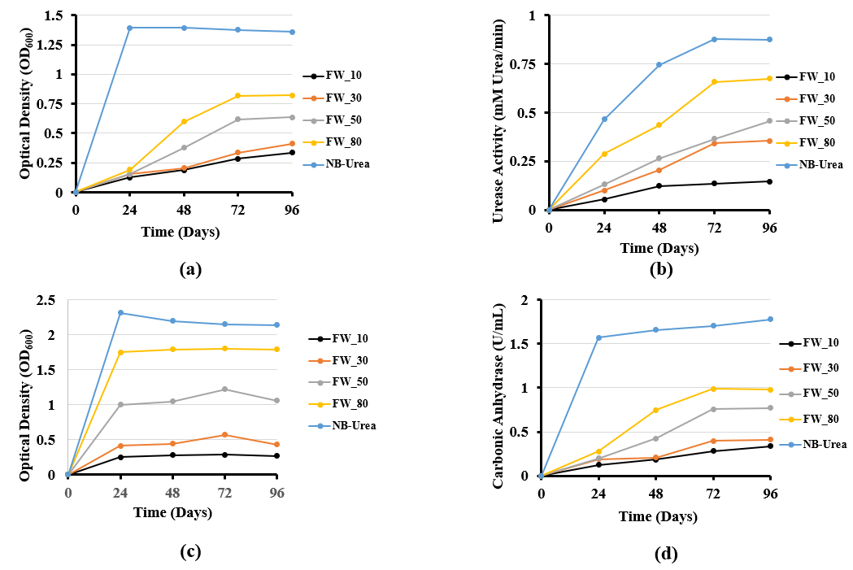

**Figure 2.** (a) OD600 of *B. licheniformis* in commercial and FV medium (b) Urease activity of *B. licheniformis* in commercial and FV medium (c) OD600 of U-1 in commercial and FV medium (d) Carbonic anhydrase activity of U-1 in commercial and FV medium

**Figure 4.** Typical SEM images of (a) Untreated coal ash, (b) Coal ash biocemented by *B. licheniformis* using FV medium, (c) Untreated Soil, (d) Soil biocemented by U-1 using FV medium

**Conclusion**

We investigated the feasibility of stabilizing fine-grained soil and coal ash from a railway embankment site via ureolytic and carbonic anhydrase biocementation using low-cost fruit and vegetable waste cultivation media. The preliminary results for the biocementation using FV showed that the bacteria successfully biocemented the fine-grained soil and coal ash (for which no unconfined compressive strength could be determined as the samples were crumbling) to cemented materials with unconfined compressive strengths of about 1500 kPa and 3000 kPa for the soil and ash respectively when ureolytic bacteria were used. In contrast, the CA bacteria increased the strength of the fine soil and coal ash to 1000 kPa and 2000 kPa. The results showed this is possible, as the treated soil had an increased unconfined compressive strength than the untreated coal and soil. This study shows that alternative lower-cost growth media sourced from fruit and vegetable waste effectively reduce ground improvement costs by biocementation.

**Acknowledgements**

The European Commission funded this work under the Horizon 2020 Marie Skłodowska-Curie Individual Fellowships Grant Number 101025184 (Grant holder: London South Bank University).

**References**

Achal, V., Mukherjee, A., Basu, P. C., & Reddy, M. S. (2009). Lactose mother liquor as an alternative nutrient source for microbial concrete production by Sporosarcina pasteurii. *Journal of Industrial Microbiology and Biotechnology, 36*(3), 433-438.

de Oliveira Maciel, A., Christakopoulos, P., Rova, U., & Antonopoulou, I. (2022). Carbonic anhydrase to boost CO2 sequestration: Improving carbon capture utilization and storage (CCUS). *Chemosphere, 299*, 134419. <https://10.1016/j.chemosphere.2022.134419>

Dhami, N. K., Alsubhi, W. R., Watkin, E., & Mukherjee, A. (2017). Bacterial community dynamics and biocement formation during stimulation and augmentation: Implications for soil consolidation. *Frontiers in Microbiology, 8*, 1267.

Esparza, I., Jiménez-Moreno, N., Bimbela, F., Ancín-Azpilicueta, C., & Gandía, L. M. (2020). Fruit and vegetable waste management: Conventional and emerging approaches. *Journal of Environmental Management, 265*, 110510. <https://10.1016/j.jenvman.2020.110510>

Fang, C., He, J., Achal, V., & Plaza, G. (2019). Tofu wastewater as efficient nutritional source in biocementation for improved mechanical strength of cement mortars. *Geomicrobiology Journal, 36*(6), 515-521.

Gomez, M. G., Martinez, B. C., DeJong, J. T., Hunt, C. E., deVlaming, L. A., Major, D. W., & Dworatzek, S. M. (2015). Field-scale bio-cementation tests to improve sands. *Ground Improvement, 168*(3), 206-216.

Jadhav, P., Sonne, M., Kadam, A., Patil, S., Dahigaonkar, K., & Oberoi, J. K. (2018). Formulation of cost effective alternative bacterial culture media using fruit and vegetables waste. *Int.J.Curr.Res.Rev, 10*, 6-15.

Lee, M. N. (2014). Bio-mediated soil: a sustainable ground improvement technique. *J.Geotek, 9*, 30-39.

Martin, V., Villarreal, F., Miras, I., Navaza, A., Haouz, A., González-Lebrero, R. M., Kaufman, S. B., & Zabaleta, E. (2009). Recombinant plant gamma carbonic anhydrase homotrimers bind inorganic carbon. *FEBS Letters, 583*(21), 3425-3430.

Mavroulidou, Safdar, M. U., M., Gunn, M. J., Gray, C., Payne, I., Garelick, J., & Purchase, D. (2020 Innovative methods of ground improvement for two problematic UK railway earthwork materials, 16th Int. Conf. on Environ. Sci. and Technology, CEST2019, Rhodes 4-7 September, 2019

Meng, H., Shu, S., Gao, Y., He, J., & Wan, Y. (2021). Kitchen waste for Sporosarcina pasteurii cultivation and its application in wind erosion control of desert soil via microbially induced carbonate precipitation. *Acta Geotechnica, 16*(12), 4045-4059. <https://10.1007/s11440-021-01334-2>

Omoregie, A. I., Muda, K., Rahman, M. R., Bakri, M. K. B., Ngu, L. H., Ong, D. E. L., Basri, H. F. B., Hong, C. Y., & Mokhter, M. A. (2023). Impact of palm oil mill effluent as an economic medium for soil fixation via microbially induced carbonate precipitation. *Biomass Conversion and Biorefinery,* <https://10.1007/s13399-023-03889-4>

Omoregie, A. I., Ngu, L. H., Ong, D. E. L., & Nissom, P. M. (2019). Low-cost cultivation of Sporosarcina pasteurii strain in food-grade yeast extract medium for microbially induced carbonate precipitation (MICP) application. *Biocatalysis and Agricultural Biotechnology, 17*, 247-255. <https://10.1016/j.bcab.2018.11.030>

Safdar, M. U., Mavroulidou, M., Gunn, M. J., Garelick, J., Payne, I., & Purchase, D. (2020). Biocementation of an organic soil using indigenous ureolytic bacteria. *Greenchem6,* Thessaloniki, Greece 20 - 23 Sep 2020

Safdar M. U., Mavroulidou, M., Gunn M. J., Garelick J, Payne I., Purchase D., (2021) “Innovative methods of ground improvement for railway embankment Peat Fens foundation soil”, *Géotechnique*, 71 (11), 985-998

Sagar, N. A., Pareek, S., Sharma, S., Yahia, E. M., & Lobo, M. G. (2018). Fruit and vegetable waste: Bioactive compounds, their extraction, and possible utilization. *Comprehensive Reviews in Food Science and Food Safety, 17*(3), 512-531.

UNEP. (2021). *UNEP food waste index report 2021.* ().

Yang, Y., Chu, J., Cao, B., Liu, H., & Cheng, L. (2020). Biocementation of soil using non-sterile enriched urease-producing bacteria from activated sludge. *Journal of Cleaner Production, 262*, 121315. <https://10.1016/j.jclepro.2020.121315>

Yang, Y., Chu, J., Cheng, L., & Liu, H. (2022). Utilization of carbide sludge and urine for sustainable biocement production. *Journal of Environmental Chemical Engineering, 10*(3), 107443.