Shipping Cost Uncertainty, Endogenous Regime Switching

and the Global Drivers of Inflation

Christina Anderl
London South Bank University

Guglielmo Maria Caporale
Brunel University London

Revised, February 2024

Abstract
The recent Covid-19 pandemic has disrupted global supply chains and led to large increases in shipping costs. This paper first provides shipping cost mean and uncertainty measures by using the endogenous regime switching model with dynamic feedback and interactions developed by Chang et al. (2023). The uncertainty indicator measures overall risk in the shipping market and is shown to represent a useful addition to the existing set of economic and financial uncertainty indices. Both the shipping cost mean and uncertainty measures are then included in structural VAR models for the US, the UK and the euro area to examine the pass-through to headline CPI, core CPI, PPI and import price inflation vis-à-vis other global and domestic shocks. The results suggest that shipping cost uncertainty shocks have sizeable effects on all inflation measures and are characterised by a stronger pass-through than that of other domestic or global shocks. Unlike the latter, they also affect significantly core CPI inflation. These findings imply that shipping cost mean and uncertainty should also be considered by policymakers when assessing the global drivers of inflation.

Keywords: Shipping cost uncertainty, inflation pass-through, endogenous regime switching
JEL Classification: C13, E31, E37

Corresponding author: Professor Guglielmo Maria Caporale, Department of Economics and Finance, Brunel University London, Uxbridge, UB8 3PH, UK. Email: Guglielmo-Maria.Caporale@brunel.ac.uk; https://orcid.org/0000-0002-0144-4135

We are grateful to Yoosoon Chang for providing us with the Matlab code for the regime switching models used in this paper. We would also like to thank two anonymous referees for their useful comments on an earlier version of this paper.

Introduction
In recent years, global supply chain disruptions associated with increasing and highly volatile shipping costs as well as supply bottlenecks have created price pressures in many economies. These issues have become especially relevant during the Covid-19 pandemic, which was characterised by particularly high volatility and abrupt changes in shipping costs. These developments represent a challenge for central banks, since disruptions to the shipping market not only affect import and producer prices, but can also get passed through to consumer price inflation and thus potentially have second-round effects on inflation. To date, only very few studies have examined the impact of shipping costs on inflation and economic activity (Carrière-Swallow et al., 2023), despite their importance as measures of transportation costs and their being much more volatile than other global factors such as oil prices. In particular, there is no available evidence concerning the variables determining the switch from low to high volatility periods in the shipping market.

The present study aims to provide new insights into these issues by constructing a shipping uncertainty measure which can be a useful addition to the existing set of economic and financial uncertainty measures not specifically capturing this type of risk. The shipping cost series used for the analysis is the monthly Baltic Dry Index (BDI) from February 1985 to September 2023; this index reflects real time supply and demand conditions and is the most informative about developments in the shipping market. In particular, the BDI is an index which measures the average price paid for transporting dry bulk materials, such as iron ore, coal, grain and alumina, across 20 sea shipping routes, which account for half of world oceanic trade. In this paper, an unsynchronised endogenous regime switching model with dynamic feedback and interactions is estimated to extract latent mean and volatility factors (Chang et al., 2023). The latter can be seen as a measure of shipping cost uncertainty and thus of overall risk in the shipping market. Next, the forecasting performance of the estimated specification is compared to that of several other regime switching models, including a volatility switching one, a standard Markov-switching one with an exogenous Markov chain, and the time-varying transition probabilities switching model by Diebold et al. (1994) with several transition variables. The shipping cost uncertainty indicator is then compared to a range of existing measures of economic and financial uncertainty. Finally, the pass-through of this new measure of uncertainty to inflation, inflation expectations and economic activity is assessed by estimating a structural VAR model for the US, the UK and the euro area (EA). In particular, the pass-through of shipping cost uncertainty shocks is compared to that of other global shocks in the case of four different measures of inflation, namely headline consumer price inflation, core consumer price inflation, producer price inflation and import price inflation. The analysis is motivated by the crucial importance for central banks of understanding the global drivers of inflation.

The remainder of the paper is organised as follows: Section 2 briefly reviews the relevant literature, Section 3 outlines the empirical framework, Section 4 describes the data and discusses the results, and Section 5 offers some conclusions and policy recommendations.

Literature Review
The existing literature uses two main indicators of shipping costs and supply chains pressures respectively. The first is the BDI, which is a shipping freight cost index and is based on three major indices (Capesize, Panamax and Supramax) which cover 20 sea routes. Since this index measures the demand for shipping capacity against the supply of dry bulk carriers, where dry bulk consists of materials used as raw inputs in the production of intermediate and finished goods including steel, food and electricity, it is regarded as a measure of cross-border transportation costs which represent a large input component in the production process. For this reason the BDI is often viewed as an indicator of future production and economic growth (Bildirici et al., 2015). The other Baltic Exchange indices, the Baltic Clean Tanker Index and the Baltic Dirty Tanker Index track the cost of shipping petroleum and crude oil respectively (Michail, 2020; Michail and Melas, 2020). We focus on the dry bulk market, which is the largest cargo shipping market and accounts for over half of world oceanic trade (Nomikos and Tsouknidis, 2023). Since the BDI is a useful measure of global demand pressures originating from the shipping market, it can be seen an indicator of economic activity (Kilian, 2009). It has several advantages over other leading indicators since, unlike payroll or consumer confidence measures, it does not suffer from data adjustment and revision requirements and is not subject to speculation present in stock or bond markets (Ruan et al., 2016). The Global Supply Chain Pressure Index (GSCPI) instead combines manufacturing indicators with transportation costs to represent supply chain conditions. Global transportation costs are measured using the BDI and the Harpex index, while supply chain components are measured by means of the Purchasing Manager’s Index surveys for the US, the UK, the euro area, Japan, China, South Korea and Taiwan. The GSCPI is only available since 1998 and is computed as the standard deviation from the average; it is therefore an uncertainty measure, but it less suitable to represent overall price conditions. Amongst the measures of supply chain pressures and transportation costs, the BDI is the only one capturing global shipping costs over a long time period and therefore provides the best insights into the evolution of shipping cost uncertainty over time.

Some of the recent literature has assessed the economic implications of supply chain pressures and uncertainties. For instance, Di Giovanni et al. (2022) find that, during the Covid-19 pandemic, global supply chain bottlenecks, which represent negative supply shocks, explained inflation in the euro area better than in the US, where demand shocks played a greater role. LaBelle and Santacreu (2022) measure industry exposure to supply chain disruptions in the form of changes in backlogs and delivery times. They report that their impact on US inflation is significant but heterogeneous with respect to industries and transmitted with a delay. Using local projections, Liu and Nguyen (2023) conclude that a positive one standard deviation shock in the supply chain pressures index increases import price inflation by up to 0.9 percentage points, inflation expectations by up to 0.1 percentage points, and producer price inflation by up to 10 percentage points. However, the latter is found to change as costs move along the production chain. Ye et al. (2023) employ a panel nonlinear autoregressive distributed lag model and find that global supply chain pressures affect inflation asymmetrically in advanced and emerging economies. De Santis (2024) jointly identifies energy supply and supply chain disruption shocks in a Bayesian VAR model of the euro area. His results indicate a persistent effect of the latter on core inflation, but only a transitory effect of the former. Finally, Tillmann (2024) reports that supply chain disruptions have asymmetric effects on euro area inflation, with adverse shocks having a stronger and more persistent impact.

Alongside the literature on supply chain pressures and their impact on inflation a new strand has been developing which instead focuses on shipping costs. For instance, Herriford et al. (2016) use a structural vector autoregressive model to analyse the pass-through of shipping costs to US inflation, which they find to be only moderate. Michail et al. (2022) estimate a vector error correction model and threshold regressions to assess the relationship between inflation and shipping costs for the euro area; they conclude that a shock to freight rates mostly affects inflation in sectors with items which have traditionally been manufactured outside the euro area. Isaacson and Rubinton (2023) find that, while the pass-through of shipping cost growth to import price inflation is generally moderate, shipping costs reached such high levels during the Covid-19 pandemic that they resulted in 5.87% import price inflation in the US. Their additional analysis suggests significant heterogeneity in the pass-through over time and across commodity types, but does not provide evidence on the pass-through of BDI volatility. Finally, Carrière-Swallow et al. (2023) examine the impact of shipping costs on different price indices for a panel of advanced and emerging economies. Sharp increases in the BDI are found to lead to large increases in import and consumer prices as well as in inflation expectations, but the effect is weaker in countries with an inflation targeting regime or well-anchored inflation expectations.

Other studies instead investigate the relationship between shipping costs and other economic variables and find evidence that movements in the BDI reflect changes in economic activity. For instance, Bakshi et al. (2012) suggest that BDI growth has significant in-sample and out-of-sample predictive power for global stock returns and industrial production growth. Also, using daily data in a panel of the G7 economies, Apergis and Payne (2013) show that the BDI is able to explain movements in both industrial production and financial assets better than oil prices.

Despite its importance as a measure of shipping costs, the BDI has thus far been largely overlooked as a global driver of inflation, neither has shipping cost uncertainty been properly measured and its impact on other variables examined in depth. We contribute to the literature by addressing these issues using the empirical framework outlined in the next section.

Empirical Framework

3.1 The Unsynchronised Endogenous Regime Switching Model
Markov-switching models are designed to capture the transition between regimes in the case of time series which are characterised by both tranquil and turbulent periods. However, standard models do not allow for time-varying transition probabilities which are driven by endogenous feedback from past changes. Since our aim is to examine the likelihood that high shipping cost volatility will persist, a regime switching method is needed that can incorporate this source of uncertainty. Therefore, we use the model developed by Chang et al. (2023), which allows the mean and volatility to switch in an unsynchronised manner:

$$\begin{aligned}y_{t}-μ\left(s_{m,t}\right)=\sum_{k=1}^{p}{γ_{k}(}y_{t-k}-μ\left(s_{m,t-k}\right))+σ\left(s_{v,t}\right)u_{t}\#\left(1\right)\end{aligned}$$

where $y_{t}$ represents shipping costs, and $μ$ and $σ$ are the mean and volatility respectively, which are both time-varying and depend on the two state processes $s_{m,t}$ and $s_{v,t}$. Low and high mean (volatility) states are represented by $s_{m,t}$ ($s_{v,t}$) and the state processes are defined as $s_{i,t}=1\{w_{i,t}≥τ_{i}\}$ for $i=m,v$. The switch between low and high mean (volatility) states is determined by the mean (volatility) regime factor $w_{m,t} (w_{v,t})$ according to the threshold $τ_{m} (τ_{v})$. The two latent factors $w_{t}={(w_{m,t},w_{v,t})}^{'}$ are assumed to follow the following first-order stationary bivariate autoregressive process:

$$w_{t}=Αw_{t-1}+v_{t}$$

where $Α=\left(\begin{matrix}α_{mm} & α_{mv} \\ α_{vm} & α_{vv}\end{matrix}\right)$ and the innovations $v_{t}={(v_{m,t},v_{v,t})}^{'}$ are $i.i.d.$ and correlated with the previous shipping cost change innovation $u_{t-1}$ according to the following correlation matrix:
$$Ρ=\left(\begin{matrix}1 & ρ_{vu}^{'} \\ ρ_{vu} & Ρ_{vv}\end{matrix}\right)=\left(\begin{matrix}1 & & \\ ρ_{v_{m},u} & 1 & \\ ρ_{v_{v},u} & ρ_{v_{m},v_{v}} & 1\end{matrix}\right)$$

This means that, in the unsynchronised endogenous regime switching model in $(1)$ (UERS hereafter), the bivariate latent regime factor $w_{t}$ is determined by the innovations $v_{t}$ and by the dynamic interaction between the two regime factors. The latter are given by the autoregressive coefficient matrix $Α$ and the correlation matrix $Ρ$. What differentiates this model from other regime switching ones is the way in which the time-varying transition probability of remaining in a low mean and high volatility regime is defined, namely:

$$\begin{aligned}P \left\{s_{t}={\left(0, 1\right)}^{'} | s_{t-1}={\left(0, 1\right)}^{'}, F_{t-1}\right\}= \\ Φ{\left(τ\right)}^{-1}\int_{-∞}^{τ}{Φ_{v|u}(τ-}ρ_{vu}u_{t-1}-Aw_{t-1}) ϕ(w_{t-1}) dw_{t-1}\#\left(2\right)\end{aligned}$$

where ${s_{t}=(s_{m,t}, s_{v,t})}^{'}$, $F_{t-1}$ is the information set available at time $t-1$, ${τ=(τ_{m}, τ_{v})}^{'}$ and $Φ_{v|u}$ is the conditional distribution of previous regime factor innovations $v_{t}$ given $u_{t-1}$. The feedback effects from the past innovations to shipping cost changes to the mean and volatility regime factors are measured by vector $ρ_{vu}u_{t-1}={{(ρ}_{v_{m},u}u_{t-1},ρ_{v_{v},u}u_{t-1})}^{'}$, which affects the regime determination process. The endogenous feedback can occur through two different channels. If $ρ_{{u,v}_{m}}≠0$, past innovations to shipping cost changes affect the mean regime factor, while, if $ρ_{{u,v}_{v}}≠0$, they affect the volatility regime factor. The time-varying transition probabilities result from the endogenous feedback channel where the state is correlated with the underlying process. Chang et al. (2021) propose an algorithm and modified filter which is suitable for models with multiple latent regime factors and can account for this endogenous channel.

The key point is that conventional regime switching models do not allow for feedback from past shipping cost changes to drive the transition probabilities. By contrast, endogenous unsynchronised regime switches in mean and volatility provide valuable information on the probability that any present changes in shipping costs will persist over subsequent periods, and thus enable market participants and policymakers to estimate more accurately overall risk in the shipping market.

3.2 Forecasting Performance Comparisons
The unsynchronised endogenous regime switching model is then compared to various rival specifications in terms of its forecasting performance. One is based on the endogenous switching model developed by Chang et al. (2017):

$$\begin{aligned}y_{t}=\sum_{k=1}^{p}{γ_{k}(}y_{t-k}-μ)+σ\left(s_{t}\right)u_{t}\#\left(3\right)\end{aligned}$$

where all elements are defined as before but now only the volatility is allowed to switch with respect to a single state $s_{t}$ and a latent factor $w_{t}$. $w_{t}$ follows a random walk according to $w_{t}=αw_{t-1}+v_{t}$ with $\left|α\right|<1$. The error terms are $\left(\begin{aligned}u_{t} \\ v_{t}\end{aligned}\right)\sim i.i.d.$ We refer to the model in $\left(3\right)$ as the volatility endogenous regime switching model (VERS). Another obvious choice is a standard regime switching model with an exogenous Markov chain (MCRS) which can be seen as a baseline against which to compare endogenous regime switching models. Finally, Diebold et al. (1994) developed a regime switching model with time-varying transition probabilities (TVRS), in which the transition probabilities are logistic functions of a predetermined transition variable $z_{t}$. We consider several possible variables for $z_{t}$, namely (1) lagged BDI, (2) lagged global inflation to account for overall increases in global prices and (3) lagged global output gap to represent overall demand for shipping goods. We use 5-, 10-, and 30-year rolling-windows to construct the forecasts for the UERS, the VERS, the MCRS, the TVRS with lagged BDI (TVRS-BDI), the TVRS with lagged global inflation (TVRS-INF) and the TVRS with the lagged global output gap (TVRS-IP). The out-of-sample performance of the models is compared using the root mean square error (RMSE) and the relative RMSE.

3.3 A VAR Model Including Shipping Cost Uncertainty
Mean and volatility regime factors can be extracted from the main UERS model and then used as the shipping cost mean and shipping cost uncertainty indicator in the following analysis, whose aim is to establish their relative importance as drivers of inflation vis-à-vis other global shocks, such as oil price and exchange rate shocks. For this purpose, we estimate a structural VAR model of the following form:

$$\begin{aligned}X_{t}=β+ΘX_{t-1}+ε_{t}\#\left(4\right)\end{aligned}$$

where $X_{t}$ is an $8×1$ vector of endogenous variables including inflation $(π_{t})$, output $(g_{t})$, inflation expectations $(π_{t}^{e})$, oil prices $(δ_{t})$, the policy rate $(i_{t})$, the exchange rate ($s_{t}$) and the two regime factors extracted from the UERS, namely $w_{m}$ and $w_{v}$ which represent shipping cost mean and shipping cost uncertainty respectively. $β$ is a constant and $ε_{t}$ stands for the structural shocks. We estimate the model for three major economies, namely the US, the UK and the euro area (EA). We consider four different inflation indicators, namely headline consumer price inflation (CPI), core consumer price inflation which excludes food and energy (core CPI), producer price inflation (PPI) and import price inflation (IPI). Since the BDI measures shipping costs of dry bulk it is of interest to assess the pass-through of shipping cost mean and uncertainty shocks to inflation rates at different production stages. The inclusion of output and oil prices into the model also controls for demand and input price driven changes in the BDI, whilst including inflation expectations enables us to assess whether shipping cost uncertainty makes it more difficult to anchor them. Overall, the selection of variables in the model allows us to analyse the transmission of various domestic and global shocks to inflation, which is highly relevant for the design of monetary policy.

We use sign restrictions to identify seven shocks in the model. These are detailed in Table 1. A domestic supply shock is a cost-push shock which reduces output growth but increases inflation and appreciates the real exchange rate. A domestic demand shock increases both inflation and output growth. We assume that these effects occur with a lag. A global oil price shock increases both inflation and inflation expectations, but lowers output with a lag and raises the oil price contemporaneously. A shipping cost shock is expected to lower output but to raise both inflation and inflation expectations with a lag, and to increase shipping cost on impact (LaBelle and Santacreu, 2022). A shipping cost uncertainty shock is assumed to increase inflation and inflation expectations with a lag and shipping cost uncertainty contemporaneously, whilst the effect on output is left unrestricted following an agnostic identification approach (Uhlig, 2005). A contractionary monetary policy shock reduces inflation with a lag, but raises the policy rate contemporaneously. An exchange rate appreciation lowers both inflation and output with a lag, and increases the real exchange rate contemporaneously. The estimation is based on the Bayesian approach as in Uhlig (1994) and uses the algorithm by Rubio-Ramirez et al. (2010).

Table 1. Sign restrictions in the VAR model
 | Supply | Demand | Oil price | Shipping cost (mean) | Shipping cost uncertainty (volatility) | Monetary policy | Exchange Rate
$$π_{t}$$ | $$+$$ | $$+$$ | $$+$$ | $$+$$ | $$+$$ | $$-$$ | $$-$$
$$g_{t}$$ | $$-$$ | $$+$$ | $$-$$ | $$-$$ |  |  | $$-$$
$$π_{t}^{e}$$ |  |  | $$+$$ | $$+$$ | $$+$$
$$δ_{t}$$ |  |  | $$+$$
$$w_{m,t}$$ |  |  |  | $$+$$
$$w_{v,t}$$ |  |  |  |  | $$+$$
$$i_{t}$$ |  |  |  |  |  | $$+$$
$$s_{t}$$ | $$+$$ |  |  |  |  |  | $$+$$
Notes: Sign restrictions with $(+)$ indicating a positive response to the shock and $(-)$ indicating a negative response.

Data and Empirical Results

4.1 Data Description
We obtained monthly Baltic Dry Index (BDI) data from February 1985 to September 2023 from Bloomberg. Due to limited data availability for other variables, we estimate the VAR model starting in January 1990 for the US, in January 2000 for the UK, and in January 1997 for the euro area. The series for headline consumer price inflation and core consumer price inflation (excluding food and energy) are from the Organisation for Economic Co-operation and Development (OECD) Inflation (CPI) database for all countries. Producer price inflation is taken from the OECD Inflation (PPI) database for all countries. The import price inflation series is obtained from the Federal Reserve Bank of St Louis (FRED) for the US, from the Office for National Statistics for the UK and from Eurostat for the EA. We use industrial production as a proxy for aggregate output; the source is the OECD Main Economic Indicators series. Inflation expectations are obtained from surveys, specifically the University of Michigan Survey of Consumers for the US, the YouGov/Citigroup Inflation Expectations Survey for the UK and the OECD Consumer Opinion Future Tendency of Inflation Survey for the euro area. The policy rates are from the Bank for International Settlements (BIS) Policy Rates dataset. The oil price series is the West Texas Intermediate (WTI) from FRED. The exchange rates series are the are real effective exchange rates from the BIS Effective Exchange Rate Indices dataset. We also include world output and world inflation series, more precisely the OECD total industrial production index and the OECD total inflation (CPI) series. All variables are expressed in their annual growth rates, except the policy rates which are in levels.

We also obtained a range of uncertainty and volatility measures to compare to shipping cost uncertainty. The Global Supply Chain Pressures Index data are taken from the Federal Reserve Bank of New York for the period of January 1998 to August 2023; the global Economic Policy Uncertainty Index (EPU) is provided by the Policy Uncertainty Website created by Baker, Bloom and Davis for the period January 1997 to August 2023; the Chicago Board Options Exchange (CBOE) Volatility Index (VIX) for the period January 1990 to August 2023 and the CBOE Crude Oil ETF Volatility Index (OVX) for the period May 2007 to August 2023 are both obtained from FRED. The Purchasing Manager’s Index for the United States (PMI) has been retrieved from the Institute for Supply Management for the period January 1990 to August 2023. Finally, we obtained annual data from 1995 to 2020 on the share of intermediate imports in total imports for the US, the UK and the euro area from the OECD Trade in value added (TiVA) dataset.

Figure 1 shows the BDI series and its growth rate (Panel A), the latter being calculated as the first difference in the log of the index, as well as its volatility, which is computed using a simple GARCH(1,1) model (Panel B). It can be seen that shipping costs were relatively low between February 1985 and August 2002, but subsequently underwent various abrupt changes. For instance, after increasing steadily from $2,081 per tonne in January 2006 to $11,440 per tonne in May 2008, they had fallen sharply to $851 by October 2008. BDI volatility was stable up until the early 2000s but then increased significantly in 2008 and remained high thereafter, and spiked around time of the global financial crisis and of the Covid-19 pandemic. Visual inspection suggests that high mean and high volatility periods do not always coincide. While both were high at times during the global financial crisis and the Russian invasion of Ukraine, several periods in between, including the Covid-19 pandemic, were characterised by low shipping costs but high volatility. These observations motivate the choice of a model specification allowing the mean and volatility to switch in an unsynchronised manner.

Figure 1. BDI price and volatility
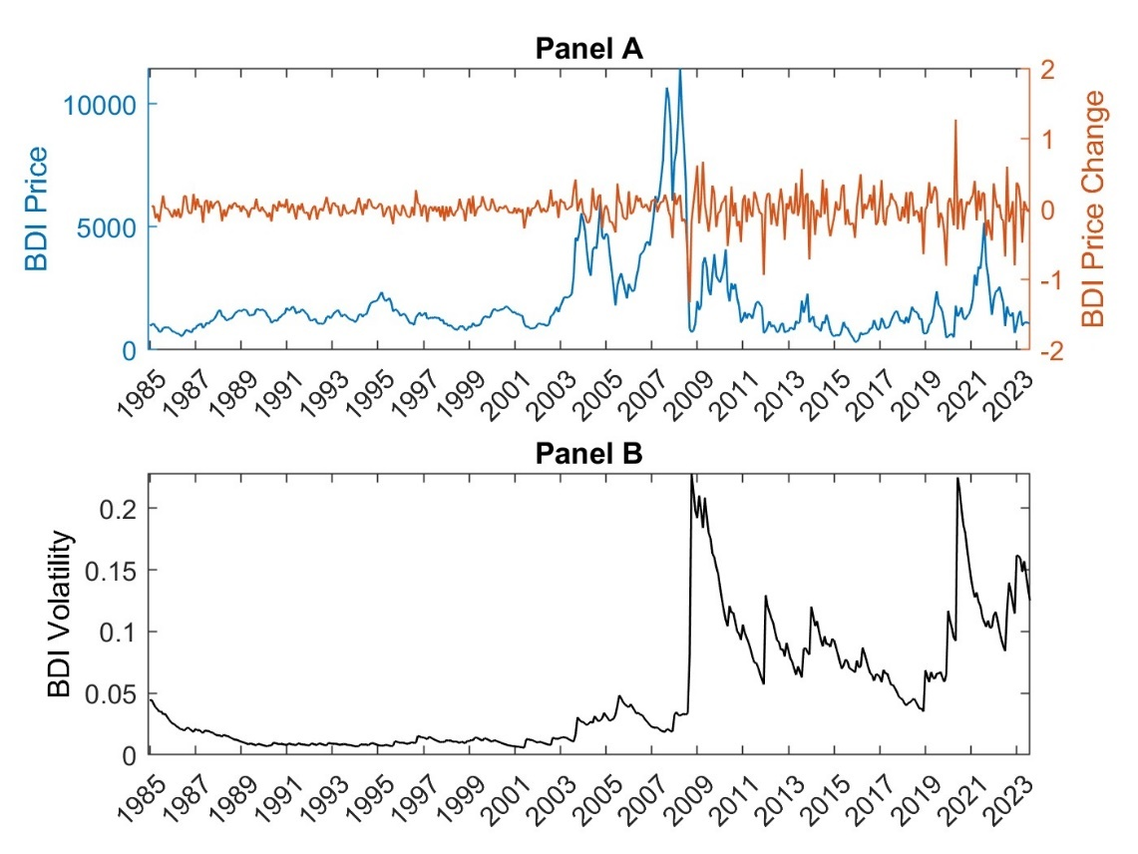
Notes: Panel A shows the BDI price and rate of growth over time, while Panel B displays the conditional volatility of the BDI.

4.2 Extracted Factors and Transition Probabilities
Figure 2 displays the mean (Panel A) and volatility (Panel B) factors extracted from the UERS. The former was high for long periods till September 2003 and briefly between August 2006 and December 2007. Since the global financial crisis, it has remained relatively low compared to the threshold (the red dashed line). The latter was low until September 2003, after which it exceeded the threshold value of the standard MCRS model with exogenous volatility (the dashed red line) for 33 periods. Since the global financial crisis, shipping cost volatility has remained persistently high, and it has almost continuously exceeded the threshold until the end of the sample, with a total of 218 months being spent in the high volatility regime. Note that the mean and volatility factors seem to move in opposite directions, i.e. during high (low) volatility periods the mean tends to be low (high). These dynamics seem to be captured more accurately by a model that allows both mean and volatility to switch in an unsynchronised manner, compared to a simpler model, such as the VERS, which allows only volatility to switch. The persistently high volatility observed after the global financial crisis also coincides with a period during which the BDI was relatively low. Given these findings we proceed to examine the transition probabilities of remaining in the low mean and high volatility regime to assess the likelihood of a high volatility regime prevailing.

Figure 2. Extracted factors from the UERS
Panel A – Mean factor | Panel B – Volatility factor
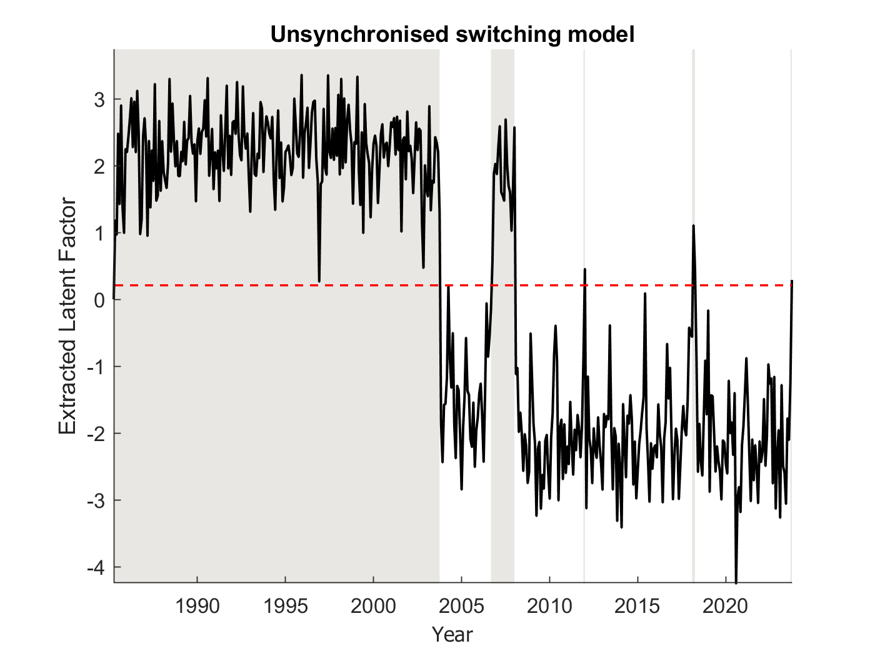 | 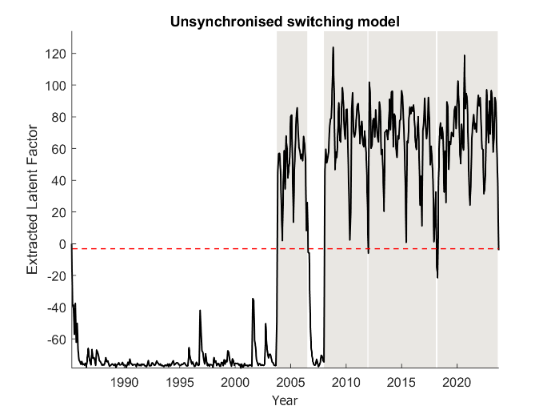
Notes: The extracted factors are represented by the black line while the estimated threshold is depicted by the red dashed line. The grey shaded areas indicate periods of high mean (Panel A) and high volatility (Panel B).

Figure 3. Correlation and coherence of mean and volatility factors
Panel A: Correlation | Panel B: Coherence
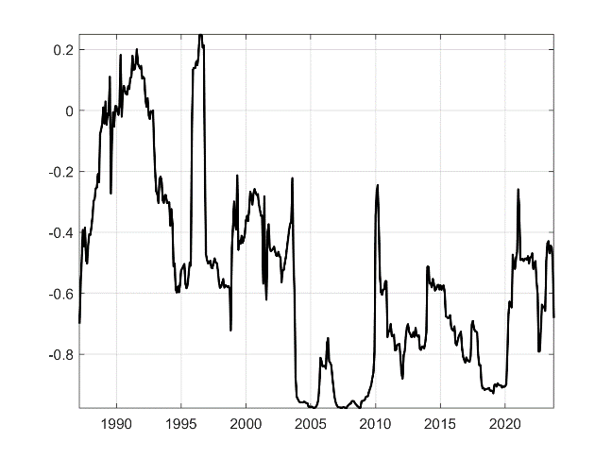 | 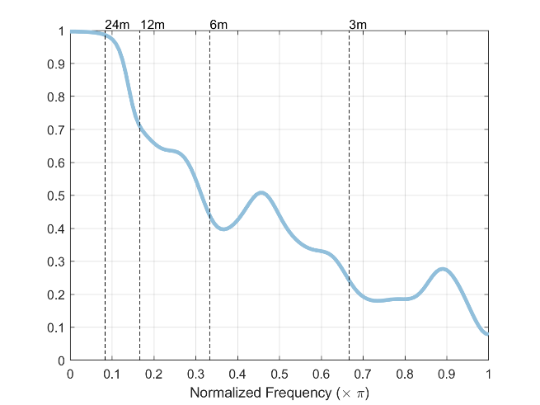
Notes: The correlation between the mean and volatility regime factors is based on a 24-month rolling window. The coherence is computed using the full sample.

Figure 4. Transition probabilities in the UERS
Panel A | Panel B
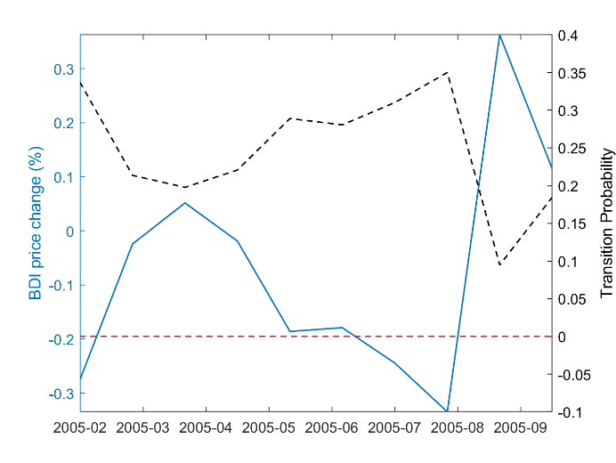 | 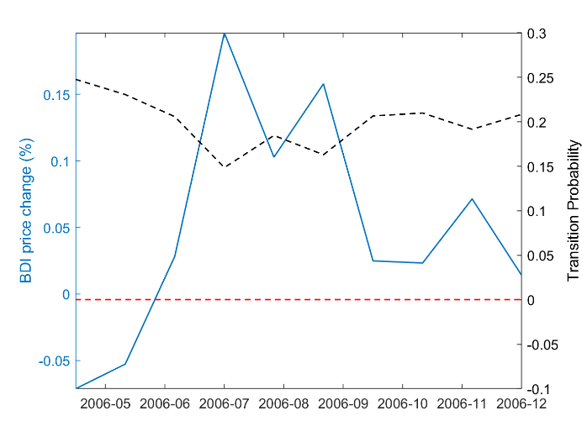
Panel C | Panel D
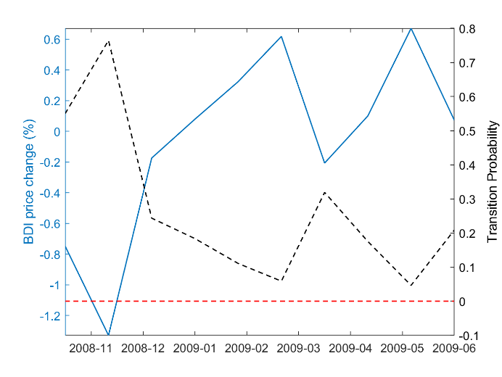 | 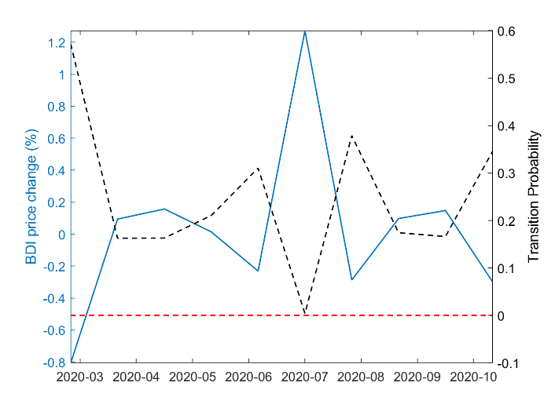
Notes: The dashed black line represents the time-varying transition probabilities obtained from the UERS, the solid blue line shows the BDI price changes and the dashed red line indicates the constant transition probability estimated from the exogenous MCRS.

Figure 3 plots the 24-month rolling window correlation (Panel A) and the coherence (Panel B) between the mean and volatility factors. The correlation is highly time-varying and negative for most of the sample. The mean and volatility factors are especially highly correlated during the global financial crisis and the following recession, as well as during the period immediately before the Covid-19 pandemic, which is consistent with the evidence presented in Figure 2 regarding their moving in opposite directions. Finally, the coherence graph indicates stronger co-movement of the two factors at lower frequencies, such as 3 and 6 months.

Figure 4 displays, for selected periods, the time-varying probability of remaining in the same low mean and high volatility regime. Panel A concerns a period of high commodity prices in 2005; the transition probability fluctuates slightly at first, but then declines sharply (whilst BDI increases). Panel B refers instead to a period characterised by hurricane disruptions in 2006; here the transition probability remains constant despite large BDI price changes. Panel C shows a high transition probability of almost 0.8 at the onset of the global financial crisis, which quickly declines to an average value of 0.2 and moves in the opposite direction to the BDI growth rate. At the beginning of the Covid-19 pandemic, the transition probability is similarly high, but then declines and fluctuates, once again mirroring BDI changes (Panel D). In all cases, the transition probability of remaining in the low mean and high volatility regime is positive and larger than the near-zero constant transition probability obtained from the exogenous MCRS model (the dashed red line). The behaviour of the time-varying transition probabilities indicates that the likelihood of the high uncertainty regime persisting changes quite substantially across time periods, which suggests that risk in the shipping market varies and therefore needs to be modelled accordingly. On the whole, the evidence obtained so far suggests that the extracted volatility factor from the UERS is an appropriate measure of shipping cost uncertainty.

4.3 Forecast Evaluation and Comparison to Existing Uncertainty Measures
In this sub-section we compare the performance of the UERS model to that of competing regime switching models, and also our extracted shipping cost uncertainty factor to alternative uncertainty measures. Table 2 compares the out-of-sample forecasting performance of the UERS with the VERS, a standard Markov-switching model with constant transition probabilities (MCRS) and the three regime switching models with time-varying transition probabilities outlined in section 3.2 (TVRS-BDI, TVRS-INF, TVRS-IP). As this table shows, the endogenous regime switching model with feedback and dynamic interaction (UERS) outperforms the others in terms of the RMSE and relative RMSE. These findings support using the extracted factors from the UERS as shipping cost mean and uncertainty indicators in the subsequent analysis.

Table 2. Forecast comparison
 | UERS | VERS | MCRS | TVRS-BDI | TVRS-INF | TVRS-IP
5-year window
RMSE | 0.1241 | 0.1427 | 0.1893 | 0.1905 | 0.1889 | 0.1916
Relative RMSE | 86.97 | 100.00 | 132.66 | 133.50 | 132.38 | 134.27
10-year window
RMSE | 0.1253 | 0.1435 | 0.1932 | 0.1948 | 0.1931 | 0.1959
Relative RMSE | 87.32 | 100.00 | 134.63 | 135.75 | 134.56 | 136.52
30-year window
RMSE | 0.1307 | 0.1467 | 0.2130 | 0.2149 | 0.2129 | 0.2161
Relative RMSE | 89.09 | 100.00 | 145.19 | 146.49 | 145.13 | 147.31
Notes: Forecast comparison based on one-step-ahead forecasts.

We now compare our shipping cost uncertainty measure with various existing uncertainty and volatility measures. Table 3 shows the pairwise correlation of our shipping cost uncertainty indicator with the Global Supply Chain Pressures Index (GSCPI), the Economic Policy Uncertainty Index (EPU), the CBOE Volatility Index (VIX), the Purchasing Manager’s Index (PMI) and the CBOE Crude Oil Volatility Index (OVX). In general, the correlation of the shipping cost uncertainty factor with the other uncertainty measures is weak, being strongest with EPU.

Table 3. Comparison with other uncertainty indicators
 | $$w_{v}$$ | $$GSCPI$$ | $$EPU$$ | $$VIX$$ | $$PMI$$ | $$OVX$$
$$w_{v}$$ | 1.0000
$$GSCPI$$ | 0.0715 | 1.0000
$$EPU$$ | 0.2503 | 0.4867 | 1.0000
$$VIX$$ | 0.0574 | 0.1197 | 0.2087 | 1.0000
$$PMI$$ | -0.1031 | 0.3871 | 0.0119 | -0.5196 | 1.0000
$$OVX$$ | 0.1122 | 0.2633 | 0.3968 | 0.7508 | -0.4539 | 1.0000
Notes: Correlation between individual uncertainty indicators.

Figure 5. Shipping cost uncertainty and the GSCPI
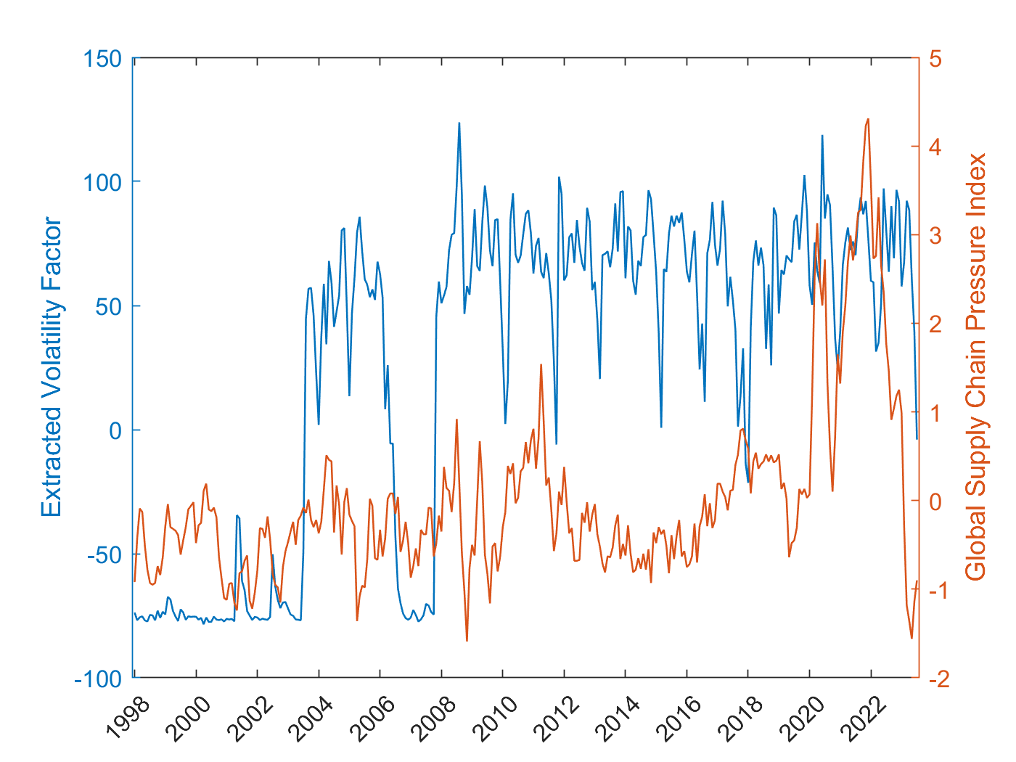
Notes: The extracted volatility factor from the UERS, which represents shipping cost uncertainty is represented by the blue line, while the GSCPI is represented by the orange line.

Figure 5 plots both our shipping cost uncertainty measure and the GSCPI, which is the closest indicator to ours for capturing global supply chain uncertainties including shipping costs. This index is often used to represent supply chain shocks, which have become much more frequent since the Covid-19 pandemic. Visual inspection reveals that our shipping cost uncertainty measure stayed at a much higher level compared to the GSCPU during the period 2003-2006 and then from 2008 onwards (with the exception of the height of the pandemic); it then declined only at the very end of the sample period, whilst the GSCPI had already started decreasing sharply at an earlier stage during the pandemic. Therefore our measure implies the presence of much higher risk in the shipping market over a longer period compared to the GSCPI.

Figure 6 plots our shipping cost uncertainty measure together with the other existing uncertainty measures already mentioned for the time periods for which they are available. It can be seen that the former behaves in a similar manner to EPU during the Covid-19 pandemic and to PMI over a longer time period.

Figure 6. Shipping cost uncertainty and other uncertainty measures
Panel A – EPU | Panel B – PMI
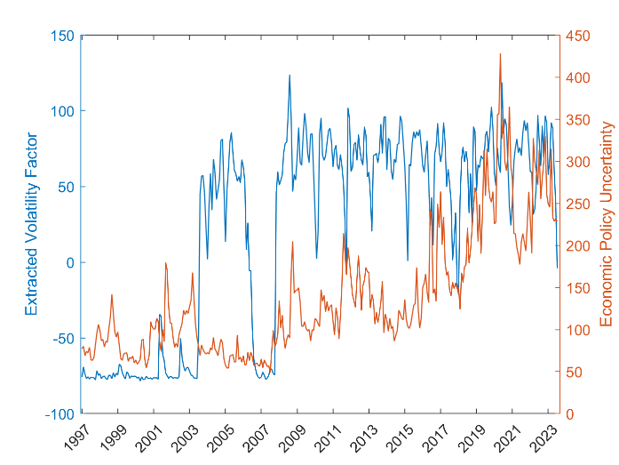 | 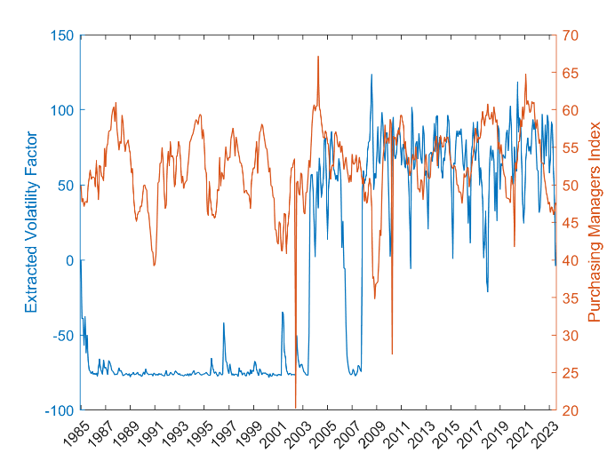
Panel C – VIX | Panel D – OVX
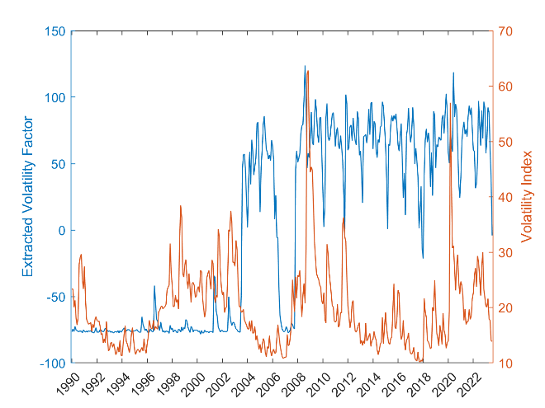 | 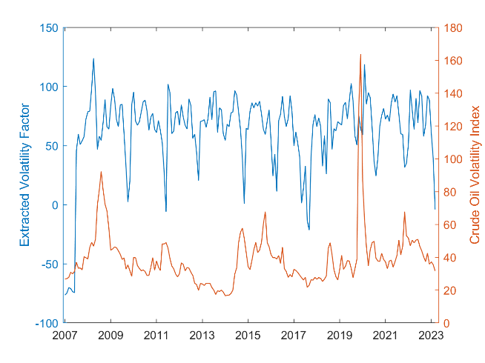
Notes: The extracted volatility factor from the UERS, which represents shipping cost uncertainty is represented by the blue line, while the other uncertainty measures are represented by the orange line. EPU is the economic policy uncertainty index, PMI is the Purchasing Manager’s index, VIX is the CBOE volatility index and OVX is the CBOE crude oil volatility index.

4.4 Shipping Cost Uncertainty and the Global Drivers of Inflation
Next we assess the pass-through of shipping cost uncertainty to inflation using our measure in the context of a structural VAR model in the case of the US, the UK and the euro area. All three of these economies have experienced an increase in their intermediate imports as a share of total imports over time, although there has been a decline in the most recent years in the case of the US and of the UK (Figure 7). Since this share varies across the three economies being examined, so will their exposure to shipping cost uncertainty. This heterogeneity makes it particularly interesting to examine the pass-through of shipping cost uncertainty in this set of countries.

Figure 7. Intermediate imports as a share of total imports
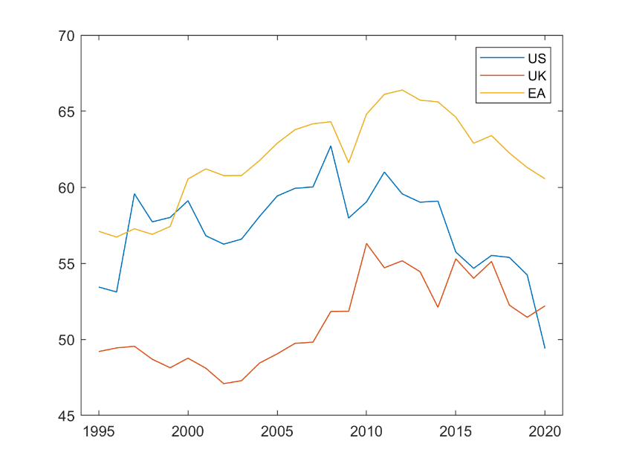
Notes: Intermediate imports as a share of total imports (%).

Figure 8 compares the responses of different measures of inflation to shipping cost mean and uncertainty shocks. Panel A suggests that the former have a positive impact on all inflation measures which tends to peak after seven months. They seem to be transmitted temporarily to PPI and IPI but permanently to CPI in the UK and the euro area. Panel B shows that shipping cost uncertainty shocks also affect inflation positively, and that the effect is approximately twice as large as that of a shipping cost mean shock. The effect on core CPI seems to be smaller than on other inflation measures but is more persistent; this reflects the basket used in this case which comprises less volatile components than the food and energy prices featuring in headline CPI. The largest response can be observed in the case of import price inflation, which is the most exposed to shocks in the global shipping market. PPI reacts equally strongly, which might be related to higher import prices affecting overall producer prices. These results are broadly consistent with the evidence presented in Figure 7. Specifically, the pass-through of shipping cost uncertainty shocks is stronger for the US and the euro area, which have a much larger intermediate import share out of total imports and are therefore more exposed to this type of shocks.

Figure 8. Response of different inflation measures to shipping cost shocks
Panel A – Response to shipping cost mean shock | Panel B – Response to shipping cost uncertainty shock
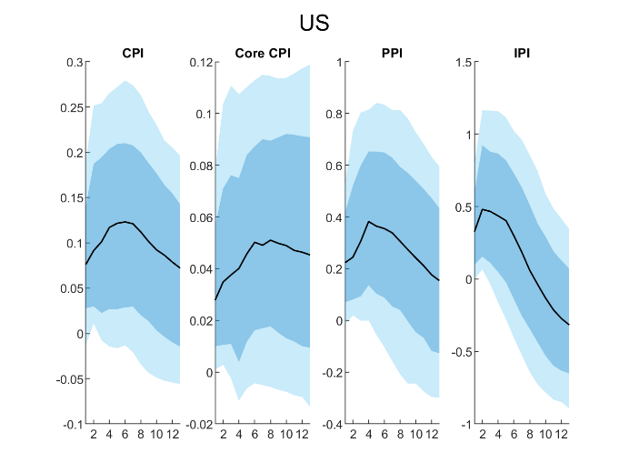 | 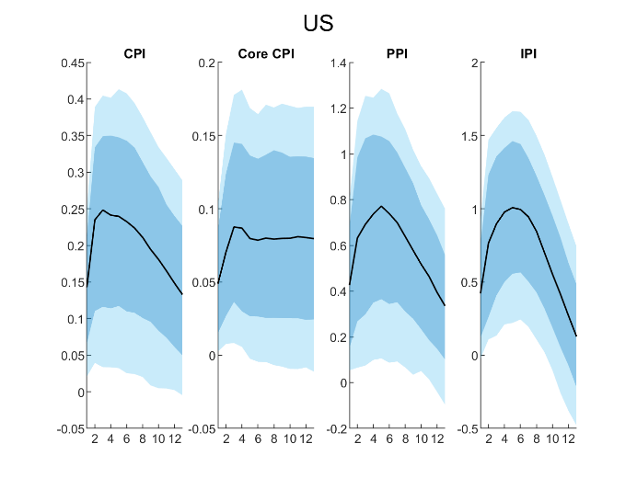
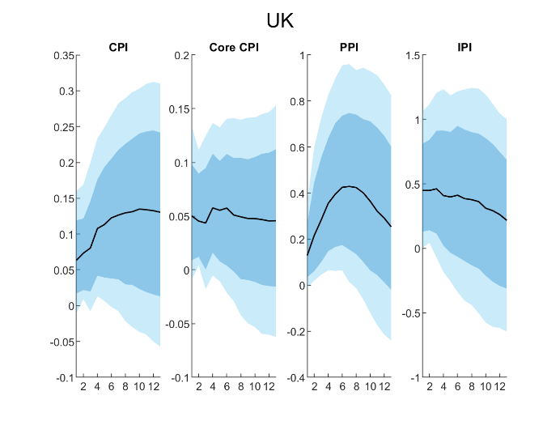 | 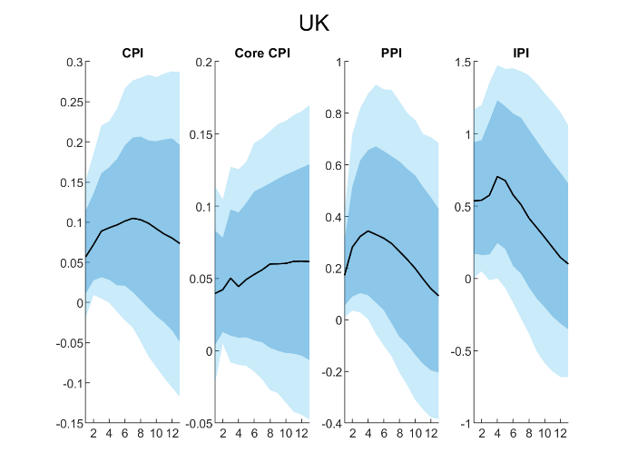
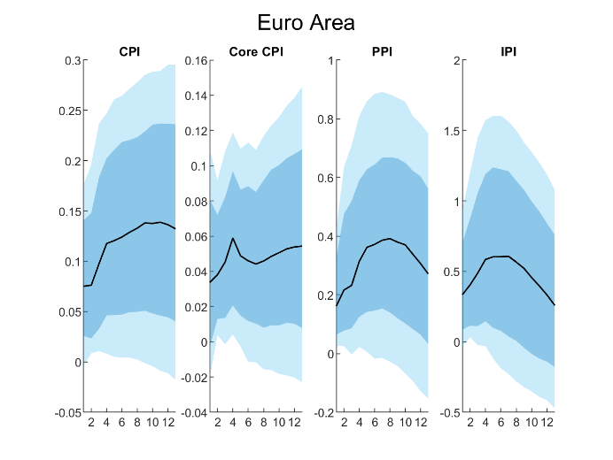 | 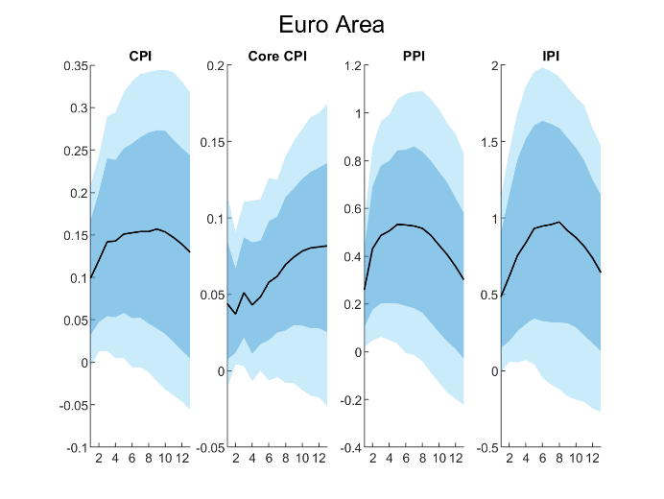
Notes: The solid black line represents the median response, the dark blue shaded area represents the 68% confidence band, while the light blue shaded areas represent the 95% confidence bands.

The hump-shaped effects of shipping cost mean and uncertainty shocks suggests that, although both increase inflation, their effects are not highly persistent for most measures. It seems the shocks to import and producer price inflation are immediately passed on to consumer prices, but these revert quickly to pre-shock levels. Our findings are slightly different from previous ones. Specifically, while Liu and Nguyen (2023) also report a stronger impact on producer than on consumer prices, we find a much stronger response of import prices. Further, compared to our results, Carrière-Swallow et al. (2023) report a flatter response of consumer price inflation and a more volatile response of import price inflation to shipping cost shocks. Overall, the evidence we find concerning the pass-through of shipping cost mean and uncertainty shocks to inflation is much stronger than that previously reported in the literature (see, for instance, Herriford et al., 2016; Isaacson and Rubinton, 2023). This presumably reflects the fact that we distinguish between shipping cost mean and uncertainty shocks which, for instance, enables us to capture some previously unexplained volatile response of inflation.

Figure 9 shows the responses of the different measures of inflation to other global shocks. Panel A indicates that the effects of oil price shocks are similar in shape to those of shipping cost uncertainty shocks, but the latter are almost twice as large for all measures of inflation in the US and for PPI and IPI in the UK and the euro area. This suggests that shipping cost uncertainty shocks have a greater impact on producer and import prices than oil price shocks and thus are an important additional global factor driving inflation. In the UK oil price shocks seem to have an increasing and persistent effect on CPI and core CPI while this effect is insignificant for the euro area. Panel B shows a negative pass-through of exchange rate appreciations to inflation which is strong initially and also persistent for CPI and core CPI, while for PPI and IPI it peaks after approximately seven months and then dies away. It appears therefore that exchange rate changes are passed on to consumer prices and affect them permanently.

Figure 10 concerns the effects of domestic shocks on inflation, more precisely demand shocks (Panel A), (cost-push) supply shocks (Panel B), and monetary policy shocks (Panel C). The response to a domestic demand shock is flat for all measures of inflation in all three economies. There are similarities between the effects of domestic supply shocks and those of shipping cost uncertainty and oil price shocks. However, the response of inflation to domestic supply shocks is much weaker than to shipping cost uncertainty shocks, especially in the case of producer and import price inflation, which are more heavily influenced by global shocks. All inflation measures respond weakly and negatively to contractionary monetary policy shocks, but the response of PPI and IPI is much larger than that of CPI and core CPI. In most cases the initial effect is short-lived and reverts to zero after 12 months.

Figure 9. Response of different inflation measures to other global shocks
Panel A – Response to oil price shock | Panel B – Response to exchange rate shock
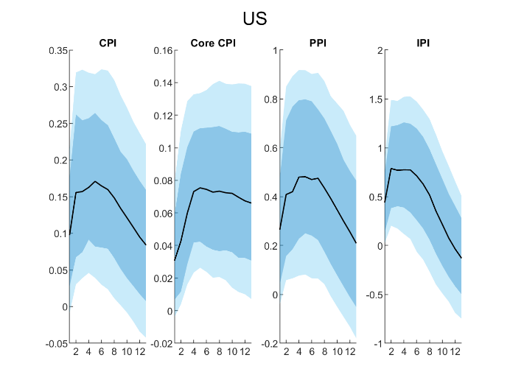 | 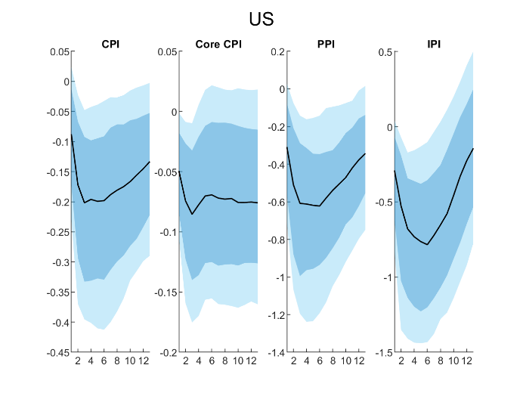
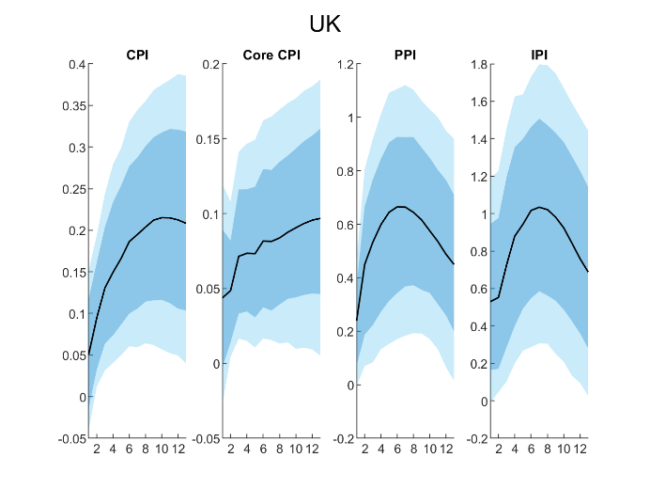 | 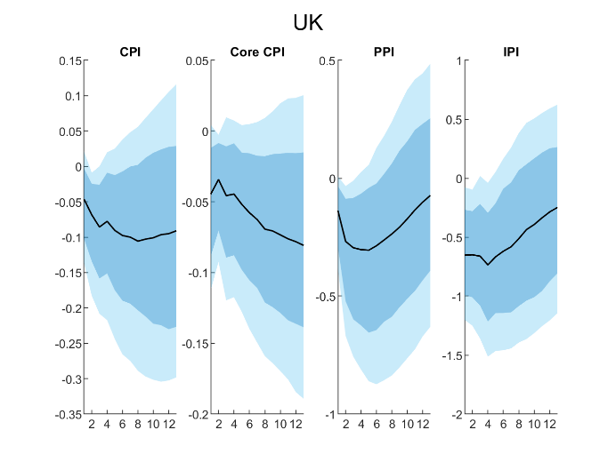
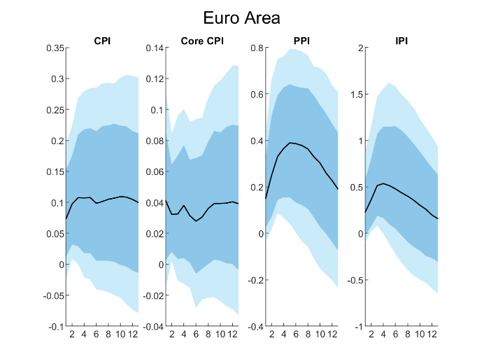 | 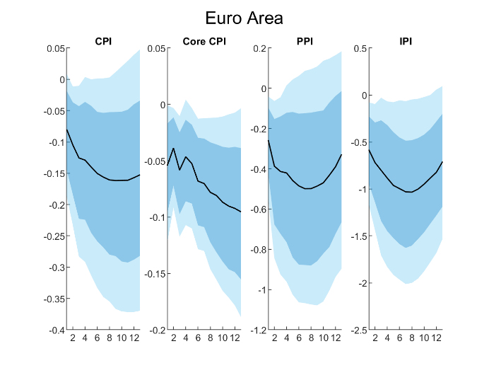
Notes: The solid black line represents the median response, the dark blue shaded area represents the 68% confidence band, while the light blue shaded areas represent the 95% confidence bands.

Figure 10. Response of different inflation measures to domestic shocks
Panel A – Response to demand shock | Panel B – Response to domestic supply shock | Panel C – Response to monetary policy shock
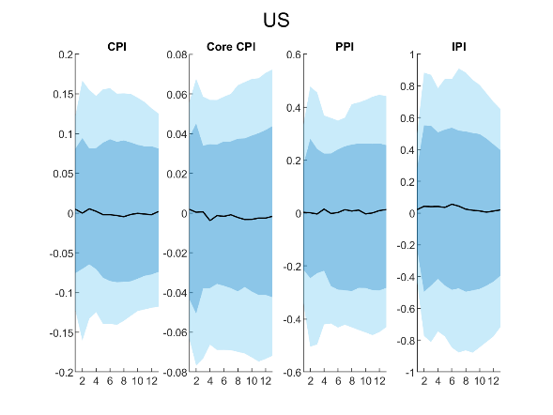 | 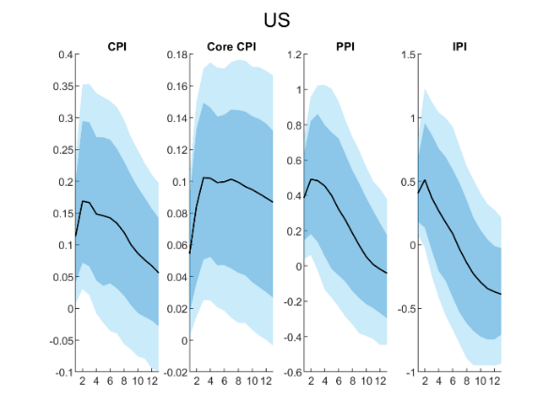 | 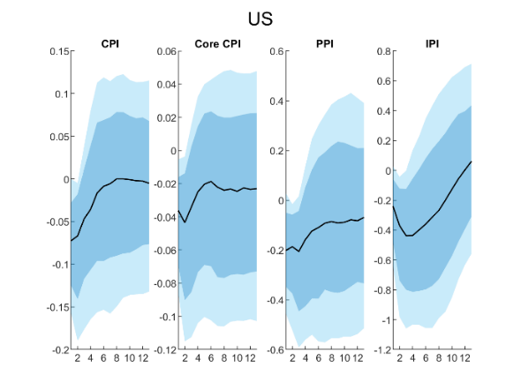
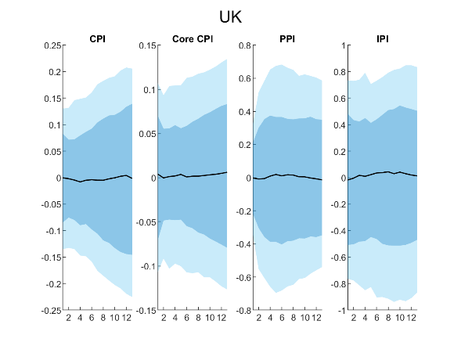 | 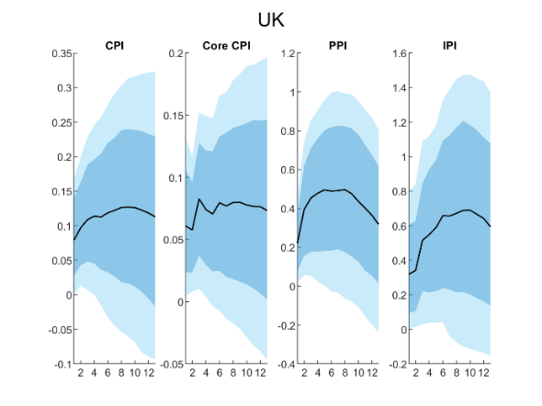 | 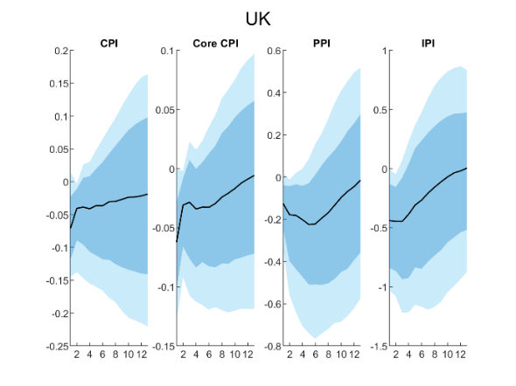
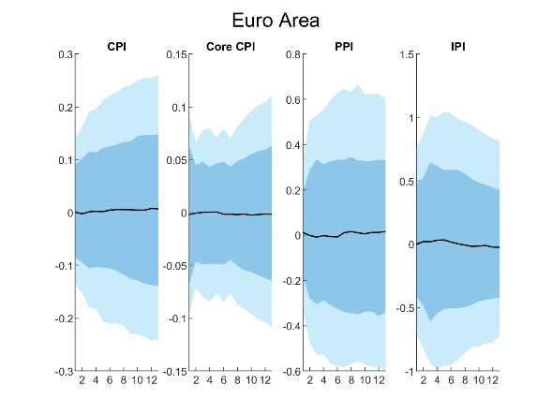 | 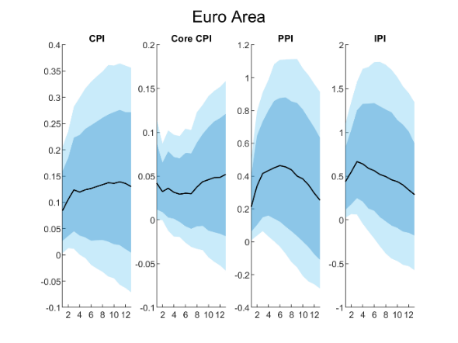 | 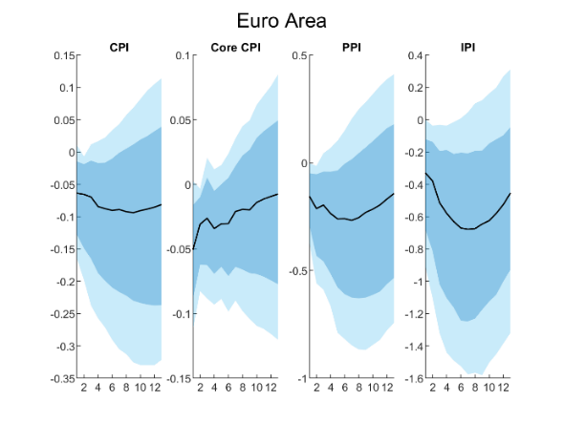
Notes: The solid black line represents the median response, the dark blue shaded area represents the 68% confidence band, while the light blue shaded areas represent the 95% confidence bands.

Figure 11. Responses of other variables to shipping cost shocks
Panel A – Response to shipping cost mean shock | Panel B – Response to shipping cost uncertainty shock
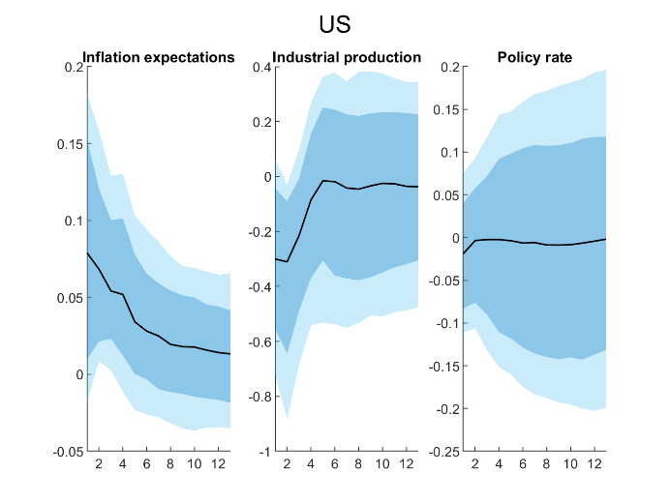 | 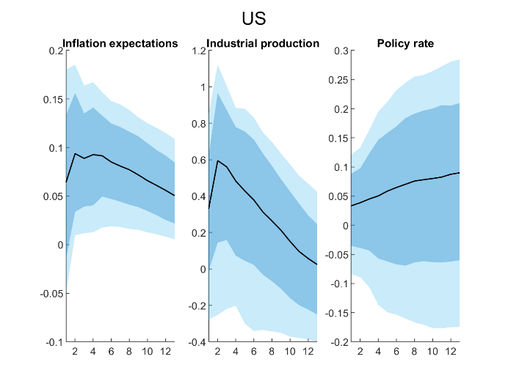
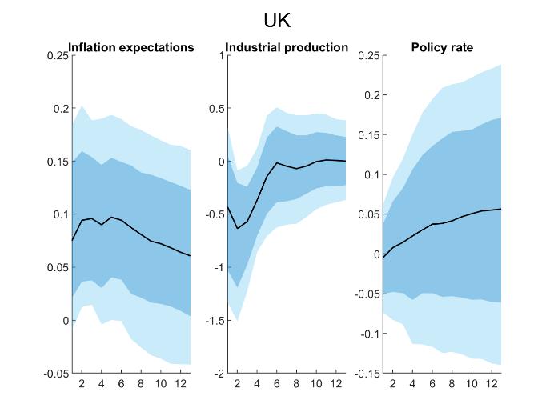 | 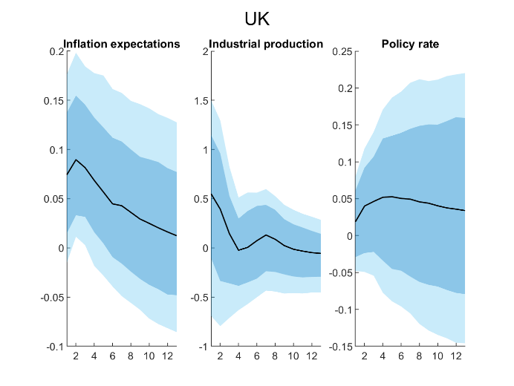
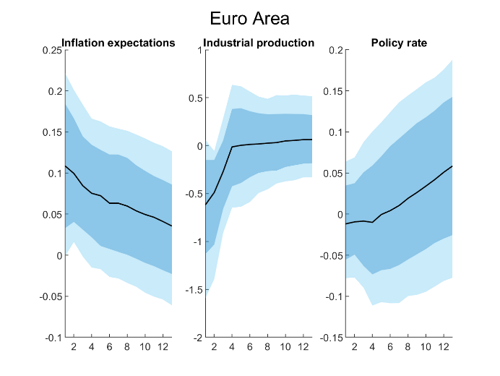 | 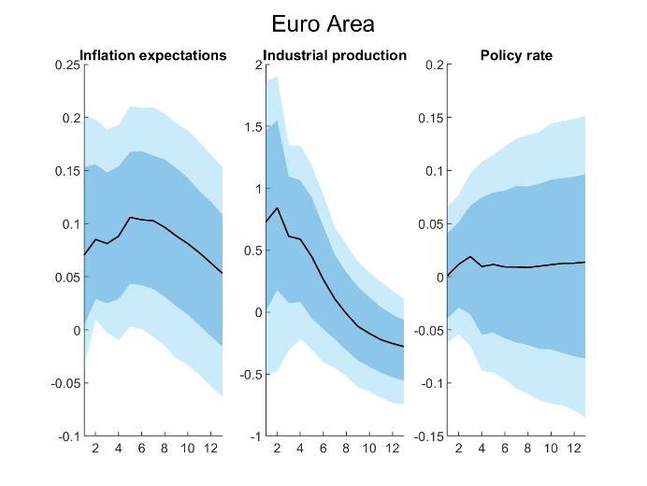
Notes: The solid black line represents the median response, the dark blue shaded area represents the 68% confidence band, while the light blue shaded areas represent the 95% confidence bands. The IRFs are obtained from the CPI model.

Finally, Figure 11 displays the responses of other domestic variables to shipping cost mean (Panel A) and uncertainty shocks (Panel B). Initially, inflation expectations respond slightly and positively, but then they experience a steady decline. It appears that they remain anchored in the medium term. Industrial production increases sharply and remains high after a shipping cost mean shock, but declines quickly after an initial positive response to heightened shipping cost uncertainty. The effect on the policy rate is largely insignificant.

Next, we consider the contribution of each different shock to changes in inflation over time, specifically headline (Panel A) and core consumer price inflation (Panel B). Since the former includes food and energy prices, which are usually highly volatile, it should be much more vulnerable to global shocks than the latter. Knowledge of the factors responsible for deviations of inflation from its mean value is crucial for central banks to assess the sources of inflationary pressures in the economy. Panel A suggests that shipping cost uncertainty shocks are much more important drivers of US headline inflation than shipping cost mean shocks. Moreover, the former affect inflation over the entire sample period and therefore risk in the shipping market seems to be a more persistent determinant of inflation deviations than other factors, as already found by Carrière-Swallow et al. (2023). In particular, it appears that shipping cost uncertainty was the main driver of inflation in the US during the global financial crisis, much more than domestic demand, supply and monetary policy shocks. Therefore central banks aiming to control inflation should pay special attention to this type of shock, and also to exchange rate shocks, given the evidence of a high exchange rate pass-through to consumer prices in the US since 2021.

The results reported in Panel B indicate that shipping cost uncertainty shocks (and mean shocks until 2010) are relatively more important for headline CPI in the UK than in the US. In the UK, domestic shocks generally play a smaller role than global shocks such as oil price and supply chain uncertainty shocks. The evidence in Panel C suggests instead a much larger contribution of shipping cost mean shocks in the euro area compared to the US and UK. This is consistent with the fact that the euro area has the highest intermediate import share of total imports of all three economies, which makes it more sensitive to shipping cost uncertainty shocks. However, surprisingly, despite the euro area having the highest exposure to global shocks of the three economies considered, domestic supply and monetary shocks appear to play a greater role than the other global shocks, with the exchange rate pass-through being particularly low in recent years.

Figure 12. Historical shock decomposition of headline consumer price inflation
Panel A – Shock decomposition for the US
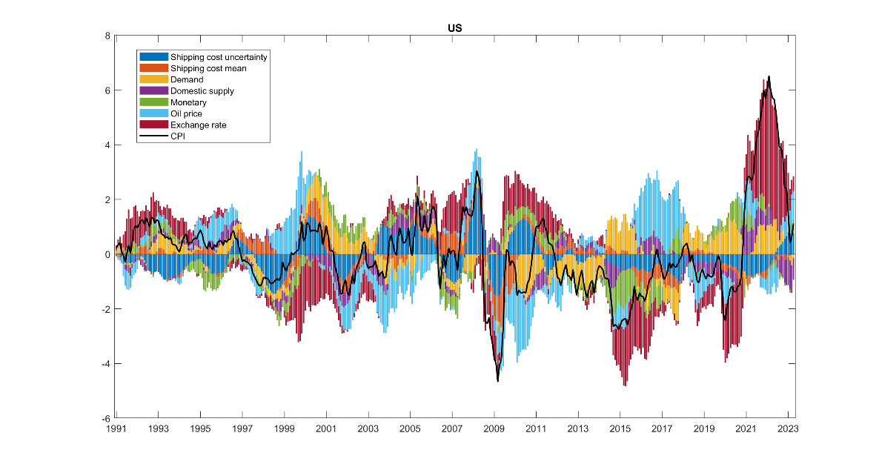
Panel B – Shock decomposition for the UK
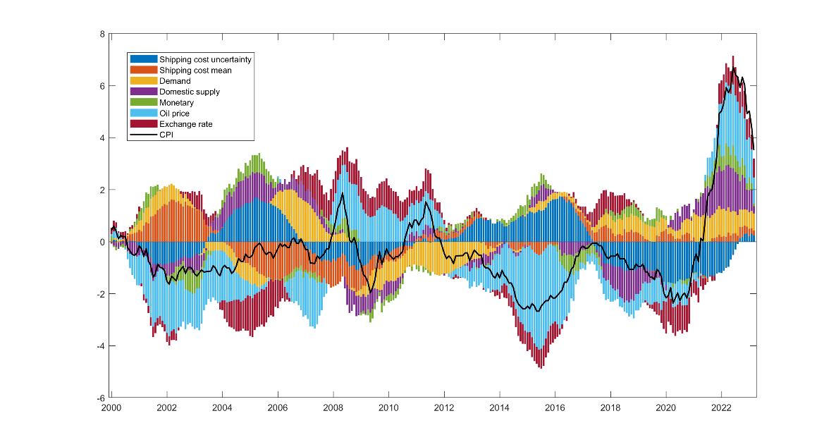
Panel C – Shock decomposition for the EA
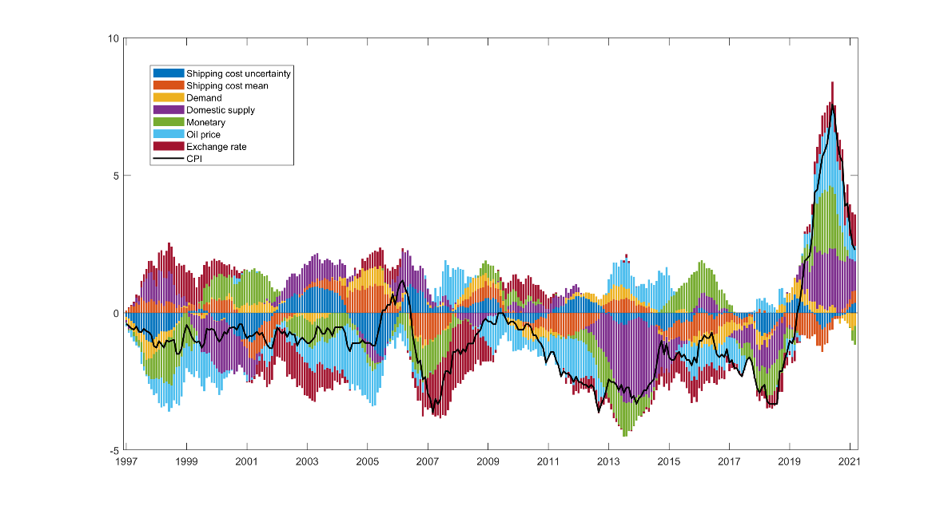
Notes: CPI is headline consumer price inflation expressed as deviations from the mean.

Figure 13. Historical shock decomposition of core consumer price inflation
Panel A – Shock decomposition for the US
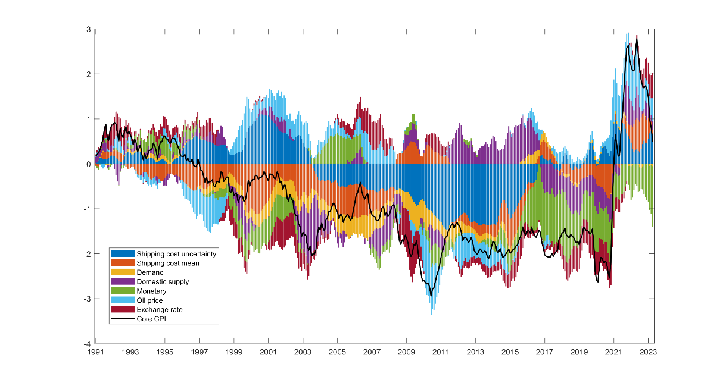
Panel B – Shock decomposition for the UK
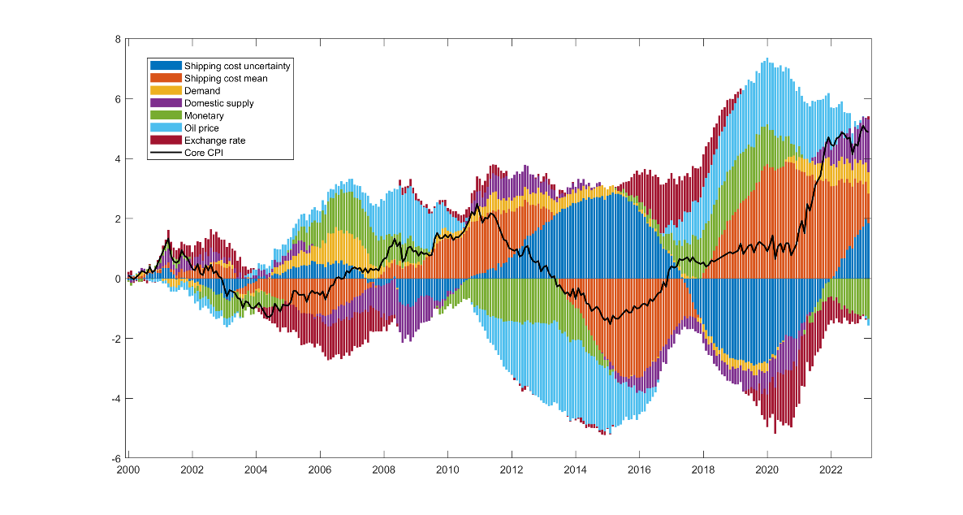
Panel C – Shock decomposition for the EA
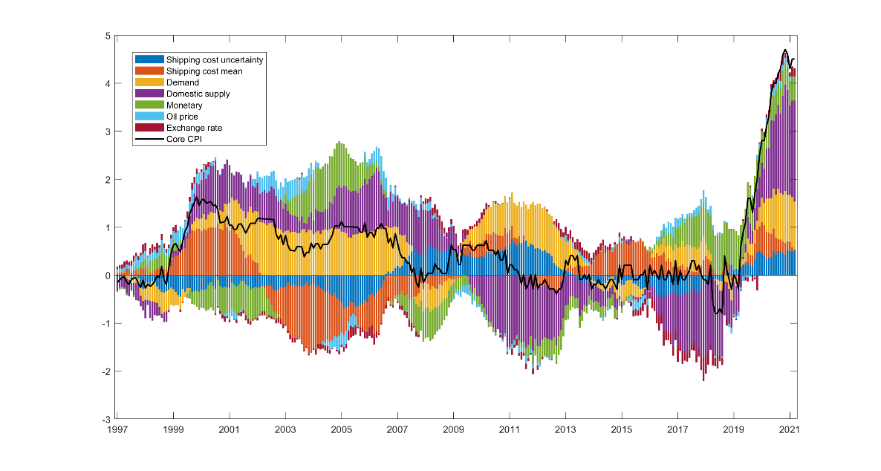
Notes: Core CPI is consumer price inflation excluding food and energy and expressed as deviations from the mean.
Figure 13 reports the corresponding results for core CIP inflation. In the case of the US (Panel A) shipping cost mean and uncertainty shocks contribute much more to core than to headline inflation changes. During the global financial crisis, and for several years afterwards, shipping cost uncertainty helped to reduce inflationary pressures. Monetary policy shocks are also more important for core than for headline inflation. Similar conclusions can be reached for the UK (Panel B), although oil price shocks remain important for core inflation. Shipping cost mean and uncertainty shocks seems to have opposite effects on inflation during several periods, including the Covid-19 pandemic, when mean shocks added to inflationary pressures while uncertainty shocks eased them. This suggests that it was mainly increases in the cost of shipping that pushed inflation higher at the time. In the euro area (Panel C) core inflation appears to be almost entirely driven by domestic shocks in addition to shipping cost mean and uncertainty shocks. In fact, the latter two seem to be the only global shocks with a significant impact on core inflation in recent years in the euro area. Shipping cost mean and uncertainty shocks can increase the price of imported goods, which directly influences consumer prices and can therefore have a strong impact on core inflation. In addition, shocks related to shipping costs can increase the costs of intermediate inputs, which are usually passed on to core consumer prices. Therefore they should also be taken into account by European monetary authorities focusing on core inflation.

Conclusions
This paper applies the endogenous regime switching model with dynamic feedback and interactions developed by Chang et al. (2023) to extract shipping cost mean and volatility factors based on the Baltic Dry Index (BDI), where the latter can be regarded as a measure of shipping cost uncertainty. The estimated endogenous regime switching specification is compared to a range of competing models in terms of its out-of-sample forecasting performance. A structural VAR model is then estimated to assess the relative importance of the pass-through of the derived shipping cost mean and uncertainty shocks to different inflation measures vis-à-vis other global and domestic shocks. Specifically, the analysis is conducted for CPI, core CPI, PPI and import price inflation in the case of the US, the UK and the euro area.

The main findings can be summarised as follows. First, the endogenous regime switching specification allowing for dynamic feedback and interactions appears to capture accurately shipping costs and uncertainty, and it outperforms alternative models in terms of its forecasting properties. Second, the extracted volatility factor is a useful indicator of shipping cost uncertainty. A comparison with existing uncertainty measures shows that it captures risk in the shipping market at times when other indices such as the GSCPI do not. Third, shipping cost uncertainty shocks are found to play an important role in driving inflation since they exhibit a stronger pass-through to inflation than other global or domestic shocks, but, even in their presence, inflation expectations remain anchored. Finally, shipping cost mean and uncertainty shocks are the only global ones with a significant impact on core consumer prices in addition to domestic factors, especially in recent years.

These results have important implications for policymakers. Central banks have largely overlooked shipping costs and the related uncertainty as global drivers of inflation. Our analysis instead provides evidence of a significant pass-through to inflation (however measured) of shocks to these variables. Both shipping cost mean and uncertainty are clearly one of the global drivers of inflation and have sizeable effects, especially in the case of core inflation. They should therefore be carefully considered by monetary authorities aiming for price stability. These can use the shipping cost mean and uncertainty indicators in their inflation forecasts in order to design appropriate policy responses to shocks originating from the shipping market. In particular, given the finding that the pass-through is stronger when a country has a higher intermediate import share out of total imports, they need to be aware that this might increase the vulnerability of inflation to these additional global shocks when designing policies to target inflation. In addition, the calculated uncertainty measure can be useful for market participants as an early warning signal of heightened risk in the shipping market.

The present paper has two limitations, namely it does not account for asymmetries in the pass-through of shipping cost shocks to inflation, and it does not distinguish between different transmission channels of shipping cost shocks through inflation expectations or the firm cost pass-through channel. Both are interesting issues for future research to investigate.

References
Apergis, N. and Payne, J.E., 2013. New evidence on the information and predictive content of the Baltic Dry Index. International Journal of Financial Studies, 1(3), pp.62-80.
Bakshi, G.S. Panayotov, G. and Skoulakis, G., 2012. The Baltic Dry Index as a Predictor of Global Stock Returns, Commodity Returns, and Global Economic Activity, AFA 2012 Chicago Meetings Paper.
Bildirici, M.E., Kayıkçı, F. and Onat, I.Ş., 2015. Baltic Dry Index as a major economic policy indicator: the relationship with economic growth. Procedia-Social and Behavioral Sciences, 210, pp.416-424.
Carrière-Swallow, Y., Deb, P., Furceri, D., Jiménez, D. and Ostry, J.D., 2023. Shipping costs and inflation. Journal of International Money and Finance, 130, p.102771.
Chang, Y., Choi, Y., & Park, Y., 2017. A new approach to model regime switching. Journal of Econometrics, 196, 127–143.
Chang, Y., Herrera, A.M. and Pesavento, E., 2023. Oil prices uncertainty, endogenous regime switching, and inflation anchoring. Journal of Applied Econometrics. Online publication ahead of print.
Chang, Y., Kwak, B., Park, J. Y., & Qiu, S., 2021. Regime switching models with multiple dynamic factors. Mimeograph: Indiana University.
De Santis, R.A., 2024. Supply chain disruption and energy supply shocks: impact on euro area output and prices. ECB Working Paper, No 2024/2884.
Di Giovanni, J., Kalemli-Özcan, Ṣ., Silva, A. and Yildirim, M.A., 2022. Global supply chain pressures, international trade, and inflation. National Bureau of Economic Research, No. w30240.
Diebold, F., Lee, J. H., &Weinbach, H., 1994. Regime switching with time-varying transition probabilities. In C. Hargreaves (Ed.), Nonstationary Time Series Analysis and Cointegration, Advanced Texts in Econometrics (pp. 283–302). Oxford University Press.
Herriford, T., Johnson, E.M., Sly, N. and Smith, A.L., 2016. How does a rise in international shipping costs affect US inflation?. Macro Bulletin. Federal Reserve Bank of Kansas City.
Isaacson, M. and Rubinton, H., 2023. Shipping prices and import price inflation. Federal Reserve Bank of St. Louis Review.
Kilian, L., 2009. Not all oil price shocks are alike: Disentangling demand and supply shocks in the crude oil market. American Economic Review, 99(3), pp.1053-1069.
LaBelle, J. and Santacreu, A.M., 2022. Global supply chain disruptions and inflation during the COVID-19 pandemic. Federal Reserve Bank of St. Louis Review.
Li, L., 2022. The dynamic interrelations of oil-equity implied volatility indexes under low and high volatility-of-volatility risk. Energy Economics, 105, p.105756.
Liu, M.L., Ji, Q. and Fan, Y., 2013. How does oil market uncertainty interact with other markets? An empirical analysis of implied volatility index. Energy, 55, pp.860-868.
Liu, Z. and Nguyen, T.L., 2023. Global Supply Chain Pressures and US Inflation. FRBSF Economic Letter, 2023(14), pp.1-6.
Michail, N.A., 2020. World economic growth and seaborne trade volume: quantifying the relationship. Transportation Research Interdisciplinary Perspectives, 4, p.100108.
Michail, N.A. and Melas, K.D., 2020. Shipping markets in turmoil: An analysis of the Covid-19 outbreak and its implications. Transportation Research Interdisciplinary Perspectives, 7, p.100178.
Michail, N.A., Melas, K.D. and Cleanthous, L., 2022. The relationship between shipping freight rates and inflation in the Euro Area. International Economics, 172, pp.40-49.
Nomikos, N.K. and Tsouknidis, D.A., 2023. Disentangling demand and supply shocks in the shipping freight market: Their impact on shipping investments. Maritime Policy & Management, 50(5), pp.563-581.
Ravn, M.O. and Uhlig, H., 2002. On adjusting the Hodrick-Prescott filter for the frequency of observations. Review of Economics and Statistics, 84(2), pp.371-376.
Ruan, Q., Wang, Y., Lu, X. and Qin, J., 2016. Cross-correlations between Baltic Dry Index and crude oil prices. Physica A: Statistical Mechanics and its Applications, 453, pp.278-289.
Rubio-Ramirez, J.F., Waggoner, D.F. and Zha, T., 2010. Structural vector autoregressions: Theory of identification and algorithms for inference. The Review of Economic Studies, 77(2), pp.665-696.
Tillmann, P., 2024. The asymmetric effect of supply chain pressure on inflation. Economics Letters, p.111540.
Uhlig, H., 1994. What macroeconomists should know about unit roots: a Bayesian perspective. Econometric Theory, 10(3-4), pp.645-671.
Uhlig, H., 2005. What are the effects of monetary policy on output? Results from an agnostic identification procedure. Journal of Monetary Economics, 52(2), pp.381-419.
Ye, M., Si Mohammed, K., Tiwari, S., Ali Raza, S. and Chen, L., 2023. The effect of the global supply chain and oil prices on the inflation rates in advanced economies and emerging markets. Geological Journal, 58(7), pp. 2805-2817.

The output gap is measured by applying the Hodrick-Prescott filter with monthly-frequency adjusted smoothing parameters (Ravn and Uhlig, 2002) to world industrial production data.
www.policyuncertainty.com
The dataset was discontinued after 2020.
A high correlation between OVX and VIX is found by many studies investigating volatility connectedness between equity and oil market volatility (Liu et al., 2013; Li, 2022). The stock market is often regarded as the primary source of uncertainty from which changes are transmitted to crude oil markets; this has been amplified by a deeper financialization of crude oil markets since 2005.

