DOI: 10.18462/iir. 10.18462/iir.icr.2023.0360
Modelling energy consumption in supermarkets to reduce energy use and greenhouse gas emissions using EnergyPlus
Elias EID^{*(a,b)}, Alan FOSTER^{(a)}, Judith EVANS^{(a)}, Denis LEDUCQ^{(b)}, Fatou-Toutie NDOYE^{(b)} and Graciela ALVAREZ^{(b)}
- London South Bank University, Bristol, BS40 5DU, UK, eide@lsbu.ac.uk*
- Université Paris-Saclay, INRAE, FRISE, 92761, Antony, France
ABSTRACT
New refrigeration system configurations and other innovating technologies in retail need to be considered to reduce energy use and greenhouse gas emissions. In supermarkets, there is a strong interaction between refrigerated display cases, supermarket structure, internal machinery, customers, and the store’s HVAC system. The impact of these interactions on the energy and carbon emissions of a medium sized supermarket in Paris was modelled using EnergyPlus™. The results were calibrated against a typical UK store and validated for the French store. The effects of applying the technologies identified to have the greatest potential to reduce carbon emissions (changing the refrigerant to R744, changing from gas to electrical heating and adding doors to chilled cabinets) were modelled. The impact of climate change on ambient temperature and the impact of changes to the grid conversion factor were predicted for the store in Paris from 2020 to 2050.

Keywords: Refrigeration system, Retail, Energy use, Greenhouse gas emissions, HVAC, EnergyPlus™
- INTRODUCTION
Studies have estimated that 26-35% of global greenhouse gas emissions are a result of food and agriculture. Approximately 18-29% of these emissions are related to the food supply chain (the remaining proportion is related to land use, crop and animal production) (Poore and Nemecek, 2018; Crippa et al, 2021). Emissions from the food chain emanate from energy used, fuels and loss of often high global warming potential (GWP) refrigerants. However, the food chain from the farm gate to the consumer faces several challenges in combating global warming and adapting to the effects of climate change. As reported by Widell (2021), about 60% of food is refrigerated at some point in the food chain and it is estimated that 70% of food system GHG emissions are related to perishable food. Therefore, it is vital to develop and demonstrate solutions to reduce these emissions.
In this context, as part of the European Green Deal, a European Union (EU) research and innovation project is looking at how the food industry can significantly reduce GHG emissions by 2050. The ENOUGH (European food chain supply to reduce GHG emissions by 2050) project was developed to support the EU's Farm-to-Fork strategy and provide a holistic strategy to transform the European food sector into a system that is environmentally friendly, resilient, healthy, and equitable.
Supermarkets are complex due to the interactions between the external ambient conditions, the display cabinets, the store HVAC system, and internal heat loads (equipment, customers, lighting). Computer models can generate a better understanding of how all these factors interact and have been used to aid designers and engineers decide on the best options to reduce carbon emissions.
Work to model supermarkets has been carried out by a number of researchers. Arias (2005) used CyberMart to simulate building heating and cooling loads, HVAC systems and seven different refrigeration systems in supermarkets. Differences between some measured and simulated values were found and it was concluded that fully validating the model across a whole year was not possible due to lack of data and some limitations in the capabilities of CyberMart. Hill (2015) assessed the capability of three modelling tools: Simplified Building Energy Model (SBEM), an Excel Model, and EnergyPlus (US Department of Energy) and concluded that the freeware EnergyPlus model was the most appropriate tool to analyse the complex interactions in supermarkets.
The aim of this work was to assess the impact of various opportunities to reduce carbon emissions from supermarket stores and to determine how close to carbon neutrality stores could become by 2050. The paper presents results from an EnergyPlus model that examines the impact of external and internal environmental conditions on energy consumption and carbon emissions from a medium sized supermarket in Paris when new technologies were applied. The model was initially calibrated using data from an average UK store where the level of detailed information required for such a calibration was available. The impact of changes to climatic temperature and changes to the electrical grid conversion factor from 2020 to 2050 are presented. The environmental impact was characterised by the total equivalent warming impact (TEWI).
- MATERIALS AND METHODS
  - Supermarket modelled
Information on the French store modelled is provided in Table 1.
Table 1. Information for the French supermarket
Location | Paris
Store temperature (°C)  Total size (m²)  Sales area (m²)  Store height (m) | 17 - 20  2,100  1,085  6
Store energy consumption (kWh/y) | 540,000
Store fuel source | 100% electrical energy
Number of cold stores | 8
Length of display cabinets (m):  Produce (0 - 4°C), remote  Dairy (0 - 4°C), remote  Meat (0 - 4°C), remote  Frozen (-18°C), remote  Display cabinet height (m)  Doors | 102.5  22.5 (36 doors)  36.25 (58 doors)  25 (40 doors)  18.75 (25 doors)  1.5  On all chilled and frozen cabinets
Refrigeration system  Refrigerant charge (kg)  Type of HVAC system | CO₂ booster system (R744)  180  Air handler unit (AHU) – sales area  Packaged terminal air conditioner (PTAC) – office area
  - Modelling of the supermarkets
    - Methodology
EnergyPlus V22.2.0 simulation engine, SketchUp Pro (Trimble Inc.) 2022, and OpenStudio (NREL, ANL, LBNL, ORNL, and PNNL) V1.5.0 software were used to calculate the required cooling and heating capacity and total energy consumption for the modelled scenarios. SketchUp was used to draw and create the model geometry, while OpenStudio was used to add and modify properties such as weather files, construction, materials, occupancy, internal loads, schedules, water, HVAC, and refrigeration systems. EnergyPlus was used to simulate energy consumption. Results were presented in the OpenStudio graphical user-friendly interface.
    - Model geometry
The geometry for the 2,100 m² French supermarket had 5 spaces: sales, offices, dry storage, cold storage, and a machine room, with areas of 1,085 m², 111 m², 267 m², 526 m² and 111 m², respectively. The office area had one window (Figure 1).
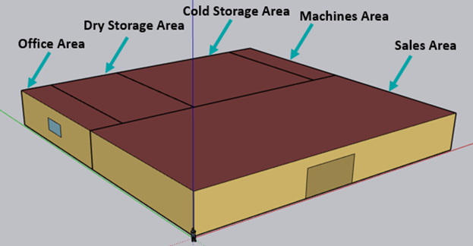
Figure 1. Geometry of the supermarket with space types
    - Model inputs
Details of the model inputs are presented in Table 2.
EnergyPlus weather files associated with London (calibration store) and Paris (validated store used for modelling) were applied for 2020 and 2050 to assess the impact of climate change. A representative concentration pathway (RCP) 4.5 weather file was applied for the 2050 scenarios. This is described by the Intergovernmental Panel on Climate Change (IPCC) as a moderate scenario in which emissions peak around 2040 and then decline.
The opening hours of the supermarket, number of people, lighting, equipment, and the hours of operation of different components like ovens for bakery were added in the schedule tab. Space load definitions fall into several categories including people, lighting, electric, gas, and other equipment uses. Therefore, lighting including individual lamps, desk lamps, arrays of fluorescent tubes, emergency exit lights, and many more were considered in the simulation. Furthermore, cash register, printer and vending machines, microwaves, ovens, etc. were also taken into consideration.
A construction set in the library related to a supermarket envelope defined by American Society of Heating, Refrigeration and Airconditioning Engineers (ASHRAE) was loaded. Using this default construction set, materials from OpenStudio’s built-in libraries were automatically loaded.
Water use equipment was modelled in a similar way to electric equipment. First, a definition is created to represent a piece of equipment such as a toilet or sink. Then, the peak flow rate, the number of toilets and the maximum target temperature for the heating were specified. A hot water system includes a pump, a service water loop with a water heater on the supply side and a water use connection on the demand side.
By default, HVAC systems and components in OpenStudio are "auto sized". This means that equipment flow rates, heating and cooling capacities, and other related properties are automatically determined by EnergyPlus engine using a sizing algorithm driven by the load generated by thermal zones. The HVAC’s control logic attempts to follow the thermal zone’s thermostat set point. The HVAC system had a cooling coil, an electric or gas heating coil, a fan supply, and an outside air system. The office area is controlled by a Packaged terminal AC (PTAC) which is independent of other areas.
For direct expansion (DX) R404A and R448A simulations (used for calibration of the model), the system was split into two racks (one for low temperature and one for medium temperature cabinets) with an air-cooled condenser and 4 compressors each. The simulated R744 booster refrigeration system was composed of a gas cooler, a flash tank, 4 medium temperature (MT) compressors that work in both subcritical and transcritical operations linked to chilled cabinets and cold stores and 4 low temperature (LT) compressors that only work in subcritical mode linked to frozen cabinets and cold stores. Evaporators were present inside the refrigerated cabinets.
Table 2. Model inputs
Weather file | Paris / London. 2050 weather file: RP 4.5
Opening hours schedule | From 8:30 am – 9 pm (Monday-Saturday)  From 9 am – 1 pm (Sunday)
Calendar year | 2020
Fuel type | Electrical / natural gas (NG) Heating
Construction set  Material set | ASHRAE Supermarket 2013  Concrete, Gypsum, Typical Insulation, etc.
Loads | People (people/m²) Lights (W/m²) Electric (W/m²)  Sales area 0.086111 12 19  Office area 0.053820 10 3.875009  Machines area 0.035951 2.62 2.906256  Cold Storage area 0.035951 2.62 -  Dry Storage area 0.053820 2.62 3.336812  Different schedules during opening and closing hours
Bakery | 18 W/m² – 3 hours/day (8-11am) – Included in electric load of sales area
Heating thermostat | 21°C Day - 19°C Night
Cooling thermostat | 24°C
Water system  Target temperature | Service hot water loop  60°C
HVAC system | AHU for sales and cold storage areas - PTAC for offices  Cooling DX Rated COP 3  Heating efficiency 1 (electric), 0.8 (gas)  Fan total efficiency 0.7  Controlled thermal zones Sales area, office area, cold storage area  Outside air schedule 1 during the day and 0 during the night
Refrigeration system | Compressors R404A/R448A Centralised direct expansion– R744 booster system R404A/R448A: Copeland-DISCUS-3DF3-120E-TFD R744 Bitzer: 2GSL-3K-4SU (subcritical low stage) – 4FTC-20K (high transcritical stage)  Condenser 2 air cooled condenser: variable speed fan of 7 kW each (HFC/HFO blend) Gas cooler: 1 variable speed fan of 10 kW  Evaporating temperature Chilled/Frozen: -8/-33°C for HFC/HFO blend and -5/ -30°C for R744  Defrost 1h/day (total), off cycle for chilled, 1400 W/m electric defrost for frozen cabinets  Anti-sweat heater None for chilled, 100 W/m for frozen cabinets  Cabinet infiltration schedule 1 (no barrier) during the day – 0.2 at night (night blinds) 0.3 during the day – 0.1 at night (with doors on cabinets)  Rated latent heat ratio 0.2 without doors on cabinets – 0.3 with doors on cabinets  Minimum condensing T (°C) 21°C for HFC/HFO blend and 10°C for R744 in subcritical operation  Transition T (°C) 27°C outdoor T°C to switch from subcritical to transcritical operation⁴  T gas cooler 3 K greater than ambient T⁴  Receiver pressure (R744) 40 bar
Display cabinets  (sales area) | Case length (m) Case height (m) Operating T (°C) Cooling capacity (W/m) Fan (W/m) Light (W/m)  Chilled food 83.75 1.5 3 1000 30 20  Frozen food 18.75 1.5 -18 400 30 20
Cold chambers  (ColdStorage area) | Walk in cooler no. Total surface area (m²) Height of doors (m) Operating T (°C) Cooling coil capacity (W) Fan (W) Light (W) Defrost (W)  1-2 43 2 -18 4690 735 120 2500  3-8 43 2 3 4690 735 120 2500  Insulated floor U value: 0.207 W/m². K  Insulated surface U value facing zone: 0.235 W/m². K  Stocking door U value facing zone: 0.3785 W/m². K
  - Total equivalent warming impact (TEWI)
The TEWI characterises CO_{2e} emissions and is a useful tool to study the impact of supermarket systems on global warming. The TEWI combines the direct and indirect emissions of CO_{2e}. For any system, TEWI is based on the following relation:
$TEWI=\left(GWP×m×L\right)+(E×β)$ Eq. (1)
Where TEWI is the kg of CO_{2e} produced during a year; $\left(GWP×m×L\right)$ are direct emissions of CO_{2e} due to refrigerant leakage; $(E×β)$ are indirect emissions of CO_{2e} associated with electrical energy consumption; GWP is the Global Warming Potential of the refrigerant; m is the refrigerant charge (kg); L is the leakage rate per year; E is the electrical energy consumption per year (kWh/year); β is the CO_{2e} equivalent emissions per kWh of electrical energy produced, indirect emission factor (kg CO_{2e}/kWh). Table 3 summarises the parameters used in the TEWI’s calculations. A UK Government figure of 0.184 kg of CO_{2e} per kWh was used for the combustion of NG (UK Government, 2016). GWPs (100-year horizon) for HFC/HFO blend were taken from the IPCC AR4 report (2007). The same refrigerant charge was considered for all refrigerants. The leakage rate in European countries was assumed to be 0.1. According to Aurora (2021), the electrical carbon emission factor was 0.057 kg CO_{2e}/kWh for France in 2020.
Table 3. Table showing the values used in the TEWI calculations
Parameter | Value
GWP: R744 / R448A / R404A | 1 / 1387 / 3922
m (kg) | 180
L (In European countries) | 0.1
E (kWh/year) | Total electrical energy of each simulation output
Natural gas combustion factor (kg CO_{2e}/kWh) | 0.184
β (kg CO_{2e}/kWh) – France 2020 | 0.057
  - Model calibration and validation
The model was calibrated against data from Foster et al. (2018a) for energy use in an average UK supermarket (based on data from one retailer), because data concerning the breakdown of energy and many other parameters in the French store were missing. Data used in the Foster et al. (2018a) study contained information on the division of energy used within UK stores from store sub-metering. A mean value was used to represent an average store. This mean store size of 5,845 m² store was larger than the store modelled in Paris of 2,100 m². It has been reported by Foster et al. (2018a) that the total energy consumption of supermarkets above ~2,000 m² is relatively linear with the size of the store. It was therefore assumed that the energy consumed by the larger UK store could be linearly adjusted to the size of the French store.
The calibration store operated on R404A. However, as R404A is rarely used today it was assumed that the calibration store operated on R448A. An assumption was made that as R448A is a drop in for R404A, the energy consumption would remain the same with R448A and R404A. As standard EnergyPlus compressor curves were not available for R448A the R404A compressor curves were applied and were assumed to also apply for R448A.
Once calibrated the model was then validated against the total energy used in the French store.
  - Calibration with UK store
The UK store was used to calibrate the model. Many parameters were studied, and many trial-and-error simulations were conducted varying many variables to reach acceptable correlation with the real data of the average UK store. Table 4 presents the data from the UK store adjusted for size with the French store and the resulting energy consumption predicted by the model after calibration. The heating energy consumption below is the heat load into the store. There is another portion of energy in the average store named others. This portion could be added anywhere since it is unmetered and gave us flexibility in calibrating our model.
Table 4. Breakdown of annual energy consumption of the UK store
 | HVAC | Interior equipment | Heating | Refrigeration | Lighting | Water systems + pumps | Others | Total
Calibration store (kWh/year) | 56,430 | 158,107 | 159,660 | 236,741 | 101,714 | 16,776 | 122,450 | 851,878
Simulated UK store (kWh/year) | 56,497 | 160,603 | 156,103 | 243,436 | 103,525 | 16,883 | ---------- | 737,047
% difference | 0.1% | 1.6% | -2.2% | 2.8% | 1.8% | 0.6% | ---------- | -13%
- results and discussion
  - Validation with the Paris store
The calibrated model was adjusted to model the Paris store (doors added to the chilled cabinets, R744 booster system, electrical resistive heating, weather data for Paris applied). The resulting total energy consumption predicted by the model and that used by the French store were then compared. The French store consumed 540,000 kWh/year. The model predicted 546,594 kWh/year (an error of 1.2%). Figure 2 shows the divisions between the energy using components for the modelled store.
Annual consumption (kWh/yr)  Heating 26,633  Cooling 19,417  Interior lighting 103,525  Interior equipment 160,603  Fans 37,372  Pumps 197  Water systems 16,686  Refrigeration 182,161  Total annual energy 546,594  TEWI 31.2 t CO_{2e}/year | 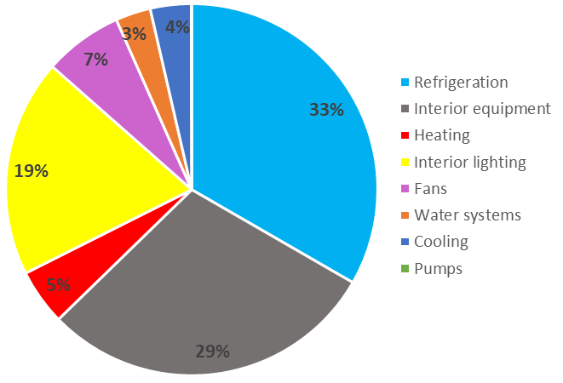
Figure 2: Energy consumption and TEWI for the validated French store
  - The Paris store with open fronted cabinets, gas heating and R404A/R448A refrigerants
If the Paris store was modelled with open fronted cabinets, gas heating and either R404A or R448A as the refrigerant, the energy consumed would be 775,875 kWh/year (Paris weather file). The TEWI of the store would be 142.3 t CO_{2e}/year if R404A was applied and 96.6 t CO_{2e}/year if a more realistic drop in refrigerant, R448A, was applied (Figure 3).
Annual consumption (kWh/yr)  Heating 152,472  Cooling 233  Interior lighting 103,525  Interior equipment 160,603  Fans 57,033  Pumps 197  Water systems 16,686  Refrigeration 253,789  Total annual energy 744,536  575,378 kWh (77% electrical) 169158 kWh (23% NG)  TEWI (R448A) 96.6 t CO_{2e}/year  57.7 t CO_{2e} electrical 38.9 t CO_{2e} combustion | 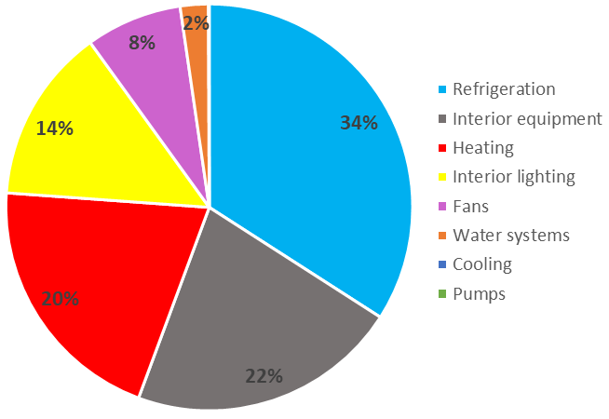
Figure 3: Energy consumption and TEWI for the French store with gas heating
  - The Paris store with electrical heating
Electrical heating had a greater impact on the TEWI, reducing it from 96.6 CO_{2e}/year to 67.4 CO_{2e}/year (a reduction of 30% due to the differences between the gas and electricity conversion factors and the efficiency of the gas boiler). Electrical heating in Paris was particularly beneficial due to the low French grid carbon conversion factor.
  - The Paris store when R744 was applied
If a R744 booster system was applied to the simulated UK store (in addition to electrical heating), this had an impact on the refrigeration energy and TEWI (Table 5). Overall energy consumption for the R744 booster system was less than that for the R404A system. This was due to the R744 system having a lower condensing temperature (resulting in a higher COP), plus the fact that the system only operated in transcritical mode for a small percentage of the year.
Applying a R744 booster system reduced the refrigeration energy consumptions by 4.5%. Mitsopoulos et al. (2019) stated that the energy consumption of R744 is equivalent to that of R404A systems. In other work by Gullo et al. (2017) where they compared the performance of R744 in Oslo, London, Frankfurt, Milan, and Athens, they found that the R744 system reduced energy consumption in all locations except Athens. Annual energy savings of 11% were found when switching from R404A to R744 booster system in London. As London and Paris have relatively similar weather (mean annual temperature of 11.7°C in Paris and in 10.8°C in London), the model correlation appears acceptable.
The greatest impact of changing to a R744 booster system was the 38% reduction in TEWI. The results show the necessity of switching to a natural fluid such as R744 for environmental sustainability.
Table 5. Impact of applying a R744 booster system
 | R448A | R744
Refrigeration | 253,589 kW/year | 242,208 kWh/year
Total annual energy | 744,536 kWh/year | 732,956 kWh/year
TEWI | 67.4 t CO_{2e}/year | 41.8 t CO_{2e}/year
  - The Paris store with doors on the chilled cabinets
If doors were then added (in additions to electrical heating and R744), the total energy consumption was predicted to be 546,594 kWh/year (a further reduction in energy of 25%) as presented in the validation section (3.1). The impact of adding doors was to reduce the cooling load of the chilled display cabinets. This increased the net cooling demand of the store HVAC in summer and decreased the net heating demand in winter. The shortfall in cooling in the summer meant that the store air conditioning needed to operate (it was not needed previously when the chilled cabinets were open fronted). It was also noted that the HVAC fan consumption decreased by 34% when adding doors. This could be attributed to the fact that heating was reduced from 152,472 to 26,633 kWh/yr.
Refrigeration energy was reduced from 242,208 to 182,161 kWh/year (a reduction of 25%). This percentage was compared to reported savings of 18-51% when adding doors stated by Foster et al. (2018b). The simulated values therefore fall within this range. A 26% CO_{2e} emission savings were achieved when adding doors which show the necessity of applying this technology (in addition to the application of natural refrigerants) for energy and environmental purposes.
  - Future decarbonisation of stores
The impact of climate change and changes to the grid conversion factor in France were assessed. An assumption was made that the design of the current store in Paris would not change to determine the levels of carbon emissions savings that would occur through changes that are already predicted.
    - Impact of climate change
The impact of climate change alone for 2020 and 2050 is shown in Figure 4. The simulation showed that heating was reduced by 22%, and HVAC cooling and refrigeration increased by 25% and 1.6%, respectively. However, the total energy consumption increased by only 0.3%.
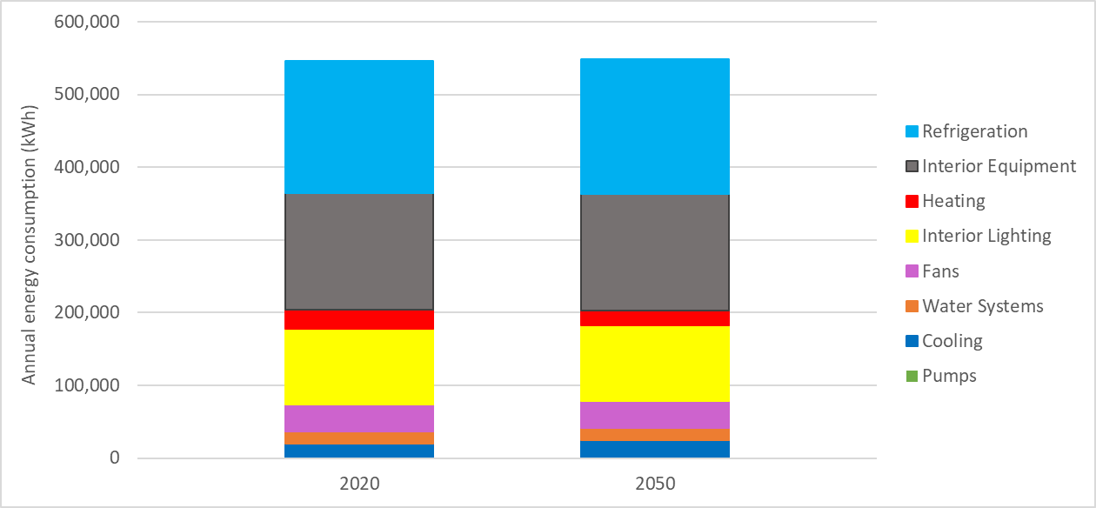
Figure 4. Energy use in the Paris supermarket in 2020 and 2050
    - Impact of changes to electrical grid conversion factor
Climate change had little impact on the total energy consumption of the supermarket in Paris. Therefore, changes to the electrical grid carbon conversion factors from France were applied from 2020 to 2050 from Aurora (2021) (Table 6).
Table 6. Predicted electrical carbon factors and corresponding TEWI
 | 2020 | 2025 | 2030 | 2035 | 2040 | 2045 | 2050
$β$ (kg CO₂/kWh) | 0.057 | 0.045 | 0.034 | 0.037 | 0.040 | 0.032 | 0.023
France has a low electrical carbon factor because a large proportion of nuclear power is used to generate electricity. However, between 2030 and 2040, there is a small increase in the predicted factors. This could be explained by the use of fossil fuels during the transitions from nuclear to renewables. Based on these conversion factors the predicted CO_{2e} emissions for the store reduce from 31.3 t CO_{2e}/year in 2020 to 12.7 t CO_{2e}/year in 2050 (a reduction of 60%) (Figure 5). There are ambitions to reach net zero carbon emissions by 2050, this result demonstrates that carbon storage will be required to off-set the emissions produced.

Figure 5. Predicted CO_{2e} emissions in a Paris supermarket from 2020 to 2050
- CONCLUSION
The main objective of this work was to develop a methodology to model the total energy consumption of a supermarket with reasonable accuracy. Using OpenStudio and EnergyPlus, good agreement was found between the calibrated and validated stores.
The influence of changing from gas to electrical heating, moving to a R744 booster refrigeration system, and adding doors to chilled cabinets were assessed. Moving to electrical heating in Paris reduced CO_{2e} emitted by 30%. Moreover, 38% of CO_{2e} emitted savings were achieved when switching to R744. Adding doors to the cabinets had a major impact on energy consumption reducing it by 26%. The model demonstrated the interactions between the refrigeration system and HVAC in the supermarkets. By adding doors to cabinets, the heating required in the store was reduced, but this also resulted in the needs for air conditioning in the summer months. By better balancing the cooling and heating demands, it might be possible to remove the need for space cooling in the summer.
Even though the electrical grid carbon conversion factor will decrease by 60% in France between 2020 and 2050, this is insufficient alone to reduce emissions to zero or close to zero. Therefore, additional technologies (in addition to the ones investigated: electrical heating, R744 and doors) will need to be applied to achieve absolute or close carbon neutrality. Further work is ongoing to investigate a range of additional technologies and their impact when applied to supermarkets across Europe.
ACKNOWLEDGEMENTS
The work within this paper received funding from the European Union’s Horizon 2020 research and innovation programme under grant agreement No 101036588.
NOMENCLATURE
AC  AHU  ANL  ASHRAE  COP  CO₂  DX  EU  GHG  GWP  HVAC  INRAE  IOR  IPCC  LBNL  LSBU  LT  MT  NG  NREL  ORNL  PNNL  PTAC  RCP  SBEM  T  TEWI  UK | Air conditioning  Air handler unit  Argonne National Laboratory  American Society of Heating, Refrigeration and Airconditioning Engineers  Coefficient of performance  Carbon dioxide  Direct expansion  European Union  Greenhouse gas  Global warming potential  Heating, ventilation and air conditioning  Institut National de Recherche Pour l’Agriculture, l’Alimentation et l’Environnement  Institute of refrigeration  Intergovernmental panel on climate change  Lawrence Berkeley National Laboratory  London South Bank University  Low temperature  Medium temperature  Natural gas  National Renewable Energy Laboratory  Oak Ridge National Laboratory  Pacific Northwest National Laboratory  Packaged terminal air conditioner  Representative concentration pathway  Simplified building energy model  Temperature  Total equivalent warming impact  United Kingdom
REFERENCES
Arias J., (2005). Energy Usage in Supermarkets - Modelling and Field Measurements. Division of Applied Thermodynamics and Refrigeration, Department of Energy Technology, Trita REFR Report No. 05/45. ISSN 1102-0245. ISRN KTH/REFR/05/45-SE. ISBN 91-7178-075-0.
Aurora Energy Research LTD, (2021). The role of cloud computing and data centres in achieving power sector emissions reductions in Europe. Digital Transformation and a Net Zero Emissions Europe. Ref: DIRV1-0216.
Crippa, M., Solazzo, E., Guizzardi, D. et al. (2021). Food systems are responsible for a third of global anthropogenic GHG emissions. Nature Food.
Foster, A., J. Evans, and G. Maidment, (2018a). "Benchmarking of supermarket energy consumption." 5th International Institute of Refrigeration Conference on Sustainability and the Cold Chain. IIR, 2018.
Foster A., Hammond E., Brown T., Maidment G., and Evans J., (2018b). IIR - Technological options for retail refrigeration. Paris International Institute of Refrigeration/ London South Bank University; Road Map Technologies report, 26 January 2018.
Gullo P., Tsamos K., Hafner A., Ge Y., Tassou S., (2017). State-of-the-art technologies for transcritical R744 refrigeration systems – a theoretical assessment of energy advantages for European food retail industry. Energy Procedia 123 (2017) 46-53.
Hill F., (2015). Modelling heat transfers in a supermarket for improved understanding of optimization potential. School of Mechanical, Aerospace and Civil Engineering.
IPCC AR4 (2007). https://www.ipcc.ch/assessment-report/ar4/. Accessed 16.11.22.
Mitsopoulos G., Evangelos S., Dimitrios T., Evangelos B., Christos T., and Stavros A., (2019). ‘Annual Performance of a Supermarket Refrigeration System Using Different Configurations with CO2 Refrigerant’. Energy Conversion and Management: X 1 (January): 100006. https://doi.org/10.1016/j.ecmx.2019.100006.
Poore, J., and Nemecek, T. (2018). Reducing food’s environmental impacts through producers and consumers. Science, 360(6392), 987-992.
UK Government. GHG conversion factors (2016). https://www.google.com/url?sa=t&rct=j&q=&esrc=s&source=web&cd=&cad=rja&uact=8&ved=2ahUKEwio3OjdtJL9AhUTi1wKHaanAZgQFnoECAoQAQ&url=https%3A%2F%2Fassets.publishing.service.gov.uk%2Fgovernment%2Fuploads%2Fsystem%2Fuploads%2Fattachment_data%2Ffile%2F526957%2Fghg-conversion-factors-2016update_MASTER__links_removed__DECC_Standard_Set.xls&usg=AOvVaw3MRUZeznMQ6CD8nUN-BWt0. Accessed 13.02.23.
Widell K., (2021). ENOUGH – a new project that will identify how food industry can become net zero by 2050. New EU Research and Innovation Project ENOUGH: A European Food Chain Supply to Reduce GHG Emissions by 2030 and achieve carbon neutrality by 2050.

The impact of changes to the condenser fan power was tested in the model and found to have minimal impact.
CO2 Product Guide 2021 for Refrigeration. Emerson. Applications co2-product-guide-2021-for-refrigeration-applications-en-gb-4217772.pdf (emerson.com)
For estimating the latent air infiltration load, the model requires that the user provide the latent heat ratio (LHR) for the refrigerated cases at rated conditions. It typically ranges from 0.1 to 0.3 depending on case configuration (e.g., multi-deck open case versus glass door reach-in) and case operating temperature.
Sharma, V., Fricke, B., & Bansal, P. (2014). Comparative analysis of various CO2 configurations in supermarket refrigeration systems. International journal of Refrigeration, 46, 86-99.

