The effect of heat conduction through fins on the performance of finned-tube CO₂ supercritical gas coolers

X. Zhang, Y.T. Ge*

School of the Built Environment and Architecture
London South Bank University, 103 Borough Road, London, SE1 0AA, UK

ABSTRACT

Air cooled CO₂ finned-tube gas coolers are widely used in CO₂ transcritical refrigeration systems due to simplified structural designs. However, the longitudinal heat conduction along fins can lead to inverse heat transfer between adjacent tubes and thus capacity degradation of the heat exchanger. To cope with this adverse effect, the heat exchanger design with split fins between tube rows can be applied although further verification and analysis are expected. Subsequently, as explained in this paper, detailed CFD models have been purposely developed and simulated for the CO₂ gas coolers with both continuous and split fins to quantify the effect of the heat conduction through fins. At various operating conditions of both air and refrigerant sides, totally 36 cases were simulated to study the influence of air inlet velocity, air inlet temperature, CO₂ pressure and CO₂ mass flow rate as well as the heat conduction along fins on the performance of the finned-tube gas coolers with and without split fins. The simulation results show that the approach temperature can be reduced by 0.6 - 7.5K for the heat exchanger with split fins and a specific tube circuitry arrangement. Subsequently, the maximum and average heating capacities can be increased up to 22% and 10% respectively when the finned-tube CO₂ gas cooler with split fins is applied. Furthermore, the simulation results show that the application of split fins should be designed and implemented appropriately based on different designs of tube circuitry arrangement in the heat exchanger.

Keywords: CO₂ finned-tube gas coolers, split fins and continuous fins, heat conduction along fins, Computational Fluid Dynamics (CFD), CO₂ transcritical cycles

* Corresponding author.
E-mail address: yunting.ge@lsbu.ac.uk (Y.T. Ge)

Nomenclature

A area [m²] Greek symbols
C_{p} specific heat at constant pressure [J/kg.K] α heat transfer coefficient [W/(m.K)]
d tube inner diameter [m] ∆ difference
f fanning friction factor 𝛒 density [kg/m³]
$f_{p}$ fin Pitch [m] 𝛏 friction coefficient
h enthalpy [J/kg] 𝛍. dynamic viscosity [Pa·s]
j Colburn factor Subscripts
k thermal conductivity [W/(m.K)] a air
L flow length [m] i inner, ith grid
$\dot{m}$ mass flow rate [kg/s] in inlet
Nu Nusselt number o outer
P pressure [Pa] out outlet
Pr Prandtl number r refrigerant
Q heat transfer [W] revout refrigerant at evaporator outlet
Re Reynolds number revin refrigerant at evaporator inlet
T temperature [K] rcpout refrigerant at compressor outlet
u, v, w velocity components [m/s] rcpin refrigerant at compressor outlet
x, y, z direction coordinates [m]

Introduction

As important components, finned-tube heat exchangers are widely used in industry processes and energy conversion systems such as heating, ventilation, air conditioning and refrigeration due to their high compactness and low costs. With respect to a traditional finned-tube heat exchanger, it has continuous fins and one or more tube rows, in which air or gas fluid flows through the fins while liquid or gas working fluid is flowing inside the tubes. The larger heat transfer surface area of the fins can reduce the thermal resistance of fin side and lead to higher overall heat transfer coefficient of the heat exchanger. The heat exchanger compact structure can also contribute to less volume and lower weight. The working fluids applied in the finned-tube heat exchangers can be different for various applications.
Since the working fluid leakage from the heat exchanger is unavoidable, it is imperative to select an appropriate working fluid to minimise its direct environmental impact because of the leakage. As a natural working fluid with zero Ozone Depletion Potential (ODP) and negligible Global Warming Potential (GWP), CO₂ has attracted more and more attentions and has been widely used in transcrtical refrigeration systems in which CO₂ finned-tube gas coolers are the main components. In addition, CO₂ has superb thermal-physical properties including high specific heat, high thermal conductivity and low viscosity, which could potentially enhance the heat transfer of CO₂ fluid flow in the CO₂ gas cooler. Even so, the high performance of the CO₂ gas cooler and its associate system is also dependent on the operating condition on the airflow side and the heat exchanger designs. As one of the important performance parameters, the refrigerant exit temperature of a CO₂ gas cooler has significant impact on the operational efficiency of the refrigeration cycle. At a specific operating condition for a CO₂ transcritical refrigeration cycle, the lower gas cooler CO₂ exit temperature implies the higher heating effect, higher cooling effect and higher COP in the cycle. The temperature difference between the refrigerant exit temperature and incoming air flow temperature is called approach temperature. In that case, the approach temperature should be minimised to ensure a high cycle efficiency. On the other hand, at a fixed operating condition and approach temperature, the gas cooler CO₂ pressure can be optimised to maximise the cycle COP.
Apart from the operating conditions, the heat exchanger designs can also affect the approach temperature or refrigerant exit temperature and thus the heat exchanger and system performance. For a CO₂ finned-tube gas cooler, due to particular thermophysical properties of CO₂ and its single-phase flow, the CO₂ refrigerant undergoes abrupt temperature drop at the beginning along the CO₂ tube flow path [1]. The large CO₂ temperature gradient can lead to inverse heat transfer between two neighbour tube rows through heat conduction of fins and cause higher refrigerant exit temperature or approach temperature and thus deteriorate system efficiency [2]. Similar conclusions were obtained by Ciofalo [3] and Romero-Méndez [4] that the induced heat conduction through fins could degrade the heat exchanger performance. Therefore, it is essential to investigate experimentally and theoretically for the heat exchanger optimal designs so as to minimise the negative effect of the heat conduction through fins.
An experimental investigation was carried out to examine the effect of heat conduction through fins for a microchannel serpentine gas cooler of a transcritical CO₂ air-conditioning system [5]. Some sections of fins where the heat conduction was most significant were cut to evaluate and compare the performance of the gas coolers with and without cutting fins. As results, the gas cooler heating capacity was improved up to 3.9 % while the approach temperature was reduced by 0.9 to 1.5K when the cutting or split fins were applied. Correspondingly, the system COP could be improved 5% if the effect of heat conduction through fins could be minimised. Zilio et al. [6] conducted an experimental investigation on finned-tube CO₂ gas coolers with and without split fins and different tube circuitry arrangements. It was found that for the same gas cooler, the heating capacity and system COP could be increased 3.7% to 5.6% and 5.7% to 6.6% respectively when the split fins were applied. It also indicated that the different tube circuitry arrangements in the coil could affect the effect of split fins on the coil performance although further quantitative analysis is expected. The negative effect of reversed heat conduction could also cause some capacity degradations to other types of heat exchangers such as printed circuit heat exchangers [7] and finned-tube evaporators [8, 9]. Based on the experimental results, the higher longitudinal heat conduction through fins due to the larger superheat at the evaporator exit could degrade more cooling capacity than the coil without split fins [9]. In other words, if the refrigerant superheat at the evaporator outlet is small, the effect of the longitudinal heat conduction would be insignificant. In addition, the degree of capacity degradation could also be affected by the air-side flow rate.
Alternatively, the effect of heat conduction through fins on the performance degradations could also be predicted by corresponding in-house modelling development and simulation for various types of heat exchangers including crossflow [10], periodic-flow [11], plate-fin and tube-fin [12,13], perforated plate matrix [14], and finned-tube [15]. The research outcomes from these modelling analyses showed that the negative effect of the longitudinal heat conduction should be taken into account for the optimal designs and operations of the heat exchangers. It was also shown that the longer the fin cut was the more improvement for the coil heating capacity although further validation is expected. On the other hand, compared to in-house models,
Computational Fluid Dynamics (CFD) is believed to be a more efficient and accurate simulation method to evaluate, compare and optimize heat exchangers with various designs. It is thus a preferable modelling method to predict and analyse the effect of the longitudinal heat conduction on the performance of heat exchangers with different types. Correspondingly, the quantitative assessment strategy for the effect of heat conduction on the performance of a cross-corrugated heat exchanger at different geometry parameters was applied by Doo et al. [16]. To facilitate the analysis, the respective CFD model was developed to evaluate the performance of the heat exchangers with different designs in which a theoretical method of ‘network-of-resistance’ was applied to calculate the heat conduction. Some design options such as various plate thickness and corrugation geometry were considered in the calculation of heat conduction.
Another CFD simulation model on a cross-wavy heat exchanger was developed by Ma et al. [17] to predict the effect of heat conduction. It was found that the higher inlet temperature and higher Reynolds number of the working fluids could lead to extensive effect of heat conduction on the heat exchanger performance.
It can be revealed from above literature reviews that the heat conduction along fins can degrade the heat exchanger capacity at different levels depending on the extents of the heat conduction. A heat exchanger with split fins is an efficient and applicable way to reduce the negative effect of heat conduction on the heat exchanger capacity. This has been verified experimentally and theoretically by a number of investigators. The experimental investigation in this area is limited due to the limitation of the test circumstances such that it is difficult to obtain extensive results from the experiment only. The theoretical analysis with an in-house model is a handy method for this research purpose but its accuracy needs to be validated and it is hard to produce detailed simulation results in terms of temperature and pressure profiles etc. A CFD modelling is an efficient and accurate way for the heat exchanger performance evaluation with different designs but needs to cope with the disadvantage of high computation time if the heat exchanger structure is quite complicated. Although there are limited CFD modelling development and analysis on the heat conduction effects, from the authors’ acknowledges, there are very few investigations with CFD modelling on the finned-tube CO₂ gas coolers with and without split fins. The optimal design of split fins and their effect on the heat exchanger performance need to be further investigated and clarified.
Subsequently, a CFD model with novel technique has been developed and explained in this paper for the finned-tube CO₂ gas cooler with or without split fins. To save computation time and maintain reasonable accuracy, the CFD model is developed with an integration of both 1D and 3D models. The 1D model is developed to predict the refrigerant side heat transfer process while the 3D model is built to calculate the external airside heat transfer process. The effects of heat conduction through fins on the performance of the CO₂ gas coolers with and without split fins are therefore analysed by the developed CFD model. The reversed heat conduction along fins will degrade the heat exchanger capacity , effectiveness and also the operational efficiency of its associated refrigeration system, which are also predicted by the model. In addition, the model can be used to quantify the effect of the split fins on the heat conduction and heat exchanger performance at various tube circuitry arrangements. The research outcomes from this paper can contribute significantly the CFD modelling technique on finned-tube CO₂ gas coolers with and with split fins as well as detailed simulation results of the effect of the heat conduction through fins on the heat exchanger and system performance. This provides essential strategies for the optimal design of finned-tube CO₂ gas coolers.

Numerical study

Geometry descriptions

In this study, as shown in Figure 1(a), the finned-tube CO₂ gas cooler in staggered arrangement under consideration consists of 3 depth tube rows along the airflow or longitudinal direction and each row has 18 tubes in the transverse direction. The air flows from bottom to top passing passages between fins and outer tubes while the CO₂ refrigerant flows through inner tubes numbered from 0 (inlet) to 53 (outlet) forming cross-counter flow arrangement with the airflow. The specifications of the gas cooler to be modelled are listed in Table 1. Conventionally, to simplify the installation process of the heat exchanger, a number of continuous fins are applied, as shown in Figure 1(a). In that case, significant heat could be transferred or conducted through the longitudinal fins between two adjacent tube rows. Based on the literature reviews, to enhance the heat exchanger performance, the continuous fins should be replaced with or cut into the split fins between two adjacent tube rows with the larger temperature differences. Correspondingly, in this paper, as shown in Figure 1 (b), the continuous fins are split between the first and the second adjacent tube rows of the heat exchanger. To clarify, the CO₂ gas coolers with continuous fins and split fins are named as Gas cooler A and Gas cooler B respectively. The CO₂ gas coolers with the same tube circuitry arrangement but different fin designs are therefore modelled, evaluated and analysed.

Governing equations and assumptions

To predict the CO₂ gas cooler performance at different designs and operating conditions and with acceptable accuracy and computing time, the gas cooler CFD model was developed based on the following assumptions:
- The gas cooler operates under steady state condition.
- Assuming symmetry condition across the middle plane between two consecutive fins, therefore, air flow hydraulic behaviours between each passage of any two consecutive fins in the heat exchanger are assumed the same.
- The refrigerant temperature and its other parameters and thermophysical properties remain unchanged when it flows within a short segment defined by the model.
- Since there is not much air flow passing through the elbow tubes of the heat exchanger, the elbow tubes are assumed as thermally insulated. Therefore, there is no temperature change for the CO₂ fluid flowing through each elbow tube.

The three-dimensional (3D) CFD model for the CO₂ finned-tube gas cooler has been developed and numerically solved in ANSYS Fluent 18.2. Based on the fin pitch (1.5 mm) and airside operating parameter ranges of temperature from 302.55 to 308.15 K, density from 1.167 to 1.146 kg/m³ and dynamic viscosity from 1.866×10⁻⁵ to 1.893×10⁻⁵ Pa·s, the airflow Reynolds numbers are calculated in the range of 94.1–282.3. Therefore, the air flows in this study are considered within the laminar region. As listed below, the governing conservation equations including mass, momentum and energy are applied in the 3D CFD model to capture the detailed thermal-hydraulic performance of the air flows.
Conservation of mass:
$\frac{∂u}{∂x}+\frac{∂v}{∂y}+\frac{∂w}{∂z}=0$ (1)
Conservation of momentum:
$ρ\left(u\frac{∂u}{∂x}+v\frac{∂u}{∂y}+w\frac{∂u}{∂z}\right)=-\frac{∂P}{∂x}+μ(\frac{∂^{2}u}{{∂x}^{2}}+\frac{∂^{2}u}{{∂y}^{2}}+\frac{∂^{2}u}{{∂z}^{2}})$ (2)
$ρ\left(u\frac{∂v}{∂x}+v\frac{∂v}{∂y}+w\frac{∂v}{∂z}\right)=-\frac{∂P}{∂y}+μ(\frac{∂^{2}v}{{∂x}^{2}}+\frac{∂^{2}v}{{∂y}^{2}}+\frac{∂^{2}v}{{∂z}^{2}})$ (3)
$ρ\left(u\frac{∂w}{∂x}+v\frac{∂w}{∂y}+w\frac{∂w}{∂z}\right)=-\frac{∂P}{∂z}+μ(\frac{∂^{2}w}{{∂x}^{2}}+\frac{∂^{2}w}{{∂y}^{2}}+\frac{∂^{2}w}{{∂z}^{2}})$ (4)
Conservation of energy:
$ρC_{p}\left(u\frac{∂T}{∂x}+v\frac{∂T}{∂y}+w\frac{∂T}{∂z}\right)=\frac{∂}{∂x}\left(k\frac{∂T}{∂x}\right)+\frac{∂}{∂y}\left(k\frac{∂T}{∂y}\right)+\frac{∂}{∂z}\left(k\frac{∂T}{∂z}\right)$ (5)
It should be noted that, as a function of pressure and temperature , each thermophysical property of air in equations 1-5 is calculated and correlated with the NIST properties software REFPROP 8.0. The correlations are therefore converted as User Define Functions (UDFs) and input into the CFD Fluent model development and simulation. A UDF is a C language programme that can be linked into Fluent to customize material properties, boundary conditions and user-supplied model equations and adjust computed values once at each iteration.

CFD modelling descriptions

In this study, the numerical analyses are carried out to investigate fluid heat transfers, pressure drops, temperature variations and heat conduction effects of the finned-tube CO₂ gas coolers. Due to the large amount of fins installed in the heat exchanger, it is not appropriate to build a detailed CFD model with entire fins, which would otherwise requires extremely long computation time. To cope with this issue, the overall heat exchanger CFD model is divided into two phase sub-models, namely, Phase I and Phase II models. The heat transfer of the airflow passing through the gas cooler is a combination of two parts including convection heat transfer along the fin surfaces and convection heat transfer through tube external walls. These two part heat transfers can be easily described in Phase I model with representatively one fin passage due to the symmetrical characters of fins along the tubes. Correspondingly, for the Phase I model, one coil element is purposely selected which is comprised of two neighbour fins and tube sections and air domain between them, as highlighted in green colour in Figure 1(a). Based on such a simplification, airside heat transfer coefficients and pressure drops can be calculated at different operating conditions once the boundary parameters are determined. According to the geometric symmetry and same air flow pattern characteristics in each coil element, the entire heat exchanger is simplified as 10 coil elements to reduce computation time. In such a case, the Phase Ⅱ model contains 10 fins without fluid domains to predict the performance of the whole gas cooler. The airside heat transfer coefficients of each grid achieved from Phase I model are assigned to the surface of fins and tubes of Phase Ⅱ model and used as boundary conditions. In these two developed models, C language subroutines are written by Visual Studio 2017 and imported into Ansys Fluent 18.2 by User Define Function (UDF) to calculate the thermal-hydraulic performance of CO₂ refrigerant flow. The UDF is then linked with Fluent to achieve the matching and assignment of the heat transfer coefficient in each grid with the Phase II model. For each pipe, energy conversation equation needs to be applied and solved. The tube inner walls apply localised correlations of heat transfer coefficient and hydraulic calculations to predict the temperature, pressure and heat flux of refrigerant along the gas cooler. Tube inner walls are divided into several segments along its flow direction. The CO₂ inlet temperature of each segment is determined by heat transfer rate of upstream fluid. The heat flux in each segment is determined by the following energy balance equation $Q_{r}=\dot{m}c_{p}\left(T_{r,i}-T_{r,i+1}\right)={}_{r,i}A_{i}(T_{r,i}-T_{wall})$, where the energy enters into next segment equals to the energy leaving last segment after transferring heat to air and surrounding fins. Hence, the CO₂ temperature profile can be computed.
More importantly, since this study aims to investigate the effect of heat conduction through fins and to reduce its negative impact, the gas cooler with split fins needs to be modelled. To achieve this, the material thermal conductivity value of meshed fins along the split line (‘CD’ in Figure 1(a)) is set to approaching zero, avoiding the heat to be transferred from hotter tubes to colder tubes across fin surfaces. Therefore, the gas cooler with either continuous fins or split fins can be simulated by using the same CFD models but different specifications on the split lines. Consequently, with this simplified and new modelling approach, the performance of gas cooler with split fins and continuous fins can be both predicted at various operating conditions. These include the air inlet temperature ranging from 29.4 to 35 ˚C, airflow inlet velocity varying from 1 to 3 m/s, refrigerant pressure changing from 9 to 11 MPa and refrigerant mass flow rate ranging from 0.038 to 0.076 kg/s.
Airside heat transfer coefficient is a major parameter to be determined by this CFD model. It is determined by the heat flux and temperature difference between tube outer surface and airflow. Considering that the air temperatures around various tube rows are different as air flowing through fins, it is not accurate to use one air average temperature to calculate the heat transfer coefficient. To abstain more accurate airside heat transfer coefficient $h_{air}$, air temperature is calculated differently at each of those three sections 1,2 and 3 as shown in Figure 1(a). The first section is from the airflow exit to the middle plane between the first and the second tube rows. The second section is from the end of section 1 to the middle plane between the second and the third tube rows. The third section is from the end of section 2 to the airflow inlet. Correspondingly, the three-section air average temperatures are named as ${ T}_{1,air}$ ,${ T}_{2,air}$ and ${ T}_{3,air}$ respectively. Therefore, the air side heat transfer coefficient of each grid can be calculated as:
$α_{a,i}=\frac{Q_{a,i}}{A_{i}(T_{wall,i}-T_{a,average})}$ (6)
The Colburn j-factor is expressed as:
$j= \frac{Nu}{{RePr}^{1/3}}$ (7)
The fanning f-friction factor is defined as the ratio of sheer stress and flow kinetic energy density, relating to the pressure drop of airflow through the coil:
$f= \frac{∆Pf_{p}}{2{ρu}^{2}L}$ (8)
The calculation of refrigerant side heat transfer coefficient is crucial to determine the overall performance of the gas cooler. In this CFD model, Gnielinski’s correlation is used to calculate the CO₂ heat transfer coefficient [18]:
$Nu=\frac{ξ/8(Re-1000)Pr}{12.7\sqrt{\frac{ξ}{8}}\left({Pr}^{\frac{2}{3}}-1\right)+1.07}$ (9)
where Filonenko’s correlation is used to calculate the friction coefficient [18]:
$ξ={(0.79\ln\left(Re\right)-1.64)}^{-2}$ (10)
While Reynolds number ($Re$), Nusselt number (Nu) and Prandtl number ($Pr$) are expressed respectively in Eqs. (11), (12) and (13).
$Re= \frac{ρud}{μ}$ (11)
$Pr= \frac{μc_{p}}{k}$ (12)
$Nu= \frac{α_{r}k}{d}$ (13)
For fully developed CO₂ single-phase turbulent flow in tubes, Gnielinski’s correlation has been widely used for heat transfer calculations. It can approximately predict 90% of the 800 experimental results with deviation less than 20% over a range of 3000 ≤ Re ≤ 5×10⁶, 0.5 ≤ Pr ≤ 2000 and L/d ≥ 10 [19]. The operating parameters in this study are within these ranges. It is noted that the accuracy of Gnielinski’s correlation for the calculation of CO₂ heat transfer coefficient during its supercritical tube-side heat rejection process has been verified by other researchers. As an example, from the research results by Pettersen et al. [20], the mean deviation between experiment results and the corresponding calculations with Gnielinski’s correlation were 8%for 0.787 mm ID micro-tubes, showing fairly good agreement. However, Gnielinski’s correlation could underpredict the heat transfer coefficient of supercritical CO₂ cooling processes in macro-tubes compared to experimental data, especially near pseudocritical region where thermophysical properties change rapidly. Dang and Hihara [21] conducted a comparison of CO₂ heat transfer coefficient between Gnielinski’s correlation and experimental results for a 6 mm ID tube with pressure of 8 MPa, demonstrating that Gnielinski’s model underpredicted the data by 30%. According to Olson’s [22] report, Gnielinski’s correlation underpredicted the data of supercritical CO₂ by 11% - 47% for a 10.9 mm ID tube with pressure varied from 7.4 to 13 MPa. From the research carried out by Oh and Son [23], it is known that the mean deviation of CO₂ heat transfer coefficient between Gnielinski’s correalation and experimental data for a 7.75 mm ID tube with pressure of 7.5 – 10 MPa was 36.2%. Nevertheless, Rossetti [24] proposed a CFD modelling of CO₂ gas cooler with 8.22 mm ID diameter tubes and pressure of 8-9.1 MPa, in which Gnielinski’s correlation was used. The results showed that the predicted CO₂ exit temperature and heating capacity agreed fairly well with experimental data. In addition, according to the CFD simulation results by Sánchez et al. [25], the uncertainty of CO₂ exit temperature was less than ±3˚C while Gnielinski’s correlation was applied. The above-mentioned results indicate the feasibility of using Gnielinski’s correlation in supercritical CO₂ cooling processes even though larger discrepancies could be caused in the region close to the critical point. On the other hand, since the total thermal resistance of the CO₂ gas cooler is normally dominated by that of air side, the discrepancy of CO₂ side heat transfer coefficient calculation will not significantly affect the overall heat transfer performance of the CO₂ gas cooler. Further, since the investigated CO₂ pressures in this paper are above 9 MPa which are somewhat above the critical point, the application of Gnielinski’s correlation for the heat transfer calculation is thus acceptable. Furthermore, the bulk average properties are used to calculate the heat transfer coefficient.
This CFD modelling development process can be divided into pre-processing, solver set up and post-processing. In the pre-processing part, the coil geometries are built in SolidWorks 2017 and meshed in Ansys ICEM CFD 18.2 with hexahedral type elements as shown in Figure 2. The specification of CFD model meshes is shown in Table 2. The meshed models are then loaded into Ansys Fluent 18.2 to perform the numerical simulations. Material properties, boundary conditions, solution methods and convergence criteria are set up in this software. The SIMPLE scheme is used to solve the coupling of pressure and velocity. All equations are solved by second order discretization scheme. Values of under-relaxation factors for pressure, density, momentum, energy are 0.3, 1, 0.7, 1 respectively. The convergence criteria of continuity, velocity and energy for Phase Ⅰ model are 10⁻¹⁰, 10⁻¹⁰ and 10⁻¹³ respectively. The predetermined convergence of energy for Phase Ⅱ model is 10⁻¹³. The solution is iterated until convergence is achieved. In the post-processing stage, data extractions and result visualizations can be achieved.

Mesh sensitivity test

Mesh sensitivity test has been carried out in this study to ensure the CFD simulation results are independent of the mesh element number. Table 3 indicates the predicted refrigerant outlet temperature against the number of mesh elements. For Phase I and Phase II models, three different numbers of hexahedral type meshes are tested respectively to achieve the optimized grid number under a specified operating condition. For grid number of 769,120 in Phase I model and 1,351,897 in Phase II model, refrigerant outlet temperatures have higher values and can be decreased by 5.6 K and 7.6 K each when grid numbers are increased to 993,168 and 1,745,710 respectively. Once the grid numbers of both models increase further to 1370572 and 3132924 each, the refrigerant outlet temperatures decrease by 0.2% and 0.3% respectively, which can be treated as nearly no changes. As a consequence, grid numbers of 1370572 and 3132924 are selected for models of Phase I and Phase II individually to ensure acceptable simulation accuracy and meanwhile maintain less computational cost.

Boundary conditions

The boundary conditions applied in this study are listed in Table 4. In Phase I model, at the upstream boundary condition, airflow parameters with uniform inlet velocity and temperature are specified. The airside outlet pressure is set as zero to obtain the relative pressure drop between airflow inlet and outlet. As to the tube inner wall, CO₂ refrigerant side heat transfer coefficient and temperature are assigned by using UDF. No slip condition is applied to the fin side walls. Once the Phase I model of gas cooler is solved, the airside heat transfer coefficient of each grid can be obtained and assigned to fin and tube external wall surfaces of Phase II model as the boundary conditions. Therefore, in Phase II model, heat transfer coefficients and temperatures of both airflow and CO₂ sides are applied as the boundary conditions.

Model validations

The numerical work of Ge and Copper [1] used correlations of Wang et al. [26] to determine the airside fanning f-friction and Colburn j-factor and obtained simulation results for CO₂ gas coolers with reasonably accuracy. The CFD numerical predictions of friction and Colburn factor in this study with varied airflow Reynolds numbers from 94.1to 282.3 have been compared with those calculated by Wang’s correlations at the same operating conditions and are plotted in Figure 3. As depicted, the deviations of these two factors between present work and those calculated by Wang’s correlations are all within 15%, which are reasonable and acceptable. Regarding to this specified finned-tube CO₂ gas cooler, Hwang [27] presented detailed experimental data. The specially designed experiment by Hwang [27] was set to explore the performance of the finned-tube gas cooler in transcritical refrigeration system at different operating conditions with various operating parameters including air inlet temperature, velocity, refrigerant mass flow rate and operating pressure. The experimental facilities included an airflow duct, two environmental chambers consisted of an evaporator, a finned-tube gas cooler, an expansion valve and a compressor. Thermocouples were put on the right places of gas cooler to measure and collect temperatures of refrigerant. In this study, the numerically predicted refrigerant temperature profiles of the finned-tube gas cooler with continuous fins are compared with the published experimental results from Hwang [27] under the same operating conditions. 36 simulation measurement and simulation cases are run and compared. Figure 4 depicts the comparisons between the simulation and experimental results for the CO₂ outlet temperatures. The discrepancies between the simulation results and those of measurements are all within +5K. Correspondingly, the percentage errors of calculated cooling COP will all be less than 10% when the evaporating temperature and compressor performance are fixed. Overall, the above comparison results show that the CFD simulation solutions have good agreement with empirical correlations and published experimental data. Hence, the developed CFD models can be applied to investigate the performance of the finned-tube gas cooler at various operating conditions and designs particularly with and without split fins.

Results and discussion

Temperature contours of continuous and split fin surfaces

From the CFD model simulation, the temperature contours of fin surfaces for the coil with continuous and split fins at different air inlet velocity but at the same air inlet temperature are demonstrated in Figure 5. The effects of the split fins on the heat conduction through fins are clearly illustrated by the temperature distributions on the fin surfaces. For the coil with continuous fins as presented in Figure 5(a) (b) (c), the fin surface temperatures change smoothly starting from the external wall surface of refrigerant inlet tube ‘0’ to the external wall surface of refrigerant outlet tube ‘53’, as shown in Figure 1. These also indicate that greater heat will be conducted between the first and second tube rows due to the significant temperature difference between these two tube rows. However, the fin surface temperature differences between the second and the third tube rows are relatively small indicating less heat conduction through the fins. On the other hand, the heat conductions through fins are lessened with higher airflow velocity. Even so, to reduce the effect of heat conduction through the fins, it is more efficient to split the fins between the first and the second tube rows as shown in Figure 1(b). Subsequently, as shown in Figure 5 (d), (e) and (f), the heat conductions through fins between the first and the second tube rows are totally prevented such that the average fin surface temperature in the first tube row is slightly higher than that of coil with continuous fins. Meanwhile, the fin surface average temperatures along the second and the third tube rows of the coil with split fins are much lower than those of coil with continuous fins. Therefore, at the same operating condition, the average fin surface temperatures of the coil with split fins are relatively lower than those of coil without split fins. To quantify these, the variations of row average fin surface temperatures at different airflow velocities for gas coolers with continuous and split fins are calculated and shown in Figure 6. As depicted, for the coil with continuous fins, the row average fin surface temperatures decrease smoothly from row 1 to row 3 due to the larger refrigerant temperatures from row 1 and continuous heat conductions through fins. The higher airflow velocity contributes to lower fin surface temperature due to the enhanced heat transfer between high temperature fin surface and low temperature air flow. For the coil with split fins, the row average fin surface temperatures are not smooth anymore such that there is a big temperature drop from the row 1 fin surface temperature to row 2 fin surface temperature when airflow velocity is fixed. The fin average surface temperature of row 3 is much less than that of row 1. Subsequently, the reduced heat conduction through the fins due to the application of split fins will potentially decrease the refrigerant temperature at the heat exchanger outlet.

Refrigerant temperature profiles for the coil with or without split fins

The CO₂ temperature profiles along the tube circuit for the coil with or without split fins at different operating conditions can be predicted by this CFD model and shown in Figure 7. The effects of heat conduction between adjacent tubes through fins on the CO₂ temperature profiles are clearly demonstrated particularly for the coil without split fins. From the simulation results, it is observed that the refrigerant temperature drops dramatically along the first tube row with tubes numbered from ‘0’ to ‘17’ for both gas coolers. This can be explained that the large temperature difference between CO₂ refrigerant and surrounding airflow along the first tube row leads to higher heat release from the refrigerant side to airflow side. However, for the gas cooler with continuous fins, the refrigerant temperature increases gradually from tube ‘27’ until tube ‘36’ due to the effect of longitudinal heat conduction through the fins. This can be explained that the reversed heat conduction through fins from high temperature tube row reheats CO₂ refrigerant to a higher temperature value before it is cooled down again by the low temperature airflow through the third tube row. This reversed heat conduction phenomenon is more prominent when the airflow velocity is at a lower value of 1 m/s. By contrast, for the coil with split fins, the longitudinal fin heat conduction between the first and second tube rows is avoided leading to a smoother refrigerant temperature decrease along the refrigerant flow path. The maximum temperature difference at tube ‘36’ between two gas coolers is up to 18.9 °C, which occurs under the operating condition of airflow inlet velocity at 1m/s. It should also be noted that the CO₂ temperatures for gas cooler B in the first tube row (‘0’ to ‘17’) are always higher than those corresponding values of gas cooler A. This is because that heat from the first-row fins of gas cooler B can only dissipate within the first row.
For the coil with or without split fins, the CO₂ exit temperature decreases with the increase of airflow inlet velocity, which indicates that the lower airflow velocity cannot offer higher heat transfer coefficient and therefore better thermal-hydraulic performance. The CO₂ exit temperature difference between split gas cooler and non-split gas cooler reaches the maximum value when the airflow inlet velocity is down to 1m/s. Under identical air inlet velocity of 1m/s and air inlet temperature conditions of 302.55K and 308.15K, the CO₂ exit temperatures can be reduced in average by 4.22K and 3.99K respectively by splitting fins. Another interesting observation from the simulation results is that at the same operating condition of airflow, the refrigerant temperature decreases more at higher refrigerant pressure. For a CO₂ transcritical refrigeration cycle, the CO₂ refrigerant pressure can be optimised so as to maximise the cooling COP [28]. On the contrary, the higher refrigerant mas flow rate leads to the less refrigerant exit temperature decrease when spilt fins are applied.
For all 36 simulated cases, the CO₂ exit temperature decrease is in a range of 0.6 to 7.5K when the split fins are applied to the gas cooler. Correspondingly, the approach temperature is also reduced at various extents for the coil with split fins due to the blocked heat conduction from the first tube row through fins. The simulation results demonstrate that the heat conduction through fin has important effect on the CO₂ temperature profile along the tube circuit while the gas cooler performance can be greatly improved with the design and implement of split fins.

Heating capacity , effectiveness and cooling COP for the coil with continuous and split fins

It is known that the lower refrigerant exit temperature can contribute to higher heating capacity of the gas cooler and thus better COP in its associated refrigeration system. The coil heating capacities at different operating conditions are therefore simulated for the gas cooler with and without split fins, as shown in Figure 8. As depicted, the higher airflow velocity and higher refrigerant mass flow rate lead to increased heating capacity for both gas coolers. In addition, at the same operating condition, as expected, the heating capacity of gas cooler with split fins is always higher than that of gas cooler without split fins particularly at lower air flow velocity. This is contributed by the reduced heat conduction through fins for the coil with split fins and subsequent decreased CO₂ exit temperature. Compared to Figure 8 (a) and (c), the higher airflow inlet temperature leads to lower coil heating capacity due to reduced temperature difference between refrigerant and airflow sides. Quantitively, for all circumstances, there are respectively 22% and 10% maximum and average increase rates of heating capacity for gas cooler B when split fins are applied. In addition, at lower air inlet velocity and temperature, the advantages of split finned-tube gas cooler become more obviously compared to those of non-split gas cooler.
The effectiveness of the finned-tube gas cooler can be calculated as the ratio of actual heating capacity to the maximum heating capacity at a fixed operating condition as expressed in Eqs. (14), (15) and (16). The better effectiveness can lead to the higher heat exchanger performance. To demonstrate this, the effectiveness is thus calculated for the heat exchanger with or without split fins and at different operating conditions , as listed in Tables 5 and 6. The simulation results show that effectiveness increases with higher incoming air flow rate. Importantly, there are various improvements for the effectiveness when the split fins are applied and the maximum improvement is 22.28%.
$ε= \frac{Q_{actual}}{Q_{max}}$ (14)
$Q_{actual}={\dot{m}}_{CO2}\left(h_{CO2,in}-h_{CO2,out}\right)={\dot{m}}_{air}\left(h_{air,out}-h_{air,in}\right)$ (15)
$Q_{max}=\min\left\{\begin{aligned}{\dot{m}}_{CO2}\left(h_{CO2,in}-h_{CO2,out}\right), T_{CO2,out}=T_{air,in} \\ {\dot{m}}_{air}\left(h_{air,out}-h_{air,in}\right), T_{air,out}=T_{CO2,in}\end{aligned}\right.$ (16)
The states of compressor inlet and outlet are the same as the evaporator outlet and gas cooler inlet respectively. In addition, the refrigerant enthalpy at the evaporator inlet is the same as that of gas cooler outlet. The system cooling COP can therefore be calculated as below:
$COP=\frac{h_{revout}-h_{revin}}{h_{rcpout}-h_{rcpin}}$ (17)
As depicted in Figure 9, similar effect can be found between the coil heating capacity and system cooling COP at different operating conditions of the gas cooler with or without split fins. The lower air inlet temperature and higher refrigerant mass flow rate can both benefit to
the system efficiency. Meanwhile, the cooling COP of the coil with split fins is always higher than that of coil without split fins at any operating condition.
On the other hand, if the system cooling capacity or cooling COP is kept constant, the gas cooler can be designed and manufactured smaller when split fins are applied.

Effect of split fins on the performance of coil with different circuitry arrangement

As demonstrated and explained from previous sections, the performance of the gas cooler and its associated system can be greatly improved if split fins are applied to the coil. This is mainly contributed to the significant reduction of heat conduction through fins from the first tube row to the second and the third tube rows due to the larger temperature difference. As seen from Figure 7, the average CO₂ temperature in the first tube row (tube numbers from ‘0’ to ‘17’) is much larger than that of the second tube row (tube numbers from ‘18’ to ‘35’). By contrast, the average CO₂ temperature in the third tube row (tube numbers from ‘36’ to ‘53’) is quite close to that of the second tube row. Subsequently, it is the most effective to split the fins between the first and the second tube rows, as shown in Figure 1. It can be imaged that if the average temperature difference between two adjacent tube rows is not significant, the application of split fins between them in the coil might not be effective and necessary. To verify this, in this paper, the tube circuitry arrangement of the coil shown in Figure 1 is modified and depicted in Figure 10 in which the refrigerant flows in turn between the first and the second tube rows before flowing into the third tube row.
With the developed CFD model, the refrigerant temperature profiles along refrigerant flow direction at different operating conditions for the gas coolers with and without split fins are predicted and shown in Figure 11. As depicted in Figure 11, at each specific operating condition, the average refrigerant temperatures between the first and the second tube rows are quite close. It is also observed that the refrigerant temperature changes wavily from inlet to tube number ‘21’ due to the refrigerant flows in turn between the first and the second tube rows and the different airflow temperatures around these two rows. Consequently, at each operating condition, the refrigerant temperature decreases smoothly in general along the tube circuit until it reaches close to the refrigerant exit for the coil with or without split fins. There are some degrees of refrigerant temperature increases from tube ’50’ to tube ‘53’ because of the heat conduction through the fins from high temperature tubes of ‘1’, ‘2’, ‘5’ and ‘6’ in the second tube row. It thus implies that the split fins between the second and the third row might be more effective for the tube circuitry arrangement shown in Figure 10.
The ineffective split fins between the first and the second tube rows for this tube circuitry arrangement can also be demonstrated for their effects on the coil heating capacity, as shown in Figure 12. As depicted, at a specific operating condition, the heating capacity is slightly increased when the split fins are applied as shown in Figure 10. In average, the heating capacity increase is only about 2% comparing to the 10% increase when the split fins are applied in the coil shown in Figure 1. The simulation results further verify that the split fins should be applied between two adjacent tube rows with the largest temperature difference so that the consequent heat conduction through fins can be prevented.

Conclusions

In order to investigate the effect of heat conduction through fins on the performance of a finned-tube CO₂ gas cooler and the cooling COP of its associated transcritical refrigeration system, a new 3D CFD model for the CO₂ gas cooler with continuous and split fins has been developed, validated and simulated at different operating conditions. The CFD model is a combination of two phases’ models which can accurately predict airside heat transfer coefficients and refrigerant temperature profiles for the CO₂ gas coolers at different operating conditions and at reasonable computation time. The simulation results show that the heat conduction through the fins does exist for the CO₂ gas cooler and it can affect negatively the heating capacity and system cooling COP. To cope with these negative impacts, an effective strategy is to apply split fins in the gas cooler design which has been verified and demonstrated by the developed CFD model. Ultimately, the following key points have been obtained from this study:
- Heat conduction through fin surfaces should not be neglected for the finned-tube CO₂ gas cooler due to large temperature difference between two adjacent tube rows. It is observed that heat is dissipated smoothly through the whole fin surfaces for the coil with continuous fins. On the contrary the heat dissipation is limited and restricted for the coil with split fins. Splitting fins is therefore necessary and an effective method to eliminate most of the heat conduction along fins.
- The refrigerant flow temperature profile from refrigerant inlet to outlet undergoes smooth decrease along the tube circuit for the coil with split fins. By contrast, for the coil with continuous fins, the refrigerant flow can be reheated in the middle way before it reaches the coil exit due to the negative effect of heat conduction through fins.
- The approach temperature decreases with the increase of air inlet velocity, refrigerant pressure and refrigerant mass flow rate for the gas cooler with or without split fins. However, at the same operating condition, further reduction of approach temperature can be achieved by the coil with split fins. The lower approach temperature can increase the heating capacity of the heat exchanger and cooling COP of its associated refrigeration system. The CFD simulation also shows that the performance of both heat exchanger and system could be further improved at lower inlet airflow velocity and reduced inlet airflow temperature.
- The simulation results verify that the split fins should be applied between two adjacent tube rows with the largest temperature difference so that the consequent heat conduction through fins can be prevented. In that case, the different tube circuitry arrangements should be considered for the location of split fins.
- This detailed CFD modelling development method and simulation results can contribution significantly to better understand the effects of heat conduction through fins and thus optimize the designs of the finned-tube CO₂ gas coolers as well as the better controls and operations of the associated transcritical refrigeration systems.

Acknowledgement

The authors would like to acknowledge the support received from Ashwell Biomass Ltd, Research Councils UK (RCUK, EP/R000298/1) and Innovate UK for this research project.

References

[1] Y.T. Ge, R. Cropper, Simulation and performance evaluation of finned-tube CO₂ gas coolers for refrigeration systems, Applied Thermal Engineering 29(2009) 957-965.
[2] Y.T. Ge, X. Zhang, J. Sun, Performance analysis of finned-tube CO₂ gas cooler with advanced 1D-3D CFD modelling development and simulation, Applied Thermal Engineering 176 (2020) 115421.
[3] M. Ciofalo, Local effects of longitudinal heat conduction in plate heat exchangers, International Journal of Heat and Mass Transfer 50 (2007) 3019-3025.
[4] R. Romero-Méndez, M. Sen, K. Yang, R. McClain, Effect of tube-to-tube conduction on plate-fin and tube heat exchanger performance, International Journal of Heat and Mass Transfer 40 (1997) 3909-3916.
[5] C. Park, P. Hrnjak, Effect of heat conduction through the fins of a microchannel serpentine gas cooler of transcritical CO₂ system, International Journal of Refrigeration 30 (2007) 389-397.
[6] C. Zilio, L. Cecchinato, M. Corradi, G. Schiochet, An assessment of heat transfer through fins in a fin-andtube gas cooler for transcritical carbon dioxide cycles, HVAC&R Research 13 (2007) 457-469.
[7] S. Baek, J. Kim, S. Jeong,J. Jung, Development of highly effective cryogenic printed circuit heat exchanger (PCHE) with low axial conduction, Cryogenics 52 (2012) 366-374.
[8] R. Romero-Mendez, M. Sen, K.T. Yang, R.L. McClain, Effect of tube-to-tube conduction on plate-fin and tube heat exchanger performance, Int. J. Heat Mass Transfer 40(1997) 3909-3916.
[9] P.A. Domanski, J.M. Choi, W.V. Payne, Longitudinal heat conduction in finned-tube evaporator, 22nd IIR International Congress of Refrigeration. Beijing, China (2007).
[10] J. Chiou, The effect of longitudinal heat conduction on crossflow heat exchanger. Journal of Heat Transfer 100 (1978) 346-351.
[11] G. Bahnke, C. Howard, The Effect of Longitudinal Heat Conduction on Periodic-Flow Heat Exchanger Performance, Journal of Engineering for Power 86 (1964)105-117.
[12] C. Ranganayakulu, K. Seetharamu, K. Sreevatsan, The effects of longitudinal heat conduction in compact plate-fin and tube-fin heat exchangers using a finite element method, International Journal of Heat and Mass Transfer 40 (1997)1261-1277.
[13] S. Borjigin, T. Ma, M. Zeng, Q. Wang, A Numerical Study of Small-Scale Longitudinal Heat Conduction in Plate Heat Exchangers, Energies 11 (2018)1727.
[14] G. Venkatarathnam, S. Narayanan , Performance of a counter flow heat exchanger with longitudinal heat conduction through the wall separating the fluid streams from the environment, Cryogenics 39 (1999)811-819.
[15] V. Singh, V. Aute, R. Radermacher, Investigation of Effect of Cut Fins on Carbon Dioxide Gas Cooler Performance, HVAC&R Research 16 (2010) 513-527.
[16] J. Doo, M. Ha, J. Min, R. Stieger,A. Rolt, C. Son, Theoretical prediction of longitudinal heat conduction effect in cross-corrugated heat exchanger, International Journal of Heat and Mass Transfer 55 (2012) 4129-4138.
[17] T. Ma, J. Zhang, S. Borjigin, Y. Chen, Q. Wang, M. Zeng, Numerical study on small-scale longitudinal heat conduction in cross-wavy primary surface heat exchanger, Applied Thermal Engineering 76 (2015) 272-282.
[18] V. Gnielinski V, New equations for heat and mass transfer in turbulent pipe and channel flow, Int. Chem. Eng. 16 (1976) 359–368.
[19] T.L. Bergman, F.P. Incropera, D.P. DeWitt, A.S. Lavine, Fundamentals of heat and mass
transfer, 6th edition (2005), John Wiley & Sons.
[20] J. Pettersen, R. Rieberer, S.T. Munkejord, Heat transfer and pressure drop for flow of supercritical and subcritical CO₂ in microchannel tubes. Norwegian University of Science and Technology Department of Refrigeration and Air Conditioning (2000).
[21] C. Dang, E. Hihara, In-tube cooling heat transfer of supercritical carbon dioxide.
Part 1. Experimental measurement, International Journal of Refrigeration 27(2004) 736-
747.
[22] D. Olson, D., Heat Transfer of Supercritical Carbon Dioxide Flowing in a Cooled Horizontal Tube, NIST Interagency/Internal Report (NISTIR), National Institute of Standards and Technology, Gaithersburg, MD. (2000).
[23] H. Oh, C. Son, New correlation to predict the heat transfer coefficient in-tube cooling of supercritical CO2 in horizontal macro-tubes, Experimental Thermal and Fluid Science 34(2010) 1230-1241.
[24] A. Rossetti, S. Marinetti, S. Minetto, Multi-physics simulation of CO2 gas coolers using equivalence modelling, International Journal of Refrigeration 90 (2018) 99-107.
[25] D. Sánchez, R. Cabello, R. Llopis, E. Torrella, E., Development and validation of a finite element model for water – CO2 coaxial gas-coolers, Applied Energy 93(2012) 637-647.
[26] C. Wang, K. Chi, C. Chang, Heat transfer and friction characteristics of plain fin-and-tube heat exchangers, part II: Correlation, International Journal of Heat and Mass Transfer 43 (2000) 2693-2700.
[27] Y. Hwang, DDH. Jin, R. Radermacher, J. Hutchins, Performance measurement of CO₂ heat exchanger, ASHRAE Trans (2005) 306-316.
[28] M.H. Kim, J. Pettersen, C. Bullard, Fundamental process and system design issues in CO₂ vapor compression systems, Prog. Energy Combust. Sci. 30 (2004)119–174.

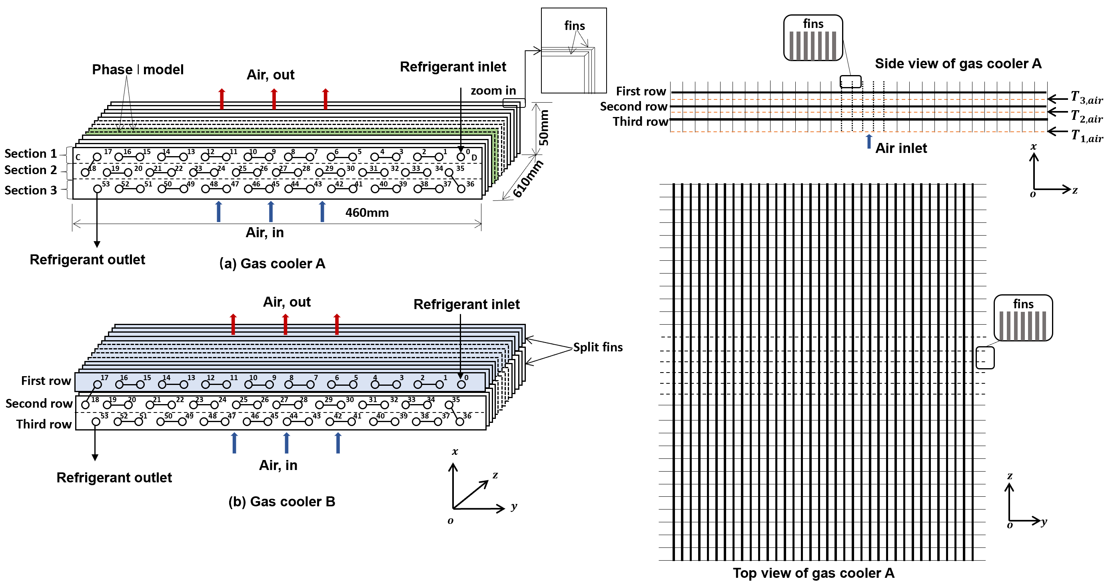
Fig.1. Schematic diagram of finned-tube CO₂ gas coolers with and without split fins.

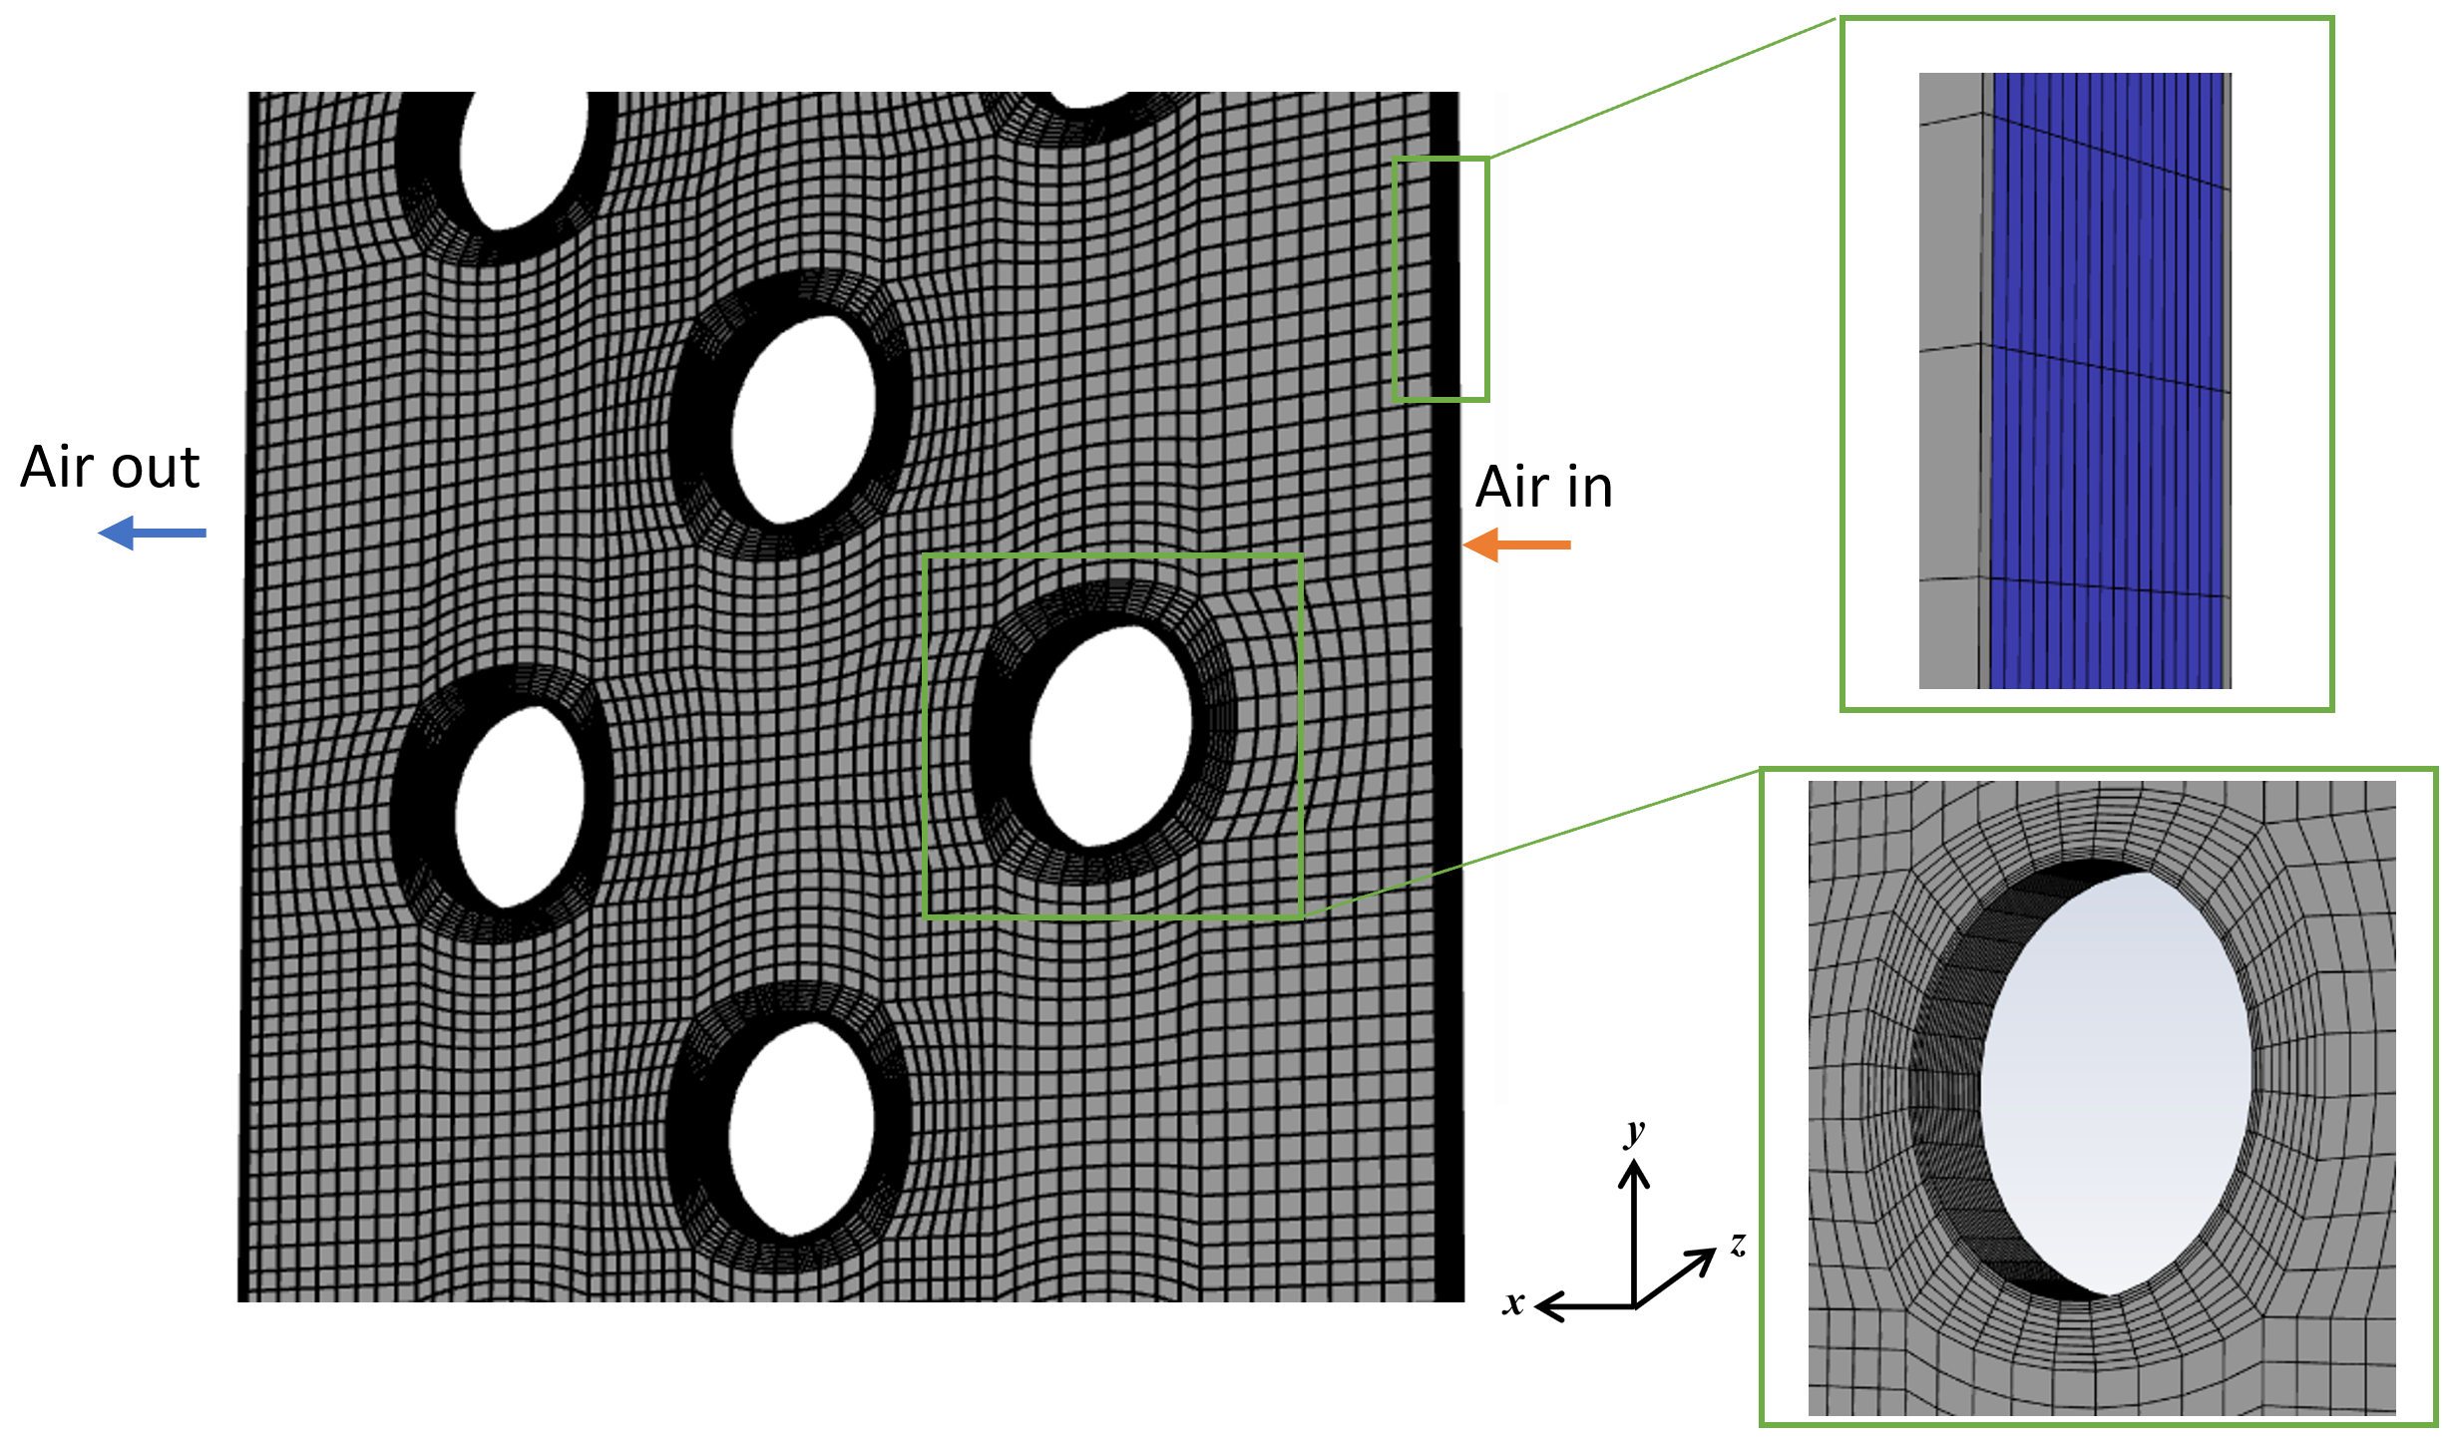
Fig.2. Meshing of the 3D CFD model.

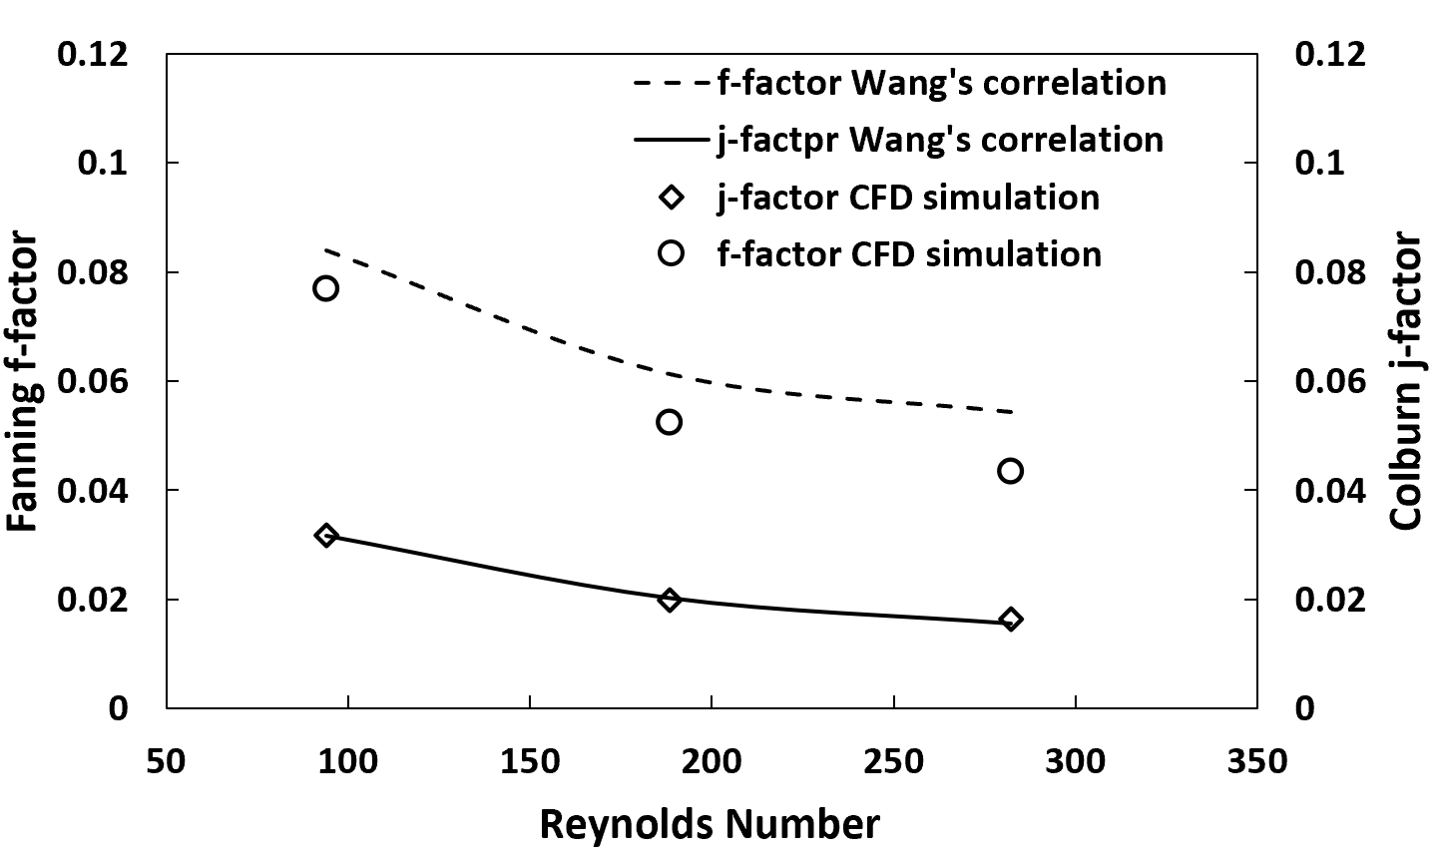
Fig. 3. Comparisons of airflow heat transfer and hydraulic factors at varied Reynolds numbers between simulation results and correlations from literatures.

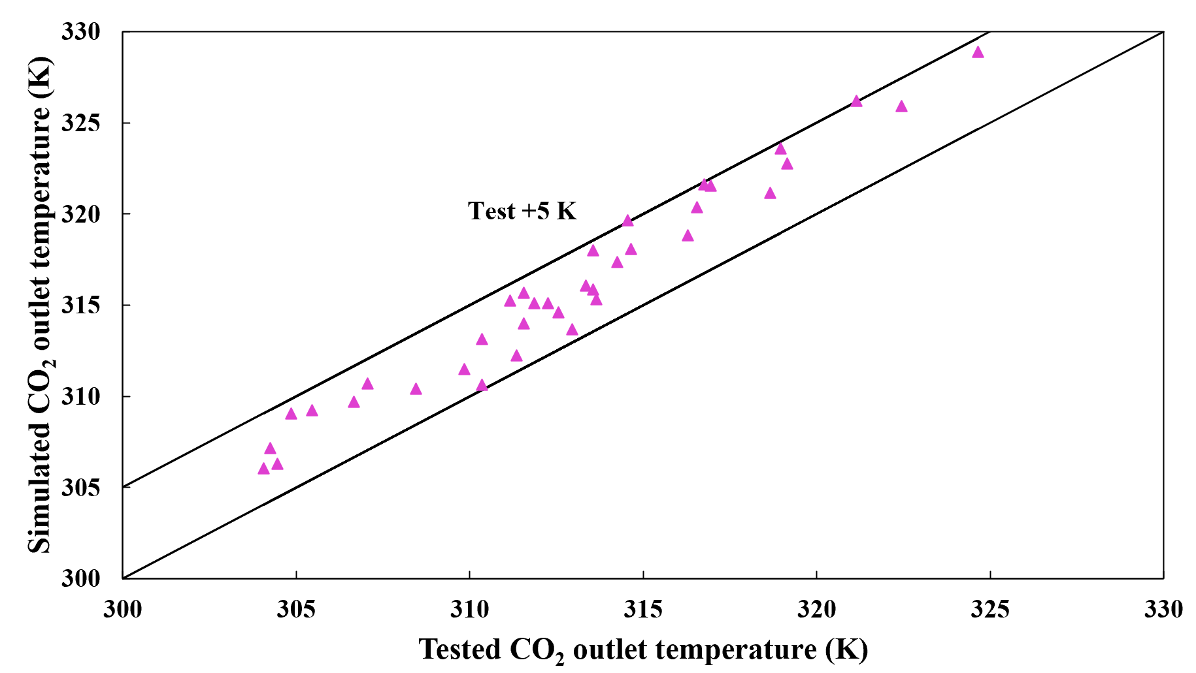
Fig. 4. Comparisons of simulation and test results for CO₂ outlet temperatures of the gas cooler.

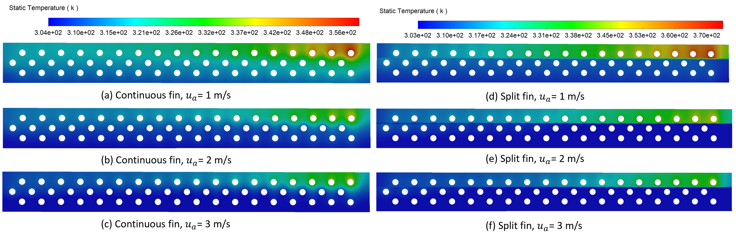
Fig. 5. Temperature distribution of fin surfaces for the gas coolers with and without split fins (operating condition:$T_{air,in}=302.55K, {\dot{m}}_{CO2}=0.038kg/s, P_{CO2,in}=9MPa$).

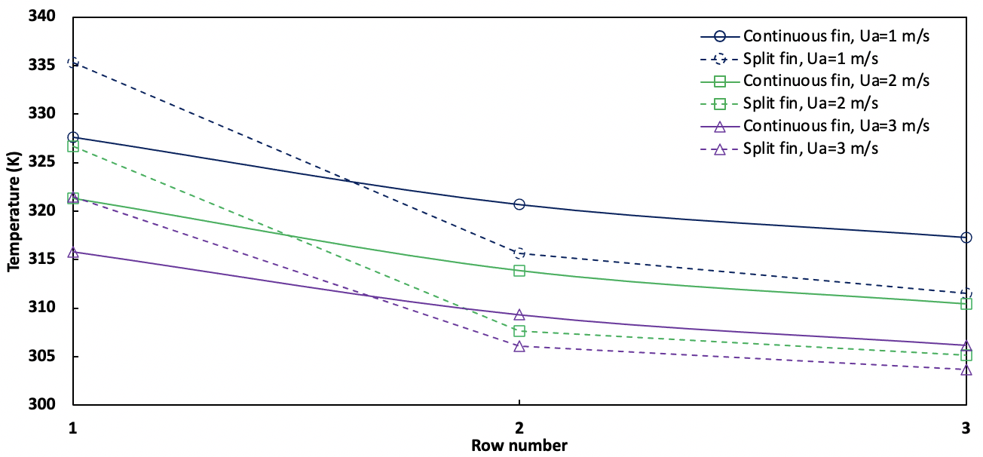

Fig. 6. Variations of row average fin surface temperatures at different airflow velocities for the gas coolers with continuous and split fins

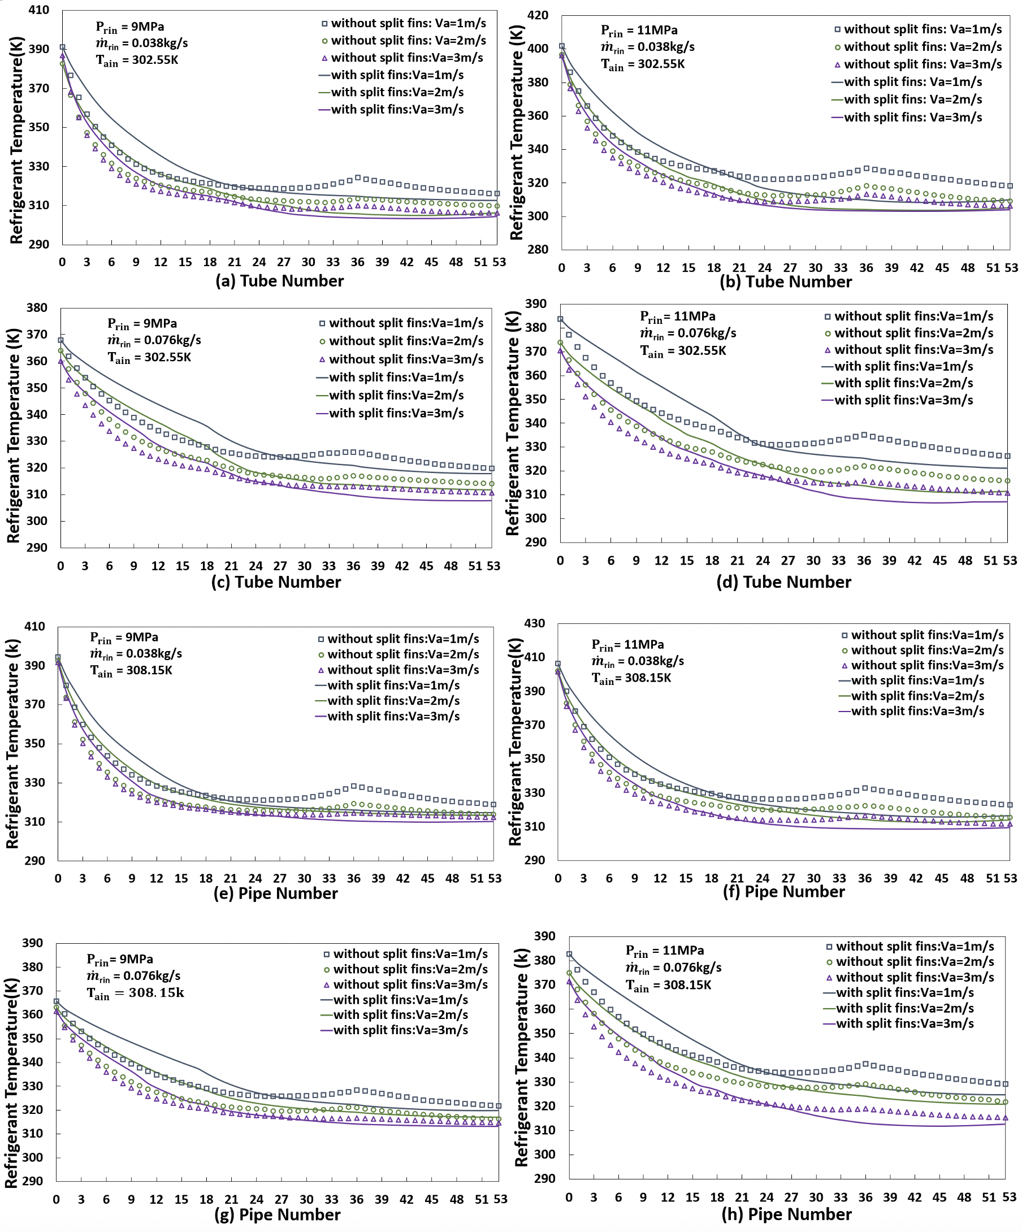
Fig. 7. Comparison of refrigerant temperature profiles along pipe flow direction at different operating conditions for the gas coolers with and without split fins.

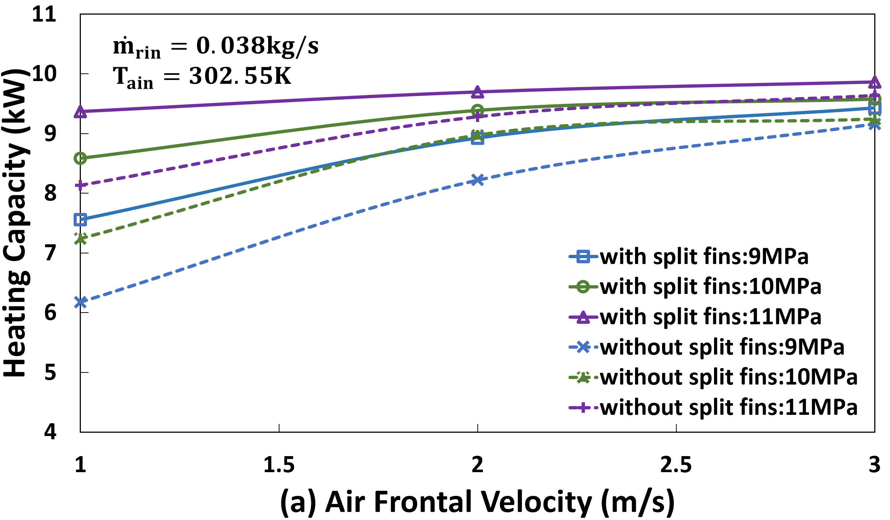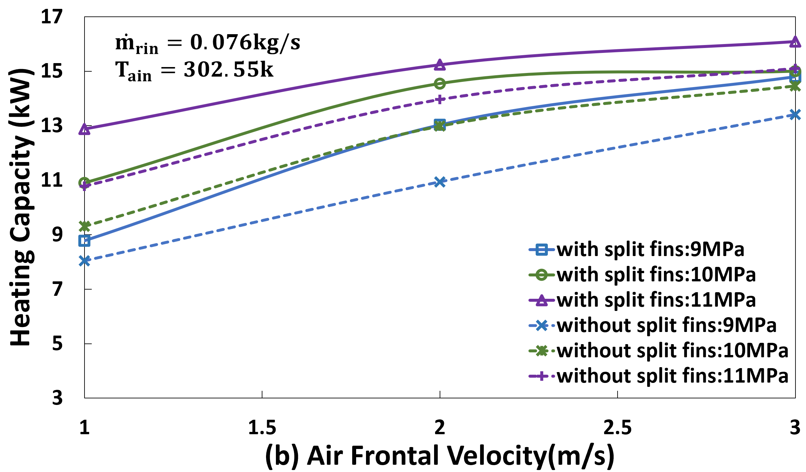
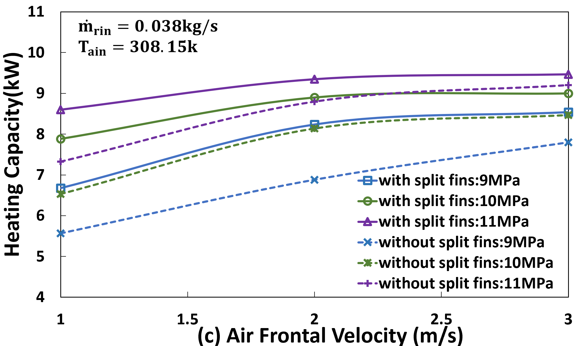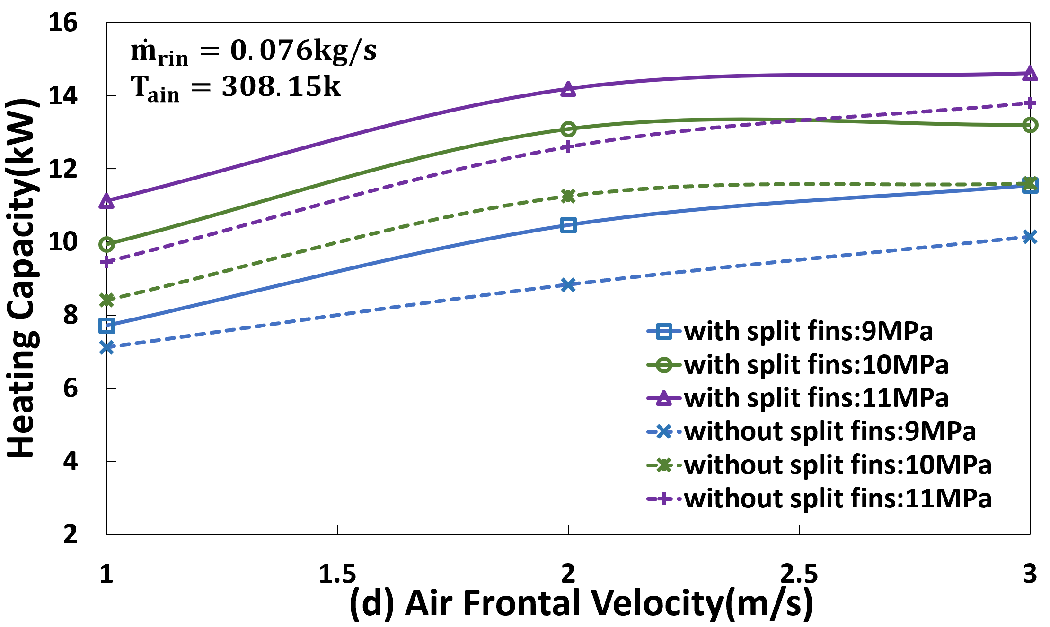
Fig. 8. Comparison of heating capacity at different operating conditions for the gas coolers with and without split fins.

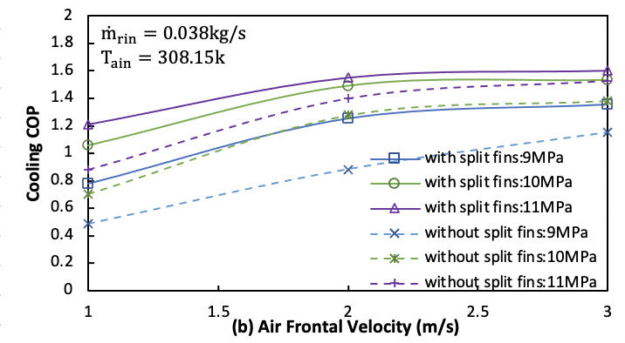
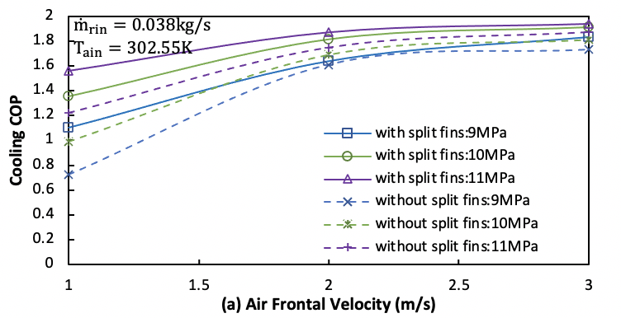
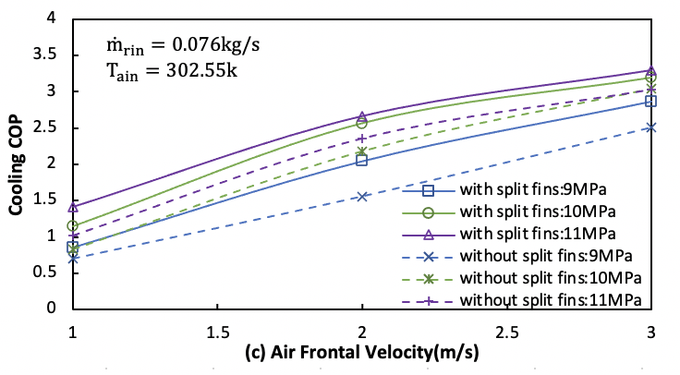
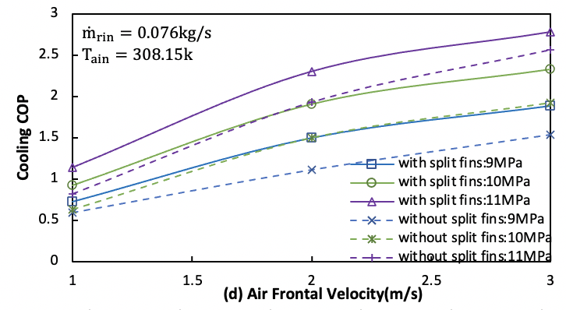

Fig. 9 Variations of cooling COP at different operating conditions for gas coolers with and without split fins

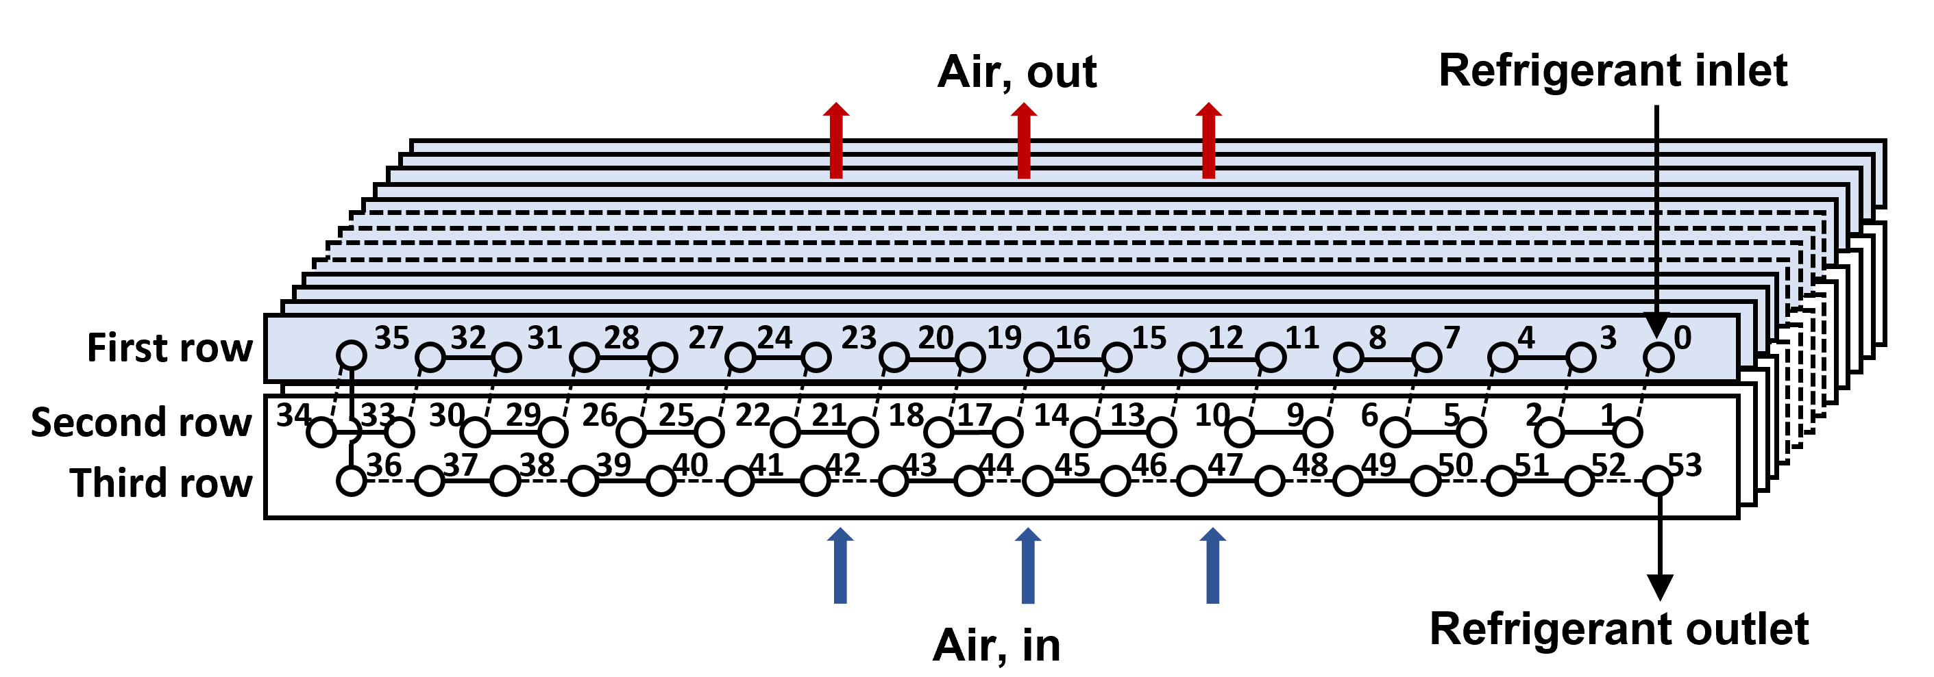
Fig. 10. Schematic diagram of the CO₂ gas cooler with split fins and modified tube circuitry arrangement.

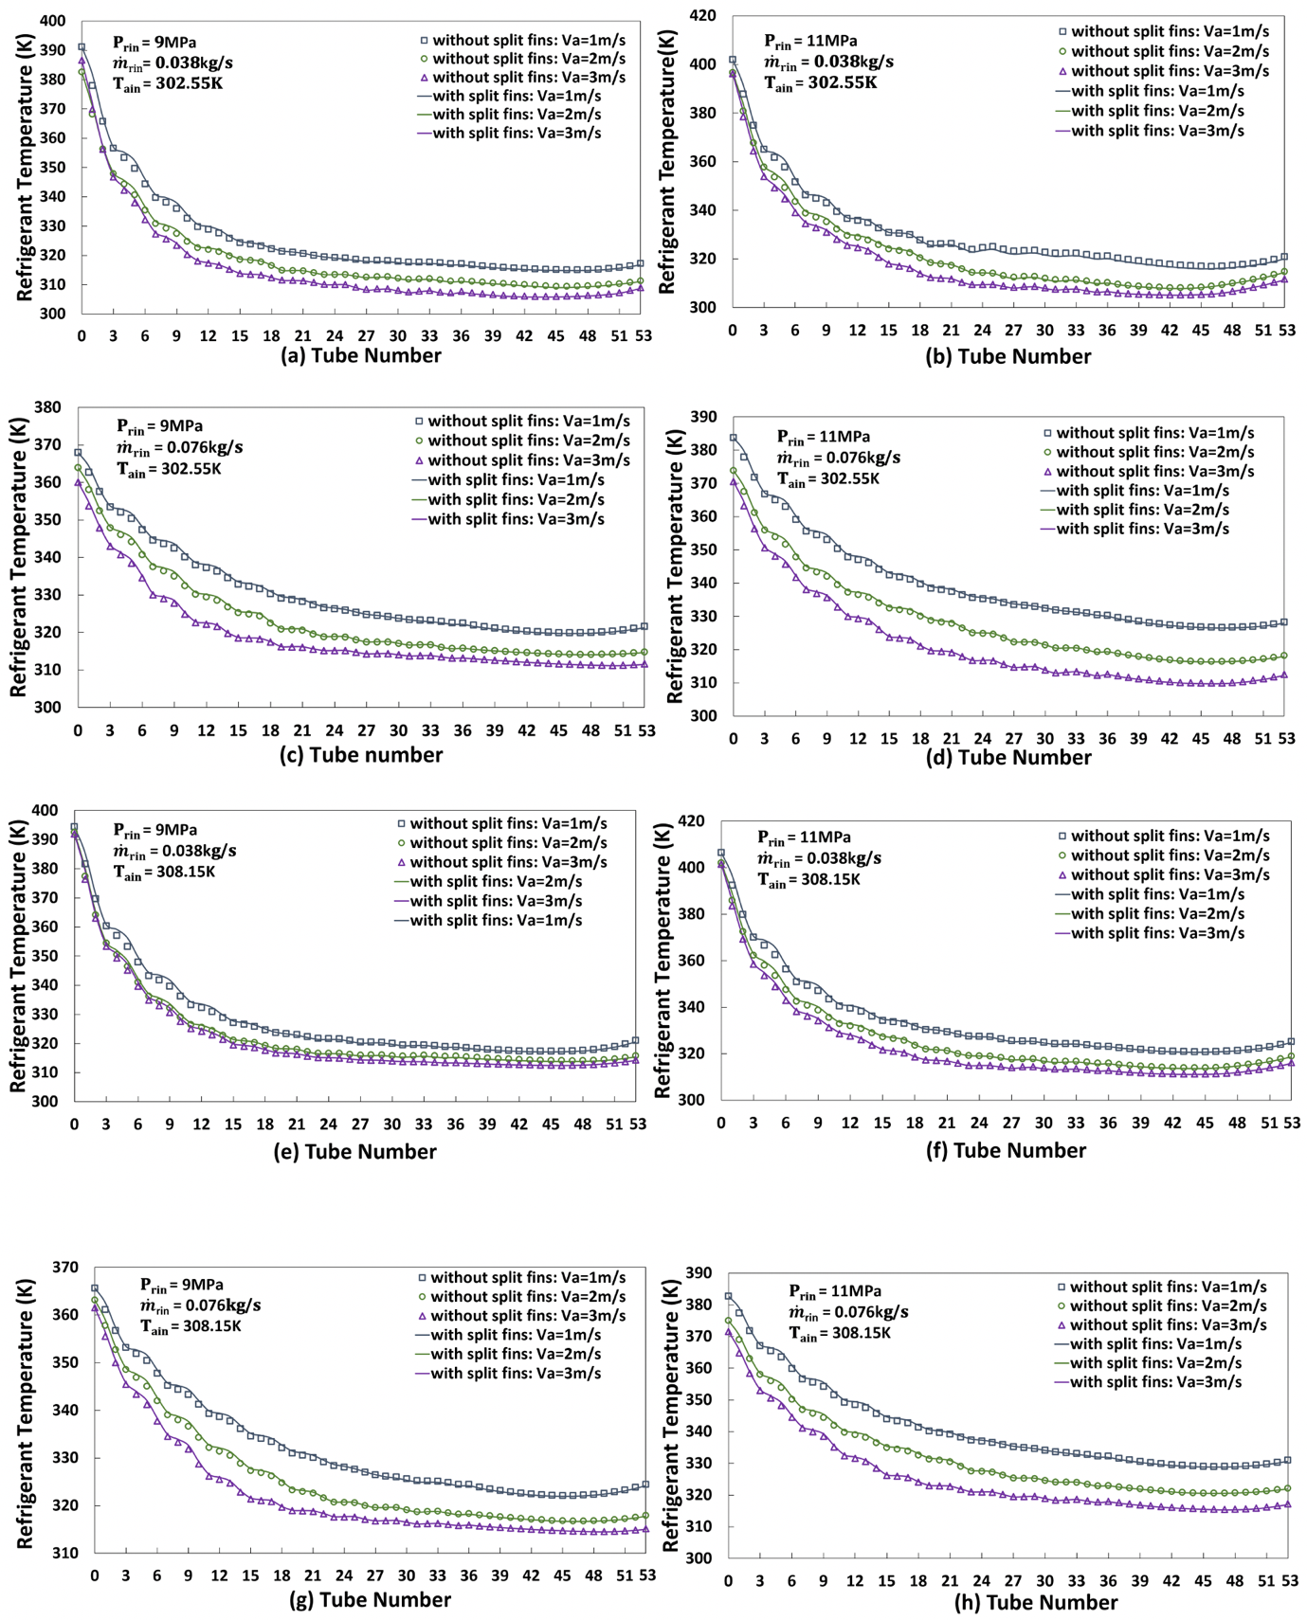

Fig. 11. Refrigerant temperature profiles along refrigerant flow direction at different operating conditions for the gas coolers with and without split fins.

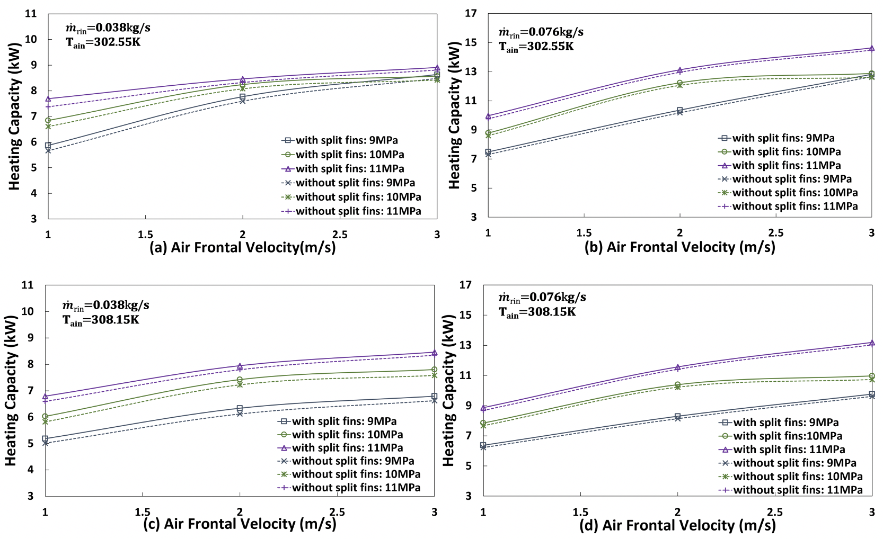

Fig. 12 Heating capacity at different operating conditions for the gas coolers with and without split fins.

Table 1. Tube and fin geometry parameters.
Dimensions | Value
$W×H×D$ (m) | $$0.61×0.46×0.05$$
$A_{f}$ (m²) | 0.281
$f_{p}$(mm) | 1.5
$f_{t}$(mm) | 0.13
N | 3
$D_{o}$ (mm) | 7.9
$D_{i}$(mm) | 7.5

Table 2. Specification of CFD model meshes.
Parameters | Phase-I model | Phase-Ⅱ model
Mesh type | hexahedral | hexahedral
Number of elements | 1370572 | 3132924
average aspect ratio | 0.97 | 0.97
average skewness | 0.64 | 0.64
average orthogonal quality | 0.89 | 0.89

Table 3. Comparison of refrigerant exit temperatures at different grid numbers.
 | Elements number | Refrigerant exit temperature (K)
Phase I model | 769,120 | 315.99
 | 993,168 | 310.38
 | 1370572 | 309.71
Phase II model | 1351897 | 315.53
 | 1745710 | 307.89
 | 3132924 | 306.91

Table 4. Boundary conditions.
Model | Boundary | Condition
Phase ǀ model | Airside inlet | $m_{a}=u·ρ·A$, ${T=T}_{a,in}$
 | Airside outlet | Pressure outlet, $P_{gauge}=0$
 | Tube inner walls | HTC = $h_{CO2}$, ${T=T}_{CO2}$
 | Fin side walls | $$u=v=w=0, \frac{∂T}{∂x}=0$$
Phase ǁ model | Fin surfaces | $$HTC=h_{a,i}, T= T_{a}$$
 | Fin side walls | $$u=v=w=0, \frac{∂T}{∂x}=0$$
 | Tube inner walls | HTC = $h_{CO2}$, ${T=T}_{CO2}$

Table 5. Effectiveness ε of gas cooler with and without split fins ($T_{air,in}=302.55K)$.
$V_{air}$ (m/s) | $$m_{{co}_{2}}$$  (kg/s) | ε of gas cooler A |  |  | ε of gas cooler B |  |  | % improvement
 |  | 9 (MPa) | 10 (MPa) | 11 (MPa) | 9 (MPa) | 10 (MPa) | 11 (MPa) | 9 (MPa) | 10 (MPa) | 11 (MPa)
1 | 0.038 | 0.619 | 0.710 | 0.786 | 0.757 | 0.841 | 0.906 | 22.285 | 18.548 | 15.202
2 | 0.038 | 0.861 | 0.907 | 0.922 | 0.935 | 0.948 | 0.964 | 8.547 | 4.622 | 4.500
3 | 0.038 | 0.940 | 0.938 | 0.960 | 0.967 | 0.972 | 0.982 | 2.906 | 3.602 | 2.365
1 | 0.076 | 0.459 | 0.512 | 0.576 | 0.501 | 0.599 | 0.689 | 9.218 | 17.061 | 19.538
2 | 0.076 | 0.641 | 0.755 | 0.797 | 0.763 | 0.846 | 0.870 | 19.095 | 12.002 | 9.138
3 | 0.076 | 0.807 | 0.866 | 0.882 | 0.891 | 0.898 | 0.940 | 10.357 | 3.730 | 6.562

Table 6. Effectiveness ε of gas cooler with and without split fins ($T_{air,in}=308.15K)$.
$V_{air}$ (m/s) | $$m_{{co}_{2}}$$  (kg/s) | ε of gas cooler A |  |  | ε of gas cooler B |  |  | % improvement
 |  | 9 (MPa) | 10 (MPa) | 11 (MPa) | 9 (MPa) | 10 (MPa) | 11 (MPa) | 9 (MPa) | 10 (MPa) | 11 (MPa)
1 | 0.038 | 0.605 | 0.678 | 0.739 | 0.726 | 0.818 | 0.867 | 19.974 | 20.673 | 17.337
2 | 0.038 | 0.756 | 0.867 | 0.908 | 0.905 | 0.949 | 0.965 | 19.680 | 9.374 | 6.220
3 | 0.038 | 0.860 | 0.905 | 0.953 | 0.941 | 0.961 | 0.980 | 9.467 | 6.280 | 2.844
1 | 0.076 | 0.463 | 0.501 | 0.548 | 0.502 | 0.592 | 0.645 | 8.290 | 18.156 | 17.615
2 | 0.076 | 0.586 | 0.698 | 0.771 | 0.694 | 0.812 | 0.868 | 18.443 | 16.320 | 12.552
3 | 0.076 | 0.681 | 0.744 | 0.868 | 0.775 | 0.847 | 0.918 | 13.912 | 13.869 | 5.856

