Quantum Information Processes in Protein Microtubules of Brain Neurons

Nicolae Enaki, Vlad Koroli, Sergei Palistrant, Sergiu Bazgan, Andrei Nistreanu, Marianna Turcan, Tatiana Pislari and Yurii Boshneaga,
Quantum Optics Laboratory, Institute of Applied Physics
Academy of Sciences of Moldova, MD-2028, Moldova
vl.koroli@gmail.com

Niki Lambropoulos and Shushma Patel,
Department of Informatics, London South Bank University, London, UK
nikilambropoulos@gmail.com

Sze Chai Kwok
DPhil, Neuroimaging Laboratory, Santa Lucia Foundation,
Via Ardeatina 306, 00179, Rome, Italy
sze-chai.kwok@st-hughs.oxon.org

Andrei Khrennikov
Department of Mathematics, International Center for Mathematical Modelling in Physics and Cognitive Sciences, Linnaeus University
Vaxjo, S-35195, Sweden
andrei.khrennikov@lnu.se

Manuel Marinucci
Forschungszentrum Informatik, FZI
Haid-und-Neu-Straße 10–14, 76131 Karlsruhe, Germany
marinuc@fzi.de

Lucia Pannese
Imaginary SRL, Italy
Via Mauro Macchi str. 52, I- 20123 Milano, Italy
lucia.pannese@i-maginary.it

Marta Arniani and Roger Torrenti
Sigma Orionis, Buropolis 1, 1240 route des dolines
06560 Valbonne Sophia Antipolis, France
marta.arniani@sigma-orionis.com

Sergei Maslobrod
Laboratory of Applied Genetics
Institute of Genetics and Plant Physiology
Academy of Sciences of Moldova, MD-2002, Moldova
maslobrod37@mail.ru

Victor Scherbakov and Evgenii Kuznetsov
Laboratory of Algebra and Topology
Institute of Mathematics and Computer Science
Academy of Sciences of Moldova, MD-2028, Moldova
kuznet1964@mail.ru

I. Moldovanu, S. Odobescu, A. Cernei, A. Lupusor, O. Misic
Institute of Neurology and Neurosurgery, MD-2028 Moldova
omisic@yandex.ru

Victor Vovc, Oleg Arnaut and Nellu Ciobanu
Department of Biophysics
University of Medicine and Pharmacy "Nicolae Testemitanu"
MD-2028, Moldova
victor.vovc@usmf.md

Piotr Tuzlucov
Department of Radiotherapy, Institute of Oncology
MD-2025, Moldova
askpeter@rambler.ru

Abstract—We study biologically ‘orchestrated’ coherent quantum processes in collections of protein microtubules of brain neurons, which correlate with, and regulate, neuronal synaptic and membrane activity. In this situation the continuous Schrodinger evolution of each such process terminates in accordance with the speciﬁc Diosi–Penrose (DP) scheme of ‘objective reduction’ (‘OR’) of the quantum state. This orchestrated OR activity (‘Orch OR’) is taken to result in moments of conscious awareness and/or choice. We analyze Orch OR in light of advances and developments in quantum physics, computational neuroscience and quantum biology. Much attention is also devoted to the ‘beat frequencies’ of faster microtubule vibrations as a possible source of the observed electro-encephalographic (‘EEG’) correlates of consciousness.

Keywords—quantum information processes; quantum consciousness; protein microtubules of brain neurons

- Introduction
All living cells of plants, animals and humans continuously emit ultraweak biophotons (ultraweak electromagnetic waves) in the optical range of the spectrum, which is associated with their physiological states and can be measured using special equipment. Neural cells also continuously emit biophotons. The intensity of biophotons is in direct correlation with neural activity, cerebral energy metabolism, EEG activity, cerebral blood flow and oxidative processes [1,2]. According to Van Wijk et al [3], there are significant correlations between the fluctuations in biophoton emission and fluctuations in the strength of electrical alpha wave production in the brain. Some unpublished observations suggest that the state of the biophoton field of a person may be connected to the state of the brain as measured by the EEG (e.g., degree of synchronization and coherence) [4]. Certain meditative states characterized by a high degree of coherence in the EEG may well be accompanied by a high degree of coherence in the biophoton field [4], although measurements correlating the coherence of the biophoton field and the EEG readings have not been made yet. In this situation it is very important to study the interaction of biomolecules with biophotons of brain neurons and to quantitatively investigate possible connections between the EEG and the biophoton production.
There is no doubt that EEG waves are deeply involved with the basic functioning of the brain. The EEG waves associated with two distant neurons are strongly correlated and this supports the view that EEG waves are related to the properties of the brain as a coherent quantum system.
In modern optogenetics much attention is devoted to the possibility to manipulate neurons with light [5-7]. In this situation spatially-precise neuronal control and monitor the activities of individual brain neurons are realized with the help of optogenetic actuators (channelrhodopsin, halorhodopsin, archaerhodopsin) and temporally-precise recordings can be made with the help of optogenetic sensors for calcium (Aequorin, Cameleon, GCaMP), chloride (Clomeleon) or membrane voltage (Mermaid).
At present much attention is devoted to the nature of consciousness and mechanism by which it occurs in the brain [8]. In this situation consciousness depends on biologically ‘orchestrated’ coherent quantum processes in collections of microtubules within brain neurons [9]. It is very important to unify micro and macro levels: quantum-statistical properties of quantized fields insight MTs and EEG signals [10], because superradiant optical computing in networks of microtubules may provide a basis for biomolecular cognition and a substrate for consciousness [11], fMRI and SPECT (single-photon emission computed tomography) are also very important tools for investigation of cooperative processes in protein microtubules of brain neurons. There has been a strong recent interest in applying quantum theory in cognitive science [12]. It should be noted that special evaluation of altered states of consciousness (ASC), induction of ASC by different physical methods: electrical stimulation (direct and alternating current), magnetic stimulation, sound (binaural) stimulation compared with placebo in healthy volunteers will give more insight about nature of consciousness from quantum biophysical point of view [13-15].

- Fluctuation Function of Protein Microtubules
At present much attention is paid to the coupling between fluctuation function S_{z}(t) of protein MTs and EEG signal, influence of coherence in biophoton field (Fig. 1) on coherence in neuronal system and correlations between the fluctuations in biophoton emission and fluctuations in the strength of electrical alpha wave production in the brain [10]
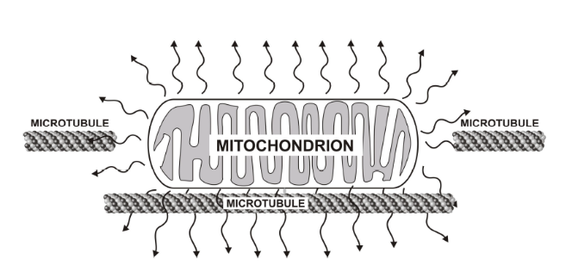

Fig. 1. Representation of biophotons produced by mitochondria and the interaction of biophotons with microtubules
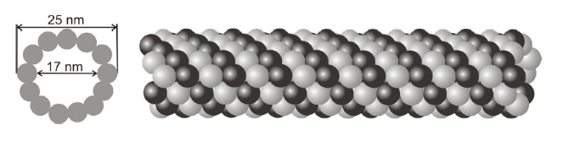

Fig. 2. MTs are hollow cylinders composed of protein units called tubulin. The inner diameter of an MT is 17 nm and the outer diameter is 25 nm. The lengths of MTs vary widely from nanometers to micrometers. MTs have been considered to act as QED-cavities [16, 17].

It should be emphasized that MTs have been considered as optical cavities (Fig. 2) [16] with quantum properties [17], capable of supporting only a single mode [18] or perhaps a few widely spaced (in the frequency domain) modes. Rahnama et al [10] is successfully applied a fully quantum mechanical formalism of the Jaynes-Cummings model (JCM) [19-21]. It is noticed that MTs are biological hollow cylinders with a 17 nm inner diameter and a 25 nm outer diameter (Fig. 2) [22], composed of units called tubulin dimers, each of which has the dimensions 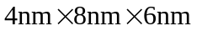 [16]. Tubulin can be viewed as a typical two-state quantum mechanical system, where the dimers couple to conformational changes with 10⁻⁹ - 10⁻¹¹ sec transitions due to electron transitions in hydrophobic pockets, corresponding to an angular frequency in the range 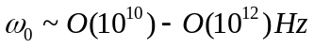 [16]. Using a first-order-approximation estimate of the quality factor for the MT cavities (i.e. Q_{MT}), it has been found that 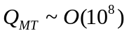 [16]. High-quality cavities encountered in Rydberg atom experiments dissipate energy on time scales of 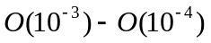 sec and have Q’s which are comparable to Q_{MT} [16]. Frequencies of visible light are on the order of THz and Wang et al [23] have detected visible light in the brain as biophotons. Also, transition frequencies in tubulins are on the order of THz [16]. In order to get more physical insight about Quantum Brain Dynamics it is necessary to carefully examine properties of a single protein microtubule [24] from quantum-mechanical point of view. This will give new possibilities for realization and manipulation of quantum information processes with the help of entanglement and non-local canals in the ensemble of microtubules of brain neurons (Fig. 3).
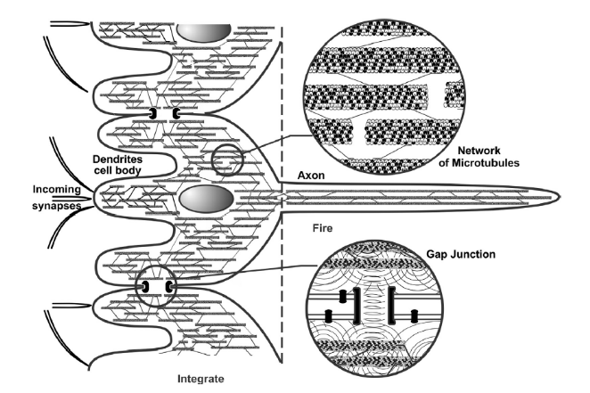

Fig. 3. An ‘integrate-and-ﬁre’ brain neuron, and portions of other such neurons are shown schematically with internal microtubules. In dendrites and cell body/soma (left) involved in integration, microtubules are interrupted and of mixed polarity, interconnected by microtubule-associated proteins (MAPs) in recursive networks (upper circle, right). Dendritic–somatic integration (with contribution from microtubule processes) can trigger axonal ﬁrings to the next synapse. Microtubules in axons are unipolar and continuous. Gap junctions synchronize dendritic membranes, and may enable entanglement and collective integration among microtubules in adjacent neurons (lower circle right). In Orch OR, microtubule quantum computations occur during dendritic/somatic integration, and the selected results regulate axonal ﬁrings which control behavior.

Let us investigate quantum brain dynamics and analyze fluctuation function of MTs in the case, in which MT has three energy state: ground state 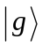, first excited 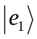 and second excited 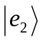 biomolecular states. In this situation it is assumed that at the initial moment t = 0 MT is situated in the ﬁrst excited state and quantized electromagnetic ﬁeld in the Holstein–Primakoﬀ SU(1,1) coherent state [19, 20]
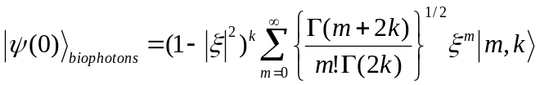(1)
where 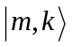 are the eigenvectors of the Casimir operator
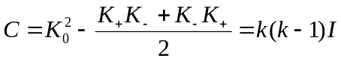 (2)
k is the so-called Bargmann index and 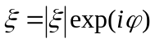 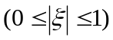. In the present model k=½ and SU(1,1) CS can be written through oscillator number states
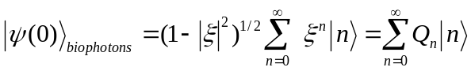 (3)
In this case the initial state – vector of the coupled MT - field system takes the following form
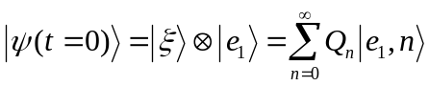 (4)
Exact analytical solution for state-vector of the MT - field coupled system can be obtained by using Schrodinger equation:
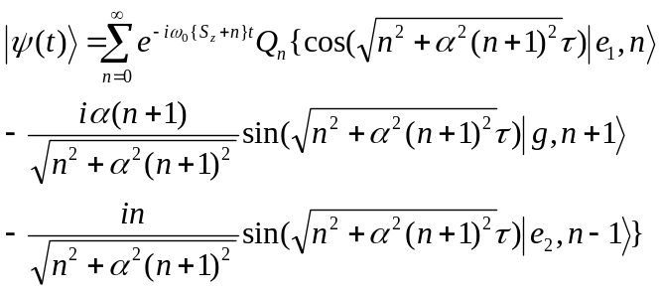(5)
where dimensionless time is equal 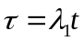, 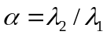, 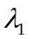 and 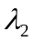are MT - field coupling constants [10].
By using solution (5) one can obtain exact analytical solution for fluctuation function S_{z}(t) in the following manner
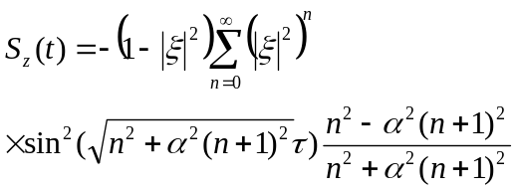 (6)
In ﬁgure 4 we show S_{z}(t) as a function of time for cases |ξ|=0.6 and 0.9, α = 0.1 and 0.01. In this situation it is observed that the higher the initial mean biophoton number n(t = 0)=|ξ|²/(1−|ξ|²), the higher S_{z}(t). There are also some jumps in the fluctuation function, in which a strong energy exchange between the MTs and ﬁeld subsystems takes place.
It should be noted that present JCM with intensity-dependent coupling [19, 20] in the best way describes quantum vibrations of MTs of brain neurons and gives more insight about faster microtubule vibrations as a possible source of the observed EEG correlates of consciousness from quantum biophysical point of view.
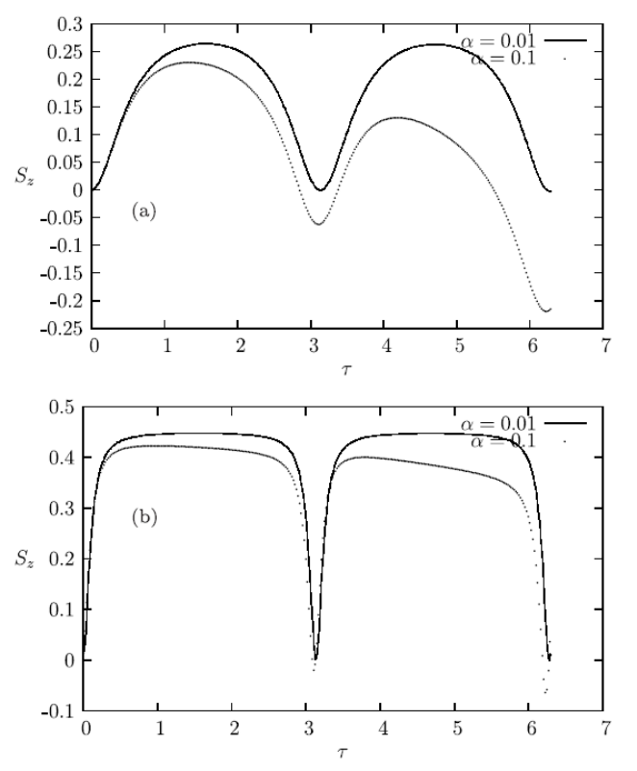

Fig. 4. S_{z}(t) as a function of the dimensionless time τ for cases α = 0.1 and 0.01: (a) |ξ|=0.6, (b) |ξ|=0.9.

- Quantum Entanglement and Non-local Models of Quantum Information Processes in Microtubules of Brain Neurons

Quantum entanglement is, according to Erwin Schrodinger in 1935, the essence of quantum physics and inspires fundamental questions about the principles of nature. By testing the entanglement of particles we are able to ask fundamental questions about realism and locality in nature. Local realism imposes certain constraints in statistical correlations of measurements on multi-particle systems. Quantum mechanics, however, predicts that entangled systems have much stronger than classical correlations that are independent of the distance between the particles and are not explicable with classical physics.
In non-local models of quantum mechanics quantum system behaves as a whole no matter how far separated its components. In other words, correlations betwwen electrons or photons, composing the whole quantum system exist at distances much larger than the dimensions of composed parts. It should be noted that experimental demonstration of quantum correlations over more than 10 km was realized by Tittel et al [25]. Moreover, quantum entanglement distribution over 100-kilometre free-space channels are successfully demonstrated by Yin J et al [26]. It should be emphasized that quantum entanglement takes place also in living species, in which biophotons are generated by mitochondria [10]. In this situation each living cell is giving off, or resonating, a biophoton field of coherent energy. If each cell is emitting this field, then the whole living system is, in effect, a resonating field-a ubiquitous nonlocal field. And since biophotons are the entities through which the living system communicates, there is near-instantaneous intercommunication throughout, which is the basis for coherent biological organization - referred to as quantum coherence. Capacity for evolution rests not on aggressive struggle and rivalry but on the capacity for communication and cooperation. In this sense the built-in capacity for species evolution is not based on the individual but rather living systems that are interlinked within a coherent whole: Living systems are thus neither the subjects alone, nor objects isolated, but both subjects and objects in a mutually communicating universe of meaning. Just as the cells in an organism take on different tasks for the whole, different populations enfold information not only for themselves, but for all other organisms, expanding the consciousness of the whole, while at the same time becoming more and more aware of this collective consciousness.
Because protein microtubules of brain neurons are quantum optical devices [9-11], [16, 17] it is instructive to study the generation of squeezing and entanglement in microtubules to obtain more insight about nature of consciousness from quantum biophysical point of view. In this situation non-local correlations takes place between different microtubules of brain neurons and therefore quantum information in the brain may be transmitted through non-local canals (https://www.youtube.com/watch?v=0fu_k8_tae0).

- Conclusion
In the present paper the possibility of quantum information processes in MTs of brain neurons is investigated. Much attention is devoted to the quantum-statistical properties of protein microtubules. It is shown that fluctuation function of MTs S_{z}(t) has the tendency towards oscillations but exact periodicity of S_{z}(t) oscillations is violated. It should be noted that exact periodicity of S_{z}(t) oscillations takes place when one of the dipole moment matrix transition elements between neighbouring molecular levels tends to zero. In this situation fluctuation function determines number of generated biophotons in protein microtubules and is connected with oscillations of EEG signal.
Much attention is also devoted to the possibility of entanglement and non-local canals for Quantum Information Processes in microtubules of brain neurons. In this situation entanglement and non-local correlations exist between biophotons and tubulin structures of different MTs, situated at distances much larger than their own dimensions.

References
[1] Y. Isojima, T. Isoshima, K. Nagai, K. Kikuchi, H. Nakagawa, “Ultraweak biochemiluminescence detected from rat hippocampal slices”, NeuroReport, 6, pp. 658–660, 1995.
[2] M. Kobayashi, M. Takeda, K. Ito, H. Kato, H. Inaba, “Two-dimensional photon counting imaging and spatiotemporal characterization of ultraweak photon emission from a rat's brain in vivo”, J Neurosci Methods, 93, pp. 163–168, 1999.
[3] R. Van Wijk, S. Bosman, J. Ackerman and E. Van Wijk, NeuroQuantology, l6, pp. 452–463, 2008.
[4] M. Bischof, “Biophotons - The light in our cells”, J. Optom. Photother. March, pp. 1–5, 2005.
[5] T. Richner et al, “Optogenetic micro-electrocorticography for modulating and localizing cerebral cortex activity”, 2014 J. Neural Eng., 11, pp. 016010–016021, 2014.
[6] A. M. Aravanis et al, “An optical neural interface: in vivo control of rodent motor cortex with integrated ﬁberoptic and optogenetic technology”, J. Neural Eng., 4, pp. S143-S156, 2007.
[7] F. Wu et al, “An implantable neural probe with monolithically integrated dielectric waveguide and recording electrodes for optogenetics applications”, J. Neural Eng., 10, pp. 056012–056020, 2013.
[8] P. Manzelli, N. Lambropoulos, S. C. Kwok and V. Koroli, (2014). “Quantum Creativity: the Possibility for Human Super Cognition”, In the Caos Management Journal, Special Edition 92/2014-November, article #186. http://www.caosmanagement.it/186-quantum-creativity-the-possibility-for-human-super-cognition
[9] S. Hameroff and R. Penrose, “Consciousness in the universe, a review of the ‘Orch OR’ theory”, Physics of Life Reviews, 11, pp. 39-78, 2014.
[10] M. Rahnama, J. A. Tuszynski, I. Bуkkon, M. Cifra, P. Sardar and V. Salari, “Emission of Mitochondrial Biophotons and their Effect on Electrical Activity of Membrane via Microtubules”, J. Integrative Neuroscience, 10, pp. 65-86, 2011.
[11] M. Jibu, S Hagan, S. R. Hameroff, K. H. Pribram and K. Yasue, “Quantum optical coherence in cytoskeletal microtubules: implications for brain function”, Biosystems, 32(3), pp. 195-209, 1994.
[12] A. Khrennikov, I. Basieva, E. N. Dzhafarov and J. R. Busemeyer, “Quantum models for psychological measurements: an unsolved problem”, PLOS ONE, 9, pp. e110909 - e110916, 2014.
[13] I. Moldovanu and V. Vovc “A new conceptual dimension of functional neurology: altered states of consciousness”, Bul. Acad. Sci. of Moldova. Medical Sciences, 2(38), pp. 8–15, 2013.
[14] N. Cojocaru and I. Moldovanu “Altered states of consciousness induced by voluntary hyperventilation”, Pilot study. Bul. Acad. Sci. of Moldova. Medical Sciences, 2(38), pp. 109-111, 2013.
[15] I. Moldovanu, V. Vovc and A. Cernei “Induction and phenomenological structure evaluation of altered states of consciousness through the use of various physical factors (transcranial electrical stimulation, binaural sound stimulation, their combination) compared with placebo in healthy volunteers”, 2015 (to be published).
[16] N. E. Mavromatos, A. Mershin and D. V. Nanopoulos, “QED-cavity model of microtubules implies dissipationless energy transfer and biological quantum teleportation”, Inter. J. Mod. Physics B, 16, pp. 3623-3642, 2002.
[17] N. E. Mavromatos and D. V. Nanopoulos, “On Quantum Mechanical Aspects of Microtubules”, Inter. J. Mod. Physics B, 2, pp. 517-542, 1998.
[18] M. Jibu, K. H. Brinbram and K. Yasue, “From conscious Experience to Memory Storage and Retrieval: The role of quantum brain dynamics and boson condensation of evanescent photons”, Inter J Mod Physics B, 10, pp. 1735–1754, 1996.
[19] N. A. Enaki, V. I. Koroli and S. Bazgan, “Nonclassical light in two-photon Jaynes - Cummings model of a three-level atom with different dipole transitions”, Indian Journal of Physics, 88, pp. 25-29, (2014).
[20] V. I. Koroli, “Cooperative interaction of photons and phonons with radiation centers, Quantum Optics” (LAP, LAMBERT Academic Publishing Saarbrücken, Germany) 128 pages (2013).
[21] E. T. Jaynes and F. W. Cummings, “Comparison of quantum and semiclassical radiation theories with application to the beam maser”, Proc IEEE, 51, pp. 89–109, 1963.
[22] M. Cifra, J. Pokornэ, D. Havelka and O. Kučera, “Electric field generated by axial longitudinal vibration modes of microtubule”, BioSystems, 100, pp. 122 – 131, 2010.
[23] Ch. Wang, I. Bуkkon, J. Dai and I. Antal, “Spontaneous and visible light-induced ultraweak photon emission from rat eyes”, Brain Res, 1369, pp. 1–9, 2011.
[24] Satyajit Sahu, Subrata Ghosh, Batu Ghosh, Krishna Aswani, Kazuto Hirata, Daisuke Fujita and Anirban Bandyopadhyay, “Atomic water channel controlling remarkable properties of a single brain microtubule: Correlating single protein to its supramolecular assembly”, Biosensors and Bioelectronics, 47, pp. 141–148, 2013.
[25] W. Tittel et al, “Experimental demonstration of quantum correlations over more than 10 km”, Phys. Rev. A, 57, pp.3229-3232, 1998.
[26] J. Yin et al, “Quantum teleportation and entanglement distribution over 100-kilometre free-space channels”, Nature, 488 (7410), pp. 185-193, 2012.

