Nano‐synthesis, characterization, modeling and molecular docking analysis of Mn (II), Co (II), Cr (III) and Cu (II) complexes with azo pyrazolone ligand as new favorable antimicrobial and antitumor agents

Mohamed Gaber¹ | Abdalla M. Khedr^{1,2} | Mohammed A. Mansour^{3,4} | Mohsen Elsharkawy¹

- Chemistry Department, Faculty of Science, Tanta University, Tanta 31527, Egypt

- Department of Chemistry, Faculty of Applied Science, Umm Al–Qura University, Makkah, Saudi Arabia

- Biochemistry Division, Chemistry Department, Faculty of Science, Tanta University, Tanta 31527, Egypt

- Institute of Cancer Sciences, University of Glasgow, Garscube Estate, Switchback Road, Glasgow G61 1QH, UK

Correspondence

Abdalla M. Khedr, Department of Chemistry, Faculty of Applied Science, Umm Al–Qura University, Makkah, Saudi Arabia.

Email: abkhedr2010@yahoo.com

Novel nanosized Mn (II), Co (II), Cr (III) and Cu (II) complexes were synthe-sized with 2‐((5‐oxo‐1,3‐diphenyl‐4,5‐dihydro‐1H‐pyrazol‐4‐yl)diazenyl) benzoic acid, HL applying precipitation method. Their structures were characterized based on the elemental and thermal analyses, spectra (FT‐IR, UV–Vis, MS, ESR and XRD), conductivity and magnetic moment measurements. IR spectra offered that HL behaves as monobasic tri‐dentate ligand towards Mn (II), Cr

- and Cu (II) and monobasic bi‐dentate towards Co (II). The XRD results unambiguously confirmed the crystalline nature and nano‐sized particles of Cu (II) complex while HL and other complexes exhibited amorphous phases. The magnetic moment data, UV–Vis and ESR spectra supported the formation of octahedral geometries for Mn (II), and Cr (III) complexes, whereas Co (II), and Cu (II) complexes showed tetrahedral arrangement. The activation param-eters for the thermal degradation stages were theoretically calculated using TGA curves. The obtained data showed the inspected complexes as favorable antimicrobial drug candidates. The studied compounds were screened out for their antitumor and antimicrobial activities. The inspected compounds exhib-ited a reasonable antibacterial activity and weak antitumor efficacy. The in vitro results were confirmed using the in silico molecular docking analysis (docking server) applying x‐ray crystallographic structures of the proteins (4 m01, 3 t88, 1zap & 4ynt) from PDB (Protein Data Bank). HL and probably its complexes displayed adequate binding with the receptors of 4 m01, 3 t88, 1zap, and 4ynt microorganisms. The obtained data show the inspected complexes as favorable antimicrobial drug candidates.

KEYWORDS

antimicrobial, antitumor, modeling, molecular docking, nanosized metal complexes

1 | INTRODUCTION

Pyrazolones are defined as oxo five‐membered heterocy-cle derivatives comprising two neighboring nitrogen atoms. They contain two double bonds inside the moiety; imparting an aromatic character to these molecules. Pyrazolones are still economically important precursors for both pharmaceuticals and dyes.^{[1]} Pyrazolone deriva-tives have numerous pharmacological applications like analgesic,^{[2]} antipyretic, anti‐inflammatory,^{[3]} anti-bacterial, antifungal,^{[4]} anti‐infective,^{[5]} antioxidant,^{[6]} anticonvulsant, anti‐depressant, anti‐hyperglycemic and anti‐proliferative agents. Besides, they have the ability to extend noteworthy anticancer influences by inhibiting diverse types of enzymes that act serious roles in cell division.^{[7]} 4‐Aminoantipyrine is one of the superior celebrated pyrazolone derivatives which is applied for the protection towards oxidative stress and has a prophy-lactic influence on various diseases involving cancer.^{[8,9]} Due to the reactivity of position‐4 in the pyrazolone ring, it undergoes a coupling reaction with a number of aryl diazonium chlorides forming 4‐arylazo derivatives, which are considered as an important class of azo dyes. The azo‐derivatives of pyrazolone compounds have enticed great interest because of their prospect prominence in medicinal chemistry as antimicrobial agents.^{[10]} Further-more, antipyrine derivatives and their complexes with

different metal ions can serve as antiparasitic agents and antitumor substances.^{[11,12]} Moreover, azo dye metal

complexes in which the azo group is included in bonding are derived from azo compounds comprising donor func-

tions such as COOH, OH, SH, NH₂, in a congenial posi-tion so as to form five or six membered chelates.^{[13]} In

view of the obove facts and the importance of such azo dye bearing NO donor atoms,^{[12,13]} we reported here the

coordination character of azo dye ligand derived from 4‐aminoantipyrine towards Mn (II), Co (II), Cr (III) and Cu (II) ions. The structural formulae of the complexes are investigated using analytical and spectral techniques. The molecular modeling was performed for the ligand and all complexes to assert their structural formula. Moreover, the antimicrobial efficiencies of the inspected compounds were examined towards different types of bacteria and fungi. Also, their antitumor activities were investigated against the human hepatocellular carcinoma cells HEPG2. Molecular docking analysis was achieved in silico to examine the ligand for its inhibitory performance on the receptor of 1zap (secreted aspartic protease from Candida albicans), 4ynt (Aspergillus flavus FAD glucose dehydrogenase), 3 t88 (Escherichia coli), and 4 m01 (Staphylococcus aureus adhesion protein). Different parameters like free energy of inhibition constant, Ki (μM), vdW + Hbond + desolv energy (kcal/mol), binding

(kcal/mol), total intermolecular energy (kcal/mol), and electrostatic Energy (kcal/mol) and were determined. Also, the totally interaction profile (hydrogen bonds & hydrophobic interaction), and hydrogen bonding interac-tions (HB plot) were investigated.

2 | EXPERIMENTAL

1,3‐Diphenyl‐5‐pyrazolone, anthranilic acid, triethylamine, ethanol, diethylether, DMSO, DMF, MnCl₂•4H₂O, CoCl₂•6H₂O, CrCl₃•6H₂O and CuCl₂•2H₂O were of high purity and was applied as purchased.

2.1 | Synthesis of azo Pyrazolone ligand (HL)

o‐Amino benzoic acid (0.01 mol, 1.37 g) was dissolved in concentrated HCl (10 ml) and H₂O (10 ml), cooled to 5 °C and treated with a cold aqueous solution of NaNO₂ (0.01 mol, 0.69 g). The diazotized amine was added grad-ually to an ice‐cold solution of 1,3‐diphenyl‐5‐pyrazolone (0.01 mol, 2.25 g) in 10% aqueous NaOH (50 ml). After completing the addition process, the reaction mixture was left to stand in a cold chest for 12 hr. The obtained precipitate was filtered off, washed with H₂O and recrys-tallized using ethanol as an orange crystal of HL (Figure 1). The purity of ligand was examined applying melting point constancy and thin layer chromatographic (TLC) tools.

2.2 | Synthesis of the Nano‐sized metal chelates

The following recommended general procedures were used. A hot ethanolic solution (30 ml) of HL (0.001 mol, 0.384 g) was mixed with 1 mM of the metals salts [MnCl₂•4H2O (0.1979 g), CoCl₂•6H₂O (0.2379 g), CrCl₃Cl₂•6H₂O (0.2664 g), CuCl₂•2H₂O (0.1705 g), dis-solved in ethanol (40 ml) in the presence of six drops of triethylamine as a basic medium. The reaction mixture was mixed together and heated under reflux on water bath for 12 hours with occasional stirring. Both the pres-ence of triethylamine as basic medium and contentious
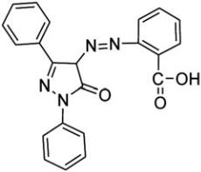

FIGURE 1 Molecular structure of 2‐((5‐oxo‐1,3‐diphenyl‐4,5‐ dihydro‐1H‐pyrazol‐4‐yl)diazenyl) benzoic acid (HL)

stirring enhance the formation of nano‐sized particles. The volume of the reaction mixture was reduced by evap-oration of solvent until precipitation of the complex, which was filtered off and washed consequently with H₂O, warm ethanol and diethyl ether followed by drying in vacuum (over anhydrous calcium chloride).

2.3 | Instrumentations, measurements and methods

Perkin‐Elmer 2400 CHN Elemental Analyzer was applied to determine C, H and N contents. The metal content was investigated by the aid of inductively coupled plasma (ICP) technique after decomposition of the metal com-plexes using nitric acid. The molar conductance of metal complexes were determined in DMF (10⁻³ mol L⁻¹) by the aid of a conductivity meter JENWAY model 4070 Conductance Bridge at room temperature. Infrared spectra were achieved as KBr discs using a Jasco FT‐IR– 4100 (Tsukuba, Japan) within 4000–200 cm⁻¹ range. Stan-dard electron impact mass spectra (E.I) of the free ligand and complexes 1–4 were performed by the aid of a Finnigan MAT 8222 Spectrometer at 70 eV. UV–Vis spec-tra were taken in freshly prepared DMF solution from 200 to 800 nm with T80 + UV–Vis spectrometer. Magnetic moments of the complexes were determined applying a Sherwood scientific magnetic susceptibility balance. EPR spectrum of Cu (II) complex (4) as powder was performed using a Jeol JES‐RE1X EPR spectrometer working in the X‐band, 9.435 GHz (at Alexandria University). XRD patterns of the inspected materials were obtained using a X‐ray diffractometer (GNR, APD2000PRO, Italy) at Central Laboratory, Tanta University, Egypt. Whole patterns were measured at 0.03 ° min⁻¹ scanning rate, applying Cu/Kα₁ radiation with a graphite monochroma-tor. TGA (thermal gravimetric analysis) of complexes 1–4 were investigated (under nitrogen as atmosphere) using a Shimadzu TG‐50 thermal analyzer from ambient tempera-ture up to 800 ^{ο}C (with 10 ^{ο}C/min heating rate). Antifungal and antimicrobial activities of all compounds under interest were examined at Micro‐Analytical Center, Cairo

University applying a modified Kirby‐Bauer disc diffusion method.^{[14,15]} Evaluation of the antitumor activities of the

investigated compounds against human liver Carcinoma cell lines (HEPG2) was carried out at the Regional Center for Microbiology and Biotechnology (Al‐Azhar University) using the well‐known recommended method.^{[15–17]}

2.4 | Molecular docking using docking server

Docking Server software was applied to perform the molecular Docking calculations. The empirical charges

were computed using MOPAC2009 and then added to the organic ligand atoms. Rotatable bonds were specified in the docking process, and non‐polar hydrogen atoms were merged. The calculations were executed to validate the binding of the ligand with the receptor of 1zap (secreted aspartic protease from Candida albicans), 4ynt (Aspergillus flavus FAD glucose dehydrogenase), 3 t88 (Escherichia coli), and 4 m01 (Staphylococcus aureus adhesion protein). AutoDock tools were applied to append the solvation parameters, essential hydrogen atoms, and Kollman united atom type charges. In order to calculate the electrostatic terms, and the van der Waals, auto Dock parameter distance‐ and set‐ dependent dielectric functions were applied, respectively. The Solis

- Wets local search method and The Lamarckian genetic algorithm (LGA) were applied in order to implement the docking simulations.

3 | RESULTS AND DISCUSSION

3.1 | Nature and stoichiometry of the formed complexes

The physical and analytical characteristics of the scruti-nized ligand and complexes 1─4 are collected in Tables 1. The chemical composition and stoichiometry of the pre-pared metal complexes were confirmed by the results of elemental analysis. The gained data showed satisfactory coincidence within the proposed molecular formulae. These data supported formation of complexes exhibit 1:1 (M:L) stoichiometry. Complexes 1─4 were found to be stable in air (for a long time), insoluble in diversified organic solvents but soluble to great extent in DMSO and DMF. The molar conductance values (Table 1) are found to be within the range 8.50–14.00 Ω⁻¹ cm² mol⁻¹. These values indicated the non‐electrolytic character of the complexes 1─4.^{[18]} The metal complexes which con-tain chloride ion were also tested qualitatively with silver nitrate and no precipitation was detected which can be taken as a proof that the complexes are non‐electrolytes.

3.2 | FT‐IR and ¹H NMR spectra and bonding modes

The inspection of IR spectrum of the parent ligand HL compared with that of complexes 1─4 (Figure 1S) denoted certain characteristics differences as presented in Table 2. The infrared spectra of the metal chelates were closely similar among themselves. In HL spectrum, the band appeared at 1520 cm⁻¹ corresponding to ν_{N=N} shifted to higher frequency by 15–40 cm⁻¹ in complexes 1─4 spectra supporting its coordination to Mn (II), Co (II), Cr (III) and Cu (II) ions.^{[19]} The sharp carboxylic v_{sym}

Comp. |  |  | Molecular formula |  |  |  | M. Wt. Found | Colour | Microanalysis; Found (Calc.) %
No. |  |  | (Empirical formulae) |  |  |  | (Calc.) | (Λ_{m}) | %C | %H | %N | %M
Ligand |  |  | HL |  |  |  | (384.55) | Orange | 69.14 | 4.95 | 14.52 | __
 |  |  | (C₂₂H₁₆N₄O₃) |  |  |  | (384.39) | (−‐‐) | (68.74) | (4.20) | (14.58) | (−‐‐)
1 |  |  | [MnLCl (H₂O)₂]•2H₂O |  |  |  | (545.11) | D. yellow | 48.36 | 4.36 | 10.49 | 9.98
 |  |  | (C₂₂H₂₃ClMnN₄O₇) |  |  |  | (545.83) | (8.50) | (48.41) | (4.25) | (10.26) | (10.07)
2 |  |  | [CoLCl (H₂O)]•C₂H₅OH |  |  |  | (541.11) | D. brown | 52.97 | 4.76 | 10.52 | 10.00
 |  |  | (C₂₄H₂₃ClCoN₄O₅) |  |  |  | (541.85) | (10.00) | (53.20) | (4.28) | (10.34) | (10.88)
3 |  |  | [CrLCl₂(H₂O)]•2H₂O |  |  |  | (560.01) | D. Orange | 46.78 | 5.88 | 9.55 | 9.74
 |  |  | (C₂₂H₂₁Cl₂CrN₄O₆) |  |  |  | (560.33) | (14.00) | (47.16) | (3.78) | (10.00) | (9.28)
4 |  |  | [CuLCl]•H₂O |  |  |  | (500.74) | Green | 52.49 | 3.12 | 11.30 | 12.55
 |  |  | (C₂₂H₁₇ClCuN₄O₄) |  |  |  | (500.39) | (11.00) | (52.81) | (3.42) | (11.20) | (12.70)

TABLE 2 Important IR spectral bands (cm⁻¹) and their assignment for the ligand HL and its metal complexes

 | IR spectra
Compounds | ^{Ν}N=N | ν_{C=O} (ring) | ν_{C=N} (ring) | ^{ν}sym(COO‐) | ^{ν}M‐O | ^{ν}M‐N
HL | 1520 | 1665 | 1493 | 1783 | ‐‐ | ‐‐
1 | 1560 | 1656 | 1487 | 1734 | 603 | 504
2 | 1556 | 1658 | 1489 | 1712 | 612 | 433
3 | 1553 | 1652 | 1489 | 1727 | 609 | 491
4 | 1535 | 1647 | 1497 | 1727 | 612 | 492

(COO⁻) of the free ligand HL appeared at 1783 cm⁻¹ showed obvious shifts to lower frequencies in the metal complexes, and appeared within 1712–1734 cm⁻¹ range. This behavior confirmed that the ligand coordinates to the metal ions through the O‐atom of the carboxylate group. The stretching band of carbonyl group ν (C=O) of 5‐pyrazolone moiety did not show significant wave-number shift in complex 2 indicating non‐participation of the carbonyl‐O atom in binding to Co (II), whereas; appreciable downward wavenumber shifts 9–18 cm⁻¹ in complexes 1, 3, and 4 confirming that oxygen atom of pyrazolone moiety was coordinated to Mn (II), Cr (III) and Cu (II) ions. According to these IR data, HL behaves as monobasic tri‐dentate ligand towards Mn (II), Ni (II) and Cu (II) and monobasic bi‐dentate towards Co (II). In the spectra complexes 1─4, the broad band around 3429–3440 cm⁻¹ are attributed to the presence of coordi-nated water. Appearance of non‐ligand bands ranging between 603–612 cm⁻¹ and 433–504 cm⁻¹ in the com-plexes are characteristic of M‐O and M‐N bands, respectively.^{[15]}

The ¹H NMR spectrum of the investigated ligand HL (Figure 2S) showed two singlets at 14.91 and 12.06 ppm; each one is integrated for one proton. NH Proton of the pyrazolone ring appeared in the same position as HL

which elucidates the assignment of NH proton of the pyrazolone ring. The proton at 4 position of the pyrazolone ring appears as a singlet at 7.67 ppm inside the multiplet region. The multiplet at 7.26–8.11 ppm is due to the aryl protons of the two benzene rings.

3.3 | Inspection of mass spectra

Mass spectra were applied to underline the constitutions and pureness of the synthesized ligand and its chelates (Figure 3S). The free ligand fragmentation showed the molecular ion peak at 384.55, which is coincide with its theoretical value (384.39). Mass spectra of [MnLCl (H₂O)₂]•2H₂O, [CoLCl (H₂O)]•C₂H₅OH, [CrLCl₂(H₂O)]

•2H₂O, [CuLCl]•H₂O presented precise molecular ion peaks (calc.) at 545.11 (545.83), 541.11 (541.85), 560.01 (560.33), 500.74 (500.39), respectively, corresponding to the parent ion [ML]⁺. Also, appearance of various peaks due to assorted fragments trough sequential degradation of the base compound is excellent evidence supporting the proposed molecular structure [15]. Ideal evidence backing the suggested structures of the complexes result from the decomposition of complexes 1─4 via elimination of HL, which confer rise to the occurrence of a molecular ion peak assignable to the free ligand. This is triumphant

character for metal complexes involving various types of ligands (ML) that decompose via incision of the ligand– metal bond during the ionization process.^{[20]}

3.4 | Thermo‐gravimetric analytical studies

The TGA curves of complexes 1─4 were on performed under N₂ gas flow from ambient temperature up to 800 °C at a heating rate of 10 °C/min (Figures 4S). Apply-ing TGA curves, the mass loss was determined for the various thermal degradation stages in comparison with those theoretically computed for the suggested formula depending on the results of micro‐analyses. In generality, TGA denoted the formation of metal oxide as a residue from which the percentage of metal (%) is calculated and found to be in favorable conformity with that gained from analytical measurements.^{[21]} The acquired data showed that complexes 1─4 decomposed in four steps for complex 1 and three steps for complexes 2, 3 and 4. The decomposition steps, theoretical calculated, and found mass losses, temperature ranges, as well as final products observed in each thermal decomposition process are presented in Table 3.

suggested by Coats‐Redfern (Figures 5S‐8S).^{[22]} The thermo‐kinetic activation parameters of thermal decompo-sition steps of complexes 1─4 are presented in Tables 1S and prove the following points;

a‐ H* exhibited positive values denoting the endother-mic nature of all thermal decomposition processes.

b‐ S* have positive values for complexes 1─4, reveal-ing that the activated complex is less ordered

compared with the reactants and/or the reactions are very quick.^{[23]}

c‐ Increasing of G* values in appropriately or signifi-cant way for the subsequently decomposition steps as a result of increasing T S* values on going from one step to another which disregard values of H*. This reverberates that the rate of abstraction of the

posterior parts of ligand will be lower than that of the forerunner.^{[24]} This can be bemoaned to the

structural rigidity of the vestige complex after libra-tion of one or more ligand parts, in comparison with the precedent complex, which needs more energy for its rearrangement before sustaining any further compositional alteration.

3.5 | Thermo‐kinetic parameters

The order of reaction (n) mechanism of thermal degrada-tion process, frequency factor (A), andactivation energy (E), for various stages in thermal decomposition com-plexes 1─4 were investigated using integral method

3.6 | ESR Spectrum of cu (II) complex

The powder X‐band ESR spectra of Cu (II) complex (4) at room temperature displayed a broadened characteristic without hyperfine splitting due to the dipolar interaction from the ESR spectrum of a set of magnetic parameters.

TABLE 3 Thermogravimetric analysis (TGA) of complexes 1─4
 | Molecular formula | Temp. range | Mass loss %
No | (Empirical formulae) | (°C) | Found | Calc. |  | Assignment
1 | [MnLCl (H₂O)₂]•2H₂O | 31–93 | 6.68 | 6.59 |  | Loss of hydrated 2H₂O molecules.
 | (C₂₂H₂₃ClMnN₄O₇) | 93–225 | 6.79 | 6.59 |  | Removal of coordinated 2H₂O molecules.
 |  | 225–346 | 28.03 | 28.48 |  | Elimination of Cl, CO₂, C₆H₅.
 |  | 346–390 | 45.50 | 45.31 |  | Decomposition of the organic ligand and
 |  |  |  |  |  | formation of MnO as a residual product.
2 | [CoLCl (H₂O)]•C₂H₅OH | 31–85 | 8.50 | 8.48 |  | Evaporation of C₂H₅OH molecule.
 | (C₂₄H₂₃ClCoN₄O₅) | 85–326 | 29.50 | 29.62 |  | Removal of H₂O, Cl, CO₂, C₅H₃.
 |  | 326–376 | 46.00 | 45.83 |  | Decomposition of the organic ligand and
 |  |  |  |  |  | formation of CoO + C as a final product.
3 | [CrLCl₂(H₂O)]•2H₂O | 45–115 | 7.22 | 6.42 |  | Removal of hydrated 2H₂O molecule.
 | (C₂₂H₂₁Cl₂CrN₄O₆) | 115–287 | 16.23 | 15.88 |  | Loss of coordinated H₂O + 2Cl molecules.
 |  | 287–470 | 54.29 | 55.53 |  | Decomposition of the organic ligand and
 |  |  |  |  |  | formation of Cr + 6C as final product.
4 | [CuLCl]•H₂O | 40–140 | 3.40 | 3.59 |  | Loss of hydrated H₂O molecule.
 | (C₂₂H₁₇ClCuN₄O₄) | 140–301 | 6.22 | 7.09 |  | Loss of coordinated Cl molecules.
 |  | 301–465 | 71.46 | 71.02 |  | Decomposition of the organic ligand and
 |  |  |  |  |  | formation of CuO + C as a residue.

Two anisotropic signals was appeared in ESR spectrum of Cu (II) complex 4 (Figure 9S). The shape of ESR spectrum supports tetrahedral geometry around Cu (II) center. Cu

- complex 4 showed g_{eff}‐value (2.1222) with a positive mutation from the free electron value (2.0023) which is assigned to the significant covalent character in the bonding between the ligand and Cu (II) ion. Hence, the metal ligand bonding in these complexes exhibit ulti-mately covalent character.^{[25]}

3.7 | UV–vis spectra and magnetic moment studies

The electronic absorption spectra of ligand and complexes 1─4 were achieved applying in Nujol mull technique. The spectrum of HL displayed band at 24752 cm⁻¹ correspond-ing to charge transfer transition within the ligand molecule. This band exhibited red shift in the range 422– 1168 cm⁻¹ in complexes 1─4 spectra supporting the participation of C=O and N=N in complex formation.^{[26]} The calculated magnetic moment value for Mn (II) complex 1 was found to be 6.10 B.M. The spectrum of the Mn (II) complex displayed a weak bands at 17391 and 23255 cm⁻¹ corresponding to the ⁶A₁g → ⁴Eg(4D) and ⁶A₁g → ⁴T₁g(4D) transitions, respectively.^{[27]} These results supported the high spin octahedral geometry around the Mn (II) ion and considerable covalent character.^{[28]} Co

- complex 2 presented two bands at 17513 and 28326 cm⁻¹ which can be attributed to ⁴A₂ → ⁴T₁(F), ⁴A₂ → ⁴T₁(P) transitions, respectively, in a tetrahedral arrangement.^{[29]} Complex 2 exhibited a moment value equals 3.80 BM confirming its paramagnetic character. Cr (III) complex 3 showed two bands at 18726, and

27322 cm⁻¹ can be assigned to ⁴B_{1g} →⁴Eª_{g}, and ⁴B_{1g} →⁴E^{b}_{g} transitions, respectively, reinforcing the lifting of the degeneracy of the orbital triplet (in octahedral symmetry) in the order of increasing energy and assuming D_{4h} symmetry.^{[30]} It has 5.40 BM magnetic moment values in agreement with the suggested geometry. Cu (II) complex

- showed a band at 18552 cm⁻¹ attributed to ²T₂ → ²E transition supporting tetrahedral geometry around the central Cu (II) ion. The subnormal μ_{eff} value of Cu (II) complex (1.10 BM) announces the Cu‐Cu interaction.^{[31]}

3.8 | XRD studies

Meaningful structural data concerning microcrystalline nature of HL and complexes 1─4 can be obtained from inspecting their XRD.^{[32]} The diffraction pattern of all compounds were achieved within 2θ (scattering angle) from 10 to 90°. XRD pattern of free ligand HL are fully different compared with those of each metal complex (Figure 2), supporting complex formation. The XRD

FIGURE 2 XRD spectral patterns of HL and complexes 1─4
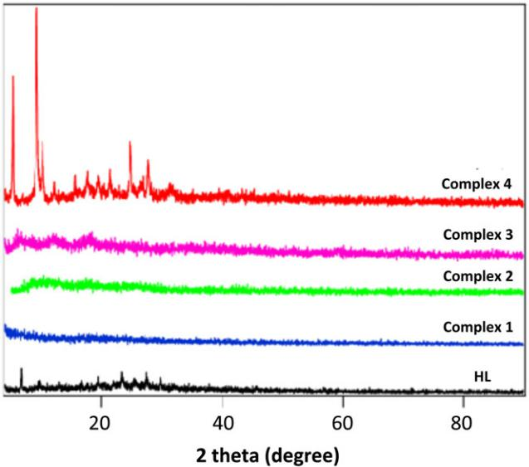

patterns revealed that Cu (II) complex 4 exhibit nano‐ crystalline phase, whereas HL and complexes 1─4 showed amorphous nature. This behavior may suppos-edly be assigned to the incorporation of the H₂O mole-cules. A comparative analysis between the patterns of ligand and those of metal complexes refers to the absence of smearing or contamination with starting reactants. The value of average particle size of Cu (II) complex 4 was calculated applying the Deby‐Scherrer equation, and found to be 5.3627 nm.

The occurrence of the novel compounds in such scru-pulous modernistic nanometer scale ordinarily attract formidable attention due to their outstanding functional properties and a wide range of interesting technological

applications, including microelectronics, optics, catalysis, chemical and bio‐sensors.^{[33]}

3.9 | Molecular modeling studies

The model geometric structures of HL and complexes 1─4 have been achieved by optimization of their bond lengths, dihedral angles and bond angles, using the hyper chem. 8.03 molecular modeling program.^{[34]} The structures were optimized (Figures 3–7) with minimum energies acquired applying the quantum chemical calcu-lations. Selected bond lengths and bond angles of signifi-cant importance are presented in Tables 2S–6S. As shown presented in Figure 3, the studied ligand has a planner form. The bond lengths between atoms in coordination center are C(3)‐O(13) = 1.192, C(4)‐N(14) = 1.318, N(14)‐N(15) = 1.338, N(15)‐C(21) = 1.452, C(27)‐ O(28) = 1.366 and C(27)‐O(29) = 1.208 Å. Upon chela-tion, the bond lengths of free ligand HL are altered to some extent, essentially for the atoms in direct interaction

FIGURE 3 Optimized molecular structure of 2‐((5‐oxo‐1,3‐ diphenyl‐4,5‐dihydro‐1H‐pyrazol‐4‐ yl)diazenyl) benzoic acid (HL)
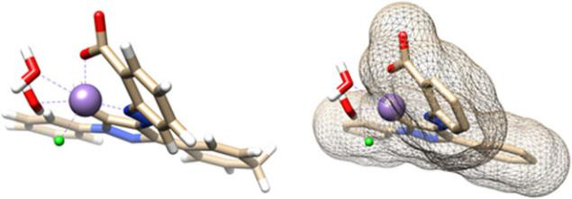
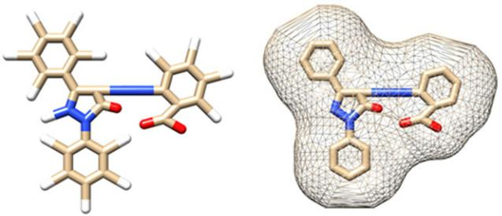

FIGURE 4 Optimized molecular structure of Mn (II)‐complex (1)
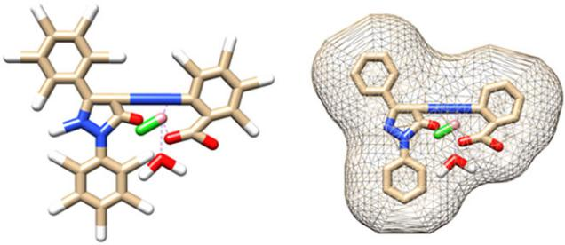

FIGURE 5 Optimized molecular structure of Co (II)‐complex (2)
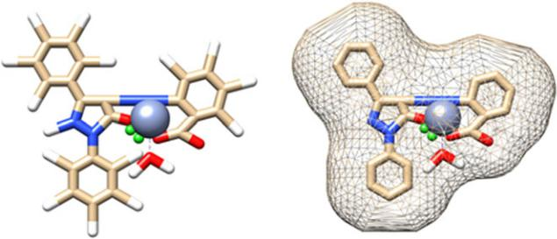

with the metal ions. Otherwise, the bond lengths of the rest atoms in HL are slightly or not altered upon chelation with the metal ions under interest. The optimization revealed that Mn (II) complex 1 has an octahedral geometry. The bond lengths of central metal atom with the chelating atom are Mn(31)‐N(20) = 1.786, O(29)‐Mn(31) = 1.888, O(22)‐Mn(31) = 1.884, Mn(31)‐

O(35) = 2.375 and Mn(31)‐O(32) = 1.893 Å. Also, The bond lengths of Cr (II) ion with the chelating atoms are Cr(30)‐N(15) = 1.968, O(13)‐Cr(30) = 1.937, O(29)‐ Cr(30) = 1.847, Cr(30)‐Cl(31) = 2.260, Cr(30)‐ O(33) = 1.968 Å. The bond angles around Mn and Cr atoms (Tables 3S and 5S) are quite near to an octahedral geometry,^{[35]} indicting sp³d² hybridization. Co (II) and Cu (II) complexes are found to attain distorted tetrahe-dral structures where the hydroxyl oxygen atom and N‐atom are coordinated to the metal center. In Cu (II) complex 4, the bond lengths of Cu atom and chelating atoms are Cu(30)‐N(15) = 1.902, O(13)‐Cu(30) = 1.849, O(29)‐Cu(30) = and Cu(30)‐Cl(31) = 2.160 Å. The bond angles of ligand are changed upon chelation with Cu

- and Co (II) ions. The largest changes occur for those bonding the N‐atom and hydroxyl oxygen supporting their co‐ordination to the metal centers (Tables 4S and 6S). As example, the optimization bond angles around Co‐atom are C(31)‐N(15)‐Co(30) = 115.66, N(15)‐Co(30)‐ Cl(31) = 110.79, Co(30)‐O(32)‐H(33) = 109.47 and O(29) Co(30)‐O(32) = 110.80, which confirms the distorted tetrahedral geometry of the complex 2. The computed bond angles around Cu atom are C(3)‐O(13)‐ Cu(30) = 116.02, O(13)‐Cu(30)‐N(15) = 100.12, N(15)‐ Cu(30)‐O(29) = 97.38 and C(21)‐N(15)‐Cu(30) = 125.17^{ο}. From the change between minimum and maximum bond angles around Co (II) and Cu (II) ions distorted tetrahe-dral geometries are proposed.^{[36]} The evanescence of O‐H bond and appearance of novel M‐O bond supported the participation of carboxylic hydroxyl group in chelate formation.^{[37]} As a result of electronegativity difference

between the oxygen and nitrogen atoms, the M‐O bond length differs than that of M‐O bond.^{[38,39]}

FIGURE 6 Optimized molecular structure of Cr (III)‐complex (3)
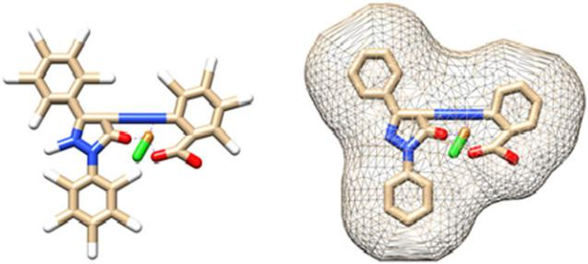

FIGURE 7 Optimized molecular structure of Cu (II)‐complex (4)

3.10 | In‐vitro antifungal and antibacterial assays

The in‐vitro antimicrobial efficiencies of HL and the inspected complexes 1─4 were examined against E. coli, P. vulgaris, S. aureus, B. subtillis, A. fumigatus and C.

albicans stratify the modified Kirby–Bauer disc diffusion technique.^{[14,15]} The obtained results are displayed in
Table 7S. The free ligand under interest and complexes 1─4 did not display any anti‐fungal activities against the examined organisms. The free organic ligand and com-plexes 1─4 showed moderate to high efficiencies across

E. coli and P. vulgaris. Furthermore, the HL and complexes 2 and 3 exhibited moderate activities against S. aureus and B. subtillis. This character may be clearfield depending on the concepts of chelation theory.^{[40]} This theory states that a diminution in the metal polarizability could reinforce the lipophilicity of the metal complexes. This causes a slump of the permeability of the cells, resulting in inter-vention with normal processes of the cells. Hence, the complexation leads to make the azo compounds act as more potent and vigorous antimicrobial agents, inhibiting

the growth of bacteria more and more compared with than the parent organic ligand.^{[41]} So, it is concluded that the

chelation process significantly affects the efficacy of mate-rials that are potent towards microbial strains.

3.11 | Antitumor activity evaluation

Novel anticancer agents are in need to combat the acquired drug resistance often seen in cancer patients.^{[42]} The anticancer performance of HL and complexes 1─4 was detected in vitro against human hepatocellular carci-noma cells (HEPG2) utilizing Doxorubicin (Dox) as a ref-erence drug (IC₅₀ = 4.73). Also, the untreated cells were applied as a reference control. Each data point was deter-mined as the average of three separated experiments and specified as mean ± SD. Growth inhibition of 50% (IC₅₀) is determined as the compound concentrations, which leads to a 50% lowering in cell proliferation pending the tested compound incubation.^{[43]} From the gained results it is shown that the growth inhibition of the tested cells is strongly affected by the character of metal ion and increases in the order; Mn (II) complex < Cr (III) com-plex < Co (II) complex < Cu (II) complex < HL. This denotes that the type of metal ion play a significant role in determining the anticancer efficiency.^{[44]} According to Shier.^{[45]} the compounds displaying IC₅₀ values within 10.00–25.00 μg/ml range are considered weak anticancer agents, compounds exhibit IC₅₀ value between 5.00– 10.00 μg/ml are moderate, whereas those below 5.00 μg/ml are strong anticancer agents. HL and complexes 1, 2, 3 and 4 exhibited a weak activity towards human liver Carci-noma cell line (HEPG2) and showed IC₅₀ values of 15.3, 174, 52.4, 102 and 23.5 μg/ml, respectively.

3.12 | Molecular docking analysis

The inhibition constant, Ki (μM), free energy of binding, total estimated energy of vdW + Hbond + desolv (kcal/mol), total intermolecular energy parameters and electrostatic energy were computed to evaluate the favor-able binding of HL to the proteins. Table 4 presented the complete profile of all mentioned parameters of HL for its interaction with receptor of 4 m01 (Staphylococcus aureus adhesion protein), 3 t88 (Escherichia coli), 1zap (secreted aspartic protease from Candida albicans), and 4ynt (Aspergillus flavus FAD glucose dehydrogenase). One of the most favorable bindings of the ligand was its binding with 4ynt and 3 t88 and proteins with evaluated free energy of binding −6.91 and − 6.98 kcal/mol, respec-tively. Also, the ligand showed the inhibition constant (ki) of 7.59 and 8.56 μM of 3 t88 and 4ynt, respectively. Figure 10S displays the binding of the azo pyrazolone ligand (HL) to the protein 3 t88. A 2D plot was generated where hydrogen bonds, non‐ligand bond, and ligand bond, in addition to their lengths were mentioned (Figure 10S). A HB plot has been generated to mention interactions with various amino acids of the protein (Figure 8). Similarly, Figures 11S–16S showed the binding pattern of the azo pyrazolone ligand (HL) with 1zap (secreted aspartic protease from Candida albicans), 4ynt
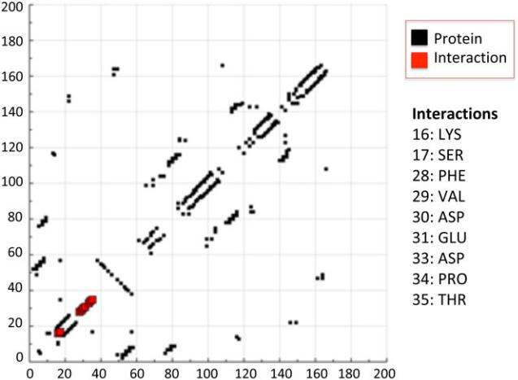

FIGURE 8 HB plot of interaction between azo pyrazolone ligand (HL) and receptor of Escherichia coli (3 t88)

TABLE 4 Binding energies for the interactions between azo pyrazolone ligand (HL) and 3t88, 4m01, 1zap and 4ynt

 | Est. Free Energy of | Est. Inhibition | vdW + Hbond + desolv | Electrostatic | Total Intermolec.
Interaction | Binding (kcal/mol) | Constant, Ki (μM) | Energy (kcal/mol) | Energy (kcal/mol) | Energy (kcal/mol)
Ligand‐3 t88 | −6.98 | 7.59 | −8.94 | −0.02 | −8.96
Ligand‐4 m01 | −4.64 | 394.25 | −5.53 | +0.06 | −5.47
Ligand‐1zap | −5.87 | 49.61 | −7.63 | −0.04 | −7.67
Ligand‐4ynt | −6.91 | 8.56 | −8.07 | −0.01 | −8.08

(Aspergillus flavus FAD glucose dehydrogenase), and 4 m01 (Staphylococcus aureus adhesion protein). Colletively, the in silico molecular docking analysis confirm the in vitro findings of the anti‐microbial activity of azo pyrazolone ligand (HL) and possibly its complexes. Hence, our findings present these complexes as novel nano‐synthesized azopyrazolone complexes with antimi-crobial activities.

4 | CONCLUSION

Four novel nano‐size Mn (II), Co (II), Cr (III) and Cu (II)] complexes with 2‐((5‐oxo‐1,3‐diphenyl‐4,5‐dihydro‐1H‐ pyrazol‐4‐yl)diazenyl) benzoic acid (HL) were synthe-sized. The complexes were investigated using spectral (FT‐IR, UV–Vis, ESR, MS), thermal and elemental analy-ses. The XRD confirmed the nano‐sized nature of Cu (II) complex. Mn (II) and Cr (III) complexes have octahedral arrangement while Co (II) and Cu (II) complexes have distorted tetrahedral configuration. Molecular modeling was performed by the molecular mechanic calculation using the hyper chem. 8.03 molecular modeling program to give the most stable geometry. The mechanism, E, n,

H*, S*, A, and G* values for thermal decomposition of the inspected complexes were determined from TGA curves applying Coats‐Redfern method. Azo pyrazolone ligand (HL) and complexes 1─4 displayed a weak anti-cancer activity and a reasonable anti‐microbial activity as confirmed by the in vitro and in silico studies.

REFERENCES

- J. I. Saad, A. El Achari, J. Mol. Struct. 2018, 1154, 557.

- M. A. Abdelgawad, M. B. Labib, W. A. M. Ali, G. Kamel,

  - A. Azouz, E. EL‐Nahass, Bioorg. Chem. 2018, 78, 103.

- G. Mariappan, B. Saha, L. Sutharson, A. Singh, S. Garg, L. Pandey, D. Kumar, Saudi Pharm. J. 2011, 19, 115.

- N. Parekh, K. Maheria, P. Patel, M. Rathod, Int. J. Pharm. Tech. Res. 2011, 3, 540.

- S. R. Kamat, R. S. Salunkhe, P. B. Choudhari, R. P. Dhavale, A.

  - Mane, T. R. Lohar, Res. Chem. Intermed. 2018, 44, 1351.

- P. Manojkumar, T. Ravi, G. Subbuchettiar, Acta Pharm. 2009, 59, 159.

- A. Zaoui, Hammal, N. Bennamane, S. Merabtene, B. N. Kolli, Int. J. Pharm. Bio. Sci. 2013, 3, 732.

- S. E. Forest, M. J. Stimson, J. D. Simon, J. Phys. Chem. B 1999, 103, 3963.

- P. Santos, A. Antunes, J. Noronha, E. Fernandes, A. J. S. C. Vieira, Eur. J. Med. Chem. 2010, 45, 2258.

- A. A. S. Al‐Hamdani, W. Al‐Zoubi, Spectrochim. Acta A 2015, 137, 75.

- T. Aysha, A. Lycka, S. Lunák Jr., O. Machalický, M. Elsedik,

  - Hrdina, Dyes Pigm. 2013, 98, 547.

- M. N. Al‐Jibouri, Eur. Chem. Bull. 2014, 3, 447.

- R. Gup, B. Kirkan, Spectrochim. Acta A 2005, 62, 1188.

- A. C. Scott, Laboratory Control of Antimicrobial therapy, in Practical Medical Microbiology, 13th ed. (Eds: J. G. Collee,

  - P. Duguid, A. G. Frasa, B. D. Marmion), Churchill Livingestone, Edinburgh 1981.

- M. Gaber, A. M. Khedr, M. Elsharkawy, Appl. Organomet. Chem. 2017, 31. https://doi.org/10.1002/aoc.3885

- T. Mosmann, J. Immunol. Methods 1983, 65, 55.

- A. P. Wilson, in Cytotoxicity and viability assays in animal cell culture: A practical Approach, 3rd ed. (Ed: J. R. W. Masters), Oxford University Press, Oxford 2000.

- D. C. Onwudiwe, A. C. Ekennia, E. Hosten, J. Coord. Chem. 2016, 69, 2454.

- A. M. Khedr, M. Gaber, K. M. Saad‐allah, Chin. J. Inorg. Chem. 2014, 30, 1201.

- B. K. Singh, P. Mishra, B. S. Garg, Transition Met. Chem. 2007, 32, 603.

- K. Y. El‐Baradie, M. Gaber, Chem. Pap. 2003, 57, 317.

- J. Liu, D. Song, H. Guan, Russ. J. Appl. Chem. 2016, 89, 1009.

- C. R. Vinodkumar, M. K. Muraleedharan, P. K. Radhakrishnan,

  - Therm. Anal. Calorim. 2000, 61, 143.

- W. H. Mahmoud, G. G. Mohamed, M. M. I. El‐Dessouky, Spectrochim. Acta A 2014, 122, 598.

- T. M. A. Ismail, J. Coord. Chem. 2005, 58, 141.

- A. Z. El‐Sonbati, M. A. Diab, A. A. El‐Bindary, S. G. Nozha, Spectrochim. Acta A 2011, 83, 490.

- S. Chandra, L. K. Gupta, Ind. J. Chem. Soc. 2005, 82, 454.

- K. Siddappa, M. Kote, P. C. Reddy, T. Reddy, J. Chem. Pharm. Res. 2011, 3, 780.

- N. El‐wakiel, M. El‐keiy, M. Gaber, Spectrochim. Acta A 2015, 147, 117.

- A. M. A. Alaghaz, R. A. Ammar, Eur. J. Med. Chem. 2010, 45, 1314.

- M. Gaber, N. A. El‐Wakiel, H. El‐Ghamry, S. K. Fathalla,

  - Mol. Struct. 2014, 1076, 251.

- A. A. Fahem, Spectrochim. Acta A 2012, 88, 10.

- A. Salimi, R. Hallaj, S. Soltanian, Biophys. Chem. 2007, 130, 122.

- HyperChem Version 8.03, Hypercube, Inc., Gainesville, FL.

- K. El‐Baradie, N. A. El‐Wakiel, H. A. El‐Ghamry, Appl. Organomet. Chem. 2015, 29, 117.

- S. Amer, N. A. El‐Wakiel, H. A. El‐Ghamry, J. Mol. Struct. 2013, 1049, 326.

- A. Despaigne, J. Silvva, A. Carmo, O. Piro, E. Castellano,

  - Beraldo, J. Mol. Struct. 2009, 920, 97.

- T. A. Yousef, G. M. Abu El‐Reash, R. M. El Morshedy, J. Mol. Struct. 2013, 1045, 145.

- T. A. Yousef, G. M. Abu El‐Reash, R. M. El‐Morshedy, Polyhedron 2012, 45, 71.

- A. M. Khedr, M. Gaber, E. H. Abd El‐Zaher, Chinese J. Chem. 2011, 29, 1124.

- A. Kulkarni, P. G. Avaji, G. B. Bagihalli, S. A. Patil, P. S. Badami,

  - Coord. Chem. 2009, 62, 481.

- A. S. Sultan, H. Brim, Z. A. Sherif, Cancer Sci. 2008, 2, 272.

- S. H. Etaiw, S. A. Amer, M. M. El‐Bendary, J. Inorg. Organomet. Polym. 2011, 21, 662.

- X. Riera, V. Moreno, C. J. Ciudad, V. Noe, M. Font‐Bardía,

  - Solans, Bioinorg. Chem. Appl. 2007, 98732.

- W. T. Shier, Mammalian Cell Culture on $5 a Day: A Lab Manual of Low Cost Methods, University of the Philippines, Los Banos 1991.

SUPPORTING INFORMATION

Additional supporting information may be found online in the Supporting Information section at the end of the article.

