STEAM-MiTiS: An MR Spectroscopy Method for the Detection of Scalar-Coupled Metabolites and Its Application to Glutamate at 7 T
Alessandra Toncelli,¹* Ralph Noeske,² Mirco Cosottini,^{3,4} Mauro Costagli,^{4,5} Valentina Domenici,⁶ Gianluigi Tiberi,^{4,5} and Michela Tosetti^{4,5}

Purpose: We herein present a spectroscopic technique for the detection of scalar-coupled metabolites based on stimulated echo acquisition mode (STEAM). The method is based on the time evolution of scalar-coupled metabolites at different mixing times and a constant echo time. The technique is optimized for targeting the metabolite glutamate at 7T.
Methods: Numerical simulations were used to optimize the parameters to maximize the chosen metabolite signal. The maxi- mum detection efficiency and metabolite signal as a function of echo time were used to identify the optimal parameters. In vitro and in vivo validations of the method were also performed.
Results: This method canceled all the strong singlet lines and signals from macromolecules and preserved signals originating from the scalar-coupled metabolites. The subtracted spectrum was strongly simplified, but the complete spectral information of the traditional STEAM acquisition was retained in the sum spectrum.
Conclusions: The simulations performed in this study were in agreement with the experimental results, and a clear detection of the metabolite of interest was obtained. The applicability in vivo was also demonstrated, with the selective detection of glu- tamate in human brain. This technique is simple, suitable for standard MR systems without sequence programming and could be used to detect other metabolites. Magn Reson Med 74:1515–1522, 2015. VC 2014 Wiley Periodicals, Inc.
Key words: scalar-coupled metabolites; MR spectroscopy; ultra-high field; metabolite detection

INTRODUCTION
MR spectroscopy (MRS) has proven to be a reliable and noninvasive technique for the detection of brain metabo- lites. However, many metabolites consist of coupled spin

¹INFN and Department of Physics, University of Pisa, Pisa, Italy.
²MR Applications and Workflow Development, GE Healthcare, Berlin, Germany.
³Dipartimento di Ricerca Traslazionale e delle Nuove Tecnologie in Medic- ina e Chirurgia, University of Pisa, Pisa, Italy.
⁴Fondazione IMAGO7, Pisa, Italy.
⁵Laboratorio di Fisica Medica e Biotecnologie per la Risonanza Magnetica IRCCS Fondazione Stella Maris, Pisa, Italy.
⁶Dipartimento di Chimica e Chimica Industriale, University of Pisa, Pisa, Italy
systems and often overlap with much stronger singlet signals, which prevents their clear detection. This is the case, for example, for glutamate (Glu), glutamine (Gln) and g-aminobutyric acid (GABA), whose concentration can undergo alterations in neurodegenerative diseases and psychiatric disorders. Consequently, there has been great interest in the possibility of spectral editing of the signal of these neurotransmitters that play such an important role in the metabolism of the brain.
Traditionally, editing approaches for the detection of these metabolites have been based either on optimization of echo time (TE) (1,2), multiple quantum filtering (3–7), J-resolved spectroscopy (8–12), or other two-dimensional editing techniques (13–16). However, all these techni- ques require specific sequences that are not usually available on MR systems. At 7T spectral overlap of other resonances like Gln (17) and GABA is still an important issue, unless a careful choice of sequence timing is per- formed (1,18,19). In most cases, the quantification of Glu is still performed through fitting of the overlapping resonances and macromolecules (20–26). Therefore, the reliability of the uncontaminated quantification depends upon the robustness of the data processing and fitting programs used. Some investigators have also developed customized editing sequences to accomplish Glu spectral editing (27,28).
Recently, a simple metabolite detection technique has been applied to the point-resolved spectroscopy (PRESS) localization technique to obtain spectral editing of citrate in the prostate at 1.5T and 3T (29) and of Glu, Gln, and myo-inositol in the human brain at 4.7T (30). In these cases, the authors exploit the asymmetry of the PRESS sequence and subtract two spectra with same TE and dif- ferent interpulse timing. The analysis is performed through accurate analytical solutions and/or numerical simulation of the time evolution of the spin systems under PRESS excitation. Metabolite signal intensity is predicted to undergo a large modulation as a function of interpulse timing (29), and the optimized combinations that maximize the signal in the subtracted spectrum are identified by analyzing the signal intensity or the inte- grated area at specific TEs (29,30).
In the present study, we applied a similar method to the stimulated echo acquisition mode (STEAM) localiza- tion sequence at 7T for the spectral editing of Glu. This approach was used as far as back 1998 for the detection (or editing) of lactate at clinical field strength (31); how- ever, to the best of our knowledge, a systematic optimi- zation of the acquisition parameters has never been

+

reported. The proposed method is called STEAM-mixing time subtraction (MiTiS) and involves the acquisition of two different STEAM spectra with the same TE but dif- ferent mixing times (TMs) for each J-coupled metabolite. The sum of the two spectra gives the complete STEAM spectral information at that specific TE, but the differ- ence of the two acquisitions cancels out the singlet con- tributions while preserving the information of scalar- coupled metabolites. The use of the STEAM localization sequence instead of PRESS leads to an inherent 50% loss of the signal from the volume of interest, but it per- mits the use of shorter TEs and a larger variation in the interpulse time; this is because in PRESS, the time between the two refocussing pulses is part of the echo time, therefore it can never exceed half of TE. In addi- tion, the use of STEAM leads to a more complicated sig- nal modulation because of the formation of multiple quantum coherences and polarization transfer effects (32). Instead of being a problem, this feature can be an advantage for obtaining “spectral editing” or selective detection of the desired metabolites. Moreover, because the STEAM sequence employs only excitation pulses, the specific absorption rate is generally lower than it is for PRESS.
We present a method that is optimized for the selec- tive detection of Glu at 7T. Compared with other meth- ods for the detection and quantification of Glu at 7T, STEAM does not require sequence programming and helps in obtaining a spectral simplification that permits the use of simple, homemade fitting programs for quanti- fication while controlling possible contamination from other resonances. This application at ultra-high field strength can be considered as a proof of principle, but this work can also serve as a guide for the optimization of the acquisition parameters in the selective detection of other scalar-coupled metabolites and/or at other field strengths due to the versatility of the method.
To determine the parameters that maximize the signal of Glu in the subtraction spectrum, we performed a com- plete simulation of all possible combinations of the two mixing times. We accomplished systematic numerical simulations as a function of both TE and TM and calcu- lated all the possible TM_{i}-TM_{j} combinations for each TE. We performed numerical simulations instead of analyti- cal modeling because J-coupling tends to weaken at higher field strength; therefore, at 7T, the Glu system is a complex mixture of weakly and strongly coupled spins that makes analytical solution of the complete system infeasible. On the contrary, the numerical approach takes all strong and weak couplings into account; therefore, it can provide more reliable results, especially for compli- cated systems.
The Glu system is labeled as AMNPQ according to the Pople notation (33). The PQ group (2.33–2.35 ppm) is usually the target for in vivo detection because it has been shown that, with appropriate sequence timings, it is possible to spectrally separate the PQ groups of the two metabolites (19), with better separation at higher field strength. The MN group (2.03–2.13 ppm) is hin- dered by the strong singlet line of N-acetylaspartic acid (NAA) and the A peaks at 3.75 ppm cannot be spectrally separated from the analogous Gln peaks. In principle,
the STEAM-MiTiS method could overcome both difficul- ties; in particular, the superposition of the MN peak with the strong NAA singlet is of little concern because the method is capable of canceling out the singlet signals that do not undergo scalar evolution with the mixing time. The A peaks instead suffer from strong overlap with the Gln signal. In this case, the best combination of TMs for subtraction should not only maximize the signal but also minimize Gln contribution. For these reasons, we performed the simulations on all the spin groups sep- arately and compared the results to find the best combi- nation of mixing times.
Simulation results were tested with phantom acquisi- tions, and we ascertained the linear dependence of the processed metabolite signal. We herein demonstrate the in vivo feasibility of STEAM-MiTiS for the detection of Glu in the human brain.

METHODS
Numerical Simulations
Density matrix simulation at various TEs and TMs were performed with the VESPA package (http://scion.duhs. duke.edu/vespa/), and the following analysis was imple- mented with a homemade routine in MATLAB (Math- Works, Natick, Massachusetts, USA).
Theoretical simulations were performed to identify the metabolite response to a standard STEAM sequence with crusher gradients simulated around the second and third excitation pulses by creating four copies of the operator matrix at that point, rotating at 0◦, 90◦, 180◦, and 270◦ to each other, applying the 90◦ pulses and TM period, and then adding the four copies back into one normalized matrix. Simulations were performed at various TEs and TMs, and each spectrum was broadened using a 9-Hz Lorentzian filter to better approximate in vivo experi- mental data. In the calculation, ideal pulses were consid- ered, so any possible errors in pulse shape and angle were not taken into account. Metabolite information regarding the coupling constant J and chemical shift dif- ference D were taken from the literature (34). T₁ relaxa- tion during the TM period was not considered, because
in this case TM << T₁.
Simulations were performed at TE ¼ 12 ms and then
from 15 to 100 ms with 5-ms step increments and TMs in the range 0.1–35 ms with a 0.1-step increment for a total of 6300 calculated free induction decays (FIDs) and
39.69 · 10⁶ difference spectra. In fact, the subtracted sig- nal is strongly dependent on TM with a large quasi- periodic modulation, which can have a period as short as 0.3 ms. On the contrary, the signal dependence with TE is not so large; therefore, we judged that decreasing the TE step size further was unnecessary. The bounda- ries of the TE range were chosen by taking into account the reduction of T₂ decay at 7T. Measured T₂ decay con- stants of Glu at 7T in the human brain range from 88 to 139 ms in the literature, depending on the region of the brain being observed (35); therefore, we did not extend the simulations to TE longer than 100 ms.
For every TE, we built a TM-TM map of the metabolite detection efficiency (h), which is a dimensionless value

calculated as the magnitude of the maximum subtracted intensity divided by twice the maximum peak at that TE:
All phantom acquisitions were performed with 64 averages and number of excitations ¼ 8. In addition to using the optimized TE and TM₁-TM₂ couples deter-

hTE
max ðabsðI_{TE}ðTM_{i}Þ— I_{TE}ðTM_{j}ÞÞÞ
2max ðabsðI_{TE}ðTM_{i}ÞÞÞ
¼
[1]
mined from the analysis of the simulations as specified in the text, we also performed acquisitions at other TE and TM₁-TM₂ couples to test the simulation prediction;

where I_{TE}(TM_{i}) denotes the intensity of the spectrum
simulated at TE and TM_{i} and the maximum is calculated at every TE over the whole spectral range under analysis and all the possible TM_{i} and TM_{j} couples.
The maxima in the maps identify the TM₁-TM₂ combi- nations that maximize the metabolite detection efficiency as a function of TE. For comparing the results at various TEs, we plotted the maximum metabolite detection effi- ciency as a function of TE. We then calculated the maxi- mum predicted signal, given by the metabolite detection efficiency multiplied by the maximum peak at every TE weighted with an exponential T₂ decay of 100 ms, which can be considered an average value for the whole brain.

Experimental Setup
All experiments were performed using a MR950 7.0 T system (GE Healthcare, Milwaukee, Wisconsin, USA) equipped with a two-channel transmit/32-channel receive coil (Nova Medical, Wilmington, Massachusetts, USA).
Prior to actual spectroscopy acquisitions, particular care was devoted to the RF calibration procedure to set the optimum transmit gain (TG) to calibrate B1þ in the volume of interest (VOI) by means of the Bloch-Siegert (BS) shift method (36) that was implemented by modify- ing a standard PRESS sequence (37). Two off-resonant BS pulses (6 ms Fermi pulses, 64 kHz relative to water, K_{BS} ¼ 110 rad/G²) applied symmetrically around the last refocusing pulse were included. Data processing was implemented in MATLAB. Optimal TG was calculated from the mean of the Bloch-Siegert phase shift (37).
The single-voxel STEAM sequence was performed with three linear phase Shinnar-Le Roux designed excitation pulses with 2.3 kHz bandwidth and 3.6 ms pulse width. The acquisition was modified for acquiring two different FIDs with identical parameters (repetition time ¼ 2000 ms; spectral width ¼ 5000 Hz; number of points ¼ 4096; voxel size ¼ 2 × 2 × 2 cm³ for all acquisitions and spe- cific TE; number of scans and number of excitations that will be reported for each acquisition) and two different mixing times in interleaved fashion. Data analysis was performed with a homemade routine in MATLAB, and consisted in zero-filling, coil combination, Gaussian apodization (1.25 Hz for in vitro and 4 Hz for in vivo acquisitions), frequency alignment of the water line (applied only to in vivo acquisitions), internal water ref- erence, FID average, fast Fourier transform, residual water subtraction, and constant-value baseline correction.

Phantom Measurements
For in vitro acquisitions, we used homemade phantoms containing a standard solvent (72 mM K₂HPO₄, 28 mM KH₂PO₄, 200 mM Na formate [catalog #71539, Sigma Aldrich, St. Louis, MO, USA], 1 g/L NaN₃, 1 mM TSPS),
10 mM of creatine (Cr), and various concentrations of Glu (12.5 mM, 9.1 mM, 6.3 mM, and 2.4 mM).
moreover, a systematic test was performed at TE ¼ 65 ms. In this case, we acquired 51 spectra at a 0.5-ms step increments from TM ¼ 10 ms to TM ¼ 35 ms.

In Vivo Measurements
Spectra were acquired in five healthy volunteers who gave their written informed consent to the procedure on the basis of the adhesion to an experimental protocol named “Clinical impact of ultra high-field MRI in neuro- degenerative diseases diagnosis” (RF-2009–1546281) approved and funded by Italian Ministry of Health and cofunded by the Health Service of Tuscany. The study was approved by the local ethics committee. VOI was located in the left primary motor cortex (M1). The STEAM sequence was performed with the same parame- ters used for phantom acquisitions, except for 80 aver- ages for a total acquisition time of 6 min and 40 s.
Quantification was performed through least-square fitting of the Glu line in the subtracted spectrum and the Cr line in the sum spectrum with the corresponding simulated spectra without correction for different T₁ and T₂ values, which are expected to be similar for these two metabolites (24). Relative concentration was calculated as the ratio of the fitted areas and absolute estimate was obtained assum- ing 8 mM Cr concentration in the brain (26).

RESULTS
Simulations
Simulation results were analyzed by calculating all the possible difference spectra for every TM_{i}-TM_{j} couple. From these, we extracted the maximum metabolite detec- tion efficiency h and predicted maximum signal for every spin group at each TE.
Figure 1 shows two examples of TM-TM maps. The left map (Fig. 1a) shows the metabolite detection effi- ciency h of the MN group for TE ¼ 40 ms, the right map (Fig. 1b) shows the metabolite detection efficiency of the PQ group for TE ¼ 65 ms. As expected, the maps are symmetric and present zeroes along the main diagonal, which refers to the subtraction of two spectra with the same TM that are identical. As a convention, TM₁ will always refer to the shorter TM in the TM₁-TM₂ couple. The patterns show some regions with high metabolite detection efficiency but with a large modulation super- imposed, which makes the localization of the real max- ima difficult. We performed the simulations at a 0.1-ms TM step size to highlight the real pattern of the result. These features are common for all maps, but the quasi- period of the modulation depends on TE and is peculiar for each metabolite and spin group, in agreement with the findings reported by Snyder et al. (29).
Figure 1a shows that the zones of highest editing effi- ciency for the MN group at TE ¼ 40 ms were concen- trated in the region TM₁ ¼ 4–8 ms, TM₂ ¼ 10–24 ms. The

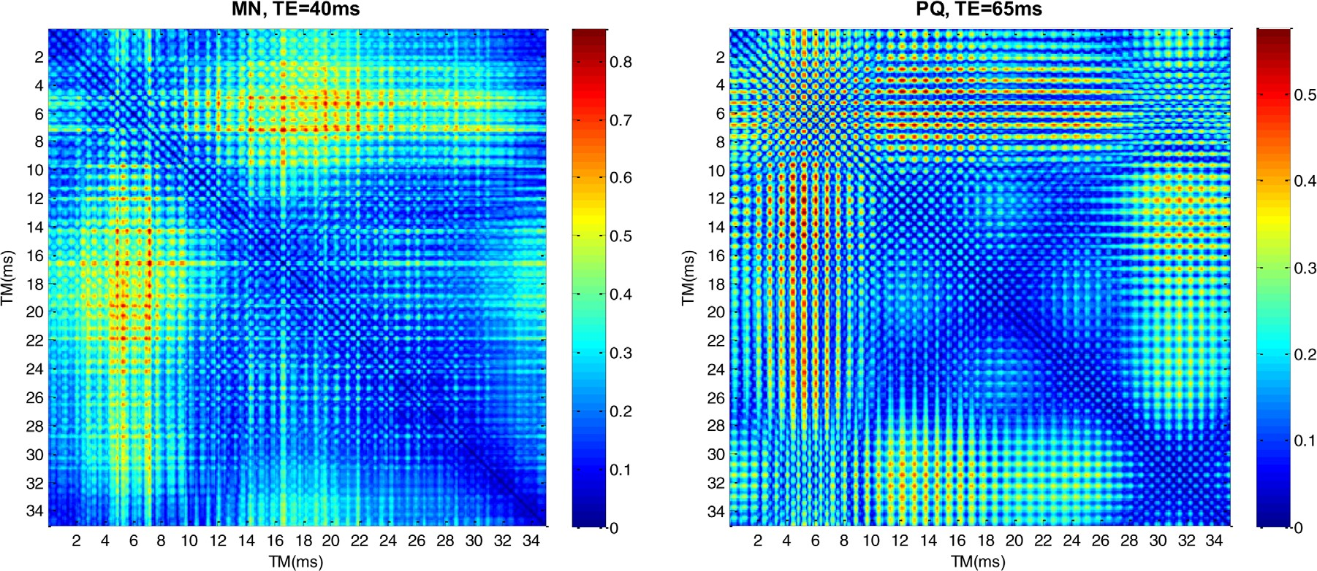

FIG. 1. Color plot of the detection efficiency (h) for all possible TM-TM combinations. a: MN group at TE ¼ 40 ms. b: PQ group at TE ¼ 65 ms.

highest efficiency h was found at coordinates (TM₁, TM₂) ¼ (7.2, 16.6), even if other local maxima were pres- ent, and the maximum efficiency was 0.86.
Figure 1b shows that different regions of high efficiency for the PQ group were identified at TE¼ 65 ms: one was located in the region TM₁ ¼ 10–16 ms, TM₂ ¼ 29–35 ms and was centered at (TM₁, TM₂) coordinates (13 ms, 31.5 ms), and another one was located in the region TM₁ ¼ 4–8 ms, TM₂ ¼ 10–24 ms with the highest peak located at (5.3 ms, 14.6 ms) corresponding to h ¼ 0.56.
Figure 2a shows the trend of the maximum metabolite detection efficiency for the three spin groups of Glu. The MN group has always the highest efficiency with respect to the other groups, and its maximum is reached for TE ¼ 40 ms. The efficiency of the PQ and A groups is similar: they both show a trend in increasing the effi- ciency with TE, and in all cases, the efficiency is higher than 0.5 for TE > 50–60 ms. The efficiency of all the three spin groups becomes similar at long TE.
Figure 2b shows the predicted maximum signal weighted for T₂ decay for every spin group in arbitrary units. Although the highest metabolite detection effi- ciency was found for the MN group, at every TE the highest subtracted signal was predicted for the PQ group, instead, and the weakest for the A peak. This is because although the metabolite detection efficiency may be high, if the maximum signal at that specific TE is low, it can result in a low signal. For this reason, we preferred the intensity of the signal over the metabolite detection efficiency. In all cases, the maximum signal was pre- dicted at intermediate TE—that is, in the region 50–70 ms for all the spin groups. The highest signal was found for the PQ group at TE ¼ 60–65 ms. It is worth noting that the maximum signal before T₂ decay weighting showed a trend at increasing with TE similar to the metabolite detection efficiency, but the exponential T₂ decay reduced the signal at long TE, making it unfavora- ble to use a TE longer than 80 ms.

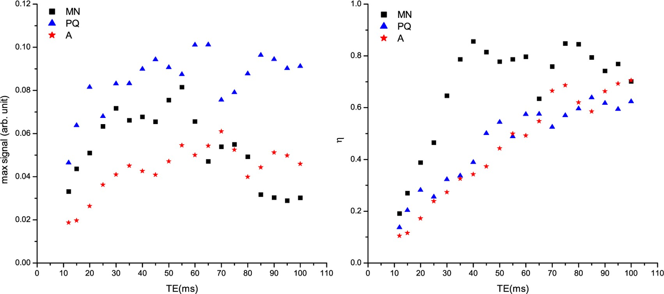

FIG. 2. a: Maximum detection efficiency (h) for the three spin groups of Glu as a function of TE. b: Predicted maximum signal (max I) for the three spin groups of Glu as a function of TE.

Table 1
Optimized Parameters for the Various Spin Groups of the Metabolites of Interest

TE (ms) | Group | TM₁ (ms) | TM₂ (ms) | h | Max I  (arbitrary units) | Gln/Gluª (%) | GABA/Gluª (%)
12 | PQ | 1.1 | 7.6 | 0.14 | 0.046 | 7.5 | 36
12 | PQ | 7.6 | 13.3 | 0.10 | 0.035 | 85 | 69
12 | MN | 12.9 | 32.2 | 0.19 | 0.033 | 21 | 2.5
12 | A | 0.3 | 2.9 | 0.11 | 0.019 | 118 | 18
12 | A | 6.1 | 6.9 | 0.08 | 0.015 | 118 | 1.9
40 | MN | 7.2 | 16.6 | 0.86 | 0.041 | 29 | 36
55 | MN | 7.2 | 10 | 0.75 | 0.078 | 65 | 14
55 | A | 6.9 | 13.7 | 0.48 | 0.053 | 14 | 8
60 | PQ | 6.4 | 13.3 | 0.56 | 0.098 | 29 | 65
65 | PQ | 5.3 | 14.6 | 0.56 | 0.10 | 0.5 | 23
65 | PQ | 13 | 31.5 | 0.47 | 0.082 | 3 | 31
70 | A | 9 | 15.7 | 0.56 | 0.052 | 9 | 3
ªRatio of the integrals of the Gln or GABA signals with that of Glu over the spectral range of the Glu spin group shown as a percentage.

Table 1 summarizes a selection of the results obtained from the simulations. For each spin group, the combina- tions of TM₁ and TM₂ that maximized the metabolite detection efficiency and the maximum signal are pro- vided. Some of these maxima occurred at TM < 10 ms and would have thus been difficult to implement due to MR system limitations in the minimum TM obtainable because of finite pulse and gradient durations. When
this was the case, we included other secondary maxima that occurred at longer TMs. Table 1 also shows the
overlap was 3% and 31%, respectively. If the concentra- tion range of these metabolites in the human brain is taken into account, this corresponds to a contamination of 1.5% for Gln and 5.1% for GABA.

Phantom Measurements
We performed measurements on phantoms containing 10 mM of Cr and various concentrations of Glu (12.5 mM,
9.1 mM, 6.3 mM, and 2.4 mM). Preliminary tests at vari- ous TE and TM -TM combinations were compared with
i j

main maxima obtained at TE ¼ 12 ms, which is the short-

est TE in the standard STEAM sequence.
The Glu signal suffers from potential spectral overlap with other scalar-coupled resonances. In particular, the main signals that can cause overlap come from the Gln and GABA protons, and, even if their concentration in the human brain is expected to be a factor of 2 and 6 lower than the Glu concentration, respectively, it is nec- essary to investigate the residual contamination of these metabolite signals. Therefore, we calculated the integral of the Gln and GABA subtracted signals for the three dif- ferent spectral regions corresponding to the three Glu
spin groups from the simulated spectra using the same concentration for all metabolites. For every (TM , TM )
the simulations to check the agreement. In particular, a
systematic test was performed at TE ¼ 65 ms. Some of the results are shown in Figure 3. The selection of the TM₁- TM₂ couples was made to show the possible large variabil- ity in the metabolite detection efficiency of the PQ signal, which in these examples ranged from 1.8% to 47%. The singlet lines of Cr were clearly visible in all acquisitions, but they canceled out in the difference spectra even if a residual signal was sometimes visible, likely due to imper- fect phasing or frequency alignment. The Glu signals detected at the various TMs were, in general, different; therefore, a signal was retained for the PQ group in the difference spectra as expected, but in some cases the resid-

¹ ² ual was below the noise level. For example, Figure 3a

combination, the Gln and GABA integrals in the spectral
region of the edited Glu spin group were compared with the integral of the Glu signal in the same spectral region; the ratios are shown as percentages in Table 1. Because the TM₁-TM₂ combinations were not optimized for the minimization of this overlap, the results show a large
1
2

variability, but in general both the Gln and GABA signals
shows a predicted h is as low as 1.8%. With the combina- tion shown in Fig. 3b, h was 5.4% and a residual signal could be barely seen. Figure 3c shows a combination with a much higher h (18%), and Figure 3d shows the combi- nation chosen for the in vivo validation of the method [(TM , TM ) ¼ (13 ms, 31.5 ms), h ¼ 47%]. In this last case,

were much weaker than the Glu integral, except for two cases due to the overlap of the A spin of Gln, as expected; in fact, these spin groups cannot be spectrally separated with optimization of the interpulse timing. Interestingly enough, this overlap can be kept lower than 10% at longer TEs. Moreover, the overlap of Gln and GABA was higher than 50% in only four cases and two cases, respectively. Some combinations appear to be par- ticularly efficient in suppressing these overlapping resonances, yielding residual contamination lower than 20%, and one combination (TE ¼ 70 ms) shows residual overlap of both metabolites lower than 10%. Finally, for the combination used in this study, the Gln and GABA
the residual signal from the PQ group was the highest,
and those from the MN and A groups were negligible.
Measurements were also performed on phantoms with various Glu concentrations and a linear fit of the meas- ured intensities with a 10% experimental error con- verged to a x² value of 0.26; therefore, the usual quantification of the metabolite based on the fitting of the line intensity or integral area can be applied.

In Vivo Measurements
We acquired the spectra on healthy volunteers with TE ¼ 65 ms and TM₁ ¼ 13 ms, TM₂ ¼ 31.5 ms. The chal- lenge of fully subtracting large signals from two

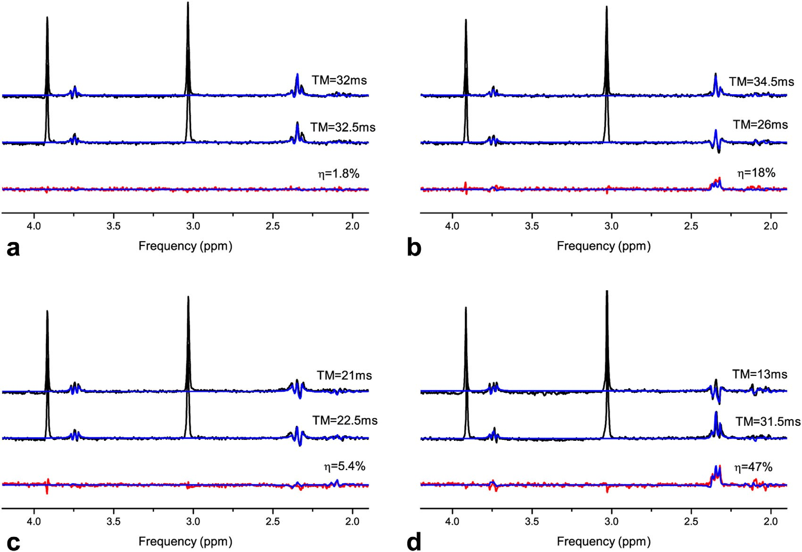

FIG. 3. Examples of Glu phantom STEAM-MiTiS acquisitions with TE ¼ 65 ms and various TM. Black lines represent the experimental acquisitions, red lines represent the subtracted spectra, and blue lines represent the simulations superimposed on the data. TM combi- nations were chosen to show the variability of the detection efficiency.

acquisitions can be addressed by interleaved acquisition and postprocessing to correct for frequency and phase shifts in between acquisitions. Figure 4 shows a typical spectrum and the result of subtraction with the simula- tion superimposed. Both acquisitions showed the typical in vivo STEAM spectrum with signals both from the main metabolite singlets (NAA, Cr, choline, etc.) and

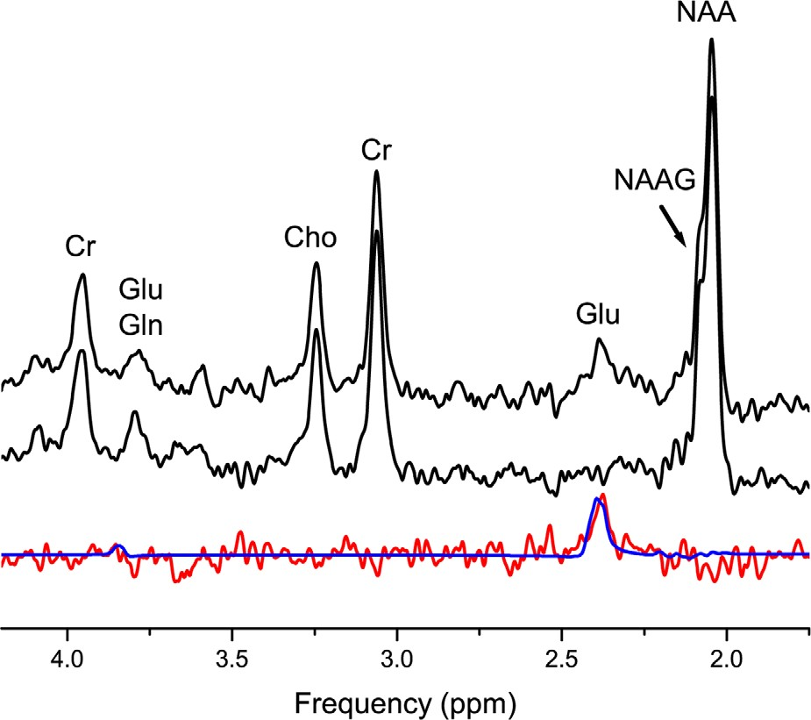
FIG. 4. In vivo STEAM-MiTiS acquisitions with TE ¼ 65 ms and TM₁ ¼ 31 ms, TM₂ ¼ 13.5 ms and the assignment of the main sig- nals. The red line represents the subtraction of the two spectra with the simulation (in blue) superimposed.
multiplets (Glu, myo-inositol, etc.) as well as the contri- bution from macromolecules. The difference spectrum shows only one clear signal attributed to the PQ spin group of Glu, all the others being efficiently suppressed by data processing.
Absolute quantification of Glu with this method can be challenging due to T₂ relaxation during TE and zero- quantum T₂ relaxation during TM. Because T₂ values for Glu and Cr are in close agreement in various brain regions (24), we performed quantification relative to Cr. Concentration results were obtained in the range 1.37– 1.60, which, assuming 8 mM Cr concentration in the brain (26), yielded to an absolute concentration range of 11–12.8 mM/L. This result is in fairly good agreement with the typical concentration values expected in healthy human brain (38).

DISCUSSION
We present a metabolite detection method based on the subtraction of two STEAM acquisitions with the same TE and different TMs.
The use of STEAM-MiTiS instead of PRESS leads to two clear advantages. First, the TM is completely inde- pendent of the TE; therefore, at a fixed TE, the TM can be varied without prior constraints. On the contrary, in PRESS, the two 180◦ pulses act as refocusing pulses for the excitation. In this case, the total TE is 2t₁ 2t₂, where t₁ is the interpulse time between the first 90◦ pulse and the following 180◦ refocussing pulse, and t₂ is the time between the first echo (which occurs at 2t₁) and
þ

the second 180◦ pulse. This poses an inherent limitation to the range in which t₁ and t₂ can be varied, especially at short TEs. Second, the multiple 90◦ pulses of the STEAM sequence lead to the formation of multiple quan- tum coherences and can induce polarization transfer effects (32). For this reason, scalar-coupled spin systems excited with the STEAM sequence show a much more complicated signal modulation than with PRESS excita- tion, and this can help in obtaining good detection of the desired metabolite.
Numerical simulations of the standard STEAM acquisi- tions at various TEs and TMs were performed to find the sequence parameters that maximize the metabolite signal. A large TM-dependent modulation of the MR signal in the Glu system, under STEAM excitation, was predicted from density matrix simulations. The modulation was dependent on the spin group and TE chosen. At certain echo times, by increasing TM by a few tens of millisec- onds, a significant change of the spectral lines was observed for Glu at 7T. As a result, in many cases, we found a quasi-periodic modulation of the difference spec- trum as a function of the TM_{i}-TM_{j} couple, but no simple relationship with the coupling constant of the spin group under investigation was observed. In fact, both the ampli- tude and the period of the modulation were strongly dependent on the echo time and on the spin group. This can be accounted for by recalling that the intensity of the signal of one STEAM acquisition depends on TM and shows a peculiar periodic oscillation in intensity and shape that depends on TE. Therefore, the difference of two such signals must retain the same feature; in particu- lar, the same periodicity can be found along all the hori- zontal and vertical lines in the TM-TM map. A similar observation has been reported for PRESS excitation (30). The amplitude and frequency of the modulation was found to be dependent on the B₀ field as well, with a shortening of the period with increasing B₀ (29). It is not surprising, then, that a sampling of the TM-TM space as short as 0.1 ms was needed at ultrahigh field strength in order to obtain reliable results. For this reason, and because the metabolite under investigation is a complex mixture of weakly and strongly coupled spin systems, it was not possible to predict a priori the behavior of spin groups at a given TE; it is for this reason that all spin groups were included in the simulation.
At every TE, the highest metabolite detection effi- ciency was calculated for the MN group. Moreover, for all spin groups, the calculated detection efficiency showed a tendency to increase with TE. However, this does not imply that the maximum predicted signal was increasing; despite a high detection efficiency, if the maximum signal at that specific TE is low, a TM_{i}-TM_{j} combination can result in a low signal.
Although the highest detection efficiency was pre- dicted for the MN group, the PQ group showed the high- est predicted signal. This is in agreement with the fact that, typically, the Glu PQ peak is the target for most in vivo studies, due to the greater amount of signal avail- able. It is worth noting, however, that the subtraction of two asymmetric PRESS spectra on the PQ group was pre- dicted to not yield the necessary signal variation to per- form subtraction spectroscopy until a field strength of
18.8T (29). This limitation was overcome by the use of STEAM-MiTiS instead of PRESS, due to the multiple quantum coherences and polarization transfer effects produced by the series of 90◦ pulses.
Furthermore, all of the spin groups showed a tendency to increase the maximum subtracted metabolite signal with TE, but due to the short T₂ decay, the maximum signal was reached at intermediate TE (60–65 ms), and an overall decrease of the signal was calculated. From these results, the PQ group was identified as the best choice for metabolite detection, and TE ¼ 65 ms and TM₁/TM₂ ¼ 13/31.5 ms were selected as the sequence parameters for in vivo validation of the method.
Phantom measurements confirmed simulation results. Cr signal was present in all acquisitions, but the differ- ence spectrum preserved only the Glu signal, as expected. Moreover, the intensity of the Glu signal in the difference spectrum depended strongly on the choice of the (TM₁,TM₂) couple. With a suboptimal choice, the residual signal could easily be lower than the noise level, while a careful choice of the sequence parameters yielded maximum signal.
In addition, in vivo acquisitions showed the same can- cellation of all undesired signals. Nevertheless, it must be noted that the variability of the signal intensity of in vivo acquisition can be a potential problem; however, this can be taken into account with careful data process- ing and comparison of the signals of all the singlets (especially Cr, Cho, and NAA) before subtraction.
We also investigated with the simulations the possible contribution of overlapping resonances (Gln and GABA using the same concentration as Glu) to the subtraction signal and found that in most cases, the residual contri- bution was much lower than the Glu signal and could be made even lower than 10%.
Density matrix simulations and in vitro experiments on Gln (AMNPQ spin system), GABA (I2S2W2 spin sys- tem), and lactate (A3X spin system) predicted a similar behavior of the subtracted signal; therefore, detection of these metabolites with STEAM-MiTiS should be feasible at 7T and will be the subject of future work.
This approach has the advantage of being simple and directly applicable with the use of the standard STEAM sequence, which is available on all MR scanners. More- over, the ratio D/J decreases with decreasing field strength. As a result, metabolites are more strongly coupled at lower field strength, and it is reasonable to assume that the method could be applied at lower field strength, making it directly applicable to clinical scan- ners without any sequence programming.
Another advantage of STEAM-MiTiS is that it does not require a priori knowledge of relaxation parameters of the metabolites because it involves two acquisitions at the same TE. Moreover, it is particularly useful to detect a signal when it is hindered or contaminated by other metabolites; therefore, it could be applied to other spin systems. This is the case, for example, in glycine contam- ination from the myo-inositol resonance around 3.54–3.62 ppm, as well as Cho and Tau or N-Acetyl Aspartyl Gluta- mate, NAA, citrate, and aspartate in the 2–3 ppm region.
In conclusion, STEAM-MiTiS has been shown to be able to detect Glu in the human brain at 7T and is also a

promising method for the detection of other scalar- coupled metabolites even at clinical field strength.

ACKNOWLEDGMENTS
We thank Maria Grazia Alessandri for phantom prepara- tion and Mark Symms for help revising the manuscript.

REFERENCES
- Yang S, Hu J, Kou Z, Yang Y. Spectral simplification for resolved glu- tamate and glutamine measurement using a standard STEAM sequence with optimized timing parameters at 3, 4, 4.7, 7, and 9.4 T. Magn Reson Med 2008;59:236–244.
- Mullins PG, Chen H, Xu J, Caprihan A, Gasparovic C. Comparative reliability of proton spectroscopy techniques designed to improve detection of J-coupled metabolites. Magn Reson Med 2008;60:964–969.
- Thompson RB, Allen PS. A new multiple quantum filter design pro- cedure for use on strongly coupled spin systems found in vivo: its application to glutamate. Magn Reson Med 1998;39:762–771.
- Kim H, Wild JM, Allen PS. Strategy for the spectral filtering of myo- inositol and other strongly coupled spins. Magn Reson Med 2004;51: 263–272.
- Trabesinger AH, Weber OM, Duc CO, Boesiger P. Detection of gluta- thione in the human brain in vivo by means of double quantum coherence filtering. Magn Reson Med 1999;42:283–289.
- Zhao T, Heberlein K, Jonas C, Jones DP, Hu X. New double quantum coherence filter for localized detection of glutathione in vivo. Magn Reson Med 2006;55:676–680.
- Choi C, Zhao C, Dimitrov I, Douglas D, Coupland NJ, Kalra S, Hawesa H, Davis J. Measurement of glutathione in human brain at 3T using an improved double quantum filter in vivo. J Magn Reson 2009;198:160–166.
- Terpstra M, Henry PG, Gruetter R. Measurement of reduced glutathi- one (GSH) in human brain using LCModel analysis of difference- edited spectra. Magn Reson Med 2003;50:19–23.
- Ryner LN, Sorenson JA, Thomas MA. 3D localized 2D NMR spectros- copy on an MRI scanner. J Magn Reson B 1995;107:126–137.
- Behar KL, Ogino T. Assignment of resonances in the 1H spectrum of rat brain by two-dimensional shift correlated and J-resolved NMR spectroscopy. Magn Reson Med 1991;17:285–303.
- Mayer D, Spielman DM. Detection of glutamate in the human brain at
3 T using optimized constant time point resolved spectroscopy. Magn Reson Med 2005;54:439–442.
- Hurd R., Sailasuta N, Srinivasan R, Vigneron DB, Pelletier D., Nelson
S.J. Measurement of brain glutamate using TE-averaged PRESS at 3 T. Magn Reson Med 2004;51:435–440.
- Pan JW, Mason GF, Pohost GM, Hetherington HP. Spectroscopic imaging of human brain glutamate by water-suppressed J-refocused coherence transfer at 4.1 T. Magn Reson Med 1996;36:7–12.
- Lee HK, Yaman A, Nalcioglu O. Homonuclear J-refocused spectral editing technique for quantification of glutamine and glutamate by 1H NMR spectroscopy. Magn Reson Med 1995;34:253–259.
- Rothman DL, Behar KL, Hetherington HP, Shulman RG. Homonuclear 1H double resonance difference spectroscopy of the rat brain in vivo. Proc Natl Acad Sci U S A 1984;81:6330–6334.
- Choi C, Coupland NJ, Bhardwaj PP, Malykhin N, Gheorghiu D, Allen PS. Measurement of brain glutamate and glutamine by spectrally selective refocusing at 3 Tesla. Magn Reson Med 2006;55:997–1005.
- Jacobs GE, van der Grond J, Teeuwisse WM, Langeveld TJC, van Pelt J, PhD, Verhagen JMC, de Kam ML, Cohen AF, Zitman FG, van Gerven JMA. Hypothalamic glutamate levels following serotonergic stimulation: a pilot study using 7-Tesla magnetic resonance spectros- copy in healthy volunteers. Prog Neuropsychopharmacol Biol Psychi- atry 2010;34:486–491.
- Choi C, Dimitrova IE, Douglas D, Patel A, Kaiser LG, Amezcua CA, Maher EA. Improvement of resolution for brain coupled metabolites by optimized ¹H MRS at 7 T NMR Biomed 2010;23:1044–1052.
- Snyder J, Wilman A. Field strength dependence of PRESS timings for simultaneous detection of glutamate and glutamine from 1.5 to 7 T. J Magn Reson 2010;203:66–72.
- Terpstra M, Moheet A, Kumar A, Eberly L, Seaquist E, Oz G. 7 T ¹H Detects human brain glutamate concentration changes in response to hypoglycemia: a study of diabetic patients with and without hypogly- cemia unawareness. In Proceedings of the 21st Annual Meeting of ISMRM, Salt Lake City, Utah, USA, 2013. p. 113.
- Penner J, Curtis A, Gilbert K, Klassen M, Gati J, Borrie M, Bartha R. 7 Tesla in-vivo short-echo-time single-voxel ¹H semiLASER spectros- copy: a test/retest reproducibility study. In Proceedings of the 22nd Annual Meeting of ISMRM, Milan, Italy, 2014. p. 3987.
- Moheet A, Emir UE, Terpstra M, Kumar A, Eberly LE, Seaquist ER, Oz G. Initial experience with seven Tesla magnetic resonance spec- troscopy of hypothalamic GABA during hyperinsulinemic euglycemia and hypoglycemia in healthy humans. Mag Reson Med 2014;71: 12–18.
- Marsman A, Mandl RCW, van den Heuvel MP, Boer VO, Wijnen JP, Klomp DWJ, Luijten PR, Pol HEH. Glutamate changes in healthy young adulthood. European Neuropsychopharmacology 2013;23: 1484–1490.
- Gambarota G, Mekle R, Xin L, Hergt M, van der Zwaag W, Krueger G, Gruetter R. In vivo measurement of glycine with short echo-time ¹H MRS in human brain at 7T Magn Reson Mater Phy 2009;22:1–4.
- Emir UE, Tuite PJ, Oz G. Elevated pontine and putamenal GABA lev- els in mild-moderate Parkinson disease detected by 7 Tesla proton MRS. PLoS One 2012;7:e30918.
- Cai K, Nanga RPR, Lamprou L, Schinstine C, Elliott M, Hariharan H, Reddy R, Epperson CN. The impact of gabapentin administration on brain GABA and glutamate concentrations: a 7T ¹H-MRS study. Neu- ropsychopharmacology 2012;37:2764–2771.
- Nanga RPR, Hariharan H, Reddy R. An Alternate Strategy for the Quantification of the in vivo glutamate/glutamine (Glx) peak at 2.35 ppm. In Proceedings of the 21st Annual Meeting of ISMRM, Salt Lake City, Utah, USA, 2013. p. 2037.
- An L, Li S, Murdoch JB, Araneta MF, Johnson C, Shen J. Detection of glutamate, glutamine, and glutathione by radiofrequency suppression and echo time optimization at 7 Tesla. Magn Reson Med 2015;73: 451–458.
- Snyder J, Thompson RB, Wilman AH. Difference spectroscopy using PRESS asymmetry: application to glutamate, glutamine, and myo-ino- sitol. NMR Biomed 2010;23:41–47.
- Gambarota G, van der Graaf M, Klomp D, Mulkern RV, Heerschap A. Echo-time independent signal modulations using PRESS sequences: a new approach to spectral editing of strongly coupled AB spin sys- tems. J Magn Reson 2005;177:299–306.
- Sotak CH, Freeman CM. A method for volume-localized Lactate edit- ing using zero-quantum coherence created in a stimulated echo pulse sequence. J Magn Reson 1998;77:382–388.
- de Graaf RA, Rothman DL. In vivo detection and quantification of scalar coupled 1H NMR resonances. Concepts Magn Reson 2001;13: 32–76.
- Pople JA, Schneider WG, Bernstein HJ. High-resolution nuclear mag- netic resonance. New York, NY: McGraw-Hill; 1959.
- Govindaraju V, Young K, Maudsley AA. Proton NMR chemical shifts and coupling constants for brain metabolites. NMR Biomed 2000;13: 129–153.
- Marjanska M, Auerbach EJ, Valabre`gue R, Van de Moortele PF, Adriany G, Garwood M. Localized ¹H NMR spectroscopy in different regions of human brain in vivo at 7T: T₂ relaxation times and concen- trations of cerebral metabolites. Magn Reson Med 2002;47:629–633.
- Sacolick L, Wiesinger F, Hancu I, Vogel MW. B1 Mapping by Bloch- Siegert Shift Magn Reson Med 2010;63:1315–1322.
- Noeske R, Schulte R, Schirmer T. Voxel Based Transmit Gain Calibra- tion Using Bloch-Siegert Shift Method for MR Spectroscopy. In Pro- ceedings of the 20th Annual Meeting of ISMRM, Melbourne, Victoria, Australia, 2012. p. 1733.
- de Graaf RA. In vivo NMR spectroscopy, 2nd edition: principles and techniques. Hoboken, NJ: John Wiley & Sons; 2007.

