Body-scaled information for affordances in a virtual environment

de Oliveira R.F.¹, Coelho T.², Rybarczyk Y.²

¹School of Applied Sciences, London South Bank University, UK
²Electrotechnical Engineering Department, New University of Lisbon, Portugal

Introduction: The affordances available to an individual are scaled to the individual’s body. This scaling factor is important because it links object or environment properties and individual’s dimensions through an invariant value. This means there is a lawful relation underpinning (at least some) affordances. For instance, participants deem a stair climbable without the aid of hands if the raiser is smaller than 0.88 their leg length (Warren, 1984), and participants walking through a door rotate their shoulders over their longitudinal axis if the aperture is smaller than 1.4 the width of their shoulders (Warren & Whang, 1987). In the present study we replicated Warren and Whang’s study in a virtual environment.
Methods: Participants were 24 students who used a Kinect Natural User Interface to control an avatar passing through apertures. Participants performed 32 trials for each of 2 speed conditions and 4 practice sessions. There were two avatar conditions. The standard avatar condition displayed a standard avatar which responded only to shoulder rotation, while in the similar avatar condition it displayed similar kinematics and morphology to the participant. We identified the critical ratio after which participants rotated their (and the avatars’ shoulders) to pass through apertures.
Results: After the first session, critical ratios decreased significantly and there were barely any collisions. Participants showed larger ratios with the faster speed and with the similar avatar. With the standard avatar the ratio was 1.40 while with the similar avatar the ratio was 1.57.
Discussion: Participants learned to use the information available in this virtual environment to pass through apertures, and in doing so disclosed a critical ratio very similar to that found in a real environment. We will discuss implications for our view of affordances and applications to virtual environments.

References
Coelho, T., de Oliveira, R., Cardoso, T., & Rybarczyk, Y. (2014). Body ownership of virtual avatars: an affordance approach of telepresence. In Rybarczyk, Y., Cardoso, T., Rosas, J., Camarinha-matos, L. (ed.), Innovative and creative developments in multimodal interaction systems (Springer), ch. 1.
Rybarczyk., Y, Coelho, T., Cardoso, T., & de Oliveira, R. (2014). Effect of avatars and viewpoints on performance in virtual world: efficiency vs. telepresence. EAI Endorsed Transactions on Creative Technologies, 14(1), e4.
Warren, W. H. (1984). Perceiving affordances: visual guidance of stair climbing. Journal of Experimental Psychology: Human Perception and Performance, 10(5), 683-703.
Warren, W. H., & Whang, S. (1987). Visual guidance of walking through apertures: body-scaled information for affordances. Journal of Experimental Psychology: Human Perception and Performance, 13(3), 371-383.

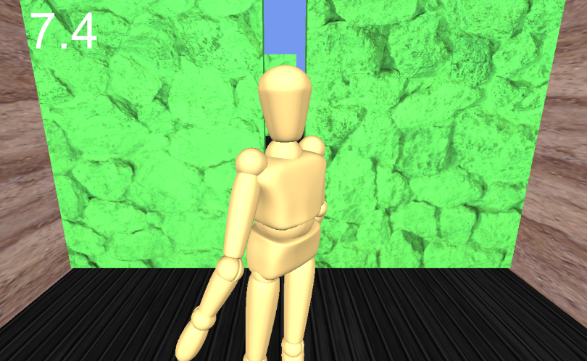
Figure 1. Virtual avatar about to pass through an aperture. This avatar is similar to the participant in its kinematics and morphology (similar condition).

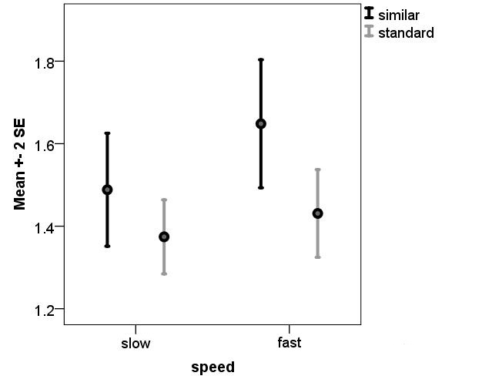
Figure 2. Critical ratios for passing through apertures in according to speed and avatar conditions. Black bars represent the similar avatar and grey lines represent the standard avatar.

