Beyond Covid-19: Maximising the ROI on Commercial Property for Key Financial Stakeholders and Landlords in the UK

Olubisi Ige, Damilola Aguda, Edward Leach and Job Momoh
School of the Built Environment and Architecture, London South Bank University, UK

ABSTRACT
All over the world and in the UK, the Architecture Engineering Construction Operational (AECO) industry has been significantly impacted by Covid 19 pandemic in recent times. In the UK, construction activities in key projects were put on hold from June 2020 due to the exponential rise in cases as it was deemed to be too dangerous to work. This in turn has had a detrimental effect on financial stakeholders and landlords of commercial properties who suffered a decline in the returns on their investments. This paper, therefore, seeks to analyse the direct and indirect impact of Covid-19 on the construction industry in the UK and to explore and develop an insight into how the Stakeholders in the industry are currently dealing with issues surrounding the commercial property investment and key financial outcomes. Subsequently, this paper will predict the expected reactions of the stakeholders in the construction industry in adapting to the ‘new normal’ going forward and the ability to maximise the return on their investments.

Keywords: Covid-19, ROI, Construction and Housing, Commercial Properties, New Normal, Financial Stakeholders.

1.0 INTRODUCTION
The impact of the novel coronavirus disease (COVID-19) on the entire world has been very significant, especially in the areas of economy and financial markets. Coronavirus causing Covid-19 which was first disclosed in Wuhan City, China towards the end of 2019 and declared a global pandemic in March 2020 by the World Health Organization (WHO) has continued to sweep across the globe, the virus being highly communicable, infecting millions of persons and leaving a high death toll in many countries, including United Kingdom (WHO, 2020). Hence, governments around the globe, including that of the United Kingdom had to institute several proactive and public health policy measures to curtail the spread of the virus such as drastic limitation in physical and social contacts leading to both local and international travel restrictions, closure of schools, leisure facilities and businesses, and other measures targeted at curbing transmission of Covid-19 virus. These actions have brought untold hardship on the global economy. The exceptional health shock experienced by the world notwithstanding, the havoc being wreaked on the world’s economy and the devastating consequences of the pandemic are apparent, although only symbolic, around the world (Takyi & Bentum-Ennin 2021).
In focus, the UK’s construction industry has been significantly impacted. Ongoing construction activities in key projects were put on hold from June 2020 due to the exponential rise in cases of Covid-19 infections as it was deemed to be too dangerous to work. Also, occupiers of commercial property have been finding things very difficult in their financial obligations as employees have been told to work from home while some have been made redundant, resulting in empty commercial office spaces and units. As a result, there have been detrimental impact on financial stakeholders and landlords who experienced a decline in the returns on their investments. Meanwhile, property ownership has long been seen as an effective investment tool for both corporate and individual investors. The financial opportunities for investors include both asset and capital growth along with rental yields providing income and cash flow streams. Investors therefore have a range of strategies available to them depending upon their own specific objectives. The aim of successful property investment will therefore include developing specific plans for key financial outcomes and success can be measured and described as a “Return on Investment”.
Although, there are several challenges and barriers that stakeholders and landlords face when maximising the “Return on Investment” on their investment properties. Research and analysis from Remit Consulting identified that out of 31,000 property leases, less than half of tenants paid their rent on time leading to a £934m income shortfall by the end of the second quarter of 2020 (Mansell, 2020). Return on investment (ROI) is a means by which landlords and financial stakeholders measure their investment to gauge the efficiency or profitability of an investment. ROI is usually recognised to be a relative gauge of a company’s success and calculated to assess businesses within an industry to each other and to their own specific accomplishment over time. The stakeholders of an investment manage their businesses to maximize ROI, understanding that ROI indicates company strength (Lingane & Olsen, 2004). In previous years, landlords and financial stakeholders within UK have had a very painless time in gaining their return on investment. However, with the pandemic situation, landlords and financial stakeholders ought to find different means of reducing the losses being experienced and channel a new way of achieving the return on their investments. Commercial Property can be identified as Offices, Industrial units and Retail and leisure spaces. These types of property have all been affected by the coronavirus pandemic in one way or the other.
This paper therefore aims to explore and develop an understanding of how the stakeholders and landlords are dealing with commercial property in the UK. Specifically, analysis on how stakeholders are maximising the return on investment in these properties would be carried out, varying small and medium-sized construction companies to gain a more reliable knowledge of the activities of the majority of the players in the industry to increase ROI. Also, there will be assessment of future of the construction Industry with regards to the demands of commercial property.

2.0 METHODOLOGY
Creswell and Creswell (2017) recognise three types of research design – qualitative, quantitative, and mixed method approaches. Qualitative approach involves the use of opinions or experiences while reflecting on non-numeric data. Quantitative research, on the other hand, is the exact opposite to a qualitative approach. It involves the use of numeric data to objectively make conclusions. Mixed methods involve the combination of quantitative and qualitative approaches. Due to the limitations of both quantitative and qualitative approaches (Johnson and Onwuegbuzie, 2004), the mixed methods approach has been adopted for this study. This involved the collection of both numeric and non-numeric data from secondary sources, such as already existing literature, reliable and established property company reports, government website and other internet sources. The blended approach helps to improve the quality of the data.
The research data collection method involved the use of secondary data. This was chosen over primary data collection method due to time constraint and the availability of existing and sufficient data to efficiently complete the research (Paradis et.al., 2016). Following this, the data collected are analysed using content analysis and descriptive methods for qualitative and quantitative data respectively.

3.0 FINDINGS AND DISCUSSION
3.1 Trends prior to the pandemic on maximising ROI
In order that financial stakeholders and landlords maximise their ROI, a typical practice prior to the pandemic times has always been to undertake a thorough analysis which includes a wide range of market study and reports. Usually, because commercial property is such a big investment, there is need to be particularly careful when deciding on the investment in order to mitigate against potential risks. Facts usually considered may include the location of the building, demand for its specific use in the selected area, similar types of property in the area under consideration, evaluation of success of competing with other investors, and ways of disrupting the existing market with different property options or rents. In addition, investors would need to assess the potential monthly rates that will be charged for the use of the property. Furthermore, investors are likely to consider as priority and give more attention to multiple use buildings. These are becoming more common for commercial investors to maximise their return on investment and manage the risk against different types of tenant. The intention of investing in a mixed-use building is to merge three or more uses into one structure. This creates several streams of income for the financial investor which maximises the most on their ROI (Urban-Hub, 2021).

3.2 Data analysis
A historical pre-covid-19 UK office market investment performance is shown in Fig. 1a. It shows a downward trajectory in performance from year 2017, suggesting that the market has been slowing down towards end of year 2019. On the other hand, Fig. 1b shows a disparity between the start of the year and towards the end of 2020. At the start of February 2020, almost 100% of office workers were working within the offices in the UK. Towards the end of march and the start of April the same year, the pandemic restrictions were put in place which resulted in everyone having to work from home or stop working all together. This can also be seen in the construction industry as the closure of sites which halted all large and small projects across the UK. This also led to productivity been lowered across all industries, resulting to a dip in the UK economy for 2020. Currently, majority of the workforce are still not in the offices as they may have agreed it is safer to keep working from home. Fig. 1b then shows how vacant offices are still within the UK and that not up to 80% of offices workers have returned by November 2020 (Young, 2020).

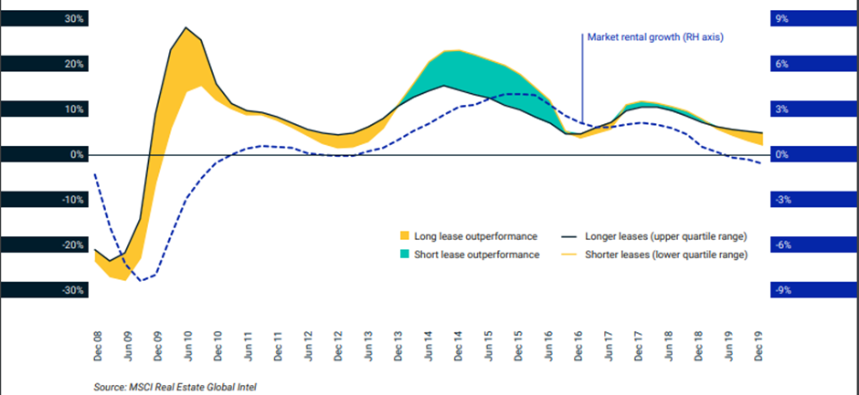
Figure 1a: UK quarterly property index before covid-19.
(MSCI, 2020)

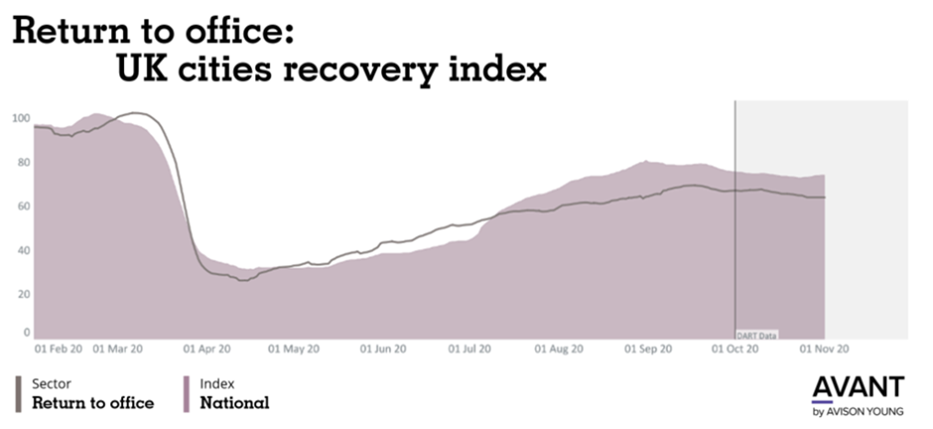
Fig. 1b: Return to office; UK cities recovery index
(Young, 2020)

Fig. 2 outlines the leasing in the largest cities in the UK in million square feet. It is a graph that illustrates from Q1 2009 to Q3 of 2020 with the amount of out-of-town leasing and total volume of leasing. Prior to the pandemic, leasing was at an all-time high with over 60% of total leasing volume in 2017 to then dropping to its lowest to just over 10%. With the out-of-town leasing, it has shown the opposite as in 2017 the out-of-town percentage dropped to as little as 25% and in 2020 increasing to 60%. This could have been because the pandemic affecting the landlords pricing to cover losses, so businesses have moved out of towns and cities as it is too expensive for them to lease out buildings in the difficult times.
Within the years 2013 to 2016, there have been a good balance of total leasing volume and out-of-town leases fluctuating within 15% of each other. This shows that the leasing market is relatively stable and that no external factors have affected the prices of leasing within the nine largest cities in the UK. The Prices for leasing have stayed the same, only changing slightly in the three years of focus.

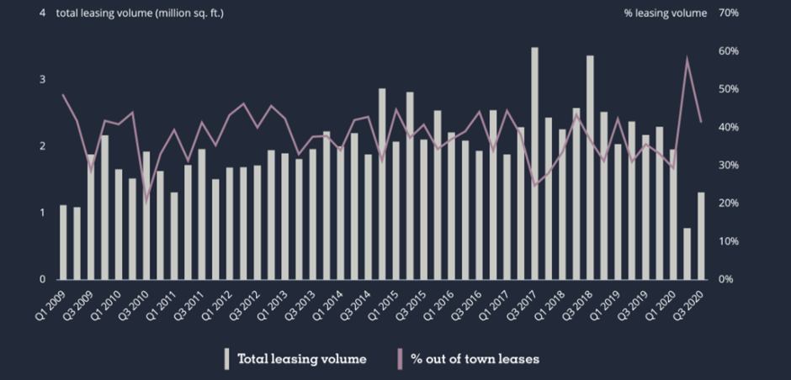
Fig. 2: Out of town leasing in UK big nine cities
(Young, 2020)

Fig. 3 shows how much of a hit the commercial property sector has taken from the pandemic. This graph is broken down into four subsections: All property, retail, office and industrial. The graph shows the rates of annual rental growth for the outlined industries.
Firstly, Retail Property has had the biggest reduction in rental growth. As at the start of the year, the percentage of growth has been 1% and by the end of the year it dramatically dropped to -8%. This is likely due to the government putting restrictions in place so that only essential shops could stay open, and all other stores would remain shut.
Office space has also taken a hit with its twelve-month difference of 5% rental growth to only 1%. This again has to do with offices having to close due to the pandemic.
Industrial building has had the least impact in twelve months as from 4 % drop to 3% with only 1 % difference between the start to the end of the 12-month focus. This is because industrial buildings have been able to remain open throughout the pandemic, with the popularity of online sales and delivery.

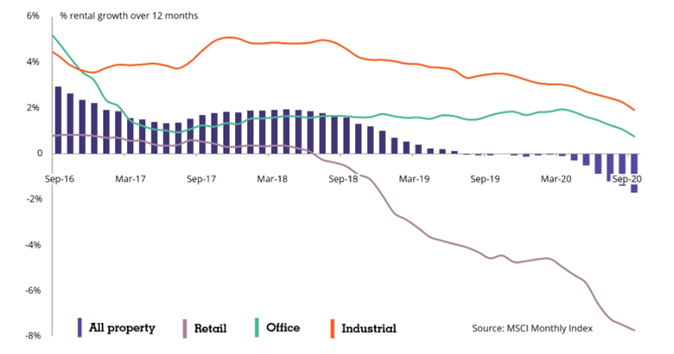
Fig. 3: Average annual rental growth for retail, office and industrial spaces
(Young, 2020)

Finally, Fig. 4 is showing the annual investment by sectors: office, retail, and leisure, industrial and alternative. This graph is within a ten-year study where the amount of investment has been analysed in billions. From an investment standpoint, the industrial sector had increased its investment from £5Bn to over £10Bn with its lowest year being 2010 and its highest investment year being 2017. There has been a steady increase over the ten-year period. The latter stages of the graph show a slight drop in investment but still a large gain from the start.
The retail and leisure sector has had a decline in investment with over £20bn invested in its highest year of Q2 2015 to under £10Bn in Q2 of 2020. This decline is mainly due to the coronavirus pandemic. No shops or other retail stores were allowed to open, and hence potential investors are less interested.
Alternative buildings have also had an increased investment in the 10-year period similar to the industrial sector but just to a higher extent with its lowest investment £5Bn to its largest investment quarter of £25Bn.
Finally, office space investment has been partially stable throughout the ten-year study as it has had similar investments of a minimum of £15Bn and its highest only being slightly more of £20Bn (Young, 2020).

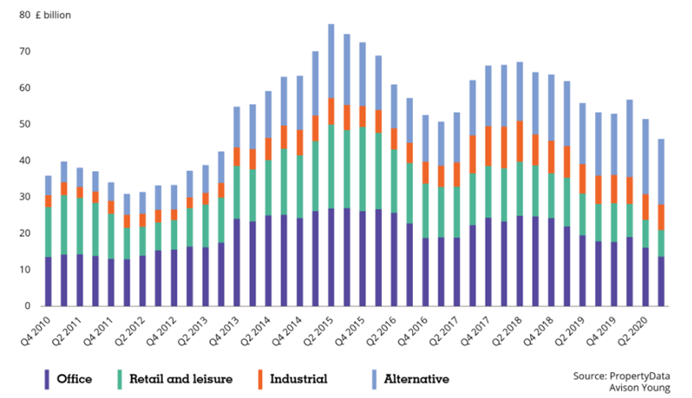
Fig. 4: Rolling annual investment transactions by sector
(Young, 2020)

3.3 Discussion
From the above data, there have been many bumps in the road with the current climate of pandemic affecting not only the construction and commercial property industry, but also the entirety of the UKs industry and economy with the GDP of the UK declining by 9.9% overall (ONS, 2020). Office spaces in London and other cities across the UK have started to allow their workers back in to resume a somewhat normal working week again. However, from Fig. 1b, it shows that 20% of workers are still not going back to the offices. This could lead to a large number of companies not going back to their offices and consequently, leases not getting renewed. This could however open an opportunity to convert the empty offices to apartments by utilising the space to fit several units, provided the planning authorities permit. This can benefit London boroughs as they have to hit years target for social housing. For instance, Southwark council is committed to reach their target of 11,000 new homes by 2043 and with developers having to offer councils 10% of their developments. (Southwark, 2020).
Meanwhile, leasing within the UK’s cities and outside the cities have changed within the last few years. In all cases such as retail, offices, and industrial buildings, the rental growth has dropped from the start of 2016 to September 2020. The drops in rental growth can be connected to the companies offshoring their work to other European countries or elsewhere in the UK as it is significantly cheaper, prior to them moving rental rates, which could have been a lot higher and within cities. With companies moving out, this will drop the rental price of the buildings as there would be less of a demand to the facilities. Hence, financial investors and landlords have lost income significantly within this period. However, with this drop in annual growth, it could increase the demand for the rental properties in the near future as the landlords will have dropped the yearly prices to use the properties for other alternatives. This will affect the retail and offices spaces mostly.
Annual investment into commercial sector has changed in the last 10 years according to Fig. 4. Industrial sector has had the least money invested with only £5bn which grew to a little above £10bn. On the other hand, retail and leisure recorded the highest amount of capital invested in the commercial sectors and throughout the years it has fluctuated in the amount of investment with the start of year 2020 dropping to its lowest investment year of £10bn. This is due to the pandemic restrictions within the UK with all retail stores except for food and medical shops being closed. This means investors will be reluctant in investing in this sector as these uncertain times will not yield a good return on their investment.
Office spaces recorded the largest single amount of investment and Q2 2015 they received 25bn in annual investment transactions, a 10bn jump from just over 10bn in Q4 2010. This can be seen to stay at a similar level for many years as more and more companies are using offices spaces to conduct work, however, with the global pandemic it has seen the investment dropping back to £10bn.

4.0 CONCLUSION
The findings show that the financial stakeholder and landlords are maximising their return on investments in several different ways. This can be seen in the types of property they invest in, the fixed leases that they charge their tenants, and the buy and selling of commercial property. Within the beginning of the spread of covid, a lot of the rental leases were not fully paid due the buildings having to close down by the government precautions to lessen the spread of the virus. However, leases that were fixed and signed prior to the pandemic had to pay their rent. Therefore, it has not disrupted the flow of income to the investors Furthermore, the companies that had struggled had to liquidate, thereby contributing to financial stakeholders and landlords’ ROI downward trend.
The analysis has shown that investors have many ways of maximising the returns on their original investment. In the future, the investments will be better as the research behind them will be vastly improved. Additionally, the damage from covid-19 to the construction industry would have repaired itself. Also, no matter what impact Covid-19 has brought to investors, they will always seek the best ROI and that those who are the most adaptable will gain the most post pandemic.

REFERENCES
Creswell, J. W., & Creswell, J. D. (2017). Research design: Qualitative, quantitative, and mixed methods approaches. Sage publications.
Johnson, R. B., & Onwuegbuzie, A. J. (2004). Mixed methods research: A research paradigm whose time has come. Educational researcher, 33(7), 14-26.
Lingane, A., & Olsen, S. (2004). Guidelines for social return on investment. California management review, 46(3), 116-135.
Mansell, G. (2020). COVID-19 IMPACTS UK REAL ESTATE. Available at https://www.cushmanwakefield.com/en/united-kingdom/insights/covid-19-impacts-uk-real-estate. Accessed 10/06/2021.
MSCI (2020). Real Estate Research Snapshot, 2020 Part 1. Available at https://www.msci.com/documents/1296102/20085524/MSCI_Research_Snapshot_2020H1_FINAL.pdf. Accessed 28/07/2021.
Office for National Statistics. (2020). Coronavirus and the impact on output in the UK economy: December 2020. Available at https://www.ons.gov.uk/economy/grossdomesticproductgdp/articles/coronavirusandtheimpactonoutputintheukeconomy/december2020. Accessed 17/07/2021.
Paradis, E., O'Brien, B., Nimmon, L., Bandiera, G., & Martimianakis, M. A. (2016). Design: Selection of data collection methods. Journal of graduate medical education, 8(2), 263-264.
Southwark Council, (2020). Southwark Housing Strategy to 2043. Available at https://www.southwark.gov.uk/assets/attach/11206/SP104-Southwark-Housing-Strategy-to-2043-2015-.pdf. Accessed 7/06/2021.
Takyi, P. O., & Bentum-Ennin, I. (2021). The impact of COVID-19 on stock market performance in Africa: A Bayesian structural time series approach. Journal of Economics and Business, 115, 105968.
Urban-Hub. (2021). Mixed-use buildings: make the most of your building. Available at https://www.urban-hub.com/buildings/mixed-use-buildings-for-diversified-sustainable-sites/#:~:text=A%20mixed%2Duse%20building%20aims,building%20or%20a%20small%20area. Accessed on 05/05/2021.
WHO. (2020). Coronavirus disease 2019 (COVID-19). Available at https://www.who.int/docs/default-source/coronaviruse/situation-reports/20200423-sitrep-94-covid-19.pdf?sfvrsn=b8304bf0_2#:~:text=Retrospective%20investigations%20by%20Chinese%20authorities,%2C%20some%. Accessed 17/06/2021.
Young, A. (2020). 2021 forecast. https://www.avisonyoung.co.uk/en_GB/2021-forecast-uk last accessed 17/2/2021. Accessed 17/06/2021.

