Flexible Control of Acoustic Conditions in a Music Rehearsal Space Using Airbeds

Shearer, Douglas John;; Dance, Stephen¹ Gomez Agustina, Luis, Justin Randell
1: Corresponding author: dances@lsbu.ac.uk

London South Bank University
103 Borough Road, London, SE1 0AA

ABSTRACT
Henry Wood Hall is a former church in central London which was successfully repurposed as an orchestral rehearsal space. However, the trustees of the hall desired a more flexible use of the space and in March 2018 instructed the LSBU Acoustics Group to develop, test and install a flexible solution which would create a balanced acoustic suited to smaller ensembles and voice. This would require the reduction of the reverberation in the hall at low frequencies. The solution should, for a modest budget, be flexible enough to be changed within the hour-long break between sessions. Laboratory tests were undertaken on inflated airbeds in the LSBU reverberation chamber to determine the low frequency absorption potential of these consumer goods. The model with the most promising performance was selected and dependence on inflation was determined. Room acoustic measurements were taken in the hall before and after the airbeds were installed, showing the desired level of reduction in reverberation time in the lower frequency bands.
Keywords: Music, Room Acoustics, Absorbing Materials

Introduction
Holy Trinity Church in Borough, Central London was built in 1842, but was abandoned after suffering bomb damage during the Second World War. It was refurbished in the 1970s for use as a rehearsal and recording venue for the London Symphony Orchestra (LSO) and London Philharmonic Orchestra (LPO) and other ensembles such as the Royal Opera House. As Henry Wood Hall, it remains a busy venue in these roles, as well as for occasional public concerts.
The hall measures 10m high, 19m wide and 31m long at its longest and has a volume of approximately 5800m³. It comprises a main area with four rostra of increasing height, plus elevated choir stalls at the rear of the main space. The walls are made from Bath stone, the ceiling is lightly coffered with a plaster finish and the floor construction is wood parquet [1]. The recessed windows are covered by floor-to-ceiling curtains which can also be used to adjust the acoustics to the users’ preference. The condition with some or all curtains open is generally preferred by users of the hall, due to a preference for natural light, rather than for acoustic reasons (see Figure 1).

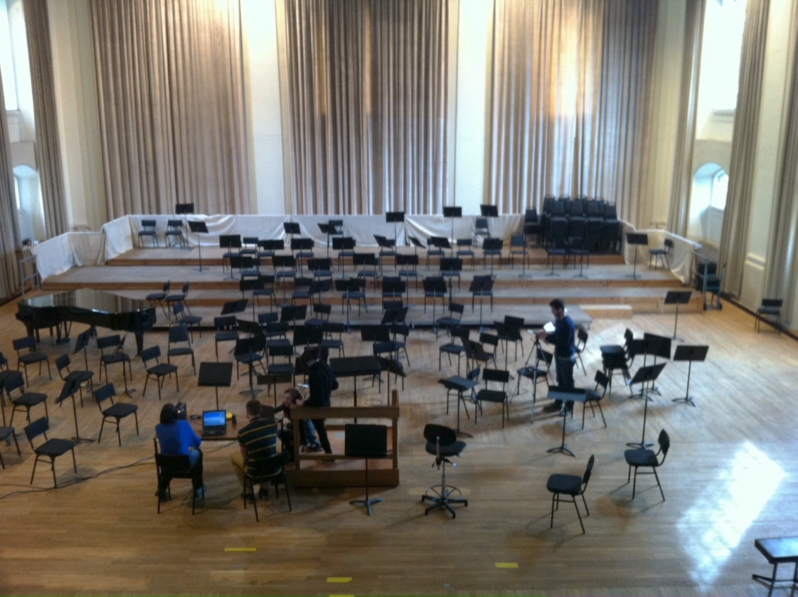
Figure 1: The main floor of Henry Wood Hall viewed from the choir stalls.

2. Room Acoustic Measurements
The hall’s room acoustic parameters were measured in accordance with ISO3382-1:2009 [2] in several configurations. The baseline Reverberation Time (RT) of the hall in three conditions; with all curtains closed; with all curtains open; and a condition where curtains are partially open (the most common usage condition) are shown in Figure 2. This shows the curtains are a useful absorber in the mid and high frequency ranges and also at low frequencies when all are closed, by which point high frequencies are attenuated substantially.

Figure 2: Baseline reverberation time (T₂₀) showing dependency on curtains.
Anecdotally, the acoustic of the hall is generally considered good by users, but does, however have a “warm” character, which is not to the taste of all, with some concern expressed about “boominess”, and indeed there is a distinct peak in the reverberation time curve around 125 Hz as shown in Figure 2.

3. The Brief
Henry Wood Hall’s management were looking to expand its use, notably for opera rehearsals, and asked the LSBU Acoustics Group to provide an affordable, flexible solution to improve the hall’s suitability for voice and small ensemble, one which could be installed or removed within an hour, the changeover time between sessions at the hall, as a typical day’s schedule could include vocal and orchestral sessions on the same day. The hall is a busy space and there was limited access time for measurement and installation, hence the demand for an easily portable solution. In addition, the hall is Grade II listed historic building and as such, could not be changed structurally.

3.1 The Proposed Solution
The existing curtains in the hall were considered suitable for adjusting high and mid-range reverberation time, therefore it was decided to provide a complimentary solution to target the lower frequency “boominess”, in this case using off-the-shelf airbeds as portable membrane absorbers. Airbeds were attractive for their cost, availability, light weight and ease and speed of deployment. They also had the advantage of not requiring any fixing to the existing building structure.
In the most simplified analysis an airbed will act as a membrane absorber. Cox and D’Antonio [3] present a much—used relation for predicting the resonant frequency of a membrane absorber.
 | $$f=\frac{60}{\sqrt{md}}$$ | Equation 1
where f is the resonant frequency in Hz, m is the unit mass of the membrane in kgm⁻² and d the depth of the absorber in m.
However, airbeds deviate from the classical model of a membrane absorber; with inflation comes curvature of much of their surface, with deformation under pressure being constrained by internal drop cords which maintain a near-planar overall shape; these latter also add additional moving mass and damping. Adelman-Larsen et al tested air mattresses during the development of the Flex Acoustic inflatable absorbers used in large venues for amplified music [4]. They noted this divergence from classical membrane behaviour, suggesting the resonant frequency to be around four times that given by Equation 1, while recognising that the complexity of construction renders the concept of a single resonant frequency as being reductive [5]. This led to the need to undertake laboratory tests to demonstrate the sound absorbing performance of various types of airbeds, the dimensions of which are summarised in Table 1.

Airbed | Length (m) | Width (m) | Depth (m) | Number Used | Area (m²)
Lilo | 1.87 | 0.71 | 0.12 | 6 | 7.9
Bestway | 1.9 | 1.37 | 0.22 | 4 | 10.4
Livivo | 2 | 1.6 | 0.44 | 4 | 12.8
Table 1: Dimensions of the three airbed designs tested.

4. Laboratory Tests
Tests of three airbed types were undertaken to measure sound absorption in accordance with ISO354:2003 were undertaken in LSBU’s Reverberation Chamber [6]. This chamber has a volume of 202 m³. Figure 3 shows an example of an ISO 354:2003 test including a omni-directional sound source and omni-directional Class 1 microphone. The measurements were taken using a winMLS computer measurements system and used an averaged result of three exponential swept sine signals for each of the 12 source-microphone positions. Temperature and humidity was also measured.
Figure 3: Airbeds undergoing testing in the LSBU reverberation chamber.

4.1 Absorption Coefficient Results
Absorption coefficients were derived in accordance to ISO 354:2003 from the measured reverberation times. The results are shown in Figure 4.

Figure 4: Comparison of Absorption Coefficients of three airbeds measured in accordance with ISO354:2003.
It can be seen from Figure 4 that the airbeds’ absorption was broad containing resonant peaks .The frequency at which peak absorption occurs has an inverse relation with airbed thickness, in line with Equation 1, and likewise the amount of absorption at the lowest frequencies increases with airbed thickness; see Figure 5. However, the broadness of the absorption with multiple peaks was found to be due to the complex internal structure of the airbeds.
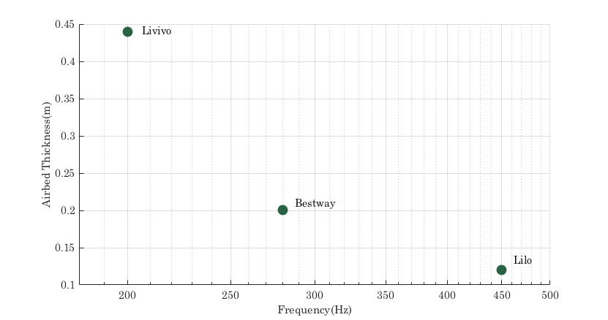
Figure 5: Dependence on airbed thickness on the lowest frequency peak in absorption for three airbeds.
The Livivo airbed, the thicker of the three designs, was chosen for use in Henry Wood Hall as it displayed stronger absorption at lower frequencies and a broader range of absorption. A further test was undertaken to compare the absorption achieved with mounting of these airbeds propped around the corners and edges of the room as opposed to the ISO354:2003 standard mounting which used the centre of the reverberation room. Improved performance was found particularly at lower frequencies: conveniently this also happened to be the required location for installation in the hall; see [7] and [8].

4.2 Effect of the Level of Inflation
The expected use of the airbeds was for a single rehearsal session of 3-4 hours, so maintaining operating pressure over long periods was not envisioned as a problem. Although difficult to measure precisely in the Livivo airbeds, pressure dependency on absorption was estimated based on reverberation time measurements. It was known that the built-in pump with automatic cut-off took 150 seconds to achieve full inflation of one airbed. As such, reverberation time measurements were repeated at different inflations based on 1/2, 1/4 and 1/8 of the fully inflated inflation time, as well as the not inflated condition.

Figure 6: Dependence on inflation, four Livivo airbeds in the reverberation chamber.
Figure 6 shows the dependency of absorption on inflation. It can be seen that the material itself offers mid-frequency absorption with inflation offering limited benefit above 1000 Hz. The breath of the absorption consistently increased with inflation with two peak absorption frequencies at 200 Hz and 500 Hz. The 200 Hz peak showed a particular increase with inflation matching the predicted membrane response. Finally absorption below 125Hz was significantly greater at full inflation.

5. Installation and Testing
Space limitations in the hall constrained the number of airbeds and hence the amount of absorption which could be installed. There was space to the rear and sides of the rostra and in the choir stalls at the rear of the auditorium (see Figure 7). Using each airbed’s built-in pump, the 30 airbeds were pumped up and moved into position by four people. The total time for the installation was just under one hour, and thus meet the required target time.
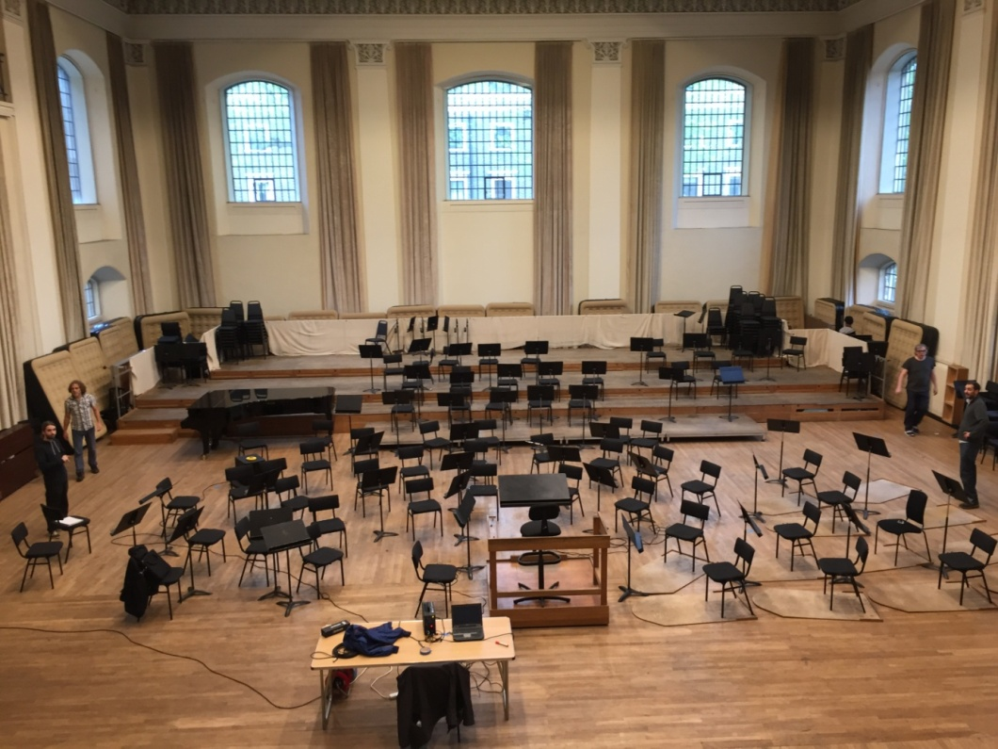
Figure 7: Airbeds upon installation in Henry Wood Hall.
ISO3382-1:2009 results for reverberation time before and after installation of the 30 airbeds is shown in Figure 8. As predicted, the reduction in reverberation time was focused at the difficult to treat lower frequencies. The most effected frequency bands were in the 63-250Hz range, showing that the absorption behaviour was in line with that predicted by the ISO 354 tests. Reverberation time reduction was well spread over three octave bands, with little change above 1 kHz.

Figure 8: Measured reverberation time in Henry Wood Hall with and without 30 inflated airbeds.

6. Conclusions
Airbeds were selected as an acoustic treatment in a large, boomy orchestral rehearsal space. ISO 354:2003 tests were undertaken in the reverberation room to establish their sound absorbing performance. Having selected an appropriate airbed type, determined the best location and the established the correct quantity required to flatten the reverberation time response, an ISO 3382-1:2009 assessment of the hall was undertaken before and after installation. The result was a small but significant reduction of reverberation time in the lower frequency bands following installation of the airbeds.
For operational reasons, it was not possible to issue a questionnaire to the users of the hall to determine an in-depth response from musicians to the changed acoustic using a questionnaire. However, conversations with management and several leading conductors indicated a very positive response, with comments including that the hall was “drier in the lower register”, and appreciating its discreet form “[the] solution is not visible to the orchestra or conductor”. Interestingly, some comments mentioned that the hall seemed less “harsh”, “…I have to say I can hear a difference; it seems less harsh when large forces are playing all at once”. In the finalised installation, all the airbeds were hidden from view at ground level and the conductors were not told what changes had been made these comments confirmed that the solution had met the original design brief.
This solution was intended to be affordable, flexible and portable, and intended for occasional use. However, and somewhat unexpectedly, 26 of the airbeds have remained deployed in the hall for all rehearsals since installation and appear to be popular for all repertoire. Of the remaining airbeds two had failed and two were taken away for further testing. All the remaining airbeds have been re-inflated once in a period of more than one year and hence have delivered a near maintenance free solution.

7. Acknowledgements
This work was supported by The Royal Academy of Music, Henry Wood Hall and The UK Acoustics Network (UKAN).

8. References

[1] | Historic England, “The Henry Wood Hall, including gate piers and railings,” [Online]. Available: https://historicengland.org.uk/listing/the-list/list-entry/1385999. [Accessed 19th February 2019].
[2] | BS ISO 3382-1: Measurement of room acoustic parameters: part 1: performance spaces, British Standards Institute, London, 2009.
[3] | T. J. Cox and P. D'Antonio, Acoustic absorbers and diffusers: theory, design and application, Second Edition ed., London, New York: Taylor & Francis, 2009.
[4] | Flex Acoustics, “Flex Acoustics,” [Online]. Available: http://flexac.com/. [Accessed 26th February 2019].
[5] | N. W. Larsen, E. R. Thompson and A. C. Gade, “Variable low-frequency absorber for multi purpose concert halls,” in Forum Acusticum, Budapest, 2005.
[6] | BS ISO 354: Measurement of sound absorption in a reverberation room, British Standards Institute, 2003.
[7] | D. J. Shearer, L. Gomez Agustina, E. Ballestero and S. Dance, “Henry Wood Hall: the creation of a flexible acoustic using airbeds,” in InterNoise 2019, Madrid, 2019.
[8] | D. J. Shearer, “Case studies in the absorption of low frequency sound in music rooms,” 2020, PhD Thesis.

