performance prediction of the Full-Scale Bardenpho process using A genetic adapted time-delay neural network (GATDNN)

Yoon-Seok Timothy Hong¹, Byeong Cheon Paik*

¹ London South Bank University, 103 Borough Road, London, SE1 0AA, United Kingdom
* Department of Environmental System Engineering, Chonnam National University, Daehak-ro 50, Yosu-si, Chonnam 59626, Republic of Korea

Abstract- Wastewater treatment systems are characterized by large temporal variability of inflow, variable concentrations of components in the incoming wastewater to the plant, and highly variable biological reactions within the process. The behavior of observed process variables within a wastewater treatment plant (WWTP at a certain time instant is the combined effect of various processes initiated at different moments in the past. This is called a time-delay effect in the system. Due to the nature of strong nonlinear mapping, neural networks provide advantages as a modeling and identification tool over a structure-based model. However, the determination of the architecture of the artificial neural networks (ANNs) and the selection of key input variables with a time delay is not easy. in our research, a genetic adapted time-delay neural network (GATDNN), which is a combination of time-delay neural network(TDNN) and genetic algorithms(GAs), was developed and applied to the full-scale Bardenpho advanced sewage treatment process. In a GATDNN, a three-step modelling procedure was performed: (1) selection of significant input variables to maximise the predictive accuracy for each specific output; (2) finding a suitable network topology for the ANN-based process estimator; (3) sensitivity analysis. The results demonstrate that the modelling technique presented using a GATDNN provides a valuable tool for predicting the outputs with high levels of accuracy and identifying key operating variables. This work will permit the development of a reliable control strategy thus reducing the burden of the process engineer.

Keywords: Bardenpho process, artificial neural networks (ANNs), genetic adapted time-delay neural network (GATDNN), genetic algorithms (GAs), time-delay neural network (TDNN)

Introduction

Phosphorus removal from watewaters is required to protect receiving waters from eutrophication. A variety of biological nutrient removal (BNR) processes, have been developed to meet the increasingly stringent effluent discharge requirements. BNR systems offer the advantages of elimination of chemical addition and of reduction in the volume of sludge produced.

Activated sludge process has been modelled by several investigators to improve process performance and to reduce the operating costs. The IAWPRC activated sludge model number 1 (ASM1), which is based on a matrix system comprising the relevant component and process rates, is the best known model and has been applied to simulate process dynamics (Henze et al, 1986). Recently, ASM2 incorporating biological phosphorus removal has been developed (Gujer et al, 1995).
Although these structure-based models have been successfully applied for design and modelling purpose, there are still many problems in applying such a complex model to real process modelling and control. These include the following:
- These models require the specification of a large number of parameters, many of which are difficult to measure. For example, ASM2 consists of 17 processes and 10 dissolved components.
- These models need to respecify parameter values for different operational conditions
- There are no on-line sensors which can identify and estimate the many of the important parameters.
- Most of the BNR processes have time-varying characteristics that are inherently nonlinear (Hong and Paik, 2008; Lee et al., 2011).

These constraints make structure-based modelling difficult from a real plant application viewpoint. As an alternative to a structure-based model, there has been major research interest in artificial neural networks (ANNs), a powerful tool for nonlinear modelling and process control. A number of researchers have successfully applied ANN to wastewater treatment processes (Capodaglio et al, 1991;Cote et al, 1995;Du et al, 1996;Zhao et al, 1997).

The advantages of the ANN technique over the classical models are:
- it has the ability to learn complex nonlinear relationship with limited prior knowledge of the process structure
- it can perform inferences for an unknown combination of input variables.

However, when applying ANN to a new problem, it is very hard to determine the architecture of the ANN and select which input variables are key for a specific process. In order to overcome these problems, Genetic Algorithms (GAs) have been used to develop the architecture of an ANN (Miller et al, 1989;Whitely et al, 1990; Harp et al, 1990;Angeline et al, 1994;Maniezzo, 1994).
We introduce a genetic adapted time-delay neural network (GATDNN) which employs a GAs to design the architecture of the time-delay neural network (TDNN) based on finite-duration impulse response (FIR) neural network (Wan, 1990, 1994) and to select input variables. Then, the usefulness of a GATDNN as a dynamic modelling and identification tool for a complex full-scale Bardenpho wastewater treatment plant located at Rotorua, New Zealand is demonstrated. Input sensitivity analysis is performed to describe the relative strengths of the effects that input variables have on output variables in a GATDNN.

Methodology

Time-Delay Neural Network (TDNN)

Among the variety of ANN architectures that have been proposed, the multilayer feedforward neural networks with the standard backpropagation algorithms are frequently applied to biological processes. However, a major limitation of the standard backpropagation algorithms is that they can only learn an input-output mapping that is static. This means that the common multilayer feedforward neural networks are static, having no internal time delays and responding to a particular input by immediately generating a specific output (Day & Davenport, 1993). Therefore they are unable to respond to time-varying patterns.

Dynamic neural networks are necessary since the most common biological processes have dynamic characteristics. For a neural network to be dynamic, it must be given memory (Haykin, 1994). One way in which this requirement can be accomplished is to incorporate time delay into a synaptic structure of the neural network and to adjust their values during the learning phase. This ANN is the so-called time-delay neural network (TDNN), which is typically described as a layered network in which the outputs of a layer are buffered several time steps and then fed fully connected to the next layer (Waibel et al., 1989;Wan, 1994). The best known TDNN is the FIR neural network, which resembles a standard feedforward network where each synapse is replaced with an adaptive FIR linear filter and is trained using temporal backpropagation algorithms in which error terms are symmetrically filtered backward through the network (Wan, 1990,1994). The most basic FIR neural network with a tapped delay line is shown in Fig.1.
The output 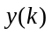corresponds to a weighted sum of past delayed values of the input:
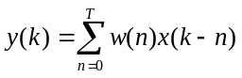 (1)
The output 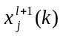 of a neuron in layer l at time k is now taken as the activation function of the sum of all filter outputs that feed the neuron (Fig. 1):
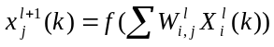 (2)
where vector 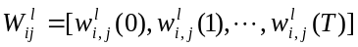 is the coefficient for the synaptic filter connecting neuron i to neuron j in layer l and 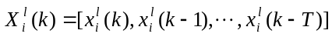 denotes the vector of delayed states along the synaptic filter.
Now, assume that neuron j lies in the output layer with its actual output denoted by and that the desired output is denoted by 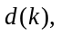both of which are measured at time k. The goal of the network training is to minimise the following cost function 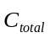:
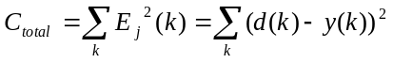 (3)
To compute an estimate of the optimum weight vector 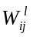 that attains the above goal, the weight-update equation, called temporal backpropagation algorithm is used as the following pair of relations (Wan, 1990, 1994):
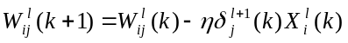 (4)
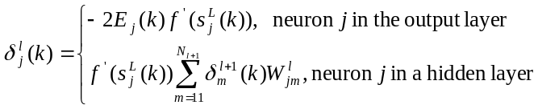 (5)
where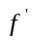is the derivative of the activation function , and 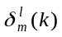is a vector of propagated gradient terms.
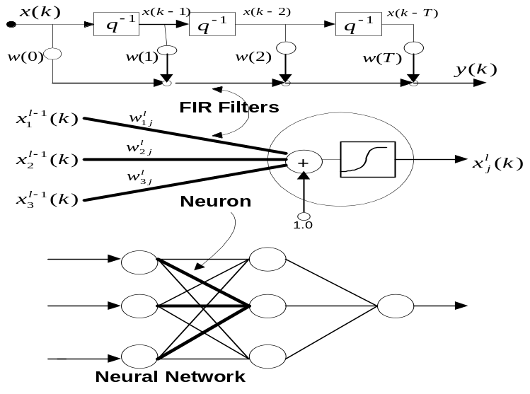
Figure 1. The architecture of TDNN (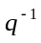 represents a unit time delay operator, i.e.,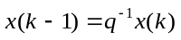).

Time-Delay Neural Network (TDNN) with a Genetic Algorithm

GAs are a parallel, global optimisation technique based on natural population genetics which are used to develop solutions to problems. They utilise a survival-of-the- fittest concept among string structures through genetic operators such as reproduction, crossover, and mutation (Goldberg, 1989). The success of GAs is based in their ability to keep in existence those parts of a solution, which have a positive influence on the outcome, and proceed with optimising the non-optimal parts. Due to their powerful behaviour as search engines, this GAs is being applied to problem solving in scientific, engineering, and even business contexts.

In order to solve a problem using GAs, the parameters of the problem (phenotype) must be coded into a genotype. A genotype may be represented by a bit string, an integer or float number string or other symbol string. The GAs work on a population of genotypes searching globally for the optimum genotype by applying genetic operators with respect to quality. The quality of a genotype is calculated by extracting the phenotype it represents and evaluating the fitness of the phenotype.
In our case, this means that a binary bit string (genotype) can be decoded into the topology of the neural network (phenotype). The fitness of the neural network is then calculated with respect to a quality function that may include the ability of the neural network to learn (train error) and generalise (test error), its complexity (amount of units and links) and various other criteria.
In this paper, a GANN, which is a combination of GAs and TDNN, is based on the following cyclic procedure.
Step 1: Initialisation Generate an initial population of binary bit strings (genotype) to be evaluated for TDNN randomly.
Step2: Decoding Decode the binary bit strings into TDNN structure. This process builds a TDNN (phenotype) based on the genotype.
Step 3: Fitness-value calculation Train and test the TDNN to determine fitness and compute and compare the fitness of the TDNN. The fitness-value function is the inverse of the cost function, i.e. maximising the fitness value corresponds to minimise the cost function.
Step 4: Reproduction Select those TDNN in the population which are better. The process of selection ensures the genotype (individuals) of higher quality are more likely to be chosen for reproduction than those of lower quality. There are several ways of selecting genotypes. This research used a roulette wheel selection in which genotypes were randomly extracted.
Step 5: Population Refilling Refill the population back to the defined size. Since a GA uses selection methods which drop poor phenotypes, the population needs to be filled every generation. This process is based on cloning whereby the survivors of the selection process are cloned to refill the population.
Step 6: Crossover Pair up the genotypes and mutate the genotypes by exchanging genes. This operator tries to combine vital parts of two individuals in order to create a superior individual. Although it is possible to choose multi-point crossover, two point crossover was selected, because multi-point crossover does not improve the optimisation process (Goldberg, 1989).
Step 7: Mutation Alter the genotypes according to the mutation probability. Mutation, which is the main engine of GAs, is used to introduce new solutions and prevent the population from unrecoverable loss of important information. Mutation probability is usually kept low to prevent a negative influence on crossover and to maintain a strong causality. With high mutation rate (e.g.0.5) the GAs would turn into a random search.
Step8: Repetition Steps 2-7 are repeated from generation to generation so that the best fitness value increases until the termination criteria are satisfied.
Through the above cyclic process, the better TDNNs survive and their features are preserved in future generations and are combined with others to find a better TDNN.
The procedures of a proposed GATDNN described in the above is shown in Fig.2.
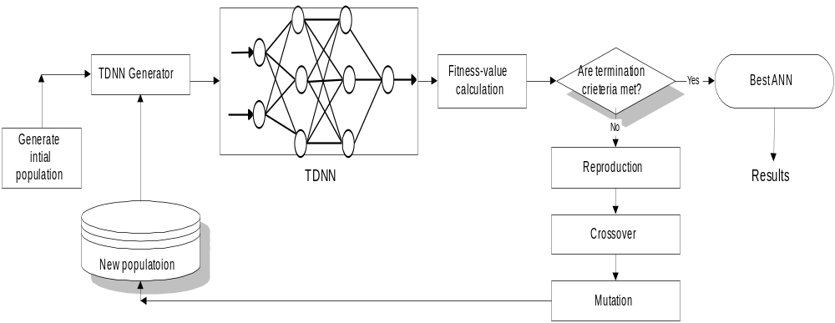

Figure 2. Cyclic process of a GANN

Results and Discussions

Description of Bardenpho Process at Rotorua

Rotorua’s wastewater (sewage) in New Zealand is treated daily at a central Wastewater Treatment Plant that uses a 5-stage Bardenpho process, the first full biological nitrogen and phosphorus process used for municipal wastewater in New Zealand. The Bardenpho process of Wastewater Treatment was developed by James Barnard of South Africa in the 1970’s. It is a biological nutrient removal process which goes through four stages. Anaerobic sludge is obtained from the anaerobic treatment tank of the plant and mixed with food waste, grass, or wastepaper. This organic waste material is subjected to anaerobic fermentation for a period of 2 to 4 days at a temperature of 30 to 40 ºC. Anaerobic sludge is used to obtain broth for fermentation. The fermentation broth is then sent through alternating anaerobic-aerobic-anoxic cycles in batch reactors. When under anaerobic conditions, phosphorous is secreted from the microbes that accumulate phosphorous. When the fermentation broth is then subjected to aerobic conditions, the phosphorous is taken up by the accumulating microbes. Nitrifying bacteria oxidize the ammonia nitrogen in this stage. When the final anoxic tank is filled with this broth, the oxidized nitrogen is converted to nitrogen gas by the bacteria.

In May 1982, a new 5-stage modified Bardenpho process was commissioned into operation in Rotorua, New Zealand. The layout of Rotorua’s Bardenpho process is shown in Fig. 3. The Bardenpho process employs an initial anaerobic zone followed by an anoxic zone which is then followed by an aerobic zone. The recycled sludge from the secondary clarifier is mixed with the influent wastewater, and a mixed liquor recycle from the aeration basin is introduced into the anoxic zone. As the recycled sludge contains very a little nitrate, anaerobiosis can be achieved in the anaerobic zone. Additional major elements of the Rotorua plant include introduction of volatile fatty acids (VFA) generator from fermentation of primary sludge, dissolved air flotation (DAF) thickener for waste activated sludge handling, and belt filter press for sludge dewatering.

The Rotorua’s Bardenpho process serves a population of approximately 60,000 people. It has the capacity to serve a population of 75,000. At the plant, we treat an average of 18,000m³ (18,000,000 litres) of wastewater each day. We have the capacity to treat a daily average wastewater intake of 27 000m³. Most of Rotorua's wastewater is generated by domestic use. A small percentage is from industrial use.

In the Bardenpho process, as no chemicals are used, operating costs are lower and there is also no problem with removal of sludge that can come from sludge containing chemicals. Bardenpho Process plants are simple to operate and do not require any retraining of personnel. The sludge that is obtained in the final stages does not require any further treatment and can be easily disposed of. One of the main disadvantages of the Bardenpho process is the number of tanks required, which greatly increases capital cost. Detention times also need to be very strictly monitored and constant evaluation made of the BOD and COD values

Modelling and results of Rotorua’s Bardenpho process using a time-delay neural network with a genetic algorithm

When applying artificial neural network to simulate a complex biological wastewater treatment process, the input selection is important to obtain reliable process estimation. Inputs of each output were determined through prior knowledge of the Bardenpho process characteristics and statistical relationship known through correlation analysis. In our work, a GATDNN was applied for one-step-ahead prediction of the following variables: effluent total phosphorus (TP), effluent ammonia (NH₄), effluent suspended solids (SS), effluent organic nitrogen (Org-N), and effluent COD. Further detail relating to the sets of inputs and outputs for each prediction task is given in Table 1.

A total of 89 data sets were compiled from Bardenpho process described in previous section. The data was split into two sets: (1) a training set including 80% of the data, and (2) a test set including the remaining 20%.
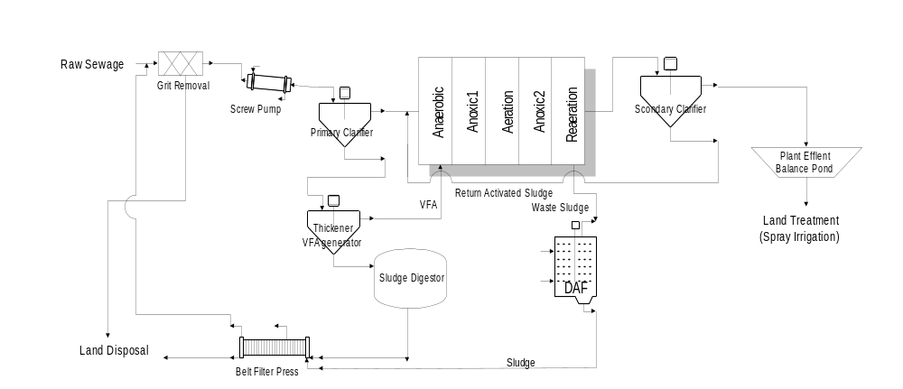Figure 3. Layout of Bardenpho process at Rotorua

Firstly, a proposed GATDNN was used for predicting one-step-ahead effluent TP concentration. In this case the 15 measured variables were used as the inputs to a GATDNN for the prediction of one-step-ahead effluent TP concentration.
The genetic parameters of GAs in a GATDNN are summarised in Table 2 and are identical for all modelling tasks.
Table 2. The genetic parameter of GAs

Population size | 30
No. of generations | 30
Minimum number of neurons per layer | 1
Maximum number of neurons per layer | 32
Crossover probability | 0.8
Mutation probability | 0.25

Due to the nature of GAs, a GATDNN is a never-ending process as shown in Fig. 2.
The termination criterion used was based on the number of generations. A general rule of thumb for the number of generations is 2 times the number of input variables. In our experience, 30 generations was sufficient to evolve the architecture of ANN and to obtain a desired level of prediction accuracy. It has been found that only one hidden layer was required to give satisfactory predictions. Therefore, one hidden layer was used in all modelling tasks for simplicity's sake.
After reaching 30 generations, GAs at 9 generation found an optimal topology of TDNN with the minimum Mean Squared Error (MSE) between the observed and predicted data. A topology of TDNN found was 6 inputs, one hidden layer with 10 neurons with logistic sigmoid function. Each hidden neuron had 7 connections back to the input layer, and the network had one output with a hyperbolic tangent transfer function with 1 connection back to each of the neurons in the hidden layer. Table 1 shows the significant input variables and the topology of the TDNN founded by GAs over each output.
The significant input variables that contribute to treatment efficiency of effluent TP are shown in Table 3, along with the results of sensitivity analysis. Through sensitivity analysis, Table 3 indicates which of the input variables have the greatest effect on the one-step-ahead effluent TP concentration when the inputs are varied between -10 and +10% of the base values. The relative input variables sensitivity ranking over effluent TP are in the order of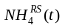, 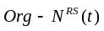, 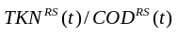, 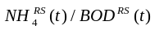, 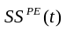, and 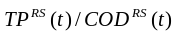.

Table 3. The relative input variable sensitivity ranking over effluent TP

Input Name | One-step ahead 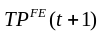
 | 0.356
 | 0.241
 | 0.133
 | 0.105
 | 0.069
 | 0.061

Table 1. Initial input-output variables, input variables selected in a GATDNN, and topology of TDNN.

Input variables | Output variable | Input variables selected by GAs | Topology of TDNN found by GAs
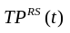,,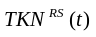, ,,,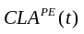,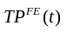,,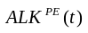,,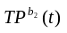,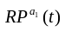,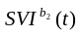,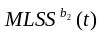, |  | ,,,,, | 6 inputs and 1 hidden layer with 10 Logistic neurons with 6 connections.  1 output neuron using a linear transfer function and 1 connection each
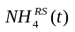,,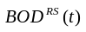,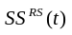,,,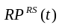,,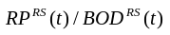,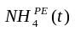,,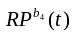,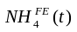 | 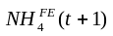 | ,,,,,,, | 8 inputs and 1 hidden layer with 17 Logistic neurons with 5 connections.  1 output neuron using a linear transfer function and 1 connection each.
,,,,,,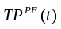,,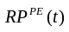,,,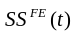 | 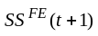 | ,,,,,,,, | 9 inputs and 1 hidden layer with 33 Logistic neurons with 7 connections.  1 output neuron using the tanh transfer function and 1 connection each.
,,,,,,,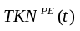,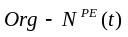,,,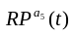,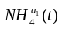,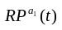,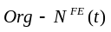 | 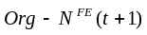 | ,,,,,,, | 8 inputs ad 1 hidden layer with 29 Logistic neurons with 7 connections.  1 output neuron using the tanh transfer function and 1 connection each.
,,,,,,,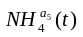,,,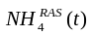,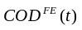, | 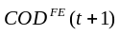 | ,,,,,,,, | 9 inputs ad 1 hidden layer with 30 Logistic neurons with 5 connections.  1 output neuron using the tanh transfer function and 1 connection each.

Fig.4 shows the difference between the predicted value by a GATDNN and the observed value, and demonstrates the ability of a GATDNN to fit the fluctuating effluent TP concentration even under changing operating conditions.
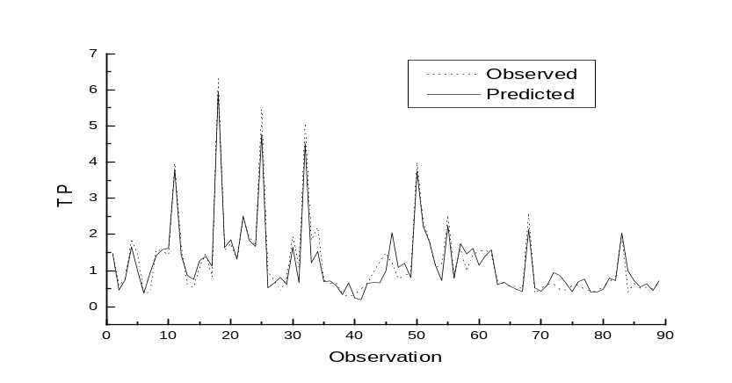
Figure 4. One-step-ahead prediction of effluent TP

The plots in Fig.5 show the comparisons between the observed data and the one-step-ahead predictions for effluent SS, effluent NH₄, effluent Org-N, and effluent COD. It can be seen that effluent COD prediction is the worst whereas that of NH₄ is the most accurate. As shown in Fig. 6, the results for each simulation produced good predictions. Even though the simulation of effluent COD is the worst accuracy relatively, it follows the same pattern as the observed data, except for observation No.85. The results of sensitivity analysis for Org-N, NH₄, SS, and COD are presented in Table 4.
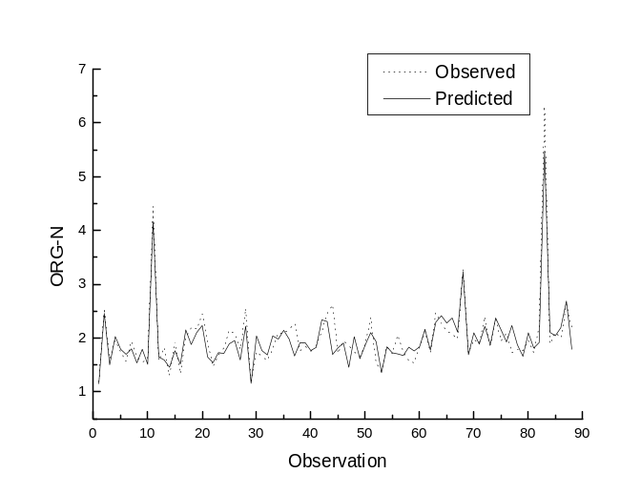
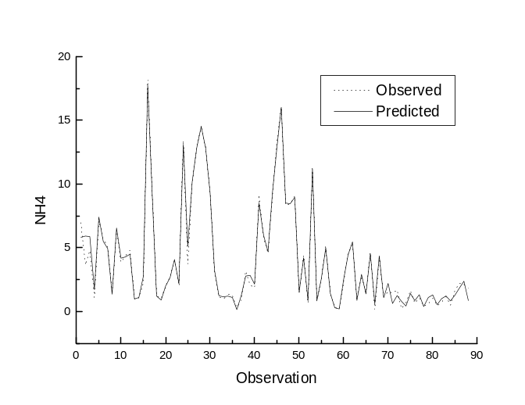
In spite of the varied operational conditions in the complex Bardenpho process, the simulation results demonstrate that the modelling technique using a GATDNN provides a valuable tool for predicting the outputs with high levels of accuracy and for understanding the dynamic behaviour of the process.

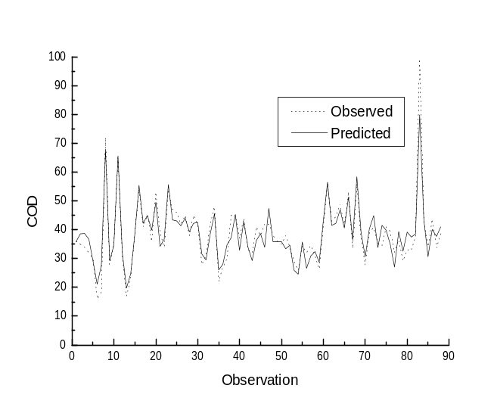
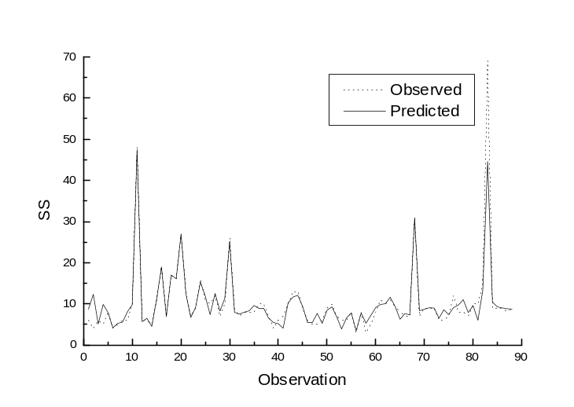

Figure 5. The comparisons between the observed data and the one-step-ahead predictions for effluent Org-N, effluent NH₄, effluent SS, and effluent COD.

Table 4. Results of sensitivity analysis over Org-N, NH_{4,} SS, and COD

(a)

Inputs | One-step-ahead
 | 0.221
 | 0.198
 | 0.162
 | 0.093
 | 0.082
 | 0.076
 | 0.046
 | 0.022

(b)

Inputs | One-step-ahead
 | 0.272
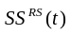 | 0.123
 | 0.112
 | 0.108
 | 0.092
 | 0.069
 | 0.065
 | 0.047

(c)

Inputs | One-step-ahead  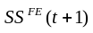
 | 0.397
 | 0.137
 | 0.129
 | 0.091
 | 0.062
 | 0.055
 | 0.046
 | 0.033
 | 0.021

(d)

Inputs | One-step-ahead  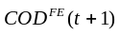
 |  | 0.133
 |  | 0.131
 |  | 0.119
 |  | 0.116
 |  | 0.11
 |  | 0.094
 |  | 0.085
 |  | 0.053
 |  | 0.033

Conclusions

A GATDNN, which can be applied to a complex biological process such as the Bardenpho process, has been developed and implemented. Using a GATDNN, we performed a three-step modelling procedure: (1) select significant input variables to maximise the predictive accuracy for each specific output; (2) find a suitable network topology for the ANN-based process estimator; (3) run sensitivity analysis according to a data set obtained from the previous operation of a GATDNN.
In contrast to the development of a traditional structure-based model such as ASM1 or ASM 2, a GATDNN offers a solution with a high degree of accuracy without prior knowledge of the structure of the relationships that exist in a given complex process. The use of a GAs provides an advantage over an ANN relying on trial-error method in building a topology of ANNs, as potentially better structure of ANNs and significant operating variables may easily be found through GAs. Most significantly, this GATDNN approach uses wastewater plant specific data to improve process performance and identify key operating variables.
The modelling approach discussed here has the potential to be successfully implemented within a design and control strategy and is readily applicable to a variety of other complex biological and manufacturing processes.

Notations

ALK Alkalinity as CaCO₃
BOD Biochemical Oxygen Demand
CLA Chloride concentration
COD Chemical Oxygen Demand
MLSS Mixed Liquor Suspended Solids concentration
NH₄ Ammonia concentration
Org-N Organic nitrogen concentration
RP Reactive phosphorus concentration
SS Suspended solids concentration
SVI Sludge Volume Index
TKN Total Kjeldahl Nitrogen
TP Total phosphorus concentration

Superscripts

RS Raw wastewater
PE Primary clarifier effluent
FE Secondary clarifier effluent

References

- Henze M., Grady C.P.L., Gujer W., Marais G.V.R., and Matsuo T. "Activated sludge model No.1." IAWPRC Sci. Tech, Rep. No.1, London, England (1986).
- Gujer W., Henze M., Hino T., Matsuo T., Wentzel M.C., and Marais G.V.R., “The activated sludge model No.2: biological phosphorus removal”, Water Sci. and Technol., London, England, 31(2), 1-12 (1995).
- Hong, Y.-S.T., and Paik, B.C., “Evolutionary multivariate dynamic process model induction for a biological nutrient removal process”. Journal of Environmental Engineering, American Society of Civil Engineers (ASCE), Vol. 133:12, 1126-1135 (2007).
- Lee, J-W, Hong, Y.-S.T., Suh, C-H, and Shin, H.-S., “Sequential modelling of a full scale wastewater treatment plant using an artificial neural network”, Bioprocess and Biosystems Engineering. Vol. 34:363-373, DOI 10.1007/s00449-011-0547-6 (2011).
- Capodaglio A. G., Jones H.V., Novotny V., and Feng X., “Sludge bulking analysis and forecasting: application of system identification and artificial neural computing technologies”, Wat. Res. 25, 1217-1224 (1991).
- Cote M., Grandjean B. P.A., Lessard P., and Thibault J., “Dynamic modelling of the activated sludge process: improving prediction using neural networks”, Wat. Res. 29, 995-1004 (1995).
- Du Y.G., Tyagi R.D., and Bhamidimarri., R. “Neural network analysis of the diffusional limitations in activated sludge process. Process Biochemistry, 31, 753-763 (1996).
- Zhao H., Hao O.J., McAvoy T.J., and Chang C.-H., “Modelling nutrient dynamics in sequencing batch reactor”, J. Envir. Engng. Am. Soc. Civ. Engrs. 123, 311-319 (1997).
- Miller G.F, Todd P.M., and Hedge S.U., “Designing neural networks using genetic algorithms”, Proc. of the Third Int'l Conf. on Genetic Algorithms and Their Applications, Morgan Kaufmann, San Mateo, CA, 379-384 (1989).
- Whitely D., Starkweather T., and Bogart C., “Genetic algorithms and neural networks: optimizing connections and connectivity”, Parallel computing, 14, 347-361 (1990).
- Harp S.A., Samad T., and Guha A., “Designing application-specific neural networks using the genetic algorithm”, Advances in Neural Information Processing Systems, 2, Morgan Kaufmann, San Mateo, CA, 447-454 (1990).
- Angeline P.J, Saunders G.M., and Pollack J.B., “An evolutionary algorithms that constructs recurrent neural networks”, IEEE Transactions on Neural Networks, 5, 54-64 (1994).
- Maniezzo V., “Genetic evolution of the topology and weight distribution of neural networks”, IEEE Transactions on Neural Networks, 5, 39-53 (1994).
- Wan E.A., "Temporal backpropagation for FIR neural networks." IEEE International Joint Conference on Neural Networks, Vol 1, 575-580, San Diego, CA (1990).
- Wan E.A., “Time series prediction by using a connectionist network with internal delay lines”, In Time Series Prediction: Forecasting the Future and Understanding the Past (A.S. Weigend and N.A. Gershenfeld, eds.), Addison-Wesley, 195-217 (1994).
- Day S.P., and Davenport M.R., “Continuous-time temporal back-propagation with adaptive time delays”, IEEE Transaction on Neural Networks, 4, 348-354 (1993).
- Haykin S., Neural Networks: a Comprehensive Foundation, Upper Saddle River, New Jersey: Prentice Hall (1994).
- Waibel, A., Hanazawa, T., Hinton, G., Shikano, K., and Lang, K.J., “Phoneme recognition using time-delay neural networks”, IEEE Transactions on Acoustics, Speech, and Signal Processing ASSP 37, 328-339 (1989).
- Goldberg D.E., Genetic Algorithms in Search, Optimization and Machine Learning, Addison Wesley (1989).

Perfomance Prediction of the Full-Scale Bardenpho Advanced Sewage Treatment Process Using a Genetic Adapted Time-Delay Neutral Network (GATDNN)

Yoon-Seok Timothy Hong¹, Byeong Cheon Paik*

¹ London South Bank University, 103 Borough Road, London, SE1 0AA, United Kingdom
* Department of Environmental System Engineering, Chonnam National University, Daehak-ro 50, Yosu-si, Chonnam 59626, Republic of Korea

유전자 적응형 시간 지연 신경망(GATDNN)을 이용한 바덴포(Bardenpho) 고도하수처리 공정의 성능 예측

Abstact

Wastewater treatment systems are characterized by large temporal variability of inflow, variable concentrations of components in the incoming wastewater to the plant, and highly variable biological reactions within the process. The behavior of observed process variables within a wastewater treatment plant (WWTP at a certain time instant is the combined effect of various processes initiated at different moments in the past. This is called a time-delay effect in the system Due to the nature of strong nonlinear mapping, neural networks provide advantages as a modeling and identification tool over a structure-based model. However, the determination of the architecture of the artificial neural networks (ANNs) and the selection of key input variables with a time delay is not easy. in our research, a genetic adapted time-delay neural network (GATDNN), which is a combination of time-delay neural network(TDNN) and genetic algorithms(GAs), was developed and applied to the full-scale Bardenpho advanced sewage treatment process. In a GATDNN, a three-step modelling procedure was performed: (1) selection of significant input variables to maximise the predictive accuracy for each specific output; (2) finding a suitable network topology for the ANN-based process estimator; (3) sensitivity analysis. The results demonstrate that the modelling technique presented using a GATDNN provides a valuable tool for predicting the outputs with high levels of accuracy and identifying key operating variables. This work will permit the development of a reliable control strategy thus reducing the burden of the process engineer.

Keywords: Bardenpho advanced sewage treatment process, artificial neural networks (ANNs), genetic adapted time-delay neural network (GATDNN), genetic algorithms(GAs), time-delay neural network(TDNN)

* Corresponding author
E-mail: bpaik@jnu.ac.kr
요약문

폐수처리공정은 복잡한 생물학적 처리과정과 많은 입력변수들의 시간에 따른 강력한 동적 인 변동성으로 인해서 이전의 운전 상황이 차후의 운전상황에 많은 영향을 미친다. 이런한 현상을 시간지연 효과라 한다. 강력한 비선형 매핑(mapping) 특성 때문에 신경망은 구조 기반 모델에 대한 모델링 및 식별 도구로서의 이점을 제공하지만, 일반 인공신경망 (ANN)의 경우 시스템 설계방식(architecture)의 결정 및 시스템에서의 시간 지연과 관련된 주요 입력 변수의 선택은 쉽지 않다. 그래서 본 연구에서는 시간 지연 신경망과 유전자 알고리즘을 결합한 유전자 적응형 시간 지연 신경망 (GATDNN)을 개발하여 바덴포(Bardenpho) 고도하수처리 공정 모델링에 적용하였다. GATDNN에서 3 단계 모델링 절차가 수행되었다. (1) 각 특정 출력에 대한 예측 정확도를 극대화하기 위해 중요한 입력 변수 선택 (2) ANN 기반 프로세스 추정기에 적합한 네트워크 토폴로지(topology)를 찾기 (3) 민감도 분석. 모델링 결과 GATDNN을 사용하여 제시된 모델링 기술이 높은 정확도로 출력을 예측하고 주요 작동 변수를 식별하는 데 유용한 도구임을 보여주었다. 이 작업은 고도하수처리장 운전을 위한 신뢰할 수 있는 제어 전략의 개발을 가능하게 하여 엔지니어의 부담을 줄여 줄 수 있다.

주제어 : 바덴포(Bardenpho) 고도하수처리 공정, 인공 신경망 (ANN), 유전자 적응형 시간 지연 신경망 (GATDNN), 유전자 알고리즘(GAs), 시간 지연 신경망(TDNN)

I.서 론

부영양화로 인한 수역을 보호하기 위해서는 인위적으로 하폐수로부터 인을 제거해야 한다. 점차 엄격 해지는 폐수 배출 요구 사항을 충족시키기 위해 다양한 생물학적 영양물질 제거(BNR) 공정이 개발되었다. 이러한 BNR 시스템은 슬러지 발생량을 감소 시키고, 영양물질을 감소시키기 위해 첨가하는 화학물질 양을 줄이는 이점을 제공한다.
많은 연구자들이 공정 성능을 향상시키고 운영 비용을 줄이기 위해 활성슬러지 공정을 모델링하였다. IAWPRC 활성 슬러지 모델 1 (ASM1)은 관련 구성 요소 및 공정 효율을 포함하는 매트릭스 시스템을 기반으로 개발되었으며, 현재 가장 잘 알려진 모델로 활성슬러지 공정에서 일어나는 동력학적 현상을 시뮬레이션 하는데 적용되고 있다.⁽¹⁾ ASM1이 개발된 이후에 생물학적 인 제거를 포함하는 생물학적처리 공정을 모델링하기 위해ASM2가 개발되었다.⁽²⁾ 이러한 구조 기반 모델(structure-based model)이 설계 및 모델링 목적에 성공적으로 적용되어 사용되고 있지만, 실제 처리장의 모델링과 제어에 적용하는 데는 여전히 많은 문제점을 안고 있다. 이러한 문제점들은 다음과 같다.

1.이들 모델은 많은 설계 및 운전 인자가 지정되어 있으며, 그 중 대다수는 측정하기가 어렵다. 예를 들어, ASM2는 17 개의 공정과10 개의 용해된 물질로 구성된다.
2.이들 모델은 다른 운전 조건에서는 운전 인자 값을 재 지정하도록 요구한다.
3. 중요하고 많은 설계 및 운전 인자를 식별하고 측정할 수 있는 온라인 센서가 없다.
4. 대부분의 BNR 공정은 본질적으로 시간에 따라 변화하는 비선형적인 특성을 갖는다.^{(3,4)}

이러한 제약 사항 때문에 이들 구조 기반 모델링(structure-based modelling)은 실제 규모 처리장에 적용하는 데는 어려운 점이 많다. 구조 기반 모델의 대안으로 많은 연구자들이 비선형 모델링 및 공정 제어에 뛰어난 인공 신경망 (artificial neural network, ANN)에 대한 연구를 수행하였으며, ANN을 하폐수처리 공정에도 성공적으로 적용해 왔다.⁽⁵⁻⁸⁾

고전적 모델에 비해 인공신경망 기법의 장점은 다음과 같다.

(1) 공정 구조에서 제한된 사전 지식으로 복잡한 비선형 관계를 학습 할 수 있는 능력
(2) 입력 변수의 알려지지 않은 조합에 대해 추론할 수 있는 능력

그러나 인공신경망 을 새로운 것에 적용할 때 인공 신경망 의 시스템 설계방식(architecture)을 결정하는 것과 어떤 입력 변수가 특정 공정에 중요한지 선택하는 것이 매우 어렵다. 이러한 문제점을 극복하기 위해 인공신경망의 시스템 설계방식(architecture)개발 수단으로 유전자 알고리즘 (Gas, genetic algorithms)가 사용되어 왔다.⁽⁹⁻¹³⁾
Finite-duration impulse response (FIR) 신경망^{(14,15)}을 기반으로 한 시간 지연 신경망 (time-delay neural network, TDNN)의 구조를 설계하고 입력 변수를 선택하기 위해 유전자 알고리즘를 사용하는 유전자 적응형 시간지연 신경망 (genetic algorithms time-delay neural network, GATDNN)를 개발하였다. 본 연구에서는 개발된 유전자 적응형 시간지연 신경망을 실제 규모의 바덴포(Bardenpho) 하수고도처리 공정의 동력학적 모델링에 적용하여 처리장 운전 제어의 도구로서 유용성을 입증하고자 하였다. 입력 변수가 유전자 적응형 시간지연 신경망의 출력 변수에 미치는 영향을 설명하기 위해 입력 민감도 분석도 아울러 수행하였다.

II. 방법

1. 시간지연 신경망 (time-delay neural network, TDNN)

다양한 인공 신경망의 시스템 설계방식(architecture) 중에서 표준 역전파(back propagation) 알고리즘을 사용하는 다층 피드 포워드(feedforward) 신경망이 주로 생물학적 공정에 적용된다. 그러나 표준 역전파 알고리즘의 경우는 정적인 입출력 매핑(mapping)만 학습할 수 있다. 이것은 전방전달신경망(feedforward neural network)이 정적이며 내부 시간 지연이 없고 특정 입력에 특정 출력을 즉시 생성하여 응답한다는 것을 의미한다.⁽¹⁶⁾ 그러므로 시간에 따라 변하는 패턴에는 반응 할 수 없다는 한계점을 가지고 있다.
일반적으로 생물학적 공정은 동력학적인 특성을 가지고 있으므로 동적 신경망이 필요하다. 신경망이 동력학적이기 위해서는 기억이 주어져야 한다.⁽¹⁷⁾ 이 요구 사항을 달성 할 수 있는 한 가지 방법은 시간 지연을 신경망의 접합구조에 통합하고 학습 단계에서 값을 조정하는 것이다. 이 인공 신경망은 일반적으로 계층의 출력이 여러 시간 단계로 버퍼링(buffering)된 후, 다음 계층에 완전히 연결되어 공급되는 계층화 된 망으로 설명되는 소위 시간 지연 신경망 (TDNN)이다.^{(15,18)} 가장 잘 알려진 TDNN은 FIR 신경망으로 표준 전방전달신경망(feedforward neural network)과 유사하다. 각 신경접합부(synapse)는 적응형 FIR 선형 필터로 대체되고, 오차(error) 항이 망을 통해 역으로 필터링(filtering) 된 시간적 역전파 알고리즘을 사용하여 학습된다. ^{(13,14)} 가장 기본적인 FIR 신경망을 Fig. 1에 도식하였다.

출력 값 은 과거 지연된 입력 값의 합으로 활성화 함수로 나타난다.
(1)

K 시간 l 층에서 뉴런(neuron)의 출력 값 은 뉴런을 공급하는 모든 필터 출력 값의 함수로 나타난다(Fig.1).

(2)

여기서, 벡터 는 l 층에서 뉴런 i 와 뉴런 j 를 연결하는 스냅스 필터(synaptic filter)의 계수이고, 시냅스 필터를 따라 지연된 상태의 벡터를 나타낸다.

이제 뉴런 j 가 출력층에 있고 그 실제 출력이 로 표시되고 원하는 출력은 로 표시 되며, 이 모두는 k 시간에 측정된 것으로 가정한다. 신경망에서 학습(neural network training)의 목표는 다음과 같은 비용 함수()를 최소화 하는 것이다.

(3)

위의 목표를 달성하는 최적 가중치 벡터 를 산정하기 위해 시간적 역전파 알고리즘(temporal backpropagation algorithm)이라고 하는 가중치 갱신 방정식이 다음과 같은 관계식으로 사용된다. ^{(13,14)}

(4)
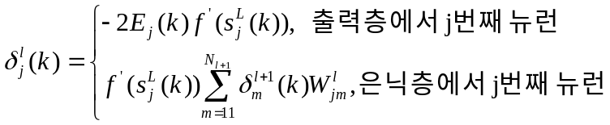 (5)

여기서 는 활성화 함수의 미분함수이며, 는 전파된 경사(gradient) 항의 벡터이다

Figure 1. 시간 지연 신경망 (TDNN)의 시스템구조 ( represents a unit time delay operator, i.e.,).

2.유전자 알고리즘(GAs)이 수반된 시간지연 신경망(TDNN)

유전자 알고리즘(genetic algorithms, GAs)은 어떤 문제에 대한 해결책을 개발하는 데 사용되는 자연 개체군 유전학에 기반한 평행하고 포괄적인 최적화 기술이다. 그들은 복제, 교차, 돌연변이와 같은 유전적 조작를 통해 현존하는 구조들 중에서 생존을 위한 최적의 개념을 이용한다 (Goldberg, 1989). 유전자 알고리즘의 성공은 결과에 긍정적인 영향을 미치는 솔루션(solution) 부분을 계속 유지하고 최적이 아닌 부분을 최적화하는 능력을 기반으로 한다. 이러한 유전자 알고리즘는 검색 엔진으로서의 매우 효과적으로 사용되기 때문에 과학, 공학 및 비즈니스 컨텍스트(business context)에서의 문제 해결에 적용되고 있다.
유전자 알고리즘를 사용하여 문제를 풀기 위해서는 문제의 매개 변수 (표현형)를 유전자형으로 코딩해야 한다. 유전자형은 비트 문자열, 정수 또는 부동 소수점 숫자 문자열 또는 다른 기호 문자열로 나타낼 수 있다. GAs 은 품질(quality)로 표현되는 유전 연산자를 적용하여 최적의 유전자형을 전반적으로 검색하는 유전자형 집단에 대해 작업한다. 유전자형의 품질(quality)은 표현형을 추출함으로써 계산되는 데, 그것은 표현형의 적합성을 나타내고 평가한다.
이는 이진 비트(bit) 문자열 (유전자형)이 신경망 (표현형)의 토폴로지 (topology) 로 디코딩(decoding)될 수 있다는 것을 의미 한다. 그런 다음 신경망의 적합성은 신경망이 학습 (훈련 오류), 일반화 (시험 오류), 복잡성 (단위 및 링크의 양) 및 다양한 다른 기준을 포함 ​​할 수 있는 품질 기능과 관련하여 계산된다.
본 논문에서는 유전자 알고리즘와 시간 지연 신경망으로 조합된 유전자 적응형 시간지연 신경망 (GATDNN)가 다음과 같은 주기적 절차로 진행된다.

1 단계 : 초기화 - 시간지연 신경망에 대해 평가할 이진(binary) 비트(bit) 문자열 (유전자형, genotype)을 무작위로 초기 개체군을 생성한다.
2 단계 : 디코딩 - 이진 비트 문자열을 시간지연 신경망구조로 디코딩 한다. 이 과정은 유전자형에 따라 시간지연 신경망 (표현형, phenotype)을 구축한다.
3 단계 : 적합도 값 계산 - 적합도를 결정하기 위해 시간 지연 신경망을 훈련시키고 테스트 하여 시간지연 신경망의 적합도를 계산하고 비교한다. 적합도 값 함수는 비용 함수의 역수이므로 적합도 값을 최대화 하는 것은 비용 함수를 최소화 하는 것이 된다.
4 단계 : 복제 - 개체군에서 더 나은 시간지연 신경망을 선택한다. 이 선택 과정은 낮은 품질의 것보다 높은 품질의 유전자형 (개인)이 복제로 선택 될 가능성을 높인다. 유전자 형을 선택하는 몇 가지 방법이 있다. 이 연구에서는 유전자형을 임의로 추출한 룰렛 휠(roulette wheel) 선택을 사용하였다.
5 단계 : 개체군 채우기 - 개체군을 초기에 지정된 크기로 다시 채운다. GAs는 부실한 표현형(phenotype)을 떨어뜨리는 선택 방법을 사용하기 때문에 개체군이 모든 세대에서 채워져야 한다. 이 과정은 선택 과정에서 생존자가 개체군을 채우기 위해 복제되는 것에 기반한다.
6 단계 : 교차 – 유전자형(genotype)이 짝을 지어 유전자 교환을 통하여 유전자형을 돌연변이 시킨다. 이 연산자는 우수한 유전자형을 만들기 위해 두 유전자형의 중요한 부분을 결합을 시도한다. 많은 교차를 선택할 수도 있으나 그것이 반드시 최적의 과정을 개선하지 않기 때문에 이 연구에서는 두 개 교차를 선택하였다. ⁽¹⁹⁾
7 단계 : 돌연변이 - 돌연변이 확률에 따라 유전자형을 변형한다. 유전자 알고리즘 의 주요 엔진 인 돌연변이는 새로운 솔루션(solution)을 도입하고 개체군이 중요한 정보를 복구 할 수 없게 하는 것을 방지하기 위해 사용된다. 돌연변이 확률은 교차에 부정적인 영향을 방지하고 강한 인과 관계를 유지하기 위해 일반적으로 낮게 유지된다. 돌연변이 점유율이 높으면 (예 : 0.5) 유전자 알고리즘이 무작위(random) 검색으로 바뀐다.
8 단계 : 반복 - 단계 2-7은 세대마다 계속 반복되고, 종료 기준이 만족 될 때까지 계속 진행되면서 가장 좋은 적합도 값이 얻어진다. 위의 주기적 과정을 통해 더 우수한 시간지연 신경망이 생존하고 그 기능이 미래 세대에 보존되며, 더 우수한 시간지연 신경망을 찾기 위해 다른 시간지연 신경망들과 결합된다.

위에서 언급한 유전자 적응형 시간지연 신경망 (GATDNN)의 수행 과정을 Fig.2에 나타내었다.

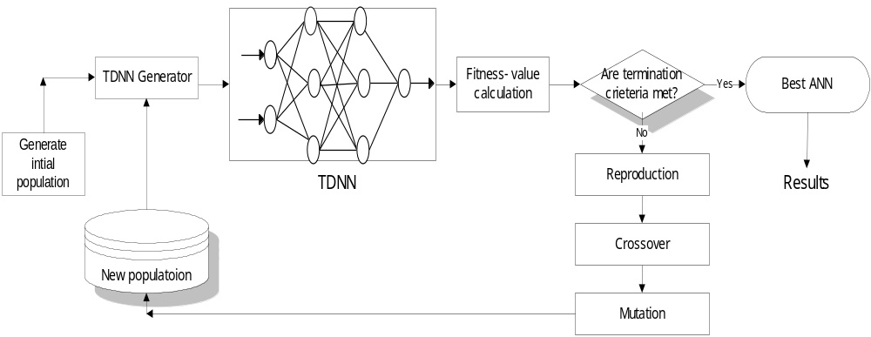

Figure 2. 유전자 알고리즘을 이용해서 최적의 시간지연 신경망구조를 찾는 과정도

III.결과 및 고찰

1. 바덴포(Bardenpho) 고도하수처리 공정

뉴질랜드의 로토루아(Rotorua) 시에 위치한 로토루아 하수처리장은 생물학적 질소 및 인을 제거하는 고도하수처리장으로 혐기조-무산소조-호기조-무산소조-호기조로 구성된 5단계 바덴포(Bardenpho) 공정으로 구성되어 있으며, 로토루아 시 도시하수는 이곳 중앙 하수처리장에서 매일 처리되고 있다. 바덴포(Bardenpho) 공정은 1970년 남아프리카의 James Barnard에 의해 개발되었으며, 처음에 개발된 바덴포 공정은 무산소조-호기조-무산소조-호기조 로4 단계를 거쳐 생물학적 영양물질을 제거하였다. 5단계 바덴포(bardenpho) 고도하수처리 공정에서 사용되는 혐기성 슬러지는 식물(plant), 음식물 쓰레기, 잡초, 휴지 등의 혼합 물질을 처리하는 혐기성 처리 탱크에서 얻어지며, 이들 유기성 폐기물은 30 ~ 40 ℃의 온도에서 2 ~ 4 일 동안 혐기성 발효가 진행된다. 5단계 바덴포(Bardenpho) 공정에서 인은 혐기성 조건하에서 인을 축적하는 미생물로부터 세포 밖으로 방출 되며, 호기성 조건에서는 인을 축적하는 미생물에 의해 과잉 흡수된다. 질산화 박테리아는 호기성 조에서 암모니아성 질소(NH₄-N)를 산화시켜 질산화성 질소(NO₃-N)을 생성한다. 무산소 조에서 산화된 질소(NO₃-N)는 박테리아에 의해 질소(N₂) 가스로 전환된다.
로토루아(Rotorua) 시의 고도하수처장에 도입된 수정5단계 바덴포 (Bardenpho) 공정은 1982년 5월부터 가동되어 왔으며, 공정의 배치도는 Fig.3 에 나타내었다. 수정5단계 바덴포(Bardenpho) 공정은 혐기성조-무산소조-호기성-무산소조-호기조(반응)로 구성되며, 2차 침전지의 반송 슬러지는 혐기조 앞 쪽으로 반송되어 유입 하수와 혼합된다. 또한, 호기조에서 질산화된 질소의 탈질을 유도하기 위해 호기조에서 앞의 무산소조로 혼합액 일부를 반송한다. 로토루아(Rotorua) 고도하수처리장에는 1차 침전지의 슬러지를 발효하여 휘발성 지방산 (VFA)을 얻을 수 있는 발효조와, 2차침전지의 활성슬러지 처리를 위한 용존공기부상(DAF) 장치와 슬러지 탈수용 벨트필터프레스(belt filter press) 장치를 갖추고 있다.
로토루아(Rotorua) 시의 바덴포(Bardenpho) 고도하수처리장은 현재 인구 6만명이 배출하는 하수량을 처리하고 있으며, 설계 인구는 75,000명 이다. 현재 하수처리장의 하루 처리량은 18,000 m³ 이며, 설계 처리량은 27,000m³/day 으로 대부분 도시에서 발생하는 하수를 처리하고 있다. 바덴포(Bardenpho) 고도 하수처리 공정에서는 어떠한 화학 약품을 사용하지 않기 때문에 운영비가 낮고, 화학 물질을 함유한 슬러지에서 발생할 수 있는 슬러지 처리 문제가 없다. 또한, 공정 운전이 비교적 간편하여 직원의 재교육이 필요가 없는 장점이 있으며, 최종 단계에서 얻어진 슬러지는 손 쉽게 처분할 수 있다. 그러나, 이 공정의 단점은 반응조 수가 많아 초기 건설 비용이 크게 증가한다는 것이다.

Figure 3. 로토루아 (Rotorua)에 있는 바덴포 (Bardenpho) 폐수처리공정도

2. 유전자 알고리즘(GAs)이 수반된 시간 지연 신경망(TDNN)을 이용한 바덴포(Bardenpho) 공정 모델링 및 결과

인공 신경망을 사용하여 복잡한 생물학적 하폐수 처리 공정을 시뮬레이션 (simulation) 할 경우 입력 변수의 선정은 신뢰할 수 있는 결과를 얻는 데 매우 중요하다. 바덴포(Bardenpho) 공정의 특성에 대한 사전 지식과 상관 관계 분석을 통해 얻은 통계적 관계를 통하여 각 출력에 대한 입력 변수가 결정되었다. 본 연구에서 유전자 적응형 시간지연 신경망는 유출수의 총 인 (TP), 유출수의 암모니아 (NH4), 유출수의 부유 물질 (SS), 유출수의 유기 질소 (Org-N) 및 유출수의 COD 을 예측하는 데 적용하였다. Table 1 에 각 예측 작업에 대한 입력 변수와 출력 변수를 나타내었다.
앞에서 설명한 바덴포(Bardenpho) 공정으로부터 총 89 개 세트의 측정 자료를 가져와 모델링을 위해 컴퓨터에 입력하였다. (1) 측정 자료의 80% 는 모델식이 만들어지는 훈련(training)에 사용되고 (2) 나머지 20% 는 만들어진 모델식을 테스트 하는데 사용하도록 두 세트로 분리하였다.
첫째, 제안 된 유전자 적응형 시간지연 신경망은 하루 앞선(one-step-ahead, t+1) 유출수 TP 농도를 예측하는 데 사용된다. 이 경우 15 개의 측정된 변수가 유출수 TP 농도의 예측을 위한 유전자 적응형 시간지연 신경망의 입력으로 사용되었다. 유전자 적응형 시간지연 신경망에서 GAs의 유전적 매개 변수는 Table 1에 나타나 있으며 모든 모델링 작업에서 동일하게 적용된다.

Table 1. The genetic parameter of GAs
군집수 (Population size) | 30
세대수 (No. of generations) | 30
은닉층에서 최소 뉴런수 | 1
은닉층에서 최대 뉴런수 | 32
교차확률(Crossover probability) | 0.8
변이확률(Mutation probability) | 0.25

유전자 알고리즘의 특성상 유전자 적응형 시간지연 신경망은 Fig. 2와 같이 끝없이 순환되는 과정이다. 이러한 과정이 반복되면서 종료되는 기준은 세대(generation)수를 기반으로 하였다. 일반적으로 세대수는 입력 변수 수의 2배로 정해진다. 경험적으로 볼 때 30세대수이면 인공신경망를 구성하여 원하는 수준의 정확도로 예측하는 데 충분하다. 하나의 은익층을 사용하는것이 만족스러운 예측을 내리는 데 필요하다는 것이 발견되었다. 따라서 우리 연구에서도 하나의 하나의 은익층 (one hidden layer)을 사용하였다.
30세대수에 도달한 후에 9세대수 유전자 알고리즘에서 측정된 데이터와 예측한 데이터 간의 평균 제곱 최소 오차(minimum Mean Squared Error, MSE)를 갖는 TDNN의 최적 토폴로지(topology)가 발견된다. 시간지연 신경망은 은 6개의 입력변수와 활성화함수로 로지스틱 시그모이드(logistic sigmoid) 함수를 갖는 10개의 뉴런(neuron)으로 갖춰진 은익층1으로 구성된다. 각각의 은익 뉴런은 입력층에 7개 연결를 가지고 있고, 이러한 망(network)는 은익층에 있는 각각의 뉴런과 하나로 연결된 하이퍼볼릭 탄젠트(hyperbolic tangent) 전달함수를 보유한 출력층1를 갖는다. Table 2는 중요한 입력 변수들과 각 출력층에 대한 유전자 알고리즘에서 만들어진 시간지연 신경망은 의 토포로지(topology)를 보여준다.
유출수 총인(total phosphorus, TP)의 처리 효율에 영향을 미치는 입력 변수들의 민감도 분석 값을 Table 3에 나타내었다. 민감도 분석을 통하여 입력 변수들은 기준 값에서 -10%와 +10% 사이에서 유출수 총인(TP) 농도에 크게 영향을 미치는 것으로 나타났다. 유출수 총인(TP)에 대한 민감도 순위는 , , , , , 순으로 나타났다.

Table 2. 유존자 알고리즘에 의해서 최적화된 시간지연 신경망구조 (최적입력변수, 시스템구조, 은닉뉴론수, 은닉층에서 사용된 활성화함수의 수)

입력변수 | 출력변수 | 유전자 알고리즘에의해서 최적화된 입력변수 | 유전자 알고리즘에의해서 최적화된 시간지연 신경망의 구조
,,, ,,,,,,,,,,,, |  | ,,,,, | 6 inputs and 1 hidden layer with 10 Logistic neurons with 6 connections.  1 output neuron using a linear transfer function and 1 connection each
,,,,,,,,,,,, |  | ,,,,,,, | 8 inputs and 1 hidden layer with 17 Logistic neurons with 5 connections.  1 output neuron using a linear transfer function and 1 connection each.
,,,,,,,,,,, |  | ,,,,,,,, | 9 inputs and 1 hidden layer with 33 Logistic neurons with 7 connections.  1 output neuron using the tanh transfer function and 1 connection each.
,,,,,,,,,,,,,, |  | ,,,,,,, | 8 inputs ad 1 hidden layer with 29 Logistic neurons with 7 connections.  1 output neuron using the tanh transfer function and 1 connection each.
,,,,,,,,,,,, |  | ,,,,,,,, | 9 inputs ad 1 hidden layer with 30 Logistic neurons with 5 connections.  1 output neuron using the tanh transfer function and 1 connection each.

Table 3. 총인 (Total Phosphorus)유출수에 대한 입력변수 민감도 분석 결과

입력변수 | 에 대한 민감도
 | 0.356
 | 0.241
 | 0.133
 | 0.105
 | 0.069
 | 0.061

Fig. 4는 유전자 적응형 시간지연 신경망에 의한 예측 값과 측정 값의 차이를 보여 주며, 유전자 적응형 시간지연 신경망은 운전 조건이 변화하더라도 변동되는 유출수의 총인(TP) 농도에 잘 맞도록 예측할 수 있는 능력을 보여준다.

Figure 4. 총인 (TP)유출수에 대한 하루앞선 에측 결과 (One-step-ahead prediction)

Fig. 5에 유출수의 SS, NH₄, Org-N, COD측정값과 한 단계 앞선 예측값(t+1)를 그래프로 비교하여 나타내었다. 유출수의 NH₄농도가 가장 정확하게 예측되는 것으로 나타났으며, 유출수의 SS와 Org-N 농도 시뮬레이션 결과도 좋은 것으로 나타났다.
유출수의 COD 예측은 No.85 측정값 예측을 제외하고는 다른 그래프와 동일한 패턴을 보이면서 비교적 양호한 것으로 나타났다. Org-N, NH₄, SS 및 COD의 민감도 분석 결과는 Table 4에 제시하였다.
복잡한 Bardenpho 하수고도처리 공정의 다양한 운전조건에도 불구하고 시뮬레이션 결과는 유전자 적응형 시간지연 신경망을 사용하는 모델링 기술이 높은 정확도로 출력을 예측하고 하수고도처리 공정의 동적인 현상을 이해하는 데 유용한 도구를 제공함을 보여주었다.

Figure 5. 시간지연 신경망에 의한Org-N유출수, NH₄유출수, SS유출수, 그리고 COD유출수에 대한 하루앞선 에측 결과.

Table 4. Org-N유출수, NH₄유출수, SS유출수, 그리고 COD유출수에 대한 입력변수 민감도 분석 결과

(a)

입력변수 | 에 대한 민감도
 | 0.221
 | 0.198
 | 0.162
 | 0.093
 | 0.082
 | 0.076
 | 0.046
 | 0.022

(b)

Inputs | 에 대한 민감도
 | 0.272
 | 0.123
 | 0.112
 | 0.108
 | 0.092
 | 0.069
 | 0.065
 | 0.047

(c)

입력변수 | 에 대한 민감도
 | 0.397
 | 0.137
 | 0.129
 | 0.091
 | 0.062
 | 0.055
 | 0.046
 | 0.033
 | 0.021

(d)

입력변수 | 에 대한 민감도
 |  | 0.133
 |  | 0.131
 |  | 0.119
 |  | 0.116
 |  | 0.11
 |  | 0.094
 |  | 0.085
 |  | 0.053
 |  | 0.033

IV.결론

바덴포(Bardenpho) 고도하수처리 공정과 같은 복잡한 생물학적 공정에 적용 할 수 있는 유전자 적응형 시간지연 신경망이 개발되고 구현되었다. 유전자 적응형 시간지연 신경망을 사용하여 다음과 같은 3 단계 모델링 절차를 수행하였다. (1) 각 출력에 대한 예측 정확도를 극대화하기 위해 중요한 입력 변수를 선택한다. (2) 인공신경망은 기반에 적합한 네트워크 토포로지(topology)를 찾는다. (3) 유전자 적응형 시간지연 신경망의 선행 조작으로 부터 얻어진 데이터에 따라 민감도 분석을 실시한다.
ASM1 또는 ASM 2와 같은 전통적인 구조 기반 모델의 개발과 달리 GATDNN은 주어진 복잡한 공정에 존재하는 관계의 구조에 대한 사전 지식 없이 고도의 정확성을 갖춘 솔루션(solution)를 제공한다. 유전자 알고리즘를 사용하면 인공신경망의 토폴로지(topology)를 구축 할 때 시행 착오 방법에 의존하는 인공신경망을 보다 더 유리한 데, 이는 인공신경망의 더 나은 구조와 중요한 운영 변수가 유전자 알고리즘를 통해 쉽게 발견 될 수 있기 때문입니다. 가장 중요한 점은 이 유전자 적응형 시간지연 신경망 접근법은 하폐수처리 공정의 특정 데이터를 사용하여 공정의 성능을 향상시키고 중요한 운전 변수를 찾아 낸다는 것이다.
여기서 논의된 모델링 접근법은 설계 및 운전제어에서 성공적으로 구현될 잠재력을 가지고 있으며, 다양하고 여러 복잡한 생물학적 처리공정에 쉽게 적용될 수 있다.

Notations

ALK Alkalinity as CaCO₃
BOD Biochemical Oxygen Demand
CLA Chloride concentration
COD Chemical Oxygen Demand
MLSS Mixed Liquor Suspended Solids concentration
NH₄ Ammonia concentration
Org-N Organic nitrogen concentration
RP Reactive phosphorus concentration
SS Suspended solids concentration
SVI Sludge Volume Index
TKN Total Kjeldahl Nitrogen
TP Total phosphorus concentration

Superscripts

RS Raw wastewater
PE Primary clarifier effluent
FE Secondary clarifier effluent

References

- Henze M., Grady C.P.L., Gujer W., Marais G.V.R., and Matsuo T. "Activated sludge model No.1." IAWPRC Sci. Tech, Rep. No.1, London, England (1986).
- Gujer W., Henze M., Hino T., Matsuo T., Wentzel M.C., and Marais G.V.R., “The activated sludge model No.2: biological phosphorus removal”, Water Sci. and Technol., London, England, 31(2), 1-12 (1995).
- Hong, Y.-S.T., and Paik, B.C., “Evolutionary multivariate dynamic process model induction for a biological nutrient removal process”. Journal of Environmental Engineering, American Society of Civil Engineers (ASCE), Vol. 133:12, 1126-1135 (2007).
- Lee, J-W, Hong, Y.-S.T., Suh, C-H, and Shin, H.-S., “Sequential modelling of a full scale wastewater treatment plant using an artificial neural network”, Bioprocess and Biosystems Engineering. Vol. 34:363-373, DOI 10.1007/s00449-011-0547-6 (2011).
- Capodaglio A. G., Jones H.V., Novotny V., and Feng X., “Sludge bulking analysis and forecasting: application of system identification and artificial neural computing technologies”, Wat. Res. 25, 1217-1224 (1991).
- Cote M., Grandjean B. P.A., Lessard P., and Thibault J., “Dynamic modelling of the activated sludge process: improving prediction using neural networks”, Wat. Res. 29, 995-1004 (1995).
- Du Y.G., Tyagi R.D., and Bhamidimarri., R. “Neural network analysis of the diffusional limitations in activated sludge process. Process Biochemistry, 31, 753-763 (1996).
- Zhao H., Hao O.J., McAvoy T.J., and Chang C.-H., “Modelling nutrient dynamics in sequencing batch reactor”, J. Envir. Engng. Am. Soc. Civ. Engrs. 123, 311-319 (1997).
- Miller G.F, Todd P.M., and Hedge S.U., “Designing neural networks using genetic algorithms”, Proc. of the Third Int'l Conf. on Genetic Algorithms and Their Applications, Morgan Kaufmann, San Mateo, CA, 379-384 (1989).
- Whitely D., Starkweather T., and Bogart C., “Genetic algorithms and neural networks: optimizing connections and connectivity”, Parallel computing, 14, 347-361 (1990).
- Harp S.A., Samad T., and Guha A., “Designing application-specific neural networks using the genetic algorithm”, Advances in Neural Information Processing Systems, 2, Morgan Kaufmann, San Mateo, CA, 447-454 (1990).
- Angeline P.J, Saunders G.M., and Pollack J.B., “An evolutionary algorithms that constructs recurrent neural networks”, IEEE Transactions on Neural Networks, 5, 54-64 (1994).
- Maniezzo V., “Genetic evolution of the topology and weight distribution of neural networks”, IEEE Transactions on Neural Networks, 5, 39-53 (1994).
- Wan E.A., "Temporal backpropagation for FIR neural networks." IEEE International Joint Conference on Neural Networks, Vol 1, 575-580, San Diego, CA (1990).
- Wan E.A., “Time series prediction by using a connectionist network with internal delay lines”, In Time Series Prediction: Forecasting the Future and Understanding the Past (A.S. Weigend and N.A. Gershenfeld, eds.), Addison-Wesley, 195-217 (1994).
- Day S.P., and Davenport M.R., “Continuous-time temporal back-propagation with adaptive time delays”, IEEE Transaction on Neural Networks, 4, 348-354 (1993).
- Haykin S., Neural Networks: a Comprehensive Foundation, Upper Saddle River, New Jersey: Prentice Hall (1994).
- Waibel, A., Hanazawa, T., Hinton, G., Shikano, K., and Lang, K.J., “Phoneme recognition using time-delay neural networks”, IEEE Transactions on Acoustics, Speech, and Signal Processing ASSP 37, 328-339 (1989).
- Goldberg D.E., Genetic Algorithms in Search, Optimization and Machine Learning, Addison Wesley (1989).

