**Liquid Pressure Amplification in Refrigeration Systems – Potential for Reducing Energy Consumption in Retrofit Applications**

1. **Hadawey, S. A. Tassou*, Y. T. Ge**

*School of Engineering and Design, Brunel University, Uxbridg, Middlesex,*

*UB8 3PH, UK*

*Tel +44 (0)1895 266865*

*\*E-mail:* [*Savvas.tassou@brunel.ac.uk*](mailto:Savvas.tassou@brunel.ac.uk)

**Abstract:** The LPA technology utilises a refrigerant pump in the liquid line after the receiver to maintain a high enough pressure differential across the expansion valve to compensate for the pressure drop in long liquid lines. This allows the condenser pressure to be varied in line with variations in the ambient temperature leading to lower discharge pressures during periods of low ambient temperatures and lower compressor power consumption. Operation at lower pressures also increases the refrigeration capacity of the system enabling it to cope with increased load demands. LPA can be applied to new refrigeration plant and as a retrofit to existing plant. LPA also enables the use of liquid injection into the discharge line of the compressor which de-superheats the refrigerant vapour before entering the condenser. This increases the capacity of the condenser which in turn enables operation of the plant at lower condensing temperatures. This paper considers the application of a LPA and liquid injection to a cold store refrigeration system. The analysis has shown that more than 10% energy saving over and above the savings that can be achieved with floating head pressure, can be achieved by adopting the use of LPA in conjunction with liquid injection.

***Keywords:*** Liquid Pressure Amplification, Refrigeration systems, Liquid Injection, Energy Savings.

**1. Introduction**

The Dairy sector is one of the major refrigeration energy users in the food industry. Significant energy and financial savings can be achieved by adopting new refrigeration technologies and practices. One such technology which has been available on the market for direct expansion evaporator vapour compression systems for a number of years but has not as yet found wide application is Liquid Pressure Amplification.

Technologies to solve the problems resulting from altitude difference and long extension pipes between the outdoor and indoor units are essential to achieve good system performance and reliability. Long pipe lines and altitude differences increase the possibility of flash gas generation at the expansion devise inlet which reduces the refrigerant flow rate and system performance [1].

The liquid refrigerant pump technology modifies a conventional direct-expansion, vapour-compression refrigeration system by adding a simple, low-power pump in the liquid refrigerant line. This addition allows the minimum head pressure control to be adjusted to allow lower compressor discharge pressure at lower ambient temperatures. This, in turn, leads to reduced compressor load and increased refrigeration capacity [2]. The pump normally raises the pressure of the liquid line between 1.0 and 1.5 bar above the condensation pressure [3].

LPA can be applied to new refrigeration plant and as a retrofit to existing plant. Refrigerant pumps used in LPA systems even though are designed so that the heat released from the motor does not enter the refrigerant circuit, they do impart an enthalpy and hence a temperature increases due to the pumping process.

The greater the head developed by the pump, the greater the enthalpy increase of the refrigerant and thus there is a compromise between the pressure increase of the refrigerant in the liquid line and the temperature increase to avoid flashing of the refrigerant liquid [4].

Sub-cooling of the refrigerant liquid at the condenser outlet can help in this respect [5].

The LPA technology also enables the use of liquid injection into the discharge line of the compressor which de-superheats the refrigerant vapour before entering the condenser. This increases the heat transfer surface of the condenser that is available for two-phase heat transfer which in effect increases the capacity of the condenser and enables operation of the plant at lower condensing temperatures. Liquid injection can also be an effective method of controlling sub-cooling at the condenser outlet [1].

This paper considers a case study of the application of a LPA and liquid injection to a cold store refrigeration system in a dairy plant. The main aim of the case-study was to investigate the performance of the LPA technology as installed and estimate the energy savings and environmental performance of the system. The analysis through hourly system simulations considers the impact of ambient conditions on the energy performance of LPA and contrasts this with the energy savings that could be obtained with floating head pressure control but without the LPA system.

**2. The investigated facility**

The case study considers a 100 kW cold room refrigeration system at a dairy plant in Northern Ireland. A schematic diagram of the system is shown in Figure 1.

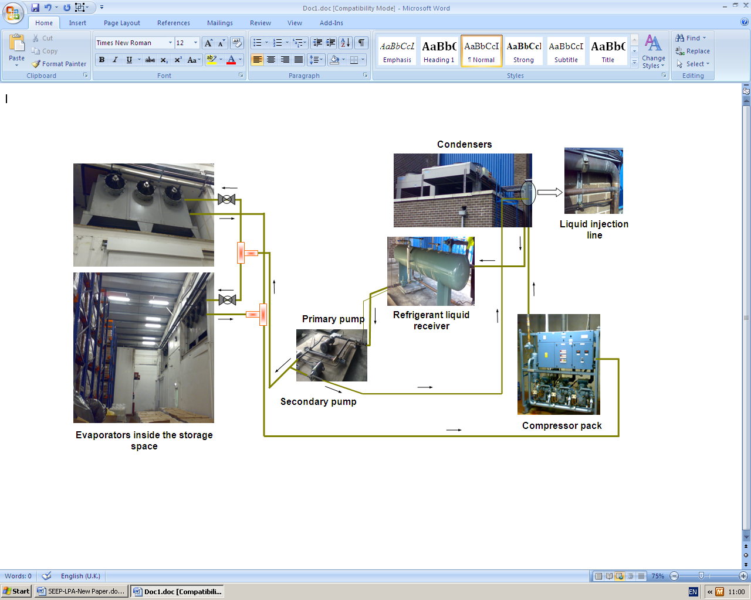The LPA refrigeration system is one of three refrigeration systems used to maintain a cold storage space of 1049 m² floor area at a temperature of 4°C. The system employs three Bitzer 6G30.2 semi hermetic compressors and a Searle MDG205 6D condenser feeding 4 evaporator coils in the cold room. The refrigerant employed is R404a. A liquid delivery (LPA) pump Hy-save 875IND is fitted into the liquid line whereas another pump Hy-save 809IND is used to provide liquid injection to the compressor discharge line.

Figure 1. Schematic diagram of refrigeration system with LPA

**Condensers**

**3. Technology analysis**

To increase the overall efficiency of refrigeration systems, LPA can be supplemented by liquid injection into the discharge line to desuperheat the discharge gas. Desuperheating using small quantities of liquid injection makes more efficient use of the condenser- less heat transfer area is used to desuperheat the gas and more area is available for two phase heat transfer. This leads to lower condensing temperature and higher cycle efficiency.

Data obtained for a short period before and after commissioning of the LPA technology through a web based monitoring system were used to investigate the performance of the system and energy savings achievable. The refrigeration system was comprehensively instrumented with pressure and temperature sensors to measure temperatures and pressures at different points in the cycle. Other parameters monitored included the ambient temperature and the power consumption of the compressor.

The data were extrapolated over a whole year and through system simulation were used to evaluate the seasonal performance and energy savings potential of the system.

3.1 Data analysis

Data for two days before the retrofit and four days after the installation of the LPA and liquid injection pump have been used for the analysis. The variation of condensing temperature, evaporating temperature, liquid line temperature & outdoor temperature is shown in Figure 2. It can be seen that the variation of the ambient temperature for the six day period was very similar before and after the installation of the LPA and hence it can be reasonably assumed that the comparative results between the two systems are independent of ambient temperatures.

Figure 2 shows that the condensing temperature was maintained fairly constant before the installation of the LPA at an average value of 36°C. It can also be seen that the condensing temperature was fairly independent of the ambient temperature as the head pressure was controlled at a fixed setting of around 17 bar.



Before the retrofit

After the retrofit

Figure 2. Temperatures Variation before and after the LPA

Retrofit



Figure 4. Variation of Compressor Power Consumption and the Refrigeration Effect before and after the Retrofit

Before the

retrofit

After the retrofit

The variation of the liquid line temperature shows a small dependence on the ambient temperature, rising during the day and dropping during the night. This is due to the better heat transfer and subcooling of the refrigerant liquid at lower ambient temperatures.

Figure 3 shows the variation of compressor suction and discharge pressures and temperatures in the system before and after the retrofit. It can be seen that the discharge pressure dropped from 17 bar to around 9.8 bar after the retrofit, whilst the discharge temperature dropped from around 64°C to approximately 44°C. The suction pressure and temperature remained fairly constant before and after retrofit as the system was designed to maintain a constant temperature in the cold store.

Figure 4 shows the variation of the compressor power consumption which was obtained by multiplying the work done by the compressor by the refrigerant mass flow rate.

Figure 3. Variation of Compressor Temperature and Pressure before and after the LPA Retrofit



Before the retrofit

After the retrofit

The average compressor power was around 44 kW before and 33 kW after the LPA retrofit, representing a 25% reduction. The refrigeration effect (refrigerant enthalpy difference) across the evaporator coils before and after the retrofit of the LPA was found to increase from around 120 kJ/kg to around 150 kJ/kg and the average refrigerant mass flow rate was around 0.97 kg/s, as it can be seen from Figure 4.

3.2 Theoretical cycle analysis

The EES software was used to analyse the cycle. Steady state conditions were assumed and average values were taken from the measured data. The enthalpy values at the various points in the cycle before and after the retrofit are given in Figure 5 and the resulting energy flows in Table 1. It can be seen from Table 1 that the use of LPA in conjunction with floating head pressure control offers the potential to decrease compressor power consumption by 25%. The capacity of the evaporator coil increases by 15% and the heat rejected at the condenser by 5%.

The inlet conditions to the condenser were established based on the quantity of refrigerant liquid injected into the compressor discharge line. The mass flow rate injected to the discharge line of the compressor was 5% of the total mass flow rate, the inlet condenser temperature drops from 44°C to 36°C. The inlet condenser enthalpy was evaluated using the energy balance equation as follows:

 (1)

 (2)

 (3)

**7**

Liquid injection

pump

Condenser

Compressor

**3**

**8**

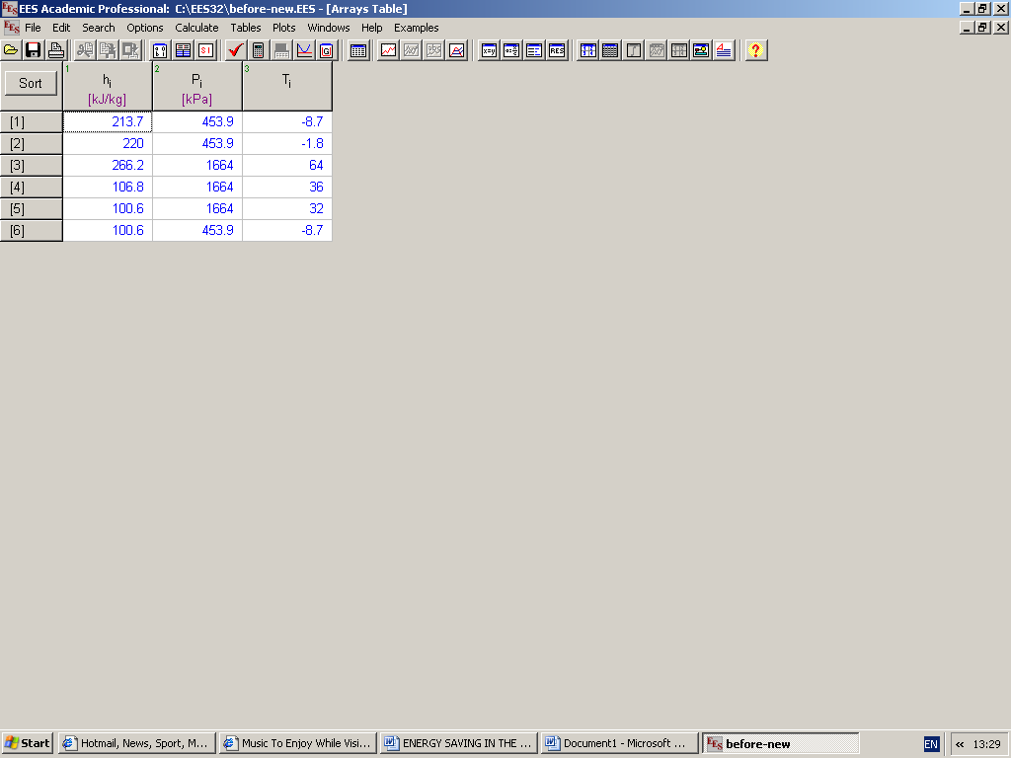

Before the retrofit

**1**

**2**

**3**

**4**

**6**

**5**

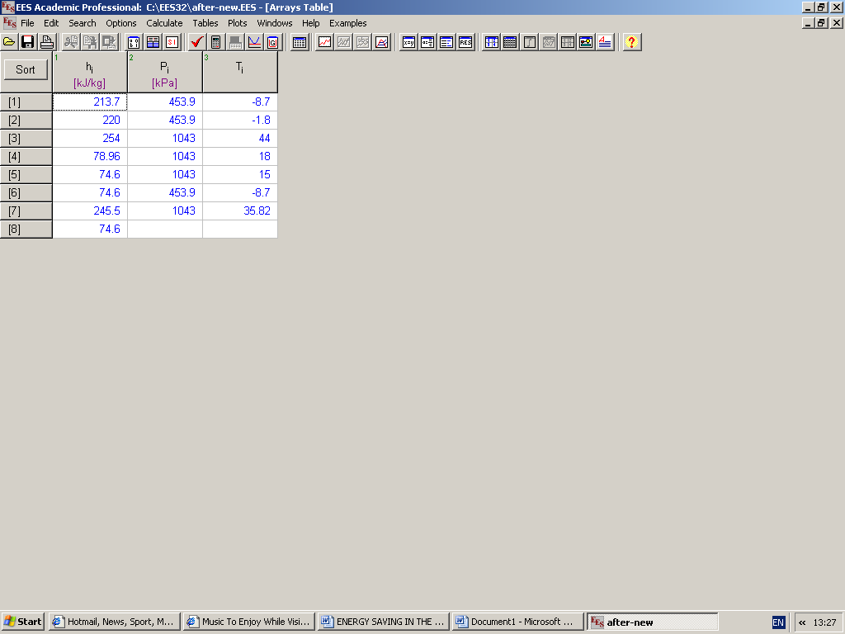

After the

retrofit

**8**

**3**

**7**

**4**

**6**

**2**

**1**

**5**

Figure 5. Temperatures, pressures and enthalpies of the cycle before& after the LPA retrofit

|  |  |  |  |
| --- | --- | --- | --- |
| Components | Before the retrofit | After the retrofit | Saving % |
| Compressor power consumption kW | 44 | 33 | 25 |
| Heat rejected at condenser kW | 154.6 | 161.5 | - 5 |
| Heat absorbed at evaporator kW | 115.8 | 133.7 | 15.5 |
| Super-heating °C | 6.9 | 6.9 | - |
| Sub-cooling °C | 4 | 3 | - |

Table1. Compressor power, cooling capacity and heat rejection

Liquid injection resulted in around 8.5 kW of cooling of the discharge gas and 5% reduction in heat rejection at the condenser compared to LPA without liquid injection. Table 2 shows that injecting 5% of the total mass flow rate into the discharge line causes a reduction of around 5 % in the condenser fan power.

3.3 Annual system simulations

To determine the potential energy savings of LPA over a year, the refrigeration plant was modelled using a refrigeration system model built within the TRNSYS simulation environment. The following operating states conditions were considered for comparison:

Refrigerant: R404A

Minimum condensing temperature: 15 °C (with LPA), 20 & 23 °C (without LPA)

Evaporating temperature: -7.5 °C

Floating temperature difference: 10 °C

Temperature difference of equivalent pressure drop in suction line: 1.2 °C

Suction line superheating: 6.9 °C

Liquid line sub-cooling: 3°C with LPA & 4.0 °C without LPA.

Locations: Belfast and London

From above information, the refrigerant state parameters at compressor inlet and outlet, condenser outlet, and evaporator inlet and outlet were determined. The equivalent cooling effect, specific compressor work and cooling COP were determined

|  |  |  |  |
| --- | --- | --- | --- |
| Heat rejection at the condenser | Heat  Rejected  kW | Fan Power  kW | Increment of  condenser fan power |
| Without modification | 154.6 | 13.6 | - |
| With modification, but no injection | 169.8 | 14.9 | 9.5% |
| With modification, but with 5% of the total refrigerant mass flow rate injection | 161.5 | 14.2 | 4.4% |

Table 2. Effect of liquid refrigerant injection on heat rejection at the condenser

3.3.1 Cooling load

The cooling load of the refrigeration system was correlated from the measured site data at different ambient temperature Due to lack of site data, it was assumed that the cooling load is constant at 50 kW when ambient air temperature is below 0°C. Consequently, the correlation of the cooling load with ambient air temperature was generalised as follows:

$Q_{cool}(kW)=\left\{\begin{aligned}50.398 when t_{amb}≤0 ℃ \\ 6.4433×t_{amb} + 50.398 when t_{amb} >0 ℃\end{aligned}\right.$ (4)

$Q_{cool}(kW)=\left\{\begin{aligned}50.398 when t_{amb}≤0 ℃ \\ 6.4433×t_{amb} + 50.398 when t_{amb} >0 ℃\end{aligned}\right.$

Therefore, the actual refrigerant mass flow rate in the system can therefore be calculated:

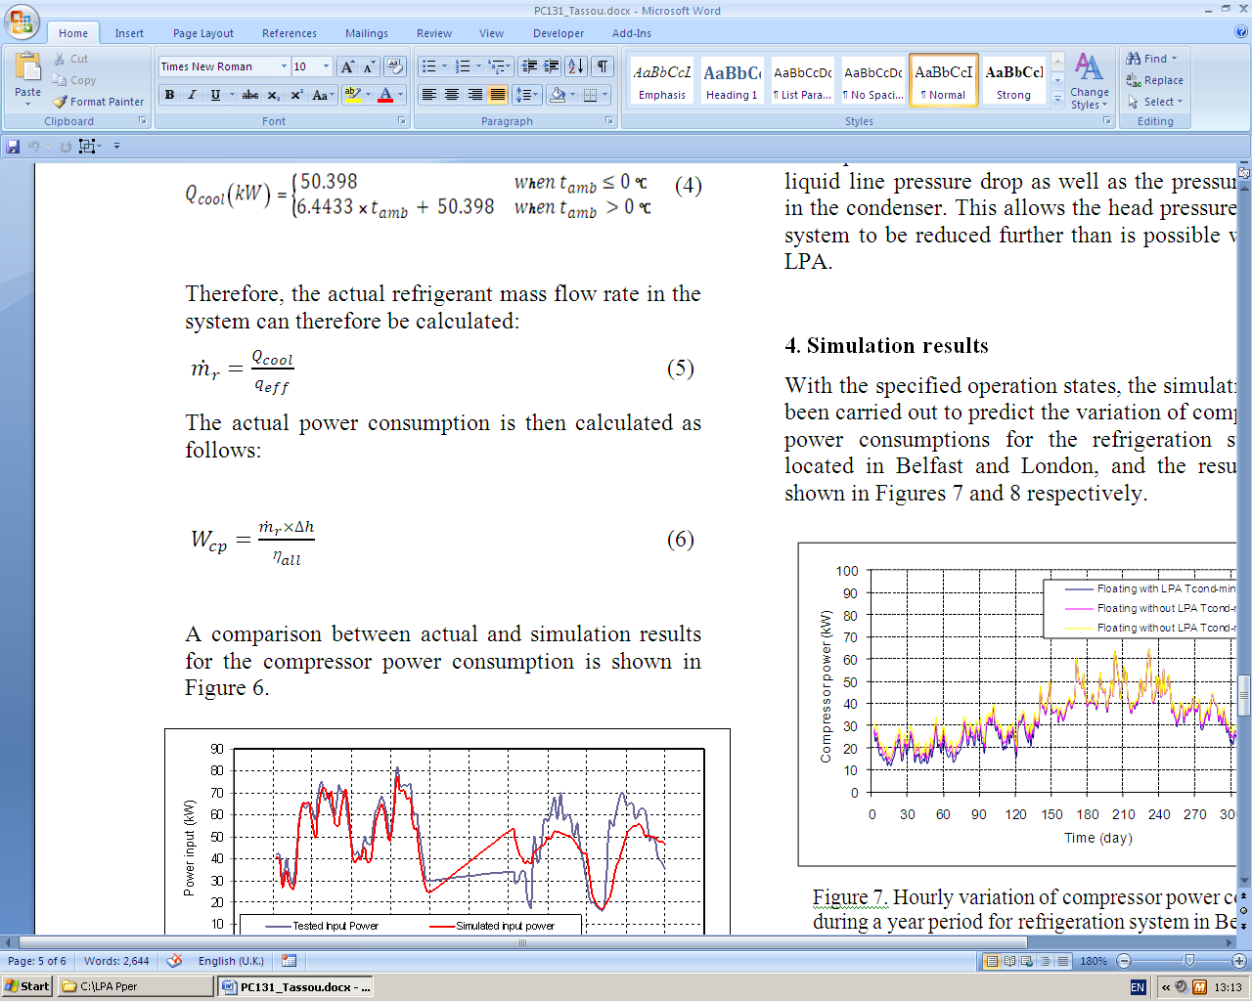 (5)

The actual power consumption is then calculated as follows:

 (6)

A comparison between actual and simulation results for the compressor power consumption is shown in Figure 6.



Figure 6. Comparison between actual and simulation results for compressor power consumption

It can be seen that the simulation can predict reasonably well the actual power consumption of the compressors.

The differences that can be seen between the two values is mainly due to the difficulty in accurately modelling the load on the refrigeration plant which is not only a function of ambient temperature but also the operating schedule of the cold room and doorway traffic. The benefits of LPA arise from the fact that it allows the condensing pressure to be reduced in line with reductions in the ambient temperature. LPA is therefore used in conjunction with floating head pressure control. In conventional head pressure control, the condensing temperature and hence pressure is controlled to a fixed value above the ambient temperature. This temperature differential is normally 10 oC. There is, however, a minimum value below which the head pressure cannot be reduced as a minimum pressure differential is required across the thermostatic expansion valve to ensure satisfactory operation. With the use of LPA, the pressure before the expansion valve can be increased to overcome the liquid line pressure drop as well as the pressure drop in the condenser. This allows the head pressure of the system to be reduced further than is possible without LPA.

**4. Simulation results**

With the specified operation states, the simulation has been carried out to predict the variation of compressor power consumptions for the refrigeration systems located in Belfast and London, and the results are shown in Figures 7 and 8 respectively.

Figure 7. Hourly variation of compressor power consumption during a year period for refrigeration system in Belfast



Figure 8. Hourly variation of compressor power consumption during a year period for refrigeration system in London

|  |  |  |  |  |  |  |  |
| --- | --- | --- | --- | --- | --- | --- | --- |
| Location | Tcond_min  (°C) | LPA Installation | Annual compressor power consumption (kWh) | Location | Tcond_min  (°C) | LPA Installation | Annual compressor power consumption (kWh) |
| Belfast | 15 | Y | 265312 | London | 15 | Y | 317226 |
| 20 | N | 277548 | 20 | N | 326888 |
| 23 | N | 292477 | 23 | N | 339816 |

Table3. Annual compressor electrical energy consumption

To make the comparison, the annual compressor power consumption at each condition is listed in Table 3.

Table 3 shows that in Belfast when LPA is applied, the compressor power consumption saving is 4.4% and 9.3% respectively when compared with systems without LPA and minimum condensing temperatures at 20°C and 23°C.

In London when LPA is applied, the compressor power consumption saving is 3.0% and 6.6% respectively when compared to systems without LPA and minimum condensing temperatures of 20°C and 23°C. Due to lower ambient temperature, the compressor power consumption in Belfast is always less than that in London at the same operating state.

**5. Conclusions**

Liquid pressure amplification allows operation at lower condensing pressures than is possible with floating head pressure control alone. The energy savings will depend on the minimum allowable pressure differential across the thermostatic expansion valve and the ambient temperature.

The use of liquid injection in combination with LPA will increase further the energy savings possible due to the de-superheating of the discharge refrigerant gas which will increase the condenser capacity and thus reduce the difference between the ambient and condensing temperature.

The analysis in this case study has shown that the use of LPA in conjunction with liquid injection can lead to up to 10% energy savings over and above those achievable with floating head pressure alone. The level of energy savings that can be achieved with LPA, however, is system specific and each application will require careful consideration of the savings against the capital cost of the technology.

**Nomenclature**

***Symbol Description***

 The refrigerant enthalpy (kJ/kg)

 Refrigerant mass flow rate (kg/s)

 Ambient temperature (°C)

& Cooling load (kW) & Heat absorbed at evaporator (kW)

 Minimum condenser temperature (°C)

*qeff* Cooling effect (kW)

 Actual compressor power consumption

(kW)

 Enthalpy difference of compressor outlet and inlet (kJ/kg)

 Compressor overall efficiency

**References**

1. Hoon K, Sunil L, Yongchan K, 2008, Effects of liquid refrigerant injection on the performance of a refrigeration system with an accumulator heat exchanger. International Journal of Refrigeration, 31, pp. 883-891.
2. Kim Y, 1993, Two phase flow of HCFC-22 and HFC-134a through short tube orifices. PhD Thesis, Taxas A & M University, USA.
3. MacWhirter A, 1998-1999, Liquid pressure amplification, Proceedings of the Institute of Refrigeration, 7-1, pp. 6-1 to 6-7.
4. Douglas T R, Hiki H, 2005, Evaluation of liquid pressure amplifier technology, International Journal of Air-Conditioning and Refrigeration, Vol.13 No. 3, pp. 110-127.
5. Cole R A, 1998, The case for refrigerant liquid subcooling, Heating, Piping, and Air Conditioning, December, pp.50-55.