A Variant Q-sorting Methodology for Building Diagnostic Trees
Sahar Sabbaghan, Cecil E. H. Chua, and Lesley A. Gardner
Abstract— Diagnostic theories are fundamental to Information System (IS) practice and are represented as trees. While there are approaches to validating diagnostic trees, these validate the overall performance of the tree rather than identifying ways incorrect diagnoses can occur. It is important to fully validate diagnostic trees, because even if the tree gives the correct decision “most of the time,” it is possible for incorrect decisions traveling down little used branches of the tree to result in catastrophic decisions. This paper describes the process of using a variant of q-sorting to validate diagnostic trees. In this methodology, diagnostic trees that independent experts develop are transformed into a quantitative form, and that quantitative form is tested to determine the inter-rater reliability of the individual branches in the tree. The trees are then successively transformed to incrementally test if they branch in the same way. The results help researchers not only identify quality items for use in a diagnostic tree, but also facilitate diagnoses of problems with those items and facilitate the reconciliation of discrepant trees by experts. The methodology validates not only the whole tree, but also its subparts.

Index Terms— Diagnostic theories, Diagnostic-Tree, Inter-rater reliability, Tree, Q-sorting.

INTRODUCTION
D
iagnostic theories are fundamental to Information Systems (IS) practice. A diagnostic theory is used to identify why a particular situation occurs. Diagnostic theories have wide applicability. For example, Mycin [1] and other expert systems [2], [3] often diagnose errors using diagnostic theories. Beyond expert systems, diagnostic theories are useful to identifying the root cause of a phenomenon. As an example, a diagnostic theory was used to improve a production line by highlighting possible areas of inefficiency [4]. Finally, diagnostic theories are integral to follow-up customer satisfaction surveys. When customers indicate they are dissatisfied, we may send a second survey to identify the source of dissatisfaction. This second survey often has an embedded diagnostic theory. Examples includes surveys which identify the reasons for poor online purchase experiences [5] or surveys that unveil the relative ranks of the different web strategies to build trusting beliefs [6].
Many diagnostic theories are optimally represented as a tree, i.e., a diagnostic tree, where intermediate nodes represent information important for the decision making process and leaf nodes represent the optimal decision. The decision making process begins with a generic problem (e.g., users do not find a technology useful) and as additional information is obtained, the system navigates through the branches of the tree corresponding to the obtained information until sufficient information is available to make a decision (e.g., why users do not find the technology useful). All the above highlighted examples are of diagnostic trees.
The validation of diagnostic trees has been little investigated. Existing methodological approaches to validation (e.g., the use of expert judgement [7]) focus on the overall validity of the diagnostic tree, without considering whether parts of the tree may not be valid. Existing quantitative techniques (e.g., the use of edit distance [8]) are not integrated into methodological approaches, and thus it is not clear how their results can be applied to improve diagnostic trees.
Nevertheless, systematic approaches to validity are necessary. In a diagnostic tree that diagnoses diseases, for example, it is not sufficient to say the diagnostic tree generally outperforms the human doctor. It is possible for the situations where the diagnostic tree does not outperform the human doctor that the tree prescribes fatal medicine. We must validate not only overall tree performance, but also the performance of individual tree branches.
Manual assessment of the tree can be very challenging, as the problem of assessing every branch is time-intensive -the growth of branching is exponential. There are no automated ways of testing, as this requires domain knowledge. Furthermore, validation is not just simply identifying that a diagnostic tree or a branch of the tree is correct or incorrect. We also want to know why the tree is incorrect or what systematic problems exist. For example, if there are numerous errors in the lower branches of the tree, these could all be caused by a systematic structural error at the top of the tree. This paper introduces a methodology for validating diagnostic trees that validates not only the overall tree, but subparts of the tree as well.
This paper is constructed in the following manner. We first introduce diagnostic trees and demonstrate the gaps in existing validation techniques. Our methodology relies on the use of two independent experts to develop independent diagnostic trees which we then assess. Correspondingly, we need to categorize the possible differences between two diagnostic trees. We thus follow our literature review with a taxonomy of such errors. Following from this, we present a modified q-sorting approach alongside an example of its use to develop an Instagram self-efficacy diagnostic tree. We then conclude the paper.

Diagnostic Trees and their Properties
Diagnostic trees are designed to explore potential root causes of a phenomenon, where large constructs are unpacked to explore and identify the different dimensions. Each dimension is represented as one or more questions and their corresponding answers, which provide information. The information is arranged in a tree structure, where questions lower in the tree more closely relate to a potential root cause. The decision process involves performing a depth-first traversal of the tree, where each stage of the traversal involves choosing a branch representing particular information. As one navigates deeper down the tree, more information is accumulated. This continues until either the end of the tree or a particular depth of the tree is reached, whereupon a decision can be made.
Diagnostic trees have particular properties. First, all items except the penultimate child have at least two children. An item with only one child has no “branching” and hence no accumulated information and no choice; clearly this cannot be allowed. Second, items higher up the tree are formatively defined by items lower down the tree. Hence, items concerning higher level concepts are mapped to items with greater precision. The items thus have a parent-child relationship. This means items higher up in the tree are more important than those lower in the tree. Thus, it is important to first validate the top of the tree, then the next level, etc. This saves effort as there is no point developing subitems for a poorly defined item.

Diagnostic-Tree for Assessing Instagram Self-Efficacy
As an example, consider a diagnostic tree on perceived skill using Instagram (i.e., Instagram self-efficacy), designed to identify systematic reasons for users’ failure to engage with various Instagram functions. Self-efficacy is key for understanding how individuals adopt new tools and develop skill in the use of those tools. It is a pivotal concept for understanding technology acceptance, implementation, and use [9]–[11]. Self-efficacy is, “People's judgments of their capabilities to organize and execute courses of action required to attain designated types of performances. It is concerned not with the skills one has but with judgments of what one can do with whatever skills one possesses” [12, p. 391]. Because people who have low self-efficacy in Instagram are less likely to use it in the future as compared to those with a high degree of self-efficacy [10], [13], it is important to consider improving Instagram self-efficacy as part of a strategy to promote use.
The diagnostic tree designer has determined there are five principal issues (overarching constructs) users could have: (1) linking Instagram to other social media accounts, where users have difficulty connecting their Instagram account and content such as posts and stories to their other social media accounts (such as Twitter, Tumblr and Facebook), (2) social information management, where users experience difficulty in managing social information (e.g., posts or stories) produced by others on the platform. Users may find certain functions such as tagging, retagging, copying, and replying challenging [14], [15]. (3) content creation, where users have difficulty creating new content to be consumed by others, (4) interactions, where users have difficulty interacting with other users, such as on chats or video calls, and (5) account management, where users have difficulty configuring their personal account settings. These were identified as a result of an inter-rater based Q-sort identified in Step 2 of our methodology detailed below. Each overarching construct in turn unpacks to hundreds of possible specific causes. For example, “editing” can be unpacked to items such as choosing a filter, adjusting certain settings (i.e., light, colour, and contrast), using effects, using photo props, and using additional photo editing apps with Instagram. Fig. 1 presents the example Instagram self-efficacy diagnostic tree. These were identified as a result of an inter-rater based Q-sort identified in Step 2 of our methodology detailed below.
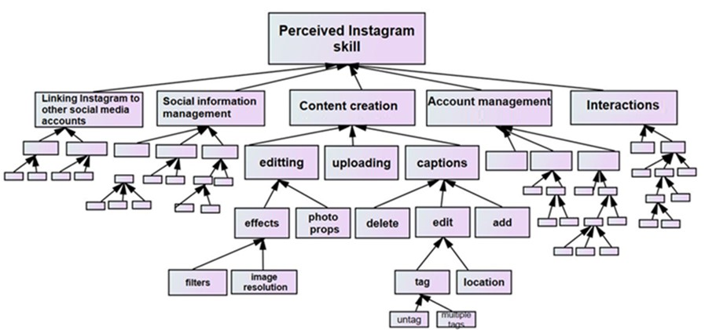
Fig. 1. Diagnostic tree for Instagram self-efficacy

Existing Approaches to Diagnostic Tree Validity
Existing approaches to validating diagnostic trees essentially take two forms: methodological and quantitative techniques. Most methodologies do not integrate the more advanced quantitative techniques, and quantitative techniques are often employed in isolation.

Methodological
The major validation methodologies used for validating diagnostic trees are:
Expert Review. One common approach to validating diagnostic trees is expert review, where experts are given the tree and methodologically examine it for errors [16]. Expert reviews can provide valuable insight into usability problems and can be beneficial in evaluating a diagnostic tree across all stages of development [17]. One example is the Efficient Machine Fault Diagnosis Expert System (EMFDES), where validation was done by developing diagnostic trees with the use of multiple domain experts who identified different issues within the system [3]. Another is the Healthy Habits (HeH) system, where three experts with 5-15 years of research experience in their individual fields of expertise reviewed the diagnostic tree and individually identified strengths and shortcomings [16].
Comparison. Much research structures the diagnostic tree validation as a competition or test [18]. In some situations, the test is against a data set with known properties, the correct diagnosis is known, and the diagnostic tree is evaluated as fit for purpose, if it correctly diagnoses a certain number of cases (precision) and does not fail to misdiagnose a certain number of cases (recall). For instance, discrete-event systems (DESs) are often tested by comparing them to a known dataset [19].
In other situations, experts are considered the proxy for the correct answer, and the diagnostic tree is evaluated to determine how close the diagnostic tree’s answers are to the experts’ [3]. Air handling units (AHUs) are often tested in this way [20].
The principal problem with comparison approaches is only the overall performance of the tree is evaluated. It is possible for the tree to overall perform better than other systems, but perform worse on particular problems. Also, in some cases, diagnostic trees perform better at comparisons because of factors unrelated to the quality of the tree. For example, diagnostic tree systems can outperform human experts simply because they are more consistent, do not suffer from fatigue, and are immune to cognitive biases like framing [7].

Quantitative
Various quantitative techniques have been proposed for validating diagnostic trees. However, these quantitative techniques are generally applied in isolation, rather than being incorporated into systematic methodologies. Most quantitative techniques also suffer from problems in their measurements. Applicable quantitative techniques include edit distance, factor analysis and cluster analysis.
Edit distance. When an edit distance algorithm is applied to a diagnostic tree, one assumes two diagnostic trees built for the same purpose- for example, two separate trees developed by two independent experts. The edit distance algorithm is applied to identify how dissimilar the two trees are with the implication this dissimilarity indicates problems with one or both trees.
Edit distance algorithms calculate the number of changes (typically identified as insertions, deletions, and updates) necessary to transform one tree into another [21], [22]. There are a number of limitations of edit distance algorithms for facilitating diagnostic tree validation. First, edit distance algorithms produce summary statistics on the overall similarity of two trees. These do not facilitate a diagnosis of errors. They do not, for example, tell us that most errors occur in the top of the tree (very bad) or at the bottom of the tree (not so serious)-or tell us that most of the errors are occurring in the children of node 1. Second, edit-distance measures do not take into account sample size. Clearly if there are two trees, each having 50 nodes, where 10 changes are required to transform one into the other, this is different from two trees, each having 500 nodes where only 10 changes are required. In statistical thinking, we want to compare the statistic to some probability distribution to standardize results according to “sample size”. We then calculate confidence intervals or p values of significance, where the threshold (typically 0.05 or 0.01) is sample size independent. The tree edit-distance literature has no equivalent analogue.
Factor analysis. Factor analytic techniques have also been proposed for diagnostic trees [23]. Factor analysis works by grouping together items that are highly correlated, or testing a proposed model of how correlated items are to the actual correlation between items [24]. Factor analysis is difficult to apply to diagnostic trees, because traditional factor analysis was designed for tabular, rather than the nested data found in trees. As a result, factor analysis can only be applied to very simple trees of low nesting [25]–[27]. In addition, highly nested trees have statistical properties that confound factor analysis. In a good, nested diagnostic tree, the children of a particular item are highly orthogonal (i.e., uncorrelated). However, these children are moderately correlated with their parent. For example, consider the items “(1) I can edit a photo using Instagram,” “(2) I know how to crop my photo” and “(3) I know how to apply effects to my photo.” (2), and (3) should relate to (1), because (1) is their parent, if you know how to crop or apply effects, you know something about editing photos. But, (2), and (3) are orthogonal to each other- knowledge of cropping should not impact knowledge of effect application and vice-versa. Hence, they should not have a strong correlation with each other. Traditional factor analytic measures such as factor loading, “which is the correlation between the original variables and the factors, and the key to understanding of the nature of a particular factor” [24, p. 89] or structural-equation model-based confirmatory factor analysis [28], [29] have limited applicability to such situations.
Cluster Analysis. Cluster analysis employs techniques similar to factor analysis. In many cases, cluster analysis employs similarity measures distinct from correlation [24], [30]. Diagnostic trees that employ cluster analytic techniques include those in customer relationship management (CRM), where customer reviews are mined for commonalities which are then employed to diagnose product weaknesses [31] and in bankruptcy prediction [32].
Cluster analysis algorithms employ their own specific distance measures to cluster. Examples include single linkage clustering [28] and weighted pair groups clustering [29]. These distance measures assume particular properties of the underlying data, which are not always true. As a result, many cluster analytic techniques generate spurious results [35], [36].
The main problem with quantitative techniques generally is the garbage in-garbage out problem. Quantitative techniques establish the validity of the results based on assumptions about the numeric properties of valid diagnostic trees. Often, valid diagnostic trees do not have those numeric properties. For example, they have a sample size in which the technique was not calibrated for (edit distance), or have correlational properties not assumed by techniques such as factor analysis or cluster analysis. It is well recognized that quantitative techniques should only be applied when the technique user has a thorough grasp of the numeric properties of the data. However, missing from the conversation on applying such techniques to diagnostic trees is an understanding of how the technique user can obtain sufficient understanding for ascertaining the viability of a quantitative technique.

Errors Across Pairs of Diagnostic Trees
Definitions: We are proposing a methodology based on comparing diagnostic trees developed independently by two experts. In the below, we formally define terms employed in the remainder of the paper, based on definitions in [37].
- Root is the node with no parent. The root of the tree is on level 0.
- Top-level are first-degree descendants of the root. The top level of the tree has a level of 1.
- Descendant is the nth degree child of a parent. A first-degree descendant of a node is also called a child node.
- Parent is a node with descendants.
- Branch includes the descendants that share the same top-level node.
- Level is the distance of a node from the root. A node is on the n + 1 level of its parent node. As an example, a node located on the 3rd level is three levels below the root node and its parent is on the 2nd level. Levels closer to the root are considered higher levels and levels further from the root are considered lower levels.

A Taxonomy of Differences Across Trees
For our methodology to work, we first need to identify possible ways two diagnostic trees can be structurally dissimilar. Given two diagnostic trees T and T’, the following are the ways the trees can be arranged differently. In each arrangement, the difference in position of item A represents a certain type of error. Fig. 2 (a-c) presents these separate arrangements.
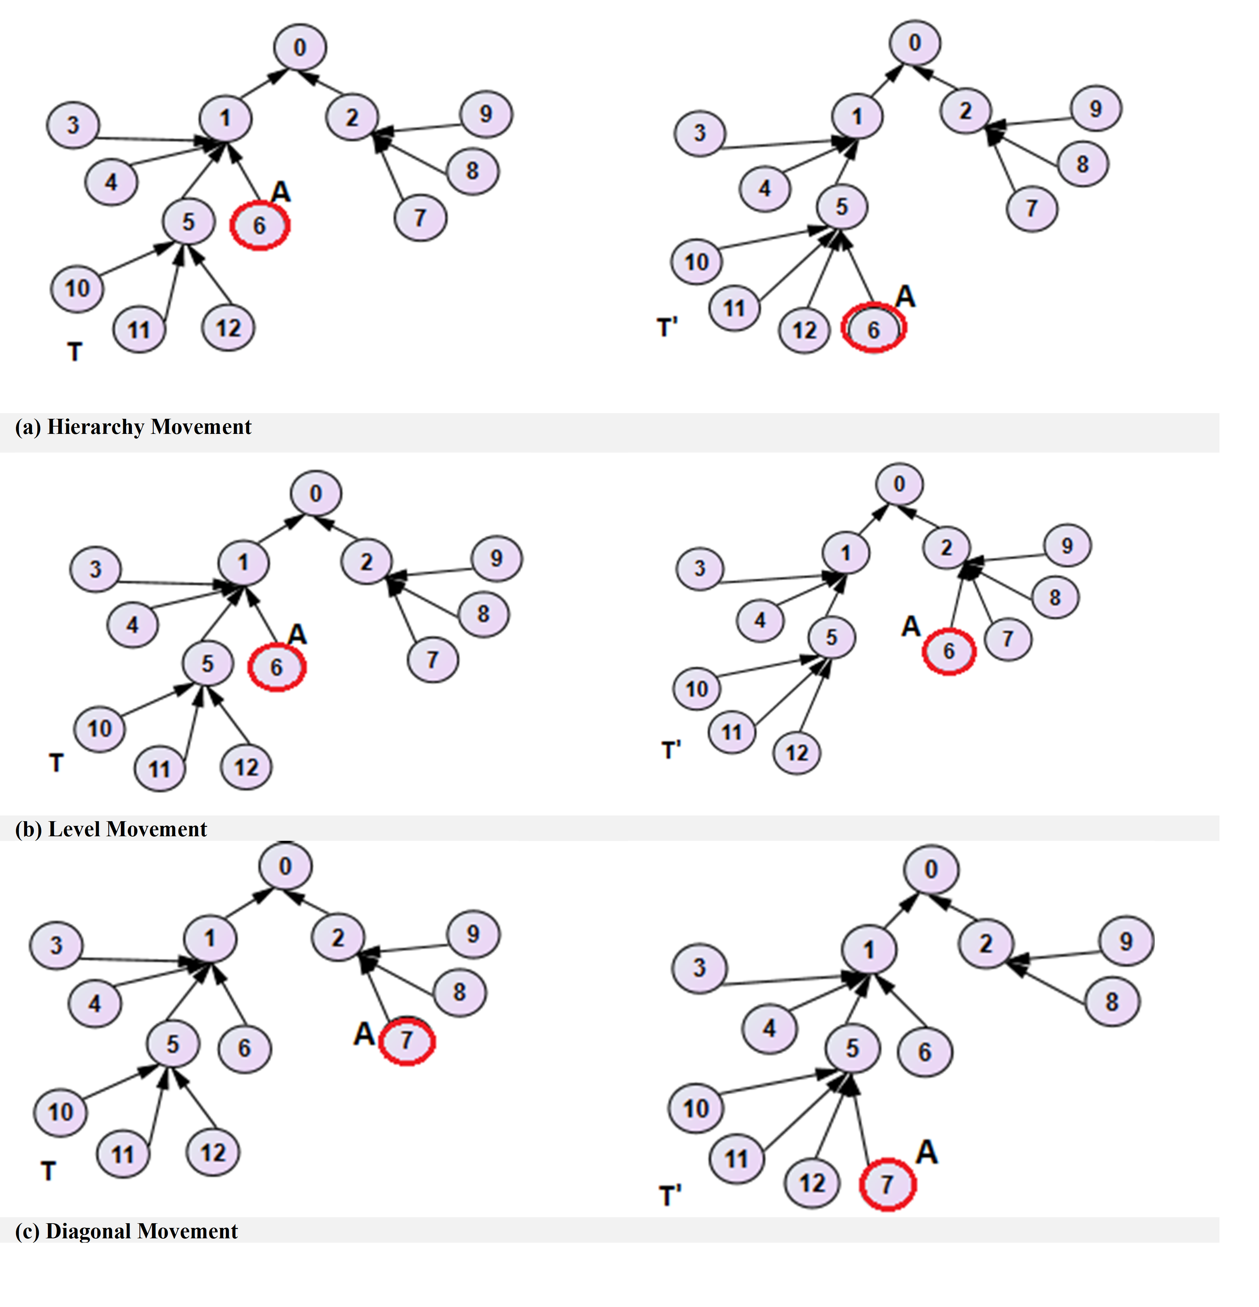
Fig. 2. Presents problematic item A for diagnostic tree.
Hierarchical Movement. In Fig. 2(a) A is found in the same branch of items of the tree but is placed in different levels. In the figure, A across both trees is a descendant of item 1. However, while in tree T, A is directly mapped to item 1, A in tree T’ is directly mapped to item 5. We call this a hierarchy movement.
Level Movement. In Fig. 2(b), A is from completely different families of items but is found at the same level. In tree T, A is a direct child item of item 1, while in tree T’ it is a direct child of item 2. In both cases, A is on the same level. We call this a level movement.
Diagonal Movement. In Fig. 2(c), A is both in a different level and family of item of the tree. We call this a diagonal movement.
Swap. In Fig. 3, there is another item B where A and B have changed places. We call this a swap. Swaps are considered because they reflect a single cognitive difference between two experts. There are effectively three kinds of swaps (hierarchical, level, and diagonal). In the contrasting examples of Fig. 3, A and B have swapped places.
Missing data points. Finally, it is possible for one person to be unable to map an item into the tree, while the other was able to do so. In total, there are therefore 7 kinds of errors comprising 3 kinds of movements, 3 kinds of swaps and a situation where one person put an item in the tree, but the other did not.
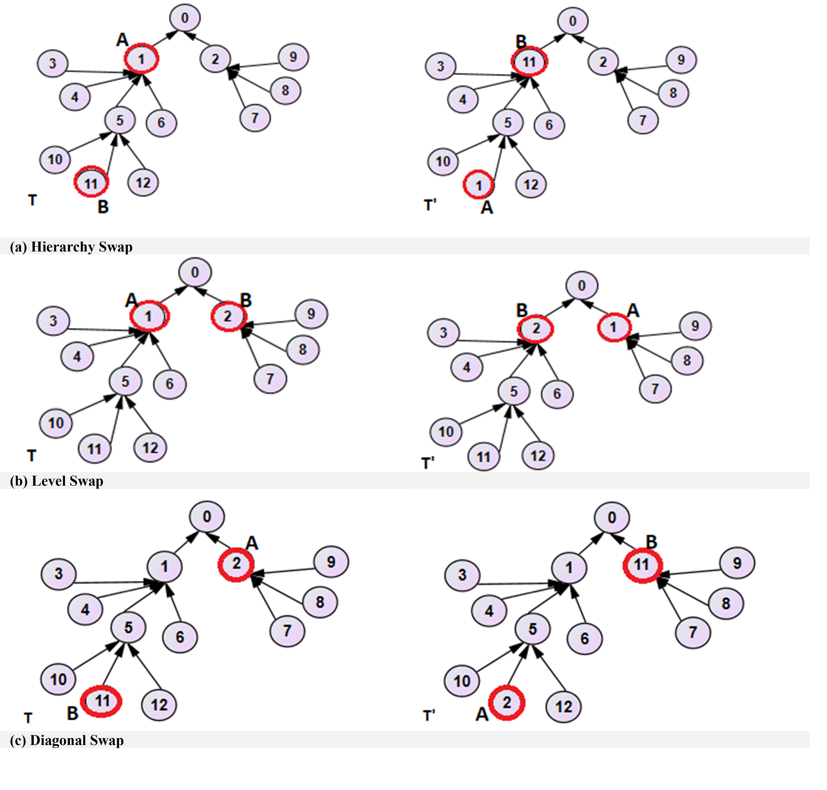 Fig. 3. Presents problematic item A and B for diagnostic tree.

Modified Q-Sort Approach
Our modified q-sort methodology is intended to ensure a constructed diagnostic tree is consistent across experts (i.e., has validity). We cannot use a traditional q-sort [38], because it only has one level of branching, where you group all items into a set of buckets. Our methodology not only assesses the validity of the tree, but also diagnoses where in the tree the inconsistencies are between experts. Our q-sort methodology requires three key components:
(1) Access to knowledge sources such as a library, or online forums. The knowledge sources must be rich enough that the items for the diagnostic tree can be obtained from these knowledge sources. A variety of knowledge sources may be used. These includes posts in online forums, videos, tutorials, reviews, letters, biographies, speeches, reports, books, [39] interviews, focus groups, and observations of the phenomenon. What a relevant knowledge source is, will differ depending on the diagnostic tree domain and in most cases, a collection of knowledge sources may be required.
(2) At least two experts. Experts must be blind and independent of the study. Most studies have indicated that two experts are sufficient for assessing inter-rater reliability [40], [41]. However, in cases where the context is new, then more than two experts may be required [42]. Experts should have the following characteristics. One, experts must be expert in the domain. Two, experts must have a strong command of the language of the topic and diagnostic tree. A strong command of the language is necessary because the hierarchical layout of diagnostic tree items means experts must understand words that clue a reader into whether an item is more or less specific. We found individuals with poor command of the English language fail to comprehend such hierarchy-related words as “overall” or “generally.”
(3) Access to and comfort with use of the following pieces of equipment:
- spreadsheet software, such as Microsoft Excel, to be able to transfer the diagnostic tree into a table, where one column represents the parent items and the other the child items. This is important to analyse the correspondence between the experts’ trees.
- statistical software, such as SPSS, to calculate Goodman and Kruskal’s Lambda, Cohen’s Kappa, and Goodman and Kruskal’s Gamma [43] to analyze experts’ trees.
- digital boards that allow one to manipulate and save a tree structure
- non-digital tools such as stationary (paper, cards, or sticky notes), cutting tools (scissors, cutters, or clippers), and writing tools (such as pencil, pen, or marker). These are used to create cards to capture each item in the diagnostic tree item bank. Experts physically drop the cards into cardboard boxes in a manner similar to a traditional q-sort [38]. The boxes equivalent to the number of top-level constructs in the tree (see Step 2 below).
- Collaborative software (such as Microsoft Team, or Zoom) to allow simultaneous work among the experts, which is useful in reconciling items of the diagnostic tree.
We have found it important to have tools capable of both representing diagnostic trees in a digital (digital boards) and physical (items on paper sorted into boxes) environment. Some examples of ideal digital formats are digital whiteboards or large screens. Digital formats allow experts to visualize the overall tree, save their work, and be able to move items around by using tools such as cut and paste. Saving work is important, because experts often want to restore their work from a prior point. In addition, paper formats are useful as they can be worked on in different locations (i.e., at home, office) and can be spread over a large area (e.g., the floor).
As illustrated in Fig. 4, our q-sort methodology has the following steps: (1) Build items for the diagnostic tree, (2) Identify top level constructs for the diagnostic tree, (3) Incorporate distractors, (4) Select one top-level construct, (5) Sort and map process, (6) Revise the tree, (7) Calculate, evaluate and interpret inter-rated scores (8) Address structural discrepancies, (9) Create the final diagnostic tree and (10) Empirically validate the diagnostic tree. The components required for each step are identified by color coding the steps. Specifically, blue indicates the use of knowledge sources, green indicates the use of blind and independents experts, and orange means both use of technology and non-digital formats. To illustrate our q-sort methodology, we employ an example of developing a diagnostic tree to elicit problems users have when using Instagram.
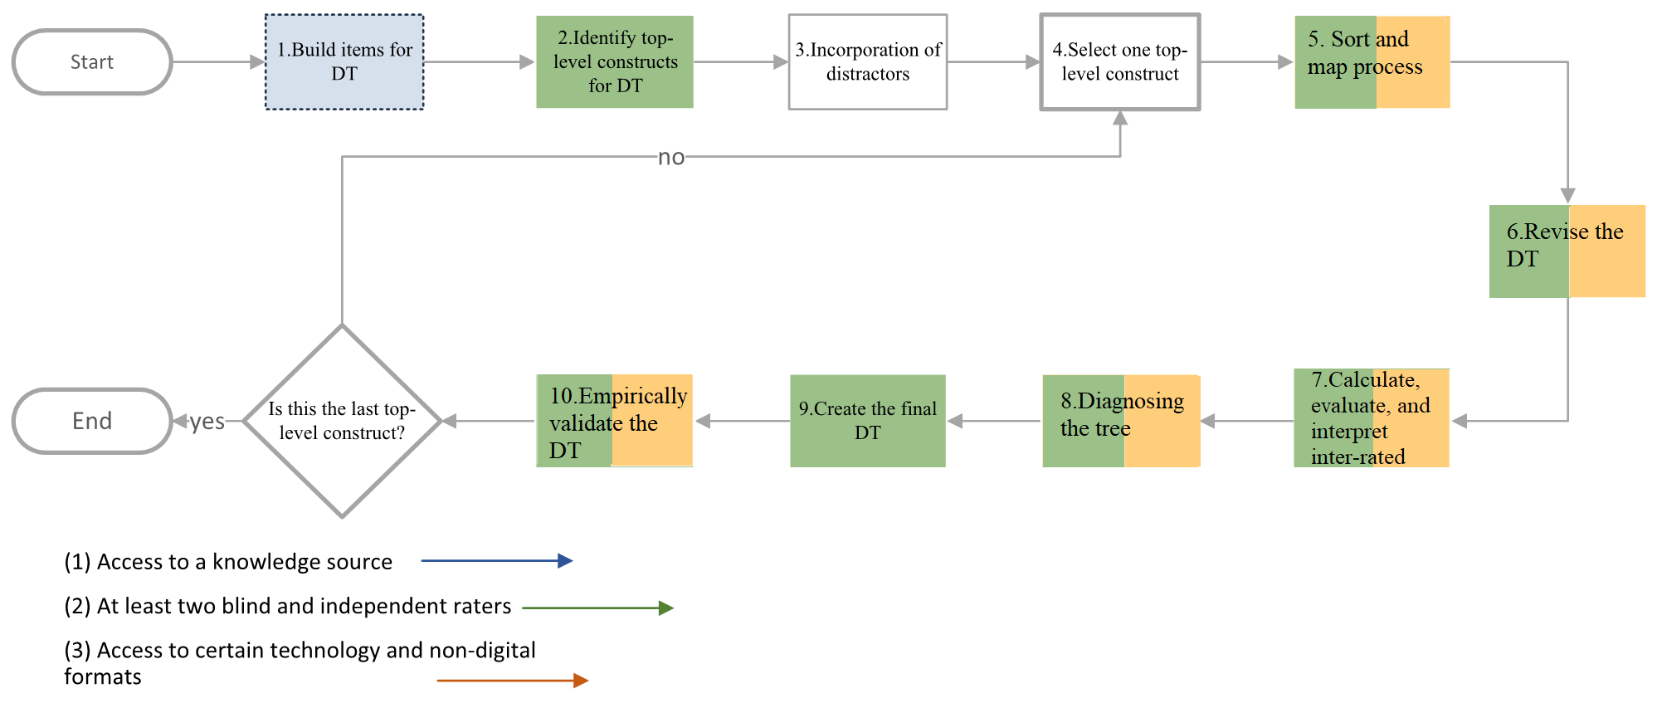
Fig. 4. Steps for our q-sort methodology

Step 1: Build the items for the diagnostic tree. This step is supposed to identify all items that will be employed in the diagnostic tree, as shown in Fig. 5. By the end of this step, the items should capture the entire scope of the problem domain of the diagnostic tree. The concept of scope encompasses both (1) that all subdimensions of the concept captured in the diagnostic trees are represented in the items, and (2) for any possible subdimension, all possible actionable causes of that subdimension are captured in the items. Step 1 comprises two sub-steps which iterate: (a) build the item bank and (b) assess the item bank.
Step 1(a). Build Item Bank. For step 1(a), We examine each knowledge source, which provides a distinct understanding of possible root causes of the domain. For example, existing journal articles capture information about Instagram and Instagram self-efficacy [10], [44]–[46]. Similarly, social media sources, such as reviews and blogs, can provide a wide range of in depth information on issues a user may face with a product or service [47], [48]. For our Diagnostic Tree for Instagram, a variety of sources were used, such as websites (Instagram help and troubleshooting), reviews and comments from different app stores (Apple app store and Google play, and forums (Reddit). Each provides inspiration to create the item bank.
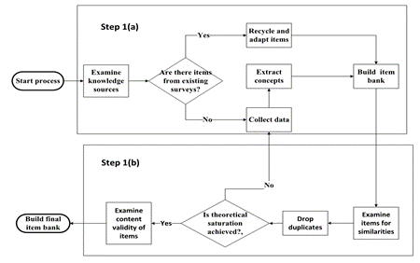
Fig. 5. Flowchart of the process for building the items for the diagnostic tree.
We employ the term “item” in the same way as Edwards and Bagozzi [49, p. 156] , i.e., “observable, quantifiable scores obtained through self-report, interview, observation, or other empirical means.” A “concept” is a mental image or general notion of something. It summarizes observations and ideas about all the characteristics of that image [50, p. 49]. For instance, one online review stated, “I tried to set up an account on Instagram and an automatic pop-up told me someone was already using my email on Instagram.” In this context, several concepts exist, including account creation, pop-up, and email in use. New items can be developed based on these concepts such as “I know how to create an account using my email” and “I know what to do if I can't sign up for an account because an account with my email address or phone number already exists.” As another example, a comment from 2018 from the Apple app store stated, “You can post whatever you want add anything to your story and add filters, stickers and gifs to your photos and you can explore different accounts and bookmark, like and comment on everything you find.” Here new concepts such as “adding to a story” or “exploring bookmarks” can be identified. Consequently, items such as I know how to add a story or I know how to use a bookmark, can be constructed. As a result of step 1(a), we collected approximately 260 items for our self-efficacy Instagram survey.
For step 1(b), we test items for the following issues:
- similarities across items- if two items essentially capture the same idea, one is dropped. We dropped approximately 40 duplicates in our Instagram self-efficacy survey, and 220 items remained.
- scope testing- we test for “theoretical saturation” [51]. This is done by ascertaining whether new items were created from step 1(a). We determine a threshold of a number of times to check for new items before we give up. In our Instagram self-efficacy instrument, this number was 10. This number is determined by the complexity of the context of the study, availability and sample size of the knowledge sources. If new items were created in step 1(a), we reset the number of times back to 0, as there is potential for identifying more items and loop back to step 1(a). Otherwise, we increment the number of times by 1 (several sources have already been assessed). If the number of times is less than the threshold, we loop back to step 1(a). Otherwise, we consider that there is no further information from the knowledge sources which we can build our items upon that can be obtained and stop
- Content validity-we test items for relevance to the context of the study. This is done by employing two independent and blind experts who go through the items. If both experts mark any item as irrelevant to the context of the study, that item is dropped. If only one expert marks an item as irrelevant, then that item is either dropped or edited, as this flags an error. For example, in our Instagram self-efficacy diagnostic tree, several items referred to using Instagram for business. However, in our context, we only focused on perceived Instagram skill for daily use. These items were marked as not relevant by both experts and dropped. In our diagnostic tree, nearly 20 items were dropped, leaving 200 items.
Step 2: Identify top-level constructs for the diagnostic tree. Top-level constructs formatively define the domain of the diagnostic tree. This step determines what these constructs are, so all items can be mapped to these constructs. There are two ways to identify top-level constructs. One way is to perform a traditional q-sort. There are two varieties of traditional q-sort possible, both of which require two independent and blind experts. In the first variety, boxes are prelabelled, and experts sort items into the boxes. In the second variety, experts determine the number of boxes and sort into those boxes. In both varieties, inter-rater reliability is assessed using the 0.6 Cohen’s Kappa threshold used for exploratory research [52]. As an example, in our Instagram self-efficacy diagnostic tree, we employed two blind and independent experts to go through the items and put them into as many categories as they saw fit. Each expert grouped the items in 5 categories independently, where the researcher then labelled each category based on the items inside. The 5 identified categories were, (1) linking Instagram to other social media accounts, (2) social information management, (3) content creation, (4) interactions, and (5) account management. We then assessed inter-rater reliability. Kappa was 0.601, above the recommended threshold for exploratory studies [52]. If the Cohen’s Kappa threshold is met, there are still other issues that need to be resolved. For instance, some items may not map to the top-level constructs. When this occurs, a decision has to be made as to whether additional top-level constructs should be established. In this case, a new box is labelled and added to the other boxes. The q-sorting is then repeated, and inter-rater reliability is assessed.
Another way is to review the literature to establish the framework and scope of the top-level constructs of the diagnostic tree. For instance, in the context of computer self-efficacy (CSE) which is a person’s judgment of his or her ability to use a computer system, the top-level constructs can be developed using the theoretical framework of a study such as Scott and Walzak [53] who unpack CSE to cognitive engagement, prior experience, computer anxiety, and organizational support.
Step 3: Incorporate duplicate and distractor items in the bank. This step is principally employed to partial out error of the diagnostic tree instrument from error associated with the expert. The typical diagnostic tree test bank can contain hundreds of items. The duplicate and distractor items are used to assess rater attentiveness during the q-sorting methodology. Duplicate and distractor items are traditional mechanisms for assessing rater attentiveness [54]. It is important to ensure that distractor items are clearly independent of items being assessed by the expert. When experts miss the fact that items are duplicated, or categorize distractor items along with legitimate ones, it signals a lack of rater attention. For example, on a diagnostic tree about Instagram, one distractor item could be “The education level is sufficient” as this is clearly independent of the Instagram context.
It could be argued that distractor items are unnecessary, because poor inter-rater reliability would serve as an effective proxy. However, inter-rater reliability is also indicative of poor item phrasing. It is necessary to be able to partial out the effect of experts and items separately, as fatigue is a real concern because of the number of items. The number of distractors is subject to the complexity and novelty of the context and number of items an expert would need to sort. For instance, in our Instagram self-efficacy diagnostic tree, the item bank consisted of 200 survey items, to which 10 duplicate items and distractors were added. Hence a total of 210 items were given to the experts.
Step 4: Select one top-level construct at a time. As each diagnostic tree can contain hundreds of items, to map all the items at once can be exhausting and too heavy of a cognitive load for experts to perform in a single session. Instead, experts are only given the items from one top-level construct to q-sort before moving on to other top-level constructs and their items. Also, they are given a period of time (e.g., a week) to finish q-sorting that branch. This is ok, because the validity of the top-level constructs is already addressed in step 2. In this step, the branch to validate is selected. In our example, there were five top level constructs. Experts began with the items in the top level construct, “linking Instagram to other social media accounts.” Once this was completed, they moved to the items in “social information management” and so on.
Step 5: Sort and map items into a tree. Two blind and independent experts who have sufficient knowledge and skills need to be recruited. In our study, we employed experts who had experience and knowledge on Instagram skill. In addition, prior to study commencement, experts are trained to explicitly draw the tree. It is necessary prior to asking for a q-sort that experts be given examples of tree diagrams from other domains. Without such illustrations, experts tend to perform traditional q-sorts. After training, experts are given a set of items and are told to map items in a tree. Each item is assigned a number from 1 to N, where N is the total number of items. The “root” item, which is a dummy item developed for statistical purposes is given the number 0.
There are two sets of mapping rules. The second set is more comprehensive and designed to identify certain types of errors with the items. The first set of rules is disclosed to the experts who map the tree according to those rules. The first set of rules are:
- Items that share a common theme are grouped together
- Each group should be labelled.
- An item within each group which conceptually matches each label should be identified. For instance, if a label “security of account” is given, then items such as resetting password, two-factor authentication, and security code may be mapped to that label. If such an item does not exist then the expert should tag that group, such as circling the items or marking the group with a tick.
- Within each group, sub-groups are then created, and the labelling process continues.
- Items concerning lower level concepts (children) are mapped to higher level concepts (parents). The root (dummy with value 0) has no parent.
Once the mapping is done, the second set of rules is applied by the researchers to the mapping to identify further problematic questions. The additional rules in the second set are:
- An item cannot have just one child item. It must have two or more children.
- A single parent should not have more than 7 child items mapped to it. From a cognitive perspective, the number of objects an average human can hold in short-term memory is 7 ± 2 [55]. Based on this, other studies have suggested options and response categories should be constrained to this number [56], [57]. Therefore, we constrain branching to 7 branches, because when too many options are offered simultaneously, the burden placed on memory is increased [58], [59]. This in turn causes people to be unable to choose [55].
- Except for items identified as distractors or duplicates, the tree must be fully connected.
By withholding the second set of rules from experts, we are able to identify certain classes of problematic items. If only one child item is mapped to a parent item, this indicates that the parent item is either underdeveloped or we have not identified sufficient child items representing subconcepts of that item. Similarly, if an item has more than 7 child items, this suggests the concept is too complex, and perhaps should be refined into a smaller subset of child concepts. Finally, if an item other than the distractor is not mapped to any item by one or more experts, one of two possibilities exists: (a) the item is badly worded or vague, or (b) experts have made mistake(s) because of (for example) fatigue. Feedback from this step is employed to refine the items in the diagnostic tree.
As an example of the process of mapping items into a tree for the first set of rules, consider Fig. 6, which presents the result of two experts developing trees around the concept of the overarching top-level construct “account management for Instagram,” which is represented by item 1. For both experts, item 2, which refers to knowing how to create an account, is mapped to item 1. While the tree has only one top-level construct, recall from step 4 that experts are only mapping one branch of the tree.
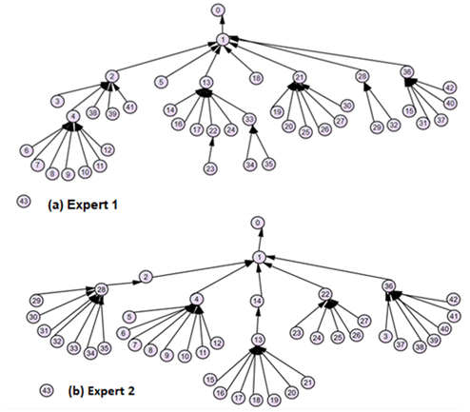
Fig. 6. Experts’ tree diagram for the top-level construct “Account Management”.
For expert 1, item 13 is the child of item 1 in level 2. However, expert 2 has only mapped it to item 14 as a single child. Hence, expert 2 can not distinguish the difference between items 13 and 14. After discussing this with the experts, several reasons for the discrepancy were identified. One, the term “post” was too general. “Post” and “story” have different meanings in the Instagram context, as a story is viewed for a limited time while a post or photo is viewed for as long as the user desires. Two, users differentiate the terms post and photo, as a post may not be a photo. As a result of this discrepancy, the original item 13 “I know how to control my visibility and privacy of my posts on Instagram” was edited to “I know how to control my visibility and privacy of my photos, stories, and posts on Instagram.” Similarly, item 14 was changed from “I know how to control the visibility of my posts” to “I know how to control the visibility of my photos” to differentiate posts from photos. Both experts identified one item (item 43 for both experts) as unconnected. Item 43 contained the distractor item, which suggests experts were paying attention when performing the q-sort.
Step 6: Revising the diagnostic tree. In this step, the experts are given the second set of rules and the items refined from the previous step and asked to remap the tree. We continue to assess the face validity [60] of the items by employing two blind and independent experts. Any item marked by either expert as confusing is re-edited. As an example of this process of mapping items, consider Fig. 7, which presents the result of the two experts developing trees around the concept of “account management for Instagram.” The trees experts developed are clearly discrepant. In the following steps, we show how we identify and reconcile discrepancies.
Step 7: Calculate, evaluate and interpret inter-rater scores. To determine whether trees are “similar enough” to be valid, we perform an iterative contingency table analysis to evaluate the overall fitness and diagnose the problems. This step consists of two sub-steps, (1) transformation of the diagnostic tree into a table and (2) the assessment of the inter-rater scores.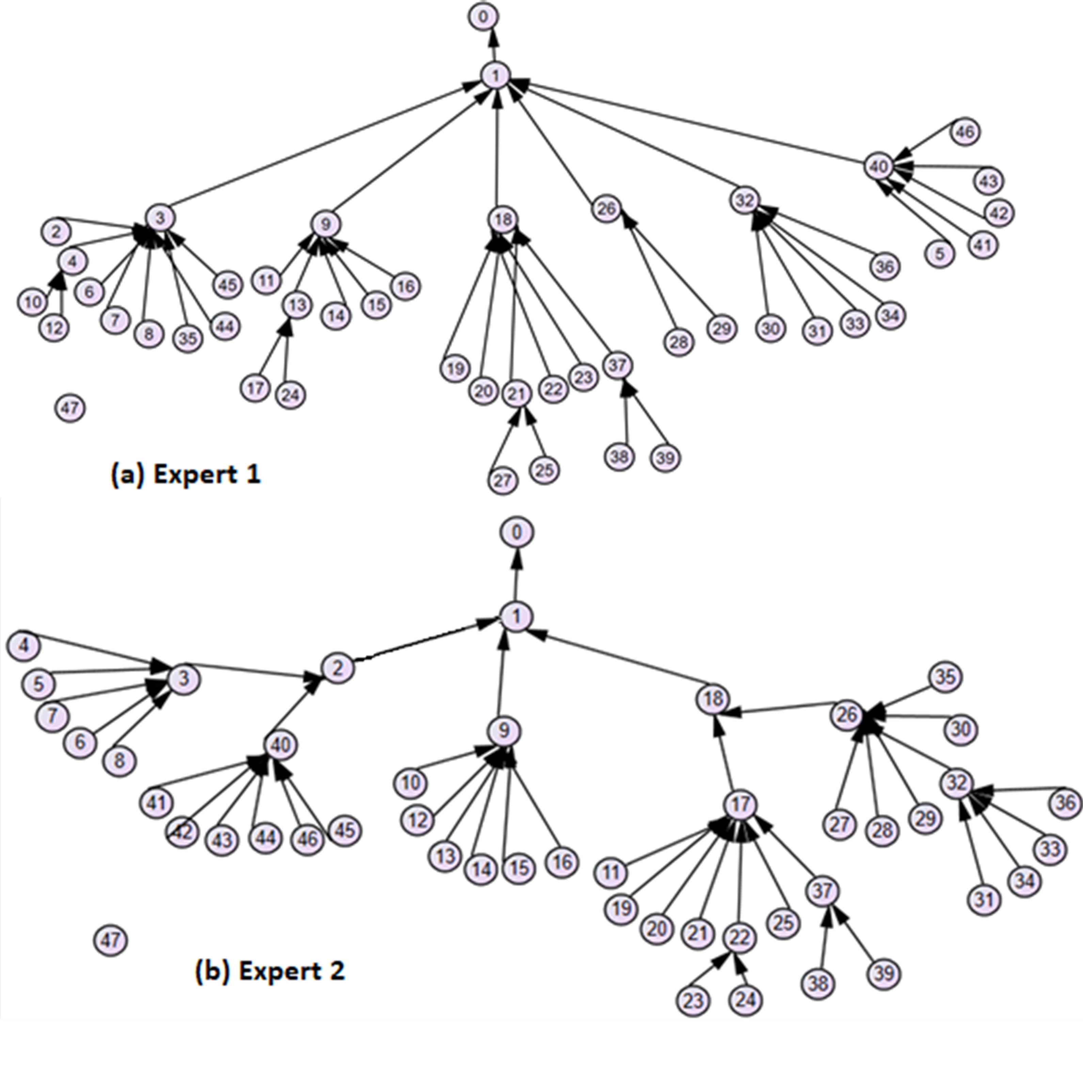
Fig. 7. Second round tree diagram for the top-level construct “account management for Instagram.”

Step 7(a). To calculate the similarity of each tree, certain measures of association are used. To perform these calculations, the trees developed by the experts need to be transformed into a table with five columns, which are the list of items (1 column), the parent column from each expert (2 columns), and the level columns for each expert. In the analysis, we compare the parent columns of the two experts using the level columns to restrict the data for analysis. As an example, Table 1 demonstrates the transformation of the tree in the first round for the top-level construct “Account Management for Instagram.” Expert 2 has mapped three items (2,9,18) to item 1, while expert 1 has mapped six items (3,9,18,26,32, 40) to item 1. The results in Table 1 correspond to the diagrams in Fig. 7.

items | Parent items for Expert1 | Parent items for Expert2 | Level for Expert 1 | Level for Expert 2
item 0 | 0 | 0 | 0 | 0
item1 | 0 | 0 | 1 | 1
item2 | 3 | 1 | 3 | 2
item3 | 1 | 2 | 2 | 3
item4 | 3 | 3 | 3 | 4
item5 | 40 | 3 | 3 | 4
item6 | 3 | 3 | 3 | 4
item7 | 3 | 3 | 3 | 4
item8 | 3 | 3 | 3 | 4
item9 | 1 | 1 | 2 | 2
item10 | 4 | 9 | 4 | 3
item11 | 9 | 17 | 3 | 4
item12 | 4 | 9 | 3 | 3
item13 | 9 | 9 | 3 | 3
item14 | 9 | 9 | 4 | 3
item15 | 9 | 9 | 3 | 3
item16 | 9 | 9 | 3 | 3
item17 | 13 | 18 | 4 | 3
item18 | 1 | 1 | 2 | 2
item19 | 18 | 17 | 3 | 4
item20 | 18 | 17 | 3 | 4
item21 | 18 | 17 | 3 | 4
item22 | 18 | 17 | 3 | 4
item23 | 18 | 22 | 3 | 5
item24 | 13 | 22 | 4 | 5
item25 | 21 | 17 | 4 | 4
item26 | 1 | 18 | 2 | 3
item27 | 21 | 26 | 4 | 4
item28 | 26 | 26 | 3 | 4
item29 | 26 | 26 | 3 | 4
item30 | 32 | 26 | 3 | 4
item31 | 32 | 28 | 3 | 5
item32 | 1 | 28 | 2 | 5
item33 | 32 | 32 | 3 | 6
item34 | 32 | 32 | 3 | 6
item35 | 3 | 26 | 3 | 4
item36 | 32 | 32 | 3 | 6
item37 | 18 | 17 | 3 | 4
item38 | 37 | 37 | 4 | 5
item39 | 37 | 37 | 4 | 5
item40 | 1 | 2 | 2 | 3
item41 | 40 | 40 | 3 | 4
item42 | 40 | 40 | 3 | 4
item43 | 40 | 40 | 3 | 4
item44 | 3 | 40 | 3 | 4
item45 | 3 | 40 | 3 | 4
item46 | 40 | 40 | 3 | 4
Table 1. Mapping of items to each other for the top-level construct “Account Management”.
These tables are not analysed in their entirety immediately. Instead, we begin analysis with the top 3 levels of the tree and work our way downward one level at a time. This is because problems at higher levels can impact the lower levels. Thus, initially, only data from the top 3 levels of the tree are analysed. Then, data from the top 4 levels etc.
As a result of disagreement, it is possible for experts to have a different number of items at each level. Here, expert 1 has created a tree with 4 levels, while expert 2 has created one with 5 levels. Tests on contingency tables for two different sample sizes can not be done. To address this, if an item does not exist for one expert, we replace the null value that represents the mapping in the table with a number that has not been previously assigned. This method of handling null values biases statistical results downward [61], which is desirable, as lower statistical values indicate poorer fit. As an example, consider the two trees created by expert 1 and expert 2 in Fig. 7. We first identify the top 3 levels which is presented in Table 3. Items such as 12 and 13 for both experts are both in level 3. However, in the example, experts disagree on the level of such items as 4, 5, 6, and 7. For these items, we insert dummy items (items 74-100) for expert 2, as presented in Table 3. The dummies are italicized in the table.

items | Parent items for Expert1 | Parent items for Expert2 | Level for Expert 1 | Level for Expert 2
item 0 | 0 | 0 | 0 | 0
item1 | 0 | 0 | 1 | 1
item2 | 3 | 1 | 3 | 3
item3 | 1 | 2 | 2 | 2
item4 | 3 | 100 | 3 | 3
item5 | 40 | 99 | 3 | 3
item6 | 3 | 98 | 3 | 3
item7 | 3 | 97 | 3 | 3
item8 | 3 | 96 | 3 | 3
item9 | 1 | 1 | 2 | 2
item11 | 9 | 95 | 3 | 3
item12 | 4 | 9 | 3 | 3
item13 | 9 | 9 | 3 | 3
item15 | 9 | 9 | 3 | 3
item16 | 9 | 9 | 3 | 3
item18 | 1 | 1 | 2 | 2
item19 | 18 | 94 | 3 | 3
item20 | 18 | 93 | 3 | 3
item21 | 18 | 92 | 3 | 3
item22 | 18 | 91 | 3 | 3
item23 | 18 | 90 | 3 | 3
item26 | 1 | 18 | 2 | 2
item28 | 26 | 89 | 3 | 3
item29 | 26 | 88 | 3 | 3
item30 | 32 | 87 | 3 | 3
item31 | 32 | 86 | 3 | 3
item32 | 1 | 85 | 2 | 2
item33 | 32 | 84 | 3 | 3
item34 | 32 | 83 | 3 | 3
item35 | 3 | 83 | 3 | 3
item36 | 32 | 81 | 3 | 3
item37 | 18 | 80 | 3 | 3
item40 | 1 | 2 | 2 | 2
item41 | 40 | 79 | 3 | 3
item42 | 40 | 78 | 3 | 3
item43 | 40 | 77 | 3 | 3
item44 | 3 | 76 | 3 | 3
item45 | 3 | 75 | 3 | 3
item46 | 40 | 74 | 3 | 3
Table 2. Insertion of dummy item.

Step 7(b). In the second sub-step, as presented in Fig. 8, we calculate the statistics Goodman and Kruskal’s Lambda, Cohen’s Kappa, and Goodman and Kruskal’s Gamma [43]. These three statistics together provide useful information for evaluating the similarity of two trees. Prior research recommends Lambda>0.7, Kappa >0.4 and Gamma>0.3 as good thresholds for tree fit [37]. This corresponds to about 30% of the two trees being different. Thus, so long as the trees meet satisfactory thresholds for similarity, we add one more level and perform the comparison again. If the entirety of both diagnostic trees built by the experts meet the thresholds, then the final tree can be built in step 9.
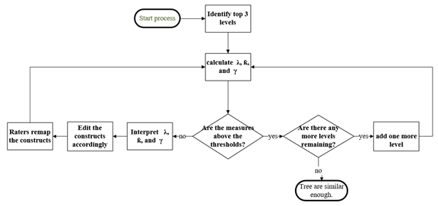
Fig. 8. Flowchart of the q-sorting evaluation process.

If the measures do not meet satisfactory levels, then the scores are interpreted to identify problematic items. These items will then be edited, and experts are asked to remap the items in step 8. This evaluation process is guided by our three statistics, which each behave differently depending on what is inconsistent between the two trees [37]. As presented in Table 3, Gamma is particularly sensitive to differences in levels (hierarchy movements or swaps), while Kappa is sensitive to differences within a level of the tree (level movements or swaps). Lambda is sensitive to “movements” where a single node or branch differs between the two trees, and not sensitive to “swaps” where two nodes or branches are substituted.

Num. | Interpretation of measures | Type of error
1 | Gamma and Kappa are both lower than threshold | Diagonal movements or swaps
2 | Gamma is lower than threshold | Hierarchy movement or swap
3 | Kappa is lower than threshold | Level movement or swap
4 | 1. Lambda is lower than threshold | Movements
5 | 1. Lambda is higher than threshold 2. Gamma is low | Hierarchy swap
6 | 1. Lambda is higher than threshold 2. Kappa is low | Level swap
7 | 1. Lambda is higher than threshold 2. Kappa and Gamma are both low | Diagonal swap
Table 3. Summary of interpretation of the measures.

In our Instagram self-efficacy case, Lambda (λ) Kappa (ƙ), and Gamma (γ) for the top 3 levels were calculated as per Table 4. Lambda (λ) is 0.532, Kappa (ƙ) is 0.109, and Gamma (γ) is 0.104. Here, Kappa and Gamma are the lowest scores, which identifies that the principal problem is disagreement with the mapping of items of the same level and hierarchy. Visually, as illustrated in Fig. 7, we can see this as expert 2 ‘s tree has more levels than expert 1, while expert 1 has more branches. This affects items 3, 5, 11,12, 17, 19, 20, 21, 22, 26, 27, 32, 35 and 40. In addition, the measures indicate many diagonal movements, which can be identified as items 11, 17, 26, and 32. Resolution of these discrepancies is addressed in step 8.

Construct “Account Management” | (λ) | (ƙ) | (γ)
Three levels | 0.532 | 0.109 | 0.104
Recalculation of the three levels | 0.722 | 0.556 | 0.719
4 levels | 0.701 | 0.670 | 0.769
All levels | 0.703 | 0.671 | 0.810
Table 4. Contingency table test of inter-expert agreement for the top-level construct “account management for Instagram.”

When these issues are resolved and experts remapped the items (i.e., came back from step 8 to step 7), the measures were recalculated as per Fig. 9. This time, Lambda (λ) was 0.711, Kappa (ƙ) 0.556, and Gamma (γ)0.719 which met the thresholds and allowed us to proceed to the next level. We added the fourth level and fifth level and recalculated Lambda (λ) Kappa (ƙ), and Gamma (γ), and edited the items accordingly. The final results are in Table 4.
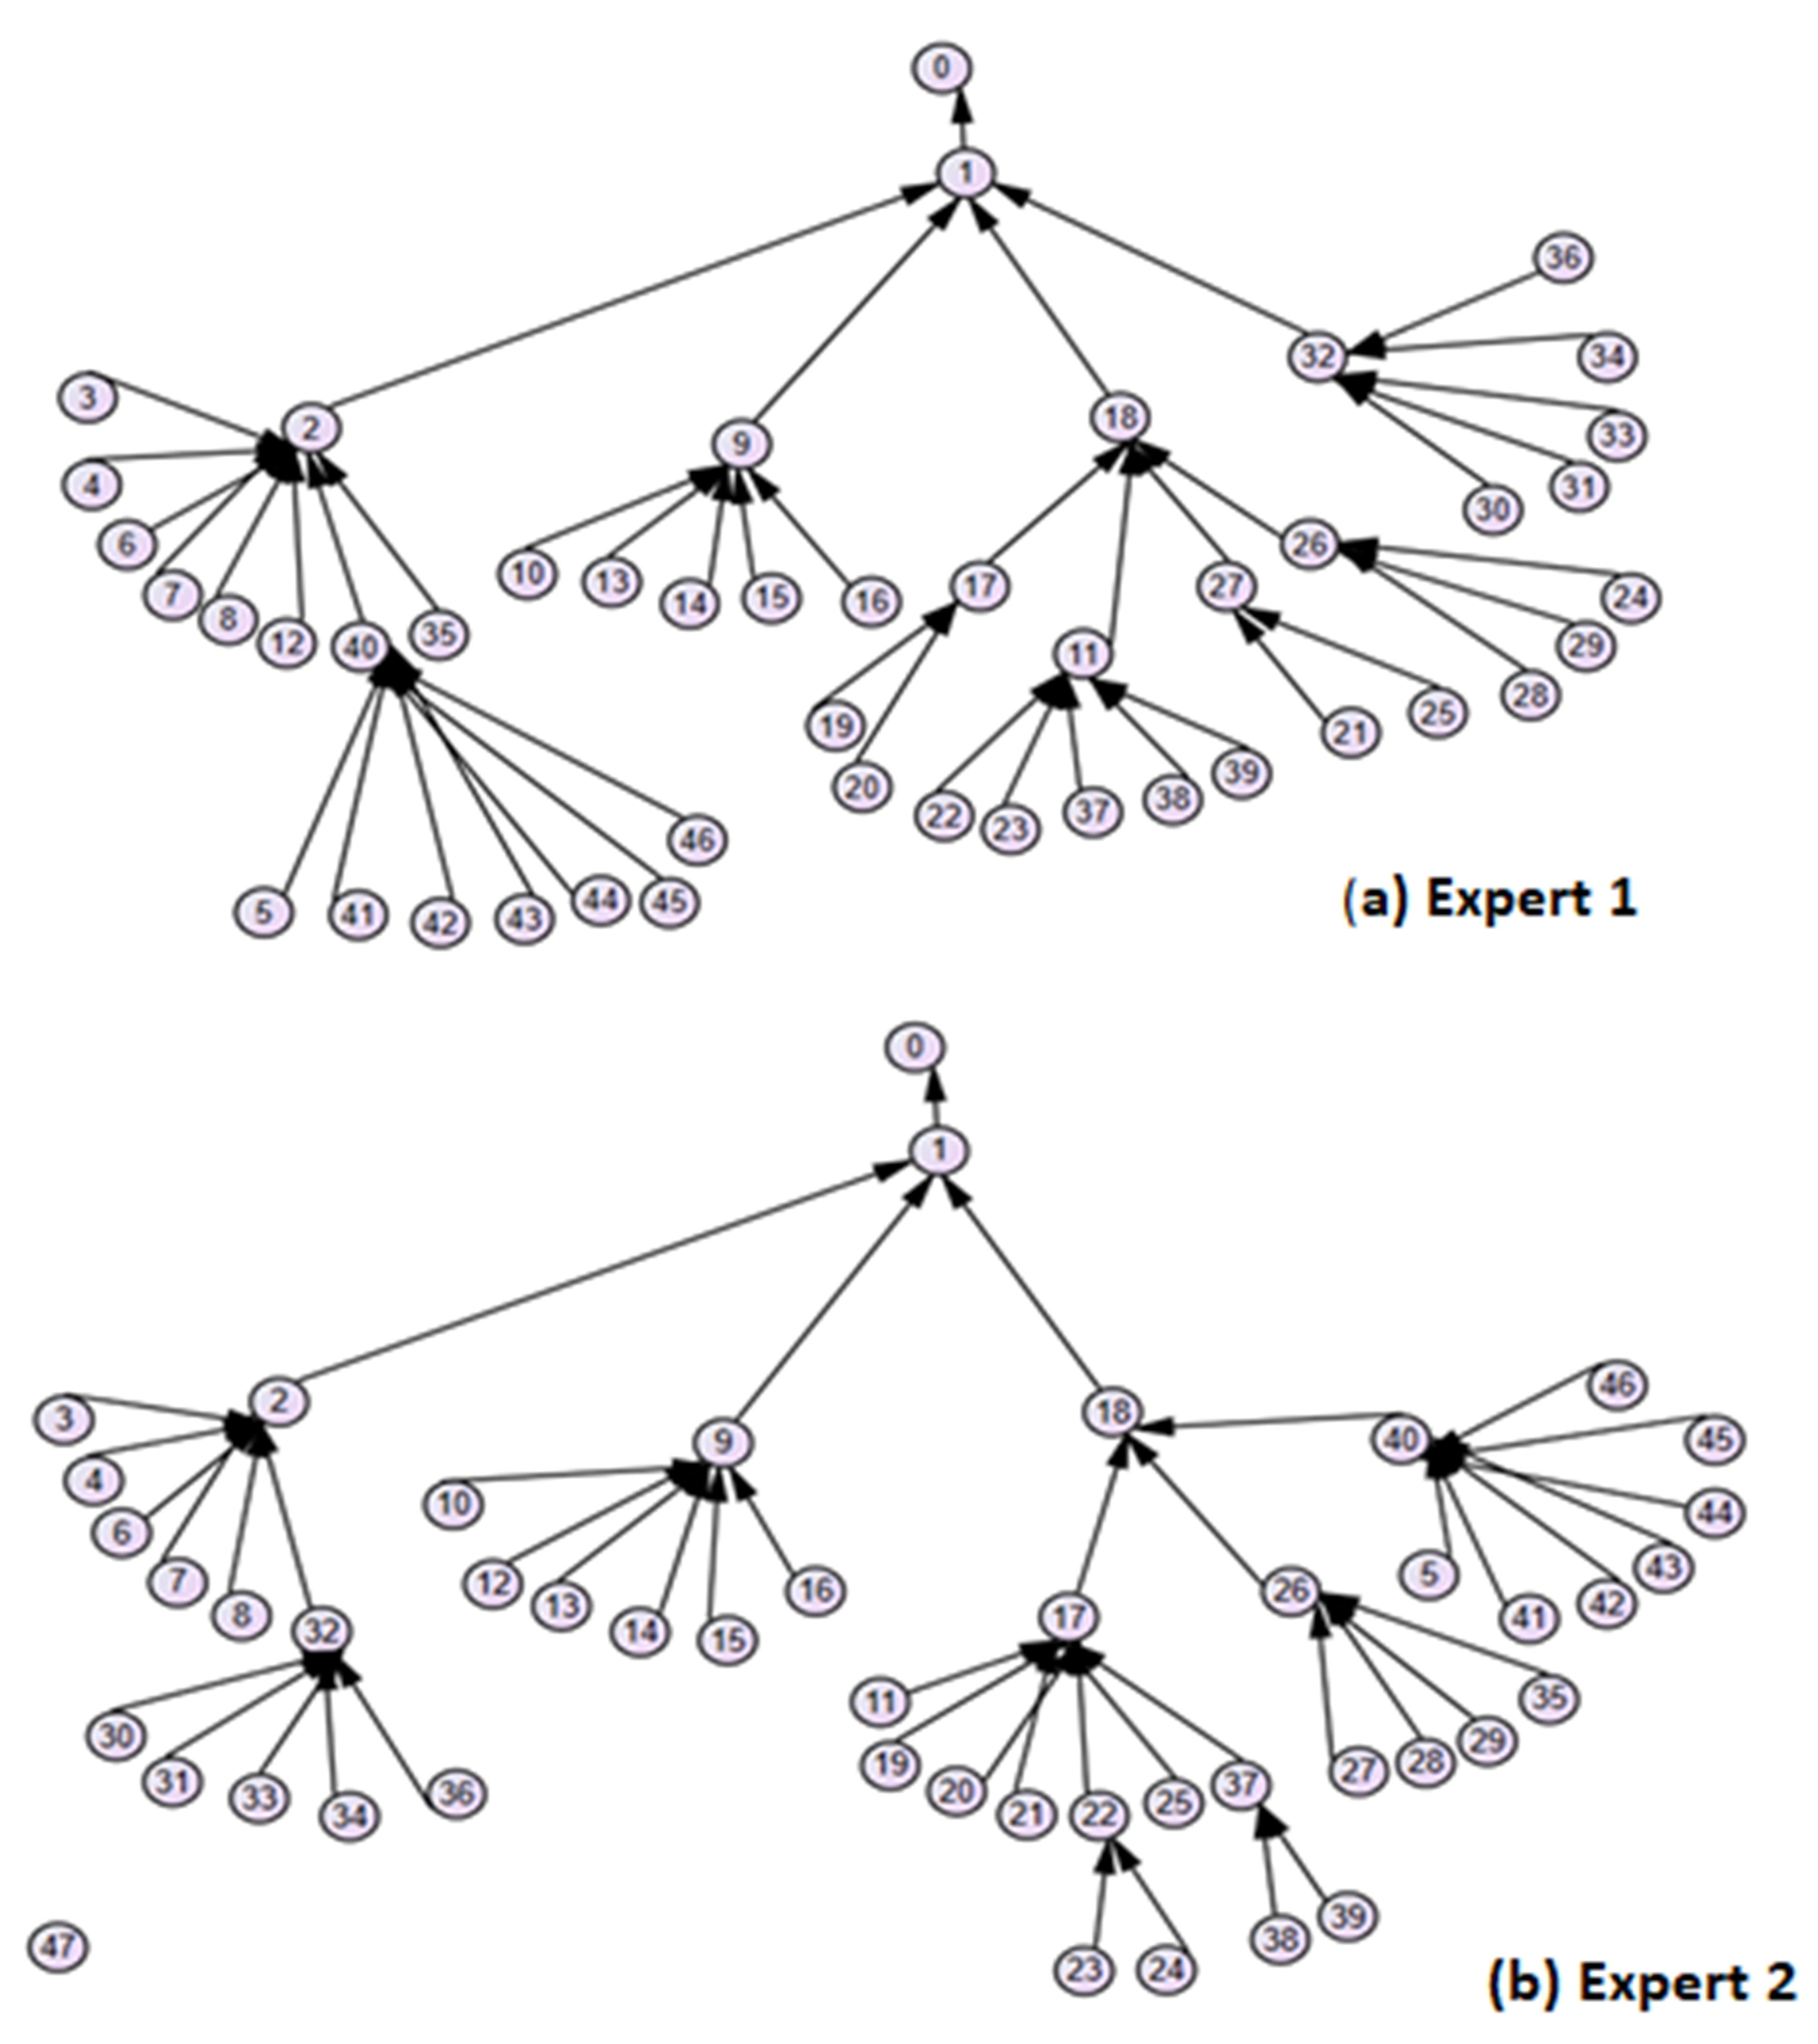
Fig. 9. Third round tree diagram for the top-level construct “account management for Instagram.”

Step 8: Diagnosing the trees. In this step, as presented in Fig. 9, based on the results from step 7, we identify the problematic items and systematically resolve them. As a result of the analysis, we edited items 3, 5, 11,12, 17, 19, 20, 21, 22, 26, 27, 32, 35 and 40. For instance, we edited item 40 from “I know how to secure my Instagram” to “I know how to secure my Instagram account” in which we added the term “account” - the term “my Instagram” is too general and could mean several things, such as one’s profile, one’s posts, or one’s login. We then gave the experts the modified set of items and asked them to redo the mapping.
Step 9: Building the final diagnostic tree and design. When satisfactory levels of significance and suitable thresholds are achieved, items that experts disagree on need to be reconciled and the design of the tree finalized. This is done in three steps. First, the experts are given the problematic items and we explain why such discrepancies exist using the statistics Goodman and Kruskal’s Lambda, Cohen’s Kappa, and Goodman and Kruskal’s Gamma [43]. Next, we ask the experts to discuss the discrepancies. Finally, depending on the consensus decision by the experts, the items or the mapping of the items is revised. In cases where experts can not agree, either the researchers intervene and assist with the final mapping or alternatively a new set of experts are invited and asked to do the q-sort. In our case this, was not necessary as experts were able to arrive at a consensus for all discrepancies. As an example, consider the diagnostic tree presented in Fig. 10. After the reconciliation, several items were remapped. For instance, in the third round, experts disagreed on which item should be the parent of item 40 “I know how to secure my Instagram account.” Expert 1 mapped item 40 to item 2 “I know how to create an Instagram account,” while expert 2 mapped item 40 to item 18 “I have the ability to control the visibility and privacy of the Instagram account”. After discussion, the experts and researchers agreed to map item 40 to item 18 “I have the ability to control the visibility and privacy of the Instagram account.”
It should be observed that while we were concerned with the number of branches each item could have (i.e., the “breadth” of the tree), we implemented no controls on the “depth” of the tree. The rule of thumb when developing instruments requiring user feedback is to have at most 10 questions. This normally takes users 5 minutes to fill. Any longer, and there is an increased risk of fatigue and dropouts [62], [63]. From the perspective of diagnostic trees, a diagnostic tree with 2 branches per item nested 10 levels deep would have 2¹⁰ or 1024 questions, i.e., more questions than need to be asked. Thus, typically, the depth of the tree structure does not pose an issue in design.
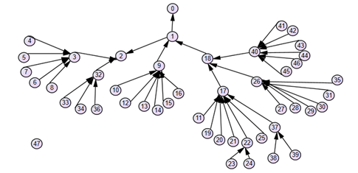
Fig. 10. Final mapping “account management for Instagram” tree.
Step 10: Empirically validating the Diagnostic tree. Our Diagnostic Tree (DT) is designed to identify systematic reasons for users’ failure to engage with various Instagram functions. There are clearly many forms of validity, such as construct, internal, and external validity [64], and a full validation of any measurement instrument is time intensive. One way to validate a Diagnostic Tree is to assess it against an external criterion. For the Instagram self-efficacy for account management, online comments or reviews were used as an external criterion. We extracted comments from Reddit, in particular subreddits, such as, “r/Instagram” or “r/socialmedia’, using keywords such as account, profile, privacy, and security, because it concerns complaints about Instagram. We then retrieved all the data from the search. We then cleaned the data and dropped duplicates. We obtained a total of 193 comments. Next, two independent experts were given the comments and the categories and were asked to map each comment to the categories. In our research design, experts could elect to not map comments to categories, and this occurred. When unmapped comments were reviewed by researchers, it was determined they were either irrelevant to the context of the study or vague and hence were dropped. For instance, the comment “Instagram blocks my Live for using my own music” was dropped as it was marked as irrelevant, as it was not related to the context of Instagram self-efficacy for account management. A total of 41 such comments were dropped. The inter-rater reliability was significant, and kappa was 0.603. Interestingly, of the 153 comments, expert 1 and expert 2 could only map 52 and 62 items respectively to levels below the first two levels. What this means is that the diagnostic tree allowed for a more in-depth diagnosis for why Instagram users had account management problems than the actual Reddit complaints. This therefore provides some evidence our diagnostic tree is superior to at least other traditional source of diagnostic information (i.e., online forums).

Conclusion
This paper introduced a new q-sort methodology for validating diagnostic trees. Existing approaches are limited in their ability to assess these types of trees for a number of reasons. Consider the example of the diagnostic tree in Fig. 1, for Instagram self-efficacy. Existing expert review and comparisons-based techniques are insufficient, because they focus only on evaluating the tree’s overall fitness, rather than considering the fitness of the individual branches- they do not include methodological processes for validating tree branches. For example, while the overall tree might be alright, if the “content creation” branch performs poorly, we would continue to have a segment of unhappy users. With respect to quantitative techniques, if a quantitative technique demonstrates our diagnostic tree has poor validity, it does not then articulate for us what the issue with validity is- we just simply know the validity score is poor. Thus, the key distinction between ours’ and others’ techniques is in our focus on evaluating not only the whole tree, but parts of the tree. This is done by: (1) having our experts assess only part of the diagnostic tree at one time, (2) performing quantitative statistical tests on successive elements of the tree, working from the top of the tree down to the end nodes, and (3) using statistical measures that what part of two trees are dissimilar.
Our paper makes several contributions. First, we introduce a methodology which not only validates the overall diagnostic tree, but also validates components of the tree. In performing validation, we not only identify that something is wrong, but what is wrong, i.e., whether the problem is at the top or bottom of the tree, and whether the problem is a hierarchical, or level issue. Our methodology is furthermore systematic and follows a step-by-step procedure that others can follow. Our methodology thus provides a rigorous way by which existing diagnostic trees (e.g., in expert systems and follow-up customer satisfaction surveys) can be validated prior to launch. In addition, as part of evaluating our validation process, we developed a new diagnostic tree for Instagram self-efficacy. This diagnostic tree will prove helpful not only for identifying the key gaps in Instagram’s user experience, but also more generally expands our understanding of user self-efficacy as a concept [13]. Our work allows for a more systematic evaluation of the elements of user self-efficacy and why users perceive themselves as not particularly self-efficacious.
The development of our new q-sort methodology opens up several opportunities for information systems research. First, most empirical information systems research focuses on explaining causal relationships. For instance, methods such as Structural Equation Modeling (SEM) are used to examine causal relationships and to test the hypotheses between the observed and latent items in a research model [65]. However, in many situations, one may desire to know why such relationships exist or fail to hold. For instance, Bagozzi [66] highlights that research on the technology acceptance model has demonstrated the relationship between perceived usefulness, ease of use, and intention to use, but cannot articulate why this relationship holds. As a practical matter, we often want to determine why (for example) users find a technology to not be useful, or not easy to use. As an example, researchers have investigated why users find the Web not particularly easy to use, they identified several reasons, such as slow data access, difficulty searching for specific information, information clutter, time delays due to images, the unreliability of sites, and incomplete category searches [67]. In this case a diagnostic theory would be useful where each end node represents a possible reason why the Web is not easy to use. Our development of a systematic methodology facilitates the development of diagnostic trees to answer these kinds of questions.
Finally, as ongoing research on validating our methodology, we used it to create a diagnostic tree survey of café customer satisfaction and used it in a number of cafes [68]. We compared the results against two other techniques, specifically (1) a traditional customer satisfaction survey, and (2) a content analysis of online customer reviews. Preliminary results indicate that our diagnostic tree has several advantages over the other tools. It has a higher response rate, requires fewer items for respondents to answer, which reduces fatigue effect, has better item discrimination in that respondents tend to provide more extreme scores, and has a higher agreement among respondents for each item than a traditional survey. It also provides a more precise diagnostic than customer reviews, which tend to be short and non-descriptive. Our development and evaluation of this diagnostic tool is ongoing.
As with all validation methodologies, our q-sort methodology has limitations. One, similar to expert reviewers, it is fallible and biased. They often focus on specific kinds of problems and may miss important issues [17]. Two, results of an expert review depend on experts’ qualifications [7], [69]. Many diagnostic trees are complex, [70] requiring knowledge from multiple domains [3]. Thus, there may not be experts able to review an entire diagnostic tree. Finally, most diagnostic trees are complex, and experts often experience fatigue during review, which can compromise review quality [7]. We provide procedures that control the cognitive exhaustion of experts. However, our methodology remains exhausting.
Second, our methodology is best suited for diagnostic theories where one is interested in unpacking the reasons of why. Therefore, it is not suitable for establishing relationships among variables, such as in process or variance theories. As an example, in one study, Activity Theory was used to identify contradictions and congruencies between flow techniques and software development practices, and the dialectical interaction between contradictions and congruencies which can lead to a stage of change [71]. Similarly, in many cases, we may be interested in identifying which variable has the biggest impact on another variable. For instance, the aim of one study was to identify factors that increased the use of technology in the workplace [72] or another who identified factors that influenced knowledge sharing behaviour via weblogs [73]. In such case, our methodology has limited applicability.
Finally, our methodology does not evaluate nomological properties of the diagnostic tree. Nomological validity refers to the degree to which the constructs fit within the logical network of theory [74], [75]. In other words, it is a measure of the theoretical correspondence between theory and the measures used in the diagnostic tree. However, most methodologies do not have statistical tests of nomological validity [75], [76].

References

[1] E. Shortliffe, Computer-based medical consultations: MYCIN, (Vol. 2). Elsevier., 2012.
[2] C. Angeli, “Online expert systems for fault diagnosis in technical processes,” Expert Syst., vol. 25, no. 2, pp. 115–132, 2008.
[3] S. C. Liu and S. Y. Liu, “An efficient expert system for machine fault diagnosis,” Int. J. Adv. Manuf. Technol., vol. 21, no. 9, pp. 691–698, 2003.
[4] W. J. Hopp, S. M. R. Iravani, and B. Shou, “A diagnostic tree for improving production line performance,” Prod. Oper. Manag., vol. 16, no. 1, pp. 77–92, 2007.
[5] J. Luo, S. Ba, and H. Zhang, “The effectiveness of online shopping characteristics and well-designed websites on satisfaction,” MIS Q., vol. 36, no. 4, pp. 1131–1144, 2012.
[6] C. L. Sia, K. H. Lim, K. Leung, M. K. O. Lee, W. W. Huang, and I. Benbasat, “Web strategies to promote internet shopping: Is cultural-customization needed?,” MIS Q. Manag. Inf. Syst., vol. 33, no. 3, pp. 491–512, 2009.
[7] R. M. O’Keefe, O. Balci, and E. P. Smith, “Validating expert system performance.,” IEEE Expert, vol. 2, no. 4. pp. 81–90, 1988.
[8] K.-C. Tai, “The tree-to-tree correction problem,” J. Assoc. Comput. Mach., vol. 26, no. 3, pp. 422–433, 1979.
[9] G. Torkzadeh and T. P. Van Dyke, “Effects of training on Internet self-efficacy and computer user attitudes,” Comput. Human Behav., vol. 18, no. 5, pp. 479–494, 2002.
[10] D. R. Compeau and C. A. Higgins, “Computer self-efficacy: Development of a measure and initial test,” MIS Q., vol. 19, no. 2, pp. 189–211, 1995.
[11] Y. Zheng, J. Wang, W. Doll, X. Deng, and M. Williams, “The impact of organisational support, technical support, and self-efficacy on faculty perceived benefits of using learning management system,” Behav. Inf. Technol., vol. 37, no. 4, pp. 311–319, 2018.
[12] A. Bandura and Albert, “Self-efficacy: Toward a unifying theory of behavioral change.,” Psychol. Rev., vol. 84, no. 2, pp. 191–215, 1977.
[13] M. J. Keith, J. S. Babb, P. B. Lowry, C. P. Furner, and A. Abdullat, “The role of mobile-computing self-efficacy in consumer information disclosure,” Inf. Syst. J., vol. 25, no. 6, pp. 637–667, 2015.
[14] J. Caverlee, L. Liu, and S. Webb, “The SocialTrust framework for trusted social information management: Architecture and algorithms,” Inf. Sci. (Ny)., vol. 180, no. 1, pp. 95–112, 2010.
[15] V. Mirzaee, M. N. Razavi, and L. Iverson, “Improving personal and social information management with advanced tagging,” in Proceedings of the 36th annual conference of the Canadian Association for Information Science (CAIS), University of British Columbia, Vancouver, June 5-7, 2008.
[16] T. R. Chang, E. Kaasinen, and K. Kaipainen, “Persuasive design in mobile applications for mental well-being: Multidisciplinary expert review,” Lect. Notes Inst. Comput. Sci. Soc. Telecommun. Eng. LNICST, vol. 61, pp. 154–162, 2013.
[17] M. Tory and T. Möller, “Evaluating visualizations: Do expert reviews work?,” IEEE Comput. Graph. Appl., vol. 25, no. 5, pp. 8–11, 2005.
[18] H. Blockeel and J. Struyf, “Efficient algorithms for decision tree cross-validation,” J. Mach. Learn. Res., vol. 3, no. 4–5, p. 9, 2001.
[19] G. Lamperti and M. Zanella, “Flexible diagnosis of discrete-event systems by similarity-based reasoning techniques,” Artif. Intell., vol. 170, no. 3, pp. 232–297, 2006.
[20] R. Yan, Z. Ma, Y. Zhao, and G. Kokogiannakis, “A decision tree based data-driven diagnostic strategy for air handling units,” Energy Build., vol. 133, pp. 37–45, 2016.
[21] K. H. Green and B. P. Ricca, “Graph theoretic methods for the analysis of data in developing systems,” Qual. Quant., vol. 49, no. 5, pp. 2037–2060, 2014.
[22] C. Klinkmüller and I. Weber, “Analyzing control flow information to improve the effectiveness of process model matching techniques,” Decis. Support Syst., vol. 100, pp. 6–14, 2017.
[23] L. R. Novick and S. M. Hurley, “To matrix, network, or hierarchy: That is the question.,” Cogn. Psychol., vol. 42, pp. 158–216, 2001.
[24] J. F. Hair, R. E. Anderson, R. L. Tatham, and W. C. Black, Multivariate Data Analysis, vol. 1, no. 6. Prentice Hall, 1998.
[25] M. G. Capra, “Factor analysis of card sort data: An alternative to hierarchical cluster analysis,” Proc. Hum. Factors Ergon. Soc., pp. 691–695, 2005.
[26] A. Lake and C. Cook, “Use of factor analysis to develop OOP software complexity metrics,” Proc. Sixth Annu. Oregon Work. Softw. Metrics, pp. 1–15, 1994.
[27] J. Sun, “Assessing goodness of fit in confirmatory factor analysis,” Meas. Eval. Couns. Dev., vol. 37, no. 4, pp. 240–256, 2005.
[28] J. Anderson and D. Gerbing, “Structural equation modeling in practice: A review and recommended two-step approach,” Psychol. Bull., vol. 103, no. 3, pp. 411–423, 1988.
[29] R. B. Kline, Principles and Practice of Structural Equation Modeling, Third. New York: The Guilford Press, 1998.
[30] D. Jiang, C. Tang, and a Zhang, “Cluster analysis for gene expression data: A survey,” IEEE Trans. Knowl. Data, vol. 16, no. 11, pp. 1370–1386, 2004.
[31] J. Zhan, H. T. Loh, and Y. Liu, “Gather customer concerns from online product reviews - A text summarization approach,” Expert Syst. Appl., vol. 36, pp. 2107–2115, 2009.
[32] C. Serrano-Cinca and B. Gutiérrez-Nieto, “Partial least square discriminant analysis for bankruptcy prediction,” Decis. Support Syst., vol. 54, no. 3, pp. 1245–1255, 2013.
[33] J. C. Gower and G. J. S. Ross, “Minimum Spanning Trees and Single Linkage Cluster Analysis,” Appl. Stat., vol. 18, no. 1, p. 54, 1969.
[34] R. R. Sokal, “A statistical method for evaluating systematic relationships,” Univ. Kansas Sci. Bull., vol. 38, no. February, pp. 1409–1438, 1958.
[35] D. J. Ketchen Jr. and C. L. Shook, “The application of cluster analysis in strategic management research: An analysis and critique,” Strateg. Manag. J., vol. 17, no. November 1994, pp. 441–458, 1996.
[36] B. S. Everitt, S. Landau, M. Leese, and D. Stahl, Cluster analysis, 5th ed., vol. 14, no. 1. Wiley, 2011.
[37] S. Sabbaghan, C. E. H. Chua, and L. A. Gardner, “Statistical measurement of trees’ similarity,” Qual. Quant., no. 0123456789, 2020.
[38] J. Block, “An introduction to the Q-sort method of personality description,” Q-sort method Personal. Assess. Psychiatr. Res., pp. 3–26, 1961.
[39] B. G. Glaser and A. L. Strauss, The Discovery of Grounded Theory: Strategies for Qualitative Research. London: Aldine Publishing Company, 1967.
[40] J. Fleiss, B. Levin, and M. Cho Paik, Statistical Methods for Rates and Proportions. 2013.
[41] K. L. Gwet, “Computing inter-rater reliability and its variance in the presence of high agreement,” Br. J. Math. Stat. Psychol., vol. 61, no. 1, pp. 29–48, 2008.
[42] J. Vargo, J. C. Nesbit, K. Belfer, and A. Archambault, “Learning object evaluation: Computer-mediated collaboration and inter-rater reliability,” Int. J. Comput. Appl., vol. 25, no. 3, pp. 198–205, 2003.
[43] W. H. Goodman, L. A., & Kruskal, “Measures of association for cross classifications.,” J. Am. Stat. Assoc., vol. 49, pp. 732–764, 1954.
[44] P. Sheldon and K. Bryant, “Instagram: Motives for its use and relationship to narcissism and contextual age,” Comput. Human Behav., vol. 58, pp. 89–97, 2016.
[45] K. P. Hocevar, A. J. Flanagin, and M. J. Metzger, “Social media self-efficacy and information evaluation online,” Comput. Human Behav., vol. 39, pp. 254–262, 2014.
[46] G. Walsh, M. Schaarschmidt, and H. von Kortzfleisch, “Employees’ Company Reputation-related Social Media Competence: Scale Development and Validation,” J. Interact. Mark., vol. 36, pp. 46–59, 2016.
[47] S. M. Mudambi and D. Schuff, “What makes a helpful online review? A study of customer reviews on Amazon.com,” MIS Q., vol. 34, no. 1, pp. 185–200, 2010.
[48] D. Yin, S. D. Bond, and H. Zhang, “Anger in consumer reviews: unhelpful but persuasive?,” Forthcom. MIS Q., pp. 1–74, 2020.
[49] J. R. Edwards and R. P. Bagozzi, “On the nature and direction of relationships between constructs and measures,” Psychol. Methods, vol. 5, no. 2, pp. 155–174, 2000.
[50] A. Lauffer, Understanding your social agency, 3rd ed. London: SAGE Publications Ltd, 2010.
[51] G. A. Bowen, “Naturalistic inquiry and the saturation concept: A research note,” Qual. Res., vol. 8, no. 1, pp. 137–152, 2008.
[52] R. J. Landis and G. G. Koch, “The Measurement of Observer Agreement for Categorical Data,” Biometrics, vol. 33, no. 1, pp. 159–174, 1977.
[53] J. E. Scott and S. Walczak, “Cognitive engagement with a multimedia ERP training tool: Assessing computer self-efficacy and technology acceptance,” Inf. Manag., vol. 46, no. 4, pp. 221–232, 2009.
[54] K. A. Ericsson, N. Charness, P. J. Feltovich, and R. R. Hoffman, The Cambridge Handbook of Expertise and Expert Performance, no. 1. 2003.
[55] G. Miller, “The magical number seven, plus or minus two: Some limits on our capacity for processing information,” Psychol. Rev., vol. 63, no. 2, pp. 81–97, 1956.
[56] B. Weijters, E. Cabooter, and N. Schillewaert, “The effect of rating scale format on response styles: The number of response categories and response category labels,” Int. J. Res. Mark., vol. 27, no. 3, pp. 236–247, 2010.
[57] L. J. Simms, K. Zelazny, T. F. Williams, and L. Bernstein, “Does the number of response options matter? Psychometric perspectives using personality questionnaire data,” Psychol. Assess., vol. 31, no. 4, pp. 557–566, 2019.
[58] C. C. Preston and A. M. Colman, “Optimal number of response categories in rating scales: reliability, validity, discriminating power, and respondent preferences,” Acta Psychol. (Amst)., vol. 104, no. 1, pp. 1–15, 2000.
[59] N. Borgers, J. Hox, and D. Sikkel, “Response effects in surveys on children and adolescents: The effect of number of response options, negative wording, and neutral mid-point,” Qual. Quant., vol. 38, no. 1, pp. 17–33, 2004.
[60] G. A. Churchill, “A paradigm for developing better measures of marketing constructs,” J. Mark. Res., vol. 16, no. 1, p. 64, 1979.
[61] A. De Raadt, M. J. Warrens, R. J. Bosker, and H. A. L. Kiers, “Kappa coefficients for missing data,” Educ. Psychol. Meas., vol. 79, no. 3, pp. 558–576, 2019.
[62] M. Galesic and M. Bosnjak, “Effects of questionnaire length on participation and indicators of response quality in a Web Survey,” Public Opin. Q., vol. 73, no. 2, pp. 349–360, May 2009.
[63] M. Galesic, “Dropouts on the Web: Influence of changes in respondents’ interest and perceived burden during the Web survey,” J. Off. Stat., vol. 22, no. 2, pp. 313–328, 2006.
[64] W. R. Shadish, T. D. Cook, and D. T. Campbell, Experimental and Quasi-Experimental for Generalized Designs Causal Inference. Houghton Mifflin Company, 2002.
[65] R. H. Hoyle, Structural equation modeling: Concepts, issues, and applications. Thousand Oaks, CA,: SAGE Publications, 1995.
[66] R. P. Bagozzi, “The legacy of the technology acceptance model and a proposal for a paradigm shift,” J. Assoc. Inf. Syst., vol. 8, no. 4, pp. 244–254, 2007.
[67] A. L. Lederer, D. J. Maupin, M. P. Sena, and Y. Zhuang, “Technology acceptance model and the World Wide Web,” Decis. Support Syst., vol. 29, no. 3, pp. 269–282, 2000.
[68] S. Sabbaghan, L. A. Gardner, and C. Chua, “Computer-Adaptive Surveys ( CAS ) as a means of answering questions of why,” Pacific Asia Conf. Inf. Syst., pp. 1–15, 2017.
[69] Y. Yoon, T. Guimaraes, and Q. O’Neal, “Exploring the factors associated with expert systems success,” MIS Q., vol. 19, no. 1, pp. 83–106, 1995.
[70] S. Dalal and R. S. Chhillar, “Empirical study of root cause analysis of software failure,” ACM SIGSOFT Softw. Eng. Notes, vol. 38, no. 4, p. 1, 2013.
[71] D. Dennehy and K. Conboy, “Going with the flow: An activity theory analysis of flow techniques in software development,” J. Syst. Softw., vol. 133, pp. 160–173, 2017.
[72] V. Viswanath and B. Hillol, “Technology acceptance model 3 and a research agenda on interventions,” Decis. Sci., vol. 39, no. 2, pp. 273–315, 2008.
[73] T.-K. Yu, L.-C. Lu, and T.-F. Liu, “Exploring factors that influence knowledge sharing behavior via weblogs,” Comput. Human Behav., vol. 26, no. 1, pp. 32–41, Jan. 2010.
[74] B. J. Calder, L. W. Phillips, and A. M. Tybout, “Beyond external validity beyond external validity,” J. Consum. Res., vol. 10, no. 1, pp. 112–114, 1983.
[75] S. B. Mackenzie, P. M. Podsakoff, and N. P. Podsakoff, “Construct measurement and validation procedures in Mis and Behavioral Research : Integrating new and existing techniques,” MIS Q., vol. 35, no. 2, pp. 293–334, 2011.
[76] A. Diamantopoulos, P. Riefler, and K. P. [1] E. Shortliffe, Computer-based medical consultations: MYCIN, (Vol. 2). Elsevier., 2012.

Sahar Sabbaghan is a Lecturer at London South Bank University, UK. She received a PhD in Information Systems from University of Auckland. Her main research interest is in creating new research methodologies for Information Systems. She has several publications in top conference proceedings and journals.

Cecil Eng Huang Chua is an Associate Professor at the Missouri University of Science and Technology, USA. Cecil has several publications in such journals as Information Systems Research, Journal of the AIS, MIS Quarterly and the VLDB Journal. He is an editor for multiple journals including the Information Systems Journal and Information & Management.

Lesley Gardner is an Associate Professor and Deputy Head of Information Systems and Operations Management, at the University of Auckland, NZ. She has over 120 publications in top conference proceedings and Journals. Her research areas focus on hypermedia, digital documents, and digital influences on society.

Manuscript received April 09, 2020; revised July 11, 2020 and November 23, 2020; accepted April 26, 2021. Sahar Sabbaghan is with London South Bank University, UK (e-mail: sabbaghs@lsbu.ac.uk). Cecil Eng Huang Chua is with Missouri University of Science and Technology, USA (e-mail: cchua@mst.edu). Lesley Gardner is with the University of Auckland, NZ (e-mail: l.gardner@auckland.ac.nz).

