**Desire Thinking and Craving as Predictors of Problematic Internet Pornography Use in Women and Men**

Claudia Marino1,2, Fiordalisa Melodia1, Erika Pivetta1, Giovanni Mansueto3,4,5, Sara Palmieri2,3,4, Gabriele Caselli3,4, Natale Canale1, Alessio Vieno1, Francesca Conti1 and Marcantonio M. Spada2

1 Department of Developmental and Social Psychology, University of Padova, Padova, Italy

2 Division of Psychology, School of Applied Sciences, London South Bank University, London, UK

3 Studi Cognitivi, Cognitive Psychotherapy School and Research Center, Milan, Italy

4Department of Psychology, Sigmund Freud University, Milan, Italy

5Department of Health Sciences, University of Florence, Florence, Italy

Authors’ email:

[claudia.marino@unipd.it](mailto:claudia.marino@unipd.it)

[fiordalisa.melodia@gmail.com](mailto:fiordalisa.melodia@gmail.com)

[erika.pivetta@phd.unipd.it](mailto:erika.pivetta@phd.unipd.it)

[g.mansueto@milano-sfu.it](mailto:g.mansueto@milano-sfu.it)

[s.palmieri@milano-sfu.it](mailto:s.palmieri@milano-sfu.it)

[g.caselli@milano-sfu.it](mailto:g.caselli@milano-sfu.it)

[natale.canale@unipd.it](mailto:natale.canale@unipd.it)

[alessio.vieno@unipd.it](mailto:alessio.vieno@unipd.it)

[francesca.conti.1991@gmail.com](mailto:francesca.conti.1991@gmail.com)

[spadam@lsbu.ac.uk](mailto:spadam@lsbu.ac.uk)

\* Correspondence should be addressed to:

Claudia Marino, Dipartimento di Psicologia dello Sviluppo e della Socializzazione, Università degli Studi di Padova, via Venezia 8, 35131 Padova, Italy. E-mail: [claudia.marino@unipd.it](mailto:claudia.marino@unipd.it)

**Desire Thinking and Craving as Predictors of Problematic Internet Pornography Use in Women and Men**

**Abstract**

Introduction: According to the recent adaptation of the I-PACE model, desire thinking and craving might be closely related to problematic Internet pornography use. The overall aim of the present study was to investigate the role of two components of desire thinking (imaginal prefiguration and verbal perseveration) and craving in problematic Internet pornography use. Furthermore, we examined gender differences in the underlying mechanism linking desire thinking to problematic Internet pornography use.

Method: A total of 414 Italian adults (mean age = 27.55 years, SD = 6.13; age range= 18 – 58; 53.6% men) participated in this study. Participants completed an online survey to assess problematic Internet pornography use, pornography craving, desire thinking and problematic Internet use. Path analyses and a multi-group approach were used to test the relationships among variables and to explore gender differences.

Results: Imaginal prefiguration was associated to pornography craving which, in turn, was associated to verbal perseveration as proximal antecedent of problematic Internet pornography use, above and beyond the effect of age, relationship status, and problematic Internet use. Two paths significantly differed between men and women: the path between verbal perseveration and problematic Internet pornography, which for women was weaker and did not reach significance; and the path between problematic Internet use and problematic Internet pornography use that was not significant for women.

Conclusions: In line with the I-PACE model, the present study provided support for the potential role of desire thinking in problematic Internet pornography use as a specific Internet-use disorder and expanded the literature in the field by testing unexplored gender differences. Preventive and clinical implications are discussed.

**Keywords:** problematic Internet pornography use; desire thinking; craving; gender differences.

**1. Introduction**

With technological advances over recent decades, the Internet has become the most important means of distribution of pornography, increasing both the time of consumption of pornographic content and the potential consequences on individual health due to access, affordability, and anonymity (Boies et al., 2004; Chen et al., 2018a; Cooper et al., 1999). Internet pornography or cyberpornography is defined as “the use of the Internet for any activity (text, audio, or graphics) that involves sexuality” (Cooper et al., 2002, p. 106) and it has become steadily more dependable, easily accessible, and affordable, and constant source of sexual reward.

Online pornography viewing is a widespread phenomenon, with a prevalence rate of 96.6% of men and 77.7% of women (Li & Zheng, 2017), and researchers have been claiming that excessive engagement could result in addiction-like symptoms (e.g., Keane et al., 2016). However, problematic Internet pornography use has not been recognized as a mental disorder in DSM-5 and ICD-11 classifications. Nonetheless, there is growing concern (e.g., Duffy et al., 2016; Keane et al., 2016) about the negative consequences of problematic Internet pornography use for daily life, including financial, legal, occupational, and relational issues as well as psychological problems (e.g., irresponsible search for gratification, blame). Given the lack of a formal definition, different terms have been used in pornography research, leading to several inconsistencies in the methodology and assessment tools (Ley et al., 2014; de Alarcón et al., 2019).

Among its conceptualisations, problematic Internet pornography use has been defined as a form of obsessive–compulsive disorder (Cooper et al., 2004; Young, 2005), as a symptom of hypersexual disorder (Reid et al., 2011), as a behavioural addiction (Griffiths, 2001; Meerkerk et al., 2006), and, more recently, as a specific Internet-use disorder (Brand et al., 2016). Notably, a wide array of evidence (e.g., Brand et al., 2016; Elmquist et al., 2016; Gola et al., 2016; Love et al., 2015; Walsh et al., 2020) shows similarities between problematic Internet pornography use and substance use disorders or other behavioural addictions in terms of neurobiological, cognitive, and behavioural mechanisms. These include the compulsion to achieve a specific desired target, the perception of losing control, the repetitive implementation of maladaptive behaviours despite awareness of the negative consequences, and craving (Brand et al., 2011; Laier et al., 2013; Skinner & Aubin, 2010; Tiffany & Wray, 2012;). Furthermore a number of risk factors for problematic Internet pornography use have been identified, such as male gender, being young, lack of religiosity, intense Internet use, unpleasant mood states, inclination to sexual boredom, and novelty seeking (Ballester-Arnalet al., 2017; Frangos et al., 2011; Štulhofer et al., 2016). Indeed, it has been shown that men tend to consume pornography in a solitary mode for arousal and masturbation purposes (Morgan, 2011), whereas women prefer to involve the partner in pornography use (Bridges & Morokoff, 2011). These gender differences could be explained by the fact that men traditionally have been the primary consumers of pornography, and most sexual scenarios are generally directed toward men’s needs and fantasies that may result in less enticement to women (e.g., Hen et al., 2020; Solano et al., 2018).

A recent adaptation of the I-PACE model (Brandtner et al., 2021), integrating theoretical assumptions from the Elaborated Intrusion Theory of Desire (EIT; Kavanagah et al., 2005) and the Self-Regulatory Execution Function Model (S-REF; Spada et al., 2013), suggested that problematic Internet pornography use, conceptualized as a specific Internet-use disorder, might be closely related to desire thinking (DT) (Caselli & Spada, 2010) and craving. Therefore, the aim of the present study is to test the role of DT and craving in problematic Internet pornography use in women and men.

**1.1. Desire Thinking**

Desire thinking (DT) is a multi-dimensional cognitive, conscious and voluntary process involving the elaboration of a desired target, which may be an activity, an object, or a state (Kavanagah et al., 2009), at two levels: (i) Imaginal Prefiguration, referring to the allocation of attentional resources to target-related information, followed by mental imagery elaboration (e.g., imagination or memory recall) (Kavanagh et al., 2009); and (ii) Verbal Perseveration, consisting of repetitive self-talk regarding the desired targets (Caselli & Spada, 2010). Research has shown that DT is positively associated with, but distinct from, craving, because DT is conceptualized as a perseverative, conscious, and intentional process, while craving is considered an automatic and motivational experience (Caselli et al., 2012; Caselli & Spada, 2011; May et al., 2004). DT appears to be a transdiagnostic process, as individuals report similar qualitative experiences towards a wide range of targets (Caselli & Spada, 2010). In line with this view, a recent systematic review and meta-analysis (Mansueto et al., 2019) showed that DT is indeed associated with various addictive behaviours (e.g., alcohol dependence, nicotine use, problematic Internet use and gambling); in addition, in both clinical and comparison samples a strong association was found between addictive behaviours and both Verbal Perseveration and Imaginal Prefiguration. These findings align with the adapted I-PACE model (Brandtner et al., 2021), which stresses the presence of interactions between DT (in both its components) and craving, eventually resulting in specific Internet-use (problematic) behaviours. Interestingly, as pointed out in the model, a bidirectional relationship may also exist between metacognitions and DT, in that they are involved in the cognitive attentional syndrome (Mansueto et al., 2019). In this regard, one previous study on problematic Internet pornography use (Allen et al., 2017), besides confirming the central role of DT and craving, has found that positive metacognitions about DT (i.e., usefulness of DT in distracting from negative thoughts and emotions), triggered by environmental cues, directly influence its imaginal and verbal components, ultimately determining an escalation of craving.

**1.2. Craving**

Craving for pornography can be considered as a transient and intense urge that fluctuates over time and as a relatively stable preoccupation to use pornography (Kraus et al., 2015; Kraus & Rosenberg, 2014). For this reason, understanding which type of processes (such as DT) may influence and maintain craving in the context of pornography might be useful to better understand specific users’ perceived experience and provide targeted interventions. With regards to Internet pornography use, craving may be determined by external Internet features such as access and anonymity or individual physiological characteristics such as sexual sensation-seeking (Rosenberg, 2009). Indeed, problematic Internet pornography use has been associated with greater craving, sexual arousal, and compulsive masturbation (Laier et al., 2013, Laier et al., 2014). Individuals with higher levels of craving towards online pornography use appear to show more symptoms of problematic Internet pornography use (e.g. loss of control, social problems) (Snagowski et al., 2015). Notably, harmful consequences may also occur among individuals who use pornography without experiencing psychological distress (Chen et al., 2018c).

**1.3. Aim of the Present Study**

According to the new theoretical assumptions of the I-PACE model (Brandtner et al., 2021), DT and craving are two distinct but intertwined constructs which develop as affective and cognitive responses to the perception of internal and external triggers via two entering pathways: a pleasure-oriented pathway (entailing the expected gratifications of DT) and a relief-oriented pathway (reflecting the expected compensations of DT) (Brandtner et al., 2021). It is postulated that when a person engages in DT as a dysfunctional coping mechanism associated with irrepressible craving and diminished behavioural control, problematic Internet-use disorders like problematic Internet pornography use may arise. Consistently, a study by Brandtner and Brand (2021) found that higher levels of negative emotional reactivity were significantly associated to increased DT, which, in turn, positively predicted craving for online pornography viewing.

In light of previous research and the I-PACE model (Brandtner et al., 2021), the present study aimed to further investigate the relationship between the two components of desire thinking, Imaginal Prefiguration (IP) and Verbal Perseveration (VP), craving, and problematic Internet pornography use in a general sample of Italian adults. Specifically, we tested the potential mechanism linking DT components to craving and problematic Internet pornography use. Brandtner and Brand (2021) showed that DT (as a latent variable comprising IP and VP) predicts craving for online activities. Moreover, Allen and colleagues (2017) tested a model of problematic Internet pornography use in which positive metacognitions are associated to DT-IP which in turn is associated with DT-VP, resulting in craving and negative metacognitions. Similarly, in other desire thinking research (e.g., Caselli et al., 2015) craving was the final result of the consequential effect of DT-IP and DT-VP. In the present study, in addition to the direct effect of DT-IP on DT-VP (Caselli & Spada 2015; 2016; Martino et al., 2017), we tested whether craving mediates the relationship between the two dimensions of DT in line with findings related to other potential online addictive behaviours (i.e., problematic Facebook use [Marino et al., 2019]) that highlighted such mediating role of craving. In the context of Internet pornography, it could be the case that the allocation of attention to positive anticipatory imagery of the desired activity (DT-IP) might first trigger the sense of deprivation for the craved activity (i.e., Internet pornography use), thus increasing the intensity of pornography craving. Such multisensory elaboration and activation, in turn, might produce self-talk about worthwhile reasons to engage in Internet pornography engagement (DT-VP) that have been found to be strictly associated with permissive beliefs related to the acceptability of a maladaptive behaviour despite objective negative consequences (e.g., Caselli et al., 2020). Therefore, it was hypothesized that DT-IP would be associated with pornography craving, which in turn would be associated with DT-VP as a proximal predictor of problematic Internet pornography use, above and beyond a series of control variables including age, relationship status, and problematic Internet use. Problematic Internet use was chosen as a covariate of problematic Internet pornography use because it can be also conceptualized as a specific form of problematic Internet-use disorder (Brandtner et al., 2021). Indeed, whereas problematic Internet pornography refers to the specific inability to stop using pornography and a generalized obsession with pornography use, generalized problematic Internet use covers relevant psycho-social dimensions (e.g., preference for online social interactions, Internet use for mood regulation) that might play an important role in the context of Internet sex activities like pornography (e.g., Coduto et al., 2020). Moreover, despite several studies have reported gender differences in problematic pornography use both offline and online, with men scoring higher than women (e.g., Bőthe et al., 2018; Chen et al., 2018b; Ševˇcíková et al., 2014), to date, to our knowledge, no study has explicitly tested whether the underlying mechanism linking DT to problematic Internet pornography use differ in men and women. Therefore, the present study adopted a multi-group approach in order to explore potential gender differences in the hypothesized pattern of relationships among variables.

**2. Methods**

**2.1. Procedure and Participants**

Data were collected by researchers at the University of [blinded for review] through an online questionnaire. The link to the questionnaire was promoted by means of advertisements shared in thematic social networking sites groups and forums from November 2018 to May 2019. Inclusion criteria were: (i) being over 18 years; and (ii) being able to complete the questionnaire in Italian. Participants received information about the study and gave their online consent before starting the survey. Their anonymity was guaranteed as no personal data or Internet Protocol address were collected. No compensation was given for participating in the study. The study adhered to the Declaration of Helsinki with regards to ethical standards for research. A total of 451 participants responded to the questionnaire. However, 37 questionnaires were uncompleted (i.e., participants started to answer to the questionnaire but did not complete it) and were excluded. The questionnaire took about 15-20 minutes to complete. Therefore, the analyses were run on a final sample of 414 participants (mean age = 27.55 years, SD = 6.13; age range= 18 – 58 years; 53.6% males). Sexual orientations reported were heterosexual (87.9%), bisexual (8.2%), and lesbian/gay (3.9%). The most common relationship status was being in a relationship (68.6%) followed by being single (31.4%). With regards to their education level, the majority of the participants (65.5%) reported having obtained a higher degree (Bachelor’s or Master’s degree or PhD), 30% had a high-school diploma, and the remaining 4.55% comprised elementary, secondary, or other education.

**2.2. Measures**

**2.2.1. Problematic Internet Pornography Use**

Problematic Internet pornography use was assessed using the Italian version of the Cyber Pornography Addiction Test (CYPAT) (original Italian version by Cacioppo, et al., 2018). The 18 items (e.g., “I have continued watching porn sites despite some negative consequences”) assess the inability to stop using pornography, significant negative effects because of the behaviour, and a generalized obsession with pornography use. Items were rated on a 5-point scale (from (1) “not at all” to (5) “a lot”). Items were summed to obtain a continuous score for problematic Internet pornography use with higher scores indicating higher levels of problematic use. The Cronbach’s alpha for the scale was .92 (95% CI .91-.93).

**2.2.2. Pornography Craving**

Pornography craving was assessed using the Pornography Craving Questionnaire (PCQ-12) (Kraus & Rosenberg, 2014), which measures perceived control over using pornography, changes in mood, psychophysiological reactivity, and intentions for using pornography. The 12 items (e.g., “I will watch porn as soon as I get the chance”) were rated on a 7-point scale (from (1) “completely disagree” to (7) “completely agree”). The items were translated from English to Italian and back-translated in English by one independent bilingual psychologist. The items were summed to obtain a continuous score for craving with higher scores indicating higher levels of craving. The Cronbach’s alpha for the scale was .93 (95% CI .92-.94).

**2.2.3. Desire Thinking**

Desire Thinking (DT) was measured using the Desire Thinking Questionnaire (original Italian version by Caselli & Spada, 2011) consisting of two dimensions of 5 items each: DT-IP (Desire Thinking – Imaginal Prefiguration; e.g., “I imagine myself doing the desired activity”) and DT-VP (Desire Thinking – Verbal Perseveration; e.g., “I repeat mentally to myself that I need to practice the desired activity”). In this study, the desired activity was “watching porn online”. Items were rated on a 4-point scale (from (1) “almost never” to (4) “almost always”). The scores on the two dimensions were summed to obtain a continuous score for DT-IP and DT-VP with higher scores indicating higher levels of DT. The Cronbach’s alpha for the DT-IP subscale was .85 (95% CI .83-.87), and .88 (95% CI .86-.90) for the DT-VP subscale.

**2.2.4. Problematic Internet Use**

Problematic Internet use was assessed with the Italian version of the Generalized Problematic Internet Use Scale-2 (Fioravanti et al., 2013; original English version by Caplan, 2010). The 15 items are rated on an 8-point scale (from (1) “definitely disagree” to (8) “definitely agree”) and measures the preference for online social interactions, mood regulation, cognitive preoccupation, compulsive use, and negative outcomes. Items were summed to obtain a continuous score for problematic Internet use with higher scores indicating higher levels of problematic use. The Cronbach’s alpha for the scale was .91 (95% CI .90-.93).

**2.3. Statistical Analysis**

First, a series of Welch’s t-tests for independent samples were conducted in order to compare the scores of the study variables between women and men. Second, the associations between the variables of interest were tested with correlation analyses on the whole sample and then for women and men separately. Third, the hypothesized model of the inter-relationships between the study variables was tested through a path analysis using Mplus 8.2 (Muthén & Muthén, 2017). Specifically, a single observed score for each variable and the robust maximum likelihood method estimator (MLR) suitable for non-normally distributed variables (Satorra & Bentler, 1994) were used. Bias-corrected bootstrap confidence intervals with 5000 bootstrapped iterations were used for calculating indirect effects, which were considered significant if their 95% confidence interval did not include zero. In our model, DT-IP was the independent variable; pornography craving and DT-VP were the mediators; and problematic Internet pornography use was the dependent variable (Figure 1). Age, problematic Internet use, and relationship status were included as covariates of the dependent variable. The explained variance of each endogenous variable (R2) and the total coefficient of determination (TCD; Bollen, 1989; Jӧreskog & Sӧrbom, 1996) were considered to evaluate the goodness of fit of the model. The TCD is commonly considered a reliable fit index of models run as path analysis and it represents the joined effect of all predictor variables on the dependent variable.

The model was first tested on the whole sample and then in the two gender groups. Then, the null hypothesis of equality of the path coefficients across gender groups was tested with a series of Wald chi-square tests of parameter equalities in Mplus (Muthén & Muthén, 2017; Wang & Wang, 2012, pp. 276-278; for recent applications of this method, see also Gini et al., 2018). In other words, in the multi-group model, unstandardized coefficients were compared between groups (with the “Model test” command) to test for gender differences in the associations between the study constructs (Loehlin, 1998).

**3. Results**

Descriptive statistics and bivariate correlations for the whole sample are reported in Table 1. Some variables showed a non-normal distribution (supporting the use of the MLR estimator for the path analyses). As expected, problematic Internet pornography use was found to be positively associated with all the variables of interest in the whole sample (Table 1), with the strongest association observed with DT-IP (*r* = .57; *p* < .001). Moreover, a medium association was observed between pornography craving and the two dimensions of DT (*r* = .52; *p* < .001 with DT-IP; and *r* = .54; *p* < .001 with DT-VP). The small correlations between generalized problematic Internet use and pornography use on the whole sample (*r* = .32; *p* < .001; Table 1) and across gender groups (*r* = .22; *p* < .01 for women and *r* = .46; *p* < .001 for men; Table 2) suggested that the two variables are associated but are not overlapped. Overall, men and women showed a similar pattern of bivariate associations among the variables of interest, with men’s correlations being slightly higher than women’s ones (e.g., the association between problematic Internet use and problematic Internet pornography use; Table 2). Welch’s t-tests highlighted differences across the two gender groups with men scoring significantly higher than women in all variables (except for scores on problematic Internet use which are comparable across women and men) (Table 2).

As shown in Figure 1, the path analysis on the whole sample revealed that DT-IP was associated to pornography craving which, in turn, was associated to DT-VP as proximal antecedent of problematic Internet pornography use, above and beyond the effect of age, relationship status, and problematic Internet use. Moreover, three indirect effects were found significant: the effect of DT-IP on problematic Internet pornography use via two mediators (pornography craving and DT-VP), and the effect of DT-IP on problematic Internet pornography use via pornography craving, and via DT-VP independently (Table 3). The squared multiple correlations for the endogenous variables indicated that the model accounted for 38% of the variance in problematic Internet pornography use, and 50% of DT-VP. Less variance was explained for pornography craving (27%). Finally, the total amount of variance explained by the model (TCD = .52) indicated a good fit to the observed data that corresponds to a correlation of *r* = .72. According to Cohen’s (1988) traditional criteria for evaluating effect sizes, this is a large effect size.

Figure 2 shows the results of the multi-group path analysis (women/men). The comparison of the unstandardized path estimates between gender groups revealed significant differences in the associations between the study constructs. That is, the omnibus Wald test of parameter constraints was statistically significant (Wald 𝜒2(9) = 27.94, *p* = .001), indicating that gender did influence the magnitude of the model paths. Specifically, two paths significantly differed between women and men: the path between DT-VP and problematic Internet pornography use (which for women was weaker and did not reach the significance; Wald 𝜒2(1) = 10.40, *p* = .001); and the path between problematic Internet use and problematic Internet pornography use (which was not significant for women; Wald 𝜒2(1) = 9.60, *p* = .002). The other paths were comparable among women and men. With regards to indirect effects, for women, only the indirect effect of DT-IP on problematic Internet pornography use via pornography craving was found significant, whereas three indirect effects were significant for men: the effect of DT-IP on problematic Internet pornography use via two mediators (pornography craving and DT-VP), and the effect of DT-IP on problematic Internet pornography use via pornography craving, and via DT-VP independently (see Table 3).

The squared multiple correlations for the endogenous variables indicated that the model accounted for 29% and 37% of the variance in problematic Internet pornography use for women and men respectively, 44% and 49% of DT-VP, and for less variance in pornography craving (28%, 24%).

**4. Discussion**

The present study provided support for the potential role of DT and craving in increasing the risk of problematic Internet pornography use conceptualized as a specific Internet-use disorder (Brandtner et al., 2021) and expanded the literature in the field by testing unexplored gender differences. Overall and consistently with findings from other addictive behaviours (Caselli & Spada, 2015; Mansueto et al. 2019; Martino et al., 2017), DT-IP was found to be associated with pornography craving, which in turn was associated with DT-VP as a proximal predictor of tendencies towards problematic Internet pornography use. Although DT is not considered maladaptive per se, it becomes maladaptive when applied to unrealistic or unattainable goals, or goals whose achievement conflicts with other personal purposes (Caselli & Spada, 2015). As in the case of Internet pornography, DT may lead to dysfunctional consequences, such as an increase in the accessibility of images and memories of one-self watching porn online and an interference with the regulation of craving (Caselli & Spada, 2011; 2013; Spada et al., 2013). Specifically, in the current model, DT-IP (in the form of anticipation of the sensations that one would feel online) might contribute to the escalation of craving for accessing cyberporn content. Such urge, along with imaginal prefiguration (Allen et al., 2017), is likely to lead to engagement in repetitive self-talk regarding the need to access cyberporn content (DT-VP), which in turn puts users at risk of problematic Internet pornography use, in terms of obsession with Internet pornography, perceived inability to stop or control using Internet pornography, and negative consequences for daily life. A possible explanation for the consequential effect of craving on DT-VP and, finally, on the risk of problematic Internet pornography use might lie in the plausible underpinning role of permissive beliefs suggested by Caselli and colleagues (2021) who have found that desire thinking facilitates the occurrence of permissive beliefs in Alcohol Use Disorder via experimental manipulation. It could be argued that verbal perseveration and permissive beliefs about the acceptability of Internet pornography use may be intertwined processes in that they both seem to be proximal consequences of craving. Indeed, especially in the context of Internet pornography - where moral incongruency and shame are involved (Floyd et al., 2022; Grubbs & Perry, 2019) - users might be more prone to engage in self-licensing thoughts (such as “I deserve this, there is nothing wrong in using cyberporn”) in order to resolve their cognitive dissonance. This thinking style might be part of verbal perseveration about the desired activity that, at the end, is likely to increase the risk of problematic Internet pornography use because of hampered self-control ability to resist to the target behaviour. Furthermore, craving was also directly associated with problematic Internet pornography use supporting the theoretical perspective that craving plays a significant role in the development and maintenance of addictive behaviours in general (Ashrafioun & Rosenberg, 2012), including problematic Internet pornography use (Kraus, 2013). Indeed, the intensity of craving has often been linked to compulsive and poorly controlled use (Kraus & Rosenberg, 2014).

Results of the multi-group analyses revealed that the model is overall equally plausible across genders, with the exception of the association between DT-VP and problematic Internet pornography use that was smaller and non-significant for women as compared to men. Despite the lack of previous studies on such differences prevents the possibility to compare findings, in this study women showed lower levels of problematic Internet pornography use compared to men suggesting that women might be at lower risk of problematic use. The significant association with DT-VP only among men but not among women might be due to the fact that, like in other addictive behaviours, DT-VP usually tends to increase along with problematic engagement in the desired activity (as in the case of men), whereas DT-IP tends to play an important role also in community samples, that is among people with low levels of problematic use like women (Caselli & Spada, 2015). It could be argued that DT-VP may be useful for women in the short term as a form of negative reinforcement to ‘manage’ craving by shifting attention away from the intense craving experience onto the elaboration of the desired target resulting in great effort to stay offline, thus decreasing the likelihood to engage in problematic Internet pornography use. However, in the case of men, the positive association between DT-VP and problematic Internet pornography use indicates that DT may help to delay gratification in the long-term, potentially leading, however, to an escalation of craving if the desired target is pervasively imagined and elaborated, but not obtained. Consequently, the desired target may become the only way to gain relief from rapidly escalating distress (Caselli & Spada, 2011). Moreover, despite the comparable observed process across genders, it should also be noted that women scored lower in all the cyberpornography-related variables included in the study. A possible explanation for these gender differences may also be connected with the cultural gender stereotype, in which women tend to underestimate their exposure/consumption to Internet pornography as compared to overestimation by men (Hen et al., 2020). Similarly, it could be that women might be less prone to declare high levels of DT about Internet pornography in order to adhere to social expectancies.

Finally, with regards to control variables in the multi-group model, only problematic Internet use among men was significantly associated with problematic Internet pornography use, sustaining the idea that generalized tendency to prefer online social interactions, compulsive use of the Internet and deficient mood and cognitive self-regulation might constitute a problematic way to use the Internet for specific activities, such as cyberpornography use (Caplan, 2010). In the multi-group model neither age nor relationship status were significantly associated with the outcome, whereas their effects, though relatively weak, reached the significance in the model run on the whole sample. This could be due to the modified sample size of the whole sample compared to the two subsamples of males and females. Nonetheless, it is worth noticing that single users not engaged in a stable relationship may show more involvement in cybersex activities (e.g., Ballester-Arnal et al., 2014) and adults might be more likely to report higher levels of problematic use, probably due to higher awareness of the negative consequences of such dysfunctional behaviour. However, it should also be noted that the sample of the current study was mostly made of young adults. Therefore, future studies should look at age differences in problematic Internet pornography use more in depth and using a gender-balanced sample.

**4.1. Limitations**

The present study has several limitations. The causality of the associations cannot be inferred from cross-sectional studies. Long-term longitudinal studies are needed to examine the nature of the relationships and how they may change over time among both males and females. Moreover, this is only the second study suggesting the mediating role of craving between the two dimensions of DT (Marino et al., 2019) and more studies are needed in order to ascertain the most plausible underpinning mechanism. Therefore, in order to partially overcome this important shortcoming of the study, results of a model following the traditional order of variables (DT-IP, DT-VP, craving and problematic behaviour) are shown in APPENDICES A (whole sample), B (multi-group analysis) and C (table of the indirect effects). Briefly, the results on the whole sample aligned with previous findings (Allen et al., 2017). Multi-group analysis confirmed the main findings of the present study revealing the same gender differences, with the addition of a slightly stronger association between DT-IP and DT-VP in men as compared to women. Beyond the order of the mediators, it should be noted that the construct could also have circular effects on each other and more studies are needed in order to understand the underlying mechanisms of problematic Internet pornography use.

Another limitation is that the non-significant association between DT-VP and problematic Internet pornography use for women (β = .19, *p* = .081) might be also due to the relatively small sample size and more studies are needed in order to test gender differences. The sample is Italian but results may differ in other cultural and religious settings. Future cross-national studies should take into account religion and cultural variables in order to further advance the knowledge about DT and problematic Internet pornography use. Moreover, the sample mainly comprises heterosexual individuals, not allowing to grasp any differences for individuals with other sexual orientations. Furthermore, less than 4% of the sample reported extreme levels of problematic Internet pornography use (i.e. scoring above 2 Standard Deviations from the Mean) and even less (i.e. 8 participants) reported scores 3 Standard Deviations above the Mean. For this reason, they were kept in the analyses as they are part of the general population and did not influence the main results. However, future studies should focus on users reporting high levels of problematic Internet pornography use in order to observe potential differences in the studied mechanisms between problematic users and “normal” users. Finally, positive and negative metacognitions were not included in the study despite they play an important role in the metacognitive tenet (Wells, 2000; 2009) in propagating negative affects once a desire thinking episode has started, which may possibly lead to an escalation of perceived perception of loss of control over the behaviour (Caselli & Spada, 2013; 2015).

**4.2. Clinical implications**

Some clinical implications arise from the findings of the current study. In terms of assessment, information about DT should be gathered during the anamnesis process of problematic Internet pornography use. Individuals with problematic Internet pornography use should be socialized to the idea that DT may contribute to the persistence of problematic Internet pornography use. In terms of interventions, in line with the metacognitive tenet (Wells, 2000; 2009), reducing the propensity to engage in DT should be considered as a possible preventive and therapeutic target for the treatment of problematic Internet pornography use. It is plausible that interventions reducing DT may contribute to reduce craving for pornography levels and problematic Internet pornography use levels. This could be achieved through the use of Metacognitive Therapy techniques (Wells, 2000; 2009), which allow for gaining flexible control over attention and thinking style (Wells, 2000; 2009). These include Detached Mindfulness (Wells, 2000; 2009), the Attention Training Technique (ATT), and Situational Attentional Refocusing (SAR) (Wells, 2000; 2009).

**5. Conclusions**

Overall, in line with what is hypothesized by the I-PACE model (Brandtner et al., 2021), the present study supported the role of DT and craving in problematic Internet pornography use. However, our empirical findings indicate the need to consider the two dimensions of DT separately in problematic Internet-related uses, as DT-IP and DT-VP could be processes differently intertwined with craving depending both on specific activities and users’ characteristics, such as gender. In conclusion, examining the role of DT and craving in problematic Internet pornography use is crucial in understanding and preventing maladaptive thinking styles that result in irresistible craving experiences and may contribute to unwanted behaviours such as problematic Internet pornography use. Women and men with problematic Internet pornography use can benefit from intervention programs (Wells, 2000; 2009) aimed at reducing DT.

**References**

Allen, A., Kannis-Dymand, L., & Katsikitis, M. (2017). Problematic Internet Pornography use: The role of craving, desire thinking, and metacognition. *Addictive Behaviors*, *70*, 65-71. <https://doi.org/10.1016/j.addbeh.2017.02.001>

Ashrafioun, L., & Rosenberg, H. (2012). Methods of assessing craving to gamble: A narrative review. *Psychology of Addictive Behaviors*, 26(3), 536–549. [https://doi.org/10.1037/a0026367](https://psycnet.apa.org/doi/10.1037/a0026367)

Ballester-Arnal, R., Castro Calvo, J., Gil-Llario, M. D., & Gil-Julia, B. (2017). Cybersex Addiction: A study on Spanish college students. *Journal of Sex & Marital Therapy*, *43*(6), 567-585. <https://doi.org/10.1080/0092623X.2016.1208700>

Ballester-Arnal, R., Castro-Calvo, J., Gil-Llario, M. D., & Giménez-García, C. (2014). Relationship status as an influence on cybersex activity: cybersex, youth, and steady partner. *Journal of Sex & Marital Therapy, 40*(5), 444-456. <https://doi.org/10.1080/0092623X.2013.772549>

Boies, S. C., Cooper, A., & Osborne, C. S. (2004). Variations in Internet-related problems and psychosocial functioning in online sexual activities: Implications for social and sexual development of young adults. *CyberPsychology & Behavior*, *7*(2), 207-230. <https://doi.org/10.1089/109493104323024474>

Bollen, K. A. (1989). *Structural equations with latent variables* (Vol. 210). John Wiley & Sons. <https://doi.org/10.1002/9781118619179>

Bőthe, B., Tóth-Király, I., Zsila, Á., Griffiths, M. D., Demetrovics, Z., & Orosz, G. (2018). The development of the Problematic Pornography Consumption Scale (PPCS). *The Journal of Sex Research*, 55(3), 395-406. <https://doi.org/10.1080/00224499.2017.1291798>

Brand, M., Laier, C., Pawlikowski, M., Schächtle, U., Schöler, T., & Altstötter-Gleich, C. (2011). Watching pornographic pictures on the Internet: Role of sexual arousal ratings and psychological-psychiatric symptoms for using Internet sex sites excessively. *Cyberpsychology, Behavior and Social Networking*, 14, 371–377. [https://doi.org/10.1089/cyber.2010.0222](https://psycnet.apa.org/doi/10.1089/cyber.2010.0222)

Brand, M., Young, K. S., Laier, C., Wölfling, K., & Potenza, M. N. (2016). Integrating psychological and neurobiological considerations regarding the development and maintenance of specific Internet-use disorders: An Interaction of Person-Affect-Cognition-Execution (I-PACE) model. *Neuroscience & Biobehavioral Reviews*, *71*, 252-266. <https://doi.org/10.1016/j.neubiorev.2016.08.033>

Brandtner, A., & Brand, M. (2021). Fleeing through the mind’s eye: desire thinking as a maladaptive coping mechanism among specific online activities. *Addictive Behaviors*, *120*, 106957. [https://doi.org/10.1016/j.addbeh.2021.106957](https://psycnet.apa.org/doi/10.1016/j.addbeh.2021.106957)

Brandtner, A., Antons, S., Cornil, A., & Brand, M. (2021). Integrating Desire Thinking into the I-PACE Model: a Special Focus on Internet-Use Disorders. *Current Addiction Reports*, *8*(4), 459-468. https://doi.org/10.1007/s40429-021-00400-9

Bridges, A. J., & Morokoff, P. J. (2011). Sexual media use and relational satisfaction in heterosexual couples. *Personal Relationships*, *18*(4), 562-585. [https://doi.org/10.1111/j.1475-6811.2010.01328.x](https://psycnet.apa.org/doi/10.1111/j.1475-6811.2010.01328.x" \t "_blank)

Cacioppo, M., Gori, A., Schimmenti, A., Baiocco, R., Laghi, F., & Caretti, V. (2018). Development of a new screening tool for cyber pornography: Psychometric properties of the Cyber Pornography Addiction Test (CYPAT). *Clinical neuropsychiatry*, *15*(1), 60-65.

Caplan, S. E. (2010). Theory and measurement of generalized Problematic Internet Use: A two-step approach. *Computers in Human Behavior*, *26*(5), 1089-1097. <https://doi.org/10.1016/j.chb.2010.03.012>

Caselli, G., & Spada, M. M. (2010). Metacognitions in Desire Thinking: A preliminary investigation. *Behavioural and Cognitive Psychotherapy*, *38*(5), 629. <https://doi.org/10.1017/S1352465810000317>

Caselli, G., & Spada, M. M. (2011). The desire thinking questionnaire: Development and psychometric properties. *Addictive Behaviors*, *36*(11), 1061-1067. [https://doi.org/10.1016/j.addbeh.2011.06.013](https://psycnet.apa.org/doi/10.1016/j.addbeh.2011.06.013)

Caselli, G., & Spada, M. M. (2013). The metacognitions about desire thinking questionnaire: Development and psychometric properties. *Journal of Clinical Psychology*, *69*(12), 1284-1298. <https://doi.org/10.1002/jclp.21999>

Caselli, G., & Spada, M. M. (2015). Desire Thinking: What is it and what drives it?. *Addictive Behaviors*, *44*, 71-79. [https://doi.org/10.1016/j.addbeh.2014.07.021](https://psycnet.apa.org/doi/10.1016/j.addbeh.2014.07.021)

Caselli, G., & Spada, M. M. (2016). Desire Thinking: A new target for treatment of addictive behaviors?. *International Journal of Cognitive Therapy*, *9*(4), 344-355. <https://doi.org/10.1521/ijct_2016_09_15>

Caselli, G., Gemelli, A., Ferrari, C., Beltrami, D., Offredi, A., Ruggiero, G. M., Sassaroli, S., & Spada, M. M. (2021). The effect of desire thinking on facilitating beliefs in alcohol use disorder: An experimental investigation. *Clinical Psychology & Psychotherapy, 28*(2), 355-363. <https://doi.org/10.1002/cpp.2511>

Caselli, G., Nikcevic, A., Fiore, F., Mezzaluna, C., & Spada, M. M. (2012). Desire Thinking across the continuum of nicotine dependence. *Addiction Research & Theory*, *20*(5), 382-388. <https://doi.org/10.3109/16066359.2011.644842>

Chen, L. J., Wang, X., & Chen, S. M. (2018b). Reliability and validity of the Problematic Internet Pornography Use Scale-Chinese Version among college students. *Chinese Journal of Public Health*, *34*(7), 1034-1038.

Chen, L. J., Yang, Y., Wang, X. M., & Wang, X. (2018c). Relationship between academic self- efficacy and internet sexual addition: A multiple mediation model. *Chinese Journal of Clinical Psychology*, *26*(4), 706–711. doi: [10.16128/j.cnki.1005-3611.2018.04.017](http://dx.doi.org/10.16128/j.cnki.1005-3611.2018.04.017)

Chen, L., Ding, C., Jiang, X., & Potenza, M. N. (2018a). Frequency and duration of use, craving and negative emotions in problematic online sexual activities. *Sexual Addiction & Compulsivity*, *25*(4), 396-414. [https://doi.org/10.1080/10720162.2018.1547234](https://psycnet.apa.org/doi/10.1080/10720162.2018.1547234)

Coduto, K. D., Lee-Won, R. J., & Baek, Y. M. (2020). Swiping for trouble: Problematic dating application use among psychosocially distraught individuals and the paths to negative outcomes. *Journal of Social and Personal Relationships, 37*(1), 212-232. <https://doi.org/10.1177/0265407519861153>

Cooper, A. L., Delmonico, D. L., Griffin-Shelley, E., & Mathy, R. M. (2004). Online sexual activity: An examination of potentially problematic behaviors. *Sexual Addiction & Compulsivity*, *11*(3), 129-143. <https://doi.org/10.1080/10720160490882642>

Cooper, A. L., Morahan-Martin, J., Mathy, R. M., & Maheu, M. (2002). Toward an increased understanding of user demographics in online sexual activities. *Journal of Sex &Marital Therapy*, *28*(2), 105-129. <https://doi.org/10.1080/00926230252851861>

Cooper, A., Putnam, D. E., Planchon, L. A., & Boies, S. C. (1999). Online sexual compulsivity: Getting tangled in the net. *Sexual Addiction & Compulsivity: The Journal of Treatment and Prevention*, *6*(2), 79-104. <https://doi.org/10.1080/10720169908400182>

de Alarcón, R., de la Iglesia, J. I., Casado, N. M., & Montejo, A. L. (2019). Online Porn Addiction: What we know and what we don’t—A systematic review. *Journal of Clinical Medicine*, *8*(1), 91. <https://doi.org/10.3390/jcm8010091>

Duffy, A., Dawson, D. L., & Das Nair, R. (2016). Pornography Addiction in adults: A systematic review of definitions and reported impact. *The Journal of Sexual Medicine*, *13*(5), 760-777. <https://doi.org/10.1016/j.jsxm.2016.03.002>

Elmquist, J., Shorey, R. C., Anderson, S., & Stuart, G. L. (2016). A preliminary investigation of the relationship between early maladaptive schemas and compulsive sexual behaviors in a substance-dependent population. *Journal of Substance Use*, *21*(4), 349-354. <https://doi.org/10.3109/14659891.2015.1029021>

Fioravanti, G., Primi, C., & Casale, S. (2013). Psychometric evaluation of the generalized problematic internet use scale 2 in an Italian sample. *Cyberpsychology, Behavior, and Social Networking*, *16*(10), 761-766. <https://doi.org/10.1089/cyber.2012.0429>

Floyd, C. G., Volk, F., Flory, D., Harden, K., Peters, C. E., & Taylor, A. (2022). Sexual Shame as a Unique Distress Outcome of Morally Incongruent Pornography Use: Modifications and Methodological Considerations. *Archives of Sexual Behavior, 51*(2), 1293-1311. <https://doi.org/10.1007/s10508-021-02104-7>

Frangos, C. C., Frangos, C. C., & Sotiropoulos, I. (2011). Problematic Internet Use among Greek university students: an ordinal logistic regression with risk factors of negative psychological beliefs, pornographic sites, and online games. *Cyberpsychology, Behavior, and Social Networking*, *14*(1-2), 51-58. <https://doi.org/10.1089/cyber.2009.0306>

Gini, G., Marino, C., Pozzoli, T., & Holt, M. (2018). Associations between peer victimization, perceived teacher unfairness, and adolescents' adjustment and well-being. *Journal of School Psychology*, *67*, 56-68. <https://doi.org/10.1016/j.jsp.2017.09.005>

Gola, M., Wordecha, M., Marchewka, A., & Sescousse, G. (2016). Visual sexual stimuli—Cue or reward? A perspective for interpreting brain imaging findings on human sexual behaviors. *Frontiers in Human Neuroscience*, *10*, 402. <https://doi.org/10.3389/fnhum.2016.00402>

Griffiths, M. (2001). Sex on the Internet: Observations and implications for Internet Sex Addiction. *Journal of Sex Research,* *38*, 333–342. <https://doi.org/10.1080/00224490109552104>

Grubbs, J. B., & Perry, S. L. (2019). Moral incongruence and pornography use: A critical review and integration. *The Journal of Sex Research, 56*(1), 29-37. <https://doi.org/10.1080/00224499.2018.1427204>

Hen, M., Karsh, N., Langer, E., & Shechter, R. (2020). Gender differences in implicit exposure to cyber-pornography. *The Journal of Social Psychology*, *160*(5), 613-623. [https://doi.org/10.1080/00224545.2020.1719963](https://psycnet.apa.org/doi/10.1080/00224545.2020.1719963)

Jӧreskog, K. G., & Sӧrbom, D. (1996). LISREL 8: User’s reference guide. *Chicago: Scientific Software*.

Kavanagh, D. J., Andrade, J., & May, J. (2005). Imaginary relish and exquisite torture: the elaborated intrusion theory of desire. *Psychological Review*, *112*(2), 446.  [https://doi.org/10.1037/0033-295X.112.2.446](https://psycnet.apa.org/doi/10.1037/0033-295X.112.2.446)

Kavanagh, D. J., May, J., & Andrade, J. (2009). Tests of the elaborated intrusion theory of craving and desire: Feature of alcohol craving during treatment for an alcohol disorder. *British Journal of Clinical Psychology*, *48*, 241–254. <https://doi.org/10.1348/014466508X387071>

Keane, H. (2016). Technological change and sexual disorder. [https://doi.org/10.1111/add.13355](https://psycnet.apa.org/doi/10.1111/add.13355)

Kraus, S. W. (2013). *Excessive appetite for pornography: Development and evaluation of the pornography craving questionnaire (PCQ-12)*. Bowling Green, State University.

Kraus, S. W., Meshberg-Cohen, S., Martino, S., Quinones, L. J., & Potenza, M. N. (2015). Treatment of compulsive pornography use with naltrexone: A case report. *The American Journal of Psychiatry, 172*(12), 1260-1261. [https://doi.org/10.1176/appi.ajp.2015.15060843](https://psycnet.apa.org/doi/10.1176/appi.ajp.2015.15060843)

Kraus, S., & Rosenberg, H. (2014). The pornography craving questionnaire: Psychometric properties. *Archives of Sexual Behavior*, *43*(3), 451-462. <https://doi.org/10.1007/s10508-013-0229-3>

Laier, C., Pawlikowski, M., Pekal, J., Schulte, F. P., & Brand, M. (2013). Cybersex Addiction: Experienced sexual arousal when watching pornography and not real-life sexual contacts makes the difference. *Journal of Behavioral Addictions,* 2, 100–107. <https://doi.org/10.1556/jba.2.2013.002>

Laier, C., Pekal, J., & Brand, M. (2014). Cybersex Addiction in heterosexual female users of Internet pornography can be explained by gratification hypothesis. *Cyberpsychology, Behavior, and Social Networking*, *17*(8), 505-511. [https://doi.org/10.1089/cyber.2013.0396](https://psycnet.apa.org/doi/10.1089/cyber.2013.0396)

Ley, D., Prause, N., & Finn, P. (2014). The emperor has no clothes: A review of the ‘Pornography Addiction’ model. *Current Sexual Health Reports*, *6*(2), 94-105. <https://doi.org/10.1007/s11930-014-0016-8>

Li, D., & Zheng, L. (2017). Relationship quality predicts online sexual activities among Chinese heterosexual men and women in committed relationships. *Computers in Human Behavior*, *70*, 244–250. <https://doi.org/10.1016/j.chb.2016.12.075>

Loehlin, J. C., & Martin, N. G. (1998). A comparison of adult female twins from opposite-sex and same-sex pairs on variables related to reproduction. *Behavior Genetics*, *28*(1), 21-27. <https://doi.org/10.1023/A:1021452630561>

Love, T., Laier, C., Brand, M., Hatch, L., & Hajela, R. (2015). Neuroscience of Internet pornography addiction: A review and update. *Behavioral Sciences*, *5*(3), 388-433. <https://doi.org/10.3390/bs5030388>

Mansueto, G., Martino, F., Palmieri, S., Scaini, S., Ruggiero, G. M., Sassaroli, S., & Caselli, G. (2019). Desire Thinking across addictive behaviours: A systematic review and meta-analysis. *Addictive Behaviors*, *98*, 106018. [https://doi.org/10.1016/j.addbeh.2019.06.007](https://doi.org/10.1016/j.addbeh.2019.06.007" \t "_blank" \o "Persistent link using digital object identifier)

Marino, C., Caselli, G., Lenzi, M., Monaci, M. G., Vieno, A., Nikčević, A. V., & Spada, M. M. (2019). Emotion regulation and desire thinking as predictors of Problematic Facebook Use. *Psychiatric Quarterly*, *90*(2), 405-411. <https://doi.org/10.1007/s11126-019-09628-1>

Martino, F., Caselli, G., Felicetti, F., Rampioni, M., Romanelli, P., Troiani, L., ... & Spada, M. M. (2017). Desire Thinking as a predictor of craving and binge drinking: a longitudinal study. *Addictive Behaviors*, *64*, 118-122. <https://doi.org/10.1016/j.addbeh.2016.08.046>

May, J., Andrade, J., Panabokke, N., & Kavanagh, D. (2004). Images of desire: Cognitive models of craving. *Memory*, *12*, 447– 461. <https://doi.org/10.1080/09658210444000061>

Meerkerk, G. J., Van Den Eijnden, R. J., & Garretsen, H. F. (2006). Predicting compulsive internet use: It’s all about sex! *CyberPsychology & Behavior,* *9*, 95–103. <https://doi.org/10.1089/cpb.2006.9.95>

Morgan, E. M. (2011). Associations between young adults' use of sexually explicit materials and their sexual preferences, behaviors, and satisfaction. *Journal of Sex Research*, *48*(6), 520-530. <https://doi.org/10.1080/00224499.2010.543960>

Muthén, B., & Muthén, L. (2017). *Mplus* (pp. 507-518). Chapman and Hall/CRC.

Reid, R. C., Li, D. S., Gilliland, R., Stein, J. A., & Fong, T. (2011). Reliability, validity, psychometric development of the Pornography Consumption Inventory in a sample of hypersexual men. *Journal of Sex and Marital Therapy*, *37*, 359–385. <https://doi.org/10.1080/0092623X.2011.607047>

Rosenberg, H. (2009). Clinical and laboratory assessment of the subjective experience of drug craving. *Clinical Psychology Review*, *29*(6), 519–534. <https://doi.org/10.1016/j.cpr.2009.06.002>

Satorra, A., & Bentler, P. M. (1994). Corrections to test statistics and standard errors in covariance structure analysis. In A. von Eye & C. C. Clogg (Eds.), Latent variables analysis: Applications for developmental research (pp. 399–419). Sage Publications, Inc.

Ševčíková, A., Šerek, J., Barbovschi, M., & Daneback, K. (2014). The roles of individual characteristics and liberalism in intentional and unintentional exposure to online sexual material among European youth: A multilevel approach. *Sexuality Research and Social Policy*, *11*(2), 104-115. <https://doi.org/10.1007/s13178-013-0141->6

Skinner, M. D., & Aubin, H. J. (2010). Craving's place in addiction theory: Contributions of the major models. *Neuroscience & Biobehavioral Reviews*, *34*, 606–623. <https://doi.org/10.1016/j.neubiorev.2009.11.024>

Snagowski, J., Wegmann, E., Pekal, J., Laier, C., & Brand, M. (2015). Implicit associations in Cybersex Addiction: Adaption of an Implicit Association Test with pornographic pictures. *Addictive Behaviors*, *49*, 7-12. <https://doi.org/10.1016/j.addbeh.2015.05.009>

Solano, I., Eaton, N. R., & O’Leary, K. D. (2018). Pornography consumption, modality and function in a large internet sample. *The Journal of Sex Research*. <https://doi.org/10.1080/00224499.2018.1532488>

Spada, M. M., Caselli, G., & Wells, A. (2013). A triphasic metacognitive formulation of problem drinking. *Clinical Psychology & Psychotherapy*, *20*(6), 494-500.  <https://doi.org/10.1002/cpp.1791>

Štulhofer, A., Jurin, T., & Briken, P. (2016). Is high sexual desire a facet of male hypersexuality? Results from an online study. *Journal of Sex & Marital Therapy*, *42*(8), 665-680. <https://doi.org/10.1080/0092623X.2015.1113585>

Tiffany, S. T., & Wray, J. M. (2012). The clinical significance of drug craving. *Annals of the New York Academy of Sciences*, 1248, 1–17. <https://doi.org/10.1111/j.1749-6632.2011.06298.x>

Walsh, S.D., Sela, T., De Looze, M., Craig, W., Cosma, A., Harel-Fisch, Y., Boniel-Nissim, M., Malinowska-Cieslik, M., Molcho, M., Vieno, A., Ng, K., & Pickett, W. (2020). Clusters of Contemporary Risk and their Relationship to Mental Well-being among 15- year old Adolescents across 37 Countries. *Journal of Adolescent Health*, *66*(6), S40-S49. <https://doi.org/10.1016/j.jadohealth.2020.02.012>

Wang, J., & Wang, X. (2012). *Structural equation modeling with Mplus: methods and applications*. Wiley. https://doi.org/10.1002/9781118356258

Wells, A. (2000). *Emotional disorders and metacognition: Innovative cognitive therapy*. Wiley.

Wells, A. (2009). *Metacognitive therapy for anxiety and depression*. Guilford Press.

Young, K. S. (2005). An empirical examination of client attitudes towards online counseling. *CyberPsychology & Behavior*, *8*, 172–177. <https://doi.org/10.1089/cpb.2005.8.172>

**Table 1**

*Means, Standard Deviations, Ranges, and Inter-Correlations of Study Variables*

|  |  |  |  |  |  |  |  |  |  |  |
| --- | --- | --- | --- | --- | --- | --- | --- | --- | --- | --- |
| Variable | *M* | *SD* | Range | Skewness (SE) | Kurtosis (SE) | 2 | 3 | 4 | 5 | 6 |
|  |
| 1. PIPU | 25.93 | 1.81 | 18-71 | 1.81(.12) | 3.11(.24) | .38\*\*\* | .57\*\*\* | .49\*\*\* | .32\*\*\* | .10\* |
| 1. DT-IP | 9.71 | 3.90 | 5-20 | .52(.12) | -.65(.24) |  | .67\*\*\* | .52\*\*\* | .21\*\*\* | -.02 |
| 1. DT-VP | 8.39 | 3.74 | 5-20 | 1.07(.12) | .30 (.24) |  |  | .54\*\*\* | .29\*\*\* | -.002 |
| 1. PC | 29.01 | 16.11 | 12-84 | 1.20(.12) | .86 (.24) |  |  |  | .31\*\*\* | .05 |
| 1. PIU | 42.95 | 19.47 | 15-102 | .63(.12) | -.33(.24) |  |  |  |  | -.13\*\* |
| 1. Age | 27.55 | 6.13 | 18-58 |  |  |  |  |  |  | - |

*Note.* *N* = 414; PIPU = Problematic Internet Pornography Use; DT-IP = Desire Thinking – Imaginal Prefiguration; DT-VP = Desire Thinking – Verbal Perseveration; PC = Pornography Craving; PIU = Problematic Internet Use; \**p* < .05; \*\**p* < .01; \*\*\* *p* <.001.

**Table 2**

*Means, Standard Deviations of Study Variables in Women and Men; Welch’s t-tests; Inter-Correlations of Study Variables (Women above the Diagonal [N = 192]; Men below the Diagonal [N = 222])*

|  |  |  |  |  |  |  |  |  |  |  |  |  |
| --- | --- | --- | --- | --- | --- | --- | --- | --- | --- | --- | --- | --- |
|  | **Women** | | **Men** |  | **Welch’s**  ***t*-tests** |  | **Correlations** | |  |  |  |  |
| Variable | *M* | *SD* | *M* | *SD* | *t*(412) | *p* | 1 | 2 | 3 | 4 | 5 | 6 |
|  |
| 1. PIPU | 21.16 | 5.48 | 30.05 | 11.93 | -9.96 (320.09) | <.001 | - | .39\*\*\* | .42\*\*\* | .48\*\*\* | .22\*\* | -.11 |
| 2. DT-IP | 8.94 | 3.69 | 10.37 | 3.97 | -3.81(409.73) | <.001 | .35\*\*\* | - | .63\*\*\* | .57\*\*\* | .25\*\*\* | -.08 |
| 3. DT-VP | 7.33 | 3.04 | 9.30 | 4.04 | -5.64(404.45) | <.001 | .57\*\*\* | .68\*\*\* | - | .51\*\*\* | .24\*\*\* | -.05 |
| 4. PC | 24.13 | 12.89 | 33.24 | 17.40 | -5.98(402.77) | <.001 | .42\*\*\* | .49\*\*\* | .49\*\*\* | - | .29\*\*\* | -.09 |
| 5. PIU | 43.63 | 19.34 | 42.37 | 19.61 | .66(404.98) | .511 | .46\*\*\* | .20\*\* | .36\*\*\* | .37\*\*\* | - | .05 |
| 6. Age | 25.04 | 3.58 | 29.73 | 7.00 | -8.75(338.76) | <.001 | -.07 | -.10 | -.14\* | -.05 | -.21\*\* | - |

*Note.* PIPU = Problematic Internet Pornography Use; DT-IP = Desire Thinking – Imaginal Prefiguration; DT-VP = Desire Thinking – Verbal Perseveration; PC = Pornography Craving; PIU = Problematic Internet Use; \**p* < .05; \*\**p* < .01; \*\*\* *p* <.001.

**Table 3**

*Standardized Indirect Effects of the Independent (DT-IP) on the Outcome (Problematic Internet Pornography Use) via the Mediators (Pornography Craving and DT-VP)*

|  |  |  |  |  |  |  |  |  |  |  |  |
| --- | --- | --- | --- | --- | --- | --- | --- | --- | --- | --- | --- |
|  | Whole Sample (*N* = 414) | | | | Women (*N* = 192) | | | Men (*N* = 222) | | | |
| Path | Estimate | | 95% CI | | Estimate | 95% CI | | Estimate | | 95% CI | |
| DT-IP 🡪 PC 🡪 DT-VP 🡪 PIPU | .061 | .036 | | .096 | .025 | -.001 | .085 | .051 | .028 | | .096 |
| DT-IP 🡪PC 🡪 PIPU | .125 | .064 | | .194 | .168 | .062 | .286 | .067 | .010 | | .142 |
| DT-IP 🡪 DT-VP 🡪 PIPU | .245 | .171 | | .330 | .094 | -.013 | .205 | .283 | .199 | | .432 |

*Note.* 95% CI = bias-corrected bootstrapped confidence interval; PIPU = Problematic Internet Pornography Use; DT-IP = Desire Thinking – Imaginal Prefiguration; DT-VP = Desire Thinking – Verbal Perseveration; PC = Pornography Craving.

**Figure 1**

*Proposed Theoretical Model*

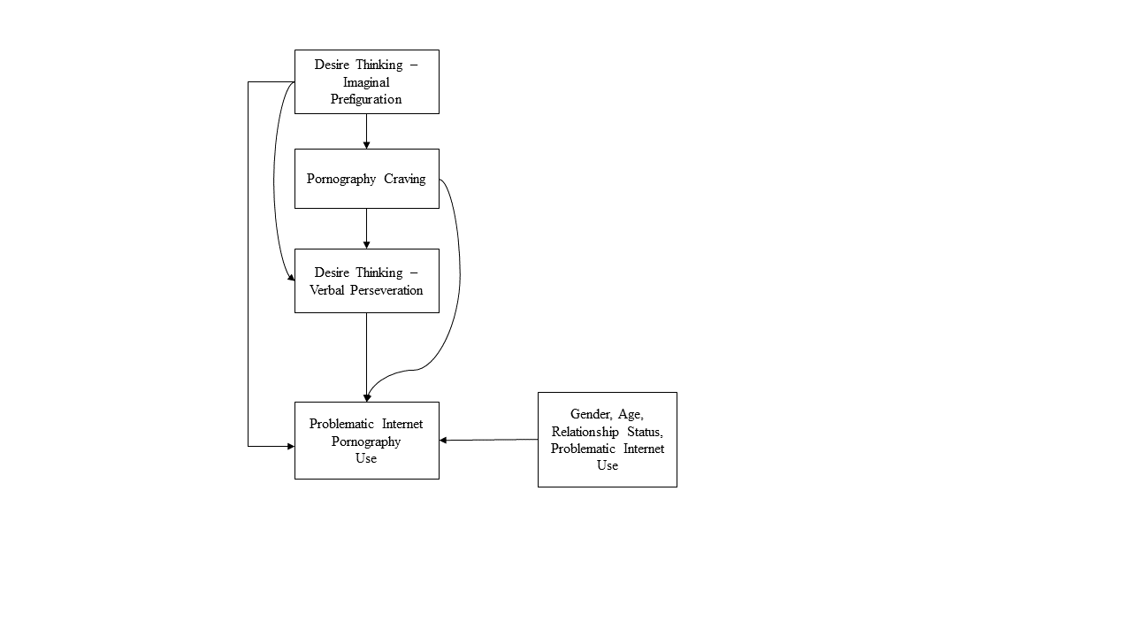

**Figure 2**

*Model of the Inter-Relationships between the Study Variables (Whole Sample)*

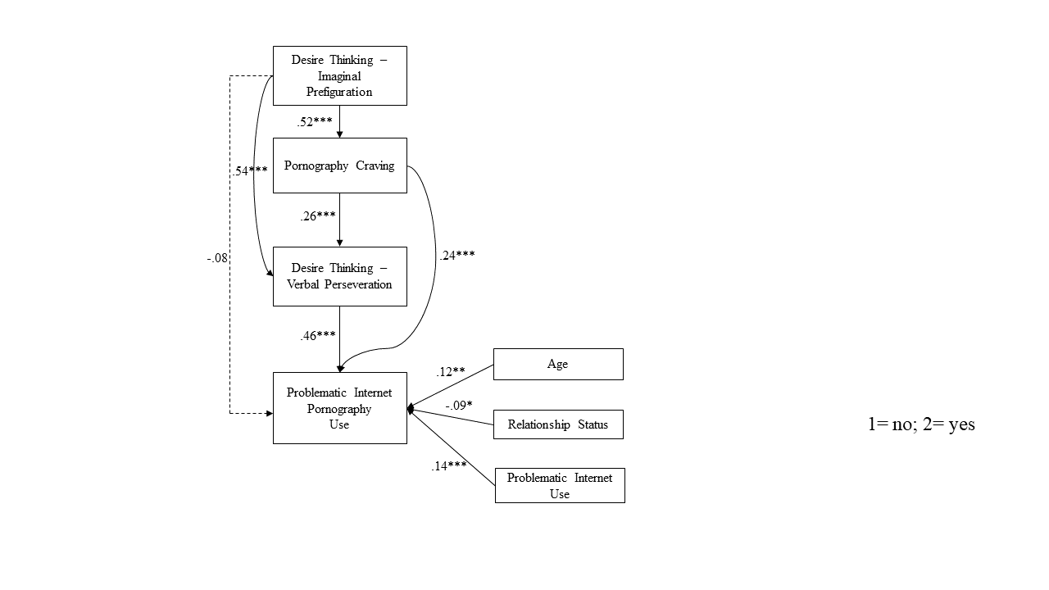

*Note.* *N* = 414; Relationship Status: 1= Not in a relationship; 2= In a relationship; \**p* < .05; \*\**p* < .01; \*\*\* *p* <.001.

**Figure 3**

*Tested Model through Multi-Group Analysis in Gender Groups (Women vs. Men)*

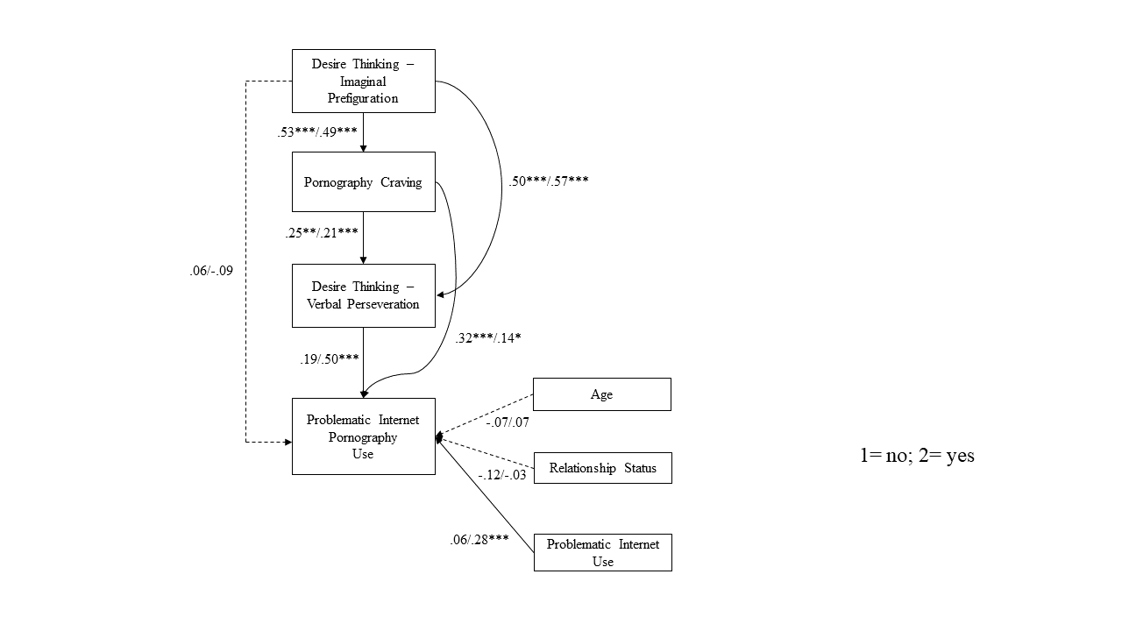

*Note. N* = 414 (*N* = 192 women; *N* = 222 men); Relationship Status: 1= Not in a relationship; 2= In a relationship; \**p* < .05; \*\**p* < .01; \*\*\* *p* <.001.

**APPENDIX A**

*Second Model of the Inter-Relationships between the Study Variables (Whole Sample)*

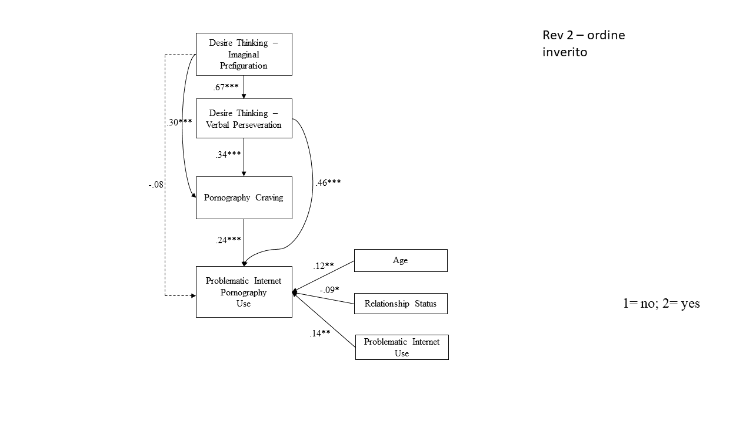

*Note.* *N* = 414; Relationship Status: 1= Not in a relationship; 2= In a relationship; \**p* < .05; \*\**p* < .01; \*\*\* *p* <.001. R2 (Desire Thinking – Verbal Perseveration) = .55; R2 (Pornography Craving) = .36; R2 (Problematic Internet Pornography Use) = .38.

**APPENDIX B**

*Secon Tested Model through Multi-Group Analysis in Gender Groups (Women vs. Men)*

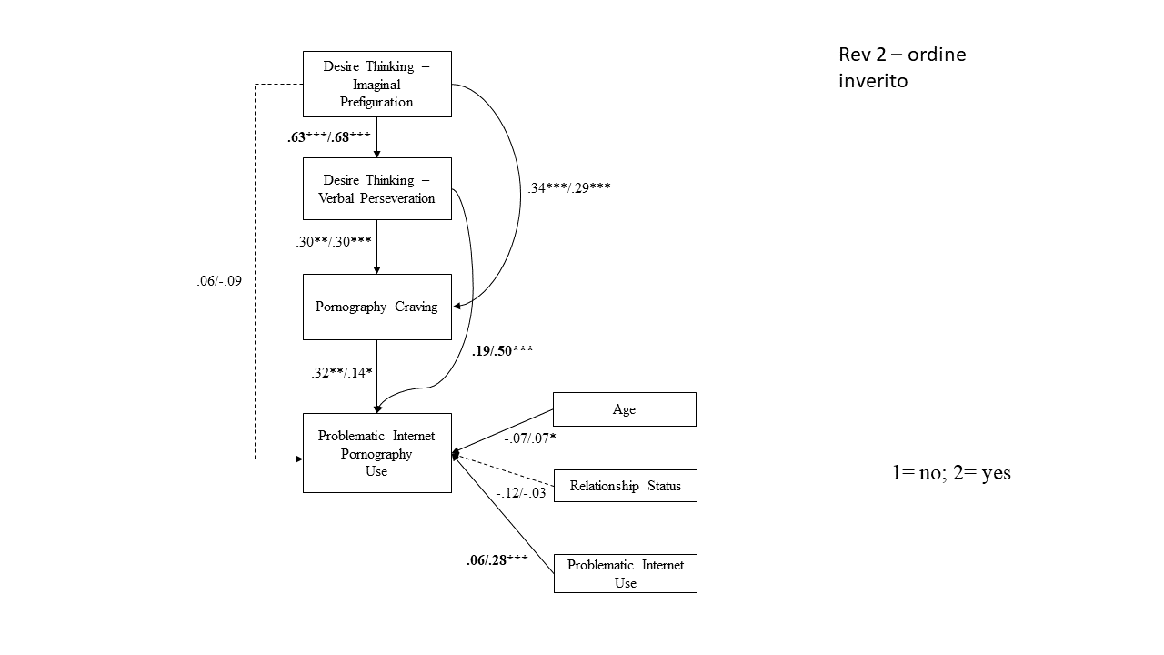

*Note. N* = 414 (*N* = 192 women; *N* = 222 men); Relationship Status: 1= Not in a relationship; 2= In a relationship; \**p* < .05; \*\**p* < .01; \*\*\* *p* <.001. Omnibus Wald 𝜒2(9) = 27.83, *p* = .001. Three paths (in bold) significantly differed between women and men: the path between DT-IP and DT-VP (Wald 𝜒2(1) = 5.11, *p* = .024); the path between DT-VP and problematic Internet pornography use (Wald 𝜒2(1) = 10.40, *p* = .001); the path between problematic Internet use and problematic Internet pornography use (which was not significant for women; Wald 𝜒2(1) = 9.60, *p* = .002). The other paths were comparable among women and men.

**APPENDIX C**

*Standardized Indirect Effects of the Independent (DT-IP) on the Outcome (Problematic Internet Pornography Use) via the Mediators (DT-VP and Pornography Craving)*

|  |  |  |  |  |  |  |  |  |  |  |  |
| --- | --- | --- | --- | --- | --- | --- | --- | --- | --- | --- | --- |
|  | Whole Sample (*N* = 414) | | | | Women (*N* = 192) | | | Men (*N* = 222) | | | |
| Path | Estimate | | 95% CI | | Estimate | 95% CI | | Estimate | | 95% CI | |
| DT-IP 🡪 DT-VP 🡪PC 🡪 PIPU | .054 | .031 | | .084 | .061 | .028 | .110 | .028 | .008 | | .063 |
| DT-IP 🡪PC 🡪 PIPU | .071 | .039 | | .115 | .107 | .043 | .207 | .040 | .012 | | .089 |
| DT-IP 🡪 DT-VP 🡪 PIPU | .306 | .232 | | .382 | .118 | .000 | .233 | .334 | .259 | | .467 |

*Note.* 95% CI = bias-corrected bootstrapped confidence interval; PIPU = Problematic Internet Pornography Use; DT-IP = Desire Thinking – Imaginal Prefiguration; DT-VP = Desire Thinking – Verbal Perseveration; PC = Pornography Craving.