Figure 4. Forest-plot for Knowledge Outcome Excluding High-Risk Studies

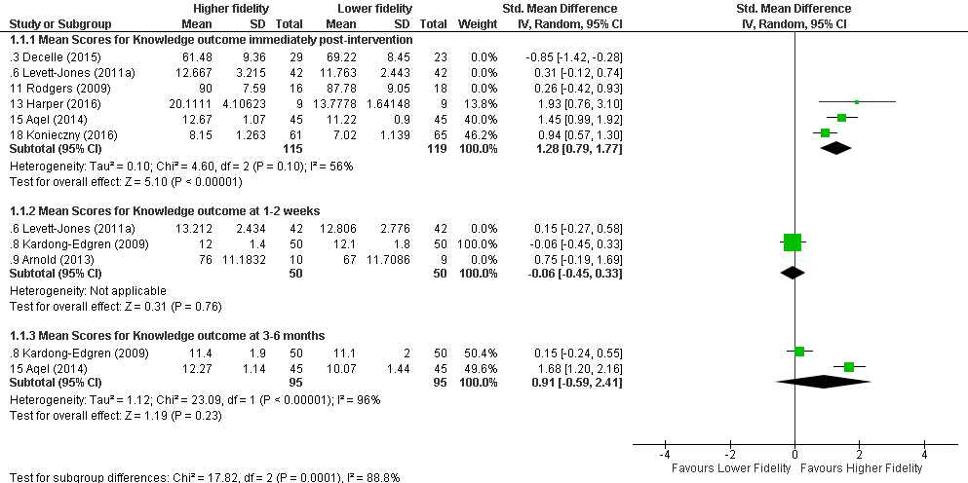

Statistical Package: Review Manager (RevMan-5.3).The Cochrane Collaboration (2014).

