

**Towards the Determination of Acoustic Characteristics of Ventilation Plastic Ducts in the Built Environment**

**Zekic, Suzana[1]**

**Imtech Engineering Services London & South**

**20 Kingston Road, Staines-upon-Thames, Middlesex TW18 4LG**

**Gomez-Agustina, Luis[2]**

**London South Bank University**

**103 Borough Rd, London SE1 0AA**

**ABSTRACT**

**In recent years there has seen a surge in the use of plastic ducts in residential ventilation systems as an alternative to galvanized sheet ducting. This is mainly owed to cost, installation and other practical benefits afforded by plastic ducts. However to date there is no information on the acoustic characteristics of this type of ducts to enable accurate prediction of duct borne noise levels received in residential and other noise sensitive indoor spaces. This lack of accurate information often leads practitioners to make crude estimations or base their calculations on galvanized ducting acoustic data. These approximations can result in over attenuated designs which use unnecessary silencers introducing additional cost, regenerated noise and inefficiency. Designs that result in under attenuated systems will require costly retrospective mitigation measures. The aim of the research is to determine the acoustic characteristics of plastic ducts and their connections mainly used in residential ventilation. The experimental scope will cover a wide range of duct physical features, fluid dynamic parameters and acoustical performance indicators. This papers presents the research design, literature review, the devised test methodologies and expected outputs**

**Keywords:** Plastic Duct, Galvanised duct, Silencer, Ventilation, Attenuation

**I-INCE Classification of Subject Number:** 26

Click here to check the I-INCE Classification

<http://i-ince.org/files/data/classification.pdf>

# INTRODUCTION

Ducts carry fluids (liquid and gases) and this transport can generate significant levels of noise. Ductwork systems also convey the noise generated from other elements where they are connected to and from areas they pass through. These sources of noise are an important consideration in internal building design (CIBSE, 2016 and ASHRAE, 2015).

Galvanised steel ducts have been employed in large range of industries and applications around the world for many years and are still the most widespread type of duct for ventilation purposes (see figure 1). Since plastic ducts became an alternative to galvanised ducts, they have been employed in a range of industrial applications. However their use in ventilation in the built environment (see figure 2) is relatively recent.

From the year 2002, changes were implemented in the UK building regulations to demand better thermal insulation performance and air-tightness in residential buildings in order to protect resource and the environment (Davies, 2013). These stricter requirements have partially caused the increase of use of mechanical ventilation systems in the residential sector. That increase is also due to the attempt by these systems to tackle other interrelated performance factors such as air pollution, external noise ingress, security concerns, seasonal temperature variability, air tightness and effective moisture removal.

Mechanical ventilation with heat recovery (MVHR) is generally used for the residential mechanical ventilation as it recovers heat energy from the extract air offering energy efficiency benefits.

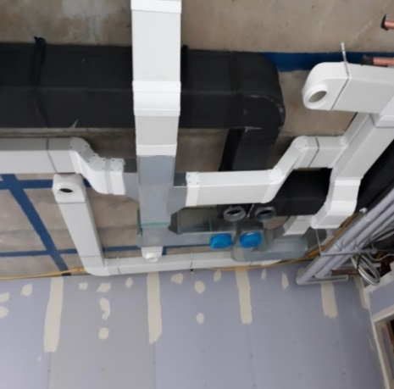

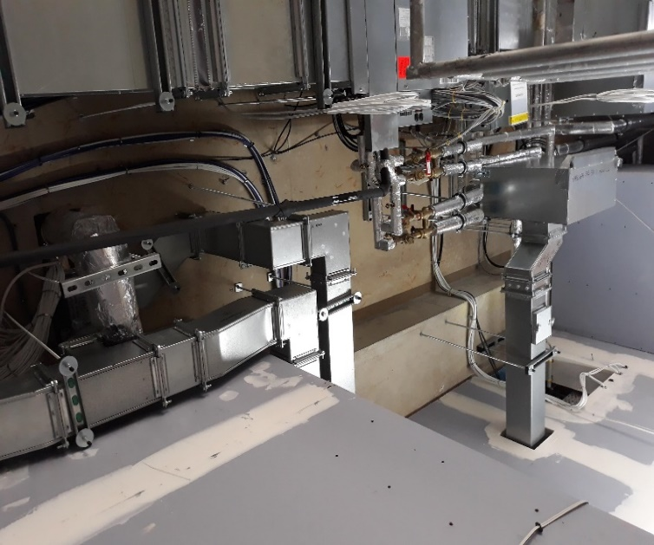

Figure2 Typical installation using plastic duct for the residential whole house ventilation

Figure1 Typical galvanised steel duct installation for the residential whole house ventilation

In recent years in the UK, Europe and the USA the type of duct used in residential MVHR installations has shifted from galvanised steel to plastic as plastic duct systems offer an increased ease of installation and lower costs for small duct profiles required for residential low ventilation flow rates. Plastic ductwork is employed in other applications such as industrial plants and distribution systems. It is speculated that the application of plastic ducts could follow the trend seen to date and begin to be used in other ventilation system in the built environment such as offices, galleries, exhibition centres, hospitals, gymnasia, educational buildings etc.

However, to date no research or information exists in the literature on the acoustic performance of plastic ducts of any size or application. This lack knowledge prevents the accurate prediction of duct borne and / or breakout noise emissions from supply and extract systems utilising plastic ductwork. Consequently, the prediction of the duct borne noise emissions calculated at the design stage, is performed either by using the acoustic properties data of galvanised steel ducts or by making crude allowances or estimates. These approaches can result in systems that are unnecessarily over attenuated, specifying needless silencers (see figure 3) which increase the costs, energy, flow resistance and overall inefficiency of the system.

The lack of relevant information, accurate data and reliable predictions can also lead to ventilation systems that require intrusive and costly retrospective mitigating measures to attempt to remedy unexpected high noise emissions at the end of the project.

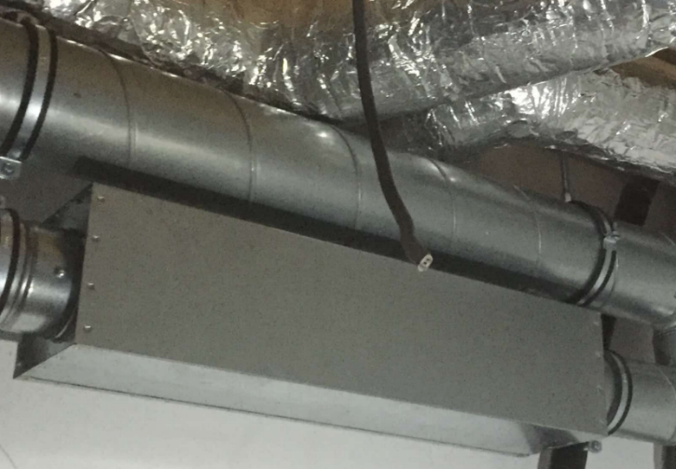

Figure 3 Galvanise steel silencer installed in residential ventilation system

Furthermore, spatial coordination with other trades in ever reducing building services zones could be improved with better knowledge of plastic duct acoustic behaviour that would enable most optimum duct sizes suitable for system.

The literature review also revealed a lack of suitable acoustic testing procedure for plastic ducts. Existing test procedures and data generated for galvanised ducting systems appears to be old, partially incomplete and unreliable.

From recent explorative communications and anecdotal evidence collected from the concerned industry in the UK it appeared that there is an overwhelming consensus of the need for knowledge and accurate data on the acoustic performance of plastic ducts.

This paper presents the formation stages and research design of the project recently commenced.

# RESEARCH AIM AND OBJECTIVES

The research project aims to determine the acoustic characteristics of plastic ducts and its ancillaries for the development of databases, prediction models and guidance in the design of practical ventilation installations.

The research is structured and organised to achieve the following research objectives:

1. Development of dedicated and suitable test procedures – through the initial literature review no specific acoustic testing procedure for plastic duct was found hence a new bespoke test procedure will need to be developed based on existing test procedures for galvanized steel duct work and silencer systems
2. Design and build of customized test rigs –for testing plastic ducts, ancillaries and installation configurations
3. Generation of experimental test data in laboratory and in situ settings for a comprehensive range of elements and installation configurations
4. Development of parametric databases for design and analytical purposes
5. Creation of prediction models – as a design tools tool to enable accurate prediction of the noise emissions for different installation configurations and applications.
6. Development of practical guidance for designing ventilation systems using plastic duct configurations

# RESEARCH SCOPE

In order to achieve the set aim and objectives for this project the overall works were evaluated and the following variables and factors were considered for inclusion in the scope:

**Geometrical / duct configuration**: Plastic ducts of different densities, materials, wall thicknesses and roughness, cross sectional profiles, cross-sectional areas and structural formations, straight duct sections, range of bends, junctions.

**Installation**: Different jointing and installation methods.

**Acoustic parameters**: Transmission loss per unit length, breakout, break-in noise emissions, and regenerative sound power levels.

**Flow dynamic and environmental parameters**: air flow rate, pressure loss, temperature, humidity.

**Additional**: Determination of low-frequency absorption, end reflection, the impact of fluid dynamic performance, as well as the effect of higher temperatures on the acoustic properties.

# LITERATURE REVIEW

An extensive literature review has been carried out. The review aimed to find information on the acoustic performance or characteristics of plastic ducts, acoustic design involving plastic ductwork, or relevant test methodologies suitable to the aim and objectives of this research.

**Plastic Duct Acoustic Properties**

The Chartered Institute of Building services Engineers (CIBSE), the leading authority in building services engineering in the UK, lists acoustic performance in the form of wide-ranging tables and graphs for only galvanised steel ductwork, with no mention of the plastic duct and its acoustic properties (CIBSE, 2016).

The American Society of Heating, Refrigeration and Air-Conditioning Engineers (ASHRAE) in their handbooks (ASHRAE, 2015, 2017) provide a range of information for sheet metal duct and its ancillary elements sound attenuation inclusive of unlined and lined variations, however plastic ducting is not mentioned and no acoustic data is provided.

Building Services Research & Information Association (BSRIA) published guidance on acoustic calculation of ventilation ducting systems (BSRIA, 2007). However only galvanised steel acoustic properties were tabulated without any inclusion or mention of plastic duct data

Building Engineering Services Association (BESA) in its plastic ductwork specification document (BESA, 2000) does not include any guidance nor information about the acoustic performance of the plastic duct.

Furthermore, plastic duct manufacturers’ published data was broadly reviewed (Nuaire, 2016, Vent-Axia 2017) however no acoustic data was featured in the review documents.

In publications by Fry (1988) and by Istvan and Beranek (2006), they provide general guidance for building services engineers on the acoustics of ventilation systems. However, these seminal works do not include any mention of the plastic duct acoustic properties.

In a review of the acoustic characteristics of galvanised steel ducts available from a range of sources; a lack of strong agreement was found among the published data (ASHRAE 2017, CIBSE 2016, Istvan and Beranek 2005, Fry 1985, Sharland 1972).

Brooks et al. (2003) recommend caution in using non-metal ducts explaining that with non-metal ducts, high in duct attenuation can be quoted by the manufacturers due to absorptive wall surfaces whereas no data for the break in or break out of the same profiles is made available.

In a thorough search in the literature, no investigations, design guidance or data on the acoustics of plastic ducts has been found.

**Acoustic Testing Methodology**

A review of test procedures used for obtaining acoustic data from galvanised steel ducts was undertaken.

The test guidance to determine sound attenuation of galvanised ducts is described by Fry (1985) and based on BS 4718: 1971 (later superseded by BS EN ISO 7235: 2003 and current 2009 version). Also ASTM E477 (1999) Standard Test Method for Measuring Acoustical and Airﬂow Performance of Duct Liner Materials and Prefabricated Silencers describes obtaining acoustic insertion losses, airflow generated noise and pressure drop as a function of airflow.

For the purpose of initial testing section BS EN ISO 7235: 2009 is considered as the most relevant and suitable dynamic method for testing plastic duct straight duct and duct ancillaries.

British Standard, BS EN ISO 11691: 2009 describes a static method for acoustic testing of silencers could also serve as a guidance and reference in the determination of a dedicated test procedure for plastic ducts and their configurations.

Nelson et al (1983) described methods of measuring the breakout/break-in noise levels of straight galvanised ducts.

In the second edition of Munjal’s publication on the subject of acoustics of ducts and muffles (2014), the theoretical and numerical assessment of the same are covered at length however with no mention of plastic ducts. Nevertheless these titles will be reviewed at greater lengths as reference for the creation of dedicated test procedures

Related research papers on duct acoustics contain some guidance on experimental/testing methods. Ukpoho and Oldham (1991) developed computational methods as well as experimental ones regarding regenerative noise levels inside ducts. Turner and Fairhall (1989) defined numerical methods for the prediction of branches attenuation. Istvan et al. (1983) undertook a numerical and empirical analysis of breakout noise from ducts. Although all these works were based only on galvanised steel ducts, they will provide an invaluable knowledge base from which developed dedicated test procedures and prediction models.

Mechel et al (1983) referring to EN ISO 7235 :2009 described a facility for testing ducted sound silencers under the influence of air flow. It should be noted that the testing facility described occupied over the 2000m3 with scaled up equipment and the test rig. The article can provide useful guidance for planning acoustic testing of plastic ducts, providing the test procedure remain applicable and reliable when scaled down.

In summary, the limited and old body of knowledge on determination of duct acoustics is based solely on galvanised steel ducts. However, the validity of that knowledge applied to plastic ducts remains unknown.

# METHODOLOGY

The methodology for this research project is fully quantitative. It will essentially make use of empirical and analytical techniques and tools. Documentary analysis will support empirical and analytical processes. The methodology involving the creation of dedicated test procedures and data presented in suitable formats, will be developed to satisfy requirements of quality and by reliability of industrial professional bodies. The overall approach will follow a sequential order of linked stages. The preliminary methods as applicable for each stage of the methodology are described below.

**Experimental testing**

Dedicated test methods suitable for plastic ducting element and systems, will be developed and validated. These new methods will be informed by the most relevant test procedures and guidance and research available for galvanised steel ducts and silencers.

Initially dedicated methods will be devised based on two current standardized guidance.

British Standard, BS EN ISO 7235: 2009 identifies methods of obtaining insertion losses for ducted silencers and air terminal units in the laboratory environment with airflow, also called dynamic method incorporating noise and air flow with a calibrated supply fan source. A supply fan delivering high air volumes generating a range of in duct air velocities as a sound source, will be used when obtaining regenerative sound power levels for straight duct and all types of bends.

British Standard, BS EN ISO 11691: 2009 provides test procedures to measure the insertion loss of ducted silencers and other duct elements without flow as a laboratory survey method for static approach using a loudspeaker as a controllable sound source.

Through testing the following acoustic parameters will be determined as a function of air flow volumes, velocities and pressure losses:

* + - Attenuation per unit length (transmission losses)
    - Noise breakout emissions per unit length
    - Noise break in admissions per unit length
    - Noise breakout, break-in and attenuation for different ancillary items as noted below.
    - Regenerative sound power levels for all of the above

Tests of all of the above will be carried out using different duct jointing methods as well as utilizing different fixing/installation arrangement.

Variables to be consider will include different geometrical and duct configuration such as:

* + - plastic ducts of different densities
    - different materials
    - different wall thicknesses and roughness
    - different cross sectional profiles, cross-sectional areas and structural formations,
    - straight duct sections
    - range of bends: 900 degrees, 450degrees and junctions.

Furthermore, assessment and the effect of different jointing and installation techniques to the noise emission will be also investigated

Lastly, it is proposed to determine low-frequency absorption and the impact of fluid dynamic performance, as well as the effect of higher temperatures on the acoustic properties of the plastic duct and its ancillaries.

Sound intensity determination will be explored as a potential novel method to develop dedicated more suitable and efficient test techniques.

Due to a wide range of the data to be collected, a series of test rigs and setups will be required to be devised to support the creation of the dedicated tests methods.

**Data analysis and data collation**

Large quantity of data will be cross analyzed using spread sheets and other analytical tools. Parametric tables, charts and graphs will be produced to document validated performance data.

**Production of prediction models**

Based on the data collated and the comprehensive analysis, multi variant prediction models will be created making use of spread sheets and other analytical software tools. Prediction models will be validated and aimed to be highly practical and useful tools in the design of real world projects.

**Production of the design guide**

The findings and knowledge generated from the previous outputs will be collated to produce a practical guidance for the design of ventilation systems using plastic ducts components. Documentary analysis from relevant and specific industrial information will further inform the production of the guidelines. Guidance and prediction tools will be presented in digital, online and highly accessible format aligned with stringent industry requirements.

# EXPECTED IMPACT AND SIGNIFICANCE OF THE RESEARCH

A wide range of positive impact and benefits are expected from the research outputs:

**Increased project accuracy and reliability**– The design of ventilation systems incorporating plastic ducting will be undertaken with greater accuracy and certainty, known allowing for early and accurate project cost and elimination of risks.

**Energy efficiency** - the accurate prediction of the noise emissions will prevent the unnecessary application of the noise control measures (e.g. silencers) avoiding system resistance and maintaining good energy efficiency of the system. Following on, from the more accurate ventilation design, the selection of the fans will be more suitable utilising better operating characteristics adding to energy efficiency concept.



**Purge and overheating** –The noise generated from purge ventilation and overheating removal systems in dwellings could be dealt satisfactorily with the existing whole house ventilation system, once detailed understanding of acoustic performance of the plastic ducts is obtained. It is speculated that plastic duct could handle higher air volumes without decrementing acoustic performance. Understanding about breakout/ break-in and regenerative sound power levels associated with high air volumes, will help to determine whole house ventilation scheme and the plastic duct system suitability for purge and overheating.

**Improved design practice** – effective design guidance, will ensure optimum use of plastic ducting whilst meeting specified ventilation performance and acoustic criteria.



**Future trends** – better understanding of acoustic properties of plastic ducts will enable the expansion of their utilisation (in place of galvanised steel) beyond small scale ventilation applications.



**Duct sizes and shapes** – from the gained understanding of the duct’s geometrical impact on regenerative noise, design of the duct will be reviewed and optimised, for space reduced material and installation costs.

# CONCLUSION

This paper presents a project which aims to obtain the acoustic properties of plastic ducts as used in ventilation systems. A comprehensive literature review was carried and confirmed that to date there is no research studies, industrial information or data on the acoustic performance of plastic ducts or on the testing of the same.

It was ascertained that the most applicable testing methodology for the objectives of this project relates to performance testing described in standards for galvanised steel silencers. However this test guidance has been found to not be fully suitable and reliable and for the stringent and specific purposes of this project.

This project will allow the prediction of the noise emissions from ventilation plastic ducts to be accurate and reliable giving way for future expansion for larger plastic duct installations.

# REFERENCES

ASHRAE (2017) *ASHRAE Handbook Fundamentals.* Atlanta. ASHRAE.

ASHRAE (2015) *ASHRAE Handbook* *HVAC Applications.* Atlanta. ASHRAE.

ASTM (1999) Standard Test Method for Measuring Acoustical and Airﬂow Performance of Duct Liner Materials and Prefabricated Silencers. West Conshohocken

BESA (2000) DW154 *Specification for Plastic Ductwork.* Penrith. BESA Publications.

Biggs, C. (2018) *RE: Plastic Ducting tests*. Personal e-mail to S. Zekic, 23 March.

Biggs, C. (2018) *RE: Plastic Duct technical information*. Personal e-mail to S. Zekic, 7January.

British Standard Institution (2009) *BS EN ISO 7235: 2009 Acoustics —Laboratory measurement procedures for ducted silencers and air-terminal units — Insertion loss, flow noise and total pressure loss.* London: BSI.



British Standard Institution (2009) *BS EN ISO 11691: 2009 Acoustics — Measurement of insertion loss of ducted silencers without flow — Laboratory survey method.* London: BSI.



Brooks, P.J., Iacouzze, G.L., Talbott, T.A., (2003) *Duct System Design Guide*. Ohio: McGill AirFlow Corporation.

BSRIA (2007) *Guide to HVAC Building Services Calculations*, Bracknell, ImageData Group.

Butt, J. (2017) *RE: Acoustic testing of the plastic duct*. Personal e-mail to S. Zekic, 13 June.

CIBSE (2016) *CIBSE Guide B4* *Noise and vibration control for building services system.* Norwich, CIBSE.

Davies, H. (2013) Tracing the continuing development of Part L, Modern Building Services, 9 (11) pp. [Online] Available from: MODBS. <http://www.modbs.co.uk/news/fullstory.php/aid/12062/Tracing_the_continuing_development_of_Part_L.html> [Accessed 25 February 2019]

Fry, A. (1988) *Noise Control in Building Services*. Oxford: Pergamon.

Istvan, L.V., Beranek, B. (1983) Definition of and relationship between breakout and break-in sound transmission loss of pipes and ducts. In: *INTER-NOISE and NOISE-CON Congress and Conference Proceedings, InterNoise83*, Edinburgh Scotland, July 1983.

Istvan, L.V., Beranek, B. (2006) *Noise and Vibration Control Engineering* 2nd Edition, New Jersey: Wiley.

Mechel, F.B. et al. (1983) A new facility for testing ducted sound attenuators. In: *INTER-NOISE and NOISE-CON Congress and Conference Proceedings, InterNoise83*, Edinburgh Scotland, July 1983

Munjal, M.L. (1987) *Acoustics of Ducts and Mufflers*, Canada. John Wiley & Sons Ltd

Mylona, A. (2018) *Re: CIBSE Guide B4 (2016) Imtech comments*. Personal e-mail to: S. Zekic, 22 October.

Nelson, P. A. et al. (1983) The measurement of “Breakout” and “Break-in” transmission loss of rectangular duct. In: *INTER-NOISE and NOISE-CON Congress and Conference Proceedings, InterNoise83*, Edinburgh Scotland, July 1983

Nuaire, 2016, Ductmaster, *Ducting and Ancillaries.*

Sharland, T. (1972) *Flakt Woods Practical Guide to Noise Control.* Colchester: Flakt Woods Ltd.

Turner, M. Fairhall, D. (1989) *The Division of Sound power at duct branches*, IOA.

Ukpoho, A. U., Oldham, D.J. (1991) *Regenerated Noise Levels due to closely spaced Duct Elements*, PIOA.

Vent Axia (2017) *Specification Range*, 11th Edition, Vent Axia.

1. suzana.zekic@imtech.co.uk
2. gomezagl@lsbu.ac.uk