SOUND EXPOSURE OF STAFF AT A CONSERVATORIE

S Dance Acoustics Group, London South Bank University, UK
D Shearer Acoustics Group, London South Bank University, UK
G Zepidou AECOM, London, UK

INTRODUCTION
The Acoustics Group has collaborated with the Royal Academy of Music since the enforcement of the Control of Noise at Work Regulations in 2008 [1]. Now, the research has turned towards sound exposure of the staff. Sound monitoring in the form of dosimetry was undertaken during practice, rehearsal and performance for eleven members of staff covering seven disciplines: conducting, piano, strings, vocal, jazz, percussion, and brass. In addition, the auditions were measured for the first time to establish a baseline for sound exposure. The paper presents an analysis of the dataset to assess compliance with the regulations, an average daily level of 85 dBA and a peak of 135 dBC.

DOSIMETRY
Dosimetry was undertaken over the autumn term of 2019/2020. Based on the knowledge gained from previous sound monitoring of music students eleven individuals were identified as potentially at risk from high sound exposure due to music[2,3]. The ten classes identified were operatic conducting, orchestral conducting, trumpet, trombone, horn, violin, piano, jazz, percussion and vocal. In addition auditions for bass trombone and tenor trombone were measured.

Instrumentation
Audio³ Sound badges were used to take the measurements as they were specifically designed to be small, light in weight and discreet whilst meeting IEC 61252 standard for personal sound exposure monitoring equipment [4]. Badges were positioned on the shoulder of the musician. In addition Norsonic Nor140 Class 1 sound level meters were used to measure in room sound levels. The equipment was calibrated using a Nor1251 Class 1 calibrator for the Norsonic meter, 114 dB at 1 kHz, and a Rion NC74 class 1 calibrator was used for the Sound badges, 94 dB at 1 kHz. The instrumentations were set to measure the following acoustic parameters: LAeq,T, LAmax, Lc_{Peak} and Noise Dose.

Music Classes
Music classes were measured over two days: 19-20th November 2019, with results as shown in Table 1.

Table 1: Sound exposure of Music Professors during classes
Measurement | Dur(H:M:S) | L_{Aeq} | Peak | Dose %
Trumpet | 01:00:00 | 95.9 | 121.2 | 155.1
Trombone | 02:00:00 | 96.6 | 122.2 | 364.7
Violin | 03:00:00 | 90.3 | 103.3 | 127.6
Piano | 04:12:27 | 84.8 | 113.6 | 50.7
Jazz/Big Band | 02:55:57 | 90.9 | 120.1 | 142.5
Soprano | 03:00:00 | 100.8 | 102.6 | 1443.6
Percussion | 02:00:00 | 94.4 | 132.2 | 219.4
Horn | 02:30:00 | 90 | 120.6 | 99.2
It can be clearly seen from Table 1 that peak levels were well within the allowed limits. However, in every case, except piano, the sound exposure levels were in excessive of the allowed limits.

Activities varied in length from 1 hour to more than 4 hours in the case of the piano class. The result that stands out is the vocal class for the sopranos which resulted in 1443.6% sound dose over 3 hours.

Ensembles
Three ensembles were monitored to establish the sound exposure of conductors: a dress rehearsal of the Magic Flute; an orchestral repertoire session in a concert hall; and a symphonic wind rehearsal of Mozart in the same concert hall.

Magic Flute Rehearsal
On the 12th November 2019 the final dress rehearsal of Mozart’s Magic Flute was monitored. Two meters and two badges were used. The meters were positioned at the rear of the pit and another next to the conductor. The badges were worn by the bassoonist and the horn player, see Figure 1. The opera was performed in two halves: 63 minutes and 70 minute halves, a total of 2 hours and 13 minutes. Table 2 shows the measured levels, no peak measurements were taken.

Table 2: Magic Flute Sound Dose
 | L_{Aeq} | L_{Amax} | Dose%
Pit Rear Corner (Meter) | 84.4 | 107.0 | 24.0%
Conductor (Meter) | 81.1 | 101.7 | 11.1%
Bassoon (Badge) | 93.4 | 111.6 | 192.4%
Horn (Badge) | 91.8 | 124.0 | 132.9%

The results show that the meters measured lower levels than the badges, but the meters are consistent with the rear meter recording a 3 dB higher level than for the conductor, see Table 2.

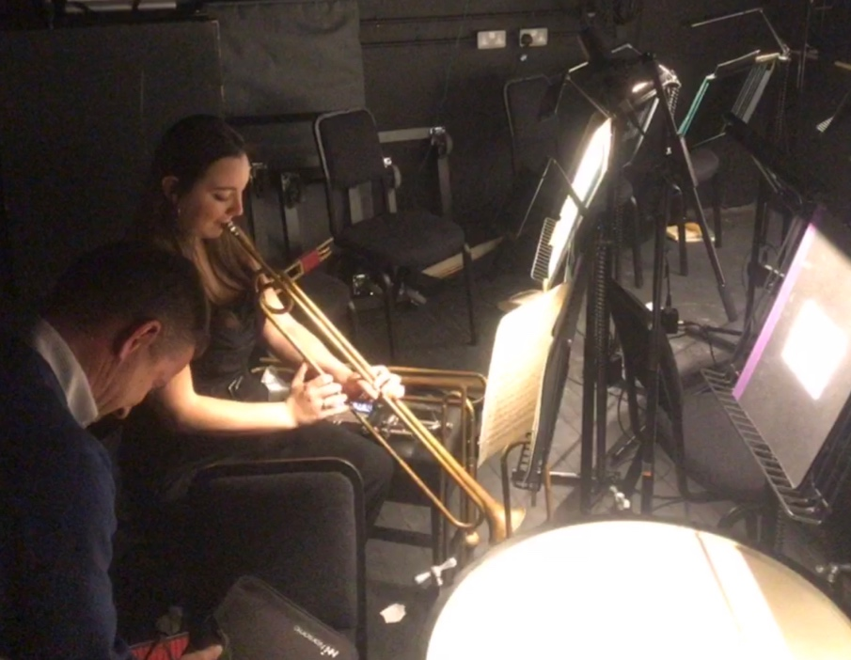
Figure 1: Setting up SoundBadges in the Sainsbury Theatre orchestra pit

The conductor’s reading was well within the allowed limits. The musicians recorded marginally higher levels than allowed; the limit value is equivalent to a 159% sound dose, equivalent to 87 dBA at the ear. The horn player had the highest maximum value 124 dBA but in the performance played very little. Neither musicians nor the conductor wore hearing protection.

Orchestral Repertoire Session
An orchestra repertoire session was measured on 20th November 2019 in a concert hall. The session lasted 2 hours with another hour of discussion about the music and the rehearsal, see Table 3. The SoundBadge was worn by the conductor and the sound meter positioned near to the conductor.

Table 3: Orchestra Repertoire: Ravel in a Concert Hall
Measurement | Dur(H:M:S) | L_{Aeq} | Peak | Dose %
Conductor (Badge) | 03:00:00 | 84.7 | 123.5 | 35.0
Near Conductor (Meter) | 02:00:00 | 81.8 | 113.3 | 11.9

It can be clearly seen from Table 3 that the peak levels were well within the regulated limits. The sound dose was found to be well below the allowed limit at 35% on the conductor and 11.9% near to the conductor. What is interesting is that it appears in the discussion part of the session, the last hour, the conductor contributed significantly to the dose level recorded, probably due to his own raised voice when talking to the orchestra.

Symphonic Wind Rehearsal
On the evening of the 20th November 2020 a symphonic wind rehearsal was measured in a concert hall setting, see Table 4. The conductor and the flutist were badged and measured were taken over 3 hours, which included a 15 minute break between Weill and Mozart rehearsals.

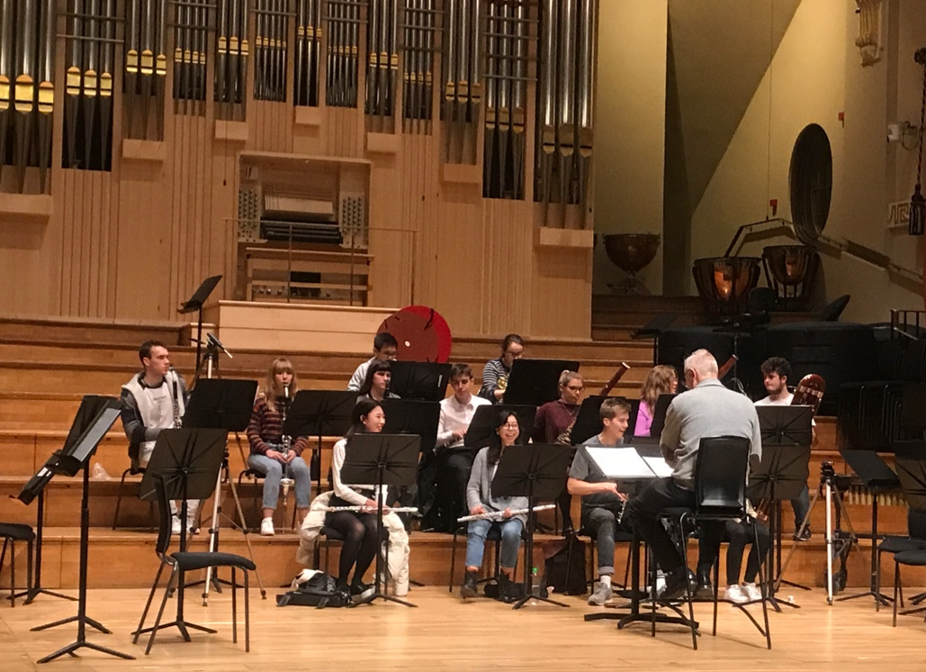
Figure 2: Wind rehearsal in Dukes Hall
In addition areas of the stage were measured using sound meters including Percussion, Timpani, Woodwind, and Horn sections plus the rear of the hall.

Table 4: Symphonic Wind Rehearsal in a Concert Hall
Measurement | Dur(H:M:S) | L_{Aeq} | L_{CPeak} | Dose %
Conductor (Badge) | 02:45:00 | 84.1 | 123.6 | 27.9
Flute/Piccolo (Badge) | 02:45:00 | 98.9 | 127.9 | 853.1
Percussion (Meter) | 02:47:19 | 84.1 | 118.4 | 28.3
Hall- back right 15m (Meter) | 02:47:00 | 73.8 | 104.5 | 2.6
Timpani (Part 1 - Weill) Meter | 01:45:00 | 79.5 | 122.8 | 6.1
Clarinets/Flutes (Part 1 - Weill) Meter | 01:44:00 | 82.8 | 120.2 | 13
Horns (Part 2 - Mozart) Meter | 01:00:00 | 82.8 | 110.6 | 7.5
Basset Horns (Part 2 - Mozart) Meter | 01:00:00 | 83.7 | 111.5 | 9.3

It can be seen from Table 4 that the sound meter of the various areas of the stage was well within the allowable limits for both sound exposure and peak levels. The level in the audience was particularly low, LAeq of 73.8 dB over the 2 hours and 47 minutes of the rehearsal and even the percussion was an average of 84.8 dBA. However, when the badge results are considered the conductor measured at 84.1 dBA on average, a sound dose of 27.9%. Although, the flutist had a sound dose of 853.1% due to an average sound level of 98.9 dBA. This indicates that piccolo playing is dangerously loud.

2.4 Auditions

For the first time auditions were measured for trombone candidates to the conservatoire. On the 26th November 2020 in a small rehearsal room trombone auditions were held: 14 in the morning and 12 after lunch. One member of staff was present for all auditions and wore a SoundBadge, two other music professors were also present, alternating their attendance. All members of staff used hearing protection during the 15 minute assessments. Only the afternoon session was monitored using two sound meters in the audition room and the warm-up room, see Table 5.

Table 5: Audition sound exposure for Trombone players
Measurement | Audition Meter L_{Aeq} | Audition Meter L_{peak} | Warm Up Meter L_{Aeq} | Warm Up Meter L_{peak}
002 – 1345 Bass Tr | 88.3 | 111.3 | 91.0 | 116.3
003 – 1400 Bass Tr | 87.5 | 111.4 | 90.4 | 118.9
004 – 1415 Bass Tr | 85.8 | 109.4 | 87.0 | 116.8
005 – 1430 Bass Tr | 85.7 | 110.2 | 80.7 | 110.9
006 – 1445 Bass Tr | 85.8 | 110.1 | 78.4 | 114.4
007 – 1500 Bass Tr | 84.7 | 110.0 | 94.9 | 119.3
008 – 1515 Tenor Tr | 87.7 | 110.3 | 93.8 | 119.8
009 – 1530 Tenor Tr | 88.8 | 113.1 | 96.9 | 125.1
010 – 1545 Tenor Tr | 90.0 | 112.3 | 50.2 | 94.3
011 – 1600 Tenor Tr | 81.3 | 111.5 | 88.8 | 118.2
012 – 1615 Tenor Tr | 88.2 | 110.0 | 87.3 | 119.2
013 – 1630 Tenor Tr | 90.3 | 112.7 | 80.6 | 103.3
Trombone Total: | 87.0 | 113.1 | 84.9 | 125.1

The Music Professor was measured over a 3 hours and 10-minute period recording an LAeq of 93.4 dBA, a sound dose of 275.7%. It should be remembered that this was only for half a day, 12 auditions; hence the overall sound dose for the 26 auditions is estimated at 597%. Luckily hearing protection was worn as the professors as all reported feeling a little shell-shocked at the end of the day.

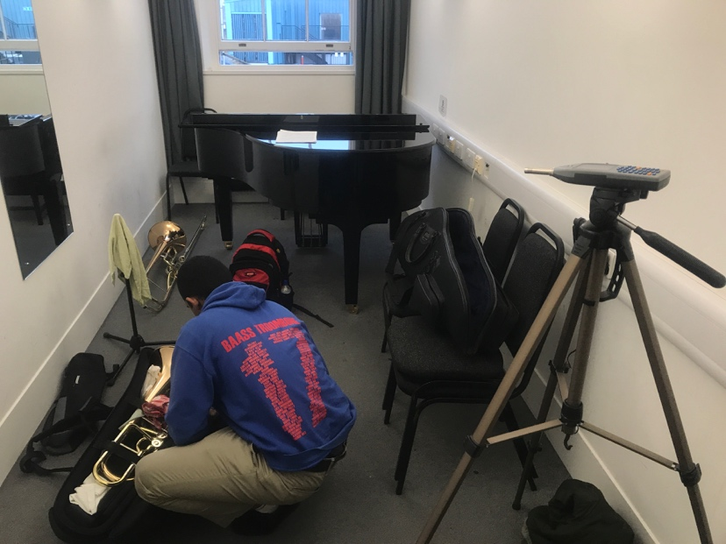
Figure 3: The warm-up room for audition sessions
The candidates could warm up in another room before their audition, hence a comparison between warm-up and audition can be made. It can be seen from Table 5 that overall the audition sound levels were higher than the warm-up, 87 dBA vs 84.9 dBA, respectively.

CONCLUSIONS
The results of the measurements of the sound exposure have clearly shown that nearly all instruments expose the music professor to too high sound levels. The exceptions are conductors, pianist and perhaps violinists. The worst cases were found for the flutists and the sopranos. Hence for these musicians suitable hearing protection needs to be found. It should be noted that at no time were the peak level limits reached, even for the percussionists.

Another finding was that the sound levels measured in the room for the trombone auditions were above the allowed limit, 87 dBA, higher than for the warm-up room, 84.9 dBA, although the total exposure per person was only 30 minutes so the sound exposure was well within the allowed limit. This indicates that candidates give their all during their audition and hence bombard the assessors. This was confirmed by the measured sound dose for the Music Professor, 297% in 3 hours, an estimated daily dose of 597%. However, hearing protection was worn at all times by the assessors.

Finally, measuring the sound level in the room appears to give a consistently lower level than the sound level measured on the shoulder, where the dosimeter was worn. This difference was found to be 6 dBA for the trombone auditions and 3 dBA for the conductor. This could be explained by the body reflection and the proximity of the microphone to the body increasing the sound pressure.

ACKNOWLEDGEMENTS
This work was partially funded by the EPRSC UK Acoustics Network (EP/R005001/1) and London South Bank University.

REFERENCES

- Health and Safety Executive, Control of Noise at Work Regulations 2005,
- S.Dance, D. Shearer, G.Zepidou, Face the Music: A 12 year study of the sound of performance and hearing of classical music students, Proc, International Congress on Acoustics, 2019 Aachen
- S. Dance, G. Zepidou, Sound Exposure of Choristers, Noise and Health, 21(98), 2020
- www.Audio-3.com. User manual [accessed 27-01-20]

