Semi-Automatic Quantification of Kidneys from 3D Ultrasound in Pediatric Hydronephrosis
Juan J. Cerrolaza, Enrico Grisan, Nabile Safdar, Craig A. Peters, Emmarie Myers, James Jago, and Marius George Linguraru
Abstract— This paper introduces a complete framework for the quantification of renal structures (parenchyma, and collecting system) in 3D ultrasound (US) images, a difficult and barely studied challenge. First, the segmentation of the kidney is performed using a variant of the popular active shape models, properly tailored to the imaging physics of US image data. The framework also includes a new graph-cut based method for the segmentation of the collecting system, including brightness and contrast normalization, and positional prior information. The significant advantage (p<0.05) of the new method over previous approaches in terms of segmentation accuracy has been successfully verified on clinical 3DUS data from pediatric cases with hydronephrosis. The promising results obtained in the estimation of the volumetric hydronephrosis index demonstrate the potential of our new framework to quantify anatomy in US and asses the severity of hydronephrosis.

INTRODUCTION
Ultrasound (US) imaging, with its non-irradiating properties, is the mainstay of imaging in pediatric urology. Renal US is one of the most common pediatric US studies, allowing quick, safe, and relatively inexpensive evaluation of the kidney and urinary tract. Recent work [1] has demonstrated the potential value of automated US imaging processing for the assessment of hydronephrosis (distention of the renal calyces and pelvis due to obstruction of the urinary tract; see Fig. 1), affecting 2-2.5% of children [2] in a wide spectrum of severity. In this context, an early diagnosis is very important in order to identify those critical kidneys that require surgery. However, the robustness of automated US based tools for diagnosing and treating hydronephrosis relies on the accurate parameterization and segmentation of kidney anatomy. Although the quality of US images has increased considerably in recent years, they still suffer from low signal-to-noise ratio, signal attenuation and dropout, and missing boundaries due to the orientation dependence of acquisition, making the detection of organs and object of interest particularly challenging. Although there is increasing interest in developing new segmentation methods for sonographic images [3] in other application areas like echocardiography or transrectal ultrasound, there is a dearth of literature discussing automated segmentation of renal structures in the image processing field [4,5,7], and most of the approaches reported focused on 2DUS [4].
Trying to reduce the subjectivity and variability in the computation of hydronephrosis index (HI) proposed by Saphiro et al. [6] (a quantitative measure of the hydronephrosis severity, defined as 100 × ($A_{P}$)/($A_{K}$), where $A_{P}$ and $A_{K}$ represent the total area of the renal parenchyma (P) and the entire kidney (K) including the dilated pelvis and/or calices, respectively), Mendoza et al. [7] presented one of the first approaches to segment both, the kidney and its collecting system (CS) from 2DUS images. However, the segmentation and thus the computation of HI can still be significantly affected by the selection of a single 2D sagittal US slice containing a longitudinal section of the kidney and its CS [12]. Thus, our aim is to improve the US-based evaluation of kidney diseases, such as hydronephrosis [1], by 3D kidney quantification in US.
In this paper, we present, to the best of our knowledge, the first complete framework for the quantification of renal structures (P and CS) in 3DUS, extending the previous work presented in [11]. To deal effectively with the particular challenges that arise when working with 3DUS renal images, the algorithm has been divided in two parts. First, the segmentation of the kidney is performed semi-automatically using the novel 3D kidney segmentation framework, recently proposed in [11]. In this work, we proposed a tailored variant of the classic Active Shape Models (ASM) [8], particularly weak in dealing with US images due to their highly variable appearance. To address this challenge, we previously proposed a new tailored approach to the imaging physics of US, which we name Gabor-based Appearance Models (GAM).
Once the kidney has been segmented using GAM, we use the hypoechoic nature of CS in hydronephrotic renal US to create a new graph-cut (GC) [9] based segmentation algorithm. This new approach presented here includes two main novelties to address the challenges of segmenting the CS from 3DUS images. The first one is an intensity normalization stage able to compensate for the specific brightness and contrast adjustment performed by the sonographer during the acquisition process. The second novelty is the use of positional priors into the GC framework. The inclusion of these new positional maps allows for a better location of the CS and its differentiation from other hypoechoic structures such as the renal pyramids (see Fig. 1(b)).
Finally, the new renal-segmentation framework is tested on a set of 3DUS pediatric kidneys from patients diagnosed with hydronephrosis of varying severity.
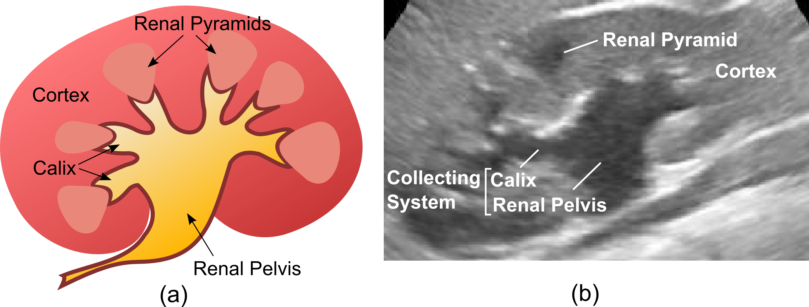
Figure.1. Imaging the kidney. (a) Anatomy of the kidney. (b) US longitudinal view of a hydronephrotic right kidney and identification of relevant anatomical structures.

Methodology

A. Kidney Segmentation via GAM
On the way to the segmentation of the renal system, the segmentation of the kidney is obtained first by means of the novel framework recently presented by Cerrolaza et al. [11]. Inspired on the well-known ASM algorithm [8], the method was tailored to deal with the specific challenges raised by the segmentation of US images. First, weights were defined for each landmark based on the position relative to the center of the US probe to allow to compensate for the image dependency on the propagation direction of the US wavefront. Second, a Gabor filter bank was used to create a new US-based appearance model at different scales. This multiscale characteristic was incorporated into the segmentation algorithm to create a hierarchical approach, where different image features were considered at different deformation stages of the process. The reader is referred to [11] for a detailed description of the method.

B. Collecting System Segmentation
Once the kidney has been segmented, we propose a GC-based formulation for the segmentation of the CS. Despite the fact that CS can be partially identified thanks to its hypoechoic nature in hydronephrotic renal US, its segmentation is particularly challenging due to undefined shape, blurred boundaries, and heterogeneous structures of different shapes and intensities inside the kidney (i.e., the renal pyramids in very young children), which can confuse even the experienced eye (see Fig. 1(b)). Furthermore, the intensity inhomogeneity between cases, caused by the specific brightness and contrast adjustment performed by the sonographer during the acquisition process, is especially relevant in the context of histogram-based approaches like GC, where an accurate representation of “object” (i.e., CS) and “background” intensity distributions is essential.
Our approach includes two major novelties to deal with the aforementioned drawbacks. First, a new intensity normalization stage based on the estimation of the decompression parameters of the US signal allows normalization of the intensity histograms of the 3DUS images. Second, a new specific positional map is incorporated to identify those regions that are more likely to belong to the CS based on their anatomical location.
In GC, an image, $I$, is segmented by means of the optimization of the cost function
$E\left(A\right)= \sum_{p∈I}{R_{p}\left(A_{p}\right)+ λ\sum_{\{p,q\}∈N}{B_{p,q}∙δ_{A_{p}≠A_{q}}}}$ 
where where $A$ is a labeling vector specifying assignments, either “object” or “background”, to voxels $p$ in $I$; the coefficient λ ≥ 0 specifies the relative importance of the voxel-wise regional term $R(A)$ versus the boundary term $B(A)$, given the neighborhood system represented by $N$. Typically, the regional term $R_{p}(∙)$ reflects the probability that voxel $p$ belongs to the “object” or “background” region based on intensity distribution models previously estimated from a set of training images. Thus, the intensity inhomogeneity between cases is US data is particularly relevant.

Probability Density Normalization. Unlike the simplified model proposed by Mendoza et al. [7], where only a constant brightness bias effect was considered, a more general approach is adopted here. In particular, we propose to improve the robustness and accuracy of the intensity-based probability models in (1) by estimating not only the specific brightness, but also the contrast adjustments of each image. Typically, the original radio frequency (RF) signal captured by the US probe, $I_{RF}$, is compressed to improve the visualization of the US B-mode image,$I$. A common model for the typical log-compression law used in the literature is
$I=a \log\left(I_{RF}\right)+b$ (2)
where $a$ and $b$ represent the unknown contrast and brightness adjustments respectively. Assuming a Rayleigh distribution for the original $I_{RF}$, Seabra and Sanches [10] proposed a sliding-window based approach to revert the log-compression law in (2). Considering the parameters $a$ and $b$ as constants inside a small sliding-window of the image, $s_{k}$, $\hat{a}$ and $\hat{b}$ are estimated by averaging the observed ${\hat{a}}_{k}$ and ${\hat{b}}_{k}$ within these regions (the reader is referred to [10] for further details on the calculation of ${\hat{a}}_{k}$ and ${\hat{b}}_{k}$). Once $\hat{a}$ and $\hat{b}$ are estimated, the image, and thus its intensity histogram, can be normalized as
$\overline{I}=\overline{a}(\left(I-\hat{b}\right)/\hat{a})+\overline{b}$, (3)
with $\overline{a}$ and $\overline{b}$ are normalization constants defined as the average of $\hat{a}$ and $\hat{b}$ through the entire image dataset. Once the contrast and brightness have been normalized for each of the images in the training set, we can estimate the probability density functions, $f_{t}^{r}$, that define the “object” (r: CS) and “background” (r: P) regional terms, $R_{p}\left(A_{p}\right)$, in (1). Suppose now ${\overline{I}}_{t}$ represents the new normalized test image (i.e., the image to segment). $f_{t}^{r}$ is estimated via Gaussian-kernel density estimation (GKDE) over the weighted set of the $M∈N$ closest images in the training set:
$f_{t}^{r}=G\text{KDE}\left({\left\{d_{j}∙{\overline{I}}_{j}^{i}\right\}}_{j=1,…,M}\right)$, (4)
where $\left\{{\overline{I}}_{j}^{r}\right\}$ is the set of normalized intensity samples in the region r from the j-th nearest image, and $d_{j}∈R^{+}$ is a constant that define the proximity to ${\overline{I}}_{t}$. Here, we define the proximity between ${\overline{I}}_{t}$ and the $k-th$ training case, ${\overline{I}}_{k}$, by means of the Bhattacharyya distance ($BD)$ between two intensity distributions $K_{t}$ and $K_{k}$
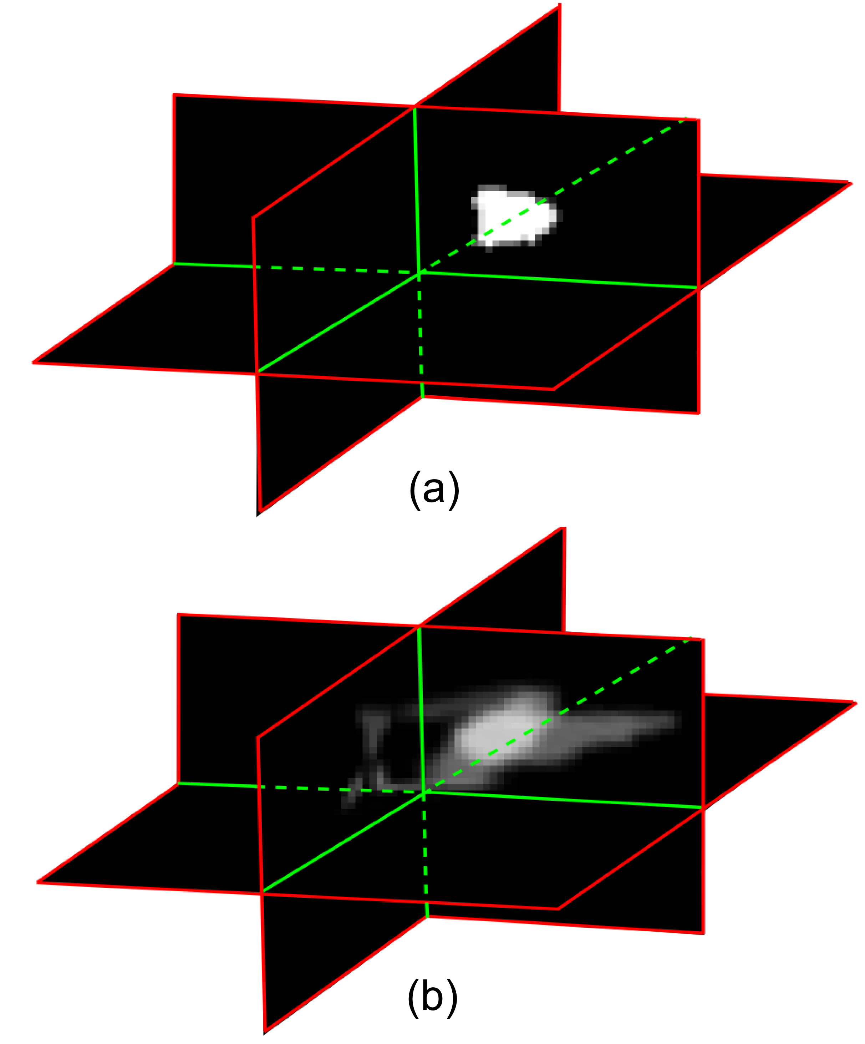

Figure. 2. Positional map example. (a) Binary mask of the CS manually segmented. (b) Probability positional map obtained using the M = 4 closest images (5).
${BD}_{t,k}= -\log{\int{\sqrt{K_{t}\left(x\right)K_{k}(x)}}dx}$  
In particular, $K_{t}$ and $K_{k}$ represent the intensity distribution inside the kidney. The Bhattacharyya distance measures the similarity of two continuous distributions, thus, the weights $d_{j}$ can be defined from the set of $M$ training images with higher $BD$ as $d_{j}={BD}_{j}/{BD}_{\left\{M\right\}}$, where ${BD}_{\left\{M\right\}}=\sum_{j=1,..,M}{{BD}_{j}}$.

Probability Positional Maps. Having selected the $M$ most similar cases to the test image, we use this set to create a specific positional model for CS and P in ${\overline{I}}_{t}$. These positional maps will help to differentiate the CS from other hypoechoic structures like the renal pyramids. Under the hypothesis that the spatial disposition of the CS in these $M$ cases is similar to the new target case, ${\overline{I}}_{t}$, both, the $CS$ (${\left\{{CS}_{j}\right\}}_{j=1,…,M}$), and $P$ (${\left\{P_{j}\right\}}_{j=1,…,M}$), are mapped into the segmented kidney region obtained from Section II.A. Thanks to the landmarks correspondence provided by the PDM built in section II.A, we can define an affine deformation field to obtain the mapped regions ${\hat{CS}}_{j}^{t}$, and ${\hat{P}}_{j}^{t}$. The probabilistic positional maps, $p_{t}^{r}$, are calculated via multivariate GKDE (MGKDE): $p_{t}^{CS}=MG\text{KDE}\left({\left\{d_{j}∙{\hat{CS}}_{j}^{t}\right\}}_{j=1,…,M}\right)$, and $p_{t}^{P}=MG\text{KDE}\left({\left\{d_{j}∙{\hat{P}}_{j}^{t}\right\}}_{j=1,…,M}\right)$. Fig. 2 shows the probability positional map obtained for a particular case.

Graph-Cut Based Segmentation. From the two probability density maps defined above, (i.e., intensity-based and positional-based probability maps) we propose the following definition of the regional term for a voxel $v$:$R_{p}\left(v\right)= f^{r}\left(v\right)+β_{GC}{ p}^{r}(v)$, where $β_{GC} ϵ R^{+}$ is a constant that balance the two terms. The intensity based boundary term between neighboring voxels, $v_{1}$ and $v_{2}$, is defined as
$B_{v_{1},v_{2}}=\text{exp}\left(-{\left(\overline{I}\left(v_{1}\right)-\overline{I}\left(v_{2}\right)\right)}^{2}/\left(2 {σ_{GC}}^{2}\right)\right)$   
where $σ_{GC} ϵ R^{+}$. Since CS is a single connected structure inside the kidney, we select the optimal candidate from the whole set of regions provided by the GC segmentation algorithm. In particular, we define CS as the region with maximum average probability of being CS.

Experimental Results
We validated our kidney struture segmentation method on a set of 8 3DUS pediatric right kidneys images diagnosed with hydronephrosis of varying severity. Image data were acquired from a Philips iU22 system with X6-1 xMATRIX Array transducer. The average volume size was $484 ×404 ×256$ voxels, and the resolution ranged from 0.15 mm to 0.82 mm. For each image, kidney and its CS were delineated manually by an expert radiologist to provide the ground truth. The method was evaluated using the leave-one-out cross-validation. Besides the 8 hydronephrotic cases, the statistical shape model was refined using an additional set of 11 healthy cases. The appearance model for each landmark was built from profiles normal to the surface of 21 voxels length, and the search space during the landmark updating process was set to 10 voxels on each side. The rest of the configuration parameters were determined empirically using an iterated grid search approach. In particular, the selected values were: $γ$ = 0.65; $λ=0.25$; $M=4$; $β_{GC}=2$; and $σ_{GC}=0.9$. The initialization of GAM requires minimal user intervention, selecting two point clicks to roughly define the major axis of the kidney.
Table 1 shows the segmentation error of both, K and CS, using the new approaches proposed here, GAM, and the tailored version of GC, TGC. We compared these results with those provided by the classical ASM and GC, respectively. It can be observed that GAM and TGC provide not only better average results, but also lower standard deviations than ASM for the three accuracy metrics studied: Dice’s coefficient (DC), average point-to-surface distance PSD, and the relative volume difference RVD. The improvements achieved by GAM and TGC in comparison with ASM and GC were statistically significant (p-value < 0.005), as assessed by means of a Wilcoxon paired signed non-parametric test. Unlike the kidney, where the final shape is controlled by the statistical shape model, the absence of a predefined anatomical structure makes the segmentation of the CS particularly challenging. Despite the hypoechoic nature of the CS, its segmentation is highly dependent to the quality of the US image, being particularly sensitive to the contrast between CS and P. To analyze the performance of the new TGC, the set of images was divided into two groups: images with high CS-P contrast (4 out of 8 cases), and images with low contrast, as assessed qualitatively. While the performance of both, TGC and GC, was similar for the first group (DC: 0.78 ± 0.11 vs. 0.74 ± 0.08), is in the low-contrast group where the new histogram normalization and the positional probability map are particularly relevant (DC: 0.50 ± 0.10 vs. 0.13 ± 0.14).
Finally, the potential utility of the new segmentation framework for the assessment of pediatric hydronephrosis was evaluated computing the volumetric HI (computed as percentage) for all the cases. The average error when using a classical ASM-GC approach was 32 ± 35 percentage points, while when using the new GAM-TGC framework was 2.5 ± 1 percentage points, a precise quantification of disease with significant improvement (p-value < 0.005) in diagnosis.

Conclusions

In this paper, we present a new framework for the segmentation of structures in 3DUS images. Inspired by the classical ASM algorithm, the new appearance model was tailored to the imaging physics of US image data. Our clinical application is the quantification of renal structures in cases with pediatric hydronephrosis. First, the segmentation of the kidney was obtained using a new orientation-based landmark weighting to compensate for the image dependency on the propagation direction of the US wavefront, and a multiscale Gabor appearance model. Having segmented the kidney its collecting system was delineated using a new GC-based approach that incorporates brightness and contrast normalization, and positional prior information. The results show significant improvements in the segmentation accuracy of both renal structures, especially in those US images particularly challenging with low image contrast. The promising results obtained in the estimation of the volumetric hydronephrosis index demonstrate the potential utility of the new proposed framework for the assessment of hydronephrosis among the pediatric population, where US imaging is the mainstay for early diagnosis. Moreover, our quantification method tailored to US images is general and can be applied to the segmentation of other organs and objects from challenging US data.

- Segmentation Error in Hydronephrotic Kidneys
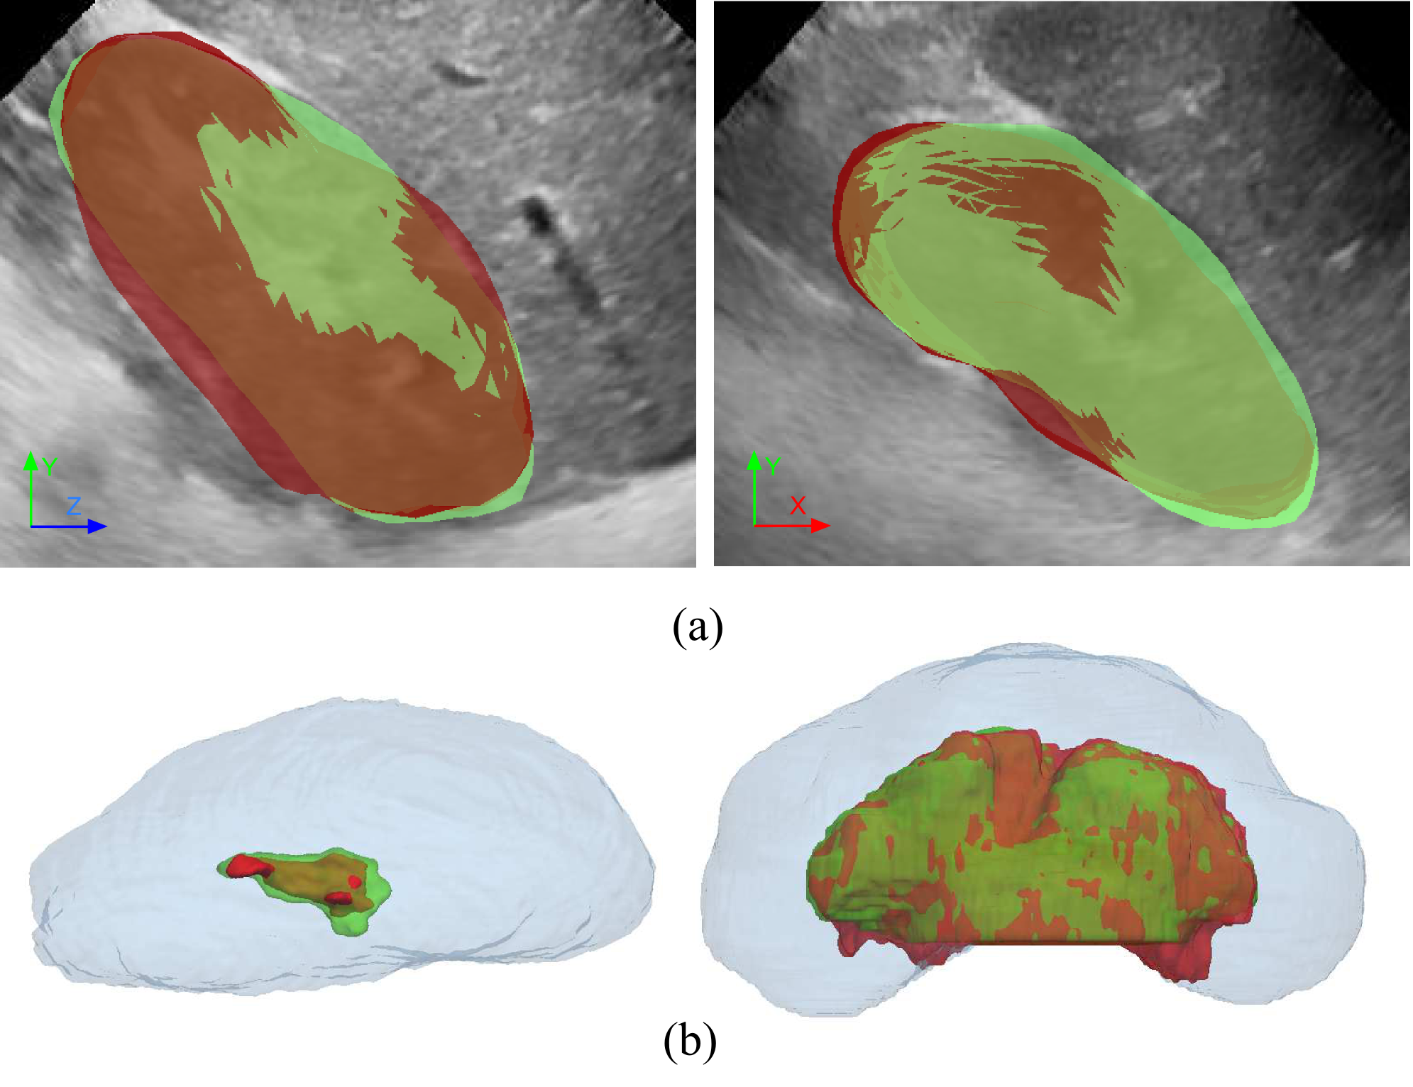
Figure. 3. Segmentation example. (a) Kidney segmentation using the new GAM. The ground truth is shown in green, while the obtained segmentation appears in red. (b) CS segmentation using the proposed TGC. The case on the left corresponds to a non-critical hydronephrotic case (HI = 99.1%; estimated HI = 99.4%). The case on the right illustrates a critical case (HI = 73.7%; estimated HI = 72.5%).
 | K-ASM | K-GAM | CS-GC | CS-TGC
DC | 0.78±0.08 | 0.86±0.04 | 0.44±0.34 | 0.62±0.19
PSD (mm) | 3.57±0.95 | 3.06±0.36 | 1.35±1.20 | 0.35±0.27
RVD | 0.07±0.05 | 0.03±0.02 | 0.45±0.33 | 0.26±0.20
Segmentation accuracy evaluation of ASM, GAM, GC, and TGC. The table present the average error and standard deviation for the Dice’s coefficient (DC), the point-to-surface distance (PSD), and the relaive volume difference (RVD).

Acknowledgment
This project was supported by a philanthropic gift from the Government of Abu Dhabi to Children’s National Health System.

References
- J.J. Cerrolaza, et al. “Ultrasound Based Computer-Aided-Diagnosis of Kidneys for Pediatric Hydronephrosis.” SPIE Medical Imaging (2014).
- M. Riccabona.”Obstructive diseases of the urinary tract in children” lessons from the last 15 years. Ped. Radiology. 40(6), 947-955 (2010).
- J. A. Noble, et al. “Ultrasound image segmentation: a survey.” IEEE Trans. on Med. Imag., 25(8), 987-1009 (2006)
- J. Xie, et al. “Segmentation of kidney from ultrasound images based on texture and shape priors.” IEEE-TMI. 24(1), 45–57 (2005)
- M. Martin-Fernandez et al. “An approach for contour detection of human kidneys from US images using Markov fields and active contours.” Med. Img. Anal. 9(1) 1–23 (2005)
- S. Shapiro, et al.. “Hydronephrosis index: A new method to track patients with hydronephrosis quantitatively.” Urology 72(3), 536–538 (2008).
- C.S. Mendoza, et al. “Automatic Analysis of Pediatric Renal Ultrasound Using Shape, Anatomical and Image Acquisition Priors.” MICCAI 2013. 8151, 259-266 (2013)
- T. F. Cootes et al. “Active shape models - their training and application.” Comput. Vis. Image Underst. 61(1) 38-59 (1995)
- Y Boykov et al. “Fast approximate energy minimization via graph cuts.” IEEE TPAMI. 23(11), 1222–1239 (2001).
- J. Seabra and J.M. Sanches “RF Ultrasound Estimation from B-Mode Images.” In: Ultrasound Imaging: Advances and Applications, (2012)
- J.J. Cerrolaza, et al. ”Segmentation of Kidney in 3D-Ultrasound Images Using Gabor-based Appearance Models.” In: IEEE International Symposium on Biomedical Imaging, 633-636 (2014)
- J.J. Cerrolaza, et al. “The Value of 3DHydronephrosis Index in the Assessment of Pediatric Hydronephrosis.” In: Proceeding of Radiological Society of North America (2014).

Juan J. Cerrolaza (corresponding author; e-mail: jcerrola@ childrensnational.org), and Emmarie Myers are with the Sheikh Zayed Institute for Pediatric Surgical Innovation, Children’s National Health System, Washington DC, USA. Enrico Grisan is with the Department of Information Engineering, University of Padova, Padova, Italy. Nabile Safdar is with the Department of Radiology and Imaging Sciences, Emory University School of Medicine, Atlanta, USA. Craig A. Peters is with the Sheikh Zayed Institute for Pediatric Surgical Innovation, and the Department of Pediatric Urology, Children’s National Health System, Washington DC, USA. James Jago is with Philips Healthcare, Bothell, WA, USA. Marius George Linguraru is with with the Sheikh Zayed Institute for Pediatric Surgical Innovation, Children’s National Health System, Washington DC, USA, and with the School of Medicine and Health Sciences, George Washington University, Washington DC, USA.

