Control and Monitoring Systems Update for Thermal Printers
Gholamhossein Shirkoohi¹, Member, IEEE, Shiva Eghbal Behbahani^{1,2}, Student Member, IEEE, Zhanfang Zhao¹, Andrew Gibbons², Gary Cowlard²
¹School of Engineering, London South Bank Univesity,
¹London SE1 0AA, UK, email: maziar.shirkoohi@lsbu.ac.uk
²Open Date Equipment Ltd., Puma Trade Park, Morden Rd, Mitcham CR4 4DG, UK
Abstract—A new control and interface system is to be introduced for a series of thermal printers which emerged as the result of obsolescence of some of the components within a well in demand and high precision operating set of printers congruent to the market they were designed for. The obsolescence of some of the main components led to the need for creation of new design for these printers with improved features and performance. This paper describes the modifications proposed and the projection for modernisation and improved capability for these printers.

Index Terms— Colibri ARM processor, FPGA, Interface, Obsolescence, Thermal Printer.

INTRODUCTION
T
HIS paper describes the development of a new control and interface system for a thermal transfer printer that arose as the result of obsolescence of some of the components within a well in demand and high precision operating set of printers congruent to the market they were designed for. The obsolescence of some of the main components led to the need for creation of new design for these printers with improved features and performance.
A thermal printer is a printing device that uses thermal energy rather than impact energy for printing. Thermal printers are categorized into two types; thermal transfer and direct thermal. Both use a thermal print-head containing between 200 to 600 resistive heating elements, or (dots) per linear inch (dpi), arranged in a linear array. In direct thermal type the heated print head is applied directly to thermo-graphic paper that has a thermal sensitive coating which must be heated above some minimum temperature level to have chemical reaction and initiate a colour change. In thermal-transfer printers the heated print-head is applied to a ribbon that transfers dye from a colour ribbon onto a receiver substrate. Printing is carried out by activating the thermal dot element in the print-head by a pulse and having heat generated at the end point with data corresponding to the image or text. This heat is then transferred to paper area or ribbon beneath it while the colour ribbon and receiver substrate are driven, thus writing the entire image or text area with tiny dots during a single pass per colour.[1-3] The darkness in the pixel depends on the amount of heat transferred. By adjustment of the length of the energising pulse to each tiny dot element in the head during the printing cycle, a truly continuous tone image can be produced [1]. Thermal-direct printers are advantageous because they do not require ribbons; they are limited to special chemically treated paper, whereas thermal transfer printers can use a wide variety of substrate materials such as paper and various synthetics. The chemically treated paper required for direct thermal printers blackens when exposed to heat or sunlight and fades as it ages, but thermal-transfer printer’s materials can endure harsh environmental conditions such as extreme heat, cold and moisture [2]. The quality of print depends on the number of pixels per mm area, size of pixels and amount of voltage for heat generation [3].
The heart of the thermal printer is the thermal print head that contains a matrix of heating elements. Each element is selectively energized so that the power dissipated causes the top surface of the selected element to become hot. This hot surface then produces permanent localized dot on thermally sensitive paper that is pressed against it. By selectively energizing groups of heater elements, different groups of dots can be formed on the thermally sensitive paper defining alphanumeric characters, barcodes, images or other data.
The main objective of the work could be described as developing a system based on the current available thermal transfer printer hardware. The new hardware would be expected to satisfy the requirements within specific proven mechanics. Some of the well-designed parts in the current hardware are the stepper motor drives, which in the new printer would need to be located inside the printer assembly rather than (as is currently) in power supply unit. Speed is also very important for these printers. One useful feature is for the printer to start printing while the print head speed is accelerating. It is desired to have a single board with all the components. Fig. 1. Show the IQ Thermal Printer configured for some in house test for printing speed. Motor drive boards and main board and sensor connectors are visible in Fig. 2. The IQ Thermal Printer with assembled Colibri T20 SODIMM sized computer module on board. There is also the need for revising the user interface, touch screen, USB and the Ethernet and allowing continuous along with intermittent printing. The new printer should also have as much backwards compatibility as possible with the earlier products. The desired approach would therefore be to update the hardware of the printer(s) by changing the obsolete/legacy components and then updating the software to be compatible with the new hardware. The project is considered as having two main parts; electronics circuit design and software, working very closely together.

System modification
The first main step was to upgrade the current Colibri PXA270 processor module. On the new Colibri some of the old pins have been removed and some of the pin names and numbers are changed. In order to upgrade the processor to the T20 [4], programme codes written in C++ had to be modified accordingly for the Tegra processor. New executable file was created and further changes were made in VHDL codes to accommodate the new connections between FPGA and Microprocessor. The board was rewired and the new program was deployed on the device on a test platform and it was tested. Colibri T20 operates on the Windows CE6, so the platform is upgraded to one level higher. However, it would be advantages if it could be upgraded to the latest version available (currently Windows CE2013) since this would considerably affect the performance. Next the communication between the Colibri T20 and the FPGA had to be examined, which involved re-wiring a board using the correct interface with the corrected pin arrangement for both the new processor and the FPGA. A new modified and redesigned prototype board was manufactured by company’s PCB manufacturer and the FPGA and new Colibri module were tested in a dedicated thermal printer designated for this purpose. Fig. 3 shows the Colibri T20 SODIMM sized computer module board that is used in the modified system to replace the original module. Fig. 4 shows the schematic of the FPGA component designed in Proteus software. Some of the pin connections are shown. FPGA is connected to components such as Colibri processor, memory, stepper motor drives and print head.

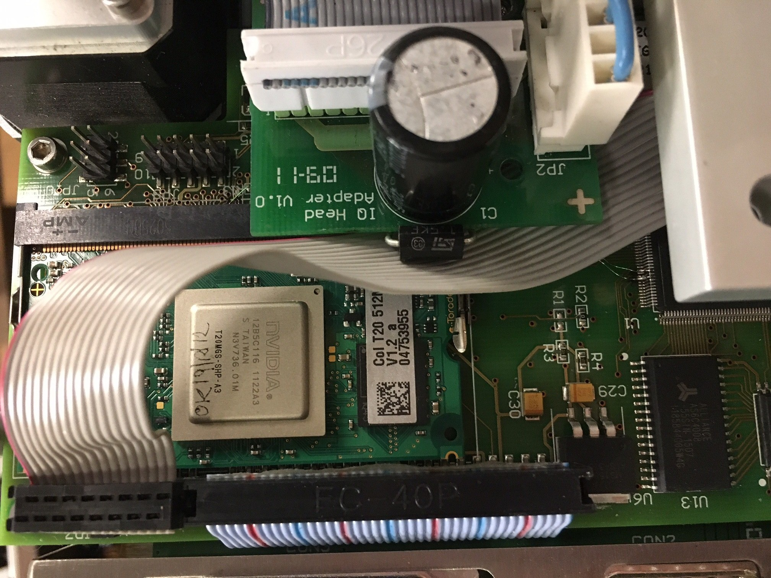
Fig. 2. The IQ Thermal Printer with assembled Colibri T20 SODIMM sized computer module on board.
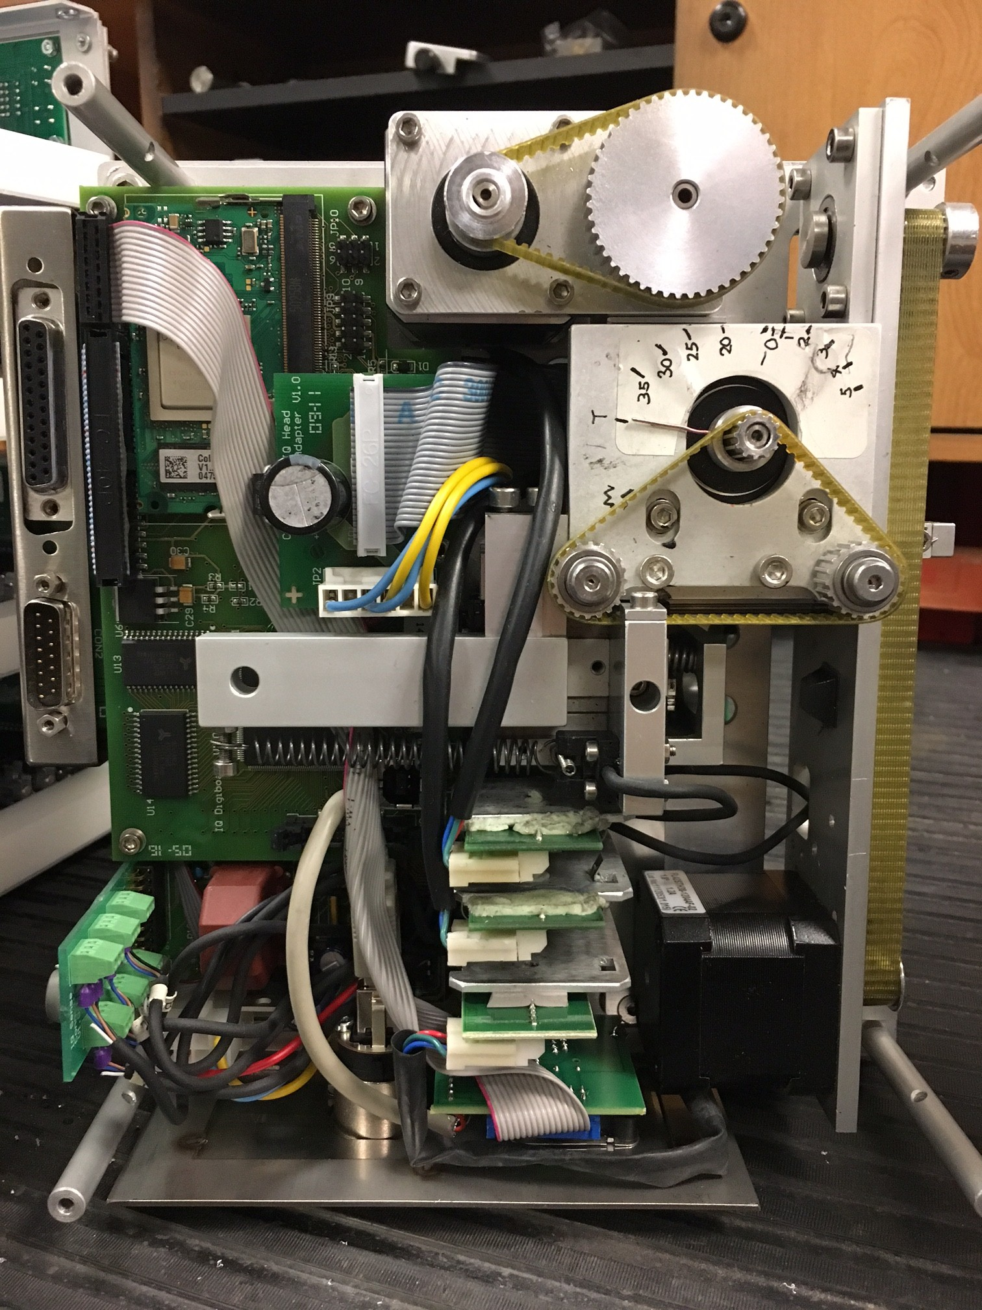
Fig. 1. The IQ Thermal Printer configured for some in house test for printing speed.
Fig. 5 shows the block diagram for the Colibri T20 communication interface. The older Colibri PXA270 used a PCMCIA to control the FPGA but the T20 Colibri does not have this interface and controls the FPGA with memory interface. The modified printer shows good communication between FPGA and Colibri by calibrating the print head position and the printing. Printing speeds are user adjustable from 50 to 400 mm/s on the TC2 and iQ printers. It is usually set according to the speed of parent machine, which is the packaging machine or a machine that feeds or drives the substrate through the printer. Other manufacturers have quote speeds of up to 730 mm/s depending on substrate, ribbon or print quality. The speed of the print with new processor is seen to be much higher than experienced previously. Rate of print is the number of prints per minutes and it is an important factor in evaluating a printer. We have conducted preliminary tests on prints per minute. The old iQ printer operated at a maximum rate of 500 prints per minute, the T20 prototype operated at almost 900 prints per minute on the same 10 mm long print. Print quality was not evaluated; only mechanical operation of the mechanism. This print speed is not currently suitable for deployment, however, it does show that the printer would now be capable of printing around 600-700 usable prints per minute. This by far is the fastest speed reached to date. The display also functions faster and responds faster to requests made by touching different buttons in touch menu. The USB and Ethernet ports on the printer with new Colibri were also tested. USB port functioned correctly but Ethernet port could not be set up initially and did not seem to be able to obtain the IP address. This was later rectified by identifying the right pins on the board and connecting them and became fully functional. Fig. 6 shows the thermal print ribbon used for transfer of text and imeges on to the target surface, through the heated printer head matrix. The ribbon is arranged around nip rollers to be streched to avoid jamming or defects in the prints. The ribbon is automatically advaced once each individual print operation is completed. One important parameter for the printers is the space left on the ribbon after two consecutive prints. It has to be arranged to have the minimun ribbon wasted, as ribbon rolls are consumables that need to be replaced and are expensive. This distance is calculated and movement of ribbon is opmitised in the codes to have least waste.
The current FPGA device on the IQ (Actel Pro ASIC Plus FPGA APA150 PQFP208) is fairly old, but the existing VHDL codes are generic and are written in high level language, behavioural structure (descriptive) therefore they can be transferred to a newer FPGA device in Actel family using the Libero SOC software. The I/O pins were different in the alternative FPGA device considered for upgrade, Actel Pro ASIC 3, however the corresponding pins were identified and utilised in the new design. To have this device the main board needs to be redesigned once again since the power pins on the new FPGA are different.

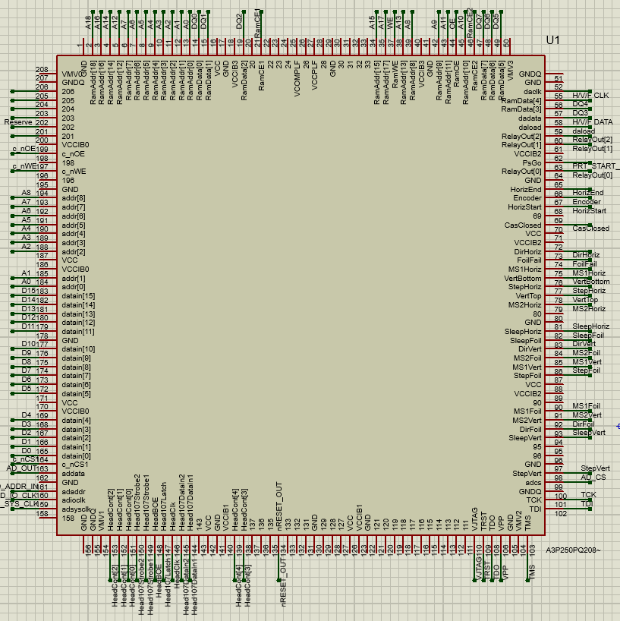

Fig. 4. Schematic of the FPGA component designed in Proteus software.
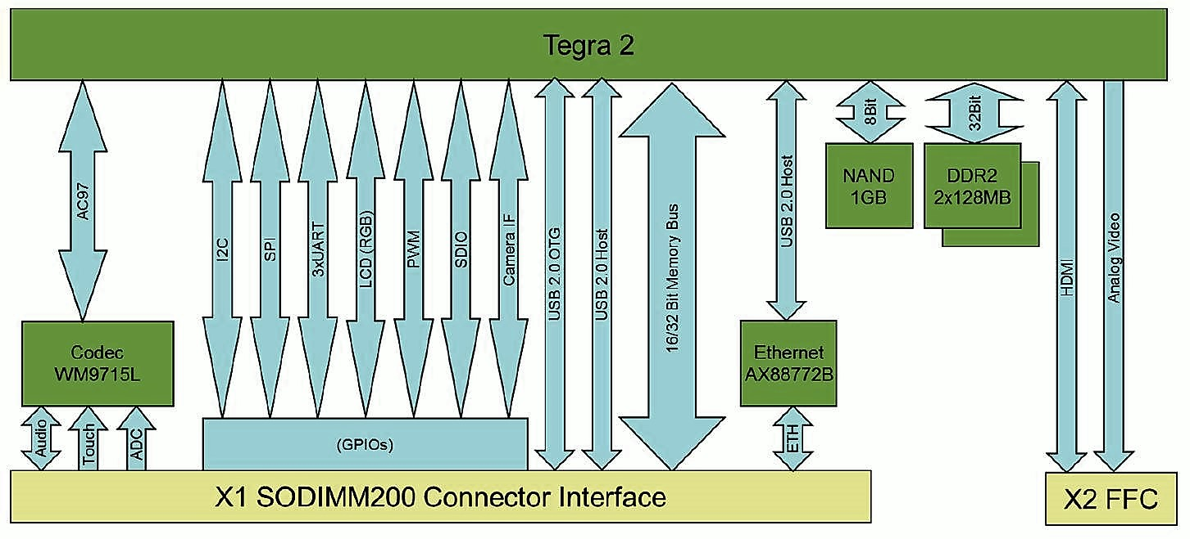

Fig. 5. Block diagram for the Colibri T20 [5]

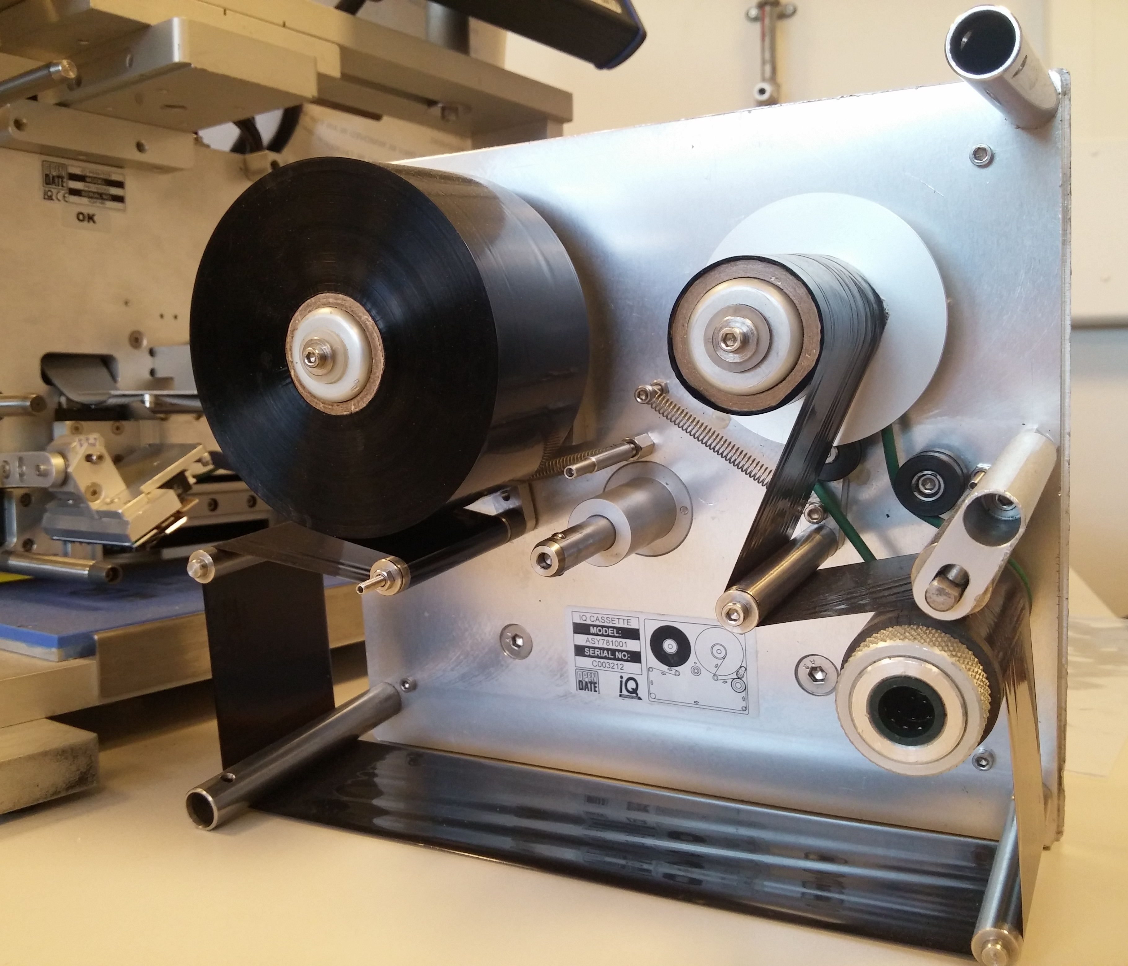

Fig. 6. Thermal transfer print ribbon assembly.
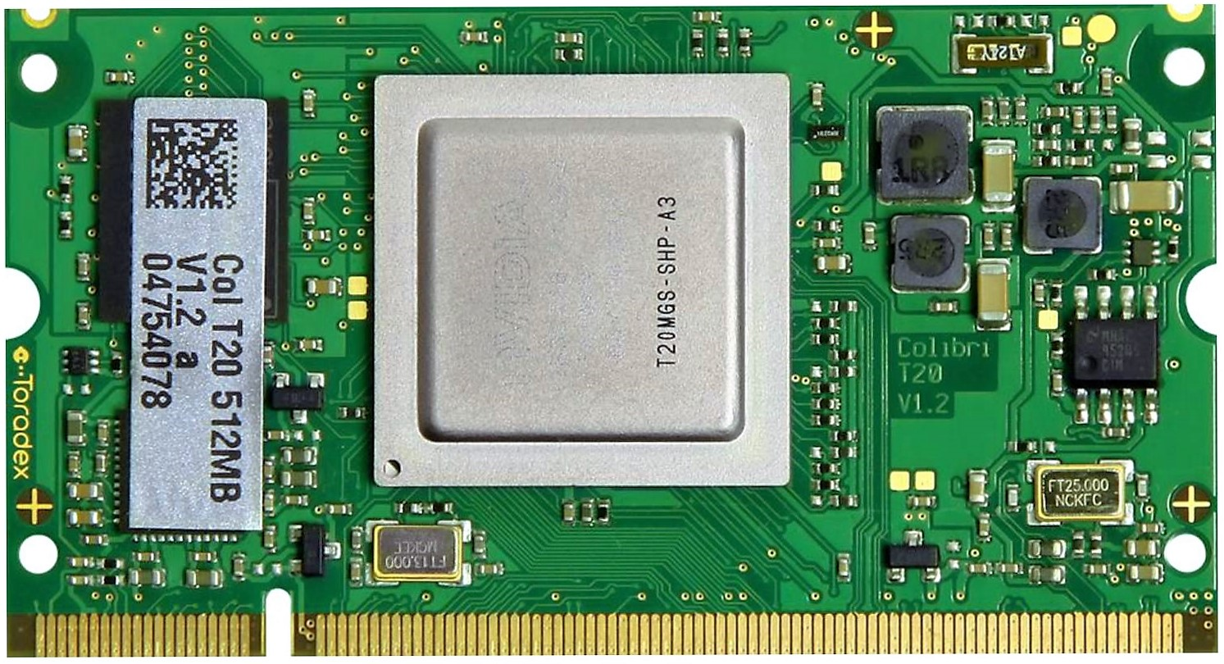

Fig. 3. Colibri T20 SODIMM sized computer module board [5]
The space inside the TC2 printer range was measured so that laying out the basic dimensions of the new PCB could be implemented, to suit all or as many of the printers as possible. Proteus software has been employed to design a multilayer PCB for the new system. The software was chosen amongst others because initially it seemed to have a more complete library and was easier to work with, however during the process of designing a board from scratch, because the original project files were not available, it became evident that it is not the most user friendly software available for this application and the inherent library does not have most of the components needed for designing the new board. However, after spending some time on this problem a schematic and PCB layout for the FPGA was created by allocation of a package which was created using the imported BSDL file in the software that configures the pins and specifies the packaging. BSDL is a Boundary Scan Description Language that is a subset of VHDL language. Boundary scan and Joint Test Action Group are the terms generally used to refer to IEEE standard 1149.1 [6]. It includes pin names, electrical types and their mappings on to pads in the footprints. It is used to describe how JTAG is implemented in a particular device. JTAG being an electronic association for verifying and testing PCB after manufacturing. It has become the industry standard for verifying integrated circuits and testing a board’s connectivity after it has been assembled. The JTAG standard has been adopted by FPGA manufacturers as the most universally accepted method for configuring devices in addition to the standard testing functionality [7]. JTAG is a viable high performance configuration interface especially if measures are taken to maximize its speed. The functionality of JTAG is controlled by a simple finite state machine. The JTAG standard requires four serial signals. The universality and scalability of JTAG makes it a good interface to access FPGA configuration memory [8].
The schematic for Colibri was created but in order to have the component in the PCB layout it needed to have an allocated package. There was no suitable package for the Colibri available in Proteus library. Therefore, a package with 200 pins was created using the datasheet of a 200 pin DDR SODIMM connector from one of the links provided by Toradex, to represent the processor connector and the STEP file was imported. STEP file is a CAD file format, usually used to share 3D models between users with different CAD systems. Now the 3D model of Colibri in the PCB layout is the shape of the actual SODIMM connector. Figures 3 and 5 show the SODIMM size ARM Colibri T20 computer module board, and its associated block diagram. When the prototype PCB boards are ready then meaningful comparisons as can be provided as it would be possible to conduct exhaustive testing.
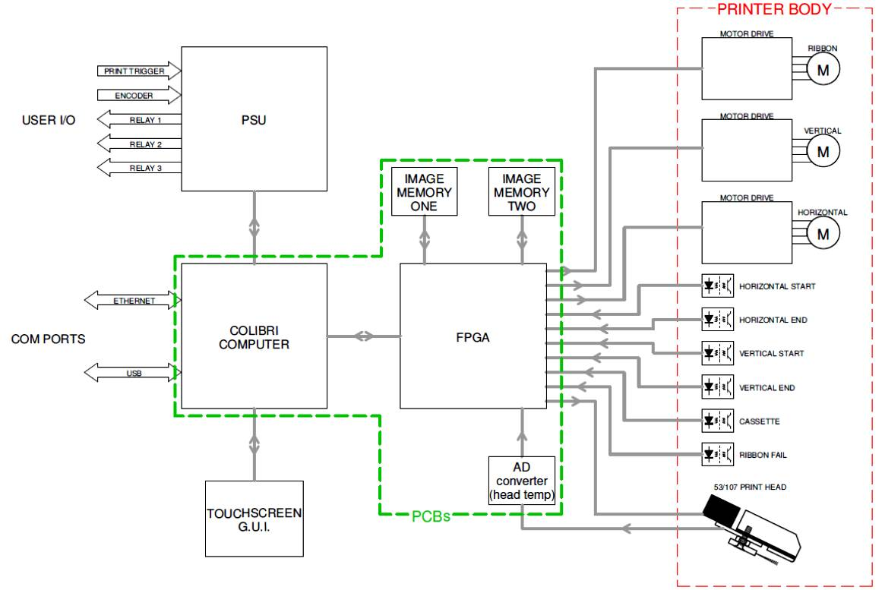

Fig. 7. Block diagram for the Thermal Printer IQ showing processor and FPGA and drive systems.
Fig. 7 shows the block diagram for the printer circuit. The main blocks are associated with the FPGA, procassor, power supply unit and the touch screen GUI module. Both processor and the FPGA have accsess to two memory modules. The diagram shows the distinctive sections which are assembled on the main printed circuit board (PCB), and the parts which are included in the printer body. The FPGA communicates with the motor drive units that control the movement of the ribbon and the print head. The obsolesence of the componets affeted several components within the system which resulted in the development of a completely new system. Although the touch contron system was fully functional, a new design for this unit was also considered which imcluded modernisation of the module which was based on resistive sensors, to a much more versetile capacitive arrangement.
There is also the need to replace the current touch screen. This touch screen is resistive which is analogue so it requires an analogue to digital converter, and it works based on single contact points. The more modern touch screens are capacitive and operate digitally. The current touch screen may not be produced anymore after short while so it too will become obsolete; hence this modification should also be adopted for the new generation of printers. The library and the codes for the current screen can be adapted to help with developing the interface for new touch screen. There are also other issues that need to be considered such as the chipset, LVDS and connectors. Utilisation of the capacitive screen is however essential being the new technology, compared to the existing arrangement which is nearing obsolescence.

Conclusion
A new control and interface system is to be introduced for a series of thermal printers have been designed and are under construction. The need for modification, development and modernisation of the existing control and monitoring systems resulted from the obsolesence of some of the key components of the thermal printers. Since the printers are well in demand, the development of the new systems had to be carried out incrementally whilst the orders and supplies have been maintained. The work has led to the need for creation of new far better and superior designs, currently being developed for these printers with improved features and performance. The predominant intentions in this project are to bring the technical knowledge lost by having products developed externally from the company and to eliminate obsolete components from the existing printer electronics systems. These will form the cornerstone of an innovative new printer system based on the knowledge gained during this one. Performance benefits are mainly confined to improvements due to faster processing electronics.

Acknowledgment
The authors wish to thank InnovateUK for financial support provided for this work through the KTP grant (KTP010086 LSBU-Open Date Equipment).

References
- P. W. Webb, R. A. Hann, “Measurement of thermal transients in a thermal print head used for dye diffusion colour printing,” IEE Proceedings A - Science, Measurement and Technology, Vol. 138 (1), 1991.
- T. R. Payne, H. R. Plumlee, “Thermal printer”, IEEE Journal of Solid-State Circuits, Vol. 8 (1), pp. 71-78, 1973.
- A. V. Shingala et al., “Low Cost Thermal Printing Solution for Devnagari Font,” Int. Journal of Engineering Research and Applications, Vol. 4 (8), pp. 77-81, 2014.
- Actel Pro ASIC Plus Family FPGAs datasheet, Actel Corporation, Mountain View, CA, USA, www.actel.com, 2009.
- Colibri T20 Datasheet, Rev 1.4, Toradex AG, 6048 Horw, Switzerland, www.toradex.com, 2015.
- IEEE standard for test access port and boundary-scan architecture,” IEEE Std 1149.1-2013 (Revision of IEEE Std 1149.1-2001), pp. 1–444, 2013.
- R. C. Cofer, B. F. Harding, Rapid System Prototyping with FPGAs: Accelerating the Design Process, Newnes (Elsevier Inc.), 1st ed., embedded technology series, 2005.
- A. Gruwell, P. Zabriskie, M. Wirthlin, “High-Speed FPGA Configuration and Testing through JTAG,” 2016 IEEE AUTOTESTCON, pp.1-8, 2016.

