Ultrasound Super-Resolution
with Microbubble Contrast Agents

Sevan Harput¹, Kirsten Christensen-Jeffries², Jemma Brown², Robert J. Eckersley^{2*}, Christopher Dunsby^{3*} and Meng-Xing Tang^{1*}

1. Department of Bioengineering, Imperial College London, London, SW7 2BP, UK, Mengxing.Tang@imperial.ac.uk
2. Department of Biomedical Engineering, Kings College London, London, SE1 7EH, UK
3. Department of Physics and Centre for Pathology, Imperial College London, London, SW7 2AZ, UK
* These authors contributed equvally to this work

Abstract— Ultrasound super-resolution imaging can be achieved by localizing spatially isolated microbubble contrast agents over multiple imaging frames. In vivo images with resolutions of ~10-20 microns in deep tissue have been demonstrated. The technique has the potential to revolutionize the way micro-circulation can be visualized and quantified, and has implications in a wide range of clinical applications including cancer, diabetes and beyond. In this paper we describe the principle of the technique with in vivo results demonstrating the superior resolution achieved compared with existing ultrasound imaging. We also discuss the challenges and opportunities in the area of 3D imaging including, imaging speed, tissue motion and microbubble localization errors.
Keywords—ultrasound super-resolution, super-localisation microscopy, microbubbles, contrast agents

Introduction
Optical super-resolution techniques have revolutionised the role fluorescence microscopy can play in the life sciences. Such super-resolution is achieved by selectively staining the sample with photoactivatable fluorescent molecules and analysing the acquired images to localise spatially isolated activated molecules. Localisation events are accumulated over time to build up the final image. In this way, the diffraction limit imposed by the physics of wave propagation and image formation is overcome.
Recently it has been shown that ultrasound (US) super-resolution is feasible by localising spatially isolated microbubble (MB) contrast agents [1] [2] [3] [4] [5] [6]. Compared to its optical counterpart, US super-resolution imaging is capable of much deeper tissue penetration. In this paper we describe the US localisation-based super-resolution method, show results demonstrating the improvement in resolution obtained, and end with a discussion of future challenges and opportunities.
This research was supported by the EPSRC (EP/N14855/1 and EP/N015487/1).

Super-resolution ultrasound imaging of microvasculature with MB contrast agents
Blood flow information is commonly used to identify tissue function and pathology, e.g. to diagnose cardiovascular diseases and detect cancerous tissue. However, the US scattering from blood is very weak compared to surrounding tissue structures, which can differ by up to 3 orders of magnitude. The use of microbubbles (MBs), typically with a lipid shell surrounding a gas core, in US imaging enables real-time imaging of blood flow with higher sensitivity and specificity in both large vessels and microvasculature due to their non-linear behaviour under US frequencies approaching the bubble’s resonant frequency [7]. However microvessels on the order of 10s of μm are difficult to resolve as the US wavelength is between 100-1500 μm for the clinical US frequency range of 1-15 MHz.
Visualisation of microvascular flow and structure beyond the diffraction limit has been achieved in medical US imaging in phantoms [1] and in vivo [4-5]. It was possible to overcome this resolution limit by localizing spatially isolated MBs through multiple frames and forming a super-resolved image from the super-position of all localisations in many image frames (see Fig 1). Other techniques achieving super-resolution even for a high concentration of MBs without spatial isolation are also reported, but the achievable improvement in resolution is limited [8].
.
.
.
.
.
.
++++

Figure 1: Ultrasound super-resolution can be realised by localizing spatially isolated MBs (shown as blue dots in the top two images) in multiple frames and forming a super-resolved image (bottom right) from the super-position of all localisations in many image frames.

Techniques that localise isolated MB signals require an appropriate image processing algorithm to detect and separate the MB and tissue response. Various tissue and MB separation methods have been developed such as Pulse Inversion which extracts the nonlinear MB behaviour [9], subtraction of consecutive frames – which is sensitive to any change between frames due to MB movement, dissolution, or destruction – and singular value decomposition – which can extract MB scattering from the background with an assumption of tissue and MBs having different spatial and temporal coherences [10].
Visualisation of microvascular structures below the diffraction limit in vivo in a mouse ear using a conventional US imaging system employing pulse inversion imaging and localisation of many MBs is shown in Fig. 2.

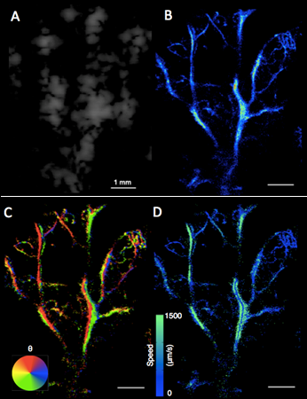
Fig. 2. Comparative images of mouse ear microvasculature using standard contrast enhanced US, single bubble localization method, and optical microscopy obtained using a surgical microscope. (a) A single high microbubble concentration image frame acquired using conventional Cadence CPS imaging mode. (b) Super-resolution image created as a probability density map where brightness represents the number of bubbles localized in a given location. (c) Corresponding optical image of the vasculature within the same mouse ear acquired in vivo. Scale bars, 1 mm. Images adapted from [4].

Current challenges and opportunities
US super-resolution imaging is still in its development phase with a number of unique problems to solve, particularly given that the structures to be imaged can be on the order of 10s of μm and that MB speeds can be <1mm/s.

Motion Correction
As US super-resolution relies on the accumulation of localisations over time (tens of seconds or minutes), tissue motion must be corrected to sub-wavelength accuracy in order for super-resolution to be achieved. There is therefore a range of existing motion estimation and registration algorithms to be evaluated for this application. Fig. 3 demonstrates the importance of motion correction for US super-resolution imaging. However, it is still impossible to compensate for the out-of-plane motion in 2D imaging. The use of high frame rate imaging can help reduce tissue motion effects.
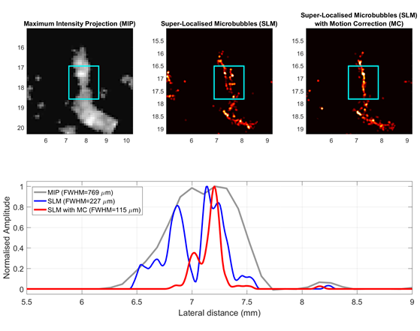
Fig. 3. Contrast enhanced ultrasound images of human tibialis anterior muscle perfused with Sonovue contrast agents are processed with the super-localisation method. Acquisition was performed by a Philips iU22 clinical US scanner using a 3-9 MHz linear array probe, MI of 0.06, and a frame rate of 13 Hz. (Top-left) Maximum intensity projection of 500 CEUS images. (Top-middle) Super-resolution image created by super-localisation of MBs without motion correction. (Top-right) The same super-resolution image with motion correction through image registration of neighbour frames. (Bottom) Microvessels’ thickness measured inside the cyan boxes and averaged.

Accurate Localisation
Existing methods are based on calculating positions of MBs by using the centroid, finding a local axial maximum in the travelling hyperboloid or fitting a 2-D Gaussian function to the beamformed signal. As the MBs can have variable temporal responses due to their polydispersity, Fig. 1 shows scattered pressure from MBs of three different sizes. In this simulated behaviour, all three MBs at the same position respond differently to the same excitation signal. There are examples to show both experimentally, and in simulations, that localisation methods which identify the beginning of the returning microbubble signal are required to obtain good positional accuracy for super-localisation across a polydisperse microbubble population [11].
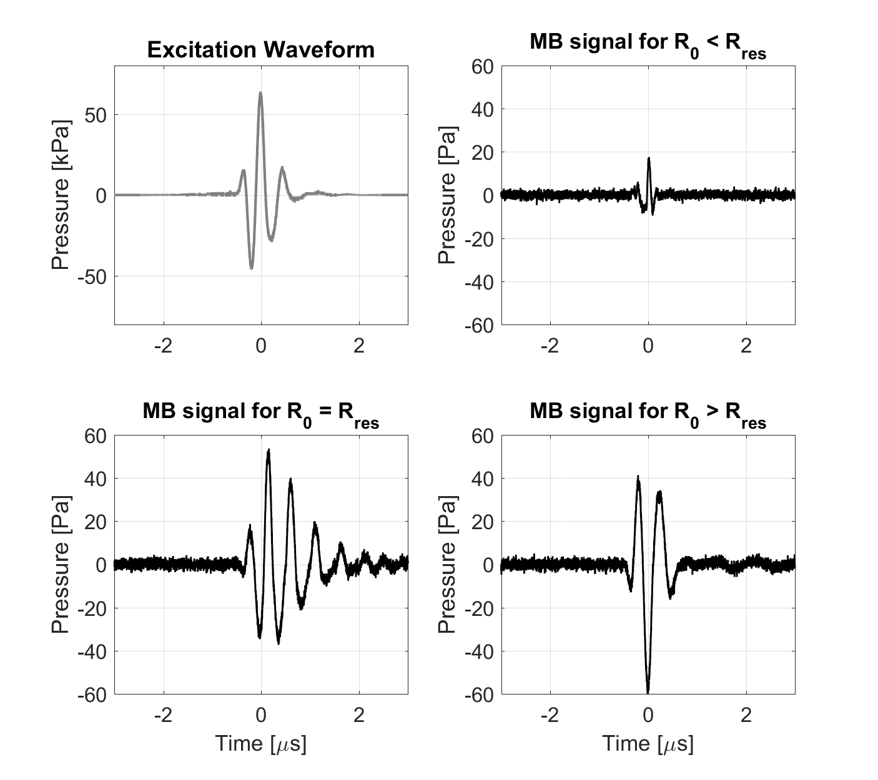
Fig. 1. (Top-left) Pressure waveform radiated from the ultrasound probe measured with a hydrophone. This waveform was used to excite three microbubbles in simulations. (Top-right) Scattered pressure from a microbubble smaller than the resonance size. (Bottom-left) Scattered pressure from a microbubble at the resonance size. (Bottom-right) Scattered pressure from a microbubble larger than the resonance size.

2D vs 3D Imaging
Most existing super-resolution studies use a 2D US imaging system, and even by spatially scanning the 2D probe to generate a 3D data set, it is not straight-forward to generate super-resolution in the 3rd dimension. 3D imaging with, e.g., a 2D matrix probe, would be able to address this challenge. Furthermore, motion correction problems can be solved deterministically in 3D for a region of interest that stays within the imaging region and by the elimination of out-of-plane motion. However this makes real-time imaging even more demanding due to the increased number of sensors, where a typical 1D US probe will have up to 256 elements, while a typical 2D matrix US probe will have thousands of elements.

Acquisition Time
While the use of high frame rate imaging (up to tens of thousands of frames per second) can significantly increase the amount of data acquired, and hence the number of MB localisations per unit time, due to slow flow in capillaries MBs may appear static during high frame rate imaging and thus increasing the acquisition speed over a certain frame rate may not have any benefit. Furthermore, the slow MB perfusion rate in small vessels sets the ultimate limit on the time required for the MBs to sample the entire microvasculature in a given region.

Conclusions
US super-resolution techniques have unlocked the potential for imaging vascular structures beyond the diffraction limit at depths which exceed those of existing optical or high-frequency US techniques. These wide-ranging opportunities also come with various challenges to progress the technique to clinical use.

References

[1] | O. Viessmann, R. J. Eckersley, K. Christensen-Jeffries, M. X. Tang and C. Dunsby, "Acoustic super-resolution with ultrasound and microbubbles," Phys. Med. Biol., vol. 58, no. 18, pp. 6447-6458, 2013.
[2] | Y. Desailly, O. Couture, M. Fink and M. Tanter, "Sono-activated ultrasound localization microscopy," Appl. Phys. Lett., vol. 103, no. 17, p. 174107, 2013.
[3] | M. O’Reilly and K. Hynynen, "A super-resolution ultrasound method for brain vascular mapping," Med. Phys., vol. 40, no. 11, p. 110701, 2013.
[4] | K. Christensen-Jeffries, R. J. Browning, M.-X. Tang, C. Dunsby and R. J. Eckersley, "In Vivo Acoustic Super-Resolution and Super-Resolved Velocity Mapping Using Microbubbles," IEEE Trans. Med. Imaging, vol. 34, no. 2, pp. 433-440, 2015.
[5] | C. Errico, J. Pierre, S. Pezet, Y. Desailly, Z. Lenkei, O. Couture and M. Tanter, "Ultrafast ultrasound localization microscopy for deep super-resolution vascular imaging," Nature, vol. 527, no. 7579, pp. 499-502, 2015.
[6] | D. Ackermann and G. Schmitz, "Detection and Tracking of Multiple Microbubbles in Ultrasound B-Mode Images," IEEE Trans Ultrason Ferroelectr Freq Control, vol. 63, no. 1, pp. 78-82, 2016.
[7] | A. Stanziola, M. Toulemonde, Y. Yildiz, R. Eckersley and M.-X. Tang, "Ultrasound Imaging with Microbubbles," IEEE Signal Processing Magazine, vol. 33, no. 2, pp. 111-117, 2016.
[8] | A. Bar-Zion, C. Tremblay-Darveau, O. Solomon, D. Adam and Y. Eldar, "Fast Vascular Ultrasound Imaging With Enhanced Spatial Resolution and Background Rejection," IEEE Trans. Med. Imaging, vol. 36, no. 1, pp. 169-180, 2017.
[9] | D. Simpson, C. Chin and P. Burns, "Pulse inversion Doppler: A new method for detecting nonlinear echoes from microbubble contrast agents," IEEE Trans Ultrason Ferroelectr Freq Control, vol. 46, no. 2, pp. 372-382, 1999.
[10] | C. Demene and e. al., "Spatiotemporal Clutter Filtering of Ultrafast Ultrasound Data Highly Increases Doppler and fUltrasound Sensitivity," IEEE Trans. Med. Imaging, vol. 34, no. 11, pp. 2271-2285, 2015.
[11] | K. Christensen-Jeffries, S. Harput, J. Brown, P. Wells, P. Aljabar, C. Dunsby, M.-X. Tang and R. J. Eckersley, "Microbubble Axial Localization Errors in Ultrasonic Super-Resolution Imaging," EEE Trans Ultrason Ferroelectr Freq Control, accepted for publication.

