This paper is part of a special issue on Education Acoustics

Teaching Acoustics during a pandemic: Lab in a Box for Experiments at Home

S. Dance¹
¹ School of the Built Environment and Architecture, London South Bank University, London, SE1 0AA, UK

dances@lsbu.ac.uk

ABSTRACT

In March 2020 with the advent of COVID emergency plans were put in place to deliver the Masters’ course in Environmental and Architectural Acoustics entirely on-line. This was necessary as although the acoustics laboratory is large, it was deemed to be unsafe for face-to-face teaching due to a complete lack of ventilation in the anechoic and reverberation chambers. Hence, it was necessary to create an alternative for the 2020/21 delivery. In September 2020 it was decided that a “Lab in a box” supported by on-line demonstrations and pre-recorded films would create the best alternative experience for the postgraduate students. The “Lab in a box” allowed the demonstrations to be replicated at home or in the garden using a Windows based calibrated measurement platform based on audio components. Examples of such laboratories included Fast and Slow measurements, Noise exposure, Noise Survey, Loudness, Reverberation Time, and Speech Intelligibility. The results showed that the students gained from more independence, increased flexibility in deliver achieving very similar marks. This has opened-up the possibility of increasing student numbers by reusing these alternative teaching strategies in the future.

PAC 43.10Sv

- INTRODUCTION
In March 2020 during the initial COVID outbreak emergency plans were put in place to deliver the London South Bank University Masters’ course in Environmental and Architectural Acoustics entirely on-line. It was decided that on-line delivery was the only option for 2020/21 delivery due to the continuing possibility of further Lockdowns. This was necessary as although the acoustics laboratory is large, it was deemed to be unsafe for face-to-face teaching due to a complete lack of ventilation in the anechoic and reverberation chambers. Hence, it was necessary to create an alternative. It was decided that a “lab in a box” that could be distributed to students around the world supported by on-line demonstrations and pre-recorded films would create the best alternative experience for the students. This was supplemented by existing resources created as part of the "Theodore John Schultz Grant for Advancement of Acoustical Education" awarded by the Newman Student Award Fund and included: an Architectural Acoustic workbook [1], web-based room acoustic modelling software [2], and videos illustrating principles of acoustics [3]. The key difference is that the “Lab in a box” allowed the students to experiment at home or in the garden.

The MSc course takes place over one year and consists of six taught modules delivered over the course of one academic year [4]. Each module focuses on theoretical or practical aspect of acoustics, or in some cases both theory and practice, see Table 1. This paper explores how the practical aspects of acoustics can be delivered in two specific modules: Acoustics Laboratory and secondly, Subjective and Environmental Acoustics, both first semester modules. The theoretical aspects of the course were easy to deliver using on-line tool, Microsoft Teams [5]. However, due to international students- and the associated time difference, it was decided that half of the material be pre-recorded and put up on the virtual learning environment, Moodle [6], at least two days before the lecture. The pre-recordings used the Panopto system [7], although if the lecturer wished to appear in the corner of the screen all the materials needed to be moved two inches to the right!

Table I: Design of the Master’s in Environmental and Architectural Acoustics

 | Research Methods | Subjective +  Environmental | Measurement + Control | Acoustic Labs | Architectural Acoustics | Masterclass in Acoustics
Theory | Y | Y | Y | N | Y | Y
Practical | N | Y | Y | Y | Y | Y

- PRACTICAL APPROACH
The practical aspects of the course consist of two main approaches: computing and laboratory-based work. This was necessary as six out of the seven modules have practical assignments, see Table 1. The assignments were for the first time all marked electronically using a tablet and stylus providing both rapid and convenient feedback to the students.

- Computer Work
The course offers access to the latest and leading commercial software. To enable the software to be used by students ICT organised a virtual system, called Cloudpaging Player with Global Protect software creating a Virtual Private Network [8]. Once the software is installed students can remotely access software and run the simulations on-line. Site licenses for CATT-Acoustics [9] was used to teach architectural acoustics, CADNA-A for environmental acoustics [10], and MATLAB for coding [11].

- Laboratory Work
The laboratories issue was more difficult to solve. It was necessary to create a complete acoustic measurement platform that was both affordable and could be shipped around the world. It was also essential that the measurement platform could be calibrated. The measurement platform when combined with a series of experiments to demonstrate the principles of acoustics formed the basis for “The Lab in a Box”. As an auxiliary plan it was decided to record every experiment on campus, so that by September 2020 twelve short films were created over a period of two days to cover the labs in the Acoustics Laboratory module. These films were recorded under strict COVID secure conditions with signed off risk assessments with three people present and used older Bruel and Kjaer kit to better illustrate the principles under investigation, see Figure 1. The filming and editing undertaken by entrepreneurial students from our Film School and was completed by early October 2020. The edited films were uploaded on-line to Moodle, along with the lab sheets and all the experimental data taken at the time of the recordings. The experimental data was designed to be analyzed live on MS Teams to extract the maximum possible educational value. Finally, during all recordings and live sessions branded attire was worn to emphasize a feeling of community and quality, see Figure 1.

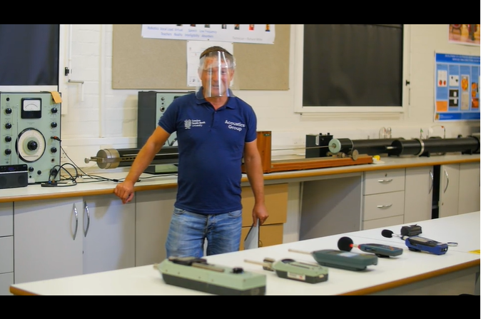

FIG 1. Shows a COVID safe delivery of a filmed laboratory experiment

- LAB IN A BOX

Given the Acoustics Group does not have enough resources to give every Masters’ student a Class 1 sound level meter, another solution had to be developed quickly. It should be noted that each of the students in our UK based Institute of Acoustics Diploma course received a Class 1 sound level meter to undertake their experiments; hence the lack of instrumentation for the Masters' students. Under a very tight deadline it was decided that a computerized measurement system would form the basis of the “Lab in a Box”. The Acoustics Group had previously trialed the shareware software ARTA [12], a PC based computerized measurement platform, as part of our architectural acoustics module. Hence, ARTA would form the best available software platform. This did not best please the students with a background in audio technology as they preferred Apple products.

- Instrumentation and Equipment
An inexpensive solution was necessary that could be quickly bought, packaged, and shipped nationally and international to meet the start of term deadline, late September 2020. The only assumption made was that the student would have a Microsoft Windows laptop available. The main limitations were budget, $250, and the system must be portable. ARTA is a very capable measurement platform. The software can measure impulse responses (RT, EDT, Speech Intelligibility), fast and slow time weightings, overall weighted sound levels with logging, real-time frequency analysis in octaves and 1/3 octaves, loudness (Phons/Sones), and Noise Criterion (NC, NR, PNC, RC, NCB). This met the teaching requirements of four modules: Acoustics Laboratory, Architectural Acoustics, Measurement and Control of Sound, and Subjective Acoustics.

It was then necessary to specify the hardware. It was felt that audio based equipment rather than acoustic instrumentation would be used due to budgetary restrictions. The hardware specified was a USB sound card: Behringer UHD202 along with a Behringer ECM8000 omni-directional measurement condenser microphone [13]. This allowed 48 kHz 24-bit measurements to be taken using ARTA. A simple single driver sound source with lithium-ion batteries was found Anker Soundcore Mini Mark 1 [14]. These were connected to the sound card using a balanced XLR cable for the microphone and Jack-to-mini-Jack cable for the speaker, giving a total measurement range of 10m, deemed to be sufficient for most homes. To calibrate the systems 13 Class 2 sound calibrators by Voltcraft SLC-100, were purchased [15]. These calibrators included a sleeve which provided a snug fit for the non-standard 12.5mm Behringer microphone. Finally, additional equipment was purchased including: a tuning fork, a mechanical music box and a digital metronome by Me Ideal M50, see Figure 2.
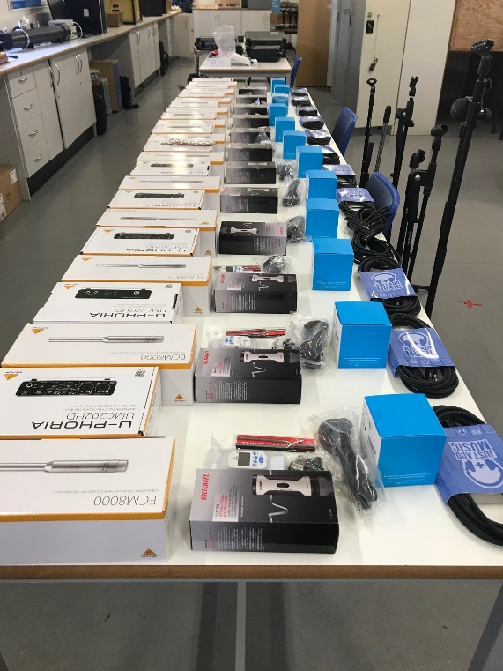

FIG 2. Shows the “Lab in a Box” kits before shipment. Primary components were a Class 2 Voltcraft SLC-100 calibrator, Behringer ECM8000 microphone, a Behringer UHD202 sound card and an Anker Soundcore Mini Mark 1 speaker.

- Smartphone Sound App
In case that international shipping could not ship the “Lab in a Box”, due to a lack of international flights a back-up solution was also offered. This solution had to use what the student might already have at home. As such, an iPhone smartphone was deemed a reasonable assumption [16]. An application was identified as free and simple to use, SPLnFFT app [17] which had been previously identified as a quality iPhone app for acoustic measurements [18,19].

- Class 1 Sound Level Meter
The lecturer also had access to a Class 1 sound level meter and Class 1 sound calibrator, (Norsonic Nor140). Figure 3 shows this meter being used an example of noise exposure measurements in the garden. This meter also was used for live on-line demonstrations to explain the difference in the quality of the measurements compared to the ARTA measurement platform and the SPLnFFT app. This was achieved through side-by-side comparisons for instance difference in calibrator accuracy, or experiments under low noise conditions. In addition, the lecturer had access to vibration kit which included transducer, micro-dot cable, accelerometer, vibration calibrator and an example of an isolating plate, mass spring system. This allowed on-line demonstration of fundamental principles of how to measure vibration, how a sound meter can be converted into a vibration meter, how decibels can be converted to acceleration, as well as vibration control.
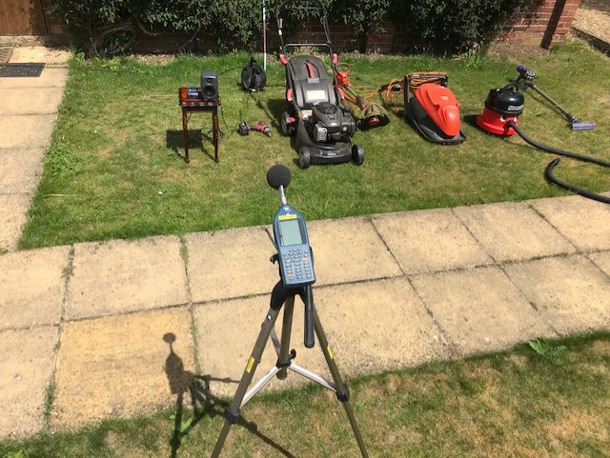

FIG 3. Shows a lab at home experiment demonstrating noise exposure measurements

- DELIVERY AND REPORTING

The main point of contact with the students was through Moodle, the on-line virtual learning environment, which the students gained access through their university email address. Each week a pre-recorded film was uploaded to Moodle; Fig. 4 shows a still-frame from a filmed impact sound demonstration. The Moodle content also provided links to the live section, lab sheet, lecture notes, and recorded data from the filmed experiments. There were two types of modules to deliver: purely practical and a mixed theory and practice module.

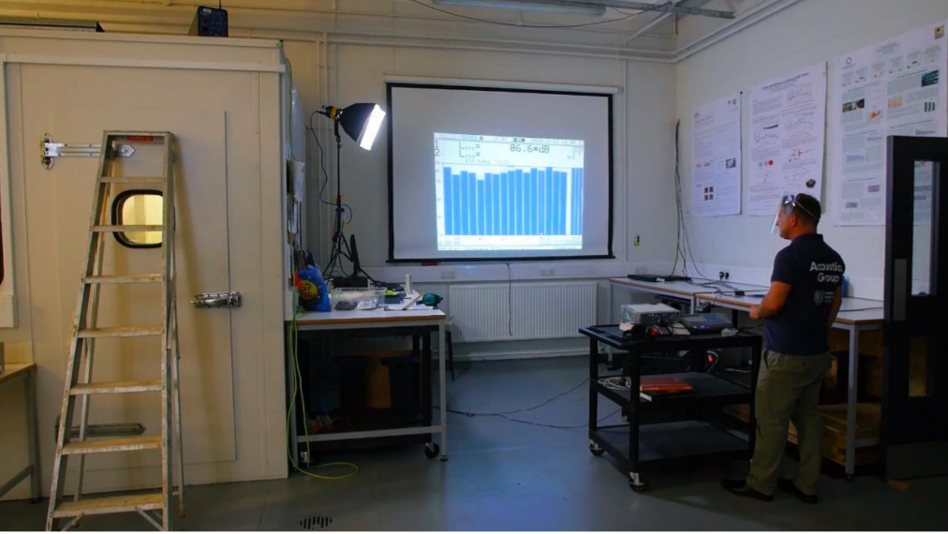

FIG 4. Shows a filmed laboratory to demonstrate impact transmission of sound

- Fully Practical Module
The delivery of the purely practical module was divided into two halves. The first half of the lecture was covered by the pre-recorded film of the experiment, approximately 15-25 minutes, in length; a full list is given in Table II. This was followed by a discussion of the laboratory and an analysis of the experimental data with a comparison to the expected theoretical result.

Table II: Equipment required for Acoustic Laboratory module experiments undertaken at home

 | Sound  Calibration | Environmental Parameters | Fast+ Slow | Facade | Noise  Survey | Sound  Propagation | Reverberation
Equipment | Calibrator | None | Metronome | Wall | Domestic Appliance | Loudspeaker + Garden | Room with Duvet

The second half of the lecture is where the students attempted to replicate the experiment at home using additional equipment, see Table II. Figure 5 shows how the façades experiment can be undertaken to demonstrate the effect on sound pressure close to a flat surface. There were six experiments that could not be replicated at home including determination of sound power, calculation of normal angle of incidence sound absorption coefficient, calculation of random incidence sound absorption coefficient, sound insulation both air-borne and impact based, and vibration isolation. These experiments were filmed, and the students wrote up their own analysis of the results.
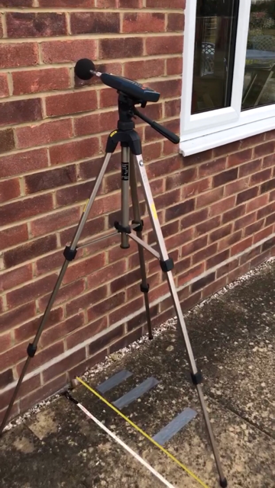

FIG 5. Show an at home lab experiment to demonstrate the effect of a façade on sound pressure

- Mixed Theory and Practical Modules
The delivery of each mixed module consisted of two equal halves. The first half of the lecture covered the theory, which was pre-recorded, with a live section to cover Question and Answers. This had the additional advantage of providing an offset in any international time difference experienced by the student. The second half of the lecture covered the live at home experiment using Teams with the students using what was to hand. For example, Figure 6 shows how a duvet reduced reverberation and thus increased speech intelligibility. Table III provides further examples of at home “Lab in a Box” type experiments created by the students as part of the Subjective and Environmental Acoustics module.

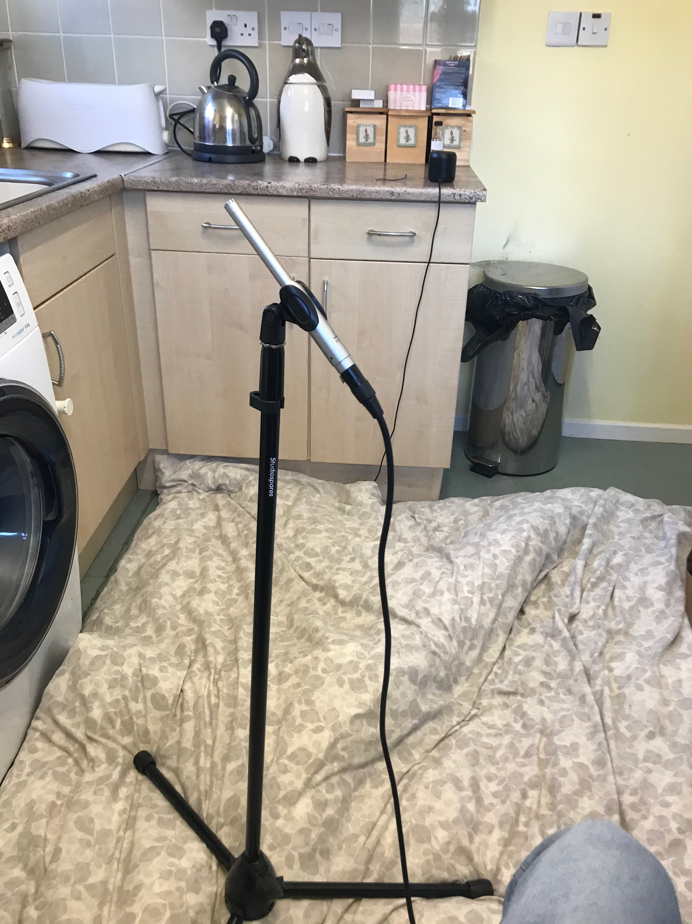

FIG 6. Shows a “Lab in a Box” example: Effect of reverberation on speech intelligibility using a duvet in a kitchen setting.

Table III: Sound sources for Subjective and Environmental Acoustics module experiments using Lab in a Box at Home
 | Noise Exposure | Loudness | Noise Criterion | Speech Intelligibility | Environmental Noise BS4142
Sound Sources | Kettle, Extractor Fan, Hoover, Hairdryer | Drill, Hoover, Hairdryer, Metronome | Kitchen, Bathroom, Living Room | Anker Speaker in Kitchen with/without duvet and with/without extract fan | Lawnmower

The assignment was to write a professional report based on one of the experiments. This report should detail the theory behind the experiment, what standards and guidance could be applied, methodology applied, results, critical analysis, uncertainty, improvements / non-compliance, and conclusions. In addition, experimental results should be compared to theory as filmed, as well as with their own experimental data. This could be followed by comparing the quality of the data collected by different measurement systems Class 1 sound level meter, ARTA measurement system, and Sound App on a smartphone.

- A MINI CASE STUDY

To illustrate the approach taken a student report will be used as an example of how the “Lab in a Box” can be effectively used to supplement teaching. The mini case study is focused on the Noise Survey experiment where firstly subjective observations are compared to objective measurements in dBA and dBZ. Secondly, to establish if the dominant frequency of a sound source can be determined from the A weighting network using the difference between the dBA and dBZ, dBA-dBZ using 1/3 octave bands. This would be useful if a sound level meter had no real-time frequency analysis option. The student has taken the filmed experiment data and produced analysis for the ambient condition in the anechoic and reverberant chambers, traffic noise, impact noise, and sound from louvres, a drill and a fan.

The student used the ARTA measured platform, calibrated the system and took dBA, dBZ measurements and 1/3 octave band spectrum of four additional sources of sound. The sound sources were a vacuum cleaner, a balloon burst, a hairdryer and aircraft noise as measured in their garden in West London, see Figure 7. The results of the analysis are given in Table IV.

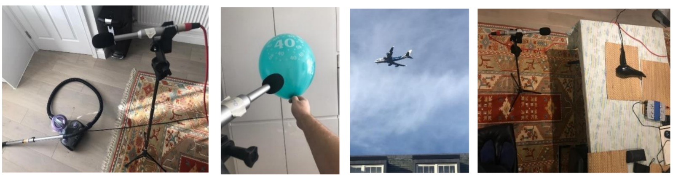
FIG 7. Shows “Lab in a Box” student measurements of a vacuum cleaner, a balloon burst, aircraft noise and a hairdryer.
Table IV: Student observations of measured sound sources, dBA and dBZ, from the Noise Survey at home experiment including frequency analysis

Measurement | Subjective Assessment  of Loudness (%) | Sound Level (LAeq) | Sound Level (LZeq) | dBA-dBZ | Predicted Dominant Frequency (Hz) | Measured Dominant Frequency (Hz)
Vacuum Cleaner 1.5m | 80 | 72.8 | 74.6 | -1.8 | 630 | 630
Balloon Burst 1m | 90 | 93.7 | 93.4 | -0.3 | 1000 | 1250
Hairdryer 1m | 85 | 78.7 | 77.8 | 0.9 | 1600 | 1250
Aircraft Noise 700m | 65 | 62.7 | 71.5 | -8.8 | 250 | 63

The student analysis of the observations demonstrated that dBA did more closely match the subjective loudness of the sound sources than the dBZ measurements. This was much more clearly seen from the filmed experimental data but did reinforce that perceived sound of ambient noise levels are more accurately represented using the dBA parameter. The second learning outcome was more clearly demonstrated by the student experiment as they used more machinery type noise sources where the dominant frequency was identified with a 1/3 octave band frequency.

- FEEDBACK

The student expectation was managed so that they understood that under COVID teaching would be significantly different, whilst keeping the same learning outcomes and maintaining fairness. It was also explained that the model of delivery could continue into Semester 2, which commenced in late January 2021. The size of thecohort was in-line with previous years, 15 students, and attendance was near 100%. Student feedback was through Module Evaluation Questionnaires and through the full-time and part-time course representatives. So far, the feedback has been excellent, 80% happy, and assignment marks slightly improved on previous years, an average mark of 75% vs 68% in the previous year for Acoustics Laboratory and 71% vs 64% for Subjective and Environment module. There are three possible reasons why the average mark consistently improved by 7%. First, the filmed laboratories could be watched any number of times, unlike a normal experiment. Second, the experimental data was collected by the lecturer and hence complete. Third, the At Home Experiments were awarded bonus marks.

Students had the option of on-campus tutorials, but none was taken up, preferring on-line delivery. Social engagement was maintained using Teams with the student left alone to discuss work/education materials over an on-line coffee. The students did eventually all meet up on the last day taught day of the course, mid May 2021, to discuss and give feedback on the year. This occurred in a local pub’s beer garden, as this was the only publicly accessible space, at this point the international students had made the journey to London to enable them to undertake project work in the Acoustics Laboratory.

Four specific points were made by the students. First, the international students explained the “Lab in a Box” shipment had been problematic. Second, that test signals send through Teams were immediately cancelled out as noise and hence the lectures on pure tones and pink noise were less than successful. Third, the students felt the ARTA provided an excellent software platform for calibrated acoustic measurements although microphone sensitivity did vary considerably after calibration. Finally, feedback from the students indicated that they enjoyed the freedom of undertaking their measurements to add to those measured of the filmed laboratories.

- CONCLUSIONS

To overcome the difficulties posed by the pandemic an approach which combined on-line teaching, pre-recorded lectures, filmed laboratories, Lab at Home experiments, desktop-based computer modelling, and live Q&A sessions was employed. The pre-recordings helped the international students overcome implicit time differences due to limitations on international travel.

The specification of the “Lab in a Box”, a fully calibratable acoustic measurement system, for under $250, helped create a better student experience under difficult conditions. The creation of the,” Lab in a Box” allowed the students to undertake the practical aspects of the course during the year. The legacy of teaching during a Lockdown was greater use of on-line tools, a library of filmed experiments and the rapid adoption of computer software tools utilized through VPNs. This will aid in the delivery of a new undergraduate course, Apprenticeship in Acoustics, where the employers desired that the students be taught the very latest tools and techniques. Hence, this year’s Masters’ students provided the pilot study for the rollout of the new course, starting at London South Bank University in September 2022. The year has accelerated the rollout of Blended learning which is now highly likely to become the main mode of Higher Education teaching in the future. The final legacy is the creation of public engagement materials suitable for use by schools at High School level [20]. The experiments can be undertaken in class using a large screen to display the results to provide an understanding of acoustics in physics lessons.

ACKNOWLEDGEMENTS
The teaching / research was only made possible through the EPSRC UK Acoustics Network Grant which supported the development and rapid purchase of the equipment to build the “Lab in a Box”. Finally, my thanks goes to all the students on the course.

REFERENCES
- M. D. Egan. Architectural Acoustics Workbook, www.Newmanfund.org/Schultz-prize, 1994
- S. Dance. Web-based noise control prediction model for rooms using the methods of images, www.Newmanfund.org/Schultz-prize, 2007
- M. Ermann, Animations illustrating room acoustics, www.Newmanfund.org/Scultz-prize, 2012
- S. Dance. Masters in Acoustics at London South Bank University - A route on to our PhD programme, Proc. IoA/SFA, Nantes, 2012
- www.microsoft.com/en-gb/microsoft-365/microsoft-teams/group-chat-software [accessed 20/10/20]
- www.moodle.org [accessed 20/10/20]
- www.panopto.com [accessed 20/10/20]
- www.software2.com/appsanywhere/integrations/numecent-cloudpaging [accessed 20/10/20]
- www.catt-se [accessed 20/10/20]
- www.datakustik.de [accessed 20/10/20]
- www.mathworks.com [accessed 20/10/20]
- www.artalabs.hr [accessed 20/10/20]
- www.behringer.com [accessed 20/10/20]
- www.anker.com [accessed 20/10/20]
- www.voltcraft.cz [access 20/10/20]
- J. Zeman, S. Dance, D. Abraham. Acoustic uses for the iPhone. Proc. IoA 32(3), Ghent, 2010
- apps.apple.com/us/app/splnfft-noise-meter/id355396114 [accessed 20/10/20]
- A. Chucri, C.A Kardous, P. B. Shaw. So How Accurate Are These Smartphone Sound Measurement Apps? https://blogs.cdc.gov/niosh-science-blog/2014/04/09/sound-apps/ April 9th 2014 [accessed 20/10/20]
- C.A Kardous, P. B. Shaw. Evaluation of smartphone sound measurement applications, Journal of the Acoustical Society of America 135, EL186 (2014); https://doi.org/10.1121/1.4865269
- www.acoustics.ac.uk [accessed 20/10/20]

FIG 1. Shows a COVID safe delivery of a filmed laboratory experiment

FIG 2. Shows the “Lab in a Box” kits before shipment. Primary components were a Class 2 Voltcraft SLC-100 calibrator, Behringer ECM8000 microphone, a Behringer UHD202 sound card and an Anker Soundcore Mini Mark 1 speaker.

FIG 3. Shows a lab at home experiment which demonstrates noise exposure measurements

FIG 4. Shows a filmed laboratory to demonstrate impact transmission of sound

FIG 5. Show an at home lab experiment to demonstrate the effect of a façade on sound pressure

FIG 6. Shows a “Lab in a Box” example: Effect of reverberation on speech intelligibility using a duvet in a kitchen setting.

FIG 7. Shows “Lab in a Box” student measurements of a vacuum cleaner, a balloon burst, aircraft noise and a hairdryer.

