Assessing the performance gap of two dynamic thermal modelling software tools when comparing with real-time data in relation to thermal loss

Bahareh Salehi BSc(Hons), MSc, PhD, MCIBSE
Department of Mechanical Engineering, London South Bank University, UK
bahareh.salehi@mottmac.com

Deborah Andrews MA(RCA), PhD, DIC, MIED, IEng, CEnv, FRSA
Department of Mechanical and Design Engineering, London South Bank University, UK
deborah.andrews@lsbu.ac.uk

Issa Chaer BEng, CEng, PhD, MCIBSE, SFHEA, F.Inst R
School of the Built Environment and Architecture, London South Bank University, UK
chaeri@lsbu.ac.uk

Elizabeth J Newton BSc(Hons), PhD
School of Applied Science, London South Bank University, UK
liz.newton@lsbu.ac.uk

Aaron Gillich BEng, MSc, PhD, CEng, MEI, FHEA
School of the Built Environment and Architecture, London South Bank University, UK
gillicha@lsbu.ac.uk

Abstract

Managing thermal loss is a key topic that needs further investigation as it has a direct link to reducing the energy load in buildings. One of these thermal loss management methods can be the use of shading devices.
Dynamic thermal models normally used at the early stages of the building design can play an important role in the decision-making process regarding the use of shading devices. This paper presents the results of a real-world study assessing the potential of using a sealed cellular blind as a passive energy conservation method, where the real-world results are compared with the simulated results generated with environmental design solutions limited thermal analysis software (EDSL Tas) and integrated environmental solutions virtual environment (IES VE). During the real-world study, a positive impact of having blinds was seen whereby the window surface temperature increased and office heating energy consumption was lowered. Both software tools were able to predict a similar trend of results for the window surface temperature in with and without blind scenarios whereas for energy consumption although in the presence of a blind a consistent correlation is seen between measured and calculated values but not without a blind. This can be attributed to the inability of the software tools in demonstrating the effect of in filtration in the absence of a blind or shading device i.e., a clear window scenario.
Practical Application
:
The performance gap analysis regarding thermal loss between dynamic thermal
models and real-world settings within buildings can enhance the predictability of the building energy software tools used by designers. Early design inputs within buildings can prevent costly building re-work to improve the building’s energy performance. This can also improve the understanding within the building industry of the importance of reducing thermal loss through the use of shading devices and ensuring the software tools used to model these devices are as close to real-world settings as possible.

Keywords

Building performance gap, building thermal simulation, EDSL Tas, heat loss, IES VE, real-world data collection.

Introduction

The built environment sector contributes to more than 60% of global energy consumption and statistics indicate that more than half of carbon dioxide is emitted from buildings (1,2). Taking this proportion into consideration, it is clear that the focus should be on reducing building energy consumption levels (1,2). As part of the Climate Change Act 2008, the UK committed to reducing carbon emissions by 80% in 2050 compared to 1990 levels (1) which was amended in 2019 to 100% making the UK a “Net Zero Emitter” (3). Despite this pledge, the Climate Change Risk Assessment report in 2017 and also the Sixth Carbon Budget 2020 highlighted that the UK had very few guidelines in place for existing buildings to enable them to adapt to higher and lower temperatures (4,5). Therefore, action is needed to find innovative ways to reduce heat loss in existing buildings and make the existing stock of UK buildings more climate resilient (6). One of the key improvements that can be made towards the energy efficiency of buildings especially during winter is balancing the reduction in heat loss (which includes having more efficient insulation and a considerable reduction in infiltration) with the benefits of solar gains received by a building (7).
There are various methods to reduce heat transfer from buildings including glazing optimisation such as vacuum glazing, gas-filled glazing, triple vacuum glazing and multilayer glazing; methods for frame optimisation can also make a difference in thermal retention within a building (8,9). One method which has been investigated in various studies is the use of shading devices which can act as an extra layer of insulation for windows resulting in reduced heat loss whilst maintaining solar gain when needed. Although the impact of shading devices on thermal retention has been investigated in many studies, the majority have been heavily reliant on simulation results or experimental research studies that have been conducted in very controlled laboratory-like settings which are not always representative of the real-world conditions (10–12).
Despite various studies showcasing the benefits of shading devices use in buildings whether through simulated results or controlled environment experiments(10–14), they seem to be less prevalent in UK buildings compared to their more widespread use in Europe which can be due to many factors (15). One of the key factors that has limited the use of shading devices is their limited consideration at early design stages when dynamic thermal models are developed. It is optimal to include shading devices from early design stages to realise the greatest benefits. It is essential then to ensure the integrity of these models and building energy software programs and that the input data used by the building designers are as close as possible to real-world performance. There have been very few studies conducted that highlight the differences between simulated results and real-world values; however, in 2018, a research paper compared the real-time data, measured from a London apartment using various shading devices, with the simulated results generated by IES VE. Although this research study focused on overheating it highlighted discrepancies between the simulation and reality (16) and highlighted the ever-existent disparity between simulated results and real-world results.
This paper focuses on the comparison of results between the dynamic thermal models of a shading device when using DTM software tools (including EDSL TAS and IES VE) and real-world results of an actual installed shading device in relation to heat loss (window surface temperature and energy consumption), which ultimately illustrates how shading devices are an effective method in tackling heat loss in buildings. Within this test, the selected shading device was an internal sealed cellular blind installed on a single glazed window. This paper included a sensitivity analysis on the simulated software results in relation to the shading device, in addition an assessment of the impact of glazing temperature on occupants’ thermal comfort was conducted. The findings ultimately raise the question of whether the gap between simulated and real-world scenarios can be made smaller to promote more effective use of these devices.

Real-world Data Collection

The test room was situated in an east facing (110°) office, located on the 7th floor of the London South Bank University Tower Block, situated in central London, UK (51.4978° N, 0.1012° W) (Figure 1).
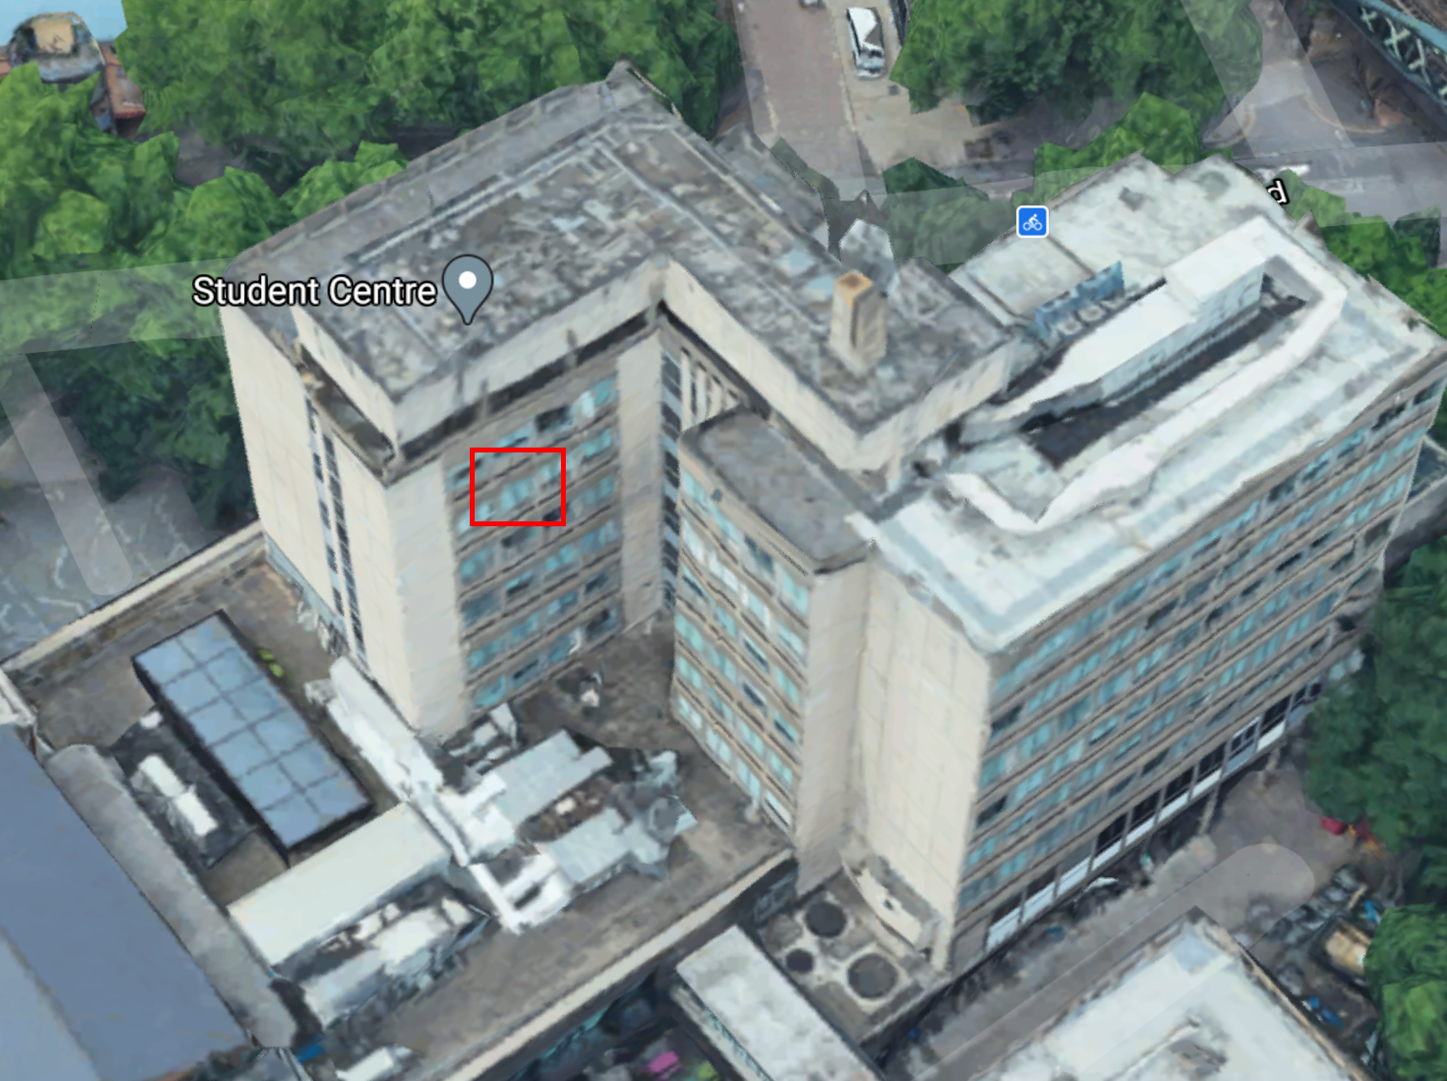
Figure 1: Aerial photograph of Tower Block, London South Bank University. The red square shows the location of the test room. North is the top of the photo. Google Maps 2021.

Layout and Construction

Figure 2 shows the room and window geometry where the height of the room is 2.66 m (3.03m without the suspended ceiling).
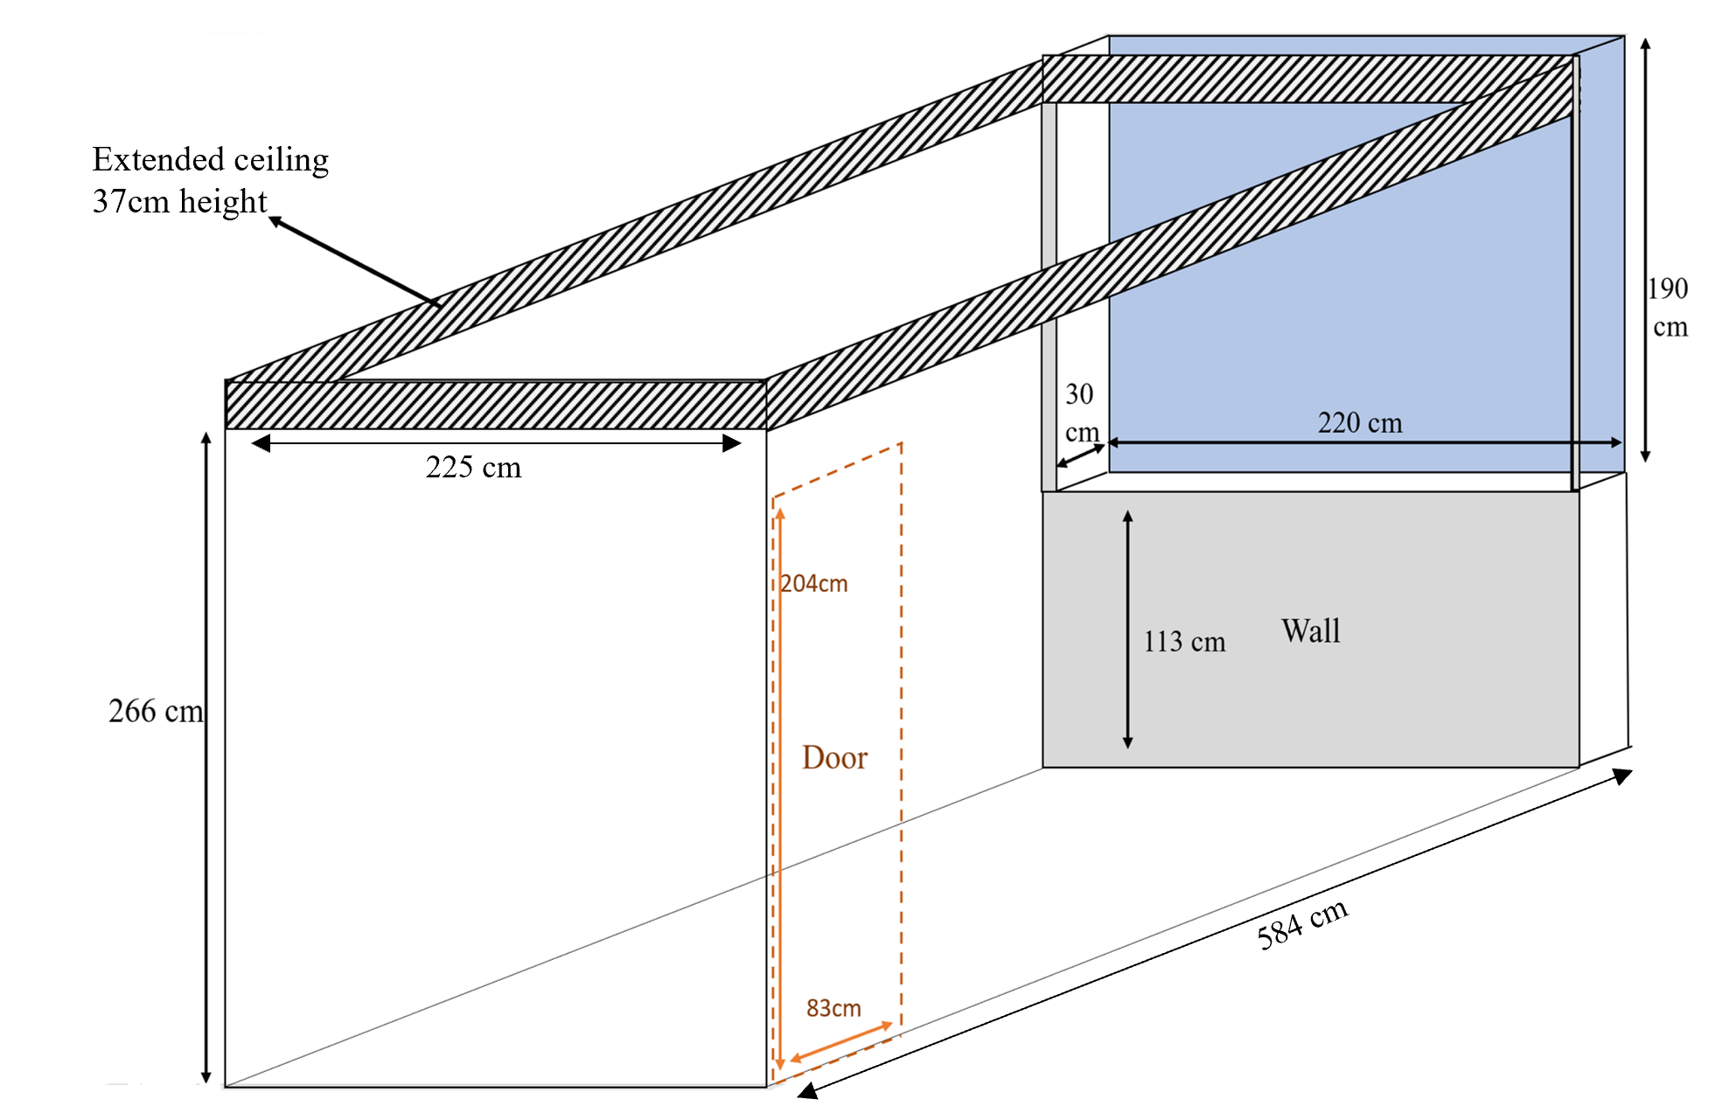
Figure 2: Room and window sizes. Please note that the sizes in this picture are not to scale
The ceiling, flooring and all internal party walls were all connected to other rooms/parts of the building with only one exposed external wall. Table 1 presents the construction elements of the test room which are all based on assumptions and observation.
Table 1: Construction elements of the test room.
Building Element | Description
Floor | Concrete floor
Ceiling | Suspended ceiling
Internal wall | Concrete wall without insulation
External wall | Concrete block with precast concrete panels
Door | Plywood- 20 mm thickness
Window | Single glazed window with aluminium frame

Shading Specification

The shading device used in this test was an internal sealed cellular blind with a side-channel to reduce the air permeability of the blind through the perimeter gaps which refers to the gap between the blind and the window reveal. The cellular structure has three insulating air layers enabling a more energy-efficient setup (17) (Figure 3). Visible reflection of this blind was 0.63, solar reflection was 0.57 and both visible and solar transmissions of this blind were zero.
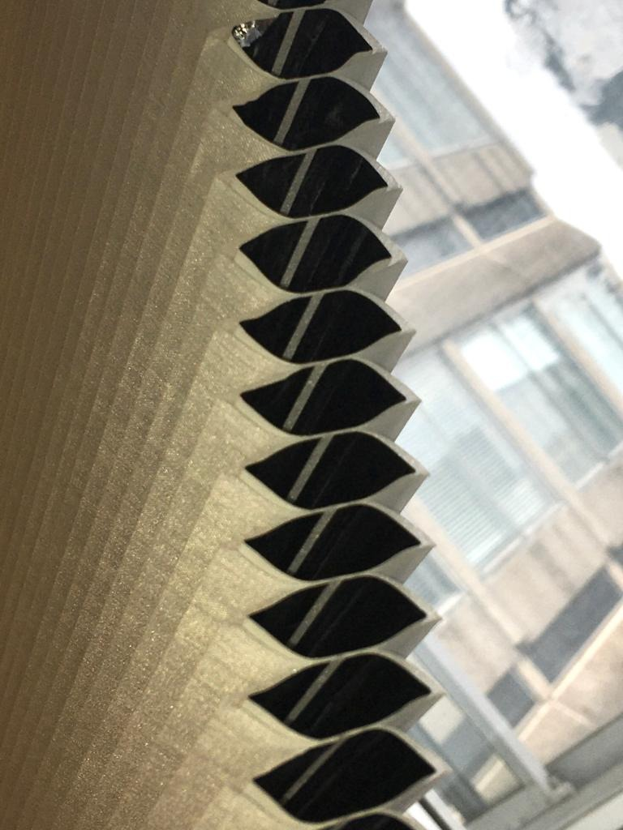

Figure 3: Cellular dimout blind. Left: cellular structure of the blind. Right: representing the blind when it is sealed using side channels

Methodology

The real-time data collection process was conducted for the duration of 22 nights where the main data collection occurred overnight (17:00 to 08:00 the following day). The real-time data collection was split into two scenarios, one being 11 nights with the blind installed (extended) and the other 11 nights without the blind present (blind drawn up) where no individual was present in the room. According to CIBSE Guide A, the recommended comfort criteria for offices in winter is 21-23 °C (18). As this test was conducted during March 2021, the heating setpoint was set at 24 °C to increase the temperature difference between internal and external environments.

Measuring Parameters and Equipment

Indoor Parameters

The window glass and blind surface temperature values were measured using insulated thermocouples (type TX-1/0.3mm PFA). Sensors were installed on the internal side of the window glass and blind to enable measurement of the average surface temperatures. These thermocouples were all connected to a data logger (Datataker DT500) with an accuracy of ±0.16% (19). This data logger was then connected to a laptop enabled with a data capture software where the data was saved and formed a data monitoring system. In addition, using the same variant of insulated thermocouples, the indoor dry-bulb air temperature was measured by three sensors and three different heights in the middle of the room; the average of these values was taken to represent the room air temperature and avoid the effect of stratification.
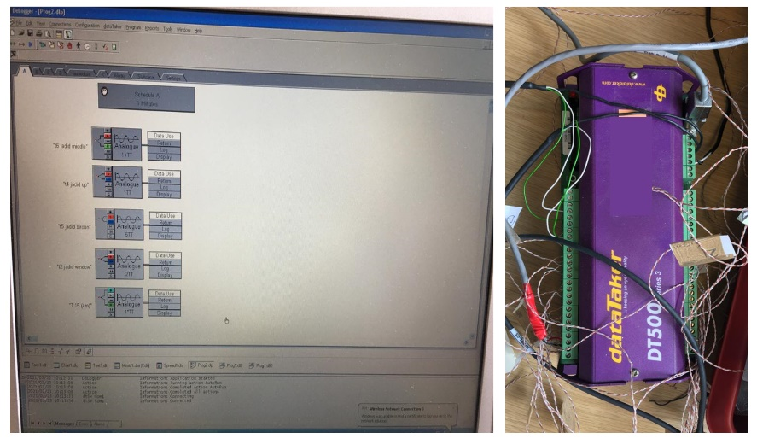
Figure 4:Internal data monitoring system

Prior to data collection, the thermocouples and the monitoring system were calibrated at 10-second intervals for temperatures ranging between 2°C to 40°C. This was achieved via a temperature-controlled Grant W28 stirred water bath with a temperature stability of ± 0.004°C which also included a built-in temperature controller and electric heater. An equation was derived using the calibration results for each sensor. Utilising the derived calibration equations of each sensor, the corresponding results were then calibrated.
To maintain the internal room temperature, a 3kW thermostatically controlled electric turbo convector heater equipped with a timer was utilised. This heater was connected to an RS PRO power metering socket which had the capability to save the cumulative energy consumption value in kWh with the resolution of ±0.01 kWh.
To ensure correct identification of the uncertainty of each sensor, an uncertainty analysis was conducted. Afterwards, the uncertainty analysis was performed for each parameter using the uncertainty propagation law (20):
$$u\left(X\right)=(\frac{1}{n})\sqrt{\sum_{1}^{n}{{(u_{T})}^{2}}}$$
Where u(X) is the uncertainty of the sensors for location X and u_{T} is the uncertainty of the individual sensor in location X. So, the total uncertainty for glass surface temperature measurement was ±0.10°C, total uncertainty for internal dry-bulb air temperature was ±0.15°C and for blind surface temperature, this was ±0.12°C.

Outdoor Parameters

Three sensors were installed on the weather station stand which includes a dry-bulb air temperature sensor (rht+ probe with the accuracy of ±0.2 °C), a solar radiation sensor (CMP 3 pyranometer with the sensitivity of 5-20 mV) and an illuminance sensor (SKS 310 pyranometer). This weather station was positioned outdoor, and the external sensors located on the weather station were calibrated in advance by the manufacturer and connected to a battery-operated Skye data logger (DATAHOG2) to enable the data to be saved (Figure 5).

Figure 5: External weather Station

Dynamic Thermal Model
An 8-floor building was modelled in two software tools to simulate the closest condition to the test environment (real-world case study) especially in relation to replicating how high up the test room was from the ground (7th floor) (Figure 6). This allows consideration of the influence of adjacent rooms and floors on the thermal behaviour of the test room. To ensure a more accurate comparison, the geometry and orientation of the modelled room are made the same as the real-world case study.
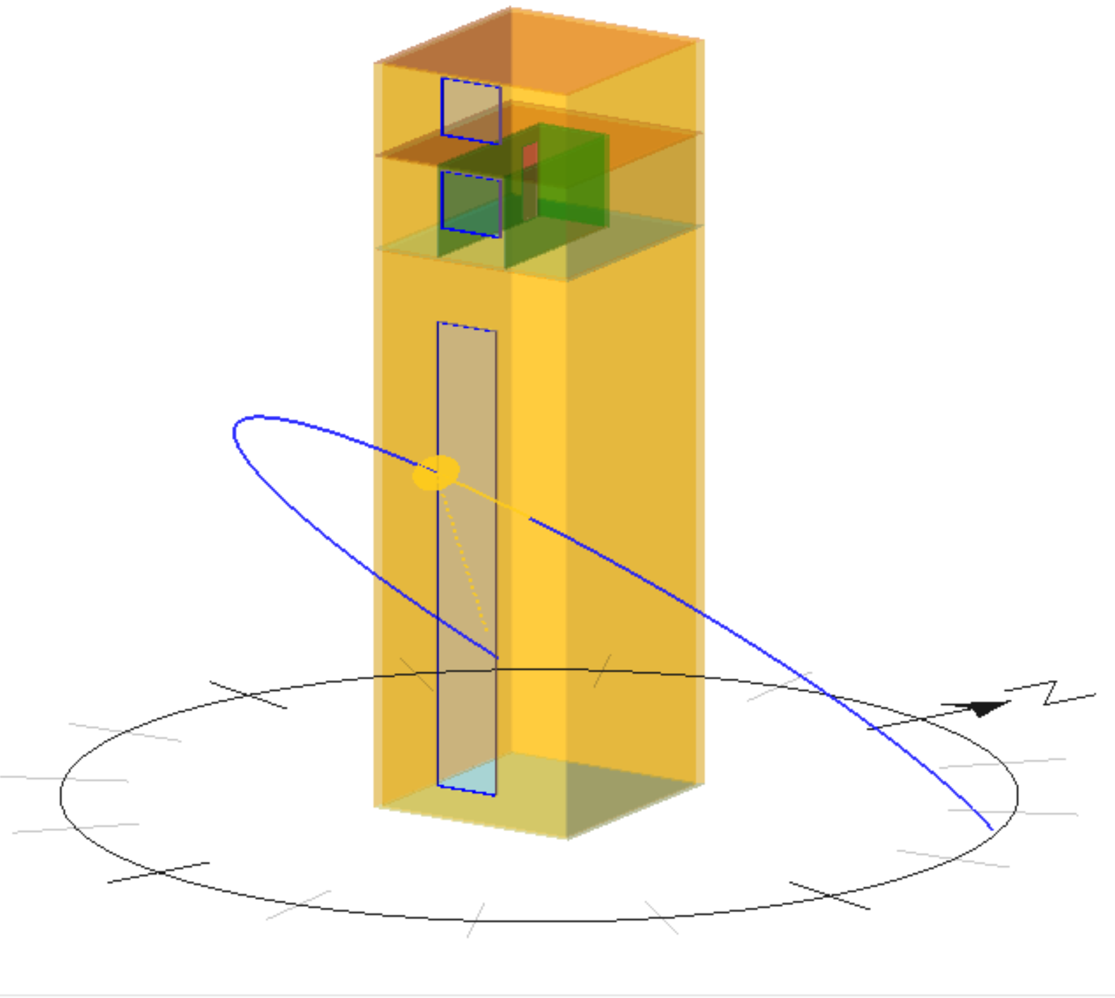
Figure 6: Example 3D model of the test room located on the 7th floor of Tower Block modelled in EDSL Tas

Construction Material and Properties

The construction properties and materials of the test room were assigned according to the CIBSE TM 53, CIBSE Guide A and through observation as stated in Table 1 (21). Table 2 showcases the thermal transmittance values of the building elements used in the dynamic model.
Table 2: Thermal transmittance of the building elements used in dynamic thermal model generated with EDSL Tas and IES VE
Building Element | U-value (W/m². ºC)
Internal floor/ceiling | 1.11
External wall | 0.60
Internal wall | 0.59
Window (without blind) | 5.81
Door | 1.82

Shading Specification

Table 3 presents the input which the software package requires to enable modelling of the shading devices in terms of solar gain and thermal performance. The reference to “input” data means it is either directly sourced from the shading manufacturer or assumed by the modeller (22).

Table 3: Software input values for modelling shading devices
Input parameter |  | Unit | Values
Solar / Visual properties | Solar transmittance | - | 0
 | Solar reflectance | - | External: 0.57
 |  |  | Internal: 0.57
 | Light transmittance | - | 0
 | Light reflectance | - | External: 0.63
 |  |  | Internal: 0.63
Thermal performance properties | Thickness | mm | 20
 | Conductivity | W/m.°C | 0.04
 | Emissivity | - | External: 0.1
 |  |  | Internal: 0.1

Thermal conductivity and emissivity of the blind used in the test were not provided by the respective manufacturers. The emissivity of the cellular blind, which is a ratio between 0 to 1, was assumed as 0.1 which represents a low emissivity surface and high thermal resistance (23). According to the European Solar Shading Organisation (ES-SO), the default value for the conductivity of an internal single layer roller blind is 0.1 W/mK, as most materials are thin and of a similar thickness (24). However, as the blind used in this study was a multi-layer thermal insulating cellular blind with high capability in reducing the heat transfer through the blind, the thermal conductivity was assumed as the low value of 0.04 W/mK. When using EDSL Tas, the blind is considered as a transparent layer within the window construction and the distance between the blind and the window glass was specified as a layer of air with a thickness of 100 mm.
The required inputs for shading devices in IES VE are different from EDSL TAS. For this case study, according to the manufacturer, solar transmittance and absorptance values were zero and 0.57, respectively. By substituting these values in the equation below provided by IES VE, shading coefficient (SC) is calculated as 0.37 and short-wave radiant fraction (SWRF) is equal to zero.
$$SC=T+0.87*A$$
Where T is solar transmittance and A is solar absorptance. The short-wave radiant fraction (SWRF= T/SC) is calculated by dividing solar transmittance by the shading coefficient (SWRF= T/SC) (25).

Internal Gains, Infiltration and Heating System

Prior to the real-world test, the air permeability of the room was assessed through a blower door test which provided the value of infiltration to be 1.89 Air Change per Hour (ACH). As the window and door were closed during the test, the ventilation was considered to be zero in the simulation. During the test, the room was unoccupied, and the lights were all turned off. The monitoring system including a laptop and a data taker were working 24 hours a day to store the captured data from the sensors. Consequently, the equipment gain i.e. the internal monitoring system (laptop and data logger) was assumed as 5 W/m² in the model (18).
The heating system used in the test room was an electric heater which was working from 17:00 to 08:00 the following day to maintain the temperature at 24°C. The heating system schedule and setpoint considered in the model were set to the same values as the real-world case study.

Weather File
When comparing the simulation results with the real-world data collected during the test, the simulation weather file needed to represent the real weather conditions during the test period to reduce the discrepancies between the real and simulated measurements. A custom weather file was generated using the real-time weather data which were either measured on-site (located 10m far from the test room) or derived from the nearest weather station measured by the Met Office (Kew Gardens, St James’s Park and Heathrow weather station).

Results and Discussion

Real-world Case Study

Thermal Images

In order to better visualise the effect of a cellular internal blind on heat transfer during the heating season, a thermal camera (model FLIR ONE PRO LT) was used to capture infrared photos. Figure 7 and Figure 8 show the effect of the blind on the inside surface temperature which increased from 13.6°C to 22.5°C (8.9°C difference). Considering the average room temperature of 23°C, when there is no blind the difference between the blind surface temperature (window) and the room temperature is close to 10°C which also highlights the importance of efficient thermal symmetry within the buildings. CIBSE Guide A states if there is > 10°C difference between the vertical wall and the internal room temperature then thermal discomfort will be experienced(18).
It should be highlighted that localised discomfort can be evident when an occupant is positioned adjacent to the cold glazing through the process known as thermal (longwave) radiant heat exchange. This could have a significant impact on an individual’s well-being in addition to the local air temperature.

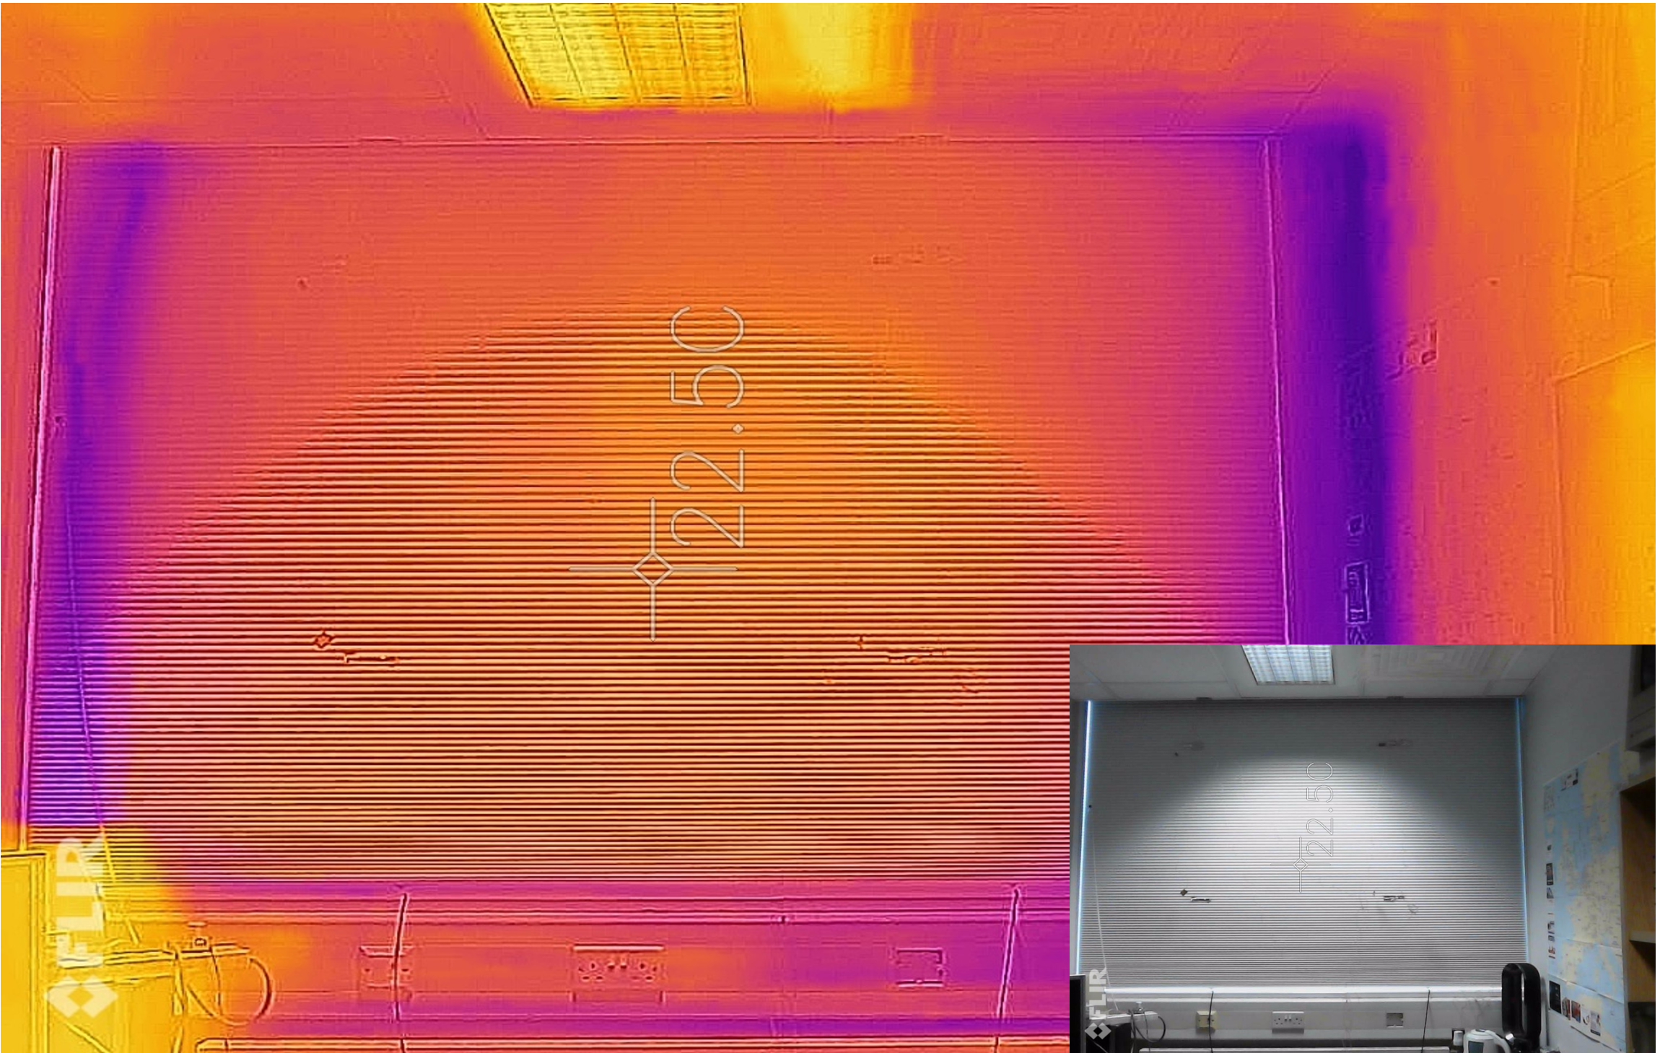
Figure 7:Thermal image captured with blind showing the blind area with a surface temperature of 22.50 °C
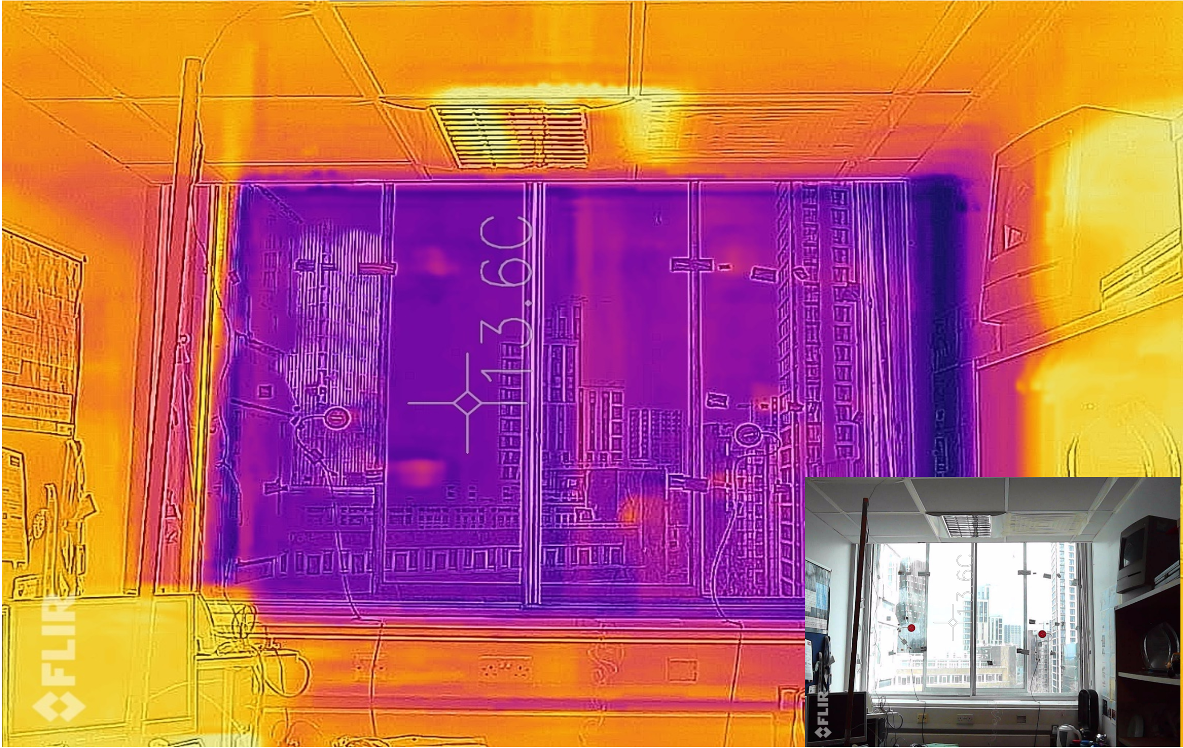
Figure 8:Thermal image captured without blind showing the glass area surface temperature of 13.60 °C

Real-world Results

Real-time data were collected for eleven days with a blind installed and eleven days without a blind during March 2021 to illustrate the effect of the blind on energy consumption and window surface temperature. Table 4 presents the wind velocity and differential dry-bulb air temperature (internal and external) (ΔT_{in-out}) in with and without blind scenarios which shows that there is no significant difference in the external conditions between these scenarios.
Table 4: Descriptive analysis results of external condition
 | Blind | Mean | Std. Deviation | N
ΔT_{in-out} (°C) | With Blind | 17.97 | 2.32 | 11
 | Without Blind | 16.19 | 1.98 | 11
Wind (m.s⁻¹) | With Blind | 2.10 | 0.75 | 11
 | Without Blind | 2.49 | 2.41 | 11

It was observed that energy consumption had been reduced considerably in the presence of the blind (Figure 9). The results show that during the presence of the blind, energy consumption was approximately 51% lower than when there is no blind (based on the comparisons between the 11-day average energy consumption, with and without blind).
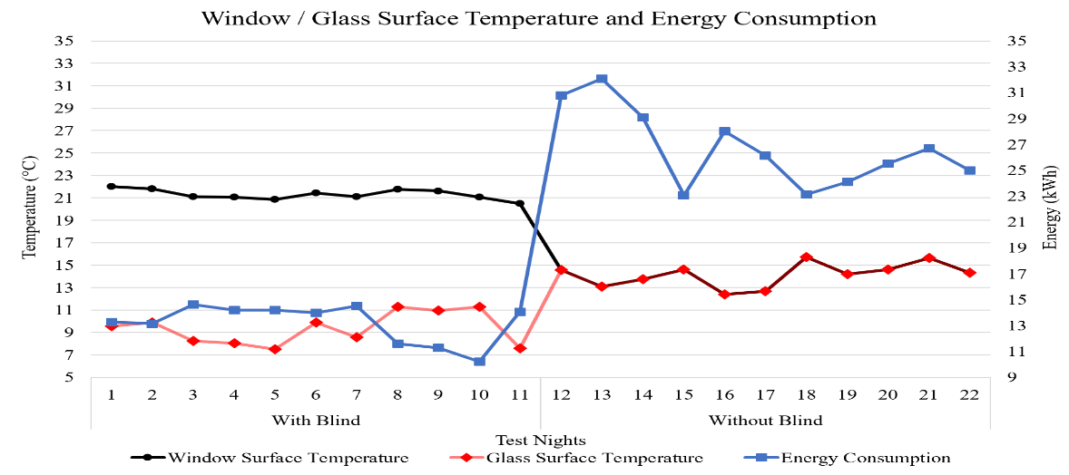
Figure 9:Energy consumption and window/glass surface temperature, while the internal air temperature was maintained at 24°C during the night

For thermal comfort consideration purposes, the internal surface of the window was assessed. This means that when there was no blind, the internal side of the glass was considered as the window surface and in presence of the blind, the internal side of the blind was considered as the window’s surface. So, the window surface temperature was approximately 34% higher in the presence of a blind (warmer) which means the average glass surface temperature (the glass behind the blind) was reduced by approximately 34%. This means the blind has acted as an insulating layer (Figure 9).

Dynamic Thermal Model Results

To investigate the results of the dynamic thermal model produced in EDSL TAS and IES VE, the hourly simulated results are compared with the real-world data from the case study. It is important to note that these values are analysed from 18:00 to 08:00 the following day to allow overnight values to be considered. Although the heating system was active / operational from 17:00, the results are considered from 18:00 in both the simulations and the real-world study to negate the impact of thermal mass within the first hour after turning the heater on. This means the thermal mass of the elements within the room are not adversely affecting the results and a more stable temperature is maintained.
Comparisons were made by using parameters such as surface temperature and energy consumption against time plots and by considering the mean error ($\overline{E}$) to measure the errors (differences) between software predictions and real-time measurements results as below:
$\overline{E}=\sum_{t=1}^{n}{(E_{t})/n}$
In this analysis Error (E_{t}) is calculated as below:
$E_{t}=P_{t}-M_{t}$
Where E_{t} is the error at hour t(°C), P_{t} is the predicted value at hour t (°C), M_{t} is the measured value at hour t (°C) and n is the total number of hours in the comparison period (26).

Window Internal Surface Temperature

One of the parameters investigated was the internal surface temperature of the window (°C), with and without a blind. In this section, as the blind is considered part of the whole window system, the internal surface of a window in the presence of a blind, represents the internal surface of the blind itself and when there is no blind, the internal surface of the window is considered as the glass surface. Figure 10 presents the simulated internal window surface temperature results in EDSL TAS, IES VE and the real-world measured values. To make comparisons between the modelled results and the real-world data collected, the uncertainty of the real-world surface temperature measurement was calculated as ±0.10°C for the glass surface (without blind) and ±0.12°C for blind surface temperature (with blind) in Section ‎2.3. It is observed in Figure 10 and Figure 11 that the predicted/simulated internal surface temperature of the window with a blind reflected a similar trend to the measured values. When the blind was extended the window surface temperature was higher than when there was no blind present.

Figure 10:Window Internal Surface Temperature- Measured vs Simulated

Figure 11:Window Surface Temperature Mean Errors

Energy Consumption

The energy consumption required to maintain the temperature at 24 °C during the test period is simulated using the models generated by EDSL TAS and IES VE. The cumulative energy consumption was measured in the real-world setting with the resolution of ±0.01 kWh. As it is illustrated in Figure 12, the simulated energy consumption did not follow the same pattern as the measured values. The differences between the simulated and measured values are presented in Figure 13 which shows that the simulated values have very little fluctuation and do not showcase the reduction in energy consumption when a blind is extended the way the measured values highlighted.

Figure 12: Energy Consumption - Measured vs Simulated

Figure 13: Energy Consumption Mean Errors

Sensitivity Analysis

A sensitivity analysis was performed to evaluate the effect of total room infiltration and blind input parameters (shade to glass distance, shading emissivity and shading conductivity) when they were altered (increased or decreased) within the software, on the results from the simulated model including the window internal surface temperature and energy consumption in the presence of blind scenarios.
Each of the parameters were altered within both software tools to better understand whether this alteration had any impact on the surface temperature and energy consumption when compared to the base model (without alteration). Once this comparison was performed, the percentage of the variance of results (increase or decrease) compared to the non-altered model was obtained. As an example, the room infiltration (ventilation heat loss) which was measured to be 1.89 ACH during the real-world test (base-case model), was reduced in both software tools and set at 0.25 ACH i.e., the default value in the software to ascertain the impact of this fluctuation on the simulated model in terms of window internal surface temperature and energy consumption. For EDSL TAS, this alteration was considered for the shading conductivity of the window as well whereby it was increased from 0.04 W/mK (base-case model) to 2 W/mK. The alteration was then applied to both emissivity and shade to glass distance (m) whereby emissivity was increased from 0.1 (base-case model) to 0.9 and shade to glass distance was considered both at maximum (0.3 m) and minimum (0.01 m) values in relation to 0.1 m (base-case model). This was investigated in the presence of a blind as shown in Figure 14, the impact on this reduction was mainly seen on energy consumption which varied by approximately 47% in EDSL Tas and 65% in IES VE and no or less than 20% impact on window surface temperature or heat loss was seen.
In IES VE, four calculated input values are specified for shading modelling whereby only additional thermal resistance is considered key for reducing heat loss. The other three factors including Daytime resistance, Shading coefficient and short-wave radiant fraction are mainly considered for daytime simulations. Analysing the nighttime resistance shows that reducing nighttime resistance to zero could alter the energy consumption by approximately 12% and decrease the window internal surface temperature by approximately 35%.
Reviewing the results in Figure 14 shows that altering shading fabric parameter values such as conductivity,emissivity and nighttime resistance could affect the window surface temperature, which is an element to consider when assessing thermal comfort. However, these elements did not have a significant impact on energy consumption in the room in the model and altering certain input values did not seem to have any impact on the results. For instance, increasing the shade to glass distance for more than 0.1 m did not alter the results in EDSL Tas.

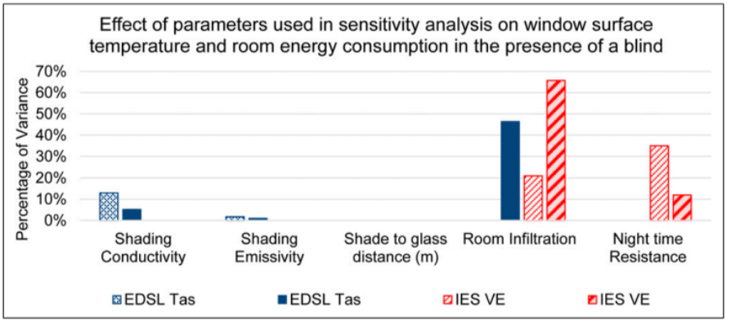
Figure 14: Effect of parameters used in sensitivity analysis on window surface temperature and room energy consumption in the presence of a blind

Conclusion

The results from the real-world study highlighted that using an internal sealed cellular blind has the potential to reduce the energy consumption required to maintain the internal dry-bulb air temperature at 24 °C from 17:00 to 08:00, by 51% in the presence of a blind. Additionally, having the blind increased the window surface temperature by 34%. This increase had a positive impact on thermal comfort as due to the exchange of long-wave radiation between the occupant (if present) and the window area, the higher surface temperature can improve thermal comfort in colder seasons.
Results reached after comparing real-world measurements and values derived from EDSL TAS and IES VE thermal modelling of the shading device showcased that the models followed the similar pattern of the real-world trend in relation to window surface temperature but struggled to showcase the reduction impact of shading devices when a blind is introduced in relation to energy consumption. After conducting a sensitivity analysis on the input data for the shading device modelling within EDSL TAS and IES VE software tools, it was noted that factors such as room infiltration (total room ventilation) have a more significant impact on window surface temperature and especially room energy consumption. Both software tools were unable to specifically factor in and include the room infiltration impact in the prediction and model in the presence of a blind, and therefore the inclusion of a blind did not reduce the energy consumption as much as the real-world test. Due to the window surface temperature value being relevant to a specific area of the test room (window),elements such as the blind fabric or material played a bigger role in altering window surface temperature. Considering EDSL TAS is more suited and equipped to include these factors (blind fabric/material) in its model, there was a closer match between the thermal model and real-world measurements in relation to the window surface temperature in comparison with IES VE results.
Further studies and investigations are essential to identify various elements that affect the thermal retention capabilities of shading devices. This includes using different types of shading devices and at different durations i.e., during the day where solar radiation is taken into account. Also, a comparison of the results between the measured real-time data and the predicted results of the thermal dynamic models is essential to test the ability of software packages in modelling the shading devices concerning thermal retention.
More extensive investigation into the effect of shading devices on heat loss both in real-world settings and in simulated models is recommended especially with regard to energy consumption because (for example) EDSL TAS and IES VE were unable to predict the effect of the blind similar to the real-world measurements. This can be tested with a different type of heating system using various software packages with a focus on energy consumption levels throughout the test.

Acknowledgements

London South Bank University is acknowledged for providing the office for the real-world case study and funding the project.

References

1. Gledhill T, Kempton J, Swan WC, Fitton R. The variability of UK domestic energy assessments. In 2016.
2. Anderson JE, Wulfhorst G, Lang W. Energy analysis of the built environment - A review and outlook. Renew Sustain Energy Rev [Internet]. 2015;44:149–58. Available from: http://dx.doi.org/10.1016/j.rser.2014.12.027
3. Skidmore C. The Climate Change Act 2008 (2050 Target Amendment) Order 2019. LegislationGovUk [Internet]. 2019;2008(1056):1–2. Available from: https://www.legislation.gov.uk/uksi/2019/1056/contents/made
4. Goverment H. UK Climate Change - Risk Assessment 2017 [Internet]. 2017. Available from: www.gov.uk/
5. Committee on Climate Change. The Sixth Carbon Budget [Internet]. 2020. Available from: www.theccc.org.uk/publications
6. Tink V. The measured energy efficiency and thermal environment of a UK house retrofitted with internal wall insulation. 2018.
7. McLeod RS, Hopfe CJ. Hygrothermal implications of low and zero energy standards for building envelope performance in the UK. J Build Perform Simul. 2013;6(5):367–84.
8. Ali H, Hayat N, Farukh F, Imran S, Kamran MS, Ali HM. Key design features of Multi-Vacuum glazing for windows a review. Therm Sci. 2017;21(6):2673–87.
9. Collins RE, Turner GM, Fischer-Cripps AC, Tang JZ, Simko TM, Dey CJ, et al. Vacuum glazing-A new component for insulating windows. Build Environ. 1995;30(4):459–92.
10. Wood C, Bordass B, Baker P. Research into the thermal performance of traditional windows: timber sash windows, Executive Summary. 2009.
11. Lunde HA, Lindley JA. Effects of Window Treatments in Cold Climates. Home Econ Res J. 1988;16(3):222–34.
12. Smith N, Isaacs N, Burgess J, Cox-Smith I. Thermal performance of secondary glazing as a retrofit alternative for single-glazed windows. Energy Build. 2012 Nov;54:47–51.
13. Garber-Slaght R, Craven C. Evaluating window insulation for cold climates [Internet]. Available from: http://meridian.allenpress.com/jgb/article-pdf/7/3/32/1765333/jgb_7_3_32.pdf
14. Fitton RP. “The Thermal Energy Performance of Domestic Dwellings in the UK.” 2016.
15. Seguro F, Palmer J. Solar Shading Impact. 2016;(June):55.
16. Venturi L, Deborah Andrews D, Grussa Z DE, Issa Chaer D. The Challenge of Modelling Solar Shading Products and Their Impact on the Built Environment. 2018.
17. Luxaflex. Insulating & Energy Saving Blinds [Internet]. 2018 [cited 2021 Mar 26]. Available from: https://www.luxaflex.co.uk/sustainability/energy-efficiency/
18. Butcher K, Craig B, Chartered Institution of Building Services Engineers. Environmental design : CIBSE guide A. 2019th ed. 2019.
19. Reference C. User ’ s Manual Datataker Manual.
20. Lindberg V. Uncertainties and Error Propagation Part I of a manual on Uncertainties, Graphing, and the Vernier Caliper. Online [Internet]. 2000; Available from: https://www.geol.lsu.edu/jlorenzo/geophysics/uncertainties/Uncertaintiespart2.html
21. Jentsch M, Chartered Institution of Building Services Engineers T. Refurbishment of non-domestic buildings, TM53. 2013. 89 p.
22. BSI. BS EN 14500-2021. Blinds and Shutters- Thermal and visual comfort- test and calculation methods.
23. Berkeley L. Energy Savings from Window Attachments. 2013.
24. European Solar Shading Organization. Solar shading saves energy [Internet]. Available from: http://www.es-so.com/
25. IESVE. Shading Devices [Internet]. Available from: https://help.iesve.com/ve2018/shading_devices.htm
26. Roberts BM, Allinson D, Diamond S, Abel B, Bhaumik C Das, Khatami N, et al. Predictions of summertime overheating: Comparison of dynamic thermal models and measurements in synthetically occupied test houses. Build Serv Eng Res Technol. 2019 Jul 1;40(4):512–52.

