Elevated temperature material properties of cold-formed steel hollow sections
Finian McCannª, Leroy Gardner^{b}, Sophie Kirk^{c}

Abstract
Elevated temperature material tests on cold-formed steel coupons cut from circular, rectangular and square hollow sections have been conducted, including both steady-state and transient-state tests. The experimental apparatus, methods of testing and results obtained are fully described. Temperature dependent retention factors for stiffness, strength and ductility were determined and compared to those provided in the European Standard EN 1993-1-2:2005 and the Australian Standard AS 4100:1998. It was found that the codified retention factors, despite being derived on the basis of tests on hot-finished material, are also applicable to cold-formed hollow sections. A design proposal from the literature for the prediction of ultimate strain has been also shown to be suitable for application to cold-formed hollow sections. A new expression for predicting strain at fracture has been proposed that provides a lower bound estimate of the test results derived in the current study.

Keywords: Cold-formed, elevated temperatures, fire design, hollow sections, material properties, steel, structural engineering, tensile testing, tubular sections
ª Corresponding author. Department of Civil and Environmental Engineering, Imperial College London, SW7 2AZ, UK. Phone: +44 7943525139. Email: finian.mccann@imperial.ac.uk
^{b} Department of Civil and Environmental Engineering, Imperial College London, SW7 2AZ, UK. Email: leroy.gardner@imperial.ac.uk,
^{c} Department of Civil and Environmental Engineering, Imperial College London, SW7 2AZ, UK. Email: sophie.kirk10@imperial.ac.uk
Symbols

Latin script symbols
A_{o} original cross-sectional area
E_{θ} modulus of elasticity at temperature θ
f_{0.2,θ} 0.2% proof stress at temperature θ
f_{2.0,θ} stress at 2% strain at temperature θ
f_{u,θ} ultimate tensile strength at temperature θ
L gauge length
k_{X} retention factor for material property X

Greek script symbols
ε_{f,θ} fracture strain at temperature θ
ε_{u,θ} ultimate strain at temperature θ
θ temperature

- Introduction

In recent years, a significant amount of research has been conducted into the behaviour and performance of steel structures in fire conditions. Reviews have been carried out of fire engineering research on columns and beams [1], composite structures [2], connections [3] and design approaches [4]. Findings arising from the research have been used to formulate and extend design codes such as the European Standard EN 1993-1-2 [5] and the Australian Standard AS 4100 [6].

Fire is now generally treated as a specific limit state for which a structure must be designed, as opposed to simply applying a prescribed level of fire protection [7]. A key effect that must be gauged when conducting analysis and design of steel, or composite steel-concrete, structures in fire is the loss of stiffness and strength of the material with increasing temperature, along with changes in ductility. Accurate assessment of elevated temperature material properties is essential for use in numerical parametric studies and in underpinning the development of fire design codes. In the present study, the full-range elevated temperature stress–strain response of cold-formed steel hollow sections is studied. In particular, although it is known that the mechanical properties of steel at room temperature are influenced by cold-work [8], it is not clear whether the elevated temperature properties of typical cold-formed steel hollow sections can still be presented as constant proportions of the room temperature values using the same retention factors as for hot-finished material. This will be explored for all key mechanical properties (i.e. relating to strength, stiffness and ductility).

There is extensive literature concerning the elevated temperature testing of steel material and structural elements. A variety of cold-formed steel products and grades, including S355 circular hollow sections (CHS) and rectangular hollow sections (RHS) were tested by [9, 10]. Tests on cold-formed specimens of grades G450 and G550 steel were conducted by [11, 12], while high-strength steel (S690) specimens were examined by [13]. A study [14] of the effects of elevated temperature on cold-formed Q345 steel provided empirical equations for retention factors for modulus of elasticity, yield strength and ultimate strength. A comparison between the results of the test programmes conducted by [9] and [12], together with the predictive models provided in EN 1993-1-2 [5], the ASCE manual [15] and proposed by [16], was made by [17]. A significant spread of experimental results, as well as some differences between the models themselves, was observed. In the present study, comparisons are made with the results of [9–11] since these tests were also performed on cold-formed material.

- Experimental study

  - Introduction

In this section, an experimental study is described in which coupons cut from cold-formed S355 steel circular, square and rectangular hollow section (CHS, SHS and RHS, respectively) members have been tested at elevated temperatures. Two testing methods were employed – steady-state (isothermal) and transient-state (anisothermal). In the steady-state tests, the coupons were heated to a target temperature that was held constant while the coupon was subjected to an increasing axial tensile load until fracture. In the transient-state tests, the coupons were loaded with a tensile stress that was maintained constant while the coupon was heated until fracture. Steady-state tests enable stress-strain curves, which are suitable for use in numerical models, to be obtained directly, while transient-state tests more closely mimic the conditions to which material would be subjected to in a structure under fire conditions, i.e. static load followed by increasing temperature. Values were obtained for the following temperature-dependent material properties, where θ is temperature,
- Modulus of elasticity, E_{θ}
- Yield strength (0.2% proof strength), f_{0.2,θ}
- Strength at 2% strain, f_{2.0,θ}
- Ultimate stress, f_{u,θ}
- Ultimate strain, ε_{u,θ}
- Strain at fracture, ε_{f,θ}
These properties are illustrated in Figure 1. From the test results, temperature-dependent retention factors were calculated for each of the material properties, which are compared later in Section 5 with existing experimental results, code provisions and predictive models from the literature.

  - Test apparatus

The test apparatus, located in the Structures Laboratory of the Department of Civil and Environmental Engineering at Imperial College London, is shown in Figure 2. It comprised an Instron 750 hydraulic testing machine, an electric furnace capable of heating to temperatures up to 1100°C, a heat control unit with temperature probes which were inserted into the furnace, thermocouples attached to the test specimens, rock-wool insulation at either end of the furnace and an extensometer. The extensometer, shown in Figure 3, comprised two clamps fixed to the specimen with pointed bolts, two invar rods, a contact plate and a linear variable differential transducer (LVDT). The machine load, machine displacement, LVDT displacement and thermocouple readings were recorded using the DATASCAN data acquisition equipment and logged using the DSLOG computer package at a frequency of 1 Hz.

  - Test specimens

The test specimens were all extracted from cold-formed grade S355J2H steel hollow section members produced according to EN 10219-1 [18]. The cross-sections of the members and the number of tests conducted are summarised in Table 1.

Each coupon had an overall length of 800 mm, with the central 600 mm having a nominal width of 20 mm. In order to ensure that the coupons failed within the gauge length (thus providing full stress-strain curves up to fracture), the test pieces were narrowed by a further 2 mm in this region. The extensometer was aligned with the centre of the furnace to ensure that the length of coupon being measured coincided with the region of the furnace at the target test temperature. Standard gauge lengths of , where A_{o} is the original cross-sectional area of the coupons in the narrowed region, were also marked onto the specimens for the calculation of the fracture strain after testing.

  - Testing methods

As mentioned in Section 2.1 and described in the following sub-sections, two complementary elevated temperature material testing methods were employed in the programme. All tests were conducted in accordance with ISO 6892 parts 1 and 2 [19, 20], following the prescribed heating rates and loading rates.

    - Steady-state (isothermal) tests
In the steady-state tests, the specimens were heated up to the target temperature at a rate of 10°C/min. Typically, a period of 10 to 15 minutes was allowed after the heating phase for the temperature to settle. The target temperatures ranged from room temperature to 1000°C in increments of 100°C. The testing machine was set to load control for the heating phase so that the upper jaw of the machine could displace to accommodate the thermal expansion of the specimen, thus ensuring no load was induced. The tensile coupons were then tested until fracture under displacement control at a displacement rate of 0.05 mm/s, in keeping with the strain rates set out in [19, 20]. The results of the steady-state tests are presented in Section 3.

    - Transient-state (anisothermal) tests
The transient-state test specimens were loaded in tension to a particular level and then subjected to increasing temperature until failure. The applied stress levels ranged from 10% to 90% of the ultimate strength at room temperature f_{u,20°C} for the RHS specimens and from 20% to 80% for the SHS specimens. While maintaining the loads at these levels with the testing machine set to load control, the furnace was activated and the temperature increased at a rate of 10°C/min until failure. The heating rate of 10˚C/min was reported by [21] to be similar to the rate of temperature increase of protected steelwork during a fire, and thus provides a good representation of typical fire conditions. Since the strength of the steel decreases with increasing temperature, the higher the applied stress level, the lower the failure temperature. The results of the transient-state tests are presented in Section 4.

The displacement readings from the extensometer comprised components relating to the mechanical tensile strain of the coupons, the thermal strain of the coupons and also some thermal strains associated with the extensometer apparatus itself. For the steady-state tests, once the target temperature was achieved, the extensometer reading was zeroed and thus only the mechanical strain was measured. For the transient-state tests, however, both mechanical and thermal strains arise with increasing temperature. To isolate the thermal strains, extensometer readings were taken during the heating phase of an unloaded coupon up to 1000°C. The resulting thermal strains were then deducted from the total temperature-strain plots to give the mechanical strains induced from the effect of the applied load alone.

By examining the full set of transient-state temperature-strain curves, of which there were one for each applied stress level, stress-strain curves were derived by extracting strains corresponding to a specific temperature from each curve, and plotting these against the respective applied stresses, as demonstrated in Figure 4, resulting in a set of isothermal stress-strain curves. For higher temperatures, for example at θ₂ in Figure 4, fewer data points are available since for transient-state tests performed at the higher applied stress levels (f₃ in the example) the failure temperature is lower than the temperature in question.

- Steady-state test results

In this section, the results of the steady-state tests are presented. A total of 27 steady-state tests were conducted across the three cross-sections, yielding stress-strain curves for a series of distinct temperatures. The key mechanical properties at each temperature were then extracted from these curves.

3.1 Determination of mechanical properties

Mechanical properties were determined from each steady-state test and normalised by the respective property at room temperature in order to compare with retention factors given in EN 1993-1-2 [5], AS 4100 [6] and derived from previous tests [9, 11]. The retention factors derived from the steady-state test results are presented in Section 5, along with retention factors derived from the transient-state test results.

The modulus of elasticity was determined from the experimental stress-strain data by means of a best fit through the initial linear portion of the curve. The range of linear elastic behaviour decreased for higher temperatures due to the reducing strength and the increasingly nonlinear response of the material. In addition to the limited linear elastic range at higher temperatures, cold-formed steel material in general does not possess a well-defined yield point. Hence, the 0.2% proof strength was taken as an effective yield strength of the material [22]. The strength at 2% strain was also extracted from the stress-strain curves, as this strength is typically employed in the design of steel elements in fire [23], due to a greater tolerance for larger deformations in this design scenario [24]. The ultimate strength f_{u,θ} was taken as the maximum stress observed during the tensile tests, with the ultimate strain ε_{u,θ} being the corresponding strain. The fracture strain ε_{f,θ} was determined by measuring the extension across two half-gauge lengths marked on the specimen either side of the fracture location and dividing by the original gauge length.

3.2 Stress-strain curves

The isothermal stress-strain curves recorded for the CHS, RHS and SHS specimens are shown in Figures 5 to 7, respectively. As expected, overall trends of reduced strength and stiffness, earlier and more pronounced nonlinearity and increased ductility are observed with increasing temperature. Also, particularly at lower temperatures, the CHS material exhibits a more rounded stress–strain response with higher ultimate strain values than the RHS and SHS materials, but lower ultimate strength values. This may be attributed to the higher level of cold-work experienced by the RHS and SHS specimens during forming [8, 25].

3.3 Elastic modulus and 0.2% proof strength

Values of modulus of elasticity obtained from the steady-state tests across the three cross-sections are presented in Table 2 and Figure 8. The results show the anticipated trend of reducing modulus of elasticity with increasing temperature, albeit with some scatter present. This reflects the sensitivity of the values obtained from the tests to small variations in the test setup and the measurement method, and has been observed previously [9, 10, 17]. Comparisons with the transient-state test results are described in Section 4.2.

The measured values of 0.2% proof strength at elevated temperature are presented in Table 3 and Figure 9. It can be seen that the 0.2% proof strength is maintained approximately at its room temperature level for temperatures up to 400°C for all cross-sections. For temperatures higher than 400°C, the strength begins to decrease noticeably. At lower temperatures, the RHS and SHS material may be seen to possess higher 0.2% proof strengths than the CHS material, which may be due to the additional cold-work experienced during forming, although the benefit of cold-work seems to disappear after about 700°C.

3.4 Strength at 2% strain and ultimate strength

The measured values of strength at 2% strain from the steady-state tests are provided in Table 4 and are shown in Figure 10, while the ultimate tensile strengths are given in Table 5 and Figure 11. As was observed for the 0.2% proof strength, for temperatures up to approximately 400°C, there is little to no reduction in both the strength at 2% strain and the ultimate strength of the cold-formed steel material. For higher temperatures, there is again a noticeable loss of strength with increasing temperature. Comparisons with the transient-state test results are described in Section 4.3.

3.5 Ultimate strain and fracture strain

The values of ultimate strain derived from the steady-state results are presented in Table 6 and shown in Figure 12. It may be observed that although a clear trend is not immediately apparent, the ultimate strain generally decreases with increasing temperature up to 800°C. This may also be seen in the shape of the stress-strain curves (see Figures 5 to 7) where the ultimate strength is attained sooner after yielding as the temperature increases. This is then followed by an extended period of necking before final fracture of the coupon. For temperatures above 800°C, the ultimate strain increases again.

Values of fracture strain recorded from the steady-state tests are presented in Table 7 and shown in Figure 13. It can be seen that there is a general trend of increasing ductility as the temperature increases up to 800°C, where the fracture strain is at a maximum. For temperatures higher than 800°C, the trend is reversed and the fracture strain decreases. It has been explained by [26] that this effect is related to the phase change that steel undergoes at temperatures of about 800°C. It appears that there are opposing trends in ultimate strain and fracture strain with increasing temperature, suggesting that greater overall ductility, indicated by increased fracture strain, is associated with the ultimate strength being attained at lower strains. Comparisons with the transient-state test results are described in Section 4.4.

- Transient-state test results

In this section, the results of the transient-state results are presented. A total of 13 transient-state tests were conducted – nine on RHS specimens and four on SHS specimens.

4.1 Determination of mechanical properties

In the transient-state tests, a constant load was applied to the specimens and then the temperature was increased until fracture. The stresses corresponding to the constant applied loads were specified as fixed percentages of the ultimate strength of the material at room temperature, and are given in Table 8. Predicted failure temperature ranges, based on the ultimate strengths of the material obtained from the steady-state tests are also shown. It can be seen that the actual failure temperatures generally fell within the predicted ranges.

Stress–strain curves were derived from the temperature–strain data using the method described in Section 2.4.2. Since the number of applied stress levels was limited, the production of full stress-strain curves was restricted and the post-yield behaviour was often not captured, especially for the SHS curves where the highest stress level was 80% of f_{u,20°C}. It was thus not possible to extract values for 0.2% proof strength from the transient-state stress-strain curves; however, values for the strength at 2% strain were extracted by determining the temperature at which the 2% strain was achieved for a particular stress level.

It was also not possible to extract results for ultimate strain since the ultimate strength for a particular transient-state test was taken as the constant stress applied during that test, and thus the concept of a particular strain corresponding to the ultimate strength is not applicable. As was carried out for the steady-state tests, results for fracture strain were obtained manually through measurement of the specimens after the tests.

4.2 Modulus of elasticity

The results for modulus of elasticity from the steady-state tests and the transient-state tests are compared in Figure 8. It can be seen that the results obtained from the two testing methods are generally in good agreement. In keeping with the results from the steady-state tests, a general trend of decreasing stiffness with increasing temperature is observed.

4.3 Strength at 2% strain and ultimate strength

The steady-state results and the transient-state results for strength at 2% strain are compared in Figure 10. As can be seen, the results are in close agreement, with the transient-state test results being slightly lower than those from the steady-state tests.

Results for ultimate strength obtained from the transient-state tests are compared with those obtained from the steady-state tests in Figure 11. It is observed that ultimate strength values from transient-state testing tend to be slightly higher than their steady-state counterparts.

4.4 Fracture strain

The results for fracture strain are compared between the steady-state and transient-state tests in Figure 13. Despite there being some scatter present at temperatures between 500–700°C, it can be seen that the trends displayed in the steady-state data and the transient-state data agree reasonably well, with ductility increasing with temperature up to a peak value at 800°C. For higher temperatures, ductility decreases again.

5. Retention factors

In this section, retention factors derived from both the steady-state and transient-state test results are presented and compared with those provided in EN 1993-1-2 [5] and AS 4100 [6] and those reported in [9, 11]. The retention factor k_{X} for a particular material property X of the steel is defined as k_{X} = X_{θ} / X_{20°C}, i.e., the values are normalised by the respective value at room temperature. In EN 1993-1-2 [5], retention factors are provided for the modulus of elasticity E_{θ}, 0.2% proof strength (yield strength) f_{0.2,θ}, strength at 2% strain f_{2.0,θ} and ultimate strength f_{u,θ}. The Australian Standard AS 4100 [6] provides retention factors for the modulus of elasticity and 0.2% proof strength. Comparison of retention factors given in EN 1993-1-2 [5] with those set out in BS 5950-8 [27], which provides separate factors for hot-finished and cold-formed material, show that the EN 1993-1-2 [5] factors are the same as the BS 5950-8 [27] values for hot-finished steel. It is therefore assumed that the EN 1993-1-2 [5] values are intended for application to hot-finished steel, as was also assumed by [11]. Where possible, comparison is also made between the results of the present study and the BS 5950-8 [27] retention factors for cold-formed steel material.

5.1 Modulus of elasticity and 0.2% proof strength

Retention factors for modulus of elasticity k_{E} are presented in Table 9 and shown in Figure 14. Comparison is made with EN 1993-1-2 [5], AS 4100 [6] and the results of [11, 12]. Comparison is not made with the results of [9, 10] as the values reported therein are identical to the EN 1993-1-2 [5] retention factors. It can be seen that, while there is some scatter observed in the values obtained from certain steady-state tests, the retention factors follow a clear trend of decreasing stiffness with temperature. Overall, it appears that AS 4100 [6] over-predicts the retention factors for modulus of elasticity, especially for temperatures higher than 400°C, while the EN 1993-1-2 [5] values tend to agree more closely with the results of the present study. It can also be seen that the results of the present study, especially those derived from tests on RHS and SHS specimens, agree well with those found by [11] for plated samples.

The retention factors for the 0.2% proof strength k_{0.2} are presented in Table 10 and Figure 15. For temperatures up to 600°C, the values of k_{0.2} determined from the results of the present study are slightly below the EN 1993-1-2 curve [5], while for temperatures higher than 600°C, the results of the present study are marginally above the code provisions. The retention factors set out in AS 4100 [6] generally provide a lower bound to the test results between 300–600°C and align well for temperatures above this level. The additional test results from the literature on cold-formed material (S355 [9] and G450 [11] steel) follow similar trends to the results of the present study, though are lower at higher temperatures. Overall, the values proposed by EN 1993-1-2 [5] for hot-rolled sections are deemed suitable for application to cold-formed material. Overall, there is good agreement across the tested temperature range between the results of the present study and the results of [9] for grade S355J2H steel and [11] for grade G450 steel.

5.2 Strength at 2% strain and ultimate strength

Since retention factors for strength at 2% strain k_{2.0} are not provided by AS 4100 [6], comparison of k_{2.0} is made with the results of [11], the provisions EN 1993-1-2 [5] and the provisions of BS 5950-8 [27], which specifies distinct retention factors for the strength of steel at 0.5%, 1.5% and 2.0% strain for cold-formed steel material. The retention factors for strength at 2% strain derived from the steady-state and transient-state tests are presented in Table 11 and Figure 16. As was found for k_{0.2}, for temperatures up to 400°C, the retention factors for strength at 2% strain are slightly below the EN 1993-1-2 [5] and BS 5950-8 [27] curves. For temperatures above 400°C, the retention factors from BS 5950-8 [27] provide a lower bound to the results of the present study, while the EN 1993-1-2 [5] curve slightly over-predict the retention factors. However, overall, the values for k_{2.0} from EN 1993-1-2 [5] agree satisfactorily with the results of the present study. It can be seen that the results of [11] for plated grade G450 material, which align well with EN 1993-1-2 [5], are also in good agreement with the results of the present study.

Retention factors for ultimate strength k_{u} are shown in Table 12 and are compared in Figure 17 with those from Appendix A of EN 1993-1-2 [5] and a fitted formula for ultimate strength proposed by [11] of the form
$$k_{u}=\frac{f_{u,θ}}{f_{u,20°C}}=a-\frac{{\left(θ-b\right)}^{n}}{c}, (1)$$
where a, b, c and n are constants derived from regression, with values recommended by [11] based on their tests on cold-formed material of a = 1.0, b = 22°C, c = 5.6 × 10⁸ and n = 3 for 22°C ≤ θ < 450°C, and a = 0.043, b = 1000°C, c = -1.12 × 10¹¹ and n = 4 for 450°C ≤ θ ≤ 1000°C. Retention factors for ultimate strength are not provided in AS 4100 [6]. For temperatures up to approximately 400°C, the results for k_{u} are over-predicted by the EN 1993-1-2 [5] curve, but for higher temperatures the curve provides a lower bound to the results of the present study. Overall, there is good agreement between the EN 1993-1-2 [5] curve and the retention factors of the present study. It can also be seen that for temperatures above 400°C, the design curve of [11] provides a lower bound for the retention factors of the present study, while for lower temperatures the retention factors are slightly over-predicted by the design curve.

5.3 Ultimate strain and fracture strain

Retention factors for ultimate strain k_{εu} derived from the steady-state tests are presented in Table 13 and Figure 18, with comparison made with a design curve proposed by [11]. Although the experimental data exhibit significant scatter, it can be seen that the design curve provides a lower bound for the retention factors for ultimate strain across almost all of the tested temperature range. The curve is rather conservative at lower temperatures when compared with the retention factors of the present study. Similar conservatism was reported by [11] when compared with the results of tests on G450 and G550 plate materials.

The retention factors for fracture strain k_{εf} are shown in Table 14 and Figure 19. Owing to an absence of predictive expressions for the fracture strain of cold-formed steel material at elevated temperatures in the literature, a design curve for k_{εf} is proposed herein, which is also shown in Figure 19. The curve is described by the expression
$$k_{εf}=\frac{ε_{f,θ}}{ε_{f,20°C}}=1+1.4×{10}^{-6}{\left(θ-20°C\right)}^{2}. (2)$$
As can be seen from Figure 19, the design curve provides a reasonable approximation for k_{εf} across the tested temperature range.

6. Conclusions

Tensile tests have been performed at elevated temperatures on a total of 40 coupons cut from cold-formed grade S355J2H steel hollow sections. 27 steady-state tests and 13 transient-state tests were carried out. The temperatures at which the tests were conducted ranged from room temperature to 1000°C. The test coupons were cut from three different cross-section shapes, namely circular, rectangular and square hollow sections. The results obtained for modulus of elasticity, ultimate tensile strength, strength at 2% strain and strain at fracture from the two testing methods (steady-state and transient-state) were compared and found to be generally in good agreement. Results for 0.2% proof stress and ultimate strain were extracted from the steady-state tests only. Retention factors were derived for all the mechanical properties by normalising the values recorded at elevated temperatures by the respective values of the properties at room temperature.

Some scatter was observed in the results for modulus of elasticity from both the steady-state and the transient-state tests. The retention factors derived from them were found to agree well with the provisions of EN 1993-1-2 [5]. Less scatter was observed in the results for the strength and ductility of the specimens. It was found that for temperatures up to 400°C, the retention factors derived from the results of the present study for 0.2% proof strength, strength at 2% strain and ultimate strength were slightly lower than those given in EN 1993-1-2 [5], but for higher temperatures, the results align very closely with the provisions of EN 1993-1-2 [5]. Overall, it is recommended that the retention factors set out in EN 1993-1-2 [5] for modulus of elasticity, 0.2% proof strength (yield strength), strength at 2% strain and ultimate strength are suitable for use in the design of cold-formed CHS, SHS and RHS elements.

A design formula proposed by [11] for the retention factor for ultimate strain was compared with the results of the present study and was found to provide appropriate lower bound predictions, with some conservatism at lower temperatures. A formula for the prediction of the fracture strain of cold-formed steel material at elevated temperatures was proposed in the present study, which was shown to provide generally conservative results across the tested temperature range.

Further work is recommended to increase the pool of available experimental results for the mechanical properties of cold-formed steel sections at elevated temperatures. Such data can to be used to determine parameters for elevated temperature stress-strain models, such as those of the form proposed by [28].

7. Acknowledgements

The authors would like to express their sincere gratitude to the European Union for the help provided through the Project RFSR-CT-2012-00025, carried out with a financial grant from the Research Programme of the Research Fund for Coal and Steel.

The authors would also like to thank the technical staff of the Structures Laboratory at the Department of Civil and Environmental Engineering at Imperial College London, in particular Gordon Herbert and Leslie Clark, for their expertise, guidance and assistance in conducting this research.

References

- Kodur V, Dwaikat M. Response of steel beam-columns exposed to fire. Eng. Struct. 2009;31:369–79.

- Lawson RM. Fire engineering design of steel and composite buildings. J. Const. Struct. Res. 2001;57:1233–47.

- Al-Jabri KS, Davison JB, Burgess IW. Performance of beam-to-column joints in fire – A review. Fire Safety Journal 2008;43:50–62.

- Franssen J-M, Kodur V, Zaharia R. Designing Steel Structures for Fire Safety. London: Taylor & Francis; 2009.

- Comité Européen de Normalisation. EN 1993-1-2: Design of steel structures – Part 1-2: General rules – Structural fire design. Comité Européen de Normalisation; 2005.

- Standards Australia. 1998. AS 4100-1998 Steel Structures. Standards Australia.

- Bailey CG. Structural fire design: core or specialist subject? Struct. Eng. 2004;82(9):32–8.

- Rossi B, Afshan S, Gardner L. Strength enhancements in cold-formed structural sections – Part II: Predictive models. J. Const. Steel. Res. 2013;83:189–96.

- Outinen J, Mäkeläinen P. Mechanical properties of structural steel at elevated temperature and after cooling down. Structures in Fire – Proceedings of the 2nd International Workshop, Christchurch, New Zealand. 2002:273–90.

- Outinen J, Kaitila O, Mäkeläinen P. High-temperature testing of structural steel and modelling of structures at fire temperatures. Research report TKK-TER-23, Helsinki University of Technology, Laboratory of Steel Structures, Helsinki, Finland; 2001.
- Chen J, Young B. Experimental investigation of cold-formed steel material at elevated temperatures. Thin-Walled Structures 2007;45(1):96–110.

- Chen J, Young B. 2005. Mechanical properties of cold-formed steel at elevated temperatures. 17th International Specialty Conference on Cold-Formed Steel Structures: Recent Research and Developments in Cold-Formed Steel Design and Construction, November 4–5, 2004, Orlando, FL, United states, University of Missouri-Rolla 2005:437–65.

- Chen J, Young B, Uy B. Behaviour of high strength structural steel at elevated temperatures. J. Struct. Eng. 2006;132(12):1948–54.

- Ye J, Chen W. Elevated temperature material degradation of cold-formed steels under steady- and transient-state conditions. J. Mater. Civ. Eng., ASCE 2013;25(8):947–57.

- American Society of Civil Engineers. Structural fire protection. ASCE committee on fire protection, Manual No. 78, ASCE, Reston, Va; 1992.

- Poh KW. Stress-strain-temperature relationship for structural steel. J. Mater. Civ. Eng., ASCE 2001;13(5):371–9.

- Kodur V, Dwaikat M, Fike R. High-temperature properties of steel for fire resistance modelling of structures. J. Mater. Civ. Eng,, ASCE 2010;22(5):423–34.

- British Standards Institution. EN 10219-1: Cold formed welded structural hollow sections of non-alloy and fine grain steels – Part 1: Technical delivery conditions. British Standards Institution; 2006.

- British Standards Institution. Metallic materials – tensile testing Part 1: Method of test at ambient temperature (BS EN ISO 6892-1: 2009). British Standards Institution; 2009.

- British Standard Institution. Metallic materials – tensile testing Part 2: Method of test at elevated temperature (BS EN ISO 6892-2: 2011). British Standards Institution; 2011.

- Elghazouli AY, Cashell KA, Izzuddin BA. Experimental evaluation of the mechanical properties of steel reinforcement at elevated temperature. Fire Safety Journal 2009;44(6):909–19.

- Knobloch M, Pauli J, Fontana M. Influence of the strain-rate on the mechanical properties of mild carbon steel at elevated temperatures. Materials and Design 2012;49:553–65.

- Knobloch M, Pauli J, Somaini D, Fontana M. Stress-strain response and cross-sectional capacity of steel sections in fire. Proceedings of the Institution of Civil Engineers: Structures and Buildings 2012;166(8):444–455.

- Gardner L, Insausti A, Ng KT, Ashraf M. Elevated temperature material properties of stainless steel alloys. J. Const. Steel Res. 2010;66(5):634–47.

- Wardenier J, Packer JA, Zhao X-L, van der Vegte GJ. Hollow sections in structural applications. Geneva: CIDECT; 2010.

- Cooke GME. An introduction to the mechanical properties of structural steel at elevated temperatures. Fire Safety Journal 1998;13(1):45–54.

- British Standards Institution. BS5950-8: Structural use of steelwork in building – Part 8: Code of practice for fire restraint design. British Standards Institution; 2003.

- Ramberg W, Osgood WR. Description of stress-strain curves by three parameters. National Advisory Committee for Aeronautics, Washington, DC, USA, Technical note 902; 1943.

Figure 1 Definition of measured elevated temperature material properties
Figure 2 Elevated temperature testing apparatus
Figure 3 Extensometer components used to record strain
Figure 4 Derivation of isothermal stress-strain curves from transient-state test temperature-strain data
Figure 5 Stress-strain curves for circular hollow sections from steady-state tests
Figure 6 Stress-strain curves for rectangular hollow sections from steady-state tests
Figure 7 Stress-strain curves for square hollow sections from steady-state tests
Figure 8 Measured values of modulus of elasticity from steady-state and transient-state tests
Figure 9 Measured values of 0.2% proof strength from steady-state tests
Figure 10 Measured values of strength at 2% strain results from steady-state and transient-state tests
Figure 11 Measured values of ultimate strength from steady-state and transient-state tests
Figure 12 Measured values of ultimate strain from steady-state tests
Figure 13 Measured values of fracture strain from steady-state and transient-state tests
Figure 14 Comparison of retention factors for modulus of elasticity
Figure 15 Comparison of retention factors for 0.2% proof strength
Figure 16 Comparison of retention factors for strength at 2% strain
Figure 17 Comparison of retention factors for ultimate strength
Figure 18 Retention factors for ultimate strain, compared with the proposal of Chen and Young (2007)
Figure 19 Retention factors for fracture strain compared with design proposal

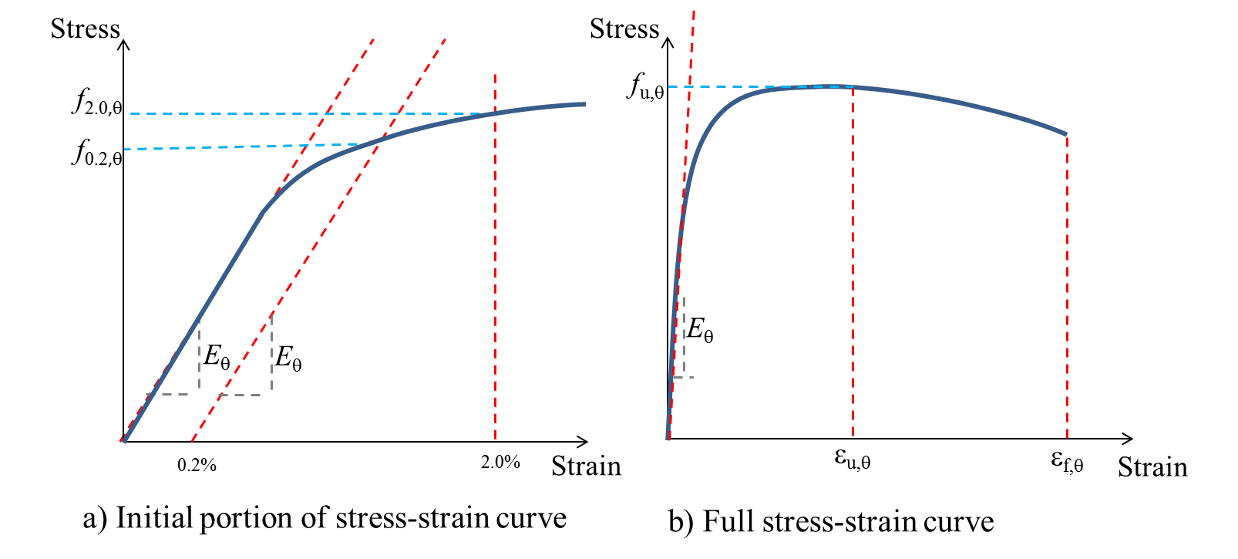
Figure 1

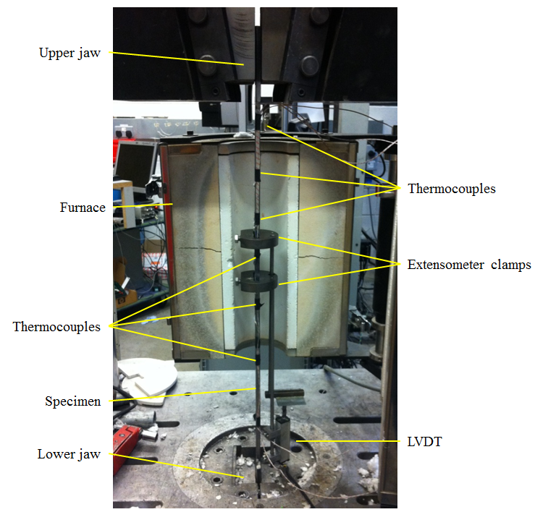
Figure 2

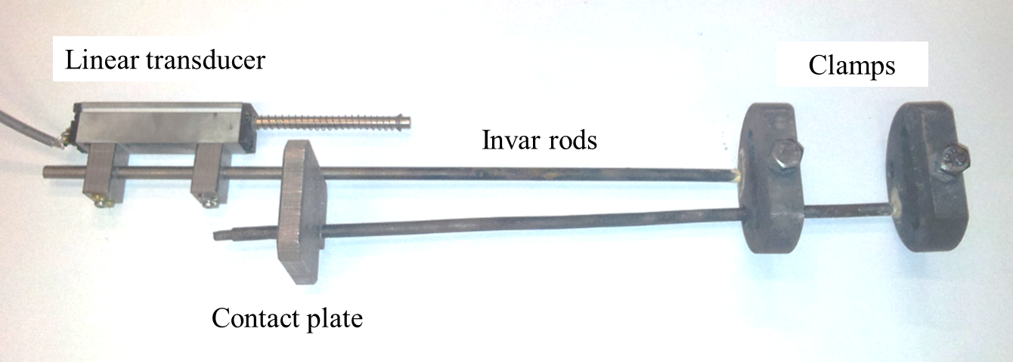
Figure 3

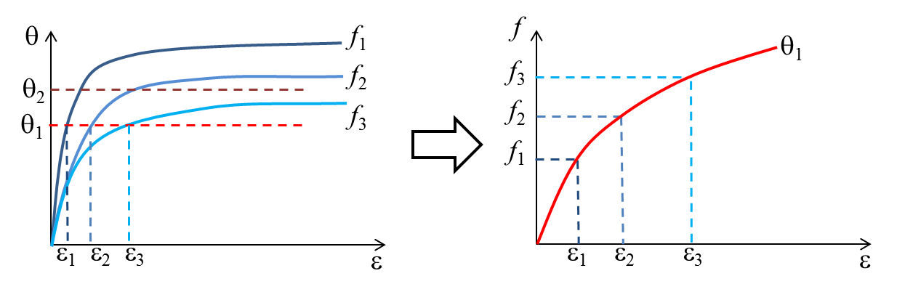
Figure 4

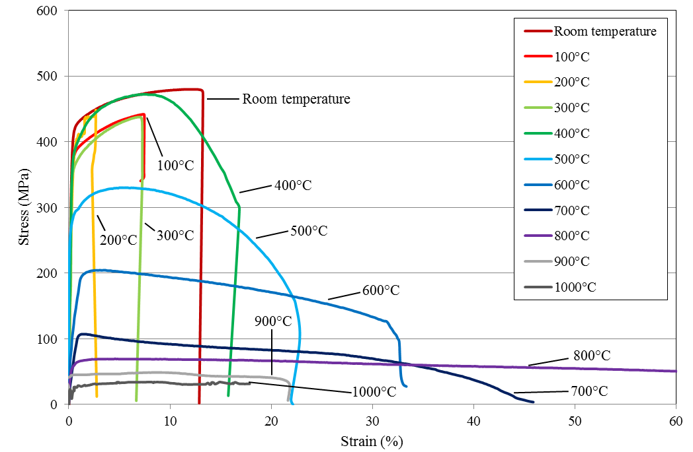
Figure 5

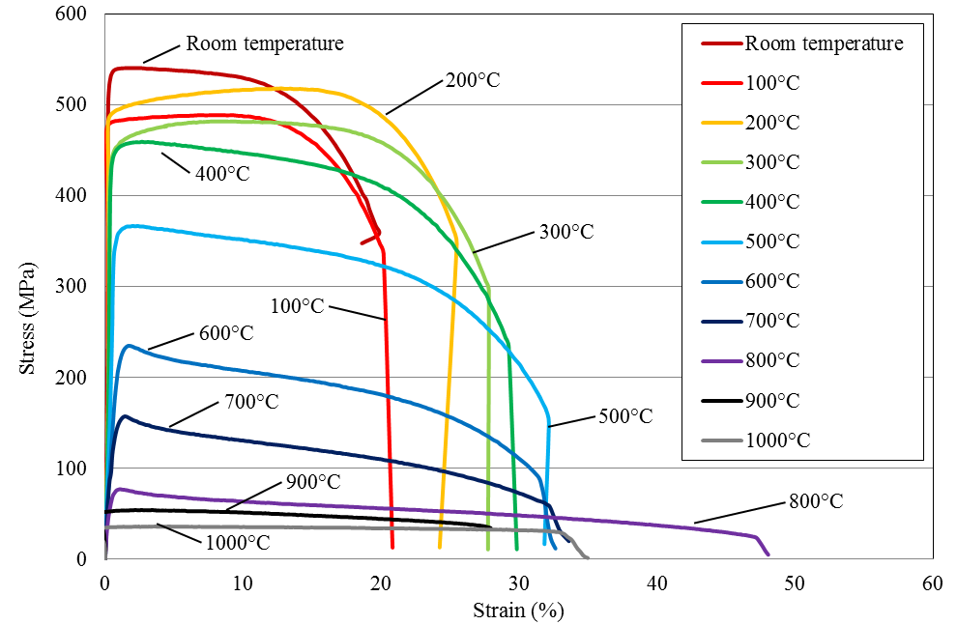
Figure 6

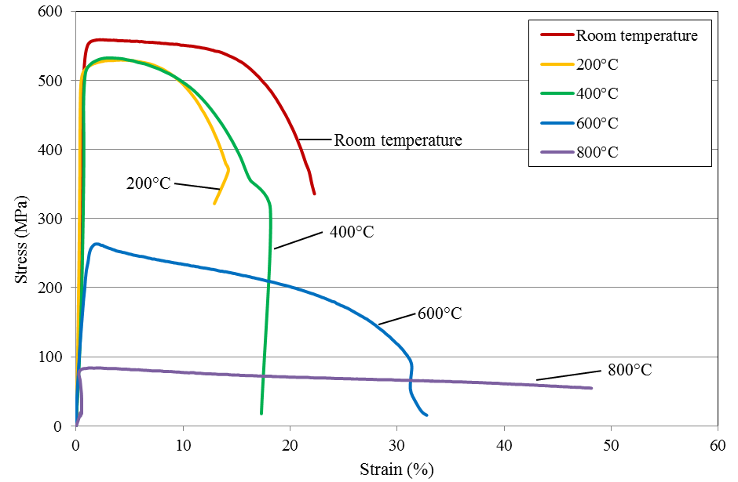
Figure 7

Figure 8

Figure 9

Figure 10

Figure 11

Figure 12

Figure 13

Figure 14

Figure 15

Figure 16

Figure 17

Figure 18

Figure 19

Table 1 Summary of specimen cross-sections and number of tensile coupon tests conducted
Section | Steady-state tests | Transient-state tests
CHS 193.7×8 | 11 | -
RHS 250×150×10 | 11 | 9
SHS 150×150×8 | 5 | 4

Table 2 Measured values of modulus of elasticity from steady-state tests
Temperature (°C) | Modulus of elasticity (MPa)
 | CHS | RHS | SHS
20 | 198600 | 198600 | 205000
100 | 200300 | 181300 | -
200 | 126800 | 163000 | 196500
300 | 123000 | 160700 | -
400 | 102200 | 159600 | 163500
500 | 114200 | 92700 | -
600 | 46800 | 54000 | 27900
700 | 11200 | 23700 | -
800 | 34000 | 20800 | 4700
900 | 7900 | 6000 | -
1000 | 9700 | 850 | -

Table 3 Measured values of 0.2% proof strength from steady-state tests
Temperature (°C) | 0.2% proof strength (MPa)
 | CHS | RHS | SHS
20 | 404 | 537 | 531
100 | 367 | 482 | -
200 | 373 | 493 | 510
300 | 360 | 444 | -
400 | 385 | 448 | 511
500 | 265 | 357 | -
600 | 115 | 219 | 224
700 | 107 | 139 | -
800 | 57 | 69 | 84
900 | 45 | 54 | -
1000 | 26 | 36 | -

Table 4 Measured values of strength at 2% strain from steady-state tests
Temperature (°C) | Strength at 2% strain (MPa)
 | CHS | RHS | SHS
20 | 443 | 541 | 558
100 | 417 | 485 | -
200 | 425 | 501 | 526
300 | 396 | 467 | -
400 | 435 | 451 | 529
500 | 318 | 367 | -
600 | 204 | 234 | 263
700 | 107 | 153 | -
800 | 66 | 75 | 84
900 | 45 | 54 | -
1000 | 31 | 36 | -

Table 5 Measured values of ultimate strength from steady-state tests
Temperature (°C) | Ultimate strength (MPa)
 | CHS | RHS | SHS
20 | 480 | 541 | 559
100 | 453 | 489 | -
200 | 435 | 519 | 529
300 | 438 | 482 | -
400 | 475 | 460 | 532
500 | 330 | 367 | -
600 | 205 | 235 | 263
700 | 107 | 157 | -
800 | 68 | 77 | 84
900 | 49 | 54 | -
1000 | 33 | 36 | -

Table 6 Measured values of ultimate strain from steady-state tests
Temperature (°C) | Ultimate strain (%)
 | CHS | RHS | SHS
20 | 10.400 | 1.496 | 2.540
100 | 7.392 | 6.883 | -
200 | 2.660 | 12.801 | 4.087
300 | 6.971 | 8.067 | -
400 | 7.460 | 2.661 | 2.894
500 | 5.300 | 1.997 | -
600 | 3.071 | 1.756 | 1.980
700 | 1.389 | 1.463 | -
800 | 4.566 | 1.061 | 2.207
900 | 8.194 | 2.577 | -
1000 | 7.507 | 3.671 | -

Table 7 Measured values of fracture strain from steady-state tests
Temperature (°C) | Strain at fracture (%)
 | CHS | RHS | SHS
20 | 13.2 | 24.3 | 22.3
100 | 7.1 | 24.3 | -
200 | 2.4 | 28.6 | 14.2
300 | 14.3 | 31.4 | -
400 | 21.4 | 31.4 | 18.2
500 | - | 35.7 | -
600 | 27.8 | 35.7 | 33.2
700 | 45.7 | 35.7 | -
800 | 89.9 | 47.1 | 51.6
900 | 44.3 | 31.4 | -
1000 | 36.4 | 38.6

Table 8 Tensile stresses applied in transient-state tests, predicted failure temperature ranges and actual failure temperatures
 | RHS |  |  | SHS
% of f_{u,20°C} | Applied stress (MPa) | Predicted failure temperature (°C) | Actual failure temperature (°C) | Applied stress (MPa) | Predicted failure temperature (°C) | Actual failure temperature (°C)
100% | 541 |  |  | 559
90% | 495 | 20 – 300 | 94 | - | - | -
80% | 441 | 400 – 500 | 394 | 458 | 400 – 600 | 484
70% | 402 | 400 – 500 | 456 | - | - | -
60% | 332 | 500 – 600 | 503 | 346 | 400 – 600 | 558
50% | 275 | 500 – 600 | 572 | - | - | -
40% | 231 | 500 – 700 | 554 | 194 | 600 – 800 | 659
30% | 168 | 600 – 700 | 660 | - | - | -
20% | 114 | 700 – 800 | 767 | 88 | 600 – 800 | 756
10% | 54 | 800 – 1000 | 791 | - | - | -

Table 9 Experimentally-derived retention factors for modulus of elasticity
Temperature (°C) | k_{E}
 | CHS steady-state | RHS steady-state | SHS steady-state | RHS transient-state | SHS transient-state
20 | 1.000 | 1.000 | 0.596 | 1.000 | 1.000
100 | 1.009 | 0.913 | - | 0.969 | -
200 | 0.639 | 0.820 | 0.936 | 0.906 | 0.817
300 | 0.619 | 0.809 | - | 0.831 | 0.725
400 | 0.515 | 0.804 | 0.779 | 0.769 | 0.690
500 | 0.575 | 0.466 | - | 0.598 | 0.509
600 | 0.236 | 0.272 | 0.133 | 0.280 | 0.081
700 | 0.057 | 0.120 | - | 0.049 | -
800 | 0.171 | 0.105 | 0.022 | - | -
900 | 0.040 | 0.030 | - | - | -
1000 | 0.049 | 0.004 | - | - | -

Table 10 Experimentally-derived retention factors for 0.2% proof strength
Temperature (°C) | k_{0.2}
 | CHS steady-state | RHS steady-state | SHS steady-state
20 | 1.000 | 1.000 | 1.000
100 | 0.908 | 0.898 | -
200 | 0.923 | 0.919 | 0.960
300 | 0.890 | 0.827 | -
400 | 0.953 | 0.834 | 0.962
500 | 0.656 | 0.665 | -
600 | 0.285 | 0.408 | 0.422
700 | 0.264 | 0.258 | -
800 | 0.140 | 0.129 | 0.158
900 | 0.111 | 0.100 | -
1000 | 0.065 | 0.067 | -

Table 11 Experimentally-derived retention factors for stress at 2% strain
Temperature (°C) | k_{2.0}
 | CHS steady-state | RHS steady-state | SHS steady-state | RHS transient-state | SHS transient-state
20 | 1.000 | 1.000 | 1.000 | 1.000 | 1.000
100 | 0.941 | 0.896 | - | - | -
200 | 0.958 | 0.927 | 0.943 | - | -
300 | 0.893 | 0.864 | - | 0.815 | -
400 | 0.980 | 0.834 | 0.948 | - | -
450 | - | - | - | 0.685 | 0.821
500 | 0.717 | 0.679 | - | 0.537 | -
550 | - | - | - | 0.500 | 0.620
600 | 0.459 | 0.432 | 0.471 | - | -
650 | - | - | - | 0.241 | 0.348
700 | 0.240 | 0.283 | - | - | -
712 | - | - | - | - | 0.158
750 | - | - | - | 0.083 | -
800 | 0.150 | 0.138 | 0.151 | - | -
900 | 0.102 | 0.100 | - | - | -
1000 | 0.069 | 0.066 | - | - | -

Table 12 Experimentally-derived retention factors for ultimate strength
Temperature (°C) | k_{u}
 | CHS steady-state | RHS steady-state | SHS steady-state | RHS transient-state | SHS transient-state
20 | 1.000 | 1.000 | 1.000 | 1.000 | 1.000
100 | 0.945 | 0.904 | - | - | -
200 | 0.905 | 0.959 | 0.947 | - | -
300 | 0.912 | 0.891 | - | - | -
400 | 0.989 | 0.850 | 0.953 | - | -
450 | - | - | - | 0.913 | -
480 | - | - | - | - | 0.821
500 | 0.688 | 0.679 | - | - | -
550 | - | - | - | 0.713 | -
560 | - | - | - | - | 0.620
600 | 0.428 | 0.435 | 0.471 | 0.608 | -
650 | - | - | - | 0.508 | 0.348
700 | 0.223 | 0.291 | - | 0.416 | -
750 | - | - | - | 0.311 | 0.158
800 | 0.141 | 0.143 | 0.150 | - | -
900 | 0.102 | 0.100 | - | - | -
1000 | 0.068 | 0.067 | - | - | -

Table 13 Experimentally-derived retention factors for ultimate strain
Temperature (°C) | k_{εu}
 | CHS steady-state | RHS steady-state | SHS steady-state
20 | 1.000 | 1.000 | 1.000
100 | 0.711 | 4.602 | -
200 | 0.256 | 8.559 | 1.609
300 | 0.670 | 5.394 | -
400 | 0.717 | 1.779 | 1.139
500 | 0.510 | 1.335 | -
600 | 0.295 | 1.174 | 0.780
700 | 0.134 | 0.978 | -
800 | 0.439 | 0.710 | 0.869
900 | 0.788 | 1.723 | -
1000 | 0.722 | 2.455 | -

Table 14 Experimentally-derived retention factors for fracture strain
Temperature (°C) | k_{εf}
 | CHS steady-state | RHS steady-state | SHS steady-state | RHS transient-state | SHS transient-state
20 | 1.000 | 1.000 | 1.000 | 1.000 | 1.000
94 | - | - | - | 1.059 | -
100 | 0.536 | 1.000 | - | - | -
200 | 0.179 | 1.176 | 0.638 | - | -
300 | 1.085 | 1.294 | - | - | -
390 | - | - | - | 1.235 | -
400 | 1.623 | 1.294 | 0.815 | - | -
455 | - | - | - | 1.294 | -
480 | - | - | - | - | 3.022
500 | - | 1.471 | - | 1.235 | -
560 | - | - | - | 1.294 | 2.853
600 | 2.109 | 1.471 | 1.491 | - | -
613 | - | - | - | 1.412 | -
659 | - | - | - | - | 3.053
700 | 3.466 | 1.471 | - | - | -
746 | - | - | - | - | 3.060
800 | 6.826 | 1.941 | 2.318 | - | -
900 | 3.360 | 1.294 | - | - | -
1000 | 2.758 | 1.588 | - | - | -

