Innovative methods of ground improvement for two problematic UK railway earthwork materials
MAVROULIDOU M.^{1*}, SAFDAR MU¹, GUNN MJ¹, GRAY C.¹, PAYNE I.², GARELICK J.² , and PURCHASE D.³
¹London South Bank University, 103 Borough Road, SE1 OAA, London, UK
²Network Rail, UK
³School of Natural Sciences, Faculty of Science and Technology, Middlesex University, UK

*corresponding author:
e-mail: mavroum@lsbu.ac.uk

Abstract The paper focuses on emerging (bio-) chemical techniques used to improve engineering properties of two problematic earthwork materials of the UK rail network to address transport earthwork infrastructure resilience in view of climate change. Studied techniques include novel cementing agents (e.g. alkali-activated cements), and/or soil cementation through calcite precipitation mediated by screened and isolated non-pathogenic indigenous bacteria, enhanced by bioaugmentation and electrokinetic treatment. The proposed treatments were evaluated based on unconfined compressive strength (UCS). For the ash, regular cement gave the best results however the feasibility of using alternative stabilisers merits further study. UCS and CaCO₃ measurements proved biocementation of peat for a number of treatment combinations. Electrokinetic treatment enhanced the strength of the peat. Ongoing work is carried out to optimise treatments and implementation methods towards the upscaling of the techniques.

Keywords: Disaster risk management; Solid waste management; sustainability; innovative cements; calcite precipitation; electrokinetics; ground improvement.
- Introduction
In a number of European countries, old and poorly constructed railway transport infrastructure earthworks are suffering from serviceability problems or failures. They require continuing and costly maintenance/ remediation works that produces considerable waste and environmental pollution. This is becoming a major constraint for railway owners and operators, especially in view of the increased risk of hazards posed by climate change. In this paper we study in situ chemical stabilisation for improved sustainability of maintenance practices. We focus on two problematic materials of the UK railway network, namely peat (a soft foundation soil also subject to oxidation wastage) and locomotive coal ash, used as a regulatory layer in the late 19th and early 20th centuries to maintain poorly constructed embankment height. Ash degradation has since been causing continued problems for railway owners and operators. This has led to a replacement scheme in parts of the London Underground network, generating vast quantities of waste and demand of non-renewable natural granite aggregate. It has therefore become imperative to find ways of stabilising rather than replacing this ash. Treatments considered were common chemical soil stabilisers such as cement (suitable for most inorganic soil types) or lime, most suitable for clays/clayey soils as well as sodium silicate (waterglass, WG), used for grouting versus more novel cementing agents, namely: (a) alkali-activated (AA) cements (Provis et al, 2015) containing an industrial by-product, ground granulated blast furnace slag (GGBS) and a waste material, paper sludge ash (PSA); (b) enzymatically induced calcite precipitation, using a commercially supplied enzyme or an enzyme obtained from microorganism action here used for the peat soil.. For the peat, which is under existing embankments, we also used electrokinetics (EK) as a promising technique to implement treatments.
- Laboratory testing
The ash sample as collected from the field was a mixture of ash, ballast, organic matter (plant remains) and other impurities/debris. Its particle size distribution based on dry sieving is shown in Fig 1. It is a multi-graded soil (C_{u}=22) with fines content of 1.3%. The material used for testing was the portion passing the 4.75mm mesh sieve as discarding large particles and debris /impurities enabled testing using conventional laboratory apparatus. The pH of the sieved sample was 7.7 and its natural moisture content was 30.1%. At this water content the corresponding standard Proctor compaction bulk density was 1.33 g/cm³; this was the compaction density used for all unconfined compressive strength (UCS) testing samples. The peat soil was taken from two boreholes at an East Anglian railway site. The presented results are based on eighteen soil samples (nine from each borehole) from depths of 0-2m with similar pH, water and organic contents (average values of 7.15, 55.5% and 51% respectively). The samples were described as dark brown, mostly amorphous, with a mixture of mineral and organic soil fractions. Fig 1 shows the particle size distribution of the portion of the soil sample retained for testing (passing 1.18 mm sieve) based on sieving, followed by hydrometer testing (BS, 1990). Enrichment for ureolytic bacteria and selection of isolates was followed by microbial identification and diagnosis using matrix-assisted laser desorption/ ionization time-of-flight/time-of-flight tandem mass spectrometry (MALDI-TOF/TOF MS) proteomic-based biotyping approach. Candidate strains for biocemen-tation were then selected based on urease activity measured with a Urease Activity Assay kit (Colorimetric; Abcam, US). The success of the treatments was assessed based on the unconfined compressive strength (UCS) of statically compacted peat samples at the original dry density of the peat (0.919 g/cm³), their CaCO₃ content measured by acid digestion and SEM-EDS tests (not shown here).
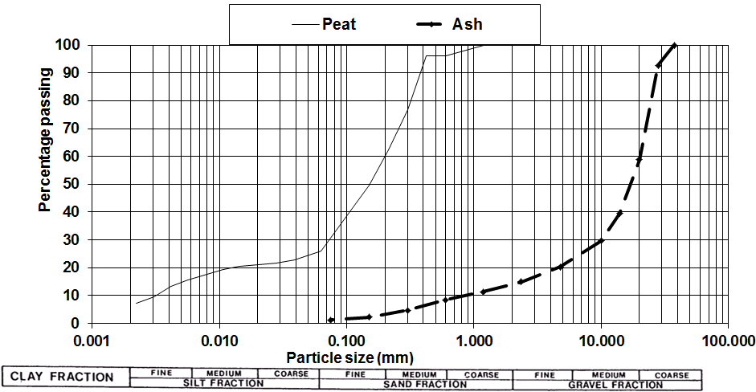
Figure 1. Particle size distribution of tested samples
- Results
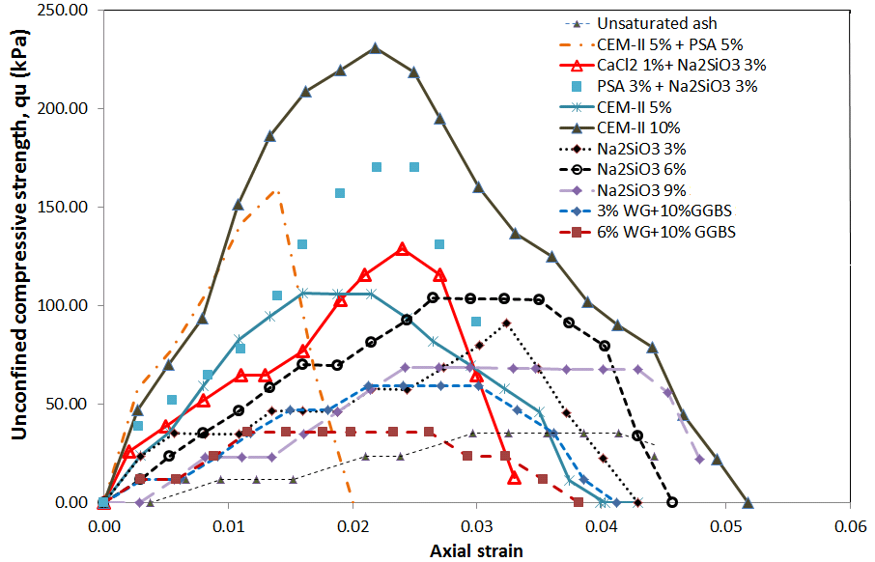
Figure 2. Indicative results of ash treatment
Fig 2 shows some indicative results of chemical treatment of ash (implemented in slurry/solution form). All treated ash samples showed enough cohesion to be tested using UCS procedures, despite the higher moisture contents than the untreated ash (thus reducing suction effects). Whilst cement applied at dosages of 10% gave the best results, satisfactory unconfined compressive strengths were obtained in a number of other cases (e.g. mixes with sodium silicate). Enzymatically induced calcite precipitation did not occur for the ash and needs to be further investigated. For this reason biocementation was not attempted for the ash, until calcite precipitation using commercial enzymes has been proven. For the peat microbially induced calcite precipitation was proven, as shown in Table 1 with indicative results of Bacillus licheniformis (BL) and Lysinibacillus fusiformis (LF) tests. Namely UCS (q_{u}) strengths increased and increased CaCO₃ content was detected. Most presented results used pressure flow for treatment implementation unless marked EK (electrokinetics); for EK (r),(l),(m), refer respectively to right and left electrodes and middle of sample. EK (with polarity reversal) enhanced the processes (even without the use of bacteria EK was successful in increasing the peat strength) (Table 1). Some limited study of other chemical peat treatments (7-day curing) was also performed: GGBS activated by lime slurry showed promise but feasible implementation under existing embankments needs to be investigated.
Table 2. Indicative results of peat biocementation study
Test ID | Culture (cfu/ml) | CH₄N₂O (M) : CaCl₂ (M) | Flushing(days) | Curing (days) | q_{u} (kPa) | CaCO₃ (%)
Peat | N/A | N/A | N/A | N/A | 174 | 0.06
Nutrients | N/A | N/A | 3 | 7 | 313 | 0.13
BL1 | 1x10⁸ | 0.25:0.25 | 3 | 1 | 341 | 0.99
BL2 | 1x10⁸ | 0.75:0.75 | 3 | 1 | 428 | 1.28
BL3 | 1x10⁸ | 1:1 | 3 | 1 | 380 | 0.91
BL4 | 1x10⁸ | 1:1 | 3 | 7 | 352 | 0.85
BL5 | 1x10⁸ | 1:1 | 3 | 14 | 348 | 0.74
BL6 | 1x10⁷ | 0.25:0.25 | 3 | 1 | 340 | 0.93
BL7 | 1x10⁷ | 0.75:0.75 | 3 | 1 | 400 | 1.19
LF1 | 1x10⁷ | 1:1 | 3 | 1 | 341 | 0.82
LF2 | 1x10⁸ | 1:1 | 3 | 1 | 400 | 1.03
LF3 | 1x10⁸ | 1:1 | 3 | 7 | 326 | 0.22
EK-BL | 1x10⁸ | 1:1 | 14 | 1 | 458 (r)  412(m)  448 (l) | 1.71  1.16  1.24
EK-nutrient | N/A | N/A | 14 | 1 | 378 (r)  320(m)  356 (l) | 0.13  0.13  0.19
EK-water | N/A | N/A | 14 | 1 | 359 (r)  305(m)  347 (l) | 0..20  0.14  0.19
- Conclusions
The results show potential soil improvements for the techniques used. Further optimization of mixes and processes is underway. For ash, the feasibility of enzymatically induced calcite precipitation needs to be further investigated. For the peat biocementation using indigenous non-pathogenic bacteria was proven; this is environmentally beneficial, as the interference on the local microbial ecology is reduced compared to solutions using exogenous to the location bacteria. The implementation methods are actively investigated towards upscaling: in particular EK is studied as a method of conveying the treatments under the existing embankments without pore pressure development or change of groundwater table level (this reduces peat oxidation and wastage hazards). The results are of particular importance for linear infrastructure owners, who have interest in finding more sustainable earthwork maintenance methods, minimising waste and costs.
References
BS 1377:1990 (1990). Methods of test for soils for civil engineering purposes. Classification tests. BSI, London, UK.
Provis, J., Palomo, A. and Shi, C. (2015). Advances in understanding alkali-activated materials. Cement and Concrete Research, 78A, 110-125.

