COMMUNITY RESPONSE FROM NOISE EMISSIONS FROM LONDON HELIPORT OPERATION

Luis Gomez Agustina, Stephen Dance
The Acoustics Group, School of the Built Environment and Architectural, London South Bank University, London SE1 0AA. UK

email: gomezagl@lsbu.ac.uk

- The noise emissions from the operation of heliports situated in cities can have significant adverse impacts on a large number of local residents. Despite its significance this topic is under studied. This paper presents the subjective part of a novel study on the noise emissions and associated impact from the London (UK) heliport operation. The heliport is situated in a densely populated area with the nearest residency located at 150m from the heliport boundary. The complete study was designed to obtain relevant objective and subjective data during the summer months. An extensive community response survey was implemented during the same period of the noise monitoring exercise in the form of an online questionnaire to obtain perceptions and attitudes from residents of the three boroughs surrounding the heliport. Subjective survey results were analysed to quantify and qualify the extent of the noise effects on residents. These results were also contrasted against the objective results and other relevant social surveys found in the literature. A high participation rate was obtained and results showed that noise emissions from the heliport operation cause adverse impact on quality or life and well-being of a large majority of respondents. The level of annoyance reported by respondents appeared higher than the level of annoyance attributed to noise measurements at monitoring sites reported in the objective survey. Results from the objective part of the study are presented in a separate paper elsewhere.

Introduction
Heliports located in metropolitan and urban areas offer convenient and swift airborne transport to strategic locations in the middle of densely populated areas. Essential services such as police, ambulance, emergency services and the military may use these heliports. However, typically most flights from privately owned heliports are allocated for business activity and recreational purposes [1]. Despite the economic and civil benefits that urban heliports can bring to the host city, there has been increasing concern amongst members of the public on the adverse effects of helicopter noise on the well-being and quality of life [2][3]. Numerous and interrelated factors can be involved in the acceptability of heliport operations in densely populated urban areas. These factors can be acoustically related such as the close proximity of the heliport and flight routes to residences, building vibration and the distinctive and impulsive nature of helicopter noise.
Non-acoustical factors such visual intrusion, fear of crashing, air pollution, opinion on purpose of the flights, lack of control and property devaluation can be significant contributors to the lack of acceptability and subsequence annoyance experienced by local communities [4].
Only a limited number of relevant studies [3] [5][6-10] could be found in the literature investigating the noise emissions from urban heliport operations and their impact on the local community. However, most of those can be considered relatively dated when considering the recent advances in helicopter noise control. This may suggests a lack of research attention on this significant urban environmental problem. Only few relevant studies to our investigation were found in the literature which covered London (England, UK) [8-11].
A complete study was carried out on the noise emissions and their impact on local residents from the London Heliport operations. This study consisted of a long term noise monitoring exercise (Objective survey) and a community response survey (Subjective survey). The subjective survey, which this paper reports, was designed and implemented in 2017 to collect information on the perceptions and attitudes of local residents from the noise emissions. Results allowed to qualitatively assess the significance of impact from the noise emissions received by affected residents. The subjective survey was also intended to complement the objective study and to allow comparison of findings between the two. The objective part of the complete study is reported in a another paper elsewhere [12]

London Heliport
The London Heliport is located by the south bank of the river Thames in Battersea, London SW11 3BE, and is London’s only commercial heliport. The heliport at Battersea was built in 1959, when the urban landscape in London and particularly around the river banks exhibited a much less presidential built density. It is sited in an area of rapid housing development, Fig.1.
Operational restrictions were first imposed on the heliport by the former Greater London Council (GLC) during the 1970’s. The maximum of annual movements has since been limited to 12,000 with a maximum of 80 movements per day. This allowance does not include air ambulance, police or military aircraft. The Heliport is only allowed to operate from 0700-2300 hours, 7 days a week. Most helicopters flying to or from the heliport are instructed, when possible, fly over the centre of the river Thames and be at the highest possible safe altitude while approaching or taking off [2]. From 2005 the minimum flying altitude for helicopters to fly over London has been reduced to 1000feet [2]. London Heliport operates a “Fly Neighbourly” policy [1] in attempt to minimise the potential environmental noise impact on the local community.
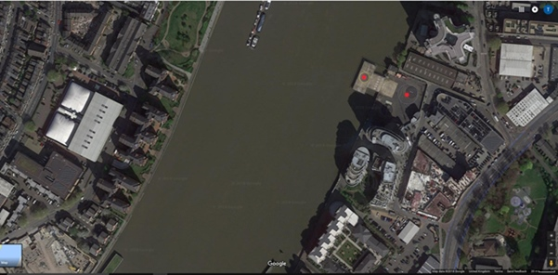
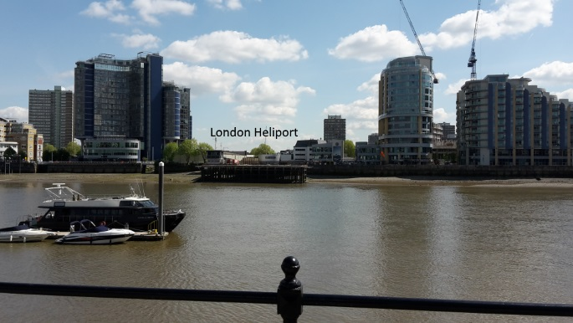
Figure 1: Left, Aerial view of London Heliport (red dots) and surrounding housing developments,©GoogleMaps; Right, London Heliport landing pad view from the north bank.

Survey design
An online survey questionnaire was chosen as the most suitable tool to obtain information from a large and representative sample of the target population. The design aimed to collect demographic, perceptual and attitudinal data from residents of the three boroughs surrounding the heliport namely: Wandsworth, Hammersmith and Fulham (H&F), Kensington and Chelsea (K&C). The survey was publicised through the boroughs’ online communication channels between July and September 2017. The participation in questionnaire was of opted-in basis and anonymous.
Eligible respondents were defined as any resident of any of the three boroughs of interest above the age of 18. The questionnaire consisted of 33 close ended multi choice type of questions. The last question allowed the respondent to add comments in a free text box. This consultation period was made to approximately coincide with the objective survey period (May 2017- September 2017). Summer months were defined in the questions as the period between 2nd May and 2nd September.
Questions were grouped in three section relative to the type of data intended to gather. These section were called: 1- About your home, 2- About the noises you hear and related issues 3- Some information about you. The questionnaire development consisted of a series of draft iterations and pilot runs to help to provide confidence in the validity and reliability of the final version of the questionnaire and its results.

Results
This section presents statistical results and other relevant information from responses of the most important questions. Analytical discussion is also grouped in different subsections.

Participation
A total of 1570 valid completed online questionnaires were received and processed. The total number of residents in three boroughs was 661,200 (2016 census).
61.2% of the respondents declared that have lived in their property between 5 and 10 years or more; 21.2% between 2 and 5 years. Only 7.6% declared to have lived in their property one year or less. This shows that a large proportion of the respondents (sample) have lived long enough in their property to have experienced noise emission from the heliport noise emissions.
Almost half of the responses were received from Wandsworth residents (49.4%), while almost the other half came from H&F (48.6%). Response rate from K&C was extremely low (2%). This is likely to be attributed to a weak or non-existent promotion of the survey in that borough in the wake of the Grenfell Tower Fire (14/11/ 2017). The proportion of male respondents was of 50.5% while females was 44.5%. The vast majority of respondents (89%) were aged between 25 and 75 years old.

About the participant’s home
More than three quarters of the sample (78.3%) own their home, while 19.9% declared that they rent their home.
42.7 % of the respondents have their home in direct line of sight or slightly off line of sight of the heliport. 31.8% have their home not facing the river shore or in a street set back.
The proportion of respondents whose home was within 1600m from the heliport is 61.7%. It is worth to note that 17.2% situated their home at more than 1600m from the heliport and 21.2% responded that they did not know the approximate distance of their home from the heliport.
This data suggests that substantial proportion of the respondents live within an area affected by the heliport or by the approach and take of flight paths.
Almost three quarters of the respondents (73.4%) reported to have openable double glazed or better windows where they spend most of their time at home, while one quarter (25.1%) declared to have single glazed windows.

About the noises heard and related issues
Detailed results from the two main attitudinal questions Q12 and Q13 of the questionnaire are presented below in Fig. 2 and Fig. 3.

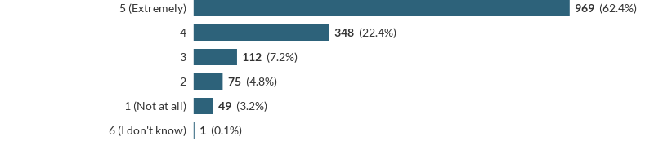
Q12: “Thinking about the summer months (2nd May – 2nd Sept), when you are at home with windows open, how much if at all, does helicopter noise disturb or annoy you? Please rate between 1= (Not at all) to 5= (Extremely) “

Figure 2 : Responses to Q12 on annoyance from helicopter noise with windows open during summer months
Figure 2 shows that 84.8% of respondents felt highly annoyed by helicopter noise during summer months with windows open.

Q13 “Thinking about the summer months (2nd May – 2nd Sept), when you are at home with windows closed, how much if at all, does helicopter noise disturb or annoy you? Please rate between 1= (Not at all) to 5= (Extremely)”

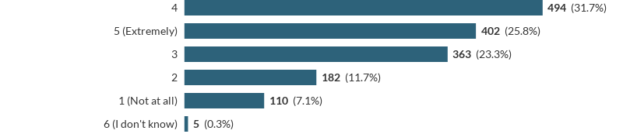
Figure 3 : Responses to Q12 on annoyance from helicopter noise with windows open during summer
Figure 3 shows that 57.5% of respondents felt highly annoyed by helicopter noise during summer months with windows closed. The majority of respondents (57 %) felt able to differentiate clearly between helicopters flying overhead without interacting with the heliport and helicopters approaching to land or leaving the heliport.
The vast majority of respondents (80.6%) expressed that on average they heard very frequently or frequently helicopter noise during an average summer day
Between 72% and 82% of respondents declared that helicopter noise in the summer time interfered with the following activities: having a conversation, quiet leisure activities, listening to the radio, spending time in the accessible outdoor area of the home, or having the windows open.
The majority of respondents (52.4%) felt that helicopter in the summer time (2nd May – 2nd Sept) noise interfere with sleeping patterns, “e.g. the time you go to bed or get up, or are kept awake”.
The vast majority of respondents (95.8%) believed that helicopter noise sounded much louder than the background noise in their home at the time of a fly pasts. This result is consistent with the relevant results obtained in the objective (noise monitoring) survey.

Figure 4 show response distribution to question 18 of the online questionnaire.

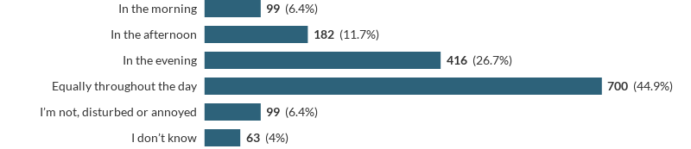
Q18 “In a typical weekday during summer (2nd May – 2nd Sept), please indicate if there is a part of the day when you were most, disturbed or annoyed by helicopter noise ?”

Figure 4 : Part of a weekday of summer when disturbance/annoyance from helicopter noise is mostly felt.
The two most selected factors that most disturb residents from the heliport operation were: loudness of helicopter noise (30.6%) and frequency content of helicopter noise (14.2%).

Other relevant attitudinal information
46.1 % of respondents have considered “sometimes” “often” or “very often” moving out of their home because the helicopter noise.

Figure 5 shows the response distribution to the question Q27 about the respondent awareness of a selection of sources of information on helicopter noise.

Q25 Are you aware of any of the following ? (Please select the ones that apply)
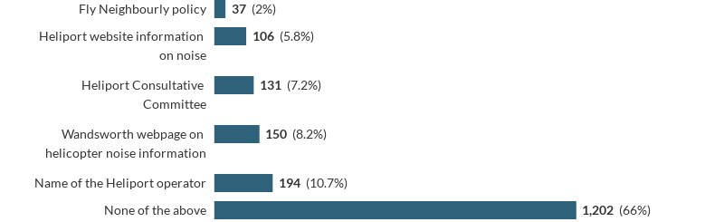
Figure 5: Respondents awareness of sources of information on helicopter noise related issues

Despite the proportion of affected residents seen in results reported above, only 11.1% of the respondents declared they have made a formal complaint about the helicopter noise
More than a quarter of the respondents (27.4%) expressed that would be happy to participate in semi-structured interviews and more than a third (33.9%) would be happy to volunteer to allow helicopter noise measurements to be taken at their home.
Almost half of the respondents (49%) provided extra comments in the last free text box question. The vast majority of these comments expressed dissatisfaction, frustration and/or distress as a result of noise emission from the heliport operation. A very small proportion of comments indicated overall satisfaction or no disturbance caused by the heliport noise emission. These comments reflect the percentage or residents not annoyed or bothered by helicopter noise as shown in Fig. 2, 3 and 4.

Below there is a collection of some examples of comments (verbatim) provided in the free text box provided in the last section of the questionnaire.
“The noise can be deafening. You have to stop whatever you're doing until the helicopter passes especially when they fly too low, which is very often. I end up never using my balconyn as a result”.

“The very large black helicoptor is now becoming a regular occurance, this makes the entire flat vibrate when it is active on the helipad and when flying past”.
“have never complained as I assume like the Heathrow complaints procedure it is a waste of time as nothing changes”.
“..and we have to actually stop telephone conversations when the helicopters take off and land”
“I have noticed an increase in noise pollution from helicopters over the past year. It affects me and my husband every day and we find the noise stressful, as well as interfering with our daily activities (talking on the phone/working from home/watching TV etc). We are considering selling our flat and moving areas SOLELY due to the noise pollution of this area”.

“The frequency of helicopters flying past our house (particularly between Friday and Sunday) has got worse over the last 12 months. The noise is so loud that it cuts above conversations, TV, or any other noise. We have had to close our doors during the hot summer months on occasions in order to be in our home. Please help us!!”.

“I live in Prices Court. Noise has got far worse since the new tower block has been built by the railway bridge. NoW almost every single helicopter approaches Prices Court before turning to approach the heliport. The approach and takeoff paths have changed since the new building due to its height. I cant now have the windows or doors open (which has been a nightmare with the recent hot weather) because of the noise making it impossible to hear the television or anything else”.

“I've noticed more activity over the years and neighbours asked me to complete this survey. I'm not that close to the heliport that I'm bothered by it every day and frankly have become desensitized to the sound, but visitors and overnight guests notice the noise.
“When out and about in the neighbourhood, especially by the river, the frequency is more noticeable and I imagine for people in the flats on the river, it must be unbearable”.

“I am irritated by pilots keeping the engines running on the ground. The noise bounces off the flats opposite. Some pilots pass opposite my third floor flat. Others higher up. Some take off or land more vertically than others. More use the west side than the east.”

“Noise and volume of traffic is out of control, the peaceful river residential area i brought into, is now a noisy polluted stressful location. .. more and more helicopters, more noise.. more pollution.. its absurd the vast amount of time and money spent on monitoring the helicopters, wasted complaints.. is no one listening.. sit by the river opposite the heliport try and have a conversation, its impossible, try and work from home impossible.. try and live peacefully”.

“It's been there longer than I have (I've been there 17 years) and so not sure why anyone would complain. Perhaps before people move in they should be told about it if they're very sensitive but as far as I'm concerned it's great!”.

“The Battersea heliport is part of the community and I have no wish to stop the operation. We should however insist on quieter aircraft”.

From a content text analysis of the information collected in the free text box, it appears clear that important adverse effects are created on the quality of life and well being of many residents by the heliport operation noise emissions.

Residents of the three boroughs were not offered the possibility to direct complaints to the researchers of the surveys. However, at least 26 unofficial and spontaneous complaints and reports have been received by the researchers via email complaining about the adversely impact on living conditions and well being caused by the heliport operation noise emissions.
From a content text analysis and from the unofficial complaint emails received by the researchers, it appears that affected residents are not clear where or how best direct their formal complaints.

Discussion
Some factors limited a desired higher participation rate. These included that the survey opened for a short time, the limited publicity provided by relevant boroughs, the survey run during summer holiday session and the virtual absence from K&C respondents.
Despite the above factors, the participation obtained can be regarded as very high if only Wandsworth and H&F boroughs are considered.
The demographic data of the sample provided evidence of the required diversity, relevance and validity of respondents.
The proportion of adversely affected residents by noise emission from the heliport operation in those two boroughs is very high.
The large majority of responses reporting extreme annoyance came from distances within the helicopter´s Air Traffic Zone which covers an area of 1800m of radius centred at the heliport.
The majority of respondents (52.6%) who stated that live within 1600m of the heliport helicopters approaching or leaving routes felt highly annoyed by helicopter noise with windows open, while 4.4% of respondents expressed “not annoyed at all ” or “very little annoyed”.
The level of annoyance caused by helicopter noise reported by respondents appears higher than the level of annoyance attributed to noise measurement at monitoring sites [12]. However it is important to note that many non-acoustical factors (such as location time of the day, socio economic factors) may influence when expressing attitudes and perception (annoyance/disturbance).
Qualitative results from a content text analysis of the information collected in the free text box appear consistent with quantitative results from relevant questions of the questionnaire. Those results clearly reveal the important adverse effects created by the heliport operation noise emissions on the quality of life and well being of many residents.
The main limitation of the subjective survey was the fact that responses were received only from residents who were aware of the online survey and decided to of opt-in to participate.
From responses obtained it appears that many affected residents are not be aware of the complaint systems available. That suggests that a more representative number of official complaints would be received if an effective and coordinated complaint handling system were in place.
The survey results suggest that despite implementing the specific recommendation of the 2006 GLA Study (London in a Spin) to establish a formal complaint recording and monitoring scheme for the heliport there is a very significant local reservoir of complaints about helicopter noise that are currently not being recorded.
Hence, it is believed that the current complaint handling and recording system is not suitable and appear ineffective. The survey questionnaire showed a high level of unawareness of their existence. It is recommended that a full review of the current system is undertaken with a view of improving its effectiveness and transparency.

Conclusions
A subjective survey in the form or an online survey questionnaire was designed and implemented in 2017 to collect perceptions and attitudes of local residents on the noise emissions from the London heliport operation. The subjective study complements an objective survey based on noise monitoring measurements undertaken simultaneously and reported elsewhere [12].
The survey questionnaire obtained a high participation rate.
The majority of respondents reported to feel extremely annoyed / disturbed by helicopter noise with windows open or closed.
Noise emissions from the heliport operation cause adverse impact on quality or life and well-being of a large majority of respondents.
Most responses received came from distances within the heliport Air Traffic Zone.
Results from this study are consistent with complaints received and logged by Heliport and local authorities’ complaints systems.
The level of annoyance caused by helicopter noise reported by respondents appears higher than the level of annoyance attributed to noise measurements at monitoring sites (see noise monitoring survey report [12]).
An upgraded and more effective complaint handling and monitoring system is recommended to be implemented as a more representative and reliable source of information on the impact of heliport operation noise emissions on affected local residents.

REFERENCES
- London Heliport, (2018). [Online], last accessed on 28 Jan 2018, available : http://www.londonheliport.co.uk/community/environment/
- London Assembly Environment Committee. London in a spin, a review of helicopter noise (2006):
- FAA (2004). Report to Congress: Nonmilitary Helicopter Urban Noise Study. Report of the Federal Aviation Administration to the United States Congress, Washington DC, USA. (2004).
- Waddington, D and Kendrick, P, Research into the improvement of the management of helicopter noise , Project Report, DEFRA, London, (2008)
- Fields JM, Powell CA. Community reactions to helicopter noise: results from an experimental study. Langley: NASA Langley Research Center, (1987).
- C.A.Powell. Subjective Field Study of Response to Impulsive Helicopter Noise, NASA Technical Paper 1833, (1981)
- J.M. Fields and C.A. Powell. Community reactions to helicopter noise: Results from an experimental study, Journal of the Acoustical Society of America, 82, 479-492, (1987)
- Ollerhead, J.B., Past and Present U.K. Research on Aircraft Noise Effects. Proceedings of the Noise-Control 93, Williamsburg, Virginia, USA, (1993).
- Ollerhead J.B., Jones C.J., Social Survey of Reactions to Helicopter Noise, London: Civil Aviation Authority, (1994)
- National Academies of Sciences, Engineering, and Medicine. Assessing Community Annoyance of Helicopter Noise. Washington, DC: The National Academies Press, (2017).
- Atkins, C.L.R., Brooker, P., Critchley, J.B. Helicopter disturbance study: main report. Civil Aviation Authority, DR Report 8304, London, UK. (1983).
- Dance, S. and Gomez Agustina, L. An investigation of the noise from London Heliport and the Effect on the Local Residents, Proceedings of Euronoise, Crete, Greece, 27-31 May, (2018).

Highly annoyed is taken as the compound descriptor formed of “extremely annoyed” corresponding to score 4 and “highly annoyed” is implied to correspond to score 4. Similarly “not annoyed at all” correspond to score 1 and “very little annoyed” is implied to correspond to score 2.

