A renewable lignin-derived bio-oil for boosting the oxidation stability of biodiesel

Yusuf Umar ª, Orlando Velasco ª, Omar Y. Abdelaziz ^{b,c}, Omar Aboelazayem ^{d}, Mamdouh A. Gadalla ^{e,f}, Christian P. Hulteberg ^{b,}*, Basudeb Saha ^{a,}*

ª School of Engineering, London South Bank University, 103 Borough Road, London
SE1 0AA, United Kingdom
^{b} Department of Chemical Engineering, Lund University, Naturvetarvägen 14, 221 00 Lund, Sweden
^{c} Department of Chemical Engineering, Cairo University, 1 Gamaa Street, Giza 12613, Egypt
^{d} Department of Chemical and Environmental Engineering, Faculty of Engineering, University of Nottingham, Nottingham NG7 2RD, United Kingdom
^{e} Department of Chemical Engineering, The British University in Egypt, El Sherouk City, Cairo 11837, Egypt
^{f} Department of Chemical Engineering, Port Said University, Port Fouad City, 42526 Port Said, Egypt
*E-mail addresses: christian.hulteberg@chemeng.lth.se; b.saha@lsbu.ac.uk
Abstract

The valorisation of lignin is being increasingly recognised to improve the economics of pulp and paper making mills. In the present study, an integrated lignin–glycerol valorisation strategy is introduced with an overarching aim for enhancing the process value chains. LignoBoost kraft lignin was subjected to base-catalysed depolymerisation using glycerol as a co-solvent. The generated bio-oil was used as a renewable additive to biodiesel for enhancing the oxygen stability. The influence of three independent parameters including temperature, time and glycerol amount on lignin depolymerisation was investigated. Response surface methodology was applied to design the experiments and to optimise the process for maximising the yield and antioxidant impact of bio-oil. The results showed that glycerol has a positive qualitative and quantitative impact on the produced bio-oil, where an enhancement in the yield (up to 23.8%) and antioxidant activity (up to 99 min induction period) were achieved using the PetroOxy method (EN16091). The addition of 1 wt% bio-oil on biodiesel led to an improvement in the oxidation stability over a neat sample of up to ~340%, making it compliant with European standard (EN14214). The proposed process presents a biorefinery paradigm for the integrated utilisation of waste cooking oil, lignin and glycerol.

Keywords:
Biodiesel; Lignin valorization; Renewable antioxidants; Supercritical methanolysis; Response surface methodology; Oxidation stability.
Graphical abstract

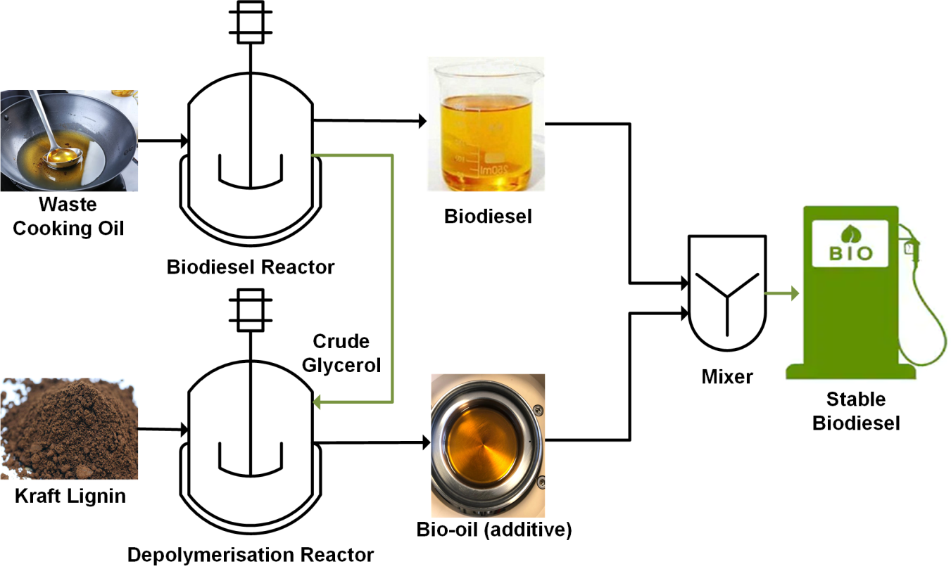

Highlights
- Bio-additives from the base-catalysed depolymerisation of LignoBoost kraft lignin.
- Effect of reaction variables on bio-oil yield and biodiesel oxidation stability.
- Oxidation stability of biodiesel increased up to 340% by adding 1 wt% bio-additive.
- An integrated biorefinery concept for valorising lignin and glycerol waste streams.

Abbreviations:
BBD, Box–Behnken design; FFA, free fatty acids; IP, induction period; RSM, response surface methodology; WCO, waste cooking oil.

1. Introduction

Biodiesel is identified as an alternative renewable fuel to petroleum diesel. It is composed of mono-alkyl esters of long-chain fatty acids derived from vegetable oil, algae and animal fats. It is conventionally produced via transesterification in the presence of a catalyst and an alcohol, such as methanol or ethanol, resulting in glycerol as the main side-product. Methanol is widely used as an alcohol due to its availability, low cost and the similar properties of methyl esters with petroleum diesel [1]. Second-and third-generation feedstocks, including non-edible vegetable oils and waste cooking oil, are considered as potential resources for biodiesel production as they do not compete with the resources of the food industry. Such feedstock are known to contain a high level of free fatty acids (FFA) of which are subjected to several pre-treatment steps prior to transesterification, including esterification and neutralisation. The presence of water during the conventional transesterification also results in saponification side reactions [2,3]. Recently, supercritical production of biodiesel has been reported as an efficient process for simultaneous transesterification and esterification of triglycerides and FFAs. The reaction occurs at elevated temperature and pressure to reach the supercritical condition of the used alcohol [4]. This technology offers several advantages, including simple product separation (only biodiesel and glycerol), elimination of wastewater (washing step), rapid reaction time and high yield of biodiesel. On the other hand, the high excess of alcohol and safety concerns in process operation are considered as the main drawbacks [1,5].

Our research group has comprehensively worked on the supercritical production of biodiesel from different waste cooking oil (WCO) feedstocks. The work has started with low acidity WCO collected from households, where the optimal yield of biodiesel achieved was 91% [6,7]. We have then considered high-acidity WCO collected from industries where we have observed an increase in biodiesel yield by up to 98% at relatively milder conditions [8] and an average of 99% conversion of the FFAs [9]. However, we have noticed that the produced biodiesel has relatively low oxidation stability, an aspect that initiated the present research.

One of the main concerns in commercialisation of biodiesel is the oxidation stability [10]. Oxidation alters the physiochemical properties of biodiesel and leads to further complications by the formation of undesirable products in diesel engines. The products formed damage the engine by causing elastomer degradation, mechanical degradation, etc., and as a result, leading to failure of engine parts [11]. An antioxidant is a compound that delays the oxidation reactions of biodiesel. A naturally occurring antioxidant exists in biodiesel feedstock [12]. Lima et al. [13] reported that Buriti oil showed high oxidative stability despite its high level of unsaturation ~80% due to the presence of natural antioxidant tocopherols. However, tocopherols have negligible effects compared to most of the commercial phenolic antioxidants [14]. It has also been reported that tocopherols get destroyed during transesterification, caused by elevated temperatures, which could be the main reason for having low stability biodiesel from supercritical processes [15].

Lignin is the most abundant aromatic-based biopolymer on Earth, and its aromaticity makes it a platform macromolecule with high potential for the production of various valuable products [16]. The valorisation of lignin to higher-value applications is essential to improve the economics of biomass conversion [17–19]. Lignin in the pulp and paper industry is mostly considered as a waste side-product where it is conventionally used on-site and burnt in recovery boilers to generate energy. LignoBoost is a well-proven technology for commercial-scale lignin extraction from kraft black liquor [20]. This process enables the recovery of high-purity lignin with rather high solid content and low ash and carbohydrate contents. The recovered lignin has a diverse range of possible applications, from bulk uses, e.g. as a fuel for boilers and lime kilns, to value-added uses, e.g. carbon fibres. In view of the prevailing role of kraft technologies and that lignin is an abundant, inexpensive, renewable aromatic resource, new applications targeting the exploitation of kraft lignin from black liquor are anticipated [21].

Studies on base-catalysed (alkali) depolymerisation of lignin into phenolic compounds have been conducted in the literature and are still a mainstay of lignin conversion research [22–24]. The reactions are ordinarily carried out at elevated temperatures (240–330 °C) in the presence of a soluble base (mainly NaOH) as a catalyst and water as a solvent [25]. Sodium hydroxide is already used as an active cooking chemical in the pulping process. This aspect increases the potential of applying such homogeneous alkali catalytic system for lignin conversion from a process integration viewpoint and the implementation of this technology, for instance, in the pulp and paper industry or future biorefinery concepts.

The transition towards renewable antioxidants has gained interest due to non-toxicity compared to commercial phenolic antioxidants. Rial et al. [10] have evaluated the effect of renewable additive produced from cagaite leaves (Eugenia dysenterica DC.) on the oxidation stability of soybean biodiesel. The addition of 50 ppm of the extract has enhanced the induction period (IP) from 4.53 to 6.04 h (Rancimat method). They have also mentioned that the extract has higher efficiency than quercetin (commercial antioxidant) in retarding the oxidation of biodiesel. Similarly, Devi et al. [26] have evaluated the influence of leaf extract of Thuja oreantalis L. as a renewable antioxidant. They have mentioned that 100 ppm of the Thuja extract has enhanced the IP from 4.55 h to 6.79 h (Rancimat method). Specifically, the application of lignin as a renewable antioxidant for biodiesel was introduced by Xin and Saka [27]. They reported that adding woody lignin together with vegetable oil and methanol prior to starting the reaction resulted in biodiesel with higher oxidation stability. They also stated that lignin has a catalytic effect on biodiesel produced by the supercritical method. This was extended by the Thermochemical Processes Research Group in Spain, where they developed processes that enable producing renewable antioxidant additives from various lignin-derived bio-oils, reporting improvements between 135 and 250% in oxidation stability over neat biodiesel [28–30].

Glycerol is regarded as the main side-product during biodiesel production. The adaptation and increase in biodiesel production would eventually lead to an increase in waste crude-glycerol. Numerous studies have focused on the valorisation of glycerol to various value-added products [31,32]. For instance, Hulteberg and Leveau [33] investigated the process of converting glycerol to propane and recommended a commercial demo scale in the range of 1,000–10,000 tonnes per annum. Moreover, the steam reforming of glycerol has attracted attention to generating hydrogen for applications in fuel cells [34]. Glycerol has also been identified as a green solvent for chemical industries [35,36].
This work demonstrates an integrated approach for the utilisation of glycerol as a co-solvent in lignin depolymerisation towards the production of renewable antioxidants that could enhance the oxidation stability of biodiesel (Fig. 1). The process integrates the biodiesel process side-product (glycerol) to enhance the production of high-quality bio-oil from lignin as a renewable antioxidant. The effects of reaction temperature, residence time and glycerol amount on the yield and antioxidant activity of bio-oil were investigated using the PetroOxy stability tester. Numerical and graphical optimisation of reactions variables were performed using response surface methodology (RSM) to identify conditions that can lead to a bio-oil fraction with the highest yield and antioxidant activity.

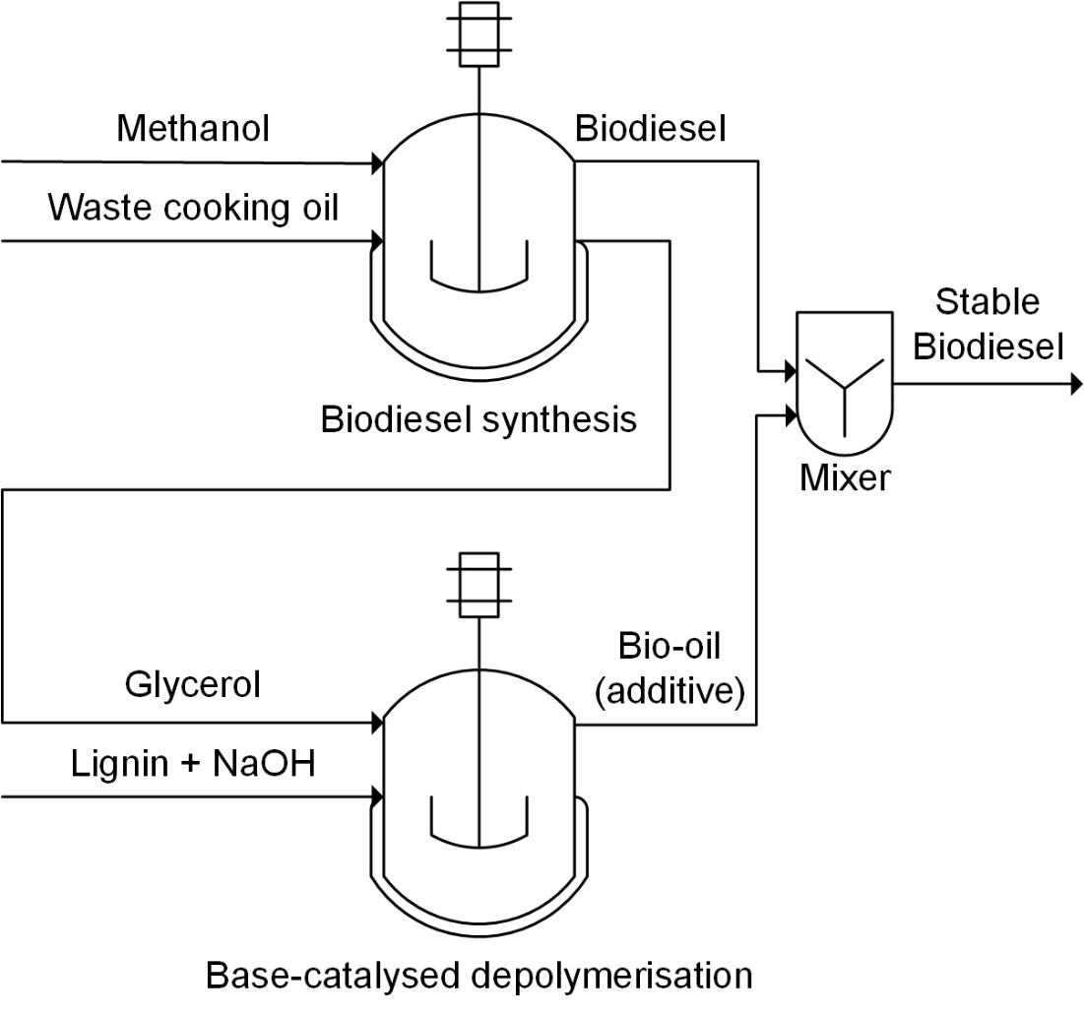

Fig. 1. A schematic of the proposed integrated biorefinery approach.

2. Materials and methods

2.1. Materials

WCO from various restaurants and industries located in Egypt were blended to form a realistic mixture. Methanol (MeOH, 99%), ethyl acetate (EtOAc), glycerol, sodium hydroxide (NaOH) and hydrochloric acid (HCl) were purchased from Fisher Scientific UK Ltd (Loughborough, UK). Liquid CO₂ cylinder (99.9%) fitted with a dip tube was purchased from BOC Ltd., UK. Softwood kraft lignin was supplied as a dry powder from the LignoBoost demonstration plant (Bäckhammar, Sweden). This lignin material is described by its rather low carbohydrate and ash contents and a sulphur content usually below 3% [21]
and has been characterised in more detail in our previous studies [37,38].

2.2. Experimental procedures

2.2.1. Transesterification of biodiesel

The detailed procedure for the transesterification of biodiesel using supercritical methanolysis has been described previously by our research group [8]. In brief, biodiesel was produced by mixing WCO with methanol at a methanol-to-oil ratio of 10:1 and deionised water at 6% molar. The reaction temperature was set to 245 °C at a pressure of 125 bar using CO₂ at a stirring rate of 320 rpm for about 20 min. After quenching the reactor, the product mixture was fed into a centrifuge to split glycerol and biodiesel. Biodiesel was loaded in a rotary evaporator to recover unreacted methanol. The physicochemical properties and the composition of the feedstock are reported in our previous work [9,39].

2.2.2 Base-catalysed depolymerisation of lignin

The depolymerisation of lignin was performed in a 100 mL reactor (model 4590, Parr instrument company, USA) equipped with a thermocouple (type J), heating mantle, a controller (model 4848) and a mechanical stirrer. An aqueous solution of LignoBoost lignin (50 g/L) and 0.6 g of NaOH as a catalyst with glycerol as a co-solvent was mixed before being loaded to the reactor. The homogeneous mixture was loaded to the reactor where reaction time started once the desired temperature was reached. After achieving the specified reaction time, the reactor was then quenched with an ice bath. The product mixture exiting the reactor was acidified using 1N HCl to pH ≤ 2 prior to centrifugation (1500 rpm, 3 min per cycle). The filtered mixture was then extracted using a volume ratio of 3:1 of EtOAc, vigorously shaking and kept at room temperature for around 10–15 min in a decantation funnel. EtOAc was then separated after decantation of the aqueous phase using a rotary evaporator under vacuum conditions, indicating a recovery and reutilisation of the extraction solvent. The solvent-free portion of the organic phase (bio-oil) was used as an antioxidant additive for biodiesel. A schematic for the workup protocol is shown in Fig. 2. The yield of bio-oil was calculated on a weight basis, according to Eq. (1).

Yield_{bio-oil} (%) = (mass_{bio-oil}/mass_{initial-lignin}) × 100 (1)

Depolymerisation product mixture

HCl 1N
Acidification (pH 1-2)

Centrifugation and filtration
Solids

Ethyl acetate
Liquid–liquid extraction

Recovered ethyl acetate
Rotary evaporator

Bio-oil

Fig. 2. Workup protocol after lignin depolymerisation to obtain the bio-oil fractions.

2.2.3. Accelerated oxidation method

The relative resistance of the produced biodiesel to oxidation was analysed by a small-scale rapid oxidation tester known as PetroOxy. An accelerated oxidation test was used to analyse the oxidation stability of biodiesel. The test was carried out using the standard method of EN 16091 on a PetroOxy device (Anton Paar, Dahlewitz, Germany). The sample was prepared by adding 1 wt% of lignin-based bio-oil with biodiesel. The mixture was then fed to a centrifuge were the bio-oil–biodiesel soluble fraction was analysed for oxidation stability. The chamber cell was purged with oxygen twice before loading 5 mL of biodiesel/bio-oil mixture. The test cell was closed and automatically charged with oxygen up to 7 bar and heated to a standardised temperature of 140 °C. An initial pressure drop indicates that biodiesel has begun to oxidise after maximum pressure has been reached. The IP represents the elapsed time between the start of the test and the breakingpoint when the pressure drops by 10%, which indicates oxidation resistance.

2.3. Experimental design

RSM was applied to minimise the number of experiments and to investigate the relationship between the variables and responses via the Box–Behnken Design (BBD) method. The effect of three independent variables of lignin depolymerisation on the bio-oil yield and PetroOxy IP was investigated. The application of BBD in an experimental design specifies the position of design points and estimate the regression coefficients near the centre of the design space. This provides the probability of effective optimisation of the process variables. It also allows the development of a numerical model and study of the interactive effects of variables on the responses [40].

The independent variables were identified as temperature, glycerol content and time, which are labelled as A, B and C, respectively. Three levels of each variable were studied following the regulations of the BBD method. The selected three levels for each variable were coded as -1, 0 and +1, as shown in Table 1. The identified variables and levels resulted in the generation of 15 randomised experiments. To reduce the unexplained inconsistency in responses, the performed experimental runs were designed in a randomised manner and to meet the assumptions of the statistical methods in analysing the experimental data [41].

Table 1. Experimental design variables and their coded levels
Factor | Code | levels
 |  | -1 | 0 | +1
Temperature (°C) | A | 225 | 250 | 275
Glycerol (wt%) | B | 0 | 10 | 20
Time (min) | C | 30 | 60 | 90

2.4. Statistical analysis

Design Expert 11 software (Stat-Ease Inc., Minneapolis, MN, USA) was used for the design of experiments, numerical optimisation, regression and graphical analysis. The regression models were developed to a general full quadratic equation, as presented in Eq. (2):

$Y=b_{o}+\sum_{i=1}^{n}{b_{i}x_{i}}+\sum_{i=1}^{n}{b_{ii}x_{i}^{2}}+\sum_{i=1}^{n-1}{\sum_{j>1}^{n}{b_{ij}}x_{i}x_{j}}+ ℇ$ (2)

where Y is the expected response (bio-oil yield and oxidation stability), b_{o} represents the constant model coefficient, b_{i}, b_{ii}, b_{ij}, indicates coefficients for the intercept of linear, quadratic, interactive terms, respectively, while X_{i}, X_{j} are independent variables (i≠j). The number of independent variables is shown in the parameter n, and the random error appears in the term ɛ. The accuracy of the predicted models was examined using various statistical methods including adequacy precision, coefficient of correlation (R²), adjusted coefficient of determination (R²_{adj}) and the predicted coefficient of determination (R²_{pred}). The predicted models were evaluated and analysed using Analysis of Variance (ANOVA) to assess the significance of the selected parameters and the adequacy of the developed models. ANOVA works based on p-value test, where p-value less than 0.05 of a parameter indicates significant in the process. The lack of fit analysis was also employed to study the fitting accuracy of the predicted models to the experimental data.

3. Results and discussion

3.1. Regression model development

The software generated 15 randomised runs that were carried out experimentally to account for the PetroOxy IP, being in the range of 26–99 IP min, and bio-oil yield in the range of 4.1–23.8 % (Table 2). Numerous regression analyses were performed on the experimental results to match the experimental data with the mathematical models. Four mathematical regression models were used to fit the experimental data, including linear, two factors interactions (2FI), quadratic and cubic polynomials. The software suggested a 2FI and quadratic models for bio-oil yield and PetroOxy IP, respectively, as presented in Eqs. (3) and (4):

Y₁ = 11.79 + 4.71 A + 3.39 B + 0.22 C + 4.43 AB – 0.4 AC – 0.8 BC (3)

Y₂ = 45.3967 + 14.9425 A + 4.9975 B + 9.8725 C + 1.1425 AB + 16.4175 AC – 3.2275 BC + 4.53542 A² – 6.20958 B² + 7.51542 C² (4)
where Y₁ and Y₂ represent the response variables the bio-oil yield and the PetroOxy IP of biodiesel, respectively, while A, B, and C represent the independent variables, that is, temperature, glycerol and time, respectively. AB, AC and BC represent the interaction between the independent variables. A², B² and C² represent the excess of each independent variable. A positive sign of each variable coefficient has an indication of a synergistic effect on the response, while a negative sign indicates an antagonistic effect on the response.

Table 2. Experimental design matrix with the actual and predicted data
Run | Temperature (°C) | Glycerol (wt%) | Time (min) | Actual yield (%) | Predicted yield (%) | Actual PetroOxy (min) | Predicted PetroOxy (min)
1 | 275 | 20 | 60 | 23.8 | 24.31 | 62.5 | 64.8
2 | 250 | 10 | 60 | 14.1 | 11.79 | 44.8 | 45.4
3 | 225 | 0 | 60 | 5.1 | 8.11 | 27.2 | 24.9
4 | 225 | 20 | 60 | 4.1 | 6.04 | 32.7 | 32.6
5 | 275 | 10 | 30 | 14.6 | 16.67 | 48.2 | 46.1
6 | 250 | 20 | 90 | 12.6 | 14.60 | 60.3 | 58.4
7 | 250 | 10 | 60 | 12.0 | 11.79 | 46.2 | 45.4
8 | 275 | 0 | 60 | 7.1 | 8.69 | 52.4 | 52.5
9 | 225 | 10 | 30 | 5.8 | 6.45 | 48.7 | 49.1
10 | 250 | 0 | 30 | 9.9 | 7.37 | 26.7 | 28.6
11 | 275 | 10 | 90 | 17.7 | 16.32 | 99.0 | 98.7
12 | 250 | 20 | 30 | 17.2 | 15.75 | 45.3 | 45.1
13 | 250 | 10 | 60 | 13.8 | 11.79 | 45.2 | 45.4
14 | 250 | 0 | 90 | 8.5 | 9.42 | 54.6 | 54.8
15 | 225 | 10 | 90 | 10.5 | 7.70 | 33.9 | 36.0

3.2. Statistical analysis

The developed 2FI model for bio-oil yield reports a p-value of 0.0035 (Table 3), which implies that the model is highly significant. The PetroOxy IP, on the other hand, exhibited a high degree of significance with a p-value model of <0.0001, as presented in Table 4. The lack of fit analysis was observed as non-significance in both cases, i.e. p-values of 0.1394 and 0.0593 for the 2FI and quadratic models, respectively. These results confirm the precision of the model in predicting the experimental results. Furthermore, the values of R² and R²_{adj} were estimated to be 0.91 and 0.78, respectively, for the bio-oil yield response, and 0.99 and 0.98 for the PetroOxy IP. In addition, the adequacy precision test, which defines the ratio between the predicted response and the relative error (signal-to-noise ratio), has been examined. The test resulted in values of 10.41, and 38.11 for bio-oil yield and PetroOxy IP, respectively, where a value higher than 4 is usually preferred [41]. A plot representing the predicted data against actual data is illustrated in Figs. 3a and b. The strong correlation between the actual and the predicted results are represented with minor deviations from the 45º line.

Table 3. ANOVA for the bio-oil yield using the 2FI model
 | Sum of squares | Difference | Mean square | F-value | p-value | Significanceª
Model | 351.39 | 6 | 58.57 | 8.87 | 0.0035 | S
A-Temperature | 177.66 | 1 | 177.66 | 26.89 | 0.0008 | S
B-Glycerol | 91.80 | 1 | 91.80 | 13.90 | 0.0058 | S
C-Time | 0.40 | 1 | 0.40 | 0.061 | 0.8107 | NS
AB | 78.32 | 1 | 78.32 | 11.86 | 0.0088 | S
AC | 0.64 | 1 | 0.64 | 0.097 | 0.7636 | NS
BC | 2.56 | 1 | 2.56 | 0.39 | 0.5509 | NS
Residual | 52.85 | 8 | 6.61 |  | – | –
Lack of fit | 50.27 | 6 | 8.38 | 6.49 | 0.1394 | NS
ª S, significant; NS, not significant

 | Sum of squares | Difference | Mean square | F-value | p-value | Significanceª
Model | 4344.12 | 9 | 482.68 | 85.94 | <0.0001 | S
A-Temperature | 1786.23 | 1 | 1786.23 | 318.04 | <0.0001 | S
B-Glycerol | 199.80 | 1 | 199.80 | 35.57 | 0.0019 | S
C-Time | 779.73 | 1 | 779.73 | 138.83 | <0.0001 | S
AB | 5.22 | 1 | 5.22 | 0.9296 | 0.3792 | NS
AC | 1078.14 | 1 | 1078.14 | 191.96 | <0.0001 | S
BC | 41.67 | 1 | 41.67 | 7.42 | 0.0416 | S
A² | 75.95 | 1 | 75.95 | 13.52 | 0.0143 | S
B² | 142.37 | 1 | 142.37 | 25.35 | 0.0040 | S
C² | 208.55 | 1 | 208.55 | 37.13 | 0.0017 | S
Residual | 191.65 | 8 | 23.96 | – | – | –
Lack of fit | 26.96 | 3 | 8.99 | 16.02 | 0.0593 | NS
Table 4. ANOVA for the PetroOxy IP using the quadratic model
ª S, significant; NS, not significant

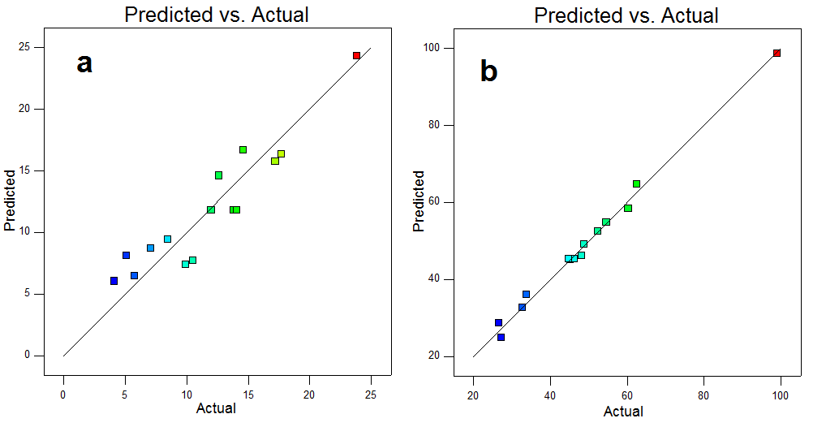
Fig. 3. Predicted vs actual data for the response variables: (a) yield of bio-oil and (b) PetroOxy IP.

It was observed from the ANOVA results, Tables 3 and 4, that some equation parameters are non-significant, including C, AC and BC in Eq. (3) and AB in Eq. (4). However, the residence time variable (C) was not excluded as it represents a core variable in this study. Accordingly, the equations were simplified by excluding the non-significant variables. The simplified equations are given in Eqs. (5) and (6).

Y₁ = 11.786 + 4.712 A + 3.387 B + 0.225 C + 4.425 0.4 AC – 0.8 BC (5)

Y₂ = 45.397 + 14.943 A + 4.998 B + 9.873 C + 16.418 AC – 3.228 BC + 4.535 A² – 6.21 B² + 7.515 C² (6)

3.3. Effect of process variables and their interactions

3.3.1. Effect of reaction temperature

Temperature is an important factor that drives the fragmentation of lignin into low-molecular-weight products. In order to analyse the individual effect of temperature, other process variables were fixed at the optimal conditions (glycerol amount of 17.03 wt% and residence time of 90 min). From the ANOVA results of Table 3, the reaction temperature was found as significant positive parameter where it has a directly proportional relationship with bio-oil yield as shown in Fig. 4a. The increasing effect of reaction temperature resulted in an equivalent increase in bio-oil yield up to 23.8% bio-oil yield (see Table 2). Although the maximum achieved bio-oil yield shown in Fig. 4a is 16.6%, higher values are reported in Table 2, which indicates the influence of other parameters together with temperature on bio-oil yield. The limited range of temperatures considered for this study was due to the restriction of glycerol inclusion in the reaction regime, as it has a boiling point of about 290 °C. In addition, higher depolymerisation temperatures (>325 °C) may allow cracking and repolymerisation reactions which could lead to a decrease in bio-oil yield [42].

On the other hand, the reaction temperature was observed as a significant parameter on PetroOxy IP, as shown in Table 4. This means that the bio-oil produced at higher depolymerisation temperature has better antioxidant activity. The increase of temperature between 225 °C and 275 °C resulted in a 70% increase in PetroOxy IP (Fig. 4b). An increase in depolymerisation temperature suggests the increased production of low-molecular-weight phenolic compounds, including phenol derivatives, thus increasing the amount of hydrogen that can power up the antioxidant effect [43]. A similar observation has also been reported by Lavoie et al. [28] for black liquor obtained from semi-chemical pulping of straw. In their study, an increase of about 60% in the IP was attained upon increasing the reaction temperature from 250 °C to 300 °C during the catalytic depolymerisation of barley straw black liquor.

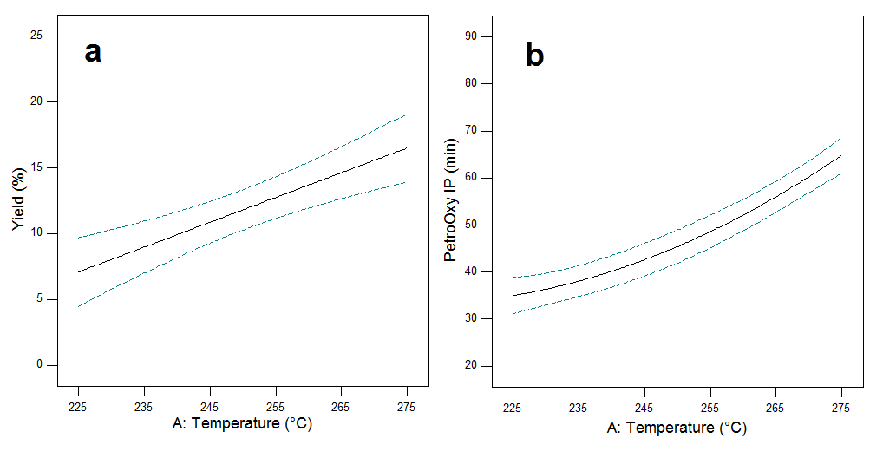
Fig. 4. The individual effect of the reaction temperature on (a) bio-oil yield (b) PetroOxy IP.

3.3.2. Effect of glycerol addition

The addition of glycerol in depolymerisation reaction has significantly increased the yield of produced bio-oil. The effect of glycerol addition on the process responses was analysed at fixed conditions of temperature and residence time at 275 °C and 90 min, respectively. As shown in Fig. 5a, the bio-oil yield increased from 8.3% to 15% when glycerol was added up to 20 wt%. It was also observed as a significant parameter from ANOVA results shown in Table 3. Glycerol is a polyol, which contains three hydroxyl groups, and the increase in fibre liberation will promote the degradation of lignin. It has been used as an efficient co-solvent for hydrothermal liquefaction of rice straw where it has improved the yield and quality of produced bio-oil [44]. The addition of crude glycerol improves the bio-oil yield probably due to acids present, which could react with the lignin macromolecules to form a stable organic compound. A significant increase was also observed in the yield of bio-oil derived from waste materials upon adding glycerol as a co-substrate [45]. Higher values of bio-oil yield resulted at higher reaction temperatures, referring to the importance of studying the interactive effect of glycerol and temperature on bio-oil yield (Section 3.3.4).

Glycerol was found as a significant parameter affecting PetroOxy IP (Table 4). The increased glycerol amounts of up to 15 wt% during the depolymerisation of LignoBoost lignin resulted in an increase in the bio-oil antioxidant activity. As shown in Fig. 5b, the PetroOxy IP of biodiesel increased from 35 to 45 min. This indicates that glycerol addition has not only enhanced the bio-oil yield but also improved the quality of the produced bio-oil with higher antioxidant activity. To the best of the authors' knowledge, the effect of glycerol addition on antioxidant activity of lignin-derived bio-oil has not been reported previously. The results suggest possible enhancement of phenols production from lignin in the presence of up to 15 wt% glycerol, which calls for further research on elucidating such chemical insights.

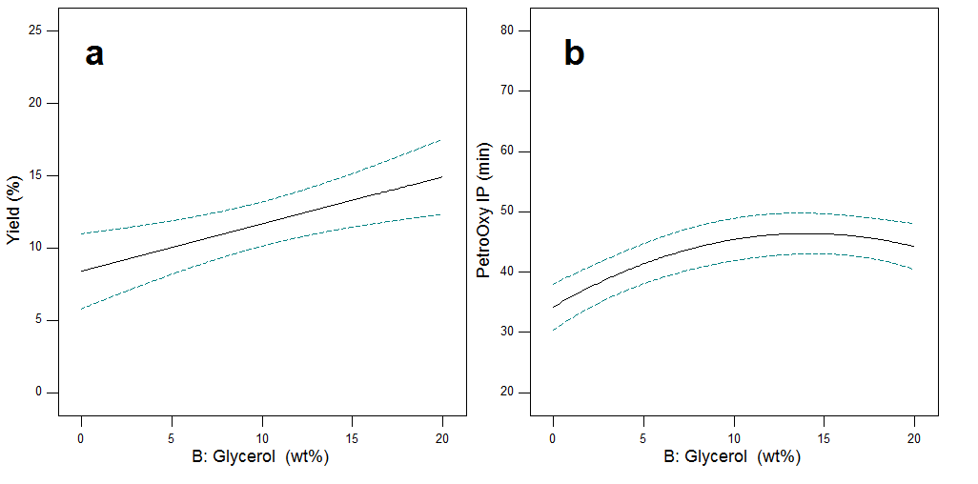
Fig. 5. The individual effect of the glycerol on (a) bio-oil yield (b) PetroOxy IP.

3.3.3. Effect of residence time

The single effect of residence time was studied at a constant temperature and glycerol addition of 275 °C and 17.03 wt%, respectively. The ANOVA results tabulated in Table 3 showed a non-significance of the residence time for the bio-oil yield. This means that the variation of reaction time between 30 to 90 min has no considerable effect on the bio-oil yield (Fig. 6a). This may be attributed to the pre-heating duration prior to reaching the reaction set temperature, as during this period (~20 min), the main reactions relevant to base-catalysed lignin depolymerisation could have likely occurred. Similar behaviour has also been described by Olarte et al. [46] in which there was no significant difference in the yields of the liquid products obtained between 15 and 60 min during depolymerisation of organosolv lignin with NaOH at temperatures between 165 and 350 °C. Short residence time favours bio-oil yield where lengthy residence time can influence the repolymerisation of lignin products dependent on temperature and secondary reactions that could lead to high char formation [42,47].

On the other hand, the residence time effect on PetroOxy IP was shown as a significant parameter in Table 4. An increase in time provides higher quality bio-oil with enhanced antioxidant activity with increased PetroOxy IP (Fig. 6b). The PetroOxy IP increased from 42 to 63 min when the reaction time increased from 30 to 90 min. Although the present study has observed no significant difference in bio-oil yield with increasing the reaction time, the produced bio-oil at longer reaction time has a higher antioxidant effect on biodiesel. This observation indicates that several decomposition reactions could occur to the produced fixed amount of bio-oil through the reaction time, where the produced compounds are probably converted to phenols over time.

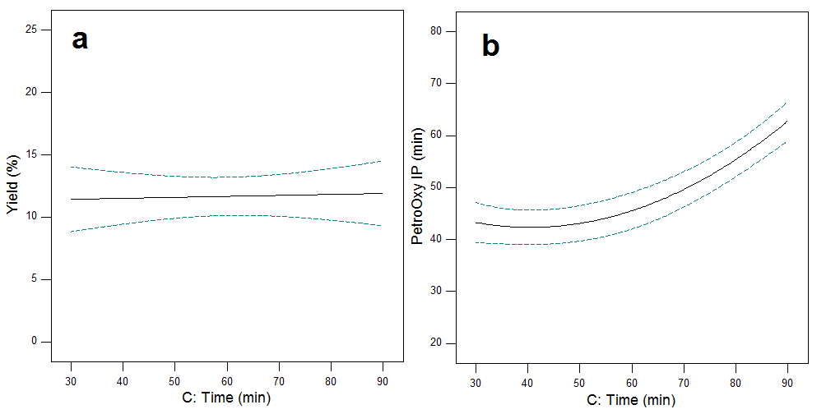
Fig. 6. Individual effect of reaction time on (a) bio-oil yield (b) PetroOxy IP.

3.3.4 Interactive effects of process variables

In the previous sub-sections, the individual effects of variables on bio-oil yield and PetroOxy IP were discussed. However, these effects were demonstrated, whilst keeping other variables at constant values. For instance, Fig. 5a showed that the range of bio-oil yield was lower than 20% over the full range of glycerol, while higher values were observed experimentally. The reason behind this is the dependence of the effect of glycerol on bio-oil yield by the value of reaction temperature. Hence, it is crucial to study and analyse the interactive effects of variables, as each variable might have different effects on the response at different levels of other variables. Table 3 indicates that temperature and glycerol (AB) additions have a highly interactive effect on bio-oil yield with a p-value of 0.0035. In addition, the interaction of reaction temperature and time (AC) is highly significant on PetroOxy IP, as mentioned in Table 4.

The highly significant interactive effect between reaction temperature and glycerol addition is shown in Fig. 7, where the increasing effect of glycerol is highly dependent on the temperature. For instance, the effect of glycerol at 225 °C would be negligible compared to the increasing effect of glycerol at 275 °C. Accordingly, it is not accurate to highlight that glycerol addition has a significant effect on bio-oil without mentioning the range of the studied temperature. This may attribute that the activity of glycerol in enhancing the depolymerisation of lignin is dependent on the reaction temperature. Accordingly, choosing the optimal glycerol addition should be considered together with the reaction temperature.

Similarly, the increasing effect of reaction time on PetroOxy IP is highly dependent on the value of temperature (Fig. 8). The increasing influence of reaction time on PetroOxy IP is not significant at 225 °C, while it is highly significant at 275 °C. The PetroOxy IP increased from 43 min to 99 min by increasing the reaction time from 30 to 90 min at 275 °C. Studying the individual effect of reaction time at a constant temperature would thus lead to a wrong indication of the true explanation, and this is why considering the interaction effect of variables is essential. This result has a critical indication for the high dependence of reaction temperature on the antioxidant activity of bio-oil. The extended reaction time enhances the conversion of bio-oil components into phenolic compounds only at elevated temperature.

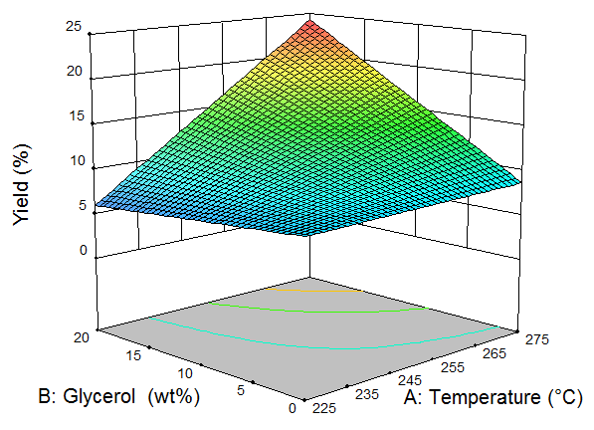

Fig. 7. Response surface plot for reaction temperature and glycerol amount vs bio-oil yield.

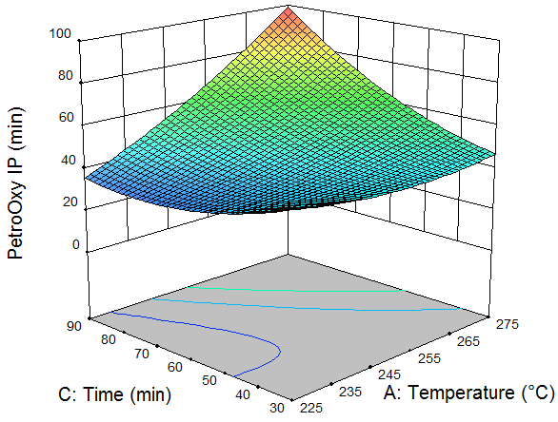
Fig. 8. Response surface plot for temperature and residence time vs PetroOxy IP.

3.4. Process optimisation
The application of RSM in experimental design enabled the development of a regression model that was used to predict the optimal reaction conditions based on the specified targets. The optimisation targets are set to maximise both process responses, i.e. the yield of bio-oil and the PetroOxy IP, as shown in Table 5. However, the importance of maximising the PetroOxy IP has set with the highest importance as this study is aiming to enhance the oxidation stability of biodiesel. Furthermore, the reaction temperature and time were set to be minimised to lower the process energy consumption (with lower importance). The software generated some 49 solutions, where the solution with the highest desirability percentage (96.2%) was selected as shown in Fig. 9. The developed optimal conditions have achieved bio-oil yield of 21.25% and PetroOxy IP of 97.6 min at a reaction temperature of 275 °C, glycerol amount of 17.03 wt% within 90 min.

In an attempt to validate the developed optimal conditions, an experimental run was carried out at the predicted conditions. The validation experiment has resulted in 20.9% and 96.2 min for bio-oil yield and PetroOxy IP, respectively. The experimental data show very similar results at the predicted optimal conditions with a relative error between 1.4–1.6% for both responses.

Table 5. Optimisation constraints to predict the optimisation targets for bio-oil
Factor | Code | Goal | Importance | Limits
 |  |  | Scale 1–5 | Lower | Upper
Temperature (°C) | A | Minimise | 1 | 225 | 275
Glycerol (wt%) | B | In range | - | 16 | 18
Time (min) | C | Minimise | 1 | 30 | 90
Bio-oil yield (%) | Y₁ | Maximise | 3 | 4.1 | 23.8
PetroOxy IP (min) | Y₂ | Maximise | 5 | 28 | 99

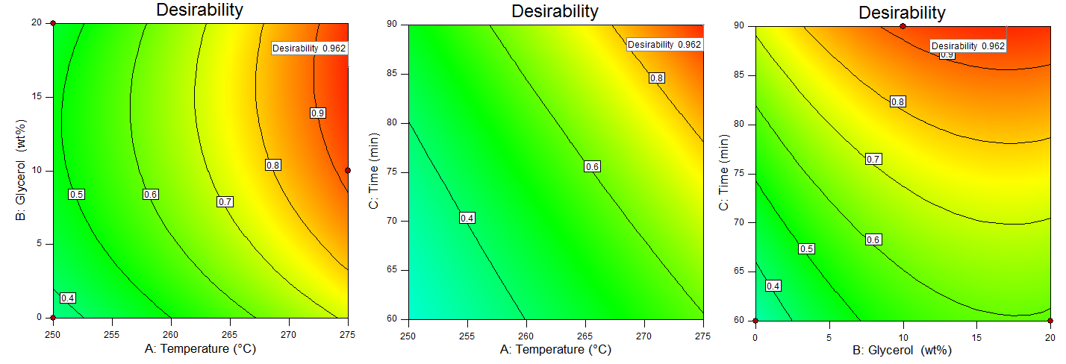
Fig. 9. Contour plot for the interactive effect of process variables of the optimisation desirability.

3.5 Oxidation stability of biodiesel

The PetroOxy IP of the neat biodiesel (without any additives) was estimated to be 22.23 $±$ 1.83 min. The improvement of PetroOxy IP after doping biodiesel with bio-oil (oxy improvement) was determined by Eq. (7).

Oxy improvement = ((Oxy _{doped biodiesel} - Oxy _{neat biodiesel}) /Oxy _{neat biodiesel}) × 100 (7)

According to the designed optimum conditions, the PetroOxy IP reached 97.6 min by doping biodiesel with 1 wt% of bio-oil. In comparison to the neat PetroOxy IP (22.23 min), the addition of 1 wt% of bio-oil enhances the oxidation stability of biodiesel with up to ~340%. The addition of 1 wt% of bio-oil synthesised from extracted fractions originating from pinewood fast pyrolysis and from barely straw black liquor has previously enhanced the oxidation stability of biodiesel with improvements of about 146% and 211%, respectively [28,48]. To the best of our knowledge, the present work reports a substantial improvement compared to relevant work in the literature (Fig. 10). It is worth mentioning that the doped biodiesel meets the EN 14214 biodiesel specification.

Fig. 10. Oxy improvement of biodiesel doped with various lignin-derived bio-oil additives.

4. Conclusions

A green approach for enhancing the oxidation stability of biodiesel using renewable additives extracted from kraft lignin has been developed. Glycerol, the side-product of biodiesel process, has been utilised as a co-solvent in lignin depolymerisation. A set of experiments based on BBD has been carried out to assess the influence of reaction temperature (225–275 °C), glycerol content (0–20 wt%) and residence time (30–90 min). Two empirical models have been obtained, representing the process variables function in each process response. The results have shown that the introduction of glycerol as a co-solvent has not only enhanced the bio-oil yield but also improved the quality of the produced bio-oil. The addition of glycerol has resulted in bio-oil with higher antioxidant activity. Numerical and graphical optimisation have been carried out to determine the optimal conditions for the process, with an overarching aim to maximise the antioxidant activity of the bio-oil. The developed optimal conditions have been validated experimentally resulting in bio-oil yield of 20.9% and PetroOxy IP of 96.2 min at a reaction temperature of 275 °C, glycerol amount of 17.03 wt% and residence time of 90 min. The experimental run at the developed optimal conditions has shown very similar results to the predicted data with a relative error between 1.4% and 1.6% for both responses. The addition of 1 wt% of the produced bio-oil at optimum conditions has significantly enhanced the oxidation stability of neat biodiesel by ~340%. Further research is however required to include detailed characterisation of the produced bio-oil in order to investigate its physico-chemical properties as well as to elucidate the compounds responsible for its antioxidant potential. This work introduces an integrated biorefinery approach that has the applicability of valorising kraft lignin and glycerol for the production of renewable antioxidants for enhancing the oxidation stability of biodiesel.

CRediT authorship contribution statement

Yusuf Umar: Investigation, Methodology, Software application, Formal analysis, Validation, Data curation, Writing - original draft, Visualization. Orlando Velasco: Investigation, Validation. Omar Y. Abdelaziz: Conceptualization, Methodology, Writing - review & editing, Visualization, Project administration. Omar Aboelazayem: Conceptualization, Methodology, Software application, Formal analysis, Writing - review & editing, Project administration. Mamdouh A. Gadalla: Writing - review & editing, Supervision, Funding acquisition, Project administration. Christian P. Hulteberg: Resources, Writing - review & editing, Supervision, Funding acquisition, Project administration. Basudeb Saha: Resources, Writing - review & editing, Supervision, Funding acquisition, Project administration.

Declaration of competing interest

The authors declare that they have no known competing financial interests or personal relationships that could have appeared to influence the work reported in this paper.

Acknowledgements

This paper is based upon the work supported by the British Council UK and Science, Technology & Innovation Funding Authority (STDF) Egypt through the Newton Institutional Links Programme (IDs 261862377 and 27738), the Swedish Foundation for Strategic Research (RBP14-0052), the Swedish Energy Agency (45241-1 and 49701-1), London South Bank University, and Lund University.

References
[1] O. Farobie, Y. Matsumura, State of the art of biodiesel production under supercritical conditions, Prog. Energy Combust. Sci. 63 (2017) 173–203. https://doi.org/10.1016/j.pecs.2017.08.001.
[2] D. Singh, D. Sharma, S.L. Soni, S. Sharma, D. Kumari, Chemical compositions, properties, and standards for different generation biodiesels: A review, Fuel. 253 (2019) 60–71. https://doi.org/10.1016/j.fuel.2019.04.174.
[3] M.M. Naeem, E.G. Al-Sakkari, D.C. Boffito, M.A. Gadalla, F.H. Ashour, One-pot conversion of highly acidic waste cooking oil into biodiesel over a novel bio-based bi-functional catalyst, Fuel. 283 (2021) 118914. https://doi.org/10.1016/j.fuel.2020.118914.
[4] O. Aboelazayem, M. Gadalla, I. Alhajri, B. Saha, Advanced process integration for supercritical production of biodiesel: Residual waste heat recovery via organic Rankine cycle (ORC), Renew. Energy. 164 (2021) 433–443. https://doi.org/10.1016/j.renene.2020.09.058.
[5] P. Andreo-Martínez, V.M. Ortiz-Martínez, N. García-Martínez, A.P. de los Ríos, F.J. Hernández-Fernández, J. Quesada-Medina, Production of biodiesel under supercritical conditions: State of the art and bibliometric analysis, Appl. Energy. 264 (2020) 114753. https://doi.org/10.1016/j.apenergy.2020.114753.
[6] O. Aboelazayem, M. Gadalla, B. Saha, Biodiesel production from waste cooking oil via supercritical methanol: Optimisation and reactor simulation, Renew. Energy. 124 (2018) 144–154. https://doi.org/10.1016/j.renene.2017.06.076.
[7] O. Aboelazayem, M. Gadalla, B. Saha, An experimental-based energy integrated process for Biodiesel production from waste cooking oil using supercritical methanol, Chem. Eng. Trans. 61 (2017) 1645–1650. https://doi.org/10.3303/CET1761272.
[8] O. Aboelazayem, M. Gadalla, B. Saha, Valorisation of high acid value waste cooking oil into biodiesel using supercritical methanolysis: Experimental assessment and statistical optimisation on typical Egyptian feedstock, Energy. 162 (2018) 408–420. https://doi.org/10.1016/j.energy.2018.07.194.
[9] O. Aboelazayem, M. Gadalla, B. Saha, Derivatisation-free characterisation and supercritical conversion of free fatty acids into biodiesel from high acid value waste cooking oil, Renew. Energy. 143 (2019) 77–90. https://doi.org/10.1016/j.renene.2019.04.106.
[10] R.C. Rial, T.C. Merlo, P.H. Michalski Santos, L.F. Dias Melo, R.A. Barbosa, O.N. de Freitas, C.E. Domingues Nazário, L.H. Viana, Evaluation of oxidative stability of soybean methyl biodiesel using extract of cagaite leaves (Eugenia dysenterica DC.) as additive, Renew. Energy. 152 (2020) 1079–1085. https://doi.org/10.1016/j.renene.2020.01.121.
[11] J.C. Girardi, R.A. Bariccatti, F.Y. Savada, D. Borsato, S.N. Melegari de Souza, C.Z. Amaral, M. Prior, Response surface methodology for the optimization of oxidative stability through the use of natural additives, Renew. Energy. 159 (2020) 346–355. https://doi.org/10.1016/j.renene.2020.06.050.
[12] T.R. Nogueira, I. de Mesquita Figueredo, F.M. Tavares Luna, C.L. Cavalcante, J. Evangelista de Ávila dos Santos, M.A. Sousa Lima, T.S. Josino da Silva, L.K. Almeida Moreira Leal, F.M. Nunes, M. Alexsandra de Sousa Rios, A.T. Ávila Pimenta, Evaluation of oxidative stability of soybean biodiesel using ethanolic and chloroform extracts of Platymiscium floribundum as antioxidant, Renew. Energy. 159 (2020) 767–774. https://doi.org/10.1016/j.renene.2020.06.062.
[13] R. Pereira Lima, P.T. Souza da Luz, M. Braga, P.R. dos Santos Batista, C.E. Ferreira da Costa, J.R. Zamian, L.A. Santos do Nascimento, G.N. da Rocha Filho, Murumuru (Astrocaryum murumuru Mart.) butter and oils of buriti (Mauritia flexuosa Mart.) and pracaxi (Pentaclethra macroloba (Willd.) Kuntze) can be used for biodiesel production: Physico-chemical properties and thermal and kinetic studies, Ind. Crops Prod. 97 (2017) 536–544. https://doi.org/10.1016/j.indcrop.2016.12.052.
[14] M. Chakraborty, D.C. Baruah, Investigation of oxidation stability of Terminalia belerica biodiesel and its blends with petrodiesel, Fuel Process. Technol. 98 (2012) 51–58. https://doi.org/10.1016/j.fuproc.2012.01.029.
[15] Y.C. Sharma, B. Singh, S.N. Upadhyay, Advancements in development and characterization of biodiesel: A review, Fuel. 87 (2008) 2355–2373. https://doi.org/10.1016/j.fuel.2008.01.014.
[16] O.Y. Abdelaziz, A.A. Al-Rabiah, M.M. El-Halwagi, C.P. Hulteberg, Conceptual Design of a Kraft Lignin Biorefinery for the Production of Valuable Chemicals via Oxidative Depolymerization, ACS Sustain. Chem. Eng. 8 (2020) 8823–8829. https://doi.org/10.1021/acssuschemeng.0c02945.
[17] A.J. Ragauskas, G.T. Beckham, M.J. Biddy, R. Chandra, F. Chen, M.F. Davis, B.H. Davison, R.A. Dixon, P. Gilna, M. Keller, P. Langan, A.K. Naskar, J.N. Saddler, T.J. Tschaplinski, G.A. Tuskan, C.E. Wyman, Lignin valorization: Improving lignin processing in the biorefinery, Science (80-. ). 344 (2014). https://doi.org/10.1126/science.1246843.
[18] R. Rinaldi, R. Jastrzebski, M.T. Clough, J. Ralph, M. Kennema, P.C.A. Bruijnincx, B.M. Weckhuysen, Paving the Way for Lignin Valorisation: Recent Advances in Bioengineering, Biorefining and Catalysis, Angew. Chemie - Int. Ed. 55 (2016) 8164–8215. https://doi.org/10.1002/anie.201510351.
[19] P. Zhu, O.Y. Abdelaziz, C.P. Hulteberg, A. Riisager, New synthetic approaches to biofuels from lignocellulosic biomass, Curr. Opin. Green Sustain. Chem. 21 (2020) 16–21. https://doi.org/10.1016/j.cogsc.2019.08.005.
[20] H. Wallmo, A. Littorin, H. Karlsson, K. Lindholm, R. Stern, G. Christiansen, The evolution of lignoboost technology and the refining of lignin for end product uses - Part 1, in: Pulping, Eng. Environ. Recycl. Sustain. Conf. 2016, PEERS 2016, 2016: pp. 809–815.
[21] P. Tomani, The lignoboost process, in: Cellul. Chem. Technol., 2010: pp. 53–58.
[22] A. Toledano, L. Serrano, J. Labidi, Improving base catalyzed lignin depolymerization by avoiding lignin repolymerization, Fuel. 116 (2014) 617–624. https://doi.org/10.1016/j.fuel.2013.08.071.
[23] R. Katahira, A. Mittal, K. McKinney, X. Chen, M.P. Tucker, D.K. Johnson, G.T. Beckham, Base-Catalyzed Depolymerization of Biorefinery Lignins, ACS Sustain. Chem. Eng. 4 (2016) 1474–1486. https://doi.org/10.1021/acssuschemeng.5b01451.
[24] O.Y. Abdelaziz, K. Li, P. Tunå, C.P. Hulteberg, Continuous catalytic depolymerisation and conversion of industrial kraft lignin into low-molecular-weight aromatics, Biomass Convers. Biorefinery. 8 (2018) 455–470. https://doi.org/10.1007/s13399-017-0294-2.
[25] W. Schutyser, T. Renders, S. Van Den Bosch, S.F. Koelewijn, G.T. Beckham, B.F. Sels, Chemicals from lignin: An interplay of lignocellulose fractionation, depolymerisation, and upgrading, Chem. Soc. Rev. 47 (2018) 852–908. https://doi.org/10.1039/c7cs00566k.
[26] A. Devi, V.K. Das, D. Deka, A green approach for enhancing oxidation stability including long storage periods of biodiesel via Thuja oreantalis L. as an antioxidant additive, Fuel. 253 (2019) 1264–1273. https://doi.org/10.1016/j.fuel.2019.05.127.
[27] J. Xin, S. Saka, Improvement of the oxidation stability of biodiesel as prepared by supercritical methanol method with lignin, Eur. J. Lipid Sci. Technol. 111 (2009) 835–842. https://doi.org/10.1002/ejlt.200800220.
[28] J.M. Lavoie, T. Ghislain, E. Bahl, J. Arauzo, A. Gonzalo, N. Gil-Lalaguna, J.L. Sánchez, Renewable antioxidant additive for biodiesel obtained from black liquor, Fuel. 254 (2019) 115689. https://doi.org/10.1016/j.fuel.2019.115689.
[29] N. Gil-Lalaguna, A. Bautista, A. Gonzalo, J.L. Sánchez, J. Arauzo, Obtaining biodiesel antioxidant additives by hydrothermal treatment of lignocellulosic bio-oil, Fuel Process. Technol. 166 (2017) 1–7. https://doi.org/10.1016/j.fuproc.2017.05.020.
[30] J. Palomo, S. Moles, J. Salafranca, N. Gil-Lalaguna, A. Gonzalo, J.L. Sánchez, Production of antioxidants for biodiesel from straw black liquor depolymerization, in: WIT Trans. Ecol. Environ., 2019: pp. 97–108. https://doi.org/10.2495/ESUS190091.
[31] T.S. Ahmed, O.Y. Abdelaziz, G.W. Roberts, Preparation of Al2O3/AlF3-Supported Ruthenium Catalysts for the Hydrogenolysis of Biodiesel-Derived Crude Glycerol, Ind. Eng. Chem. Res. 55 (2016) 5536–5544. https://doi.org/10.1021/acs.iecr.6b00500.
[32] J. Kaur, A.K. Sarma, M.K. Jha, P. Gera, Valorisation of crude glycerol to value-added products: Perspectives of process technology, economics and environmental issues, Biotechnol. Reports. 27 (2020) e00487. https://doi.org/10.1016/j.btre.2020.e00487.
[33] H. Christian, L. Andreas, Scaling up a Gas-Phase Process for Converting Glycerol to Propane, Catalyst. 10 (2020) 1007.
[34] M. Badia-Fabregat, L. Rago, J.A. Baeza, A. Guisasola, Hydrogen production from crude glycerol in an alkaline microbial electrolysis cell, Int. J. Hydrogen Energy. 44 (2019) 17204–17213. https://doi.org/10.1016/j.ijhydene.2019.03.193.
[35] N.L. Huamán-Castilla, M.S. Mariotti-Celis, M. Martínez-Cifuentes, J.R. Pérez-Correa, Glycerol as alternative co-solvent for water extraction of polyphenols from Carménère pomace: Hot pressurized liquid extraction and computational chemistry calculations, Biomolecules. 10 (2020) 1–14. https://doi.org/10.3390/biom10030474.
[36] A. Wolfson, C. Dlugy, Y. Shotland, Glycerol as a green solvent for high product yields and selectivities, Environ. Chem. Lett. 5 (2007) 67–71. https://doi.org/10.1007/s10311-006-0080-z.
[37] O.Y. Abdelaziz, K. Ravi, F. Mittermeier, S. Meier, A. Riisager, G. Lidén, C.P. Hulteberg, Oxidative Depolymerization of Kraft Lignin for Microbial Conversion, ACS Sustain. Chem. Eng. 7 (2019) 11640–11652. https://doi.org/10.1021/acssuschemeng.9b01605.
[38] F. Walch, O.Y. Abdelaziz, S. Meier, S. Bjelić, C.P. Hulteberg, A. Riisager, Oxidative depolymerization of Kraft lignin to high-value aromatics using a homogeneous vanadium–copper catalyst, Catal. Sci. Technol. 11 (2021) 1843–1853. https://doi.org/10.1039/D0CY02158J.
[39] Y. Umar, O. Aboelazayem, Z. Echresh, M. Gadalla, B. Saha, Waste cooking oil valorisation into biodiesel using supercritical methanolysis: Critical assessment on the effect of water content, in: Eur. Biomass Conf. Exhib. Proc., 2019: pp. 1495–1500.
[40] V. Onyenkeadi, O. Aboelazayem, B. Saha, Systematic multivariate optimisation of butylene carbonate synthesis via CO2 utilisation using graphene-inorganic nanocomposite catalysts, Catal. Today. 346 (2020) 10–22. https://doi.org/10.1016/j.cattod.2019.03.027.
[41] Douglas C. Montgomery, Design and Analysis of Experiments - 8th edition, John Wiley & Sons, Inc., 2013.
[42] C. Ji, Z. He, Q. Wang, G. Xu, S. Wang, Z. Xu, H. Ji, Effect of operating conditions on direct liquefaction of low-lipid microalgae in ethanol-water co-solvent for bio-oil production, Energy Convers. Manag. 141 (2017) 155–162. https://doi.org/10.1016/j.enconman.2016.07.024.
[43] M.A.R. Raycroft, J.P.R. Chauvin, M.S. Galliher, K.J. Romero, C.R.J. Stephenson, D.A. Pratt, Quinone methide dimers lacking labile hydrogen atoms are surprisingly excellent radical-trapping antioxidants, Chem. Sci. 11 (2020) 5676–5689. https://doi.org/10.1039/d0sc02020f.
[44] L. Cao, C. Zhang, S. Hao, G. Luo, S. Zhang, J. Chen, Effect of glycerol as co-solvent on yields of bio-oil from rice straw through hydrothermal liquefaction, Bioresour. Technol. 220 (2016) 471–478. https://doi.org/10.1016/j.biortech.2016.08.110.
[45] S. Xiu, A. Shahbazi, V. Shirley, M.R. Mims, C.W. Wallace, Effectiveness and mechanisms of crude glycerol on the biofuel production from swine manure through hydrothermal pyrolysis, J. Anal. Appl. Pyrolysis. 87 (2010) 194–198. https://doi.org/10.1016/j.jaap.2009.12.002.
[46] M.V. Olarte, Base-catalyzed depolymerization of lignin and hydrodeoxygenation of model compounds towards production of renewable fuel additives, Georgia Institute of Technology, 2011.
[47] Y. Guo, T. Yeh, W. Song, D. Xu, S. Wang, A review of bio-oil production from hydrothermal liquefaction of algae, Renew. Sustain. Energy Rev. 48 (2015) 776–790. https://doi.org/10.1016/j.rser.2015.04.049.
[48] M. García, L. Botella, N. Gil-Lalaguna, J. Arauzo, A. Gonzalo, J.L. Sánchez, Antioxidants for biodiesel: Additives prepared from extracted fractions of bio-oil, Fuel Process. Technol. 156 (2017) 407–414. https://doi.org/10.1016/j.fuproc.2016.10.001.

