Part 2 of AOB: Art of Being an Acoustician

On the 21st April 2023 the inaugural Art of Being an Acoustician meeting was held at the Little Ship Club, London. The idea for this event was first broached by Past President Stephen Turner as complementary to the long-running Art of Being a Consultant. UKAN’s Early Career Specialist Interest Group supported the concept for the creation of a researched focused event where the career path and experience of senior acousticians, current acousticians and new acousticians could be aired. To this end Professor Stephen Dance invited the presenters from as broad a background as possible, see Figure 1.

The event was free to attend if you attended the previous day. Professor Dance introduced the event, beginning with a description of the UK Acoustics Network. Always thank the money. The morning session began with Ken Marriott, a retired independent consultant who started out in mathematics before applying his skills to an image intensifier at Queen Elizabeth College. He then joined Serck before starting his own business. He described, “Small Noise Problems ” which were anything but small, see Figure 2. These included: offshore oil platforms, refineries, and processing plants creating vibro-acoustic issues. His finale was fixing a problem for the Royal College of Music created by it’s neighbour Imperial College’s Engineering department. An exhaust stack had been installed which was acting as a organ pipe producing 130 dB at 25 Hz as measured at a distance of 10m. He found Kestrels had nested right on the top of the stack! Professor Stephen Dance presented his path into acoustics from a computer science background and his journey so far. Steve emphasised no one’s path is direct, but you learn on the journey. He described projects he found challenging including urban wind turbines on the buildings used for filming World War Z, how to convince the CEO/CFO/CTO/COO of FTSE100 companies the value of acoustics through the C-Leadership programme run by KPMG. He finished with how he thought that musicians were the most talented individuals and that half of the acousticians he knows are musicians! Dr Bradford Backus of Audio-3 closed out the morning session with stories of biking to Radio Shack to buy the bits to make his own loudspeakers. Taught by Dr Bose at MIT Brad’s main complaint was that his acoustic research lab had no windows! Brad brought along a great demonstration of cross noise cancellation loudspeaker pairs which really broadened the sound image, see Figure 3.

After lunch, Professor Dance introduced the idea of how the IOA/UKAN could integrate their various groups. He then demonstrated the broad nature of acoustics through the recent Research Excellence Framework 2014-2020 (ref.ac.uk) results. Twenty-five real-world impact case studies that involved acoustics were identified. He showed that every Research Council funded acoustics, and that Lindsey’s wheel of acoustics could be completed with research undertaken in the UK. He also showed a fantastic geographical spread of universities across the UK undertaking impactful acoustics research.

The afternoon session focused on current acousticians, 10-20 years of experience. Dr Islah Ali-MacLachan works at Birmingham City University as an Associate Professor as course director for sound based courses. He conveniently happened to have a placement student at a local consultancy he was visiting that day. Issy’s path in acoustics came from combining audio and algorithms, taking the IOA Diploma in Noise Control late on, see Figure 4. He showed his PhD work (2011-2018) of how machine learning could be used to identify who is playing the flute. An algorithm which could be used to automate many identification tasks. Dr Ben Fenech of UKHSA (formerly Public Health England) gave an overview of his career. Studying Mechanical Engineering in Malta to DTU in Denmark to studying for a PhD at ISVR on aerodynamic noise sources, see Figure 5. Ben talked about how his interested swung towards the effect of noise on health. He found a book Stress, Appraisal and Coping to be his new bible, a change from Bies and Hanson’s Engineering Noise Control text! The afternoon’s session finished with Adam Spencer from the Health and Safety Executive, formerly Dept of Levelling Up, Housing and Communities. Adam without doubt had the most tortuous route into acoustics: the Navy, Nursing, Public Health then completing the Diploma, see Figure 6. Adam covered trying to convince a minister why the building regulations were important and hence should be prioritized, then with Grenfell, the landscape completely changed.

Coffee and pastries were served before the final session: early career acousticians, those with less than 10 years of experience. Gareth Davies of Holoplot presented his career path from a degree in Product Design to front of house on worldwide tours, see Figure 7, to settling down to acoustic consultancy at WSP, via a Masters in Acoustics from LSBU. He found working for Holoplot combined his experience of sound system design and creating exciting implementations. He showed the projects he’s working on from the Las Vegas Sphere to new mosques which exceeded speech intelligibility criteria without the sound system interfering with the aesthetic of the building. Gareth was followed by Josie Nixon who came from a geography background finding acoustics through environmental management, taking the Diploma and a Masters in Acoustics at LSBU. She showed the results of her quiet drone research created through empirical testing of blade designs. Josie finished with a story about how she conquered her fear of Public Enquires with the kind support of a colleague from another consultancy. Dr Lin Wang completed the session, a lecturer at Queen Mary College, a UKAN Challenge Champion and an Early Career SIG lead, see Figure 8. Dr Wang found acoustics through signal processing working on quietening drones combining microphone arrays and machine learning. He recently was awarded a UKAN risky project grant to undertake bioacoustics monitoring using drones.

The event ended with Professor Dance explaining the need to find a path to the future, perhaps through UKAN++ bringing together IOA/ASA/AAS to create more international outreach and researcher exchange agreements. Professor Richard Craster, a founder of UKAN, greeted all the delegates and presenters at the bar, where discuss continued. We hope the delegates, from apprentices to diploma students to PhD researchers enjoyed the event.

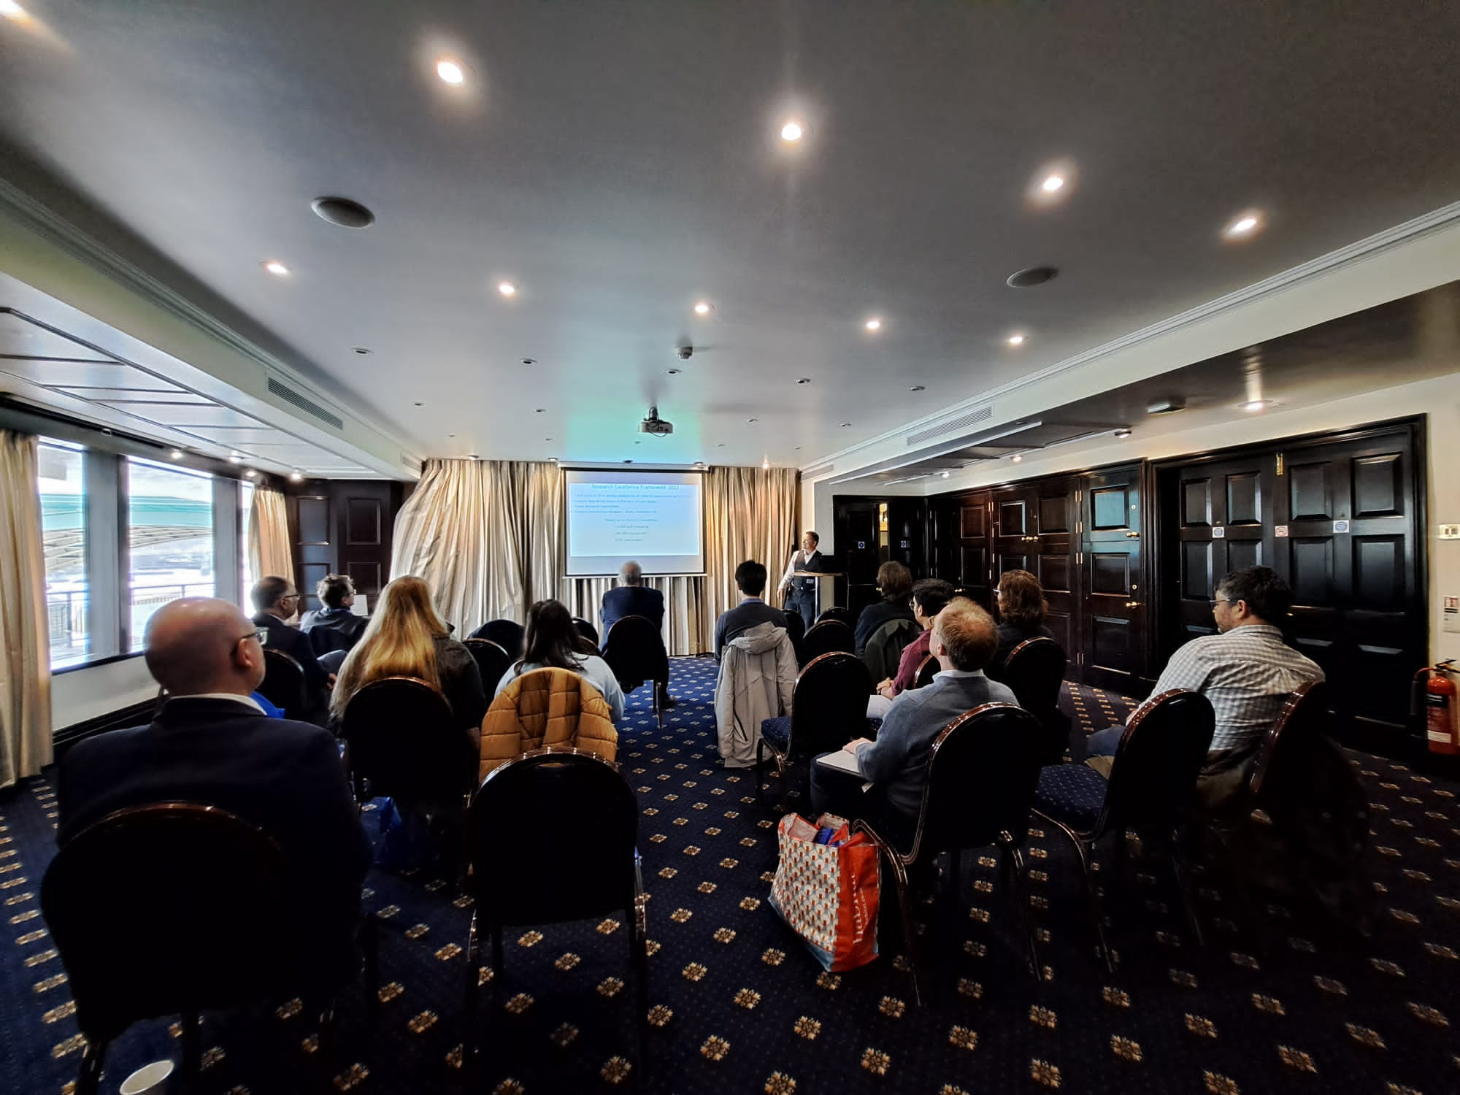

Figure 1. Professor Stephen Dance introduces the Art of Being an Acoustician

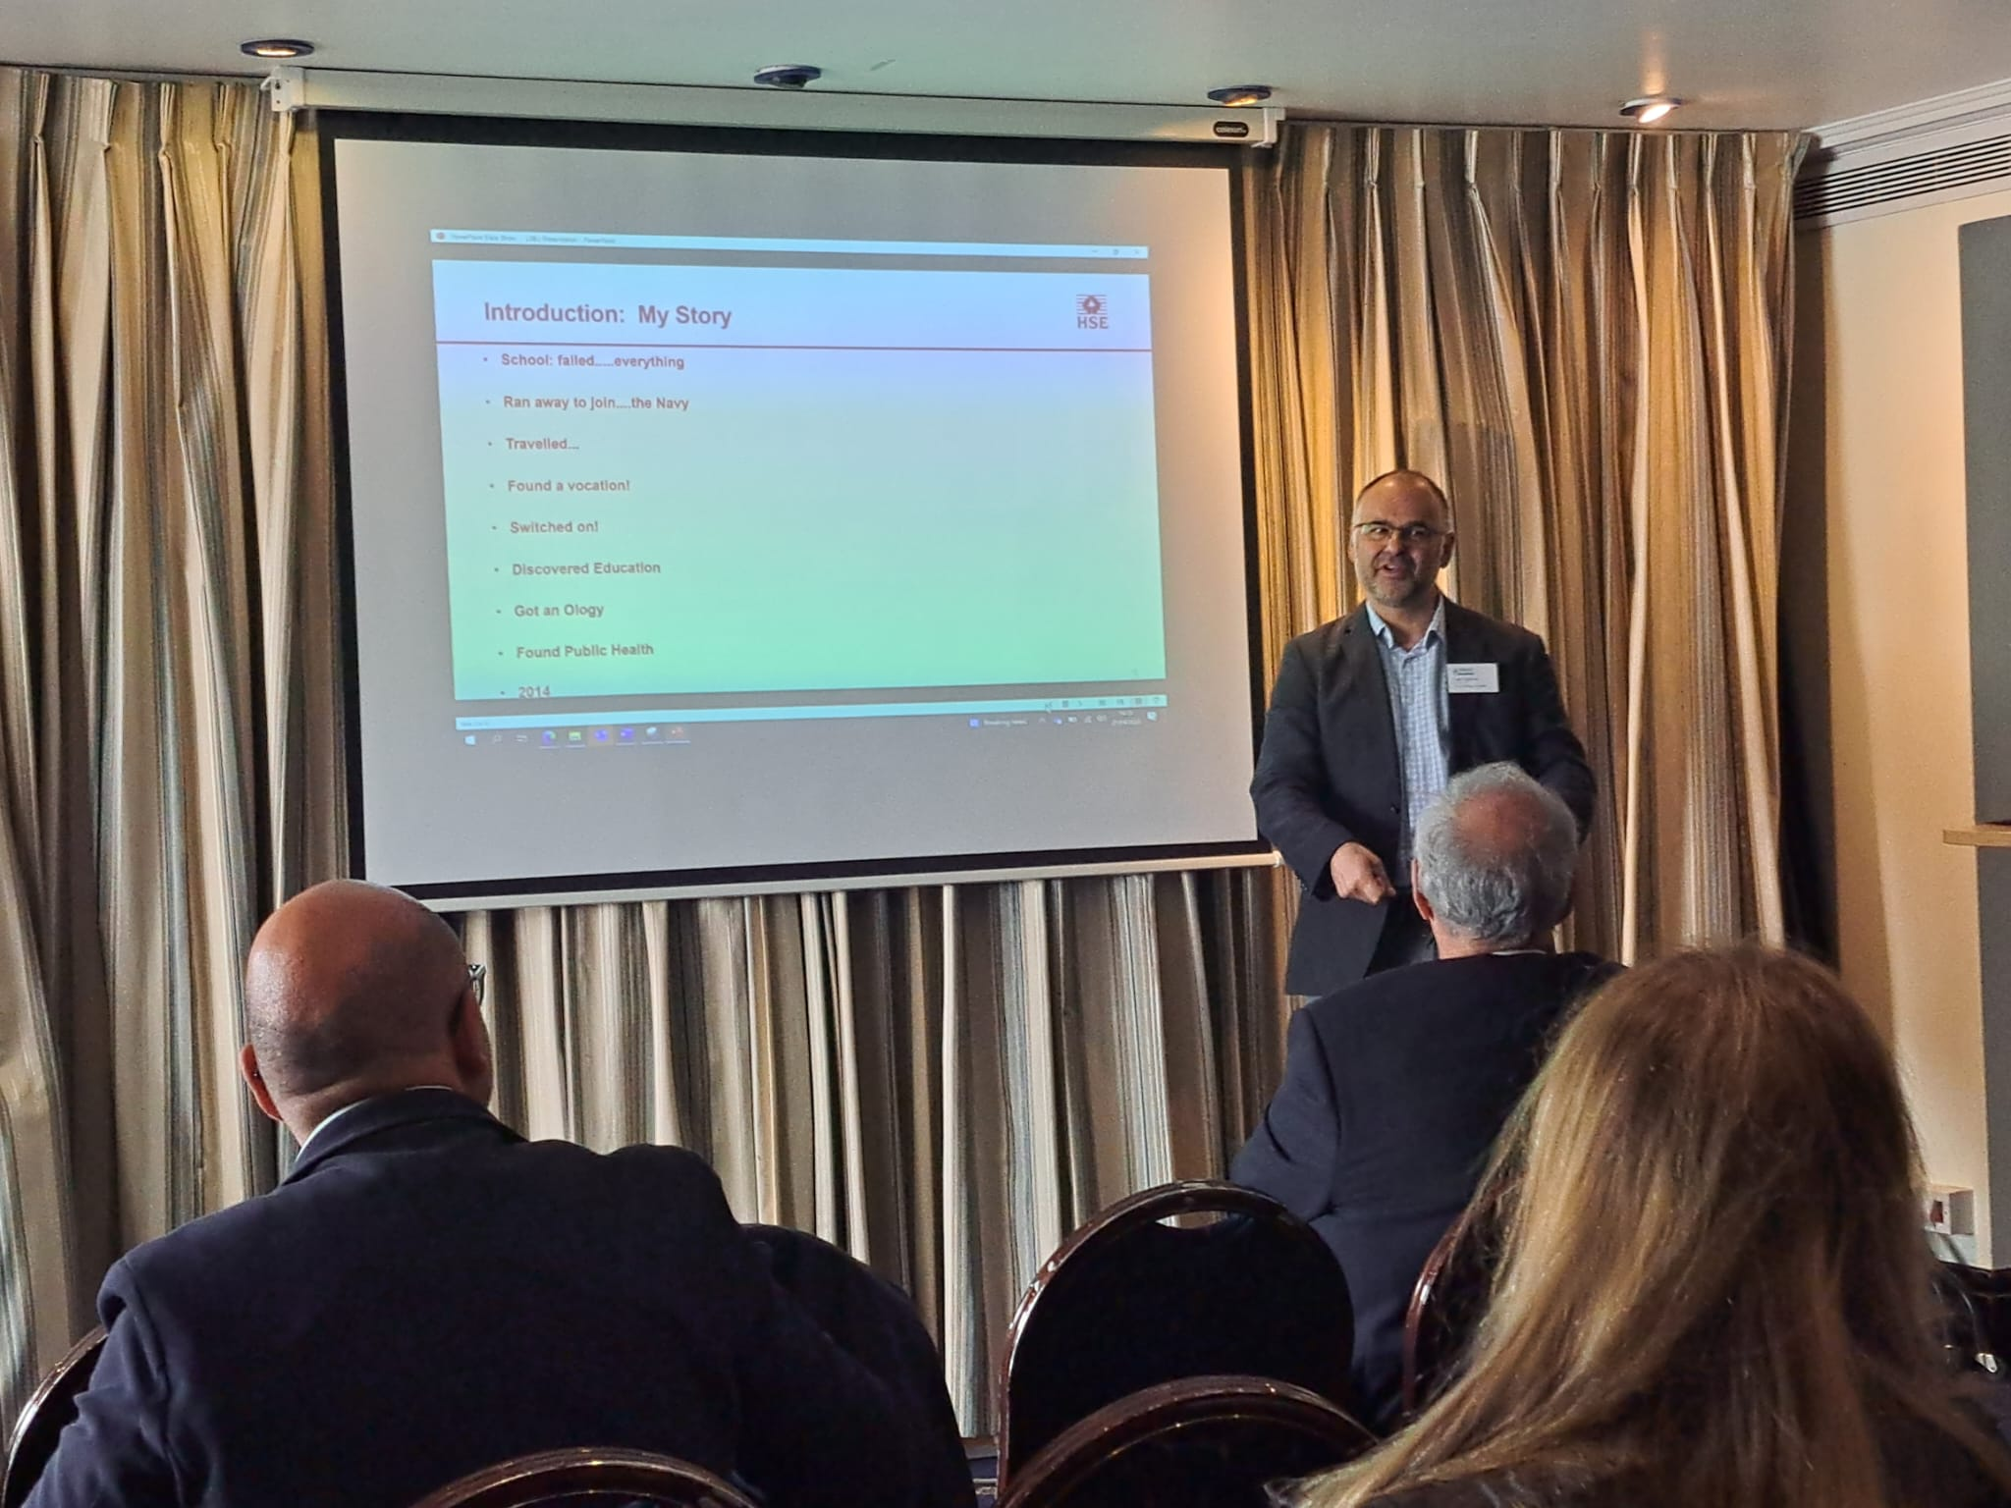

Figure 6. Adam Spencer giving his journey into acoustics

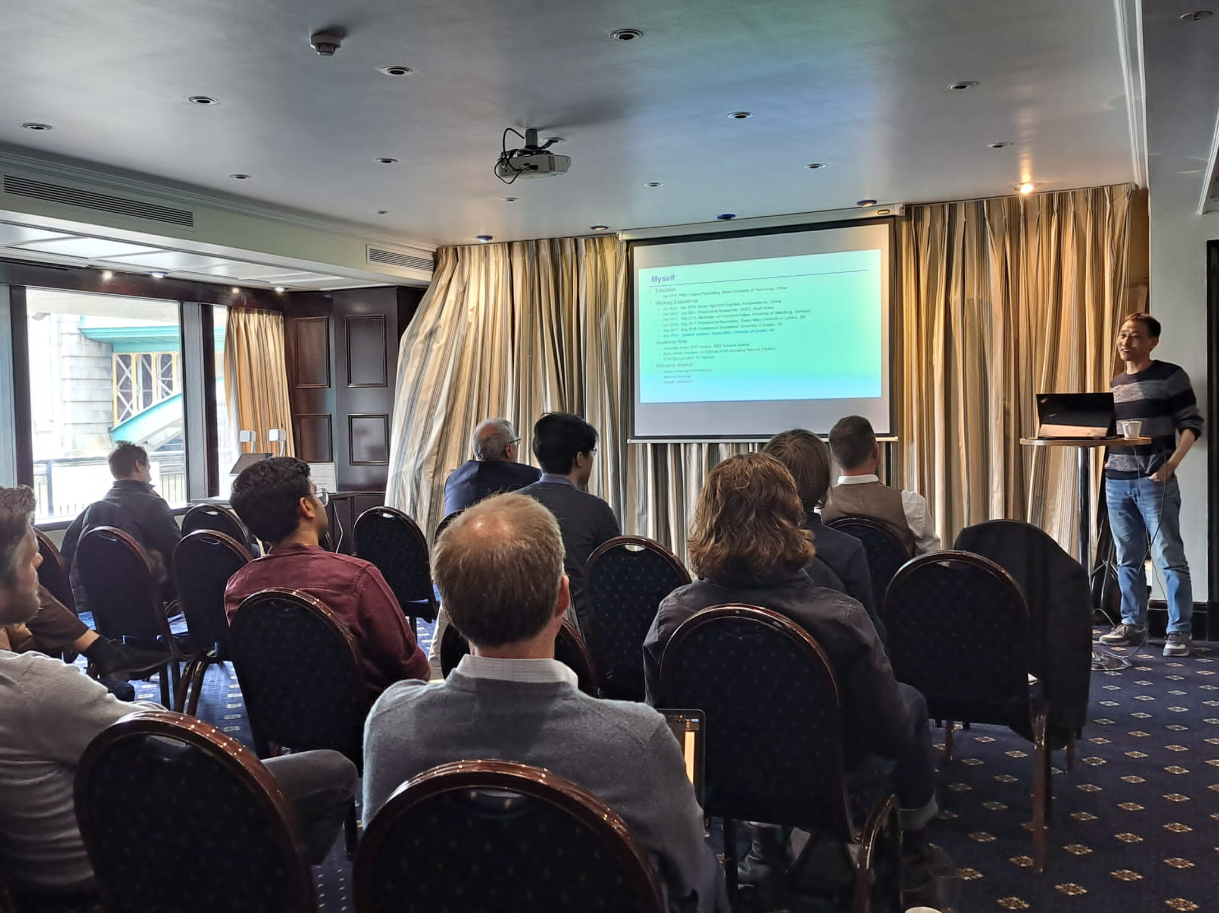

Figure 8 Dr Lin Wang presenting his CV – he enjoyed being a postdoc researcher

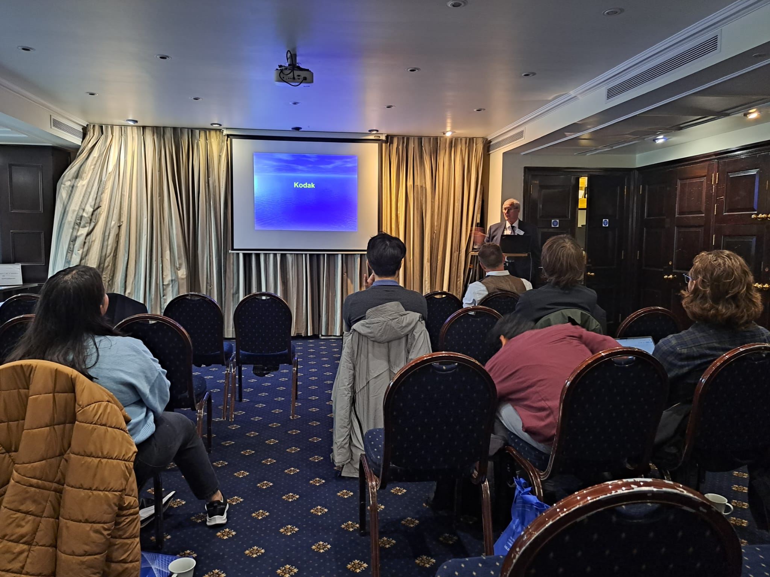

Figure 2. Ken Marriott sharing his stories of vibrating structures

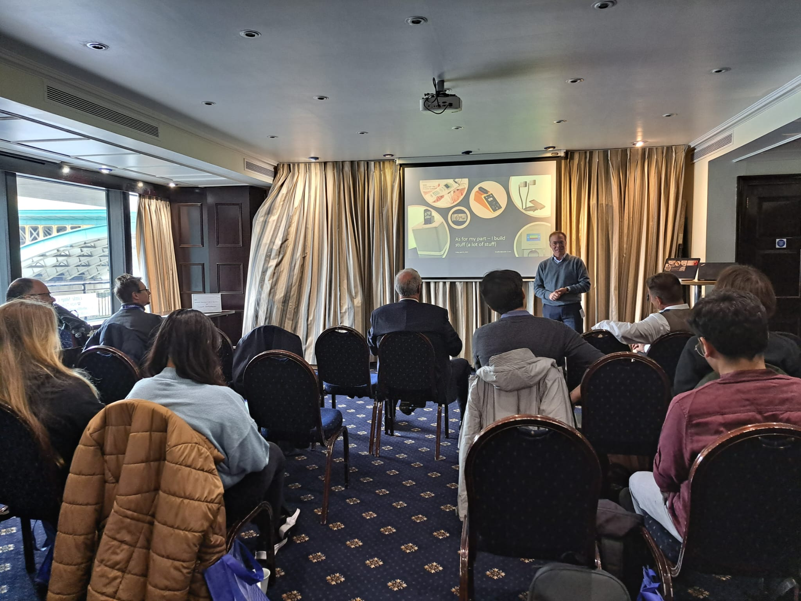

Figure 3. Dr Bradford Backus of Audio-3 presenting all the products he has designed

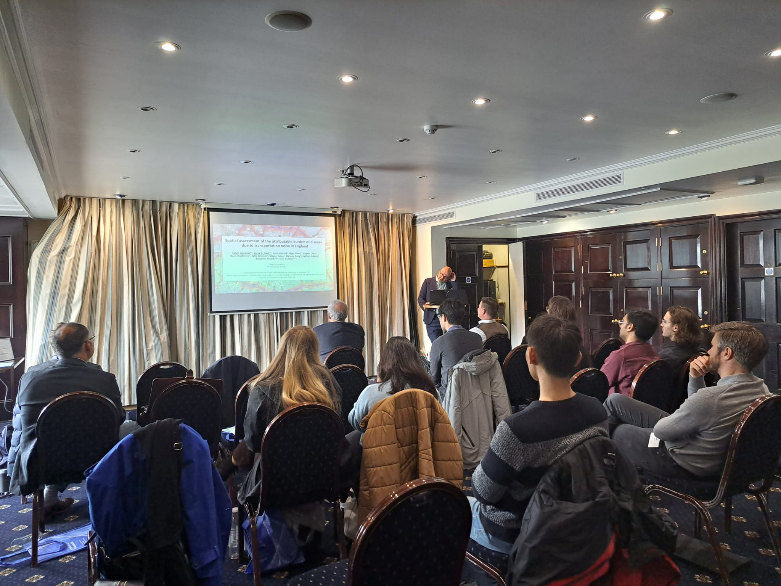

Figure 5 Dr Ben Fenech presented the collaborative work on the burden of disease due to transportation disease

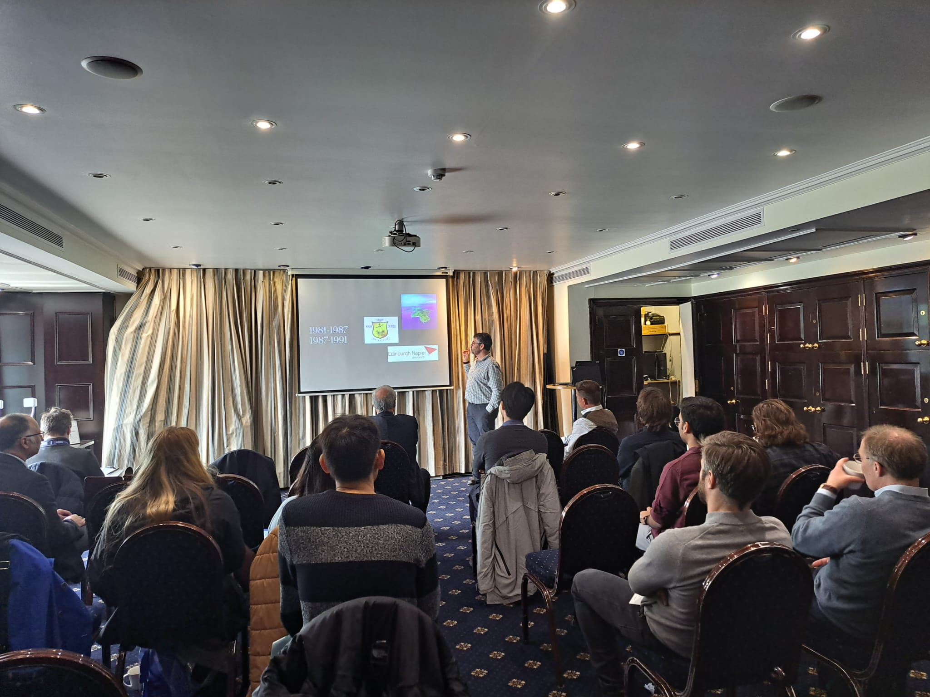

Figure 4. Dr Isalah Ali-MacLachan winning working for the most univerities

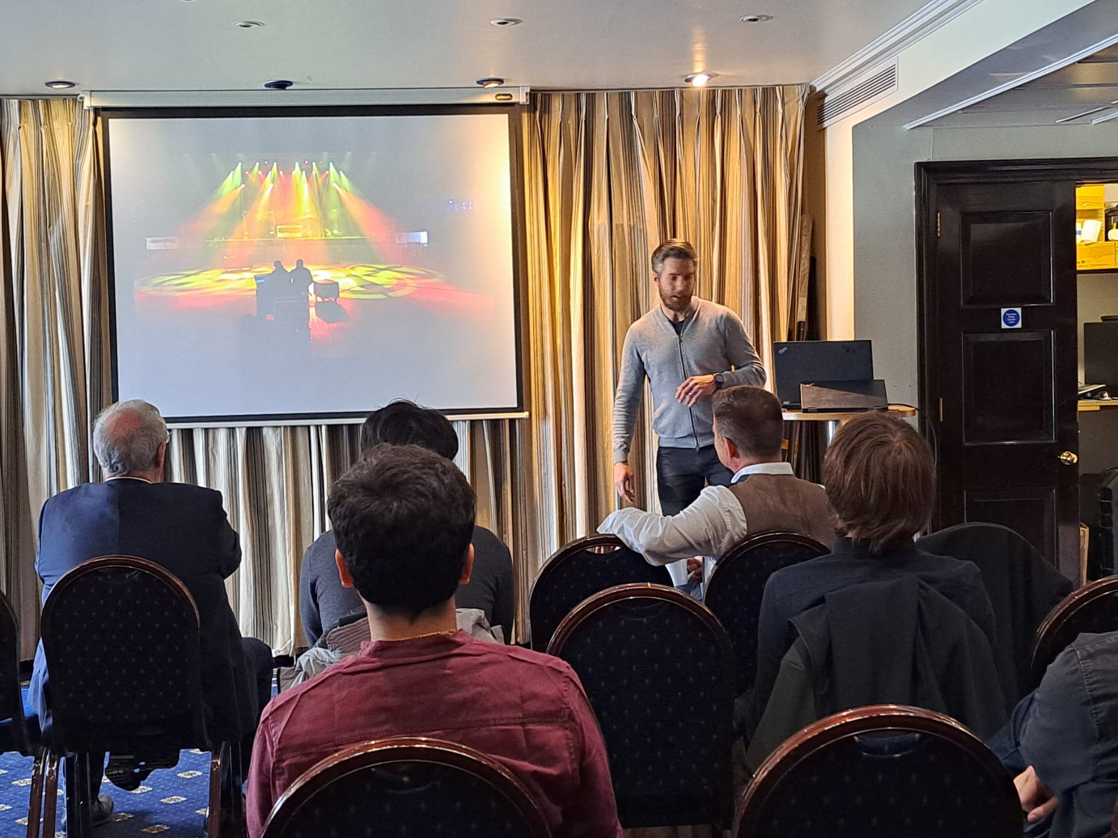

Figure 7 Gareth Davies explaining litfe on the road was creative and uexciting ntil you have to settle down