Ultrafine Nanolatexes Made via Monomer-Starved Semicontinuous Emulsion Polymerisation in the Presence of Water-Soluble Chain Transfer Agents
Shahriar Sajjadi¹, Yan Chen², and Fatemeh Jahanzad³
¹King’s College London, Strand, London, UK, WC2R 2LS (Shahriar.sajjadi-emami@kcl.ac.uk). ²Tianjin Key Laboratory on Technologies Enabling Development of Clinical Therapeutics and Diagnostics, School of Pharmacy, Tianjin Medical University, Tianjin 300070, China. ³ Division of Chemical and Petroleum Engineering, London South Bank University, London, UK, SE1 0AA

Abstract
Ideal chain transfer agents are usually water insoluble as they do not affect the kinetics of polymerisation reactions occurring in the water phase. Water-soluble chain transfer agents act non-ideally by easily crossing the water phase and affecting the kinetics of polymerisation including nucleation. In this research, a partially water-soluble chain transfer agent (CTA), 2-Butanethiol, was used in the monomer-starved semicontinuous emulsion polymerisation of styrene as a means to affect the kinetics of water phase and synthesise ultrafine nanolatexes. Batch emulsion polymerisations were also carried out for comparison. In the batch process, the termination of chain transferred radicals in the water phase was found to be quite dominant, resulting in the formation of large polymer particles with polydisperse molecular weights and slow rate of reaction. By contrast, for the semicontinuous process, the application of the CTA reduced the average size of particles, by enhancing the rate of nucleation via increasing the rate of radical entry into micelles, and provided a good controllability over molecular weight distribution as well as the rate of polymerisation.
Introduction
Many applications of nanolatexes with small size of particles (below 30 nm) also require narrow molecular weight distributions (MWDs)., Monomer-starved semicontinuous emulsion polymerisation is a widely used technique to produce nanolatexes.,,,,,, Lower molecular weights are usually obtained for latexes produced by semicontinuous process, compared to those from batch process. Furthermore, the molecular weight of polymer can tightly be controlled by the rate of monomer addition.,,
Different formulations or process variables have been used in monomer-starved semicontinuous emulsion polymerisation as a means to further reduce the size of nanoparticles. Examples include using an extremely low monomer feed rate to limit particle growth, water-soluble comonomers to enhance nucleation, high reaction temperatures,^{13,} or oil-soluble initiators. However, the use of chain transfer agents (CTA) has not been exploited yet. Chain transfer agents are commonly used in emulsion polymerisations to control molecular weight distribution (MWD) of polymers by terminating the growing polymer chains and transferring the radical activity to the CTA molecules. These latter molecules can diffuse to the aqueous phase if they are water soluble.,, Water-insoluble chain transfer agents, such as dodecyl mercaptan (n-DDM), are usually considered as ideal CTAs because they only affect the molecular weights of resulting polymers. Ideal CTAs do not affect the kinetics of polymerisation including particles size and number (N_{p}), and the rate of reaction (R_{p})., This is because the transferred radicals of hydrophobic transfer agents will remain in particles and initiate another chain therein. Such CTAs can often produce polymers with narrow molecular weight distribution (MWD)., However there are reports in the literature that suggest narrow MWDs are difficult to achieve using hydrophobic CTAs under certain conditions because of difficultly involved in their transport to the polymerisation loci; the transfer of hydrophobic chain transfer agents from monomer droplets to the reaction loci is diffusion controlled.^{15, 20,} While the application of semibatch or semicontinuous emulsion polymerisation, in which CTA is added gradually in the course of reaction, can help obtain better molecular weight uniformity, it still cannot completely resolve the problem.
Water-soluble CTAs do not impose diffusion limitation and can easily reach reaction loci. Therefore they terminate the growing chains and produce polymers with a narrower chain size distribution, but may affect R_{p} and N_{p} because of significant CTA-derived radicals desorption into the water phase. In a highly monomer-starved semicontinuous process, the rate of reaction is usually controlled by the rate of monomer addition (R_{a}), suggesting that a relatively water-soluble CTA may not affect R_{p}. The idea of reducing the size of polymer particles by the early termination of polymer chains via chain transfer reactions appears to bear significant potential for making nanolatexes with smaller particle size and more uniformity. Nomura and coworkers have already stated that the desorbed radicals can enter the micelles and form new particles during nucleation stage in batch emulsion polymerisations.^{18,} Smeets and co-workers have also reported the use of a catalytic chain transfer agent to enhance radical exit and thereby decrease the size of particles in a batch emulsion and microemulsion polymerisation. Transferred radicals formed by water-soluble chain transfer agents can easily exit the particles and participate in several kinetics events that might lead to an enhanced nucleation, in addition to a controlled molecular weight.
In this research, we aimed to exploit this idea by using a relatively water-soluble CTA in a monomer-starved semicontinuous process. Most researches on monomer-starved semicontinuous process have either used sparingly water-soluble CTA bearing small effect on particle size ,, or employed a seeded system, where the effect of CTA on N_{p} was irrelevant. Relatively water-soluble CTAs have been used in semicontinuous emulsion polymerisation in the past but only as a means to control MWD. We studied thiol family in terms of water solubility and boiling temperature in connection with the reaction temperature. We selected a relatively water-soluble chain transfer agent, 2-butanethiol or sec-butyl mercaptan (1.32 g·l_{aq}⁻¹, at 20ºC). Such CTAs are favourably partitioned into water phase and thus may enhance radical desorption and particle nucleation. Thiols with higher water solubility are also available, but they are usually volatile. The corresponding batch polymerisations were also conducted for the sake of comparison.
Experimental Work
Chemicals: Analytical grade styrene, potassium persulfate, sodium dodecyl sulfate (SDS) and sodium hydrogen carbonate (SBc), all obtained from Sigma–Aldrich, were used as monomer, initiator, emulsifier, and buffer, respectively. The inhibitor was removed from the monomer by using an ion exchange column (Sigma–Aldrich) prior to use.
Apparatus: Polymerisations were carried out in a standard 1-L jacketed glass reactor. The stirrer rate was kept constant at 300 rpm. The temperature of the reactor content was controlled at 70 ± 1.0°C by water with appropriate temperature being pumped through the jacket.
Procedure: The recipe for the experiments is given in Table 1. Two types of operation were carried out. In semicontinuous process, the aqueous solution of surfactant was firstly added to the vessel. The system was allowed to return to the reaction temperature when the aqueous solution of the initiator was added. Styrene monomer mixed with a weighed quantity of CTA, was then added to the reactor vessel using a dosing pump at a fixed feeding rate (R_{a} =13.0 ml·h⁻¹). In batch process, all ingredients except for the initiator, were added to the reactor vessel, heated up to the reaction temperature 70°C, followed by the addition of the aqueous solution of the initiator. An inhibition period of 1-2 min was observed for batch polymerisation reactions to start, which was excluded from the conversion – time data. The start of reaction was continuously checked by precipitation of a sample of latex in methanol. All ingredients were purged with nitrogen for 15 min to remove the oxygen dissolved, prior to use
Measurements: Conversions were measured gravimetrically. Two types of conversions were used for semicontinuous process. Instantaneous conversion (x_{i}) indicates the conversion in the reactor at time t, and overall conversion (x_{o}) indicates the conversion based on the overall monomer used in the recipe. The z-average diameter of particles (D_{z}) was measured using Malvern nanosizer (DLS). The number of particles was calculated according to the following equation
$N_{p}= \frac{ρ_{m}R_{a}tx_{i}}{π/6D_{v}^{3}ρ_{p}}$ (1)
where ρ_{m} and ρ_{p} are the density of styrene monomer and polystyrene, which are 0.909 g·ml⁻¹ and 1.044 g·ml⁻¹, respectively. A conversion factor of C_{f} = 0.9 was found to relate D_{z} to D_{v} required for calculation of the number of particles so that D_{v,}= C_{f}∙∙D_{z} .¹² Using the D_{v} data and total amount of emulsifier in the reaction mixture, the surface coverage ratio of particles (θ) was calculated using Langmuir model.¹² The weight-average molecular weight (${\overline{M}}_{w}$) of polymer was measured by static light scattering technique (SLS; Malvern) using simplified Rayleigh equation.¹² The rates of polymerisation (R_{p}) and particle formation (dN_{p}/dt) were calculated from the slopes of x_{o}-t and N_{p}-t curves, respectively.
Table 1. Recipe and conditions used for the study of polymerisations in the presence of CTA.
Ingredients/Reaction conditions | Quantity
Styrene (ml) | 50
SDS (g·l_{aq}⁻¹) | 10.0
KPS (mmol.l_{aq}⁻¹) | 4.0
SBc (mmol.l_{aq}⁻¹) | 4.0
CTA (wt%) | 0-4.0
Water (ml) | 600
Temprature (°C) | 70
Feed rate (ml·h⁻¹) | 13.0

Results
Two sets of experiments were carried out via batch and semicontinuous processes to investigate the effect of CTA on the kinetics of polymerisation. The concentration of CTA was varied from 0 to 4.0 wt%, based on monomer.
Conversions
Figure 1ab shows the variations in conversions versus time for different CTA concentrations for both batch and semicontinuous processes, respectively. The overall rate of polymerisation (R_{p}) in batch process was suppressed in the presence of CTA with a degree increasing with CTA concentration, as shown in Figure 1a. Similar experimental results have also been obtained by others.^{18,29} However, for semicontinuous process, the rate of polymerisation was not much sensitive to the amount of CTA used as it was controlled by the rate of monomer addition so that R_{p} = R_{a} (Figure 1b).
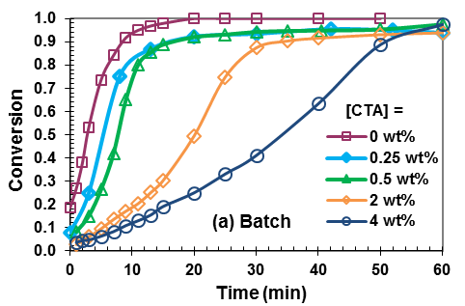 | 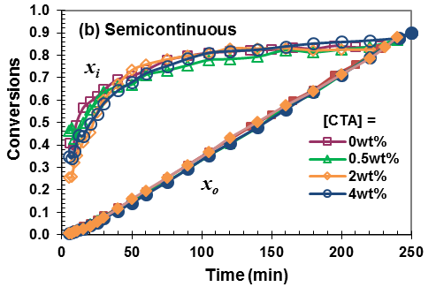
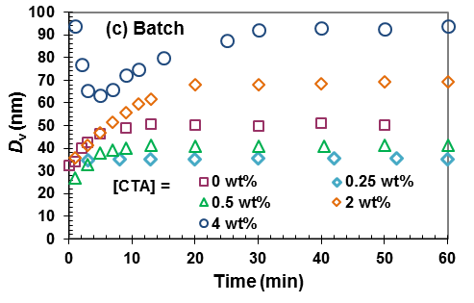 | 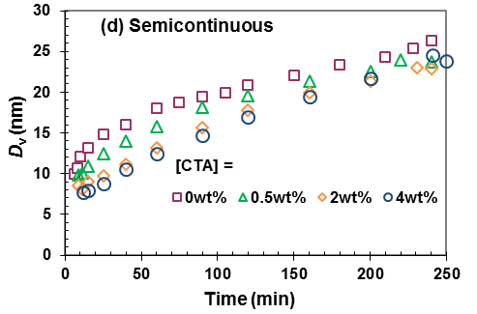
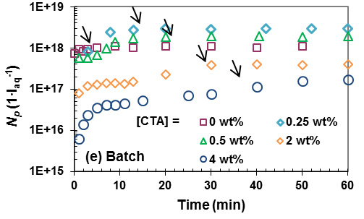 | 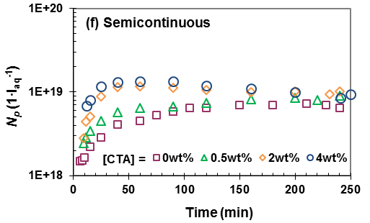
Figure 1. (a) conversion and (b) instantaneous conversion x_{i} and overall conversion x_{o}, (c) and (d) volume-average particle diameter, and (e) and (f) particle number versus time for polymerisations with various CTA concentrations for batch and semicontinuous process, respectively. The arrows in (e) indicate the end of particle nucleation.

Particle size and number
The results for particle size and number in the course of reactions are shown in Figure 1cdef. The particle size increased with time for all runs, as expected, but the growth was more significant for batch process because of smaller number of particles formed for a given amount of monomer. In the batch process and in the presence of monomer droplets, particles grew quickly within seconds so that their early size evolution could not be measured. Because of particle growth being restricted in semicontinuous process due to slow addition of monomer and a large number of particle formed, particle size could be monitored right from the beginning when the particle was nucleated until the end of polymerisation. The final size of particles from the batch process initially decreased with increasing [CTA] (< 0.50 wt%), but increased at higher CTA concentration if [CTA] > 2.0 wt%), as shown in Figure 1c. The number of particles followed an opposite trend (Figure 1e). For the semicontinuous process, however, the size of particles considerably decreased and their number increased with increasing CTA concentration, as seen in Figure 1d. However, a limited coagulation, identified by a drop in N_{p} for [CTA] ≥ 2.0wt% , occurred that reduced the difference in the generated N_{p} at different [CTA]. A factor of 2 increase in N_{p} was resulted when [CTA] was increased from 0 to 4.0 wt%.
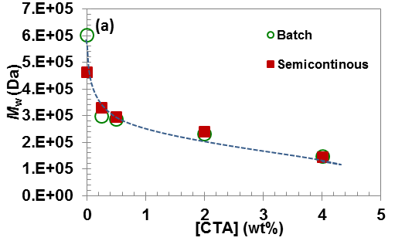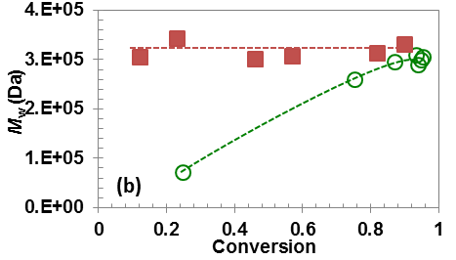

Figure 2. (a) Weight average molecular weight (${\overline{M}}_{w}$) of final polymer nanolatexes versus CTA concentration and (b) evolution of ${\overline{M}}_{w}$ with overall conversion for both batch and semicontinuous processes at [CTA] = 0.25 wt%.

Molecular weight of polymer (${\overline{M}}_{w}$)
The average cumulative molecular weight, ${\overline{M}}_{w}$, of the final latexes, drawn against CTA concentration in Figure 2a, decreased with increasing CTA concentration almost in a similar way for both batch and semicontinuous processes. Although similar final values were reached for both processes, Figure 2b shows the ${\overline{M}}_{w}$ trajectories with overall conversions were quite different. The cumulative ${\overline{M}}_{w}$ from the batch process continuously increased with time/conversion. By contrast, ${\overline{M}}_{w}$ remained fairly constant throughout the semicontinuous process, in a similar way to those observed in both processes in the absence of CTA.¹² Note that despite similar ${\overline{M}}_{w}$ produced by both processes, the polydispersity, indicated by variations in ${\overline{M}}_{w}$ in the course of reaction, was quite significant for polymers produced by batch process.

Discussion
Particle nucleation
The assumption of 0-1 radical number is well accepted for small particles during nucleation period in emulsion polymerisation. A radical arising from the chain transfer reaction to CTA can have two distinctive fates; a) It can remain inside the particles and propagate there. In this case there will be no effect on the kinetics of polymerisation. b) It leaves the particles and enters into the aqueous phase. Since the CTA used is relatively water soluble, it is appropriate to assume that the most likely fate for the transferred radicals is to leave the particle, following four possible fates as follows. 18, 1) It can re-enter a free micelle and form a new particle. 2a) It can enter an existing ‘inactive’ or ‘dormant’ polymer particle and propagate inside that particle. 2b) It can enter an existing ‘active’ or “propagating” polymer particle and terminate with the radical inside the particle. 3) It can be terminated by another radical in the aqueous phase. Fate 2b can be justified on the ground that particles during nucleation are small and can only have one growing radical. Therefore, the entry of a secondary radical into a particle having a growing radical inside will lead to an instantaneous termination. The effects of these fates on R_{p}, N_{p}, and dN_{p}/dt in a typical batch emulsion polymerisation are summarised in Figure 3. Fates 1 and 2a do not have a significant effect on R_{p} as these events would not alter the concentration of radicals in the system. Fate 2a has no tractable effect on N_{p} and dN_{p}/dt either. However, a dominant fate 1 would lead to a substantial increase in N_{p} and dN_{p}/dt, because it forms new particles by deactivating existing particles, with no substantial effect on R_{p} during nucleation (we ignore the difference in the growth rate of newly nucleated and grown particles because of their monomer concentration). Fates 2b and 3 can be considered as events associated with radical loss, which might imply a decrease in both N_{p} and R_{p} at the first glance. While this is true for fate 3, is only partially true for fate 2b, as for the latter only R_{p} is reduced because of the reduced rate of particle growth. A decreased rate of growth for particles, associated with fate 2b, however, can increase the nucleation time by depressing the rate of micelle depletions. This can increase N_{p}, but will not significantly affect dN_{p}/dt (ignoring the small effect of the reduced rate of particle growth on the concentration of micelles). The particle re-entry fates, 2a and 2b, which compete with fate 1, occur concomitantly. They become dominant at the later stage of nucleation when the number (and size) of particles exceeds that of remaining micelles, and their combined effects are an increase in N_{p} and a reduction in R_{p}, with no significant effect on dN_{p}/dt.

Fates of CTA transferred radicals |  | Theoretical effects |  |  | Experimental
 |  | N_{p} | dN_{p}/dt | R_{p}
1. Re-entry into micelles to form new particles |  |  |  |  | 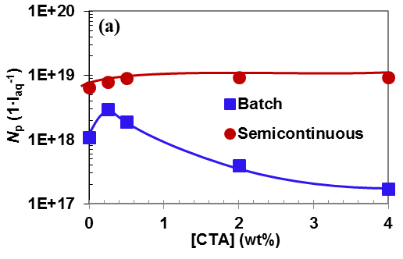
2.a Re-entry into a dormant particle |  |  |  |  | 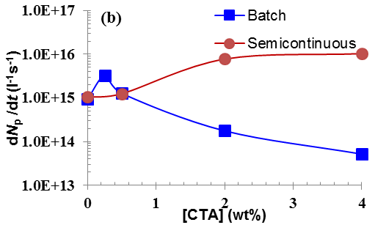
2.b Re-entry into a propagating particle (polymer phase termination) | 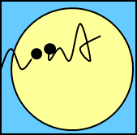
3.Re-entry into water and water phase termination |  |  |  |  | 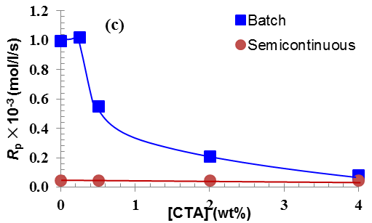
Figure 3. The schematics of fates for the chain transferred desorbed radicals and their effect on N_{p}, dN_{p}/dt, and R_{p}. Variations of a) number of particles (N_{p}), b) rate of particle nucleation (dN_{p}/dt), and c) rate of polymerisation (R_{p}) versus chain transfer concentration ([CTA]). Fate 1 was found to be dominant at low [CTA] but fate 3 at high [CTA].

We do not have any experimental means to distinguish the real fates of desorbed radicals. However, we will rationalise the results in the light of guidelines presented in Figure 3. Fates 1 and 3 have more significant and detectable effects on the polymerisation features compared to fates 2 (a and b). Comparing the N_{p}-[CTA], dN_{p}/dt - [CTA], and R_{p}-[CTA] trends against the guidelines depicted in Figure 3, then one can suggest that for batch process fate 1 is more effective at low [CTA] but fate 3 at high [CTA]. This conclusion can make sense if the rate equation for the chain transfer radicals is visited.
$${\frac{d{[\dot{CTA}]}_{w}}{dt}}_{}=k_{tr}^{CTA}{[\dot{R}]}_{p}{[CTA]}_{p}+k_{tr}^{CTA}{[\dot{R}]}_{w}{[CTA]}_{w}-k_{tw}{[\dot{CTA}]}_{w}\sum{({[\dot{CTA}]}_{w}}+{[\dot{R}]}_{w})-k_{ap}{{[\dot{CTA}]}_{w}N}_{p}-k_{am}{{[\dot{CTA}]}_{w}N}_{m}$$ (2)
where [CTA]_{i} and $[\dot{CTA}]_{i}$ indicate the concentration of CTA and its radical with the index i referring to polymer (p) and water (w) phases, respectively, $[\dot{R}]_{w}$ is the concentration of initiator-derived radicals in the water phase, N_{m} is micelle concentration, k_{am} and k_{ap} are transferred radical re-entry constants into micelles and particles respectively, and k_{tw} is the radical termination constant in the water phase.
Note that [CTA]_{w} accounts for all radical lengths in the aqueous phase that have initiated from the CTA, and that propagation of chain transfer radicals in the water phase does not affect their concentration. The first two terms on the right side of Eq. 2 represent the rate of generation of CTA radicals assuming that all transferred radicals would leave the particles because of their high water solubility. The CTA is more soluble in water than styrene monomer. Therefore, chain transferred radicals can also directly be generated in the water phase by the reaction of initiator derived radicals with CTA molecules dissolved (2nd term in Eq.2). The third term represents radical termination in the water phase (fate 3), while the fourth and fifth terms represent radical entry into particles (fates 2a and 2b) and micelles (fate 1) respectively.
Figure 3c clearly shows a little change in R_{p} at low [CTA] but a significant decrease at high [CTA], suggesting that the radical termination in the water phase was the dominant mechanism at high CTA concentrations. The small increase in N_{p} within low values of [CTA], as seen in Figure 3b, can be attributed to the increase in the concentration of radicals in the water phase, which in turn leads to a higher rate of radical entry into micelles (fate 1). At [CTA] > 0.50 wt%, N_{p}, dN_{p}/dt, and R_{p} decreased significantly because of loss of radicals in the water phase due to termination. As a result the rate of radical entry into micelles decreased and particle nucleation period was prolonged with increasing CTA concentration (Figure 1e). Nomura and co-workers found that with an increase in the amount of CTA charged in a batch emulsion polymerisation, the number of polymer particles increased initially, but then decreased, similar to the results presented in this work. They attributed this to significant water-phase termination among initiator and desorbed radicals.¹⁸ The reason for this enhanced termination can be better understood if Eq.2 is consulted. With increasing [CTA], accompanied by increases in [CTA]_{p} and [CTA]_{w}, the rate of generation of CTA-derived radicals (the first two terms in Eq. 2) is significantly increased. This is not only because of the CTA radicals being desorbed from particles, but mainly because of the initiator-derived radicals propagating in the water phase being continuously transformed to CTA radicals. The propagating CTA radicals would also step back to primary CTA radicals, by reaction with dissolved CTA in water, before they can reach the critical size for entry. As a result, the concentration of stray CTA radicals increases, leading to fate 3 becoming dominant (the 3rd term in the above equation is proportional to${[C\dot{T}A]}_{w}^{2}$). This subsequently results in severe suppression in both N_{p} and R_{p}. Maxwell et al.³⁴ using appropriate kinetic schemes for reaction of different species, showed that for any polymerisation reaction at a given CTA concentration there might be a condition that displays a maximum in entry rate with increasing initiator concentration. Similarly, it is very likely that for any reaction condition at a given initiator concentration, there exists a CTA concentration at which the rate of radical entry reaches its maximum. Any CTA concentration above this threshold, found to be [CTA] = 0.5 wt% for the current system, will decrease the overall rate of radical entry.
We conclude that [CTA] decides which fates to be dominant in the system under study. If this statement is true, then the alteration in fates might even occur in the course of polymerisation as CTA is consumed. Figure 1e confirms this by pointing to secondary nucleation in the later stage of batch polymerisation when [CTA] was high (> 0.50 wt%). The onset of secondary nucleation was always associated with an acceleration in the rate of polymerisation, as observed in Figure 1c. This is the result of change from enhanced radical termination in the water phase to radical entry into micelles/particles, from fate 3 to fates 1 and 2, as CTA is consumed in the course of reaction. This, however, does not imply a complete domination by fates 1 and 2 as the final conversion for batch polymerisation was generally lower in the presence of CTA. This indicates a more significant radical termination in the water phase when the monomer concentration is low. It should be noted that unlike monomer, which is mainly consumed in the polymer phase, the CTA is consumed in both aqueous and polymer phase. Both initiator-derived and chain-transferred radicals can more easily find CTA, than monomer, in the water phase to react with.
Now we turn our attention to the semicontinuous run, in which R_{p} was controlled by the rate of monomer addition (R_{p} ≈ R_{a}). However, N_{p} increased consistently with increasing [CTA], unlike the batch process. A more deterministic feature of nucleation mechanism can be inferred from Figure 3ab that shows not only the N_{p}, but also the rate of particle nucleation increased with [CTA], suggesting fate 1 to be dominant in the semicontinuous process within the whole [CTA] range studied. This discrepancy between batch and semicontinuous processes stems from different ways by which CTA was used in the two processes. In batch process, all CTA was initially charged in the reactor. Because of a favoured partitioning of the CTA in water, or a high k_{CTA} = [CTA]_{w}/[CTA]_{p}, a large number of chain transferred radicals are generated in the water phase that can significantly affect the kinetics of the water phase in batch process. At low range of [CTA], for example at [CTA] = 0.25 wt% (see Table 1 for the recipe), the amount of styrene and CTA dissolved in the water phase is of the same order (note that the solubility of the CTA is 6-7 times larger than that of styrene). This condition still allowed radicals to grow to the critical size for micelle/particle entry and enhance nucleation. At high [CTA] (i.e, [CTA] = 2.0 wt%), however, the water phase was almost saturated with the CTA thus significantly reducing the chance of a propagating radical being able to reach the critical size required for entry. In the semicontinuous process, the concentration of CTA derived radicals in water always remained limited because of the delayed CTA addition. As a result of these, mechanism 1 remained dominant in the course of reaction, similar to the batch process at low [CTA]. This led to continuous increase in N_{p} with increasing CTA, as shown in Figure 1f. Furthermore, the [CTA]_{p}/[M]_{p} ratio in the particles was kept constant via slow addition of the monomer and CTA, resulting in a constant ${\overline{M}}_{w}$ in the course of polymerisation, as seen in Figure 2b.
Using molecular-weight and particle-size data, the average number of chains per particle was calculated (not shown). For the batch experiment, the number of polymer chains per particle increased an order of magnitude, from 10² to more than 10³, when CTA concentration increased from 0 to 4.0 wt%. Comparing with batch process, particles formed via semicontinuous process contained fewer chains (~10) whose number remained relatively constant with increasing CTA concentration even though the chains became increasingly shorter.
Limited particle coagulation
While the application of the CTA led to the formation of a larger N_{p} in the semicontinuous process, as shown in Figure 1f, a limited particle coagulation occurred later in the reactions so that the difference between the runs using different CTA concentrations became minimal. CTA transferred radicals do not contribute to particles stability as they do not have the sulfate end group. However, this is less likely to be the reason for the limited coagulation due to the presence of surfactant in the reaction medium. One possible reason to explain the limited particle coagulation could be that the amount of surfactant available in the system was not enough to stabilize such a large number of particles produced. In order to investigate this, the average particle surface coverage ratio by surfactant (θ) during polymerisations was calculated and shown in Figure 4. From the comparison of this graph and Figure 1f, one can easily infer that the onset of coagulation coincided with the end of nucleation when micelles were depleted and θ started to decrease. This was not expected as a surface coverage of as low as 50% has been found to produce sufficiently stable polymeric nanoparticles. Particle coagulation did not occur in the batch process because the runs using CTA ended with uninitiated micelles being present in the reaction mixture. The runs using low concentration of CTA, [CTA] = 0.25 and 0.50 wt%, consumed all micelles and had θ of around 75-85% at end of polymerisation, but did not undergo coagulation either. However, we should note that particle concentration of the latexes made via batch process was rather low and the nucleation periods (reaction time) were relatively short, which can significantly reduce the chance of coagulation.
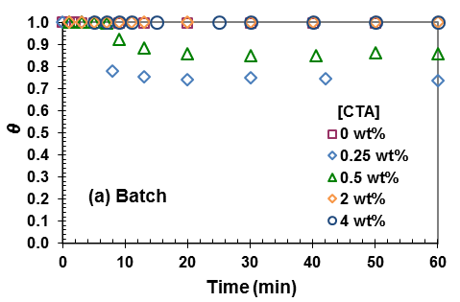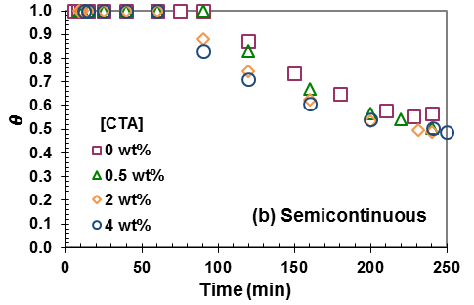
Figure 4. Particle surface coverage ratio in the course of polymerisation for various CTA concentrations via (a) batch process, and (b) semicontinuous process.
In order to improve colloidal stability of particles during the growth stage, and also find the relation between particle stability and surface coverage, the semicontinuous experiment using 4.0 wt% CTA was repeated, but this time another shot of SDS (4.8 g dissolved in 20 g of water) was gradually added to the reactor starting from t = 60 min, end of nucleation stage, onwards till 180 min. The rate of SDS addition was controlled at a low level in order to avoid accumulation of SDS in the reaction mixture that induces secondary particle nucleation. The rate of reaction did not change with application of supplementary SDS. The results for N_{p} and θ are shown in Figure 5. Particle coagulation was suppressed and particles were maintained during the growth stage. The final particle diameter was reduced from 25 to 20 nm when supplementary SDS was used. The final θ was reduced to 60%, in comparison with 50% calculated for the base experiment. It is quite intriguing that such a rather small increase in θ by feeding SDS, as shown in Figure 5, was sufficient to hinder particle coagulation. It is likely that the CTA-transferred radicals have made the polymer particles more hydrophilic and facilitated the inclusion of SDS molecules inside the particles, indicating that the calculated θ may not be reflective of the actual value. A similar phenomenon has been reported for more hydrophilic polymers such as poly vinyl acetate with SDS surfactant. This suggests that fresh surfactant may be required to further stabilise the particles.
One point worthy of attention for the batch process, which can be inferred from Figure 4, was that the mount of monomer used for some runs ([CTA] = 0, 2.0, and 4.0 wt%) was not sufficient to warrant full depletion of micelles. This is a result of higher growth rate of particles during nucleation in batch polymerisation in comparison with semicontinuous process. This, however, implies that the large variations in the final number of particles produced via batch process using different CTA concentrations could be partly due to incomplete nucleation (i.e., presence of uninitiated micelles in the latexes) for some runs.
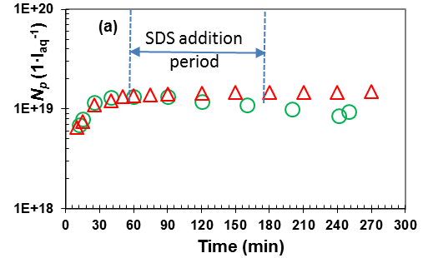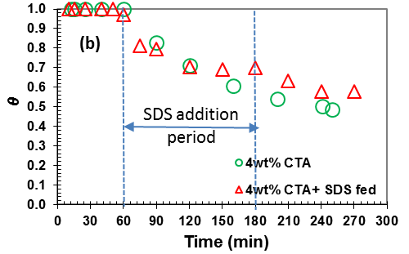
Figure 5. (a) Number of particles and (b) particle surface coverage ratio in the course of semicontinuous emulsion polymerisation for runs with [CTA] = 4wt% and different SDS addition policy. The arrows indicate the period of addition of SDS.

The use of water-insoluble CTA
In order to show the importance of water solubility of CTA in producing small particles, semicontinuous process in the presence of 1-Decanethiol (decyl mercaptan; n-DM) was also carried out. 1-Decanethiol is a chain transfer agent with negligible solubility in water. The results, as presented in Figure 6, clearly indicate that there was no significant effect of n-DM on the rate of polymerisation, and the size and number of particles. This is simply because the transferred radicals remained inside polymer particles and propagated there without leaving any significant effects on the kinetics of polymerisation. Zou et al. reported on the application of an ideal CTA (n-dodecyl mercaptan; n-DDM) in monomer-starved emulsion copolymerisation of styrene/butadiene systems under similar conditions to this work. However, they found that n-DDM affected the kinetics of polymerisation by increasing the rate of polymerisation, and by producing larger particles whose size increased with n-DDM concentration. The reason for this particular behaviour for styrene/butadiene system has been explained in the literature.³⁴
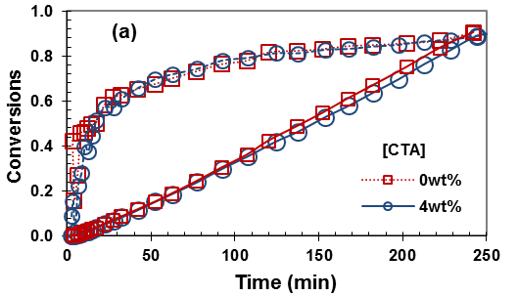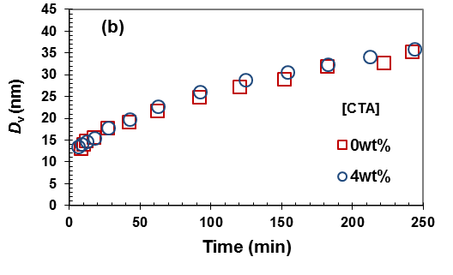
Figure 6. (a) Conversions and (b) size of particles versus reaction time in the absence and presence of 4.0 wt% 1-Decanethiol as CTA.

Conclusions
The effect of a relatively water-soluble CTA, 2-Butanethiol, on the formation of ultrafine particles via batch and semicontinuous emulsion polymerisation was studied. Using a partially water-soluble CTA makes desorption of chain transferred radicals to the water phase kinetically more important. The final molecular weights of polymer latexes decreased with increasing CTA concentration in both processes, as expected. In the batch process, the latex molecular weights were polydispere and increased with conversion. Under batch condition, the rate of polymerisation decreased with increasing CTA concentration. This was because of enhanced radical desorption and a high concentration of CTA in the water phase, which led to the accumulation of CTA-derived radicals in the water phase and their termination. Furthermore, fewer particles were produced with increasing CTA concentration except for the low concentration of CTA. In the semicontinuous process, the [CTA]_{p}/[M]_{p} ratio in the polymer particles was maintained constant, corresponding to that in the feed. This resulted in a constant molecular weight in the course of polymerisation. The concentration of CTA and CTA-derived radicals in the water phase were maintained at low level, thus avoiding enhanced water-phase radical termination. The moderate increase in the concentration of radicals in the water phase with increasing CTA concentration, caused by radical desorption, enhanced the rate of particle formation via radical entry into micelles. This reduced the size of particles to around 20 nm in diameter. Comparing with batch process, semicontinuous process using CTA could produce much smaller particles, by 1-2 orders of magnitude, at a constant rate of polymerisation with a better controllability over particles size and molecular weight. Furthermore, the presence of water-soluble [CTA] in semicontinuous process could assist producing smaller particles, by up to 25%, with lower molecular weights compared to those obtained from batch process.

Reference

H.M. Xia, X.L. Gao, Gu, Z.Y. Liu, N. Zeng, Q.Y. Hu, Q.X. Song, L. Yao, Z.Q. Pang, X.G. Jiang, J. Chen, H.Z. Chen, Low Molecular Weight Protamine-Functionalized Nanoparticles for Drug Delivery to The Brain After Intranasal Administration, Biomaterials 32 (2011) 9888-9898.
S. Hirsjarvi, L. Peltonen, J. Hirvonen, Layer-By-Layer Polyelectrolyte Coating of Low Molecular Weight Poly(lactic acid) Nanoparticles, Colloids and Surfaces B-Biointerfaces, 49 (2006) 93-99.
W.H. Ming, F.N. Jones, S.K. Fu, Synthesis of Nanosize Poly(methyl methacrylate) Microlatexes with High Polymer Content by a Modified Microemulsion Polymerisation, Polymer Bulletin 40 (1998) 749-756.
S. Sajjadi, Particle formation under monomer-starved conditions in the semibatch emulsion polymerisation of styrene. I. Experimental, J. Polym. Sci. Polym. Chem. 39 (2001) 3940-3952.
S. Sajjadi, Particle Formation under Monomer-starved Conditions in the Semibatch Emulsion Polymerisation of Styrene. Part II. Mathematical Modelling, Polymer 44 (2003) 223-237.
R. Ledezma, M.E. Trevino, L.E. Elizalde, L.A. Perez-Carrillo, E. Mendizabal, J.E. Puig, R.G. Lopez, Semicontinuous Heterophase Polymerisation Under Monomer Starved Conditions to Prepare Nanoparticles with Narrow Size Distribution. J. Polym. Sci. Polym. Chem. 45 (2007) 1463-1473.
H. Wang, Q. Pan, G.L. Rempel, Micellar nucleation differential microemulsion polymerisation, Eur. Polym. J. 47 (2011) 973 -980.
S. Sajjadi, Nanoparticle formation by monomer-starved semibatch emulsion polymerisation. Langmuir 23 (2007) 1018-1024.
J.S. Nunes, J.M. Asua, Theory-Guided Strategy for Nanolatex Synthesis. Langmuir 28 (2012) 7333.
S. Sajjadi, M. Yianneskis, Semibatch Emulsion Polymerisation of Methyl Methacrylate with a Neat Monomer Feed, Polym. Reac. Eng. 11 (2003) 715-736.
L. Rios, M.A. Cruz, J. Palacios, L.M. Ruiz, A. Garcia-Rejon, Macromol. Chem. Suppl. 10/11 (1985) 477-488.
Y. Chen, F. Jahanzad, and S. Sajjadi, Semicontinuous monomer-starved emulsion polymerisation as a means to produce nanolatexes; Analysis of Nucleation Stage Langmuir 29 (2013) 5650-5658.
S. Sajjadi, and Y. Chen, Exploring the limits of particle size for nanolatexes produced via monomer-starved semicontinuous emulsion polymerisation, Eur. Polym. J. 69 (2015) 364-373.
S. Sajjadi, Control of particle size by feed composition in the nanolatexes produced via monomer-starved semicontinuous emulsion copolymerisation, J. Colloid. Interface 445 (2015) 174-182.
J.M. Liu, Q.M. Pan, Synthesis of nanosized poly(ethyl acrylate) Particles via differential emulsion polymerisation, J. Appl. Polym. Sci. 102 (2006) 1609–1614.
Y. Zhang, Y. He, J. Zhao, Poly(methyl methacrylate) nanolatexes with high solid contents prepared by semi-continuous emulsion polymerisation in the presence of oil-soluble initiators, Eur. Polym. J. 61 (2014) 316–325.
M. Nomura, H. Suzuki, H. Tokunaga, K. Fujita, Mass Transfer Effects in Emulsion Polymerisation Systems.1.Diffusional Behaviour of Chain Transfer Agents in the Emulsion Polymerisation of Styrene, J. Appl. Polym. Sci. 51 (1994) 21-31.
M. Nomura, Y. Minamino, K. Fujita, M. Harada, The role of Chain Transfer Agents in the Emulsion Polymerisation of Styrene, J. Polym. Sci. Polym. Chem. 20 (1982) 1261-1270.
L. Harelle, T. Pith, G.H. Hu, M. Lambla, Chain Transfer Behaviour of Fractionated Commercial Mercaptans in Emulsion Polymerisation of Styrene, J. Appl. Polym. Sci. 52 (1994) 1105-1113.
J. Mendoza, J.C. De la Cal, J.M. Asua, Kinetics of the styrene emulsion polymerisation using n-dodecyl mercaptan as chain-transfer agent J. Polym. Sci. Polym. Chem., 38 (2000) 4490-4505.
P.A. Weerts, J.L.M. van der Loos, A.L. German, Emulsion polymerisation of butadiene, 4. Effect of thiols, Macromol. Chem. 192 (1991) 2009.
M. Vicente, S. BenAmor, L.M. Gugliotta, J.R. Leiza, J.M. Asua, Control of molecular weight distribution in emulsion polymerisation using on-line reaction calorimetry, Ind. & Eng. Chem. Res. 40 (2001) 218-227.
C. Sayer, J.R. Leiza, G. Arzamendi, E.L. Lima, J.C. Pinto, J.M. Asua, Dynamic optimization of non-linear emulsion copolymerisation systems - Open-loop control of composition and molecular weight distribution, Chewm. Eng. Sci. 85 (2002) 339-349.
²⁴ M.F. Cunningham, J.W. Ma, Calculating molecular weight distributions in emulsion polymerisation under conditions of diffusion limited chain transfer J. Appl. Polym. Sci. 78 (2000) 217-227.
M. Zubitur, J.M. Asua, Agitation effects in the semicontinuous emulsion polymerisation of styrene and butyl acrylate, J. Appl. Polym. Sci. 80 (2001) 841 – 851.
K. Suzuki, M. Nomura, M. Harada, Kinetics of Microemulsion Polymerisation of Styrene, Colloids and Surf. A. 153 (1999) 23-30.
N.M.B. Smeets, R.P. Moraes, J.A. Wood, T.F.L. McKenna, A new method for the preparation of concentrated translucent polymer nanolatexes from emulsion polymerisation, Langmuir 27 (2011) 575-581.
N.M.B. Smeets, T.F.L. McKenna, The synthesis of translucent polymer nanolatexes via microemulsion polymerisation, J. Colloid and Interface Sci. 2012, 383, 28-35.
A. Salazar , L.M. Gugliotta, J.R. Vega , G.R. Meira, Molecular Weight Control in a Starved Emulsion Polymerisation of Styrene, Ind. Eng. Chem. Res. 37 (1998) 3582–3591.
C. Tjiam, V.G. Gomes, Optimal Operating Strategies for Emulsion Polymerisation with Chain Transfer Agent, Ind.& Eng. Chem. Res. 53 (2014) 7526-7537.
L. Harelle, T. Pitch, G.H. Hu, M. Lambla, Chain transfer behaviour of fractionated commercial mercaptans in emulsion polymerisation of styrene, J. Appl. Polym. Sci. 52 (1994) 1105-1113.
I. Barudio, J. Guillot, G. Fevotte, Efficiency of Mercaptan Chain Transfer Agents in Emulsion Copolymerisations.1. Influence on Kinetics and Microstructure. Modeling of Radical Desorption, J. Polym. Sci. Polym. Chem. 36 (1998) 157-168.
S. Sajjadi, Population balance modelling of particle size distribution in monomer-starved semibatch emulsion polymerisation, AICHE J. 55 (2009) 3191-3205.
I.A. Maxwell, B.R. Morrison, D.H. Napper, R.G. Gilbert, The Effect of Chain transfer agent on the entry of free-radicals in emulsion polymerisation, Macromol. Chem & Phys. 193 (1992) 303-313.
S. Sajjadi, Particle formation and coagulation in the seeded semibatch emulsion polymerisation of butyl acrylate, J. Polym. Sci. Polym. Chem. 38 (2000) 3612-3630.
H.A. Edelhausser, Investigation of the disposition of surfactant in a latex by the “rate of dialysis method.” Mechanism of detergent dialysis J Polym. Sci. Part C 27 (1969) 291.
Zou , R. Pan, Q., Rempel G.L., Synthesis of styrene-butadiene copolymer nanoparticles via semi-batch differential microemulsion polymerisation, Eur. Polym. J. 64 (2015) 196-205 .

