Multi-sensory ethnography and vertical urban transformation: Ascending the Peckham Skyline
In this paper, we offer a conceptual and methodological intervention that demonstrates how multi-sensory ethnography might enrich critical analysis of vertical urban transformation. Through the lens of two sites in Peckham, southeast London—a multi-story car park and an ex-industrial warehouse complex—recently remade as leisure and retail spaces, we examine how processes and practices by which these spaces at height are designed and curated reproduce social and spatial inequalities. As we argue, in retraining the vantage point of research on verticality through attention to other senses—which we label here as non-ocular vistas—new perspectives and texture are brought to understandings of place-making, that address how power functions through the erection of physical, symbolic and sensory exclusions, and how sensorial clashes makes visible contestations over space in a changing urban environment. In this way, our contribution: (1) privileges a multi-sensory perspective in understanding how power is reproduced in and through the vertical transformation of the city; (2) intervenes in research on verticality to centre the concept of non-ocular vistas; and (3) offers a methodological innovation that make visible the subtle affects that manifest the politics of exclusion within spaces at height.

Key words
Verticality; multi-sensory ethnography; urban transformation; leisure; sensescapes

Introduction
This paper draws on our research focused on recent and ongoing transformations of spaces above street level in Rye Lane, Peckham, southeast London, to question how vertical urban development remakes power and inequality in the city. We consider how multi-sensory ethnography might enrich critical analysis of what are often repurposed spaces at height in ways that make visible the subtle reproduction of social and spatial inequalities. We turn attention to the three-dimensional geographies of the city to argue that, to fully conceive of the processes and practices by which these spaces at height are remade, requires attention to their multi-sensory registers, as much as to the spectacle they permit. As we argue, in retraining the vantage point of research on verticality through attention to other senses—which we label here as non-ocular vistas—new perspectives and texture are brought to understandings of urban development. In this way, our contribution: (1) privileges a multi-sensory perspective in understanding how power is reproduced in and through the vertical transformation of the city; (2) intervenes in research on verticality to centre the concept of non-ocular vistas; and (3) offers a methodological innovation that make visible the subtle affects that manifest the politics of exclusion within spaces at height.
We start from the observation that research on verticality neglects the practices and process through which high-up spaces are (re)made as leisure spaces, structured by and structuring of power relations and inequalities in the contemporary city. In this paper we add to body of work through an exploration of the three-dimensional geographies of contemporary urbanism. Tracking the movement from street level to ‘on high’, paying critical attention to mobility, blockages, and the sensoria of vertical transient built spaces we reposition height and vista within contemporary urban research. This reconceptualization requires a parallel methodological shift that can capture the sensorial atmospheres of places at height and the sensibility of those who use them (Rhys-Taylor, 2017), drawing attention to the spaces in between, understood in their full volume, multisensory affects, materiality and symbolic power. In this way, the paper brings together an embodied and multi-sensory approach to researching urban spaces with a volumetric understanding of urban change that allows urban research to move closer the rich experience of city life (ibid).
In classic critical urban studies, the high-up appears as the point of view of the ‘autocratic designer looking down from his bird’s eye view’ (Graham, 2015, p. 623). In this tradition there is an exaltation of the street level, where the ‘localised flaneur’ can engage all senses in phenomenological engagement with real urban life (Soja, 1996). The high-up offers visual legibility and safety, whereas the street-level is the site of full sensory immersion in the risky richness of urban life. In recent years, there has been a growing interest in the vertical dimension of urban spatial inequality that takes the above dichotomy for granted. Under the label of verticalization, this growing literature has shown how the increasing value of the high up is associated with the power of looking down and detaching from the dangers of urban messy conviviality and conflict (Elden, 2013; Graham & Hewitt, 2013; Graham, 2016).
This paper offers a more nuanced approach to researching processes of exclusion, segregation and conflict generated by vertical developments. We challenge the classic dichotomy between embedded/embodied street level and detached/ocular-centric high-up, by developing an attention and careful consideration to: 1) the multisensory aspects of the experience of high-up – what we call non-ocular vistas; 2) the manifestations of ‘the intimacies of the local, the body, the street and the everyday’ (Soja, 1996, p.313) in high-up spaces and 3) how non-ocular vistas and embodied processes operate, in these high-up spaces, also in-between and across, as people ascend, descend and interact more than just vertically and horizontally (see Harris, 2015). Thus, we want to foreground a multisensory engagement in making sense of changing spaces above street level and their role in the production of contemporary urban inequalities. From this standpoint, the view over the city is only a part of what makes the distinctive sociality and urban significance of these high-up spaces.
The multisensory politics of Peckham’s iconic views and high-up spaces
This paper results from ethnographic engagement, and a series of semi-structured interviews with local actors involved in the recent and ongoing transformations above street level in Peckham Town Centre, South East London. In particular, we focus specifically on the multisensory aspects of our ethnography on two repurposed high-up spaces of cultural significance: a 19th century industrial complex, and a multi-storey car park. The wider project of which this work is part also includes a nearby library and a planned elevated linear park, in all of which struggles over access to iconic views of the city centre play out in different ways.
In these changing spaces, we record and analyse our movements from temporary occupation of various standpoints, with a focus on the multisensory material that emanates from and assembles at yoga and art studios, evangelical churches, roof top bars, computer-based office spaces, spaces under ruination and derelict built environments. These spaces are temporary manifestations of a changing urban landscape; they promise different futures to different sectors of the population. Here, power works in and through the creation, repurposing, multiplication, and inhabitation of airspace or repurposed elevated built structures. In communicating multi-sensory experiences we offer insights into how power is distributed through these spaces.
Consider the following episode involving a local yoga studio and church located in one of the two buildings under the focus of this paper. It happened towards the end of our project, Above Street Level: rethinking power, place and encounter through the Peckham Skyline¹ and offers an example of the sensorial clashes in these high up environments.

It came to public attention in a piece published in the Evening Standard, one of the two main free newspapers distributed throughout London. The piece opens thus:

There are certain sounds – such as chanting or bamboo flutes – that may complement a yoga class. But when [owners’ names] opened up a yoga studio in Peckham’s Bussey Building, they discovered a noise that was not so yin to their yang. (Bearne, 2017).

The article goes on to quote the owners of the studio describing the challenges of the local soundscape for the meditative practice of yoga. Particularly controversial was their description of the sound of the West African churches and their worship practices bleeding over into the space of the studio: ‘There’d be massive ghetto blasters and screaming’.² There was immediate and strong local reaction to these comments on social media, which were seen as disrespectful and emblematic of the attitude of white gentrifiers towards more long-standing black residents (‘You want to move into an area because its ‘edgy’ but because you’re soulless colonisers you want to round off that edge’ Okafor, Kelechi, 6.11.17, 21.30pm, Tweet). This was followed by the comments about African churches being redacted from the online version of the article at the yoga studio owners’ request and a public apology by the owners for any ‘emotional distress’ caused by their comments.
The 5-storey Victorian industrial complex where the yoga studio is housed is also home to a nightclub, co-working space, artists’ workshop, other exercise facilities and churches. The churches occupy the ground floor, whereas the yoga studio, to which we will return further down, functions on the middle floors of the building. This incident demonstrated the complex cross-cultural inter-sensorial encounters that occur across these fast-changing, verticalized spaces and how they reveal the classed and racialized processes at place in the precarious neighbouring dynamics they engender. As Kelvin Low puts it, writing about the ‘sensory politics’ of ‘transnational urbanism’ in Singapore, our sensitivity to sensory invasions “depends on whether we perceive sensations as appropriate to the context” (Low, 2013). This paper will discuss examples of sensorial material from our ethnography and fieldwork that shows how sound, smell and touch are a crucial part of the sensory politics that shape these spaces above street level. Because the emphasis is often put on the view that height allows, we argue along with other multisensory ethnographers (Rhys-Taylor, 2017, 2013; Low 2013; Buckingham & Degen, 2012; Pink, 2009), that other senses have been for long overlooked. The specific contribution of this paper is to argue for the development of multisensory ethnographic approaches within the investigation of the spaces at height.

In the next two sections we critically review the geographical and sociological literature on vertical urban transformation in which this paper intervenes. Discussing the methodologies for conducting empirical research concerned with high-up spaces and three-dimensional urban inequalities, we emphasise the need for an extension to well-rehearsed ethnographic engagements to attend to the embodied and multi-sensory experience not only of occupying these spaces, but also of ascending to access them. This lays the groundwork for discussing of our ethnographic fieldwork in Peckham that forms the basis of the analysis presented in this paper. From ascending Peckham’s skyline, attending to the forms of sensorial detachment and engagement this entails, the curation and affect of atmospheres on the way up and in two spaces at height, we lay bare the subtle ways in which power is exercised through the design and experience of these spaces, to unveil the less-examined forms of production of racialised and classed politics of exclusion.

From height, of height, experiencing height: shifting perspectives of height in the city
The view from tall buildings in the city has come to represent taking a particular epistemological position (de Certeau, 1988; Harvey, 1989): that of the planner, or the ‘voyeur god’ (de Certeau, 1988). In these accounts the view from on high is presented as abstracted and detached in contrast to the embedded and embodied view of the person on the street, who participates in making urban space through their practices; it is also a perspective that relies heavily on the visual register (see also Sterne, 2003). Harvey pronounces that while both perspectives are ‘real enough’ the view from above is his preferred perspective, aligning this view from on high with Marxian meta-theory. As Deutsche has argued, Harvey misinterprets de Certeau who ‘emphatically rejects the impulse to mastery in aerial perspectives.’ (1996, p. 210) She continues, ‘Disembodied viewpoints, says de Certeau, yield ‘imaginary totalizations’ such as the ‘panorama-city’ and correspond to objectifying epistemologies that produce a ‘fiction of knowledge’ (ibid). Whether the view from above provides merely a fiction of knowledge or a total view, through this debate spaces at height are rendered as both perches from which to view the city and as handy tropes for epistemological arguments about the view from above.
Metaphors of verticality are common in urban theories of change. Terms such as urban growth or sub-urbanization might suggest a vertical imagination of the city—after all, one grows up and the prefix sub, recalls underground spaces—but these are just linguistic metaphors, and the conceptual work on urban change is presented predominantly on a horizontal plane. Models of urban growth such as the concentric zones of the Chicago school (Park & Burgess, 1925) and Chrystaller’s ‘central place theory’ (Pagano & Bowman 1997, p. 37), or the notion of urban sprawl tend to reduce urban form and change to horizontal models. Even a nuanced analysis of urban integration in the world system, such as Milton Santos’ ‘two circuits of the urban economy’ in countries of the developing world uses the adjectives ‘upper’ and ‘lower’ only as quantifying indicators of economic and geographic inequality (Santos, 1979) - the spatialisation of these circuits is always projected onto two-dimensional imaginations of the city.
The interest in the way cities function and change across different levels in relation to the ground is very recent. These new approaches to the urban high-up allow us to understand urban spaces as three-dimensional sites of social contestation. They also counter the lower visibility of built spaces above street level, heightening our attention to the social dynamics that might otherwise escape the attention of urbanists and urban policy. This heightened attention translates into recognizing: (1) the three-dimensional ways in which power and inequality are made; (2) what contemporary spaces at height represent in terms of power and hierarchy; and (3) the vertical significance of spatialization and perpetuation of urban inequality. For example, Stephen Graham in his treatise on verticality, highlights,
[A]s the world’s surface becomes more and more congested and urbanization girds more of our planet, so political and social struggle takes on an increasingly three-dimensional character, reaching both up from and down below ground level (Graham. 2016, p. 4).
The author argues that understanding the significance of airspace and built environment at height in contemporary political and social struggles is long overdue (see also Elden, 2013). This perspective recognizes that social and material relations stretch across vertical axes—above and below ground level—and are deeply interconnected with well-trodden horizontal axes of power, highlighting the ‘geographies, sociologies, and politics of verticalising cities’ (Graham, 2016, p. 9). This emerging literature offers a critique of ‘flat’ understandings of space inherited from cartography, looking above and below to consider how these spaces interplay within the social and material relations of contemporary urban life (see for example Elden, 2013; Graham & Hewitt, 2013; Graham, 2016).
This latest articulation of the spatial turn has persuasively communicated the ways in which vertical urban development permits exclusivity and spatial segregation for those who have the luxury to choose to occupy these spaces at height. The skyscraper becomes the marker of contemporary urban inequalities reminiscent of the dystopian world depicted in JG Ballard’s High-Rise (Hewitt and Graham, 2015) in analyses that include cities the world over (see for example Glucksberg, 2016; Rosen & Charney, 2016; Bini & d’Alessandro, 2017; Graham, 2017; Nam, 2017; Lam & Gaddol, 2017).³ The verticalization of urban life has been particularly evident in recent work on violence and fear of crime in the urban Global South. Developing from the classic analysis of the urban geography of fortified enclaves in the city of Sao Paulo (Caldeira, 1996; 2000), in which the self-segregation of urban elites depends on the erection of higher walls, a new stage in the verticalization of this self-segregation has been registered in the literature. In violent and unequal cities like Sao Paulo, Managua, Guatemala City, Rio de Janeiro and Recife, elites find refuge in high-rise buildings (Rodgers, 2004; O’Neill & Fogarty, 2013; Valenzuela, 2013; Graham, 2015; see also the Brazilian film 'High-Rise: Um Lugar ao Sol'), and in private mobility by helicopter (Cwerner, Kesselring & Urry, 2009). In some of these cities, the natural elevations of the landscape also serve as refuge for the lower classes to build urban peripheries inside the city (Fischer, McCann, & Auyero, 2014; Graham, 2016). The notion of verticalization as disembodiedness permeates much of the central analysis in the work referred to here. But it is also possible to see in some of the ethnographic detail presented an attention to the specific embodiments and socialities that these new spaces at height generate.

Towards a sensory ethnography at height
Our aim here is to bring the consideration of the sense of place in these spaces at height to the centre of the analysis. In other words, we want to move beyond the structural argument of detachment and spatial segregation towards a denser understanding of the embodiment and affect of height, volume and stacking up in these spaces and their dynamics of power distribution. We find fuller accounts of spaces at height, beyond the location for a view elsewhere, useful here. For example, in Barthes’ essay on the Eiffel Tower, he reflects on how the tower becomes ‘a little world’ in itself (‘from the ground level, a whole humble commerce accompanies its departure: vendors of postcards, souvenirs, knick-knacks, balloons, toys, sunglasses, herald a commercial life which we rediscover thoroughly installed on the first platform’ (1985, p. 249)). The tower is a place that fulfils ‘the essential function of all human sites: autarchy’ (ibid). It does so by offering the visitor a ‘whole polyphony of pleasures’ and a panoramic view in which the most prominent feature of the Parisian landscape, the Eiffel tower itself, is absent. Thus the tower affords a rich multisensory experience, characterized by simultaneous detachment from and power over the city below. But it also provides an immersive ascensive experience.
Some spaces at height in Peckham are remarkably similar to Barthes’ description of the Eiffel tower. Their main attractive power is the promise of an uncanny experience of proximity to and detachment from a neighbourhood that, in the imaginings of white middle-class consumers, is exciting and edgy (see also Benson & Jackson, 2013; Jackson & Benson, 2015). As we argue here, incorporating experiential and sensory encounters into social understandings offers insights to the distribution of power through these structures. The consideration of power has been absent from most studies of urban verticality but has been developed by those working on the relationship between ambience and power.
In the discussion that follows, we argue that access to high up spaces is restricted by some obvious filters, including passing security and being able to climb stairs. However, we also explore how power works through the ambience of these high up spaces in more subtle ways. These more elusive forms of ambient power have more often been discussed in reference to the restructuring of public space (Degen, 2008; Allen, 2006; Thörn, 2013), particularly the emergence of mall-like spaces in the city. Allen argues, in his work on the ‘ambient power’ of the Sony Center in Potsdammer Platz, Berlin, that entry to such commercial spaces is not only restricted by gates and surveillance cameras but ‘through the experience of the space itself, through its ambient qualities’ (2006, p. 442). Insights from this body of work on ambience and public space can also be brought to bear on these less porous, semi-public spaces at height in Peckham.
Degen (2008) argues that analysis of the restructuring of public space through processes of regeneration has often been approached through the register of the visual and has somewhat neglected other sensory dimensions of these changes. This neglect of non-visual registers risks missing important dimensions of how power works through space since, ‘who or what is seen, heard, touched, tasted and smelled is connected to questions about what is included and excluded in the experience of public space’ (2008, p. 22). In her work on Manchester and Barcelona, Degen uses sensory methods to provide insights into the ‘modalities of power [that] have become more dispersed and fluid, infiltrating the daily lives of individuals in more complex and insidious ways.’ (2008, p. 55). Another example of the importance of multisensory politics is Knowles’ study of plutocratic London, in which she argues that, in order to understand how power works through a place like Mayfair, we need to understand how the atmosphere of a ‘pleasure matrix’ functions. Taking the reader on a walk, she untangles the links between the space of the street, private clubs and hotels arguing that the place is ‘a complex politics of vision, by desire, and by excitement of being both seen and not seen’ (2018, p. 9).
In bringing together the work on the vertical city with this more sensory and diffuse approach to urban space, we build on (a) Harris’ call for the importance of ethnographic research in ‘opening up the geographies of the three-dimensional city’ (2015. p. 601), and (b) Back and Keith’s call to move beyond the visual as the register through which we read the city (2014). This also fits into a move towards considering the multi-sensory within ethnographic research, through the embodied practice of the ethnographer the site for the production of knowledge (see for example Pink 2009; Rhys-Taylor 2013, 2017).
Indeed, as Francisco noted in his field diary:
Sure, in high-up spaces the views are wider and longer, as the sight expands over walls, roofs, and railway bridges. It is easy to understand how this brings a sense of empowerment from the constrained vistas of street life. But what about the sounds and the smells? Aren’t they also part of the particular spatiality of the high-up? Or is there something in the more-hardly-named sensoria of spaces above street level that pulls us up to them, thus increasing their social value?
Harris (2015) emphasizes the need to find more complementary ways of bringing together the view from below with the view from above in ways that advance a similar call for a trialetics of space developed by Soja (1996). Harris’ complementarity is at the heart of his call for ethnographic analyses of everyday verticalities and the disruption of the top-down analytical perspectives more common within volumetric urbanism. Indeed, this call has been taken up to provide insights into the everyday geographies of home among those who live in high-rise residential developments (Nethercote & Horne, 2016; Baxter, 2017) and the experience of communal spaces at height in Hadi, Heath & Oldfield’s (2018) ethnography of sky gardens in Singapore. The embodiment and inhabitation of being at height also emerge as themes within such literature, including the ‘Vicarious Vertigo’ of those involved in co-producing high-up spaces (Butt, 2018), the bodily practice of urban climbers (Brighenti & Pavoni, 2017), and the experience of walking on glass viewing platforms at height (Deriu, 2018). We build on this ethnographic turn to consider what multisensory ethnography might offer not only to our understandings of how the city at height is experienced, but also how social and spatial inequalities are (re)produced through three-dimensional geographies.
Ethnographies at height make visible the uses, practices and processes through which high-up spaces are (re)made, structured, and structuring of power relations and inequalities in the contemporary city. Where we further innovate this practice is in turning our attention to how the ‘uncanny experience’ is produced not only within spaces at height, but also through the accompanying movements from street level upwards and back again.

Spaces at height in Peckham

This paper builds on an eighteen-month ethnographic research project Above Street Level: rethinking power, place and encounter through the Peckham Skyline. The central ambition of the project was to shift understandings of contemporary urban transformation from a ‘horizontalist’ bias (Graham & Hewitt, 2013), to consider what might be revealed about the role and significance of ongoing transformations at height in the remaking of the city, its power relations and distribution. With this in mind, the project focused on two interlinked questions: (1) How are encounters taking place above street level structured by and structuring of contemporary urban transformation? (2) How is power rearticulated from the top down and the ground up? The current paper attends in particular to the latter.
Peckham, in London Borough of Southwark, is an area characterized by social and ethnic mix with a multi-ethnic and busy town centre. The most recent census data documents the resident population as 54.2 per cent white, 26.9 per cent Black African, Caribbean, Black British. While the High Street that runs through the Town Centre, Rye Lane, has previously been the subject of ethnographic research at street level (Hall 2015), we turn our attention upwards, where empty spaces have been converted into places of leisure and sociality to meet the needs of a changing population. These shifting forms of occupation include roof top bars and art spaces, which replaced industrial and warehouse space; the conversion of industrial spaces and storerooms above shops for use as evangelical churches and mosques; and more recently the further conversion of these worship spaces into new commercial and art spaces. While these spaces of consumption and worship have moved upwards, high-density social housing has been pulled down and new plans to build luxury high-rise housing have been contested on the grounds of obstructing the ‘Peckham skyline’. Peckham is located in a privileged position at the Southern edge of the Thames floodplain, and these up-high spaces offer wide open views towards central London. These views have become a key attraction for some of the emergent leisure spaces and features prominently in the branding of Peckham; this is captured by the banner produced by Southwark Council and displayed in front of the Peckham Christmas tree, which depicts some of the iconic buildings of Peckham—the library, the art deco building currently occupied by Khan’s general store, the Rye Lane Chapel—against the London skyline (see Figure 1).

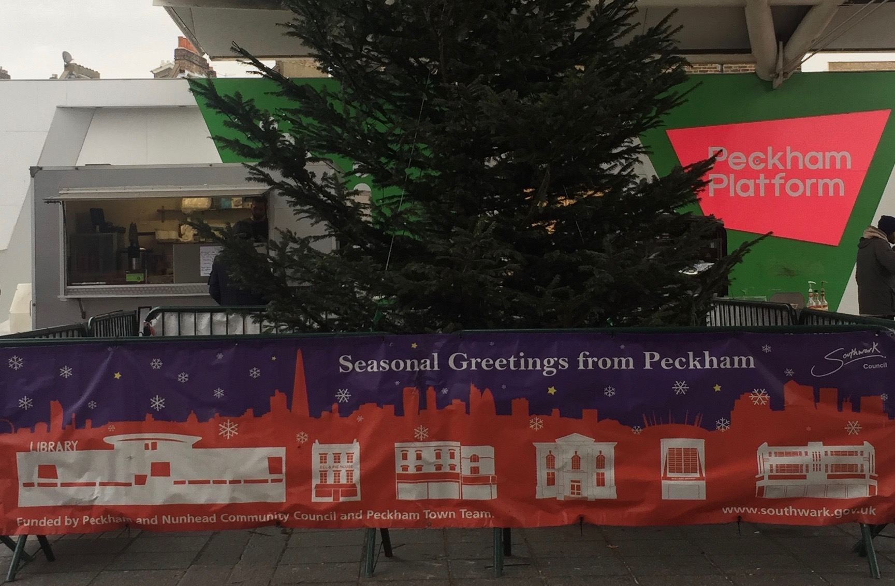
Figure 1: Seasonal Greetings from Peckham (December 2016)
As we discuss in detail below, our research aims to understand verticalization as a process inherent to the lived and affective practice of place. This is particularly important given the extent of the planned transformation of Peckham which includes—in tandem with similar processes going on in other areas of London—high-rise residential development in the town centre. The two sites at the centre of our research are: (1) The Bussey Building, a large privately owned ex-industrial estate organized around a factory and warehouse space—housing a roof-top bar and open-air cinema space (also used for roof-top yoga classes) alongside churches, workshops, a gym, and gallery spaces; and (2) The Peckham Car Park, a council-owned multi-storey car park (recently listed as an asset of community value and ear-marked for preservation by Southwark council for the next twenty years)—home to roof-top bar, a gallery and theatre space on the top levels, the recently-developed Peckham Levels—a co-working, leisure and retail complex—and an independent multiplex cinema.
We focus on these buildings in this paper and in the wider project because they are central characters in the story of the changing face of Peckham Town Centre. Both of these spaces have histories as sites of transformation and contestation, and are central to contemporary recalibrations of power within the wider neighbourhood. While the Bussey Building and the Peckham Car Park have at different points of time been earmarked for demolition (the first in 2005 and the second up to 2017), they are now open for various public uses after organized protest and action by local business owners and local interest groups.

Over the course of eighteen months, we visited these sites for specific events (e.g. the Peckham Festival, theatre and orchestral performances, open evenings), participating in yoga classes and going to the cinema, as well as stopping by at different times of day, different days of the week, and throughout the year to get a sense of the rhythms of these spaces. We supplemented this with a series of 13 interviews with local business owners, community organizations, residents and religious leaders. In this time, there has been considerable change as businesses within the space close down or move out, replaced by newcomers; once open to the elements, several floors of the multi-storey car park have been redeveloped as retail and commercial space, windows now blocking out the wind and rain.
It is through embodied ethnographic practice that we weave an attention to the high up, moving through different levels of height in the city. The fruitfulness of this methodological move depends on reflecting carefully on what makes it possible for us to enter these spaces, while others are excluded or deterred. Simply, our ability to ascend these spaces made possible by our able-bodiedness, our relative comfort in being in these spaces while these atmospheres might exclude others, and the lack of scrutiny of our access to these spaces. Indeed, the perception of us as white and middle class is central to the snap judgements that are made in allowing us into these space and our presence within them. This is despite subtle differences in our positions; one member of the research team is White British, one Portuguese and the other with mixed White British and Asian heritage. In accounting for our practice(s) of inhabiting and embodying high-up spaces and the movements between, we probe the forms of city-making that are happening up and down the vertical axis. During the fieldwork period, each of the three researchers kept a field diary that were shared online. We met up regularly to compare notes and to discuss emerging themes. Therefore, the iterative process of analysis unfolded as part of the ethnography, as is often the case in ethnographic research (Srivastava & Hopwood, 2009).

All three researchers have a background in carrying out research in Peckham. Emma and Michaela first came to Peckham in 2010 when working on a project about how middle-class residents related to the places they lived, and what this revealed about middle-class identity-making and practices of belonging (Bacqué et al, 2015).³ This brought us to a neighbourhood adjacent to Rye Lane, sometimes referred to as ‘Bellenden Village’, making us regular visitors to the area as we navigated from Peckham Rye station to the homes of our interviewees. Rye Lane was a common topic of discussion amongst those who took part in our research, exciting, exotic and discomforting (Benson & Jackson, 2013; Jackson & Benson 2014; Jackson, 2014). Francisco has also previously worked in Rye Lane on a research project on the politics of waste disposal and collection, a problem which is a growing concern amongst residents, businesses and visitors is a very visible material by-product of the diversity and changing configuration of the street’s modes of inhabitation, and material supply (High Street Challenge Cleaner Peckham Project, 2016).
The social and material fabric of Peckham is in a process of continual transformation. It is shaped by factors including infrastructural development (namely the arrival of the East London Branch of the Overground); the ongoing sell-off and demolition of social housing (Just Space et al., 2014); new residential and retail development; its newly labelled ‘cultural quarter’; the expanding night-time economy; and its diversifying consumption infrastructure (particularly in the direction of artisan goods). One of the instigators of this change is the local council, whose redevelopment plans stress the need for more cafes and restaurants, ‘as if the economic and cultural diversity … as it exists was somehow invisible to those undertaking the planning exercise’ (Hall, 2015, p. 23). But corporate interests in the transportation, commercial and residential opportunities also play a significant role both in the planning and implementation of such urban transformation. It is also worth noting that there is considerable local monitoring of these changes and opposition from established grassroots interest groups; indeed, it was partly through the success of opposition mounted by interest groups that the multi-storey car park was listed as an asset of community value, and thus saved from impending demolition plans, just as the Bussey Building had been saved from demolition in 2006 due to the actions of local grassroots campaigning.
Peckham remains intensely multicultural. It is also a hub within the London art world and its popularity as a destination for the young middle classes seems to increase every year. These ongoing urban transformations are deserving of critical attention, particularly in light of the social and ethnic inequalities they promote and augment. The impact of these transformations on the social fabric of this locality can be traced through the regeneration efforts that often threaten what already exists in the area (see e.g. Hall, 2015). They also manifest in urban space in the ways in which access and movement is shaped between various levels of height. In the next section we explore the ways in which these transformations ‘stack up’ in multilevel spaces, through a series of embodied ethnographic engagements with the most prominent high up spaces on Rye Lane.

From the Peckham skyline to street level
‘Forty years ago, Neil Armstrong set foot upon the moon, and when we reached Frank's Cafe & Campari Bar, we had an inkling how he felt. Without conﬁrming the old saw that it's better to travel than to arrive, it had been quite a journey. The four of us had met an hour earlier in despair of ever ﬁnding what had once seemed an unchallenging, if novel, restaurant address. The problem with locating "10th Floor, Peckham Multistorey Car Park’, however, is that no sign hints at the building's name, while the lift stops at the 6th ﬂoor”.
Guardian, Restaurant Review (July, 2009)
The new spaces at height of consumption, art and leisure in Peckham are photogenic and Instagram-able. Images taken at the top of the multi-storey car park—annually transformed into a sculpture gallery and alfresco bar, the latest addition being a viewing platform—often depict the view to the city of London, with the Shard and the London Eye prominent on the horizon. These images have often graced the pages of newspaper supplements and in-flight magazines, but they are also produced every day by the many visitors who come from all over London to access this particular vista of the city (Figure 2).
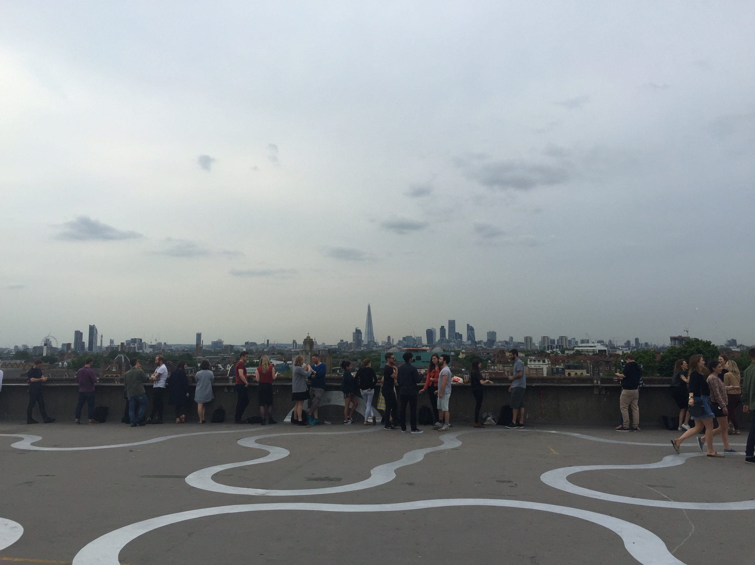
Figure 2: The ‘Peckham Skyline’ from the top of Peckham’s multi-storey car park (July 2016)
Key to these representations of the view is the ‘surprise’ resulting from the fact that such spaces/views are in the middle of Peckham. Such surprise feeds off the past reputation of the area as synonymous with either the white working class of the 1980s sitcom Only Fools and Horses or gang-related violent crime, often represented in narratives of Peckham by the murder of ten–year old Damilola Taylor in 2000, who was killed on his way home from Peckham Library.
The marketing of spaces at height through these presentations is also reliant on the contrast with street level, typically presented in stark terms. For example, a feature on Peckham published in Vogue in 2015 conjures an intense mainly visual contrast of the place:
Stylishly curated tattoos twitch and wriggle over straining muscles. Behind them, on the distant horizon, you can make out the dome of St Paul's; the throng of the City—just four miles north—feels a distant memory up here … This is the bar that draws London's disparate tribes south of the Thames … Even if they don't know much about Peckham … most of them will spend at least one Saturday evening knocking back Camparis on its rooftop … Descend to the car park's ground level, however, and the scene is altogether less serene. Balls of hair, offcuts from the local barbershops, waft along the pavement. Irate women shout on their phones. Music blasts out from stores bearing overripe fruit and vegetables of indeterminate origin. Halal butchers wheel chicken carcasses around in shopping trolleys. Welcome to Rye Lane, Peckham. (McGillicuddy, 2015)
Here, the contrast between this space at height is made through the descent to street level; it slips over into descriptions of bodies, the ‘curated’ bodies of the artists as opposed to the bodies of those below, here characterized as uncontainable, the voices and music that bleed over into public space and the illegibility of the street to the writer (‘vegetables of indeterminate origin’, indeterminate to whom, we may well ask). The serenity of the rooftop space is contingent on its removal from the street. It can be curated in a way that the street cannot. In a twist of Barthes’ point about the Eiffel Tower recalled above, the experience offered in the spaces at height is one where one can be in Peckham but not see, smell or hear it.
The Vogue article gives a sensationalized, racialized and simplistic account of the separation between street level and high-up space. It echoes a dualism built into the ways that such new spaces at height—in Peckham, London and elsewhere—are promoted, marketed and imagined. In short, this discursive construction of these spaces often pivots on the contrast to and removal from the ground below. The ‘surprise’ that such spaces could be found in Peckham feeds off this distinction.

Ascending Peckham
One way into thinking about how power articulates through the relationship between the street-level and up high lies in thinking about the process of ascending space and who this permits and excludes. Ascending into these spaces takes cultural capital, able-bodiedness, and money to participate in the consumption that takes place on high. The process of ascension itself filters bodies in physical and symbolic ways, as we discuss in further detail below.
Our starting point here is Rye Lane on a summer’s night in 2016. A group of young people are walking backwards and forwards in the street, peering closely at the brightly-lit screens of their smartphones in search of a multi-story car park. These challenges in finding spaces at height points to the exclusivity of the space—it is something that draws in those ‘in the know’ and excludes others. When they find it, they seem surprised: ‘It’s a car park!’ (Figure 3)
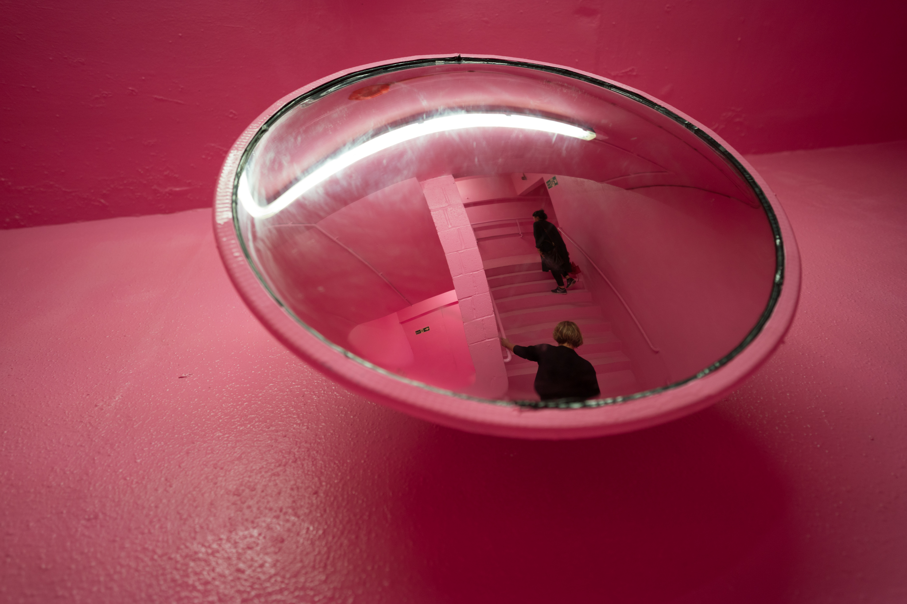
Figure 3: The bubblegum pink stairwell leading to the top of the multi-storey car park and its rooftop bar (June 2016)
Beyond knowledge of their location, ascending these spaces at height is also part of this filtering process, as Michaela describes in her field diary:
It is Sunday evening, a muggy, grey and overcast; and we are on our way to the car park to see this weekend’s offering from the Multi-story orchestra … we head to the stairs. We are the only ones there and we walk up, straight past the security guards who do not even stop us—we don’t have any bags on us. Ahead of us are a couple in their 60s or 70s; they are walking slowly through the bubblegum pink corridor and onto the stairs. The pink is losing its shine a little; as we ascend, I notice an increasing number of scruffs and even some tagging, the visual impact while still overwhelming somewhat tempered by these interruptions in the once-pristine gloss.
It does not take long to catch up with the old couple. The stairs are a challenge; I overhear the woman say that she is surprised that there is no lift. They slowly haul their way up step-by-step. Realising that there are people coming up behind them, they move to one side to let people pass. We overtake them. But this does highlight issues around the accessibility of the space and the work the location might be doing in relation to exclusion. (24th July 2016)
The ease with which Michaela passed security should not be taken as a sign that access to all is easy. Similarly, the architecture of the building and getting to the top facilitates further filtering of those who are less able-bodied; while it had previously been possible to ascend the space at the top by walking up through the car park or taking the lift part way, the leasing of these lower floors in 2016 for a co-working space restricted access to the top to one staircase at the front of the car park, and no working lifts.
The removal from street level reduces the possibilities of passers-by just popping in. But more than this, the process of ascending filters bodies; not only must a person know about the place and want to go there, they must then find it, pass security and then manage the stairs.
Climbing the stairs is not only functional but as a gallery attendant tells Francisco on another occasion, it is meant to be an ‘immersive experience’. In his field diary he reflects that:
I am left thinking that the bath of light and colour is almost like a ceremonial cleansing ritual that allows visitors to emerge at the top detached from whatever they might have picked up on the way to the entrance
This elevated and curated place is designed to produce this sense of removal from street level, to take you out of Peckham. The effect is stark. Bodies that are less able, less white, less resourced with cultural capital and the dispositions for navigating spaces of culture and consumption are absent from this rooftop bar and exhibition space. A South African friend who accompanied us on a trip to the rooftop bar commented that it reminded her of the whites-only spaces of the apartheid-era.
It is only in accounts of moving upwards that these filtering processes become visible; a series of physical and symbolic filters, from the guarded entrance to the staircase ascent, triage bodies so that the distinction between the population on the roof and that its surroundings at street level is much deeper than the physical distance between the two. Feeling comfortable with the ‘immersive experience’ of the staircase—the intense shocking pink, the smell of fresh paint covering that of urine and petrol, the hauntings of the car park-past—is another filter. Our embodied dispositions allow us to blend with the crowd that ascends to these curated atmospheres. More work would be necessary here to fully understand the processes of rejection and blockage as they are experienced by those who don’t ascend. However, an indication of these processes were provided by observation and in the interviews.
For example, Ashley, a worker in the local library who had lived and/or worked in Peckham all his life, provides a clear indication of how these places were shaped through softer forms of exclusion. Discussing how Peckham was changing, Ashley described his experiences of contemporary change in Peckham, in being made to feel that he now longer belonged in this space, where he found himself racialised:
Peckham has always been this place where it’s vibrant, it’s multicultural, but … that’s no longer there, it seems like every day there’s a new coffee shop, there’s this, there’s that. Like you said there isn’t anywhere for us to go and hang, there isn’t anywhere for us to go, okay because you go somewhere you just feel like you’re not welcome there, because automatically you go inside and people are already going to have this perception ‘here comes trouble’, they are going to automatically have that perception. So you don’t feel welcome, even though its home, home don’t feel like home no more. (Emphasis added)
When the interview turned to the new high-up spaces, Ashley described how he ‘tried to embrace it’ at first but continues ‘I will support some of these businesses, don’t get me wrong, but when you go inside there I don’t see nobody like me in there, that’s the thing.’ He describes how feeling uncomfortable has led to him turning down invitations to go to the roof top bars. A reminder of Allen’s argument that ‘there is more to the exercise of power in public places than simply the obvious, signposted arrangements’ (Allen 2006, p. 454), his reflections on feeling uncomfortable in these spaces are telling of how power functions through these atmospheres. Made in the image of young, white middle-class consumers, he finds himself racialised in a neighbourhood where he had previously felt comfortable. Atmospheres may be experienced as exclusionary signalling the existence of symbolic boundaries that deter some bodies from entering these spaces.
Sensorial struggles over space
What we have presented so far may suggest that the distinction between street level and high-up spaces is achieved without contradiction. However, these spaces are constantly permeated by more or less perceptible forms of ‘sensorial violation’ (Low, 2013), notably when sounds and smells leak into and punctuate this boundary. Drawing attention to these brings into the frame some of the struggles over space that are intrinsic to this vertical transformation of the city.
Take the case of Steve, a visual artist with a long-standing studio space high up in the Bussey Building. In his interview with Francisco he described a series of sensorial clashes stemming from the changing use of the building. He was increasingly self-conscious about the smell of paint leaking out from his studio as more office workers moved into the building, and a new neighbour had recently complained about him leaving paint marks on the door knobs. These changes made him worry about the shift of composition of the people who use the space from makers, who predominated before (in which he includes the sweatshops that used to take up a big part of the floors below) and the computer-based activities that seem to be growing with the shared office spaces and others. He thinks that if the balance continues to shift that way, he will feel isolated and may be inclined to leave.
Much of the involuntary communication between different parts of the building happens without visual contact, the receiver often left to imagine the emitter. In the following excerpt from his field diary, Francisco reflects on the sensory environment of a yoga class, taking place in the same building as Steve’s studio:
My attention escapes from the teacher’s voice, to the low continuous hum of the Indian chants, out to the smooth cadence of the trains, their screeching brakes slowly tearing the soundscape apart. The sounds coming from outside do not compete with the ones in the room, rather they alternate, call for attention from a distance before peacefully invading one’s perception. Sounds of Friday evening crowds arrive through the window, the door, the floor, the ceiling … I cannot quite identify. But I can hear them very distinctly. Coming in waves. At first, it sounds like a gathering for a big occasion. It could be an opening in the gallery space on the first floor, right underneath the ground that sustains my horizontal body. But then I realize that these human voices have different sources. And they have different vibes. There are people talking loudly as they walk through the stairwell, and there are more circumstantial celebratory assemblages of voices, entering through the window, certainly emerging from the outside corridor that gives access to the ‘cultural quarter’ of which this post-industrial building is part. Then portions of chatting voices seem to trickle down from the rooftop mixed with the music they are struggling to override. The sounds that now emerge, descend, and pass through this semi-elevated space form a quite intense 360º assemblage of atmospheres.
This excerpt gives an example of how elevated spaces can act as places where various sounds travelling from variegated sources intersect, creating different audio-assemblages. The sounds of trains, birds, workspaces, and crowds above and below arrive at the yoga studio, mixing amongst themselves and with the sounds produced inside the space. Despite the efforts of the yoga teacher to regulate this soundscape through the use of music, it is too unruly to control. Reflecting back on the example from the ‘yoga incident’ described in the introduction to this paper, what becomes interesting is how these sounds are read and judged. In this case, it is the sounds of worship that are picked out as hindering the mindful space of the yoga studio rather than any other elements of this chaotic soundscape.
According to one of our research participants, interviewed in the wake of the yoga controversy, this is a very good example of how what people feel contradicts what people say. In this case the sounds that annoy the yoga studio owners and what they associate with those sounds is unconsciously mediated by social valuations. The interviewee, a black man working on Rye Lane, showed his outrage at the words of the yoga studio owner, in particular, the mention of the ghetto blaster and the ignorance that displayed, ‘what church uses a fucking ghetto blaster?’
The prevalence of African churches (at least 4) and 3 yoga studios in the Bussey Building alone can be read as a sign of the unusual diversity of Peckham town centre and the intense change which it is undergoing. The example of the yoga controversy demonstrates the friction generated by this change. It also shows how the perception of non-visual stimuli often reveals entrenched forms of valuation that can be expressed in less guarded ways than visually coded forms of difference such as skin colour. Taken in conjunction with Steve’s worries about the changing expectations about the building as a working space, as encoded through his description of the sensory environment of the building, we can begin to understand how clashing expectations of its sensorial landscape are key to debates over the changing use of this building.

Conducting the Sensoria
One June evening, Emma and Michaela ascended the pink stairwell once again to go and see a local community orchestra perform in the Peckham car park. On this occasion helpers in bright yellow t-shirts ushered audience members towards the performance space. Michaela describes the scene:
In front of us seats fan out in a semi-circle. An audience is gathering. In front of the seating, the orchestra are already in place, adjusting their chairs, their music stands. Behind them, the raked seating which will later be used by the choirs. The seats to the left of the audience are filled with children, many of whom are in school uniform. They chat among themselves, peer out to the gathering crowd, grins spreading across their faces, energetic waves as they spot their parents and friends within the crowd. The atmosphere is relaxed, people are chatting with one another, choosing their seats. Unlike the space in the bar above, this seems to be a cross-section of the community. The young and old rub shoulders; people have brought young children along in pushchairs and dogs even. But more importantly, this is not the seemingly exclusively white space that the bar on top of the car park appears to be and a stark contrast to some of the other orchestral concerts I have been to in dedicated spaces in other parts of London.
At this performance the orchestra (predominantly white) are performing with some of the local school children (a combination of black and white, majority black). The children are sat together on the left-hand side while the proud parents wave and take pictures. Emma notes:
A pleasant warm wind blows through the concrete sides of the car park. The conductor holds up his baton. Silence falls and then a train rumbles past noisily, rumble, screeeeech. The concert is punctuated by the loud noise of the trains, but they always seem to arrive between the action.
At the performance the orchestra plays three pieces. One is an instrumental, Bach (Sleepers Wake). The next is a piece from Julius Caesar the opera and is performed by a soprano. My first instinct is to consider the parallels with the use of classical music to civilize unruly urban spaces, for example how classical music is piped into ‘problem’ tube stations to dispel people through a kind of sound colonization, but this is something different. In the final piece the children’s choir take to the stage.
‘I am the sea and I have something to say…’ the children sing verses by Egyptian poet Sabrina Mahfouz. The black soprano and a white baritone, who looks less like a classical singer and more like a Bellenden Road resident who popped out for a pint of milk (beard, checked short sleeved shirt), join in towards the end ‘Close your eyes and think of a place that beats with beauty’. In the audience a four-year old girl shouts, ‘I’m going to wet myself’ and her mum hurriedly escorts her out – probably an unusual occurrence in a classical concert, as is the dog who snouts around between our chairs. At the end of the performance there is a standing ovation.
The porous boundaries of the car park, the involvement of the children and the unconventional setting deformalize this moment of performance. While a positive review of a classical concert in the space in The Guardian stated, ‘[t]here is nonetheless a reason why most concerts (of any kind) don’t take place in multi-story car parks: the acoustic properties of a low-ceilinged, open-sided space made of concrete can be challenging.’ (Wilson, 2017), the interruptions of trains and voices, the wind through the concrete, all feed in to the production of an unusual urban sensoria. For us, this was an all too rare moment where the potential of these unusual high up spaces to bring people together was revealed.
After the fieldwork period for our study was over, Peckham Levels, opened on the middle levels of the car park. This is a multi-use space that includes, studio and office space, food outlets, galleries, a hairdresser, a children’s play area and a yoga studio. It retains some of the markings of the car park but has been modified (and weather-proofed) through the erection of dividing walls and the installation of windows. In the stairwell that leads to the Levels bright, neon colours mark out each of the six levels. On Michaela and Emma’s first visit, they found themselves disoriented, the smart directory that now adorns the wall by the entrance absent. They climbed to the top of the stairs to be faced with a large, heavy door. Uncertain whether this was the way in, they tentatively pushed it open to reveal the food and leisure space.
This stretches over two levels and includes a range of small food counters, several café-bars, a hairdresser, yoga studio, a gallery (at the time exhibiting artists from Peckham), a large area of seating and open space. While not officially included in our study, our early explorations of Peckham Levels revealed a place that seemed to mainly cater for well-off (based on the prices of food and drink available—£9 for a main meal—and also the atmosphere which seemed similar to the rooftop bars) but yet was also being used in other ways. We saw teenagers in school uniform using unguarded plug sockets to charge their phones. While it is unlikely that the sockets were put there with that intention, we could see people using the space in ways that made sense to them. Teenagers were also sitting at tables in the centre of the space, sometimes sharing a cake. Parents sat with buggies, watching their small children running around the open space, the hardnesss of the concrete here tempered with colourful soft surfacing and large foam blocks. The space was also far more mixed in terms of ethnicity of the people present than the rooftop bars. At the time of writing, this place feels a lot less securitised and exclusive than some of the other high up spaces. Whether a diversity of uses and people will be further encouraged and facilitated or clamped down on remains to be seen.
Conclusion
While the link between verticality and social inequality is writ large in recent literature, in this paper we have sought a more nuanced understanding of less perceptible workings of power through spaces at height. As we have argued, this requires moving perspectives from the horizon to the three-dimensional geographies of the city paired with a methodological shift attuned to capturing the multisensory registers of place-making and experience. The multisensory ethnographic research presented here offers critical insights into place-making in leisure spaces at height, attuned to how power functions in and is distributed through these spaces.
This conjunction of a heightened multisensory and volumetric perception of unequal urban change necessitates a contextualization of the view from the top. The iconic rooftop bar with its view to the high-rises of the London skyline, is valued by its users for its detachment from the sensorial atmosphere of the town centre where it is located. While in theory it is publicly accessible, only a select public make it to the top. Recounting the experience of trying to ascend, in conjunction with a sense of the different experiences expressed by our interviewees revealed how place-making at height rests upon the drawing of physical, sensorial and symbolic boundaries, which act as technologies of control over who can enter. They rest upon and reconstruct processes through which some bodies are valued at the expense of others, as much as some sensoria are perceived as more invasive than others. In other words, rooftop leisure spaces, such as that atop the car park, are made in ways that exclude the more socially and ethnically diverse and still generally less affluent users of Peckham Town centre, in tandem with the valuation of the contrast with the street level sensoria.
In the Bussey Building, the social/ethnic composition of the people moving through and using the spaces in-between—the stairwells, walkways and other common areas—is diverse; African church goers might rub past bearded artists in paint-splashed clothes, couples in yoga gear, and young drinkers. As we move further inside, up and back down, we see that walls, ceilings and floors once again separate and have always separated these groups. But we can also hear and smell the constant sensorial violations of these divisions, generating involuntary communication across difference, and signalling a tantalising promise of conviviality. These sensorial exchanges across these divisions also become sites of valuation and regulation, exacerbating rather than ameliorating social differentiation.
In Peckham, it is clear that there is some potential for these spaces to interrupt these inequalities, to open to broad cross-sections of the population as signalled by initiatives such as the orchestral performance that we described. The successful listing of the car park as an asset of community value, which made those projects possible in that space, signals push-back against grand plan urban transformations. Local activism, creativity and blue-sky urban thinking may, if articulated with a critical sociological and geographical awareness to the different practices already in place may open new possibilities for local escape from the sweeping processes of exclusion happening in London. These offer a glimpse of what might be. But perhaps this is too hopeful.
Indeed, we opened this paper with an example of these processes of sensorial valuation, when the African church sound was associated with the word ghetto, whilst the yoga chants are assumed to be sophisticated expressions of spirituality and physical prowess. While the liveliness of Peckham is upheld as a celebrated symbol of conviviality (Gilroy, 2004), our effort to extend from ocular vistas to multi-sensory horizons reveals entrenched forms of valuation that privilege leisure activities of some over those of other occupants as the city (at height) is remade in the image of the young, white, able-bodied middle classes.
The orchestra packs up at 8pm, the audience disperses, back down through the pink stairwell and out into the street below. The potential for another possible space at height in Peckham might be all too fleeting.
Notes
- Above Street Level: rethinking power, place and encounter through the Peckham Skyline was funded through the British Academy and Leverhulme Small Grant Scheme (Grant Number SG-153099).
- This has since been removed from the Evening Standard online article but the original comments can be found here https://www.vice.com/en_uk/article/ne34gq/the-evening-standard-removed-quotes-from-a-piece-for-causing-local-animosity
- This project led by Professor Gary Bridge and Professor Marie-Hélène Bacqué was funded by the ESRC and Agence Nationale de la Recherche (Grant Number ESRC RES-062-33-0002).

List of references
Adey, P. (2013) Air/Atmospheres of the Megacity. Theory, culture & society, 30 (7-8), 291-308.
Allen, J. (2006) Ambient power: Berlin’s Potsdamer Platz and the seductive logic of public spaces, Urban studies, 43(2), 441-455.
Back, L., & Keith, M. (2014). Reflections: Writing cities. In H. Jones and E. Jackson (eds.) Stories of cosmopolitan belonging: Emotion and location (pp. 15-28). Abingdon: Routledge.
Barthes, R. (1985) The Eiffel Tower. In S. Sontag (ed.) A Barthes reader. New York: Hill and Wang.
Baxter, R. (2017) The high-rise home: verticality as practice in London. International journal of urban and regional research, 41(2), 334-352.
Benson, M. & Jackson, E. (2013) Place-making and place maintenance: Practices of place and belonging among the middle classes. Sociology, 47(4), 793-809.
Bini, V. & d’Alessandro, C. (2017) Du skyline des CBD à la création de pôles de gratte-ciel résidentiels dans les villes nouvelles d’Afrique. Géocarrefour, 91(91/2).
Brighenti, A.M. & Pavoni, A. (2017) Climbing the city. Inhabiting verticality outside of comfort bubbles. Journal of urbanism: International research on placemaking and urban sustainability, 11(1), 63-80.
Buckingham, S. & Degen, M. (2012) ‘Sensing our way’. The senses and society, 7(3), 329–44.
Butt, A. (2018) Vicarious vertigo: The emotional experience of height in the science fiction city. Emotion, space and society, 28, 114-121. doi: 10.1016/j.emospa.2017.04.001
Charney, I. & Rosen, G. (2014) Splintering skylines in a fractured city: High-rise geographies in Jerusalem. Environment and planning D: Society and space, 32 (6), 1088–1101.
Cwerner, S., Kesselring, S. & Urry, J. (2009) Aeromobilities. London: Routledge.
de Certeau, M. (1988) The practice of everyday life. California: University of California Press.
Degen, M. (2008) Sensing cities. Regenerating public life in Barcelona and Manchester. London: Routledge.
Deriu, D. (2018) Skywalking in the city: Glass platforms and the architecture of vertigo. Emotion, space and society, 28, 94-103. doi: 10.1016/j.emospa.2017.05.005
Deutsche, R. (1998) Evictions: Art and spatial politics. Cambridge, MT: MIT Press.
Elden, S. (2013) Secure the volume: Vertical geopolitics and the depth of power. Political geography, 34, 35–51.
Fischer, B., McCann, B. & Auyero, J. (2014) Cities from scratch: Poverty and informality in urban Latin America. Durham, NC: Duke University Press.

Glucksberg, L. (2016) 'A view from the top: Unpacking capital flows and foreign investment in prime London.' City, 20 (2), 238–55. doi: 10.1080/13604813.2016.1143686.
Graham, S. (2014) Super-tall and ultra-deep: The cultural politics of the elevator. Theory, culture & society, 31(7-8), 239-265.
Graham, S. (2015) Luxified skies: How vertical urban housing became an elite preserve. City, 19 (5), 618–45.
Graham, S. (2016) The politics of verticality. London: Verso.
Graham, S. (2017) Contemporary skyscrapers turning nowhere into somewhere. Géocarrefour, 91(91/2).
Graham, S. & Hewitt, L. (2013) Getting off the ground: On the politics of urban verticality. Progress in human geography, 37(1), 72-92.
Hadi, Y., Heath, T. & Oldfield, P. (2018) Gardens in the sky: Emotional experiences in the communal spaces at height in the Pinnacle@ Duxton, Singapore. Emotion, space and society, 28, 104-113. doi: 10.1016/j.emospa.2017.09.001
Hall, S. (2015) Super-diverse street: a ‘trans-ethnography’ across migrant localities. Ethnic and Racial Studies, 38 (1): 22-37.
Harris, A. (2015) Vertical urbanisms: Opening up geographies of the three-dimensional city. Progress in human geography, 39 (5): 601–20.
Harvey, D. (1989). The urban experience. Baltimore, MD: JHU Press.
Hewitt, L., & S. Graham (2015) Vertical cities: Representations of urban verticality in 20th-century science fiction literature. Urban studies, 52 (5), 923–37.
High Street Challenge Cleaner Peckham Project (2016) Report of the steering group. Retrieved from http://www.peckhamvision.org/wiki/images/d/d9/Cleaner_Peckham_final_report_on_waste_study_compressed.pdf
Jackson, E. (2014) The pigeon and the weave: The middle classes dis/comfort and the multicultural city. In Jones, H. & Jackson, E. (eds) Stories of cosmopolitan belonging: Emotion and location (pp. 57-70). New York: Routledge Earthscan.
Jackson, E. & Benson, M. (2014) Neither ‘deepest, darkest Peckham’, nor ‘run of the mill’ East Dulwich: The middle class and their ‘others’ in an inner London neighbourhood. International journal of urban and regional research, 38(4): pp. 1195-1210.
Just Space, Lees, L., LTF & SNAG (2014) Staying put: An anti-gentrification handbook for council estates in London. Retrieved from https://southwarknotes.files.wordpress.com/2014/06/staying-put-web-version-low.pdf

Knowles, C. (2017) Walking plutocratic London: exploring erotic, phantasmagoric Mayfair. Social Semiotics, 27(3), 299-309.
Lam, P.W. & Graddol, D. (2017) Conceptualising the vertical landscape: The case of the International Finance Centre in the world's most vertical city. Journal of sociolinguistics, 21(4), 521-546.
Low, K. (2013) Sensing cities: The politics of migrant sensescapes. Social identities 19(2), 221-237.
Mcgillycuddy, L. (2015) Urban renaissance: How Peckham became London's cultural epicentre. Retrieved from http://www.vogue.co.uk/article/new-generation-of-artists-in-peckham
Nam, S. (2017) Phnom Penh’s vertical turn. City, 21(5), 622-631.
Nethercote, M. & Horne, R. (2016) Ordinary vertical urbanisms: City apartments and the everyday geographies of high-rise families. Environment and planning A, 48(8), 1581-1598.
Norman, M. (2009) Restaurant Review: Frank’s Café & Campari Bar. The Guardian, July 24, 2009, sec. Life and style. Retrieved from http://www.theguardian.com/lifeandstyle/2009/jul/25/restaurant-review-franks-cafe-campari-bar.
O’Neill, K. L., & Fogarty-Valenzuela, B. (2013) Verticality, Journal of the Royal Anthropological Institute, 19 (2), 378–89.
Pagano, M. A., & Bowman, A. O. M. (1997) Cityscapes and capital: The politics of urban development. Maltimore, MD: JHU Press.
Pérez, M.A. (2015) Exploring the vertical: science and sociality in the field among cavers in Venezuela. Social & cultural geography, 16(2), 226-247.
Pink, S. (2009) Doing sensory ethnography. London: SAGE.
Pink, S. (2013) Doing visual ethnography. London: SAGE.
Rhys-Taylor, A. (2013) The essences of multiculture: A sensory exploration of an inner-city street market. Identities, 20(4), 393-406.
Rhys-Taylor, A. (2014) Urban sensations: A retrospective of multisensory drift. In Howes, D. (ed.) A cultural history of the senses in the modern age, 1920-2000 (pp. 1-13). London: Bloomsbury.
Rhys-Taylor, A. (2017) Food and Multiculture: A Sensory Ethnography of East London. London, Bloomsbury.

Rodgers, D. (2004) ‘Disembedding’ the city: Crime, insecurity and spatial organization in Managua, Nicaragua. Environment and urbanization, 16(2), 113–24.
Rosen, G. & Charney, I. (2016) Divided we rise: politics, architecture and vertical cityscapes at opposite ends of Jerusalem. Transactions of the Institute of British Geographers, 41(2), 163-174.
Santos, M. (1979) The shared space: The two circuits of the urban economy in underdeveloped countries. London: Methuen.

Soja, E. (1996) Thirdspace: Journeys to Los Angeles and other real-and-imagined places. London: Wiley.

Srivastava, P. and Hopwood, N. (2009) A practical iterative framework for qualitative data analysis, International journal of qualitative methods, 8(1), 76-84.
Sterne, J. (2003) The Audible Past. Durham, NC: Duke University Press.
Tumasz Junior, P. (2016) A produção do espaço urbano: Características do processo de verticalização em Guarapuava PR (1999-2015). Unpublished PhD Thesis. Retrieved from: https://acervodigital.ufpr.br/handle/1884/45503
Weizman, E. (2012) Hollow land: Israel’s architecture of occupation. London: Verso Books.
Wilson, F. (2017) Multi-Story Orchestra review – concrete commitment brings car park chorus of approval. The Guardian 27th August 2017. Retrieved from https://www.theguardian.com/music/2017/aug/27/multi-story-orchestra-review-proms-bold-tendencies-peckham-car-park-choir

