Biological Basis to Child Health: Growth, Development and Reproduction

Kate Davies RN (Child), Dip HE, BSc (Hons), MSc, PGCert, PGDip
Children’s Advanced Nurse Practitioner
Senior Lecturer in Non Medical Prescribing
London South Bank University
Honorary Research Fellow in Paediatric Endocrinology
Queen Mary University of London / Barts and The London NHS Trust

Abstract
This article is the nth article in the Biological Basis to Child Health. Understanding childhood growth and development is a vital part of knowledge for a children’ nurse. This article describes childhood developmental milestones, growth and puberty, and also the male and female reproductive systems, alongside clinical examples to highlight the importance and links with growth and development.

Keywords
Growth, Development, Puberty, Reproduction

Aims and Outcomes
This article explores components of childhood growth and development, examining clinical situations which may be relevant to children’s nursing. After reading this article, the children’s nurse should be able to:
- Identify the different childhood developmental milestones
- Discuss the relevance of the different growth stages
- Outline the importance of knowledge of the reproductive systems in line with children’s nursing practice
- Explain clinical scenarios to be aware of in everyday practice.

Introduction
Assessing childhood growth and development is an important factor to consider when assessing the health of a child. Optimum growth monitoring is essential in order to maximise the health potential of a growing child, and children’s nurses are in an ideal position to weigh and measure children regularly, in order to identify deviations from what is expected.

Childhood Developmental Milestones
As well as knowing about the stages of childhood growth, it is vital that the children’s nurse has a sound knowledge of childhood developmental stages also. It is estimated that at least 1 in 5 children have a type of developmental and / or behavioural disability (Sheldrick, Merchant, & Perrin, 2011). Knowledge of gross motor skills, fine motor skills, vision, speech and language and social abilities all need to be considered, and an optimum behavioural timeline can be seen in Figure 1. Health Visitors carry out the health needs of children and their families, and explore activities which promote health (Brimble & Reddington-Bowes, 2018).

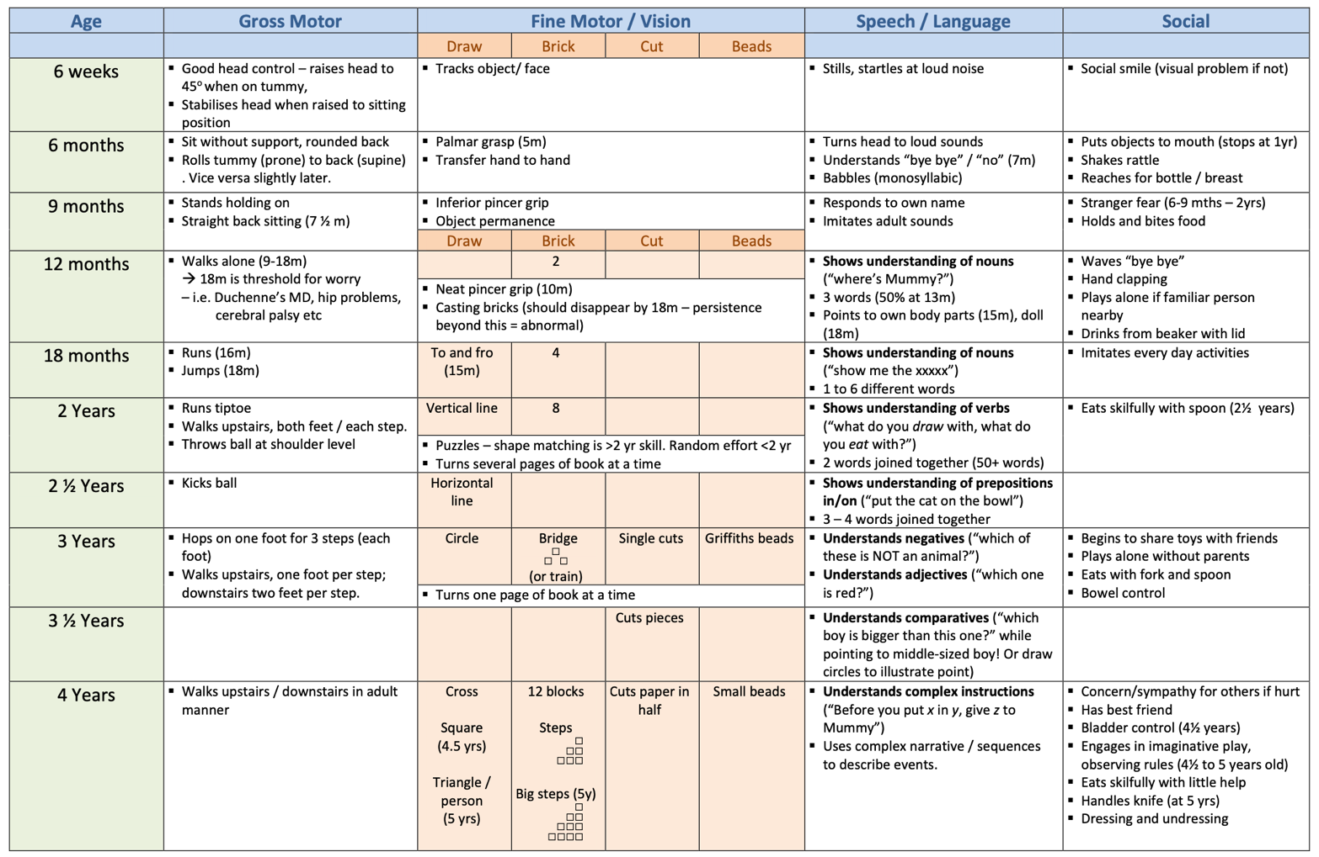

Figure 1: Developmental Timeline (adapted from RCPCH revision notes, doesn’t have to be exactly like this)

TIME OUT 1
Visit:
www.nhs.uk/conditions/pregnancy-and-baby/baby-review
Review the site with a colleague, and discuss a baby’s health and development reviews. How do assessments vary as a child gets older? Watch the video and discuss the role of the Health Visitor: what ‘red flags’ may they look out for on a home visit?
Developmental Delay
This indicates a delay in acquisition of some of the ‘skills’ fields: global developmental delay encompasses delays in all of the fields, and becomes more apparent as the child gets older, but is usually first noticed in the first two years of life (Lissauer, Clayden, & Craft, 2012). Approximately 1 in 400 children are diagnosed with cerebral palsy (Griffin & Lopez, 2018), and around 80% of the cause is attributed to antenatal causes, genetic syndromes, gene deletions or congenital infections (Lissauer et al., 2012). Initial presentation is usually in infancy, with abnormal tone or posture, delayed motor milestones, and feeding difficulties.

Down Syndrome - or Trisomy 21 – (See Cell and Genetics article) – is due to an extra chromosome 21, and affected children have some degrees of developmental delay, learning difficulty, typical facial features, and also some physiological features, such as gastrointestinal disturbances, cardiac problems or hypothyroidism (Crawford & Dearmun, 2016).

Children with autism have difficulties in making sense of their worlds, or how their brain processes information (Griffin & Lopez, 2018). Depending on the severity, there may be impaired social interaction, speech and language problems, repetitive behaviour, and other co-morbidities, such as attention difficulties or in some cases, seizures (Lissauer et al., 2012)

TIME OUT 2
Think about children with extra needs who come under your care. What members of the multi-disciplinary team would be involved, and why? Reflect on a particular child with a colleague.
Normal Childhood Growth

There are four stages in the normal growth pattern:
- Foetal
- Postnatal
- Childhood
- Puberty / Adolescence

The Foetal stage
Normal foetal growth is hugely dependent upon the health of the mother, and the size of the foetus is a clear indicator of the developing child’s health (Mayer & Joseph, 2013). (See Biological Basis to Child Health 2: Embryology). Maternal illnesses such as Hypertension, Type 1 Diabetes and autoimmune diseases can increase the risk of foetal growth restriction. Drug abuse, tobacco use and alcohol consumption can also impact the foetus’s growth, although there seems to be little consensus on alcohol allowances during pregnancy (Scholin, Hughes, Bellis, Eriksson, & Porcellato, 2019), or whether full abstinence is needed, although the latest national guidance completely advises against drinking alcohol during pregnancy (RCOG, 2018)(DOH 2016).

Foetal growth is also controlled by placental function, which is dependent on maternal diet, and controls foetal growth factors such as IGF-2 and Insulin (Lissauer et al., 2012). Earlier placental problems can have an impact, such as incomplete invasion of the trophoblast into the uterine wall (Mayer & Joseph, 2013).

Endocrine control of foetal growth is less understood (Greenstein & Wood, 2011), although it is known that growth hormone (GH) is being secreted from the developing pituitary gland by ten weeks gestation. The exact stage when GH begins to control linear growth is unclear (Wei & Gregory, 2009), although infants who have GH deficiency from birth (for example, due to congenital hypopituitarism) are only 1 – 2cm shorter in length than non-affected babies. The thyroid gland – known to be important in childhood growth – is the first gland to develop from around 24 days gestation (Webster & de Wreede, 2016), although conversely, an absent thyroid does not seem to affect foetal growth, as seen in infants with thyroid agenesis / dysgenesis (Wei & Gregory, 2009).

Postnatal Growth
In the first year of life, there is a continuation of the rapid foetal growth rate, with the infant growing approximately 25cm: this rate halves in their second year (Donaldson, Gregory, Van-Vliet, & Wolfsdorf, 2019). Obviously, the determining influential factors change, and the growth of the baby is not dependent upon maternal and placental health, but the focus is now on environmental factors, namely nutrition(Wei & Gregory, 2009), but chronic childhood disease can also have an impact, such as coeliac disease or inflammatory bowel disease, as the conditions are associated with malabsorption (Greenstein & Wood, 2011). Inadequate rates of weight and height gain in this period can be classified as ‘failure to thrive’ (Lissauer et al., 2012), and is usually diagnosed in children under two, usually due to poor nutrition (Scholler & Nittur, 2012).

Childhood Growth
During this phase, nutritional influences become less important, and hormones – particularly thyroid and growth hormone, become the main regulating mechanisms for a child’s growth (Donaldson et al., 2019). This tends to be the age when children with growth disorders will present clinically (Davies, 2017), usually due to being able to compare against other children at school. Childhood height velocity (speed of growth) ranges from around 4 – 7 cm/year, with little difference between boys and girls (Martin & Collin, 2015).

Thyroid hormone is necessary for normal childhood growth WEI and faltering growth is clearly seen in children with hypothyroidism. However, growth hormone (GH) is the main regulator of human growth, along with IGF-1 (insulin like growth factor). GH’s main control is from the hypothalamus and pituitary gland, but other factors such as adequate nutrition, stress, exercise and sleep can also affect GH secretion, as well as cases of severe emotional deprivation. One of the most common reasons for a child to present with short stature is due to GH deficiency, which affects around 1 in every 4000 children in the world each year (Moore, Whitehead, & Davies, 2019). Treatment involves a daily subcutaneous injection of manufactured GH, until the end of linear growth (Collin, Whitehead, & Walker, 2016).

TIME OUT 3
Growth hormone replacement therapy is not just used for children with growth hormone deficiency, but for a variety of conditions. Have a look at the NICE Guidance on ‘Human Growth Hormone for the treatment of growth failure in children’ (NICE, 2010), https://www.nice.org.uk/guidance/ta188 and identify the other indications in which children may require GH treatment. Discuss with a colleague and reflect if you have come across these conditions in clinical practice, and how GH affected that child and family.
Puberty
The pattern of growth now becomes more complex, and differs between boys and girls, with sex hormones being released in order to boost final height and develop into adulthood (Lissauer et al., 2012). The pubertal growth spurt is caused by increasing levels of androgens from the adrenal glands, and oestrogen production in both sexes, as a result of the hypothalamic-pituitary-gonadal axis, which results in an increase of GH (Donaldson et al., 2019). Puberty for girls usually starts two years before boys, and stops two years before also, resulting in boys still growing pre-pubertally for two years. When girls are growing at their fastest, they are growing on average 8cm/year, at around the age of 12 years, whereas boys grow taller and quicker at a rate of 10cm/year (Martin & Collin, 2015). Timing of puberty varies widely, but does tend to run closely within families (Pyra & Schwarz, 2019). Girls’ puberty tends to end around two years after girls start their periods – menarche – when growth rates rapidly decline. Boys’ growth rates start to slow down after they begin to grow facial hair (Donaldson et al., 2019).

Growth and Pubertal Assessment

Growth assessment
Growth assessment is a vital part of the overall assessment of a child (Miall, Rudolf, & Smith, 2012), and abnormal growth is an excellent indicator of an early sign of pathology (Lipman & Lessig, 2019). In the United Kingdom (UK), a nationally mandated public health programme measures the height and weight of each child on entering and leaving primary school (ages 4 and 11 years) (NHS, 2018a), and guidelines are set in order to recognise faltering growth (NICE, 2017), However, whilst height measurements are taken in schools, the focus is on children’s weights, in an overall aim to calculate children’s body mass indexes and gain data on increasing obesity figures. Studies have also shown that adequate growth monitoring can provide a basis as an early detection tool for serious underlying disorders (Scherdel et al., 2016), such as Crohn’s disease, coeliac disease or Turner syndrome, especially in Finland, which has a vastly increased frequency in measurements throughout childhood (Sankilampi, Saari, Laine, Miettinen, & Dunkel, 2013). Therefore, children’s nurses should take ample opportunity to gain height data from children whenever appropriate clinical contact is made, and early recognition of faltering growth must be acted upon.

Referral in childhood is usually made from primary care (Savage et al., 2016), where measurements are plotted in the ‘red book’ (the Personal Child Health Record), which is given to parents in the UK after the birth of their child.

Weight
Scales must be calibrated regularly to ensure accuracy. Children should wear the least amount of clothing possible, with heavy clothing such as coats removed and pockets emptied. Babies should be weighed naked, with the nappy removed (Martin & Collin, 2015).

Length
Infants should be measured lying down until the age of 2 years (Miall et al., 2012), using a neonatometer. Two people are required to undertake this, with one person gently but firmly holding the baby’s head, and the other holding the legs down and moving the adjustable footboard to the soles of their feet.

Head circumference
A newborn’s head circumference measures roughly 33 – 35cm (Martin & Collin, 2015). A flexible tape measure should be used, positioned half way between the eyebrows and hairline, and the occipital prominence at the back (See Figure 1)

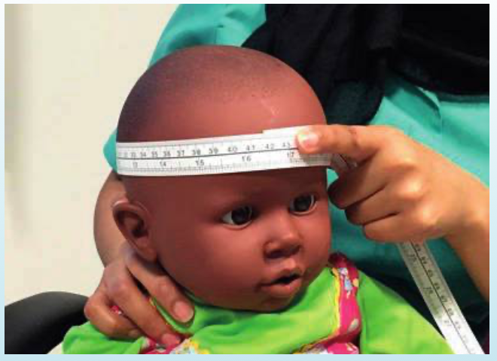

Figure 2 – Measurement of Head Circumference (Martin & Collin, 2015)

Height
Accurate stadiometers should be used, and again, calibrated regularly. Children need to remove their shoes and socks, and stand upright with their shoulder blades, buttocks and heels, and back of their head firmly against the board. The measurer should position the child’s head in the ‘Frankfurt plane’ – an imaginary line running from the eye to the ear – to ensure a horizontal position (Martin & Collin, 2015) (See Figure 3).

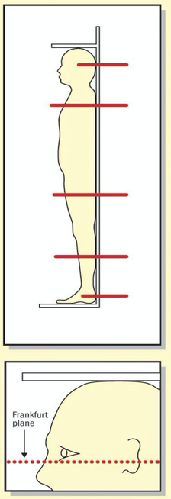

Figure 3 – Accurate measurement (Davies, 2004)

TIME OUT 4
The RCPCH (Royal College of Paediatrics and Child Health) recognise that growth is an important indicator of child health. Have a look at their website with information on the different growth charts:
www.rcpch.ac.uk/resources/growth-charts
You can also view the videos on how to weigh and measure accurately. Watch these with a colleague and practice measuring each others’ heights. Discuss what difficulties you might encounter in practice.

Pubertal assessment
Puberty is assessed against the Tanner staging scale (See Figure 4) (Tanner & Whitehouse, 1976), for both boys and girls, which classifies pubertal maturation. The Hypothalamic Pituitary Gonadal (HPG) is activated, with Gonadotrophin Releasing Hormone (GnRH) being released by the hypothalamus, and the testes or ovaries responding accordingly.

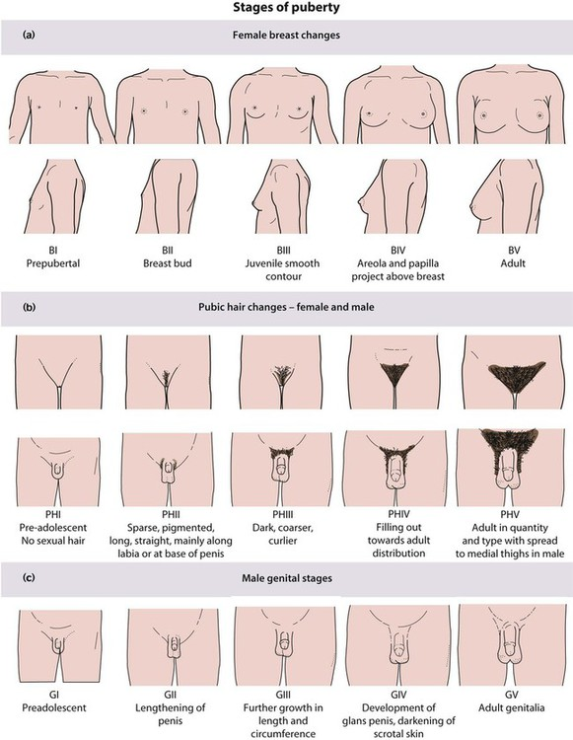

Figure 4: Pubertal rating scale

Puberty in Girls
The first signs of puberty in girls is breast budding. The normal order of puberty is:

Breast growth Acceleration in height velocity Pubic and axillary hair growthMenarche

Menarche – the start of a girls’ periods – arrives approximately 2-2.5 years after the initial onset.

Puberty in Boys
The first signs of pubertal development in boys is testicular enlargement (Wei & Crowne, 2016), which equates to testosterone secretion at the age of around 11 years ZACHARIN. Testes are measured by using a Prader orchidometer (See Figure 5)

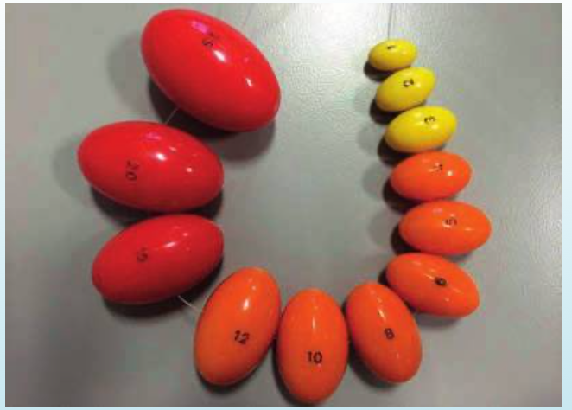

Figure 5: A Prader Orchidometer (Martin & Collin, 2015)

The volume of the testes is measured in line with the pubertal progression, and each ‘bead’ is compared to the growing testis. The colours in this orchidometer represents where in puberty the boy is: yellow is pre-pubertal, orange is in puberty and red is post adolescent growth spurt. 10mls would indicate that the boy is about to commence their growth spurt. The normal order of a boys’ growth is:

Testicular growthGrowth of penis, pubic and axillary hair growthAcceleration in height velocityVoice deepens, facial hair grows

Spermarche – the beginning of sperm development in the testes – usually occurs during the earlier stages of puberty, and the boy can have little or no pubic hair present, with only slight testicular enlargement (Nielsen et al., 1986).

Summaries of growth and pubertal development can be seen in Figures 6 and 7:

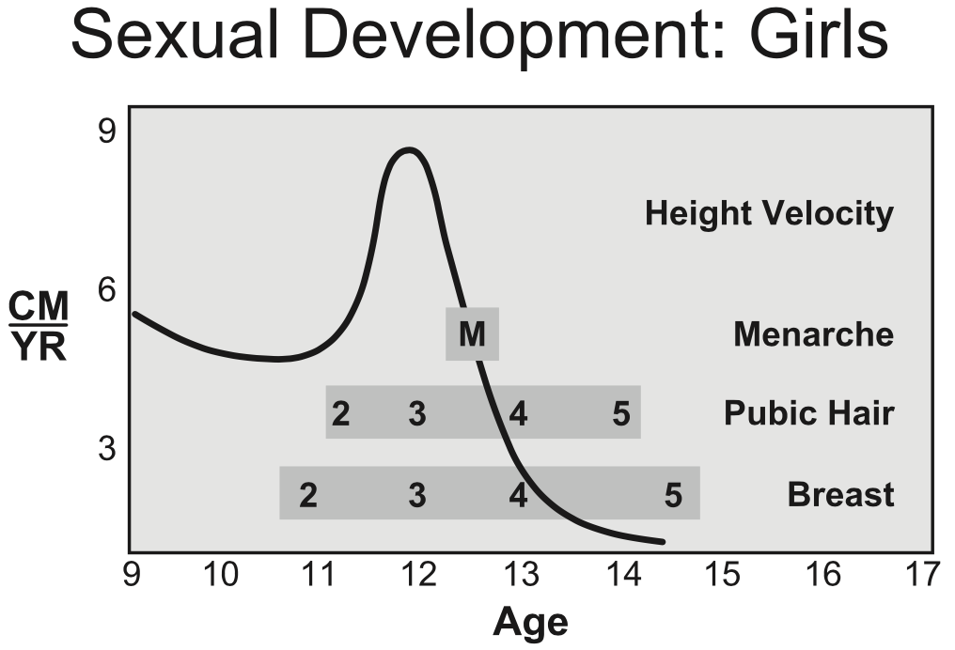

Figure 6: Sexual and growth development in girls (Rosen, 2004)

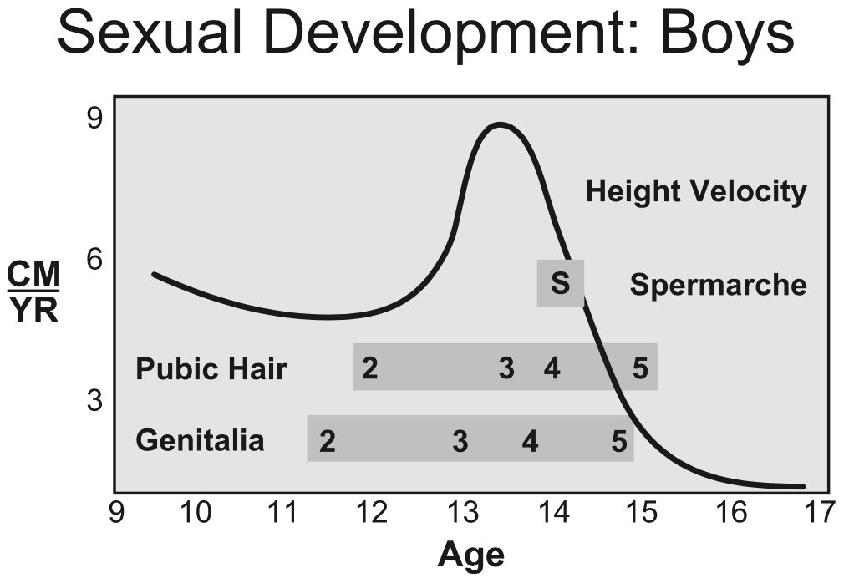

Figure 7: Sexual and growth development in boys (Rosen, 2004)

Precocious puberty (PP)
This is classified as in girls younger than eight years of age, and boys younger than nine, with data showing that puberty is now starting earlier (D. A. Klein, Emerick, Sylvester, & Vogt, 2017). There are often more pathologies associated with boys presenting with early puberty. Many causes of PP have been detailed, including early activation of the HPG axis (such as brain tumours near the pituitary gland, or congenital neuro malformations, such as septo-optic dysplasia), radiotherapy effects, or chromosomal abnormalities (Latronico, Brito, & Carel, 2016), as well as idiopathic causes. Conversely, peripheral causes, ie affecting the gonads directly with no hypothalamic-pituitary involvement – can also contribute to precocious puberty, such as congenital adrenal hyperplasia, McCune Albright syndrome, testicular overactivity or exposure to exogenous steroids (Zacharin, Banerjee, & Patel, 2013).

Treatment for precocious puberty involves multidisciplinary support, and administration of a GnRH analogue injection, which causes down-regulation of pituitary GnRH receptors, thereby suppressing the release of luteinizing hormone (LH) and follicle stimulating hormone (FSH), and then subsequently suppressing the release of gonadal sex hormones (K. Klein et al., 2016). Treatment is monthly / 3 monthly and soon to be 6 monthly injections, until the child has reached ‘correct’ pubertal age – usually the first year of secondary school.

The Female Reproductive System
The female reproductive system develops from the Mullerian ducts in an XX female, which develops into the female reproductive structures, except the ovaries. These develop, because no AMH – Anti Mullerian Hormone – is being released to block their development (Davies, 2019). A Y chromosome needs to be present to make male reproductive structures, and thus AMH from the Sertoli cells. Undifferentiated gonads begin to separate around 6 – 7 weeks gestation, when the gonadal cells segregate into either testicular tissue or ovarian tissue (See Figure 8).

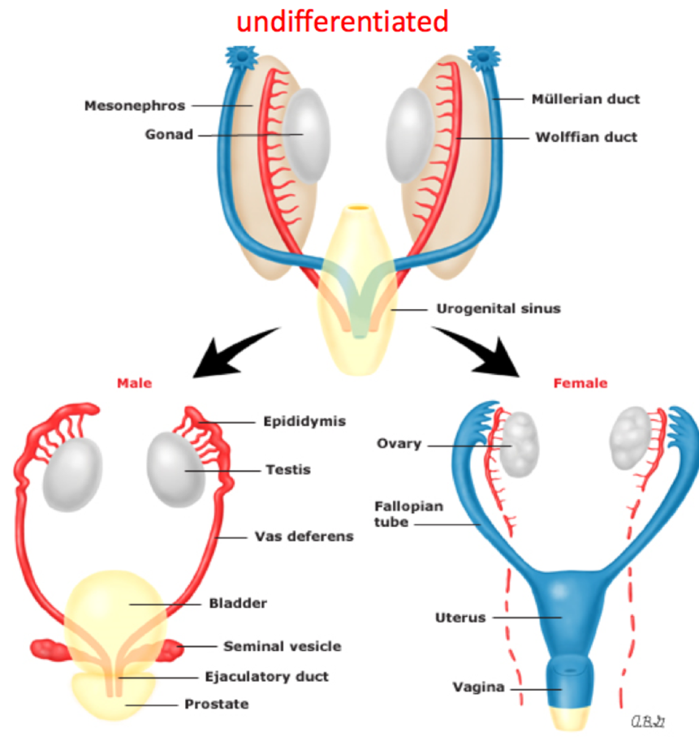

Figure 8 – AMH leading to the regression of the Mullerian ducts

The external genitalia – the vulva – consist of: the labia majora and minora, folds of skin containing sebaceous glands; the clitoris, containing sensory nerve endings; and the perineum, an area of connective tissue muscle and fat between the base of the labia minora and the anus (Waugh & Grant, 2018). (See Figure 9)

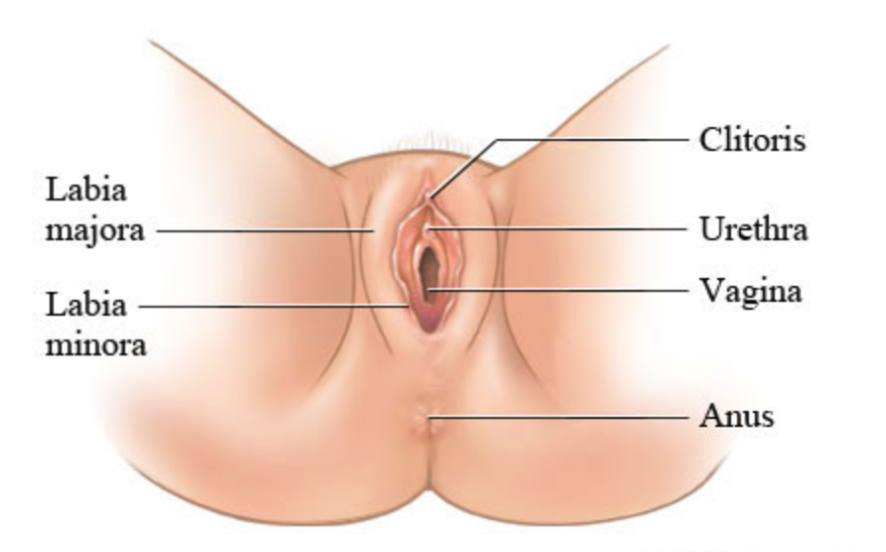

Figure 9: External female genitalia

Internally, the system contains: the vagina, a fibromuscular tube running from the external genitalia to the cervix of the uterus (Boore, Cook, & Shepherd, 2016); the uterus, lined with the endometrium, which lies in the pelvic cavity between the bladder and the rectum; the fallopian tubes, which are hollow structures attached to the corners of the uterus, and who’s function include transporting sperm and the egg to the site of fertilization, and then finally the two ovaries, which lie just behind the uterus (Heffner & Schust, 2014). (See Figure 10)

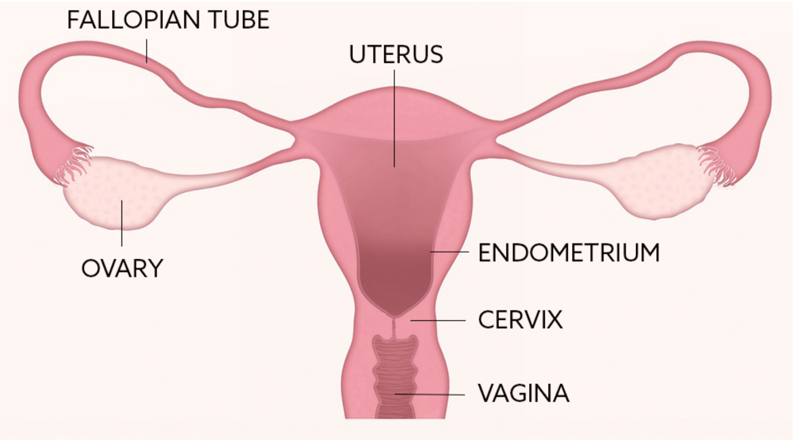

Figure 10: The Internal female reproductive system

The Ovary
Female germ cells begin with around 5 million oogenia (immature female reproductive cells) (Jung & Kee, 2015), which proceed to meiosis (see article on Cell and Genetics), although more than 99% are lost by the time of birth (Vogazianou, 2019). The surviving germ cells – primary oocytes – rest in the prophase stage of meiosis until puberty. By the 7th month of gestation, these oocytes develop surrounding layers of granulosa cells, which then form a primordial follicle. All of these follicles, containing the oocytes, are all present in the female infant’s ovaries at birth, when there are around 400,000 follicles. When puberty is near completion, FSH and LH cause the follicles to develop.

The menstrual cycle
In the absence of conception, each cycle ends in menstrual bleeding – a ‘period’. LH and FSH mediate the cyclical changes, which can be divided into four stages:
1 – The Follicular stage
This stage typically lasts around fourteen days, and leads up to ovulation. The ovarian follicles in the ovary mature, although one becomes dominant – the ‘Graffian follicle’ (H. Y. Cho et al., 2014), and suppresses the growth of the other follicles. This follicle would release the ovum in ovulation. LH and FSH levels are low, as are oestrogen and progesterone. Pulses of GnRH from the hypothalamus influence the release of LH and FSH from the pituitary gland, leading to ovulation.
2 - Ovulation
The mature ovum is pushed out of the ovarian capsule due to the LH surge, which also increases progesterone levels (see Figure 11).

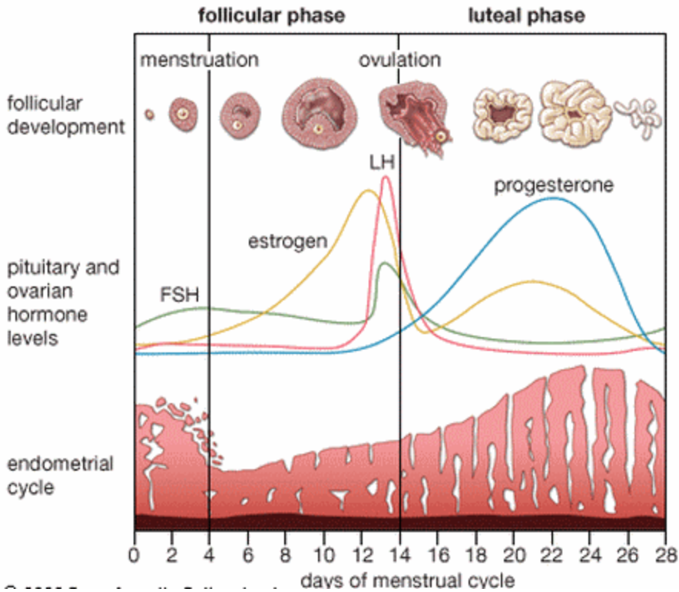

Figure 11: The menstrual cycle

After ovulation, this dominant follicle forms into a corpeus luteum (Su, Yi, Wei, Chang, & Cheng, 2017), secreting oestrogen and progesterone.
3 – The Luteal Phase
The increased levels of progesterone prevent oestrogen from stimulating the pituitary gland for another LH surge due to negative feedback, thereby reducing the levels of LH and FSH to baseline levels. This phase lasts around fourteen days. If conception has not occurred, the corpus luteum regresses and follicular development prepares for its’ next cycle. The levels of oestrogen, progesterone and Inhibin B (made in the ovarian follicles, and has a role in suppressing FSH) gradually decline, leading to degeneration of the uterine wall, which had been ‘building’ in preparation for the implantation of the zygote – the fertilised ovum (Waugh & Grant, 2018).
4 - Menstruation
The uterine wall degeneration is classified as menstruation and usually lasts for around 3 – 5 days, but is known as Days 1 – 5 of the Menstrual Cycle. The endometrium is now lost, and hormone levels plummet. The myometrium – the middle layer of the uterine wall – contracts, which can be painful, and is also accompanied by vasoconstriction to reduce the blood loss (Vogazianou, 2019). Bleeding tends to be the heaviest during the first two days, when the fluid is bright red, followed by lighter days when it may be pink or brown. On average, women lose about 30 – 70 mLs of menstrual fluid per period (NHS, 2020). About half of the menstrual fluid lost is blood, but it also includes cervical mucous, vaginal secretions and the endometrial tissue.

Dysmenorrhea
Many women and young people experience painful periods – dysmenorrhea. It is considered to be one of the most common symptoms amongst menstrual complaints (Ryan, 2017), sometimes necessitating time off school for adolescent girls. The prevalence of primary dysmenorrhea (with no abnormal associated pathology) has been cited as high as 90% amongst women aged 17 – 24 years (Ryan, 2017). Ovulatory cycles have to be present for dysmenorrhea, due to increased levels of prostaglandins, leading to increased intrauterine pressure and abnormal uterine contractions. Most adolescents will not experience dysmenorrhea on initial menarche, but only once their menstrual cycle has become established. Management focuses on excluding pathological causes and medical therapies to control the symptoms (Kho & Shields, 2019), such as NSAIDS (non steroidal anti-inflammatory drugs) or hormonal contraceptives.

Polycystic Ovary Syndrome (PCOS)
PCOS is one of the most common metabolic disorders in women of childbearing age (Shenep & Al-Zubeidi, 2017), characterised by ovarian hyperandrogenism and chronic anovulation – when ovaries do not release an oocyte during the menstrual cycle, and there is an increased risk of a higher Body Mass Index (BMI). Other factors need to be considered in adolescents, apart from the gynaecological issues: there is an increased risk of Type 2 Diabetes, cardiovascular risk, and also psychological well being (NHS, 2018b). Prescribing of the contraceptive pill can help alleviate hyperandrogenism (hirsutism and acne)(See article on Biological Basis to Child Health: Dermatology), and regulate the menstrual cycle. Combinations of Folic Acid and Myo-Inositol are also prescribed in some instances, which have a role in oocyte development , which can also help menstrual disturbance (Unfer, Carlomagno, Dante, & Facchinetti, 2012), and also Metformin, a biguanide commonly used to treat Type 2 Diabetes (Nestler, 2008).

Turner Syndrome (TS)
Turner Syndrome affects around 1 in every 2500 live female births, and is defined by a missing or abnormal X chromosome (Turner & Hozjan, 2019). Girls usually present around the age of 10 – 16 years with short stature and primary amenorrhea – where periods have not yet commenced – although diagnosis can also be made prenatally, in early childhood and later in adulthood. TS is accompanied by hypergonadotrophic hypogonadism in nearly all girls / women (raised levels of pituitary hormones LH and FSH but decreased levels of ovarian / gonadal hormones). This is due to an increased loss of oocytes from the ovaries during foetal development, and the ovaries will be non or low-functioning (Gravholt, Viuff, Brun, Stochholm, & Andersen, 2019). Pubertal development is dependant upon the particular karyotype (see Cell and Genetics article), usually necessitating oestrogen replacement to achieve optimum development of secondary sexual characteristics. All individuals with TS will have growth failure, requiring treatment with growth hormone therapy throughout childhood. Phenotypically, girls / women with TS may have a ‘webbed’ neck, micrognathia, low set ears, ptosis or strabismus, and widely spaced nipples, although each individual varies from one to the other (Shankar & Backeljauw, 2018) (See Figure 12) Other co-morbidities can include gastro-intestinal disease, middle ear infections (girls with TS can often be ‘missed’ in ENT clinics (see Senses article), cardiac anomalies (co-arctation of the aorta, hypertension) and kidney disorders (horseshoe kidney) (Gravholt et al., 2017)

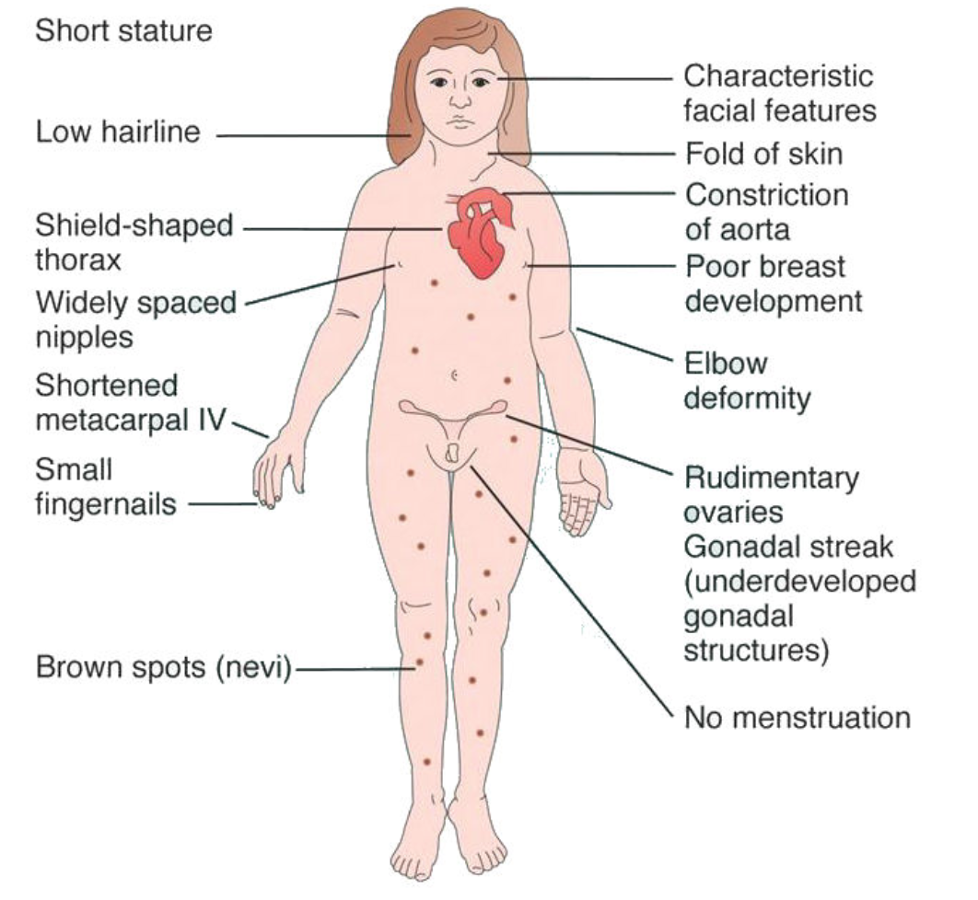

Figure 11: Turner Syndrome
The Male Reproductive System
The SRY gene, on the p arm of the Y chromosome (see Cell and Genetics article) sends signals to the ‘sex neutral’ tissue to develop into testes (Davies, 2019). These ‘undifferentiated gonads’ (see Figure 8), in the presence of this SRY gene, will segregate into testicular cords (made of Sertoli cells and germ cells) and interstitial tissue (Rey & Grinspon, 2011), and the primordial phallus will grow into the penis; urethral folds will also develop into the corpus spongiosum (erectile tissue) that surrounds the urethra, and the genital folds will subsequently fuse to form the scrotum. The male reproductive system is comprised of the testes and epididymis, vas deferens and seminal vesicles, the prostate gland and the penis (See Figure 12).

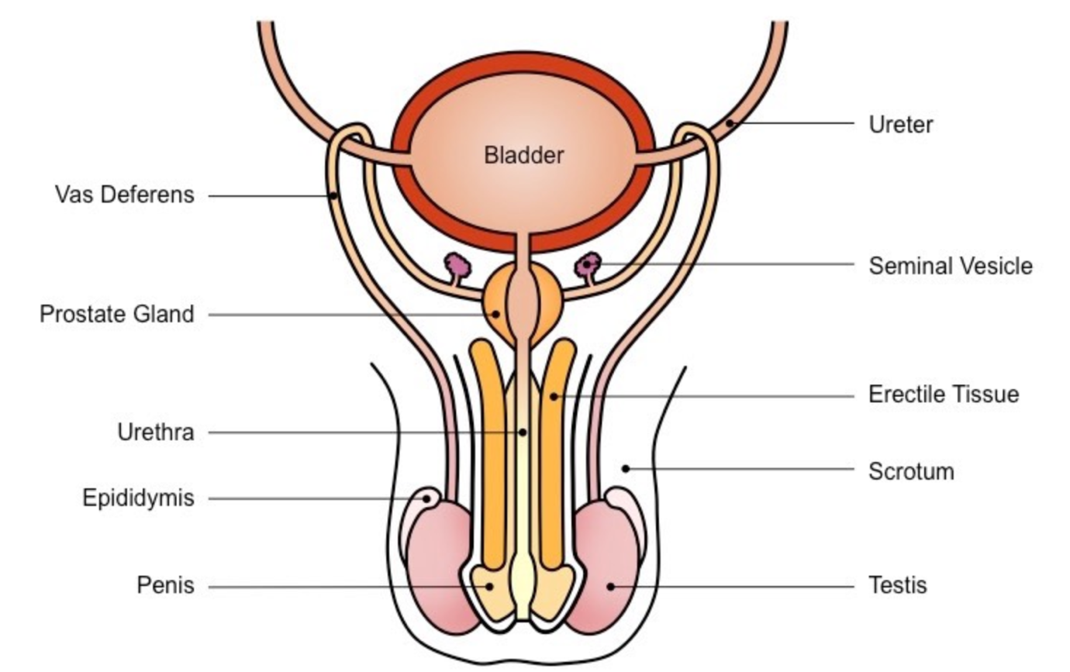

Figure 12: The male reproductive system

Testes and Epididymis
Testes begin to descend down the inguinal canal between six and ten weeks gestation, and should enter the scrotum around week 28 (Boore et al., 2016). There are two testes – they are oval in shape, and around 5cm in length and 2.5cm in diameter. They are suspended in the scrotum outside the body and maintain a temperature about 1 – 2 degrees Centigrade below the core body temperature, which is the best temperature for sperm production. There are around 300 ‘lobules’ in each testis, containing convoluted loops of seminiferous tubules, which produce sperm from germinal epithelial cells (see Figure 13). Sperm are continuously produced after puberty. Onset of spermarche, ie. The basis of achievement of reproductive capacity is an early pubertal event, sometimes with little or no pubic hair present, with testes having only slightly developed. This definitely occurs before the adolescent growth spurt, so usually around aged 12 years, or around the start of secondary school (Nielsen et al., 1986)
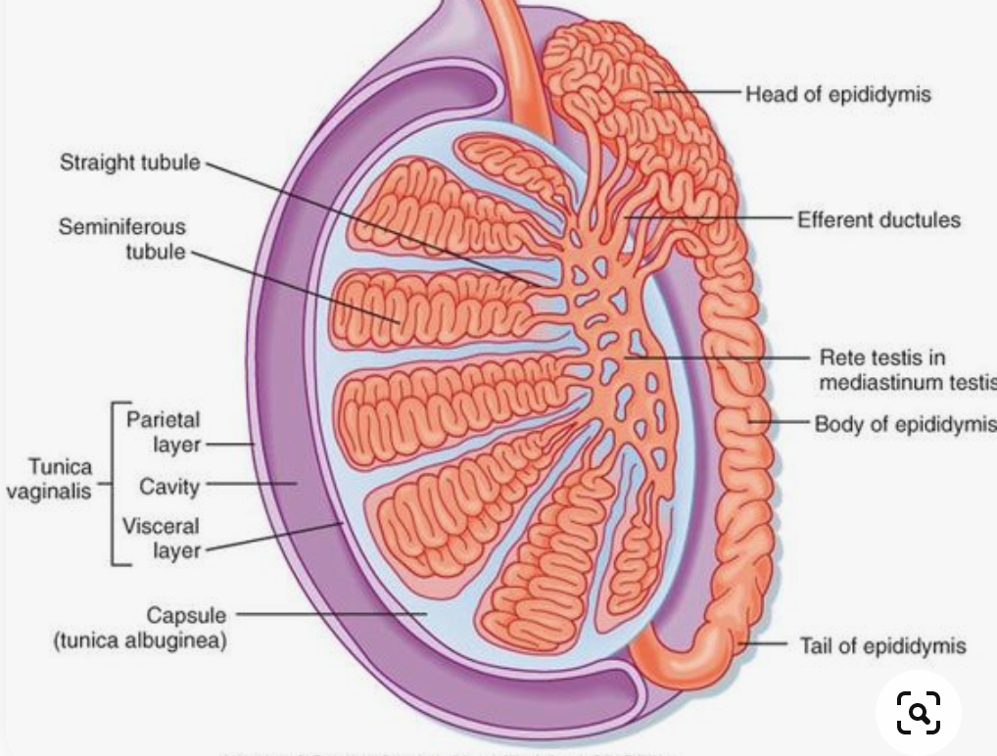

Figure 13: A testicle (picture can be similar to this)

There are approximately 200 million spermatozoa – sperm – in each ejaculation, although evidence has shown that sperm density has declined over the last fifty years, and hypospadias and cryptorchidism could be contributing factors (Carlsen, Giwercman, Keiding, & Skakkebaek, 1992). Sperm are produced by spermatogenesis in the seminiferous tubules, and mature as they pass along the epididymis where they are subsequently stored, stimulated by the release of FHS (Waugh & Grant, 2018). Primary spermatocytes undergo mitosis and meiosis (see Cell & Genetics article): primitive spermatogonia are dormant until puberty, when they are activated and are continuously maintained in mitotic rounds at the base of the seminiferous tubule (Heffner & Schust, 2014). Sertoli cells are also part of the seminiferous tubules, detected by the SRY gene (sex determining region Y), activated by FSH and secrete AMH. Also in the testes are the Leydig cells, which produce testosterone, stimulated by LH, which in turn is regulated by GnRH.

A sperm is split into three sections: the Head, Body and Tail. The head is mostly filled with the nucleus containing the DNA, and also enzymes needed to penetrate the outer layer of the prospective ovum. The body is packed with mitochondria, which can be key for fertility function (Moraes & Meyers, 2018), and then finally the tail, full of fibres to propel the sperm along the female reproductive tract.

Cryptorchidism – undescended testes
Undescended testes – cryptorchidism – is a common genital anomaly, affecting up to 8% of boys in Europe (A. Cho, Thomas, Perera, & Cherian, 2019), with about 6% of boys in the UK affected at birth. As mentioned, testes should descend into the scrotum during foetal development: if they remain in the inguinal canal, or even the abdomen, they will not function correctly. If not corrected surgically, there will be future fertility problems, the potential for testosterone deficiency, or even testicular cancer (Dwyer & Quinton, 2019). Therefore, orchidopexy – the surgical procedure to bring down a testicle into a scrotum – should be performed under the age of one year (Lee & Houk, 2013). Position of boys’ testes should be ascertained in newborn checks, and impalpable testes, or associated penile problems such as hypospadias, should necessitate urgent paediatric urology and endocrine opinions.

Hypospadias
Hypospadias presents in 1 in every 125 male live births (Hewitt & Warne, 2012), is a penile anomaly, and is defined by one or all of the following:
1 – Misplacement of the urethral meatus (ie the ‘urine hole’ – this should be at the tip of the penis, but in this situation, it could be anywhere down the shaft of the penis (see Figure 14). In some boys, the opening is at the base of the penis near the scrotum, and this is known as peno-scrotal hypospadias.
2 – The penis may be curved, known as ‘chordee’ – often brought about by the misplaced meatus, and
3 – Dorsal hooded foreskin, where the foreskin is not complete, and lies like a ‘hood’ (Thompson & Cho, 2020)

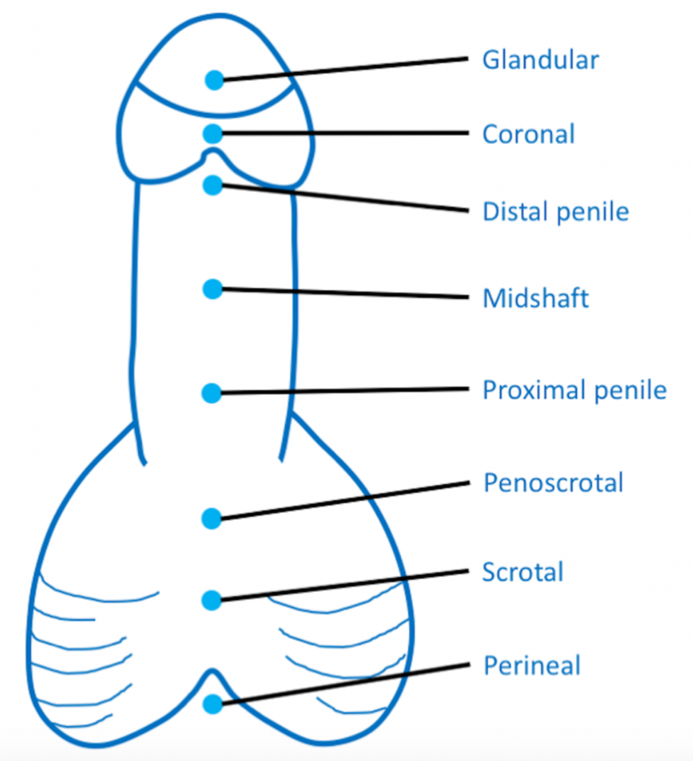

Figure 14: Hypospadias classification (Thompson & Cho, 2020)

Babies diagnosed with a hypospadias will need to undergo thorough endocrine investigations in order to rule out biochemical causes, and surgery for correction is standard, usually between 6 months and one year of age (Baskin, 2017). Most long term cosmetic and sexual outcomes are favourable (van der Horst & de Wall, 2017).

Differences of Sex Development (DSD)
DSD is an umbrella term used to describe congenital conditions in where an individuals’ gonadal (testes or ovaries), chromosomes (see Cell & Genetics article) or anatomy is atypical (Davies, 2019). Turner Syndrome, Cryptorchidism and Peno-Scrotal Hypospadias all fall under this classification, alongside other conditions, such as Congenital Adrenal Hyperplasia (CAH) in girls (see Endocrine article), resulting in ambiguous genitalia, or gonadal dysgenesis, where the gonads are replaced with fibrous tissue and are non functioning. If all genital anomalies are considered, a DSD is present in 1 in every 300 births (Rothkopf & John, 2014), although true ‘ambiguous’ genitalia is around 1 in every 5000 live births (Davies, 2019), and is more often associated with girls with CAH, and is more rare. Most children affected by these conditions must be managed in a multidisciplinary team, led by a paediatric tertiary referral centre, with a nurse specialist as an integral part of the team.

TIME OUT 5
Although some DSD are rare, some genital anomalies are more common. Discuss with a colleague how you should discuss intimate children’s conditions with parents. Visit www.dsdfamilies.org which offers advice on how to speak to families.
Infertility
Many factors can contribute to infertility – PCOS and associated anovulation can hinder the ability to conceive, as well as endometriosis or fallopian tube problems (Heffner & Schust, 2014). Gonadal failure, such as seen in Turner Syndrome, or Klinefelter Syndrome in men (Dwyer & Quinton, 2019), will result in infertility, as well as adults who have been treated with chemotherapy and / or radiotherapy from childhood cancer treatment which can have an impact on the gonads also. Boys about to undergo cancer treatment can be offered the chance to ‘bank’ sperm for future use (Gan & Spoudeas, 2013), although they will have to be reviewed by the endocrine team to undergo pubertal assessment first, in order to ascertain whether they are able to give a sperm sample.

Conclusion
This CPD article has explored aspects of childhood growth and development, in addition to the male and female reproductive systems, highlighting relevant pathophysiology in children. Optimum knowledge of growth and development is paramount, but is often overlooked in children, and children’s nurses are in a prime position to incorporate such knowledge within their nursing care, in order to provide a full picture of the child’s current health status. By exploring the Time Outs, the children’s nurse should now have a more advanced understanding on how to enhance their care when caring for any child, by focusing on aspects of their physical and cognitive development.

MCQ Questions
1 - What is not a cause of cerebral palsy?
- Genetic syndromes
- Poor feeding / neglect
- Congenital infections
- Antenatal causes

2 – What is the key influencing factor for adequate growth in the childhood stage of growth?
- Growth and thyroid hormones
- Sex hormones
- Nutrition
- Maternal health

3 – What hormone is released by the hypothalamus to stimulate the pituitary gland to release LH and FSH during puberty?
- ACTH
- GH
- CRH
- GnRH

4 – What aspect of puberty arrives first in a girl?
- Menarche
- Breast development
- Adolescent growth spurt
- Pubic hair growth

5 – What is not a cause of precocious puberty?
- Types of brain tumours
- Radiotherapy effects
- Ovarian follicle overload
- Chromosomal abnormalities

6 – Where is Anti Mullerian Hormone (AMH) made?
- Sertoli cells
- Leydig cells
- In the Graafian follicle
- Oocytes

7 – What factors are not considered in a young girl presenting with PCOS?
- Cardiovascular risks
- Gynaecological issues
- Type 2 Diabetes
- Respiratory disorders

8 – Around what week gestation would a male foetus’s testes descend into the scrotum?
- Week 6
- Week 10
- Week 20
- Week 28

9 – What aspect of a spermatozoa is key for fertility function?
- The DNA
- The Nucleus
- The Mitochondria
- The Tail

10 – What is the incidence of a difference in sex development?
- 1 in 125
- 1 in 300
- 1 in 2500
- 1 in 5000

References

Baskin, L. (2017). What is Hypospadias? Clinical Pediatrics, 1 - 10.
Boore, J., Cook, N., & Shepherd, A. (2016). Essentials of anatomy and physiology for nursing practice. London: Sage.
Brimble, M., & Reddington-Bowes, S. (2018). Universal screening and the role of the health visitor. In J. Price & O. McAlinden (Eds.), Essentials of Nursing Childen and Young People (pp. 210 - 221). London: Sage.
Carlsen, E., Giwercman, A., Keiding, N., & Skakkebaek, N. E. (1992). Evidence for decreasing quality of semen during past 50 years. British Medical Journal, 305, 609 - 613.
Cho, A., Thomas, J., Perera, R., & Cherian, A. (2019). Undescended testis. British Medical Journal, 364, 1 - 5. doi:10.1136/bmj.l926
Cho, H. Y., Kim, J. H., Kim, S. W., Shin, C. S., Park, K. S., Kim, S. W., . . . Kim, S. Y. (2014). Different cut-off values of the insulin tolerance test, the high-dose short Synacthen test (250 mug) and the low-dose short Synacthen test (1 mug) in assessing central adrenal insufficiency. Clin Endocrinol (Oxf), 81(1), 77-84. doi:10.1111/cen.12397
Collin, J., Whitehead, A., & Walker, J. (2016). Educating children and families about growth hormone
deficiency and its management: part 1. Nursing children and young people, 28(1), 32 - 36.
Crawford, D., & Dearmun, A. (2016). Down Syndrome. Nursing children and young people, October.
Davies, K. (2004). Assessment of growth failure in children: MIMS for Nurses Pocket Guide. London: Haymarket Publishing.
Davies, K. (2017). Care of the child and young person with endocrine problems. In J. Pryce & O. McAlinden (Eds.), Essentials of Nursing Children and Young People (First ed.). London: Sage.
Davies, K. (2019). Disorders of Sex Development. In S. Llahana, C. Follin, C. Yedinak, A. Grossman, K. Davies, & M. F. Keil (Eds.), Advanced Practice in Endocrinology Nursing (Vol. 1, pp. 39 - 61). Switzerland: Springer.
Donaldson, M. D. C., Gregory, J. W., Van-Vliet, G., & Wolfsdorf, J. I. (2019). Practical Endocrinology and Diabetes in Children (4th ed.). Oxford: Wiley Blackwell.
Dwyer, A. A., & Quinton, R. (2019). Classification of Hypothalamic-Pituitary-Gondal (HPG) Axis Endocrine Disorders. In S. Llahana, C. Follin, C. Yedinak, A. Grossman, K. Davies, & M. Keil (Eds.), Advanced Practice in Endocrinology Nursing (Vol. 2, pp. 853 - 870). Cham: Springer.
Gan, H. W., & Spoudeas, H. A. (2013). Preserving reproductive capacity in young boys with cancer. Trends in Urology & Men's Health, 4(3), 8-12. doi:10.1002/tre.327
Gravholt, C. H., Andersen, N. H., Conway, G. S., Dekkers, O. M., Geffner, M. E., Klein, K. O., . . . International Turner Syndrome Consensus, G. (2017). Clinical practice guidelines for the care of girls and women with Turner syndrome: proceedings from the 2016 Cincinnati International Turner Syndrome Meeting. Eur J Endocrinol, 177(3), G1-G70. doi:10.1530/EJE-17-0430
Gravholt, C. H., Viuff, M. H., Brun, S., Stochholm, K., & Andersen, N. H. (2019). Turner syndrome: mechanisms and management. Nat Rev Endocrinol, 15(10), 601-614. doi:10.1038/s41574-019-0224-4
Greenstein, B., & Wood, D. (2011). The Endocrine system at a glance (3rd ed.). Oxford: Wiley Blackwell.
Griffin, T., & Lopez, J. (2018). Care of children and young people with learning disabilities. In J. Price & O. McAlinden (Eds.), Essentials of Nursing Children and Young People (pp. 556 - 575). London: Sage.
Heffner, L. J., & Schust, D. J. (2014). The Reproductive System at a Glance. Oxford: Wiley Blackwell.
Hewitt, J. K., & Warne, G. L. (2012). 46, XY DSD. In J. M. Hutson, G. L. Warne, & S. R. Grover (Eds.), Disorders of Sex Development: An Integrated Approach to Management (pp. 63 - 80). Wurzberg: Springer.
Jung, D., & Kee, K. (2015). Insights into female germ cell biology: from in vivo development to in vitro derivations. Asian Journal of Andrology, 17, 415 - 420. doi:10.4103/1008-682X.148077
Kho, K. A., & Shields, J. K. (2019). Diagnosis and management of primary dysmenorrhea. JAMA. doi:10.1001/jama.2019.16921
Klein, D. A., Emerick, J. E., Sylvester, J. E., & Vogt, K. S. (2017). Disorders of puberty: an approach to diagnosis and management. American Family Physician, 96(9), 590 - 599.
Klein, K., Yang, J., Aisenberg, J., Wright, N., Kaplowitz, P., Lahlou, N., . . . Cassorla, F. (2016). Efficacy and safety of triptorelin 6 month formulation in patients with central precocious puberty. J Pediatr Endocrinol Metab, 29(11), 1241 - 1248. doi:10.1515/jpem-2015-0376
Latronico, A. C., Brito, V. N., & Carel, J.-C. (2016). Causes, diagnosis, and treatment of central precocious puberty. The Lancet Diabetes & Endocrinology, 4(3), 265-274. doi:10.1016/s2213-8587(15)00380-0
Lee, P. A., & Houk, C. P. (2013). Cryptorchidism. Curr Opin Endocrinol Diabetes Obes, 20(3), 210 - 216. doi:10.1097/MED.0b013e32835ffc7d
Lipman, T. H., & Lessig, M. K. (2019). The importance of auxology for growth assessment. In S. Llahana, C. Follin, C. Yedinak, A. Grossman, K. Davies, & M. Keil (Eds.), Advanced Practice in Endocrinology Nursing (Vol. 1, pp. 3 - 11). Cham: Springer.
Lissauer, T., Clayden, G., & Craft, A. (Eds.). (2012). Illustrated Textbook of Paediatrics. Edinburgh: Mosby Elsevier.
Martin, L., & Collin, J. (2015). An introduction to growth and atypical growth in childhood and adolescence. Nursing children and young people, 27(6), 29 - 37.
Mayer, C., & Joseph, K. S. (2013). Fetal growth: a review of terms, concepts and issues relevant to obstetrics. Ultrasound Obstet Gynecol, 41, 136 - 145. doi:10.1002/uog.11204
Miall, L., Rudolf, M., & Smith, D. (2012). Paediatrics at a Glance (3rd ed.). Oxford: Wiley-Blackwell.
Moore, B., Whitehead, A., & Davies, K. (2019). Short stature, growth hormone deficiency, and primary IGF-1 deficiency. In S. Llahana, C. Follin, C. Yedinak, A. Grossman, K. Davies, & M. Keil (Eds.), Advanced Practice in Endocrinology Nursing (Vol. 1, pp. 13 - 37). Cham: Springer.
Moraes, C. R., & Meyers, S. (2018). The sperm mitochondrion: organelle of many functions. Animal Reproduction Science, 194, 71 - 80. doi:10.1016/j.anireprosci.2018.03.024
Nestler, J. E. (2008). Metformin for the treatment of the Polycystic Ovary Syndrome. The New England Journal of Medicine, 358, 47 - 54.
NHS. (2018a). The National Child Measurement Programme. Retrieved from https://www.nhs.uk/Livewell/childhealth1-5/Pages/ChildMeasurement.aspx
NHS. (2018b). Polycystic ovarian syndrome. Retrieved from https://cks.nice.org.uk/polycystic-ovary-syndrome#!scenario:1
NHS. (2020, 18.2.20). Periods. Retrieved from https://www.nhs.uk/conditions/periods/
NICE. (2010). TA188 Human growth hormone (somatropin) for the treatment of growth failure in children: guidance. London: Department of Health
NICE. (2017). Faltering growth: recognition and management of faltering growth in children. NICE - National Institute of Clinical Excellence
Nielsen, C. T., Skakkebaek, N. E., Richardson, D. W., Darling, J. A. B., Hunter, W. M., Jorgensen, M., . . . Muller, J. (1986). Onset of the release of spermatozoa (spermarche) in boys in relation to age, testicular growth, pubic hair and height. Journal of Clinical Endocrinology & Metabolism, 62(3), 532 - 535.
Pyra, E., & Schwarz, W. (2019). Puberty: Normal, Delayed and Precocious. In S. Llahana, C. Follin, C. Yedinak, A. Grossman, K. Davies, & M. Keil (Eds.), Advanced Practice in Endocrinology Nursing (Vol. 1 pp. 63 - 84). Cham: Springer.
RCOG. (2018). Information for you: Alcohol and Pregnancy. Retrieved from
Rey, R. A., & Grinspon, R. P. (2011). Normal male sexual differentiation and aetiology of disorders of sex development. Best Pract Res Clin Endocrinol Metab, 25(2), 221-238. doi:10.1016/j.beem.2010.08.013
Rosen, D. S. (2004). Physiologic growth and development during adolescence. Pediatrics in Review, 25(6), 194 - 200.
Rothkopf, A. C., & John, R. M. (2014). Understanding Disorders of Sexual Development. Journal of Pediatric Nursing, 29(5), e23-e34. doi:http://dx.doi.org/10.1016/j.pedn.2014.04.002
Ryan, S. A. (2017). The treatment of dysmenorrhea. Pediatr Clin North Am, 64, 331 - 342. doi:10.1016/j.pcl.2016.11.004
Sankilampi, U., Saari, A., Laine, T., Miettinen, P. J., & Dunkel, L. (2013). Use of electronic health records for automated screening of growth disorders in primary care. JAMA, September 11, 1071 - 1072.
Savage, M. O., Backeljauw, P. F., Calzada, R., Cianfarani, S., Dunkel, L., Koledova, E., . . . Yoo, H. W. (2016). Early Detection, Referral, Investigation, and Diagnosis of Children with Growth Disorders. Horm Res Paediatr, 85(5), 325-332. doi:10.1159/000444525
Scherdel, P., Dunkel, L., van Dommelen, P., Goulet, O., Salaun, J.-F., Brauner, R., . . . Chalumeau, M. (2016). Growth monitoring as an early detection tool. Lancet Diabetes Endocrinol, 4(5), 447 - 456. doi:10.1016/S2213-8587(15)00392-7
Scholin, L., Hughes, K., Bellis, M. A., Eriksson, C., & Porcellato, L. (2019). “I think we should be singing from the same hymn sheet” - English and Swedish midwives’ views of advising pregnant women about alcohol. Drugs: Education, Prevention and Policy, 26(5), 394 - 400. doi:10.1080/09687637.2018.1478949
Scholler, I., & Nittur, S. (2012). Understanding failure to thrive. Paediatrics and Child Health, 22(10), 438 - 442. doi:10.1016/j.paed.2012.02.007
Shankar, K. S., & Backeljauw, P. (2018). Current best practice in the management of Turner Syndrome. Therapeutic advances in Endocrinology and Metabolism, 9(1), 33 - 40. doi:10.1177/2042018817746291
Sheldrick, R. C., Merchant, S., & Perrin, E. C. (2011). Identification of developmental-behavioral problems in primary care: a systematic review. Pediatrics 128(2), 357 - 363. doi:10.1542/peds.2010-3261
Shenep, L., & Al-Zubeidi, H. (2017). Characteristics and ethnic variations of adolescents with polycystic ovarian syndrome at a tertiary care centre. J Pediatr Endocrinol 2(2), 1 - 4.
Su, H.-W., Yi, Y.-C., Wei, T.-Y., Chang, T.-C., & Cheng, C.-M. (2017). Detection of ovulation, a review of currently available methods. Bioengineering & Translational Medicine, 2, 238 - 246. doi:10.1002/btm2.10058
Tanner, J. M., & Whitehouse, R. H. (1976). Clinical longitudinal standards for height, weight, height velocity, weight velocity, and stages of puberty. Archives of Disease in Childhood 51, 170 - 179.
Thompson, D., & Cho, A. (2020). Hypospadias - Classification - Management - TeachMePaedsTeachMePaediatrics. Teach Me.
Turner, H. E., & Hozjan, I. R. (2019). Diagnosis and Management of Turner Syndrome in Children and Adults. In S. Llahana, C. Follin, C. Yedinak, A. Grossman, K. Davies, & M. Keil (Eds.), Advanced Practice in Endocrinology Nursing (Vol. 2, pp. 771 - 801). Cham: Springer.
Unfer, V., Carlomagno, G., Dante, G., & Facchinetti, F. (2012). Effects of myo-inositol in women with PCOS: a systematic review of randomized controlled trials. Gynecol Endocrinol, 28(7), 509-515. doi:10.3109/09513590.2011.650660
van der Horst, H. J., & de Wall, L. L. (2017). Hypospadias, all there is to know. Eur J Pediatr, 176(4), 435-441. doi:10.1007/s00431-017-2864-5
Vogazianou, A. (2019). Anatomy and physiology of the female reproductive system. In S. Llahana, C. Follin, C. Yedinak, A. Grossman, K. Davies, & M. Keil (Eds.), Advanced Practice in Endocrinology Nursing (Vol. 2, pp. 739 - 752). Cham: Springer.
Waugh, A., & Grant, A. (2018). Ross & Wilson: Anatomy and Physiology in Health and Illness (13th ed.). Edinburgh: Elsevier.
Webster, S., & de Wreede, R. (2016). Embryology at a glance (2nd ed.). Oxford: Wiley Blackwell.
Wei, C., & Crowne, E. C. (2016). Recent advances in the understanding and management of delayed puberty. Arch Dis Child, 101(5), 481-488. doi:10.1136/archdischild-2014-307963
Wei, C., & Gregory, J. W. (2009). Physiology of normal growth. Paediatris and Child Health, 19(5), 236 - 240.
Zacharin, M., Banerjee, I., & Patel, B. (2013). Puberty: Normal and Abnormal. In M. Zacharin (Ed.), Practical Pediatric Endocrinology in a Limited Resource Setting (pp. 27 - 67). London: Academic Press.

