‘Tips and Tricks from Experienced Vapers’ leaflet for EC arm participants

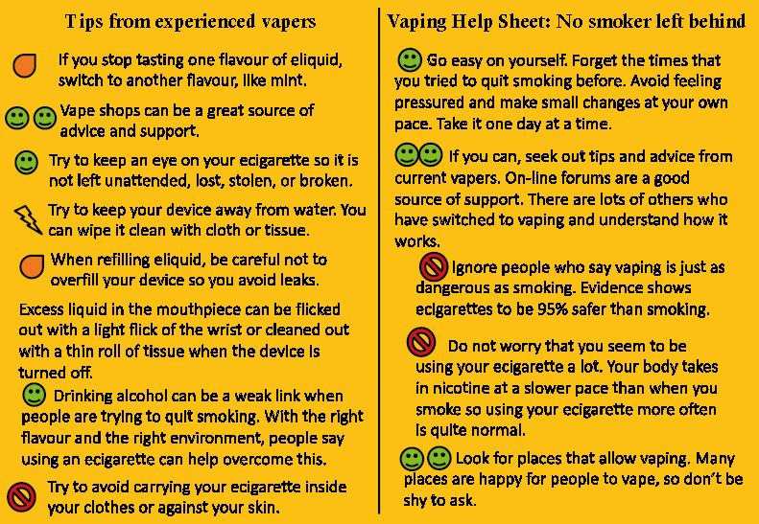

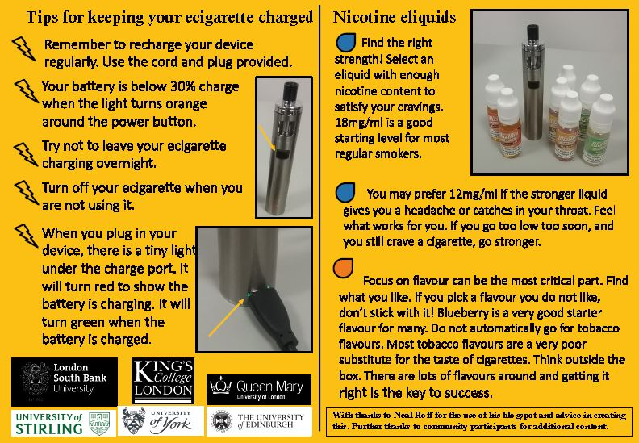

Help to quit leaflet for participants in usual care, adapted from NHS Choices
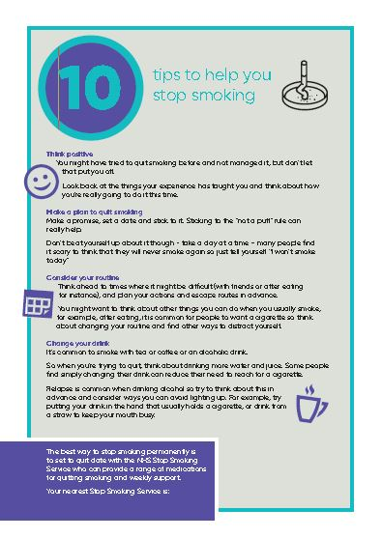
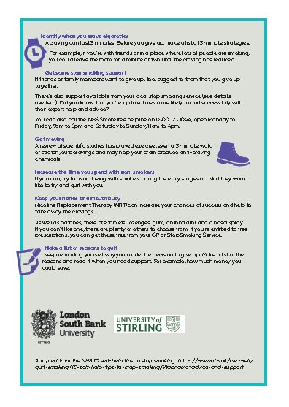

Process Evaluation participants’ interview guides
Exploring the uptake and use of electronic cigarettes provided to smokers accessing homeless centres: a feasibility study

Qualitative interview topic guide for feasibility study participants
E-cigarette arm (18/02/19)

One-to-one interviews with individuals who enrolled on the wider study and have agreed to be interviewed.

Aim to explore views on:
• Issues around the delivery of the intervention
• Perceived value of the intervention
• Barriers and facilitators to engagement with the study and EC use
• Any unintended consequences of participation and supply of the EC
• Issues relating to local context

Interviews will be adapted depending on experience, e.g. completed follow-up at 4 weeks, smoking status, successful quit or relapse etc. The topic guide is intended to ensure coverage of key topics, whilst at the same time giving respondents the freedom to express their own feelings and views as part of an open discussion.

Introduction
1. Interviewer introduction
2. Quick study summary
3. Audio recording, anonymity, opportunity to ask questions etc.
4. Encourage expression of candid thoughts and opinions
5. Consent

Background: broad smoking history and local context (also warm-up questions)
- Can you tell me a little bit about your smoking?
  - How long have you smoked / how many a day
  - Any previous quit attempts / how easy to stop (anticipated or experienced)
  - Also explore Cannabis use if relevant
- How common is smoking in those around you?
  - To what extent do you smoke with others?
- If someone from this centre wanted to stop smoking what support is there in the local area? Have you ever engaged with SSS? If yes, how did you find it?
- Wider context: how easy or hard is it to make changes to smoking given your circumstances?
  - What makes stopping smoking difficult given your circumstances?

Introduction to study participation
- When you were 1st told about the study, what were your initial thoughts and feelings?
  - How did you feel being told about the study by homeless centre staff?
  - Did you have any concerns? What were these?
  - What were your thoughts on the information you were given (e.g. information sheet) Was anything unclear? / Were your questions answered?

Deciding to take part
- Why did you agree to take part in the study?
  - Did anything put you off taking part? If yes, what? What encouraged you to take part?
  - Did you discuss taking part in the study with anyone else? (Friends / family / homeless centre staff / other professionals) What did they say?

Consent and baseline assessment
- How did you feel consenting to take part and providing personal details? e.g. DOB, ethnicity, homeless status/history, contact telephone numbers, smoking, alcohol and drug use questions, mental health questions
- How easy or difficult was it to answer the questions at the first appointment?
  - Which questions were difficult to answer? Why? (Have CRF to refer to if needed)
- How did you feel doing a CO breath-test?
- How was it having to attend the homeless centre for the appointment?
  - Probe for ease (i.e. geographical location) /cost of attendance, thoughts on duration of baseline assessment

Randomisation (Explain to pt that some sites have been allocated EC and some UC – describe)
- How did you feel when you were told you had been allocated to the e-cigarette group?
- How do you think you would have responded if you had been allocated to the usual care group? (Explain that UC means being provided with a help-quit leaflet and details of SSS and not being provided with EC kit.)

EC group - initial instructions and expectations
- What initial instructions were you given on how to use the EC? What were you told?
  - How useful were these instructions?
- What did you know about EC before you enrolled on the study?
  - Have you used EC before? If yes, how did you find it?
  - What do you believe the health effects of using an EC are? Has this changed from being on the study?
- At the beginning did you believe that the EC would help change your smoking? Has this changed over time? Did you set any goals?
  - If yes, what were these? How easy/difficult was it to keep to your goals? Why?

EC Use
- Can you describe your EC use since you were provided with the starter kit?
  - Probe for use at beginning of study until now
  - Why did you stop using EC/start smoking cigarettes during this time?
  - If dual using – when was participant dual using. How often/why do you use EC instead of smoking?
- What made it easy to use the EC / What made it difficult? Why?
- How did you find using the EC compared with smoking? With any previous use of NRT?
  - Probe for differences in satisfaction/effectiveness/cost
- Did you experience any negative effects when using the EC? If yes, can you describe these?

Thoughts on device
- What were your thoughts on the EC you were given?
- Did you have any problems with your device?
  - Probe for whether they still have the EC/was it lost/stolen/damaged/sold? If so, ask participant to describe what happened. For example: We know that for some participants, their EC was lost/stolen/got damaged.... did any of this happen to you?
- How easy or difficult did you find it to charge your EC? Why?
  - Did you have any problems with the battery / charging your EC? What issues?
- What were you thoughts on the e-liquid you were given?
  - Probe for duration (4 weeks); variety (flavour and strength); quantity; logistics

Intervention period and follow-ups
- Did you keep in weekly contact with the staff at the homeless centre about the EC?
  - How did you find the approach of staff at these follow-ups? In what way did they provide support? Did they encourage/discourage use?
  - If no weekly contact, why not?
- Were others around you when you used the EC? To what extent do you vape with others?
  - How did they respond? What did they say?
  - Did you receive further information or support from E.g. centre staff, other participants, family/friends, vaping shops etc. If yes, what?
- How did you feel about the 4-week follow-up with the researcher?
  - Probe for views on convenience; timing; duration, study team approach
  - Any issues around fixing up time for 4 week follow-up
  - We asked you some questions what products you had used and how often. How easy/difficult was it to remember what you’ve used in between appointments?
- How likely is it that you will complete the further follow-ups at 12 and 24 weeks? Why? How do you feel about the number and timing of appointments/follow-ups?

For non-completers at 4 weeks only
- What were your reasons for not taking part in the 4 week follow-up?
- What could have helped you to stay in the study?

Incentives
- How did you feel at being offered a gift voucher for attending follow-up appointments?
- How did you use your voucher? If appropriate, probe for any evidence of trading for other substances, selling, giving to someone else.
- Have you heard anything from others about how they used their voucher?

Other substance use
- Have you heard of ECs being used for other substance use? What for/how?
  - If appropriate, ask: did you add anything to EC other than e-liquid provided?
  - If knowledge, ask for perceptions of other substance use: what are the effects; benefits/drawbacks?

Overall view of experience and suggestions for improvement [if not already covered]
- How do you feel now about taking part in the study?
  - What were the benefits/drawbacks to taking part? What did you like least/most
  - Perceptions of study staff and their knowledge and understanding
- In what way could the study be improved?
- Is there anything you would like to talk about that we have not covered?
Thank participant, give Love2Shop voucher, participant to sign receipt form.

Exploring the uptake and use of electronic cigarettes provided to smokers accessing homeless centres: a feasibility study

Qualitative interview topic guide for feasibility study participants
Usual Care arm (20/04/19)

One-to-one interviews with individuals who enrolled on the wider study and have agreed to be interviewed.

Aim to explore views on:
• Issues around the delivery of the intervention
• Perceived value of the intervention
• Barriers and facilitators to engagement with the study and SSS signposting
• Any unintended consequences of participation and engagement with SSS
• Issues relating to local context

Interviews will be adapted depending on experience, e.g. completed follow-up at 4 weeks, smoking status, successful quit or relapse etc.

The topic guide is intended to ensure coverage of key topics, whilst at the same time giving respondents the freedom to express their own feelings and views as part of an open discussion.

Introduction
1. Interviewer introduction
2. Quick study summary
3. Audio recording, anonymity, opportunity to ask questions etc.
4. Encourage expression of candid thoughts and opinions
5. Consent

Background: broad smoking history and local context (also warm-up questions)
- Can you tell me a little bit about your smoking?
  - How long have you smoked / how many a day?
  - Any previous quit attempts / how easy to stop? (anticipated or experienced)
  - Also explore Cannabis use if relevant
- How common is smoking in those around you?
  - To what extent do you smoke with others?
- If someone from this centre wanted to stop smoking what support is there in the local area? Have you ever engaged with local SSS? If yes, how did you find it?
- Wider context: how easy or hard is it to make changes to smoking given your circumstances?
  - What makes stopping smoking difficult given your circumstances?

Introduction to the study
- How did you 1st hear about the study?
  - What were your initial thoughts and feelings?
  - What did you understand the study to be about?
  - Did you have any concerns? What were these?
  - What were your thoughts on the information you were given (e.g. information sheet) Was anything unclear? / Were your questions answered?

Deciding to take part
- Why did you agree to take part in the study?
  - Did anything put you off taking part? If yes, what? What encouraged you to take part?
  - Did you discuss taking part in the study with anyone else? (Friends / family / homeless centre staff) What did they say?

Consent and baseline assessment
- How did you feel consenting to take part and providing personal details? (e.g. DOB, ethnicity, homeless status/history, contact telephone numbers, smoking, alcohol and drug use questions, mental health questions)
- How easy or difficult was it to answer the questions at the first appointment?
  - Which questions were difficult to answer? Why? (Have CRF to refer to if needed)
- How did you feel doing a CO breath-test?
- How was it being at the homeless centre for the appointment?
  - Probe for ease (i.e. geographical location) /cost of attendance, thoughts on duration of baseline assessment

Randomisation (Explain to participant that some sites were allocated EC and some UC – describe)
- How did you feel being allocated to the usual care group?
- How do you think you would have responded if you had been allocated to the EC group? (Explain that EC group means being provided with an EC starter quit and 4 weeks supply of a choice of e-liquid.)

UC group only
- Can you remember the smoking advice provided by the researcher/staff member? What were you given? (Probe for help-quit leaflet and SSS signposting)
  - How useful was this information? Did you use the information provided in any way?
- After the 1st meeting (baseline) what was your intent with regards to your smoking? Why?
  - Did you want to cut down/quit? Did you set any goals? Did this change over time?
  - How easy/difficult was it to keep to your goals? Why?
  - If relevant... What were your intentions for your Cannabis use? What is the harm of smoking Cannabis compared with normal cigarettes?
- What changes (if any) did you make to your smoking during the study?
- Have you made any contact with the SSS/pharmacy during the study?
  - Probe for description/thoughts/helpfulness of any SSS support, NRT
  - If no, what were your reasons for not accessing support?
  - Is there anything that would encourage you to access SSS support?
- Have you tried any other methods to cut down/stop smoking during the study?
  - Probe for description/thoughts/perceived helpfulness of other methods

Follow-ups
- Did the centre staff keep in weekly contact with you about the study? Did they ask you about your smoking in between appointments?
  - If yes, how did you find the approach of staff at these follow-ups? In what way did they provide support? Did they encourage/discourage accessing SSS support?
  - If no weekly contact, why not?
- How did you feel about the 4-week follow-up with the researcher?
  - Probe for views on convenience; timing; duration, study team approach
  - Where there any problems around fixing up a time for 4 week follow-up?
  - We asked you some questions what products you had used and how often. How easy/difficult was it to remember what you’ve used in between appointments?
- How likely is it that you will complete the further follow-ups at 12 and 24 weeks? Why? How do you feel about the number and timing of appointments/follow-ups?

For non-completers at 4 weeks only
- What were your reasons for not taking part in the 4 week follow-up?
- What could have helped you to stay in the study?

Incentives
- How did you feel at being offered a gift voucher for attending follow-up appointments?
- How did you use your voucher? Only if appropriate, probe for any evidence of trading for other substances, selling, giving to someone else.
- Have you heard anything from others about how they used their voucher?

Other substance use
- At some of our other centres participants are being given EC to help them stop smoking... Have you heard of ECs being used for other substance use? What for/how?
  - If knowledge, ask for perceptions of other substance use: what are the effects; benefits/drawbacks?

Overall view of experience and suggestions for improvement [if not already covered]
- How do you feel now about taking part in the study?
  - What were the benefits/drawbacks to taking part? What did you like least/most
  - Perceptions of study staff and their knowledge and understanding
- In what way could the study be improved?
- Is there anything you would like to talk about that we have not covered?

Thank participant, give Love2Shop voucher, participant to sign receipt form.

Process Evaluation staff interview guides

Exploring the uptake and use of electronic cigarettes provided to smokers accessing homeless centres: a feasibility study

Qualitative interview topic guide for homeless centre staff
E-cigarette arm (18/02/19)

One-to-one interviews with members of staff working at the homeless centres supporting the study.

Aim to explore views on:
• Issues around the delivery of the EC intervention
• Perceived value and understanding of the intervention
• Barriers and facilitators to engagement with the study and EC use
• Any unintended consequences of participation and supply of the EC
• The local context

The topic guide is intended to ensure coverage of key topics, whilst at the same time giving respondents the freedom to express their own feelings and views as part of an open discussion.

Introduction
1. Interviewer introduction
2. Quick study summary
3. Audio recording, anonymity, opportunity to ask questions etc.
4. Encourage expression of candid thoughts and opinions
5. Consent

Background: role and involvement with study
- Please can you describe your role, including job title and remit?
- How did you become aware of the study?
- What has been your involvement in the study?

Smoking and cessation support for homeless clients
- What proportion of your homeless clients smoke?
- How important do you feel stopping smoking is for this group?
- Do you ever have conversations with clients about their smoking?
- If someone accessing this centre wanted to stop smoking what support is available locally?
  - What links do you currently have with SSS/local pharmacies for cessation support?
  - Have you/ would you ever signpost/refer to SSS? How would you go about this?
  - How easy or difficult it is for homeless individuals to access SSS?
  - To what extent do clients/homeless individuals try to stop smoking?
  - What makes it difficult for clients to stop smoking given their circumstances?

Initial thoughts on study
- What were your initial thoughts when you first heard about the study?
  - How did you feel when you heard you would be contributing to the delivery of the study?
  - What discussion did you have with others about the study?
  - What were your concerns?
  - How well were these concerns addressed by the research team?
- What were your previous thoughts/experiences of EC? Have your views changed since being involved in the study?

Training and support received
- What training did you receive from the study team?
  - How did you feel about the training you received/information provided?
  - Was anything unclear? Was enough information provided?
  - Was any additional support required for study processes / for EC?
  - What did you think about the provision of support?
- How responsive were the study team to any queries/concerns/arising issues?
- What other support would have been helpful?
- Have you made any links with the local SSS or vape shops from being involved in the study?
  - If yes, in what way? Has this been useful/ Why?

Recruitment
- How comfortable/easy/difficult was it to raise the issue of smoking with service users?
- How did you describe the study to potential participants?
  - To what extent did service users want to take part in the study?
- Do you think participants were provided with enough/appropriate information about the study? If no, what extra information would have been helpful?
- To what extent do you think potential participants understood the study?
  - To what extent did they have queries/concerns? What did they say?
  - In what way did they discuss taking part in the study?
- What do you feel encouraged participants to take part?
- What do you feel discouraged participants to take part?

Baseline assessment
- How easy was it to arrange consent and the baseline appointment? How did this work in practice?
- What are your thoughts on the types of personal information collected from participants at this appointment? DOB, ethnicity, homeless status/history, contact telephone numbers, smoking, alcohol and drug use questions, mental health questions
  - Did you hear any feedback from clients about the baseline questionnaire? What did you hear?
  - Did you hear any feedback from clients about providing a CO breath test? What did you hear?
Randomisation (Explain that some centres are EC group and some are UC group – describe)
- How do you feel about your centre being allocated to the EC group?
  - How do you think service users feel about this?
- Participants were informed that they were part of the EC group after they has completed the baseline questionnaire. What are your thoughts on that approach?
- How would you have felt if your centre had been allocated to the usual care arm?

EC intervention
- How did you feel providing the initial instructions for EC use? (only ask if appropriate)
  - What made this difficult/easy?
- How easy or difficult was it for clients to use the EC provided?
  - What kinds of problems did they have
  - What extra support did they request or need? How was this provided?
  - What were the issues, if any, relating to batteries and charging?
  - Did you hear about any instances of EC being lost/stolen/damaged/sold? Can you describe these further?
- What are your thoughts on the EC provided?
  - Probe for convenience; ease of use; effectiveness; design
- What are your thoughts on the e-liquid supplied?
  - Probe for perceptions of the logistics of providing e-liquid, duration (4 week supply), variety (flavour and strength), quantity.
- How easy/difficult was it for clients to use the EC given their circumstances?
- Where are clients allowed to vape? Where there any discussions around where they could vape?

Follow-ups
- How did you feel being asked to maintain regular weekly follow-ups with participants?
  - To what extent were participants followed up weekly?
  - What made it easy / difficult to keep in regular contact with participants?
  - What would help to maintain this contact?
- Participants then have a 4 week follow-up with a member of the study team.
  - What are your thoughts on this follow-up? Probe for convenience, timing, duration
- What do you see as the issues, if any, with arranging the 4 week follow-up?
- How likely do you think participants will engage with further follow-ups, for example, at 12 and 24 weeks? Why?
- Why did you think it might be difficult for participants to engage/attend follow-up appointments?
- What could help with keeping participants in the study and attending follow-up appointments?

Incentives
- How do you feel about participants receiving with gift vouchers for attending follow-ups?
  - Have you come across any evidence of how vouchers were used?
  - Has there been any evidence of trading vouchers for other substances?

Other substance use
- Have you seen any evidence of the EC being used for other purposes/substances
  - What have you come across/heard?
  - What do you think would be the benefits/drawbacks of using the EC in this way?

Overall view of study and suggestions for improvements
- How do you feel about this centre being involved in the study?
  - What has been the feedback from other staff/managers?
  - What are the benefits/drawbacks to being involved? Probe for the centre; for service users for staff
- What are your thoughts about the study team?
  - E.g. their knowledge, understanding and response?
- Which elements of the study could be improved?
- Would you recommend or discourage other homeless centres to take part? Why?
- Would you like to discuss anything else that we have not already covered?
Thank participant for taking part
Exploring the uptake and use of electronic cigarettes provided to smokers accessing homeless centres: a feasibility study

Qualitative interview topic guide for homeless centre staff
Usual Care arm (29/04/19)

One-to-one interviews with members of staff working at the homeless centres supporting the study.

Aim to explore views on:
• Issues around the delivery of usual care (control group)
• Perceived value and understanding of the intervention
• Barriers and facilitators to engagement with the study and local SSS
• Any unintended consequences of participation and SSS access
• The local context

The topic guide is intended to ensure coverage of key topics, whilst at the same time giving respondents the freedom to express their own feelings and views as part of an open discussion.

Introduction
1. Interviewer introduction
2. Quick study summary
3. Audio recording, anonymity, opportunity to ask questions etc.
4. Encourage expression of candid thoughts and opinions
5. Consent

Background: role and involvement with study
- Please can you describe your role, including job title and remit?
- How did you become aware of the study?
- What has been your involvement in the study?

Smoking and cessation support for clients
- What proportion of your clients smoke?
- How important do you feel stopping smoking is for this group?
- Do you ever have conversations with clients about their smoking?
- If someone accessing this centre wanted to stop smoking what support is available locally?
  - What links do you currently have with SSS/local pharmacies for cessation support?
  - Have you/ would you ever signpost/refer to SSS? How would you go about this?
  - How easy or difficult it is for clients/homeless individuals to access SSS?
  - To what extent do clients/homeless individuals try to stop smoking?
  - What makes it difficult for clients to try to stop smoking given their circumstances?

Initial thoughts on study
- What were your initial thoughts when you first heard about the study?
  - How did you feel when you heard you would be contributing to the delivery of the study? (e.g. helping with recruitment/following up participants)
  - What discussion did you have with others about the study?
  - What were your concerns?
  - How were these concerns addressed by the research team?

Training and support received
- What training did you receive from the study team?
  - How did you feel about the training you received/information provided?
  - Was anything unclear? Was enough information provided?
  - Was any additional support required for study processes?
  - What did you think about the provision of support?
- How responsive were the study team to any queries/concerns/arising issues?
- What other support would have been helpful?
- Have you made any links with the local SSS from being involved in the study?
  - If yes, in what way? Has this been useful/ Why?

Recruitment
- How comfortable/easy/difficult was it to raise the issue of smoking with clients?
- How did you describe the study to potential participants?
  - To what extent did service users want to take part in the study?
- Do you think participants were provided with enough/appropriate information about the study? If no, what extra information would have been helpful?
- To what extent do you think potential participants understood the study?
  - To what extent did they have queries/concerns? What did they say?
  - In what way did they discuss taking part in the study?
- What do you feel encouraged participants to take part?
- What do you feel discouraged participants to take part?
--

--
Baseline assessment
- How easy was it to arrange the baseline appointment? How did this work in practice?
- What are your thoughts on the types of personal information collected from participants at this appointment? DOB, ethnicity, homeless status/history, contact telephone numbers, smoking, alcohol and drug use questions, mental health questions
  - Did you hear any feedback from clients about the baseline questionnaire? What did you hear?
  - Did you hear any feedback from clients about providing a CO breath test? What did you hear?
Randomisation (Explain that some centres are EC group and some are UC group – describe)
- How do you feel about your centre being allocated to the Usual Care group?
  - How do you think clients felt about this?
- How would you have felt if your centre had been allocated to the usual care arm?
  - How would clients have responded?

UC group only
- One of the study processes was for staff to provide participants with the help-quit leaflet and signpost them to the local SSS....
  - How did that work in practice? What made this difficult/easy?
- To what extent do you think clients used the information provided?
  - How helpful (or unhelpful) was this information?
- To what extent do you think clients made contact with the local SSS? What are the reasons for this?
- What (if any) issues/difficulties did you hear regarding SSS support?
- How easy/difficult was it for clients to access local SSS support given their circumstances?

Follow-ups
- How did you feel being asked to maintain regular weekly follow-ups with participants?
  - To what extent were participants followed up weekly?
  - What made it easy / difficult to keep in regular contact with participants?
  - What would help to maintain this contact?
- Participants then have a 4 week follow-up with a member of the study team.
  - What are your thoughts on this follow-up? Probe for convenience, timing, duration
- What do you see as the issues, if any, with arranging the 4 week follow-up?
- How likely do you think participants will engage with further follow-ups, for example, at 12 and 24 weeks? Why?
- Why did you think it might be difficult for participants to engage/attend follow-up appointments?
- What could help with keeping participants in the study and attending follow-up appointments?

Incentives
- How do you feel about participants receiving with gift vouchers for attending follow-ups?
  - Have you come across any evidence of how vouchers were used?
  - Has there been any evidence of trading vouchers for other substances?

Other substance use
- In other centres we are providing EC starter kits... Have you heard of EC being used for other purposes/substances?
  - What have you come across/heard?
  - What do you think would be the benefits/drawbacks of using the EC in this way?

Overall view of study and suggestions for improvements
- How do you feel about this centre being involved in the study?
  - What has been the feedback from other staff/managers?
  - What are the benefits/drawbacks to being involved? Probe for the centre; for service users for staff
- What are your thoughts about the study team?
  - E.g. their knowledge, understanding and response?
- Which elements of the study could be improved?
- Would you recommend or discourage other homeless centres to take part? Why?
- Would you like to discuss anything else that we have not already covered?

Thank participant for taking part

Baseline Questionnaire available here:
Baseline Questionnaire

Keyworker CRF available here:
Keyworker CRF

Follow up questionnaire for UC arm available here:
Follow-up questionnaire for UC arm

Follow up questionnaire for the EC arm available here:
Follow-up questionnaire for the EC arm

