

**Determination of Urban Cycling-Induced Hand-Arm Vibration and Mitigation**

**Cane, John[1]**

**London South Bank University**

**103 Borough Road, London , SE1 0AA**

**Gomez-Agustina, Luis[2]**

**London South Bank University**

**103 Borough Road, London SE1 0AA**

**ABSTRACT**

**Concerns exist in the cycling community and in relevant literature that cycling-induced, hand-arm vibration in urban environments could amount to unsafe or unduly uncomfortable levels. Published studies focus on controlled, unrepresentative samples or unusually rough surfaces. This research aims to provide vibration exposure information specific to and representative of urban bicycle commuters.**

**A programme of triaxial vibration levels and vibration exposure measurements was undertaken on a representative rigid bicycle for different conditions at the handlebar. A varied and representative sample of London (UK) roads used for commuting was employed. The effect of front shock absorbers was studied. Results were assessed against safe and comfortable levels of vibration found in relevant guidance and in occupational regulations.**

**It was found that cycling on typical urban roads and cycle routes does not expose riders to unsafe levels of hand-arm vibration. However values reached levels of discomfort potentially leading to early fatigue and discomfort. The different effectiveness of traditional suspension and novel suspension in the stem was determined and their virtues compared.**

**Keywords:** Hand Arm Vibration, Cycling Comfort, Vibration Exposure, Bicycle Suspension

**I-INCE Classification of Subject Number:** 47

# INTRODUCTION

Governments around the world are increasing emphasis on halting climate change and decreasing congestion in cities, leading many including the UK government to encourage cycling through improvements to infrastructure and public campaigns. The popularity of cycling has increased in the UK [1], making the comfort and safety of cyclists ever more important, both for the increased current number and for the encouragement of potential further cyclists. No UK-wide initiative exists to improve cycling comfort.

Conventional wisdom within the cycling community has been focused on making bicycles stiffer for improved cycling efficiency. However, with a greater emphasis on cycling as a means of commuting and working, there are many current and potential cyclists who are travelling distances of just a few miles, and for whom efficiency gains over short distances may be less important than comfort and safety.

Surfaces on which cyclists ride are usually permanent, so it is ideal for the cyclist to mitigate vibration through adjustments to their bicycle. Bicycle manufacturers promote suspension (or shock absorbers) to provide a more comfortable experience and enhanced control, especially in off-road riding. More recently, some companies have developed novel solutions to reduce vibration specific to urban or light off-road riding. However the usefulness and effectiveness of suspension in urban environments is not sufficiently researched in literature.

Anecdotal reports within the cycling community and the author’s experience of pain in the hands and shoulders during cycling and related research suggests that cyclists may be exposed to unsafe levels of whole-body vibration (WBV) in normal urban cycling [2].

Research was conducted to determine whether hand-arm vibration (HAV) induced by urban cycling might be unsafe, and whether the cyclist can make any modifications to their bike to improve their safety and comfort.

The main aim of this project was to determine the levels of hand-arm vibration exposure of the typical urban cyclist activity and assess these levels on the basis of health, safety and comfort and examine how effective suspension systems are at reducing vibration.   
The objectives of this project were to:

* Review the literature to find accepted safe and comfortable levels of hand-arm vibration from sporting bodies, government health and safety agencies or academic research
* Review the literature to Find other studies on hand-arm vibration levels of typical urban cycle routes and roads
* Measure levels of vibration exposure from a set of riding scenarios
* Determine the level of vibration and shock mitigation provided by different suspension styles.
* Assess the level of vibration exposure, safety and comfort from measurements

# Theoretical Background

This section explains some important terms and the basic functioning of bicycle suspension. Figure 2.1 illustrates a typical mountain bike, with all terms which are used in this document to describe parts of the bicycle.

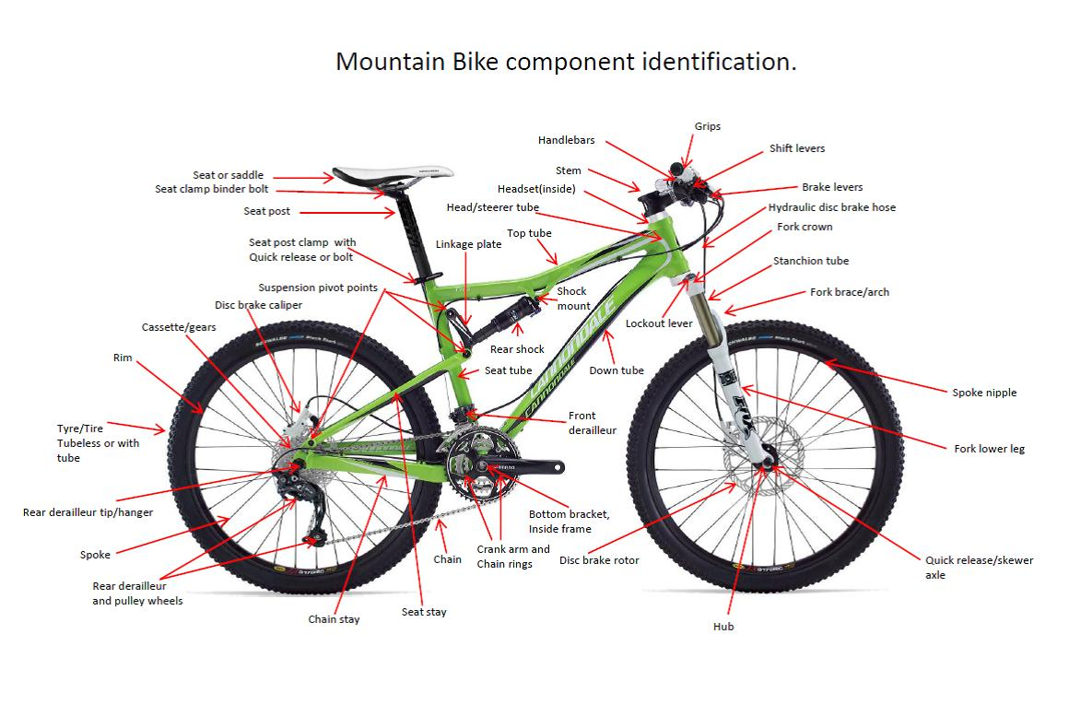

Figure 2.1 - Descriptors of Mountain Bicycle Parts [3]

Figure 2.2 shows the components of a conventional suspension fork including springs which compress, absorbing force as the wheel is pushed up by the surface. The suspension stem uses small pieces of lightweight elastomer (polymer with elastic properties) as damping material, greatly reducing weight. A view of is shown in Figure 2.3 from in front of the bicycle without handlebar and stem faceplate present. When the front wheel goes over a bump the stem is pushed down in relation to the bicycle, turning at the pivot, labelled part 3. Part 4 shows the elastomers which are compressed instead of the springs in a conventional suspension fork. Other novel mitigation measures exist including a steerer tube with spring suspension and a fork with external leaf springs.

|  |  |
| --- | --- |
| Cycle Diagrams-min  4  3 | |
| Figure 2.2 - Cutaway of Suspension Forks [4] | Figure 2.3 - Inside the Suspension Stem - adapted from [5] |

# Literature Review

A literature review was conducted in support of the experiment; findings are summarised here.

Respondents to an online questionnaire rated vibration highly in perception of comfort [6]. Sustrans recommends that surface damage be repaired [7], reducing vibration. Although cycling improves health in the cyclist and the general public (reduced pollution), there may be negative health effects. A study on WBV disproved that cycling increases the risk of reproductive issues in men but suggested a possible link with prostate cancer [8]. Short-term vibration through the hands may reduce grip strength and circulation [9]. It was found that many cyclists self-reported physical discomfort or pain during and after cycling [10].

Vibration is not transferred uniformly across the bicycle [11], so HAV and WBV should be considered separately depending on the point of contact, and changes to the saddle and frame may not improve comfort if vibrations through the hand are unmitigated.

Little research was found into vibrational comfort and safety in sport and leisure, and there are no guidelines governing safe or comfortable levels of vibration during cycling. Instead, safe levels from UK (and EU) government guidelines were investigated. Control of Vibration at Work Regulations 2005 (CoVWR) governs safe levels of HAV exposure at work in the UK. This standard uses ms-2 and the A(8) rating to assess safe levels but is focused on grave vibration-induced injuries such as tissue death. These parameters are widely accepted in vibration research and allow comparison with myriad data. ms-2 describes acceleration, while A(8) gives a rating normalised to an 8-hour working day and is weighted to focus on those frequencies most likely to cause injury. Ahv is an intermediate parameter which combines ms-2 into three dimensions.

CoVWR sets daily limits for exposure. An exposure action value (EAV) is set, which warns of a risk to the employee, and an exposure limit value (ELV), which must not be exceeded by the employee and indicates a high risk. EAV is set by CoVWR at 2.5ms-2A(8) and ELV set at 5ms-2A(8) [12]. VDV was also considered for its superior inclusion of shock information but is intended for WBV rather than HAV. It is not used in any reviewed literature for HAV making it unusable for comparative purposes. CoVWR uses the below equations to define the terms ahv and A(8). A(8) includes time consideration, but ahv does not.

In Equation 3.1, ahwx, ahwy and ahwz are the root-mean-square acceleration magnitudes in ms-2, in three orthogonal directions, x, y and z, at the vibrating surface in contact with the hand. They are frequency-weighted using the weighting Wh, defined by BS EN ISO 5349-1:2001 [15]. In Equation 3.2 *T* is the duration of exposure to vibration in seconds, of vibration magnitude *ahv* in ms-2 and *T0* is the reference duration of 8 hours, in seconds.

$$a_{hv}=\sqrt{a_{hwx}^{2}+a_{hwy}^{2}+a_{hwz}^{2}}$$

Equation 3.1 – Triaxial RMS Vibration Magnitude calculation as indicated in [19]

$$A(8)=a_{hv}\sqrt{\frac{T}{T_{0}}}$$

Equation 3.2 - Daily or Partial Exposure to HAV from One Source, A(8) [19]

ELV was found to be exceeded within 9 minutes at a cycling speed of 25km/h on some surfaces in urban routes. The action level was exceeded on most surfaces tested [13]. Smoother surfaces resulted in longer times to reach EAV, and ELV was not met in 60-minute period [14]. Common commuting times were evaluated, indicating unsafe levels during urban cycling.

# Methodology

An experiment was devised to test the level of vibration exposure while cycling over urban surfaces, and to assess the effect on vibration transmissibility of adjustments made to the bicycle. The method was designed to comply with CoVWR [19] to ensure compatibility with guidelines and other research. The method follows ISO 5349-1:2001 [15] and ISO 5349-2:2001 [16] for measurement, accelerometer mounting and calculation.

The testbed for the experiments was a Raleigh Strada 6 hybrid with no suspension, referred to as Bicycle 1. This bicycle is representative of a commuter bicycle in London. The testbed original stem was replaced with a suspension-equipped stem to form Bicycle 2. Bicycle 3 represents a similar set-up to Bicycle 1 with a similar frame and the addition of a front suspension fork. Bicycle 3 was of a similar specification to Bicycle 1. All specifications are listed in Table 4.1.

|  |  |  |  |  |  |  |
| --- | --- | --- | --- | --- | --- | --- |
| Subject | Name | Manufacture Date | Frame Size (inches) | Tyre Size | Fork Type/ Stem Type | Weight (kg) |
| Bicycle 1 | Raleigh Strada 6 | 2015 | 18 | 700x53c | Rigid (~0.8kg) / Rigid | 11.90 |
| Bicycle 2 | RedShift ShockStop (stem) | 2018 | 18 | N/A | Rigid (~0.8kg) / Elastomer | 0.29 |
| Bicycle 3 | Trek 8.3 DS | 2016 | 18 | 700x38c | Suntour NEX Suspension Fork, 63 mm Travel (~2.4kg) / Rigid | 13.2 |

Table 4.1 - Test Bicycle Specifications

Measurements in this study were made of acceleration in ms-2 because of its ready use for calculation of ratings levels and ubiquity in research and government standards. It was converted to the ahv parameter to compare vibration exposures of the cyclist. ahv is a combination of vibration level in three dimensions so it allows comparison of vibration in three dimensions using single values.

A(8) is used because of its time dimension, allowing HAV in cycling to be assessed for different use cases by changing the length of exposure to vibration. ahv and A(8) are both used in the government standards discussed here so they are compatible parameters and allow comparison with safe levels of vibration. These terms are defined and explained in the previous section.

A Rion PV-97C triaxial accelerometer weighing less than 5% of the handlebar and gear assembly, was used; data captured by Rion VM-54 data logger and Rion VP-80 pre-amplifier. The accelerometer was attached to the handlebar grip using a hose clamp as shown in Figure 4.1, fully compressing the resilient handle grip materiel. The axes were switched in processing to match Figure 4.2.

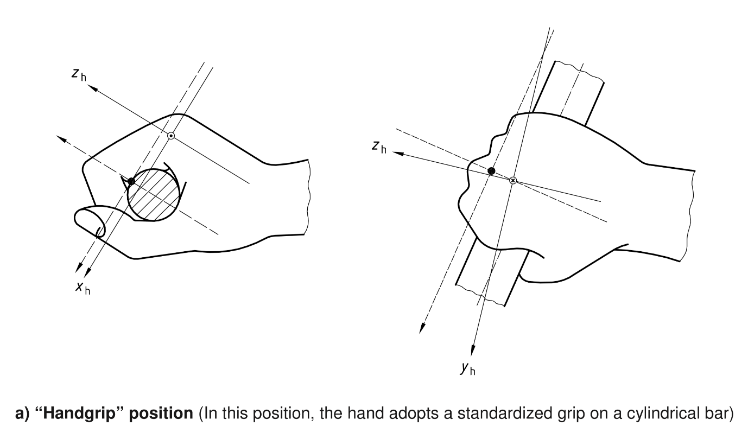

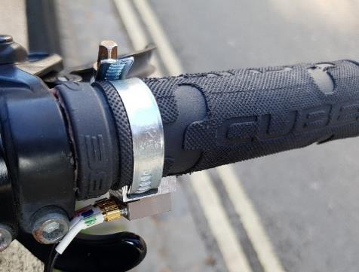

Accelerometer

**Y**

**Z**

**X**

|  |  |
| --- | --- |
| Figure 4.1 - Triaxial Accelerometer on Handlebar | Figure 4.2 - Coordinate Systems for the Hand [15] |

Vibration received at the handle bar from cycling was measured on as wide a variety of London routes as possible. Flat routes allowed a consistent speed. Few surfaces were found in London which were without deviations across the distance needed to cycle for enough time to gather a vibration measurement. It is inaccurate to grade the routes by one metric such as the size of the pieces of aggregate which are bound together, because of multiple differences which change without obvious correlation. For example, in a sample of three roads, one may be rougher than the others, but have fewer potholes. The surfaces tested were described with the categories:

* Type – the construction of the surface – categories described in Table 4.2
* Size of pieces – the prominence of the pieces of material above the binding or base material, measured by the average vertical distance from the binding surface to the top of the pieces, on a sample of 10 random pieces – only used for bound aggregate, asphalt with aggregate
* Cracks per metre – in this case cracks refers to any crack, pothole or sudden drop in the surface cause by damage – measured as one metre divided by the average number of cracks per metre
* Depth of cracks – measured as the average vertical distance from the binding surface to the bottom of the cracks, in a sample of 10 random cracks

|  |  |  |
| --- | --- | --- |
| Type | Description | Picture |
| Bound aggregate | Small pieces of material bound together, with the binding material not forming part of the top surface. |  |
| Asphalt with aggregate | Small pieces of material embedded in asphalt, where the wheel contacts both parts of the surface construction. |  |
| Brick | Bricks tessellated with small gaps between them. |  |
| Paving slabs | Large slabs (approximately 0.8m2) laid to form a pavement. |  |
| Cobblestones | Rough stones (approximately 0.15m2 each) set in a concrete base. |  |

Table 4.2 - Types of Surfaces used in this study



Table 4.3 - Test Route Details

## Procedure

The test subject (male, 1.76m, 71kg) on Bicycle 1 to the start of each of the 23 routes tested . The measurement started when the speed (22km/h) was reached. The subject continued to cycle at the target speed, monitoring the speed displayed on the smartphone mounted on the handlebar. This was repeated for each route. Tyre pressure was set to 70 psi. This is at the lower range of pressures trialled by Richard et al. [17], who found that vibration was significantly influenced by tyre pressure. The measurements for the last four routes were repeated with Bicycle 2 and 3 for comparison of the effect of components. A Samsung Galaxy S7 phone running SpeedView software was used to keep the speed constant during measurement. Speed was kept as close to 22km/h as possible, which is the average speed of commuters in the UK using Strava, an activity tracking application [18].

The vibration level was measured for each route three times, each for 20 seconds and the arithmetic average taken to find the vibration level over one minute (ahv,1min ). The ahv,1min in m/s-2 was then calculated using Equation 3.1. The A(8) was calculated for each case using Equation 3.2. This was compared to the size of pieces, number of cracks per metre and depth of cracks for each surface.

# Results

Figure 3.1, Figure 3.2, Figure 3.3 and Figure 3.4 show results of vibration exposure measurements as a function of surface roughness on Bicycle 1.

Figure 5.1 shows a strong correlation (factor 0.937) between vibration exposure (ahv) and the depth of cracks. Figure 5.2 shows a weaker correlation (factor 0.704) between the number of cracks in the surface and the vibration level. Each point represents a measurement on each route (see Table 4.3). Trendlines were drawn on the graphs to illustrate the correlation, and the trend line best fit formula is shown next to each trend line.

 

|  |  |
| --- | --- |
| Figure 5.1 – Values of ahv and Depth of Cracks in Surface | Figure 5.2 - Values of ahv vs Number of Cracks per Metre |

No correlation was found between vibration exposure (ahv) and the size of aggregate pieces (Figure 5.3).



Figure 5.3 - Values of ahv vs Size of Pieces

The vibration exposure, A(8) for each route on Bicycle 1 was calculated using Equation 3.2. Typical commuting time varies significantly. The results for A(8) are shown for exposures of different periods in Figure 5.4 using Bicycle 1.

 

|  |  |
| --- | --- |
| Figure 5.4 - Values of Ai(8) vs Route Number | Figure 5.5 - Values of ahv for Different Bicycle Components |

Vibration exposure in terms of ahv is shown for the four routes where suspension type is compared over a duration of one minute using Bicycle 1, 2 and 3. It can be seen in Figure 5.5 that the suspension stem incorporated in Bicycle 2 contributed to a reduction in measured vibration level over Bicycle 1 and the suspension fork in Bicycle 3 contributed the greatest reduction in measured vibration level. In one exception, higher vibration levels were recorded on route 23 on Bicycle 2.

Percentage vibration exposure reductions by the two suspension methods trialled in ahv levels are calculated as a percentage reduction compared to the ahv on the same route using Bicycle 1. Route 23 is not included in the table or average due to the outlier of Bicycle 2.

|  |  |  |
| --- | --- | --- |
| Route number | Percentage Reductions in ahv Value | |
| Bicycle 2 - Suspension Stem | Bicycle 3 - Front Suspension Fork |
| 20 | 5% | 15% |
| 21 | 11% | 18% |
| 22 | 9% | 10% |
| Mean Average | 9% | 14% |

Table 5.1 - Percentage Reduction in ahv Levels by Suspension Type

# Analysis and Discussion

The smaller importance of the size of pieces in surfaces tested shown in Figure 5.3 is probably due to the greater importance of the other two factors examined, shown in Figure 5.1 and Figure 5.2 (number of cracks per metre, depth of cracks). This dominance of correlation suggests that the cracks had more effect on the vibration received by the cyclist than the construction type of the surface, and the roughness of the route.

According to CoVWR [19], as EAV is set at 2.5ms-2, and ELV is set at 5ms-2, vibration exposure while riding on London roads on a typical representative commuter bicycle does not exceed levels which would likely put an operator (cyclist) at risk of permanent and serious injury.

As the results seen in Figure 5.4 represent a cross-section of some of the roads in London, it can be expected that most cyclists do not choose the roughest routes, and the exposure of a normal urban commuter would be closer to the median or lower levels measured in this study. The average distance travelled by bicycle per trip in 2017 in the UK was 3.4 miles and took 23 minutes [20]. If the cyclist makes two trips per day, to and from work for a total of 46 minutes, the expected level of exposure for the average cyclist may be between the A0.5(8) and A1(8) values on routes similar to those shown in Figure 5.4. In any type of reasonably expected route, this puts the commuting cyclist at a very low risk of injury caused by vibration. Working cyclists, exposed to vibration for up to 4 hours per day, also fall under the EAV.

The literature shows self-reported discomfort and minor injury during and after cycling [10][21] for a large proportion of the cycling community. A large part of these complaints occur in the arm and hand, so it is suspected that there may be sufficient levels of HAV to cause harm during cycling even below EAV and ELV vibration exposure levels.

As HAV has been found to be at levels deemed safe by occupational health guidance [19] during normal cycling in urban areas, it is likely that the injuries and complaints reported by cyclists are caused by shocks rather than continuous vibration. CoVWR does not provide a method of assessing the safety of shocks independent of vibration in the hand and arm, instead leaving it up to the employer to perform a risk assessment with consideration of shocks [19].

The suspension stem used is a method offering about 15mm of travel, incapable of absorbing the majority of a large impact. Route 23 featured a large dips and cracks with sharp edges. The higher vibration levels recorded on route 23 on Bicycle 2, (Figure 5.5) are probably due to hitting these at a different angle or riding position as the same test on Bicycle 1 and Bicycle 3. This is thought to be erroneous as damping should not increase transmission of vibration.

The suspension stem and suspension fork methods provided weaker reductions in vibration than expected, showing between a 5-18% reduction in the measured RMS ahv level, with an average of 9% and 14% reduction respectively. An RMS calculation does not represent peaks and transient readings adequately, instead presenting a smoothed out average of the full event. Hence the low values obtained despite the frequent shocks present in the tests.

Although the level of vibration reduction (not considering duration of exposure) is not as high as expected, it may still be desirable for some cyclists to use a suspension stem or fork to reduce discomfort and fatigue due to exposure over long rides. Lower long-term exposure to vibration and shocks from a stem suspension system may be beneficial enough despite the loss in cycling efficiency associated with a suspension system. Considering the much lower weight of the suspension stem system tested compared to the suspension fork and its similarity in performance shown in this study, it appears that the stem suspension is an more balanced system to reduce vibration, improve comfort while keeping riding efficiency.

The reliability of findings is limited by the small number of bicycles, forks and alternative suspension options available. The vibration measurement equipment available is suitable for occupational health use, outputting single-value ratings of vibration. This meant that frequency analysis and time-domain analysis was not available for a more detail analysis of results.

# Conclusions

The literature review of this project found that there are no accepted guidelines or criteria for safe levels of hand-arm vibration applicable to cycling. A lack of agreement on guidelines or criteria for comfort was also found.

Using guidelines applicable to vibration control at work as an indication of safe levels of hand-arm vibration during cycling, it was found that cycling on urban roads and cycle routes typical of London does not expose riders to unsafe levels of hand-arm vibration as defined by occupational guidance. People who cycle for a majority of the working day as their job are also not exposed to levels of hand-arm vibration which exceed government guidelines for safe vibration levels at work.

It has been shown that cyclists would experience reduced discomfort from vibration exposure with the use of front suspension. Traditional suspension using springs in a mountain bicycle-style front fork were found to give the best reduction in vibration and shock levels. The novel suspension stem style of suspension provided slightly lesser mitigation of vibration and shock, approaching the mitigation provided by traditional front suspension forks. The use of this type of suspension would improve comfort for urban cyclists, with a smaller impact on other factors of enjoyment of cycling, including aesthetic and weight.

# Further Work

* As air-oil front suspension system can significantly outperform spring-based suspension systems [22], these should be included in further tests on other suspension systems.
* Considerations for the effect of vibration on comfort at different frequencies, beyond the use of weightings related to the A(8) rating. Accommodate the fact that lower frequencies in the range of <400Hz may be more important in discerning vibrational discomfort.
* Safety criteria considering less serious but harmful effects from cycling vibration for various durations could be devised, acknowledging that vibrational safety guidelines are currently solely occupational.

# References

1. Department for Transport (2017). Table TRA0401. [online] Available at: https://www.gov.uk/government/statistical-data-sets/tra04-pedal-cycle-traffic [Accessed 10 Jan. 2018]
2. Sainte Cluque, E. (2013). Whole-body Vibration Induced by Cycling. MSc. London South Bank University.
3. MBCC Mountain Bike Club Cork. (n.d.). Beginners. [online] Available at: http://www.mbcc.ie/p/beginners.html [Accessed 20 May 2018].
4. Daniels, A. and Daniels, B. (n.d.). Cutaway Diagram of Suspension Forks. [image] Available at: https://www.pinterest.co.uk/pin/549298485775519948 [Accessed 12 Jan. 2018].
5. Huang, J. (2018). Redshift Sports ShockStop Stem Review: It's Good to be Wrong Sometimes. [online] CyclingTips. Available at: https://cyclingtips.com/2018/08/redshift-sports-shockstop-stem-review/ [Accessed 27 Jan. 2019].
6. Ayachi, F., Dorey, J. and Guastavino, C. (2015). Identifying Factors of Bicycle Comfort: An Online Survey with Enthusiast Cyclists. Applied Ergonomics, 46, pp.124-136.
7. Russell, T. (2014). Handbook for Cycle-Friendly Design. Bristol, UK, Sustrans, p.34.
8. Hollingworth, M., Harper, A. and Hamer, M. (2015). An Observational Study of Erectile Dysfunction, Infertility, and Prostate Cancer in Regular Cyclists: Cycling for Health UK Study. International Journal of Surgery, 23, p.S120
9. Bernstein, S., DʼAngelo, D., Vasko, J., Foehl, H. and Eisenhardt, J. (1995). The Effects of Short Term Vibration on Grip Strength, Sensation, and Circulation. Cardiopulmonary Physical Therapy Journal, 6(1), p.28
10. Parkin, J. and Eugenie Sainte, C. (2014). The Impact of Vibration on Comfort and Bodily Stress while Cycling. 46th Annual Universities Transport Research Group Conference. 6th-8th January 2014. Newcastle University
11. Lépine, J., Champoux, Y. and Drouet, J. (2014). The Relative Contribution of Road Bicycle Components on Vibration Induced to the Cyclist. Sports Engineering, 18(2), pp.79-91
12. The Secretary of State (2005). The Control of Vibration at Work Regulations 2005. p.3
13. Chiementin, X., Rigaut, M., Crequy, S., Bolaers, F. and Bertucci, W. (2012). Hand–Arm Vibration in Cycling. Journal of Vibration and Control, 19(16), pp.2551-2560
14. Taylor, M., Edinburgh Napier University Transport Research Institute, Edgar, A., Raine, M. and Edinburgh Napier University Engineering Research Group (2017). Cyclist Exposure to Hand-Arm Vibration and Pavement Surface Improvement in the City of Edinburgh. In: Scottish Transport Applications and Research Conference, At University of StrathclydeBritish Standards (2001a). BS EN ISO 5349-1:2001: Mechanical vibration. Measurement and Evaluation of Human Exposure to Hand-Transmitted Vibration. General Requirements. pp 3, 4, 5, 9, 13
15. British Standards (2001b). BS EN ISO 5349-2:2001: Mechanical Vibration. Measurement and Evaluation of Human Exposure to Hand-Transmitted Vibration. Practical Guidance for Measurement at the Workplace. pp. 8, 9, 11, 12, 13, 17, 37, 38.
16. Richard, S., Champoux, Y., Lépine, J. and Drouet, J. (2015). Using an Alternative Forced-choice Method to Study Shock Perception at Cyclists’ Hands: The Effect of Tyre Pressure. Procedia Engineering, 112, pp.361-366
17. Strava (2017). Insights 2016 United Kingdom. [online] Available at: http://road.cc/sites/default/files/strava-2016-end-year-insights.pdf [Accessed 16 July 2018]. p71
18. The Secretary of State (2005). The Control of Vibration at Work Regulations 2005. p.8
19. Department for Transport (2018f). Table NTS0303. [online] Available at: https://www.gov.uk/government/statistics/national-travel-survey-2017 [Accessed 16 November 2018]
20. Dettori, N. and Norvell, D. (2006). Non-Traumatic Bicycle Injuries. Sports Medicine, 36(1), pp.7-18.
21. Levy, M. and Smith, G. (2005). Effectiveness of Vibration Damping with Bicycle Suspension Systems. Sports Engineering, 8(2), pp.99-106

1. johngeoffc@gmail.com; canej3@lsbu.ac.uk
2. gomezagl@lsbu.ac.uk