Assessment of Ground-Borne Vibration from Underground Trains on a Proposed Residential Development
Jerry Rees
London South Bank University & Hilson Moran Partnership Ltd, United Kingdom.
Luis Gomez-Agustina
London South Bank University, United Kingdom.
Summary
Underground railway traffic can cause significant vibration and noise levels in buildings or structures at the surface. Good construction practice requires the estimation of vibration levels in proposed buildings of sensitive use. This paper presents the prediction and assessment of ground-borne vibration in a residential development proposed above the Piccadilly Line in London. A prediction software (PiP) developed at Cambridge University was used to determine differentials between vibration at the surface and vibration at the bottom of pile foundations. The software incorporates the effects of boundaries on wave propagation and provides useful comparisons between two locations. The differentials were applied to measurements taken at ground level to estimate the level of vibration that would excite the piles. Appropriate building transfer functions were used to predict the propagation of energy into the piles and up through the building structure. The levels of predicted tactile vibration and structure-borne noise were compared to criteria for the assessment of human response and building damage. The results showed that tactile vibration within residential room spaces will not be large enough to cause adverse human response or to cause building damage but will be large enough for levels of structure-borne noise to cause annoyance. Uncertainty in the accuracy of results has been shown to originate from assumptions made of the soil loss factor, highlighting the need for detailed examination into soil loss factors at sites where new buildings with piled foundations are proposed above, or proximate to, underground railway lines.
PACS no. 43.20.Tb, 43.40.At

- Introduction
This paper provides a methodology and estimation of tactile vibration and structure-borne noise caused by underground railway vibration for a specific case study where a development is proposed above an underground railway line. The effects on occupants of specific room spaces of the development are assessed with consideration of the difficulties and inherent uncertainties that affect the accuracy of such predictions. Conclusions are given regarding the predicted effects based on the methodology used.

  - Development Site
The proposed development site is located on a street in an urbanized area of London. London Underground Piccadilly Line tunnels pass beneath the north-west corner of the site under a proposed building and represent a potential significant vibration generating source that could have a negative impact on the future development. The particular building considered is a seven-storey structure without a basement, with commercial space on the ground floor and residential space above from first floor to sixth floor. The proposed building is to be constructed on piled foundations.
The inner face of the Piccadilly Line tunnel crown is approximately 28 m below the ground surface. Specific piles of varying depths were considered in the assessment of vibration effects due to their set horizontal distances from the tunnels.
The tunnels beneath the site are predominantly located within the London Clay geological formation. London Clay is a relatively impermeable soil and the water content is typically low because of this. Low water content has therefore been assumed in calculations of vibration wavespeed through soil used in this assessment. Soil loss factors for dry clay have been sourced from data given by Ungar and Bender [1].

- Methodology
Pipe in Pipe (PiP) prediction software was used to determine the levels of vibration at the bottom of the proposed pile foundations of the building. Nelson’s [2] transfer functions, which account for the vibration energy transmission loss/gain through the foundations, the structure of the building and resonance of the room surfaces (based on empirical data and case studies), were then applied to predict the tactile vibration and structure-borne noise effects within the room spaces of the development. The steps of propagation calculation are detailed below.

  - Step 1 – Prediction of Vibration at Pile Bases
The first stage of the vibration propagation path that required prediction was the level of vibration at the bottom of the proposed piles of the development.
The prediction of vibration propagation through the ground can be carried out using a variety of numerical methods, which can range from basic equations and functions to complex finite-element and/or boundary element analysis models.
Distance equations such as that proposed by Ungar and Bender [1] and in the safeguarding procedures for the London based Crossrail projects [3],[4] offer basic prediction methods but could be considered an oversimplification of a complex system. The equations tend not to consider any boundary effects on the waves travelling through the soil and offer limited source data.
Finite difference models are sometimes used to predict the propagation of underground train vibration in three dimensions and the time domain allowing the variations in train passes over time to be analysed. A finite difference model could be a suitable method for predicting vibration levels at the bottom of pile foundations in some circumstances, however the practicalities in obtaining the necessary information to accurately complete the model would make the resulting data difficult to define with any certainty. Due to the lack of detailed information available for the site, using complex finite difference models would likely result in a high level of uncertainty.
PiP was developed in 1999 [5],[6],[7] as an analytical 3D model for the dynamics of a circular underground railway tunnel. The model assumes the train/tunnel system to be an infinite cylindrical line-source and the surrounding soil is modelled using wave equations for an elastic continuum.
The model has been developed [7] so that it assumes the tunnel to be embedded in a ‘half space’ allowing boundary effects at the surface of the soil (a critical component in the comparison of vibration at the surface to vibration below the ground [8]) to be accounted for. The calculation of far-field displacements considers the variations in wave formation caused by boundary interactions with waves meeting the soil surface [8].
PiP can have high levels of uncertainty when predicting the specific levels of vibration at a point in the ground because of the uncertainty involved in real situations where many input factors may not be known, however Hunt [9] argues that the software is well suited to comparing the levels of vibration from one point in the ground to another by keeping consistent parameters and comparing the output levels. Using PiP in this way reduces the potential uncertainty.
For these reasons, PiP was used in combination with previously measured surface vibration data at the site to predict the difference in level from the surface to the bottom of the proposed pile foundations (the closest point of the proposed building to the Piccadilly Line train tunnels).
Aside from varying dimensions to assess the different pile depths and positions proposed, the input values for PiP were kept consistent throughout the predictions. An example PiP output chart in the frequency range 1 to 250 Hz at a pile located directly above the train tunnel is shown in Figure 2.1.

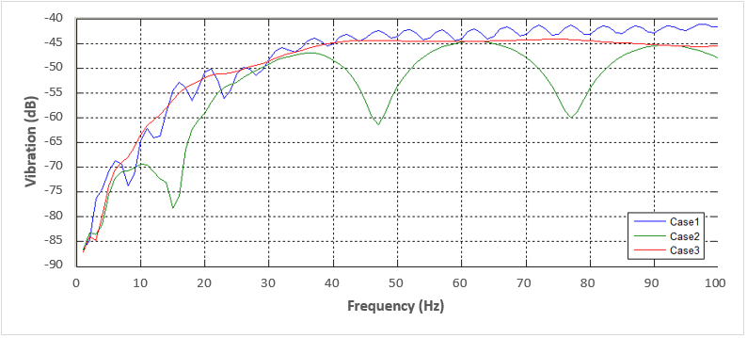
Figure 2.1: PiP Output Chart – Closest Pile
Notes: Case 1 represents the level of vibration predicted at the bottom of the pile, Case 2 represents the level of vibration predicted at the top of the pile and Case 3 represents the level of vibration at the surface measurement position.
The difference in PiP predicted level of vibration at the bottom of the pile (Case 1) to the PiP predicted level at the measurement location (Case 3) was added to the actual measured levels of vibration at the surface to obtain the actual level of vibration that would be incident at the bottom of the pile.
  - Step 2 – Prediction of Foundation to Slab Transmission and Vertical Transfer
The transmission of vibration from the ground, into the foundations and up into the super-structure of the building was predicted using Nelson’s transfer functions [2].
A range of vibration transfers are possible from minimum (best case) to maximum (worst case). To determine whether the likely transfer of energy into the super-structure of the building and the vertical transfer per floor would tend towards the minimum (typically heavyweight structures) or the maximum (typically lightweight structures) transfer scenario, the nature of the structure of the proposed building was taken into consideration.
The proposed structure of the lowest concrete slab of the building is proposed to be 250 mm thick. Thick reinforced concrete columns and floor slabs of up to 650 mm thick reinforced concrete are proposed. The structure is naturally heavy and only low frequency vibration is likely to be transmitted easily up through to the residential levels.
Based on the spectral data from the vibration measurements that were conducted onsite, the frequencies where train vibration is most significant at the surface tend to be in the 40 Hz, 50 Hz and 100 Hz frequency bands. In terms of vibration this is of relatively high frequency and the proposed structure would need a lot of energy to be excited. Considering these factors the likely transfer of vibration from the soil, to the pile foundations, into the building and up through storeys would tend towards the minimum scenario, which has therefore been adopted in the predictions of transfer into the foundations and through into the super-structure of the building. The selected transfer functions, given in dB, were applied to vibration levels at the relevant frequency. To do this, levels of vibration were converted to dB units with reference values dependent on the parameter (vibration dose value (VDV), structure-borne noise or peak particle velocity (PPV)) and then converted back using the same reference values once the transfer functions were applied [10].
  - Step 3 – Prediction of Surface Resonance
Surfaces such as raised floors, light-weight walls and suspended ceilings within room spaces are sensitive to vibration energy transmitted to them, with the level of excitation dependent on the material characteristics and dimensions.
To predict the increase in vibration due to surface resonance, worst-case transfer functions [2] have been applied in the same way as those detailed in Step 2. This enabled the potential level of re-radiated structure-borne noise to be estimated within the room.
  - Calculating Tactile Vibration
The human response to tactile vibration is assessed as a broadband level of VDV in both the daytime and night-time periods. British Standards Institution (BSI) [10] assessment applies to vibration at the point where it would be felt by residents, which for the proposed building would be in apartments from first floor level and above.
VDV levels for both the daytime and night-time periods have been predicted within commercial spaces at ground floor and in residential spaces at first floor to third floor.
The likelihood of damage to the proposed building is assessed using the level of PPV at the base of the building [11]. To calculate this, transfer functions from step 1 were applied to levels of the measured PPV on the ground to predict the PPV levels at the ground floor slab. These levels were then compared to the criteria detailed in Section 4.
  - Calculating Structure-Borne Noise
The level of re-radiated structure-borne noise within room spaces was calculated by applying the differentials and transfer functions to 1 second long samples (equivalent to a slow time response of a Sound Level Meter) of the measured acceleration levels at the surface during Piccadilly Line train passes. This enabled the L_{ASmax} level in the rooms to be predicted for each axis. The predicted structure-borne noise levels in the x, y and z axes were then logarithmically added together to obtain the spatial mean L_{ASmax} level within the room.

- Assessment Criteria
The assessment criteria for each of the effects that could occur inside sensitive room spaces of the proposed development due to vibration are detailed below. These criteria were used to evaluate the levels of predicted vibration and the potential effect on occupants of the building depending on which room they were in and the typical uses for those rooms. The likelihood of damage to the building was also assessed.

  - Tactile Vibration Assessment Criteria
BS 6472:2008 [10] sets out VDV levels for evaluating the various probabilities of adverse comment to vibration within residential buildings. The criteria are presented as ranges to reflect the differing susceptibility to vibration evident among members of the population. Adverse comment is not expected for VDVs below the ranges in the table. VDV levels of <0.2 m/s^{1.75} during the day and <0.1 m/s^{1.75} during the night are an indication of a low probability of adverse comment, with these levels adopted in considering the effects of tactile vibration on residential spaces of the development.
In the assessment of the likelihood of damage to buildings a PPV level predicted at the base of the building (the ground floor slab) of below 50 mm/s would not be expected to cause damage to a reinforced building such as that proposed [11],[12],[13]. A PPV level of 50 mm/s has therefore been adopted as the threshold for building damage to occur.
  - Structure-borne Noise Assessment Criteria
The levels of vibration required to generate noticeable noise levels within a room are much lower than levels of perceivable tactile vibration.
Currently there are no British or international standards which provide guidance on assessing the impact of structure-borne noise from railways on the occupants of a building. The Association of Noise Consultants (ANC) [13] provide discussion on the relevant research that has been carried out.
Based on review of the various applied criteria and considering the characteristics of the proposed development, 35 dB L_{ASmax} is deemed a desirable upper threshold limit for residential areas. This value is conservative but designed to ensure that whilst structure-borne noise may be perceptible to some individuals it would not materially prejudice a person’s quality of life. This criteria also has regard to the frequency of trains on the Piccadilly Lines and the aural response of people to structure-borne noise from underground trains, which is more disturbing than other sources of environmental noise (e.g. road traffic and aircraft) due to its low frequency content. This is shown by comparison of internal noise levels given in BS 8233:2014 [14] and by the World Health Organization (WHO) [15] for residential properties, where internal night-time limits of 30 dB L_{Aeq} and 45 dB L_{AFmax} are given for noise from typical environmental noise sources, to the typical criteria given for structure-borne noise by the ANC [13]. ANC listed criteria, including those where a fast time response is used, is typically lower than the BS 8233 and WHO criteria.
For ground floor commercial retail areas, a structure-borne noise level of below 45 dB L_{ASmax} has been adopted as a level where adverse comment is unlikely. This is based on typical noise levels in shops being 10 dB higher than in residential properties [16].
Reference in analysis has also been made to frequency based criteria given by the Federal Transit Administration (FTA) [17]. According to the FTA, the perceptible A-weighted structure-borne noise level of a source where the dominant frequency is at 30 Hz will be approximately 15 dB less than where the dominant frequency is at 60 Hz.

- Results
Using the methodology detailed in Section 2, the levels of tactile vibration (VDV and PPV) and structure-borne noise (L_{ASmax}) have been calculated. The results of these calculations are presented in this section and discussed in Section 5.

  - Tactile Vibration
The results of the assessment of tactile vibration in VDV, used to assess the likelihood of complaint, are presented in Table 4.1.

Table 4.1: Predicted Daytime and Night-time VDV Levels in different Spaces
Slant Distance of Pile from Tunnel (Pile Depth) | Period | Max VDV (m/s^{1.75})
 |  | Grd Floor | 1st  Floor | 2nd Floor | 3rd Floor
10.6 m  (18 m) | Day | 0.10 | 0.14 | 0.08 | 0.05
 | Night | 0.05 | 0.07 | 0.04 | 0.03
11 m  (18 m) | Day | 0.08 | 0.12 | 0.07 | 0.04
 | Night | 0.04 | 0.06 | 0.04 | 0.02
11.8 m  (18 m) | Day | 0.04 | 0.06 | 0.04 | 0.02
 | Night | 0.02 | 0.03 | 0.02 | 0.01
7 m  (24.5 m) | Day | 0.08 | 0.11 | 0.07 | 0.04
 | Night | 0.04 | 0.06 | 0.03 | 0.02
10.6 m  (24.5 m) | Day | 0.03 | 0.05 | 0.03 | 0.02
 | Night | 0.02 | 0.02 | 0.01 | 0.01
12.3 m  (24.5 m) | Day | 0.05 | 0.07 | 0.04 | 0.02
 | Night | 0.02 | 0.03 | 0.02 | 0.01
13.5 m  (24.5 m) | Day | 0.04 | 0.06 | 0.03 | 0.02
 | Night | 0.02 | 0.03 | 0.02 | 0.01
15.4 m  (24.5 m) | Day | 0.02 | 0.03 | 0.02 | 0.01
 | Night | 0.01 | 0.01 | 0.01 | 0.01
20.3 m  (24.5 m) | Day | 0.01 | 0.02 | 0.01 | 0.01
 | Night | 0.01 | 0.01 | 0.01 | 0.00
The results of the assessment of tactile vibration in PPV at the ground floor slab, used to assess the likelihood of building damage, are presented in Table 4.2.
Table 4.2: Predicted PPV at the Ground Floor Slab
Slant Distance of Pile from Tunnel (Pile Depth) | Peak Particle Velocity (mm/s) at Ground Floor
10.6 m (18 m) | 0.045
11.0 m (18 m) | 0.029
11.8 m (18 m) | 0.014
7.0 m (24.5 m) | 0.058
10.6 m (24.5 m) | 0.018
12.3 m (24.5 m) | 0.012
13.5 m (24.5 m) | 0.009
15.4 m (24.5 m) | 0.005
20.3 m (24.5 m) | 0.003
Guideline Criterion | 50.000
  - Structure-borne Noise
Table 4.3 presents the predicted L_{ASmax} re-radiated structure-borne noise levels from train passes in the commercial and residential room spaces of the proposed building.
Table 4.3: Predicted Re-radiated Structure-borne Noise Levels
Slant Distance of Pile from Tunnel (Pile Depth) | Maximum Structure-borne Noise Level (dB L_{ASmax})
 | Grd Floor | 1st Floor | 2nd Floor | 3rd Floor
10.6 m (18 m) | 53 | 54 | 49 | 44
11.0 m (18 m) | 49 | 50 | 45 | 40
11.8 m (18 m) | 42 | 44 | 39 | 34
7.0 m (24.5 m) | 56 | 56 | 51 | 45
10.6 m (24.5 m) | 42 | 46 | 41 | 35
12.3 m (24.5 m) | 39 | 42 | 37 | 32
13.5 m (24.5 m) | 33 | 37 | 32 | 27
15.4 m (24.5 m) | 29 | 33 | 28 | 23
20.3 m (24.5 m) | 24 | 28 | 23 | 18
Guideline Criterion | 45 | 35 | 35 | 35
- Analysis and Discussion
The results presented in Section 4 have been assessed against the adopted criteria for human response and the likelihood of building damage given in Section 3.

  - Tactile Vibration
The results shown in Table 4.1 indicate that when accounting for the vibration transfer into and through the building structure that vibration associated with underground train movements during both the daytime and night-time periods will fall below the range where there is a low probability of adverse comment (<0.2 m/s^{1.75} VDV_{day} and <0.1 m/s^{1.75} VDV_{night}) in all rooms of the proposed building. Adverse comment would therefore not be expected from any of the future occupants due to tactile vibration.
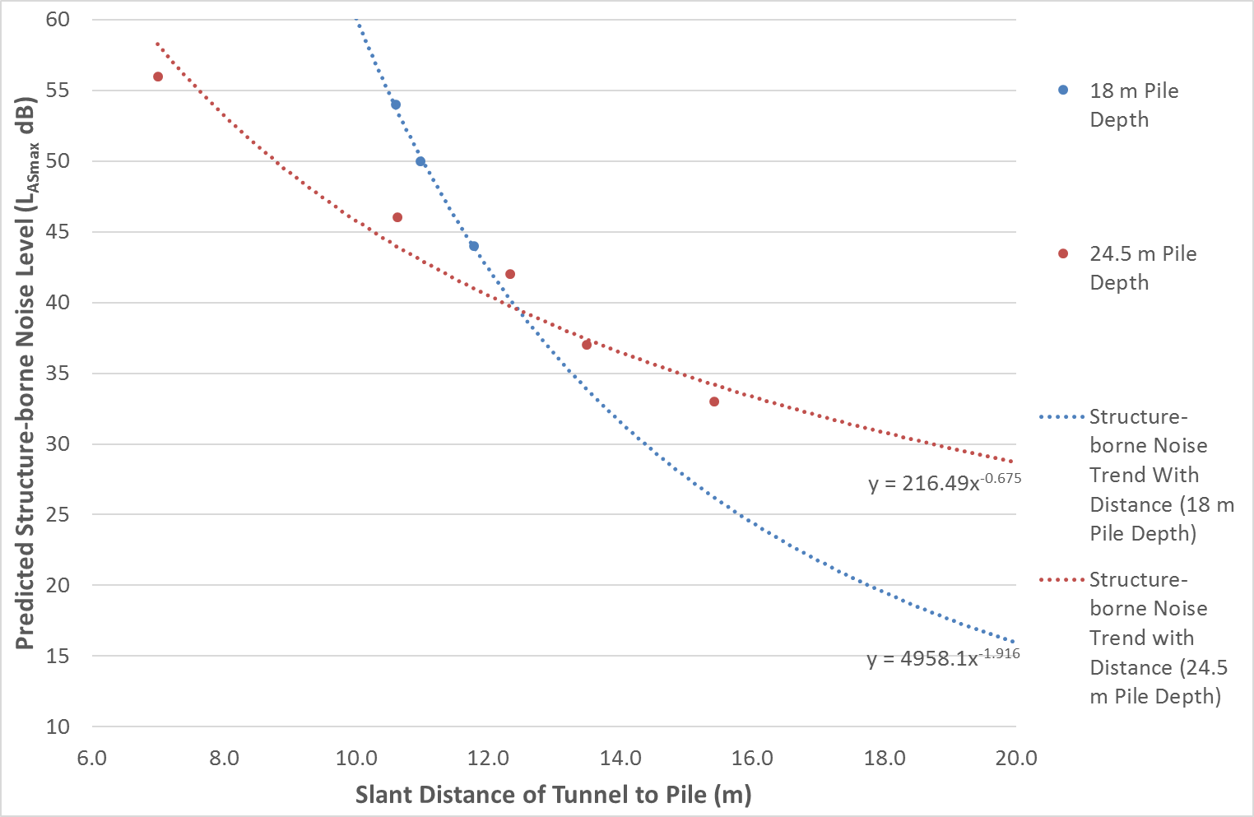
The highest VDV levels are shown to be above piles closer to the Piccadilly Line tunnel. This is to be expected as the shorter the path of propagation, the less energy will be lost along the way. Differences in the level of VDV can also be seen with deeper piles. Where the slant distance is equal but the piles are at different depths and therefore at different angles to the train tunnels, as is the case with the two piles both at 10.6 m slant distance, the shallower 18 m deep pile shows higher levels of VDV. This is likely to be because the transmission of energy in the angle of direction towards this pile (directly above the tunnel) is greater than for the 24.5 m deep pile, which is at a horizontal distance of 10 m away from the tunnel. This variation in dissipation around the tunnel is shown in Figures 5.1 and 5.2, where the x and y-axes are shown in metres and the colouration shows the variation in dB using the scale to the left of each figure. The train tunnel is represented as the white circle in the centre.
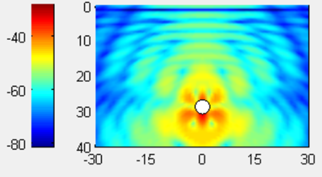
Figure 5.1: Vibration Propagation at 25 Hz
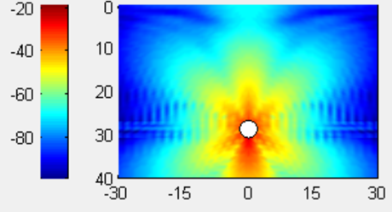
Figure 5.2: Vibration Propagation at 100 Hz
As shown in Table 4.2, and with reference to Section 3, the predicted level of PPV at the base of the building is over 49 mm/s below the level where damage to the proposed building may occur. There is therefore no likelihood of damage to the proposed building due to underground train vibration based on this assessment.
  - Structure-borne Noise
With reference to Table 4.3, structure-borne noise levels in ground floor commercial areas are predicted to be greater than the adopted design criterion of 45 dB L_{ASmax} in rooms above 18 m deep piles up to 11.8 m from the train tunnels, and above 24.5 m deep piles up to 10.6 m from the train tunnels. This corresponds to a likelihood of adverse comment ranging from low probability to adverse comment probable. In rooms beyond 11.8 m from the tunnels, the predicted structure-borne noise levels are below the adopted design criterion for commercial spaces.
The variation of structure-borne noise level at first floor with distance from the Piccadilly Line tunnel and how this varies with the two different pile depths is shown in Figure 5.3.
Figure 5.3: Predicted First Floor Structure-borne Noise Levels with Distance from Piccadilly Line Tunnels
Best fit function curves in Figure 5.3 show that structure-borne noise levels within residential apartments at first floor are predicted to exceed the adopted design criterion of 35 dB L_{ASmax} above 18 m deep piles up until a slant distance of 13.3 m from the centre of the Piccadilly Line tunnel. Above the 24.5 m deep piles this distance increases to 14.9 m. The best fit functions with distance at each floor are given in Table 5.1. They are an inverse power ratio of the distance $x$ due to the spread of energy in two dimensions.
Table 5.1: Predicted PPV at the Ground Floor Slab
Floor | Ratio of Structure-borne Noise to Slant Distance
 | 18 m Pile Depth | 24.5 m Pile Depth
Ground | $$y=9418.2x^{-2.194}$$ | $$y=283.67x^{-0.819}$$
First | $$y=4958.1x^{-1.916}$$ | $$y=216.49x^{-0.675}$$
Second | $$y=7575.4x^{-2.137}$$ | $$y=241.64x^{-0.774}$$
Third | $$y=13129x^{-2.415}$$ | $$y=267.17x^{-0.882}$$
Notes: $x$ is the slant distance from the centre of the train tunnel in m; $y$ is the structure-borne noise level in dBA.
Structure-borne noise levels exceed the residential criteria by up to 19 dB in room spaces directly above the tunnel, corresponding to a high probability of adverse comment (see Table 4.3). The greatest exceedance (by 21 dB) is predicted above the closest pile, 7 m from the tunnels.
At second floor level, the distance to where the design criterion for residential room spaces will be met reduces down to 12.4 m and 12.1 m for 18 m and 24.5 m deep piles respectively, and at third, down to 11.6 m and 10 m for 18 m and 24.5 m deep piles respectively. This shows how structure-borne noise levels decrease as one moves up the building and that fewer rooms will be adversely affected at higher floors (assuming identical floor layouts).
Assessment results indicate there is a high probability of adverse comment due to structure-borne noise in both commercial and residential room spaces of the proposed building. In such a situation, developers should consider vibration isolation measures in the building design with a view to reducing levels of audible structure-borne noise to within desirable limits.
  - Frequency Dependent Structure-Borne Noise Criteria
The FTA [17] give criteria for structure-borne noise that relates human perception to the dominant frequency as well as the magnitude. These criteria give higher values of structure-borne noise required to illicit a negative human response where the dominant frequencies are higher (around 60 Hz). The dominant frequency of the A-weighted structure-borne noise level is at around 100 Hz, therefore the predicted structure-borne noise levels can be compared to the perception limit of 40 dB of the mid-frequency FTA criteria. This criteria is 5 dB higher than the non-frequency related criteria adopted in this assessment (35 dB L_{ASmax}). The predicted structure-borne noise levels shown in Table 4.3 are still higher than this less stringent limit by up to 16 dB, although fewer rooms in the proposed building would be affected. The horizontal distance away from the tunnels where first floor rooms would be adversely affected based on this criteria would reduce to 12.2 m and 12.4 for the 18 m and 24.5 m deep piles respectively.

- Uncertainty
The sources of uncertainty that affect the prediction of vibration propagation, many of which are unquantifiable, include, but are not limited to: measurement accuracy; software uncertainty; and soil composition.
The accuracy of the measurements relies on the instrumentation accuracy as well as other sources of vibration in the area (such as passing vehicles on a nearby road). The specific equipment used to measure the data used in this investigation has an accuracy of ±3.85 ×10⁻¹² m/s², which is small enough to be considered negligible in the overall uncertainty of the investigation. The influence of other vibration sources in the area was avoided by using specific train passes without the influence of passing cars for the calculation of PPV and structure-borne noise.
Hunt [9] discussed the uncertainty of PiP in detail and showed that changing certain parameters within the software by even a small amount can give uncertainties of greater than 10 dB when predicting specific vibration levels. In the assessment presented in this paper, the software was not used to predict exact vibration levels but was used to predict the difference in level from one point in the ground to another. Using the software in this way is not nearly as susceptible to uncertainty, because the prediction of differentials does not rely as much on the exact input parameters. The actual uncertainty of using the PiP software in the methodology applied relates to the input parameters, which were kept as consistent as possible to give reliability.
The overall value of uncertainty relies significantly on the soil loss factor, which provides the greatest uncertainty factor as the soil loss factor for clay soils used is based on a range provided by Ungar & Bender [1]. Opposing ends of this range give large differences in results as it has a great effect on the calculation of the vibration wave speed. Based on this range of loss factors, the overall uncertainty value could be up to ±54 m/s^{1.75} for the specific assessments carried out, with the exact uncertainty for each pile relying on the amount of soil that the vibration propagates through. When a high soil loss factor is assumed, the PiP software predicts very low levels of vibration at the surface, much lower than were actually measured, and therefore huge differentials through the soil are predicted using this methodology. It is therefore reasonable to conclude based on the measured data that the actual loss of vibration through the soil tended towards the lower end of the range of soil loss factors. This means that the actual level of uncertainty is much lower than that given above, but cannot be exactly quantified.
The levels of uncertainty, including in the uncertainty itself, can be considered to be the obstructions to accurate predictions of vibration propagation through soil. This originates in the significant lack of research and information on different soil compositions and their loss factors.

- Conclusions
An assessment of ground-borne vibration and structure-borne noise has been undertaken for a proposed residential development at a site located above the London Underground Piccadilly Line.
Previously measured site levels of vibration at ground level caused by passing underground trains have been used to predict the levels of vibration within commercial and residential room spaces in the proposed building. A modelling program (PiP) was used to calculate differentials between vibration magnitudes at different points in the ground, enabling levels of vibration at the bottom of proposed pile foundations to be predicted using levels measured at the surface. Dedicated transfer functions were then used to predict the level of vibration transmission into and through the proposed structure of the building.
The results showed a relationship between the angle of the piles to the train tunnels and the level of vibration transmitted to them, where piles directly above the tunnels had greater level of vibration incident upon them. A relationship was also seen with distance, where greater distances resulted in greater attenuation of vibration through the soil, following an inverse power ratio due to geometric spreading of energy.
The assessment showed that tactile vibration within residential room spaces would not be large enough to cause adverse human response based on the Piccadilly Line timetables at the time of the measurements. Tactile vibration levels were predicted as being well below the levels required to cause building damage.
The assessment of structure-borne noise showed a strong likelihood of significant exceedances of the adopted criteria for both commercial and residential room spaces of the proposed building above piles located up to 14.9 m away from the Piccadilly Line tunnels. Adverse comment from the occupants of these spaces would be likely without mitigation. Structure-borne noise levels were shown to have an inverse power trend with distance away from the tunnels, with the trend depending on the depth of the piles.
The uncertainty in the investigation methodology highlighted the need for considerable, in-depth studies into soil loss factors, which are limited in research and in defined calculation methods. To enable the method used to be suitable for predicting the effects of underground train vibration, either considerable examination into soil loss factors must be undertaken or simultaneous surface and below ground level vibration measurements be taken at each site where a new building with piled foundations is proposed above, or proximate to, an underground railway line.
Acknowledgement
This project was supported by London South Bank University and by Hilson Moran Partnership Ltd.
References
[1] E.E. Ungar, E.K. Bender: Vibrations Produced in Buildings by Passage of Subway Trains; Parameter Estimation for Preliminary Design. Bolt Beranek and Newman Inc. Cambridge Massachusetts, USA, 1975.
[2] P.M. Nelson: Transportation Noise Reference Book. Butterworth & Co. (Publishers) Ltd, 1987.
[3] Crossrail: Crossrail: Information for Developers. London, Crossrail Ltd, 2008.
[4] Crossrail: Crossrail 2 / Chelsea Hackney Line: Information for Developers. London, Crossrail Ltd, 2014.
[5] J. Forrest, H. Hunt: A three-dimensional tunnel model for calculation of train-induced ground vibration. Journal of Sound and Vibration 294 (2006) 4 – 5, 706 – 736.
[6] J. Forrest, H. Hunt: Ground vibration generated by trains in underground tunnels. Journal of Sound and Vibration 294 (2006) 4 – 5, 706 – 736.
[7] M. Hussein, H. Hunt: A Software Application for Calculating Vibration due to Moving Trains in Underground Railway Tunnels. NOVEM 2009, Oxford.
[8] R.M. Thornely-Taylor: Underground Acoustics. Rupert Taylor Ltd, 2016.
[9] H. Hunt: Vibration from Underground Trains: Pipe-in-Pipe Software. PowerPoint Presentation, Cambridge University Engineering Department, University of Cambridge, 2008.
[10] British Standards Institution (BSI): BS 6472:2008 Guide to evaluation of human exposure to vibration in buildings. BSI, Great Britain, 2008.
[11] BSI: BS 7385-2:1993 Evaluation and measurement for vibration in buildings – Part 2: Guide to damage levels from groundborne vibration. BSI, Great Britain, 1993.
[12] BSI: BS 5228-2:2009+A1:2014 Code of practice for noise and vibration control on construction and open sites. Vibration. BSI, Great Britain, 2014.
[13] Association of Noise Consultants (ANC): Measurement and assessment of ground-borne noise and vibration. ANC, 2012.
[14] BSI: BS 8233:2014 Guidance on sound insulation and noise reduction for buildings. BSI, Great Britain, 2014.
[15] World Health Organization: Guidelines for community noise. WHO, Geneva, 1999.
[16] Chartered Institution of Building Services Engineers (CIBSE): CIBSE Recommended Noise Ratings For Internal Areas. CIBSE, 1999.
[17] C. Hanson, D. Towers, L. Meister: Transit Noise And Vibration Impact Assessment. Federal Transport Administration, Washington, DC, USA, 2006.

