Enhancement of thermoelectric performance in Bi_{0.5}Sb_{1.5}Te₃ particulate composites including BaTiO₃ nano dots
Yiming Cheng,¹ Junyou Yang,¹ Yubo Luo,¹ Wang Li,¹ Zheng Ma,¹ Qinghui Jiang,¹* Steve Dunn², and Haixue Yan³

1. State Key Laboratory of Materials Processing and Die and Mould Technology, and School of Materials Science and Engineering, Huazhong University of Science and Technology, Wuhan 430074, Hubei Province, PR China
2. School of Engineering, London South Bank University, 103 Borough Road, London, SE1 0AA, UK.
3. School of Engineering and Materials Science, Queen Mary University of London, Mile End road, London, E1 4NS, UK
*Corresponding Authors: E-mail address qhjiang@hust.edu.cn

Abstract
The thermoelectric particulate composites of nano ferroelectric-perovskite oxides BaTiO₃ and matrix Bi_{0.5}Sb_{1.5}Te₃ are fabricated by ball milling method and spark plasma sintering process. Ferroelectric BaTiO₃ nano dots (~ 35 nm) are uniformly distributed in the Bi_{0.5}Sb_{1.5}Te₃ matrix (grain size 5~10 μm), without observable reaction between BaTiO₃ and Bi_{0.5}Sb_{1.5}Te₃ in the samples sintered at 723 K. Interfaces between the phases work as barriers to block low energy charge carriers, lead to a decrease in the concentration of free charge carriers from 3.31×10¹⁹ to 2.73×10¹⁹ cm⁻³ at 1 vol% BaTiO₃ content. As a result of energy filtering effect and ferroelectric polarization, the Seebeck coefficient was improved ~10% and there is slight improvement ~5% of power factors as well, compared with those of the matrix phase. Meanwhile, BaTiO₃ nano dots can effectively scatter phonons, and realize the minimum lattice thermal conductivity κ_{l} (0.5 Wm⁻¹K⁻¹). After the optimization of BaTiO₃ content, the maximum ZT value of the composite is about 1.31 at 363 K, which is ~25% higher than that of single phase Bi_{0.5}Sb_{1.5}Te₃. This indicates that the introduction of ferroelectric nano dots is an effective method for optimizing the thermoelectric performance of Bi_{0.5}Sb_{1.5}Te₃.

KEYWORDS: thermoelectric, ferroelectric, BaTiO₃, Bi_{0.5}Sb_{1.5}Te₃, coupling
1. Introduction
With the rapid development of industry, energy shortage and environmental pollutions have become extremely important for human beings. For example, greenhouse gases such as carbon dioxide emitted by traditional fossil energy will cause great damage to the ecological environment and lead to global warming. Thermoelectric materials can realize the direct conversion between electricity and heat, which effectively recycle the industrial and domestic waste heat for carbon neutrality, which aroused great research interests^{[1]}. They also have the advantages of being clean, pollution-free, and free of traditional moving parts when it comes to energy conversion^{[2]}. Usually the dimensionless figure of merit ZT=S²σT/κ is used to evaluate the thermoelectric properties of materials where S, σ and κ represent Seebeck coefficient, electrical conductivity, and thermal conductivity, respectively^{[3]}. The thermal conductivity consists of electron thermal conductivity (κ_{e}) and lattice thermal conductivity(κ_{l}). Pursuing higher ZT value and conversion efficiency requires high Seebeck coefficient, high electrical conductivity and low thermal conductivity. Unfortunately, these parameters are closely related to carrier concentration and are coupled to each other, making it a challenge to obtain high thermoelectric properties. At present, there are mainly two strategies to improve ZT values, band engineering and phonon engineering which are respectively used to design and optimize electric and heat transport characteristics. The main purpose of the band engineering is to filter the electron energy around the high valley degeneracy^{[4, 5]}, Fermi levels^{[6, 7]}, optimal bandgap^{[8]}, and others^{[9]}. For phonon engineering, the main purpose is to reduce the lattice thermal conductivity and enhance phonon scattering by means of Nano-inclusions^{[10, 11]}, interface packing^{[12]}, quasi-ballistic transport of nanoscale interfaces or nanopores^{[13]}, liquid-like behavior of copper ions^{[14]}, and other techniques^{[15]}.
Bi₂Te₃ based compounds are one of the earliest studied thermoelectric materials, which have the best performance at room temperature and are dominant in the large-scale commercial applications^{[16]}, whose ZT value of ingot material is about 1 up to now. Perusing higher ZT value is needed in order to broaden the commercial applications of Bi₂Te₃ thermoelectric compounds. Phonon engineering is one of the popular and effective methods for improving their thermoelectric properties. In 1972, Loffe^{[17]} et al. proposed for the first time that point defects are generated by solid solution alloying and short-term disorder generates strong phonon scattering. Nanosized oxides as secondary particles are also used to scatter more phonons and reduce the lattice thermal conductivity^{[19-23]}. For example, Kim et al.^{[21]} fabricated Ta₂O₅ and Bi_{0.5}Sb_{1.5}Te₃ nanocomposites using high energy ball milling and spark plasma sintering. The Seebeck coefficient significantly increased and the thermal conductivity (κ) decreased substantially with the addition of nanoparticles owing to enhanced carrier scattering. Meanwhile, in situ reaction method is used to fabricate oxide particles in thermoelectric composites such as Mg₂Si^{[24]} and Yb₂O₃/Yb-filled CoSb₃^{[25]} nanocomposites, in which the phonon scattering of the oxide defects results in a remarkable reduction in the lattice thermal conductivity and obvious enhancement of ZT values. However, Rogl et al.^{[26]} mixed skutterudite powders with nonmetallic oxides (Al₂O₃) and metallic oxides (Cu₂O), produce the bulks with evenly distribution of sub-micro grains, and the goal to enhance ZT was not reached with Al₂O₃ and Cu₂O. There are the disagreements on the effect of oxides on the transport properties of thermoelectric particulate composites, and it is necessary to confirm that the enhancement of thermoelectric properties is from the phonon scattering of oxides or the doping/point defects of the in situ reaction.
Besides, some groups reported that ferroic nanoparticles can tailor the transport properties of the thermoelectric matrix, which provides a new strategy to optimize the ZT values. Zhao WY et al.^{[27]} embedded soft magnetic nanoparticles into Ba_{0.3}In_{0.3}Co₄Sb₁₂ matrix, where the couplings of super-paramagnetic behavior and electron/phonon transport properties lead to improve the thermoelectric performance. BaTiO₃ is known as a perovskite-type ferroelectric material whose Curie point is around 400 K. Below 400 K, BaTiO₃ has spontaneous polarization with ferroelectric ordering. ^{[28]} Herein, the particulate composites of BaTiO₃ and Bi_{0.5}Sb_{1.5}Te₃ are fabricated by ball milling and spark plasma sintering process. The effects of BaTiO₃ contents on the electron and phonon transport properties are investigated in detail. Energy filtering effect and phonon scattering of BaTiO₃on composite play leading roles in the optimization of thermoelectric performance. After the optimization of energy filtering effect and phonon scattering, there are large enhancements (~25%) of ZT values (~1.3) in Bi_{0.5}Sb_{1.5}Te₃ composites with 2 vol% BaTiO₃ content, compared with Bi_{0.5}Sb_{1.5}Te₃ (ZT~1.06).
2. Experimental procedures
The commercial BaTiO₃ powders (<4 μm) and Bi_{0.5}Sb_{1.5}Te₃ (BST) ingot were used as raw material. The BST ingot was manually crushed and ground with a mortar and pestle. The BST powders with fine particles were filtered by a 200-mesh sieve. The BST powders were mixed with BaTiO₃ powder with different volume contents (from 0 to 4%), put into stainless-steel pots with argon gas inside, and ground in a planetary ball mill machine with the speed ~280 r/min for 2 hours (the weight ratio of balls to powders was 20:1). The mixed powders were then loaded into a graphite mold with a diameter of 20 mm and heated at 723 K for 8 minutes under the pressure of 60 MPa in an SPS furnace (SPS-3T-3-MIN(L), Chenhua, China) in a vacuum environment. The crystal structure of the pellets was characterized by X-ray diffraction (XRD-7000, Shimadzu, Japan) and the microstructures of the samples were characterized by field emission scanning electron microscopy (GeminiSEM300, Carl Zeiss, Germany). The Seebeck coefficient and the resistivity of the samples were measured simultaneously using a home-made thermoelectric measurement system. The thermal diffusion coefficient (D) was measured by laser flash thermal analyzer (LFA-427, NETZSCH, Germany). The specific heat C_{p} of Bi_{0.52}Sb_{1.48}Te₃ was adopted from the reference^{[29]}. The density (ρ) of the samples was measured by Archimedes’ method, and the relative density reached above 95%. The thermal conductivity is calculated by the formula κ=C_{p}Dρ. The measurement inaccuracy is usually 5% of the Seebeck coefficient, 3% of the resistivity, and 7% of the thermal conductivity, respectively. Therefore, the combined uncertainty of ZT value is 12%. Hall coefficients of the samples with the thickness 0.2 mm were measured under a 0.55 T magnetic field using Hall Effect Measurement System (HMS-5500, ECOPIA, Korea).
3. Results and Discussion
Figure 1 shows the X-ray diffraction patterns of nano BaTiO₃ and BST composites with different BaTiO₃ volume content sintered at 723 K by spark plasma sintering (SPS). For all samples, the peaks near 33º belong to the strongest peak (110) of BaTiO₃ (PDF#08-0372). Other diffraction peaks of the samples belong to Bi_{0.5}Sb_{1.5}Te₃ (PDF#49-1713). This suggests that there is no obvious chemical reaction between BaTiO₃ and Bi_{0.5}Sb_{1.5}Te₃ matrix when the samples are sintered at 723 K.
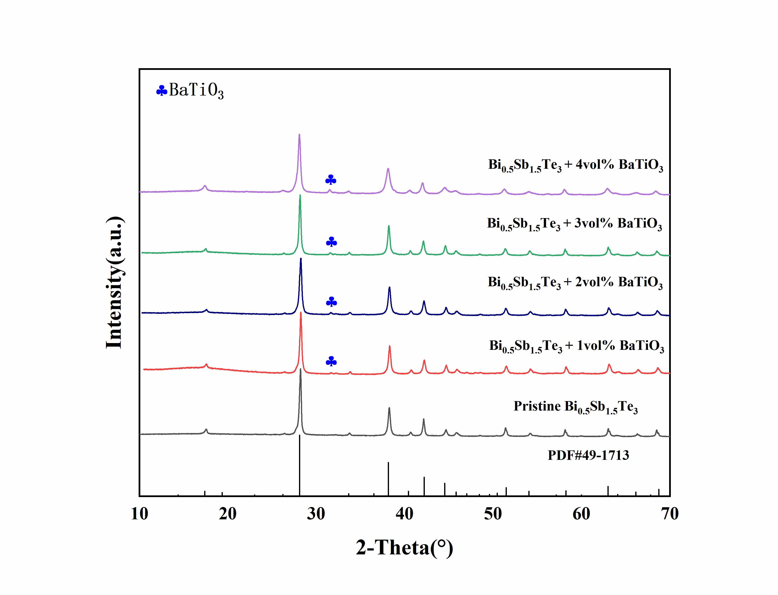Figure 1. XRD patterns of bulk samples with different volume contents of BaTiO₃
Figure 2 shows the secondary electron morphology images of the fracture surface with different magnifications of single-phase BST pellet sintered at 723 K. BST grains, with the size of 10 ~ 20 μm, show typical cleavage fracture on the surface, indicating its layer crystal structure. There are no obvious large holes in the sample, indicating that the pellet has high density (the real relative density is about 96% measured by Archimedes’ method).
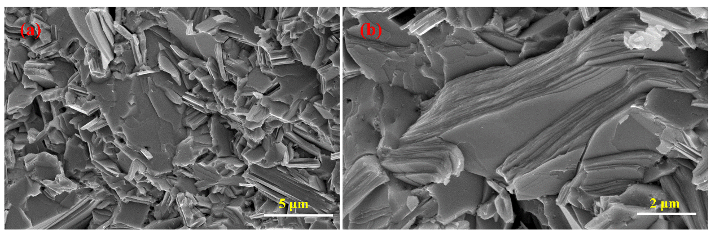
Figure 2. (a)-(b) FE-SEM micrographs of the fracture surface of pristine Bi_{0.5}Sb_{1.5}Te₃ with different magnifications
Figure 3 shows the secondary electron morphology images of the fracture surface and elemental analysis of the sintered bulk sample of 2 vol% BaTiO₃/BST composite. As shown in Figure 3a, the grain size of BST matrix is below 5 μm and smaller than that of pure BST in Fig. 2. The particles (marked by yellow circles) of second phase, with grain size <1 μm, are uniformly distributed at the grain boundaries of BST. These indicate that the second phase’s particles can effectively restrain the grain growth of BST during the sintering process, which realize grain refinement of BST matrix. Figure 3b is elemental analysis curve of the point (marked with red cross) on the sample, and its calculated elemental contents were shown in Figure 3c. Except the elements of the surrounding matrix, the main elements are Ba, Ti, and O elements, and the atomic ratio of Ba to Ti is about 1:1. Figure 3d-i was compositional mapping of all elements. Ba, Ti and O elements are significantly enriched in the absence of BST matrix elements. These results indicate that second phase should be from BaTiO₃.
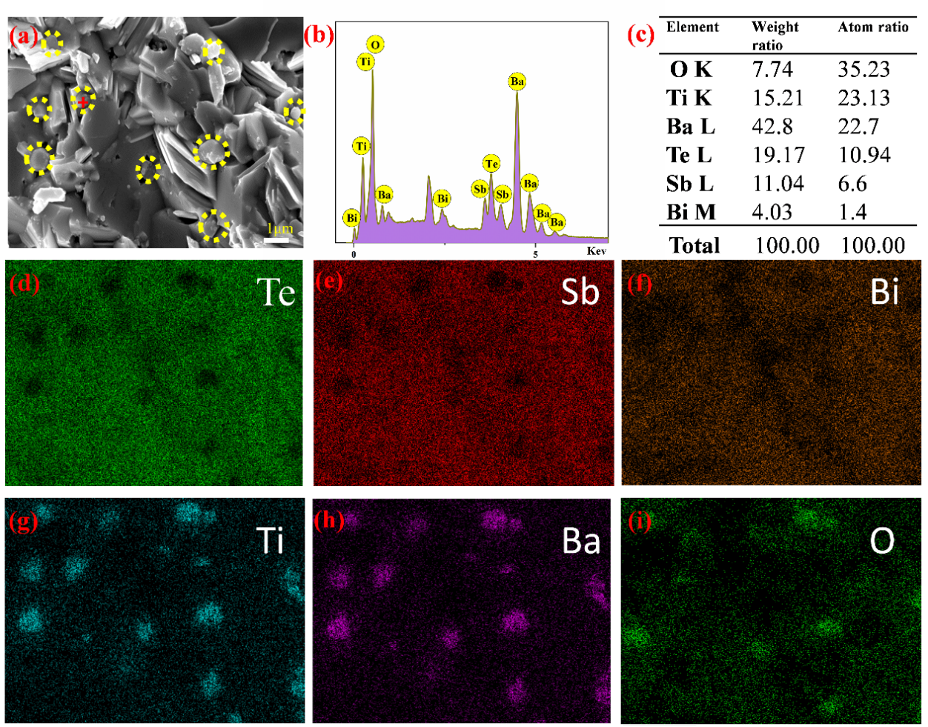
Figure 3. (a) FE-SEM micrographs of the fracture surface of 2 vol% BaTiO₃/BST sample, (b)-(c) the EDS composition analysis of the red marked area of image (a), (d)-(i) compositional mapping of all elements
DSC measurement results of 4 vol% BaTiO₃/BST composite are shown in Figure 4. As a ferroelectric material, BaTiO₃ compound has a Curie point (T_{c}) at about 130℃ when its grain size is larger than the critical size for single-domain-single-grain structure (about 0.4 μm). When the grain size is below the critical size, T_{c} of BaTiO₃ decreases with the grain size decreasing and the T_{c} of BaTiO₃ with an average grain size of 35 nm is between 80 to 120 °C^{[30]}. Near T_{c} temperature, there should be an endothermic peak in DSC curve from tetragonal-cubic transformation of BaTiO₃^{[31]}. As shown in Figure 4, an endothermic peak appears at about 85℃ corresponding to the T_{c} temperature of BaTiO₃ in the composite, which indicates that the grain size of BaTiO₃ is less than 35 nm according the relationship between grain size and T_{c} of BaTiO₃. As shown in Figure 2 and Figure 3a, (BiSb)₂Te₃ grains will grow up to several micrometers. Visible nano dots of particles distributed near the grain boundaries in (BiSb)₂Te₃ matrix (the inset of Figure 4) should be BaTiO₃ nano dots, which is related to the low sintering temperature of 900 ºC for typical BaTiO3 ceramics. The observed BaTiO₃ nano dotes is consisted with the decreased Tc in Fig4 and in literature [30, 31] .
Figure 4. Differential scanning calorimetry curve of 4 vol% BaTiO₃/BST composite (The inset is the SEM picture of the composite‘s fracture surface)
Figure 5a shows temperature dependent curves of electrical resistivity of the composites with different BaTiO₃ contents. Their resistivity increases with the increase of temperature, which accords with the typical electrical transport characteristics of heavily doped semiconductors. Table 1 lists the electrical parameters of the composites at room temperature. With the increase of BaTiO₃ content, the carrier concentration decreases from 3.31×10¹⁹ cm⁻³ to 2.18×10¹⁹ cm⁻³, while the carrier mobility of all samples are similar. According to the formula, ρ=1/neμ, the resistivity of the composites increases with the BaTiO₃ content. As a dielectric material, BaTiO₃ cannot effectively transfer carrier and its ferroelectric polarization can further decrease the conductivity, which apparently lead to the increase of the resistivity. Based on the percolation theory and effective medium theory^{[32]}, the carrier concentration and resistivity of the composite should have linear variation with BaTiO₃ content when its content is tiny. This is in conflict with the data listed in Table 1, which indicates that there is the coupling mechanism of physical transport between BaTiO₃ and BST matrix, i.e. energy filtering effect and local field related to ferroelectric polarization. The band gap and work function of BST is ~0.15 eV and 4.3 eV^{[33]}, and the band gap and work function of BaTiO₃ is ~3 eV and 4.8 eV^{[34, 35]}, respectively. According to band structure diagrams of two compounds ^{[36, 37]}, a schematic diagram (Figure 5d), can be drawn. There are energy barriers between the interfaces of hybrid materials. When the carriers migrate at the interface, low energy carriers would be blocked, and only high energy carriers can pass through the interface. This filtering effect leads to a decrease in the carrier concentration from 3.31×10¹⁹ to 2.73×10¹⁹ cm⁻³ when 1 vol% BaTiO₃ are introduced.
Figure 5. Temperature dependence of (a) electrical resistivity, (b) Seebeck coefficient, (c) and power factor (PF) of bulk samples with different BaTiO₃ contents, (d) A schematic representation of energy filtering effect in BaTiO₃/BST composites.
Table 1. The room temperature carrier concentrations (n_{e}), mobilities(μ), Seebeck coefficients, and electrical resistivities
Samples | n (10¹⁹cm⁻³) | μ(cm²V⁻¹S⁻¹) | Seebeck (μVK⁻¹) | Resistivity (μΩ m)
BST | 3.31 | 159.26 | 205.10 | 11.29
1 vol% BaTiO₃/BST | 2.73 | 146.81 | 210.25 | 11.74
2 vol% BaTiO₃/BST | 2.31 | 162.33 | 213.04 | 12.19
3 vol% BaTiO₃/BST | 2.18 | 155.28 | 214.84 | 12.35
4 vol% BaTiO₃/BST | 2.10 | 160.75 | 216.00 | 12.45
Figure 5b shows Seebeck coefficient of thermoelectric composites with different BaTiO₃ contents at different temperature. A positive Seebeck coefficient indicates p-type conductive behavior. With the temperature increasing, Seebeck coefficient of all the samples first increase to a maximum value at the intrinsic excitation temperature^{[38]} (near 363 K), and then decrease slightly due to the appearance of electron/hole pairs. The Seebeck coefficient can be expressed as the formula^{[39, 40]}:
$S=\frac{8π^{2}k_{B}^{2}}{3eh^{2}}{(\frac{π}{3n})}^{2/3}m^{*}T$ (1)
Where k_{B}, e, h and m* denote the Boltzmann constant, elementary charge, Planck constant and effective mass respectively. Seebeck coefficient is negatively correlated with carrier concentration n. Since energy filtering effect makes carrier concentrations of the composites lower (listed in Table 1), the Seebeck coefficient of the samples increase with the BaTiO₃. It is noteworthy that the Seebeck coefficient of the composite samples have an obvious upward peak near 363 K (near T_{c}=85º of BTO nano dots) compared to the matrix which can be explained as follows. During the transformation of BaTiO₃ from ferroelectric phase to paraelectric phase, the spontaneous polarization gradually weakens and disappears, and the band bending degree decreases and the curvature of band decreases. As a result, the effective mass m* and related Seebeck coefficient increase. According to power factor PF =S²/ρ, the power factors of the samples have a slight increase, as shown in Figure 5c. The power factor of the composite with 2 vol% BaTiO₃ content is about 3900 μWm⁻¹K⁻² and there is slight improvement ~5% compared with that of BST sample (3700 μWm⁻¹K⁻²) at room temperature.
Figure 6a shows thermal conductivity of BaTiO₃/BST composites with different BaTiO₃ content sintered at 723 K between room temperature and 523 K. The thermal conductivity of all the samples first decreases to the minima, and then increases rapidly above 363 K, which can be attributed to the decreased contribution of ferroelectric polarization which is zero above 85 ºC in BaTiO₃ nano dots. At the same temperature, the thermal conductivity of the composites decreases first and then increases with the BaTiO₃ content, as shown in the inset of Figure 6a. The thermal conductivity of the composite with 2 vol% BaTiO₃ content reaches the minimum value of 0.83 Wm⁻¹K⁻¹ at 333 K and there are ~20% decrease compared with that of pure BST (1.03 Wm⁻¹K⁻¹). Since ceramic BaTiO₃ has much higher thermal conductivity ~3.67 Wm⁻¹K⁻¹ near room temperature^{[39]}, this decrease of thermal conductivity should come from more phonon scattering related to interfaces and polarization. Electronic thermal conductivity can be calculated according to the formula κ_{e}=LT/ρ (where L is the Lorentz constant ~1.49×10⁻⁸W·Ω·K⁻²). As shown in Figure 6b, the electronic thermal conductivity decreases with the BaTiO₃ content because the electronic thermal conductivity is inversely proportional to the resistivity. Lattice thermal conductivity can be calculated according to the formula κ_{l}=κ-κ_{e}, which are shown in Figure 6c. The lowest lattice thermal conductivity of pure BST sample is ~0.67 Wm⁻¹K⁻¹. When a small amount of BaTiO₃ (2 vol%) are introduced into the composites, κ_{l} of the composite decreases to ~0.5 Wm⁻¹K⁻¹ although κ_{l} of BaTiO₃ is high to 3.67 Wm⁻¹K⁻¹. This indicates that BaTiO₃ nano dots can effectively scatter phonons with low and middle frequencies, which are actually crucial to realize the minimum κ_{l} in the composite, as shown in Figure 5d. When more BaTiO₃ particles are introduced, κ_{l} increase to 0.83 Wm⁻¹K⁻¹ at 4 vol% again because intrinsic high κ_{l} of BaTiO₃ phase has a key role in the composite and these is a possibly aggregation of nano dots to increase the size.
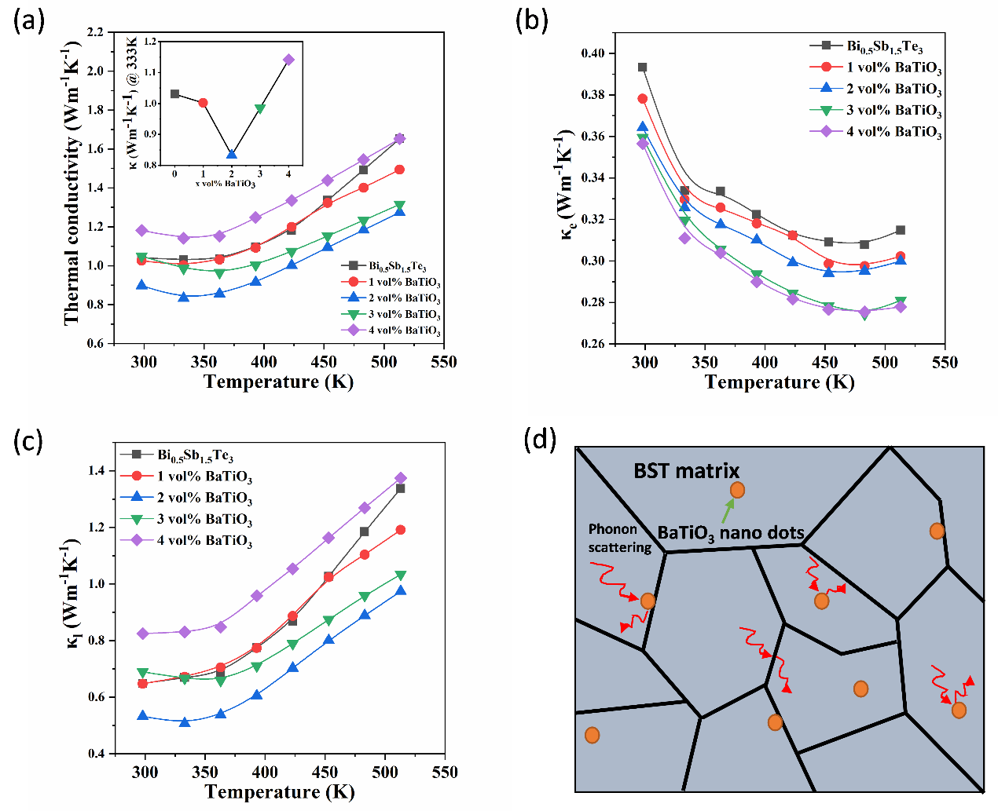
Figure 6. Temperature dependence of (a) thermal conductivity, (b) Electron thermal conductivity(κ_{e}) and (c) lattice thermal conductivity（κ_{l}） of bulk samples with different volume contents of BaTiO₃ ,(d) schematic of phonon scatterings of BaTiO₃/BST composites.
Figure 7a shows ZT values of the samples with different BaTiO₃ content at different temperatures. The ZT values of thermoelectric particulate composites with 1 vol%, 2 vol% and 3 vol% BaTiO₃ content are higher than that (~1.06) of the BST matrix. After the optimization of power factor and thermal conductivity, the maximum ZT value of the composite with 2 vol% BaTiO₃ is about 1.31 at 363 K, which are ~24% higher than that of pure BST. As shown in Figure 7b, compared with other works^{[41-43]}, BaTiO₃/BST particulate composite in our work has higher ZT peak values (~1.31) by energy filtering effect and effective phonon scattering from ferroelectric oxide particles and their interfaces.
Figure 7. (a) Temperature dependence of ZT of bulk samples with different volume contents of BaTiO₃, (b) Comparison of work on optimizing thermoelectric performance of BST by phonon engineering^{[41-43]}
4. Conclusion
The thermoelectric particulate composites of ferroelectric-perovskite oxide BaTiO₃ and Bi_{0.5}Sb_{1.5}Te₃ are fabricated by ball milling method and spark plasma sintering process. BaTiO₃ nano dots are homogeneously distributed in the Bi_{0.5}Sb_{1.5}Te₃ matrix. The mismatches of energy bands in the interfaces between two phases and the ferroelectric polarization of BaTiO₃ effectively block the low energy carriers, reduce the carrier concentrations and improve the Seebeck coefficients and power factors due to energy filtering effect. Meanwhile, ferroelectric BaTiO₃ nano dots particles (about 35 nm) can effectively scatter phonons with low and middle frequencies, which are actually crucial to realize the minimum κ_{l} in the composite. When a proper amount of BaTiO₃ (2 vol%) are introduced into the composites, κ_{l} of the composite decreases to ~0.5 Wm⁻¹K⁻¹. Energy filtering effect and phonon scattering from ferroelectric oxides nano dots can effectively realize the optimization of thermoelectric performance, and the maximum ZT value of the composites with 2 vol% BaTiO₃ content is ~1.31 at 363 K, which is ~24% higher than that of single phase Bi_{0.5}Sb_{1.5}Te₃.
Conflicts of interest
There are no conflicts to declare.
Acknowledgements
This work was supported by the National Natural Science Foundation of China (51772019, 51572098, 51632006), and the NSFC-Royal Society joint project (51811530307).
References
[1] L.E. Bell, Cooling, heating, generating power, and recovering waste heat with thermoelectric systems, Science, 321 (2008) 1457-1461.
[2] W. Liu, Q. Jie, H.S. Kim, Z. Ren, Current progress and future challenges in thermoelectric power generation: From materials to devices, Acta Mater., 87 (2015) 357-376.
[3] Z.G. Chen, G. Han, Y. Lei, L. Cheng, Z. Jin, Nanostructured thermoelectric materials: Current research and future challenge, Prog. Nat. Sci-mater, 22 (2012) 535-549.
[4] Y. Pei, X. Shi, A. Lalonde, H. Wang, L. Chen, G.J. Snyder, Convergence of electronic bands for high performance bulk thermoelectrics, Nature, 473(7345) (2011) 66-69.
[5] T. Zhu, Y. Liu, C. Fu, J.P. Heremans, J.G. Snyder, X. Zhao, Compromise and Synergy in High-Efficiency Thermoelectric Materials, Adv. Mater., 29 (2017) 1605884.
[6] A.J. Minnich, M.S. Dresselhaus, Z.F.Ren, Bulk nanostructured thermoelectric materials: current research and future prospects, Energy Environ. Sci., 2(5) (2009) 466-479.
[7] J.H. Bahk, Z. Bian, A. Shakouri, Electron transport modeling and energy filtering for efficient thermoelectric Mg₂Si_{1-x}Sn_{x} solid solutions, Phys. Rev. B, 89 (2014) 810-815.
[8] J. Zhou, R. Yang, C. Gang, M.S. Dresselhaus, Optimal Bandwidth for High Efficiency Thermoelectrics, Phys. Rev. Lett., 107 (2011) 226601.
[9] Y. Pei, H. Wang, G.J. Snyder, Band Engineering of Thermoelectric Materials, Adv. Mater., 24 (2012) 6125-6135.
[10] S.V. Faleev, F. Leonard, Theory of enhancement of thermoelectric properties of materials with nanoinclusions, Phys. Rev. B, 77 (2008) 214304.
[11] K. Zhang, Y. Zhang, S. Wang, Enhancing thermoelectric properties of organic composites through hierarchical nanostructures, Sci. Rep., 3 (2013) 1-7.
[12] Y. J., Z.W. Y., W. P., Enhanced thermoelectric performance of (Ba,In) double-filled skutterudites via randomly arranged micropores, Appl. Phys. Lett., 104 (2014) 1457.
[13] H. Liu, X. Shi, F. Xu, L. Zhang, W. Zhang, L. Chen, Q. Li, C. Uher, T. Day, G.J. Snyder, Copper ion liquid-like thermoelectrics, Nat. Mater. , 11 (2012) 422-425.
[14] E.S. Toberer, A. Zevalkink, G.J. Snyder, Phonon engineering through crystal chemistry, J. Mater. Chem. A, 21 (2011) 15843-15852.
[15] W. Zhao, P. Wei, Q. Zhang, H. Peng, W. Zhu, D. Tang, J. Yu, H. Zhou, Z. Liu, X. Mu, Multi-localization transport behaviour in bulk thermoelectric materials, Nat. Commun., 6 (2015) 1-7.
[16] Y. Liu, Y. Zhang, S. Ortega, M. Ibáñez, K.H. Lim, A. Grau-Carbonell, S. Martí-Sánchez, K.M. Ng, J. Arbiol, M.V. Kovalenko, Crystallographically Textured Nanomaterials Produced from the Liquid Phase Sintering of Bi_{x}Sb_{2- x}Te₃ Nanocrystal Building Blocks, Nano Lett., 18 (2018) 2557.
[17] W.M. Yim, F.D. Rosi, Compound tellurides and their alloys for peltier cooling—A review, Solid State Electron., 15 (1972) 1121-1140.
[18] J Li, Q. Tan, J.F. Li, et.al, BiSbTe‐Based Nanocomposites with High ZT: The Effect of SiC Nanodispersion on Thermoelectric Properties, Adv. Funct. Mater., 23 (2013) 4317-4323.
[19] D. M., H. Y., Dispersing Bi₂Mo₂O₉ nanoparticles into Bi_{0.5}Sb_{1.5}Te₃ alloys for enhanced thermoelectric figure of merit (ZT) through phonon scattering, Ceram. Int., 45 (2019) 24914-24918.
[20] M.Y. Sang, P. Dharmaiah, H.S. Kim, C.H. Lee, J.M. Koo, Investigation of Thermoelectric Properties with Dispersion of Fe₂O₃ and Fe-85Ni Nanospheres in Bi_{0.5}Sb_{1.5}Te₃ Matrix, J. Electron. Mater., 46 (2016) 2770-2777.
[21] E.B. Kim, P. Dharmaiah, D. Shin, K.H. Lee, S.J. Hong, Enhanced thermoelectric performance through carrier scattering at spherical nanoparticles in Bi_{0.5}Sb_{1.5}Te₃/Ta₂O₅ composites, J. Alloys Compd., 703 (2017) 614-623.
[22] A. Pakdel, Q. Guo, V. Nicolosi, T. Mori, Enhanced thermoelectric performance of Bi–Sb–Te/Sb₂O₃ nanocomposites by energy filtering effect, J. Mater. Chem. A, 6 (2018) 21341-21349.
[23] E.B. Kim, J.M. Koo, S.J. Hong, Effect of Ga₂O₃ Nanoparticles Dispersion on Microstructure and Thermoelectric Properties of p-Type BiSbTe Based Alloys, Arch. Metall. Mater., 62 (2017) 993-997.
[24] J. Tani, H. Kido, Fabrication and thermoelectric properties of Mg₂Si-based composites using reduction reaction with additives, Intermetallics, 32 (2013) 72-80.
[25] X.Y. Zhao, Synthesis of YbyCo₄Sb₁₂/Yb₂O₃ composites and their thermoelectric properties, Appl. Phys. Lett., 89 (2006) 092121.
[26] A. Grytsiv, F. Failamani, P. Rogl, Attempts to further enhance ZT in skutterudites via nanocomposites, J. Alloys Compd., 695 (2017) 682-696.
[27] W. Zhao, Z. Liu, Z. Sun, Q. Zhang, P. Wei, X. Mu, H. Zhou, C. Li, S. Ma, D. He, Superparamagnetic enhancement of thermoelectric performance, Nature, 549 (2017) 247-251.
[28] Q. Hu, X. Wei, Abnormal phase transition and polarization mismatch phenomena in BaTiO₃-based relaxor ferroelectrics, J. Adv. Dielectr., 09 (2019) 1930002.
[29] Y.I. Shtern, A.S. Malkova, A.S. Pashinkin, V.A. Fedorov, Heat capacity of the n -Bi₂Te_{2.88}Se_{0.12} and p-Bi_{0.52}Sb_{1.48}Te₃ solid solutions, Inorg. Mater., 44 (2008) 1057-1059.
[30] M.H. Frey, D.A. Payne, Grain-size effect on structure and phase transformations for barium titanate, Phys. Rev. B, 54 (1996) 3158-3168.
[31] Z. Zhao, V. Buscaglia, M. Viviani, M.T. Buscaglia, L. Mitoseriu, A. Testino, M. Nygren, M. Johnsson, P. Nanni, Grain-size effects on the ferroelectric behavior of dense nanocrystalline BaTiO₃ ceramics, Phys. Rev. B, 70 (2004) 024107.
[32] Q. Jiang, J. Yang, P. Hing, H. Ye, Recent advances, design guidelines, and prospects of flexible organic/inorganic thermoelectric composites, Mater. Adv., 1 (2020) 1038-1054.
[33] Y. Wang, S. Shen, H. Gao, Y. Deng, Facile fabrication of core-shell ZnO/Bi_{0.5}Sb_{1.5}Te₃ nanorods: Enhanced photoluminescence through electron charge, Appl. Surf. Sci., 361 (2016) 95-101.
[34] S. Ramakanth, K. Raju, Band gap narrowing in BaTiO₃ nanoparticles facilitated by multiple mechanisms, J. Appl. Phys., 115 (2014) 173507.
[35] D.G. Popescu, M.A. Husanu, C. Chirila, L. Pintilie, C.M. Teodorescu, The interplay of work function and polarization state at the Schottky barriers height for Cu/BaTiO₃ interface, Appl. Surf. Sci., 502 (2020) 144101.144101-144101.144107.
[36] S. Bano, D.K. Misra, J.S. Tawale, S. Auluck, Enhanced thermoelectric performance of Bi_{0.5}Sb_{1.5}Te₃ via Ni-doping: A Shift of peak ZT at elevated temperature via suppressing intrinsic excitation, J. Materiomics, https://doi.org/10.1016/j.jmat.2021.1003.1003.
[37] H. Salehi, N. Shahtahmasebi, S.M. Hosseini, Band structure of tetragonal BaTiO₃, Europhys.Lett.B, 32 (2003) 177-180.
[38] S. Bano, D.K. Misra, J.S. Tawale, S. Auluck, Enhanced thermoelectric performance of Bi_{0.5}Sb_{1.5}Te₃ via Ni-doping: A Shift of peak ZT at elevated temperature via suppressing intrinsic excitation, J. Materiomics, 7 (2021) 1264-1274.
[39] J. Xing, M. Radovic, A. Muliana, Thermal properties of BaTiO₃/Ag composites at different temperatures, Compos. Part B-eng., 90 (2016) 287-301.
[40] G.J. Snyder, E.S. Toberer, Complex thermoelectric materials, Nat. Mater., 7 (2008) 105-114.
[41] Z. Huang, X. Dai, Y. Yu, C. Zhou, F. Zu, Enhanced thermoelectric properties of p-type Bi_{0.5}Sb_{1.5}Te₃ bulk alloys by electroless plating with Cu and annealing, Scr. Mater., 118 (2016) 19-23.
[42] D.S. A, S.L. B, H.M. B, S.H.P. C, K.H.L. D, S.W.K.B. E, J.Y.C. C, S.B.E. F, Enhanced thermoelectric performance of Bi_{0.5}Sb_{1.5}Te₃ -expanded graphene composites by simultaneous modulation of electronic and thermal carrier transport, Nano Energy, 13 (2015) 67-76.
[43] C. Shen, Z.Y. Huang, F.Q. Zu, J. Xu, Z.G. Chen, Enhanced Thermoelectric Properties of Ag-Modified Bi_{0.5}Sb_{1.5}Te₃ Composites by a Facile Electroless Plating Method, ACS Appl. Mater. Interfaces, 9 (2017) 36478-36482.

