REPEATABILITY OF THE BALLOON POP AS A SOUND SOURCE IN A ROOM

L Gomez-Agustina London Southbank University (LSBU), London, United Kingdom
P Vazquez-Barrera London Southbank University (LSBU), London, United Kingdom

INTRODUCTION
A range of sound sources are used in the industry and in research to generate impulsive sounds to excite acoustically a space and obtain its response to that excitation. Room acoustic parameters, such as Reverberation Time (RT) can be derived from that impulse response (IR).
The (party) air-filled balloon pop (or burst) is a type of sound source widely employed [1-6] for producing impulsive sound excitations (see figure 1). The popularity of this source is owed to its many convenient and practical merits [1]. These include quick deployment, low cost, simplicity of operation, low weight, high portability and relatively high sound pressure levels (SPL).

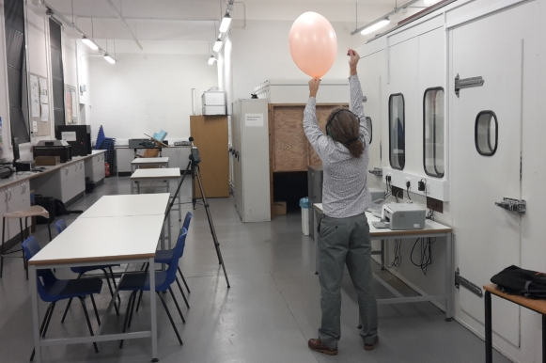

Figure 1. Balloon pop being used to obtain an impulse response of the LSBU acoustics laboratory

There is limited information in the literature reporting the suitability and reliability of the air-filled balloon pop as a sound source to obtain room acoustics parameters. In a comparative study Horvart et al [6] contrasted the peak SPL and spectra produced by firecrackers and balloons of three sizes. However, they failed to provide information on the number of samples used or repeatability of results. Cheenne et al [7] observed that the balloon diameter on its own is not a good predictor of radiated energy or spectrum. They defined a diameter factor (DF) in an attempt to overcome the variability of balloons due to resulting sizes and shapes when inflated. However, this study did not provide details on the balloons utilised and repeatability of results.
A more complete study undertaken by Pätynen et al [8], studied the directivity and spectral content of various sizes of air-filled balloons bursts measured in an anechoic chamber. The study provided details of average peak SPL values and repeatability information for different balloon sizes. However the number of samples for some sizes was insufficient to report reliable repeatability. The study did not investigate the effect of repeatability on any room acoustic parameter.

International standard ISO 3382-1:2009 [9] lists specifically the sound produced by pistol shots, spark gaps and unspecified noise bursts as examples of impulse sounds that can approximate sufficiently to an ideal impulse sound for practical purposes. The balloon pop is not mentioned in the relevant test standards ISO 3382-2:2008 [10] and in ISO 18233: 2006 [11]. It appears only explicitly mentioned in ISO 354:2003 [12] as potentially suitable impulse source for the measurement of sound absorption in a reverberation room.

The aim of this study is to determine and assess the repeatability of results from impulse responses obtained from air-filled party balloon pops as employed in field room acoustics testing.
It is expected that this study will inform practitioners on the level of reliability and suitability of the balloon pop as a sound source when selecting methods for obtaining room acoustics parameters.

experimental procedure
The repeatability of the air-filled balloon pop as an impulse sound source is evaluated based on the standard deviation (σ) values from sound pressure peak levels of SPL (Lpeak), spectral distribution and Reverberation Time (RT30) measurements obtained from bursts of two common balloon sizes samples.
Most of the experimental procedure is intended to simulate representative conditions of room acoustics measurements undertaken in the field.

The sound source
Two common sizes of readily available party latex balloons from the same manufacturer and same batch were selected as representative impulse sound source samples. The regular size has a maximum nominal inflated diameter stated by the manufacturer of 23cm and the big size of 38cm. To provide a reliable sample for statistical analysis, fifteen valid bursts were produced for each balloon size.
Party balloons of the same size and same batch can exhibit large inconsistencies in their physical characteristics when inflated.
These inconsistencies in fabrication typically cause balloons of same maximum nominal size to show different shapes and diametric sizes when inflated at the same level. Due to the same inconsistencies, it is common that when balloons of the same size and batch are inflated to the same maximum level, some explode spontaneously soon after having been inflated and other remain inflated.
An electrical balloon pump was used for inflation. To avoid spontaneous bursts and unwanted deformations due to excessive inflation, a practical step wise and observation time method was devised to determine the maximum safe level of inflation for each size.
To ensure that same level of inflation was provided to each balloon, a digital pressure manometer was used to measure internal pressure and a measuring tape to measure the balloon circumference at the approximate equatorial line. Distances were measured with a laser meter and weight with a precision scale. Table 1 shows the variability in physical characteristics and internal pressure when balloons were inflated to the same maximum safe inflation level.

Table 1: Physical characteristics and internal pressure variability of balloon samples used
Size type | Sample (n) | Weight (g) | Pressure differential with atmospheric (mbar) | Measured Circumference (cm) | Calculated diameter (cm)
Regular | 15 | 1.89 – 2.18 | 24.6 – 38.0 | 54.6 – 68.4 | 17.4 -21.8
Big | 15 | 9.73 – 10.73 | 27.2 – 42.3 | 114.9 | 36.6

To secure a fixed source position for the balloon samples, a string hanging from the ceiling was weighted down to the floor attaching the balloon mouth knot at a 1.5m from the floor (see figure 2). The nearest walls to the balloon fixed position were at 3.3m and 2.1m.

The room and the receiver
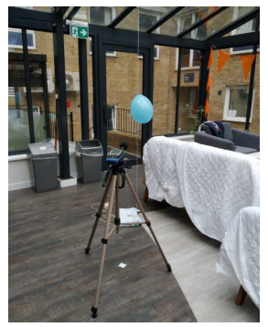
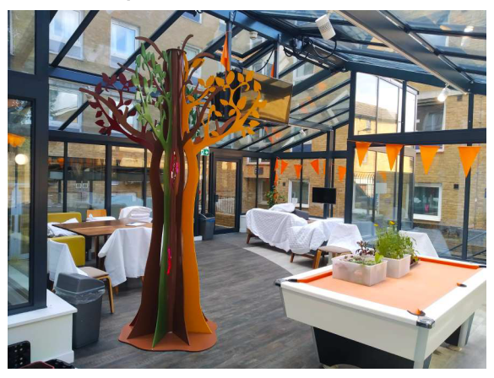
The room where all balloons samples were burst is a large social space (lounge) of 173m³ featuring a non-rectangular floor plan and a pitched ceiling. All the boundaries expect the laminated raised floor. Internal contents included padded sofas and chairs as well as a snooker table (see figure 2).
Figure 2. Left: room used; Right: balloon sample in position and sound level meter at 3m away

The receiver instrumentation consisted of: a calibrated NTI XL2 class I sound level meter (SLM) [( Pre Amplifier MA220+ microphone capsule (M2211)] fully compliant with ISO 61672-1:2013 [13], a calibrated computer based room acoustics measurement platform formed of a laptop PC loaded with ARTA v1.9.3 measuring software and an Earthworks M30/BX class I omnidirectional microphone.
The fixed receiver position was located at 3m from the source (see figure 2 right). This distance well away from the proximity of the bursts was chosen to avoid potential non-linear effects, overload on the receiving instrumentation and to represent typical room acoustics IR measurements.
The SLM microphone and Earthworks microphones were placed at the receiver position side by side (not shown in figure 2). The SLM measured Lpeak for each balloon burst while simultaneously the measuring platform captured the impulse responses from which RT30 and the spectral distribution was obtained.

Measurement procedure
Balloon samples were punctured on their equatorial line by a pointing needle attached to a rod which the researchers used to prick the balloon from a distance of 2m so to avoid reflections from the person pricking the balloon (see figure 3, left).
Fifteen valid bursts were produced for each balloon size type during the course of two hours test session.

results and analysis

Environmental conditions
Stable environmental conditions in the room during the course of the session were estimated to be approximately the same as outdoor conditions on the day and time of testing. Temperature ranged between 17°C to 20°C at 51% of relative humidity and atmospheric pressure stable at 1020mbar.
Typical broadband overall values of background noise measured for 20 seconds during the test session were LAeq= 48.0dB, LZeq= 57.8dB. This suitable low background noise remained consistent during the course of the tests.
No unexpected continuous or transient noisy events occurred during the tests. Hence it was established that background noise conditions did not contaminate measurements of the target parameters. Figure 3 (right) shows the typical background noise spectrum (LZeq) experience during the course of the test session.

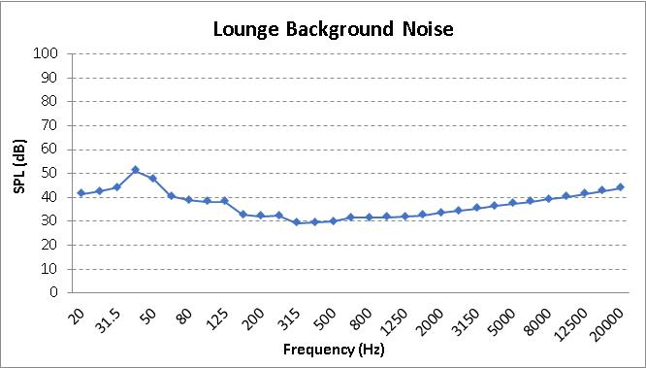
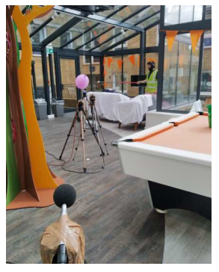
Figure 3. Left: Puncturing a balloon from 2m distance. Right: Typical background noise spectrum

Repeatability
Table 2 and table 3 show Lpeak average values and standard deviation (σ) values for the two sizes types against relevant results found in the literature. Lpeak values from literature have been referenced to 3m source-receiver distance of this study.
In the tables it can be seen that standard deviation was equal for the two size types. This close match suggests that Lpeak repeatability was independent of the balloon size. These values can be considered relatively low in related to the variability limits indicated in the international standard on SLM specifications [13].

Standard deviation for the regular size agrees well with values from Pätynen; while results for the big size from Pätynen show a higher standard deviation most likely produced by the small sample used in that study. Values from Pätynen show a substantial increase for a size increase similar to this study.

For the three sources of data shown in tables 2 and 3 it can be seen that Lpeak increases with balloon size. This general trend also seen in the literature [6][7][8] is however a non-linear relationship which depends at different degrees on several other factors.

Table 2: Regular and comparative sizes’ average Lpeak and repeatability

Source | Space | Diameter (cm) | Sample (n) | Average Lpeak (dB) | σ (dB)
this study | Lounge | 17.4-21.8 | 15 | 120.6 | 2.4
Pätynen | Anechoic | 18±1 | 30 | 129.9 | 2
Horvart | Anechoic | 15 | N/A | 123.8 | N/A

Table 3: Big and comparative sizes’ average Lpeak repeatability

Source | Space | Diameter (cm) | Sample (n) | Average Lpeak (dB) | σ (dB)
this study | Lounge | 36.6 | 15 | 129.1 | 2.4
Pätynen | Anechoic | 39-40 | 3 | 131.1 | 3.5
Horvart | Anechoic | 25 | N/A | 125.4 | N/A

Figure 4 shows that the standard deviation of the spectral distribution obtained from the fifteen impulse responses sample is equally high for both balloon sizes. The standard deviation averaged across the frequency range is the same value (2.7dB) for both balloon size types. This equivalence confirms the previous finding above that showed that repeatability is independent on the size type. The high spectral distribution repeatability seen in figure 4 agrees well with other studies [8].

As expected and as seen in other studies [6][8], the larger size type generated higher SPL levels across the frequency range. The shape of the spectra for both sizes was similar to each other and to results from other investigations [6][8]. It can be seen that both size types were able to generate sufficiently high levels at low frequency bands.

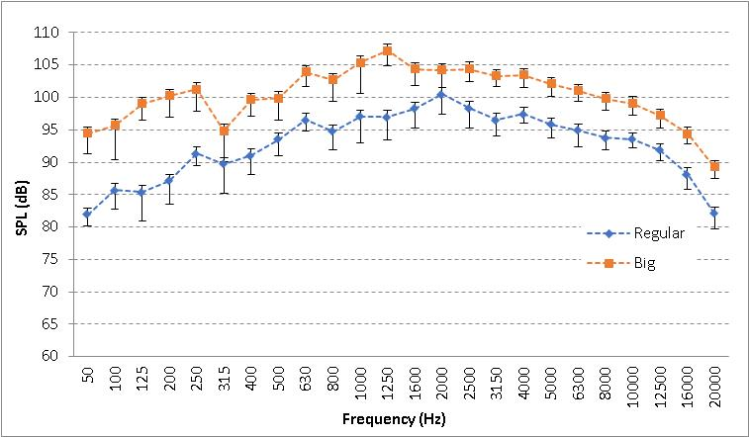

Figure 4. Average spectra for the two size types. Error bars show standard deviation (σ)

Figure 5 shows RT30 averaged values from impulse responses obtained from 15 balloon bursts for each size type. One standard deviation (σ) is shown as an error bars on each data point within the frequency range of interest.

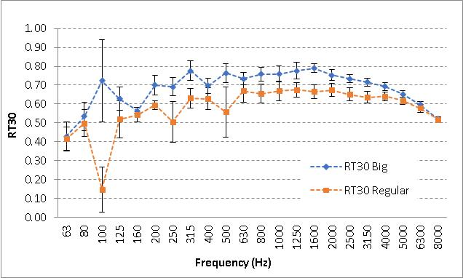

Figure 5. Mean RT30 values from impulse responses. Error bars show standard deviation (σ)

In figure 5 it can be seen that RT30 σ across most of the frequency range were relatively low for both sizes ( mean σ excluding 100Hz band = 0.04dB for big and 0.05dB for regular). These values are comparable to other studies [14][15] and considered acceptable for good RT agreement among different excitation sources. In general most of the values of standard deviation shown in figure 5 are around the Just Noticeable Difference (JND) indicated in ISO 3382-1 [9] of 5% for reverberation metrics. In general RT30 σ values were similar for the two sizes which suggests that RT30 repeatability is independent of the balloon size. This agrees with the strong agreement of Lpeak σ values between the two sizes seen above (table 2 and 3)
As expected for low frequency bands, and seen in other studies [8][14][15], values at these bands were slightly higher than for higher frequency bands. The 100Hz band showed an anomalously high values of σ particularly for the big size. The regular size showed slightly higher values at 250Hz and 500Hz bands than the big size values.

Average values of RT30 across the frequency range for the big and regular sizes in figure 5, presented an overall matching shape; however regular size values were lower than the big size ones. Across the frequency range (excluding 100Hz anomalous result) the regular size results were lower than the big size ones. The average of differences between the two sizes results was 0.08sec and the median 0.08sec. These differences are considered in other studies small for a good agreement of RT results among different sound sources [5][14] and below the inherent variations in the measurement.

From inspecting average values in figure 4 and 5, the individual measurements and signal to noise ratio (SNR) of the impulse responses, it appears that both balloon sizes were able to excite the room sufficiently at lowest frequencies bands (excluding 100Hz anomalous result) to obtain correct and repeatable RT30 values at those bands. This was possible due to the low background noise present in the room during the tests at the low frequency bands (figure 3, left). Spectral content data on similar balloons used in other studies [6][7][8] suggest that similar sizes can produce sufficient sound energy at the low frequency bands reported here.

conclusions
- The air-filled balloon pop used as impulse sound source has showed acceptable values of repeatability when evaluated on Lpeak, spectral distribution and RT30 parameters.
- For these parameters, repeatability appeared to be independent of the balloon size.
- Spectral distribution repeatability was consistently high across the frequency range for both sizes.
- In general, the repeatability found in this study is comparable with results from other investigations in the literature.
- The present initial study on repeatability of the balloon burst is intended to be continued and expanded to include other balloon sizes, different type of rooms, more receiver locations and to evaluate more acoustics parameters.

References
1. L. Gomez-Agustina, J Barnard, Practical and technical suitability perceptions of sound sources and test signals used in room acoustics testing, Proc. Internoise, Madrid (2019).
2. G. Iannace, A. Trematerra, The acoustics of the caves. Appl. Acoust., 86, 42–46, (2014)
3. R. San Martín, M. Arana, J. Machín, and A. Arregui, Impulse source versus dodecahedral loudspeaker for measuring parameters derived from the impulse response in room acoustics, The Journal of the Acoustical Society of America, 134 (1), pp. 275-284. (2013)
4. J. S. Abel, N. J. Bryan, P. P. Huang, M. Kolar, B. V. Pentcheva, Estimating room impulse responses from recorded balloon pops, Audio Engineering Society Convention 129, Audio Engineering Society, (2010)
5 P. Fausti and A. Farina, Acoustic measurements in opera houses: Comparison between different techniques and equipment, Journal. Sound Vibration. 232(1), 213–229, (2000)
6 M. Horvat, K. Jambrosic, and H. Domitrovic. A comparison of impulse-like sources to be used in reverberation time measurements, Proceedings of the Acoustics’08, Paris, France (2008)
7. D.J. Cheenne, M. Ardila, C.G. Lee, A qualitative and quantitative analysis of impulse responses from balloon bursts. J. Acoust. Soc. Am, 123, 3909 (2008)
8. J. Pätynen.B. Katz, T. Lokki, Investigations on the balloon as an impulse source, Journal of the Acoust. Soc. Am, 129 (1), (2011)
9. International Organization for Standardization, ISO 3382-1:2009 Acoustics- Measurement of room acoustic parameters. Part 1: Performance spaces. Geneva, Switzerland (2009)
10. International Organization for Standardization, ISO 3382-2:2008 Acoustics- Measurement of room acoustic parameters. Part 2: Reverberation time in ordinary rooms. Geneva, Switzerland (2008)
11 International Organization for Standardization, ISO 18233:2006 Application of new measurement methods in building and room acoustics. Geneva, Switzerland (2006)
12 International Organization for Standardization, ISO 354:2003 Acoustics- Measurements of Sound absorption in a reverberation room. Geneva, Switzerland (2003)
13. International Organization for Standardization, ISO 61672-1:2013 Electroacoustics, Sound level meters, Part 1 Specifications Acoustics-. Geneva, Switzerland (2013)
14 A. James. “Results of the NPL study into comparative room acoustic measurement techniques. Part 1. Reverberation time in large rooms,” Proc. Inst. Acoust. 25, 4 (2003)
15. K. Jambrosic, M. Horvat, H Domitrovic, Reverberation time measuring methods. Journal of the Acoust. Soc. Am., 123, 3617 (2008)

