‘Staying Alive’: The Impact of ‘Austerity Cuts’ on the LGBT Voluntary and Community Sector (VCS) in England and Wales

A TUC Funded Research Report

Fiona Colgan, Chrissy Hunter and Aidan McKearney,
Faculty of Business and Law,
London Metropolitan University

26th June 2014

Acknowledgements

We would like to thank the TUC for commissioning this study, particularly Peter Purton, Policy Officer at the TUC for his input and support throughout the research process.

In addition we would like to thank our colleagues, Ashlee Christoffersen and Jane Standing at centred and Paul Roberts from the Consortium of LGBT Voluntary and Community Organisations whose cooperation and assistance throughout the project has been invaluable.

Finally our special thanks go to the 184 LGBT VCS organisations who took the time to respond to the survey and the 21 LGBT VCS respondents who participated in the interviews. We hope that both they and the TUC will find this research report useful.
Contents

Page

Acknowledgements 3

Executive Summary 8

1 Introduction 18

1.1 ‘Austerity cuts’ 18
1.1.1 Coalition government’s ‘austerity drive’ 18
1.1.2 Impact on local government funding 19
1.1.3 Ramifications for the LGBT VCS 20
1.2 Research objectives 20
1.3 Research methodology 21
1.3.1 The survey 21
1.3.2 In-depth Interviews 22

2 LGBT VCS Sector: 24
‘Making life safer, fairer and more just for LGBT people’

2.1 LGBT VCS activities 24
2.2 Structures 25
2.3 Specific contribution 25
2.3.1 Providing services and activities to meet needs of LGBT communit(ies) 25
2.3.2 A source of expertise for the broader community 27
2.3.3 Making the case for specialist LGBT provision 28

3 Current Funding: 30
‘LGBT work is already funded disproportionately badly’

3.1 Organisation income 30
3.1.1 New community of identity organisations: income and growth 32
3.2 Income source 32
3.2.1 Public/statutory sector still major source of funding 32
3.2.2 Diversification of funding sources 33
3.3 Funding partnerships 36
3.3.1 Partnership working to improve services to LGBT people 36
3.3.2 Partnership working with non-LGBT organisations to ensure 38
LGBT ‘voice’ in provision
3.3.3 Partnership working to protect LGBT services 39
3.3.4 Partnership working: drawbacks and concerns 39

4 Changes in Funding: 41
‘Everything is up in the air- it’s hard to plan anything’

4.1 Funding: London LGBT VCS organisations 41
4.2 Funding: LGBT VCS organisations outside London 42
4.3 Political and legal issues 44
4.3.1 Varying levels of commitment to funding LGBT services/activities 44
Page

4.3.2 Difficulties and opportunities posed by the ‘Localism agenda’ 45
4.3.3 Protection afforded by the Equality Act (2010) 47

5 Funding Changes: Impact on Staff and Resources: 49
‘I can’t see any light at the end of the tunnel’

5.1 Impact on paid staff 49
5.1.1 Staffing in London LGBT VCS organisations 49
5.1.2 Staffing in LGBT VCS organisations outside London 50
5.1.3 Cuts leading to organisation restructuring, job loss and reduced hours 50
5.1.4 Anticipated future cuts leading to further restructuring and job insecurity 51
5.1.5 Funding contracts leading to worsening staff terms and conditions 52
5.1.6 Increased stress, staff turnover and loss of expertise 53
5.2 Availability of office/meeting space 54
5.2.1 Improvement: office/meeting space 56
5.2.2 Problematic: office/meeting space 56
5.2.3 About the same: office/meeting space 56
5.3 Increasing numbers of active volunteers 57
5.3.1 Volunteers: survey evidence 57
5.3.2 Volunteers: in depth interviews 58

6 Funding Changes: Impact on Service Delivery: 60
It’s fight your way out of difficulty rather than submit’

6.1 Service delivery: increased demand 60
6.2 Impact of funding cuts on services 60
6.3 Meeting organisational mission? 62
6.4 Impact on service delivery: in depth interview responses 63
6.4.1 Cutbacks in service delivery and training 63
6.4.2 Increased demand and more complex needs 64
6.4.3 Tighter funding requirements: decline in service provision and quality 65
6.4.4 Not being able to develop to meet the needs of the LGBT communi(ies) 67
6.4.5 Reduction in LGBT Visibility 68

7. Looking to the Future: 70
‘Staying alive?’

7.1 Survey evidence: attitudes 70
7.2 In depth interviews 71
7.2.1 Situation will improve 72
7.2.2 Situation will not change 72
7.2.3 Don’t know what will happen 73
7.2.4 Situation will worsen 74
7.2.5 Other 75
7.3 Moving Forward 75

Appendices 77
Figures and Tables Page

Table 1.1 LGBT VCS organisations outside London: Area of geographic 22
operation
Figure 3.1 Organisation income: All LGBT VCS organisations 30
Figure 3.2 Organisation income: LGBT VCS organisations – geographical 31
breakdown
Figure 3.3 Organisation income sources: All LGBT VCS organisations 33
Figure 3.4 Organisation income Sources: LGBT VCS organisations 34
– geographical breakdown
Figure 3.5 LGBT VCS by funding partnerships and geographical location 37
Figure 4.1 Public funding increased/decreased: LGBT VCS outside London 43
Figure 5.1 Organisations with Paid staff: LGBT VCS organisations 49
– geographical breakdown
Figure 5.2 Change to paid staff: LGBT VCS organisations outside London 50
April 2012- March 2013
Figure 5.3 Regular and Reliable Office/ Meeting Space: All LGBT VCS 55
Figure 5.4 Regular and Reliable Office/ Meeting Space: London 55
Figure 5.5 Regular and Reliable Office/ Meeting Space: Outside London 55
Figure 5.6 Change to volunteers: LGBT VCS organisations outside London 58
April 2012- March 2013
Figure 6.1 Service users/participants: LGBT VCS organisations outside 60
London April 2012-March 2013
Figure 6.2 Service Cuts Following Funding Cuts: All LGBT VCS 61
Figure 6.3 Service Cuts Following Funding Cuts: Geographical Location 61
Figure 6.4 Meeting Organisational Mission: All LGBT VCS organisations 62
Figure 6.5 Meeting Organisational Mission: LGBT VCS organisations 62
– geographical breakdown
Figure 7.1 Looking to the Future: All LGBT VCS organisations 70
Figure 7.2 Looking to the Future: LGBT VCS organisations 71
– geographical breakdown
Executive Summary: Key Findings
1. In the context of the austerity cuts the LGBT VCS has been affected by changes in levels of local government funding, and by welfare, health service and education reform. These cuts and reforms are ongoing and the full impacts have not yet been felt.

2. As LGBT service organisations have historically needed to rely on a relatively high level of public/statutory funding and support from such bodies they are particularly vulnerable when such cuts and reforms are being enforced.

3. Despite the introduction of the Equality Act 2010 and changing social attitudes, discrimination still affects LGBT people in England and Wales. Thus demand for LGBT services is still high and in some cases rising. Demand exists for LGBT services in general and specifically from different communities of interest (e.g. trans*, bisexual, BME, people with disabilities and so on). There are also differing needs to be met amongst urban and rural LGBT populations.

4. LGBT VCS organisations also provide expertise to non-LGBT public, private and voluntary sector bodies who want or need to raise awareness of LGBT, broader equality and diversity and sexual health issues.

5. Estimates that only 0.04% of overall voluntary sector income goes to the LGBT VCS supports the claim that it is underfunded in this respect. Public/statutory sector funding contributed 50.5% of funding to the LGBT VCS for the year ending March 31st 2013. The other main streams are from individuals (17.8%), National Lottery (16.5%), independent trusts/foundations (12.1%) and the private sector (0.9%).

6. Reductions in funding from the public sector mean that LGBT VCS organisations are having to diversify their search for funding. This is placing already constrained staffing resources under more pressure. Further difficulty is being experienced as more organisations are required to compete for a reduced pot of money and less established organisations are experiencing greater difficulty fundraising in this environment.

7. The direct effects of the cuts on organisations are reported as being increased difficulty in planning, using reserves to cover shortfalls in the short term, cuts to or reductions in services and service levels, reduced staffing levels including loss of posts, reduction in level of terms and conditions, moves to part time work for previously full time staff or increased reliance on volunteers. This has led to loss of morale, higher staff turnover and concomitant reduction in provision of expertise. There have also been impacts on provision of premises, whether through reduction of time available for meetings or service user access, or loss of premises altogether.

8. The above difficulties are taking place at a time of increased demand and complex needs when general provision and support is being reduced for LGBT service users.

9. In considering the future although a majority of respondents expressed the hope that things would either improve (34%) or not change (27%), a significant number were pessimistic (16%) or uncertain (19%). Responses varied with large and medium organisations considerably less optimistic than small and micro organisations. Most respondents cited the financial year 2015/16 as the ‘crunch’ year for the LGBT VCS.
1 Introduction

1.1 Austerity cuts
This report was commissioned by the Trades Union Congress to examine the impact of ‘austerity cuts’ on the LGBT voluntary and community sector (VCS). The term ‘austerity cuts’ refers to the reductions made to public spending in order to reduce the financial deficit. The Conservative-Liberal Democrat Coalition government elected in May 2010 produced an ambitious deficit reduction plan with a target to reduce the financial deficit via a programme of planned spending cuts by 2015. Although claims of a recovery are being made by the government, counter claims suggest that any recovery isn’t helping the poorest and neediest.
1.2 NHS, education and local government
The Coalition’s ‘austerity drive’ has involved a substantial reduction in funding available to or via government departments, and a reduction in overall public-sector employment of almost 8% since 2009. An integral component of the austerity drive has been a complete review of welfare spending, which has driven changes to many aspects of the welfare system. There have been changes to the NHS in England, transferring responsibility for public health from the NHS to local government. Education policy has reduced local authority control of education provision by encouraging the expansion of academies and free schools. Local Government has seen a particularly severe reduction in funding as a consequence of the austerity drive. This radical central government programme has created a complex, changing environment for public service and VCS organisations.
1.3 Broad effect of cuts
With much of the potential for ‘efficiency savings’ already exhausted, the Local Government Association (LGA) concluded any further cuts will mean that councils will be unlikely to meet all of their statutory responsibilities with respect to the delivery of front line services. Further, the LGA report suggests that the most difficult decisions on local cuts are likely to begin to bite in the year starting April 2015.
1.4 LGBT sector
The ramifications of these austerity cuts is particularly pronounced for the voluntary and charity sector given that public/statutory funding provides such a large and important proportion of overall income. Given the historical reliance of LGBT VCS bodies’ reliance on this form of funding they and their already more than averagely impacted service users are particularly vulnerable.
1.5 Research methodology
The research was organised with the assistance and collaboration of centred and the LGBT Consortium. It used two methods to collect data from the LGBT VCS:
- a survey of LGBT VCS organisations in England and Wales
- twenty one in-depth interviews with LGBT VCS organisations.
2 LGBT VCS Sector
2.1 LGBT VCS organisations
The report details the scope of 123 LGBT VCS organisations which said they raised funds or had income. It lists the 5 most commonly cited structures, comparing organisations in London and the rest of England and Wales.
2.2 Organisations’ contributions to LGBT service users
LGBT VCS aim to provide ‘community’, safe spaces and appropriate services, activities and support for service users. Provision is made either on a broad LGBT basis or on a ‘community of interest’ basis representing and addressing the specific concerns of bisexual, BME, disabled, gay men, lesbian, trans*, young or older service users. The urban/rural divide is also highlighted.
2.3 A source of expertise for the broader community
LGBT VCS organisations also provide expertise, education and training to other public, private and voluntary sector bodies who want to raise awareness of LGBT and sexual health issues. While such bodies are keen to draw on the available expertise there is often a limit on available funds to pay for such input which poses a problem for the cash-strapped LGBT VCS organisations.
2.4 Making the case for specialist LGBT provision
Such input at policy forums and with funding commissioners was viewed as crucial to tackling a lack of awareness of the specific needs of LGBT people plus the difficulties many experience in accessing ‘mainstream’ services. This was an ongoing struggle in a climate of austerity cuts where an argument was perceived to be emerging that following the introduction of the equality legislation and shifts in social attitudes, LGBT people no longer required specialist LGBT services.

3 Current Funding
3.1 Organisation income
The 102 organisations that provided income data were categorised into five income levels: nil (13.7%), micro – less than £10,000 (41.2%), small – over £10,000 but less than £100,000 (23.5%), medium – over £100,000 but less than £1,000,000 (19.6%), and large – over £1,000,000 but less than £10,000,000 (2%). The data presented seems to support claims from those in the LGBT VCS sector that it is not funded proportionately in terms of the LGBT population and its needs. However, the ongoing lack of official, reliable data on the LGBT population in the UK presents a problem in trying to measure and analyse this. In this context it is useful to note that the LGBT Consortium estimates its members’ income forms just 0.04% of overall voluntary sector income. Newer organisations some of which are community of interest groups, reported particular difficulty in accessing funding in the current austerity climate.
3.2 Income source
The breakdown of funding sources shows that funding from the public/statutory sector (including contracts) was the major source of funding for the LGBT VCS in England and Wales, accounting for £3,892,173 (50.5%) of income to the sector in the year ending 31st March 2013. The other four main sources of funding came from individuals £1,369,766 (17.8% including income from fundraising events, donations, membership fees, sale of goods, legacies, room hire etc); National Lottery distributors £1,269,296 (16.5%); Independent trusts & foundations £933,473 (12.1%) and the private sector £66,395 (0.9%). Other sources of income included partnership, one-off payments and secondment fees.
3.3 Diversification of funding sources
Interviews with the LGBT VCS organisations found that they were all making considerable efforts to diversify their funding sources in order to offset public/statutory funding cuts and protect services. LGBT VCS organisations were therefore having to spend more staff time on fundraising. A particular benefit of fundraising via this route is the ‘unrestricted’ nature of the funds raised which can be used for ‘core’ running costs which are often not included in the ‘pared-back’ contracts available from the public sector or the project specific funding available from the Lottery and trust sector. Most of the LGBT interviewees reported the non-provision of ‘core’ costs by funders as problematic for their organisations. Concerns were also raised about funding from non-LGBT sources and the fact that success rates for funding applications were perceived to be at a historically low level. The need to engage with commercial and trade union sponsorship was also acknowledged.
3.4 Funding partnerships
LGBT VCS organisations said there was an increasing pressure to bid for funding via funding partnerships in the current climate. Just under one in 5 LGBT of the 123 VCS organisations (19%) said that they were currently in funding partnerships with other LGBT organisations. One in 7 (14%) said they were currently in funding partnerships with non-LGBT organisations. LGBT VCS interviewees said they had taken up partnership working with other LGBT organisations to improve services to LGBT people; Funding partnerships with non-LGBT organisations were seen as a way of bidding for a broader range of work by ‘pooling expertise’ with appropriate organisations. Doing so could ensure that LGBT needs were considered throughout the bidding and delivery process on a broader range of projects. Although LGBT VCS were clearly open to funding partnerships where appropriate, a number of concerns were expressed about being ‘forced’ into funding partnerships, in order to secure funding. Finally, a fear expressed by some was that funders by encouraging funding partnerships had an underlying restructuring and merger agenda for LGBT VCS organisations.

4 Changes in Funding
Data on changes to funding was collected via a joint survey. London based LGBT VCS organisations were surveyed using centred’s LGBT VCS Almanac survey questions on funding in order to allow centred to build its database on the London LGBT VCS sector. The TUC survey sought additional data on funding changes from all LGBT VCS organisations across England and Wales plus historical data for the LGBT VCS sector outside London.
4.1 Funding: London LGBT VCS organisations
Using Almanac data, centred (2014) concluded that although the LGBT VCS sector’s income rose between 2009/10 and 2010/11, its income has fallen consistently since 2010/11. Further analysis indicated that LGBT VCS organisations reliant on the public sector for much of their income had taken a ‘real and significant’ hit between 2009/10 and 2013. Funding diversification plus the receipt by a number of organisations of ‘Transition Funding’, was argued by centred (2014) to be masking real reductions in public sector funding to LGBT VCS organisations in London. In addition, it concluded that the London based LGBT VCS sector appeared to be in a ‘period of high spending of reserves’ .
4.2 Funding: LGBT VCS organisations outside London
Over a quarter of LGBT VCS organisations outside London (29%) said that their income had declined between April 2012 to March 2013. As in London, LGBT VCS organisations were using reserves to maintain services where income had fallen or stayed the same at a time of increasing demand for services. One in five LGBT VCS respondents outside London said public sector funding had decreased, slightly less than half said it had not changed and one in 5 that it had increased. As with London-based organisations, 2015 was expected to be the ‘crunch year’ for cuts to public/statutory funding. However, some organisations reported losing public funding during 2013/14. One particularly problematic area was the shift in public health funding from the NHS to local government particularly where no transitional arrangements were in place. The speed of public sector cuts and changes in some localities was reported to be causing funding shortages and making it difficult to plan and organise funding and spending.
4.3 Political and Legal issues: commitment to funding LGBT services
During the LGBT VCS interviews it became apparent that commitment to funding LGBT activities and services varied within government departments and across local authorities in England and Wales. At local government level, although some councils were reported to have made considerable progress in becoming ‘LGBT friendly,’ others were perceived to be ‘dragging their heels’.

4.4 Difficulties and opportunities posed by the localism agenda
This perceived variation in commitment to LGBT provision was particularly important in light of the government’s ‘localism agenda’ and its implications for funding LGBT services and activities during a climate of austerity cuts in local government. One concern LGBT VCS interviewees raised was that as seen above local authorities may not want to fund specialist LGBT services. Another view was that LGBT people who do not wish to be to be ‘outed on their own doorstep’ may prefer to travel for specialist LGBT services which can only be provided on a city wide or county wide basis. LGBT VCS interviewees report that local authorities seem less open to cross-border working so jeopardizing these specialist LGBT services. An additional concern was how to tackle the changing funding structures. This included for example the increasing requirement to apply to a number of different funders (e.g. local authorities, schools) where previously only one bid to a funding body for cross border working may have been required.
4.5 Protection afforded by the Equality Act (2010)
During the interviews LGBT VCS participants said they had used the Equality Act in promoting awareness of LGBT issues and reminding public bodies of their duty to ensure appropriate levels of funding for LGBT services. Respondents said they aimed to do this in a positive manner, although in a few cases it was reported that threats of legal action had been required over the last two years to fight funding cuts to LGBT services. However, a lack of LGBT monitoring data in the UK meant it could be hard to hold public bodies to account. A growing view was that in part because of a lack of official monitoring data, LGBT work was disproportionately underfunded in many areas and that further public/statutory cuts were going to make the situation worse.
5 Funding Changes: Impact on Staff and Resources
5.1 Impact on Paid Staff
According to the survey, fifty three (43%) of the 123 LGBT VCS organisations had paid staff, 70 (57%) did not. A higher proportion of the LGBT VCS organisations based outside London had paid staff (46%) than those based in London (41%).
5.2 Staffing in London LGBT VCS organisations
In total there were 252 people employed in the London based LGBT VCS organisations, 132 (52%) of these were full time and 120 (48%) were part time. centred, found that the number of paid staff in the London LGBT VCS sector had decreased by 3% between 2010 and 2013. In addition, it reported that the ratio of full time to part time staff had changed from 1:04 in 2010 to 1:1.3 in 2013.
5.3 Staffing in LGBT VCS organisations outside London
Outside London, there were 174 people employed in LGBT VCS organisations, 80 (46%) of these were full time and 94 were part time (54%). Thus although a higher proportion of LGBT VCS organisations outside London had paid staff a higher proportion of these paid staff were part time. Of the organisations 17% said the number of their paid staff had increased 2012/2013, 15% said the number of paid staff had decreased. Nearly two thirds said there had been no change thus far.
5.4 Cuts leading to organisation restructuring, job loss and reduced hours
The interviews confirmed that public funding cuts had already resulted in restructuring leading to job loss in just under half of the organisations interviewed. One LGBT VCS organisation’s staff had been reduced drastically from 14 to 1.7 FTE over a period of 2 to 3 years. At least nine other organisations said they had restructured, made redundancies and/or reduced working hours as a consequence of post-election cuts to public spending. Even where staff had not been made redundant, a number of organisations admitted that in order to protect services they had reduced staff hours.
5.5 Anticipated future cuts leading to further restructuring and job insecurity
Most LGBT VCS interviewees thought that the worst of the public sector cuts was still to come. Some were already aware of the cuts they faced in 2014/15. Others, said they felt the cuts looming over them. As they saw organisational resources dwindle they reported feeling trapped in a perpetual cycle of cuts, reorganisation and rather desperate fund raising in order to keep services going. The situation could be particularly difficult where the CEO had been made redundant or was only paid for two days a week. This required a range of management responsibilities, including fundraising to be dispersed amongst an already stretched staff group.
5.6 Funding contracts leading to worsening staff terms and conditions
LGBT VCS organisations attending meetings about new areas of funding, expressed concern about the viability of new contracts as these seemed to expect ‘more for less’. Another area of concern was declining staff terms and conditions. However, the degradation of terms and conditions was expected to progress further in what was viewed as a ‘race to the bottom’ in the commissioning process. The insecurity of funding had led to the introduction of short term contracts and the expansion of zero hours contracts which was thought to be both unfair to staff and not conducive to service quality. In the new contract and project funding climate, it was agreed that staff were having to do ‘more for less money.’ A move away from specialism to generalism at work was also viewed by some as a necessary evil in the new funding climate.
5.7 Increased stress, staff turnover and loss of expertise
Both managers and employees spoke of the increased levels of stress caused by both the climate of uncertainty and increasing workloads. Some VCS organisations spoke of the efforts they made to retain good practice and safeguard staff terms and conditions where possible. Despite these efforts, staff were recognised to be facing increasing pressures at work. As public sector cuts ‘loomed,’ this exacerbated staff turnover and the sector was reported to be losing specialist expertise as people left the LGBT VCS in pursuit of job security.
5.8 Availability of office/meeting Space
The survey asked LGBT VCS organisations if they had a regular and reliable office or meeting space to conduct their activities. All 123 organisations responded to this question with over two thirds (69%) reporting that they did but just under a third (31%) saying that they did not. A lack of office or meeting space was reported by just over 1 in 3 (37%) London-based organisations as against just under 1 in 4 (23%) of the organisations based outside London. London-based organisations therefore indicated increasing difficulty in accessing free or affordable space to meet and/or hold activities as public bodies such as local authorities and schools had begun to charge for the use of facilities. One in five LGBT VCS organisations outside London said that availability of space had become problematic in 2012/13.
5.6 Increasing numbers of active volunteers: survey evidence
In response to the survey, seventy two (59%) LGBT VCS organisations said they had active volunteers (that volunteer once per month). Over three quarters (78%) of the London based organisations had volunteers whereas less than half (46%) of LGBT VCS organisations outside London said they did. There was reported to have been an increase of 8% in the number of volunteers in the LGBT VCS sector in London and a 15% increase in the total hours that volunteers contributed. LGBT VCS organisations outside London also reported an increase in volunteers. Over half of the organisations reported that volunteer numbers had increased, 31% that levels had stayed the same with only 14% saying numbers had decreased.
5.7 Volunteers: in depth interviews
LGBT VCS organisations were keen to increase volunteers where appropriate. However, volunteers needed to be viewed as complementary to rather than as replacing paid staff. Thus there was concern that some funding commissioners and politicians seemed to see volunteers as a ‘cheap option’ to running services and the provision of administrative or other support roles. Where LGBT VCS reported reduced staffing because of public sector cuts, then too often remaining staff could be expected to support volunteers which was not always ideal for either party.

6. Funding Changes: Impact on Service Delivery
6.1 Service delivery: increased demand
A majority of the LGBT VCS organisations responding to the survey reported that the number of service users and/or participants in their activities had increased over the last year. centred reported an increase of 6% in service users/participants between in London-based LGBT VCS organisations between 2011/2012 and 2012/13. Most LGBT VCS organisations (81%) outside London reported that user/participant numbers had increased, 14% said numbers had remained unchanged with only 2% saying that numbers had decreased between April 2012 and March 2013
6.2 Impact of funding cuts on services
The survey asked all of the LGBT VCS organisations (London and outside London) which had experienced a decrease in funding in 2012/13 whether they had had to cut back on services/activities. Of those who thought the question applied to them 26 (27%) of the 96 LGBT VCS organisations said they had made service cuts following a decrease in funding. Fifteen (16%) organisations said they had managed to keep services going despite funding cuts.
6.3 Meeting organisational mission
The survey asked LGBT VCS respondents to indicate whether they thought their organisation had been able to deliver against its mission and most LGBT VCS (71%) respondents seemed positive (scores of 4 and 5), a fifth (20%) scored themselves at 3 but 10% indicated they had been struggling to deliver against their mission (scores of 1 and 2, where 1= ‘unable to deliver’).
6.4 In depth interview responses: cutbacks in service delivery and training
LGBT VCS respondents reported a number of recent cutbacks in services as a consequence of funding cuts and the consequent reduction in staff and resources. Some of the local authorities had been quick to make cuts, which had had an immediate impact on LGBT service users in rural areas. Cuts had also impacted on support work for LGBT people and on training on LGBT matters for professionals working for a range of public bodies.
6.5 Increased demand and more complex needs
LGBT VCS organisations had tried to protect services by spending reserves, fundraising and if all else failed by reducing staff hours and overheads. Interviewees said the LGBT VCS was reluctant to cut back on services at what was universally agreed to be time of increasing and ever more complex need.
The changes to a range of welfare benefits were recognised to have created problems for LGBT people, with the hardest hit often being the most vulnerable. Despite legislation over the last decade addressing homophobic, transphobic and other forms of discrimination, interviewees noted that LGBT people still experienced high levels of harassment and hate crime, much of which went unreported so the problem went under the ‘radar’ of ‘mainstream’ bodies and service providers.
6.6 Tighter funding requirements: decline in service provision and quality
LGBT VCS interviewees raised concerns about the impact of the new funding regimes. One area of concern was criteria being set too high so fewer people qualified for support, thus arriving with more complex needs. Contracts were becoming more tightly focused allowing less scope for a holistic model of support for sexual health. Finally, increasing competition from ‘mainstream’ providers to win contracts was considered likely to lead to de-prioritisation of LGBT needs and concerns and thus less appropriate service provision for LGBT service users.
6.7 Not being able to develop to meet the needs of the LGBT Communit(ies)
A number of Interviewees expressed concern that the LGBT VCS would not be able to develop to meet the growing needs of LGBT communit(ies) in a climate of austerity, with equality perceived to be lower on the political agenda. Existing LGBT VCS organisations discussed work they would have liked to develop if funding was available through the public/statutory sector or via other funding sources. This included for example the provision of services for older, disabled and trans* people and also for black and minority ethnic (BME) LGBT people. This ‘cap’ on growth was problematic at a time when equality legislation and changing social attitudes meant that LGBT people were increasingly ‘out’ and visible.
6.8 Reduction in LGBT Visibility
Dismay was expressed at a decline in anti-discrimination promotional work in equalities and in tackling hate-crime at a time when the austerity climate was leading to a perceived resurgence in discriminatory attitudes across the board in England and Wales. Where funding existed it had increasingly become generalist, and less focused on specific groups, rendering LGBT and other equality issues and concerns less visible. One example offered as an important example of a decline in LGBT visibility concerned the reduction in support (financial and otherwise) for regional LGBT Pride events.

7. Looking to the Future
7.1 Future Situation of the Organisation: Survey Evidence
The survey asked LGBT VCS respondents how they viewed the future situation of their organisation. Surprisingly a third (34%) said they thought the situation would improve and just over a quarter (27%) thought there would be no change. However 16% thought things would worsen and nearly a fifth (19%) admitted they didn’t know what the future held. A higher proportion of VCS organisations based outside London were optimistic about the future situation of their organisation relative to London based organisations. London based LGBT VCS seemed to be particularly worried about the impact of the ‘Localism agenda’ for the provision of pan-London services in a range of areas. Responses also varied by size. Those from large and medium organisations were more pessimistic and indicated higher levels of uncertainty than small, micro and unfunded organisations.
7.2 Interview Evidence: Situation will Improve
Some organisations were optimistic because they perceived progress had been made on LGBT issues in recent years. This included a more positive social climate and a view that the Equality Act (2010) might provide some element of protection in the changing political and economic climate.
7.3 Situation will not change
Others took the view that there would be no change in the short term because of the protective steps they had taken, including using reserves to protect their organisation and services as they sought to fundraise from increasingly diverse sources.
7.4 Don’t know what will happen
For others, the future situation was unknown, although it was assumed that the organisation would continue to exist, it was recognised that it would need to adapt to comply with the more restricted funding available. One strategy was to try to retain activities where funding was difficult to access by switching to the use of volunteers and social media where appropriate. Even those who tried to remain optimistic recognised their organisation’s future was uncertain, particularly in a fast changing and increasingly competitive funding climate.
7.5 Situation will worsen
LGBT VCS respondents who saw the position worsening saw 2015 as the ‘crunch year’ with public funding cuts beginning to bite. LGBT VCS organisations who were pessimistic about the future, were also concerned that the sector had limited reserves and there was little community mobilisation against the cuts despite the demand for LGBT VCS services and activities being at an all-time high.
7.6 Moving Forward
The interview respondents were asked what they thought would improve the position of their organisation specifically and the LGBT voluntary & community sector more generally. Their suggestions included the need for: awareness raising on the need for specialist LGBT services; a range of changes to the funding process; more core funding and infrastructural support ; use of the Equality Act (2010) to challenge underfunding; more information on the opportunities and threats within the government’s localism agenda; official and reliable LGBT monitoring to improve adherence to the public sector duty; public bodies to offer free or affordable rooms/basic facilities; more strategic use of the funding partnership model by the LGBT VCS; building local and political acceptance of the need for specialist LGBT provision; increased LGBT community and trade union mobilisation where disproportionate cuts are faced by the LGBT (and other equality sections) of the VCS.
1. Introduction

This report was commissioned by the Trades Union Congress to examine the impact of ‘austerity cuts’ on the LGBT voluntary and community sector (VCS) in England and Wales. The research was delivered in collaboration with centred and the Consortium of LGBT Voluntary and Community Organisations.

The research focused on the perceptions and experiences of people working in the LGBT VCS and may usefully be read in tandem with the report by NatCen Social Research, funded by UNISON (2013) which focused on the ways in which recent austerity measures have affected LGBT people as service users and providers in the UK.

1.1 ‘Austerity Cuts’

The term ‘austerity cuts’ refers to the reductions made to public spending in order to reduce the financial deficit. The Conservative-Liberal Democrat Coalition government, elected in May 2010, produced an ambitious deficit reduction plan with a target to reduce the financial deficit via a programme of planned spending cuts by 2015.

However, economic growth has remained weak. It was only in mid-2013, that the Bank of England announced that the UK economy was ‘crossing the threshold to recovery’ with the economy growing at its fastest rate for six years. Despite government claims of a recovery, commentators have raised a range of concerns such as the lack of growth of secure work in the UK economy, low pay and the pressure being placed on the poorest quarter of society by the government’s spending cuts and welfare reforms.

1.1.1 Coalition government’s ‘Austerity Drive’

The Coalition’s ‘austerity drive’ has involved a substantial reduction in funding available to or via government departments, including cuts to numerous social and welfare benefits; pay caps and pension changes for public sector employees and a reduction in overall public-sector employment of almost 8% since 2009 . The devolved governments have also received cuts to their block grants between 2010 and 2016, with Wales receiving a cut of 12.6%. Some funding areas were initially ‘ring-fenced’ and protected from the worst of the cuts including frontline spending in the National Health Service, non-investment funding in schools and spending on international development. In addition the government has sought to target some initiatives at those on low incomes, for example increasing the amount that can be earned before income tax to £10,000 .

An integral component of the austerity drive has been a complete review of welfare spending. Since 2010, there have been profound changes to many aspects of the welfare system including the introduction of the ‘benefit cap’ and radical changes to household benefit, council tax benefits, child and non-dependent benefit, tax credits, disability living allowance and incapacity benefits. In addition, the Health and Social Care Act (2012) has made a number of key changes to the NHS in England, transferring responsibility for public health from the NHS to local government. Education policy has reduced local authority control of education provision by encouraging the expansion of academies and free schools. This radical central government programme has created a complex, changing environment for public service and VCS organisations.

There were initial hopes that the austerity cuts introduced in 2010 might have achieved the deficit reduction targets by 2015. However, following the poor performance of the economy, it is widely accepted that this will not happen and Chancellor George Osborne has stated that there will be a need for more annual cuts every year between 2014 and 2018, totalling £60 billion .

1.1.2 Impact on local government funding

In the 2010 Spending Review, the Treasury initially set out plans to reduce central government’s funding to local authorities (excluding education, police, and fire) by 26% (£7.6 billion) in real terms over four years from £29.7 billion in 2010-11 to £22.1 billion in 2014-15. In addition, local authorities have faced constraints on their ability to increase the income they can raise locally. Despite intense lobbying to restrict the previously announced spending review reductions, the Autumn Statement 2012 cut local government funding by an extra £445million in 2014/15. The Autumn 2013 spending review announced departmental spending limits for 2015/16 and 2016/17. Local government faced a further cut of 10% from £25.6billion to £23.5billion, the council tax freeze was also extended for another year.

Thus, Local Government has seen a particularly severe reduction in funding as a consequence of the austerity drive. By 2015, central government funding for local authorities will have been cut by 40% since 2010. Councils are currently (early 2014) a little over half way through this scheduled 40% cut in funding. Having delivered £10 billion of savings in the three years from 2011/12, local authorities are required to find the same savings again in the next two years.

With much of the potential for ‘efficiency savings’ already exhausted the Local Government Association (LGA) concluded that despite the intention to use some of their reserves, many councils’ have reached a ‘tipping point in their finances.’ Any further cuts will mean they will be unlikely to meet all of their statutory responsibilities with respect to the delivery of front line services. Further, the LGA report suggests that the most difficult decisions on local cuts are likely to begin to bite in the year starting April 2015.

1.1.3 Ramifications for the LGBT VCS

The ramifications of these austerity cuts is particularly pronounced for the voluntary and charity sector given that public/statutory funding provides such a large and important proportion of overall income. Local authorities have already reporting spending 8.4% less on grants to the voluntary sector in 2012 than they did in 2011. Furthermore, in cash-strapped times voluntary organisations and charities have been hit by a fall in donations and other forms of giving. These types of contributions fell by around 10% during the recession and have yet to recover. At the same time, the actual demands for services offered by the voluntary and charity sector has grown due to the conflation of recession, unemployment, changes to welfare benefits, falling wages and slow economic growth.

Indeed some elements of the ongoing welfare reforms may have a distinct and negative impact on LGBT people. Recent research has highlighted this plus the particular importance of the public/statutory sector in funding LGBT services. It has indicated that prejudice and a lack of awareness of the need for LGBT specialist services amongst some members of the public can make it more it difficult to fund raise for LGBT services and activities compared to other ‘more popular’ causes. This makes many specialist LGBT services/activities, including those provided by the LGBT VCS particularly reliant on public/statutory support and very vulnerable to cuts in local government spending.

1.2 Research Objectives

The research project aims to:

1. Examine the impact of public spending cuts on the funding of the LGBT VCS in England and Wales from the perspective of LGBT VCS organisations.

2. Provide examples of the ways in which funding cuts are affecting services, activities, staffing and resources within the LGBT VCS.

3. Identify how LGBT VCS organisations view the challenges arising from the austerity cuts and their thoughts on ways to assist the sector to move forward.
.

1.3 Research Methodology

The research used two methods to collect data from the LGBT VCS:

- A survey of LGBT VCS organisations in England and Wales
- Twenty one in-depth interviews with LGBT VCS organisations

1.3.1 The survey

The survey of LGBT VCS organisations was distributed and publicised by centred and the Consortium of LGBT Voluntary and Community Organisations (hereinafter the Consortium).

As centred planned to survey London LGBT VCS for its 2014 London VCS Almanac during the Summer of 2013, it was agreed to conduct the TUC funded survey of LGBT VCS organisations in England and Wales at the same time. This collaboration was positive in aiming to avoid duplication and minimise requests for information from a busy and often over-stretched LGBT VCS.

An electronic questionnaire which sought to combine questions appropriate to both the TUC project and centred’s annual Almanac survey was open for completion by LGBT VCS organisations in England and Wales from May to July 2013. Prior to and during May/June and July 2013 centred and the Consortium publicised and encouraged as many LGBT VCS organisations to participate in the survey as possible. The survey closed in July 2013 allowing data analysis for the 2014 Almanac to be done by centred (2013).

In total 184 LGBT VCS organisations across England and Wales completed the survey in full or in part. Of these 111 (60%) said their organisation was based in London and 73 (40%) said they were based in England and Wales (outside London).

As the TUC funded research aims to focus specifically on the impact of ‘austerity cuts’ on the LGBT VCS, this report will concentrate exclusively on responses from LGBT VCS respondents which said that they raised funds or had income. Of the 184 LGBT VCS respondents, 123 (67%) said they raised funds or had income. Seventy one of these organisations were in London (i.e. 64% of London organisations said they raised funds or had income). Fifty two were located in England and Wales - outside London (i.e. 71% of the organisations outside London said they raised funds or had income.

Just under half (45%) of London based fund-raising LGBT VCS organisation survey respondents said that people in the rest of the UK (outside London) had used their services during 2012/13. Table 2.1 indicates where the 52 fund-raising LGBT VCS survey respondents based outside London said they operated geographically. Organisations were allowed to provide a multiple response on this question as it was recognised that organisations may need to work across geographical areas.

Table 1.1 LGBT VCS Organisations Outside London: Area of Geographic Operation

Area of Geographic Operation | Outside London N=52 | %
Internationally | 4 | 8%
Nationally | 13 | 25%
East of England | 6 | 12%
East Midlands | 6 | 12%
London | 3 | 6%
North East England | 6 | 12%
North West England | 11 | 21%
South East England | 6 | 12%
South West England | 13 | 25%
West Midlands | 12 | 23%
Yorkshire and Humberside | 3 | 6%
Wales | 6 | 12%

1.3.2 In-depth interviews

During the completion of the survey, respondents were asked if their organisation would be willing to participate in a follow up in-depth interview to provide examples of the ways in which the funding and policy climate was affecting its work. When the survey closed, the London Metropolitan University research team sent email invitations to the LGBT VCS organisations which had indicated in the survey that they were both fund-raising and would be willing to participate in an interview.

During Autumn 2013, the London Metropolitan University team provided further information on the in-depth follow up interviews to these LGBT VCS organisations. Following this information phase, 21 LGBT VCS organisations/projects agreed to participate in the TUC funded in-depth interview stage of the research. These respondents provide an invaluable spread of experience across LGBT VCS activities in different parts of England and Wales. The 21 organisations/projects which participated in the interviews are listed below.

- Allsorts Youth Project
- biUK :
- Broken Rainbow UK
- Camden LGBT Forum
- Derbyshire Friend
- Galop
- Gendered Intelligence
- Gender Identity Research and Education Society (GIRES)
- Leicester LGBT Centre
- LGBT Consortium
- LGBT South Staffordshire
- METRO Centre
- Opening Doors London (ODL)
- Outhouse East
- OUTreach Liverpool
- PACE
- SexYOUality
- Space Youth Project
- Stonewall Housing
- UK Black Pride
- Yorkshire MESMAC

Some of these organisations/projects were established in the early 1980s (e.g. Derbyshire Friend, Galop, Leicester LGBT Centre, Pace, Stonewall Housing), others have developed over the last thirty years with Gendered Intelligence (2008); Opening Doors London (2008) and Outreach Liverpool (2013) being the most recent.

The interviews took place between December 2013 and February 2014 (in person, via telephone or Skype as appropriate). They were conducted using an interview schedule which asked questions about organisation aims and mission, funding trajectory and current and potential changes in funding. Interviewees were also asked how ‘austerity cuts’ within the LGBT VCS and the public sector more generally might be affecting their organisation and its users/clients (see appendix I).

All of the interviews were digitally recorded and transcribed verbatim. The interview data was analysed in order to identify similar or divergent themes and to explore in-depth LGBT VCS perceptions and experiences of seeking funding and delivering services in the period 2010-2013. Although most organisations were happy to be identified in the report, others chose not to be, so all responses cited in the report have been anonymised to ensure confidentiality.

2. LGBT VCS Sector: ‘Making Life Safer, Fairer and More Just for LGBT people’

We really see ourselves as a service that offers that specialism that can help LGBT people directly through improving their health and wellbeing or support them to get the services that they need through mainstream services....We’re a lifeline for many LGBT people...who we get through the door are individuals who really need that additional help and support where mainstream services have failed them in some way, whether that’s because individuals have a fear of accessing in the first place or they have actually suffered some form of discrimination in the past or can’t access those services due to their sexual orientation and gender identity.

2.1. LGBT VCS Activities

The LGBT VCS organisations surveyed (those raising funds or with income) were asked to list the activities they provided . The question allowed organisations to provide a multiple response (the complete table ranking these activities is included in Appendix II). The five most commonly cited activities overall and within London organisations were:

- Information, advice, signposting, referrals
- Events
- Newsletters and online media
- Support
- Campaigning

However, outreach rather than campaigning was amongst the 5 most commonly cited by organisations outside London.

The organisations participating in the survey and in-depth interview programme illustrate the breadth of activities undertaken by the LGBT VCS. Areas of activity covered include:

- anti-discrimination information, advice and training
- cultural and Pride activities and organisation
- domestic violence advice and support
- education and youth services
- employment advice and support
- gender identity services and support
- hate crime support and reporting mechanisms
- health e.g. sexual & mental health, counselling and substance misuse
- housing e.g. homelessness and housing benefits
- older LGBT people befriending and support
- research and educational activities
- sports membership groups
- welfare benefits advice and support

2.2. Structures

The LGBT VCS organisations were asked to describe their organisation structures. The
question allowed organisations to provide a multiple response (the complete table ranking these activities is included in Appendix III). The five most commonly cited organisation types overall were:

- Not for profit
- Community group
- Registered charity
- Membership organisation
- Company limited by guarantee

However, again there were some differences between organisations in London and outside London. For example, 50% of London organisations described their organisation as a ‘community group’ whereas only 21% outside London did so. Forty three per cent of London organisations described themselves as a ‘membership organisation’ whereas only 18% of those outside London did so. Slightly more organisations outside London described themselves as a ‘registered charity’ (45%) or ‘company limited by guarantee’ (27%) or an online group (18%).

2.3 Specific Contribution

2.3.1 Providing services and activities to meet the needs of LGBT communit(ies)

Despite the introduction of the Equality Act (2010) and changing social attitudes, research indicates that LGBT people still experience discrimination in the UK. Many LGBT people still feel marginalised and unable to disclose their sexual orientation/and or gender identity in a whole range of circumstances. LGBT VCS interviewees supported this view.

Our message to different providers, different funders, commissioners is that legislation is changing but people’s hearts aren’t changing and services aren’t changing. So people still experiencing homophobic, transphobic and biphobic abuse. They’re still experiencing domestic abuse. So people are still in need of services that know what lesbian, gay, bisexual, trans* people need.

LGBT VCS respondents were clear that in this context, it was vital that the LGBT VCS existed to provide ‘community’, ‘safe space,’ and appropriate services, activities and support.

The centre itself has a couple of main focuses. It is a local community centre for the LGBT communities, but in addition to providing that advice, guidance and support to the communities it’s an infrastructural organisation that we provide. And that means we actually provide a safe space for LGBT social support groups to meet with no or very limited costs involved. So they will be able to come and actually set up groups... we also go out and provide consultancy in terms of the LGBT community. We provide training. We are a centre of resource material around LGBT issues where individuals and organisations can come for backup support and information.

The key objectives are to continue to provide a specialist, dedicated service of support and help for LGBT survivors of hate crime, domestic abuse and sexual violence. We’re a community based organisation...best served to...provide that specialist services because in many circumstances there are no other services which LGBT people who are our clients can access.

Although many LGBT VCS organisations work across LGBT groups recognising issues of diversity, some ‘community of identity’ organisations focus on representing and addressing the specific concerns of bisexual, Black and minority ethnic (BME), disabled, gay men, lesbian, trans*, young or older LGBT people.

For a long time black LGBT people haven’t always been able to access mainstream service providers, whether it’s health care, education, employment or other. So there’s been a recognition that systemically black people are excluded and black LGBT people are doubly excluded. And then you factor in that intersection of gender and disability to people who have HIV and AIDS or those, you know, well, women or trans* people, and there are levels, degrees of exclusion and marginalisation. And so black LGBT people generally I think find it very difficult to access mainstream services, support services, whether it’s health or welfare or other, employment. And then when you inject the race, faith dimension or the disability dimension it makes it that extra bit harder.

Some LGBT people are comfortable to access advice anywhere. And they will have no problem about their sexual or gender identity. But there are other LGBT people for whom there’s maybe some issues. So for example, when we talked to a lot of trans* people, a lot were quite wary of dealing with a whole host of organisations...because they’d had very negative experiences, both real and perceived... and younger and older people were very wary about revealing information about their sexuality or their gender identity.

Because we recognise that older LGBT people are very isolated...what we call the ‘gay world’, gay bars, whatever, can be very youth oriented. So what happens if you’re an older person and you don’t have any connections and what happens if you need somebody to help you set up a computer or somebody to have a chat to or somebody to go with you to an appointment. And you don’t really know your neighbours or trust your neighbours. Or you worry that they may find out you’re
lesbian, gay, bisexual or trans*....

In addition, LGBT organisations highlighted the differing needs of LGBT people within urban and rural areas:

We find the big split is actually that within the city centre we do direct health work. So that’s around actually tackling the health issues that we see, so whether that’s drug and alcohol work, whether it’s specific mental health issues. That actually we work very directly with the LGBT community. When we’re in the country actually it’s around isolation, loneliness, access to services.. So it’s the softer elements of wellbeing that we tend to work with people in the country with and have the biggest challenges. And actually there’s a bit of an age split when we’re going into the country as well. We find our service users are either younger LGBT people or older LGBT people whereas there’s a much broader range within the city.

A few organisations, particularly those working in the HIV area have broadened their constitutional remit in order to focus on anyone experiencing any issue related to gender, sexuality, identity, or diversity whilst keeping ‘firewalls’ around LGBT representation and ensuring some services remain LGBT specific where appropriate.

We will continue to provide fire-walled LGBT youth groups for example...But other services including screening services, HIV testing services, the recognition...was that the alliances that needed to be built between the two most affected communities in X, i.e. gay men and men who have sex with men, and African communities, often heterosexual communities but not exclusively, was an important alliance to continue to build. And that has placed us in a good position in terms of supporting both affected communities and building bridges between those communities.

2.3.2 A source of expertise for the broader community

In addition to services and activities designed and targeted at the needs of LGBT people, it is important to note that the LGBT VCS participate provides expertise, education and training to other public, private and voluntary sector bodies who want to raise awareness of LGBT, broader equality/diversity issues and sexual health issues.

Last year we trained about 170 or so adults...we have the social care contract to train in social care, children and family workers, it might be going to [X] Fire and Rescue Services, it might be teacher training, governor training... And then we have our schools work. And last year we worked with over 3,500 pupils across [X]. So we have a range of services in schools... they pick from a menu of activities which can be anything from working with anti-bullying... to teacher training, assemblies, it might be to help look at their policies around reporting of hate crime incidents, or you know, homophobic incidents. So we have a whole range of menu activities... a bespoke service for each school.

We have a contract with X Council to provide training on older LGBT issues across their staff board. And that could range from anybody from porters to occupational therapists to drivers to nurses to anybody...

We work with the swinging and dogging communities, sex workers. We also do a lot of work on sex and relationships education in schools so that covers everybody. We do LGBT awareness training for teaching staff as well as well as foster carers and other professionals. ...We’ve got healthy relationships, sexual exploitation, LGBT awareness, hate crime and homophobia, sex on social media, which includes the current trend of sexting. So we cover quite a range of things really. And we also do LGBT awareness training for instance with youth workers etc.

We work with government on policy development....with major institutions such as medical regulators to develop policies for specific sectors and provide training for a whole range of employers and services providers....We’ve done major pieces of work...the suite of publications we produced was quite important. The Trans phobic bullying toolkit that we developed for the Home Office was quite important. More recently the e-resource we have on our website is proving extremely popular. And more and more organisations are using it.
However, there appeared to be two directions of travel when it came to dealing with these requests for information, expertise and participation. On the one hand there seemed to be a thirst from growing numbers of ‘mainstream’ organisations to draw on the expertise of the LGBT VCS but at the same time many of these organisations said they had limited funds to pay for this input. This posed a problem for cash-strapped LGBT organisations trying to deliver front-line services whilst also trying to make sure LGBT issues and services were represented at a range of policy making and funding forums.

We’re expected to do an awful lot of stuff for free around consultation, involvement and engagement... We’re expected to just be able to do that as if it cost nothing and it involves no time. When I’ve worked in mainstream organisations I’ve been really hard about [time spent on consultations]. And I’ve said that this has cost implications in terms of staff time, my time, etc. It’s quite hard to do that in this sector actually. It seems as though people think they’re actually doing you a favour by contacting you and asking you to be engaged in something. That’s the sense I get. I mean, obviously the alternative to that is not being asked for anything. But there is no rhyme or reason to it, there’s no structure to a lot of it so it’s as if everybody has the idea for the first time. Whichever NHS trust it might be...get on their database, they send it out to the LGBT organisations they can find... But it’s still a hell of a lot of stuff to comment on.

The reputation we’ve got as a local charity is good. The networking that we involve ourselves in...we take a measured view that it’s worthwhile, us spending the energy to increase the...knowledge of our charity, to see that we put time and energy into things to help the...greater good as it were.

What we have to do is go to a lot of meetings, you know...and it’s really a struggle for us...as a small organisation, because the more time we spend doing that, the less time we have to do frontline services. But we realise it’s essential for us to kind of keep our profile raised....I think one of the difficulties the LGBT voluntary sector faces, is that small organisations are just kind of written out of some of the larger funding streams....which means the sort of specialist services for LGBT people... particularly the same men and trans* people but also actually lesbians and bi women that are not going to domestic violence mainstream services get left out of the equation.

2.3.3 Making the case for specialist LGBT provision

Such input at policy forums and with funding commissioners was viewed as crucial to tackling a lack of awareness of the specific needs of LGBT people plus the difficulties many experience in accessing ‘mainstream’ services. This was an ongoing struggle in a climate of austerity cuts where an argument was perceived to be emerging that following the introduction of the equality legislation and shifts in social attitudes, LGBT people no longer required specialist services. This perception needed to be challenged in order to halt the de-prioritisation of specialist LGBT issues and services. Whilst ensuring they produced evidence to justify the need for LGBT services and counter this view, LGBT VCS respondents were at pains to say that they did not wish to do so at the expense of other equality groups.

We don’t want to aggressively assert our right to a limited pot. You know, it has to be fair.... the local authority is facing cuts that aren’t their responsibility in a way...They don’t have a lot of options. If there have got to be cuts in the budget it’s got to be spread across everyone. We would expect to take a hit but up to a point.

3. Current Funding: ‘LGBT Work is already Funded Disproportionately Badly’

I mean if you’re looking at even 7% of the population being LGBT, probably 10% of the population really, and if you look at the charity sector spending, it’s much less.

3.1. Organisation Income

LGBT VCS organisations were asked to provide information on their projected income to 31st March 2013 or closest financial year end. One hundred and two (83%) of the 123 LGBT VCS organisations which raised funds or had income provided information on their organisation’s total income. Of these 60 were London based organisations (85% of London organisations) and 42 were organisations based outside London (81% of organisations outside London).

Figure 3.1 presents this income data using a categorisation used by both the National Council for Voluntary Organisations (NCVO) and centred’s LGBT VCS Almanac (2014) to allow comparison.

- Micro (income is less than £10,000)
- Small (income is over £10,000 but less than £100,000)
- Medium (income is over £100,000 but under £1,000,000)
- Large (income over £1million but under £10million)

Figure 3.1 Organisation Income: All LGBT VCS organisations (N=102)

Of the 102 LGBT VCS organisations, providing information on organisation income for the financial year ending 31st March 2013 (or closest financial year end), 14 (13.7%) had nil
income; and the rest could be categorised as follows: 42 (41.2%) as micro; 24 (23.5%) as small; 20 (19.6%) as medium and 2 (2%) as large.

The data presented in this chapter does support claims from those in the LGBT VCS sector that it is not funded proportionately in terms of the LGBT population and its needs. However, the ongoing lack of reliable data on the LGBT population in the UK presents a problem in trying to measure and analyse this. In the absence of such data it is useful to note that the LGBT Consortium estimates its members’ income forms just 0.04% of overall voluntary sector income .

Figure 3.2 presents this data for LGBT VCS organisations based in London and those based outside London. For the financial year ending 31st March 2013, one in five London based organisations (20%) reported nil income compared to only one in 20 outside London (5%). In some cases this might be related to the priorities and activities of the organisation. However, survey responses also reflected instances where some London based groups said they were finding it difficult to raise funding from the public/statutory sector and other funding bodies despite being regularly contacted to participate in consultations by such bodies on LGBT issues and equality/diversity concerns.

Figure 3.2 Organisation Income: LGBT VCS organisations – Geographical Breakdown

3.1.1 New community of identity organisations: income and growth

A difficulty in gaining funding was reported to be a particular problem for some of the newer LGBT VCS organisations. A number of these had emerged as ‘community of identity’ organisations over the last 15 years to address the issues and needs of BME, disabled, bisexual and transgendered LGBT people.

We’re a voluntary not-for-profit organisation, we’re funded entirely by voluntary donations and/or fundraising that we can secure. We don’t get any public funding, when we go to meetings we pay our own expenses to get to meetings, you know, we get zero funding, we’ve got no staff, we’re all volunteers, we’re highly volunteer led, and what we’re finding is that we’re having to spend more and more of our own money to do this.

We don’t have any employees...we’re a very small organisation...Where we may have been...awarded funds we’re not getting them because...we’re quite young as an organisation, and the competition is more steep in terms of people being further down the road really...and getting the funds that we may have got. Although it’s hard to obviously sort of say that for definite...For me, it’s more about I wonder how we would have developed differently if more money [ was to] become available.

The austerity climate was making it difficult for newer VCS organisations to access funding so limiting their services/activities and potential for growth.

The cuts have come at possibly the worst time... We’re at that period where niche communities within the LGBT communities are starting to feel more visible, so take LGBT BME we have seen new organisations being created like there’s been a BME trans* specific organisation but they’re all very, very grassroots and community orientated. Don’t want funding at the moment. But they need to be supported to grow at their own pace. So if the funding situation improves in the next few years I can see opportunities for more specialist organisations coming through...but some of them will go there’s no point us trying to grow...because everything is bad at the moment.... trying to find a sustainable route for them to survive is incredibly difficult.

3.2. Income Source

LGBT VCS organisations were asked to provide a breakdown of the source of their income to 31st March 2013 or closest financial year end. Ninety Four (76%) of the 123 LGBT VCS organisations did so. Of these 60 were London based organisations (85% of London organisations) and 34 were organisations based outside London (65% of organisations outside London).

3.2.1 Public/statutory sector still major source of funding

The percentage contribution from each funding source is summarised in Figure 3.3. This shows that funding from the public/statutory sector (including contracts) was the major source of funding for the LGBT VCS in England and Wales overall, accounting for £3,892,173 (50.5%) of the income for the sector in the year ending 31st March 2013.

Figure 3.3 Organisation Income Sources: All LGBT VCS organisations (N=94)
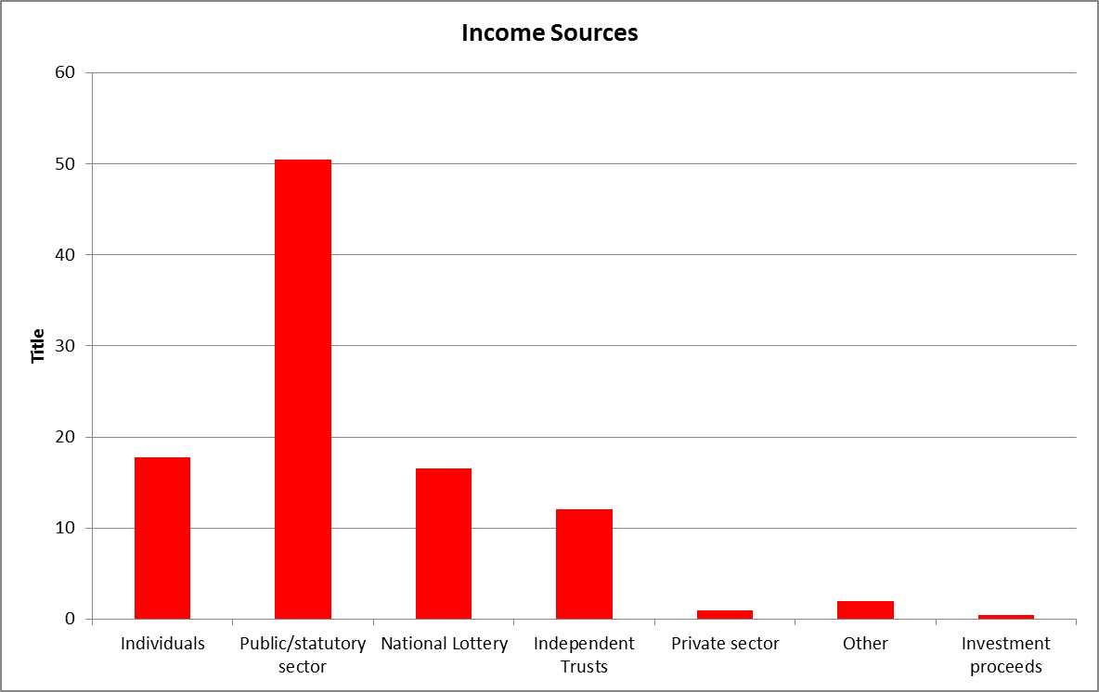
The other four main sources of funding came from individuals £1,369,766 (17.8% e.g. income from fundraising events, donations, membership fees, sale of goods, legacies, room hire etc); National Lottery distributors £1,269,296 (16.5%); Independent trusts & foundations £933,473 (12.1%) and the private sector £66,395 (0.9%). Other sources of income included partnership, one-off payments and secondment fees.

Figure 3.4 breaks this data down by source for LGBT VCS respondents based in London and those based outside London. The first major difference which may be observed concerns funding from the public/statutory sector (including contracts). Two thirds (66.5%) of LGBT VCS income outside London came from the public/statutory sector whereas London-based organisations received less than half (41.5%) from this source.

3.2.1 Diversification of funding sources

For London-based respondents overall, the second highest source of income came from individuals (25.2%) whereas for respondents outside London income from individuals accounted for only 4.2% of income. This difference may be accounted for to some extent by the higher percentage of London-based organisations (43%) which described themselves as ‘membership organisations’ (see section 2.2) compared to the survey respondents outside London (18%).

However, centred’s research also points to the increase in fundraising events being undertaken as the London LGBT VCS sector has tried to diversify its funding sources between 2010 and 2013 . Interviews with the LGBT VCS organisations found that they were all making considerable efforts to diversify their funding sources in order to offset public/statutory funding cuts and protect services.
Figure 3.4 Organisation Income Sources: LGBT VCS organisations – Geographical Breakdown

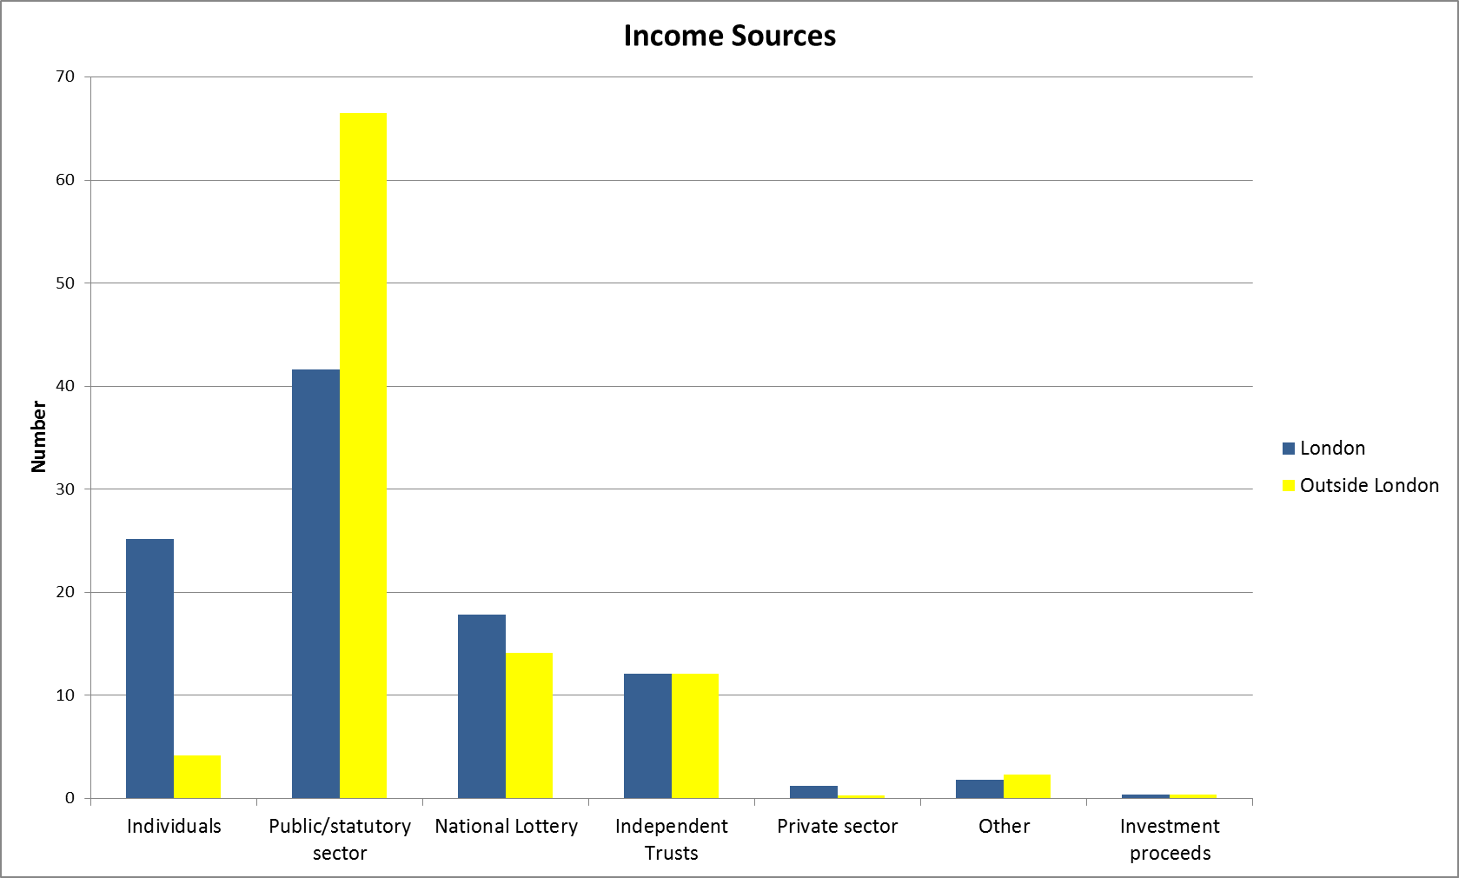

We’re adopting a bold and risky strategy next year which is around shifting the funding base from the current reliance, over-reliance on statutory funding towards something that involves a much better mix of funding, so that’s the focus on individuals, community fundraising and more unrestricted income from trusts. And that’s the high risk bit really.

LGBT VCS organisations were therefore having to spend more staff time on fundraising. It was hoped that LGBT people who were in a position to do so could be encouraged to make donations using gift aid in order to help the LGBT VCS survive the anticipated austerity cuts.

I think because we’re in a niche, for want of a better word, sort of market place, you know, there’s potential for quite a lot of support from other LGBT individuals out there. Because I think people do actually care about their own community and they’re happy to give some funding for that.

Many examples of fundraising with individuals have already been put in place with varying levels of success. An initiative by Pace (Appendix IV) and one by Opening Doors London (Appendix V) provide two illustrations. A particular benefit of fundraising via this route is the ‘unrestricted’ nature of the funds raised which can be used for example for ‘core’
running costs which are often not included in the ‘pared- back’ contracts available from the public sector or the project specific funding available from the Lottery and trust sector. Most of the LGBT interviewees reported the non-provision of ‘core’ costs by funders as problematic for their organisations.

The wonderful thing about that funding [unrestricted income] is its core costs. It pays for management. And it’s very hard for us to win costs for management from any of the trust funds because they’re charities and they want to see it all go to service delivery which is very problematic. We never get core costs. So that money even if it’s a tiny sum is absolutely critical for us.

While there was optimism that LGBT people would be willing to contribute to the sector, concerns were expressed about discriminatory attitudes proving a barrier to donations from the broader population.

We’ve seen much more raised profile around LGBT....But I’ve heard from different [colleagues] where they’ve been...asking... service users to donate money, to donate goods for the shop or whatever and then some of the [colleagues] said ‘and we’re providing an LGBT service’ and I’ve heard from three or four different of them that people have actually contacted them and said ‘I want my donation back because I’m not funding you to run groups for gays’. And that’s happened, that’s actual stories I’ve heard three or four times. So I dare say that probably happens much more than I’ve actually heard. But yes, so that there is more of a profile on that. I’d still say LGBT is not a ‘fluffy bunny’ unless it’s within the LGBT community largely. Sweeping generalisation but I think it’s a truism.

The National Lottery provided the third major source of funding to LGBT VCS organisations both in London and outside London although London-based organisations obtained 17.8% funding from this source relative to 14.1% for organisations outside London. Applications to the National Lottery and independent trusts were on the increase according to most of the organisations we interviewed although it was recognised that these were time consuming and extremely competitive. Success rates were thought to be low. One person who had worked in the LGBT VCS for 11 years said he’d ‘never known such a low success rate.’ Another concern raised by LGBT VCS interviewees was the lack of transparency in making funding applications, particularly where increasingly trusts do not provide feedback on unsuccessful applications.

What I’ve experienced just in the last year is that in trying to get into major trust funders it’s just actually really difficult. And it’s difficult to know whether that’s really because you haven’t met their criteria well enough because the project isn’t what they want to fund or because there’s some internal, you know, some kind of institutional internalised homophobia operating because they want to put their money into mainstream services because it’s seen as reaching more people. It’s really difficult to know what that is, I think it’s impossible to unpick what that’s about. You know, or is it that our applications aren’t as good as some of the other organisations in other sectors because we don’t have the resources to do applications well enough. It feels as though it’s not fair and it’s not transparent why we don’t get access to funds, in the trust funding sector.

Funding from the private sector and other sources is another area of difference with London based organisations obtaining 1.2% of their funding from the private sector whereas the LGBT VCS respondents outside London only obtains 0.3% from this source. Private sector LGBT employee network grounds were reported to provide a growing source of funding for London based groups. One small community of identity organisation explained its funding strategy thus.

We've had to turn to the private sector...I think we’ve had our first corporate sponsor, RBS, in the past year...and also the Cooperative Bank....so we’ve had to turn to groups that we wouldn’t ordinarily engage with in order to be able to generate the kind of revenue that we need. It’s not that we are operating on the basis of tens of thousands of pounds.... We fund raise everything that we spend. If we don’t have it, we don’t spend it, that’s basically how we operate, hand to mouth, we really are hand to mouth. In fact were it not for, you know, organisations like Stonewall or, you know, some of the other trade unions who have been sponsoring us then we really would be in dire straits and we wouldn’t be providing the service that we provide.

Some organisations dependent on geographical location and the ‘popularity’ of their activities were being successful in diversifying their sources of income.

We’re already in that field, philanthropic funders field, we get reasonable amounts of money from some of those charitable funders but we’re on the commercial route now as well. So we’ve constituted as a community infrastructure company, we’ve now got products to sell. So there’s a bit of a marketplace ideology that we’re trying to embrace at this charity and working with some … In fact tonight we’ve got a lovely event at Standard Chartered Bank, they’re hosting a World Aids Day event for us with some other of our partners, including BP and KPMG and those people, it’s a sort of way of reaching into those LGBT staff networks at those larger corporations to ensure that they know what we do and support us if they can.

Other organisations, particularly in less affluent and/or rural locations had less access to these sources so were inevitably more reliant on public sector and trust funding.

Historically we haven’t been so successful around for example community fundraising or private donations or legacies. We haven’t been as successful around corporate funding, donations.

Being in a rural environment with a limited number of funding opportunities particularly locally through the NHS or local authorities, it’s very difficult to position LGBT standalone service delivery in a competitive environment.

3.3 Funding Partnerships
LGBT VCS organisations said there was an increasing pressure to bid for funding via funding partnerships in the current climate. Around one in 5 of the 123 LGBT VCS organisations (19%) said that they were currently in funding partnerships with other LGBT organisations. One in 7 (14%) said they were currently in funding partnerships with non-LGBT organisations. A higher proportion of LGBT VCS organisations outside London (24%) were in partnerships with non LGBT organisations than was the case in London (12%) as can be seen from Figure 3.5.
3.3.1 Partnership working to improve services to LGBT people

The Consortium and the National Lesbian, Gay, Bisexual and Transgendered Partnership (National LGB & T Partnership) were both mentioned as useful bodies linking the LGBT VCS sector together, encouraging partnerships as well as providing a voice for the LGBT VCS in key policy areas.

We need to band together as LGBT organisations to actually work in all parts of the country...to get them [funding bodies] to consider our needs. And that’s one of the roles of the National LGB and T Partnership...to raise awareness of health structures, see how we can influence the health services in the future, so... [talking about raising funds] It’s got to be done in partnership with other organisations. And that’s the future, I think.

Figure 3.5 LGBT VCS by Funding Partnerships and Geographical Location (%) (N=123)

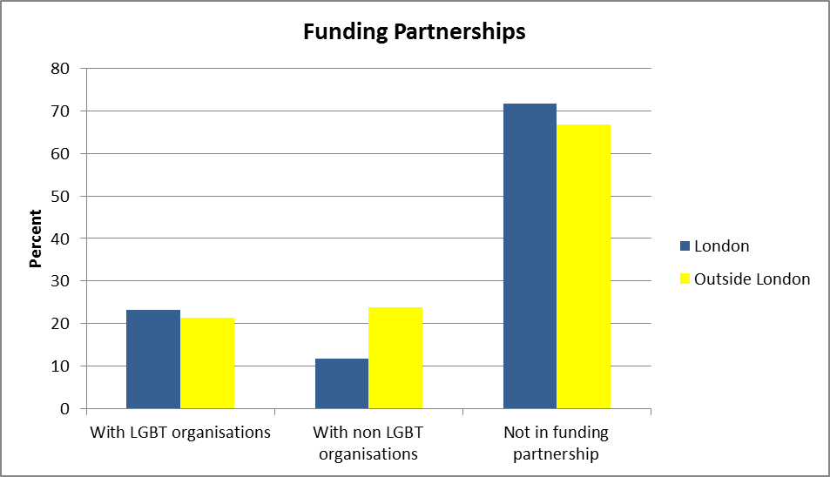

The Domestic Abuse Partnership provided one of a number of examples of funding partnerships between a consortium of LGBT organisations. Although it had been established primarily to provide continuity of service to LGBT survivors of domestic violence, it was also recognised to usefully meet the criteria of a number of the key funding bodies.

It’s made up of Broken Rainbow, London Lesbian and Gay Switchboard, who provide the helpline. Galop provides the risk assessments, the planning and the advocacy.... then Stonewall Housing provides specialist housing and advocacy and advice. And PACE provide the counselling and workshops on survivors....Also it means that we are working in partnership so we’re not replicating services. In terms of the economy of scales and putting in a strong bid....it seems to be funders are keener on...this kind of partnership working. So if you are looking at genuine pan-London things then it’s about saying well, these organisations all work across London, we can deliver a service that’s comprehensive... the voluntary sector is generally specialist....and it will save you money in the long run if you’re not getting repeat victimisation and all the things that go with that, you know, mental health etc. So that’s what they’re keen to see. I certainly see it’s more genuine partnership work rather than just consortiums of organisations that come together and actually don’t work in partnership.

This was seen as a potential route to funding by smaller organisations, including community of identity organisations given the increasingly competitive funding climate.

To be honest if for example Stonewall came and wanted to do something on bi I think we would be quite chuffed to be honest.... You know we’d be really pleased if we’d have that kind of profile but they probably would be in a better position than us to get that money if they wanted to go for it...yeah, there is a danger that those prizes can be taken away from us by bigger fish diversifying rather than by specialist groups that are just kind of coming into being.

3.3.2 Partnership with Non-LGBT organisations to ensure LGBT ‘voice’ in provision

Partnership working was viewed as important by LGBT infrastructural bodies trying to make sure an LGBT ‘voice’ is heard within the VCS field, VCS infrastructure body initiatives and commissioning processes more generally.

We try to work with NCVO, NAVCA, ACEVO and all the other core infrastructure bodies which are more generic. We try to work with them to ensure that they’ve got an LGBT voice... we’re looking at developing stronger relationships in terms of being commissioning partners with them. So they’ll be the lead commissioning partner and then we become a sub-contractor within contracts... We’re having to be the proactive partner in that. There’s a willingness when we talk to them, saying ‘oh yeah, it would be nice to have an LGBT input’ but it would be good to have them say for example ‘you’re our expert on LGBT organisations, would you support us in this bid’.

Funding partnerships were also seen as a way of bidding for a broader range of work by ‘pooling expertise’ with appropriate organisations. Doing so could ensure that LGBT needs were considered throughout the bidding and delivery process on a broader range of projects.

We’re just about to enter into a bid with our local NHS trust. We’re working with a group of local organisations to pull together bids around working with older people and we’ve been doing, obviously the LGBT element of that...So they’re the two big ones. [what is advantage of working in partnership with them?] Well, a) it’s normally something that we couldn’t or wouldn’t do on our own, but b) I think it gives us a real opportunity to work with those organisations that wouldn’t normally think about LGB&T people in the beginning of the process and making sure that our voice is amplified all the way through the process and the services are designed in such a way that they meet our community’s needs.

We’re part of a project...which is trying to improve links between LGBT groups and refugee/migrant organisations. One of the big things we’ve brought out from that partnership project is that LGBT people who are refugees, asylum seekers, migrants living across the whole country need similar support network or support services that [we] provide.

The Department for Education had a number of new programmes coming out at that particular time which was around relationships and families. And we got some partnership work going with mainstream relationship providing organisations, Relate, TCCL, and an organisation called Marriage Care... The point was to provide the
LGBT bit if you like as part of the partnership. So it’s a good model. I think it’s one we’ll be building on as well next year. Because we recognised...that there are a lot of mainstream organisations that would quite like to do a bit for the LGBT community... otherwise the alternative is that LGBT people turn up and they don’t get a good service... The idea was the sort of added value bit is that the organisations we’re partnering with get trained up in the value of...having an LGBT focus and then we’ll be able to provide it...going through their organisations with their clients.

3.3.2 Partnership working to protect LGBT services

Funding partnerships were also thought to offer one way of countering ‘austerity cuts.’ As one LGBT VCS provider said following announcements on the decommissioning of services, a number of talks between VCS organisations in the region were taking place.

We’re looking at our options currently to start to work with partner organisations to share back office...so to share building space and all that to try and reduce our costs. So we’re just looking at those options now to try and save money for the future to keep services as high as possible. [LBGT or non-LGBT?] We’re looking at both options actually. Because we’re the largest LGBT organisation locally we actually support all the smaller ones. And we’ve always done that in kind where we either offer our centre or a PO Box address, things like that which support... So we’re looking at our options within the county and city, whether that’s LGBT or non-LGBT. We’re also keeping our options open so we potentially we could look at joining forces with our partners across the border... across [X] and look at options as well.

3.3.2 Partnership working: Drawbacks and concerns

Although LGBT VCS were clearly open to funding partnerships where appropriate, a number of concerns were expressed about being ‘forced’ into funding partnerships, in order to secure funding. It was feared that this could for example ‘dilute’ specialist LGBT services, autonomy and ways of working.

I think we are always up for working in partnership but it’s not necessarily an easy thing to do...It depends really...we kind of enjoy the autonomy to do some work around projects that we do, whereas the costs that we have and also all of that would be up for negotiation if we partner up.

In particular, it was noted that working in funding partnerships could take time and that the increasingly punitive funding contracts did not always allow time for the development required to ensure partnerships worked well.

It’s difficult to make time for partnership working when it involves a lot of meetings. In fact we haven’t found that to be the most difficult thing because we’ve managed with the other partners to kind of keep that to something manageable mostly. The bit we found difficult is delivery. Because we pitched for work that was new and there was no lead-in time allowed as part of that particular funding... there was a development phase just to get that work up and running and we didn’t have any time for that. And these are payments by result contracts. A number of our contracts are that now... And what we’re hoping is to be able to pick that up by the end of the time so that we can catch up on the funding we haven’t had. But it’s as harsh as that, you know, if we haven’t delivered the outputs and the outcomes we don’t get the funding.

Working in funding partnerships could add additional stress if the funding partners did not see eye to eye during the project or saw their ‘partners’ as ‘competitors’ for a diminishing resource.

There’s a little bit of competition because the way the funding is sort of divvied up, some of the technical terms, where the funding is...part divided out amongst the organisations is different. So there was a little bit of competition and discussion and negotiation around that which was quite difficult in one of the partnerships.

And it’s been so difficult because we’re all competing. And all of our colleagues in the voluntary sector are all competing for the same money. And that’s why you’ll find that some organisations don’t like to take part in some of these things. They think that people are going to go and nick an idea, you know.

Finally, the fear expressed by some was that funders by encouraging funding partnerships had an underlying restructuring agenda and were in some cases ‘pushing’ LGBT VCS organisations towards merger.

And there are issues around merger.... I think funders you know, they want that kind of stuff. They just don’t want organisations who are partners, they want mergers.

4. Changes in Funding: ‘Everything is Up in the Air - it’s Hard to Plan Anything’

It’s November, we still don’t know what the local authority is giving us next year. And I think it was March before we knew last year, or beginning of April. And that’s crazy. You just can’t run an organisation like that. We are hoping to get the same amount of funding but people want more for less money. They want more evidence, they want you to gather more statistics, do a lot more analysis but all with less staff.

Survey data presented in the first part of this chapter was collected via a joint questionnaire (see section 1.3.1). London based LGBT VCS organisations were surveyed using centred’s LGBT VCS Almanac survey questions on funding in order to allow centred to build its database on the London LGBT VCS sector. The TUC survey questions sought additional data on funding changes from all LGBT VCS organisations across England and Wales. As no equivalent historical data existed for the LGBT VCS sector outside London, the TUC survey asked questions to identify these organisations’ perception of changes to funding between April 2012 and March 2013.

4.1 Funding: London LGBT VCS organisations
Using Almanac data, centred has been able to chart LGBT VCS income change over the period between 2009/10 and 2013. It concludes that although the London-based LGBT VCS sector’s income rose between 2009/10 and 2010/11, its income has fallen consistently since 2010/11. centred estimates that LGBT VCS sector income in 2012/13 fell by 9% compared with 2009/10. However a consideration of the data on a sub-group of approximately 20 resourced organisations for which centred has a comparable data set showed the fall was 4%, suggesting that resourced organisations may be ‘better able to navigate a difficult time than the sector as a whole’.
London based LGBT VCS organisations were asked about levels of funding from the public/statutory sector. Following a review of a sub-sample of comparable data from the Almanac 1st Edition and the 2013 survey data, centred (2014) points to an overall fall in public sector income of £634,000, representing 34% of total income (in ‘real terms’ a fall of 20%). In addition, it identified a fall in central government funding and a relative increase in local government funding, possibly related to the devolution of service responsibilities.
Further analysis indicated that LGBT VCS organisations reliant on the public sector for much of their income had taken a ‘real and significant’ hit between 2009/10 and 2013. Some organisations had experienced a fall of as much as 50% in their income from the public sector and had been forced to compensate by diversifying funding sources including fundraising from individuals and the private sector plus lottery bids (as indicated in Section 3.2.1 above). This diversification plus the receipt by a number of organisations of ‘Transition Funding’, was argued by centred to be masking real reductions in public sector funding to LGBT VCS organisations in London. This means that the real impact of the reduction in public sector funding may not become evident until 2015. The interviews with LGBT VCS organisations in London supported this view, particularly those currently in receipt of transition funding.
So next year is going to be difficult but 2015 is going to be even more difficult. Some of our critical funding streams come to an end in 2015....as well as surviving next year we’ve got to also work out what to do from 2015 onwards.
centred found that the London based LGBT VCS sector was spending just under 3% more than the income it received in the year. It concluded that the London based LGBT VCS sector appeared to be putting ‘exceptionally little by towards reserves, contingency and development’ and was in a ‘period of high spending of reserves’. London-based LGBT VCS interviewees agreed that where necessary, they were relying on reserves to function and deliver services.
We’ve had reasonable reserves at [X]. But they are dwindling. What we’ve done is we’ve got just about three months operating costs which is, I suppose, is fairly standard although six would be great but I think three is reasonable. But we’ve also got some designated reserves which, I mean, obviously are used for specific purposes. So yeah...we will be tapping into the reserves...depending on how this rather bold fundraising strategy goes. And that of course means that we’ve got less...flexibility in the future.

4.2 Funding: LGBT VCS organisations outside London

LGBT VCS organisations outside London were asked about changes in their income between April 2012 and March 2013. Amongst the 41 organisations responding to this question, 29% said that their income had declined and 27% that it had stayed about the same (27%). As in London, LGBT VCS organisations reported using reserves to maintain services where income had fallen or stayed the same at a time of increasing demand for services.

We made a decision at the start of last year with reduced funding...it’s a really important time for us to maintain services, a level of services to prove what we can do. So we did invest more of our reserves hoping that we’d be able to procure funding this financial year.

Where organisations reported an increase, had received transition funding or had managed to maintain funding levels, they reported a range of uncertainties linked to the shifting health, social care, victim services and education spending structures. This meant that they too were using their reserves to gear up to meet the perceived challenges from 2015 on through further diversification of funding sources.

We recognise there’s all these different potential opportunities whether that be growth of our schools work, whether that be developing our training programmes etc... Looking at different opportunities around the funding makeup of the charity, so whether we want to look into social capital funding or corporate sponsorship, increased individual... private donors. There’s a whole range of development opportunities which we never seem to be able to really engage with because we’re constantly fire fighting... So...there’s that frustration of not being able to move forward. I put a proposal to the board to fund a short term fund raiser which they accepted....So we’ve just recruited to that post. It’s a five month post with a view that if they’re successful then obviously we can extend that because we’ve seen the benefit…It’s...increasingly tough to get money out of trusts and funds, foundations. Whereas before we were quite successful in that. So I think it’s looking for new innovative ways of making sure that we keep ourselves sustainable It might not work in which case some of that will come out of reserves and we carry on. But we want to take that risk, you know. Reserves are there to be spent, not to be held on to in the bank, I think. So we’ll see.

The LGBT VCS respondents outside London were asked if their funding from the public/statutory sector (including contracts) had increased or decreased between April 2012-March 2013. As can be seen from Figure 4.1, 22% of organisations said public sector funding had decreased, 53% said it had not changed and 25% that it had increased.

Figure 4.1 Public funding increased/decreased: LGBT VCS outside London (N= 39)

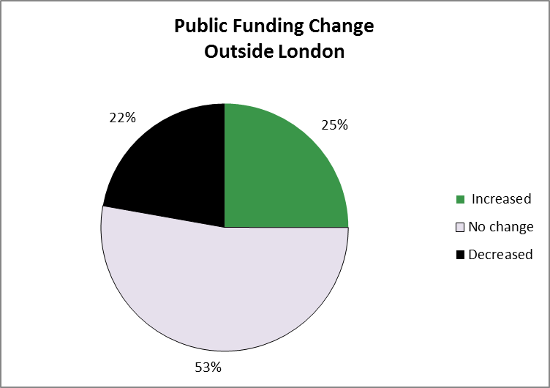

As with London-based organisations, 2015 was expected to be the ‘crunch year’ for cuts to public/statutory funding. However, some organisations reported losing public funding during 2013-14. One particularly problematic area was the shift in public health funding from the NHS to local government particularly where no transitional arrangements were in place as this complicated change-over took place.

Part of the difficulty was that we expected 2013/14 to be a transition year. We thought that with public health moving from NHS into local authority that they would take some time to settle in and sort their houses out. And in many local authorities that’s what they did, so they simply came to the third sector partners and said we’re going to take some time to sort our houses out so we will continue current levels of funding until next year until we get through a re-commissioning process. Which seemed eminently sensible and that’s what is happening in [Council X]...But not in [Council Y] so there was no transition and only very short notice and then it just meant that that public health funding came to an end in March 2013. We were able to keep our service manager on for a few months after that from reserves but no longer after that at all.

The speed of public sector cuts and changes in some localities was causing funding shortages and making it difficult to plan and organise funding and spending.

We’ve had some bad news recently, we’ve been working really hard on a Big Lottery bid. That went through, we scored really highly as an organisation with the bid but unfortunately it didn’t go through on priorities at that point. So that bid is going to go in again. Unfortunately with the speed of the cuts locally from the local authority that’s going to happen before we hear about the Big Lottery now. So we’re going to have a bit of a black hole in the organisation between services being decommissioned and hearing back from potential new funders. Despite all the work that we’ve done in trying to plan ahead, actually things happen and unfortunately we’ve got some hard decisions to make over the next four months really.

Instead of multiple providers of sexual health services, there will be one provider or one contract...providing the whole full range of sexual health services, from health promotion right through to clinical. What that means is that organisations like ourselves who do a small section of that, we were starting to look at our options to team up with bigger organisations to sub-contract through those integrated services to provide the specialist LGBT support that we can. Unfortunately with the budget cuts it means that that integrated service isn’t going to happen until 2015. But specialist providers are being cut in 2014. So it completely cuts us out of the race now. So it’s a real difficult time for us as an organisation.

Public/statutory funding changes and uncertainty were reported to be leading to instability affecting a whole range of LGBT VCS activities. These included HIV, domestic violence, hate crime, victim support, housing advice, delivery of training on LGBT issues for NHS staff and LGBT youth funding and training in schools.

The negotiations for next year for example, in 2014, are still ongoing and we don’t see that they’re going to be resolved until one or two months before we get started in 2014/15. So it makes our future planning difficult.

4.3 Political and Legal issues

4.3.1 Varying levels of commitment to funding LGBT services/activities

During the LGBT VCS interviews it became apparent that commitment to funding LGBT activities and services varied within government departments and across local authorities in England and Wales. At national level, the person ‘leading’ on an issue could be crucial.

It changes depending on who’s leading the domestic violence work and how much of an understanding they have of the subject matter...I mean, when I first came there was an individual who was leading up the work who clearly didn’t understand the subtleties around LGBT community and this subject matter. ..it took a lot of convincing as to why lesbians wouldn’t necessarily ring Women’s Aid or why it wasn’t safe to put a lesbian in a normal women’s refuge... Or trans* women, what is classed as a refuge, and some refuges do in some parts of the country still have very clear ideas of what a woman is and whether a trans* woman is necessarily able to go there.
At local government level, although some councils, particularly within urban areas, were reported to have made considerable progress in becoming ‘LGBT friendly,’ others were perceived to be ‘dragging their heels’. Some local councils were perceived to be doing the absolute minimum and as having been quick to make cuts to LGBT provision.

And the structures and systems that exist don’t allow for funding around LGBT health, wellbeing, discrimination, hate crime, issues that we know through these assessments in [2 county councils] are fundamental to our health and safety.

We do get piecemeal grants from the county council for, you know, we’ve got £5,000 this current financial year to do a work around LGBT but I believe that that’s just a piecemeal operation to be able to tick a box that we’ve actually done something around the Equality Act in Goods and Services. I don’t think there’s an actual strong commitment there for LGBT communities whatsoever. I personally feel the LGBT community has been ripped off... I mean, £5,000 off the county council for the LGBT community per se is insulting. Yeah, for a county! Where they have a population of how many million. Yeah. And how many LGBT people in the county? You know. £5,000 is an insult. Just so they can tick a box.

This variation in understanding and commitment was also perceived in London where a few inner London local authorities had consistently stepped up to fund LGBT provision for example in housing or for LGBT youth or older people which was being accessed on a pan-London basis because of the lack of provision within their own borough.

What I am disappointed with some local authorities about is that they don’t even consider the needs of LGBT people. So we’re busy negotiating with our current funders but we only get funded by four local authorities in London to provide our services. What about the other twenty nine? What I would like to see is that all local authorities contributed to that sort of support provision. The way London Councils have with our advice team, they’ve seen the need for that pan-London view.

4.3.2 Difficulties and opportunities posed by the localism agenda

This perceived variation in commitment to LGBT provision was particularly important in light of the government’s ‘localism agenda’ and its implications for funding LGBT services and activities during a climate of austerity cuts in local government. One concern LGBT VCS interviewees raised was that as seen above local authorities may not want to fund specialist LGBT services. Another view was that LGBT people are historically more ‘transient,’ in some cases because they do not wish to be ‘outed on their own doorstep’ and also because they prefer to travel for specialist LGBT services which can only be provided on a city-wide or county-wide basis.
The localism agenda....it’s underpinning everything in terms of translation of health services to local authority level and more local commissions. That disproportionally affects specialist communities because we’re not geographically based. We’re communities of interest, not communities of geography....There was a document that came out I think it was a consultation document which talked about the positive effect of cross-border commissioning. Now that would pass the majority of people by. But for me it’s such a crucial thing because a lot of our organisations...don’t work across just one local authority, they cross many local authorities.
However, LGBT VCS interviewees said that austerity cuts can make local authorities less open to cross-border working. This poses problems for the LGBT VCS, for example where one local authority funds LGBT services and a neighbouring one does not.

There’s a very strong localism agenda in local authorities which is all fine but it does mean that we run for example like HIV testing services which has generally been open access, so anyone from any borough can come along to these services even though they’re funded by [Local authority] because you don’t want to turn people away if they’re coming for an HIV test..I hope GU services will be protected from that, they will continue to be open access.

The funding that we had for the youth services here came from both [X] county council as well as [X] city council and about two years ago the county cut out all funding for anything to do with LGBT youth. So at the moment the funding that we have from the city helps pay for a sessional worker and a portion of a salary for one of our project officers whose emphasis is around the youth. But we would not turn away a young person who lives in [X] county or in [Y] county simply because they don’t live within the city. And yet that’s actually what we should be doing. We should be insisting that the county supports the centre when they send us young people from their area. At the moment they’re getting it for free.

An additional concern with respect to public health, HIV and victim support work (which had been a key source of funding for many LGBT organisations) was how to tackle the changing funding structures. This included for example the increasing requirement to apply to a number of different funders (e.g. local authorities, schools) where previously only one bid to a funding body for cross-border working may have been required. LGBT VCS organisations were trying to get a grip on what was required to tackle this changing situation.

The thing about commissioning is with all the localisation agenda...in London we’ve gone from having for example a pan-London HIV prevention initiative ...to now that being devolved to local authorities as part of the public health agenda. And we’ve been defunded as a result of that for work we’ve been doing for quite a long time...So in terms of that now what’s expected is a certain amount will happen London wide and the rest will be commissioned by local authorities. So that means do we, along with others, you know, decide to make some kind of pitch to local authorities individually, do we try to work out what sort of cluster arrangements they’re in and that is not really obvious. Or it is if you know it really well but if you don’t it’s difficult to get into that for the first time. How do we possibly have the resources to do that. And is that actually worth it financially? Because so much of the contract stuff that we have is cut to the bone so we don’t have a lot of excess for...core funding. So it’s literally fight for whatever it is that we’re commissioned for, is it worth us doing that?

Whether we agree or not with the changes that have come about as the result of the health and social care reform act, the development of the health and wellbeing boards, of clinical commissioning groups, health watch, public health England, public health in local authorities, all of those are quite significant developments that we’ve got a handle on. We understand where some of the funding opportunities will come in those, we know that most boroughs at some point will be putting out to tender sexual health or sexual and reproductive health commissioning and we’ll respond to those tenders.

At the same time, it was recognised that LGBT people individually and collectively could use the levers provided by the localism agenda and the Equality Act (2010) to push for resources and services from national and local government. This would require a return to a more campaigning LGBT activism, ‘gay politics’ in order to require local authorities and other public bodies to seek out and increase greater levels of engagement with the LGBT communit(ies).

So the future I think is grouping together in the LGBT world, grouping together with other community groups, trying to get that voice heard, trying to get politicians to waken up and say oh yes, there is a problem.

One of the positive successes...is on the confidence of service users, them saying it’s happening in [X], why can’t it happen in my borough? So they’re going to their own borough and are saying actually I want this to happen in my borough.

4.3.3 Protection afforded by the Equality Act (2010)

During the interviews LGBT VCS participants said they had used the Equality Act in promoting awareness of LGBT issues and reminding public bodies of their duty to ensure appropriate levels of funding for LGBT services. Respondents said they aimed to do this in a positive manner, recognising the difficult decisions public bodies were being forced to make as a result of Coalition government policy. However, in a few cases it was reported that threats of legal action had been required over the last two years to head off funding cuts to LGBT (and other equality groups) services.

We’ve got funding about a year ago but that was because I threatened to take them to court....we try to do things through winning friends and influencing people. In this particular instance...I said I think you are in breach of the Equalities Act, I think I can demonstrate that, and why don’t we test...that in court. And within about three hours I had an offer not just for us but for across the equalities groups, because I used the argument across equalities groups that [X] was not fulfilling statutory duties.... it was enough to alarm the commissioners into thinking bloody hell we need to find some cash here.

One health authority cut £100,000 overnight. Until we threatened to take them to court, then they took three months to cut it.

However, a lack of LGBT monitoring data in the UK meant it could be hard to hold public bodies to account.

The Equalities Act of 2010 is a proactive piece of legislation in that the burden of responsibility is now on employers to make sure that discrimination doesn’t happen in the first place. And there’s obviously the public sector duty requirements embedded in that...It’s a bit flawed really in so much as nobody really knows what to do with it. I mean, one of the things is how do you prove what you’re doing for your LGBT service users when you don’t actually monitor for your LGBT service users. So until such times as there’s legal challenges basically a lot of organisations are going to continue getting away with doing the absolute basic minimum.

So for example, we’ve been talking about monitoring for a long time, monitoring gender and sexuality. And it’s come up in the National LGB and T Partnership over a number of years...It’s still incredibly difficult to say that that’s actually resulted in any better formal monitoring out there in the NHS for example. Because influencing people who can actually change stuff in the NHS is like trying to turn a very large elephant around.

There was a view that ‘equality’ was no longer high on the agenda for many public bodies.

I think the fear is always that it’s not top of the agenda and that in these..times of austerity it becomes too easy to drop the equalities issues, you know, for it to become secondary and non-important...prejudice is allowed to come through. ‘That’s enough, that’s enough, you don’t need to carry on working around these issues’. So that will have an impact. The schools for instance are starting to be a little bit more concerned where their money is going and not picking up LGBT issues as much as they would have done a couple of years ago. So there are impacts.

A growing view was that in part because of a lack of monitoring data, LGBT work was disproportionately under-funded in many areas and that further public/statutory cuts were going to make the situation worse. Some interviewees thought one or more high profile court cases would be needed to make organisations recognise the need to take their duties to provide appropriate services to LGBT people seriously.

I think at the end of the day the only way a sector like us is really going to happen, is when there are a few well-known court cases where statutory bodies or organisations are sued for extraordinary sums of money for their underinvestment in terms of what needs to be done for LGBT people with regards to the Equality Act. When that happens in the courts and they’re stung with a lot of money they will then realise that ‘Ah, we should have invested in this area’.
5. Funding Changes: Impact on Staff and Resources – ‘I can’t see any light at the end of the tunnel.’

So many reforms to organisations, so many cutbacks, so many sector cuts. I can’t see any light at the end of the tunnel. And I would love to be able to.

5.1 Impact on Paid Staff

According to the survey, fifty three (43%) of the 123 LGBT VCS organisations had paid staff, 70 (57%) did not. A higher proportion of the LGBT VCS organisations based outside London had paid staff (46%) than those based in London (41%) as can be seen from Figure 5.1.

Figure 5.1 Organisations with Paid Staff: LGBT VCS organisations – Geographical Breakdown (N= 123)

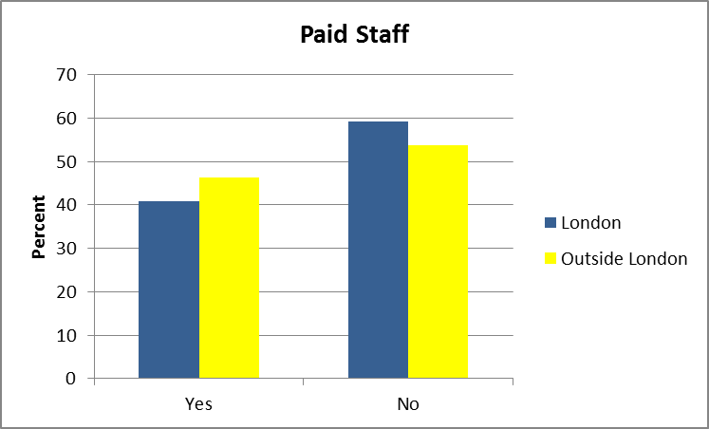

5.1.1 Staffing in London LGBT VCS organisations

In total there were 252 people employed in the London based LGBT VCS organisations, 132 (52%) of these were full time and 120 (48%) were part time.

centred, found that the number of paid staff in the London LGBT VCS sector decreased by 3% between 2010 and 2013. In addition, it reported that the ratio of full time to part time staff changed from 1:04 in 2010 to 1:1.3 in 2013. centred concluded that ‘where before there were more full time staff than part time, now the reverse is true .

5.1.2 Staffing in LGBT VCS organisations outside London

Outside London, of the 174 people employed in LGBT VCS organisations, 80 (46%)
were full- time and 94 were part-time (54%). Thus although a higher proportion of LGBT VCS organisations outside London had paid staff, this data indicates that a higher proportion of these paid staff were part time.

The survey asked LGBT VCS organisations outside London if the number of their paid staff had changed between April 2012 and March 2013. As figure 5.2 indicates although 15% said the number of paid staff had decreased, 67% said that it had stayed the same and 18% that it had increased.

Figure 5.2 Change to paid staff: LGBT VCS outside London April 12-March 13 (N=46)

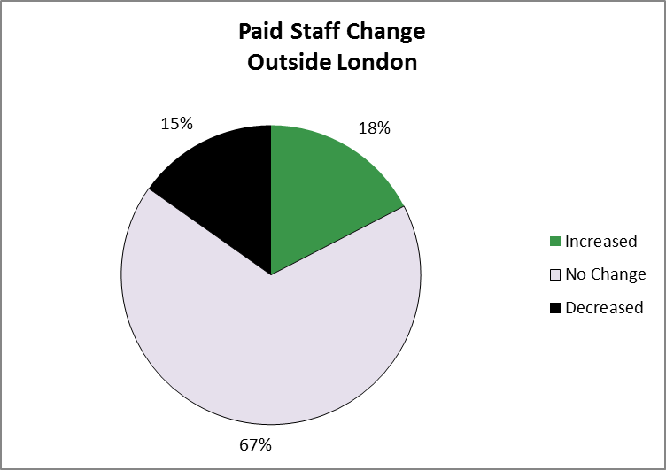

5.1.3 Cuts leading to organisation restructuring, job loss and reduced hours

The interviews confirmed that public funding cuts had already resulted in restructuring leading to job loss in just under half of the participating organisations. One organisation had been particularly affected shortly after the election of the Coalition government following the introduction of cuts to funding for voluntary sector national infrastructure organisations. As a consequence that LGBT VCS organisation’s staff had been reduced drastically from 14 to 1.7 FTE over a period of 2 to 3 years.

At least nine other organisations said they had restructured, made redundancies and reduced working hours as a consequence of post-election cuts to public spending.

When I came into post [2012] one of the first jobs I had to do was restructure the organisation...make a number of redundancies. We lost about six or seven members of staff [3 FTE]. Across the board. Service delivery and administrative roles. And we downsized in terms of people’s hours as well in some posts. We also did create some new posts out of that process. It was obvious I needed to do that if we were going to get through that year..There was quite a lot of anger about that and things were difficult.

[NHS PCT] halved our grant very quickly and you know, we just had to restructure the whole of the team...Halve it.... So that team essentially went down from three full-time members of staff to three half-time members of staff. Yeah. So as a direct result of the austerity cuts posts were fewer hours.....

There was no transition and only very short notice and then it just meant that that public health funding came to an end of March 2013. We were able to keep our service manager on for a few months after that from reserves but no longer after that... We have one staff member left...unless something happens between now and the end of March we’ll lose that staff member as well so we will be entirely volunteer driven by the end of March 2014 which is a very difficult position to be in.

A concern raised in the interviews indicated that neither public, lottery nor trust funding made provision for ‘core funding.’ This meant that at least seven of the organisations interviewed had made their CEO redundant or were operating with a part-time CEO which was not viewed as a ‘good place to be’ at a time of major change.

The staffing situation has suffered there is little money for core funding as not many trusts/funders will provide that. For example we have only been able to appoint an interim CEO two days a week otherwise...the service manager is responsible for many issues but the service manager post runs out in March. It’s difficult strategically to take the organisation forward like this.

Even where staff had not been made redundant, a number of organisations admitted that in order to protect services they had reduced staff hours.

We restructured the organisation about eighteen months ago [2012] and we cut posts. Clearly what we want is to ensure that the core service which is people picking up the phone and answering emails continues and isn’t interrupted. So we cut staffing hours...We have cut the hours of our service manager, for example. So that used to be a four day a week post, it went down to three days a week.

5.1.4 Anticipated future cuts leading to further restructuring and job insecurity

Most LGBT VCS interviewees thought that the worst of the public sector cuts was still to come. Some were already aware of the cuts they faced in 2014/15.

We’ve just had the proposed budget cuts for public health through where specialist sexual health services are being cut. So the majority of our funding will be decommissioned in March 31st. That’s currently around 90% of our income. Unfortunately it’s the case that the proposed budget cuts aren’t based on need or evidence. Sexual health services are just being cut back to the bare minimum that they have to provide and that’s it.

I would say next year from April we will face an 18% cut of one of our grants minimum. I am only surmising this.

We knew it was coming, the severity and the quickness of the cuts is what’s had the biggest impact for us.
Others, said they felt the cuts looming over them. As they saw organisational resources ‘dwindle,’ they reported feeling trapped in a perpetual cycle of cuts, re-organisation and rather desperate fundraising in order to keep services going.

Our support services are still running at the moment but the public sector cuts within local authorities themselves haven’t finished and they are still on the horizon. So while the support services are still ongoing we are in constant negotiations about cutting. So we have cut our grants, and our offer, we’ve reduced the number of staff that offer support, reduced the number of hours of support to our clients. And we have to now discuss and negotiate further cuts for next years. So we do envisage that those cuts will become bigger in 2014/15.

The situation could be particularly difficult where the CEO had been made redundant or was only available two days a week. This required a range of management responsibilities, including fundraising to be dispersed amongst an already stretched staff group.

I myself as well as the other couple of members who are paid members of staff we spend our day half of it searching for money and half of it providing services.

5.1.5 Funding contracts leading to worsening staff terms and conditions

LGBT VCS organisations attending meetings about new areas of funding, expressed concern about the viability of new contracts as these seemed to expect ‘more for less’.

I think the issue is everything costs money so everything you do...needs some recognition and some way of having that funded. If it’s about monitoring, if it’s about gathering statistics, writing reports, attending meetings, there should be some acknowledgement of that in the funding. Otherwise a contract isn’t viable.

Another area of concern was staff terms and conditions which were described as ‘rubbish’.

There is no guarantee of anything now in terms of increases in pay. We don’t have increments anymore. We don’t have annual pay rises. We don’t have a pension contribution.

However, the degradation of terms and conditions was expected to progress further in what was viewed as a ‘race to the bottom’ in the commissioning process.

I think lots of commissioners are driving us to the very bottom and they’re driving us to bid for very, very cheap tenders, they’re driving us to apply for funding at the cheapest rates...still expecting high quality services. Because a lot of other competitors are charging minimum wage, living wage, whatever. How can we guarantee high quality support if we can only offer staff a minimum wage... I think commissioners need to ...appreciate that if you are going to commission a service it can’t all be about price, there’s got to be something about quality. And I think all organisations need to realise that we need to draw a line and say...you can’t keep driving us to the bottom, this is the minimum amount, or minimum quality of standard that we’re willing to provide and it costs a certain amount of money.

The insecurity of funding had led to the introduction of short term contracts and the expansion of zero hours contracts which was thought to be both unfair to staff and not conducive to service quality.
I will try and retain and re-recruit my sessional staff which is very difficult...they’re on a zero hour contract which is something that I loathe but that’s what we’re having to do for the future and they’re not attractive, are they, zero hours contracts for people?

One of the most difficult things to deal with...is that the nature of the contracts we get is so short term. Usually never longer than a year so that people are on rolling contracts and by about December of every year before the end of the financial year they are facing vulnerability to redundancy again. And it’s utterly demoralising for people, it provides no job security. People are always on edge about whether their job is going to continue.

In the new contract and project funding climate, it was agreed that staff had to do ‘more for less money.’ This was achieved through flexible working and by working strictly to the contract being delivered.

We’ve achieved that through mainly having a very flexible staff team. For example in [X] which...in terms of their commissioning cycle they’re in front of everywhere else, we used to have two teams, a social support team and a prevention team. And now all the staff are basically poly-skilled and … I think we call it job enrichment, but you know, you’re just giving people more to do basically. And you know, we don’t hide from that. But yes, so staff are expected to work less in specialisms and be more generalist. And I think also we’ve become more focused on what we do as well. So sort of work that we did, that was general work around strengthening communities and community work and all of that sort of stuff, a lot of that has gone. And we’re focusing very much on delivering what’s in the contract.

This move away from specialism to generalism at work was reflected elsewhere in the LGBT VCS. The shift was recognised to have implications for staff job satisfaction and expertise as well implications for quality of service but was viewed by some as a necessary evil in the new funding climate.

Instead of having a trans* specialist worker and a youth worker and having specialisms within the team, actually the team need to be all-rounders. And develop that way. So that’s really going to change the structure of us as an organisation and what we’re able to do.

5.1.6 Increased stress, staff turnover and loss of expertise

Both managers and employees spoke of the increased levels of stress caused by both the climate of uncertainty and increasing workloads. Some VCS organisations spoke of the efforts they made to retain good practice and safeguard staff terms and conditions where possible.

For me as a chief executive here it’s one of the things that concerns me most, the inordinate stress placed on our staff and volunteers as a result of a) uncertainty which is just crippling, contract uncertainty, and b) the extra demands on them as a result of increased service use, access to services we provide. It’s just a toxic combination that really does place an enormous amount of stress. I’m not putting my head in the sand about that at all. There’s something about... being in it as a chief executive as well, and acknowledging my own stress around this and how I deal with that. And translating that into...workplace practices that are supportive of people in terms of leave, in terms of families, in terms of sickness, that sort of thing. And I think we’ve done reasonably well at that

However, despite these efforts, staff were recognised to be facing increasing pressures at work. The LGBT VCS was struggling to meet the complex needs being generated by the recession, welfare and social care changes, often with insecure and reduced resources.

Our advice resources become stretched because as the numbers of people go up and up the demands on our staff time become more and more stretched. And as the needs become more complex it means each staff member takes on a case which may last longer or may have bigger, wider issues than simply housing and support. You know, they may talk about alcohol and drugs and mental health, physical health. So there might be a whole range of more issues that mean the person needs support with. And where do they go for that extra support. So there’s a stretch on our current services as well as the threat of reduced services.

A consequence of this toxic mix of circumstances was reported to be high levels of stress, sickness and job turnover. As public sector cuts ‘loomed,’ this exacerbated staff turnover and the sector was reported to be losing specialist expertise as people left the LGBT VCS in pursuit of job security.

We are aware it’s around the corner...looming on the horizon...I think the biggest impact is this...people are jumping ship, people are looking for other jobs... basically skilled people working within the sector are leaving the sector for job security... a classic one is our HIV services manager he’s left our organisation two or three months ago and he’s gone on working for a housing association... [another colleague] coordinated all the activities for our positive clients in terms of drop-ins and wellbeing programmes has left and got a job in a young offenders institution...one of my workers at the moment, sessional workers, she’s just about to leave me and she has been doing youth work for years and she’s been brilliant at it, but she’s going to retrain into social work.

5.2 Availability of Office/Meeting Space

The survey asked LGBT VCS organisations if they had a regular and reliable office or meeting space to conduct their activities. All 123 organisations responded to this question with over two thirds (69%) reporting that they did but just under a third (31%) saying that they did not (Figure 5.3).

As Figures 5.4 and 5.5 indicate, a lack of office or meeting space was reported by just over 1 in 3 (37%) London-based organisations as against just under 1 in 4 (23%) of the organisations based outside London. London-based organisations therefore indicated increasing difficulty in accessing free or affordable space to meet and/or hold activities as public bodies such as local authorities and schools had begun to charge for the use of their facilities.

Figure 5.3 Regular and Reliable Office/ Meeting Space: All LGBT VCS (N=123)

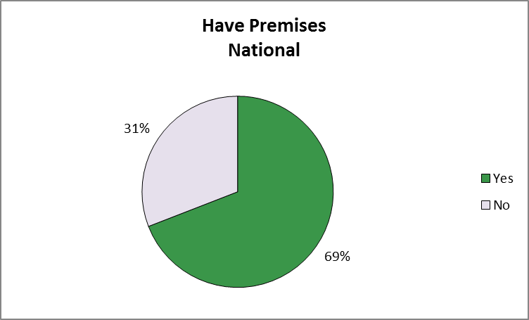

Figure 5.4 Regular and Reliable Office/ Meeting Space: London (N=71)

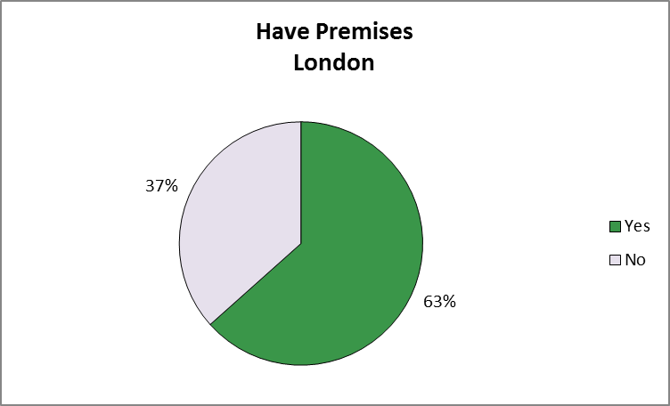

Figure 5.5 Regular and Reliable Office/ Meeting Space: Outside London (N=52)

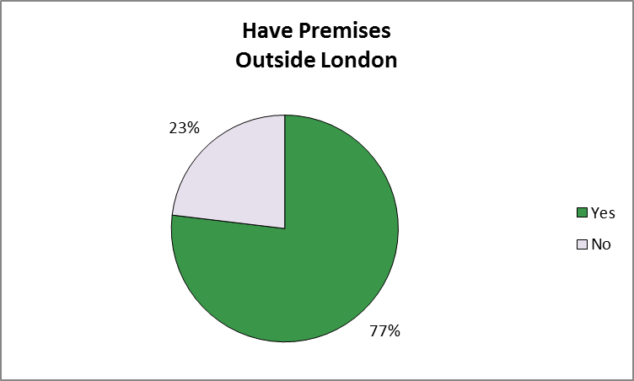

We used to be able to access free rooms at a local council...the town hall, for example, but we can’t even do that anymore. We don’t even get free rooms. I mean, yes, organisations like Stonewall provide us with free rooms and that’s really great but only when we can get them.

LGBT VCS organisation outside London were asked whether there had been any change in their access to a regular and reliable office or meeting space between April 2012 and March 2013 . Fifty two organisations outside London responded to this question, reporting that although access to a regular and reliable office space had stayed about the same for two thirds (66%), it had improved for just under 1 in 5 (17%) but had become problematic for just under 1 in 5 (17%) over the past year.

The in depth interviews sought to explore the situation concerning access to office/meeting space further.

5.2.1 Improvement: office/meeting space

For some organisations, the situation was improving. For example, this large organisation saw taking control over its estate as key to its survival, in part because it could rent space but also because it had been successful in accessing grants to renovate its buildings.

We have a five year plan...First of all is to widen our funding base, to protect present services as much as anything else....Our long term strategy is to own all our buildings. We feel it’s just a useful community asset to have and ... working with landlords... is just disastrous...for example... our head office is not disabled accessible and the landlord won’t do anything about it.

5.2.2 Problematic: office/meeting space

For other organisations, dependent on activities, the loss of meeting space, could be problematic.

Part of losing our funding means we’re unable to pay for an office. So we’re really fortunate here that we are allowed to squat but we are squatting and we could lose this as easily... to begin with we were in a shared office... They didn’t like us being in there. Politically it wasn’t a good move putting us in there.... We do have some very nitty gritty, in-depth conversations with our [service users] which others don’t want to hear.. And this is the problem when your funding gets cut and you downsize it’s very difficult to build back up again.

Even where ‘free’ or affordable space was found, it might not be appropriate to the organisation’s activities or users. For example ‘shared space’ could be

Too open, too obvious...it would put a lot of people off coming...for a lot of our people, it can take them months to walk through the door.

5.2.3 About the same: office/meeting space

Thus, maintaining reliable premises which LGBT people felt comfortable coming to was viewed as integral to their activities by most LGBT VCS interviewees.
I mean, without premises we wouldn’t be able to have the outreach that we do. We have people who walk through our doors to get help from us. So having a location is fundamental, I cannot imagine running an organisation without an office space, to have a presence... Also it would mean that those safe spaces for other social and support groups would disappear and the [building] itself is a central point for many organisations. So not having a presence, going virtual would probably disperse a lot of the energy of the LGBT community locally.

Some LGBT VCS organisations still had their premises but were aware the situation might change in light of their funding situation in the coming year.

It will impact on the centre we’ve got now which is a really good central location in X which is two minutes walk to a railway station...We’ve got free car parking on site, we’re pretty central...in terms of getting everywhere,... everybody was saying what a wonderful inviting comfortable premises we’ve got....If HIV services goes we can’t afford to run and rent these offices where we are now.

The potential loss of the premises above also had implications for service quality and staff morale as can be seen from this staff member’s view below.

When I joined the organisation as I said twelve, thirteen years ago these premises were a complete model. And my love and passion for the building all the years I’ve managed to get bits of money from here, there, for instance knock through and redecorate and get new carpets and you know, make the space into a nice space. If you put all that effort into something you feel rightly proud of, only for it to be taken away, you know, potentially disappear and have to really downscale.

5.3 Increasing Numbers of Active Volunteers
5.3.1 Volunteers: survey evidence

In response to the survey, seventy two (59%) LGBT VCS organisations said they had active volunteers.

Over three quarters (78%) of the London based organisations had volunteers whereas less than half (46%) of LGBT VCS organisations outside London said they did.
The total number of active volunteers (that volunteer once per month) was reported to be 1,352. The average number of volunteers overall per organisation in London was 16.9. The average number of volunteers overall per organisation outside London was 4.2.

However, geographic examination of the data indicated that 1,198 of the volunteers in the sector volunteered in 44 of London based organisations (average number of volunteers 27.2) whereas the remaining 154 did so with 17 LGBT VCS outside London (average number of volunteers 9.1).

There was reported to have been an increase of 8% in the number of volunteers in the LGBT VCS sector in London and a 15% increase in the total hours that volunteers contributed.

LGBT VCS organisations outside London also reported an increase in volunteers. Over half of the organisations (55%) reported that volunteer numbers had increased, 31% that levels had stayed the same with only 14% saying numbers had decreased.

Figure 5.6 Change to Volunteers: LGBT VCS Organisations Outside London April 12-March 13 (N=51)

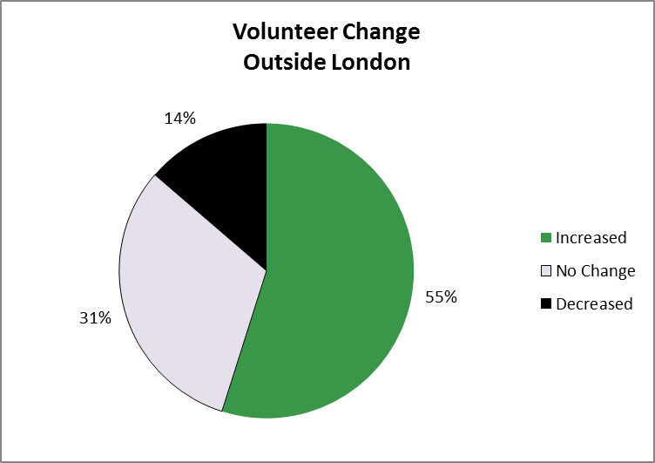

5.3.1 Volunteers: in depth interviews

LGBT VCS organisations were keen to increase volunteers where appropriate. However, volunteers needed to be viewed as complementary to, rather than replacing paid staff.

We’re really clear that we don’t use volunteers for paid staff roles. And you know, we’re really clear about that. But...we have increased what volunteers do, mainly because a) we’ve changed our services but b) because volunteers wanted to get involved in more work as well. So our retention strategy is being able to offer volunteers a wider variety of ways they can participate in the organisation. We do a lot of training with our volunteers. We really try and support them as much as we can. So it’s really good for their CVs. It’s a great way of getting into this work as well. A lot of people want to do this sort of work but there are few, there aren’t many structural ways to get in really.

It was thought that volunteers should be only be used in appropriate roles depending on their expertise, skills and the training and the oversight which the LGBT VCS organisation could provide. Thus there was concern that some funding commissioners and politicians seemed to see volunteers as a ‘cheap option’ to running services/activities and the provision of administrative or other support roles.

Even if you provide volunteers it still costs money to have volunteers. You need to support them, you need to talk to them, you need to train them, and that costs money. So to assume that these services which are vital for our communities can be done for free or can be done on very short term contracts it’s damaging the people who are receiving the services and it’s damaging the people who are working in the services.

Where LGBT VCS reported reduced staffing because of public sector cuts, then too often remaining staff could be expected to support volunteers which was not always ideal for either party.

I guess we would really like to have more volunteers and to be able to support them better. But we find it incredibly difficult to get...to employ a volunteer coordinator. So each member of staff takes on a certain number of volunteers themselves and tries to support them. But that’s strategically not as useful as it could be. I think it’s quite frustrating for volunteers as well.

In some LGBT VCS organisations, members of an organisation’s board and/or its trustees were ex-service users or employees. People who over time took on these roles based on their skills, expertise and commitment. This group of people could be crucial in keeping an organisation going and rekindling it when funding dried up and no paid staff remained as was explained by a trustee of the LGBT VCS organisation below.

We have nine trustees, volunteers like myself who have lives and do other things... But this is nine people who now that we’re facing losing our final staff member in March 2014 we just have to step up. So you know, we will be going along to run the rooms and we will be doing that sort of thing to keep it ticking over until we can improve things.
6. Funding Changes: Impact on Service Delivery – ‘It’s fight your way out of difficulty rather than submit’

The other point I’d make is that as viable charities we need to have this capacity, ability to expand and shrink as times change. And both charities have demonstrated that, both over thirty years old, both have had times of burgeoning and times of austerity, and this is probably one of the toughest times for both charities, I’d say.

6.1 Service Delivery: Increased Demand

A majority of the LGBT VCS organisations responding to the survey reported that the number of service users and/or participants in their activities had increased over the last year. According to centred’s Almanac data, London-based organisations reported an increase of 6% in service users/participants between 2011/2012 and 2012/13.

LGBT VCS organisations outside London were asked if their number of service users/participants had increased or decreased between April 2012 and March 2013. As Figure 6.1 indicates most LGBT VCS organisations (82%) outside London also reported that user/participant numbers had increased, 14% said numbers had remained unchanged with only 2% saying that numbers had decreased over the past year.

Figure 6.1 Service Users: LGBT VCS - outside London April 12-March 13 (N=51)

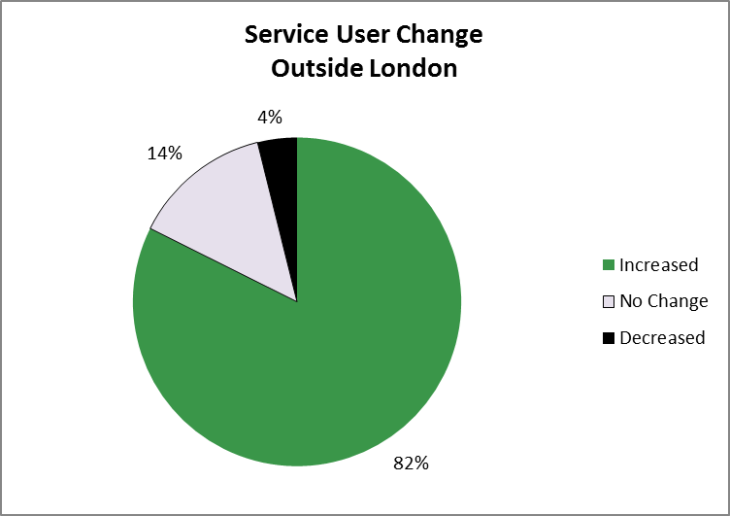

6.2. Impact of Funding Cuts on Services

The survey asked all of the LGBT VCS organisations (London and outside London) which had reported a decrease in funding in the past year whether they had had to cut back on services/activities as a consequence . As Figure 6.2 indicates although the question was viewed as ‘not applicable by 55 organisations (57%), 26 (27%) of the 96 LGBT VCS organisations responding to the question said they had made service cuts following a decrease in funding. Fifteen (16%) organisations said they had managed to keep services going despite funding cuts.

Figure 6.2 provides a geographical breakdown of this data. Fifteen London- based LGBT VCS organisations (27%) and 11 based outside London (28%) reported making cuts to services following a decrease in funding.
6.2 Service Cuts Following Funding Cuts: All LGBT VCS (N=96)
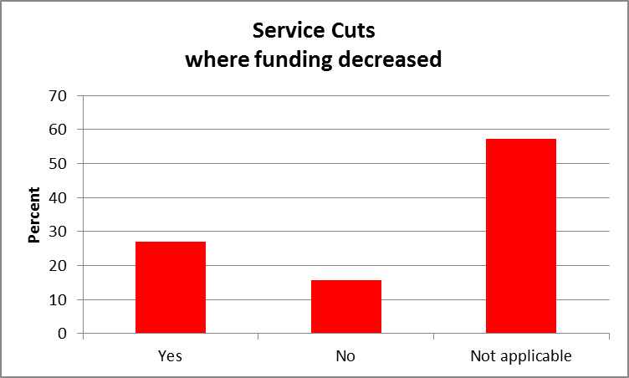

6.3. Service Cuts Following Funding Cuts: Geographical Location (%)

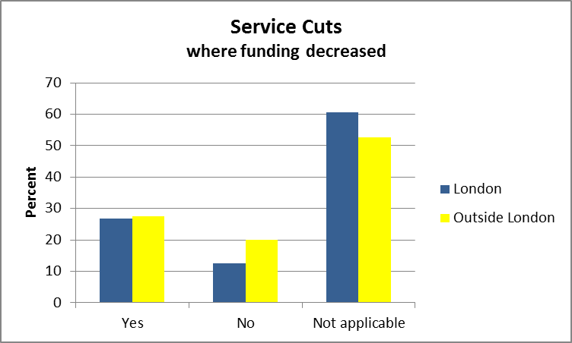
6.3 Meeting Organisational Mission

The survey asked LGBT VCS respondents to indicate whether they thought their organisation had been able to deliver against its mission in the year April 2012 to March 2013. These answers are summarised in Figure 6.4. Most LGBT VCS (71%) respondents seemed positive (scores of 4 and 5), a fifth (20%) scored themselves at 3 but 10% indicated they had been struggling to deliver against their mission (scores of 1 and 2).

Figure 6.4 Organisational Mission: All LGBT VCS organisations (N=101)

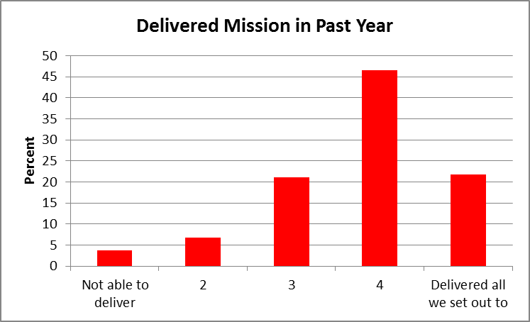

Figure 6.5 Organisational Mission: LGBT VCS organisations – Geographical Breakdown

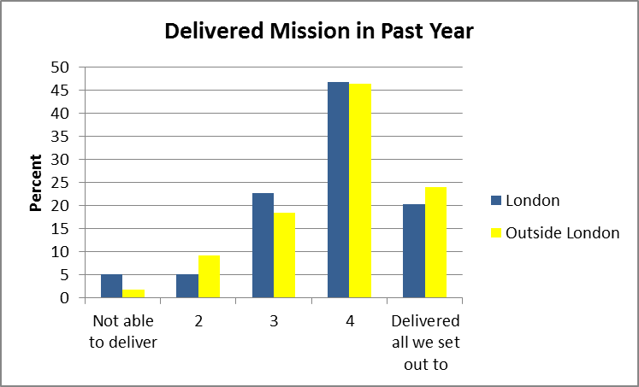
Figure 6.5 provides a geographical breakdown of this data. Though differences were marginal, London LGBT VCS respondents seemed slightly less positive in their response to this question than organisations based outside London.

6.4 Impact on Service Delivery: In-Depth Interview Responses

6.4.1 Cutbacks in service delivery and training

LGBT VCS respondents reported a number of recent cutbacks in services as a result of funding cuts and the consequent reduction in staff and resources. Some of the consequences for LGBT service users are listed below in terms of support, opening hours, group activities and advice.

We've reduced the number of hours of support to our clients.

We’ve reduced the number of hours that the centre has been open because we’ve
had so many more people walk through the doors, in order to facilitate follow-up work
we’ve had to close to people, new people walking in, in order to catch up to where
we’ve been before. So the number of staff remain the same but our workload has
increased but it would have increased even more so if the hours in the centre
remained the same. So what we do is Monday mornings between 10 am and 1 pm
when we ordinarily would have been opened we’re now closed. Wednesday
afternoon from 1 pm to 5 pm and Friday from 1 pm to 5 pm we also close our doors.
And that gives us a chance to catch up on the work that we’re doing.

It cannot be underestimated, what we have been able to offer is severely cut back. So for example, we used to run a weekly LGBT youth group. Crucial, crucial work in an area of, as demonstrated earlier this year with the suicide of a young man at a local school, crucial elements around homo, bi and transphobia that need to be addressed. And being able to provide a safe and supportive place where young people can explore their sexual or gender identity is crucial. And we can’t do that anymore. We don’t have the money to do that anymore. Similarly , the drop-ins we’ve run we’ve had to curtail them and what we offer....Simple things that make a difference to people, we’ve had to start charging for tea and coffee and biscuits and things like that because we don’t have any money to cover those things. There’s a range of different quite significant impacts for people as a result of losing staff.

There is an issue if people need specialist representation at tribunals, there’s very little of that... so what we’re doing now is giving self-help information out to people more

Because they’re saying to me oh, we’ve got no money either. It’ll stop developing for instance rolling out point of care testing in cruising grounds etc. Well, someone has got to pay for the kits.... And the response we’ve got I believe is.. it’s not our responsibility... everybody is passing the buck. They’re doing a lot more called ‘othering’, making it somebody else’s problem which isn’t actually helpful to anybody.

Some of the county councils have been quick to make cuts, which had had an immediate impact on LGBT service users in rural areas. Many of whom needed to travel quite far to find alternative sources of support. A number of LGBT VCS groups discussed the resulting problems as outlined by one example below.
The feedback...has been that, the services that we’ve had to stop are having impact on people. That not being able to attend, for instance, does have impacts on people’s emotional and social wellbeing. So the key issue in broad areas could often be isolation or unwanted attention in terms of discrimination and homophobia... So when people are isolated because of their sexuality or gender in a rural environment and services are decreasing, specialist services that fundamentally address the root cause of the isolation or the discrimination that people are experiencing, it has no option but to have a significant impact on people. And one of the ways in which we have dealt with that is...supporting people experiencing that sort of isolation through provision of counselling which is all done on a shoestring. So we’re not funded to do that so we employ volunteer counsellors who have been CP accredited and that kind of thing. And that service is overrun, so the demand on services, we continue to operate on a shoestring... becomes harder to operate them because there are so many people who need to use those services.

Cuts had also impacted on support work for LGBT people and on awareness raising on LGBT matters for professionals working for a range of public bodies.

Hate crime work, we’re not able to support as many as we would like, training professionals and working with victims....we have less time to provide information...we are trying to maintain frontline services but the funding situation is making it difficult to plan anything.

We have worked in the past...although that’s now stopped, in providing support for employees of the NHS who are LGB or T. That stopped about a year ago the NHS dropped the plan for us to support them on that and it is unfortunate. We would hope that the NHS would look at it again and see that there is potentially great value for money as well as value of improving the services they provide to those staff. At the moment there is very little support to LGBT staff members in the NHS. They are aware of it but they at the moment are neglecting it entirely.

The problem is a lot of the schools had their funding cut so they can’t always afford to buy in our programmes.

6.4.2 Increased demand and more complex needs

As seen in previous chapters, LGBT VCS organisations have tried to protect services by spending reserves, fundraising and if all else failed by reducing staff hours and overheads. Interviewees said the LGBT VCS was reluctant to cut back on services at what was universally agreed to be a time of increasing need.

Because the majority of the clients that we have got quite complex advice needs, it’s very intense work and I can only see that increasing...It’s getting this way that more and more people are struggling on lots of different aspects. So it’s not just that they’re getting less in the way of benefits. It’s their housing costs are rising, they don’t have food, they are having issues with banks, those kind of issues. What it means that people who in the past might have just got by and it’s impacting their mental health and their physical health and those kind of things. So it makes the whole process more difficult.

The volume of LGBT people seeking help was perceived to have increased because of the economic hardship created by the recession and the Coalition government’s austerity programme. Increased demand was also thought to be a result of a lack of alternative sources of assistance.

The challenges that we’ve had is that as other organisations have ceased to exist and many have stopped running, individuals who would have gone there for some of their support ...now come to us for that same support, even when that support is not something that would have been core or fundamental to what we would provide.

The changes to a range of welfare benefits was recognised to have created problems for LGBT people, with the hardest hit often being the most vulnerable, in the lowest income groups, experiencing changes to household benefit, disability living allowance and incapacity benefits for example.

So it’s people having their DLA either reduced or there’s a new benefit, called Personal Independence Payment, so they might be on DLA and then they’re being reassessed for PIP and they end up with less income. And then another group of people who maybe try for employment and support allowance and they might in the past, they might have had Incapacity Benefit where they’re not getting this new benefit. Or they’re not put into the group of people who it will be recognised that they, in order to get back into employment they need a lot more support so they don’t have to go through the same kind of job search, kind of requirements as other people. [and everything is online now] And that’s coming on as well. You have to do things online. And not just apply online but maintain your claim online. So it’s not just that you apply, it’s any changes in your life, whenever your address changes, whenever something else changes you have to go online...and you will be fined if you don’t notify certain changes.

Despite legislation over the last decade addressing homophobic, transphobic and other forms of discrimination, interviewees noted that LGBT people still experienced high levels of harassment and hate crime. As much of this went unreported, the problem goes unnoticed by ‘mainstream’ bodies and service providers.

About five years ago it was probably 50% of people who called us said that their housing problem was directly related to their sexual orientation or gender identity, that’s now gone up to two thirds. And that’s basically around issues of neighbour harassment, so you’ve got harassment from your own neighbours or from people in your locality. But also around domestic abuse, so from family members. Not just your partner but also mothers, fathers, brothers, sisters, uncles, aunts. The whole spectrum of who a family is. And that’s what we’re finding is increasing, is the family breakdown. It’s the domestic abuse. And the homophobic abuse is a spectrum of things.

6.4.3 Tighter funding requirements: decline in service provision and quality

LGBT VCS interviewees raised concerns about the impact of the new funding regimes. These seemed geared to getting ‘more for less,’ and seemed likely to result in heavier workloads for staff and poorer quality services for LGBT people.

We gained the contract... we’ve said hang on a minute, you know, our contract is worth X amount, our service costs this much, it’s not enough, you need to give us more money if you want us to make sure all is secure and...we do all these other bits and evaluate. The commissioners came back and said well, we’ll increase this but there’s an expectation that you now deliver services across county. So where we were running just city groups we’re now in [the county]. Now each trip is an hour out to these places, you know. Developing those networks there, it’s a huge county...and we’ve had no additional staff resource to do that... That’s shot us in the foot because now it’s like God, you know, we’re literally at absolute maximum capacity of all delivering all of this, all the schools work, all the volunteer opportunities, everything.

One area of concern was criteria being set too high so fewer people qualified for support. This delay in support resulted in people eventually arriving with more complex needs.

I think they would have had poorer outcomes... if I could say our biggest resource is our staff, having fewer of those or less of those hours to work with, we’re working with fewer people and we might be working with those people who are more needy but what would that mean if they have to get to a needy place rather than us being able to intervene earlier or set up structures that support people before they get into, you know, needing a lot of support.

Another big area of concern was illustrated by the changing funding for public health and HIV services. Funding was reported to be becoming more generalist and less focused on specific groups rendering LGBT and other equality issues and concerns less visible.

Unfortunately it’s the case that the proposed budget cuts aren’t based on need or evidence. Sexual health services are just being cut back to the bare minimum that they have to provide... So all specialist services including the LGBT but HIV services are being cut, student services are being cut, young people services are being cut so the most vulnerable groups in terms of sexual health are all losing their services. It’s just going to become one mainstream service. Which is really difficult for a) the community and b) us as an organisation.

The group work we’ve been running for a long time and it does some really innovative work which isn’t done by anybody else. Black Connections group for black men to meet to talk about relationships and sex and self-esteem... It’s all based on an assumption that risky, this is the short version, a risky sexual behaviour emanates from low self-esteem and that if you have good self-esteem you’re more likely to make better relationships and have less risky behaviour....So the Black Connections group won’t go on which means there won’t be a group for black men in London. We have an Asian men’s group...and that won’t continue. ...Well, there won’t be anywhere unless another provider stepped up and is able to provide it. But I suspect it will just end.

Contracts were becoming more tightly focused allowing less scope for a holistic model of support for sexual health. The LGBT VCS argued this would be less effective given the importance in tackling a whole range of issues important to sexual health including issues of self-esteem etc.

I think the LGBT side would definitely suffer. Because we’re going to have to totally just wholly focus on what we are funded to do which is HIV prevention with those who are most at risk. And I think a lot of the other bolt-on stuff and goodwill would go out of the window.

Finally, increasing competition from ‘mainstream’ providers to win contracts was considered likely to lead to de-prioritisation of LGBT needs and concerns, together with less appropriate service provision for LGBT service users.

I guess the one interesting thing is that it feels like there’s more competition from central organisations. And organisations that probably never worked with LGBT people in the past kind of see, having to do a bit of work with our communities as essential for them, you know, to get bids and stuff and often doing it quite poorly and quite ill-informed.

6.4.4 Not being able to develop to meet the needs of the LGBT Communi(ies)

One concern expressed by interviewees was the inability to meet demand for LGBT services; another was around the quality of services which could be provided under new funding regimes. A third concern was that the LGBT VCS would not be able to develop to meet the growing needs of LGBT communit(ies) in a climate of austerity when equality is perceived to be lower on the political agenda.

And it’s up to us as an organisation to respond to our community’s needs and to be a bit more innovative and a bit more creative in our thinking so that’s not just protect our own future as an organisation. Because if we’re not actually meeting the needs of our communities there’s no point of staying here. And we actually need to find out from our communities what they want from us and then we design what they need around that. If we’re not doing that we might as well just shut up and go home.

Existing LGBT VCS organisations discussed work they would have liked to develop if funding was available through the public/statutory sector or via other funding sources. This included for example the provision of services for older, disabled and trans* people.

First of all...opening a centre for trans* excellence. It’s working with older members of the LGBT community. It’s working with disabled LGBT community members. And it’s working for members who are, who have mental health issues, who are LGB & T. It’s looking at the very vulnerable members of our community who don’t actually have connections with the centre itself because we’re unable to deliver more than what actually is mainstream LGBT help. [why could you not do so?] It’s around resources and resources are simply down to money.

Also for Black and minority (BME) LGBT people.

You know, we’re seeing the links between.. drug taking for example and alcohol, substance abuse and the LGBT community. That’s not because the LGBT community has a particular predilection or, you know, a sort of obsession for substance abuse... it’s largely connected to the social emotional experience that they’re going through in terms of.. trying to come to terms with their sexuality, their sexual orientation... And in the context of BME, black LGBT community there are huge cultural barriers connected to that and what we found in many of the people that they’ve been excommunicated from their family and their communities and they’ve had to step away. But step away from that to what? You know, when the statutory services in terms of hostels for young people, for example, simply don’t exist or don’t have the capacity to deal with young LGBT people who dare to come out and risk being, you know, alienated...forced out of their homes by their families who don’t accept their sexual orientation.
However, as discussed in section 3.1.1, new community of identity organisations were finding it difficult to gain funding to develop their organisations and activities.

Well, we didn’t have any money to begin with in terms of cuts really so in that sense we don’t have the sense of, you know, oh, we’re cutting back, you know, like it’s just, it’s a shrinking exercise, we don’t have that experience. We’re still developing. For me it’s more about I wonder how we would have developed differently if we had more money become available. So we’ve never approached local authorities for funding to deliver youth projects or youth work but it is something that we could have done had money been available but it’s just not available and so we’ve not pursued that really.

This ‘cap’ on growth was problematic at a time when equality legislation and changing social attitudes meant that more LGBT people were coming forward.

We are working with more young people every year. So we’re engaging more people on a yearly basis. And you know, that’s obviously for a combination of reasons really. I think we’re a bit more noticed now. We’re quite on that sort of circuit and you know, elsewhere people are finding us online, schools are engaging with us more. It’s a combination I think between people coming out themselves at a younger age and also them knowing about it more, and knowing about [X] more so … So I think the demand is kind of, is increasing basically for our services, for the support for young people and the schools that they’re in, and families actually.

6.4.5 Reduction in LGBT Visibility

Despite the hard work of the LGBT VCS in both trying to lobby for and maintain LGBT service provision and activities, concerns were expressed about the reduction of public spending on promotional activities and promotional work. This was thought to have clear consequences for LGBT communit(ies) as discussed below.

From a funding point of view... those public sector providers who used to...have some resources available to them to be able to do...promotional work...community outreach and so forth, what we’ve seen is a complete collapse of that model. There isn’t any real significant outreach work happening anymore, consequently you’re seeing a whole generation … I genuinely feel that there’s a whole generation of particularly young black people who are actually not being engaged in the message around safe sex for example...being as effective as it needs to be. And part of that is about the lack of awareness campaigns and educational materials, the lack of public outreach via public sector providers... public funded organisations don’t have the resources anymore, the idea of doing promotional or outreach work seems to be taboo now...public authorities don’t have the resources or they’re actively told not to spend on these promotional activities.

Dismay was expressed at a decline in anti-discrimination promotional work in equalities and in tackling hate-crime at a time when the austerity climate was leading to a perceived resurgence in discriminatory attitudes across the piece in England and Wales. Where funding existed increasingly it had become generalist, making no reference to specific LGBT representation, issues or concerns.

Because there is no such thing anymore as here is your grant for LGBT services, no such thing. It’s here’s the money for moving a community centre around to get access to diverse communities, here’s the pot of money to get people not in education back into work, here’s the bit to help that victim of hate crime if it’s on a housing estate, here’s the bit to get 18-25 year olds into public speaking, here’s the bit to exchange volunteers between organisations. it’s all very difficult.

One example offered as an important example of a decline in LGBT visibility concerned the reduction in support (financial and otherwise) for LGBT Pride events. This was considered to be a consequence of lessening public funding in combination with limited resources being made available by an LGBT commercial scene which itself was described as struggling in some areas.

This year our Pride had to be cancelled due to financial reasons as well. And that had a massive impact to the LGBT community locally. Not to have that big one focus point event for visibility, for engagement...reaching the wider LGBT community was really difficult. And that is a real sign of the impact that things are happening now that even partner organisations that would have invested some time and money into Pride they just don’t have the budgets either to dedicate. So that is a clear sign to me that times are changing... Which I think that’s going to be a real big visibility thing for the LGBT community across the East Midlands and the country, losing that big event. Really it’s a focus point for a lot of LGBT people.

7. Looking to the Future: ‘Staying Alive’

The objective is staying alive. Because...funding is drying up and obviously in the current financial climate there just isn’t the money... available. [We’re] aiming to put in one bid a week at the moment. And that’s just basically about staying alive.

7.1 Survey Evidence: Attitudes

The survey asked LGBT VCS respondents how they viewed the future situation of their organisation. Figure 7.1 indicates perhaps surprisingly that a third (34%) thought that the situation would improve and just over a quarter (27%) thought there would be no change. However 16% thought things would worsen and nearly a fifth (19%) admitted they didn’t know what the future held.

Figure 7.1 Looking to the Future: All LGBT VCS organisations (N=101)

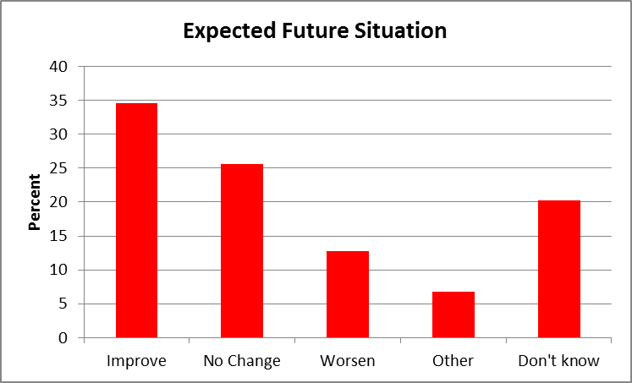

As Figure 7.2 illustrates a higher proportion of VCS organisations based outside London were optimistic about the future situation of their organisation relative to London based organisations. Just under half of the organisations outside London (43%) thought the situation would improve compared to just over a quarter of London based organisations (27%). Nearly a third of the London respondents (31%) said they expected no change whereas about a fifth (21%) of respondents based outside London took this view.

Although similar proportions of LGBT VCS respondents in London (15%) and outside London (17%) thought the situation would worsen, a higher proportion of London based organisations (24%) said they were unsure about their future compared to only 12% of those based outside London.

Figure 7.2 Looking to the Future: LGBT VCS organisations – Geographical Breakdown

Responses also varied by size of organisation income. Those from large and medium organisations indicated higher levels of pessimism and uncertainty than small and micro organisations (see definitions in section 3.1).

- Half of large and medium LGBT VCS survey respondents either thought the situation would worsen (27%) or said that they didn’t know (23%). Only 32% of large and medium sized organisations thought the situation would improve, 9% saw no change and 9% responded ‘other’.

- Just over a third of small organisations thought the situation would worsen (17%) or said they didn’t know (21%). Most said they expected no change (42%), 17% were optimistic the future situation of their organisation would improve and 4% responded ‘other’.

- The most optimistic responses came from micro organisations. Just under a quarter of micro LGBT VCS organisations either thought the situation would worsen (12%) or said that they didn’t know (10%). Nearly half (49%) thought that the situation would improve, 24% saw no change and 5% responded ‘other’.

- Amongst organisations which had earned no income in 2012/13, nearly a half either thought the situation would worsen (8%) or said that they didn’t know (36%). Thirty six per cent of respondents said they thought the situation would not change but 21% thought their situation would improve.

7.2 In depth interviews

The interviews with LGBT VCS organisations allowed these perceptions to be explored in more depth. In most cases, respondents said they had been considering the next 12-18 months when they answered this question.
7.2.1 Situation will Improve

Some organisations were optimistic because they perceived progress had been made on LGBT issues in recent years. Reasons included a more positive social climate and a view that the Equality Act (2010) might provide some element of protection in the changing political and economic climate.

I think it’s going to improve because I think we’re riding a trajectory that we’ve been kind of building towards for a long time...the issues that we look at are gaining more currency... I think that the political climate has changed, you know, in the broader sense and we have been building momentum as an organisation for the last few years. So I think we’re kind of on a trajectory that’s got some steam in it yet. And it’s going to carry us probably through the next couple of years. What’s going to happen after that, if the Tories gets another term, or Labour gets in and just allows more cuts, then you know, I think we might end up going back into the woodwork and becoming more grassroots again.

This optimism could be found in small organisations with limited funding and overheads.

Well, I think we’re kind of like steadily improving. And I think that will continue. I think it will continue because we’ve not got anything to lose because we don’t have very much at the moment....people contribute their time rather than money. And so we just have to adapt to that kind of environment.... Obviously cuts are cuts, that’s kind of a bit of a negative picture but we will try to take the positive view...I don’t want to be kind of negative because what’s the point in that?

It could also be found in large, well-established organisations which were gearing up to adapt to the new funding and political climate

Over the next twelve months I think it will improve. I think there will be more opportunities to work with NHS colleagues on winning NHS bids and for us to be properly recompensed for that. I think there’s an election coming up so some of the austerity will lessen and they’ll chuck some money at us. Cynical... but you know...they’re the two big things, I reckon.

7.2.2 Situation will not change

Others took the view that there would be no change in the short term because they were in receipt of transition funding and/or because of the protective steps they had taken. These included for example using reserves to protect their organisation and services as they sought to fundraise from increasingly diverse sources.

We know that we can survive to March 2015 on the funds that we’ve got. That means using every single penny that we have in our bank account but it means we stay around and in that time you hope new funding will come on board...because we are looking forward and thinking how do we sustain ourselves but not in just a superficial way, in a real structural way. So I’m hoping that the sustainability plan that we’ve written isn’t just something that sits on our shelves....I check [it] to make sure what our progress is against it. And actually we’re making some really interesting progress, especially around the impact analysis stuff, the data that we’re producing which is giving us our evidence base which hopefully will strengthen our funding bids.

7.2.3 Don’t know what will happen

For others, the future situation was unknown, although it was assumed that the organisation would continue to exist, it was recognised that it would need to adapt to comply with the more restricted funding available. One strategy was to try to retain activities where funding was difficult to access by switching to the use of volunteers and social media where appropriate.

Well,for the next twelve months...I know that from conversations I’ve had with Public Health that [we]...are relatively safe. However, I’m going to have to focus more on what we’re contracted to do than the bolt-on stuff. So for instance instead of facilitating our trans* group where we have had a paid sessional worker, it will [now] have to run with a volunteer...or they take autonomy for themselves to run the group themselves.... Our LGBT youth provision, I’m not going to be able to afford to run them. I’ve got to make choices in bidding for certain services and starting services using social media platforms like Skype, Facebook, Twitter.

Even those who tried to remain optimistic recognised their organisation’s future was uncertain.

I am personally an optimistic person so I would look and say we will find something. On the other side I am always worried that in six months time we will close our doors and we will become a virtual service.... it means that what we do and what we can provide will cease. And that’s very important for people to understand. I know that one of the main things that we try to do continuously is to raise awareness amongst the wider community but in particular among the LGBT community that the centre is not funded by government. If they do not help us to find the money, if they do not help us in terms of volunteering, if they do not help us by donating money, time, etc, then when they walk through the door the door will be locked, we will not be here, you know. It is as simple as that. There is no money. We source the money. Without it the centre will cease and when they need us to help them, if it’s around an issue of employment, if it’s around an issue of accessing a gender clinic, or simply my son has come out as gay what can you do to help me to, or can you do to help him or her, that won’t be there any longer.

In addition, the difficulty of bidding for funding in a fast changing and increasingly competitive funding climate, particularly against large, better-resourced LGBT and non-LGBT organisations was daunting.

You know, we’re ambitious and hopeful...we’ll try and make it all work but everyone is going to go for the same pots of money....there is still a lot of homophobia and transphobia around. I mean, LGBT is still the least funded voluntary sector community. I’m not a pessimist...I’m an optimist. I’ll look for ways of, you know, of keeping our services going because they’re so important. My issue is the funders are now getting to the point where you have to...know so much about how to convince them about contribution, attribution, evidence that most small groups are never going to be in a position to be able to do that. Stonewall or big groups like the NSPCC have full-time directors of evidence.

7.2.4 Situation will worsen

LGBT VCS respondents who saw the position worsening saw 2015 as the ‘crunch year’ with public funding cuts beginning to bite.

I think it will get worse....I really do.... Generally with the cuts we’re only just seeing what the impact is going to be. A lot of the services that have been cut are still around at the moment. Whether that’s in a reduced capacity next year that’s going to be a real impact and what we are seeing now and the increase that we’re seeing now scares me quite a lot about what’s going to happen in the future.... Luckily I spent quite a bit of time building my board up...building the skills amongst the board because actually they are a nice fire resistant thing now because my job may go after April, all my senior team may go. We don’t know. There’s the board but I’m pleased to say my board are a strong board, able to make those decisions and I’m confident will be able to continue whatever it looks like for us next year.

LGBT VCS interviewees who were pessimistic about the future, were also concerned that the sector had limited reserves. They expressed surprise that there has been little community mobilisation against the cuts despite the demand for LGBT VCS services and activities being at an all time high.

I don’t see any light at the end of the tunnel at the moment. I don’t see any hope...This isn’t being pessimistic or being overly bleak, it’s just I talk to a lot of different organisations from different sectors, not just the LGBT sector... Public sector cuts are more coming on the way. Trust funding is very difficult. We’re all fighting for the same trust funding...and we’re all fighting for our own community support and people have less money to give at the moment...the number of clients are going up, the number of complex needs are going up. I think it’s a very, very bleak picture and I’m very surprised that there’s not a lot more noise...about protecting the most vulnerable in our communities...It really brings home the fact that the LGBT charity sector is very different from the wider voluntary community sector in that we do live hand to mouth, we don’t have the reserves that we can fall back on ...A lot of our funding goes from hand to mouth, so we receive the money and it goes on services..and we’re not sure whether we can guarantee something beyond a certain point.

A perceived lack of commitment to funding specialist LGBT provision by national and local government in a climate of austerity was a third factor making LGBT VCS respondents feel pessimistic. For example some councillors were reported to seem unaware of the need for LGBT specific services, justifying this by saying ‘there are no gays in our area’. This led some of the LGBT VCS interviewees to express concerns about the impact of the ‘Localism agenda’ for the future of LGBT services.

The capacity to address and fund equalities issues becomes more parlous the more Conservative some of these local authorities become unfortunately.

I know many Conservative councillors who are very enlightened and very pro LGBT and I know many for example Labour and Lib Dem councillors who are less enlightened. So putting it down simply to politics I think might be simplistic.

7.2.5 Other

Amongst those who responded ‘Other’ to the survey there were differing views including those adopting a pragmatic position:

We face funding challenges, but this also brings opportunities, as we can be more creative in what we aim to achieve and how we do it.

We hope it will improve as we are constantly applying for funding.

However, there were other organisations which could more accurately be described to be facing a worsening situation.

We are at crisis point with a recent drastic loss of income. The next few months will either show improvement or we will be forced to plan for closure.

Building going to be knocked down - council property. Been there 8 years.

7.3 Moving Forward

The interview respondents were asked what they thought needed to happen to improve the position of their organisation specifically and the LGBT voluntary & community sector more generally. Although some said they hoped to see a change of heart or failing that a change of government by 2015, a number of other suggestions are listed below:

Awareness Raising
- Argue for stronger commitment to LGBT and equality issues at the local political and national level.
- Raise awareness of the need for more donations from LGBT individuals and the public generally plus trade unions, LGBT network groups and corporate sponsors if LGBT services and activities are to survive the austerity cuts.

Funding
- Request greater transparency in funding applications and feedback from funding bodies (e.g.: the National Lottery and Trusts).
- Argue need for provision of ‘core funding’ from public, lottery and trust funding otherwise LGBT VCS organisations are struggling to survive.
- Funding commissioners need to be convinced not to ‘race to the bottom’ when funding services. Quality is important and realistic contracts need to be negotiated.
- There needs to be a move away from one year contracts/rolling contracts which cause significant stress and job insecurity for LGBT VCS workers/employees.
- Continuation of ‘transition funding’ where LGBT organisations may be jeopardised by insecurity and rapid shifts in public/statutory funding.

Infrastructural Support
- More third-tier infrastructure support.
- Argue need for more funding for third-tier infrastructure support from funding bodies.
- Request for more information and guidance on the changing funding structures e.g. opportunities and threats attached to the localisation agenda.

Legal
- Use the Equality Act (2010) to advance a greater acknowledgement of the specific needs of the LGBT communit(ies).
- Use the Equality Act (2010) to challenge where the needs of LGBT communit(ies) are not being met by public/statutory funding.

Monitoring
- Improve LGBT monitoring in public, private and third sector bodies as one way to improve these organisation’s adherence to the public sector duty.
- Continue to provide and develop LGBT impact analysis data as a way to provide better evidence which can strengthen funding bids.

Office/Meeting Space
- Public bodies to offer free or affordable rooms/basic facilities for those LGBT VCS organisations in need of such resources, particularly community of identity organisations.

Partnerships
- Appropriate and strategic use of the funding partnership model by the LGBT VCS.
- Greater efforts among LGBT VCS organisations to work together in forms of genuine partnership to raise awareness and raise funds. This should include community of identity organisations in order to develop services appropriate to all sections of the LGBT communit(ies).
- Development of stronger relationships with non-LGBT organisations where there will be mutual benefit and result in improved provision for LGBT people.
Political
- Build local and political acceptance of the need for specialist LGBT provision.
- Make the case for greater consistency of funding of LGBT activities and services across the different government departments and local authorities.
- Increased LGBT community and trade union mobilisation to challenge any disproportionate cuts faced by the LGBT (and other equality groups) of the VCS.
- Challenge discriminatory attitudes affecting LGBT people and promote public spending on equality and anti-discrimination to tackle a rise in discriminatory attitudes since 2010.

.

Appendix I: In-depth Interviews with LGBT VCS Organisations – Interview Schedule

Research on Impact of austerity on the LGBTQI Community & Voluntary Sector

- Brief introduction to research. Thank participant for taking part
- Is the organisation willing to be identified in the research report or would it prefer to be anonymous. Intention is to include 15-20 short case studies of positive and negative examples of LGBTQI community & voluntary sector work in the current climate.
- Request to tape record the interview
- Any questions/points of clarification from the participant?
-----------------------------------------------------------------------------------------------------------------
- About the Organisation
- Please can you describe your core activities/services and target users/members.
- Is it specifically for LGBT people?
- Relevancy to LGBT people – why is it important to them?
- Where are you based and where do you run activities/provide services?
- Please provide some historical background on your organisation and these activities (e.g. date set up and any changes last 5 years).
- Please can you outline who you represent and what the points of your engagement are (within and outside LGBTQI community).

- Organisation in its context?
  - What are your organisation’s key objectives at the current time?
  - What are the key things (internal or external) supporting your organisation in achieving these objectives?
  - Are there any key barriers stopping your organisation from meeting its objectives?
  - Has demand for your services/activities changed (last year, last 5 years?)? If so, please explain.
  - Would you say your organisation has been able to deliver against your purpose or mission over the last year? If yes, why? If not, why not?

- Current Funding
- Please can you outline the trajectory of your funding over the last 5 years, identifying funding sources.
- If funding has increased/decreased over the last year can you tell me why and from which sources there has been an increase/decrease?
- Can you tell me a bit about your organisation’s funding from the public/statutory sector (including contracts) – has it increased/decreased, what has the position been re resources of public funding for your organisation (during the last year, during the last 5 years)?
- Are there any important current alternative sources of funding you can tap into? Are you doing this?
- Has your organisation had to use any financial reserves over the last 5 years and if so what are the implications of this for your organisation?
- Is your organisation in any funding partnerships with LGBTQI organisations or non-LGBTQ organisations – when and why did you enter into this partnership and how are these working to deliver activities/services to your target group(s)?

- Impact of any changes in organisation funding
- In what ways have funding changes sometimes referred to as ‘austerity cuts’ impacted on your organisation’s ability to deliver its activities/services? Please give some examples.
- See spontaneous response first then use prompts below as necessary
- Ability to deliver core set of activities and services.
  - Have you had to make any cuts/ reduction to services/activities. If so explain and discuss impact this will have had on your service users.
  - If negative impact on service users are there any alternative ways they can access activities/services
- Reduction in information to LGBT people
- Less outreach and visibility of LGBT service/info
- How have funding issues impacted on your relationships with clients and or service users.
- Less time to address prejudice/homophobia
- Staffing levels, recruitment and payment of staff
- Accommodation i.e. office/meeting space etc./relocation of services to less appropriate area
- How dependent on volunteers to help you deliver activities/services? To what extent related to funding situation? Has number of volunteers increased or decreased?
- Any other particularly negative developments linked to funding?

- Future Funding
- What is your strategy to raise funding for your organisation in the current climate?
- How do you gauge the effect of the recession on your ability to raise money through individual donors (voluntary donations) or other potential sources?

- Impact of cuts in the broader public sector.
- In what ways do you think cuts in other areas of public services have had an impact on your organisation and your service users?
- Do you think that particular subsections of the LGBTQI community have suffered more from funding cuts in the LGBTQI voluntary & community sector and public sector more generally?

- The Future
- Do you think the general situation of your organisation will improve or worsen over the next 12 months? Please explain your view
- What do you think needs to happen to improve the position of your organisation specifically and the LGBTQI voluntary & community sector more generally

- Concluding comments and thanks
- Is there anything else you’d like to say about the impact of austerity cuts on your organisation and/or the LGBTQI Community and Voluntary Sector
- Check if any documents, leaflets in addition to organisation website might be useful
- Many thanks for taking the time to participate in this interview.

Appendix II: Summary Table of LGBT VCS Activities (Ranked)

 | All %  N=122 | London %  N=70 | Outside London %  N=52
Information, advice, signposting, referrals | 66 (1) | 55% (2) | 81% (1)
Events | 66 (1) | 62% (1) | 71% (3)
Newsletters & online media | 58 (3) | 52% (3) | 65% (4)
Support | 54 (4) | 39% (5) | 73% (2)
Campaigning | 47 (5) | 41% (4) | 56% (8)
Advocacy | 45 (6) | 36% (7) | 58% (7)
Outreach | 45 (6) | 30% (10) | 65% (4)
Training | 42 (8) | 32% (8) | 56% (8)
Building knowledge | 42 (8) | 38% (6) | 48% (11)
Befriending &/or mentoring | 41 (10) | 26% (13) | 62% (6)
Education | 38 (11) | 29% (12) | 50% (10)
Supporting LGBT organisations | 37 (12) | 30% (10) | 46% (12)
Skills development | 34 (13) | 32% (8) | 37% (14)
Helpline | 29 (14) | 20% (14) | 40% (13)
Counselling | 27 (15) | 20% (14) | 37% (14)
Resource development | 27 (15) | 20% (14) | 37% (14)
Research & research services | 26 (17) | 19% (17) | 37% (14)
Youth work | 22 (18) | 13% (19) | 35% (18)
Third party reporting | 19 (19) | 12% (20) | 29% (19)
Health testing & alternative therapies | 12 (20) | 6% (22) | 19% (20)
Sport | 12 (20) | 17% (18) | 6% (22)
Religious/spiritual worship | 9 (22) | 12% (20) | 6% (22)
Direct action &/or civil disobedience | 6 (23) | 4% (24) | 8% (21)
Housing provision | 5 (24) | 6% (22) | 4% (24)

Appendix III: Summary Table of LGBT VCS Type of Organisation (Ranked)

 | All %  N=119 | London %  N=68 | Outside London %  N=51
Not for profit | 61 (1) | 60 (1) | 63 (1)
Community group | 54 (2) | 50 (2) | 21 (4)
Registered Charity | 43 (3) | 41 (4) | 45 (2)
Membership organisation | 32 (4) | 43 (3) | 18 (5)
Company Limited by Guarantee | 25 (5) | 24 (5) | 27 (3)
Network or Forum | 18 (6) | 19 (6) | 18 (5)
Online group | 16 (7) | 15 (7) | 18 (5)
LGBT project in non-LGBT organisation | 12 (8) | 10 (8) | 14 (8)
Partnership project between voluntary organisations | 7 (9) | 6 (10) | 8 (9)
Community Interest Company | 6 (10) | 7 (9) | 4 (11)
Social enterprise | 5 (11) | 4 (12) | 6 (10)
Student group | 1 (13) | 0 (14) | 2 (12)
Industrial and Provident Society | 1 (13) | 1 (13) | 0 (14)
Other | 4 (12) | 6 (10) | 2(12)

Appendix IV: PACE’s First Fundraising Event at Café de Paris, 27th February 2014.

The fund raising night featured PACE’s new Patron, Will Young, and comedian Jen Brister and there was an auction and resident DJ.

Tickets were £55 or £120 for VIP tickets. All of the funds raised on the night were used to help to keep vital PACE services going during 2014 and beyond.

Appendix V: Opening Doors London (ODL)

Opening Doors London (ODL) were continuing with their search for ongoing funding and were being driven in ever more imaginative directions by their lack of success in securing support from more traditional funding streams. So on the 15th May they managed to engage with celebrity Tweeter Stephen Fry who tweeted the message below.

The success in engaging Fry's help is recognition of two things. Firstly that ODL are able to persuade influential people that the project is worthwhile and under significant funding pressure. And secondly that funding opportunities even for projects that receive such recognition are at best precarious in the context of the austerity cuts, and at worst are leading to services not covered by other agencies to close. This engagement can therefore be understood as emblematic of the situation facing many agencies in the LGBTQ sector, some of which are highly regarded and quite established.

Opening Doors London (ODL) is a great organisation so donate if you can.
WOW!!!!! A massive thank you to the incredible Stephen Fry who has just Tweeted to his 6.8 million Twitter followers about ODL's funding crisis. Thank you, you wonderful man!! Please support us - we need your help people! Link to our donate page is in the first comment.

‘Vital service for older #LGBT Londoners @OpeningDoors Ldn at risk of closing. Pls donate now http://bit.ly/Rx8BKm.’

Trans* is used as an umbrella term to refer to the range of identities within the gender identity spectrum.
As centred planned to survey London LGBT VCS for its 2014 London VCS Almanac during the Summer of 2013, the TUC funded survey of LGBT VCS organisations in England and Wales was run at the same time. This collaboration was positive in aiming to minimise requests for information from a busy LGBT VCS. centred (2014) Almanac is available at: http://www.centred.org.uk/.
centred (2014) LGBT VCS Almanac, p. 35
centred is a London based LGBTQ organisation concerned with LGBTQ activities and community infrastructure. Over the last 3 years, it has produced the London LGBT VCS Almanac's a valuable source of data on the LGBT VCS (http://www.centred.org.uk/). This report will refer to the Almanac to make comparisons between London based LGBT VCS organisations and those outside London as appropriate.
The Consortium of LGBT VCSO supports the LGBT third sector. It is a ‘national membership organisation focusing on the development and support of LGBT groups, projects and organisations; so they can deliver direct services and campaign for individual rights’ (http://www.lgbtconsortium.org.uk/)
Mitchell, M., Beninger, K., Rahim, N. and Arthur, S. (2013) Implications of austerity for LGBT people and Services, Nat Cen Social Research, A report prepared for UNISON. [accessed 16-5-14] http://www.natcen.ac.uk/media/205545/unison-lgbt-austerity-final-report.pdf
Mark Carney, (2013) Governor of the Bank of England ‘Crossing the Threshold to Recovery’, CBI East Midlands, Derbyshire and Nottinghamshire Chamber of Commerce and the Institute of Directors at the East Midlands Conference Centre (28-8-13) http://www.bankofengland.co.uk/publications/Documents/speeches/2013/speech675.pdf [accessed 16-5-14],
TUC (2014) Casualisation and Low Pay, TUC, 9-4-14, www.tuc.org.uk/sites/default/files/Casualisationandlowpay.docx [accessed 16-5-14]
MacInnes, T., Aldridge, H., Bushe, S., Kenway, P. and Tinson, A. (2013) Monitoring Poverty and Social Exclusion 2013, Rowntree Foundation, http://www.jrf.org.uk/sites/files/jrf/MPSE2013.pdf [accessed 16-5-14]
The Economist, October 27th, 2012, Parsing public payrolls. [accessed 16-5-14]
Mitchell, M., Beninger, K., Rahim, N. and Arthur, S. (2013) Implications of Austerity for LGBT people and Services, Nat Cen Social Research, A report prepared for UNISON.
Becket, C. (2014), Assessing the Cost of Cuts in Welfare Spending for Lesbian, Gay and Bisexual People, Social Policy and Society, Cambridge Journals Online. Doi:10.1017/S1474746414000062[accessed 16-5-14]
5. The Financial Times, Austerity Audit (2013), http://ig.ft.com/austerity-audit/ [accessed 14-05-14]
Mason, R., 6th January 2014, ‘George Osborne warns of more cuts and austerity in ‘year of hard truths’, The Guardian,http://www.theguardian.com/politics/2014/jan/06/george-osborne-britain-cuts-austerity [accessed 14-05-14].
LVSC (2013) The Big Squeeze 2013: A Fragile State, file:///D:/work2/Work2/LGBT%20TUC%20project/LSVC/bigsqueeze-final-smaller%202013.pdf [accessed 14-05-14].
Local Government Association (2014), LGA Response to the 2014 Budget, http://www.local.gov.uk/web/guest/media-releases/-/journal_content/56/10180/6027395/NEWS [accessed 13-05-14]
Local Government Association (2014), Under Pressure: How Councils are Planning for Future Cuts, Available at: http://www.local.gov.uk/web/guest/publications/-/journal_content/56/10180/6173669/PUBLICATION#sthash.fR1aMiEu.kCSZboiG.dpuf [accessed 14-05-14]
The National Children’s Bureau (2012), Beyond the Cuts: Children’s Charities Adapting to Austerity, Available at: http://www.ncb.org.uk/media/705870/beyond_the_cuts.pdf [accessed 14-05-14]
National Council for Voluntary Organisations (2013) Counting the Cuts, http://www.ncvo.org.uk/images/documents/policy_and_research/funding/counting_the_cuts_2013.pdf [accessed 16-5-14].
NCVO, Policy and Research: Funding, http://www.ncvo.org.uk/policy-and-research/funding. [accessed 14-5-2014] and Cuts Watch Cymru http://cutswatchcymru.wordpress.com/press/ . [accessed 14-5-2014]
12. Becket, C. (2014), Assessing the Cost of Cuts in Welfare Spending for Lesbian, Gay and Bisexual People, Social Policy and Society, Cambridge Journals Online. Doi:10.1017/S1474746414000062.
Mitchell, M.,Beninger, K., Rahim, N. and Arthur, S. (2013) Implications of austerity for LGBT people and Services, Nat Cen Social Research, A report prepared for UNISON.
However, it has meant the survey produced slightly different data for the London LGBT VCS relative to LGBT VCS organisations in other parts of England and Wales.. For example, centred has been collecting data on income, staffing and users from the London LGBT VCS over the last 3 years so where ‘historical’ data is required we must refer to their data. As no such comparable ‘historical’ data exists for LGBT VCS organisations in England and Wales (outside London), the TUC funded survey included questions to chart their perception of changes in income and resources within the sector.
centred LGBTQ VCS Almanac, 3rd Edition (2014) available at: http://www.centred.org.uk/content/centred-lgbtq-almanac-survey.
Some small differences may exist between the TUC and centred’s figures due to definitional issues. centred’s LGBTQ VCS Almanac (2014, p.33) specifically focuses on organisations that say they are ‘LGBTQ by mission.’ We however have included projects within larger organisations or organisations with a broader diversity remit where they ‘serve and are informed and governed by LGBT people’ (examples might include: Naz Project London, the Metro Centre, Outreach Liverpool) particularly where such organisations are members of the Consortium.
This question is consistent with centred’s LGBTQ VCS Almanac (2012, 2014) survey question.
This question is consistent with centred’s LGBTQ VCS Almanac (2012, 2014) survey questions.
Press for Change (2007) Engendered Penalties: Transgender and Transsexual People’s Experiences of Inequality and Discrimination http://www.pfc.org.uk/pdf/EngenderedPenalties.pdf; Stonewall (2013) Gay in Britain http://www.stonewall.org.uk/documents/gay_in_britain.pdf [both documents accessed 20-5-14]
Mitchell, M.,Beninger, K., Rahim, N. and Arthur, S. (2013) Implications of austerity for LGBT people and Services, Nat Cen Social Research, A report prepared for UNISON.
The largest national London based LGB VCS did not participate in the survey but had it done so it would have been included in the ‘large’ category For 2011/12, that organisation employed 64 staff and had income of just over £4 million. Source: centred (2014) LGBTQ VCS Almanac, p. 34.
Estimates of the LGBT population vary from 5-7%. Despite considerable lobbying by LGB organisations, the Office of National statistics did not include a question on sexual orientation in the 2011 Census.
LGBT Consortium http://www.lgbtconsortium.org.uk/our-impact [accessed 19-5-14].
centred (2014) LGBTQ VCS Almanac, pp. 38-40.
National Council for Voluntary Organisations (NCVO); National Association for Voluntary & Community Action (NAVCA); Association of Chief Executives of Voluntary (ACEVO);
centred (2014) LGBT VCS Almanac, p. 35.
Transition funding was made available to VCS organisations likely to be affected in the short term by reductions in spending, where they were able to demonstrate that this would affect their ability to deliver services. Wiggins, K. (2010) ‘Chancellor announces £100m Transition Fund for charities in 'real hardship' Third Sector, available at: http://www.thirdsector.co.uk/news/Article/1036186/chancellor-announces-100m-transition-fund-charities-real-hardship/ [accessed at 21-4-14].
centred (2014) LGBT VCS Almanac, p. 35
As required by the Health and Social Care Act (2012).
The Localism Act (2011) introduced measures to shift power from central government to local authorities. The stated intention was to permit local authorities more flexibility to respond to the needs of their communities so allowing local services to be transformed and institutions to become more inclusive http://www.ncvo.org.uk/policy-and-research/localism [accessed 14-5-14]. This was followed by the Health and Social Care Act 2012 which transferred responsibility for public health from the NHS to local government in England resulting in substantial changes to funding arrangements for LGBT VCS at an already challenging time.
centred (2014) LGBTQ VCS Almanac, p. 14.
London organisations were not asked this question.
centred (2014) LGBTQ VCS Almanac, p. 16.
centred (2014) LGBTQ VCS Almanac, p. 17.
22% of organisations outside London had experienced a drop in public/statutory income over the past year. This data is not available for London-based VCS organisations.

