‘Scallywag Bunkers’: Geophysical Investigations of WW2 Auxiliary Unit Operational Bases (OBs) in the UK
S. Carr¹, J.K. Pringle^{1*}, P. Doyle², K.D. Wisniewski¹, & I.G. Stimpson¹
¹School of Geography, Geology and the Environment, Keele University, Keele, Staffordshire ST5 5BG, U.K.
Email: s.carr@live.com ; j.k.pringle@keele.ac.uk ; k.d.wisniewski@keele.ac.uk ; i.g.stimpson@keele.ac.uk
Twitter: @milgeol ; @Kris_Forensics ; @hypocentre
JP ORCiD: 0000-0002-0009-361X ; KW ORCiD: 0000-0001-5408-2417 ; IGS ORCiD: 0000-0002-1931-0522
²School of Law & Social Sciences, London South Bank University, 103 Borough Road, London SE1 0AA, U.K. Email: doylep8@lsbu.ac.uk PD ORCiD: 0000-0001-6003-8199 Twitter: @profpeterdoyle

*Jamie Pringle corresponding author
Word count: 8,562

Scallywag Bunkers: Geophysical Investigations of WW2 Auxiliary Unit Operational Bases (OBs) in the UK

In 1940, with the fall of France imminent, Britain prepared for invasion. After Dunkirk, with most armour and transport lost, a defence ‘stop line’ (GHQ Line) was prepared. Local Defence Volunteers (later Home Guard) were raised to buy time for the Home Army to deploy. Secret ‘Auxiliary Units’ were also formed, tasked with ‘Scallywagging’ – guerrilla activities ––in the invading army’s rear. 4-8 patrol men were highly skilled, often gamekeepers and poachers, with expert local area knowledge, with below-ground Operational Bases (OBs) in remote locations to avoid detection. No official records are released; but OBs were ‘Mark I’, enlarged deer setts, smuggler caves, etc., and Mark II, prefabricated designs by the Royal Engineers. This paper details three sites in Suffolk.
One unknown Mark I was destroyed, a Mark II was partially-intact and a Mark II was fully intact, all in secluded woods. Geophysical surveys found metal detectors optimal for location, with mid-frequency GPR/ERT optimal for characterisation. Archaeological finds included home-made braziers, 1940 kerosene heater stove, metal pans, ventilation systems and escape tunnels.
This study shows OBs varied in construction and condition, with surveys detecting and characterising them, bringing WWII British ‘invasion’ history into the wider scientific community and public domain.

Keywords: geophysics, WW2, Auxiliary Units, scallywag bunkers, United Kingdom

INTRODUCTION

This paper examines, for the first time geophysically, clandestine aspects of the British preparations for invasion following the defeat of the Britsih Expeditionary Force in Flanders in June 1940, focussing on secret ‘Auxiliary Units’ which were raised, specifically tasked with so-called ‘Scallywagging’ – guerrilla activities – behind the lines of the invading army (e.g. Lampe, 1968; Warwicker, 2008; Atkin, 2015). The Operational Bases (OBs) of these secret units were deliberately set in remote locations in order to avoid detection – and for this reason detailed study of these sites has been limited. This paper sets put to study surviving examples in Suffolk, as a means of opening up further research into this fascinating topic.
On 4 May 1940, the German Army invaded France and the Low Countries (Ellis, 1953). The original plan Fall Gelb (Plan Yellow), which was developed from October 1939 onwards, was to push through on the traditional route of the invading armies in Flanders north of the Ardennes – but ultimately this was modified, with the main thrust coming through the Ardennes themselves, a seemingly impassable area (Greiss, 2002, pp. 9–15). With the British Expeditionary Force (BEF) deployed in northern France and Flanders, the Allied plan was to cross the border of Belgium and make its thrust towards the German border, taking up a defensive position on the River Dyle; but the German assault through the Ardennes effectively divided the Allies, leaving the BEF surrounded, and severely weakening otherwise strong French armies (Ellis, 1953; Fraser, 1983; Greiss, 2002; Todman, 2016). By 21 June, France had been defeated, the evacuation of large numbers of British and French troops from the beaches of Dunkirk (and St Nazaire) had been enacted – and vast amounts of military material had been discarded as ‘all equipment not carried by hand would have to be abandoned’ (Hay, 1950, p. 94). This meant the loss of huge amounts of artillery, ammunition, armoured vehicles and transport in France that would severely limit the capability of the British Home Defences to resist invasion (Collier, 1957). As such, preparations had to be put in train for the defence of the United Kingdom by all means necessary, and particularly to defend against: 1, large scale seaborne invasion; and, 2, smaller-scale airborne invasion or raids on vital points (O’Brien, 1955, p. 356). While the United Kingdom had long-anticipated aerial assault through bombing raids (O’ Brien 1955; Collier 1956), and with part of the Home Guard’s remit being to counter enemy paratroops (hence their nickname ‘Parashots’; Fleming, 1958; Mackenzie, 1996), a seaborne invasion against weakened UK defences was a matter of concern (Collier, 1957; Fleming, 1958; Newbold, 1988; Todman, 2016).
For the Germans, the fact that the British had not capitulated and sued for peace following the failure of the BEF, and the subsequent evacuation from the beaches of Dunkirk, was a surprise, as Hitler fully expected that a negotiated peace would be forthcoming: this was not the case (Fleming, 1958). It was Admiral Raeder of the Kriegsmarine that first raised the possibility of a seaborne invasion on 21 May 1940, and it appears that he had been planning such a possibility from later in 1939 (Fleming, 1958, p. 34). Nevertheless, although the matter was raised on a number of occasions, plans were not taken forward in any meaningful manner until early July 1940, when the Ober Kommando der Wehrmacht (OKW) issued its first instructions that plans be made to carry out an invasion of England. As Fleming (1958, p. 39-40) pointed out, the lateness of these plans shows indecision: ‘eight weeks had elapsed since Raeder had first discussed the invasion of England with Hitler; six weeks since the BEF had been driven into the sea, four weeks since the fall of France, two weeks since Hitler had ordered preparations to begin “on the basis that the invasion is still only a plan, and has not yet been decided upon”’ (Fleming, 1959, pp. 40-41).
Operation Sea Lion (Seelöwe) was the invasion plan of the United Kingdom, and drew heavily on the cooperation of the main services, the Kriegsmarine (which would conduct the crossings and have to contend with the Royal Navy that opposed them); the Wehrmacht, which would provide the invading manpower; and the Luftwaffe that would be required to defeat the RAF in the air and on the ground. Indeed, aerial supremacy was seen as a vital prerequisite to invasion (Collier 1957). Invasion was predicated on the failure of diplomacy, and as late as 19 July 1940, Hitler had in a speech issued his ‘Appeal to Reason’ to the British, with the hope that a landing would not be necessary (see Longmate 1972, p. 15). Despite this, on 16 July 1940, Hitler issued Führer Directive 16 (Hitler, 1940):‘Since England, in spite of her hopeless military situation, shows no signs of being ready to come to an understanding, I have decided to prepare a landing operation against England and, if necessary, to carry it out. The aim of this operation will be to eliminate the English homeland as a base for the prosecution of the war against Germany and, if necessary, to occupy it completely.’
Nevertheless, the Germans had had little experience of amphibious landings to date, and despite preparing a large number of maps and plans in advance of the invasion (Fleming, 1958; Rose & Willig, 2002, 2004), Sea Lion had not advanced beyond the concept that the hazardous sea crossing would actually be nothing more than an extended river crossing (Collier, 1957; Fleming 1958). Sealion was to be a combined assault with amphibious landing on the southeast coast of England and paratroop landings in East Anglia and SE England. It was intended that the landings would result in a broad front that would extend from Ramsgate to Lyme Bay, which would require the landings of some 40 divisions – a huge undertaking (Fleming, 1958, p. 44). This was a tall order, meaning that it was slimmed down to a narrower front in Kent and Sussex, and would be limited to 13 divisions.
These divisions started arriving on the Channel Coast in July, and each one was divided into two echelons. The first of these comprised some 90.000 men, 650 tanks, some 4,500 horses and a large amount of field gear to be transported in the first wave; the second echelon would comprise 160,000 men, some 60,000 horses, 40,000 vehicles, 500 field-howitzers and other equipment. The transport of this huge mass of material would fall to the Kriegsmarine, under the cover of the Luftwaffe, which would also be committed to the destruction of the RAF during Operation Adlerangriff (Eagle assault) from 13 August. The commitment was large, requiring some 155 marine transports, 1,722 barges, 471 tugs and 1,161 motor boats (Collier, 1957, pp. 175-176). This was a large undertaking given the late-in-the-day planning, and it was accepted that the invasion would not be feasible much before mid-September. And with the defeat of the Luftwaffe in the air during the Battle of Britain, and the shift in emphasis of the Luftwaffe to attacks on London on 7 September, the invasion plan was first put back to late September and eventually abandoned on 12 October (Collier 1957; Fleming 1958). On the 12th June 1940 the British Government drew up plans to defend against potential invasion. These plans developed as the hostile intentions of the German forces changed, as well as the gradual replacement of the British War machine in the face of the losses at Dunkirk (Collier, 1957; Frazer, 1983; Newbold, 1988; Todman, 2016). Three successive plans were developed by the three successive generals commanding the home forces: Kirke, Ironside, and Brooke (Collier, 1958; Newbold, 1988; Lowry, 2004; Foot, 2006). The original plan to defend the islands in early May was developed by General Kirke, who identified that the main threat came from airborne troops, with the capture of ports being a pre-requisite (Collier 1957; Newbold 1988; Lowry 2004; Foot 2006). Defeat of the airborne troops would win the battle overall, and army divisions were positioned to defend these places. In the aftermath of Dunkirk came the realisation that there would be a seaborne invasion, and that airborne troops would therefore not be the only threat. The new Commander-in-Chief, General Ironside, took up his post in July and set to work creating a defensive plan that now depended on a series of defensive lines, intended to slow down the invader and to prevent him penetrating the rapidly-created first line of defence on potential invasion beaches, in front of a Home Guard-led second line of defence stop lines to slow down the invading forces. It was planned that this delay would allow retreating coastal forces to link up with reserve forces in holding the third General Headquarters (GHQ) Line, a defensive line protecting London and the industrial Midlands (Collier, 1957; Lowry 2004; Foot, 2006; Fig. 1).
In addition, secretive British ‘Auxiliary Units’ were created on the orders of the Prime Minister, Winston Churchill, with Colonel Gubbins as the commander. Gubbins was a veteran of guerrilla warfare in the Russian Civil War in 1919 and the Irish War of Independence in 1919-21 (Williamson, 2004; Warwicker, 2008; Atkin, 2015). The Auxiliary Units were tasked with guerrilla operations, including sabotage and assassination of high-ranking German Officers, in order to buy time for regular army units to retreat from the coast to the General Headquarters Lines (GHQ) for the final defence operation. In order to mask their true capability, these units were assigned Home Guard numbers (201 – Scotland; 202 - Northern England; 203 - Southern England) and comprised 4-8 civilians with expert knowledge of their local area, and in many cases familiarity with firearms, such as farmers, country landowners, gamekeepers and poachers. It was intended that these men were to operate from below-ground Operational Bases (OBs) that were set deliberately in remote locations, in order to avoid detection. Nevertheless, likely survival rates were judged to be low as 12 days (Lampe, 1968). Members of these units were colloquially known as “scallywags” and their operations as “scallywagging” (Warwicker, 2008).
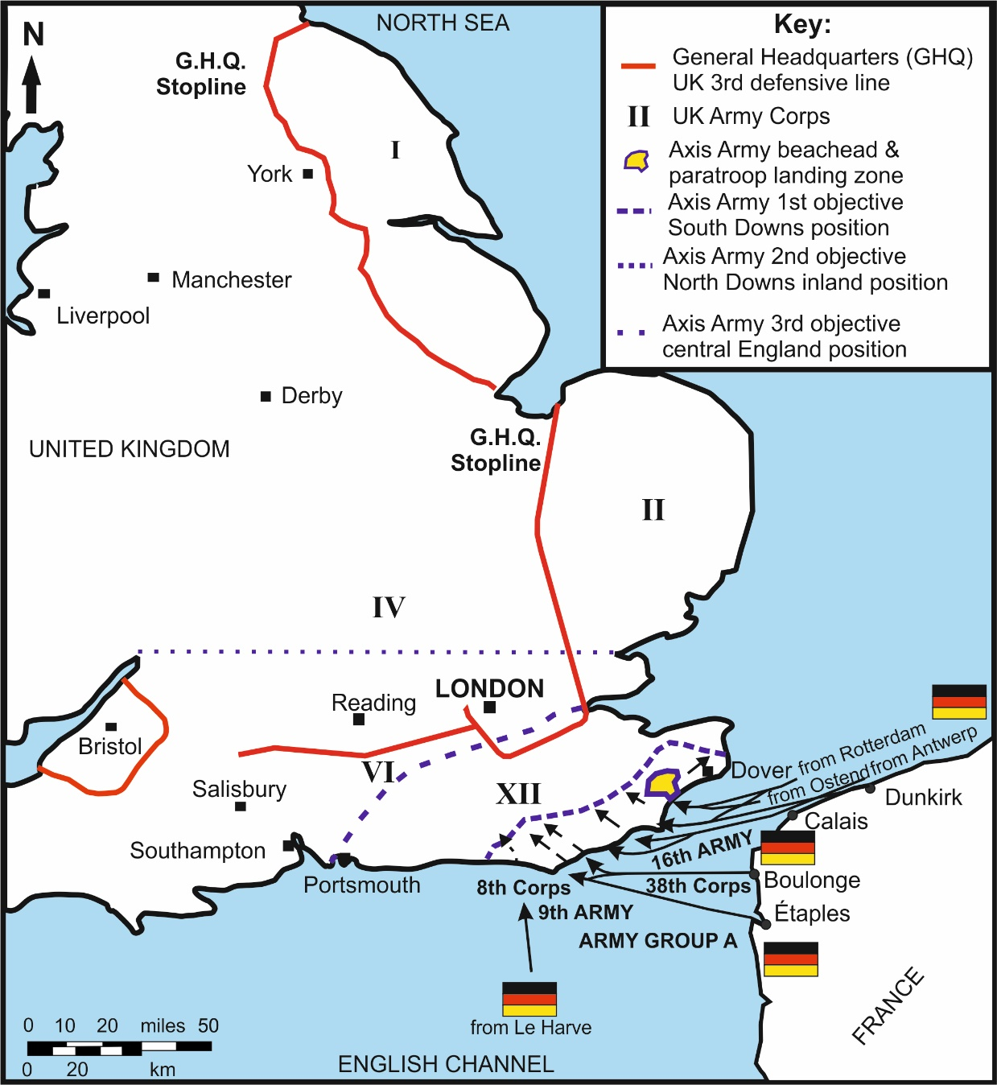
Figure 1. Schematic 1940 map showing the British General Headquarters (GHQ) 3rd defensive line, and Army Corps (see key), German Army invasion beachhead/paratroop landing zone and 1-3 location position objectives (see key). Modified from Wills (1985).
Despite the importance of the anti-invasion defences to the history of the war, and the understanding of its technicalities, most work on conflict archaeology has concentrated on: trenches, dug-outs, foxholes and battle scars of front-line conflict (see, for example, Doyle et al. 2001, 2002, 2005; Everett et al. 2006; De Meyer and Pype, 2007; Brown and Osgood 2009; Masters and Stichelbaut, 2009; Banks, 2014; Banks and Pollard, 2014; Doyle, 2015, 2017); prisoner of war camps and activities (Moore, 2006; Pringle et al. 2007; Doyle, 2011, Doyle et al. 2013; Schneider 2013; Rees-Hughes et al. 2016); or the hospitals, airfields and other logistics of war (e.g. Dobinson et al. 1997; Schofield, 2001; Passmore et al. 2013; 2017; Capps Tunwell et al. 2015).
Despite the increasing diversity of study of wartime sites, Home Front sites have been somewhat neglected, although notable exceptions have been the Defence of Britain Project in the early 2000s (e.g. see Schofield, 2004; Foot 2006), surveying the remaining known WW2 anti-invasion fortifications of Britain, and recent studies of UK air-raid shelters (see Thomas, 2016; Ainsworth et al. 2018). Previous Auxiliary Unit research has been small, limited to a few biographies and local interest groups (Lampe, 1968; Angell, 1996; Williamson, 2004; Warwicker, 2008; Watson, 2011) and thus is important to document in this crucial time in European history.
As part of the investigations of wartime sites, near-surface, multi-technique geophysical surveys have become increasingly popular (see, for example, Gaffney et al. 2004; Everett et al. 2006; Pringle et al. 2007; Fernandez-Alvarez et al. 2016; Rees-Hughes et al. 2016; Ainsworth et al. 2018), due to their capability to locate and characterise buried objects for subsequent intrusive investigations. Given the relative rarity of existing Auxiliary Unit Operational Bases, the use of the non-invasive surveys employed here represents good practice and demonstrates what can be done to locate and characterise them. As such, this paper describes multi-technique geophysical site investigations to analyse three Operational Bases in Suffolk in various states of preservation that will be typical of the remaining bases in the UK.
As such, the aims of this paper are: to record the Operational Bases at the three study sites in Suffolk; to document the geophysical and site investigations carried out; to determine the optimum geophysical technique(s) and equipment configuration(s); and, discuss how other researchers can utilise geophysical surveys to investigate these Operational Bases in the future.
‘SCALLYWAG BUNKERS’: AUXILIARY UNIT OPERATIONAL BASES

Auxiliary Unit principal roles were to gather intelligence behind enemy lines and perform guerrilla warfare including unarmed combat, assassinations, demolition and sabotage of railway lines, aircraft, fuel/ammunition depots, etc. (Lampe, 1968). Patrols needed a hidden Operational Base (OB) to rest and sleep between operations, store arms/equipment/food, heating to keep warm/cook and avoid detection. The original OBs, here designated Mark I, were constructed to take advantage of pre-existing structures for camouflage, enlarging badger setts, smugglers caves, forgotten coal mines and even old ice houses which could not be observed from the air. Consequently, these had varied configurations and ventilation systems (Lampe, 1968).
Given the challenges inherent in non-standardised constructions, the Royal Engineers (RE) were tasked with the production of a more planned system, producing a standard Mark II design, distinguished by its exit hatch, escape tunnel, concrete foundations and with corrugated sheet metal forming a main chamber (Fig. 2; Williamson, 2004). Whilst the RE was the author of these designs, and some RE units were involved in construction, it is the case that the auxiliaries themselves would generally create OBs according to specifications. With their deep knowledge of the local environment, this means that OBs were usually situated on private land, particularly in woods, in order to conceal the excavated spoil materials from being discovered, and so as not to be observed by the local population.

England
County | Battalion | No. of Patrols
Cornwall | 203 | 35
County Durham | 202 | 7
Devon | 203 | 32
Dorset | 203 | 41
Essex | 202 | 20
Hampshire | 203 | 39
Herefordshire | 202 | 6
Isle of Wight | 203 | 15
Kent | 203 | 35
Lincolnshire | 202 | 30
Norfolk | 202 | 42
Northumberland | 201 | 21
Somerset | 203 | 44
Suffolk | 202 | 33
Sussex | 203 | 28
Worcestershire | 202 | 8
Yorkshire | 202 | 33
Wales
County | Battalion | No. of Patrols
Carmarthenshire | 203 | 4
Glamorganshire | 203 | 8
Monmouthshire | 202 | 7
Pembrokeshire | 203 | 8
Scotland
County | Battalion | No. of Patrols
Aberdeenshire | 201 | 34
Borders | 201 | 21
Caithness & Inverness | 201 | 22
Fife & Angus | 201 | 23
Outer Hebrides | 201 | 7

Table 1. List of counties with their respective 1940 Auxiliary Unit Battalion (Home Guard numbers) and numbers of patrol. Note coastal counties having comparably more patrols than inland ones (courtesy of CART, 2009-2017).
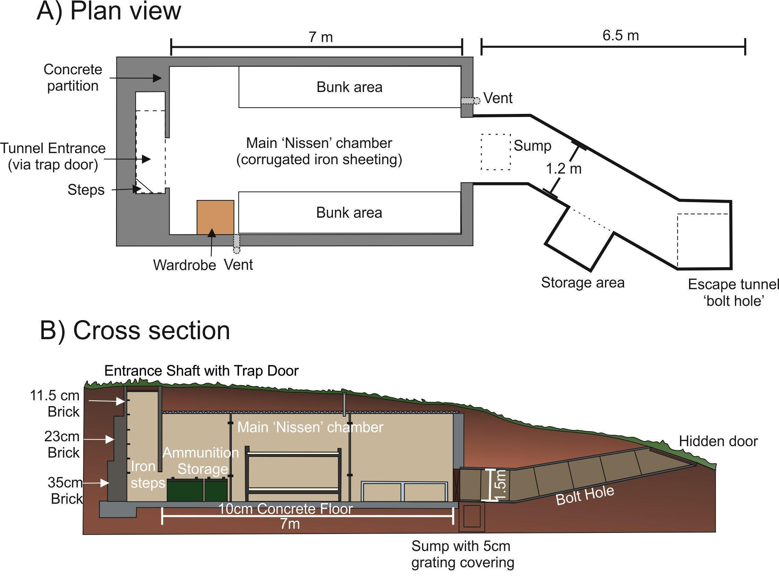
Figure 2. (A) plan view and (B) cross section of the Royal Engineer’s Mark II Auxiliary Unit Operational Base 1940 plan. Both entrance doors would be hidden or covered with vegetation (modified from Williamson, 2004).

LOCATION OF OBs IN EAST ANGLIA

In Norfolk and Suffolk, behind the first defence stop line (the coast), the second stop lines were constructed, designed to be orientated NW-SE in order to delay the invaders advancing inland, whilst allowing surviving coastal forces time to retreat to the third, or GHQ line (Liddiard and Sims, 2014; Fig. 3). As such, many of the secondary positions were deliberately sited by major river crossings and road intersections to delay the invaders advance as long as possible.
The 36 Auxiliary Unit patrol positions in Suffolk were placed just east of the initial XI Corps Black (2nd) Stop line (Fig. 4), in order that they would be situated behind the advancing enemy and just enough inland so as to avoid marshland and potential flooding, which would render OBs non-operational (Lampe, 1968).
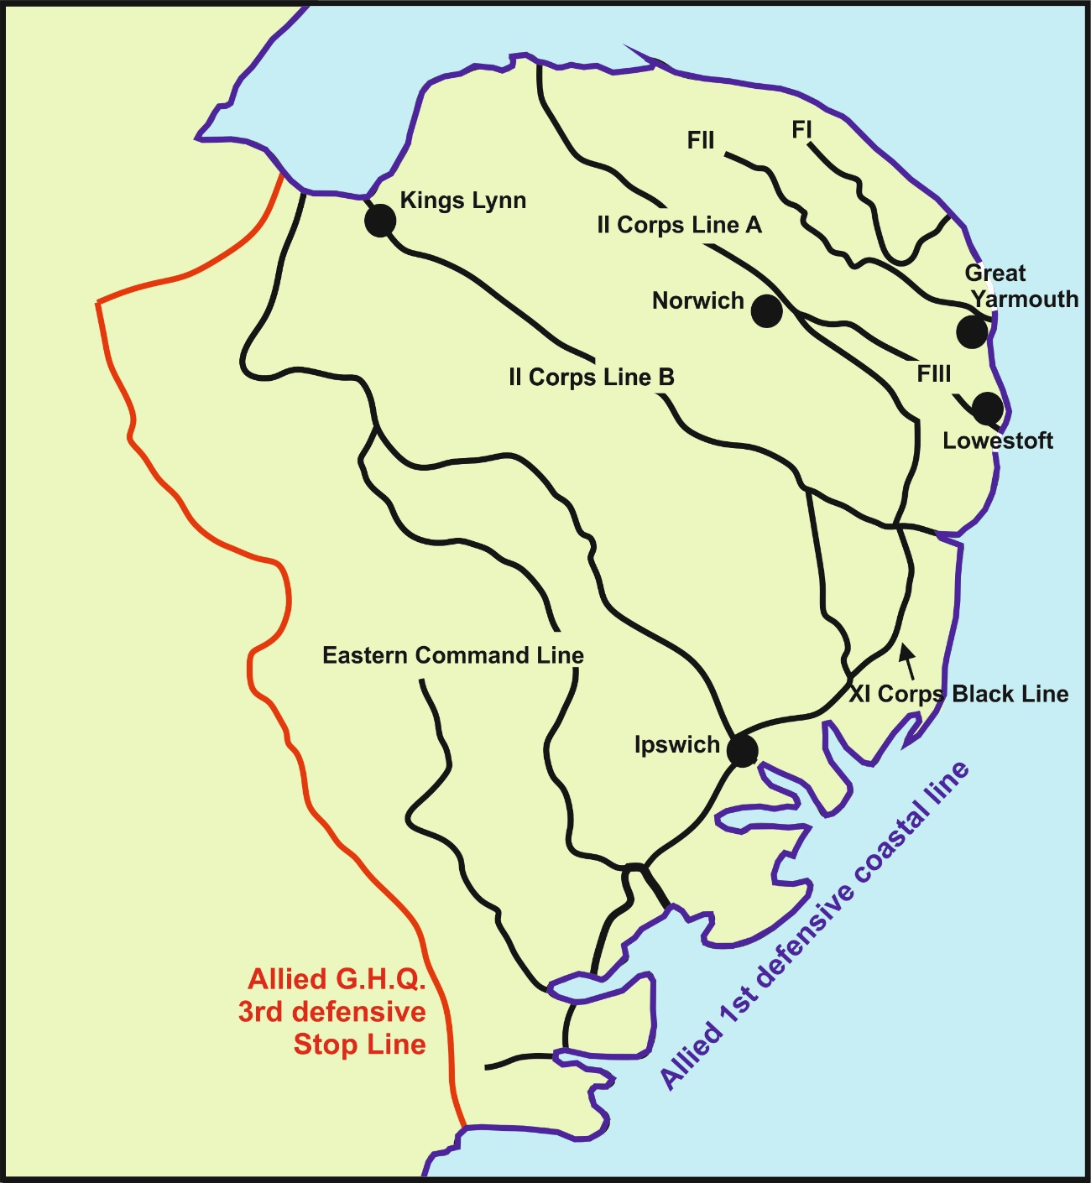Figure 3. Schematic 1940 map of East Anglia with main towns marked, showing the British 1st level defensive coastal line, the 2nd level defence lines, and the 3rd level General Headquarters (GHQ) stop line positions. Auxiliary Units were deliberately situated to allow unit patrols to attack behind enemy lines and give coastal British forces time to retreat to the GHQ lines. Modified from Dobinson et al. (1997).
Within Suffolk, the western and eastern lines showed differing construction styles. The Western lines comprised concrete pillboxes and anti-tank gun emplacements, whereas eastern lines were limited to natural anti-tank features, indicative of a more hurried construction phase. By 1941, one year after the original Operation Sea Lion directive, the defensive lines were finally fully established. 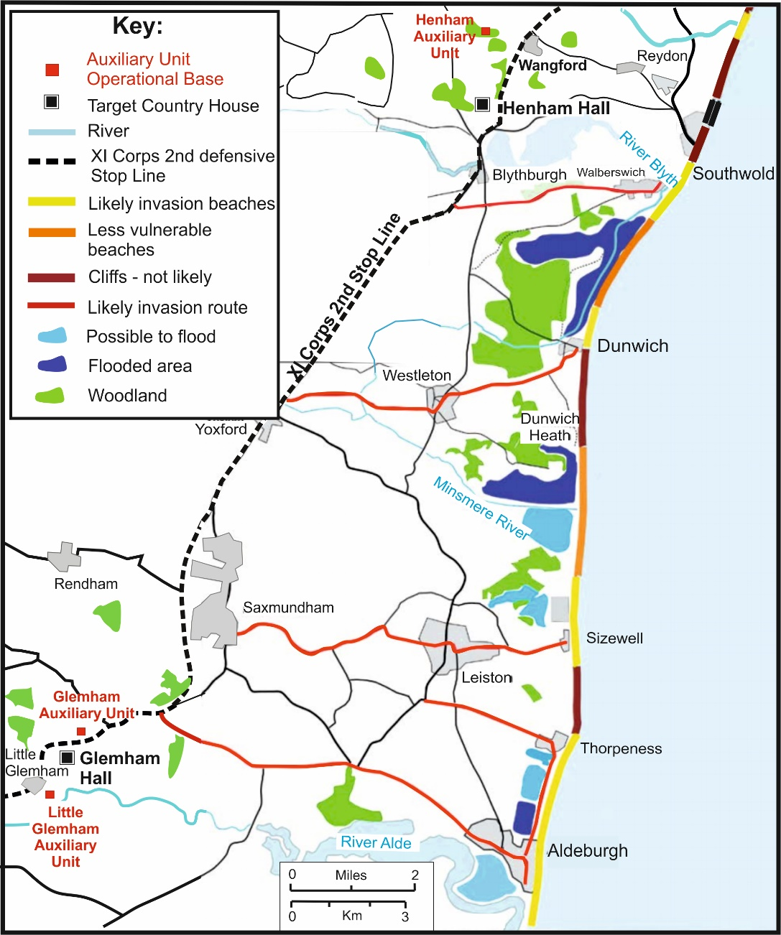
Figure 4. Schematic 1940 map of East Suffolk (see Fig. 3 for location), detailing 1st level coastal defence line (likely invasion beaches), the XI Corps 2nd level defence line, Auxiliary Unit Operational Bases investigated in this study, their likely target country houses, plus other known defensive obstacles. Modified from Liddiard and Sims (2014).

Of the 36 known Auxiliary Unit patrols in Suffolk, 33 OBs were identified (see Appendix Table A1). The British Resistance Archive (CART, 2009-2017) states that it currently has reports on 76% of all UK OBs, of which 15 were stated to be in fair condition of preservation in Suffolk. As befits the ethos of their construction, most of these are on private land; and for the purposes of our study, only two landowners permitted access for this study, specifically the bases of the Wickham Market and Wangford patrols (Fig. 4). The Wickham Market patrol had one known OBs, situated at Little Glemham, close to a major road, and, after discussions with the landowner, an unknown one at Great Glemham, close to a railway line. In addition, the Wangford patrol had an OB at Henham near major roads. All three OBs are in close proximity to the XI Corps Black Allied 2nd level defensive stop line, and were chosen as suitable sites for study.

SITE 1: LITTLE GLEMHAM OPERATIONAL BASE, SUFFOLK, UK

Little Glemham Operational Base was not in the CART records database but was mentioned by the local landowner on arrival. The OB is situated in deep immature woodland ~200 m southeast of the village of Little Glemham, 50 m from the River Ore (presumably providing a reliable water supply to the unit), and slightly uphill to avoid marshland. It is only ~100 m from a still-used London-bound railway line, and presumably the target for this patrol if it were to fall into enemy hands (Fig. 5). Soil augers determined the soil type was a dark brown (Munsell soil color 7.5YR/3/2) sandy loam with sand with flint fragments beneath.
Upon initial site inspection, the OB looked to have been destroyed and filled in (Figure 6), a common occurrence at the end of the war, carried out mostly for safety reasons in order to prevent people/animals falling into collapsed structures and due to the possibility of remaining munitions (Liddiard and Sims, 2014). Survey lines were established across the OB (Figure 5), and any surface vegetation cleared to allow relatively easy access for the geophysical surveying equipment.

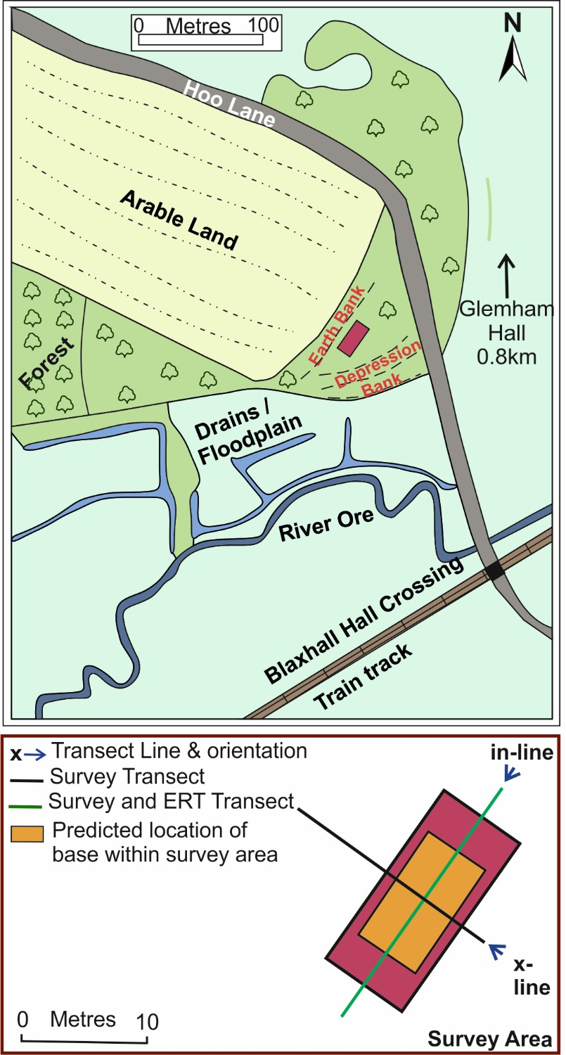
Figure 5. (Top) Schematic map of Little Glemham Operational Base used by the Wickham Market patrol unit, showing pertinent site features, including the River Ore, nearby rail and road targets and, (bottom) map of geophysical survey lines shown.

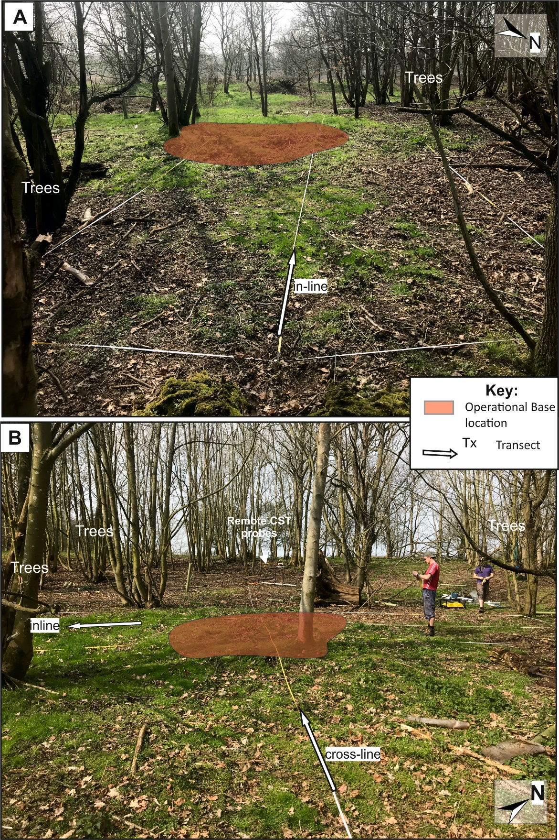
Figure 6. Annotated Little Glemham site photographs showing the presumed destroyed OB position (shaded area) and survey positions (see key and Fig. 5). Note the many immature trees onsite and relict surface metal artefacts (Fig. 17).

SITE 2: GREAT GLEMHAM OPERATIONAL BASE, SUFFOLK, UK

This site was known in the CART records database (CART, 2009-2017). It is located at the northern edge of a coniferous wood without footpaths (unlike two nearby woods), ~ 500 m north of a main road and ~ 1km north from Glemham Hall (Fig. 7). Situated in the grounds of a country estate, it is likely that the main house would have been useful to high-ranking German officers after the invasion, as a suitable local headquarters. This is consistent with the location of the OB here, as any high-ranking enemy officers would have been targets for the Wickham Market Patrol.
Upon initial site inspection it was determined that the OB had been partially destroyed, with some corrugated metal iron sheets used to block up the entrance and a remaining chamber being partly filled with sand (Figure 8). A digital video of this site is available in the Appendices. Soil augers determined the soil type was a yellowish red (Munsell soil colour 5YR/4/6) homogeneous sand.

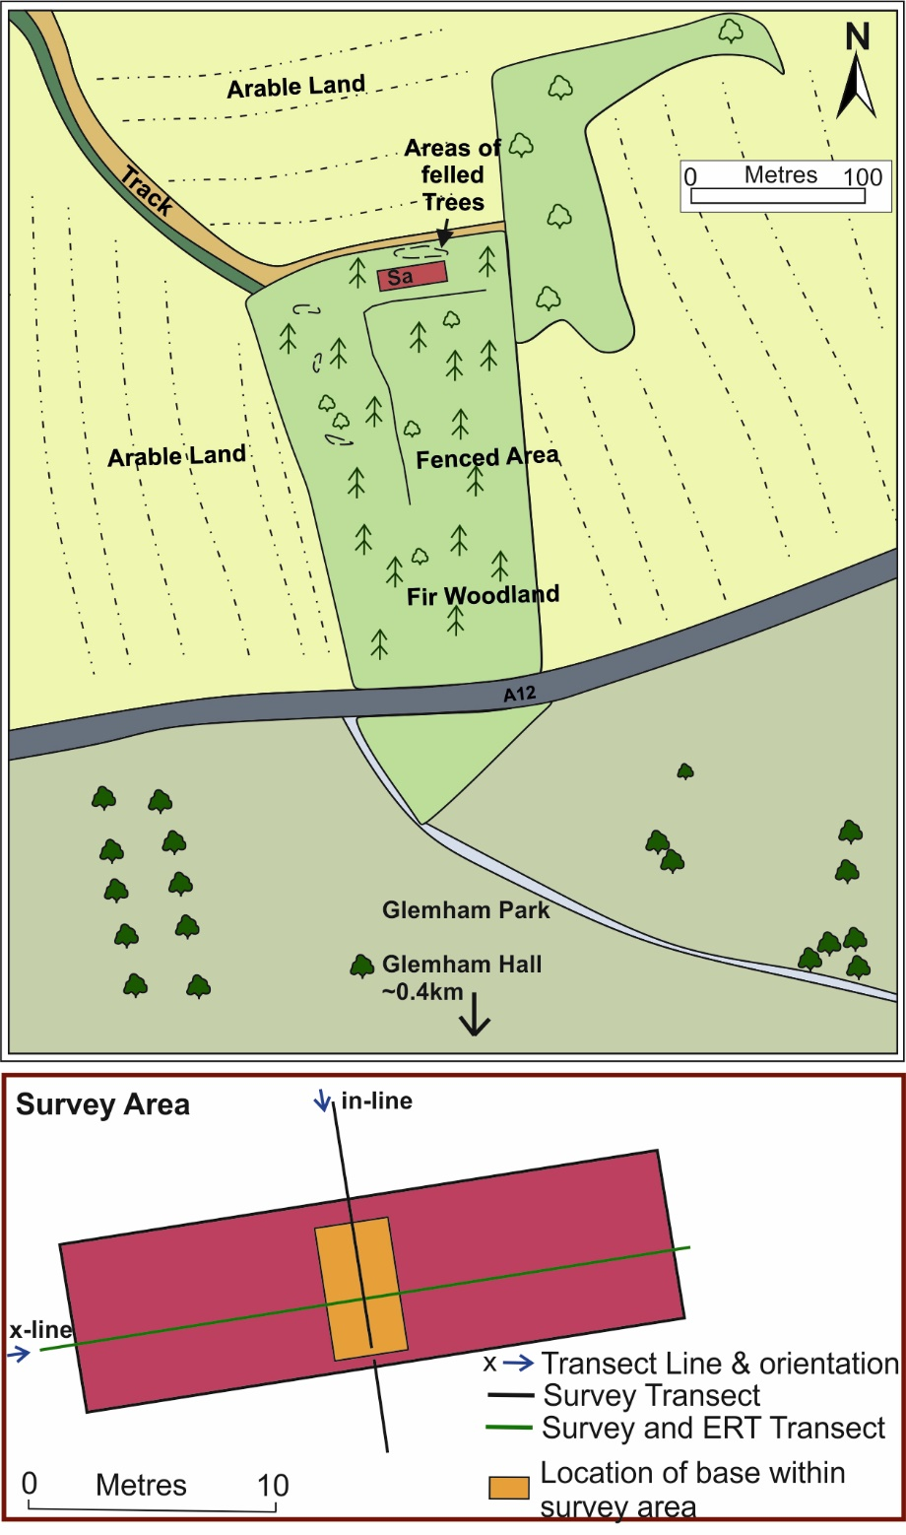
Figure 7. (Top) Schematic map of Great Glemham Operational Base used by the Wickham Market patrol unit, showing pertinent site features, including the nearby main A12, direction of nearby Glemham Hall and, (Bottom) map of geophysical survey lines shown.
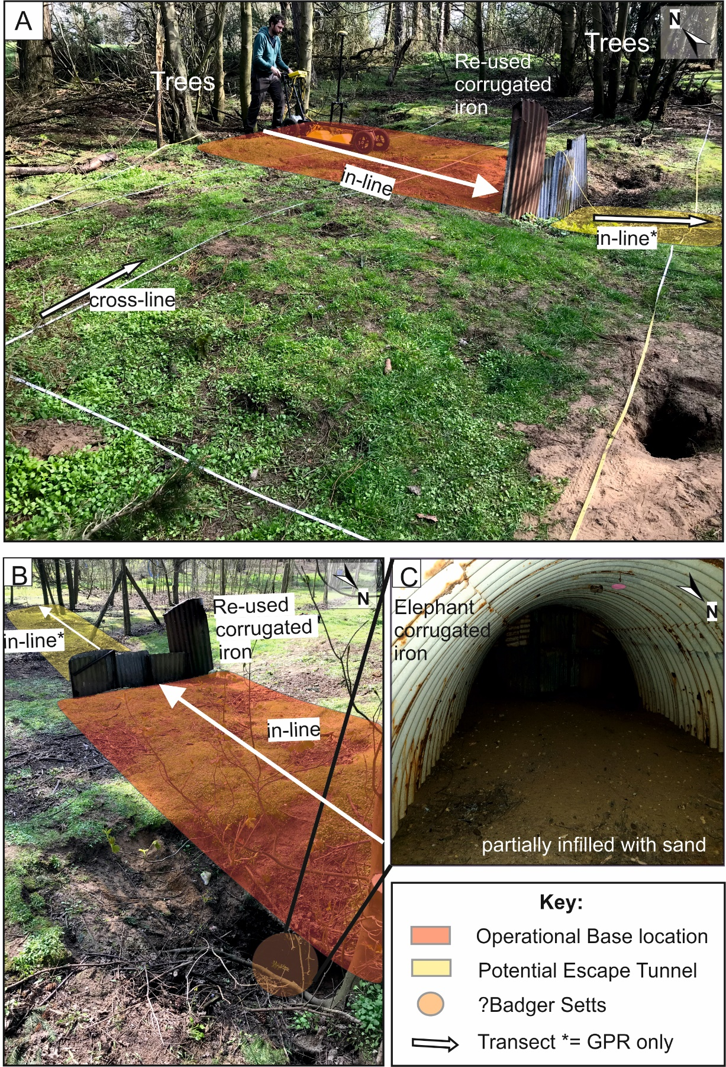
Figure 8. Annotated site 2 Great Glemham photographs showing (A/B) the position of the OB (shaded area) and survey lines (see key and Fig. 7). (C) Photograph inside the partially infilled main chamber (too unstable to enter) currently used as a badger sett.

SITE 3: HENHAM OPERATIONAL BASE, SUFFOLK, UK

This site was known in the CART records database (CART, 2009-2017), and is located at the northern edge of a deciduous wood on a steep slope, above a small stream and with a nearby quarry, ~ 1km north of Henham Hall (Fig. 9). Henham Hall represents another country estate house that could have been used as a German headquarters after invasion, thereby presenting potential assassination targets for the Wangford Patrol.
Upon initial site inspection it was determined that the OB is mostly intact, with the breeze block construction for the escape hatch being fully intact and the main route into the OB now, but the original main entrance was now collapsed (Figure 10). A digital video of this site is available in the Appendices. Soil augers determined the soil type was a strong brown (Munsell soil colour 7.5YR/5/8) pebbly sand, with the numerous flint pebbles present through the site.

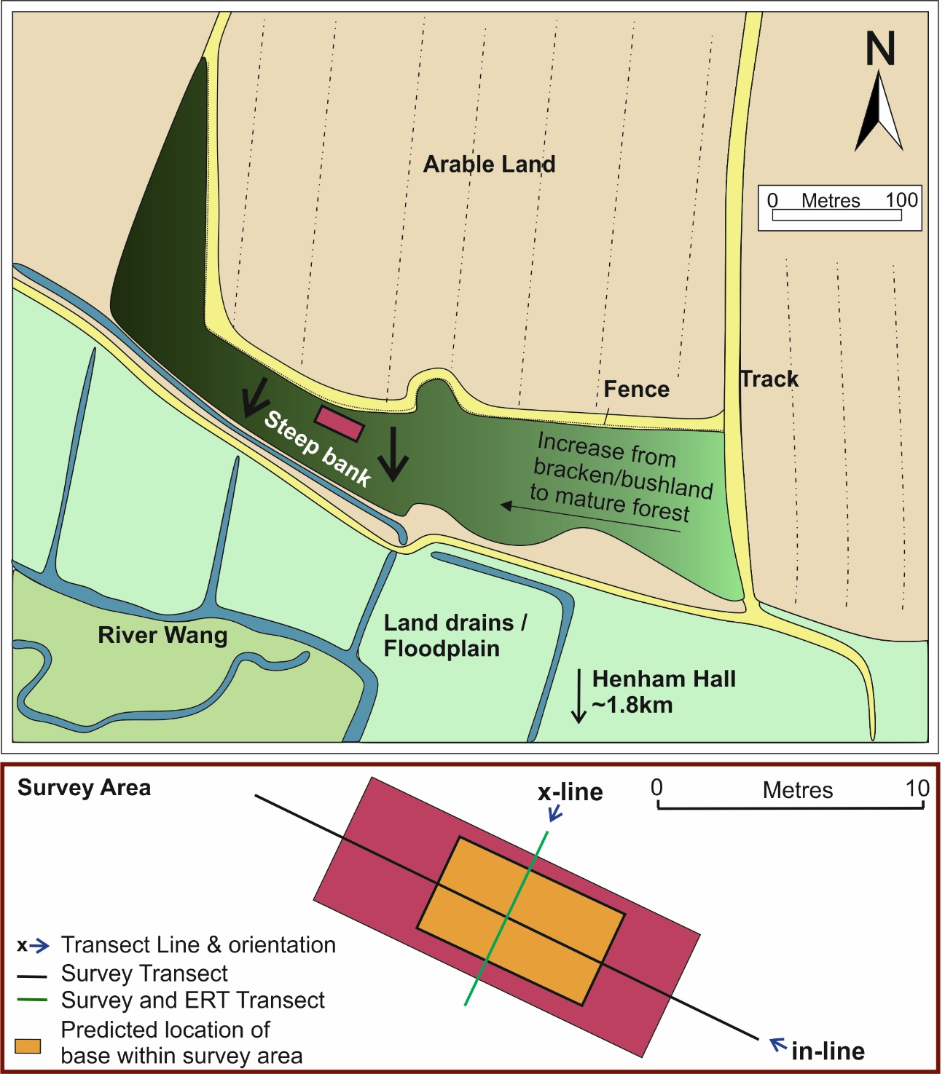Figure 9. (Top) Schematic map of Henham Operational Base used by the Wangford patrol unit, showing pertinent site features, including the River Wang, direction of Henham Hall and, (Bottom) map of geophysical survey lines shown.

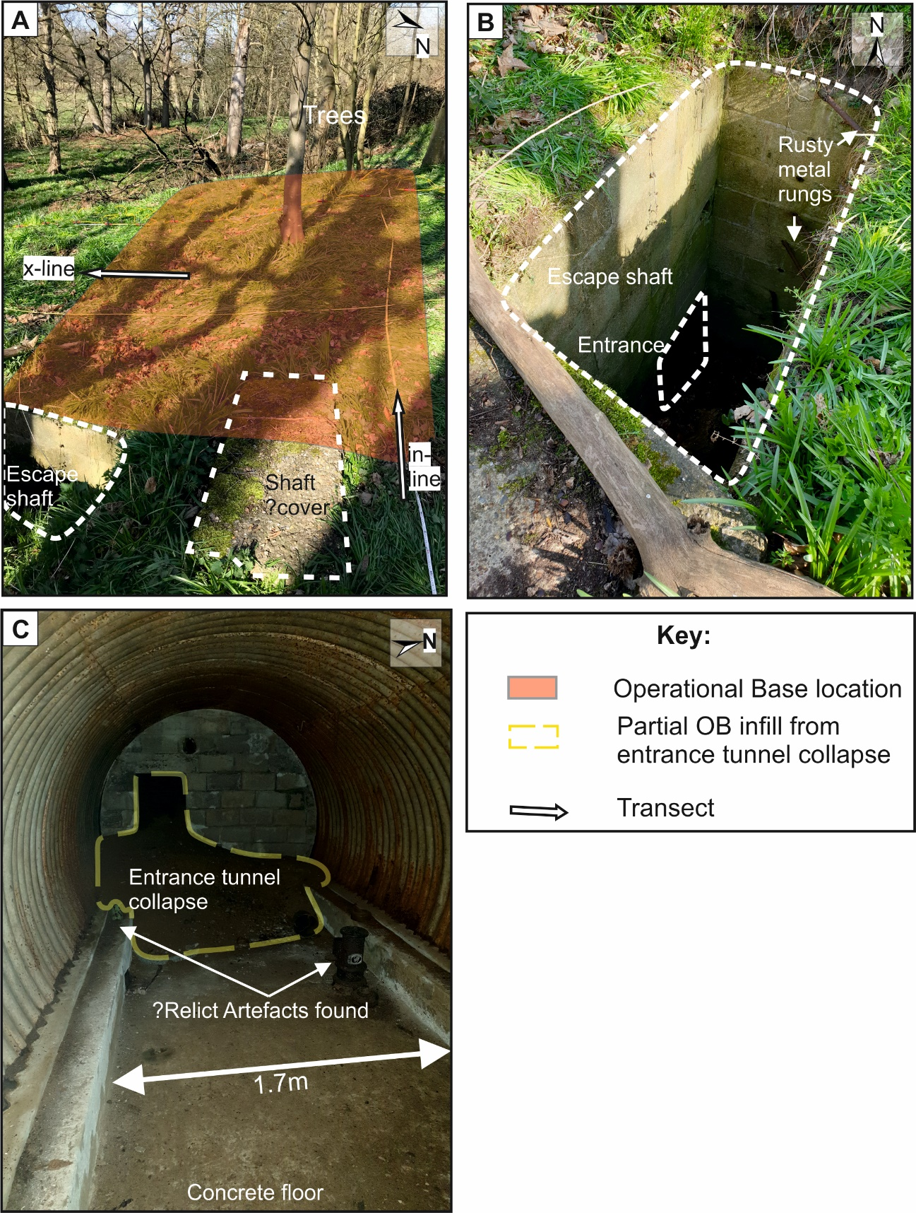
Figure 10. Annotated site 3 Henham photographs showing, (A) the position of the OB (shaded area) and survey lines, (B) escape shaft and, (C) inside the main intact chamber with collapsed tunnel entrance at the back (see key and Fig. 9). Relict artefacts are shown in Figure 18.
DATA ACQUISITION

Geophysical surveys are commonly used in onsite investigations of military sites, as they can penetrate up to 10 m below ground level (bgl) and not only detect relict features but also characterise them, especially if a combination of techniques are utilised (for example, see Reynolds, 2011, Rees-Hughes et al. 2017, Ainsworth et al. 2018).
For each OB site geophysical datasets using a variety of techniques were acquired. Shown here are one cross-line going across each OB and one in-line going along each OB (Figures 5, 7 and 9), for consistency and to allow direct comparisons to be made.

Metal Detector Surveys
Whilst comparatively simple technology, metal detectors can be used successfully to detect conductive, mostly metallic, objects (see Milsom & Eriksen, 2011). Here they were used on all three sites to determine where the OBs were located, particularly as the main OB chamber is surrounded by corrugated metal (Figure 11a). Once surface survey results were plotted and the OB position identified, the transect survey lines could then be correctly positioned directly above each OB.

Ground Penetrating Radar Surveys
GPR surveys are commonly used in archaeology as they can detect buried objects up to 10 m below ground level in ideal conditions (see Sarris et al. 2013; Dick et al. 2015). A GPR PulseEKKO™ PRO system was utilised, with the standard acquisition settings and the wheel odometer to measure survey line distances. 250 MHz, 500 MHz and 1000 MHz frequency antennas were used to collect the three different frequencies of data for each transect (Figure 11b). A standard sequential data processing sequence was applied to each 2D profile in Sandmeier™ REFLEXW v.8.5 software. This comprised picking first arrivals to move the start time to 0 ns, a time cut to remove blank data at the bottom of traces, applying a1D gain function to boost deeper reflection amplitudes and using average site velocity determinations to convert profiles from two-way time (ns) to depth (m) (see Milsom & Eriksen, 2011 for background).

Electromagnetic Surveys

Electromagnetic methods are commonly used in archaeological investigations (see De Smedt et al., 2014; Gaffney, 2008), as sensors are easily manoeuvrable, and data is collected rapidly (see Milsom & Eriksen, 2011 for details).

A Geonics™ EM31-D conductivity meter with Archer data logger was used to collect in-phase and quadrature data in the vertical dipole configuration (Figure 11c). The instrument was calibrated offsite and acquired data at ~0.1m intervals along the survey line. The data was then downloaded, despiked and detrended using Microsoft Excel software.

Bulk-Ground Electrical Resistivity Survey
Bulk ground electrical resistivity methods have also been commonly used in archaeological investigations (see Thacker and Ellwood, 2002; Terron et al., 2015; Dick et al. 2017). Generally the method is cheap, easily manoeuvrable, and data is rapidly collected. The investigation depth is dependent on the probe spacing (see Milsom & Eriksen, 2011 for details).
After testing with different probe spacings and sample intervals, a Geoscan™ RM15-D Resistivity Meter, using a parallel Constant Separation Traverse (CST) twin-probe array setting, was used with probe separation of 1.5 m, to acquire resistivity readings at 0.25m sample intervals over along the survey line (Figure 11d). The data was then downloaded, despiked and detrended using Microsoft Excel software.
A CAMPUS™ TIGRE meter was also used to collect a 2D Electrical Resistivity Imaging (ERI) 2D profile along the survey line, usually using 32 electrodes at 0.5 m spacing in a Wenner array configuration due to its near-surface sensitivities (Figure 11e). After initial testing that determined that relatively consistent contact resistances were being recorded at each electrode, a 2D profile was collected. Data processing steps were applied using Geotomo™ Res2DInv v.3.55, including: 1) removing anomalous data points; and, 2) inversion using a least-squares best-fit algorithm with a threshold set to 5% misfit and displayed using a logarithmic colour contoured scale.

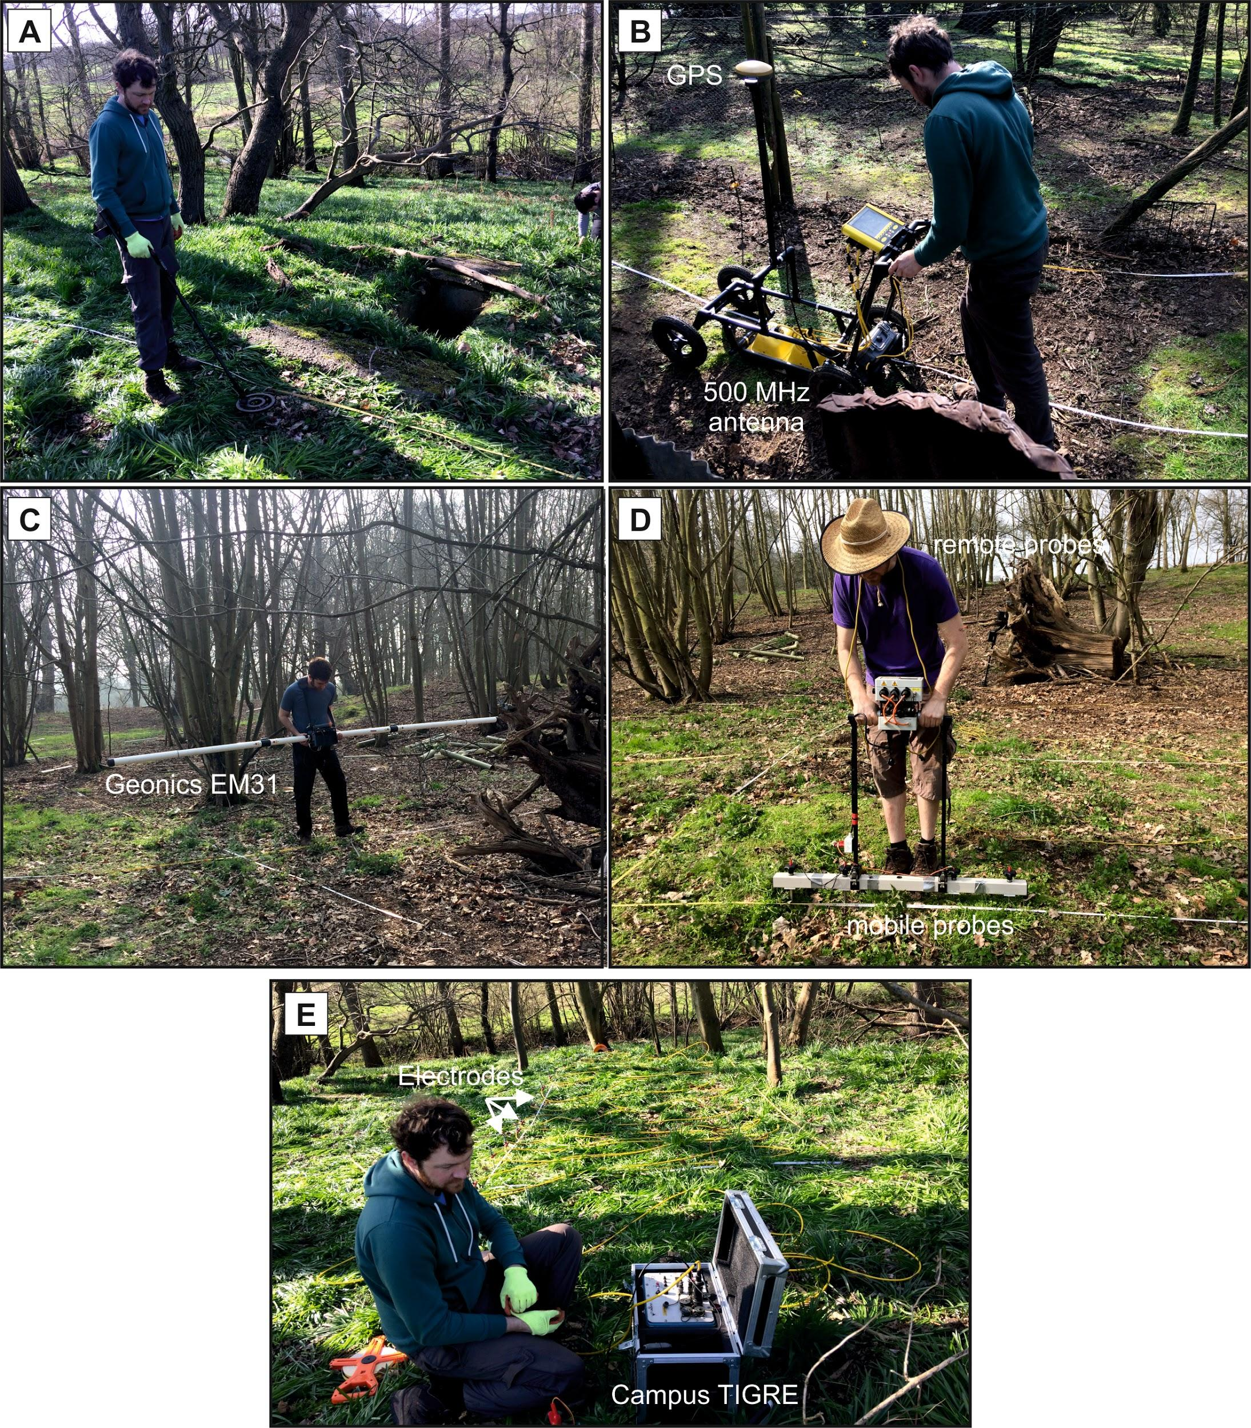Figure 11. (A) Bounty Hunter Track IV metal detector, (B) PulseEKKO Pro GPR cart, (C) Geonics EM31 Mk2, (D) Geoscan RM15D electrical resistivity meter using a dipole-dipole configuration and, (E) Campus TIGRE Electrical Resistivity Imaging 32 electrode geophysical equipment used in this study.

RESULTS

GPR surveys
At all three study sites, low frequency (250 MHz) were found to be optimal, compared to the 500 MHz and 1000 MHz frequency antenna trialled, at detecting and characterising the respective OBs (Figure 12).
At Little Glemham, background soil stratigraphy and very near-surface anomalies (probably tree roots and small objects) were present, with a lack of reflectors below 0.7m bgl over the presumed OB location (Figure 12). This suggests that the OB has been demolished (a common occurrence at the end of WW2) and back-filled with locally-derived material.
At Great Glemham, the cross-line showed a clear large anomaly centred over the partially-intact OB location with background soil stratigraphy also clear. In contrast the inline was less obvious, with a subtle horizontal reflection event being probably the OB position (Figure 12). The re-used corrugated iron was also clearly defined on the profile edge (Figure 12).
At Henham, the cross-line showed a large anomaly centred over the intact OB location with background soil stratigraphy also clear. This OB was relatively deeper bgl when compared to the Great Glemham OB (cf. Fig. 12). The inline here was more obvious, when compared to Great Glemham OB, with a high amplitude horizontal reflection event imaging the OB position (Figure 12). A deeper reflection event near the end of this profile may indicate where the OB escape shaft was located.

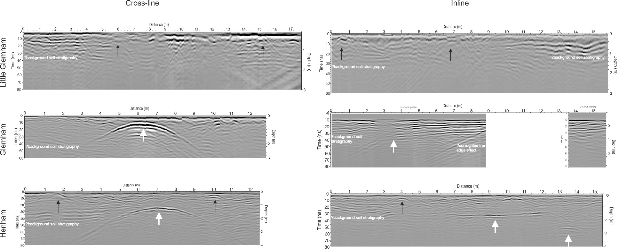
Figure 12. GPR 250 MHz 2D profiles taken over the three OB study sites (see Figs. 5, 7 and 9 for location). Black arrows indicate anomalies related to OB, white arrows are non-target anomalies (tree roots, surface debris, etc.)

Electromagnetic Surveys
At Little Glemham, quadrature conductive anomalies over the destroyed OB location were only ~2 mS/m higher than background values (Figure 14). At Great Glemham, quadrature conductive anomalies over the partially-intact OB location were ~10-15 mS/m higher than background values (Figure 14), showing it could be clearly delineated from background values using this method. At Henham, quadrature conductive anomalies over the intact OB location were ~15-20 mS/m higher than background values (Figure 14), again showing the intact chamber could be clearly delineated from background areas.
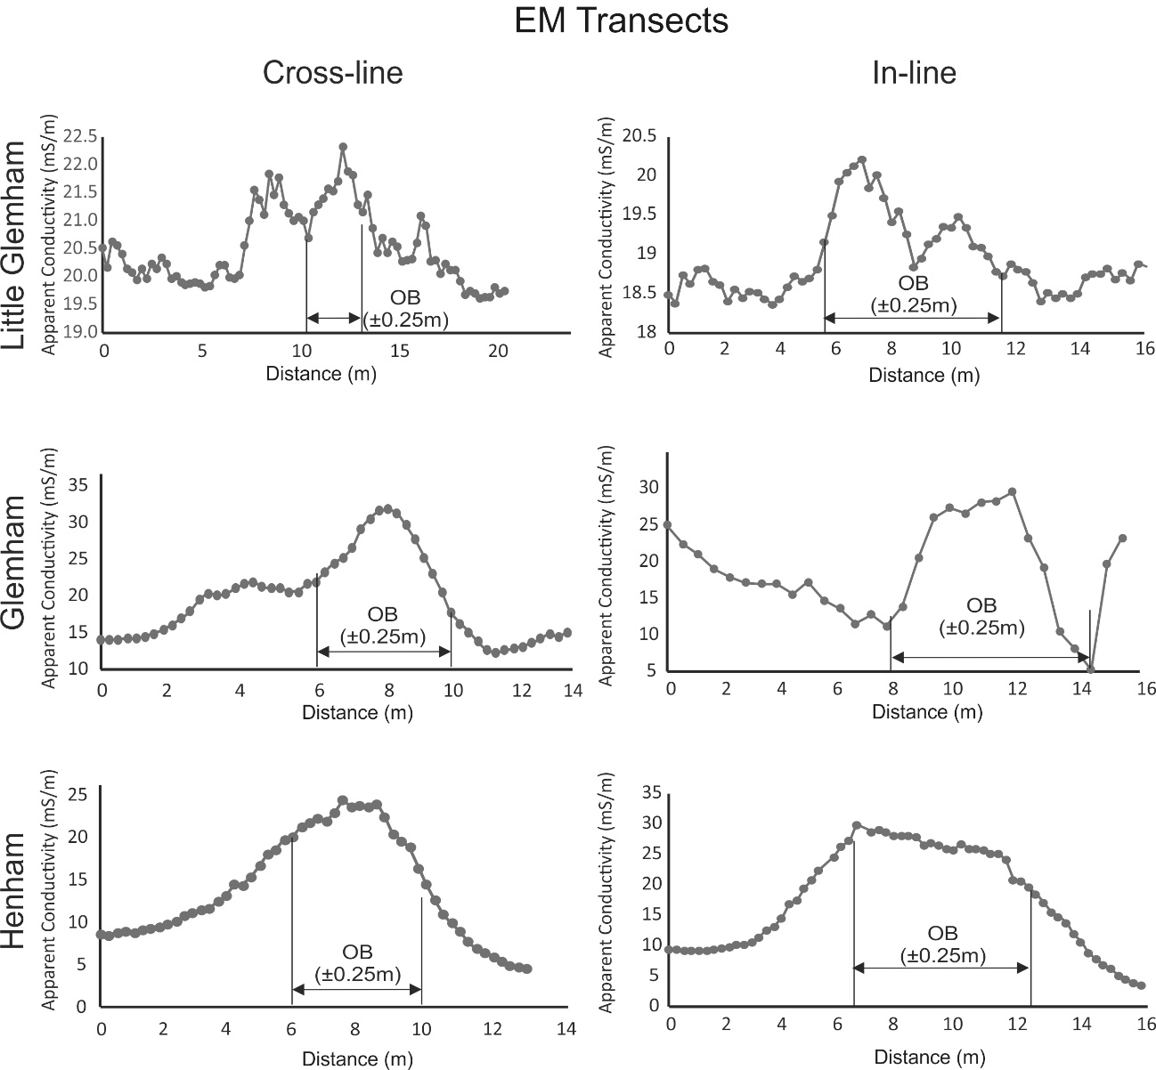
Figure 14. Electro-magnetic (EM) cross-line and in-line survey results for the three sites studied (see key and Figs 5, 7 and 9 for respective transect line locations). Approximate OB dimensions also added for comparison.

Electrical Resistivity (CST) surveys
At Little Glemham electrical resistivity high anomalies ~ +400 Ω.m, with respect to background values, were recorded over the destroyed OB location, although they were not clearly differentiated from background values (Figure 15). At Great Glemham unfortunately the data was corrupted. At Henham low resistivities ~ -700 Ω.m, with respect to background values, were recorded over the complete OB (Figure 15).

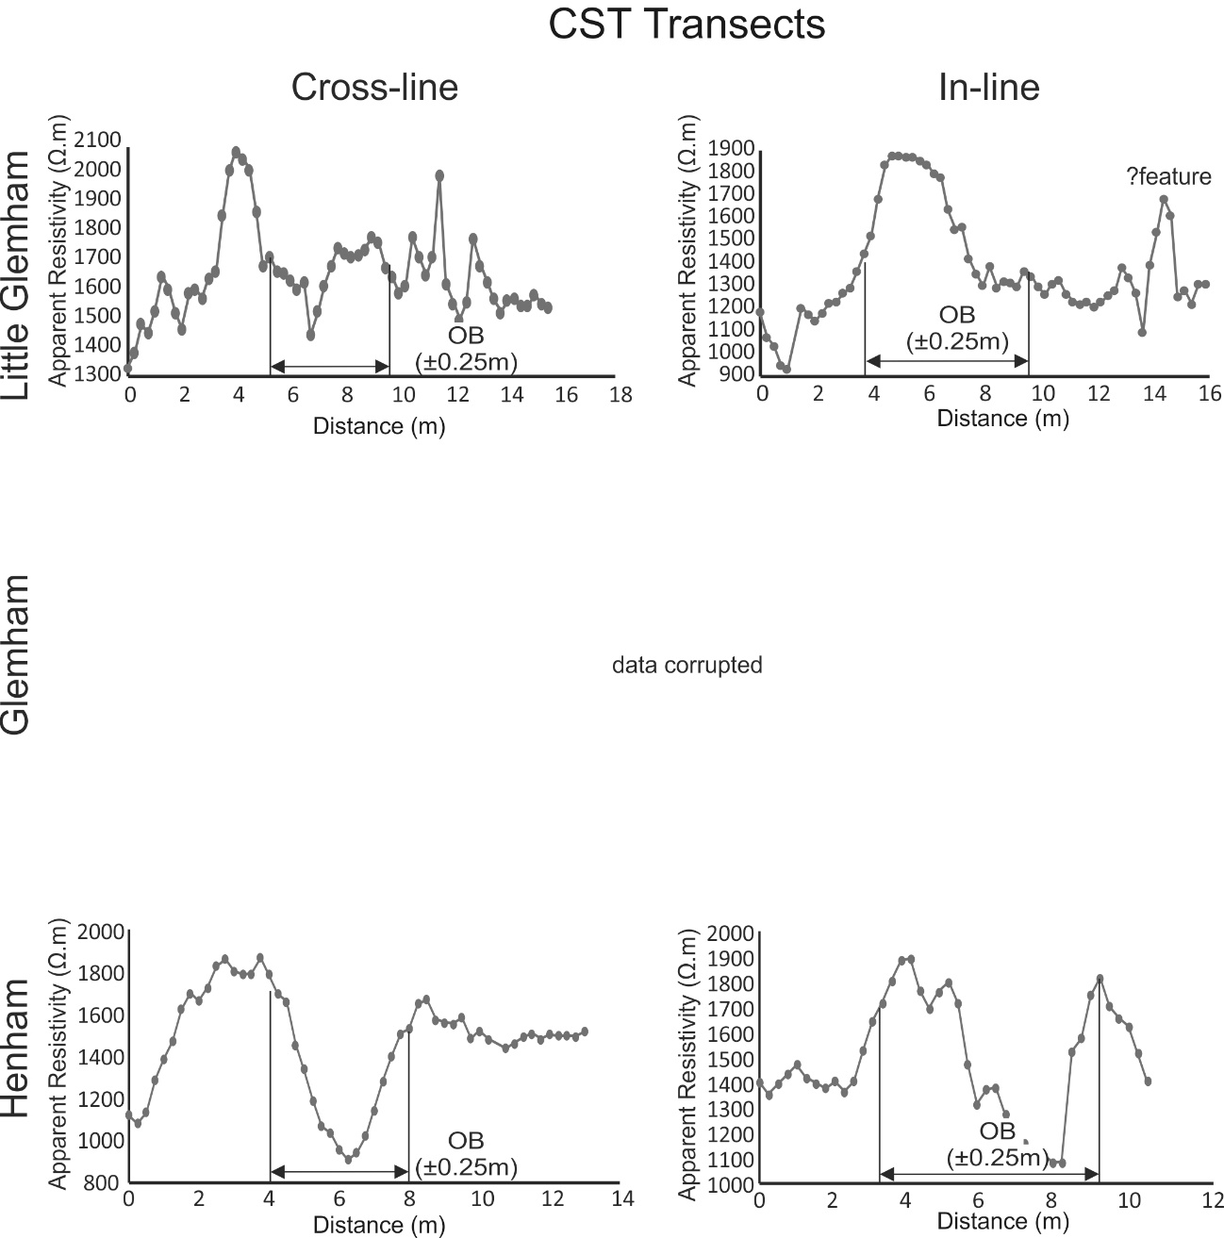
Figure 15. Electrical resistivity (CST) cross-line and in-line survey results for the three sites studied (see key and Figs 5, 7 and 9 for respective transect line locations). Approximate OB dimensions also added for comparison.

Electrical Resistivity Tomography (ERT) surveys
At Little Glemham the 2D ERT profile imaged three small anomalies but no major anomalies over the OB location. At Great Glemham a very obvious low anomaly (~180 Ω.m c.f. ~900 Ω.m background) was imaged, and at Henham a very obvious low anomaly (~1,800 Ω.m c.f. ~2,500 Ω.m background) was observed (Figure 16). The higher values at Henham compared to Great Glemham were most probably due to the soil being pebbly with more air gaps, thus increasing the resistivity values.
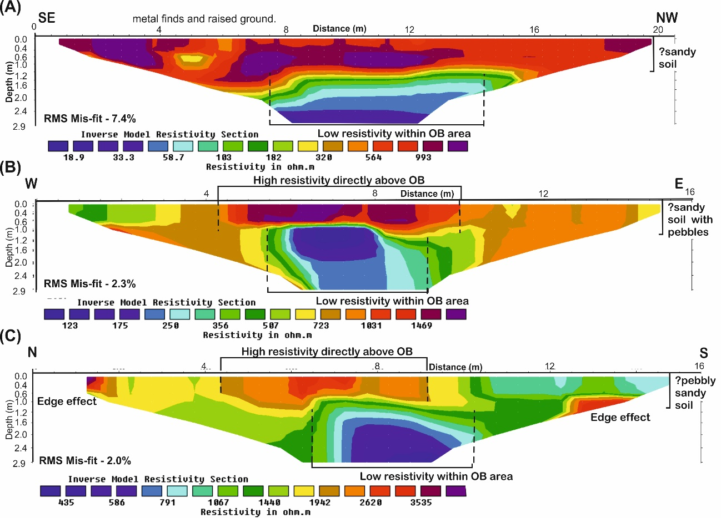
Figure 16. ERT 2D profiles collected during this study. (A) Little Glemham in-line, (B) Great Glemham cross-line and (C) Henham crossline with respective OB positions marked (see Figs. 5, 7 and 9 for respective ERT survey line locations).

Archaeological Finds

Auxiliary Unit patrols were heavily armed, including 7 x revolvers (.38 calibre), 3 x rifles (2 x .303 and 1 x silenced .22 calibre), 7 x fighting knives, 1 x Thompson machine gun (.45 calibre), 48 x No.36 hand grenades (4s fuses), 3 cases of ‘Sticky bomb’ grenades and 2 cases of phosphorus grenades (Lampe, 1968). These were largely destroyed at the end of WW2 so were not expected to still be on-site (Lampe, 1968). Nevertheless, numerous relict items consistent with wartime occupancy were found at the demolished Little Glemham OB and the largely intact Henham OB. It should be noted, however, that the purpose of the study was not to carry out a full-scale invasive archaeological investigation, so these remains were recorded simply as evidence of the use and occupancy of each OB.
Though out of archaeological context, at Little Glemham multiple metal artefacts were scattered across the site (Figure 17). These objects relate principally to the construction of the OB, including structural iron, ventilation pipes, unidentified metal objects and some artefacts associated with occupation, such as metal pots. Clearly these objects had been disturbed in position post-war, though presumably remaining in position due to the relative seclusion of the site.
At Great Glemham, the chamber is largely infilled with sand, and therefore without an invasive excavation, there was little opportunity to observe whether objects consistent with wartime occupation remained in position.
At Henham, access to the chamber was possible and the OB was found to contain artefacts in situ that are again consistent with its wartime use. Inside the OB chamber there was still associated patrol unit equipment in situ, including an intact (albeit heavily rusted) Valor Junior No. 56 kerosene heater stove, hand-made metal brazier, a blue-enamelled aluminium cooking pan (and additional example of the same pattern was recovered from the ground of the Little Glemham OB) and glazed ceramic ventilation system (Figure 18).

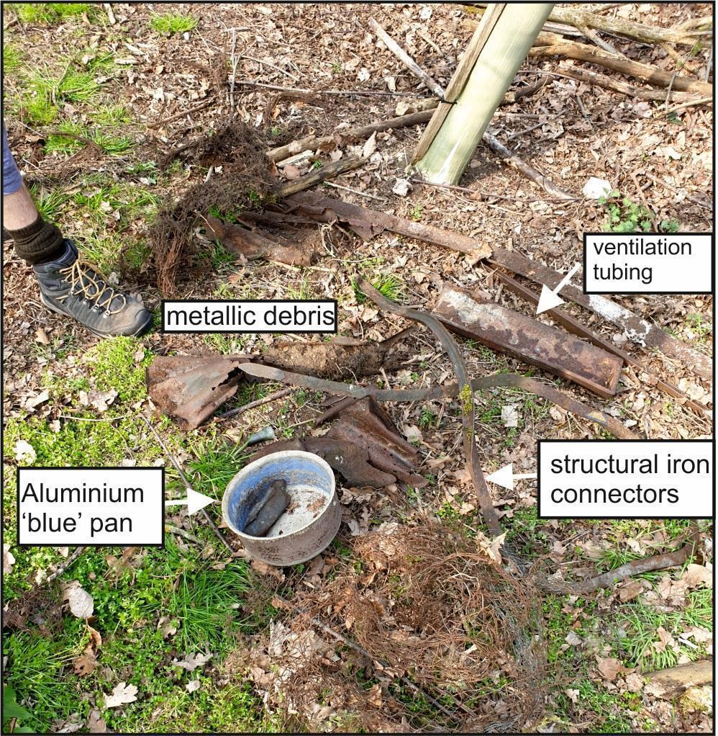
Figure 17. Archaeological finds at the Little Glemham OB site, including metal ventilation tubing and structural iron connectors, the latter indicating that this may have been a Mark I design), a blue coated aluminium pan, and various metallic fragments.
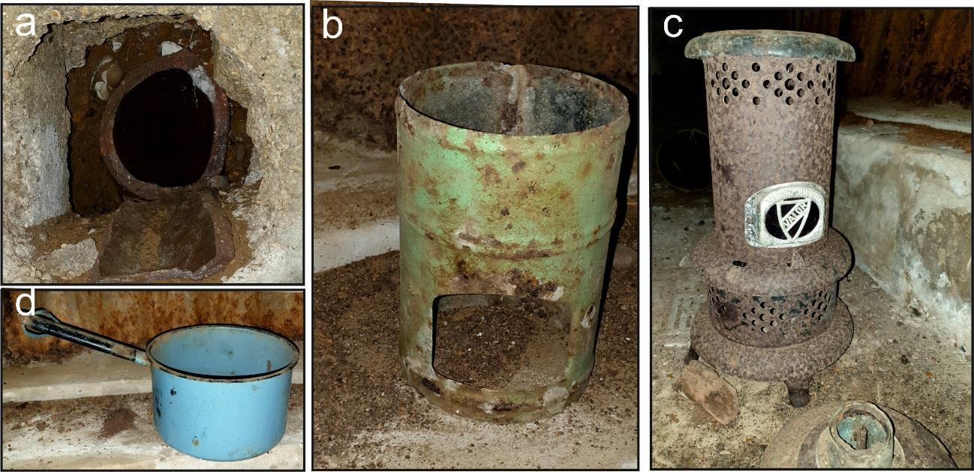
Figure 18. Archaeological finds at the Henham OB site, including: a) intact ventilation system, b) hand-made metal brazier, c) Valor Junior No. 56 kerosene heater stove, with top half on floor and d) aluminium cooking pan.

DISCUSSION
With the withdrawal of Allied troops from Dunkirk by 4 June 1940, Britain was in a parlous state. With the vast majority of the equipment of what was one the most mechanised British armies ever now abandoned in France, preparations were needed that would prepare Britain for an invasion. Though the likelihood of Operation Sea Lion being successful was conditional on the command of the English Channel, challenging both the Royal Navy and the Royal Air Force, the threat was nevertheless real. On that basis, the anti-invasion preparations carried out in 1940-41 were urgent and important. Of the most secretive of these was the development of the Auxiliary Units.
The clandestine nature of Auxiliary Units, relating to their proposed functions, and the underground Operational Bases out of which they were intended to operate, has meant that an important story of Britain during the early part of the Second World War has not yet been fully told. While there have been accounts of the activities of the Auxiliary Units (e.g. Lampe, 1968; Angell, 1996; Williamson, 2004; Warwicker, 2008; Watson, 2011), and while there have been attempts to compile lists of the location of the OB sites across the country, there have been few attempts to characterise OBs in situ. This study represents one of the first attempts to do so, and specifically so using geophysical techniques.
Whilst other studies (e.g. Doyle et al., 2013; Rees-Hughes et al. 2016; Ainsworth et al., 2018) have used aerial imagery to successfully locate wartime structures, the below-ground nature of Auxiliary Unit OBs and their deliberate location in secluded, often wooded locations has meant that this approach was not possible in carrying out this study. In addition the, as yet, absence of official acknowledgement of their important role in WW2 has meant that records, locations and other information remains hard to obtain, notwithstanding the CART database, and therefore location of OBs is highly dependent on the local landowners to pinpoint their location.
This paper suggests that a careful site approach using a combination of surveys and non-invasive geophysical methods could be used successfully to not only locate such Operational Bases, but also to: characterize their relative depths below ground level (chambers varying from 0.35 m bgl at Great Glemham to 1.2 m bgl at Henham); to determine their dimensions; and even to identify their construction materials, which mirrors other researchers’ findings on other wartime structures (e.g. Everett et al. 2006; Pringle et al. 2007; Rees-Hughes et al. 2016; Ainsworth et al. 2018).
Geophysical survey results also showed the contrasts between the different OBs, with their preservation and present condition evidenced in the geophysical datasets. For example, clear GPR anomalies were present over the intact main chambers at Great Glemham and Henham, but were not identified within the dismantled OB at Little Glemham. GPR also showed the infilling of the OB at Great Glemham but no fill at Henham. However, in contrast to the study of WW2 P.O.W. escape tunnels carried out by Rees-Hughes et al. (2016), the presumably collapsed and infilled escape tunnels could not be geophysically located in this case.
Optimal survey type(s) and equipment configuration(s) did vary between the three study sites. The surveys at Little Glemham showed metal detectors to be optimal due to the destroyed condition of the OB, thereby picking up the position of metal construction and other artefacts. ,In the case of the Great Glemham and Henham OBs, medium-frequency GPR and ERT profiles were optimal in order to locate and characterise them. Electromagnetic and electrical resistivity (CST) surveys did image the intact OB at Henham and partially-intact OB at Great Glemham, a technique that others have found in geophysical surveys of buried military relict structures (Ainsworth et al. 2018; Rees-Hughes et al. 2016), but all sites had disturbed ground which made the top 0.5 m of soil comparatively heterogeneous, and often littered with discarded metal which interfered with results. It should be noted that electrical resistivity CST surveys also had to have comparatively wide (1.5 m spaced) mobile electrodes in order to collect usable data, and only one cross-line and inline are shown in this study for clarity. More transect lines would have allowed the collection of more data and may have improved the datasets, such as shown in Ainsworth et al. (2018).
Though this study was not intended to be a full-scale archaeological excavation, a surprising number of archaeological items were found (Figs 17-18). This, together with the condition of the Henham site suggests that there is still a lot of potentially important Auxiliary Unit-related artefacts still remaining particularly, in those OBs that are in relatively good condition, representing those structures that are themselves important historically. This highlights the fact that such sites are at risk, and that further work should be carried out in the most at risk sites in order to ensure that valuable data is not lost and that archaeological contexts are not disturbed. Through its investigation of the three sites identified here, this study has highlighted the variety of OB types (both Mark I and II variants found here), their construction materials and the likely associated artefacts give an important insight into how they were utilised during this desperate period for the Allies in WW2.
Ultimately, it is a matter of conjecture how effective they would have been if the German invasion had happened. Certainly, unlike the Home Guard, the men of the Auxiliary Units were more skilled landsmen, and as such, their “scallywagging” activities, in destroying road and rail infrastructure, arms depots and potentially assassinating senior German officers, would have been disruptive as a minimum, and potentially giving vital time for coastal regular troops to retreat to the General Headquarters Lines (GHQ) for the final defensive stand.
CONCLUSIONS
This paper presents results of geophysical surveys of WW2 Auxiliary Unit Operational Bases (OBs) in three different locations in East Suffolk.
A desktop study found 78 known OBs in Norfolk and Suffolk, with three on private land in East Suffolk being investigated in this study. Of the three, Little Glemham, not previously known, was found to have been dismantled, Great Glemham partially-intact, and Henham almost fully-intact.
Initial fieldwork found metal detectors to be useful to delineate the rough location of the buried OBs, with mid-frequency GPR surveys optimal to detect the main subsurface chamber locations. Electrical Resistivity Tomography (ERT) 2D profiles also proved useful to delineate their locations, especially where dense woodland resulted in large numbers of non-target tree-root anomalies to be identified in the GPR datasets.
Available accounts suggest patrol units often created their own OBs and a variety of construction methods were seen in this study, with a presumed Mark I type in the destroyed base at Little Glemham, Mark IIs at the other two sites and breeze blocks used in the construction of the escape tunnel at the Henham OB.
For further work, all sites investigated in this study were in sandy soil, and thus other OBs should be investigated in other soil types to determine their detection and characterisation potential, and obviously in other geographical areas, in particular in the South-East of England where the main invasion force was likely to land.
This study has shown how modern geophysical site investigation techniques can provide new knowledge on the UK’s defence in WW2, with a suggested table generated to assist other researchers to locate and characterize them.

GEOLOCATION INFORMATION
These sites are on private land, and as such, should not be accessed without permission from the landowners.
The Little Glemham OB site 1 has the following co-ordinates: 52°10'10.08"N, 1°25'49.72"E. The Great Glemham OB site 2 has the following co-ordinates: 52°11'11.73"N, 1°25'57.48"E. The Henham OB site 3 has the following co-ordinates: 52°21'34.42"N, 1°36'12.42"E. A GoogleEarth KMZ file is available in the Appendices.

ACKNOWLEDGEMENTS
Hektor Rous, the Henham Park landowner, and Tom Hope-Cobbold, the Glemham Hall estate manager, are thanked for providing site access and logistical support. Ailsa and Keith Pringle are acknowledged for providing logistical support. The Coleshill Auxiliary Research Team (CART) are thanked for providing data on UK Operational Bases.

DISCLOSURE STATEMENT
There is no financial interest or benefit that has arisen from the direct applications of this research.

FUNDING DETAILS
No funding has been obtained for this study.

REFERENCES:

Ainsworth, J.T., J.K. Pringle, P. Doyle, M. Stringfellow, D. Roberts, I.G., Stimpson, K.D. Wisniewski, and J. Goodwin. 2018. “Geophysical Investigations of WWII Air-Raid Shelters in the UK.” Journal of Conflict Archaeology 13: 167-197. doi.org/10.1080/15740773.2018.1583472

Angell, S. 1996. Secret Sussex Resistance, 1940-44. Middleton Press.

Atkin, M. 2015. Fighting Nazi Occupation: British Resistance 1939–1945. Barnsley: Pen & Sword, 216 pp.

Banks, I. 2014. “Digging in the Dark: the Underground War on the Western Front.” Journal of Conflict Archaeology 9: 156-176. doi:10.1179/1574077314Z.00000000038

Banks, I., and T. Pollard. 2014. “Beyond Recall: Searching for the Remains of a British Secret Weapon of World War I.” Journal of Conflict Archaeology 9: 119-155. doi:10.1179/1574077314Z.00000000037

Capps Tunwell, D., D. Passmore, and S. Harrison. 2015. “Landscape Archaeology of World War Two: German Logistics Depots in the Fort Domaniale des Andaines, Normandy, France.” Historical Archaeology 19: 233-261. doi:10.1007/s10761-015-0287-4

Coleshill Auxiliary Research Team (CART) 2009-2017. https://www.coleshillhouse.com/ Last Accessed: 30 January 2020.

Collier, B. 1957. The Defence of the United Kingdom. History of the Second World War, United Kingdom Military Series. London: HMSO, 590 pp.

De Meyer, M., and P. Pype. 2007. “Scars of the Great War (Western Flanders, Belgium).” In Fields of Conflict: Battlefield Archaeology from the Roman Empire to the Korean War, edited by D. D. Scott, L. E. Babits, and C. Haecker, 359–382, 2 vols. Westport: Praeger.

Dick, H.C., J.K. Pringle, B. Sloane, J. Carver, A. Haffenden, S. Porter, K. Wisniewski, D. Roberts, and N.J. Cassidy. 2015. “Detecting and characterising of Black Death burials by multi-proxy geophysical methods.” Journal of Archaeological Science 59: 132-141. doi:10.1016/j.jas.2015.04.010.

Dick, H.C., J.K. Pringle, K.D. Wisniewski, J. Goodwin, R. van der Putten, G.T. Evans, J.D. Francis, J.P. Cassella, and J.D. Hansen. 2017. “Determining geophysical responses from burials in graveyards and cemeteries.” Geophysics 82: 245-B55. doi.org/10.1016/j.jas.2015.04.010

Dobinson, C, J. Lake, and A. Schofield. 1997. “Monuments of war: defining England’s 20th-century defence heritage.” Antiquity 71: 288-299. doi:10.1017/S0003598X0008491X.

Doyle, P. 2011. “Geology of World War II Allied Prisoner of War Escape Tunnels.” International Handbook of Military Geography 2: 144-156.

Doyle, P. 2015. “Examples of the geo-archaeology of trench warfare in Flanders.” In Militärhistorisch-Kriegsgeologischer Reisefüher zum Wytschaete-Bogen (Messines Ridge) bei Ypern (Belgien). 4 Vol. D. Willig edited by, 193–202. Euskirchen: Geoinformationsdiesnt der Bundeswehr, Schiftenreihe.

Doyle, P. 2017. Disputed Earth. Military Geology and Trench Warfare on the Western Front, 1914–1918. Uniform Press.

Doyle, P, P. Barton, and J. Vandewalle, 2005. “Archaeology of a Great War dugout: Beecham Farm, Passchendaele, Belgium.” Journal of Conflict Archaeology 1: 45-66. doi:10.1163/157407705774928908

Doyle, P., P. Barton, M.S. Rosenbaum, J. Vandewalle, and K. Jacobs. 2002. Geoenvironmental Implications of Military Mining in Flanders, Belgium, 1914-1917. Environmental Geology 43: 57–71. doi:10.1007/s00254-002-0642-8

Doyle, P., F. Bostyn, P. Barton, and J. Vandewalle. 2001. “The Underground War, 1914-18: Geology of the Beecham Dugout, Passchendaele, Belgium.” Proceedings of the Geologists Association 112: 263–274. doi:10.1016/S0016-7878(01)80006-7.

Doyle, P, J.K. Pringle, and L.E. Babits. 2013. Stalag Luft III: “Stalag Luft III: The Archaeology of an Escapers’ Camp.” In Prisoners of War. Archaeology, Memory and Heritage of 19th- and 20th-Century Mass Internment, edited by H. Mytum and G. Carr, 129–144. Dordrecht: Springer.

Ellis, L.F. 1953. The War in France and Flanders, 1939-1940. History of the Second World War, United Kingdom Military Series. London: HMSO, 425 pp.

Everett, M.E., C.J. Pierce, R.R. Warden, D.R. Dickson, R.A. Butt, and J.C. Bradford. 2006. “Geophysical Investigation of the June 6th 1944 D-Day invasion site at Pointe du Hoc, Normandy, France.” Near Surface Geophysics 4: 289-304. doi:10.3997/1873-0604.2005052

Fernandez-Alvarez, J-P, D. Rubio-Melendi, A. Martinez-Velasco, J.K. Pringle, and D. Aguilera. 2016. “Discovery of a Mass Grave from the Spanish Civil War using GPR and Forensic Archaeology.” Forensic Science International 267: e10-e17. doi:10.1016/j.forsciint.2016.05.040

Fleming, P. 1958. Invasion 1940. Hamish Hamilton, London, 288 pp.

Foot, W. 2006. “Beaches, Fields, Streets, and Hills the Anti-Invasion Landscapes of Britain.” CBA Research Report 144, New York: Council for British Archaeology.

Fraser, D. 1983. And We Shall Shock Them. The British Army in the Second World War. London: Hodder & Stoughton, 429pp.

Gaffney, C. 2008. “Detecting Trends In The Prediction Of The Buried Past: A Review Of Geophysical Techniques In Archaeology.” Archaeometry 50: 313-336. doi:10.1111/j.1475-4754.2008.00388.x

Gaffney, C, J. Gater, T. Saunders, and J. Adcock, 2004. “D-Day: Geophysical Investigation Of A World War II German Site In Normandy, France.” Archaeological Prospection 11: 121-128. doi:10.1002/(ISSN)1099-0763

Greiss, T.E. (ed.) 2002. Atlas for The Second World War. Europe and the Mediterranean. West Point Military History Series, New York: Square One Publishers, 83 pp.

Hay, I. 1950. Arms and the Men. London: HMSO, 330 pp.

Hitler, A. 1940. Führer Directive 16, On Preparations for a Landing Operation Against England. Manuscript, accessed at: www.alternatewars.com/WW2/WW2_Documents/Fuhrer_Directives/FD_16.htm (accessed 2 January 2020).

Lampe, D., 1968. The Last Ditch. London: Cassell, 219 pp.

Longmate, N. 1972. If Britain Had Fallen. London: BBC & Hutchinson, 276 pp.

Lowry, B. 2004. British Home Defences, 1940–45. Oxford: Osprey, 64 pp.

Masters, P. and B. Stichelbaut. 2009. “From the Air to Beneath the Soil-Revealing and Mapping Great War Trenches at Ploegsteert (Comines-Warneton), Belgium.” Archaeological Prospection 16: 279-285. doi:10.1002/arp.357

McKenzie, S.P. 1996. The Home Guard. Oxford: Oxford University Press, 262

Milsom, J. and A. Eriksen. 2011. Field Geophysics (Geological Field Guide). 4th Ed. Oxford: Wiley-Blackwell Publishers.

Newbold, D. 1988. British Planning and Preparations to Resist Invasion on Land, September 1939 – September 1940. Unpublished PhD Thesis, King’s College London, 445 pp. Available: kclpure.kcl.ac.uk/portal/files/2928115/DX199711.pdf

O’Brien, T.H. 1955. Civil Defence. History of the Second World War, United Kingdom Civil Series. London: HMSO, 729 pp

Passmore, D.G., D.C. Tunwell, and S. Harrison. 2013. “Landscapes of logistics: the archaeology and geography of WWII German military supply depots in Central Normandy, north-west France.” Journal of Conflict Archaeology 8: 165-192. doi:10.1179/1574077313Z.00000000025

Passmore, D.G., D. Capps-Tunwell, M. Reinders, and S. Harrison, 2017. “Towards an archaeology and geography of Second World War German munitions storage sites in north-west Europe.” Journal of Conflict Archaeology 12: 46.71. doi:10.1080/15740773.2017.1426535

Pringle, J.K., P. Doyle, and L.E. Babits. 2007. “Multidisciplinary Investigations at Stalag Luft III Allied Prisoner-of-war Camps: the Site of the 1944 “Great Escape”, Zagan, Western Poland.” Geoarchaeology 22: 729-746. doi:10.1002/gea.20184

Rees-Hughes, L, J.K. Pringle, N. Russill, K. Wisniewski, and P. Doyle. 2016. “Multidisciplinary Investigations at P.O.W. Camp 198, Bridgend, S. Wales: Site of a Mass Escape in March 1945.” Journal of Conflict Archaeology 11 (2-3): 166-191. doi:10.1080/15740773.2017.1357900.

Reynolds, J.M. 2011. An introduction to applied and environmental geophysics. John Wiley & Sons.

Rose, E.P.F. & D. Willig. 2002. “German Military Geologists and Terrain Analysis for Operation ‘Sea Lion’: the Invasion of England Scheduled for September 1940”. Royal Engineers Journal, 116, 265-273.

Rose, E.P.F. & D. Willig. 2004. “Specialist Maps Prepared by German Military Geologists for Operation ‘Sea Lion’: the Invasion of England Scheduled for September 1940”. The Cartographic Journal, 41, 13-35.

Sarris, A., N. Papadopoulos, A. Agapiou, M. C. Salvi, D. G. Hadjimitsis, W. A. Parkinson, R. W. Yerkes, A. Gyucha, and P. R. Duffy. 2013. “Integration of Geophysical Surveys, Ground Hyperspectral Measurements, Aerial and Satellite Imagery for Archaeological Prospection of Prehistoric Sites: The Case Study of Vészto-Mágor Tell, Hungary.” Journal of Archaeological Science 40: 1464–1470. doi:10.1016/j.jas.2012.11.001.

Schneider, V. 2013. “American, British and French PoW Camps in Normandy, France (1944–1948). Which Role for Archaeology in the Memorial Process?” In Prisoners of War. Archaeology, Memory and Heritage of 19th- and 20th-Century Mass Internment, edited by H. Mytum and G. Carr, 117– 128. Dordrecht: Springer.

Schofield, J. 2001. “D-Day Sites in England: an Assessment.” Antiquity 75: 77-83. doi.org:10.1017/S0003598X00052753

Schofield, J. 2004. Modern Military Matters. Studying and Managing the Twentieth-Century Defence Heritage in Britain: A Discussion Document. York: Council for British Archaeology.

Terron, J.M., V. Mayoral, J.A. Salgado, F.A. Galea, V.H. Perez, C. Odriozola, P. Mateos, and A. Pizzo. 2015. “Use of Soil Apparent Electrical Resistivity Contact Sensors for the Extensive Study of Archaeological Sites.” Archaeological Prospection 22: 269-281.

Thacker, P. T., and B. B. Ellwood. 2002. “Detecting Paleolithic Activity Areas through Electrical Resistivity Survey: An Assessment from Vale De Obidos, Portugal.” Journal of Archaeological Science 29: 563–570. doi:10.1006/jasc.2001.0691

Thomas, R.J.C. 2016. “Civil Defence: From the First World war to the Cold War.” Historic England. Accessed 11 May 2018. www.historicengland.org.uk/listing/selection-criteria/listing-selection/ihas-buildings/

Todman, D. 2016. Britain’s War. Into Battle, 1937–1941. London: Allen Lane, 827 pp.

Warwicker, J. 2008. Churchill's Underground Army: a History of the Auxiliary Units in World War II. Frontline.

Watson, B. 2011. Gone to Ground. Coleshill Auxilary Research team.

Williamson, A. 2004. East Riding's Secret Resistance. Middleton Press.

Wills, H. 1985. Pillboxes. A Study of the UK defences 1940. Leo Cooper Ltd.

Appendices
Digital list of known Norfolk/Suffolk Operational Bases can be found in Appendix Table A1. A GoogleEarth KMZ file of the three OB sites investigated I nthis study is available in Appendices. Digital videos of Site 2 Great Glemham and site 3 Henham can also be found in the Appendices. Link to the appendices is here: https://doi.org/10.21252/rbz5-rm96

