Model predictive control of non-domestic heating using genetic
programming dynamic models
Tiantian Dou a, Yuri Kaszubowski Lopes a, Peter Rockett a,∗, Elizabeth A. Hathway b,
Esmail Saber b,1
a Department of Electronic and Electrical Engineering, University of Sheffield, Mappin Street, Sheffield S1 3JD, UK
b Department of Civil and Structural Engineering, University of Sheffield, Mappin Street, Sheffield S1 3JD, UK

∗ Corresponding author.
E-mail address: p.rockett@shef.ac.uk (P. Rockett).
1 Current address: Civil & Building Services Engineering Division, School of
the Built Environment and Architecture, London South Bank University, London
SE1 0AA, UK.

Keywords:
Genetic programming
Dynamic non-linear system identification
Model predictive control
Building energy management
a b s t r a c t
We present a novel approach to obtaining dynamic nonlinear models using genetic programming (GP)
for the model predictive control (MPC) of the indoor temperatures of buildings. Currently, the largescale
adoption of MPC in buildings is economically unviable due to the time and cost involved in
the design and tuning of predictive models by expert control engineers. We show that GP is able to
automate this process, and have performed open-loop system identification over the data produced by
an industry grade building simulator. The simulated building was subject to an amplitude modulated
pseudo-random binary sequence (APRBS), which allows the collected data to be sufficiently informative
to capture the underlying system dynamics under relevant operating conditions.
In this initial report, we detail how we employed GP to construct the predictive model for MPC for
heating a single-zone building in simulation, and report results of using this model for controlling the
internal environmental conditions of the simulated single-zone building. We conclude that GP shows
great promise for producing models that allow the MPC of building to achieve the desired temperature
band in a single zone space.

1. Introduction
Model predictive control (MPC) [1] is a powerful control
methodology well-suited to systems in which there is an appreciable
delay between an input being applied and any observable
response, and which may also have control constraints; large
(non-domestic) buildings are among such systems. Central to
MPC is a predictive model of the dynamics of the system being
controlled. Given a prediction horizon extending some number
of discrete time steps into the future, the controller optimises
the sequence of future inputs by minimising some objective
function. Typically, this objective comprises a weighted sum over
the prediction horizon of the deviations from a desired setpoint
together with the control effort, the magnitudes of the control
changes. This latter term is designed to penalise rapid switching
of the input and hence minimise actuator wear. At every time
step, the future input sequence is optimised, the first of this input
sequence applied to the system and the whole process repeated
at the next time step. This forever advancing prediction interval
gives the technique its alternative name of receding horizon
control.
Although MPC has been widely employed in the chemical
process industries, where it had its origins, applications to buildings
are currently only at the research stage — see, for example,
Rockett and Hathway [2] for a review. Critical to MPC, whatever
its domain of application, is the performance of the predictive
model.
The generally superior climate control of MPC in buildings
compared to conventional rule-based approaches appears to offer
the potential for significant energy savings – maybe up to
25% [2] – and makes buildings MPC worth pursuing in order
to reduce CO2 emissions and to improve internal environmental
quality. However, at a round table discussion at a workshop on
MPC in buildings held in Montréal in 2011, Henze [3] noted
attendees estimated 70% of total costs for MPC implementation
were consumed by the creation and calibration of the predictive
model that lies at the heart of MPC. In fact, this figure
agrees with the 75% often quoted by the wider process-control
community [4]. Traditionally, such models are produced by extensive
fine-tuning by highly skilled control engineers. Although
the high cost of predictive model creation may be tolerable in the
highly-capital intensive environment of petrochemicals, Rockett
and Hathway [2] have pointed out that such high costs currently
make MPC economically unviable for the control of buildings. It is,
therefore, critical for the economic uptake of MPC in buildings to
create predictive models of the system dynamics using machine
learning-based methods that can learn from data obtained from
the building in operation rather than be hand-crafted by experts.
Further, the characteristics of buildings change over time, either
due to changes in use, internal alterations, or indeed external
factors, such as the erection/demolition of adjacent buildings
that change the solar gains or façade wind pressures on the
building under control. Such changes will change the dynamics
of the building and necessitate a recalibration of the predictive
model in order to maintain optimised control. Rapid and low-cost
recalibration without human intervention is thus also essential to
maximise the ongoing benefits of MPC in buildings.
Buildings are widely acknowledged to exhibit non-linear dynamics
and therefore require a non-linear predictive model. For
example, in the situation described in the present paper (see Section
3.2), the heat transfer from a conventional hydronic radiator
to the room space is non-linear [5,6]; the solar energy entering
a building via a window was found to be non-linear function
of incident radiation by Sturzenegger et al. [7]. The problem of
formulating a non-linear predictive model has been discussed in a
seminal paper by Sjöberg et al. [8]. Assuming sampling at discrete,
equally-spaced time steps, the one-step-ahead (OSA) prediction
ˆyk+1 of a dynamical system at time (k + 1) is given by:
ˆyk+1 = f (uk, uk−1, . . . , uk−n, yk, yk−1, . . . , yk−m) (1)
where u is a vector of inputs, or so-called exogenous variables.
The problem is to identify i) f , the non-linear function, (ii) the
value of n dictating how many of the previous inputs need to be
considered, and (iii) the value of m, the number of previous (autoregressive)
outputs to be included. The sets of delayed variables
{uk, uk−1, . . . , uk−n} and {yk, yk−1, . . . , yk−m} are usually termed
lag sets and compactly incorporate the ‘inertia’ of the controlled
system. To implement MPC we generally need a model that
produces a set of accurate future predictions over the so-called
prediction horizon, that is, N time steps into the future.
In principal, the search for f in (1) is over the set of all possible
functions, but in practice f is often restricted to families, such
as Volterra functions or neural networks [9]. Identification of
the lag sets (i.e. the best combination of values of n and m) is
typically performed iteratively in a manner highly dependent on
the expertise of a control engineer.
Neural networks (NNs) have been widely used for nonlinear
dynamic system identification. In order to enhance the accuracy
while minimising the model size, an architectural refinement
stage is often required. For instance, NeuroEvolution of Augmenting
Topologies (NEAT) [10] uses a genetic algorithm (GA)
to evolve both model structure and the associated parameters of
neural network models.
A further consideration with Volterra approximators and, especially,
neural networks is the large number of parameters that
have to be estimated during training, which implies a requirement
for a large amount of training data. Moreover, with reference
to (1), while training NNs can approximate the function f ,
determining the lag sets specified by n and m usually requires the
embedding of the NN training within some global search for the
network inputs determined by n,m, the so-called feature selection
problem, i.e. a search problem embedded within another search
problem.
To address the challenge specified by (1), an increasing number
of researchers have applied genetic programming (GP) to
nonlinear dynamic systems identification problems [11,12] due to
the advantage of being able to automatically optimise both model
structure and its parameters simultaneously during evolution.
Basic GP, however, has often been used to evolve the function
f either as a simple regression problem (i.e. without the autoregressive
terms yk, yk−1, . . . , yk−m), or using pre-defined lags sets,
that is, pre-specification of n and m in (1).
Rodríguez-Vázquez and Fleming [13] used GP to identify a
number of dynamical systems. Grosman and Lewin [11] used GP
to generate an empirical dynamic model of a process, a mixing
tank, and then applied it in a nonlinear model predictive control
(NMPC) strategy. The results show that the GP method provided
significantly better regulatory and servo performance than more
traditional control approaches. Recently, Feng et al. [12] also
investigated the performance of GP on non-linear dynamical systems
and NMPC, and claimed that a GP based predictive controller
can obtain satisfactory performance.
In the model training stage, however, Rodríguez-Vázquez and
Fleming, Grosman and Lewin [11], and Feng et al. [12] employed
user-specified, pre-determined lag sets, which are normally very
time-consuming to determine manually in practical applications.
Hinchliffe and Willis [14] also used GP to evolve discrete-time
models of dynamic processes, however, evolution of the appropriate
lag set of input variables was included by adding unary
back-shift (i.e. time lag) operators to the GP’s function set. The
experimental results suggest that the performance of GP shows
little difference with filter-based neural networks in terms of
model accuracy on an extruder case study. The significant point in
Hinchliffe and Willis’ [14] work is that their GP formulation is not
only able to approximate model structure (f ), but also construct
appropriate lag sets and not require their pre-specification.
Taking advantage of the fact that the Hinchliffe and Willis
GP scheme is able to evolve both model structure and lag sets
automatically during the evolution process, in this paper, we
describe the use of genetic programming for creating the dynamic
model necessary for buildings MPC. We believe this to be the first
report of the demonstration of buildings MPC using learned GP
models. As is common in the control field, we have considered
a system simulation in order to rapidly and comprehensively
explore the issues involved.
To further underscore the advance made in this paper, it
is worth briefly reviewing the process currently used for constructing
a grey-box predictive models of buildings. Following
the much-cited paper by Hazyuk et al. [6], typically analogous
resistor–capacitor (RC) linear networks comprising various numbers
of R’s and C’s, each network representing the different physical
elements (walls, floors, rooves, etc.), are manually assembled
from expert knowledge of the building. This overall composite
RC network is combined with injected heat gains from the heating
system, solar radiation through windows, etc. (modelled as
voltage or current sources) to produce an overall state–space
model. It is important to note that the heating and solar inputs are
non-linear functions of their controllable variables. For example,
energy transfer from a hydronic radiator is a non-linear function
of the mean water temperature in the radiator — see [6] for
details. Having hand-assembled a model structure, it is necessary
to identify the model’s parameter values, a task which is generally
regarded as ‘‘difficult’’ [6, p. 385], and requires input/output response
data from the building; this process is typically performed
using non-linear least-squares fitting. Unfortunately, parameter
identification is sometimes problematic due to unidentifiability —
the inability to sufficiently accurately determine a parameter’s
value due to numerical deficiencies of the model [15]. Overcoming
unidentifiability requires judicious modifications to the
model followed by re-estimation until the conditions for identifiability
are met. At that point, the calibrated model can be
validated against data from the building independent of that used
for parameter calibration; if the predictive ability of the model
is insufficient, the whole process is iterated until a satisfactory
2
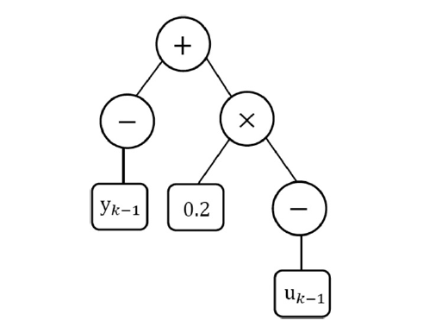
Fig. 1. Simple example GP tree.
model structure is found. The amount of highly-skilled human
intervention at every stage of this process directly motivates the
automation of the construction of predictive models to render
MPC economically-viable for buildings. A credible route to this
automation is the principal contribution of the present paper.
In Section 2, we describe genetic programming for modelling
dynamical systems and give an example for a benchmark problem
from the chemical engineering literature. We describe the building
control methodology we have used in Section 3 together with
the procedures necessary for successfully identifying a predictive
GP model of the test building. In Section 4 we report typical
results of the performance of the predictive GP model as well
as the performance of the model predictive control scheme. In
this paper, we present only representative, typical results and
defer detailed discussion of parameter settings, etc. to a future
publication. We do, however, consider these issues together with
future work in Section 5. We conclude the paper with Section 6.
2. Genetic programming
Inspired by biological evolution processes, evolutionary algorithms
(EA) solve problems by applying the theory of natural
selection to a population of individuals with the expectation of
evolving fitter models. Genetic algorithms (GA) are one class
of EA. Basically, a GA consists of a reproductive strategy for
generating offspring with better fitness using the principal genetic
operators of crossover and mutation. GP is a subset or
an extension of GA. The essential principles of GA and GP are
similar although solutions in GP are expressed as programmes
with hierarchical tree structures, which consist of pre-specified
functional and terminal nodes. This flexible tree structure provides
a dynamic and variable representation. A typical example
of such a GP tree is shown in Fig. 1, and its functional expression
is given in (2).
y(k) = (−yk−1) + (0.2 ∗ (−uk−1)) (2)
Generally, evolutionary algorithms can be classified into two
different types: steady-state and generational. In steady-state
evolution, one (or two) offspring are produced at each step and
appended to the population; the population size is then reduced
down to its original size by removing the weakest one (or two)
individuals. (In fact, the term ‘steady-state’ is a misnomer —
quasi-steady state would be more accurate.) In generational algorithms,
on the other hand, a whole new child population is
produced by repeated selection from a parent population before
the child population is swapped to become the parent population
and the process repeated. In this paper, steady-state GP is
used since this appears to yield superior search results [16]. The
following algorithm describes the evolution process of a typical
steady-state GP.
• Step 1: Population initialisation
In GP, candidates in the initial population are randomly
generated. The process of creating random trees can be implemented
in different ways [17], but two simple methods
(the ‘full’ and ‘grow’ strategies [17]) are extensively used.
In the ‘full’ method, the initial trees are created up to a
pre-defined maximum depth; the depth of a GP tree is the
minimum number of edges that need to be traversed to
reach the deepest leaf starting from the tree’s root node.
Trees are generated by randomly selecting nodes from the
function set until all the leaves reach the maximum tree
depth. In the ‘grow’ method, trees are created with more
diverse structures with some probability of terminating tree
growth before reaching the depth limit.
In order to initialise the population of trees with a variety
of shapes and sizes, Koza [18] proposed a ramped half-andhalf
method where half the initial population is created
using the ‘full’ method and half using the ‘grow’ method. In
the present work, we have used this ramped half-and-half
method for population initialisation.
• Step 2: Fitness evaluation
The performance of each tree is evaluated with a fitness
function, which is used for estimating how well a solution
performs on the given problem. Then the population
is sorted according to fitness value. Solutions with higher
ranks are more likely to be selected as parent trees to breed
child candidates in the evolution process.
• Step 3: Offspring generation
At each iteration, two GP trees are selected as parents.
Two main genetic operations, crossover and mutation, are
then applied to produce new offspring solutions. Specifically,
the crossover operator randomly selects a crossover
point in each parent tree. The child trees are then generated
by crossing over and splicing together the two trees at
the selected crossover points between two parent trees, as
illustrated in Fig. 2.
The mutation operation modifies a GP tree by randomly selecting
a mutation point in a tree, and then replacing it with
a new, randomly-generated subtree, as illustrated in Fig. 3.
After crossover and mutation, the fitness values of the newly
generated offspring are evaluated. The population is then reranked
after the appending the offspring solutions and the
two least-fit individuals deleted to return the population to
its original size.
• Step 4: Process termination
The above procedures are iterated from step 2 to step 3 until
user-specified termination conditions are met; here we have
used a fixed number of iterations.
One of the fundamental problems of GP is bloat — the inexorable
growth in tree size with no accompanying improvement
in fitness. The use of multiobjective optimisation in GP, however,
can reduce the effects of bloat by providing a selective pressure
that favours smaller models — so-called parsimony pressure. In
order to generate compact and accurate models, we have used
the twin fitness measures of tree size (number of tree nodes)
and mean squared error (MSE) over the dataset as two noncommensurable
objectives. The Pareto dominance based ranking
scheme [19] was used to rank the individuals in the population.
A fitness vector a = (a1, . . . , ap) is said to dominate b =
(b1, . . . , bp) if and only if a is partially less than b, i.e., a ≺ b
∀i : ai ≤ bi ∧ ∃i ∈ 1, . . . , p : ai < bi; in our case the fitness
vectors are the 2-vectors with node count and MSE as elements.
During the evolution process, trees with higher ranks have bigger
probabilities of being selected as parent trees to produce child
candidates, and at the end of the run the population comprises
3
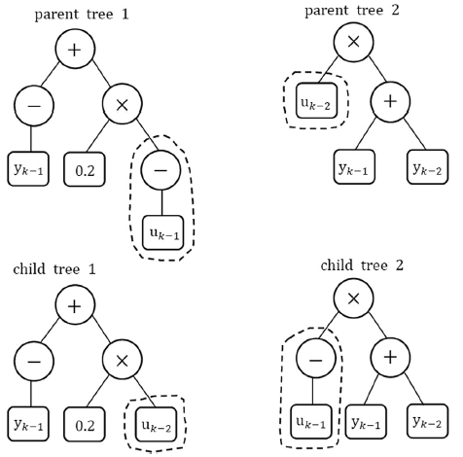

Fig. 2. Example of subtree crossover.

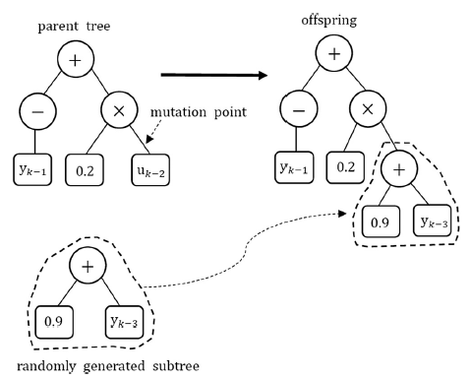
Fig. 3. Example of subtree mutation.
a set of individuals which trades-off compactness against goodness
of fit (small MSE) to the training data. Typically, this final
population spans the spectrum of small individuals with large
MSE values (underfitted models) through to large models with
small MSE values (overfitted models). We select a single, final
model as the one which has the smallest MSE over a validation
set independent to the training set.
The performance of GP on nonlinear dynamic system identification
was first evaluated on a benchmark chemical engineering
process, the Eaton–Rawlings reactor model in the following section.
Having demonstrated satisfactory performance on this task,
GP was applied to finding a dynamical model of the test building
for MPC.
2.1. Identification of the Eaton-Rawlings reactor
There have been many reports in recent years exploiting the
potential of GP for system identification, particularly in chemical
engineering applications [20]. In order to assess the suitability
of GP for nonlinear dynamic system identification, one-step-head
(OSA) prediction of a well-known benchmark chemical process,
the Eaton–Rawlings reactor model, was investigated. The Eaton–
Rawlings model [21] describes a second-order reaction occurring
in an isothermal continuous stirred-tank reactor (CSTR). The dynamics
of this reactor are expressed by the first-order, nonlinear
ordinary differential equation
dy
dt
= −hy2 −
yu
V
+
du
V
(3)
where y is the concentration in the CSTR, h is the kinetic rate
constant for the reaction, V is the reactor volume, and d is the
inlet concentration of the reactant. The manipulated variable u is
the inlet flow rate.
If the manipulated input u is assumed to change only at regular
sampling instants tk, an exact discretisation is easily derived
from the continuous-time equation; see [21] for full details.
y(k) =
[1 − τ (k − 1)μ(k − 1)]y(k − 1) + 2dτ (k − 1)μ(k − 1)
1 + τ (k − 1)[y(k − 1) + μ(k − 1)]
(4)
where
τ (k − 1) =
tanh [hT
√
μ2(k − 1) + 2dμ(k − 1)] √
μ2(k − 1) + 2dμ(k − 1)
(5)
μ(k − 1) =
u(k − 1)
2hV
(6)
In this experiment, h was 1.50 litre/mole-hr, V was 10.51 litre,
d was 3.5 mole/litre [21]. The inputs uk were a sequence of steps
of uniformly-distributed random amplitudes ranging from 0.5 to
5.0 litres per hour with a switching probability of 1.0. This input
sequence was used to perturb the reactor model (4).
To facilitate direct comparison with previous, conventional
modelling approaches, we have followed the procedure in Pearson
[21] and generated 100 statistically-independent training
sequences, each of length P = 200. The reactor responses to these
input sequences were calculated according to the discretisation
formula (4).
The performance of a GP solution was ranked by two objectives:
tree size and the MSE. The parameter settings for the
GP evolution are described in Table 1; for the identification of
the Eaton–Rawlings model, we used GP constants in the range
[0.0 . . . 1.0].
In each GP experiment, a set of solutions was obtained after
training from which the candidate with the smallest MSE over a
validation dataset was finally selected as the best model for this
run. Thus, after 100 independent training processes, the best GP
model with the smallest validation MSE among the selected 100
trees was picked as the best overall solution. The best GP model
selected had a validation MSE of 0.000121458.
We made quantitative comparison with the model – a nonlinear
autoregressive moving average model with exogenous inputs
(NARMAX) – that exhibited the best performance compared to
other hand-tuned model structures and lags studied by Pearson
[21]; the same training datasets were used to train the
NARMAX models by minimising the mean squared error metric
(8) using the NLopt nonlinear optimisation library.2 The best
NARMAX model [21] is given by:
y(k) = y0 + α y(k − 1) + β u(k − 1) + γ u(k − 1) y(k − 1) (7)
2 https://nlopt.readthedocs.io/en/latest/.
4
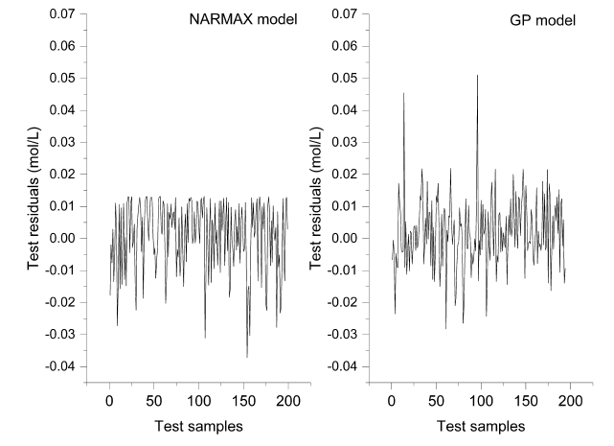
Fig. 4. Test residual comparison between the NARMAX model and the best GP model.

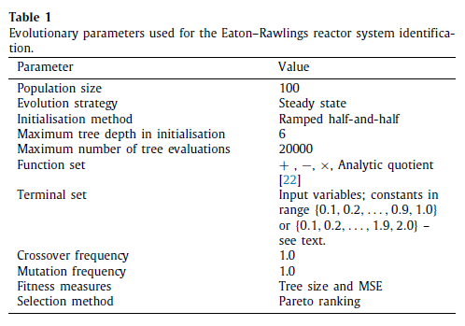
where y0, α, β, and γ are unknown parameters to be determined
by minimising the objective function, and Q is the length of the
training sequence:
J(y0, α, β, γ ) =
ΣQ−1
k=1
[ˆy(k + 1) − y(k + 1)]2 (8)
where ˆy(k + 1) is the one step ahead predicted value at time k,
and the y(k + 1) is the measured value at time k + 1.
The best validation MSE of the NARMAX models was
0.000120801, nearly equal to the value of obtained from the best
GP tree. The residuals – the differences between the true and
predicted values – of the best NARMAX and GP models over the
corresponding validation sets are shown in Fig. 4 from which it
can be seen that the GP tree exhibits comparable model accuracy
to the best NARMAX model. The residuals of the NARMAX model
show a number of negative spikes lower than −0.02, with the
absolute value of the biggest residual around 0.04. The GP model
shows two significant positive spikes, but with most of the
residuals lying in a small range around zero.
The encouraging approximation ability of the GP model on the
benchmark Eaton–Rawlings problem suggests that GP is suitable
for more general nonlinear dynamic system identification problems.
Particularly, GP does not require the functional form of the
model to be pre-specified — rather, this evolves during training.
This advantage makes GP a potential technique for identifying a
wide range of real world, nonlinear dynamic systems for which
the underlying physical principles are not known.
3. Building control methodology
In this section, we describe the procedures employed for the
MPC of buildings using predictive models obtained through a
GP-based system identification. Fig. 5 depicts the components of
the simulation system used in this work. We used an industrygrade
simulator for building physics, described in Section 3.1,
to simulate the responses of a test building. This simulator provides
a standardised interface – the Functional Mockup Interface
(FMI) [23] – that allows the interconnection of external software
units — see Section 3.1. We used this facility for two separate
tasks: first, for the open-loop collection of system identification
(SID) data detailed in Section 3.3, and second for the simulation
of the building under model-predictive control, as explained in
Section 3.6. In Section 3.5, we describe how we employed GP
using the collected SID data to obtain the required predictive
models for MPC.
3.1. Building simulator – EnergyPlus
EnergyPlus is a building energy simulator used to model
energy consumption based on dynamic heat transfer calculations
[24]. The description of the building is provided to EnergyPlus
as a text file – the input data file (IDF) – that follows a
prescribed format. The file controls all aspects of the simulation
from the building geometry and fabric to the building services
and other simulation parameters, such as occupancy.
The (key) influence of the external weather is incorporated
into the building simulation using a separate file containing
weather data, a so-called weather file. This allows repeating the
computations under different climatic conditions. In this work,
we have used design weather files generated from UK meteorological
data collected at a station located in Manchester, UK. Two
5
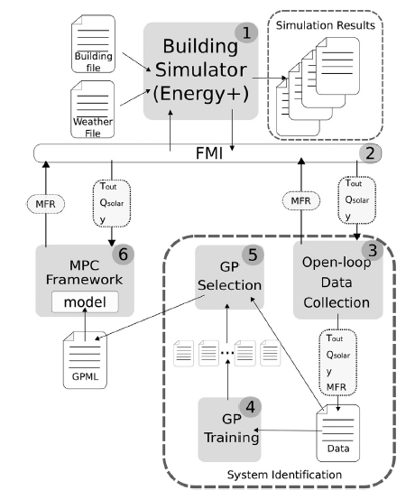
Fig. 5. Overview of the process employed in this work for MPC. The mass
flow rate (MFR) of hot water through the radiator, external temperature Tout ,
the sum of direct and diffuse solar radiation Qsolar and zone temperature y
are communicated to/from the EnergyPlus simulator via functional mock-up
interfaces (FMIs).
different weather files, both containing one year’s data, were used
in this work: the training and validation datasets were extracted
from the first weather file, while the second file was used to test
the model for a whole unbroken year.
EnergyPlus supports Functional Mock-up Interfaces (FMIs)
[23], a standardised interface for coupling software units for
co-simulation. These software units can add a variety of functionalities
to the simulation and are referred to as ‘slaves’. The
main simulator – EnergyPlus in our case – is referred to as the
‘master’. In practice, the FMI defines a set of C language function
prototypes that need to be implemented by the slave unit. The
master will then call these functions at appropriate times during
the simulation to perform various operations, such as send data,
perform calculations, read data, etc. Here we make two distinct
uses of the FMI functionality (see Fig. 5): first, we inject an
excitation sequence to perform open-loop system identification
(described in Section 3.3). Referring to Fig. 5, the mass flow rate
(MFR) to the heating radiator is varied, and the external temperature
(Tout ), sum of the direct and diffuse solar radiation (Qsolar )
and zone temperature (y) are logged at every time sampling
interval. Second, having trained the GP models on the system
identification data collected in the previous step, we used FMIs
to control the building’s heating during model predictive control
experiments (described in Section 3.6). Again referring to Fig. 5,
here under MPC control, the current environmental conditions
(Tout , Qsolar and y) are acquired from the EnergyPlus simulation via
FMIs, the optimal MFR control value calculated externally taking
into account the heating schedule, and this optimal MFR applied
at the next time step update.
3.2. Test building description
For this initial report of implementing MPC using a learned
dynamic model, we developed a single zone space with a conventional
hydronic radiator supplied by a boiler producing water
at a fixed output temperature of 67 ◦C. The heating system was
sized using EnergyPlus which determined the maximum flow of
hot water through the radiator to be 0.11 kg/s. The simulated test
building is illustrated in Fig. 6. The zone is a square room with
dimensions of 10 m × 10 m and a height of 3 m. All four walls
contain one double glazed window unit measuring 2 m × 2 m
with a sill height of 0.5 m, and placed at the centre of the external
walls. This design has a window-to-wall ratio of 13% with equal
exposure to North, East, South and West directions. The single
zone space has been set to be located in Manchester, UK, which
has an oceanic climate (Köppen classification = Cfb) and classified
as ASHRAE (American Society of Heating, Refrigeration and Air
Conditioning Engineers) climate zone 5c. The construction sets
and internal gains for this climate recommended by ASHRAE
Standard 189.1 [25] were considered for this space to make sure
a realistic set of inputs was defined in the building model for
estimating the internally-generated heat as well as the heat loss
from the façades.
We have used a setpoint temperature of 20 ◦C during occupied
(working) hours of 9am to 5pm. Outside those hours, the schedule
specified that the zone temperature was ≥ 6 ◦C to ensure frost
protection. For the present set up, we have used this schedule
for seven days a week to gather as much data about the MPC
operation as possible.
The airflow through the space consists of infiltration (0.00023
m3/s per m2 of exterior surface) and a ventilation rate of 10 l/s
per person in accordance with the Chartered Institute of Building
Services Engineers (CIBSE) Guide A [26]. The occupancy density
was 0.0565 persons/m2, the default value for office buildings
in EnergyPlus based on the ASHRAE 189.1 2009 standard. Heat
gains from people, lighting and electrical equipment were also
incorporated in a schedule.
3.3. Open-loop system identification
The design of appropriate excitation signals for collecting
identification data is the most crucial step in system identification
as the gathered data are required to be informative enough
to capture the underlying system dynamics under all relevant
operating conditions while for practical reasons, the duration of
the SID experiments should be as short as possible to minimise
disruption. Mathematically, the amplitude of the excitation signal
should cover the full range so as to maximise the power of the
excitation signal and thus the signal-to-noise ratio; the spectrum
of the input signal should excite all frequencies of interest.
For linear systems, pseudo-random binary sequences (PRBSs)
[27] are commonly used for system identification. In a PRBS, the
signal switches between two fixed amplitudes in such a way that
the autocorrelation function of the sequence approximates the
properties of white noise, and hence excites all modes of the
system. For nonlinear systems – such as that under consideration
here – switching between two fixed amplitudes cannot capture
the nonlinear behaviour [9], and so we have employed amplitude
modulated pseudo random binary sequences (APRBSs) [9] in which
the amplitude of a conventional PRBS is randomly varied, thereby
probing the nonlinear characteristics of the system.
A PRBS sequence was generated using linear feedback shift
registers where the length of the excitation sequence is controlled
by a characteristic polynomial of some degree n, and where each
polynomial coefficient was either 0 or 1. The maximum repetition
period is given by (n2 − 1) (i.e. the maximum length of the
6
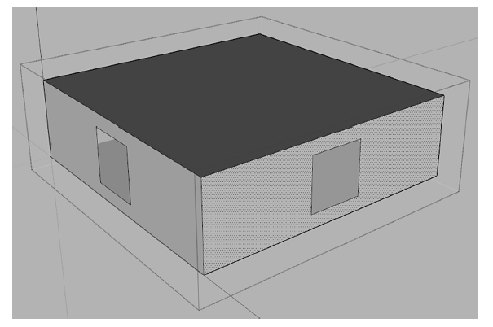
Fig. 6. SketchUp representation of the simulated building.
sequence before it starts to repeat itself). The consecutive occurrence
of the same bit is referred to as a plateau. We employed the
polynomial x7 +x6 +1, resulting in a sequence length of 127 bits
with 64 plateaux, depicted in Fig. 7(a). The interval between the
minimum and maximum radiator flows (0.00 to 0.11 kg/s) was
divided by the number of plateaux in the PRBS resulting in a set of
different amplitude levels, which were randomly assigned to the
PRBS’s plateaux, thereby generating the APRBS [9]; an example
sequence is shown in Fig. 7(b). The process of randomly assigning
amplitude levels to the PRBS plateaux was repeated to obtain a
set of different excitation sequences. Note that each repetition
of the process is likely to generate a completely different APRBS
cycle, as seen in Figs. 7(b–c).
In addition to the characteristic polynomial and the interval
of the input sequence, an APRBS is specified by a minimum holdtime
Th, that is the duration of each bit; Nelles [9] suggests that
the minimum hold-time should be the same as the dominant time
constant of the process. In our case, the only input that can be
excited is the mass flow rate through the radiator so we estimated
the dominant time constant as approximately 30 min by applying
a step excitation to the simulated zone. As a consequence, a single
APRBS-7 cycle takes around 3,810 minutes (about 2.6 days), as
depicted in Fig. 7.
3.4. Input selection
In system identification, the selection of model inputs is key to
model accuracy. Too many redundant or irrelevant input variables
hampers the search while increasing the computational burden.
Conversely, if input variables of significant influence are omitted,
the model will have systematic errors and be more likely have
poor prediction accuracy. The input and output variables used in
this paper are listed in Table 2. Full details of the input selection
criteria and experiments will be published elsewhere, but, in
brief, we performed a sensitivity analysis over the set of weather
variables with respect to predictive accuracy leaving us with Tout
and Qsolar as the most influential; the mass flow rate (MFR) is,
of course, the manipulated variable and y the predicted zone
temperature. All the variables were scaled so as to have the
training values falling in the range 0 to 1. The scaling factors used
are listed in Table 2.
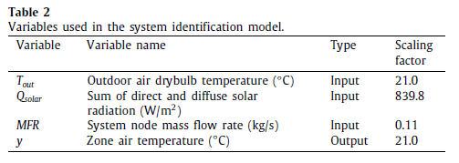
3.5. Genetic programming for building identification
• Training & validation
A dynamical predictive GP model was developed based on
an EnergyPlus simulation model and the open-loop excitation
data (see Section 3.3). Two different weather files
were employed: One weather file, denoted TRY, comprising
365 days and 35,040 samples, was used to generate
data for model training and validation (model selection).
The other dataset, denoted DSY and of the same size, was
used for estimating the model generalisation and prediction
accuracy. A particular challenge with this MPC application
is that weather conditions play a very important role in
determining the internal temperatures of the building but
they cannot be experimentally perturbed in the same way as
the radiator MFR variable. We have thus used two weather
files to allow an evaluation of performance over a complete
year independent of the training/validation data.
Since the (approximate) time constant of the simulated
building is ∼30 min, the sampling interval for the MPC was
set at half this figure, namely 15 min. The selected input
variables (see Section 3.4) were sampled every 15 min for
training, validation and testing of the GP models and the
MPC process predicts temperatures on this interval.
Given a GP model f , at time k the prediction of the zone
temperature ˆy(k+i) at time (k + i) is approximated from:
ˆy(k+i) = f (uk+i−1,uk+i−2, . . . , uk, uk−1, . . . ,
ˆy(k+i−1), ˆy(k+i−2), . . . , yk, yk−1, . . .) (9)
where i ranges from 1 to N, the length of the prediction
horizon, and u are the indexed sequence of exogenous input
vectors. In this experiment, a u vector consisted of
7
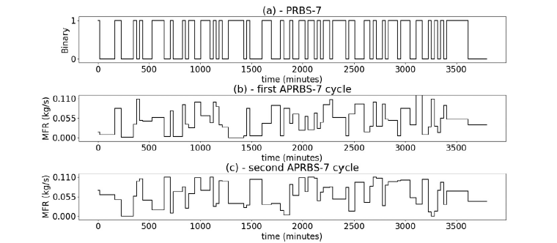
Fig. 7. A PRBS-7 sequence (a) and two different examples of APRBS-7 cycles (b–c) generated over a minimum-to-maximum flow amplitude range of 0.0 to 0.11 kg/s.
three variables: Tout , Qsolar , and MFR – see Table 2. The zone
temperature y is the predicted variable.
In the training phase, all the input and output information
is known since u consists of measured values determined
by the APRBS excitation sequence (Section 3.3) and the
known weather data; the zone temperatures up to and
including the current time k are also known. For multistep
ahead prediction, the required autoregressive values
later than time k use previously predicted values from a
series of one-step ahead predictions. For example, at time
k, ˆy(k+1) = f (. . . , yk, yk−1, . . . , yk−m). To predict two steps
ahead, ˆy(k+2) = f (. . . , ˆy(k+1), yk, yk−1, . . .). Note the use of
a predicted zone temperature ˆy(k+1) at time (k + 2) since
when the model is used in its ultimate control application,
the actual value y(k+1) will be unknown as it lies in the future
– it therefore has to be estimated. Similarly, the prediction
three steps ahead ˆy(k+2) uses both ˆy(k+1) and ˆy(k+2), and so
on. Previously predicted values are used ∀i ∈ [1 . . . N], as
necessary.
Two objectives are used to measure the performance of candidate
models during evolution: tree size and MSE. The tree
size indicates the complexity of a GP model, and provides
parsimony selection pressure that favours simpler models
during the evolutionary process. We also seek to minimise
the MSE over the training dataset by:
MSE =
ΣPk
=k′
ΣN i=1[ˆy(k+i) − y(k+i)]2
[P − max(n,m)] × N
(10)
where N is the length of the prediction horizon, and P is
the largest index on the training dataset used. Since we
require the GP model to provide accurate predictions over
the whole prediction horizon, minimising (10) provides a
selective evolutionary pressure to achieve this. The values
of upper limit on the outer summation and the normalising
term in (10) requires some clarification: Suppose we have
Q records of available training data. To train a model that
predicts N steps ahead, the final N records of the dataset can
only be used for evaluating (10) – the index k cannot exceed
(Q−N). Similarly, for an autoregressive model with n lagged
u values and m lagged y values, the first max(n,m) records
of the training set are needed to calculate the very first
prediction. Consequently, k′ , the lower limit on the outer
summation in (10), cannot be less that [max(n,m) + 1]. In
summary, the MSE in (10) is calculated over (Q − N) −
[max(n,m) − 1] consecutive records. (Conventionally, the
lower limit of this outer summation is taken as k = 1 and
any lagged inputs with (strictly) negative k indices are taken
as zero. We have not used this approach here as, in our
experience, this sometimes produces anomalous transient
predictions.)
The detailed GP parameter settings for building identification
were identical to those shown in Table 1, except we
have used constants in the range [0.0 . . . 2.0].
• Exporting the Selected GP Tree
After model validation, the best GP model was selected
for use in the EnergyPlus MPC framework. Rather than the
cumbersome inconvenience of embedding the GP training
within the MPC framework, we have exported the trained
GP model using the Genetic Programming Markup Language
(GPML) [28]. GPML is an XML-based standard for the interchange
of genetic programming trees. The implementations
of reading and writing GPML are simple and straightforward
since a number of mature, open source XML libraries
are available. A trained-and-validated GP tree can thus be
directly embedded as a ‘plug-in’ component using GPML
in larger systems, which provides both convenience and
modularity.
3.6. MPC test framework
Based on the model f in (1) approximated with a GP as
described in Sections 3.3–3.5, a control law could, in principle,
be obtained as the inverse of f – that is a mapping from desired
states to the necessary inputs. However, as f is dynamic and nonlinear,
calculating its inverse is not a trivial task. The alternative is
to perform an explicit optimisation at the current time k of the set
of values Uk = {uk, u(k+1), . . . , u(k+N−1)} using f , where N is the
prediction horizon, and adjusting Uk to yield the desired sequence
of setpoint temperatures. Thus we obtain Uk from:
Uk = argmin
ΣN
i=1
J(k + i) (11)
where N is the length of the prediction horizon. Since the (approximate)
time constant of the building’s response was determined
to be 30 min, and the MPC sampling interval was 15 min,
we adopted a value of N = 12 giving a prediction horizon of 3 h.
The function J is defined as:
J(k + i) = (ΔTk+i)2
  
temperature
+λ0 |ΔUk+i|   
control effort
+λ1uk+i
energy
(12)
where ΔTk+i = ˆy(k+i) − r(k+i) is the difference between the
predicted ˆy(k+i) and setpoint (i.e. desired) r(k+i) temperatures at
8
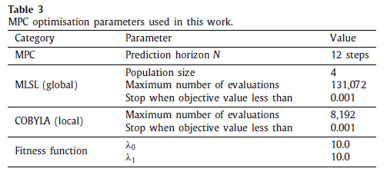
time k + i, and ΔUk+i = uk+i − uk+i−1 is the control effort. The
first term in (12) obviously penalises deviation from the desired
setpoint temperature, while the second term seeks to minimise
the extent of changes in the control variable; such a term is
frequently included in an MPC setup to minimise wear on the
system’s actuators.
The third term in (12) seeks to minimise the sum of the input
quantity, which in the present case is a proxy for input energy.
We found it necessary to include this term in (12) to ensure
that heating was turned off outside working hours when the
constraint on the setpoint temperature was relaxed to simply
being >6 ◦C to ensure frost protection. Unless this explicit energy
minimisation term was included, (11) could be minimised by
maintaining the zone temperature at 20 ◦C – obviously, >6 ◦C
– but setting the sum of the magnitudes of the control efforts
(|ΔU|) to zero. That is, not turning off heating at the end of the
working day thereby undesirably maintaining heating during the
night.
Note that the second and third terms in (12) are weighted
by the regularisation constants λ0 and λ1, which place differing
relative penalties on each of the three factors in (12). The values
of λ0 and λ1 were determined by grid search with the aim of maximising
their values subject to acceptable temperature regulation.
Predictions of zone temperature ˆy(k+i) are calculated using the GP
model described in Section 3.5.
One notable point is that in the training process, the weather
variables Tout and Qsolar are always assumed known, and for which
we have used measured values. During the validation and test
phases, however, the practical use of the model means that future
values of Tout and Qsolar are unknown. Consequently, we have
used persistent predictions for future (as yet unknown) weather
variables. Namely, the value of the weather variable at time k
is assumed to persist unchanged for the whole of the current
prediction horizon. Persistent weather prediction is known to be
reasonably accurate over the short-term [29,30] while having the
advantage of being simple to implement.
The minimisation in (11) was performed using an implementation
of the nonlinear, derivative-free optimiser COBYLA [31] together
with the Multi-Level Single-Linkage (MLSL) procedure [32,
33] from the NLopt nonlinear optimisation library.3 Although
MPC has the advantage of being able to straightforwardly incorporate
constraints on the solution, in the present work we have
used no such constraints.
The detailed MPC optimisation parameter settings for building
testing are shown in Table 3.
4. Results
In Section 4.1 we describe the results of training the GP predictive
model using the open-loop system identification data
produced using the procedure set-out in Section 3.3. Section 4.2
3 https://nlopt.readthedocs.io/en/latest/.
presents the control results from using the trained GP predictive
models in an MPC controller to regulate the zone temperature of
the building model described in Section 3.2.
4.1. GP model training
We conducted thirty GP training runs, each with an independent
initial population, using the open-loop system identification
data generated with the procedures described in Section 3.3 to
obtain 30 individual models with the best validation set MSE
per run. Among these, the model with the smallest validation
MSE overall was finally selected as the best model. January’s data
(2,880 records) were used as the training dataset and February’s
data as validation dataset. Typically, the CPU runtime of each
independent experiment takes ∼400 s (on a given computer with
3.30 GHz CPU).
The residuals (i.e. errors) for each of the i-step ahead predictions
(i ∈ [1 . . . N]) measured over the 12-month independent
test set for the best GP model are shown in Fig. 8. Here we
are assessing the important performance measure of whether
the model produces sufficiently accurate predictions over the
whole (test) year, and does not, for example, erroneously demand
heating of the building in the middle of summer.
From Fig. 8, residuals of the one step ahead prediction fall into
range from −1.25 to 1.75 ◦C; even in the summer months (June
to August) , most residuals are below 1.5 ◦C. Unsurprisingly, as
the predictions extend further into the future, the envelope of
residuals expands although only slightly. In addition, a distinct
seasonal ‘bow’ becomes more noticeable with increasing i value.
Our choice of the metric in (10) was deliberately designed to
give equal weight to the prediction errors over the whole prediction
horizon. In 12-step-ahead prediction, residuals in January,
February, March, November and December range from −2 to
2.5 ◦C. Residuals in the months such as May, June, July and August
reach their highest values of 4 ◦C and with an average lower
bound of 0 ◦C error. After increasing during summer, the sizes of
the residuals decrease later in the year. In summary, the GP model
provides promising predicted temperatures: the magnitudes of
the residuals expand with increasing prediction step size i with
the biggest residual less than 4 ◦C. The best model presented in
GPML form can be found at:
https://figshare.com/articles/gpTreeConstantWFInVall_xml/73
98797
4.2. MPC performance
Fig. 9 shows a typical result of controlling the test building
during the month of February (from the 32nd to 59th day of
the test year) using the MPC framework from Section 3. The test
weather data are independent of the data used to train/validate
the predictive model. The reference value r(k+i) was set to match
20 ◦C during working hours (9:00 to 17:00). To achieve frost
protection out-of-hours, the reference value was set at ≥ 6 ◦C.
That is, we only apply a temperature penalty out-of-hours if
the temperature falls below the frost-protection reference value.
Formally, ΔT(k+i) out-of-hours is defined as:
ΔT(k+i) =
{
ˆy(k+i) − r(k+i) if ˆy(k+i) < r(k+i).
0 otherwise.
(13)
As described in Section 3.6, we have predicted future (unknown)
weather values using persistence, that is, assuming the
variable has the same value over the whole of the prediction
horizon as it does at the start.
The upper plot in Fig. 9 shows the zone temperatures, and also
a }1 ◦C range during working hours (dotted lines). The lower
9
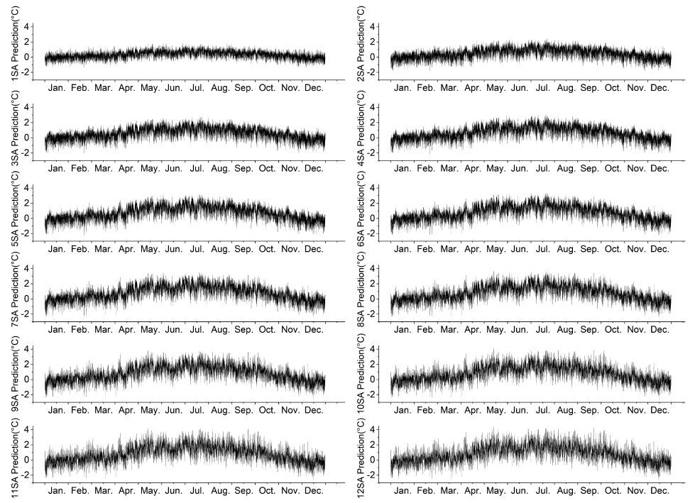
Fig. 8. Residuals (predicted - actual zone temperatures in ◦C) of the selected GP model over the test dataset for different future predictions. Each plot shows the
residuals for a given number of steps ahead — for example, ‘‘OSA’’ = 1-step head, ‘‘2SA’’= 2-steps ahead, etc. The units of the ordinate axes are Celsius.
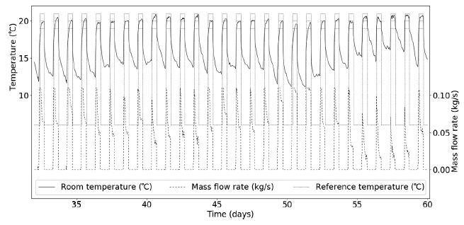
Fig. 9. Typical results of MPC controlling a single-zone room for the (test) month of February. The upper plot is the zone temperature, and the lower plot the mass
flow rate (MFR) controlled variable. The rectangular upper plot represents the temperature schedule. The dotted lines represent the temperature schedule together
with a } 1 ◦C tolerance band shown during occupied hours (9am to 5pm).
plot shows the MFR control variable (hot water flow through the
radiator).
From Fig. 9, it is clear that zone temperatures are mostly
being maintained within the }1 ◦C band during working hours.
A noteworthy feature of the MFR control variable is that it varies
fairly smoothly over the day, and is being reduced to small values
towards the ends of the working days; we infer that MPC is
exploiting the energy stored in the building’s fabric to maintain
the setpoint temperature up to the end of the working day,
thereby avoiding direct heating, if possible, which may lead to
energy savings.
Considering the thermal performance of MPC, it successfully
maintained the zone temperature within the }1 ◦C range for
83.3% and }2 ◦C for 95.2% of the (working) time. The 1 ◦C band
10
T. Dou, Y. Kaszubowski Lopes, P. Rockett et al. Applied Soft Computing Journal 97 (2020) 106695
is generally deemed comfortable, with a small proportion (less
than a quarter) of occupants feeling mildly uncomfortable at the
extremes of the 2 ◦C band [26]. Although there will be some
discomfort for the short periods outside these bands that fall at
either end of the working day, these are rare.
5. Discussion and future work
As stated above, scope of this paper is to present what we
believe to be the first report of buildings MPC using a predictive
model learned data acquired from the building. Our aim here
has been to present and document the methodology we have
used although a great deal of work remains to be done both in
terms of ‘fine tuning’ this, and in extending it. One area that
does needs to be explicitly discussed is comparator methods.
Since the GP-controller regulates the zone temperature generally
within a highly satisfactory } 1 ◦C, and exhibits no instances
of overheating and therefore wasted energy, the only reasonable
basis for comparison is the ease/cost of generation of the
predictive model — see [2]. As pointed out in Section 1, we are
aware of no comparable technique with which to make direct
comparison, and in which both the structure of the predictive
model and the composition of the lag sets are simultaneously
identified. In all other applicable techniques of which we are
aware, the search over possible model forms would need to be
embedded within a search over all possible lag sets (feature
selection). The GP approach used here thus represents a robust
and simple automated workflow for practical application of MPC
with few ‘tuning’ parameters; further GP tends to be fairly robust
to its tuning parameters.
We can identify a number of interwoven topics that will be
the subject of future work, and will be published elsewhere.
Although we have reported only one instance of a predictive
model trained on 30 days open-loop excitation data, optimisation
of the training process clearly needs to be explored systematically.
Although the test residuals shown in Fig. 8 are clearly
adequate to produce acceptable control, as evidenced by Fig. 9,
the model residuals exhibit a noticeable seasonal effect — an upward
‘bowing’ in the middle of the plots. In the summer months,
the actual temperatures are systematically somewhat higher than
those predicted by the model, but in the present application
with only heating of the building, this turns out not to make a
great difference since heating is not necessary in the summer
months. For a more complicated building, however, that includes
cooling as well as heating, these seasonal effects may produce
unacceptable conditions although for a combined heating/cooling
system, the SID procedure would obviously also need to include
excitation of both heating and cooling. Consequently, improving
the model quality is therefore clearly an area for future work, and
a number of factors need to be examined.
The duration of the open-loop excitation experiment: Although
we report only data for 30 days of system identification,
it seems possible to train adequate models with shorter data
sequences than this. The trade-off between the length of the SID
experiment and model quality needs to be explored. Naively,
one would expect model quality to improve with longer SID
sequences (= more training data), but extending the system
identification experiment has implications for both the amount of
energy used during SID as well as the practicality of conducting
the experiment.
In terms of practical application, we have established that
acceptable predictive models can be trained on data accumulated
over 30 days. Ideally, this SID timescale needs to be shortened
to be more compatible with current building project schedules,
and to be integrated with existing commissioning/testing regimes
for the heating system. One potential area of future work is to
use a much shorter SID duration and form the predictive model
using consensus prediction over multiple models [34] as has been
widely used in meteorology, econometrics, etc.
For the sake of simplicity, we have assumed persistent weather
predictions. That is, we assume the weather inputs have the
same values over the entirety of the prediction horizon as they
do at the start of the prediction horizon. Persistence is known
to be acceptable in the short term, but it is possible that more
elaborate methods [35] may give improved results, especially
for larger buildings that mandate longer prediction horizons. In
particular, short-term weather predictions are widely available
online and an avenue of future research is to examine the effect of
replacing the assumption of persistence with more sophisticated
predictions.
The length of the prediction horizon has been chosen to be
around six times the characteristic time constant of the building
(although the step response of the building is clearly not a
first-order characteristic). The trade-offs inherent in selecting a
prediction horizon are well-known in the MPC literature [1]: a
longer horizon allows a more relaxed planning timeframe and
tends to avoid overly aggressive control moves, while producing
more uncertain predictions due to the length of time into the
future over which they are being made. Shorter prediction horizons
face the converse issues. Systematic examination of setting
the prediction horizon in the context of buildings is therefore
warranted.
The MPC framework we have reported uses the rather conventional
objective of penalising deviation from a setpoint, in this
case zone temperature, together with an appropriately weighted
term to minimise control effort (a proxy for actuator wear). In
addition, we have included a term designed to minimise energy
consumption over the prediction horizon, this latter term proving
necessary for proper operation out of working hours. Clearly the
regularisation constants (here denoted λ0 and λ1) will have an
influence on the control although quite how significant these will
be also needs to be investigated.
Such a regularisation framework has been commonly used in
previously published reports on buildings MPC [2], and appears to
have been adopted straightforwardly from its widespread use in
chemical engineering and related industrial applications of MPC.
In process engineering, of course, it is frequently important to
maintain some optimal process temperature to maximise product
yield, etc. Maintaining zone temperatures within a small band,
however, is generally unnecessary in buildings. Indeed relaxing
the temperature constraints on a zone can have beneficial energysaving
advantages. More generally, tuning regularisation constants
is known to be problematic and time-consuming, and to
a large extent, a conventional regularisation framework militates
against our overall objective of automating implementation of
MPC in buildings in order to make it economically viable. Consequently,
alternative minimisation objective functions may well be
more appropriate in a building setting. For example, minimising
energy usage (over the prediction horizon) subject to the explicit
optimisation constraints of maintaining zone temperatures
within, say, a }2 ◦C band.
The system identification experiments reported here involve
open-loop excitation of the building. It is well-known that openloop
excitation can drive the system’s states to extremes since
there is no feedback control to prevent this. Apart from potentially
consuming significant amounts of energy, performing
an open-loop system identification experiment on an occupied
building would probably be unacceptable. Indeed, it is highly
likely that the occupants would take atypical actions, such as
opening windows and doors, to make the internal conditions
more acceptable to themselves, thereby undermining the validity
of the system identification data. Rockett and Hathway [2] have
11
T. Dou, Y. Kaszubowski Lopes, P. Rockett et al. Applied Soft Computing Journal 97 (2020) 106695
already suggested closed-loop system identification as a way of
addressing the shortcomings of open-loop identification for periodic
recalibration of the controller: closed-loop identification [36]
maintains the system under control using an initial predictive
model while typically applying small perturbations to the desired
setpoint from which an improved, control-capable model can be
derived. This process of closed-loop re-estimation can, of course
be repeated periodically as-and-when the building’s characteristics
change. Closed-loop recalibration of MPC’s predictive model
is clearly an area for future work where issues such as: the necessary
excitation sequence and the sensitivity of the re-estimation
procedure need to be explored.
The work presented in the paper has demonstrated successful
MPC implementation over a single-zone building. Clearly extension
to multiple-zone buildings is an obvious area of future work,
where the necessary SID procedures will need to accommodate
multiple, interacting thermal zones.
Finally, although the work presented here has been done in
simulation – as is very common in the initial steps of a control
project – the ultimate ‘proof’ of the methodology is to demonstrate
its use on a real building. This too is currently work in
progress.
6. Conclusions
In this paper, we have reported the first use of genetic programming
to obtain predictive models for the model predictive
control (MPC) of internal building temperatures. Currently, the
large-scale adoption of MPC in buildings is rendered uneconomic
by the time and cost involved in the design and tuning of predictive
models by expert control engineers. We have shown that
GP is able to automate this process using an open-loop excitation
experiment. The resulting MPC simulation is able to maintain
the internal temperature of a single-zone test building to within
}1 ◦C of the desired setpoint most of the time; we further infer
that MPC is able to effectively exploit the heat stored in the
building’s fabric towards the end of a working day rather than
applying direct heating. The results in this paper have significant
implications for enabling the wide-scale deployment of MPC in
non-domestic buildings, and for the potential reduction in CO2
emissions by improving the efficiency of building operation.
CRediT authorship contribution statement
Tiantian Dou: Software, Validation, Investigation, Writing -
review & editing. Yuri Kaszubowski Lopes: Methodology, Software,
Validation, Writing - original draft, Investigation, Writing
- review & editing, Visualization. Peter Rockett: Conceptualization,
Methodology, Investigation, Writing - original draft, Writing
- review & editing, Supervision, Funding acquisition. Elizabeth
A. Hathway: Conceptualization, Methodology, Investigation,
Writing - review & editing, Supervision, Funding acquisition. Esmail
Saber: Software, Validation, Writing - review & editing,
Visualization.
Declaration of competing interest
The authors declare that they have no known competing financial
interests or personal relationships that could have appeared
to influence the work reported in this paper.
Acknowledgement
We gratefully acknowledge the financial support of the UK
Engineering and Physical Sciences Research Council (EPSRC) grant
EP/N022351/1.
References
[1] E.F. Camacho, C. Bordons, Model Predictive Control, second ed., Springer,
London, 2004.
[2] P. Rockett, E.A. Hathway, Model-predictive control for non-domestic buildings:
Critical review and prospects, Build. Res. Inf. 45 (5) (2017) 556–571,
http://dx.doi.org/10.1080/09613218.2016.1139885.
[3] G.P. Henze, Editorial – Model predictive control for buildings: A quantum
leap?, J. Build. Perform. Simul. 6 (3) (2013) 157–158, http://dx.doi.org/10.
1080/19401493.2013.778519, Special Issue on Model Predictive Control for
Buildings.
[4] M.A. Hussain, Review of the applications of neural networks in chemical
process control - simulation and online implementation, Artif. Intell. Eng.
13 (1) (1999) 55–68, http://dx.doi.org/10.1016/S0954-1810(98)00011-9.
[5] M. Wetter, Modelica library for building heating, ventilation and airconditioning
systems, in: F. Casella (Ed.), 7th International Modelica
Conference, Como, Italy, 2009.
[6] I. Hazyuk, C. Ghiaus, D. Penhouet, Optimal temperature control of intermittently
heated buildings using Model Predictive Control: Part I – Building
modeling, Build. Environ. 51 (2012) 379–387, http://dx.doi.org/10.1016/j.
buildenv.2011.11.009.
[7] D. Sturzenegger, D. Gyalistras, M. Morari, R.S. Smith, Semi-automated
modular modeling of buildings for model predictive control, in: 4th
ACM Workshop on Embedded Sensing Systems for Energy-Efficiency in
Buildings (BuildSys ’12), Toronto, Canada, 2012, pp. 99–106, http://dx.doi.
org/10.1145/2422531.2422550.
[8] J. Sjöberg, Q. Zhang, L. Ljung, A. Benveniste, B. Delyon, P.-Y. Glorennec,
H. Hjalmarsson, A. Juditsky, Nonlinear black-box modeling in system
identification: A unified overview, Automatica 31 (12) (1995) 1691–1724,
http://dx.doi.org/10.1016/0005-1098(95)00120-8.
[9] O. Nelles, Nonlinear System Identification: From Classical Approaches to
Neural Networks and Fuzzy Models, Springer, Berlin, 2001.
[10] K.O. Stanley, R. Miikkulainen, Evolving neural networks through augmenting
topologies, Evol. Comput. 10 (2) (2002) 99–127, http://dx.doi.org/10.
1162/106365602320169811.
[11] B. Grosman, D.R. Lewin, Automated nonlinear model predictive control
using genetic programming, Comput. Chem. Eng. 26 (4–5) (2002) 631–640,
http://dx.doi.org/10.1016/S0098-1354(01)00780-3.
[12] Q. Feng, H. Lian, J. Zhu, Model predictive control of nonlinear dynamical
systems based on genetic programming, in: 36th Chinese Control Conference
(CCC), Dalin, China, 2017, pp. 4540–4545, http://dx.doi.org/10.23919/
ChiCC.2017.8028072.
[13] K. Rodríguez-Vázquez, C.M. Fonseca, P.J. Fleming, Identifying the structure
of nonlinear dynamic systems using multiobjective genetic programming,
IEEE Trans. Syst. Man Cybern. A 34 (4) (2004) 531–545, http://dx.doi.org/
10.1109/tsmca.2004.826299.
[14] M.P. Hinchliffe, M.J. Willis, Dynamic systems modelling using genetic
programming, Comput. Chem. Eng. 27 (12) (2003) 1841–1854, http://dx.
doi.org/10.1016/j.compchemeng.2003.06.001.
[15] G. Casella, R.L. Berger, Statistical Inference, Duxbury, Pacific Grove, CA,
2002.
[16] T. Dou, P. Rockett, Comparison of semantic-based local search methods for
multiobjective genetic programming, Genet. Program. Evol. Mach. 19 (4)
(2018) 535–563, http://dx.doi.org/10.1007/s10710-018-9325-4.
[17] R. Poli, W.B. Langdon, N.F. McPhee, A field guide to genetic programming,
2008, Published via http://lulu.com and freely available
at http://www.gp-field-guide.org.uk, http://dces.essex.ac.uk/staff/rpoli/gpfield-
guide/A_Field_Guide_to_Genetic_Programming.pdf.
[18] J.R. Koza, Genetic Programming: On the Programming of Computers by
Means of Natural Selection, MIT Press, Cambridge, MA, USA, 1992.
[19] C. Fonseca, P.J. Fleming, Multiobjective optimization and multiple constraint
handling with evolutionary algorithms - Part I: A unified
formulation, IEEE Trans. Syst. Man Cybern. A 28 (1) (1998) 26–37, http:
//dx.doi.org/10.1109/3468.650319.
[20] R. Vyas, P. Goel, S.S. Tambe, Genetic programming applications in chemical
sciences and engineering, in: A.H. Gandomi, A.H. Alavi, C. Ryan (Eds.),
in: Handbook of Genetic Programming Applications, Springer International
Publishing, Cham, 2015, pp. 99–140.
[21] R. Pearson, Discrete-time Dynamic Models, Oxford University Press, 1999.
[22] J. Ni, R.H. Drieberg, P.I. Rockett, The use of an analytic quotient operator
in genetic programming, IEEE Trans. Evol. Comput. 17 (1) (2013) 146–152,
http://dx.doi.org/10.1109/TEVC.2012.2195319.
[23] T. Blochwitz, M. Otter, M. Arnold, C. Bausch, H. Elmqvist, A. Junghanns,
J. Mauß, M. Monteiro, T. Neidhold, D. Neumerkel, H. Olsson, J.-V. Peetz,
S. Wolf, C. Clauß, The Functional Mockup Interface for tool independent
exchange of simulation models, in: 8th International Modelica Conference,
Dresden, Germany, 2011, pp. 105–114, http://dx.doi.org/10.3384/
ecp11063105.
[24] D.B. Crawley, C.O. Pedersen, L.K. Lawrie, F.C. Winkelmann, EnergyPlus:
Energy simulation program, ASHRAE J. 42 (4) (2000) 49–56.
12
T. Dou, Y. Kaszubowski Lopes, P. Rockett et al. Applied Soft Computing Journal 97 (2020) 106695
[25] ASHRAE, Standard for the Design of High-Performance Green Buildings
Except Low-Rise Residential Buildings, Tech. Rep. ASHRAE 189.1, American
Society of Heating, Refrigerating and Air-conditioning Engineers, Atlanta
GA, 2009.
[26] CIBSE, CIBSE Guide A: Environmental Design, Tech. rep, The Chartered
Institution of Building Services Engineers, London, UK, 2015.
[27] T. Söderström, P. Stoica, System Identification, Prentice Hall, New York,
1989.
[28] T. Dou, Y. Kaszubowski Lopes, P. Rockett, E.A. Hathway, E. Saber, GPML:
An XML-based standard for the interchange of genetic programming trees,
Genet. Program. Evol. Mach. (2019) http://dx.doi.org/10.1007/s10710-019-
09370-4.
[29] J. Antonanzas, N. Osorio, R. Escobar, R. Urraca, F.M. de Pison, F. Antonanzas-
Torres, Review of photovoltaic power forecasting, Sol. Energy 136 (2016)
78–111, http://dx.doi.org/10.1016/j.solener.2016.06.069.
[30] D. Corne, A. Reynolds, S. Galloway, E. Owens, A. Peacock, Short term wind
speed forecasting with evolved neural networks, in: 15th Annual Conference
Companion on Genetic and Evolutionary Computation, Amsterdam,
The Netherlands, 2013, pp. 1521–1528, http://dx.doi.org/10.1145/2464576.
2482731.
[31] M.J. Powell, A direct search optimization method that models the objective
and constraint functions by linear interpolation, in: S. Gomez, J.-P. Hennart
(Eds.), in: Advances in Optimization and Numerical Analysis, Vol. 275,
Springer Netherlands, 1994, pp. 51–67, http://dx.doi.org/10.1007/978-94-
015-8330-5_4.
[32] A.H.G. Rinnooy Kan, G.T. Timmer, Stochastic global optimization methods
part I: Clustering methods, Math. Program. 39 (1) (1987) 27–56, http:
//dx.doi.org/10.1007/BF02592070.
[33] A.H.G. Rinnooy Kan, G.T. Timmer, Stochastic global optimization methods
part II: Multi level methods, Math. Program. 39 (1) (1987) 57–78, http:
//dx.doi.org/10.1007/BF02592071.
[34] R.T. Clemen, Combining forecasts: A review and annotated bibliography,
Int. J. Forecast. 5 (4) (1989) 559–583, http://dx.doi.org/10.1016/0169-
2070(89)90012-5.
[35] A.R. Florita, G.P. Henze, Comparison of short-term weather forecasting
models for model predictive control, HVAC R Research 15 (5) (2009)
835–853, http://dx.doi.org/10.1080/10789669.2009.10390868.
[36] M. Gevers, Identification for control: From the early achievements to the
revival of experiment design, Eur. J. Control 11 (4–5) (2005) 335–352,
http://dx.doi.org/10.3166/ejc.11.335-352.
13

