Size Optimization of 3D Stereoscopic Film Frames

Nada Alramahi,
School of Engineering,
London South Bank University
nadaalramahi@yahoo.com

Martin Bush,
School of Engineering,
London South Bank University
martin.bush@lsbu.ac.uk

M. Rafiq Swash,
Dept of Electronic and Computer Engineering,
Brunel University London
rafiq.swash@brunel.ac.uk

Abstract

3D stereoscopic film has inherently the problem of large frame size that many 3D images compression algorithms already investigated for exploiting complex method, outputting poorly displayed frame, and takings a long processing time.
Consequently, this paper presents the development of a unique technique of clipping the redundant areas from the frames that do not appear in 3D stereoscopic film which delivered side-by-side (SbS) format over a conventional packet-based network. This implies reducing the size of the 3D film with natural depth perception.
Keywords- Optimization; Stereoscopic Film; 3D Frames; Aspect Ratio

Introduction

3D stereoscopic film processing may significantly have optimized by reducing the size of the 3D film with natural depth perception. The redundant areas from the frames that do not appear in which delivered side-by-side (SbS) format over a conventional packet-based network. Several studies have been done concerning the processes of capture, encoding, transmission and display of 3D film contents [1] but this the first time think to reduce the frames size before the compression.
In the stereoscopic film sequence, the perceived stereo-depth is dependent on the fact that subsequent frame images are captured from a different perspective and possibly by two different cameras. That gives rise to the research question whether one needs all the size of images from Left and right frames to produce stereo depth or might only use the most informative part of the frames which appear in the 3D film. Thus, the redundant part will be removed after capturing the scene from the parallel camera Side-by-Side, through computing the correlation coefficient between the data of left and right frames without losing image feature and quality.
Most studies thought that the distortion types in the conventional film are due to the impact of transmission errors in 3D stereoscopic film. Worth noting, that for both source frames more than half the subjects felt visual fatigue in some degree [1]. The results shows the current experiments find just 6% of frames not felt visual. The removal of the redundant area from the 3D film frames is achieved by computing the correlation coefficient between left and right frames to reduce the size of the frames which is the aim of this project. Firstly, the left and right frame is divided into [250x1080] sub-matrix. Secondly, scan the sub-matrix by calculating the Half Mean Correlation Coefficient to remove non-similarity between left and right frames.
The objective of this part of work is removing segments of the images that don't contribute to the 3D perceived depth, and evaluating the reduction is necessary to avoid the most important problem of conventional in broadcast systems. The structure of 3D film consists of frame pairs, thus, naturally the storage requirement is doubled and longer broadcasting time is need high internet quality. That associated with visual discomfort felt by the observers [2].
The sequence of framework side-by-side (SbS) is considering a broadcasting scenario based on 3D stereoscopic film. To reduce the size of the sequential spatial multiplex of left and right frames are structured as the base framework of this study [3]. The compression process is proposed by removing the redundant area of just 6% from the original frames to reduce the size, enhance observability and increase the accuracy.
The contributions achieved in this paper can be summarized as following:
- Stereoscopic movie compression
- Achieving a compression process by removing the redundant area of 6% from the original frames.
- Enhancing movie observability
- Increasing the compression accuracy

Background

Three dimensional stereo images are produced by simulating the way human eyes observe objects from two perspectives. That means at least two images are necessary for the production of one 3D image [4] [5] [6]. The two lenses in one camera image are arranged to have identical optical characteristics to enable them to acquire a stereo image pair [1]. The distance between two lenses in a stereo camera is 65mm has called Interaxial, effect on the distance between the image planes and the location of the cameras. 3D image (x, y, z) is a point in the scene, which is projected onto the image planes at left frame and right frame, which the images are superimposed they do not coincide. To enable these frames to be transmitted to produced 3D images at the receiving end, needs twice the bandwidth in comparison to transmitting a monocular image.
As stereoscopic problem is the size of frame display which many 3D frames compression algorithms already exist, using various methods, many are not lossless and lead to zones where frames are not well displayed or use complex method which take a long time.
But no one consider the approach of clipping the redundant areas in the images, it could reduce the size of the images then it will cause to reduce the size of the film. As shown in Fig.1 and Fig. 1, how the scenes has captured by parallel cameras and typical broadcasting architecture which a first step for multiplexing left and right frames has been added. The movie is created by left and right views and displayed in a 2D screen using the specific technique considered is SbS multiplexing [2].
Though over the next few years, digital terrestrial television will mature to enable the viewing of 3D films more prevalent [3]. On the other hand this technique has the disadvantage of losing image resolution due to the merging of two full images into one single frame [7]. Various methods for mixing the stereoscopic views into one frame have been proposed, but the most common is Side-by-Side (SbS), in which is worked to reduce the width of left and right so this paper will work about parallel cameras display (SbS) to reduce the size.

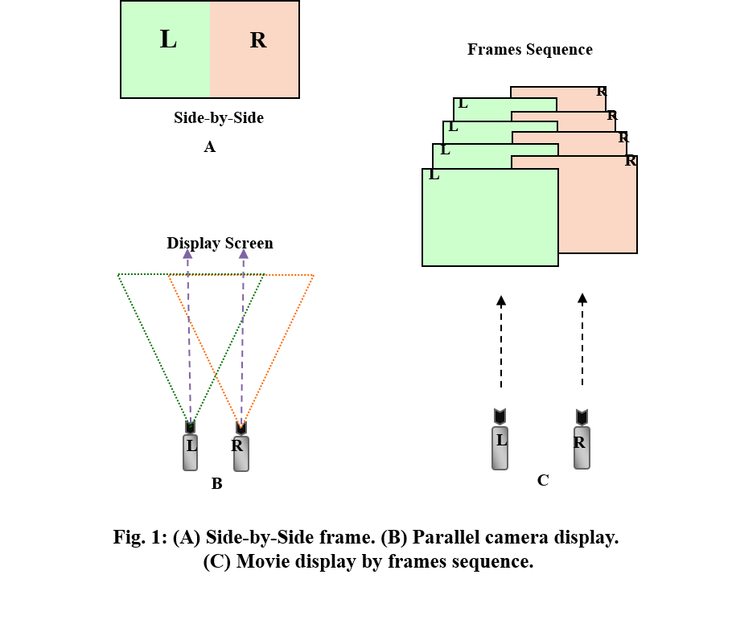

Results

In this paper, images (left and right) are captured using two identical cameras with displaced perspective. As shown in Fig. 2, the corresponding image from these two cameras will result in small section of images [A] that does not correspond to each other.
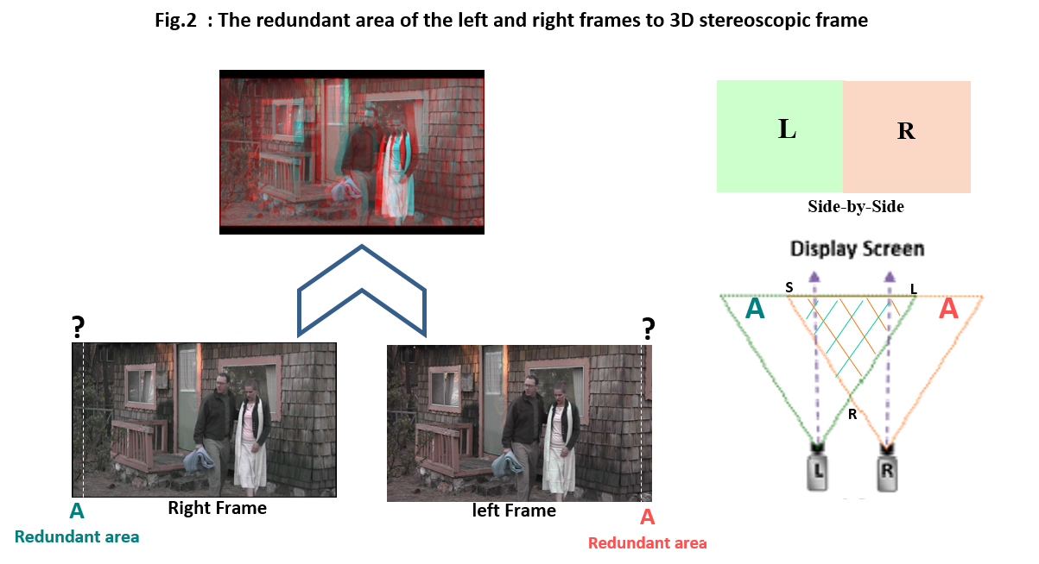
Hence, these sections do not contribute to the perceived 3D scene. The aims are to identify these sections and remove them and test to see whether the quality of the image is affect or not? Furthermore, to calculate the potential efficiency measure from such editing.
To remove the spatial redundancies that are present in both images and movie sequences (areas A), and the size of frames will crop the size of display screen as shown in Fig. 2, Fig. 3, by using Eq (5).

${B^{2}=(\frac{1}{2}C)}^{2}+D^{2}$ (1)
$B^{2}={C^{2}}/4+D^{2}$ (2)
$C^{2}=4(B^{2}- D^{2})$ (3)
$C=2\sqrt{{(B}^{2}-D^{2})}$ (4)
$C=2\sqrt{{{(D}/{cosβ)}}^{2}-D^{2}}$ (5)

That means the display screen can be known to remove the redundant area from the frames but at the same time the size of view part of the frame depends on a way of display the film. Depending on International Standards Organization (ISO) Table1, the sizes of the display screen are different and this project wants to find a way to compress the film with any kind of display and the size of the frames so to sort this problem should find another way to calculate the redundant area.
As shown in Fig. 3, the structure of a 3D camera is similar to human eyes, which are separated by approximately 65 mm (approximately 2.5 inches) from center to center. This is known as the interocular distance between the eyes. In a 3D camera, the term for the offset between the two lenses is known as inter-axial.
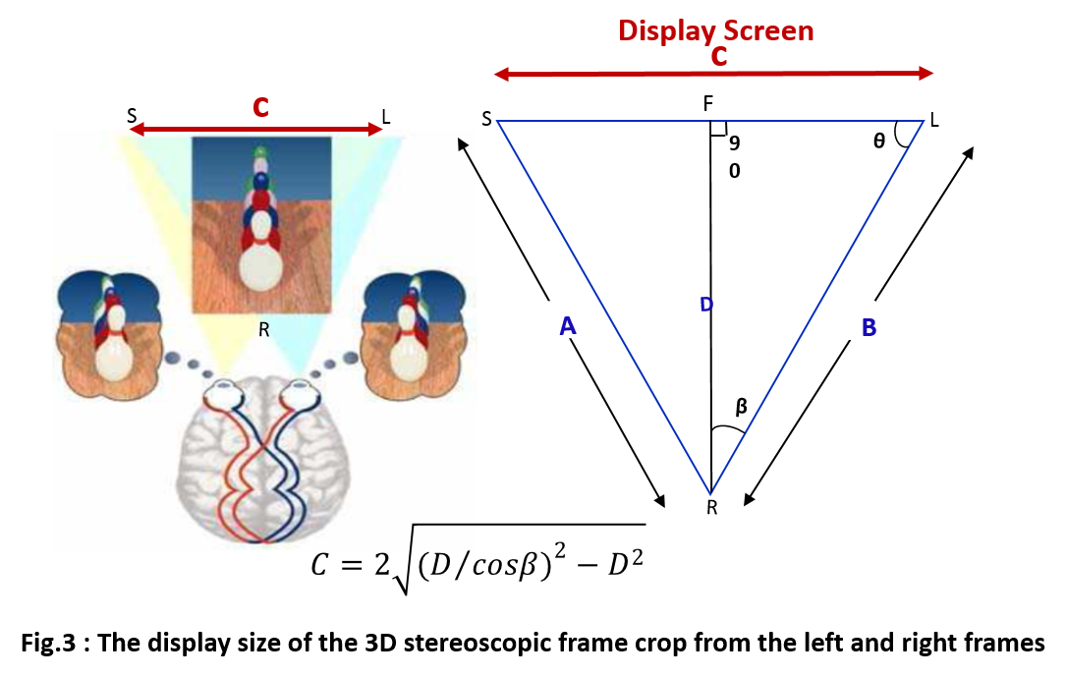

The principle of 3D stereoscopic production is separating the objects for left and right views and adding depth with lighting. The process is fundamentally based on replicating this ocular offset, called interaxial offset, which creates different views for each eye. If the two cameras are not properly aligned, parallax issues can arise that affect post-processing during editorial visual effects [8] [9].

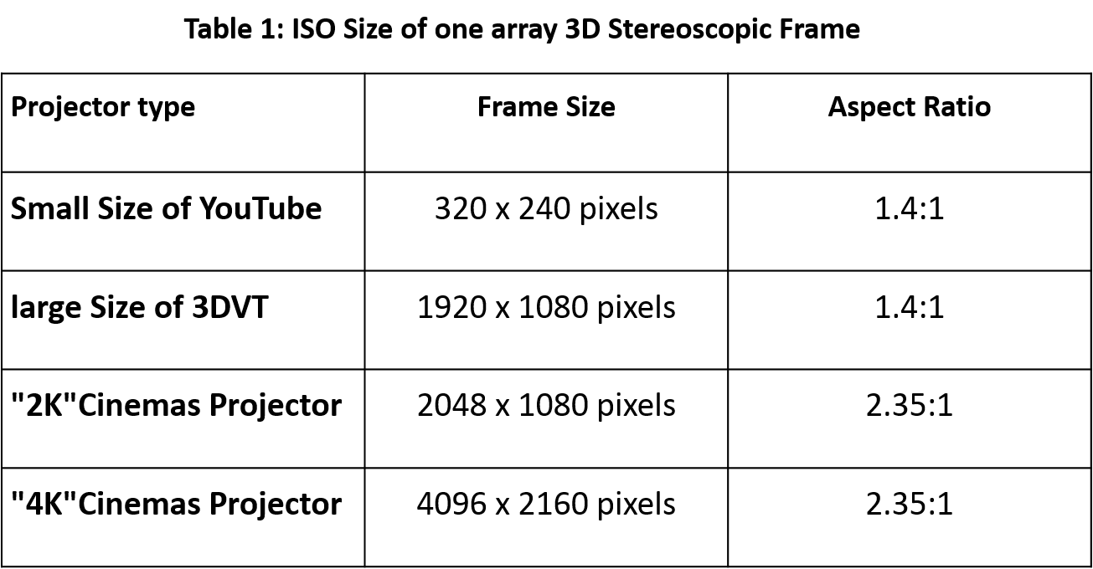

Horizontal parallax indicates a different distance between each eye. This type of parallax is normal (as the eyes are horizontally positioned). See Fig. 3. Vertical parallax is irregular in the real world and can cause fatigue and the feeling that the eyes are being concentrated on a small area of interest (like when crossing one’s eyes). Real world parallax is always in the direction of separation of the two eyes and is normally horizontal. See Fig. 3 [6,7]. Whereas, the both of view's eyes are the same distance from the Display Screen and the point half-way between the eyes lies on the perpendicular to the Display Screen that passes through its center, and the both of view's eyes are the same distance from the Display Screen and the point half-way between the eyes lies on the perpendicular to the Display Screen that passes through its center.
The principle of 3D stereoscopic production is separating the objects for left and right views and adding depth with lighting. The process is fundamentally based on replicating this ocular offset. If the two cameras are not properly aligned, parallax issues can arise that affect post-processing during editorial visual effects, which the screen Negative parallax [10] [11]:

• 6 m screen = 22 pixels/mm
• 12 m screen = 11 pixels/mm
• 18 m screen = 7 pixels/mm

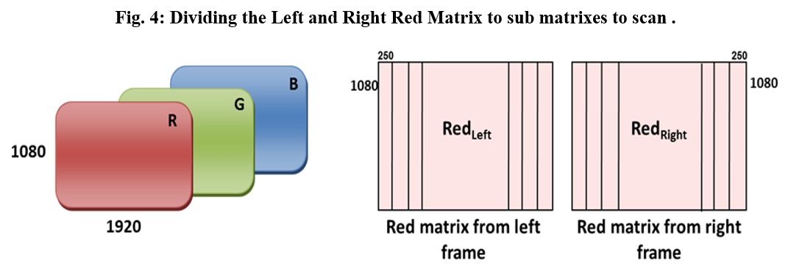
The redundant area size in left and right frames (A) in Fig. 2 can be found by computing the Correlation Coefficient in Eq (6) [1], Fig. 3:

$r=\frac{\sum_{m}{\sum_{n}{\left(X_{mn}- \overline{X}\right)- \left(Y_{mn}- \overline{Y}\right)}}}{\sqrt{\left(\sum_{m}{\sum_{n}{{\left(X_{mn }- \overline{X}\right)}^{2}}}\right)\left(\sum_{m}{\sum_{n}{{\left(Y_{mn }- \overline{Y}\right)}^{2}}}\right)}} ×\frac{1}{2}$ …(6)

In this equation X and Y are matrices representing the left and right frames, which are the same size. X and Y can be numeric or logical. The return value r is a scalar double. m and n are the dimensions of the matrices for the left and right frames. The mean of array X is calculated by treating the columns of X as vectors, returning a row vector of mean value.
The size of the redundant area is half of the mean correlation coefficient between the two frames. This may be computed using appropriate software such as MATLAB [12].
However, the frames in the film have the same size of matrices and each frame requires three matrices – Red, Green and Blue – but only one matrix for the left and right frames to calculate the size of the redundant areas and remove it from all matrices. The first step is to divide the left and right red matrices to [250x1080] sub matrix of Fig. 4, and then scan the sub matrix to calculate the Mean Correlation Coefficient because in 3D image the objects look like have a shadow and lose the quality of the original image, that come from left frame is slight different from the right frame. It comes from the near position of the left and right lenses 3D camera when capture the same since. While calculating the Mean Correlation Coefficient between the left and right frame and remove it that caused lose the quality of the image because the left and right frames are already different so remove more than should be, Fig. 5. Consequently, the size of the redundant area between two frames without losing the quality of the image is Half Mean Correlation Coefficient so it is [108x 1080]. The result of the redundant area is 6% from the original frame.
To compare the result between the original frame and new frame by calculate Peak Signal to Noise Ratio (PSNR) and Mean Square Error (MSE) are used to comparing the squared error between the original image and the reconstructed image. However, there is an inverse relationship between PSNR and MSE higher PSNR value indicates the higher quality of the image, the mean square error between the two signals is thus defined as:
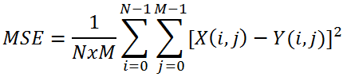
… (7)
The more Y is similar to X, the more MSE is small. Obviously, the greatest similarity is achieved when MSE equal to 0, PSNR is so defined as:

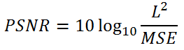
… (8)

The result for PNSR is (64.467) and for MSE is (0.023).

4. Conclusion

The prototype has programmed to remove the unobserved area from the frames via implementing the mean correlation coefficient between two frames to measure the similarity to elimination the redundant area, without losing the feature of the frames and will never deteriorate the 3D stereoscopic film quality. Consequently, this optimized solution is reducing the cost of 3D stereoscopic film solution, lowering the storage requirements, speeding up the film broadcasting with bit better visual comfort felt by the observers.

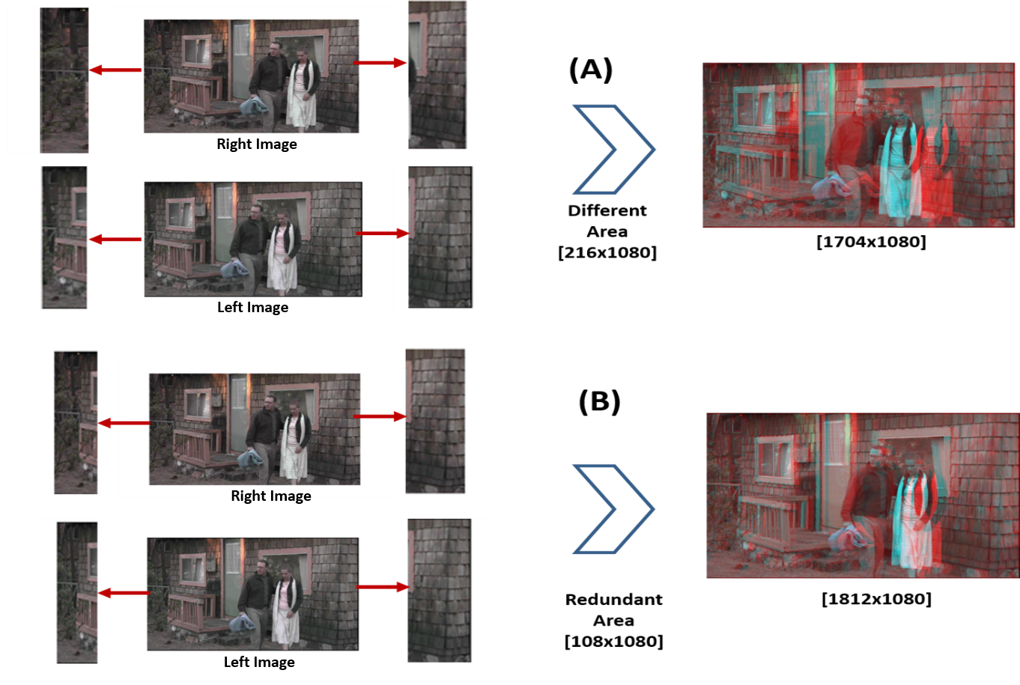
Fig. 5: The size of redundant area is half of the mean correlation coefficient between two sub red matrices frames

5. References

[1] | B. Kaufmann and M. Akil, "3D Images Compression for Multi-View Auto-Stereoscopic Displays," in International Conference on Computer Graphics, Imaging and Visualisation (CGIV'06), Sydney, Qld., 2006, pp. 128-136., Sydney, Qld.,, 2006.
[2] | J. Gutiérrez, P. Pérez, F. Jaureguizar, J. Cabrera and N. García, "Subjective assessment of the impact of transmission errors in 3DTV compared to HDTV," in 2011 3DTV Conference: The True Vision - Capture, Transmission and Display of 3D Video (3DTV-CON), Antalya,, 2011.
[3] | M. C. Forman, "Compression of Integral Three-Dimensional Television Pictures," A thesis submitted in partial fulfilment of the requirements for the degree of Doctor of Philosophy. De Montfort University., London, UK., 1999.
[4] | S. K. Hasan, FPGA implementations for parallel multidimensional filtering algorithms, Newcastle Upon Tyne: Univerity of Newcastle, PhD thesis, 2013.
[5] | S. Hasan, "S. Hasan, "Performance-vetted 3-D MAC processors for parallel volumetric convolution algorithm: A 256×256×20 MRI filtering case study,"," in 2016 Al-Sadeq International Conference on Multidisciplinary in IT and Communication Science and Applications (AIC-MITCS), Baghdad, 2016, pp. 1-6..
[6] | S. Hasan, "Performance-Aware Architectures for Parallel 4D Color fMRI Filtering Algorithm: A Complete Performance Indices Package," IEEE Transactions on Parallel and Distributed Systems, vol. 27, no. 7, pp. 2116-2129, July 1 2016.
[7] | J. Olm and B. Gaffney, "3D STEREO DIGITAL INTERMEDIATE WORKFLOW," in The VES Handbook of Visual Effects, 2010, pp. e51-e520.
[8] | S. Zwerman and J. A. Okun, The VES Handbook of Visual Effects: Industry Standard VFX Practices and Procedures, Taylor and francis, 2014.
[9] | N. A. Dodgson, "Autostereoscopic 3D Displays," Computer, vol. 38, no. 8, pp. 31-36, 2005.
[10] | W. C. Chen, F. J. Hsiao and C. W. Lin, "An automatic parallax adjustment method for stereoscopic augmented reality systems," in W. C. Chen, F. J. Hsiao and C. W. Lin, "An automatic parallax adjustment method for stereoscopic augmented reality systems2010 IEEE International Symposium on Mixed and Augmented Reality, Seoul, 2010, pp. 215-216., 2010.
[11] | F. S. a. W. S. G. Bruder, "Effects of visual conflicts on 3D selection task performance in stereoscopic display environments," in 2013 IEEE Symposium on 3D User Interfaces (3DUI), Orlando, FL, 2013, pp. 115-118., G. Bruder, F. Steinicke and W. Stürzlinger, "Effects of visual conflicts on 3D selection task performance i2013 .
[12] | Y. H. Lin and J. L. Wu, "Binocular Perceptual Model for Symmetric and Asymmetric 3D Stereoscopic Image Compression," in Y. H. Lin and J. L. Wu, "Binocular Perceptual Model for Symmetric and Asym2014 Data Compression Conference, Snowbird, UT, 2014, pp. 113-122., 2014.
[13] | M. C. RealD, "Understanding 3DProjection Efficiency," in The EDCF Guide to 3D Cinema, 2011, p. 25.

